Double-Orifice Mitral Stenosis of Rheumatic Origin: Case Report and Literature Review
Abstract
Double-orifice mitral valve (DOMV) is an uncommon anatomical anomaly, which may be either congenital or acquired. In rheumatic heart disease, subvalvular fusion and leaflet remodeling can mimic a DOMV appearance, complicating the differential diagnosis. We present the case of a 40-year-old woman with severe DOMV mitral stenosis of rheumatic origin, confirmed histopathologically after mitral valve replacement. Transthoracic echocardiography revealed two distinct mitral orifices with commissural fusion, each with a valve area of 0.7 cm². The mean transmitral gradient was 14 mmHg, with pulmonary artery systolic pressure estimated at 55 mmHg. Given the high risk of leaflet rupture with percutaneous balloon mitral valvotomy, surgical valve replacement was performed, combined with a single-vessel coronary bypass. Postoperative recovery was uneventful. This case emphasizes the importance of distinguishing congenital from acquired DOMV, as management and prognosis differ significantly. Advances in three-dimensional echocardiography and surgical outcomes in DOMV are also discussed.
Keywords: double-orifice mitral valve, mitral stenosis, rheumatic heart disease, echocardiography, valve replacement
Introduction
Double-orifice mitral valve (DOMV) is a rare morphological anomaly defined by the presence of two separate valvular orifices, typically divided by a fibrous or muscular bridge. First described in the 19th century [1], it can be congenital—an embryological malformation often associated with other cardiac anomalies—or acquired, usually secondary to rheumatic heart disease (RHD) [2]. Its estimated prevalence is <0.1% in echocardiographic series [3].
Congenital DOMV may remain asymptomatic or present with mitral regurgitation or stenosis, whereas acquired forms are generally linked to post-inflammatory remodeling and commissural fusion [4,5]. Distinguishing congenital from acquired DOMV has crucial clinical implications, as treatment strategies and prognosis differ.
Here, we describe a case of severe rheumatic DOMV stenosis in a 40-year-old woman, highlighting the diagnostic challenges and reviewing current literature on congenital versus acquired forms.
Case Report
A 40-year-old woman, diabetic, with a history of recurrent childhood pharyngitis, presented with progressive exertional dyspnea (NYHA class III) and angina (CCS class III). She had experienced dyspnea for five years, with recent worsening.
Clinical examination:
-Irregular pulse consistent with atrial fibrillation
-Diastolic murmur at the apex
-Loud pulmonary component of the second heart sound
Investigations:
- Electrocardiogram (ECG): atrial fibrillation with controlled ventricular response (85 bpm) (Figure 1).
- Chest radiograph: cardiomegaly with double right heart border, straightened left cardiac contour, and elevation of the left main bronchus ("rider’s sign") (Figure 2).

- Transthoracic echocardiography:
- Thickened mitral leaflets with restricted mobility and calcified tips
- Double-orifice appearance of the mitral valve with commissural fusion (Figures 3 and 4)
- Valve area: 0.7 cm² per orifice
- Mean transmitral gradient: 14 mmHg
- Left atrial enlargement (area: 35 cm²)
- Pulmonary artery systolic pressure: 55 mmHg
- No significant tricuspid involvement
Differential diagnosis:
Congenital DOMV was considered unlikely, given the absence of associated congenital anomalies and childhood cardiac symptoms [6,7].
Acquired (rheumatic) DOMV was favored due to history of recurrent pharyngitis, echocardiographic evidence of commissural fusion, and leaflet calcification [1,2,8].
Management:
Given the high risk of leaflet tear with percutaneous valvuloplasty, surgical valve replacement was recommended. Coronary angiography revealed significant proximal LAD stenosis, requiring concomitant bypass grafting.
The patient underwent successful mitral valve replacement with mechanical prosthesis and single-vessel CABG. Postoperative recovery was uneventful, and she was discharged on day 7. Histopathology of the excised valve confirmed rheumatic etiology, with fibrosis, calcification, and inflammatory changes.
Discussion
1. Congenital DOMV: A Developmental Anomaly
Congenital DOMV is a rare malformation, typically associated with atrioventricular septal defects or other complex congenital anomalies [6]. Three main anatomical subtypes have been described: (i) complete bridge, (ii) fenestrated type, and (iii) tunnel type. Clinical manifestations range from asymptomatic incidental findings to significant mitral stenosis or regurgitation [7]. Two- and three-dimensional echocardiography are the cornerstones of diagnosis, with surgical repair indicated in hemodynamically significant lesions [9].
2. Acquired DOMV in Rheumatic Heart Disease
Acquired DOMV is most often seen in the context of rheumatic mitral stenosis [1,2]. Commissural fusion, fibrosis, and calcification create an irregular double-orifice appearance. Unlike congenital DOMV, it is not associated with additional malformations. Echocardiographic features suggesting acquired origin include:
-Commissural and subvalvular fusion
-Irregular, asymmetric orifices
-Leaflet calcifications
-Absence of congenital anomalies [8]
Histopathological confirmation remains the gold standard. Management follows that of rheumatic mitral stenosis: percutaneous balloon mitral valvotomy (PBMV) in selected patients with favorable valve morphology, or surgical valve replacement in heavily calcified or high-risk valves [3,4].
3. Distinguishing Congenital vs. Acquired Forms
Criteria | Congenital DOMV | Acquired (Rheumatic) DOMV
Clinical history | Often congenital anomalies, childhood diagnosis | Recurrent pharyngitis, rheumatic fever history
Valve morphology | Symmetric, regular division | Irregular, calcified, commissural fusion
Associated anomalies | Frequent | Rare
Histopathology | Normal or immature tissue | Fibrosis, calcification, inflammation
4. Advances in Imaging and Management
Three-dimensional echocardiography has improved the morphological assessment of DOMV, providing detailed visualization of valve anatomy [9,10]. Recent studies highlight the role of surgical repair or replacement, with outcomes depending on etiology and valve pathology [11]. In rheumatic DOMV, PBMV may be attempted in selected cases [3,4], but surgical replacement remains the standard when leaflet calcification or subvalvular disease is extensive [8].

Conclusion
This case illustrates a rare presentation of double-orifice mitral stenosis of rheumatic origin. Careful clinical and echocardiographic evaluation, supported by histopathology, is essential to distinguish congenital from acquired DOMV. This distinction carries important therapeutic implications, as management ranges from conservative follow-up or repair in congenital cases, to valve replacement in rheumatic disease. Incorporation of advanced imaging and awareness of this entity may improve diagnostic accuracy and patient outcomes.
Abbreviation:
DOMV: Double-orifice mitral valve
CCS: Canadian cardiovascular society
NYHA: New York Heart Association
ECG: Electrocardiogram
LAD: Left Anterior Descending artery
CABG: Coronary Artery Bypass Graft
PBMV : percutaneous Balloon Mitral Valvotomy
Conflicts of Interest Statement
The authors declare no conflicts of interest.
Funding Statement
The authors received no financial support for the research, authorship, and/or publication of this article.
Consent Statement
Written informed consent was obtained from the patient for the publication of this case report, including all clinical data and accompanying images. All authors have read and approved the final manuscript and agree with its submission.

Disclaimer (Artificial intelligence)
Option 1:
Author(s) hereby declare that NO generative AI technologies such as Large Language Models (ChatGPT, COPILOT, etc.) and text-to-image generators have been used during the writing or editing of this manuscript.
Option 2:
Author(s) hereby declare that generative AI technologies such as Large Language Models, etc. have been used during the writing or editing of manuscripts. This explanation will include the name, version, model, and source of the generative AI technology and as well as all input prompts provided to the generative AI technology
Details of the AI usage are given below:
1.
2.
3.

References
- Mahla H, Reddy K, Sachan A, et al. Rheumatic mitral stenosis simulating double-orifice mitral valve. BMJ Case Rep. 2013;2013:bcr2013010047.
- Choudhury PP, Phatak SV, Paul AB, et al. Double-orifice mitral valve in rheumatic heart disease. BMJ Case Rep. 2014;2014:bcr2013010205.
- Nath RK, Varghese TG, Koshy SKG, et al. Successful balloon dilatation of both orifices in a case of double-orifice mitral valve with severe rheumatic stenosis. Catheter Cardiovasc Interv. 2016;88(2):E22–E26.
- Lo PH, Wang JK, Wu MH, et al. Inoue-balloon mitral valvuloplasty in double-orifice mitral stenosis of incomplete bridge type. Catheter Cardiovasc Interv. 2003;58(2):240–246.
- Kandpal SS, Kumar A, Mishra M, Mehta Y. A rare case of double orifice mitral valve: a case report. Ann Card Anaesth. 2021;24(4):487–489.
- Theerasuwipakorn N, Banchongkit S, Promphan W. Double-orifice mitral valve: a report of two cases with different severity and treatment. AME Case Rep. 2023;7:12.
- Setty HSSN, Pulaganti BS, Thupalli K, et al. Congenital double mitral orifice with severe regurgitation. J Cardiovasc Echogr. 2020;30(3):226–229.
- Pires N, Oliveira LP, Cardoso P, et al. Incidental finding of a double-orifice mitral valve in an elderly patient. BMJ Case Rep. 2017;2017:bcr2016218521.
- Shariff RER, Magalhães LP, Razuk A, et al. Acquired double-orifice mitral valve with severe mitral regurgitation. Eur Heart J Case Rep. 2022;6(7):ytac335.
- Faletra FF, Leo LA, Paiocchi VL, et al. Three-dimensional transesophageal echocardiography: a tool for assessment of mitral regurgitation and for guiding percutaneous edge-to-edge repair. Prog Cardiovasc Dis. 2017;60(3):305–321.
- Abdul R, Kothari V. Double-Orifice Mitral Valve. In: StatPearls. Treasure Island (FL): StatPearls Publishing; 2024.
- Faletra FF, Pedrazzini G, Pasotti E, et al. Three-dimensional transesophageal echocardiography in the assessment of mitral valve disease. Int J Cardiovasc Imaging. 2015;31(2):297–311.

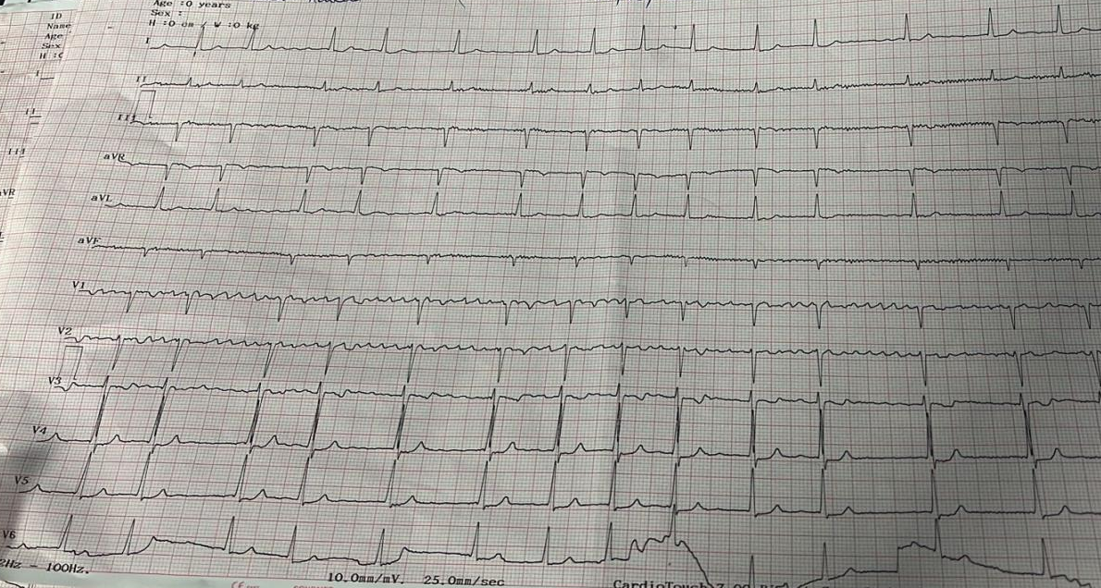
Figure 1: Electrocardiogram showing atrial fibrillation with a controlled ventricular rate of 85 bpm.

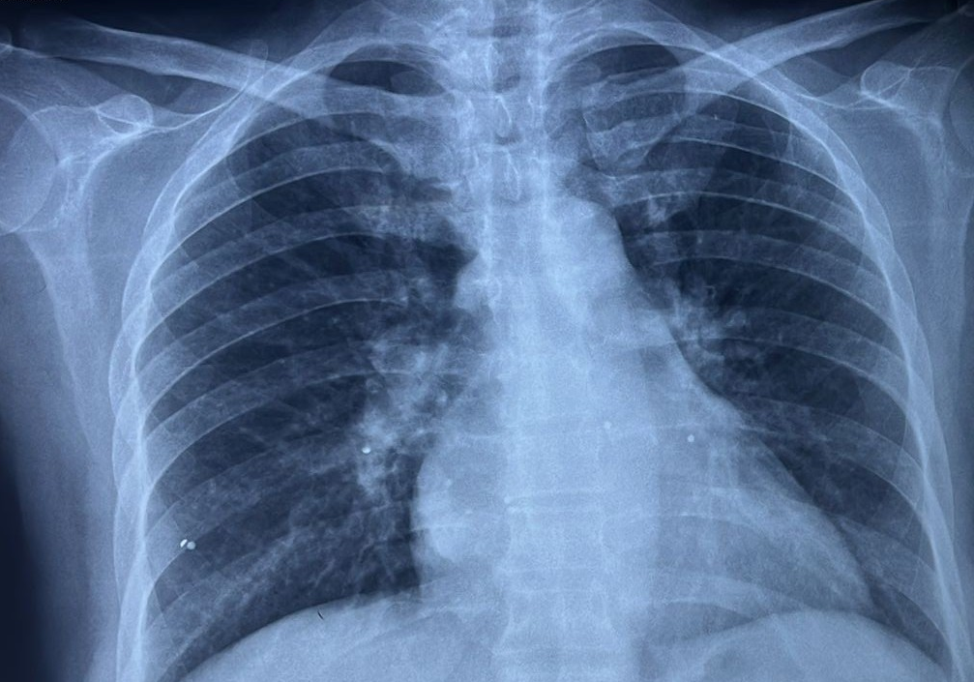
Figure 2: Frontal chest radiograph showing rightward prominence of the right heart border with a double-contour appearance, elevation of the left main bronchus ("rider's sign"), and a straightened left middle cardiac silhouette.

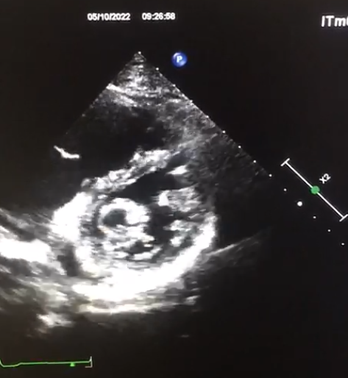
Figure 3: Transthoracic echocardiographic image showing the double-orifice appearance of the mitral valve (red arrow).

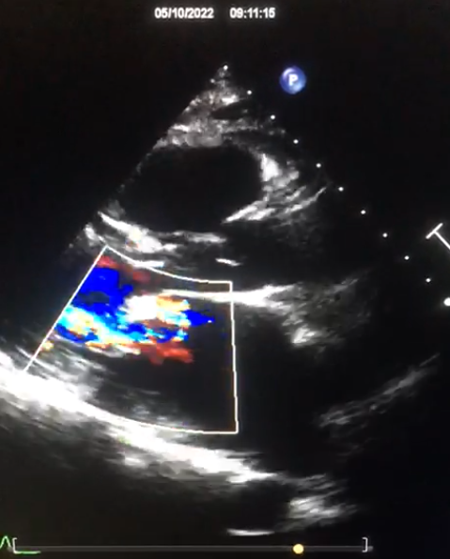
Figure 4: Color Doppler echocardiographic image demonstrating two distinct mitral inflow jets (red arrow).

