**Normalized Least Means Square (NLMS) Adaptive Algorithm as an effective method for denoising Real time ECG signal**

**Abstract**

Electrocardiogram (ECG) signals play a crucial role in the diagnosis of a range of cardiac disorders; however, they are frequently affected by various sources of noise, including baseline drift, muscle movements, electrode displacement, and electrical interference from power lines. This study introduces a robust adaptive filtering method founded on the Normalized Least Mean Squares (NLMS) algorithm, designed to effectively remove noise from ECG signals while retaining key diagnostic characteristics. The proposed methodology dynamically adjusts filter coefficients in real-time, successfully mitigating both high-frequency and low-frequency noise elements without altering essential waveform components, including the P-wave, QRS complex, and T-wave. To establish the superiority and robustness of the proposed technique, the performance of the developed prototype hardware it was evaluated using real ECG data acquired from the volunteers. The experimental result showed that the proposed stationary wavelet transform based ECG denoising technique outperformed the other ECG denoising techniques as more ECG signal components are preserved than other denoising algorithms. Comparing the outputs of both filtered and unfiltered ports, the results underscore the filter’s robustness and reliability for clinical ECG analysis, suggesting strong potential for deployment in real-time, patient monitoring systems and portable diagnostic devices. The practical application successfully demonstrated that the proposed filtering solution could function efficiently on hardware that is both relatively low-cost and portable, making it highly accessible for widespread utilization. Such advancements hold significant implications for the development of point-of-care monitoring systems and wearable health devices, ultimately enhancing the capability to deliver high-quality cardiac monitoring solutions in various healthcare settings.

**Keywords:** ECG analysis, Normalized Least Mean Squares, Infinite Impulse Response, digital filters

**Introduction**

Electrocardiography is the process of producing an electrocardiogram (ECG or EKG), a recording of the heart's electrical activity through repeated cardiac cycles. The electrocardiogram (ECG) is a time-varying electrocardiac signal that represents the electrical activity of the human heart. It is obtained using surface electromyography (EMG), where electrodes are attached to the surface of the skin in close proximity to the human heart. It is a non-invasive procedure that is widely used in hospital settings to measure and diagnose abnormal rhythms of the heart. The ECG signal measured from the patient results in a periodic waveform with multiple apexes called the PQRST-complex. (Khan 2008). ECG signals contain different kinds of information that can be used to diagnose various heart related diseases. They reflect the electrical activity of the human heart. ECG signals are usually contaminated by various types of noise and artifacts. Power line interference (PLI), baseline wander, drift in electrodes connections (electrode misconduct noise and electrode displacement artifacts), and muscle artifacts are the most effective ones. They make the diagnosing process and obtaining the required signal information a hard task to reach (Al-Safi, 2019; Halder et al., 2023).

Electrocardiograms are recorded by machines that consist of a set of electrodes connected to a central unit. Early ECG machines were constructed with analogue electronics, where the signals drove a motor to print out the signal onto paper. Today, electrocardiographs use analogue-to-digital converters to convert the electrical activity of the heart to a digital signal. Many ECG machines are now portable and commonly include a screen, keyboard, and printer on a small wheeled cart. Recent advancements in electrocardiography include developing even smaller devices for inclusion in fitness trackers and smart watches. These smaller devices often rely on only two electrodes to deliver a single lead I. Portable twelve-lead devices powered by batteries are also available. (Kavuru *et al.,* 1987). Electrical interferences, including power line noise and electromyogram (EMG) artifacts, often disrupt the ECG signal, resulting in inaccurate interpretations that can mislead healthcare providers. Additionally, baseline wander—often caused by patient movement, respiratory fluctuations, or other physiological factors—further complicates the clear representation of cardiac activity, obscuring essential information necessary for accurate diagnosis (Menaceur et al., 2024).

The electrocardiogram (ECG) is widely used for the diagnosis of heart diseases. Good quality ECG are utilised by physicians for the interpretation and identification of physiological and pathological phenomena. However, in real situations, ECG recordings are often corrupted by artifacts. Two dominant artifacts present in ECG recordings are: (1) high-frequency noise caused by electromyogram induced noise, power line interferences, or mechanical forces acting on the electrodes; (2) baseline wander (BW) that may be due to respiration or the motion of the patients or the instruments. These artifacts severely limit the utility of recorded ECGs and thus need to be removed for better clinical evaluation.

Numerous techniques have been proposed to mitigate the impact of noise on ECG signals. Traditional analogue filtering methods were initially used, including low-pass, high-pass, and band-pass filters to remove certain frequency components of the signal and suppress noise. While analog filters can be effective, they are limited by their fixed characteristics and lack adaptability to varying noise conditions (Divanpour and Amirhosein, 2015).

With the advent of digital signal processing, digital filters became the preferred approach for ECG noise filtering due to their flexibility, tunability, and ability to process signals in real-time. Commonly used digital filter types for ECG noise filtering include Finite Impulse Response (FIR) filters, Infinite Impulse Response (IIR) filters, and wavelet-based filters. Early digital filter implementations utilized fixed cutoff frequencies and filter orders, but research demonstrated the necessity for adaptive filters that can adjust their parameters dynamically based on the characteristics of the ECG signal and noise. Adaptive filters, such as Recursive Least Squares (RLS) and Least Mean Squares (LMS) algorithms, were introduced to track and remove noise more efficiently. (Divanpour and Amirhosein, 2015).

Despite the rich literature in the field of signal denoising, for clinical applications such as cardiac arrhythmia detection, there is still a genuine need for reliable methods to remove such noise and interference while extracting the subtle features of an ECG signal. For example, electrode motion artifacts are generally regarded as one of the most troublesome sources of interference since the resulting contamination overlaps with the ECG cardiac components in the frequency domain. The design of an effective ECG noise filtering system based on a digital filter is critical to ensure accurate and reliable cardiac signal analysis.

One promising approach (Alla and Nayak, 2024) leverages cascaded adaptive noise cancellation (CANC) to eliminate major noise sources, including powerline interference, muscle artifacts, electrode motion, baseline wander, and additive white Gaussian noise. The method preserves critical ECG waveforms, which is pivotal for accurate diagnosis. Kumar *et al.,* (2021), studied several denoising techniques using the stationary wavelet transform, and other denoising techniques like low-pass filtering, high-pass filtering, empirical mode decomposition, Fourier decomposition method, discrete wavelet transform to denoise an ECG signal corrupted with noise. Signal-to-noise ratio, percentage root-mean-square difference, and root mean square error were used to compare the ECG signal denoising performance. The experimental result showed that the proposed stationary wavelet transform-based ECG denoising technique outperformed the other ECG denoising techniques as more ECG signal components are preserved than other denoising algorithms.

One of the primary distinctions that sets the NLMS algorithm apart from its traditional counterpart, the Least Mean Squares (LMS) algorithm, is its implementation of normalisation within the coefficient update process. This normalisation serves a critical function by preventing the divergence of the filter's coefficients, particularly in environments characterised by rapid variations in signal levels or in the presence of noise. As a result, the NLMS algorithm typically exhibits superior convergence properties compared to the LMS algorithm, making it particularly applicable in scenarios where signal dynamics are unpredictable or highly variable.

The goal of this work is to provide a real-life solution by means of implementing a prototype device that incorporates an improved filtering technique which belong to the general class of adaptive filtering methods, to screen out contamination in ECG signals while maintaining the vital signals read from the patient.

**Methods**

This algorithm operates by dynamically adjusting its filter coefficients with the objective of minimizing the mean square error (MSE) between a pre-defined desired signal and the output that is estimated by the filter. In essence, the NLMS algorithm enhances the accuracy of signal estimation through continuous adaptation to changing signal characteristics.

The methodology is structured to address the characterization of noise in ECG signals, the design and development of a prototype device, the implementation of a digital filtering algorithm on a circuit board and the evaluation of both filtered and unfiltered output of the device.

1. **Data Acquisition:** Understanding the characteristics of each noise component is crucial for selecting appropriate adaptive filtering techniques. And this includes noise from muscular activity, baseline wander, power line interference, and electrode artifacts
2. Among the various adaptive filtering algorithms available, the **Normalized Least Mean Squares (NLMS) algorithm** was selected for its favorable trade-off between convergence speed, computational efficiency, and robustness in dynamic noise environments.
3. **Adaptive Filter Model:** The adaptive filter model typically includes a set of filter coefficients that are updated in real-time during signal processing. The formulation of the adaptive filter using the NLMS algorithm is as follows:

$y\left(n\right)= \sum_{i=0}^{M-1}{[w\left(i\right)*x\left(n-i\right)]}$ (1)

Where:

$y\left(n\right)$ is the output of the adaptive filter at time index n (the estimated denoised ECG signal)

$w\left(i\right)$ are the adaptive filter coefficients to be updated iteratively

$x\left(n-i\right)$ are the input samples of the noisy ECG signal, with M being the filter order.

let the error signal be $e(n)$ be

$e\left(n\right)= d\left(n\right)- y\left(n\right)$ (2)

Also updating the filter coefficients using $$w\left(i, n+1\right)=w\left(i,n\right)+μ*e\left(n\right)*\frac{x\left(n-i\right)}{σ^{2}+ε} (3)$$

Where:

* $w(i, n)$ is the filter coefficient $w(i)$ at time index $n.$
* μ is the adaptation step size, controlling the rate of convergence (0 < μ < 2).
* $e(n)$ is the error signal at time index n.
* $x(n-i)$ is the input sample of the noisy ECG signal at time index $n-i.$
* $σ^2$ is the power of the input signal $(x(n-i))^2$ over a specified window.
* ε is a small positive constant (typically used to avoid division by zero).

4. Validating the designed adaptive filter using experimental data. Performance evaluation includes comparing the filtered ECG signal with the original, noise-free ECG signal and assessing the filter's ability to track and suppress noise components effectively.

**The block diagram of the developed prototype for the filtered signal is as shown below**

TFT LCD

SCREEN

ARDUINO MICROCONTROLLER

+

ADAPTIVE FILTERING ALGORITHM

AD3282

ECG SENSOR

ECG ELECTRODES

HUMAN BODY

RA

LA

LL

**Figure 1. Block diagram of the developed system**

The functionality of the proposed system revolves around the efficient capture, amplification, and processing of the electrical signals generated by the human heart, as facilitated by the integration of electrocardiogram (ECG) electrodes. Once the ECG electrodes are meticulously attached to the surface of the human body at appropriate anatomical locations, they perform the crucial role of detecting the heart's electrical activity, which is a representation of the heart's rhythmic contractions and the underlying physiological state. These electrodes transduce the electrical impulses emitted during each heartbeat into low-voltage analog signals that are subsequently relayed to an AD8232 ECG sensor. The signals generated at the outset of this process are inherently weak and highly susceptible to interference from a variety of external noise sources. Such interference can arise from environmental factors, including power line noise, typically oscillating at frequencies of 50/60Hz, as well as from motion artifacts that may be introduced by the movement of the patient or subject. Additionally, the physiological activity related to muscle contraction can pose further challenges, contributing to the degradation of the integrity of the initial electrical signals.

To address these challenges, the AD8232 ECG sensor is employed as an essential analog front-end module. This sophisticated sensor is designed to amplify and refine the weak electrical signals it receives from the ECG electrodes. By employing various signal processing techniques, the AD8232 effectively elevates these minute ECG signals to a level that can be accurately measured and interpreted. This amplification is a critical step, as ensuring that the signals are above the noise floor is vital for any subsequent digital processing efforts that aim to analyze the heart's electrical activity. Once the analog ECG signal has been suitably processed and amplified by the AD8232, it is then transmitted to a microcontroller.

The microcontroller serves as the central processing unit (CPU) of the overall system, assuming a pivotal role in the interpretation of the analog signals. Upon receiving the processed analog ECG signal from the AD8232 sensor, the microcontroller undertakes the task of converting the continuous analog signal into a digital format. This conversion is imperative as it allows for enhanced analysis, storage, and transmission of the ECG data for further examination and utilization in clinical or research settings. The Adaptive Filtering Algorithm (AFA) integrated into the Arduino microcontroller serves a critical role in enhancing the quality of electrocardiogram (ECG) signal analysis by effectively mitigating various residual noise components that may compromise the accuracy of the readings. Specifically, this algorithm is adept at addressing issues such as baseline drift, which occurs due to slow variations in signal offset; muscle interference, which is introduced by electrical activity from nearby muscle contractions; and power line noise, which can be attributed to electromagnetic interference from electrical devices. By implementing the AFA, the integrity of the ECG signal is significantly improved. This is accomplished through the methodical and adaptive modification of filter parameters in response to real-time variations in the surrounding noise environment. Such adaptability is paramount in preserving the essential characteristics of the ECG waveform, including critical components like the P wave, QRS complex, and T wave, all of which are indispensable for accurate cardiac assessments.

Upon successful filtering and processing of the ECG signal, the Arduino microcontroller efficiently transmits the refined output to a Thin-Film Transistor Liquid Crystal Display (TFT LCD) screen. This screen will not only act as a vital display interface for real-time ECG monitoring but also provide a user-friendly platform for healthcare professionals or users to visualize the ECG waveform. The TFT LCD screen facilitates the identification of potential irregularities in the cardiac signal, thereby enabling clinicians to conduct thorough evaluations of cardiac conditions. In essence, the integration of the Adaptive Filtering Algorithm, in conjunction with the TFT LCD display, fosters enhanced diagnostic capabilities, leading to better-informed clinical decisions regarding patient care and cardiac health management. This innovative approach underscores the importance of technological advancements in the field of medical diagnostics, while simultaneously promoting a deeper understanding of cardiovascular health among users.

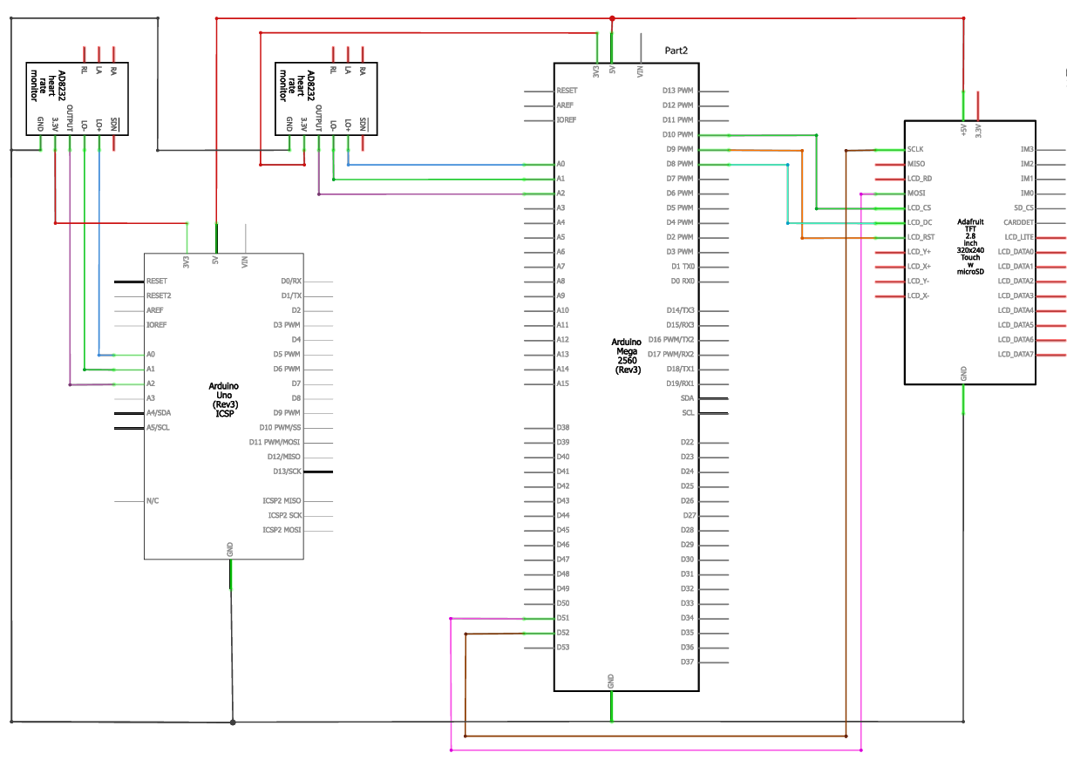

Figure 2. Complete circuit diagram of both unfiltered and filtered system

**Result and Discussion**

The performance of the developed prototype hardware and the adaptive filtering algorithm was evaluated using both synthetic ECG signals contaminated with known noise components and real ECG data acquired from volunteers. The hardware construction of the adaptive filtering system was carried out and after a series of test to certify the system's performance, the system was packaged. The packaging was done while considering the following factors: portability, ease of access to power supply, and cost. The packaging was 3D printed. The prototype device was used to carry out real time test on three volunteers to evaluate the output of both filtered and unfiltered port.

Using the Arduino IDE one can view the result/data on a graph using the Arduino Serial Plotter

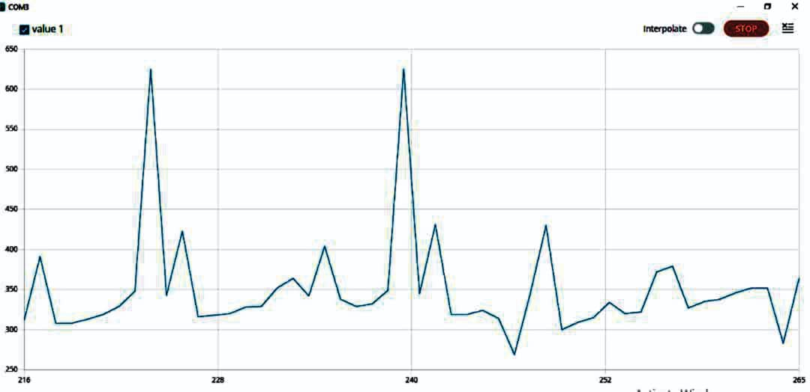

Figure 3a.Graphical representation of volunteer 1 ECG parameter using the unfiltered port

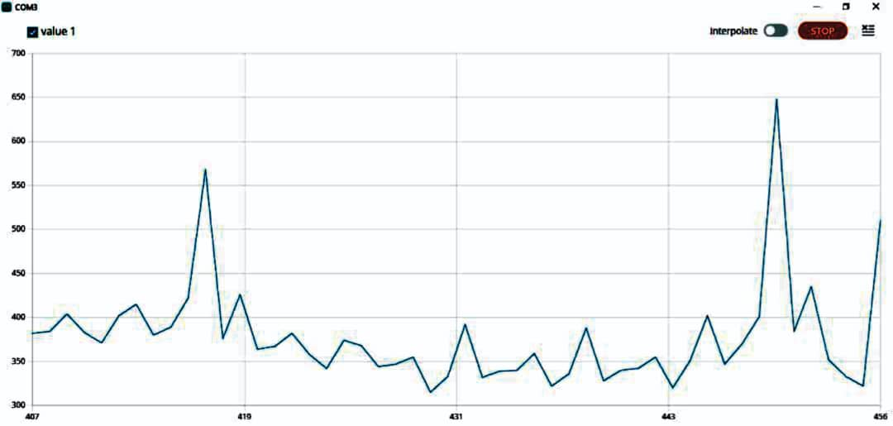

Figure3b. Graphical representation of volunteer 2 ECG parameter using the unfiltered port

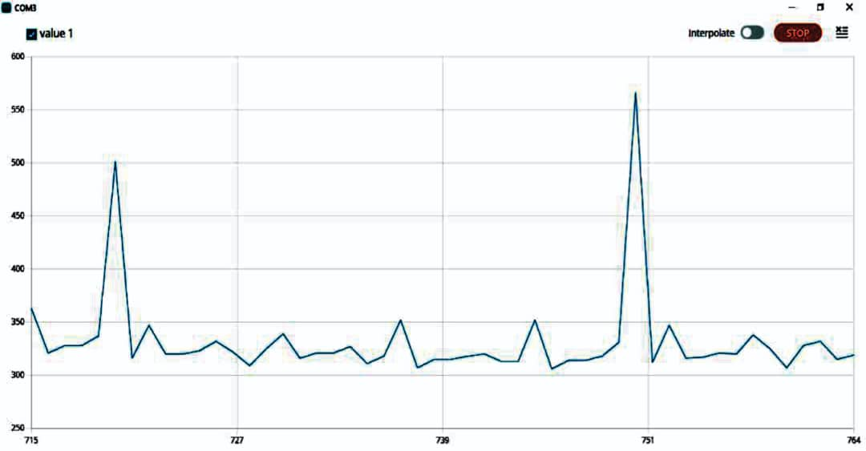 figure3c. Graphical representation of volunteer 3 ECG parameter using the unfiltered port

The graphical representation of the readings obtained from the volunteer’s using the filtered port of the prototype device based on the adaptive filtering algorithm applied by the proposed method.

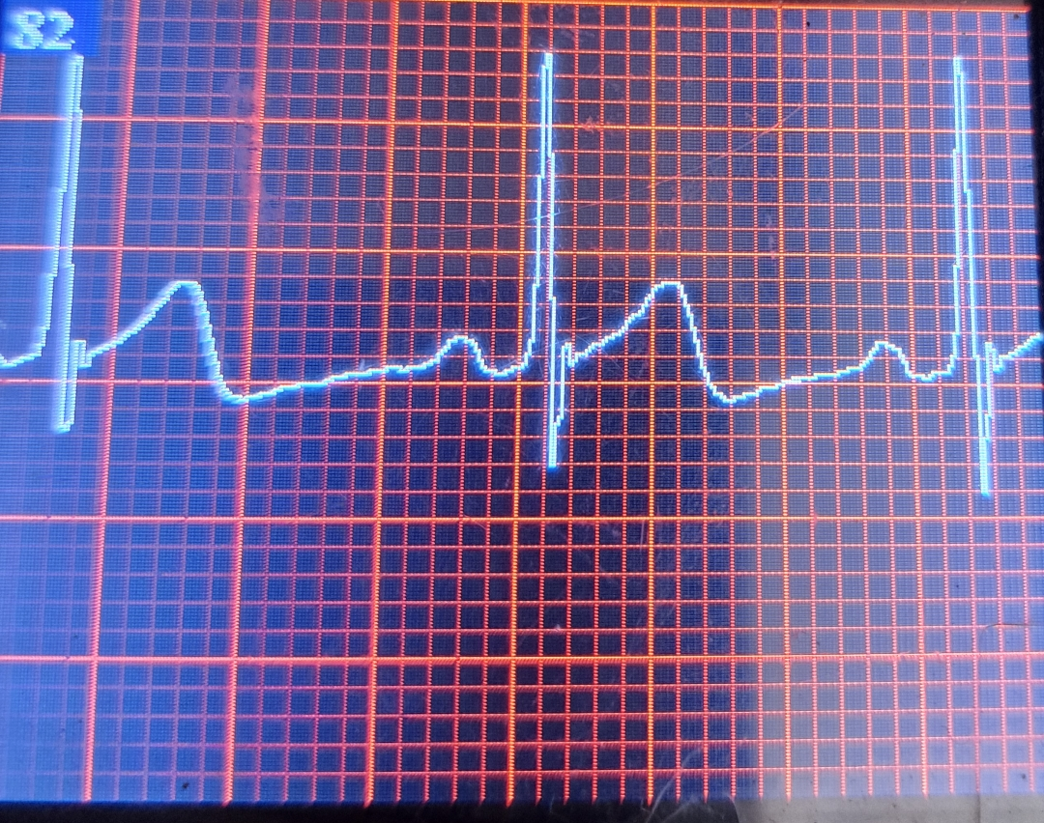 . figure4a. Graphical representation of volunteer 1 ECG parameter using the filtered port

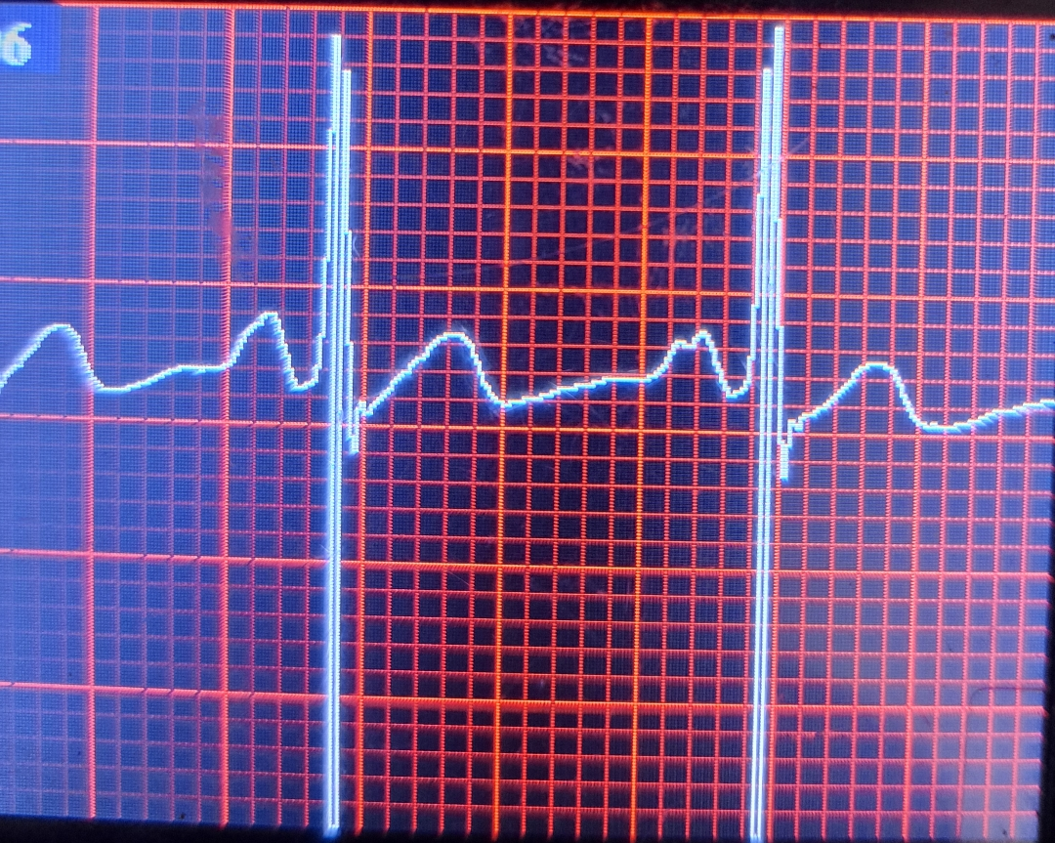

Figure 4b. Graphical representation of volunteer 2 ECG parameter using the filtered port

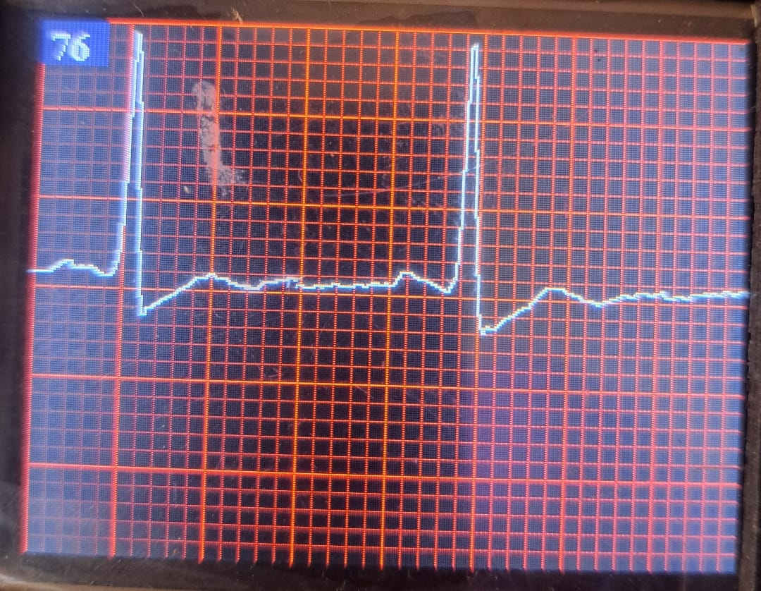

Figure 4c. Graphical representation of volunteer 3 ECG parameter using the filtered port

The systematic examination of the ECG waveform depicted in figures 3a-c, obtained through a microcontroller and illustrated via a serial plotter, reveals data that appears to be unprocessed and in its raw form (presented without any smoothing, thus not optimal for diagnostic purposes), which is sourced from a real-time recording (lead II). The amplitude reflects the analog signal values (ranging from 0 to 1023 for a 10-bit ADC resolution) plotted on the y-axis, while the time index denotes a sampling point along the x-axis.

2. Waveform Morphology

The raw waveform lacks a distinctly visible P wave, which may be obscured by noise or low resolution. The QRS complex exhibits two prominent peaks at approximately index values of ~222 and ~239, characterised by sharp, narrow, and high-amplitude spikes. These peaks are indicative of ventricular depolarisation. Although the T wave, a relatively small wave that occurs after each QRS spike, may be partially discernible, it is challenging to differentiate from baseline noise. This phenomenon is commonly observed in unfiltered data.

3. Timing and Rhythm

Utilising a standard sampling frequency of either 250 Hz or 500 Hz, the interval between QRS peaks is approximately 17 time units (specific values ranging from ~239 to 222). When the sampling rate is set to 250 Hz, each time unit equates to 4 milliseconds, resulting in an RR interval of 17 x 4, which totals 68 milliseconds. This duration corresponds to a heart rate of roughly 882 beats per minute, a value that is not physiologically plausible. This observation indicates the presence of noise within the electrocardiogram (ECG) recordings. The timing analysis further suggests that the ECG cycle is incomplete or not entirely regular.

Figures 4a-c illustrate an electrocardiogram (ECG) waveform presented on a grid, derived from a portable prototype device designed and implemented or a microcontroller-based ECG system utilising the AD8232 module in conjunction with an Arduino and a TFT display.

Each cardiac cycle depicted in the ECG encompasses several key characteristics:

- P Wave: The presence and consistency of the P wave preceding each QRS complex demonstrate normal atrial depolarisation.

- QRS Complex: The QRS complexes are sharp and narrow, occurring at regular intervals, with durations appearing normal (less than 120 milliseconds), which suggests adequate ventricular conduction.

- T Wave: The T waves are upright and follow each QRS complex, exhibiting a normal configuration and duration.

- Rhythm: The regularity of the intervals between the QRS complexes further confirms the presence of a regular sinus rhythm.

- Baseline: Minor fluctuations observed in the baseline may be attributed to potential electrode movement or signal interference.

This ECG trace suggests **normal cardiac electrical activity**, with a regular rhythm and appropriate wave morphology (no visible abnormalities in wave morphology e.g., no ST elevation/depression, inverted T waves, or prolonged intervals).

In summary, the combined functionalities of the ECG electrodes, the AD8232 sensor, and the microcontroller embedded with adaptive filtering algorithm are integral to achieving a reliable and effective ECG monitoring system that can serve various applications in medical diagnostics and research.

**Conclusion**

The aim of this research stems from the critical clinical significance of safeguarding essential electrocardiogram (ECG) features while simultaneously achieving effective suppression of various noise sources. These noise sources include, but are not limited to, power-line interference, baseline wander, artifacts caused by muscle contractions, and fluctuations resulting from electrode motion. Given the crucial role that accurate ECG readings play in diagnosing and monitoring cardiac conditions, the ability to mitigate these interferences without compromising the integrity of the ECG signal is of utmost importance.

To address these challenges, the study employed an adaptive filtering technique, with a particular focus on the implementation of the Normalised Least Mean Squares (NLMS) algorithm. This algorithm is well-regarded for its competency in dynamically adjusting the filter coefficients to minimise the error between the desired and actual signal, thereby enhancing the overall quality of the ECG data. The results from the investigations revealed a notable consistency in the filter's performance across multiple types of noise and a variety of ECG databases. Furthermore, different input signal-to-noise ratio (SNR) levels were examined, reinforcing the notion that this adaptive filtering approach possesses a broad applicability across diverse clinical environments. Moreover, the efficacy of the prototype system was further validated through its deployment in real-world scenarios, where testing was conducted with volunteer participants. This practical application successfully demonstrated that the proposed filtering solution could function efficiently on hardware that is both relatively low-cost and portable, making it highly accessible for widespread utilization. Such advancements hold significant implications for the development of point-of-care monitoring systems and wearable health devices, ultimately enhancing the capability to deliver high-quality cardiac monitoring solutions in various healthcare settings. The ability to interface seamlessly with a range of ECG monitoring platforms underscores the versatility and applicability of the research findings, paving the way for innovative approaches to remote patient monitoring and real-time health assessments.

Disclaimer (Artificial intelligence)

Option 1:

Author(s) hereby declare that NO generative AI technologies such as Large Language Models (ChatGPT, COPILOT, etc.) and text-to-image generators have been used during the writing or editing of this manuscript.

Option 2:

Author(s) hereby declare that generative AI technologies such as Large Language Models, etc. have been used during the writing or editing of manuscripts. This explanation will include the name, version, model, and source of the generative AI technology and as well as all input prompts provided to the generative AI technology

Details of the AI usage are given below:

1. Option 1

2. Option 1

3.Option 1

**References**

Alla Madhava Rao & Nayak Chandan, (2024). A robust ECG signal enhancement technique through optimally designed adaptive filters. Biomedical Signal Processing and Control, 95, 106434.

Balasubramanian, S., Naruk, M. S., & Tewari, G. (2023). Electrocardiogram Signal Denoising Using Optimized Adaptive Hybrid Filter with Empirical Wavelet Transform. Journal of Shanghai Jiaotong University (Science), 1-15.

Kavuru, Madhav S.; Vesselle, Hubert; Thomas, Cecil W. (1987). Advances in Body Surface Potential Mapping (BSPM) Instrumentation. Pediatric and Fundamental Electrocardiography. Developments in Cardiovascular Medicine. Vol. 56. pp. 315–327

Khan, I. G. (2008) Rapid ECG Interpretation. Contemporary Cardiology. Humana Press.

J. M. ski and N. Henzel. (2005) ECG baseline wander and powerline interference reduction using nonlinear filter bank. Signal Processing, 85(4):781–793.

Divanpour, Amirhosein. (2015). Analysing and filtering a sample ECG signal in matlab. 10.13140/RG.2.1.2865.1122.

He Zhuobiao & Min, Hao. (2022). Skin-induced motion artifact removal for ambulatory electrocardiography. IEEE Sensors Journal, 22(15), 15033–15043.

Kumar, A., Tomar, H., Mehla, V. K., Komaragiri, R., & Kumar, M. (2021). Stationary wavelet transform based ECG signal denoising method. ISA transactions, 114, 251-262.

Lin, H., Liu, R., & Liu, Z. (2023). ECG Signal Denoising Method Based on Disentangled Autoencoder. Electronics, 12(7), 1606.

Mao, J., Li, Z., Li, S., & Li, J. (2023). A Novel ECG Signal Denoising Algorithm Based on Sparrow Search Algorithm for Optimal Variational Modal Decomposition. Entropy, 25(5), 775.

Qian, C., Su, H., & Yu, H. (2019). Local means denoising of ECG signal. Biomedical Signal Processing and Control, 53, 101571.

Sameni, R.; M.B. Shamsollahi, C. Jutten, and G.D. Clifford. (2007), A Nonlinear Bayesian Fil- tering Framework for ECG Denoising. IEEE Transactions on Biomedical Engineering, 54.

Sayadi, M.-B. Shamsollahi, and G.D. Clifford (2010), Robust detection of premature ven- tricular contractions using a wave-based bayesian framework. Biomedical Engineering, IEEE Transactions on, 57(2):353–362.

Schrepel, Caitlin; Amick, Ashley E.; Sayed, Madeline; Chipman, Anne K. (2021). "Ischemic ECG Pattern Recognition to Facilitate Interpretation While Task Switching: A Parallel Curriculum". MedEdPORTAL. 17:11182.

Seena, V., & Yomas, J. (2014, March). A review on feature extraction and denoising of ECG signal using wavelet transform. In 2014 2nd international conference on devices, circuits and systems (ICDCS) (pp. 1-6). IEEE.

Sharma, L. N., Dandapat, S., & Mahanta, A. (2010). ECG signal denoising using higher order statistics in Wavelet subbands. Biomedical Signal Processing and Control, 5(3), 214-222.

Singh, P. and Pradhan G (2018) ‘Variational mode decomposition-based ECG denoising using non-local means and wavelet domain filtering’, Australas. Phys. Eng. Sci. Med., 41, (4), pp. 891–904

Singh G. Kaur G. Kumar V.: (2014), ‘ECG denoising using adaptive selection of IMFs through EMD and EEMD ’.  2014 Int. Conf. on Data Science & Engineering (ICDSE), Kochi, India, pp.  228–231

Tsukada, Yayoi Tetsuou; Tokita, Miwa; Murata, Hiroshige; Hirasawa, Yasuhiro; Yodogawa, Kenji; Iwasaki, Yu-ki; Asai, Kuniya; Shimizu, Wataru; Kasai, Nahoko; Nakashima, Hiroshi; Tsukada, Shingo (2019). ["Validation of wearable textile electrodes for ECG monitoring"](https://www.ncbi.nlm.nih.gov/pmc/articles/PMC6556171). Heart and Vessels. 34 (7): 1203–1211

Verma, A. R., & Singh, Y. (2019). Adaptive artifact cancelation based on bacteria foraging optimization for ECG signal. Augmented Human Research, 4(1), 1–8.

Verma, A. R., Singh, Y., & Joshi, V. (2016). Adaptive filtering using PSO, MPSO and ABC algorithms for ECG signal. International Journal of Biomedical Engineering and Technology, 21(4), 379–392.

Al-Safi, A. (2019). ECG signal denoising using a novel approach of adaptive filters for real-time processing. International Journal of Electrical and Computer Engineering (IJECE), 9(1).

Halder, A., Khandaker, M. R. A., Gomes, A. S., Tanshen, M. R., & Rahman, M. A. (2023). Performance Analysis of FIR Adaptive Filter Algorithms for Denoising Adult ECG Signals: A Comparative Study. Middle East Journal of Applied Science & Technology (MEJAST), Volume 6, Issue 2, Pages 131-143

Menaceur, N. E., Kouah, S., & Derdour, M. (2024). Adaptive filtering strategies for ecg signal enhancement: A comparative study. In 2024 6th International Conference on Pattern Analysis and Intelligent Systems (PAIS) (pp. 1-6). IEEE.