**Case report**

**Giant Retroperitoneal Spindle Cell Liposarcoma in a Post-PTCA Patient: A Rare Case Report**

**ABSTRACT**

**Background:** Retroperitoneal spindle cell liposarcoma is a rare soft tissue sarcoma characterized by slow growth but significant local expansion, often presenting late due to the silent nature of the retroperitoneal space. Diagnosis is challenging, especially in patients with significant comorbidities, and management requires a multidisciplinary approach.

**Materials and Methods:** We report the case of a 55-year-old male with a history of ischemic heart disease and post-percutaneous transluminal coronary angioplasty (PTCA) status, who presented with progressive abdominal distension and pain over two months. Clinical examination and imaging revealed a large retroperitoneal mass. Comprehensive evaluation including contrast-enhanced computed tomography (CECT), 18F-FDG PET-CT (18F Fluorodeoxyglucose Positron Emission Tomography – Computed Tomography), echocardiography, and histopathological analysis following core needle biopsy was performed.

**Results:** Imaging demonstrated a giant retroperitoneal mass measuring approximately 23 × 24.3 × 33.4 cm with low-grade FDG uptake, displacing surrounding abdominal structures without evidence of distant metastasis. Echocardiography revealed severe left ventricular systolic dysfunction with an ejection fraction of 30%. Histopathology confirmed malignant spindle cell sarcoma, consistent with spindle cell liposarcoma. Due to high perioperative cardiac risk, definitive surgery was deferred, and the patient was managed with supportive cardiac therapy under multidisciplinary supervision.

**Conclusion:** This case illustrates the diagnostic complexity and therapeutic dilemma associated with giant retroperitoneal liposarcomas in patients with significant cardiac comorbidities. A multidisciplinary approach, including precise histological characterization and individualized perioperative planning, is critical for optimal outcomes in such high-risk patients.

**Key Words:** Liposarcoma, Spindle cell sarcoma, PET-CT, Histopathology

**INTRODUCTION**

Retroperitoneal liposarcoma (RPLS) is a rare malignant neoplasm arising from adipocytic lineage, most commonly presenting in the retroperitoneum, where it accounts for approximately 40–41 % of all retroperitoneal sarcomas and 12–40 % of all liposarcomas [1,2]. These tumors typically affect adults between 40 and 60 years of age and, due to the accommodating nature of the retroperitoneal space, often grow to sizable volumes before causing clinical symptoms [2,3].

Clinically, RPLS frequently remains silent until a significant mass-occupying effect occurs, manifesting as abdominal distension, pain, or palpable lump [3,4]. Tumors exceeding 30 cm in maximum diameter or weighing over 20 kg are classified as “giant” RPLS, an extremely rare and surgically challenging subset [5–7]. Several recent investigative reports have documented cases of such giant tumors—one measured 55 cm × 30 cm × 18 cm and weighed 19.8 kg—highlighting the diagnostic and operative complexity posed by their sheer size [5]. In another series of 34 cases of giant RPLS, the prevalence of organ adherence and invasion further complicated comprehensive resection efforts [5].

From a histopathological standpoint, RPLS encompasses different subtypes—well‑differentiated, dedifferentiated, myxoid/round cell, and pleomorphic—each associated with distinct biological behaviors and prognostic outcomes [1]. Well‑differentiated forms generally exhibit indolent behavior with better survival rates, while dedifferentiated and pleomorphic variants tend to be more aggressive and prone to recurrence [3].

Imaging plays a pivotal role in the characterization and staging of RPLS. Computed tomography (CT), especially when contrast-enhanced, accurately identifies fat-containing lesions with septations or solid components, essential for differentiating liposarcoma from benign lipomatous tumors and other retroperitoneal masses [8]. Given the extent of local invasion and involvement of vital structures typical in giant RPLS, CT also guides preoperative planning and facilitates assessment of resectability.

Complete surgical resection with negative margins remains the cornerstone of treatment and is currently the only approach associated with long-term survival [3]. However, achieving R0 resection in giant tumors often necessitates en bloc removal of contiguous structures or organs, and complete resection is frequently limited by the tumor’s proximity to major vessels and vital organs [3]. The roles of perioperative chemotherapy or radiotherapy in retroperitoneal liposarcoma are currently limited; their efficacy remains controversial, especially for well-differentiated subtypes [3].

In this case report we present a case of a giant retroperitoneal spindle cell liposarcoma in a patient with significant cardiovascular comorbidity (post‑PTCA, severe LV dysfunction). This report illustrates the diagnostic challenges, multimodal imaging approach, histopathological confirmation, and therapeutic considerations in managing such a rare and complex presentation.

**Case Presentation**

A 55-year-old male, with a known history of ischemic heart disease (IHD), status post percutaneous transluminal coronary angioplasty (PTCA) with drug-eluting stent (DES) placement in the left anterior descending (LAD) artery two years prior, presented with complaints of abdominal discomfort and distension for the past two months. The pain was diffuse, dull in nature, and gradually worsening. The patient also reported a progressively enlarging abdominal lump, initially lemon-sized and increasing to approximately the size of a football. There were no associated symptoms such as vomiting, fever, altered bowel habits, or weight loss. The patient had no prior oncological or abdominal surgical history and was non-compliant with his cardiac medications.

On clinical examination, he appeared cachectic but hemodynamically stable. Abdominal palpation revealed a large, firm, non-tender, immobile mass occupying the left abdominal quadrant and extending across the midline. There were no signs of ascites or overlying skin changes. Cardiovascular examination indicated left ventricular dysfunction, including a displaced apex beat and an audible S3.

Electrocardiography showed sinus tachycardia with left anterior fascicular block (LAFB), Qs complex in V1–V5, and ST segment elevation in leads V2–V4, suggesting a prior anterior wall myocardial infarction. Transthoracic echocardiography revealed severe left ventricular systolic dysfunction with an ejection fraction of 30%, global hypokinesia, and mild dilatation of the left atrium and ventricle.

Routine biochemistry was unremarkable, including serum creatinine of 1.0 mg/dL and fasting blood glucose of 101 mg/dL.

A contrast-enhanced computed tomography (CECT) scan of the abdomen, performed on 27 May 2025, demonstrated a large, lobulated, hypodense retroperitoneal mass with internal fat, septations, and solid enhancing nodular areas, displacing bowel loops and compressing the urinary bladder—features consistent with lipomatous sarcoma. Whole-body ^18F-fluorodeoxyglucose positron emission tomography–computed tomography (FDG PET-CT) revealed a 23.0 × 24.3 × 33.4 cm mass with low-grade FDG uptake (SUVmax 4.2), extending superiorly to the gastrohepatic region and inferiorly to the pelvis, abutting and compressing adjacent structures including the pancreas, bladder, aorta, IVC, and bilateral psoas muscles. Faint FDG uptake was also noted in aortocaval lymph nodes. No distant metastases were detected.

Histological examination of the ultrasound-guided core needle biopsy from the lower abdominal wall revealed hypocellular collagenous stroma with scattered atypical spindle cells demonstrating nuclear pleomorphism, hyperchromasia, and occasional bizarre multinucleated tumor cells. No necrosis was noted. Immunohistochemical studies showed strong nuclear positivity for MDM2 and CDK4, along with diffuse positivity for vimentin. The tumor cells were negative for S-100, desmin, smooth muscle actin (SMA), and cytokeratin, thereby excluding neural, myogenic, and epithelial origins. Taken together, the morphological and immunohistochemical features were consistent with a malignant spindle cell sarcoma, most suggestive of spindle cell liposarcoma. The case was subsequently deliberated in a multidisciplinary tumor board comprising oncologists, surgeons, cardiologists, radiologists, and the histopathologist. The histopathologist’s input was pivotal in confirming the diagnosis and in outlining the criteria for assessing resection adequacy in future surgical planning. Given the tumor’s large retroperitoneal location, encasement of adjacent structures, and the patient’s severely reduced cardiac function, surgical excision was considered high-risk at that stage. Hence, initial management was directed toward medical optimization with beta-blockers, diuretics, and ACE inhibitors, with definitive surgery planned once cardiac status stabilized.

The case was discussed in a multidisciplinary tumor board. Given the tumor’s size, retroperitoneal location, and encasement of adjacent structures, surgical resection was deemed high-risk, especially in the context of severely reduced cardiac function. Initial management focused on medical optimization with beta-blockers, diuretics, and ACE inhibitors, and surgical intervention was planned once cardiac status stabilized.

After successful medical stabilization, the patient was taken up for elective surgical resection. Under combined general and epidural anesthesia, the patient was placed supine. A midline incision was made from the xiphisternum to the pubic symphysis. Intraoperatively, a massive retroperitoneal tumor measuring approximately 35 × 20 × 15 cm was identified, extending vertically from the diaphragm to the urinary bladder. The tumor was densely adherent to large bowel loops, bilateral pelvic musculature, and the left psoas muscle. The sigmoid colon was separated from the mass using diathermy, and careful dissection of the greater omentum and mesentery was performed. The feeding vessels to the tumor were ligated and cauterized. Both ureters were identified and preserved. Bilateral gonadal vessels were ligated. The mass was densely adherent to the left psoas muscle and required excision along with a portion of muscle fibers. After complete mobilization, the mass was delivered intact and sent for histopathological evaluation.

The deep inguinal ring was closed using 2-0 prolene, and the excised psoas muscle fibers were approximated. A pelvic drain (No. 32 ADK) was placed, and layered closure was completed using prolene and skin staples. The patient tolerated the procedure well and was transferred to the postoperative care unit for monitoring and further management.

**DISCUSSION**

This rare presentation of a giant spindle cell RPLS, weighing approximately 8 kg and extending across critical retroperitoneal structures, highlights several pivotal considerations in diagnosis, treatment, and prognosis.

Surgical resection remains the only curative modality for RPLS, including spindle cell variants. Achieving complete (R0 or R1) excision significantly improves overall survival and mitigates local recurrence risk [9,10]. For instance, a large series demonstrated that negative surgical margins were associated with both enhanced relapse-free survival and longer overall survival [11].

However, the perioperative risks associated with giant RPLS are substantial. Data from large cohorts reveal non-trivial rates of major complications (16–35%) and 30‑day mortality (1–10%), particularly in cases requiring extensive multivisceral or vascular resection [12,13]. Anesthesia-related management of massive intraoperative blood loss (>20 units transfused) emerged as a key determinant of postoperative morbidity and mortality in recent retrospective analyses [13]. Our patient's significant cardiac dysfunction, characterized by severe left ventricular systolic impairment, further elevated his risk profile. Incorporation of validated tools like the Revised Cardiac Risk Index (RCRI) is advised in preoperative planning when major non-cardiac procedures are considered [14].

The multidisciplinary approach is indispensable, involving oncologic surgeons, cardiologists, anesthesiologists, and radiologists. Referral to specialized sarcoma centers improves outcomes, underscoring the value of coordinated care [10]. A contemporary GEIS expert consensus emphasizes subtype-specific, perioperative planning and postoperative surveillance to optimize management [15].

The role of neoadjuvant therapy—whether chemotherapy, radiotherapy, or combined—remains controversial. While the STRASS trial found no significant benefit of preoperative radiotherapy on abdominal recurrence, selective neoadjuvant chemotherapy may be appropriate for borderline resectable or high-risk histologies [12]. In spindle cell and well-differentiated liposarcomas with low metabolic activity, the advantages of such treatments are less clear. Ongoing phase III trials (STRASS-2) are exploring whether neoadjuvant chemotherapy can increase surgical feasibility and improve disease-free survival in high-risk RPS [12].

Prognostically, histological subtype and tumor grade are key. Low-grade spindle cell liposarcomas typically confer better outcomes than dedifferentiated variants, which exhibit 5‑year survival rates as low as 20% [4]. Overall survival for RPS after complete resection ranges from 36% to 55%, while local relapse remains the most frequent cause of disease-related death [8,15]. Local recurrence develops in up to 30% of cases, often within the first five years, necessitating prolonged surveillance [16,17].

Cardiac comorbidity in RPS adds a layer of complexity. While cardiac dysfunction does not uniformly preclude surgery, management must be individualized with aggressive cardiac optimization and possible deferral of definitive surgery until function improves. Anticipation of perioperative complications mandates thorough preoperative risk stratification using clinical cardiac indices and forward-planning for intensive postoperative support.

In this case, the tumor’s massive size, low FDG uptake, and favorable histology suggested a potentially indolent course amenable to complete resection, if cardiac stabilization could be achieved. The delay in surgery permitted optimization of cardiac function but raises ongoing concerns about tumor progression. As such, individualized timing, balancing surgical benefit against patient risk, remains a cornerstone of RPS management.

**CONCLUSION**

Giant retroperitoneal spindle cell liposarcoma is a rare clinical entity that often presents late due to the expansive capacity of the retroperitoneal space, leading to significant diagnostic and therapeutic challenges. This case underscores the importance of early recognition, multimodal imaging, and histopathological confirmation for accurate diagnosis. In patients with complex comorbidities such as severe cardiac dysfunction, management must be carefully individualized through a multidisciplinary approach. While surgical resection remains the mainstay of treatment, perioperative risk stratification and optimization are critical, particularly in high-risk patients. Timely diagnosis and coordinated care are essential for improving outcomes in such rare and challenging cases.

Disclaimer (Artificial intelligence): Author(s) hereby declare that NO generative AI technologies such as Large Language Models (ChatGPT, COPILOT, etc.) and text-to-image generators have been used during the writing or editing of this manuscript.

Consent

As per international standards or university standards, patient(s) written consent has been collected and preserved by the author(s).

**REFERENCES**

1. Choi JH, Ro JY (2020) Retroperitoneal Sarcomas: An Update on the Diagnostic Pathology Approach. Diagnostics (Basel) 10(9):642. https://doi.org/10.3390/diagnostics10090642
2. Bae JM, Jung CY, Yun WS, Choi JH (2022) Large retroperitoneal atypical spindle cell lipomatous tumor, an extremely rare neoplasm: A case report. World J Clin Cases 10(8):2584–2590. https://doi.org/10.12998/wjcc.v10.i8.2584
3. Chua HB, Hussain RI, Shukor NA, Fam XI (2025) Case report: an extremely rare case of giant dedifferentiated retroperitoneal liposarcoma. Front Oncol 15:1489833. https://doi.org/10.3389/fonc.2025.1489833
4. Rachman Y, Hardja Y (2022) Giant retroperitoneal liposarcoma: A case report. Int J Surg Case Rep 97:107465. https://doi.org/10.1016/j.ijscr.2022.107465
5. Sun JN, Yang R, Jiang XL et al (2024) Giant retroperitoneal liposarcoma with multiple organ involvement: a case report and literature review. BMC Nephrol 25:281. https://doi.org/10.1186/s12882-024-03701-z
6. Shahaji C, Amit P, Prashant P, Sachin T (2012) Giant retroperitoneal liposarcoma: a case report. Case Rep Oncol Med 2012:869409. https://doi.org/10.1155/2012/869409
7. Mremi A, Macheku GS, Mondea AP, Sadiq A, Mesarieki LV (2024) Management challenges of a giant retroperitoneal liposarcoma: A case report and review of the literature. Int J Surg Case Rep 125:110629. https://doi.org/10.1016/j.ijscr.2024.110629
8. Yorke J, Agbenorku P, Awoonor-Williams R, Adinku M, Agbeko E, Manu J et al (2016) Management of retroperitoneal liposarcoma: a case report. Surg Sci 7:361–367. https://doi.org/10.4236/ss.2016.78052
9. Bonvalot S, Gronchi A, Le Péchoux C, Swallow CJ, Strauss D, Meeus P et al (2020) Preoperative radiotherapy plus surgery versus surgery alone for patients with primary retroperitoneal sarcoma (EORTC-62092: STRASS): a multicentre, open-label, randomised, phase 3 trial. Lancet Oncol 21(10):1366–1377. https://doi.org/10.1016/S1470-2045(20)30446-0
10. Kirane A, Crago AM (2016) The importance of surgical margins in retroperitoneal sarcoma. J Surg Oncol 113(3):270–276. https://doi.org/10.1002/jso.24135
11. Gronchi A, Strauss DC, Miceli R, Bonvalot S, Swallow CJ, Hohenberger P et al (2016) Variability in patterns of recurrence after resection of primary retroperitoneal sarcoma (RPS): a report on 1007 patients from the multi-institutional collaborative RPS working group. Ann Surg 263(5):1002–1009. https://doi.org/10.1097/SLA.0000000000001447
12. Carbone F, Pizzolorusso A, Di Lorenzo G, Di Marzo M, Cannella L, Barretta ML et al (2021) Multidisciplinary management of retroperitoneal sarcoma: diagnosis, prognostic factors and treatment. Cancers (Basel) 13(16):4016. https://doi.org/10.3390/cancers13164016
13. Wang J, Chen J, Liu K, Zhang H, Wei Y, Suo L et al (2024) Anesthetic managements, morbidities and mortalities in retroperitoneal sarcoma patients experiencing perioperative massive blood transfusion. Front Oncol 14:1347248. https://doi.org/10.3389/fonc.2024.1347248
14. Lee TH, Marcantonio ER, Mangione CM, Thomas EJ, Polanczyk CA, Cook EF et al (1999) Derivation and prospective validation of a simple index for prediction of cardiac risk of major noncardiac surgery. Circulation 100(10):1043–1049. https://doi.org/10.1161/01.cir.100.10.1043
15. Álvarez Álvarez R, Manzano A, Agra Pujol C, Artigas Raventós V, Correa R, Cruz Jurado J et al (2023) Updated review and clinical recommendations for the diagnosis and treatment of patients with retroperitoneal sarcoma by the Spanish Sarcoma Research Group (GEIS). Cancers (Basel) 15(12):3194. https://doi.org/10.3390/cancers15123194
16. Berger NG, Silva JP, Mogal H, Clarke CN, Bedi M, Charlson J et al (2018) Overall survival after resection of retroperitoneal sarcoma at academic cancer centers versus community cancer centers: an analysis of the National Cancer Data Base. Surgery 163(2):318–323. https://doi.org/10.1016/j.surg.2017.07.009
17. Mentzel T, Palmedo G, Kuhnen C. Well-differentiated spindle cell liposarcoma ('atypical spindle cell lipomatous tumor') does not belong to the spectrum of atypical lipomatous tumor but has a close relationship to spindle cell lipoma: clinicopathologic, immunohistochemical, and molecular analysis of six cases. Mod Pathol. 2010 May;23(5):729-36. doi: 10.1038/modpathol.2010.66.

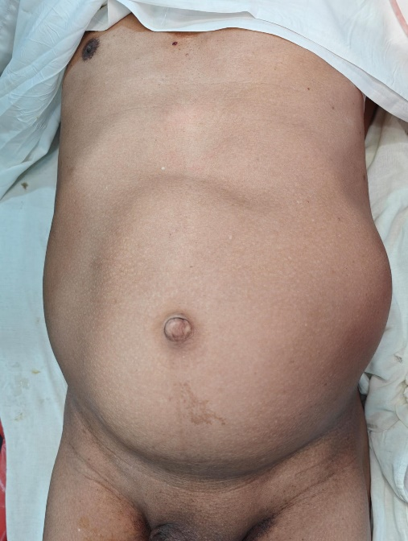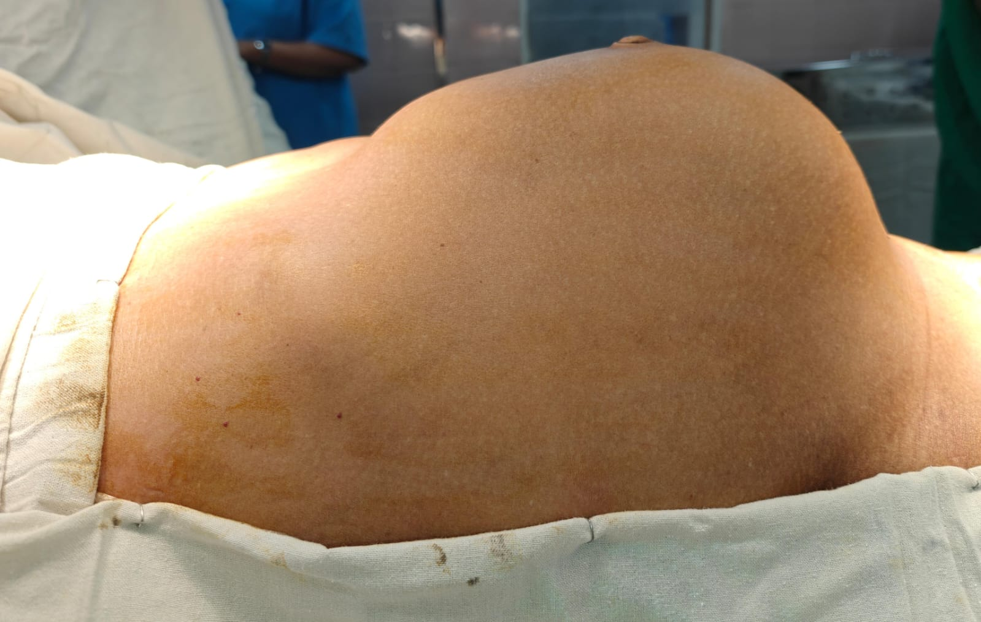**Images:**

**Image 1: Preoperative images**

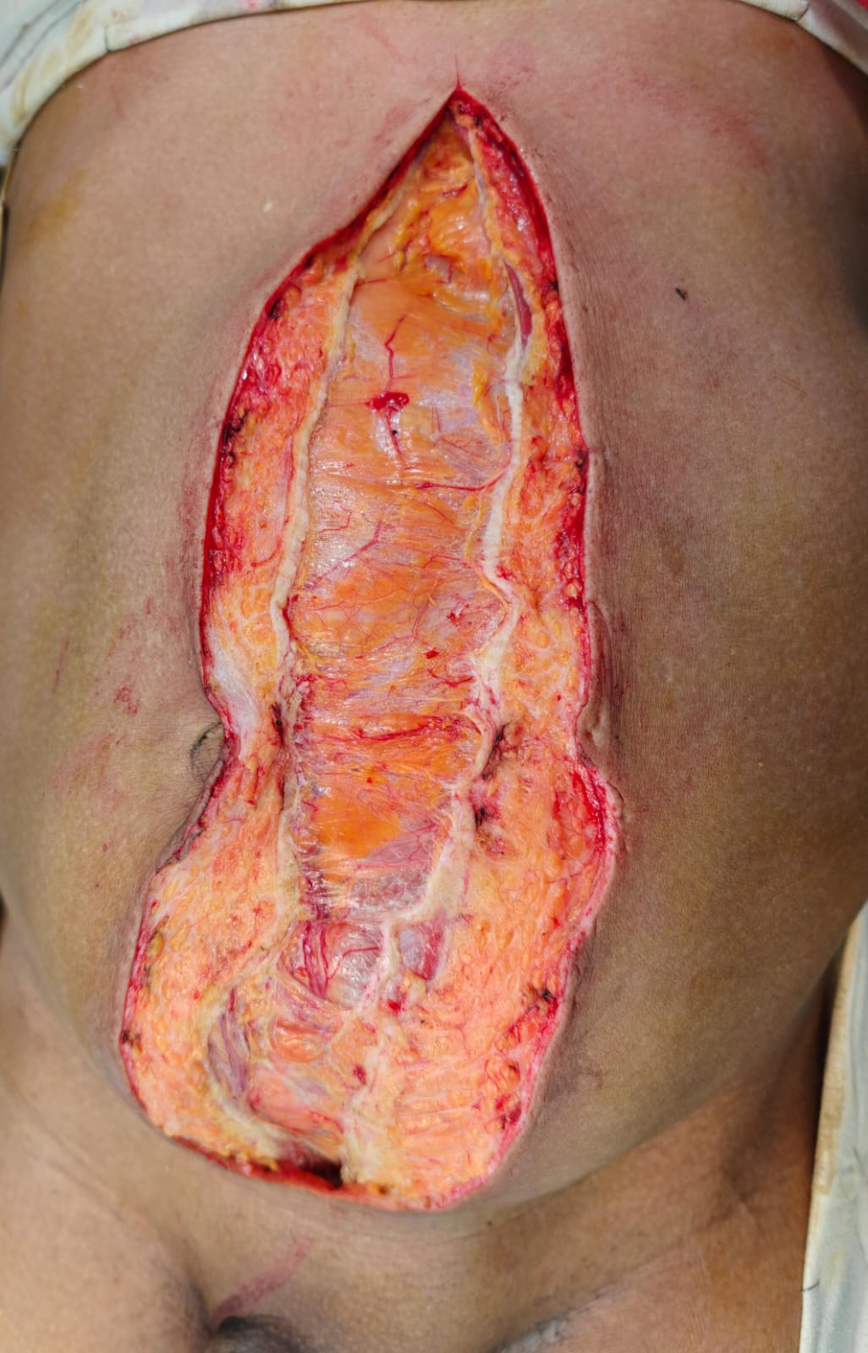

**Image 2: Tumor attached to sheath as well**

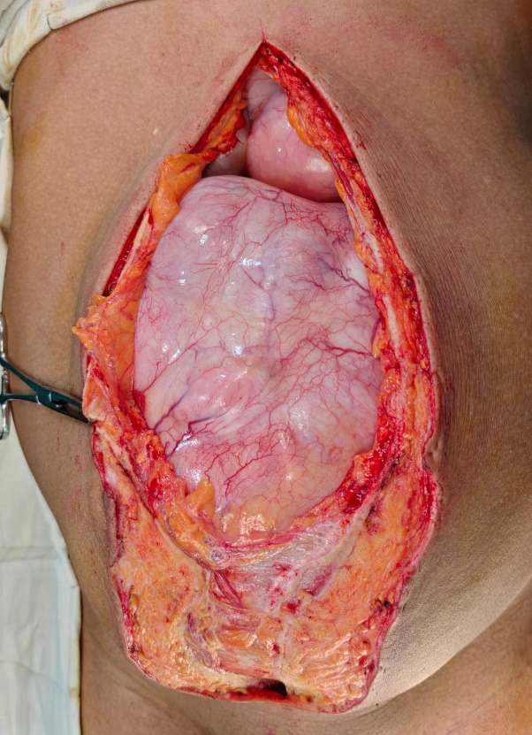

**Image 3: Tumor after opening the Rectus Sheath**

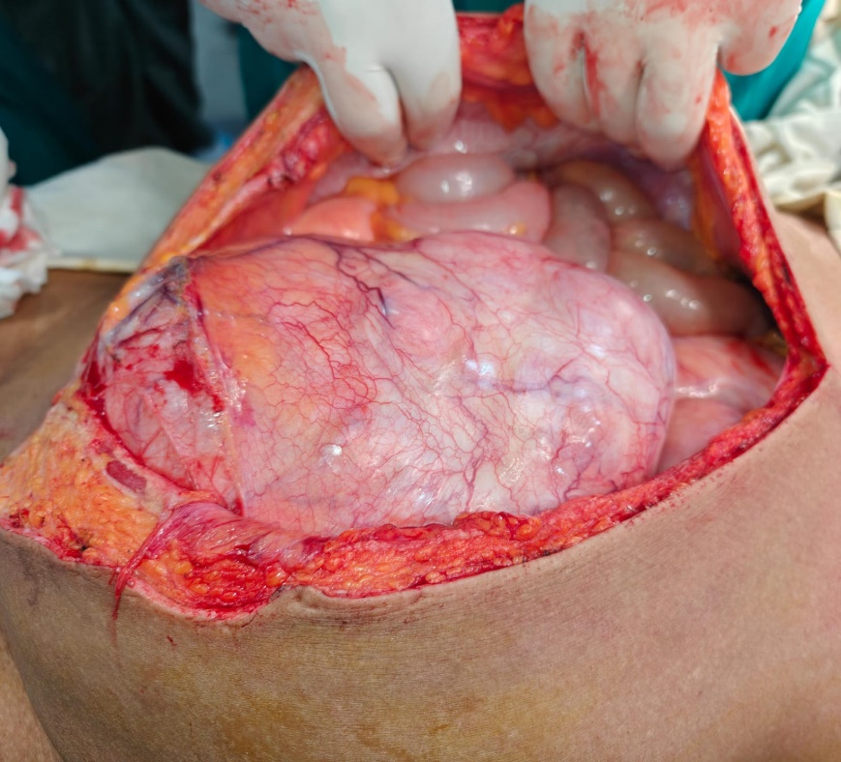

**Image 4: Compression of Bowel by the tumor**

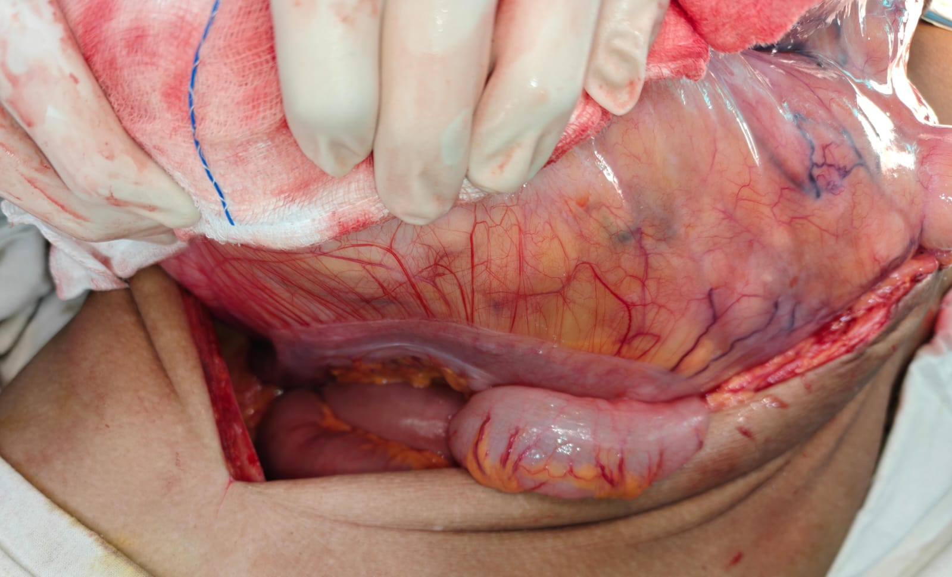

**Image 5: Tumor involving sigmoid colon**

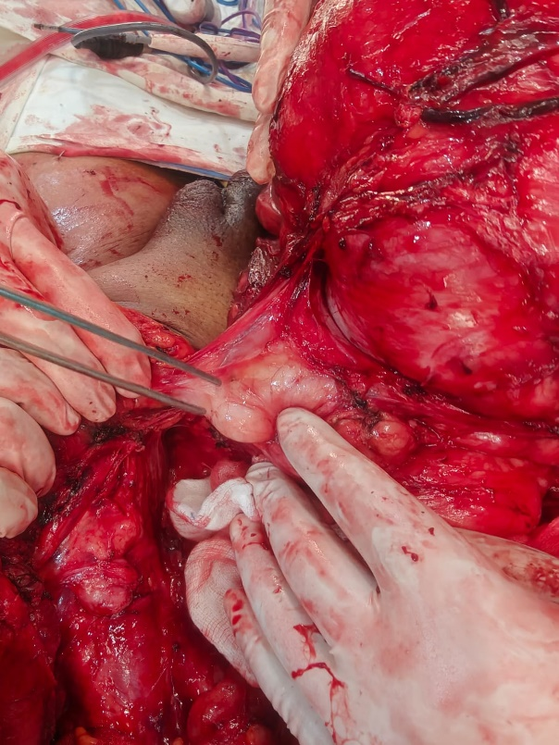

**Image 6: Tumor attached to left testis as well**

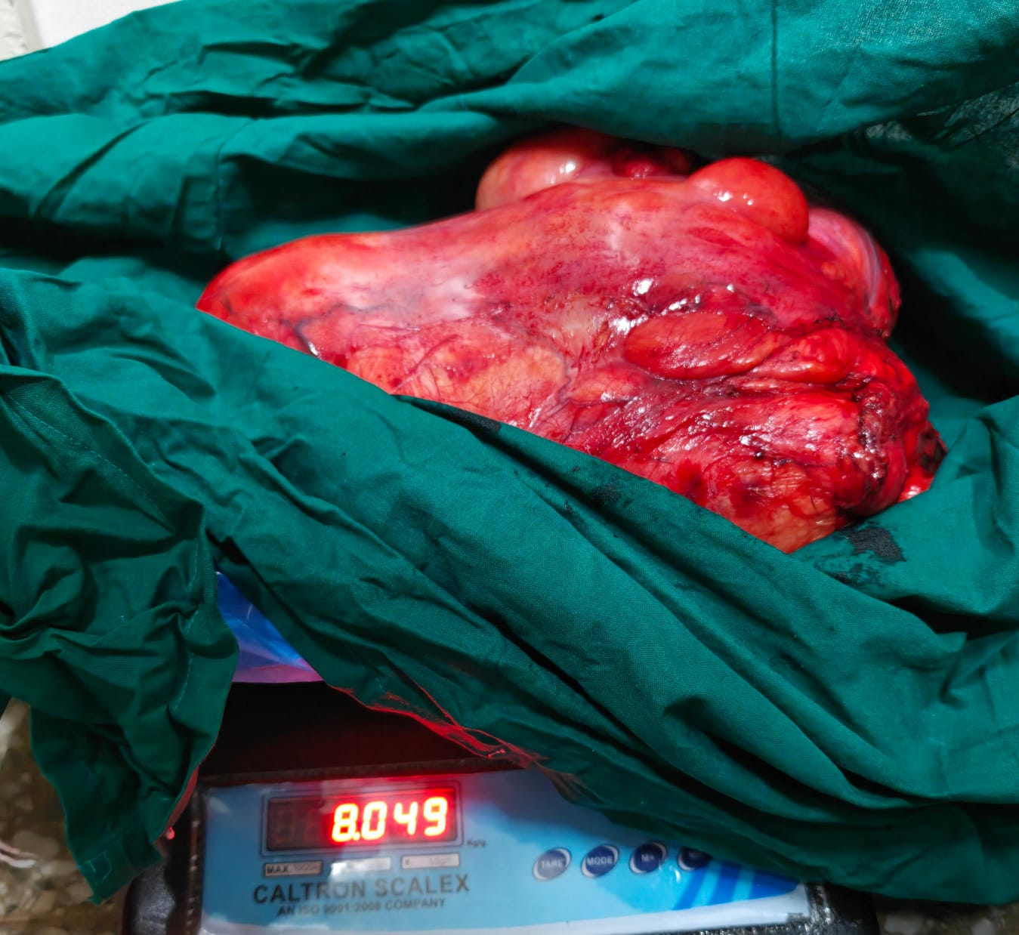

**Image 7: Tumor Weight**