Case report:
Hidden in the Mesentery: Laparoscopic Removal of a Sigmoid Cyst

Abstract

Background: Mesenteric cysts are uncommon intra-abdominal lesions. Although they can occur anywhere along the mesentery, they are most frequently found in the small bowel mesentery. Sigmoid mesenteric cysts, as demonstrated in this case, are particularly rare. While these cysts are often asymptomatic, they may cause nonspecific symptoms such as bloating, abdominal pain, or an abdominal mass. If left untreated, complications such as infection, bleeding, volvulus, or intestinal obstruction may occur.
Case presentation: We present the case of a 45-year-old woman with a history of dull, progressive pain in the left hypochondrium for 1.5 years. Contrast-enhanced CT (CECT) of the abdomen revealed an 8 × 7.9 × 8.6 cm well-defined cystic lesion in the left lumbar mesentery, suggestive of a mesenteric cyst. The patient subsequently underwent laparoscopic excision of the cyst.
Conclusion: Laparoscopic excision is a safe, minimally invasive, and effective treatment option for mesenteric cysts, reducing postoperative morbidity and shortening hospital stay. This case highlights the importance of early detection, imaging-based diagnosis, and timely surgical intervention in preventing complications.
Keywords: sigmoid colon, minimally invasive laparoscopy, mesenteric cyst management, advanced laparoscopy, primary mesenteric cyst

Introduction
Mesenteric cysts are uncommon, benign intra-abdominal lesions that develop within the mesentery of the gastrointestinal tract. Their incidence is estimated at approximately one per 100,000 hospital admissions in adults and one per 20,000 in children. While they can occur anywhere along the mesentery, the small bowel mesentery is the most frequent site of origin. In some cases, they arise from the mesocolon (24%) or the retroperitoneum (14.5%) [1]. Sigmoid mesenteric cysts are exceedingly rare. Although the precise cause is yet unknown, neoplasia, infection, trauma, lymphatic abnormalities, and poor lymphatic drainage are some of the hypothesized causes. Clinical manifestation is frequently nonspecific and might include symptoms like bowel obstruction, distension, or abdominal pain, or, in rare cases, consequences including infection, bleeding, or volvulus [2]. It can also be an unintentional finding during imaging. Many cases are only definitively diagnosed intraoperatively, and preoperative diagnosis is sometimes difficult due to their rarity and diverse appearance. The preferred course of treatment is still surgical excision because partial removal can result in recurrence. Laparoscopic excision, which offers the benefits of less postoperative discomfort, a shorter hospital stay, a quicker recovery, and better cosmesis without sacrificing oncological safety, has emerged as the favoured method because to advancements in minimally invasive surgery. This case report has been prepared in accordance with the SCARE checklist.[3]
Case Presentation
A 45-year-old woman from a rural area presented with a complaint of dull, aching abdominal pain localized to the left hypochondrium for 1.5 years. The pain was progressive, aggravated by prolonged standing and sitting, and relieved upon lying down. There was no history of vomiting, jaundice, hematemesis, altered bowel habits, or trauma. She was a known case of hypothyroidism and was on regular medication (Tablet Thyroxin 100 mcg once daily). There was no history of prior surgical interventions.
On examination, a 6 × 7 cm ill-defined lump was palpable in the left iliac fossa. It was soft to firm in consistency, mobile in the horizontal plane, and immobile in the craniocaudal plane. There was no fluid thrill, and bowel sounds were normal. Contrast-enhanced CT (CECT) of the abdomen revealed a well-defined fluid-attenuation cystic lesion in the left lumbar mesentery, measuring 8 × 7.9 × 8.6 cm, without solid components or bowel communication, suggestive of a mesenteric cyst (Figure 1).
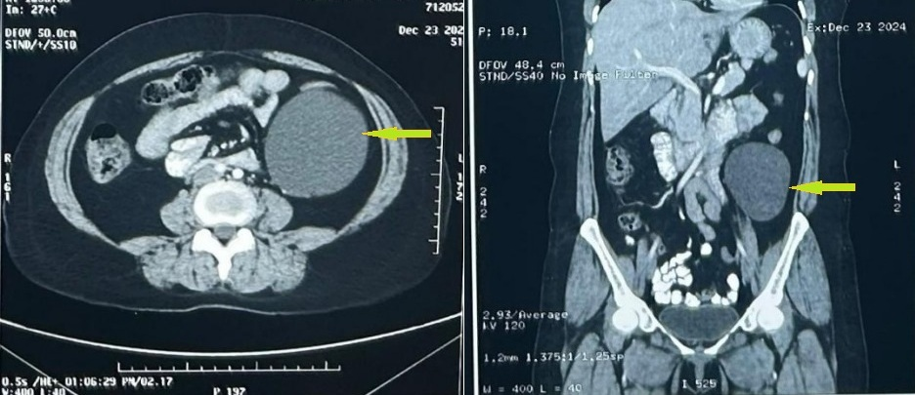

FIGURE 1: Axial section and coronal section of CECT Whole abdomen showing a well-defined cystic lesion in left lumbar region which is arising from large bowel mesentery

She underwent laparoscopic excision of the sigmoid mesenteric cyst under general anaesthesia. During peritoneoscopy the cyst was not clearly visible after entering the abdomen. It was located in the left iliac fossa but was completely concealed by the sigmoid colon and its mesentery. After retracting the sigmoid colon on anteromedially, an 8 × 6 cm size well-encapsulated cyst arising from the sigmoid mesentery was identified, containing approximately 250 ml of fluid (Figure 2). Complete enucleation of the cyst was performed. The patient had an uneventful recovery and was discharged on postoperative day 2 with appropriate postoperative instructions. Histopathology report showed a thin-walled cyst, lined with flattened endothelium, containing proteinaceous fluid, containing lymphocytes (Benign cyst).
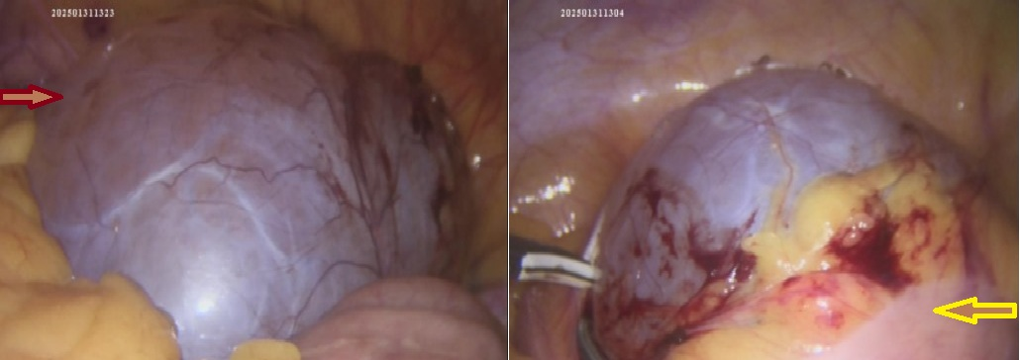

FIGURE 2: Cystic lesion arising from sigmoid mesentery (red arrow- Mesenteric cyst, yellow arrow- Sigmoid colon)

Discussion
The size, location, and appearance of mesenteric cysts can vary widely, making them a heterogeneous group of lesions. Benevieni, a Florentine anatomist, first described mesenteric cysts in 1507 [4]. In 1880, Tillaux performed the first successful removal of a mesenteric cystic tumor [4], and in 1883, Pean reported the first marsupialization of a mesenteric cyst [1]. Mackenzie later performed the first laparoscopic resection [5]. The reported incidence is approximately 1 per 100,000 hospital admissions, with no clear gender predilection, and they may occur at any age [1].
While most mesenteric cysts are asymptomatic, approximately 10% of patients present with an acute abdomen [6]. Clinical signs and symptoms can include intestinal blockage, volvulus, bleeding, or rupture of a cyst, as well as vague abdominal pain, distension, or a palpable lump. Malignant transformation has also been reported in rare cases [2]. Ovarian cysts, duplication cysts, and peritoneal inclusion cysts are among the differential diagnosis. The etiopathogenesis is diverse: benign cystic mesothelioma can develop as a result of endometriosis, trauma, pelvic inflammatory illness, or previous surgery, whereas simple lymphatic and mesothelial cysts are typically congenital [7,8].
However, Tillaux’s sign is the most characteristic physical finding of a mesenteric cyst. It is described as an abdominal mass that moves only in the horizontal plane (side to side) but not vertically. Even when Tillaux’s sign is present, confirmation with imaging—such as ultrasonography, CT, or MRI—is essential. Preoperative imaging also helps guide the choice between a laparoscopic and an open surgical approach [9]. However, in certain cases, such as our patient, the cyst may remain concealed intraoperatively by overlying bowel and mesentery, making diagnosis and surgery more difficult.
Although open surgery was traditionally the standard treatment, laparoscopic excision is now preferred due to its advantages, including smaller incisions, shorter hospital stay, and reduced morbidity. To avoid recurrence, the cyst must be completely removed; intestinal resection may be necessary if mesenteric veins are implicated. After complete excision, the prognosis is favorable, and recurrence is uncommon [10].
In addition to the uncommon sigmoid mesenteric location, this case is noteworthy for the uncommon intraoperative discovery that the cyst was completely concealed beneath the sigmoid colon and its mesentery. This "hidden" presentation emphasizes how challenging the diagnosis is and how crucial meticulous intraoperative examination is. Additionally, it reaffirms that the laparoscopic method is safe and feasible, even in difficult and uncommon situations.
Conclusions
Mesenteric cysts can be safely and effectively removed using laparoscopic excision. This case highlights the importance of early detection and the advantages of minimally invasive surgery in managing such rare lesions. As mesenteric cysts are usually asymptomatic, they are uncommon and often difficult to diagnose preoperatively. Although the majority are benign, surgical excision is recommended due to the potential risk of malignant transformation.

Disclaimer (Artificial intelligence)
Author(s) hereby declare that NO generative AI technologies such as Large Language Models (ChatGPT, COPILOT, etc.) and text-to-image generators have been used during the writing or editing of this manuscript.

References
- Kurtz R.J., Heimann T.M., Beck A.R., Holt J. Mesenteric and retroperitoneal cysts. Ann. Surg. 1986;203(1):109–112. doi: 10.1097/00000658-198601000-00017.
- Bhattacharjee A, Kulkarni V et al. A rare case of a mesenteric cyst. Cureus. 2022;14:0. doi: 10.7759/cureus.32015
- Agha RA, Franchi T, Sohrabi C, et al.: The SCARE 2020 guideline: updating consensus Surgical CAse REport (SCARE) guidelines. Int J Surg. 2020, 84:226-230. 10.1016/j.ijsu.2020.10.034
- Santana W.B., Poderoso W.L.S., Alves J.A.B., Melo V.A., Barros C., Fakhouri R. Cisto mesentérico aspectos clínicos e anátomopatológicos. Rev. Col. Bras. Cir. 2010;37(4):260–264. doi: 10.1590/s0100-69912010000400004.
- Mackenzie DJ, Shapiro SJ, Gordon LA, Ress R. Laparoscopic excision of a mesenteric cyst. Journal of Laparoendoscopic Surgery. 1993;3(3):295–299. doi: 10.1089/lps.1993.3.295.
- Lee D.L.P., Madhuvrata P., Reed M.W., Balasubramanian S.P. Chylous mesenteric cyst- A diagnostic dilemma. Asian J. Surg. 2013;39(3):182–186. doi: 10.1016/j.asjsur.2013.04.009.
- Al-Mulhim AA. Laparoscopic excision of a mesenteric cyst during pregnancy. JSLS. 2003 Jan-Mar;7(1):77-81. PMID: 12723004; PMCID: PMC3015466.
- Dursun AS, Gokhan A, Volkan S, Osman S, Cigdem T, Osman ND: Laparoscopic enucleation of mesenteric cyst: A case report. Mt Sinai J Med. 2006:1019-20.
- Kwan E, Lau H, Yuen WK. Laparoscopic resection of a mesenteric cyst. Gastrointestinal Endoscopy. 2004;59(1):154–156. doi: 10.1016/s0016-5107(03)02365-4.
- Tan, J. J. Y., Tan, K. K., & Chew, S. P. (2009). Mesenteric cysts: an institution experience over 14 years and review of literature. World journal of surgery, 33(9), 1961-1965 https://doi.org/10.1007/s00268-009-0135-x

.

