Case report
Rosemary-Induced Peritonitis: A Case of Small Bowel Perforation

Abstract
Intro
Perforation of the gastrointestinal (GI) tract by ingested foreign bodies is extremely rare , especially when talking about commonly used aromatic herbs , the perforation can nonetheless occur in patients with a hernia sac or Meckel’s diverticulum.
Case report
We report a case of a 70 YA female admitted with abdominal pain and whose investigation ( Abdominal CT) showing pneumoperitoneum led to an exploratory laparotomy that revealed a punctiform perforation of the small intestine caused by an ingested sprig of rosemary treated with simple sutures of the perforation. The evolution was normal with no complication. To our knowledge, no such case has been reported in the literature.
Discussion
Meckel’s diverticulum is the most common congenital gastrointestinal malformation. The perforation of a Meckel’s diverticulum by a foreign body is a very rare complication, with few cases reported in the literature.
Rosemary (Rosmarinus officinalis L) is a medicinal plant native to the Mediterranean region and cultivated around the world. It is commonly used here in Morocco as herbal infusion with tea or as aromatic herb in several local dishes.
There’s no case of bowel perforation caused by this herb found in the literature which makes this case report very uncommon .
Conclusion
The majority of ingested foreign bodies pass through the GI tract without complications. However, in some cases it can lead to GI tract perforation and develop acute peritonitis.
the patient was unlucky to have a physiological condition such as Meckel’s diverticulum which weakened the bowel wall.

Key words:
Peritonitis – Bowel perforation – Foreign body – Rosemary or rosemarinus – Surgery

Introduction
“Perforation of the gastrointestinal (GI) tract by ingested foreign bodies is rare, with less than 1% of ingested objects causing perforation” [1,2]. “Most foreign bodies lodge at the cricopharyngeal sphincter, and over 90% pass through the intestine if they reach the stomach” [1]. “Sharp objects, such as fish bones or pins, are common culprits” [2,4], “but perforation by non-sharp objects like rosemary (Rosmarinus officinalis L.), a rigid, fibrous culinary herb, is undocumented” [6]. “Anatomical anomalies, such as Meckel’s diverticulum, increase perforation risk by weakening the bowel wall” [3,5]. This case report describes a rare ileal perforation caused by a rosemary sprig near a Meckel’s diverticulum, emphasizing the need to consider unusual foreign bodies in acute abdominal presentations to guide timely intervention.
Case presentation
A 70-year-old female with no medical history presented to the emergency department with mild abdominal pain starting seven days prior, progressively worsening, accompanied by nausea and vomiting for one day. Physical examination revealed a hemodynamically stable patient with mild tenderness in the umbilical region. Laboratory tests showed leucocytosis (13,000/mm³) and elevated C-reactive protein (46.2 mg/L). An abdominal X-ray revealed right subdiaphragmatic free air, indicating pneumoperitoneum. An abdominal CT scan confirmed pneumoperitoneum but did not identify the perforation site or cause. Due to the presence of pneumoperitoneum and the patient’s stable condition, an emergency exploratory laparotomy was performed, as laparoscopy was unavailable at the time. Intraoperative findings revealed a 2-mm punctiform ileal perforation 50 cm from the ileocecal junction, caused by a 1-cm rosemary sprig located adjacent to a Meckel’s diverticulum. The diverticulum was observed intraoperatively but not resected or histologically confirmed, as it appeared uninflamed. No localized inflammation or abscess was noted, and the abdominal cavity was otherwise normal. The perforation was closed with 3/0 Vicryl sutures after sprig removal. The patient resumed oral nutrition two days post-surgery and was discharged after four days. A three-month follow-up showed no complications.
Discussion
“Foreign body ingestion rarely results in intestinal perforation, with sharp objects such as fish bones being the most frequently implicated” [1,2,4]. “Less than 1% of ingested foreign bodies cause perforation, as most either lodge at the cricopharyngeal sphincter or pass through the gastrointestinal (GI) tract uneventfully” [1]. “However, anatomical anomalies like Meckel’s diverticulum, a congenital malformation with a prevalence of 2–4%, increase the risk of perforation” [3,5]. “Meckel’s diverticulum, formed by incomplete obliteration of the omphalomesenteric duct during fetal development, creates a thin-walled outpouching that can trap foreign bodies or weaken the adjacent bowel wall, facilitating perforation” [3,8]. In this case, a 1-cm rosemary sprig (Rosmarinus officinalis L.), a rigid, fibrous herb commonly used in Mediterranean and Moroccan cuisine, likely perforated the ileum near the diverticulum due to its pointed structure and the mechanical vulnerability of the diverticulum’s thin wall.

“A PubMed search conducted using the terms “rosemary,” “gastrointestinal perforation,” “foreign body,” and “ileal perforation” yielded no reports of rosemary-induced bowel perforation, confirming the uniqueness of this case” [6]. “In contrast, perforations by sharp foreign bodies, such as fish bones or wooden sticks, are better documented. For instance, fish bone perforations often occur in the ileum or near Meckel’s diverticulum, presenting with similar diagnostic challenges” [4,5]. “These cases frequently report pneumoperitoneum on CT scans but difficulty identifying the foreign body itself due to its radiotransparency, as observed in our case” [4,6]. “The European Society of Gastrointestinal Endoscopy (ESGE) guidelines recommend endoscopic removal for upper GI foreign bodies, but surgical intervention is necessary for perforations, particularly when pneumoperitoneum is present” [9]. “Our patient’s early laparotomy likely prevented complications like generalized peritonitis, which has been reported in delayed fish bone perforation cases” [4,5].

“The clinical presentation of GI perforation varies widely, from mild abdominal pain to severe peritonitis or gastrointestinal bleeding” [6]. “Our patient’s mild, progressive symptoms over seven days, despite pneumoperitoneum, underscore the potential for misleadingly benign presentations, as noted in similar cases involving fish bones” [4,6]. “This diagnostic challenge highlights the critical role of imaging, particularly CT, which detects indirect signs like pneumoperitoneum or bowel wall thickening but often fails to visualize non-radio-opaque objects like rosemary” [4,6]. “The presence of Meckel’s diverticulum likely exacerbated the risk of perforation in this case, as its thin wall and potential for stasis create a nidus for foreign body entrapment” [3,5,8].

Preventing such rare perforations is challenging due to the widespread culinary use of rosemary. However, clinicians should maintain a high index of suspicion for foreign body perforation in patients with atypical abdominal pain, especially in those with risk factors like Meckel’s diverticulum. Early imaging, such as CT, can facilitate timely diagnosis, even if the foreign body is not directly visualized [6]. Public education on cautious food preparation (e.g., removing rigid herbs before consumption) may reduce the risk of accidental ingestion, though this is impractical for widespread implementation. Future studies could explore the biomechanical properties of culinary herbs like rosemary to better understand their potential to cause injury.

Limitations of this case include the lack of preoperative identification of the rosemary sprig and the absence of histological confirmation of the Meckel’s diverticulum. Additionally, the exact mechanism by which the diverticulum contributed to the perforation remains speculative, as it was not inflamed or perforated itself. Further research is needed to elucidate the prevalence and mechanisms of perforation by non-sharp foreign bodies.
Conclusion
The majority of ingested foreign bodies pass through the GI tract without complications. However, in some cases it can lead to GI tract perforation and develop an acute peritonitis .
This case of ours is one them with the foreign body being a usual aromatic herb used commonly in everyday food preparation . the patient was unlucky to have a physiological condition such as Meckel’s diverticulum which weakened the bowel wall.

Figures

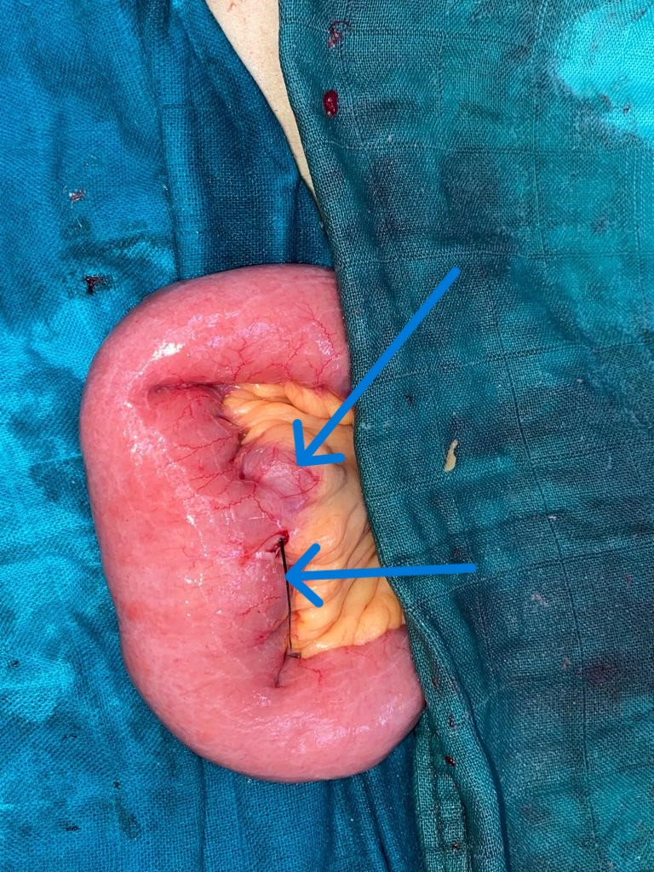
Figure 1 : Operative image showing the rosemary sprig near the Meckel’s diverticulum

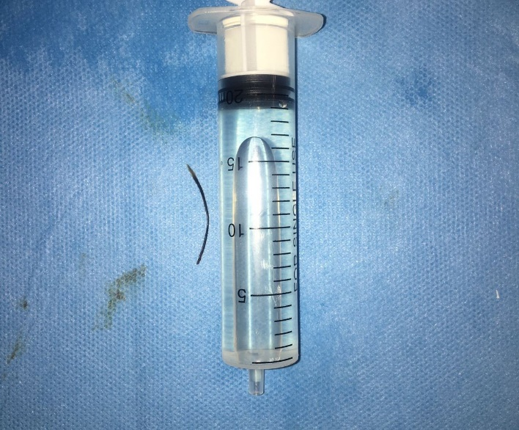
Figure 2 : Rosemary sprig after extraction
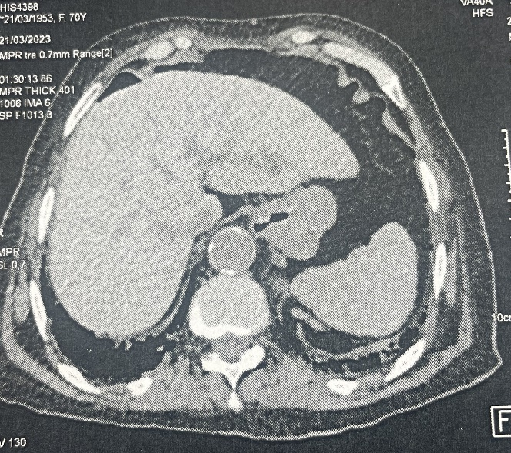
Figure 3 : Ct showing Pnemoperitoneum

Data Availability Statement

The data that support the findings of patient information are available from the corresponding author upon reasonable request.

Conflict of interest
The authors have no conflicts of interest and source of funding. The subject of study
had no commercial interest, no financial or material support.
Ethical approval
As per international standards or university standards written ethical approval has been collected and preserved by the author(s).

Patient consent
Written informed consent was obtained from the patients for publication of this case report and accompanying images. A copy of the written consent is available for review by the Editor-in-Chief of this journal on request.

Disclaimer (Artificial intelligence)
Author(s) hereby declare that NO generative AI technologies such as Large Language Models (ChatGPT, COPILOT, etc.) and text-to-image generators have been used during the writing or editing of this manuscript.

Bibliography and references
- Velitchkov NG, Grigorov GI, Losanoff JE, Kjossev KT. Ingested foreign bodies of the gastrointestinal tract: retrospective analysis of 542 cases. World J Surg. 1996 Oct;20(8):1001-5. doi: 10.1007/s002689900152. PMID: 8798356.
- Goh BK, Tan YM, Lin SE, et al. Perforation of the gastrointestinal tract secondary to ingestion of foreign bodies. World J Surg. 2006;30(3):372-377. DOI: 10.1007/s00268-005-8067-2
- Sagar J, Kumar V, Shah DK. Meckel’s diverticulum: a systematic review. J R Soc Med. 2006;99(10):501-505. DOI: 10.1258/jrsm.99.10.501
- Ibn Majdoub Hassani K, Toughrai I. Peritonitis due to ileal perforation caused by a fish bone. Pan Afr Med J. 2013;15:107. DOI: 10.11604/pamj.2013.15.107.3025
- Ward RG, Steadman JH. Perforation of Meckel’s diverticulum by a fish bone: a case report. Int J Surg Case Rep. 2020;73:209-211. DOI: 10.1016/j.ijscr.2020.07.005
- Ambe P, Weber SA, Schauer M, Knoefel WT. Swallowed foreign bodies in adults. Dtsch Arztebl Int. 2012;109(50):869-875. DOI: 10.3238/arztebl.2012.0869
- Agha RA, Borrelli MR, Farwana R, et al. The SCARE 2018 statement: updating consensus Surgical CAse REport (SCARE) guidelines. Int J Surg. 2018;60:132-136. DOI: 10.1016/j.ijsu.2018.10.028
- Uppal K, Tubbs RS, Matusz P, et al. Meckel’s diverticulum: a review. Clin Anat. 2011;24(4):416-422. DOI: 10.1002/ca.21094
- Birk M, Bauerfeind P, Deprez PH, et al. Removal of foreign bodies in the upper gastrointestinal tract in adults: European Society of Gastrointestinal Endoscopy (ESGE) Clinical Guideline. Endoscopy. 2016;48(5):489-496. DOI: 10.1055/s-0042-100456
- Choi Y, Kim G, Shim C, Kim D, Kim D. Peritonitis with small bowel perforation caused by a fish bone in a healthy patient. World J Gastroenterol. 2014 Feb 14;20(6):1626-9. doi: 10.3748/wjg.v20.i6.1626. PMID: 24587641; PMCID: PMC3925874.
- Mcpherson RC, Karlan M, Williams RD. Foreign body perforation of the intestinal tract. Am J Surg. 1957;94:564–566.
- Cotirlet A., Anghel R., Tincu E., Rau S., Motoc I., Popa E. Perforation of Meckel's diverticulum by foreign body, a rare complication. Chirurgia (Bucur) 2013;108(May-June (3)):411–413.
- Schmidt C., Brown L.M., Klomp H.J., Henne-Bruns D. Perforated Meckel’s diverticulum. Surgery. 2001;129:643–644.
- Wong J.H.L., Suhaili D.N.P.H., Kok K.Y.Y. Fish bone perforation of Meckel’s diverticulum: a rare event? Asian J. Surg. 2005;28(4):295–296.
- Webb WA. Management of foreign bodies of the upper gastrointestinal tract: update. Gastrointest Endosc. 1995;41:39–51.
- Bekkerman, M., Sachdev, A. H., Andrade, J., Twersky, Y., & Iqbal, S. (2016). Endoscopic management of foreign bodies in the gastrointestinal tract: a review of the literature. Gastroenterology research and practice, 2016(1), 8520767

