*Case report*

Role of Immunohistochemistry in a Rare Case of Undifferentiated Soft Tissue Sarcoma with Cytohistopathological Correlation

ABSTRACT

|  |
| --- |
| Soft tissue sarcomas (STS) constitute a rare subset of malignancies, posing diagnostic challenges due to their varied clinical and histopathological presentations. This case report describes a young adult female who presented with a rapidly growing thigh mass initially misinterpreted as chronic hematoma on ultrasound examination. Subsequent cytological and histopathological correlation revealed features consistent with high-grade sarcoma, necessitating further characterization through immunohistochemistry (IHC). The tumour, displaying spindle cells with pleomorphic nuclei and abundant giant cells, posed a differential diagnosis, including pleomorphic leiomyosarcoma, liposarcoma, rhabdomyosarcoma, and malignant melanoma. Immunohistochemical examination was pivotal, confirming strong Vimentin positivity and a 30% Ki67 proliferation index while ruling out CDK4, Myogenin, MDM2, S100, SMA, and CD34 markers. This case underscores the critical role of IHC in accurate diagnosis and prognosis of challenging STS cases, advocating for a multidisciplinary approach to optimize patient management. |

*Keywords: Histopathology, vimentin positive, thigh mass, immunohistochemistry, soft tissue sarcoma.*

1. INTRODUCTION

Soft tissue sarcomas account for less than 1% of all malignant neoplasms. Undifferentiated soft tissue sarcoma is a high-grade aggressive tumour with mesenchymal differentiation [1]. With two incidence peaks, one at age 50 and the other at age 80, the average age of diagnosis is 60 years, with male predominance. It usually manifests in the head, neck, viscera, retroperitoneum, and extremities during life’s sixth and seventh decades [2]. There are more than 100 distinct histologic subtypes of soft tissue tumours, most of which are STS, according to the fifth edition of the World Health Organisation (WHO) Classification of Tumours of Soft Tissue and Bone.[3] Each of these subtypes has its own distinct clinical, prognostic, and therapeutic characteristics. When examining all adult STS, liposarcoma, leiomyosarcoma, and undifferentiated pleomorphic sarcoma (UPS) are the most prevalent histotypes. Soft tissue tumours are typically classified using an assumed cell lineage method considering morphologic, immunohistochemical, and genetic characteristics. Histologically, immunohistochemical staining is generally used to make the diagnosis. Molecular testing, such as reverse transcriptase-polymerase chain reaction or fluorescence in situ hybridization, can also help because these methods can identify mutations, translocations, and recurrent gene amplifications specific to certain histologic subtypes of sarcoma [4].Sarcomas can be grouped into 3 main types based on their genetic changes- 1. Sarcomas with specific gene fusions - Example: Synovial sarcoma, which has a unique SYT-SSX fusion gene. 2. Sarcomas with single, known mutations – Example: Gastrointestinal stromal tumors (GISTs), which usually have a mutation in the c-KIT gene. 3. Sarcomas with many complex genetic changes– Example: Undifferentiated pleomorphic sarcoma (UPS) and leiomyosarcoma, which don't have a clear or specific genetic pattern. As research advances, doctors are now using both histology and genetic mutations to make more accurate diagnoses and treatment decisions [4]. Initially, the nature of the tumour is benign, eventually leading to its locally malignant nature with a wide variety of presentation and thus forming a diagnostic challenge. Surgical resection remains the mainstay of treatment [5].In our case, we would like to highlight the importance of immunohistochemistry as an essential tool for the timely diagnosis and prognosis of soft tissue sarcomas.

**2. PRESENTATION OF CASE**

A woman in her early 40s presented with swelling over the left thigh for four months. Clinically, mass measured 7 x 7cm, firm to hard, fixed and non-tender. Patient was tested HIV positive. USG findings were suggestive of Chronic hematoma. FNAC showed spindle cells with elongated pleomorphic nuclei, prominent nucleoli and bizarre forms suggestive of High-grade sarcoma (Figure 1). A surgical-wide excision of the mass was performed. Grossly, we received a skin-covered fibrofatty tissue mass measuring 8x6 cm. The cut section of the tumour was soft and fleshy (Figure 2). Histopathological examination showed tumor arranged in sheets comprised of spindle cells with elongated pleomorphic and hyperchromatic nuclei, with scant to moderate amount of cytoplasm. Also noted were plenty of pleomorphic tumour giant cells (Figure 3). Based on the cytohistopathological features, differential diagnoses considered were pleomorphic leiomyosarcoma, pleomorphic liposarcoma, pleomorphic rhabdomyosarcoma and malignant melanoma.

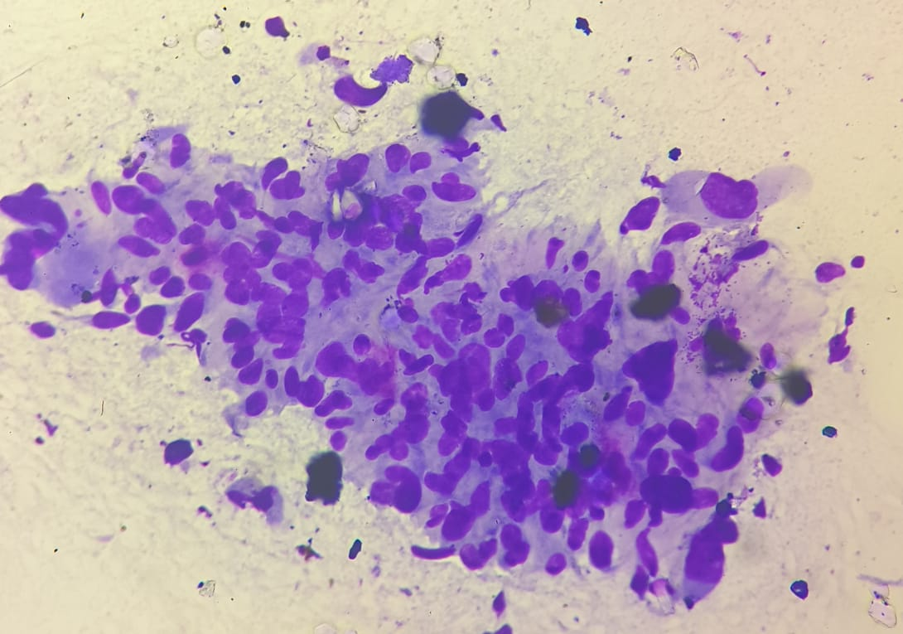

**Figure 1-** **Photomicrograph (40x, Giemsa) showing spindle cells with elongated pleomorphic nuclei, prominent nucleoli and bizzare forms suggestive of High grade sarcoma.**

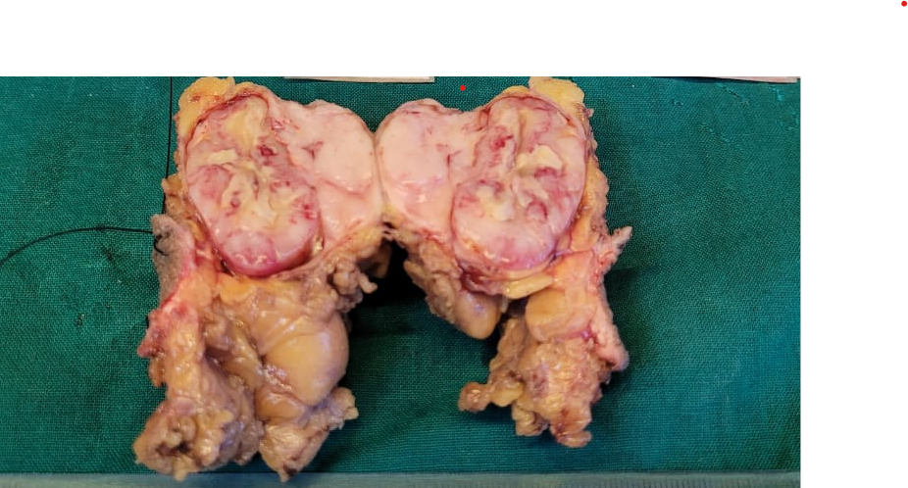

**Figure 2- The excised specimen received in the histopathology section is a skin covered fibrofatty tissue mass measuring 8 x 6 cm. The cut section is showing soft fleshy appearance.**

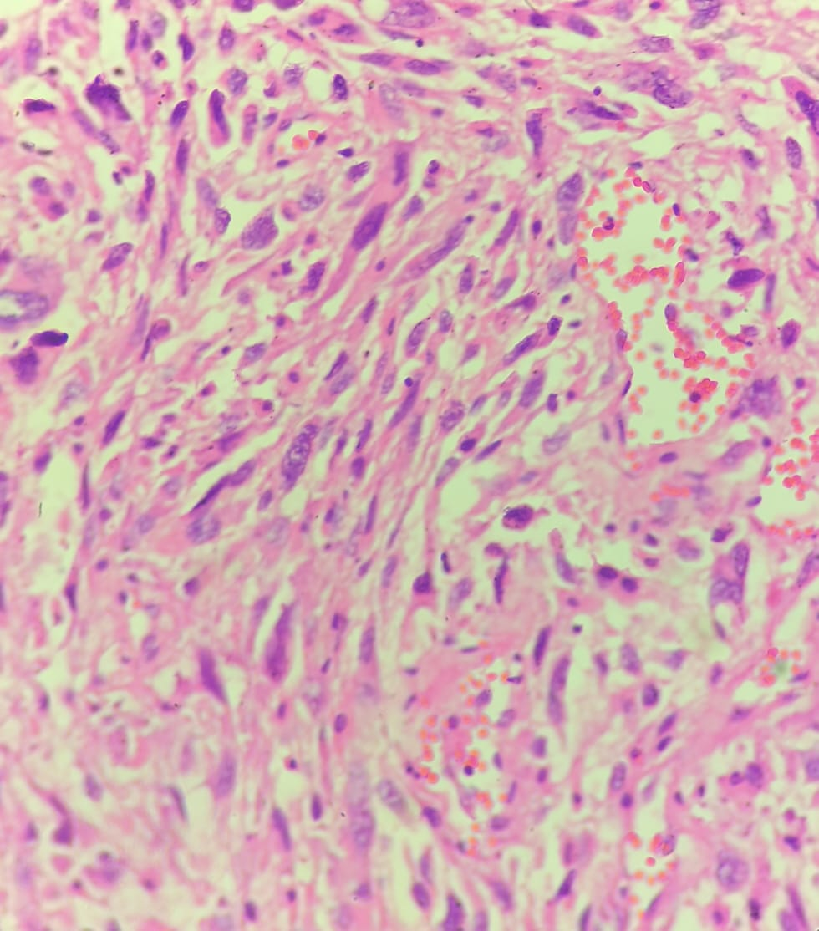

**Figure 3-** **Photomicrograph (40x, Hematoxylin & Eosin) showing tumor arranged in sheets comprised of spindle cells with elongated pleomorphic and hyperchromatic nuclei, with scant to moderate amount of cytoplasm. Also noted were plenty of pleomorphic tumor giant cells amidst.**

Immunohistochemical analysis revealed strong positivity for Vimentin, a mesenchymal marker commonly expressed in soft tissue sarcomas ( Figure 4). The proliferation index, indicated by Ki67, showed a significant 30% nuclear positivity, highlighting the tumour’s aggressive nature ( Figure 5). Notably, the tumour cells were negative for CDK4, Myogenin

( Figure 6 ), MDM2, S100, SMA (Figure 7) and CD34, ruling out alternative diagnoses and confirming the undifferentiated nature of the sarcoma. In our case, Immunohistochemistry is essential as it is challenging to diagnose on histopathology alone.

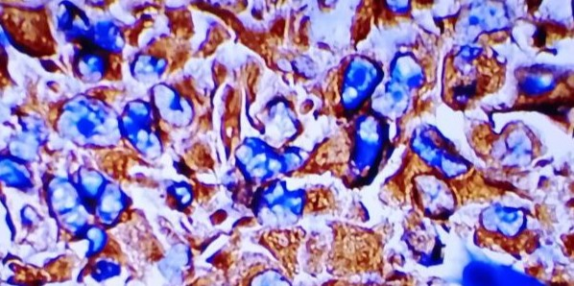

**Figure 4- Photomicrograph (40x) immunohistochemical study of vimentin showing strong cytoplasmic positivity.**

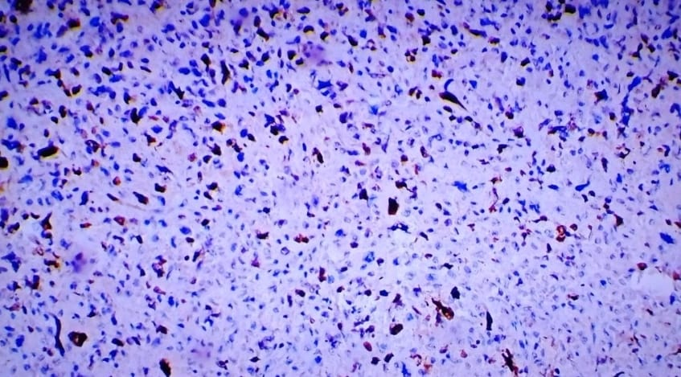

**Figure 5-** **Photomicrograph (40x) immunohistochemical study of Ki67 showing 30% nuclear positivity.**

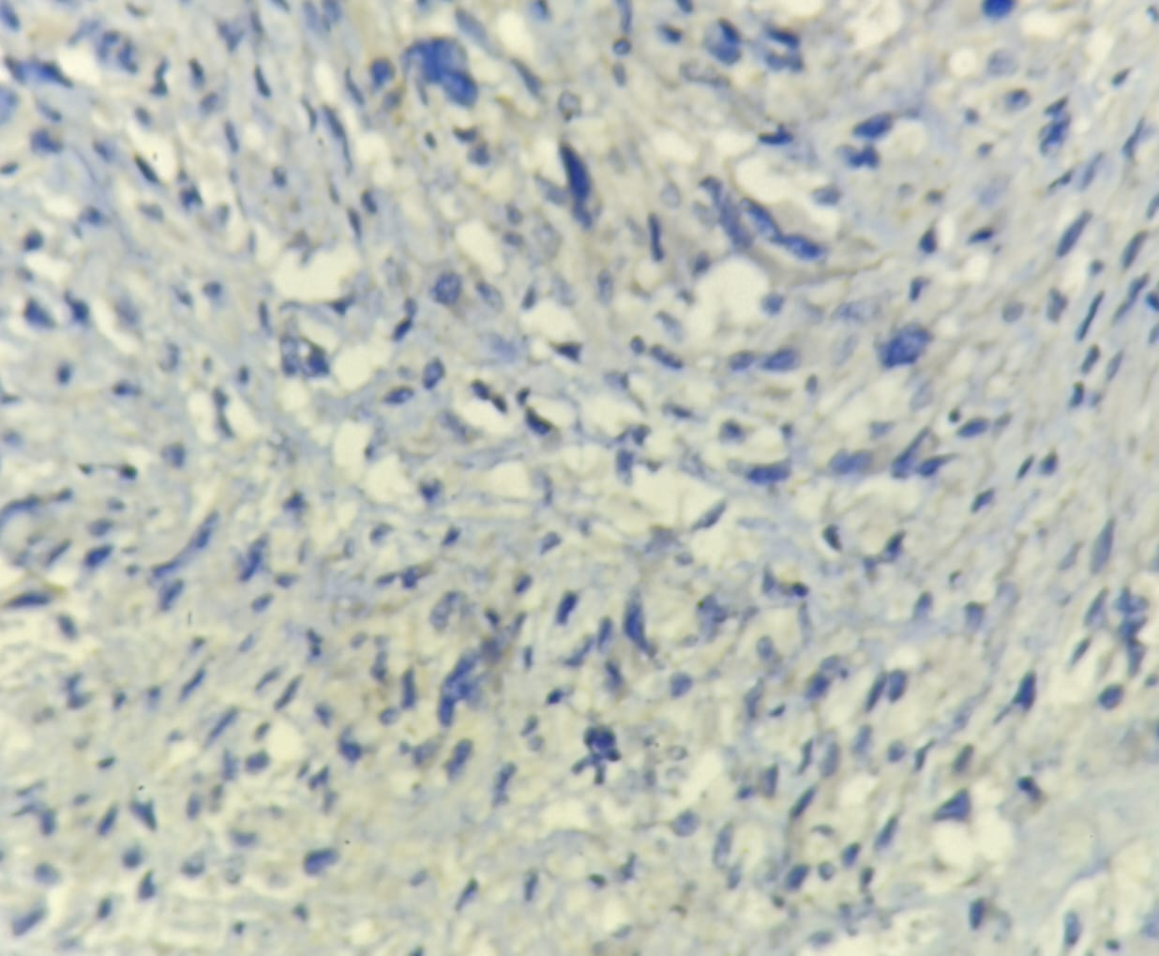

**Figure 6-** **Photomicrograph (40x) immunohistochemical study of Myogenin showing negative staining in tumor cells.**

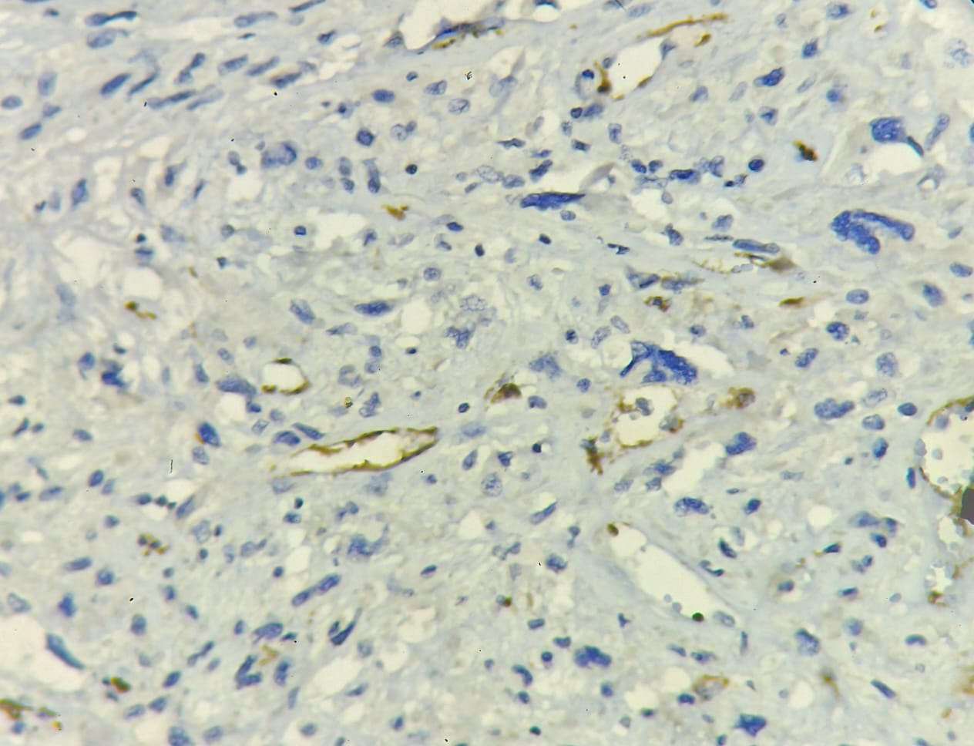

**Figure 7- Photomicrograph (40x) immunohistochemical study of SMA showing negative staining in tumor cells.**

Though USG from outside diagnostic centre was suggestive of chronic hematoma, but clinically swelling was not looking like hematoma, hence clinician suggested the FNAC. Upon cytological suggestion of sarcoma, there should have been a comprehensive work up. Unfortunately, due to patient’s unaffordability to do the MRI/PET scan, surgical intervention was planned. Wide local excision was done, post operative imaging was done and there was no metastasis. Post surgery follow up patient doing well.

3. discussion

Undifferentiated soft tissue sarcomas (USTS), including undifferentiated pleomorphic sarcoma (UPS), represent a diagnostic challenge due to their lack of definitive line-of-differentiation markers and highly pleomorphic morphology.[5] Routine histopathological examination alone is often insufficient for a conclusive diagnosis, as these tumors frequently mimic other high-grade malignancies such as pleomorphic leiomyosarcoma, liposarcoma, and malignant melanoma. In such cases, immunohistochemistry (IHC) serves as a pivotal adjunct, allowing for the exclusion of other differential diagnoses and narrowing down to an undifferentiated phenotype. Studies have emphasized the utility of IHC panels including markers like desmin, myogenin, S100, cytokeratins, and CD34, which help exclude myogenic, neural, epithelial, and vascular lineages respectively, thereby supporting a diagnosis of USTS when no specific differentiation is evident. [5] [6]

In the context of cytohistopathological correlation, IHC enhances diagnostic precision by linking cytological features such as spindle or pleomorphic giant cells with their protein expression profiles. For instance, UPS typically exhibits strong vimentin positivity, while lacking lineage-specific markers, a finding consistent with its undifferentiated nature [7]. Moreover, in recent years, IHC markers such as p16, Ki-67, and PD-L1 have also been explored not only for diagnostic purposes but also for prognostication and potential therapeutic implications. [8] In rare or atypical presentations, particularly when encountered in immunocompromised individuals, as with HIV-positive patients, IHC becomes even more indispensable due to altered tumor biology and overlapping histological patterns. Thus, immunohistochemistry remains an essential diagnostic cornerstone in the accurate classification and management of undifferentiated soft tissue sarcomas.

Clinically, patients often present with a painless mass that gradually increases in size. Sarcomas tend to be more locally concentrated than benign lesions and are frequently diagnosed at a later stage due to their indolent presentation [2]. UPS typically presents as a confined, multinodular, lobulated tumour with evidence of degeneration. The tumours are usually painless, although systemic symptoms such as fever, weight loss, and leukocytosis may be observed in the inflammatory subtype.

MRI plays a crucial role in assessing the extent of soft tissue sarcomas; however, its ability to differentiate between benign and malignant lesions, or between sarcoma subtypes, remains controversial. This is due to the nonspecific imaging characteristics shared by most soft tissue tumours, such as intermediate signal intensity (SI) on T1-weighted imaging (T1WI), high SI on T2-weighted imaging (T2WI), and heterogeneous contrast enhancement due to intratumoral hemorrhage and necrosis. Low SI on T2WI may be seen in tumours with fibrous components, such as UPS and low-grade fibrosarcomas [8].

Histopathological confirmation is essential, particularly in cases being considered for neoadjuvant therapy. A tissue diagnosis should be confirmed by an experienced sarcoma pathologist, with access to immunohistochemistry, cytogenetic studies, and molecular genetic testing if needed [4]. Histologically, UPS displays a wide variation in cellularity and morphology but consistently shows pleomorphic tumour cells. Some variants may also exhibit numerous giant cells or a prominent inflammatory infiltrate (inflammatory UPS/giant cell-rich types) [9].

In the present case, the gross and microscopic findings presented a diagnostic challenge, with differential diagnoses including pleomorphic leiomyosarcoma, pleomorphic liposarcoma, pleomorphic rhabdomyosarcoma, and malignant melanoma. The tumour exhibited spindle cells with elongated, pleomorphic, hyperchromatic nuclei and numerous pleomorphic giant tumour cells, complicating the diagnostic process. Given this morphological overlap, immunohistochemistry was critical in achieving a definitive diagnosis.

Recent developments in immunotherapy have shown promising results in various solid malignancies, including melanoma and lung cancer. Immune checkpoint inhibitors targeting the PD-1/PD-L1 pathway have demonstrated favorable responses, even in disseminated or operable disease settings. The therapeutic response is often associated with PD-L1 expression on tumour and immune cells, as well as the presence of tumour-infiltrating lymphocytes. A study by Yifan Zhang et al. found that PD-L1 immunoreactivity was more prevalent in UPS compared to chondrosarcoma and liposarcoma [10].

Adding to the complexity of the case, the patient’s HIV-positive status raises further questions regarding the role of immunosuppression in the pathogenesis and clinical behavior of STS, particularly in undifferentiated subtypes. The interplay between immunosuppression and tumour biology in such patients warrants additional exploration in future studies.

4. Conclusion

The development of metastatic disease affects the prognosis of approximately 50% of soft tissue sarcoma patients, presenting a significant challenge. Therefore, maintaining close patient follow-up is crucial to detect any tumour recurrence. This case underscores the pivotal role of immunohistochemistry in differentiating challenging soft tissue sarcomas, providing valuable information for accurate diagnosis and prognosis. The comprehensive use of a panel of markers aids in ruling out mimickers and guiding appropriate clinical management.

Consent (where ever applicable)

All authors declare that written informed consent was obtained from the patient (or other approved parties) for publication of this case report and accompanying images. A copy of the written consent is available for review by the Editorial office/Chief Editor/Editorial Board members of this journal.

Ethical approval (where ever applicable)

As per international standards or university standards written ethical approval has been collected and preserved by the authors.

Disclaimer (Artificial intelligence)

Option 1:

Author(s) hereby declare that NO generative AI technologies such as Large Language Models (ChatGPT, COPILOT, etc.) and text-to-image generators have been used during the writing or editing of this manuscript.

Option 2:

Author(s) hereby declare that generative AI technologies such as Large Language Models, etc. have been used during the writing or editing of manuscripts. This explanation will include the name, version, model, and source of the generative AI technology and as well as all input prompts provided to the generative AI technology

References

1.Babamiri B, Yavari S, Nikpey S, Faraji N, Goli R, Rahimi K. Undifferentiated soft-tissue sarcoma (STS) in a 34-year-old woman: a case report. International Journal of Surgery Case Reports. 2023 Apr 1;105:108104.

2. Zhang S, Zhang X, Zhao Z, Xu L, Xu S, Liu T, et al: Undifferentiated pleomorphic sarcoma of the extremity and trunk: a retrospective cohort study of 166 cases in a large institution. Translational Cancer Research. 2022 Apr;11(4):678.

3. Anderson WJ, Doyle LA. Updates from the 2020 World Health Organization Classification of Soft Tissue and Bone Tumours. Histopathology. 2021 Apr;78(5):644-657. doi: 10.1111/his.14265. Epub 2021 Jan 12. PMID: 33438273.

4.Gamboa AC, Gronchi A, Cardona K. Soft‐tissue sarcoma in adults: an update on the current state of histiotype‐specific management in an era of personalized medicine. CA: a cancer journal for clinicians. 2020 May;70(3):200-29.

5. Mohammed A, Abdullahi K, Amutta SB. Head and Neck Sarcomas: Demographic and Histological Characteristics in a Tertiary Hospital of a Developing Country. children.;7:8.

6. Yongu W, Elachi I, Mue D, Kortor J, Soo C, Ahachi C, Ojo B, Ngbea J. Delayed Presentation of Bone and Soft Tissue Sarcoma of the Extremity in Makurdi: Do Traditional Bone Setters Play a Role?. Journal of Advances in Medicine and Medical Research. 2017 Jan 10;22(10):1-8.

7. Thway K, Fisher C. Undifferentiated and dedifferentiated soft tissue neoplasms: Immunohistochemical surrogates for differential diagnosis. InSeminars in diagnostic pathology 2021 Nov 1 (Vol. 38, No. 6, pp. 170-186). WB Saunders.

8. Magaki S, Hojat SA, Wei B, So A, Yong WH. An introduction to the performance of immunohistochemistry. Biobanking: methods and protocols. 2018 Dec 12:289-98.

9. Black MA, Charville GW. Diagnosis of soft tissue tumors using immunohistochemistry as a surrogate for recurrent fusion oncoproteins. In Seminars in Diagnostic Pathology 2022 Jan 1 (Vol. 39, No. 1, pp. 38-47). WB Saunders.

10. **Zhang Y, Chen Y, Papakonstantinou A, Tsagkozis P, Linder‑Stragliotto C, Haglund F.** Evaluation of PD‑L1 expression in undifferentiated pleomorphic sarcomas, liposarcomas and chondrosarcomas. Biomolecules. 2022;12(2):292. doi:10.3390/biom12020292