A GIANT GALL BLADDER IN LAPAROSCOPIC CHOLECYSTECTOMY FOR ACUTE CALCULUS CHOLECYSTITIS: A CASE REPORT
Abstract:
Cholecystolithiasis, the most common biliary disorder, is more common in women. The most common complications of the gallbladder stone are biliary colic, cholecystitis, mucocele, gallbladder empyema, gangrene, perforation, and peritonitis. Laparoscopic or open cholecystectomy is the only option for the treatment of these diseases. The gallbladder may become enlarged and distended due to cystic duct or gallbladder neck obstruction due to gallstones. However, a grossly distended gallbladder ( > 14 cm in length) without any pathology is rare. Here, we are introducing a female patient aged 42 years, who is previously healthy, came to the casualty with a picture of acute calculus cholecystitis, which was confirmed by abdominal ultrasound. Laparoscopic cholecystectomy was done after two days. During the operation, a grossly distended (giant) gall bladder was found (about 18 cm after evacuation of bile and removal of the multiple stones). The post-operative period was unremarkable. The patient was discharged home after 4 days. On follow-up in the outpatient clinic, the patient had no complaints.

Keywords: gall bladder, giant gall bladder, stones, laparoscopy, cholecystectomy.

Introduction
The most common diseases of the gallbladder are asymptomatic gallstones, biliary colic, cholecystitis, mucocele, gallbladder empyema, gangrene, perforation, peritonitis, polyps, and malignancy (1). Surgical intervention in the form of laparoscopic or open cholecystectomy is the only option for the treatment of these diseases (2). Acute calculus cholecystitis is one of the emergency presentations which, if associated with gallstones impacted in the neck, would require emergency surgery (3). This impaction can also result in an over-distended gallbladder, causing mucocele or empyema (4). The length of a normal gallbladder in adults is 7.5 to 10 cm (5). A giant gallbladder is usually defined as a gallbladder measuring> 14 cm in length (6). A giant gallbladder with no marked obstructive factors is very rare (7). Indeed, in the literature, there are no more than nine cases that have been reported (8). The pathogenesis of the development of the giant gallbladder remains unknown. Usually, an increase in gallbladder volume can be due to physiological and pathological causes. The gallbladder itself can enlarge to a significant size without any functional abnormality or obstruction of the biliary tract. This physiological increase in gallbladder size usually does not require any treatment. Mechanical obstruction of the cystic duct and common bile duct due to stone, tumour, dysmorphia, adhesion, ascaris, or external pressure; Bacterial infection of the gall bladder; Gallbladder functional disorder and Diabetes Mellitus are the pathological causes of an overdistended gallbladder. Surgical trauma and pancreatic fluid reflux are other causes. Cholelithiasis and cholecystitis are the most common causes of gallbladder distension (9).
Case Report
A 42-year-old female patient, who was previously healthy, presented with acute epigastric and right-sided abdominal pain lasting for 2 days. At first, the abdominal pain was severe and paroxysmal, then became continuous and associated with nausea and vomiting. On presentation to our hospital, the patient's vital signs were normal (pulse 67 b/m, blood pressure 110/75, respiratory rate 24 and temperature 36.9). Abdominal examination revealed marked tenderness in the right upper quadrant with Positive Murphy’s sign. The routine blood test (WBCs 12.3 10^9/L, Hb 12.6 g/dL and platelets 387 10^9/L), coagulation profile, blood biochemistry, and human chorionic gonadotropin levels were within normal limits. Abdominal ultrasound showed acute on top of chronic calculus cholecystitis (Figure 1).
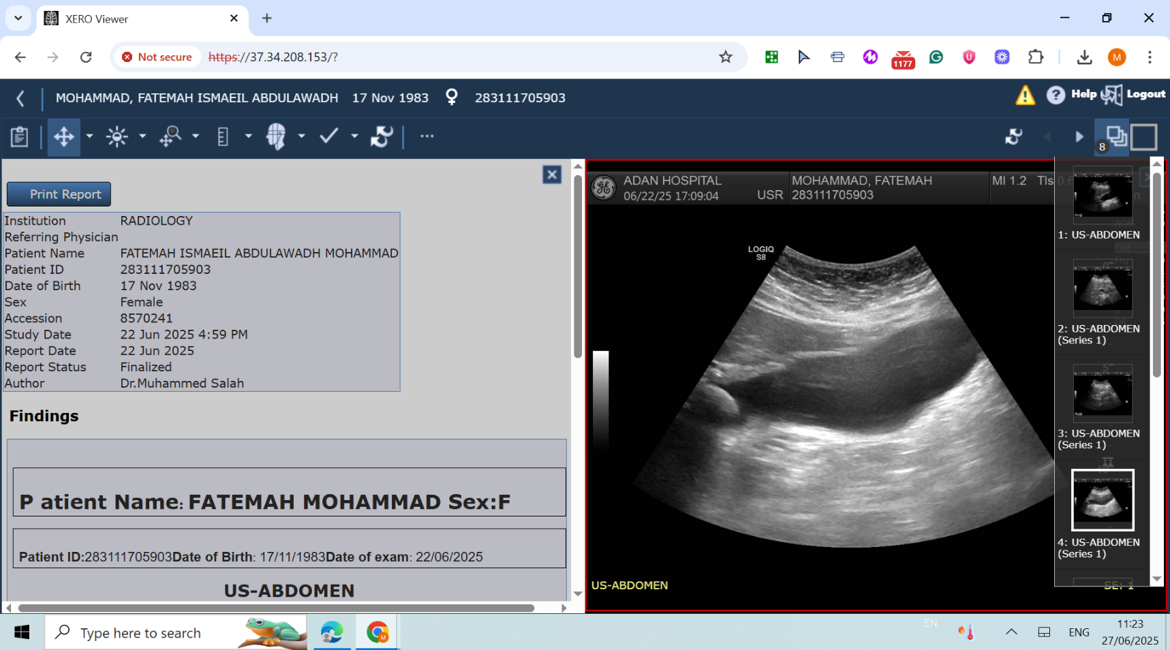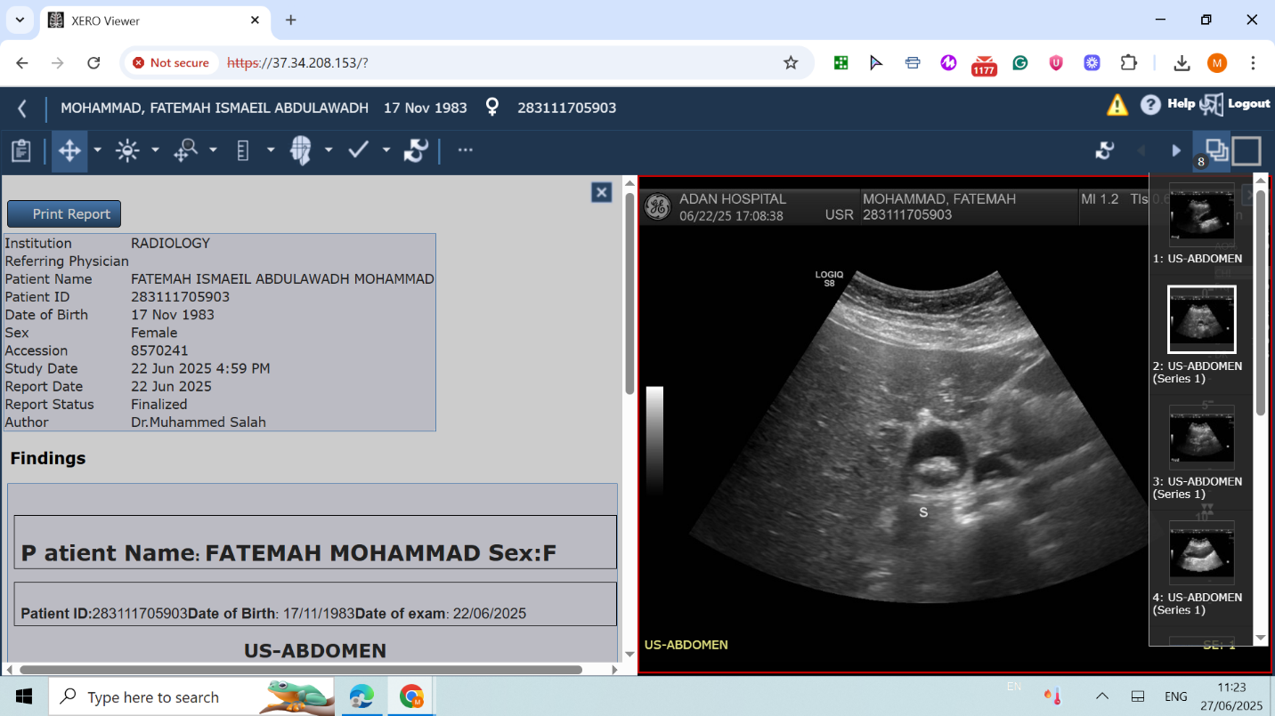
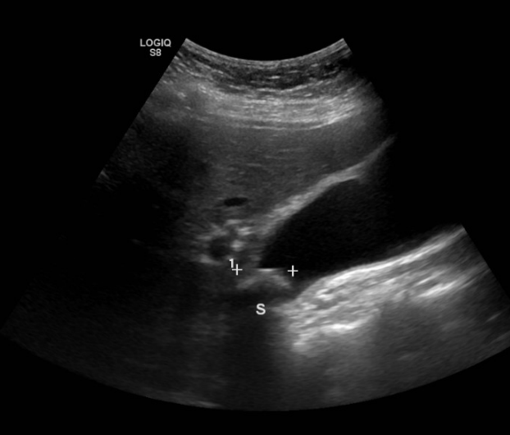
Figure 1: Abdominal ultrasound showed a hugely distended gall bladder.
The patient was admitted to the ward, intravenous fluids, pain killers, and antibiotics were started. After two days of admission, the patient underwent laparoscopic cholecystectomy under general anaesthesia. During the operation, the gallbladder was found to be grossly enlarged, reaching the right iliac fossa below the level of the umbilicus (Figure 2). The gallbladder wall was edematous, thickened, and adhered to the greater omentum. Since the gallbladder was too large to be operated on smoothly, it was decompressed, and 100 mL of mucus was aspirated (Figure 3). After decompression, the adhesions were released, and the Calot triangle was dissected. Even the lymph node of the LUND was very big (Figure 4). The critical view of safety was achieved (Figure 5). The cystic artery and duct were carefully identified. The cystic artery was clipped by 2 clips proximally and one distally, then divided in between. The cystic duct was clipped with 2 clips about 0.5 cm from the common bile duct, and one clip distally, then divided in between (Figure 6). The gallbladder was separated from the liver bed by a combination of anterograde and retrograde dissections using diathermy. The operation took about 1 hour with minimal intraoperative blood loss. A large-sized drain was fixed at the gall bladder fossa.
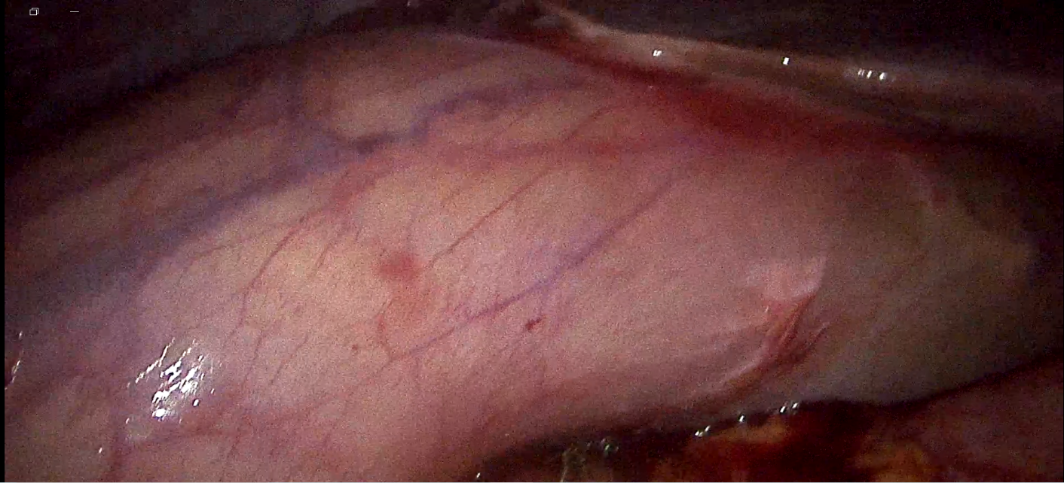
Figure 2: Huge gall bladder as seen from the edge of the liver.

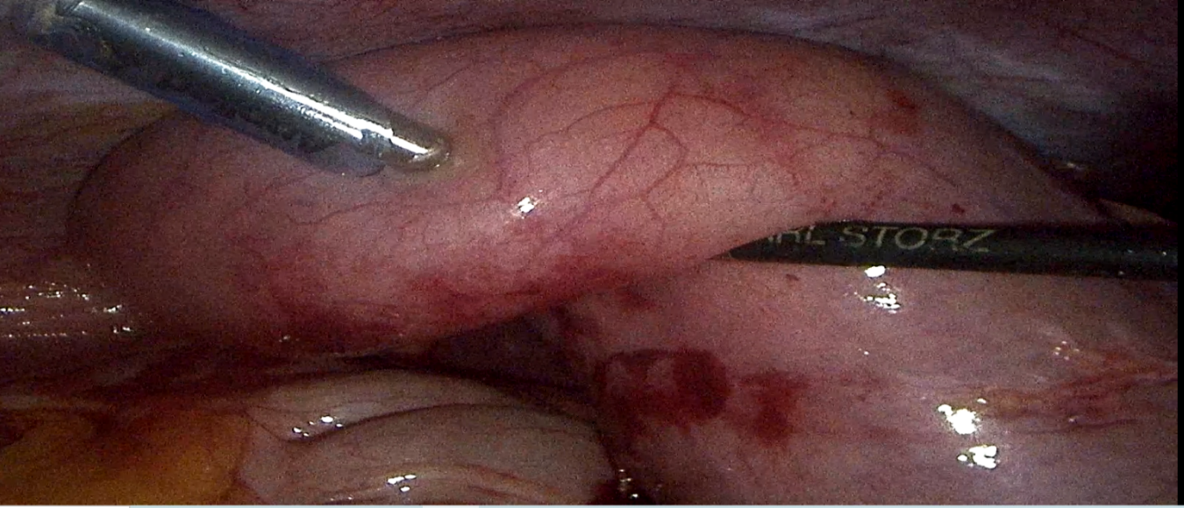
Figure 3: Aspiration of about 100 ml of mucus from the gall bladder.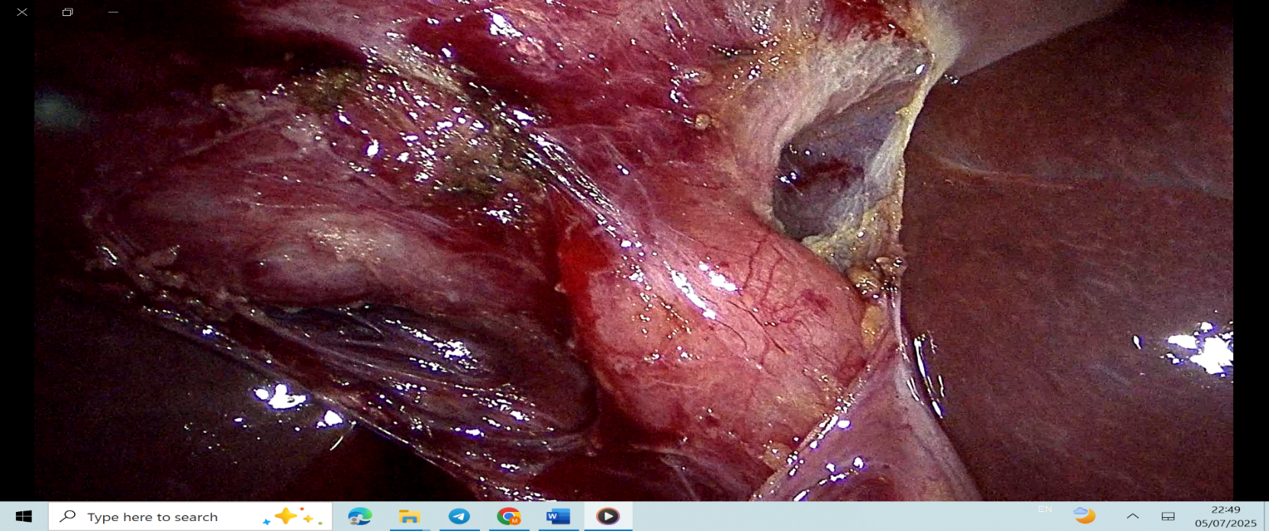
Figure 4: Very big lymph node of the LUND.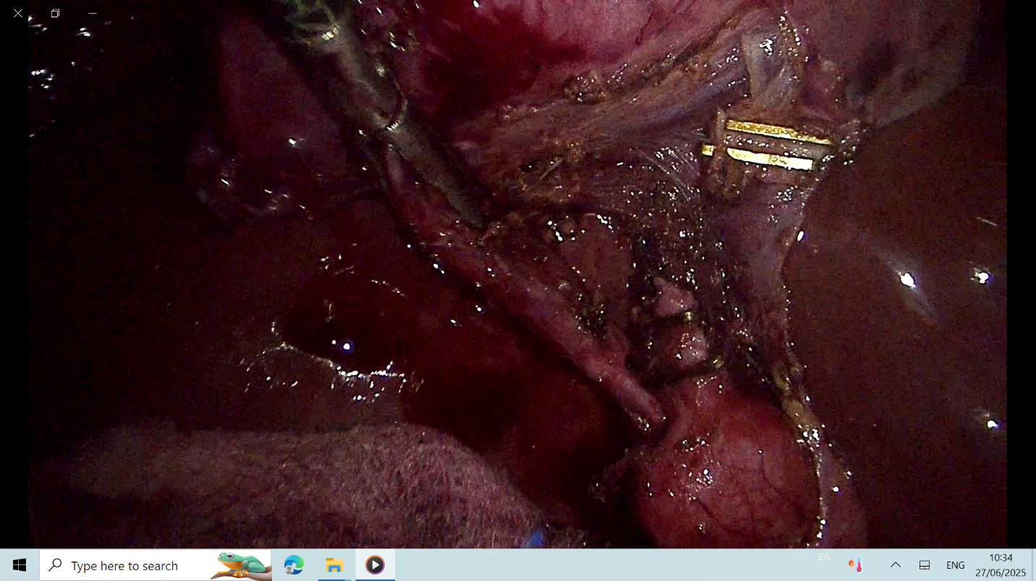
Figure 5: The critical view of safety was achieved.
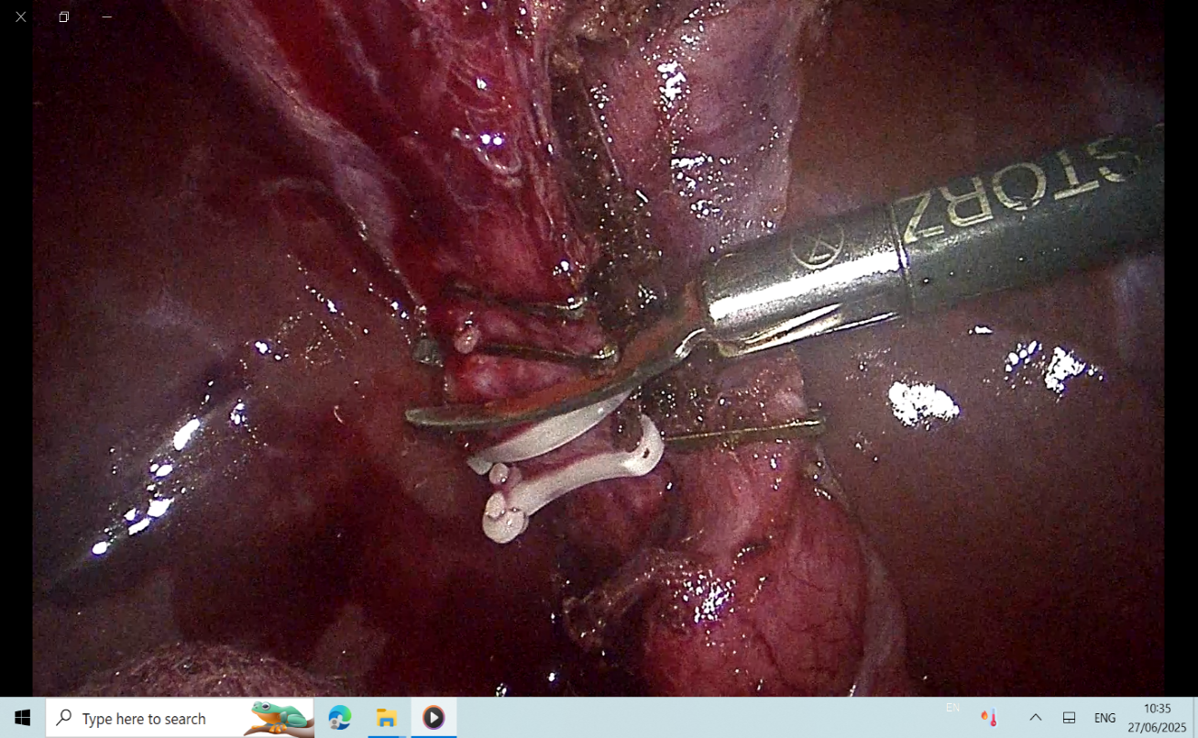
Figure 6: clipping of both the cystic artery and duct.
The postoperative recovery was uneventful, the drain was removed after 2 days, and the patient was discharged home after a hospital stay of 4 days. The histopathological examination of the gallbladder showed that the gallbladder wall was about 0.5 cm in thickness; 4.7 cm wide and 17 cm long, received in a jar full of formalin. Microscopic examination revealed acute on top of chronic calculus cholecystitis with adenomyomatosis.

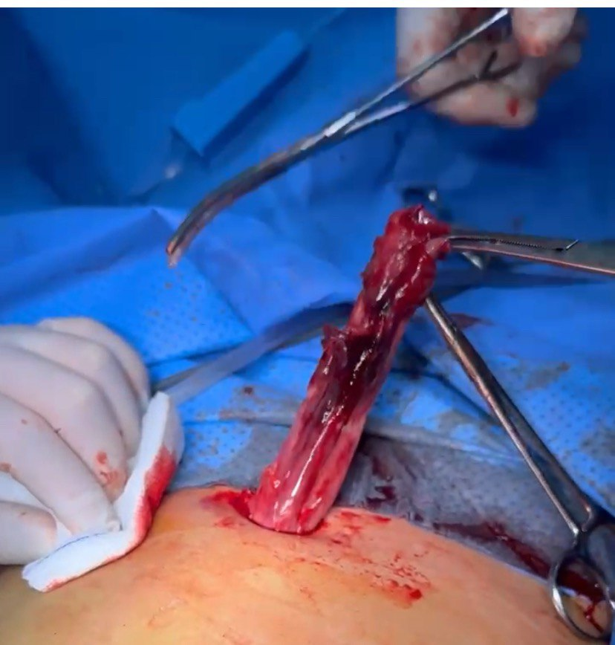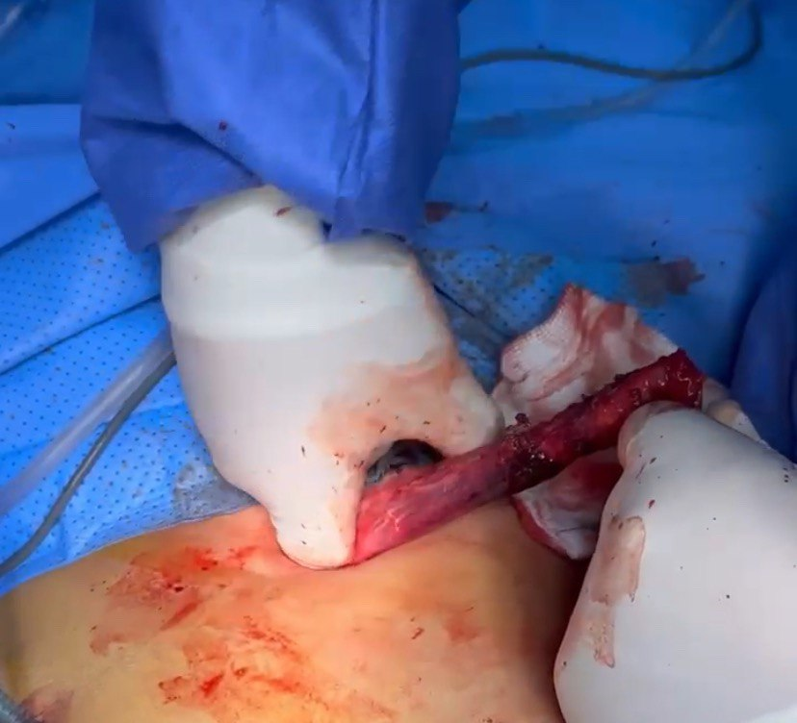
Figure 7: During the gallbladder removal through the epigastric port.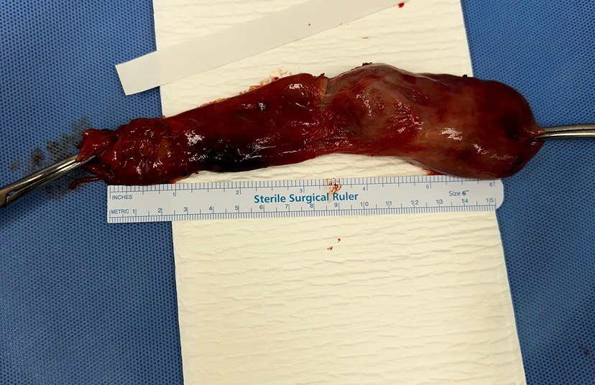 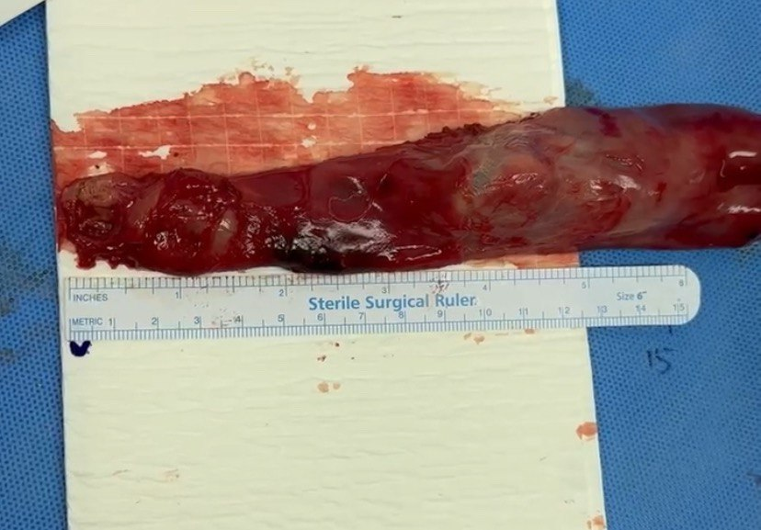
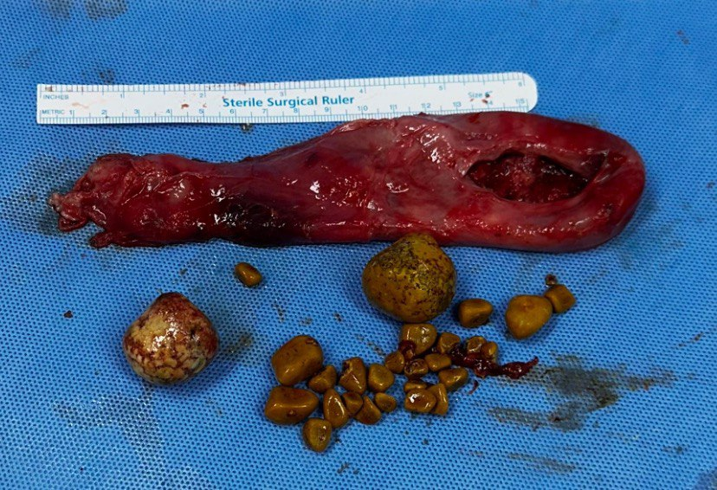
Figure 8: The excessively big gallbladder with multiple different-sized stones.
Discussion
The critical knowledge of anatomy, its variations and clinical experience is necessary for a safe and uneventful surgery (3). The gallbladder is situated on the undersurface of segments IV and V of the liver and has a peritoneal attachment to the liver (10). The gallbladder is a pear-shaped organ with an average length of 4.5 to 11.6 cm and a capacity of 30 to 50 ml (11). The presented case size was more than 18 cm after evacuation of the bile and the multiple stones. M Ullah et al. (12) revealed a case of a giant gall bladder of 27 cm. Also, Gao Yi et al. (13) showed a case of gallbladder that was found to be grossly enlarged (20 cm × 7.0 cm). The huge-sized or overdistended gallbladders are attributed to congenital anomalies, acquired or obstructive causes, as per the literature review (14). In our patient, there was no cystic duct obstruction or any other underlying disease. Postoperative pathological examination showed acute on top of chronic calculous cholecystitis, similar to routine cases of cholelithiasis. Acute calculus cholecystitis is an inflammation of the gallbladder that presents as a combination of right upper quadrant pain that may radiate to the back or right shoulder, nausea, vomiting and fever (15). In cases where the gallbladder stone is impacted at the neck of the gallbladder, the cystic duct is blocked, resulting in the accumulation within the gallbladder. This leads to an overdistended gallbladder (16). Prolonged obstruction of the cystic duct leads to continuous mucin secretion that ultimately overdistents the gall bladder, causing gallbladder wall oedema, inflammation, gangrene or perforation. In patients with diabetes mellitus, especially those who have poor control, there is autonomic neuropathy and cholecystoparesis that causes cholecystomegaly (11). Mucocele and empyema of the gallbladder are emergency pathologies that require early intervention in the form of laparoscopic cholecystectomy unless there is some definitive contraindication. Minimal scar, less pain and early mobilisation are the advantages of using the laparoscopic approach (14). Cholecystectomy, the treatment of choice for cholecystitis and gallstones, was first described by Langebuch in 1882. Laparoscopic cholecystectomy was first described by French surgeon Philippe Mouret in 1987. After more than 30 years of development, Laparoscopic cholecystectomy has become the gold standard for the treatment of symptomatic gallbladder disease. Indications for cholecystectomy include recurrent biliary colic and the development of gallstone-related complications. Laparoscopic cholecystectomy is recommended for asymptomatic gallstones under the following conditions: Multiple stones and stone diameters 2 to 3 cm; Gallbladder wall calcification or porcelain gallbladder; Gallbladder polyps (diameter ≥ 1 cm); Gallbladder wall thickness > 3 mm (accompanied by chronic cholecystitis) (13). As already shown, giant gallbladders are rare. This patient had a huge gall bladder complicated by multiple gallstones. Laparoscopic cholecystectomy was successfully performed in this patient after decompressing the gallbladder. The patient recovered well, and the abdominal pain resolved following the operation.

Conclusion
Huge gallbladders, although difficult to handle, can safely be removed via laparoscopic cholecystectomy with good outcomes. A sound knowledge of gallbladder anatomy, an experienced surgeon and his good team are the cornerstones in such surgeries.

Ethical Approval
Following international and university standards, written ethical approval has been obtained and preserved by the authors.

Consent
Written informed consent was obtained from the patient for publication of this case report and accompanying images.

References
[1] Atif QAA, Khan MA, Nadeem F, Ullah M. Health Related Quality of Life After Laparoscopic Cholecystectomy. Cureus. 2022; 14(7):e26739.
[2] Almas T, Murad MF, Khan MK, Ullah M, Nadeem F, Ehtesham M, Zaidi SM. The Spectrum of gallbladder histopathology at a tertiary hospital in a developing country: a retrospective study. Cureus. 2020 Aug 9;12(8).

[3] Yadav R, Kankaria J. Longest gallbladder: A case report. Int J Surg Case Rep. 2017; 33:127-129.
[4] Muneebullah, Javed R, Murad FM, Khan KM, Nadeem F, Shafi A. A Review of Laparoscopic Cholecystectomy; 250 Cases at Maroof International Hospital, Islamabad. J Islamabad Med Dental Coll. 2022; 11(3):169-174.
[5] Elkbuli A, Meneses E, Kinslow K, et al. Huge gangrenous gallbladder presenting as gastro-esophageal reflux disease successfully treated by laparoscopic cholecystectomy: case report and literature review. Int J Surg Case Rep. 2020;76:315–9.
[6] Fultang J, Chinaka U, Ali A. Giant gallbladder presenting as a right iliac fossa mass removed by mini-laparoscopic cholecystectomy. Cureus. 2019;11:e5576.
[7] Pina S, Rodrigues S. The silent giant. Pan Afr Med J. 2021;38:147.
[8] Zong L, Chen P, Wang L, et al. A case of congenital giant gallbladder with massive hydrops mimicking celiac cyst. Oncol Lett. 2013;5:226–8.
[9] Gao Y, He D, Feng W, Yue J, Jian Z. Laparoscopic cholecystectomy for giant gallbladder: A case report. Medicine 2023;102:40(e35429).
[10] Almas T, Murad MF, Mansour E, Khan MK, Ullah M, Nadeem F, et al. Look, but to the left: A rare case of gallbladder sinistroposition and comprehensive literature review. Ann Med Surg (Lond). 2021; 71:103016.
[11] Jahantab MB, Salehi V, Mehrabi S, Abedini L, Barhaghtalab MJY. Cholecystomegaly: A Case Report and Review of the Literature. Case Rep Gastrointest Med. 2020; 8825167.
[12] Ullah M, Murad MF, War AS, Adeel A. Large gallbladder Removed by Laparoscopic Cholecystectomy A Case report. Journal of Islamabad Medical & Dental College. 2023 Apr 19;12(1).
[13] Gao Y, He D, Feng W, Yue J, Jian Z. Laparoscopic cholecystectomy for giant gallbladder: a case report. Medicine. 2023 Oct 6;102(40):e35429.
[14] 7759/cureus.23773 10. Kuznetsov AV, Borodach AV, Fedin EN, Khromova AD. Giant gallbladder: A case report and review of literature. Int J Surg Case Rep. 2014; 5(10):673-676.
[15] Ishii H, Noguchi A, Onishi M, Takao K, Maruyama T, Taiyoh H, et al. True left-sided gallbladder with variations of bile duct and cholecystic vein. World J Gastroenterol. 2015; 21(21):6754-6758.
[16] Singh SA. The longest gallbladder with mucocele from the arabian peninsula - a case report. International Journal of Development Research. 2018; 8(3):19587 19588.

