***Case report***

**UNUSUAL LOCALIZATION OF HYDATID DISEASE: MAKING CORRECT DIAGNOSIS INTRAOPERATIVELY AND ITS MANAGEMENT**

**Abstract**

The hydatid cyst is a cosmopolitan parasitic infection which constitutes a public health problem in our country and the breeding areas of developing countries. The gluteal localization of the hydatid cyst is exceptional among the muscular localization which makes only 1 to 5% of all cyst localizations.

In this work, we present a retrospective study of a series of 3 cases of isolated and primary hydatid cysts in the gluteal muscle observed at the emergency department of visceral surgery at Ibn Sina Rabat Hospital. The aim of this study was to analyze the epidemiological, clinical, biological, radiological and therapeutic aspects of this condition. The predilection field was that of the woman, with an average age of 40 years, and without notion of contact with dogs.

The clinical picture was represented in 66.6% by signs of compression of neighbouring structures (lumbosciatica, rectal compression), and in 33.3%, the symptomatology was poor, consisting of a painless, non-inflammatory muscle swelling progressively increasing in volume, and evolving slowly in a context of preservation of general condition. No associated visceral localization was detected in any of our 3 patients. Computed tomography confirmed the diagnosis, and enabled us to specify more precisely the location of the cyst and its relationships. The diagnosis was made intraoperatively in our case.

Treatment consisted of surgical excision, supplemented in some cases by antiparasitic medical treatment. The results were generally satisfactory, and no cases of recurrence were reported in our case. Prophylaxis is the best way to combat this parasite in endemic areas.

**Keywords**: Hydatid disease, Prophylaxis, parasitic infection, cyst

**Introduction**

Hydatid disease, also known as cystic echinococcosis, is a parasitic infection caused by the larval stage of Echinococcus granulosus, a tapeworm endemic to many regions worldwide, particularly the Mediterranean, Middle East, South America, sub-Saharan Africa, and parts of Asia [21,22]. This is a potentially fatal parasitic disease, in which man is the accidental intermediate host and the dog is the reservoir and definitive host of the tapeworm echinococcus [1.2]. The World Health Organization (WHO) estimates the incidence of human infection to be more than 50/100,000 persons annually in echinococcosis endemic areas. The prevalence is high in parts of Argentina, Central Asia, and East Africa [2[3](https://pmc.ncbi.nlm.nih.gov/articles/PMC10047450/#B3-diagnostics-13-01127)].

Echinococcosis is a silent cyclo-zoonotic illness that causes severe morbidity and mortality in humans and herbivore animals [24]. Contamination occurs through the consumption of water or raw vegetables contaminated with dog faeces, or directly through contact with the parasitized dog [3] The clinical symptoms of echinococcosis are variable and are determined by the size, site and condition of the cysts[4].

Extrahepatic echinococcal cysts often pose diagnostic dilemmas and sometimes the diagnosis is made intraoperatively [5] Diagnosis is based on ultrasonography and computed tomography (CT), which remain the examinations of choice. Nuclear magnetic resonance (MRI) is also effective [6].

The diagnosis must be made in the presence of any liquid mass, especially in an endemic country such as Morocco [7]

Surgery is the most effective treatment, with a significant morbidity of conservative treatment that must be emphasized. Recent years have seen the development of percutaneous interventional radiology techniques such as puncture, aspiration, injection and re-aspiration (PAIR), and percutaneous drainage without re-aspiration, which have improved the mortality and morbidity of hydatid cysts. Post-surgical drug treatment is necessary for a complete cure. [8,9]

Prophylaxis is a real tool which must act at all levels of the epidemiological chain[10].

**Case Presentation**

**Observation 1**

This is a 29-year-old female patient, with no previous history and in particular no notion of contact with dogs, hospitalized for a gluteal mass with a rectal compression.

Symptoms began 6 months ago with the appearance of a painless right gluteal mass that progressively increased in size, causing rectal compression. All this evolved in the context of apyrexia and preservation of general condition. Clinical examination revealed a mass on the right buttock extending into the intergluteal groove, painless, kidney-shaped, 14cm in diameter and without inflammatory signs. On rectal examination, the mass was seen to extend upwards along the ana canal and to contact the rectal ampulla. The vaginal examination was normal. Ultrasound showed a homogeneous mass of hydrous density, without internal partitions or hepato-splenic abnormalities. Computed tomography (CT) showed a hydatid cyst in relation to the vulva and rectum. The hydatid disease work-up was normal. Rectoscopy showed extrinsic elevation of the rectum. Biological work-up was normal, with no eosinophilia. Treatment consisted of intraoperative puncture of the mass, which yielded a rock-water liquid. A short elective vertical incision revealed a type I hydatid cyst, contracting adhesions with the anal sphincter. Proper cleansing with hydrogen peroxide was performed, and the proligeral membrane was extracted (figure 1). Post-operative follow-up was straightforward, with no sign of recurrence after six years of follow-up.

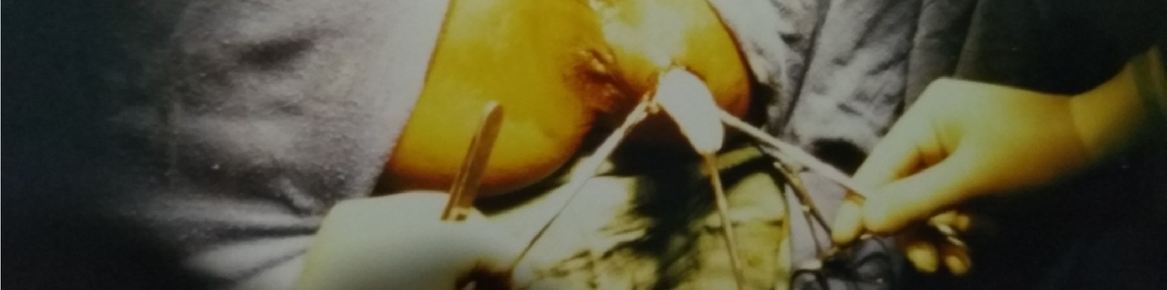

**Figure 1: intraoperative image showing extraction of the proligeral membrane**

**Observation 2:**

A 60-year-old woman, operated on for a lithiasis vesicle 20 years ago, with no notion of contact with dogs, was admitted to the department on 10/05/2008 for a swelling of the upper external part of the right buttock. The onset of symptoms was one year ago, with the appearance of a renitrating mass, progressively increasing in volume, on the right buttock without any associated signs, in the context of apyrexia and with preservation of the general condition. Clinical examination revealed a renal mass 7cm in diameter on the upper external part of the right buttock, with no inflammatory signs. 2.1. Radiological findings: Ultrasound examination revealed a 7cm cystic mass in the upper lateral quadrant of the right buttock region, with a regular wall and homogeneous fluid content, suggesting a hydatid cyst.

The liver, spleen and rest of the abdominal cavity were without abnormalities. A parietal CT scan showed a cystic mass in the right buttock, approximately 7cm in diameter, with a liquid-like structure and discrete peripheral parietal enhancement after injection of an iodine bolus. The mass was posterior in location, just behind the right iliac crest, protruding into the subcutaneous fatty tissue and in contact with the upper part of the buttock muscle, suggesting a hydatid cyst.

She underwent elective surgery after protection with hydrogen peroxide-soaked drapes and cyst isolation (figure 2). Suction puncture yielded a clear rock water liquid, and extraction of the proligeral membrane was followed by abundant cleansing with hydrogen peroxide. We then performed a pericystectomy, removing the entire hydatid cyst shell (figure 3) and draining the subcutaneous tissue with a Redon suction drain.

Post-operative follow-up was straightforward, and the patient left the department three days later with a good clinical and radiological evolution. There was no sign of recurrence over a four-year follow-up**.**

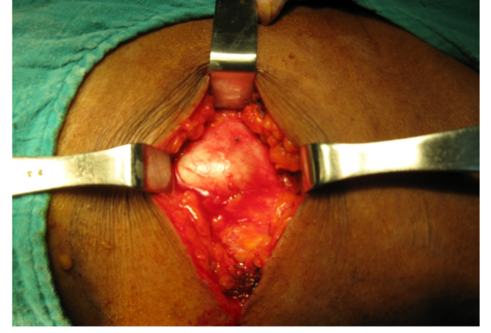

**Figure 2: Preoperative exposure of the KH after dissection**

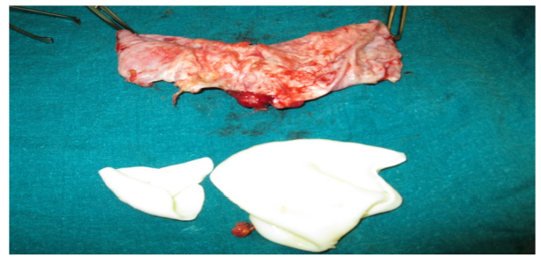

**Figure 3: Complete surgical excision specimen**

**Observation 3:**

A patient, aged 30, with no previous history, living in a rural area, was admitted to the department for a left buttock mass with lower back pain. The symptomatology began 9 months ago with the appearance of a mass in the left buttock, progressively increasing in size and causing lower back pain that was not improved by anti-inflammatory medication. All this was evolving in the context of preserved general condition and apyrexia. On examination, a painless mass was found in the left buttock, mobile in relation to the deep plane. The patient's general condition was preserved, and mobility of the left hip was not restricted. 3.1. Radiological findings: Abdominopelvic CT scan showed remodelling of the iliac wing and left sacral fin (figure 4), associated with a voluminous mass measuring 10 cm by 8 cm in diameter, with a liquid-like structure and a multiloculated appearance, shooting along the left iliac muscle and extending towards the posterior wall, infiltrating the gluteus medius and gluteus maximus muscles.

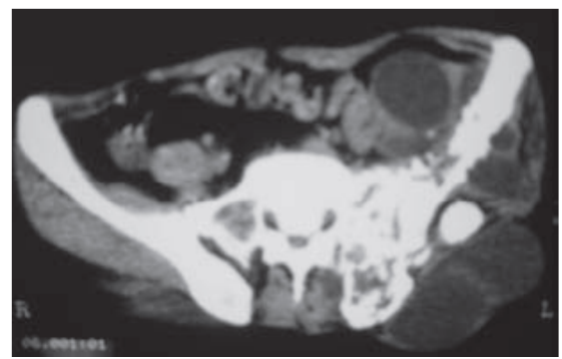

**Figure 4: CT scan showing remodelling of the iliac wing and left sacral fin**

**DISCUSSION**

Hydatidosis tends to be a disease of young adults, with the average age of discovery being 40[3].

There is a predominance of females, estimated at 70% in the majority of studies, as women are more involved than men in the care of livestock and dogs. However, hormonal or immunological factors cannot be ruled out. In France, there are as many men as women. This female predominance is found in all anatomical locations of hydatid cysts[11]. The epidemiology of hydatidosis varies. The ancestral cycle is carried out by herbivores and wild canids. This is the beginning of the more common rural cycle, which is carried out between farmed livestock and dogs[12]. Since 2005, the Ministry of Health has set up a notification system for hydatidosis, which has become a notifiable disease [13].

In 2008, Morocco officially launched a national hydatidosis/echinococcosis control program [14]. In the Maghreb, according to Ministry of Health figures, Morocco ranks 3rd after Tunisia (14 cases/100,000 inhabitants) and Algeria (10 cases/100,000 inhabitants[33]).

The initial phase of infection is always asymptomatic and may persist for several years. Clinical manifestations then depend on the location and size of the cysts. Small cysts and/or calcified cysts may remain asymptomatic indefinitely. The clinical signs are secondary [52]: Either to the existence of a mass syndrome in the affected organ. Obstruction of blood flow or lymphatic flow. A complication such as a cyst rupture with secondary superinfection.

Hydatid cysts can be found in all parts of the body, Because of their physiological role as filters capillaries and their vast capillary volume, the liver and lungs are most often affected. Cerebral, muscular, renal, bone, cardiac and pancreatic involvement is less common. Eighty-five to 90% of patients have an affected organ, and 70% have a single cyst[15].

Imaging is the essential tool for avoiding biopsy, which can trigger anaphylactic shock and should therefore be avoided altogether. Ultrasound is the first-line examination. The typical appearance is A hypoechoic round image with a smooth wall. The multiplicity of vesicles gives a “honeycomb” image. The ultrasound classification of hydatid cysts, drawn up by a WHO expert committee, allows them to be classified as either active or inactive but is only used in hepatic localizations[16]. MRI remains the best examination for diagnosing muscular cysts by showing a multiloculated cystic image. It also allows precise localization. CT scans are still useful in the d'extension assessment[17].

Biologically, hypereosinophilia is inconstant. Serology for hydatidosis is based on at least 2 screening techniques (HAI, ELISA, immuno-fluorescence, electrosynthesis, etc.), followed, in the case of positivity, by a confirmatory technique (Western Blot). Serology is highly sensitive in hepatic and pulmonary forms, whereas is positive in only around 25% of other forms. A negative serology therefore does not exclude the diagnosis [18]. Treatment of muscular hydatidosis is primarily surgical, consisting of total perikystectomy, combined with lavage with a scolicidal agent (hypertonic saline or hydrogen peroxide) to avoid dissemination during surgery. A definitive diagnosis is made by examination of the extracted mass, within which daughter vesicles are found. Microscopic examination of the hydatid fluid may reveal the presence of protoscolex if the cyst is still active[19]. Long-term monitoring of the patient is necessary in order to detect local or distant recurrence. It is based on clinical examination, imaging and follow-up serology (every 3 months, for 2 years). Serology can be negative for several months or even years. A rise in antibodies may indicate recurrence or reinfection[20].

**Conclusion**

Hydatidosis is a parasitosis that is widespread in areas where sheep are bred, notably in southern Europe, Asia, Australia, Africa and the Middle East. In Morocco, it represents a veritable public health problem.

In humans, the liver is the most frequent site of cyst development (60%), followed by the lungs (20%). Muscular hydatidosis is a rare condition, and gluteal localization appears to be exceptional, even in endemic countries. The rarity of muscle hydatidosis may be explained by the fact that the parasite passes through two filters (hepatic and pulmonary) before reaching the general circulation. Muscle is a less than ideal environment for the development of hydatid larvae, owing to the contractility of muscles on the one hand, and the production of lactate on the other. Clinically, muscular hydatidosis, and specifically gluteal localization, is characterized by a long clinical latency. It is clinically manifested by the appearance of a mass, often painless, progressively increasing in volume, with no change in general condition. However, very large cysts can cause functional discomfort or compression neuropathy This disease is reputed to be benign but can become serious due to its inescapable complications, which are dominated by cyst rupture, which can lead to clinical manifestations of hypersensitivity, such as fever, but can also lead to true anaphylactic shock. The clinical diagnosis of muscular hydatidosis is difficult to make. Imaging is an indispensable tool for avoiding biopsy, which can trigger anaphylactic shock and is therefore totally inadvisable. Treatment of muscular hydatidosis is primarily surgical, consisting of total perikystectomy, combined with lavage with a scolicidal agent (hypertonic saline or hydrogen peroxide) to avoid dissemination during surgery.

Consent

As per international standards or university standards, patient(s) written consent has been collected and preserved by the author(s).

Disclaimer (Artificial intelligence)

Option 1:

Author(s) hereby declare that NO generative AI technologies such as Large Language Models (ChatGPT, COPILOT, etc.) and text-to-image generators have been used during the writing or editing of this manuscript.

Option 2:

Author(s) hereby declare that generative AI technologies such as Large Language Models, etc. have been used during the writing or editing of manuscripts. This explanation will include the name, version, model, and source of the generative AI technology and as well as all input prompts provided to the generative AI technology

Details of the AI usage are given below:

1.

2.

3.

REFERENCES

[1]. P. L. Moro and P. Cantey, 281 - Echinococcus Species: Agents of Echinococcosis, Fifth Edit. Elsevier Inc., 2018.

[2]. Ershadi, R., Salehi, M., Roostaei, G., Rad, N. K., Soltanmohammadi, S., & Amini, H. (2025). Factors associated with hospital length of stay in patients with thoracic hydatid cyst disease undergoing surgical intervention: a retrospective study. *Journal of Cardiothoracic Surgery*, *20*(1), 39.

[3] Tamponi, C., Knoll, S., Tosciri, G., Salis, F., Dessì, G., Cappai, M. G., ... & Scala, A. (2020). Environmental contamination by dog feces in touristic areas of Italy: parasitological aspects and zoonotic hazards. *The American journal of tropical medicine and hygiene*, *103*(3), 1143.

[4]. Dziri, C., Haouet, K., & Fingerhut, A. (2004). Treatment of hydatid cyst of the liver: where is the evidence?. *World journal of surgery*, *28*, 731-736.

[5]. D. Mezioug and C. Touil-Boukoffa, “Interleukin-17A correlates with interleukin-6 production in human cystic echinococcosis: A possible involvement of IL-17A in immunoprotection against echinococcus granulosus infection,” Eur. Cytokine Netw., vol. 23, no. 3, pp. 112–119, 2012.

[6]. M. Labsi, I. Soufli, L. Khelifi, Z. C. Amir, and C. Touil-Boukoffa, “In vivo treatment with IL-17A attenuates hydatid cyst growth and liver fibrogenesis in an experimental model of echinococcosis,” Acta Trop., vol. 181, no. June 2017, pp. 6–10, 2018.

[7]. Ramos, G., Md, P., Antonio Orduña, M., & Mariano García-yuste, M. (2001). Hydatid cyst of the lung: diagnosis and treatment. *World journal of surgery*, *25*(1), 46.

[8]. Merad, Y., Derrar, H., Zeggai, A., Belkacemi, M., Belmokhtar, Z., & Adjmi-Hamoudi, H. (2020). A rare primary hydatid cyst of the psoas muscle in a rural setting: A case presentation. *Annals of Medicine and Surgery*, *59*, 86-88.

[9]. Oğur, H. U., Kapukaya, R., Külahçı, Ö., Yılmaz, C., Yüce, K., & Tuhanioğlu, Ü. (2019). Evaluation of radiologic diagnostic criteria and treatment options in skeletal muscle hydatid cysts. *Journal of Orthopaedic Surgery*, *27*(3), 2309499019881219.

[10]. Tekin, R., Avci, A., Tekin, R. C., Gem, M., & Cevik, R. (2015). Hydatid cysts in muscles: clinical manifestations, diagnosis, and management of this atypical presentation. *Revista da Sociedade Brasileira de Medicina Tropical*, *48*(5), 594-598.

[11]. Dziri, C., Haouet, K., & Fingerhut, A. (2004). Treatment of hydatid cyst of the liver: where is the evidence?. *World journal of surgery*, *28*, 731-736.

[12]. Kechiche, N., Makhlouf, D., Lamiri, R., Zouaoui, A., Sahnoun, L., Mekki, M., ... & Nouri, A. (2021). Peritoneal hydatid cysts in children: a case series of rare echinococcosis localization. *Iranian Journal of Medical Sciences*, *46*(1), 68.

[13]. Malik, A. A., Bari, S. U., Amin, R., & Jan, M. (2010). Surgical management of complicated hydatid cysts of the liver. *World journal of gastrointestinal surgery*, *2*(3), 78.

[14]. Khan, S., Younus, M., Cable, J., Hailer, F., Idrees, A., Imran Rashid, M., & Akbar, H. (2023). Epidemiology of Bovine Hydatidosis: Urbanization, dogs, animal care and proximity to slaughterhouses are important risk factors for cattle. *Pakistan Veterinary Journal*, *43*(3), 507-514.

[15]. Lewall, D. B. (1998). Hydatid disease: biology, pathology, imaging and classification. *Clinical radiology*, *53*(12), 863-874.

[16]. E. Brunetti, P. Kern, and D. Vuitton, “Expert consensus for the diagnosis and treatment of cystic and alveolar echinococcosis in humans,” Acta Trop, p. 114:1–16, 2010.

[17]. Z. Orhan, H. Kara, T. Tuzuner, I. Sencan, and M. Alper, “rimary subcutaneous cyst hydatic disease in proximal thigh: an unusual localization: a case report,” BMC Musculoskelet Disord, vol. 4:25, 2003.

[18]. E. Cappello et al., “Epidemiology and clinical characteristics of cystic hydatidosis in Western Sicily: a ten-year review,” World J Gastroenterol, p. 19:9351–8, 2013.

[19]. S. Arif et al., “Albendazole as an adjuvant to the standard surgical management of hydatid cyst liver,” Int J Surg, p. 6:448–51, 2008.

[20]. O. Thaunat and P. Priollet, “Hepatic hydatidosis,” Press. Med, p. 33:30, 2004.

[21] Wani, A. H., Iqbal, J., & Singh, G. (2024). Echinococcosis in an Unusual Site: A Rare Case Report of a Primary Hydatid Cyst in the Thigh. *International Journal of Medical and Pharmaceutical Case Reports*, *17*(4), 39–43. <https://doi.org/10.9734/ijmpcr/2024/v17i4399>

[22] Romig, T., Dinkel, A., & Mackenstedt, U. (2006). The present situation of echinococcosis in Europe. *Parasitology international*, *55*, S187-S191.

[23] Lodhia, J., Chugulu, S., Sadiq, A., Msuya, D., & Mremi, A. (2020). Giant isolated hydatid lung cyst: two case reports. *Journal of Medical Case Reports*, *14*, 1-7.

[24] Pal, M., Alemu, H. H., Marami, L. M., Garedo, D. R., & Bodena, E. B. (2022). Cystic echincoccoosis: A comprehensive review on life cycle, epidemiology, pathogenesis, clinical Spectrum, diagnosis, public health and economic implications, treatment, and control. *International Journal of Clinical and Experimental Medicine Research*, *6*(2).