**Molecular analysis of bacteria and fungi isolates from wastewater from Wupa Wastewater Treatment Plant**

**Abstract**

As the population of the earth is increasing, the rate of waste release into the environment increases. This study investigates the microbial composition of wastewater samples collected from the Wupa Wastewater Treatment Plant in Abuja, focusing on bacterial and fungal diversity. Methods included bacterial colony counting across dilution series (10⁻¹ to 10⁻⁶), bacterial identification via morphological and Gram staining, and molecular confirmation of isolates through GenBank database comparison. Results showed peak bacterial density at 10⁻¹ dilution and minimal density at 10⁻⁶. Three bacterial species were identified: *Pseudomonas aeruginosa*, *Escherichia coli*, and *Bacillus subtilis*, alongside a single fungal isolate (*Aspergillus niger*). Molecular analysis confirmed *Escherichia coli* with 99% similarity (accession NR 114042.1), *Pseudomonas aeruginosa* with 98% (accession NR 117635.1), and *Aspergillus niger* with 98% (accession NR 145759.1). These findings contribute to a better understanding of the microbial community dynamics in wastewater systems and highlight key species that may play roles in wastewater treatment processes.

Keywords: Wastewater, Bacteria, Fungi, Molecular, Treatment plant

**Introduction**

Worldwide, water is an important component of living beings as it performs unique and indispensable activities (Mohammed et al., 2020a). However, due to many anthropogenic activities, freshwater resources are deteriorating at a faster rate (Adam et al., 2020; Mohammed et al., 2024). Increasing urban population growth, industrialization, and intensive farming have led to severe disturbance of drinking water across the world, resulting in limited access to clean and safe drinking water (Adamu et al., 2022; Ibrahim et al., 2023). The rise of urbanization and industrialization has left the environment exposed to numerous pollutants which are toxic to living things (Mohammed et al., 2020a; Mohammed et al., 2020b). Pollutants arising from different industrial processes are major sources of pollution to the soil and aquatic environment (Mohammed et al., 2020a; Mohammed et al., 2020b; Ibrahim et al., 2024a).

Wastewater are water that has been adversely affected in quality by anthropogenic activities (Dadi-mamud et al., 2020). This includes water that has been used in domestic activities, industrial activities and rainwater that accumulates on surfaces and can pick up pollutants like oils, heavy metals, and trash before entering drains and waterways (Dadi-mamud et al., 2020). Wastewater treatment plants (WWTPs) are essential for mitigating pollution and recycling water, but they also serve as reservoirs for diverse microbial communities, including bacteria and fungi (Ibrahim et al., 2023; Ibrahim et al., 2024a). Fungi and bacteria play significant roles in WWTP ecosystems, with fungi complementing bacteria in nutrient processing and organic matter decomposition. While bacteria have been extensively studied, fungi often receive less attention, highlighting the need for a balanced exploration of both groups (Ibrahim et al., 2024b).

Biological parameters, such as bacteria, can predict the presence or absence of pathogens but not the extent of contamination (Mohammed and Adamu 2019). The presence of some bacterial species indicates pollution caused by human activities (Maishanu et al., 2022). Bacteria and fungi play an important role in the conversion of biological and non-biological materials by participating in several biogeochemical cycles. Microbial diversity and functionalities found in freshwater bodies are critical for the sustainable management of freshwater resources (Adamu et al., 2022; Mohammed et al., 2023). The assessment of water quality remains a major public interest in the developed world. There is a high need for monitoring water quality (Mohammed et al., 2021), hence determining the presence of pathogenic bacteria in water is a crucial problem for human and animal health protection. Microorganisms, including bacteria and fungi, are fundamental components of freshwater ecosystems, contributing to nutrient cycling, organic matter decomposition, and overall ecosystem functioning. These microscopic organisms play pivotal roles in shaping the ecological dynamics of aquatic environments. The high prevalence of diseases such as diarrhoea, typhoid fever, cholera and bacillary dysentery among the populace has been traced to the consumption of unsafe water and unhygienic drinking water production practices. Studies have been conducted on the waste water treatment at Wupa wastewater treatment; sewage effluent discharged, Wupa basin sewage treatment, Heavy metal profiles from Wupa sewage treatment. However, there is limited information on the molecular characteristics of microbial isolates from Wupa Waste water treatment Plant Abuja. Despite their importance, microbial communities in freshwater systems, such as the Wupa Waste Water Treatment Plant in Abuja, have received relatively limited attention, particularly in terms of comprehensive characterization at the molecular level (Grossart et al., 2019). Thus, this study is design to isolate bacteria and fungi in wastewater from Wupa Wastewater Treatment Plant and also to characterized them using molecular technique.

**Material and Methods**

**Study area**

The study was carried out in Wupa Wastewater Treatment Plant Abuja, Nigeria. The Wupa WWTP located in Idu district Abuja Municipal Area Council (AMAC) on coordinates 7 ̊23‟N, 9 ̊01E. Located behind the plant is the effluent- receiving river, Wupa River. It was constructed to treat wastewater generated from Phase I, II and III of Abuja Metropolis (AMAC). It was designed to handle the wastewater generated by 700,000 Population Equivalent (PE) and expandable to 1,000,000 PE, thus, the Plant can accommodate an average dry weather inflow of 5,500 cubic meters per hour and a wet weather inflow of 9,000 cubic meter per hour (Chukwu & Oranu, 2018).

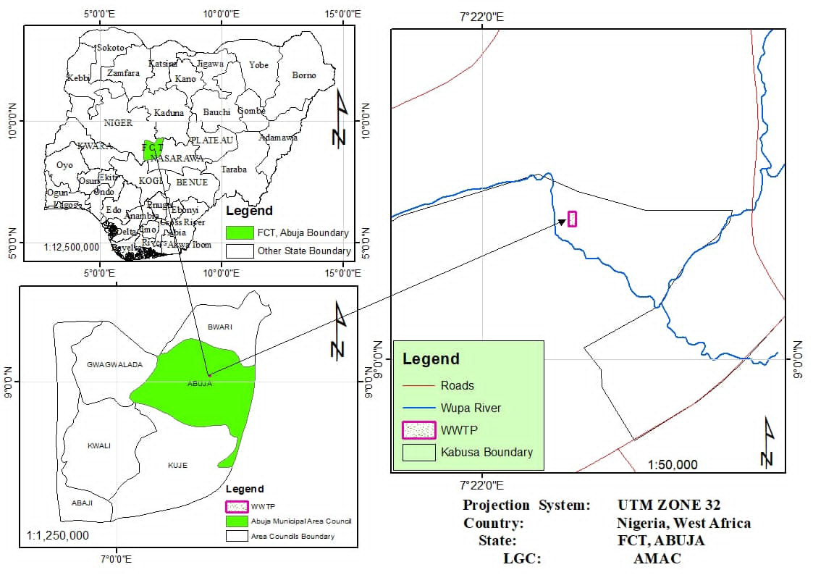

**Fig 1-The location Wupa Wastewater Treatment Plant, Abuja, Nigeria, in maps**

**Sample collections**

Wastewater samples were collected in duplicates with one litre (1L) bottles which were rinsed with the sample water twice before collection at 10cm below the surface of the water and the bottles were labelled with the location, date and time. The samples were transferred to the school laboratory for physiochemical analysis, bacterial and fungal isolation and identification.

**Microbial Analysis of wastewater samples**

Serial dilution of the samples was carried out using the procedure described by (APHA, 2017) for the pour plate method was employed and 1ml of the wastewater sample was aliquoted into a test tube containing 9ml of distilled water as a stock. Thereafter, 9ml of distilled water was measured into 6 other test tubes arranged serially and labelled and 1ml of the stock was then aliquoted into the next test tube and 1ml of that mixture was aliquoted into the next test tube; this process was continued until the 6th test tube. 10-1 10-3and 10-6 were chosen as the dilution factor. In each of the dilution 1ml was pipetted into petri dishes in duplicates. For bacterial growth; 28.0g of nutrient agar was dissolved in 1000ml of distilled water in a corked conical flask and stirred until the agar had dissolved. For fungal growth; 39.0g of Sabouraud dextrose agar (SDA) was dissolved in 1000ml of distilled water in a corked conical flask and stirred till the agar had dissolved. The media were autoclaved 121°C for 15 minutes according to manufacturers instruction. The media were allowed to cool down in a sterilized chamber then poured into peri dishes containing the 1ml diluents in the presence of a flame. The bacterial culture dishes were incubated at 37°C for 24 hours whilst the fungi culture plates were incubated at 25°C for 6 days.

**Biochemical characteristics of bacterial isolates**

Bacterial colonies were enumerated using colony counting machine. The number of colonies on the plate was multiplied by the reciprocal of the dilution factor, and a computation was performed for 1 mL of the original sample. An average count was used to produce the total count, and the results were reported as colony forming units per millilitre (CFU/ml) of sample. Bacterial samples were further sub-cultured to obtain pure cultures using nutrient agar. Furthermore, the pure culture of the bacteria isolates were subjected to various biochemical test such as catalase, indole, citrate utilization, coagulase, methyl red, Voges Proskauer, urease and sugar fermentation to ascertain the phenotypic characteristics of the organisms (Ogodo et al., 2021).

**Fungal Identification**

Potato dextrose agar was used to subculture the initial fungal colonies. The SDA was prepared according to manufacturer’s instructions; As 500mg of mortar crushed ciprofloxacin was added into the agar after it had been autoclaved at 121°C for 15 minutes to inhibit bacterial growth. The agar was dispensed into sterile petri dishes in the presence of a flame. A sterile inoculating wire was used to collect fungal colonies of interest and placed in the middle of the agar plate. Fungal colonies were observed on SDA plates under normal room temperature. Each colony was observed with the following criteria: colour, texture of colony, elevation, form, border/margin. The fungal species were further characterised using morphological characteristic (Leber and Burnham, 2023).

**Molecular characterization of Bacteria and Fungi**

This involves DNA extraction, Polymerase Chain Reaction (PCR), gel electrophoresis, gel extraction and DNA sequencing using 16s for bacteria and ITS for fungi. DNA extraction was carried out using the Zymo Research Corp Quick-DNA™ Miniprep kit (Irvine,California,USA), while PCR was done after extraction. PCR consists of three stages: pre-denaturing, denaturing (to separate the double-stranded template into two single strands), annealing (lowering the temperature to allow the DNA primers to attach to the template DNA), elongation (raising the temperature to allow the Taq Polymerase enzymes to make new strands of DNA), and final extension (Ibrahim et al., 2024b). According to BIOER GeneExplorer thermal cycler: Pre-denaturalization at 95°C for 5 minutes, denaturalization at 94°C for 1 minute, annealing at 52°C for 1 minute, elongation at 72°C for 1 minute, and final extension at 72°C for 7 minutes, cooling at 4°C. Gel Electrophoresis was carried out after PCR to view amplified DNA and the bands were viewed under and ultraviolet light, the base pair of the DNA were observed and read according to the ladder (Ibrahim et al., 2024b). Furthermore, Gel extraction was used to remove amplified genes for sequencing. Gel extraction was used to isolate desired fragments of intact DNA from agarose gel electrophoresis. Lastly, DNA Sequencing was carried out using the Sanger technique. DNA sequences were BLAST using the NCBI database.

**Result**

###### The bacteria colony count observed in this study is presented in Table 2. Bacteria colony was highest in the dilution factor of 10-1 and lowest in 10⁻⁶. The preliminary investigation of bacteria isolates from wastewater sample using morphology and gram reaction shows the presence of three bacteria isolate namely Pseudomonas aeruginosa, Escherichia coli and Bacillus subtilis (Table 2). While Aspergillus species is the only fungus species isolated in this study (Table 3).

###### The molecular identification of microbial isolates from Wupa Wastewater Samples is presented in Table 4. Sample IB1 from influent wastewater sample shows 99% similarity with that of Escherichia coli with accession number (NR_114042.1). Sample EB1 from effluent wastewater samples shows 98% similarity with that of Pseudomonas aeruginosa with accession number (NR_117635.1). Sample EF1 from effluent wastewater sample shows 98% similarity with that of Aspergillus niger with accession number (NR_145759.1)

###### Table 1: Microbial Colony Count (CFU) Before and After Treatment

|  |  |  |
| --- | --- | --- |
| Dilution | Influent | Effluent |
| 10⁻¹ | 140 | 123 |
| 10⁻³ | 130 | 101 |
| 10⁻⁶ | 87 | 92 |

Table 2:Identification of Bacterial isolates from Wupa Wastewater samples using biochemical

|  |  |  |  |
| --- | --- | --- | --- |
| Isolate code | Morphology | Gram reaction | Probable organism |
| IB1 | Pink and rod-shaped | - | *Pseudomonas aeruginosa* |
| P1 | Pink and rod-shaped | - | *Escherichia coli* |
| EB1 | Purple and rod-shaped | + | *Bacillus subtilis* |

Table 3: Microscopic Features of Fungal Isolate EF1

|  |  |  |  |
| --- | --- | --- | --- |
| Isolate code | Microscopic characteristics | Stain reaction | Probable organism |
| EF1 | Septate hyphae with chains brush like Conidia arrangement | Blue stained | *Aspergillus* sp |

Table 4. Molecular Identification of Microbial Isolates from Wupa Wastewater sample

|  |  |  |  |  |  |  |
| --- | --- | --- | --- | --- | --- | --- |
| Isolate Code | Sample Source | Accession Number | Sequence Identity (%) | Query Coverage (%) | Closest Gen Bank Relative | Closest strain |
| IB1 | Influent Bacteria | NR_114042.1 | 99 | 98.8 | *Escherichia coli* | *E. coli* strain ATCC 11775 |
| EB1 | Effluent Bacteria | NR_117635.1 | 98 | 99 | *Pseudomonas aeruginosa* | *P. aeruginosa* strain PAO1 |
| EF1 | Effluent Fungi | NR_145759.1 | 98 | 99.1 | *Aspergillus niger* | *A. niger strain* CBS 554.65 |

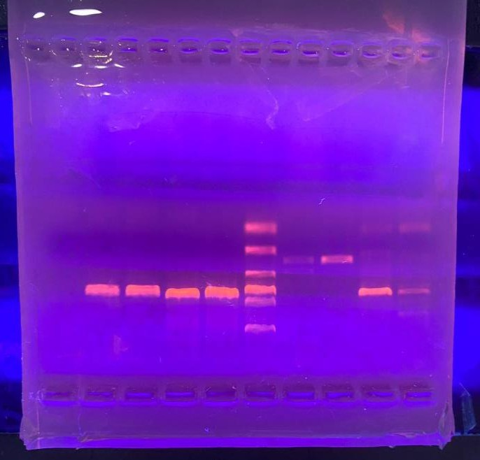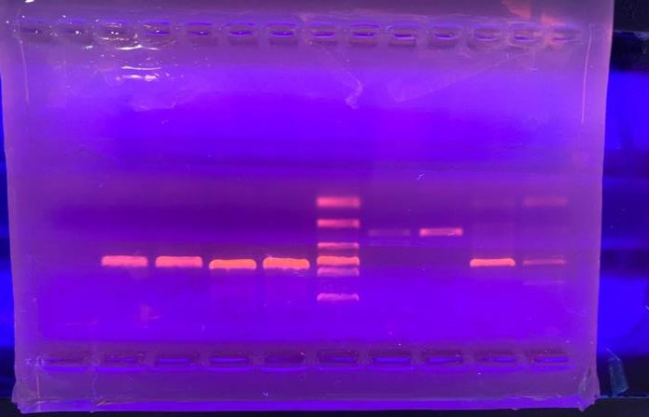

IB1 IB2 EB1 EB2

IF1 IF2 EF1 EF

2

Plate 1: Agarose Gel electrophoresis of targeted ITS 1 and ITS 4 region for microoganism isolate using 100 bp Bioline Hyper Ladder

**Discussion**

Water quality is critical to the health and sustainability of aquatic ecosystems and hydrology (Adama et al., 2023). Water also plays a significant role in the cycling of materials and can be a vector if it becomes a source of dangerous compounds and diseases (Mohammed and Adamu, 2019; Maishanu et al., 2022). The findings show a clear correlation between dilution factors and bacterial colony counts. The highest number of colonies was recorded at a dilution factor of 10-1, suggesting a higher concentration of bacteria in this sample compared to more diluted samples (such as 10-6), where the count was significantly lower. This result is consistent with the expectations in microbial studies, where higher concentrations of microorganisms are more likely to be recovered at lower dilution factors. The study conducted investigation into the microbial diversity present in wastewater samples, encompassing both bacterial and fungal isolates. Based on morphological characteristics and Gram staining reactions, three bacterial isolates *Pseudomonas aeruginosa*, *Escherichia coli*, and *Bacillus subtilis* were identified from the wastewater samples. The fungal isolate was determined to be *Aspergillus* species marking it as the sole fungal representative in this investigation. The molecular identification of microbial isolates yielded compelling results. The presence of this organism in the waste water could be as a result of different waste source being channelled into the waste water treatment plant. This group of bacteria have also been reported in water samples across Nigeria (Mohammed and Adamu 2019; Adamu et al., 2022; Maishanu et al., 2022).

Sample IB1, representing influent wastewater, exhibited a remarkable 99% genetic similarity to *Escherichia coli* as denoted by the accession number NR_114042.1. This high degree of similarity suggests that the strain isolated from the influent is closely related to a previously documented strain in the database, which could indicate its potential source, as *E. coli* is often associated with fecal contamination (Gerba, 2015). Contrastingly, effluent sample EB1 displayed a 98% similarity to *Pseudomonas aeruginosa* (accession number NR_117635.1), a pathogen known for its resilience and ability to thrive in diverse environments. This strain is noted for its occurrence in wastewater, where it can contribute to opportunistic infections in immune-compromised individuals (Crone et al., 2020). In addition, effluent sample EF1 was identified to have 98% similarity with *Aspergillus niger* (accession number NR_145759.1). *A. niger* is a filamentous fungus commonly found in soil, decaying vegetation, and various food products, but it has also been implicated in the degradation of organic compounds in wastewater treatment processes. Its presence suggests the capability of wastewater treatment systems to facilitate fungal growth that may have applications in bioremediation (Thegarathah et al., 2024). The findings of this investigation highlight the diversity of microbial communities present in wastewater and underscore the importance of molecular techniques for accurate identification and characterization of these microorganisms. Continued monitoring and identification of these microbial populations are vital for understanding their ecological roles and potential applications in wastewater management and bioremediation efforts.

**Conclusion and recommendation**

The findings of this study underscore the significant microbial diversity present in wastewater samples, with a notable predominance of *Escherichia coli* and *Pseudomonas aeruginosa* among bacterial isolates, coupled with the presence of *Aspergillus niger* as a fungal representative. The observed correlation between dilution factors and bacterial colony counts reflects the complexities of microbial proliferation within wastewater environments. Molecular analysis confirmed the identities of the isolates, providing robust evidence of their presence and potential roles in the wastewater ecosystem. These insights are crucial for developing effective wastewater management and treatment strategies, as understanding the microbial community can inform bioremediation efforts and the monitoring of pathogenic species within such environments. Future research may focus on the ecological interactions of these microorganisms and their collective impact on wastewater treatment efficacy.

Disclaimer (Artificial intelligence)

We the author(s) hereby declare that NO generative AI technologies such as Large Language Models (ChatGPT), have been used during the writing or editing of the manuscripts.

**References**

Adam, B. M., Edegbene, A. O. and Jibrin, G. (2020). Monitoring and Exploring the Spatio-temporal Variation of Physico-chemical Variables of River Hadejia, Nigeria; Using Statistical Approach. *Asian Journal of Geographical Research,* 3(1), 49-61, 10.9734/AJGR/2020/v3i130100.

Adama, B.S., Mohammed, Y.M., Musa, I.N., Samuel, P.O. & Saba, J.J. (2023). The Effect of Flood Regime on Water Quality and Plankton Distribution in Bosso Area, Minna, Niger State. *Kampala international University Journal of Science, Engineering and Technology,* 02(2), 150-156. https://doi.org/10.59568/KJSET-2023-2-1-19.

Adamu, K.M., Mohammed, Y.M., Ibrahim, U.F., Abdullahi, I.L. & Jimoh, Y. O. (2022). Assessment of some physical, chemical and biological parameters of Lake Dangana, Niger State, Nigeria. *The Zoologist,* 20, 133-140. http://dx.doi.org/10.4314/tzool.v20i1.17.

American Public Health Association (APHA 2017). Standard Methods for the Examination of Water and Wastewater. American Public Health Association

Chukwu, M. & Oranu, C. (2018). Performance Assessment of Biological Wastewater Treatment at Wupa Wastewater Treatment Plant, Abuja, Nigeria. *Nigerian Journal of Environmental Sciences and Technology,* 2(1), 46-55.

Crone, S., Vives-Flórez, M., Kvich, L., Saunders, A. M., Malone, M., Nicolaisen, M. H., Martínez-García, E., Rojas-Acosta, C., Catalina Gomez-Puerto, M., Calum, H., Whiteley, M., Kolter, R., & Bjarnsholt, T. (2020). The environmental occurrence of Pseudomonas aeruginosa. *APMIS: Acta pathologica, microbiologica, et immunologica Scandinavica*, *128*(3), 220–231. <https://doi.org/10.1111/apm.13010>

Dadi-mamud, N.J., Mohammed, A.P., Aliyu, D.A., Anyadike, M.C. & Joseph, J. (2020) Assessment *of Eichhornia Crassipes* (Water Hyacinth) as Bio-Accumulator of Contaminants in Domestic Wastewater of Makera And Chanchaga Drains. *Science World Journal* 15(3), 1597-6343

Gerba, C. P. (2015). Environmentally Transmitted Pathogens. *Environmental Microbiology*, 509–550. <https://doi.org/10.1016/B978-0-12-394626-3.00022-3>

Grossart, H. P., Van den Wyngaert, S., Kagami, M., Wurzbacher, C., Cunliffe, M., & Rojas Jimenez, K. (2019). Fungi in aquatic ecosystems. *Nature Reviews Microbiology*, 17(6), 339-354.

Ibrahim, U.F., Ndanusa, A.H., Ibrahim, A.A., Ibrahim, M.I., Shuaibu S., Olokpo S.O. & Mohammed, Y.M. (2024b). Physicochemical characteristic, molecular characterization of bacteria and fungi isolates found in the Nile Stream, Abuja Nigeria. *Dutse Journal of Pure and Applied Sciences,* 10(4c), 63-73

Ibrahim, U.F., Adamu, K.M., Mohammed, S.S.D., Chukwu, M.N. & Umar H.F. (2023). Utilization of *Bacillus subtilis and Aspergillus niger* for the Bioremediation of Heavy Metals in the WUPA Wastewater Treatment Plant, Abuja. *The 2nd International Conference on Multidisciplinary Engineering and Applied Sciences* (ICMEAS-2023).

Ibrahim, U.F., Mohammed, Y.M., Ndanusa, A.H. & Badamasi, A. (2024a) Application of Pseudomonas aeruginosa and Bacillus subtilis for Heavy Metal Bioremediation. *Nile Journal of Engineering and Applied Science,* 1(2), 1-10.

Leber, A. L., & Burnham, C. A. D. (2023). Clinical Microbiology Procedures Handbook. ASM Press. Retrieved from <https://books.google.com.ng/books?id=R8hG0AEACAAJ>

Maishanu, F., Adamu, K.M. & Mohammed, Y.M. (2022). Anthropogenic impact on some water quality characteristics of Wupa River Federal Capital Territory, Abuja, Nigeria. *Issues in Biological Sciences and Pharmaceutical Research,* 10(3), 30-38. https://doi.org/10.15739/ibspr.22.006

Mohammed, H., Adamu, K.M., Kasim, A.A., Mohammed, Y.M. & Dadi-Mamud, N.J. (2023). Bacteriological Analysis of Water from Emu-Stream, Kusotachin, Nigeria. *Lapai Journal of Applied and Natural Sciences,* 8(1), 38-44.

Mohammed, Y. M. & Adamu, K. M. (2019). Bacteria Associated with some Freshwater fishes from Dangana Lake Lapai, Nigeria. Jewel Journal of Science Research, 4 (1and2), 83-90

Mohammed, Y. M., Arimoro, F. O., Ayanwale, A. V., Adamu, K. M., Ismail, A., Umar, M., & Kanki, H. (2020a). Assessment of some physicochemical parameters of Moussa stream, Bida, Niger State Nigeria. *Journal of Public Health and Environmental Pollutions,* 4(2), 020-024.

Mohammed, Y.M., Adamu, K.M., Edegbene-Ovie T.T., Ibrahim, U.B., Danjuma, S. & Edegbene, A.O. (2024). Development of macroinvertebrates-based multimetric index to assess the ecological health of a rural river in North-central Nigeria. *Biologia* https://doi.org/10.1007/s11756-024-01824-0

Mohammed, Y.M., Arimoro, F.O. Ayanwale, A.V. Adamu, K.M., Keke, U. N., Abubakar, M. D. & Achebe. A.C. (2021). The current state of water quality and benthic invertebrate fauna in Chikke Stream (North-Central Nigeria). *Ukranian Journal of Ecology,* 11(3), 26 34.DOI: 10.15421/2021_136

Mohammed, Y.M., Arimoro, F.O., Ayanwale, A.V., Adama, B.S., Keke, U.N., Auta, Y.I., & Umar, B.I. (2020b). Seasonal changes in the abundance of benthic macroinvertebrates & physico-chemical condition of Moussa Stream Bida, Nigeria. *Tropical Freshwater Biology,* 29(1), 57-70. doi: 10.4314/tfb.v29i1.4

Ogodo, A. C., Sandeep Veda Narayana, M. S., Vardhan, P. S., Gupta, R. K., Gautam, A. K., Egbuna, C. & Kumar, S. (2021). Chapter 9 - Principles of applied microbiology and biotechnology: Technique for the screening of antimicrobial herbs. In C. Egbuna, A. P. 5.00001-0

Thegarathah, P., Jewaratnam, J., Simarani, K., & Elgharbawy, A. A. M. (2024). *Aspergillus niger* as an efficient biological agent for separator sludge remediation: two-level factorial design for optimal fermentation. *PeerJ*, *12*, e17151. <https://doi.org/10.7717/peerj.17151>