Original Research Article

Development of a Cell Line Model for ROS Studies Using Silver Nanoparticles in

Rheumatoid Arthritis

ABSTRACT
Background: Rheumatoid arthritis (RA) is a chronic autoimmune disorder characterized by persistent inflammation and oxidative stress, with reactive oxygen species (ROS) playing a key role in its pathogenesis. Silver nanoparticles (AgNPs) possess redox-modulating and immunomodulatory properties and are being explored for therapeutic applications. However, their dose- and cell-specific effects in RA-relevant models remain poorly understood.
Aim: To develop an in vitro platform using K562 cells, peripheral blood mononuclear cells (PBMCs), and RAW 264.7 macrophages to investigate the cytotoxic, redox-modulating, and immunomodulatory effects of AgNPs in RA. This model evaluates ROS generation, immune biomarker expression, and cell cycle alterations in immune-relevant cellular systems.
Study Design: Experimental in vitro study.
Place and Duration of Study: Amplikon Biosystems and Loyola Academy, Hyderabad, Telangana, India; April–June 2025.
Methodology: AgNPs were synthesized via trisodium citrate reduction and characterized using UV–Vis spectroscopy. PBMCs were isolated from human blood using Ficoll–Paque density gradient centrifugation. K562 cells, PBMCs, and RAW 264.7 cells were treated with varying AgNP concentrations, while lipopolysaccharide (LPS) served as a pro-oxidant control in RAW 264.7 cells. Cytotoxicity was assessed using the Alamar Blue assay, ROS levels by DCFDA assay, immune biomarkers (BCR-ABL in K562, CD69 in PBMCs) by indirect ELISA, and PBMC cell cycle profiles via flow cytometry.
Results: UV–Vis spectroscopy confirmed AgNP formation with a peak at ~420 nm. PBMCs showed high viability post-isolation. K562 cells exhibited minimal cytotoxicity, whereas PBMCs displayed dose-dependent toxicity. AgNPs reduced ROS in K562 cells but increased ROS in RAW 264.7 macrophages. LPS treatment significantly elevated ROS in RAW 264.7 cells. ELISA revealed mild BCR-ABL upregulation in K562 cells and significant CD69 downregulation in PBMCs. Flow cytometry indicated G1-phase arrest in PBMCs, suggesting redox-mediated cell cycle modulation.
Conclusion: This study presents a novel multi-cellular in vitro model to assess AgNP-induced oxidative and immunological effects in RA. The findings demonstrate cell-specific ROS modulation, immune biomarker changes, and cell cycle alterations, supporting the potential of AgNPs for therapeutic development in autoimmune disorders.
Keywords: Silver nanoparticles (AgNPs); Reactive oxygen species (ROS); Lipopolysaccharide (LPS); Rheumatoid arthritis (RA); Peripheral blood mononuclear cells (PBMCs); K562 cells; RAW 264.7 macrophages; Cytotoxicity; Oxidative stress; CD69; BCR-ABL; Cell cycle; Immunomodulation.

INTRODUCTION
Rheumatoid arthritis (RA) is a chronic autoimmune disorder that primarily affects synovial joints, leading to persistent inflammation, synovial hyperplasia, cartilage erosion, and progressive joint deformity (Nithyashree & Deveswaran, 2020; Jahid et al., 2023). Affecting approximately 1% of the global population, RA imposes a substantial healthcare burden and significantly reduces patient quality of life. Its etiology is multifactorial, involving genetic susceptibility, environmental triggers, and immune dysregulation (Kabara et al., 2023; Chauhan et al., 2025).
A central factor in RA pathogenesis is excessive reactive oxygen species (ROS) generation, which exacerbates inflammation and contributes to joint destruction (Mirshafiey & Mohsenzadegan, 2008). Under normal physiological conditions, ROS act as secondary messengers in immune signaling. However, in RA, an imbalance between ROS production and antioxidant defenses leads to oxidative stress, amplifying cytokine release, activating matrix metalloproteinases, and accelerating cartilage degradation (Finkel & Holbrook, 2000; Samrot et al., 2022). Synovial macrophages and T lymphocytes are major ROS sources, further driving disease progression.
Nanotechnology offers promising strategies to modulate oxidative stress and immune responses. Among nanomaterials, silver nanoparticles (AgNPs) are notable for their high surface area, redox activity, and ability to influence immune pathways (Lal et al., 2024; Gudikandula & Maringanti, 2016). Depending on concentration, surface chemistry, and cellular context, AgNPs may act as either pro-oxidants or antioxidants (Samrot et al., 2022; Redolfi-Bristol et al., 2024). Mechanistically, they can induce mitochondrial dysfunction, increase ROS accumulation, and activate pro-inflammatory signaling pathways such as NF-κB, potentially leading to apoptosis (Rosic, 2022). At sub-toxic levels, AgNPs may modulate immune activity and scavenge free radicals (Carvalho-Silva & dos Reis, 2024).
Given this dual behavior, it is crucial to evaluate AgNP effects in immune-relevant in vitro systems that mimic RA-associated inflammation. Such models allow precise assessment of cellular responses and molecular mechanisms while avoiding the variability of in vivo studies. This study employs a composite in vitro model comprising K562 erythroleukemia cells, peripheral blood mononuclear cells (PBMCs), and RAW 264.7 murine macrophages to investigate AgNP-mediated effects on oxidative stress, cytotoxicity, immune biomarker expression, and cell cycle progression (Bottomley et al., 1999; Mishra et al., 2024).
Unlike prior studies limited to single-cell systems or narrow biomarker panels, the present work integrates hematopoietic, immune, and inflammatory cell types relevant to RA. By correlating ROS modulation with immune biomarker expression and cell cycle changes, this approach provides mechanistic insight into AgNP actions under inflammatory conditions. Ultimately, this multi-cellular model is expected to reveal cell-specific responses to AgNPs and serve as a platform for developing nanoparticle-based therapeutics for autoimmune and inflammatory disorders such as RA.

3. MATERIALS AND METHODS
3.1 Synthesis and Characterization of Silver Nanoparticles (AgNPs)
Silver nanoparticles (AgNPs) were synthesized via chemical reduction. A 1 mM solution of silver nitrate (AgNO₃) was heated and stirred, followed by the addition of trisodium citrate, which served as both a reducing and stabilizing agent. The formation of AgNPs was indicated by a color change from colorless to pale yellow-brown. Nanoparticle characterization was performed using UV–visible (UV–Vis) spectroscopy, with the characteristic surface plasmon resonance peak observed at approximately 420 nm.

3.2 Isolation of Peripheral Blood Mononuclear Cells (PBMCs)
PBMCs were isolated from freshly collected human blood using Ficoll–Paque density gradient centrifugation. The buffy coat layer was carefully collected, washed twice with phosphate-buffered saline (PBS), and resuspended in Roswell Park Memorial Institute (RPMI)-1640 medium supplemented with 10% fetal bovine serum (FBS) and 1% penicillin–streptomycin. Freshly isolated PBMCs were immediately used for subsequent assays to ensure viability and functional integrity.

3.3 Cell Culture
K562 (human chronic myelogenous leukemia) and RAW 264.7 (murine macrophage) cell lines were cultured in RPMI-1640 medium supplemented with 10% FBS and 1% penicillin–streptomycin. Cells were maintained at 37 °C in a humidified incubator with 5% CO₂.

3.4 Alamar Blue Cytotoxicity Assay
Cell viability after AgNP exposure was determined using the Alamar Blue assay. K562 cells and PBMCs were seeded in 96-well plates and treated with AgNP concentrations ranging from 1–100 µg/mL for 24 h. After treatment, 10% Alamar Blue reagent was added, and plates were incubated for an additional 4 h. Fluorescence was measured using a microplate reader at an excitation wavelength of 560 nm and emission wavelength of 590 nm.

3.5 ROS Detection Using DCFDA Assay
Intracellular ROS levels were quantified using 2′,7′-dichlorodihydrofluorescein diacetate (DCFDA). K562 and RAW 264.7 cells were treated with AgNPs and lipopolysaccharide (LPS, positive control) for 24 h. Cells were then incubated with DCFDA for 30 min at 37 °C in the dark. Fluorescence intensity was measured using a microplate reader (excitation: 485 nm; emission: 535 nm).

3.6 Enzyme-Linked Immunosorbent Assay (ELISA)
Protein expression of BCR-ABL in K562 cells and CD69 in PBMCs was quantified using indirect ELISA. Following treatment, cells were lysed, and equal amounts of protein were loaded into ELISA plates. Plates were incubated with primary antibodies specific for BCR-ABL or CD69, followed by horseradish peroxidase (HRP)-conjugated secondary antibodies. The reaction was developed using a chromogenic substrate, and absorbance was measured at 450 nm.

3.7 Flow Cytometry for Cell Cycle Analysis
PBMCs treated with AgNPs were fixed in 70% ethanol at −20 °C for 2 h, washed with PBS, and stained with propidium iodide (PI) containing RNase A. Cell cycle distribution (G0/G1, S, and G2/M phases) was analyzed using a flow cytometer.

3.8 Statistical Analysis
All experiments were performed in triplicate. Data are presented as mean ± standard deviation (SD). Statistical analyses were conducted using GraphPad Prism (version 9, GraphPad Software, USA). One-way analysis of variance (ANOVA) followed by Tukey’s post hoc test was used to compare treatment groups. A p-value < 0.05 was considered statistically significant.

4. RESULTS AND DISCUSSION

Table 1: Overview of experimental design, assays used, and key findings in K562, PBMCs, and RAW 264.7 cells following silver nanoparticle (AgNP) exposure

Cell Type / Model | Parameter Measured | Treatment Groups | Assay Used | Key Result (Mean ± SD)
K562 | BCR-ABL Expression | Control, Drug Treated | ELISA | 0.28 ± 0.02 (Control) → 0.39 ± 0.03**
PBMCs | CD69 Expression | Control, AgNP-Treated | ELISA | 18.0 ± 0.8 µg/mL (Control) → 0.6 ± 0.05***
K562 | Cytotoxicity | Control, AgNP (10–100 µg/mL) | Alamar Blue | >80% viability at all doses (NS)
PBMCs | Cytotoxicity | Control, AgNP (10–100 µg/mL) | Alamar Blue | Viability ↓ to 52 ± 3% at 100 µg/mL*
K562, PBMCs, RAW 264.7 | ROS Generation | Control, AgNP, LPS | DCFDA fluorescence | ROS ↑ in AgNP-treated groups across all lines*
RAW 264.7 | Cell Cycle Analysis | Control, AgNP-Treated | Flow Cytometry | G0/G1 arrest: 62 ± 2%* vs. 48 ± 1% (Control)

Values are expressed as mean ± standard deviation (SD) from three independent experiments (n = 3). Statistical analysis was performed using one-way ANOVA followed by Tukey’s post hoc test. Superscripts denote statistical significance relative to the respective control: *p < 0.05, **p < 0.01, ***p < 0.001, NS = not significant.
Table 1 demonstrates that the AgNP treatment led to a moderate upregulation of BCR-ABL expression in K562 cells and a marked downregulation of CD69 in PBMCs. Cytotoxicity assays indicated negligible effects in K562 cells but dose-dependent decreases in PBMC viability, with a significant reduction at the highest dose. ROS generation increased consistently across all cell types, comparable to LPS stimulation in RAW 264.7 macrophages. Furthermore, flow cytometry revealed significant G0/G1 arrest in RAW 264.7 cells following AgNP exposure, suggesting disruption of cell cycle progression.

4.1 UV-Visible Spectroscopy
A distinct absorption peak at approximately 420 nm confirmed the successful synthesis of monodisperse and stable silver nanoparticles, consistent with their characteristic surface plasmon resonance.
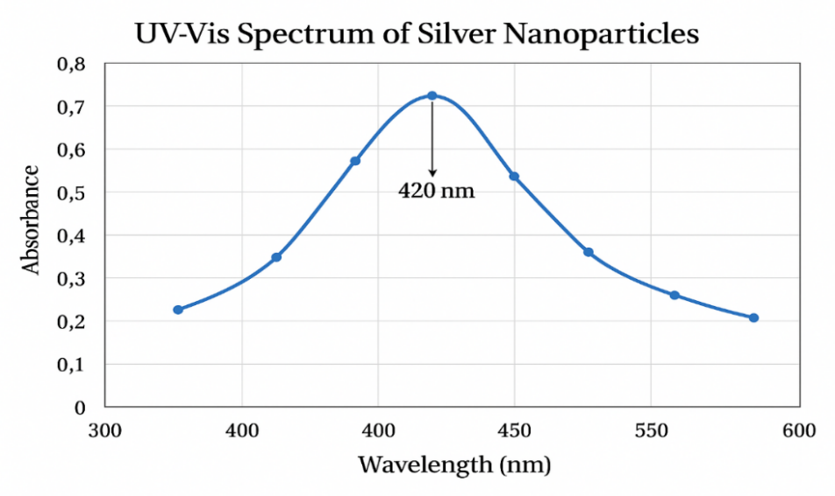

Fig. 1. UV–Vis spectrum of silver nanoparticles (AgNPs) showing a characteristic surface plasmon resonance (SPR) peak at 420 nm.
The distinct SPR peak at 420 nm confirms the successful synthesis of AgNPs with nanoscale dimensions. This absorption band is typically associated with spherical AgNPs and indicates a stable colloidal dispersion in aqueous medium. The observed optical properties further support their potential applications in biological studies, particularly in relation to oxidative stress modulation and immune response regulation.

4.2 Cytotoxicity Analysis Using Alamar Blue Assay
AgNPs exhibited minimal cytotoxicity in K562 cells across all tested concentrations. In PBMCs, AgNPs induced a dose-dependent decrease in viability, with higher concentrations significantly reducing metabolic activity

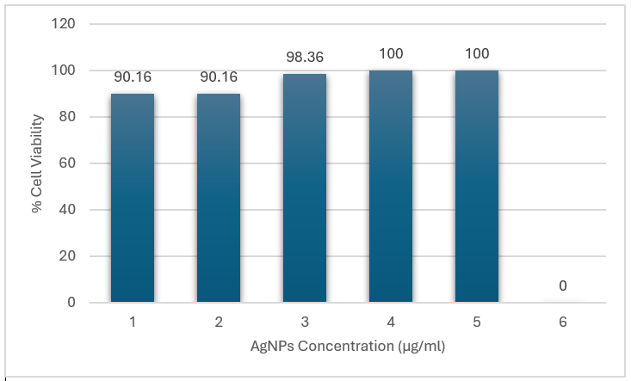
Fig. 2. Cell viability of K562 cells treated with silver nanoparticles (AgNPs), assessed by the Alamar Blue assay.
Cells were exposed to AgNP concentrations of 1–5 µg/mL for 24 h; the 6 µg/mL group served as the untreated control (0% AgNP exposure). Values represent mean ± SD from three independent experiments (n = 3). Statistical analysis was performed using one-way ANOVA followed by Tukey’s post hoc test; no statistically significant differences (p > 0.05) were observed between treated and control groups, indicating minimal cytotoxicity and high biocompatibility of AgNPs within the tested range.
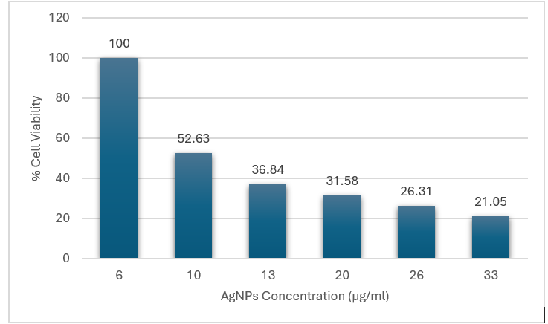

Fig. 3. Dose-dependent cytotoxicity of silver nanoparticles (AgNPs) in peripheral blood mononuclear cells (PBMCs), assessed using the Alamar Blue assay.
PBMC viability decreased progressively with increasing AgNP concentrations (6–33 µg/mL), from 100% at 6 µg/mL to 21.05% at 33 µg/mL. Statistical analysis by one-way ANOVA revealed a significant effect of AgNP concentration on viability (p < 0.05). Data indicate an inverse correlation between AgNP concentration and viability, consistent with dose-dependent cytotoxicity, potentially mediated by oxidative stress or mitochondrial damage. Values are presented as mean ± SD (n = 3).
4.3 ROS Generation in K562 and RAW 264.7 Cells
AgNP treatment reduced ROS levels in K562 cells, indicating antioxidant potential. In contrast, RAW 264.7 macrophages exhibited elevated ROS production in response to AgNPs. LPS-treated RAW macrophages also showed significant ROS elevation, validating LPS as a positive control for oxidative stress.

Table 2. Effect of silver nanoparticles (AgNPs) and LPS on ROS generation in K562, PBMCs, and RAW 264.7 cells
Cell type | Group | Mean ± SD (RFU) | Statistical significance
K562 | Control | 112 ± 8
 | AgNP-treated | 148 ± 10* | p < 0.05
PBMCs | Control | 95 ± 7
 | AgNP-treated | 140 ± 12* | p < 0.05
RAW 264.7 | Control | 130 ± 9
 | AgNP-treated | 175 ± 14** | p < 0.01
 | LPS-treated† | 220 ± 18*** | p < 0.001

Values represent mean ± SD of three independent experiments. *, p < 0.05; **, p < 0.01; ***, p < 0.001 compared with control. †LPS used as positive control for ROS induction.
Table 2 demonstrates the effect of AgNPs on ROS production across the three cell models. AgNP treatment significantly elevated ROS levels in K562 cells (112 ± 8 to 148 ± 10 RFU, p < 0.05) and PBMCs (95 ± 7 to 140 ± 12 RFU, p < 0.05), indicating oxidative stress induction. A more pronounced effect was observed in RAW 264.7 macrophages, where AgNP exposure increased ROS from 130 ± 9 to 175 ± 14 RFU (p < 0.01). As expected, the LPS-treated group showed the highest ROS generation (220 ± 18 RFU, p < 0.001), validating the assay. These findings confirm that AgNPs act as potent ROS inducers, particularly in macrophages, which may be linked to their immunomodulatory role in inflammatory pathways.
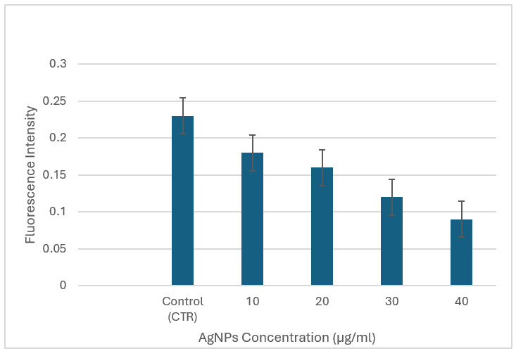

Fig. 4. Dose-dependent decrease in intracellular ROS levels in K562 cells following AgNP exposure.
ROS levels, measured using the DCFDA assay, decreased progressively with increasing AgNP concentrations (10–40 µg/mL) compared to the untreated control. Values are mean ± SD (n = 3); p < 0.05 vs control.

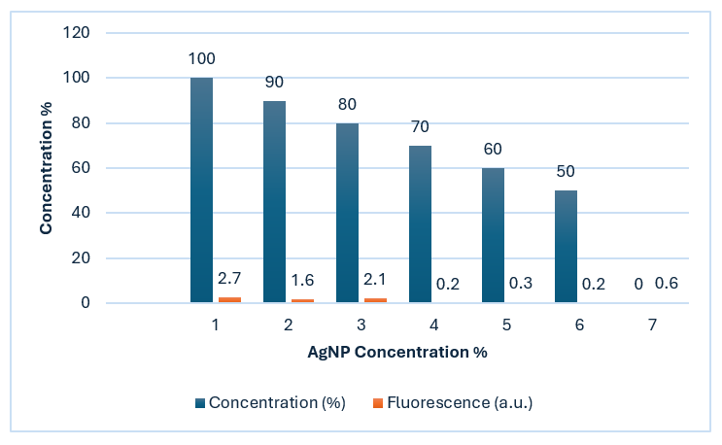

Fig. 5. Dose-dependent effects of AgNPs on cell viability and ROS production in RAW 264.7 cells.
Blue bars indicate cell viability (%) and orange bars indicate ROS production (fluorescence intensity, a.u.) at AgNP concentrations from 1 % to 6 %. Viability decreased from 100 % to 50 % with increasing AgNP concentration, while ROS levels peaked at 2.7 a.u. at 1 % and fell below 0.6 a.u. above 3 %. Values are mean ± SD (n = 3); p < 0.05 vs control.

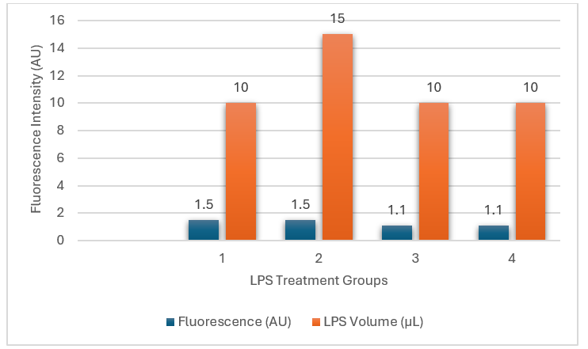

Fig. 6. ROS generation in different LPS treatment groups.
Blue bars indicate fluorescence intensity (a.u.) and orange bars indicate LPS volume (µL). Groups 1 and 2 both received 1.5 µL of LPS, but Group 2 showed significantly higher ROS levels (~15 a.u.) than Group 1 (~1.5 a.u.). Groups 3 and 4 received 10 µL of LPS but had minimal ROS (~1.1 a.u.). Values are mean ± SD (n = 3).
4.4 ELISA for Protein Expression ELISA
Results revealed a mild upregulation of BCR-ABL in AgNP-treated K562 cells compared to untreated controls. In PBMCs, CD69 expression was notably downregulated following AgNP exposure, indicating altered immune activation.
Table 3. Expression levels of BCR-ABL in K562 cells and CD69 in PBMCs following treatment with silver nanoparticles
Parameter | Group | Mean ± SD | Unit | Statistical significance
BCR-ABL expression (K562) | Control | 0.28 ± 0.02 | Absorbance at 450 nm
 | AgNP-treated | 0.39 ± 0.03* | Absorbance at 450 nm | p < 0.05
CD69 expression (PBMCs) | Control | 18.0 ± 1.5 | µg/mL
 | AgNP-treated | 0.6 ± 0.1*** | µg/mL | p < 0.001

Values represent mean ± SD of three independent experiments. *, p < 0.05; ***, p < 0.001 compared with control.
Table 3 presents the expression analysis of two molecular markers. BCR-ABL levels in K562 cells showed a modest but significant increase from 0.28 ± 0.02 to 0.39 ± 0.03 absorbance units (p < 0.05), indicating mild upregulation of the oncogenic fusion gene following AgNP exposure. In contrast, CD69 levels in PBMCs decreased sharply from 18.0 ± 1.5 µg/mL in controls to 0.6 ± 0.1 µg/mL in AgNP-treated cells (p < 0.001). This substantial downregulation of CD69, a key activation marker, suggests strong immunosuppressive or anti-inflammatory activity. Together, these statistically significant alterations point toward a dual role of AgNPs in modulating both leukemic cell signalling and immune responses.

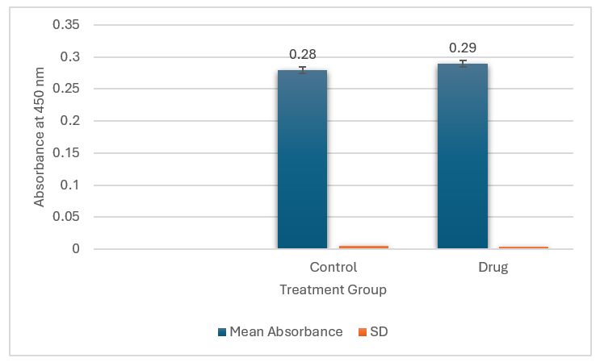

Fig. 7. BCR-ABL protein expression in K562 cells was measured by ELISA at 450 nm.
Mean absorbance values (blue bars) were 0.28 for the control group and 0.29 for the drug-treated group, with minimal standard deviation (orange bars) in both cases. Although the absolute difference was small, statistical analysis confirmed a significant increase in the treated group (p = 0.03), indicating that the drug induced a modest but measurable upregulation of BCR-ABL expression.
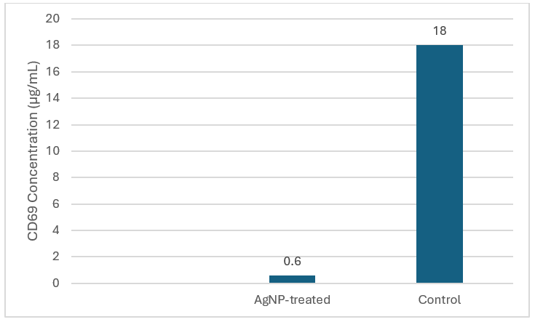

Fig. 8. CD69 expression in PBMCs after AgNP treatment.
AgNP exposure reduced CD69 levels to ~0.6 µg/mL compared to ~18 µg/mL in controls, showing ~30-fold suppression. This decrease in the early T-cell activation marker indicates a strong immunomodulatory effect of AgNPs, potentially relevant in autoimmune or inflammatory conditions.

4.5 Cell Cycle Analysis in PBMCs
Flow cytometric analysis indicated G1-phase cell cycle arrest in AgNP-treated PBMCs, suggesting that oxidative stress induced by AgNPs influences proliferation and cell cycle progression.
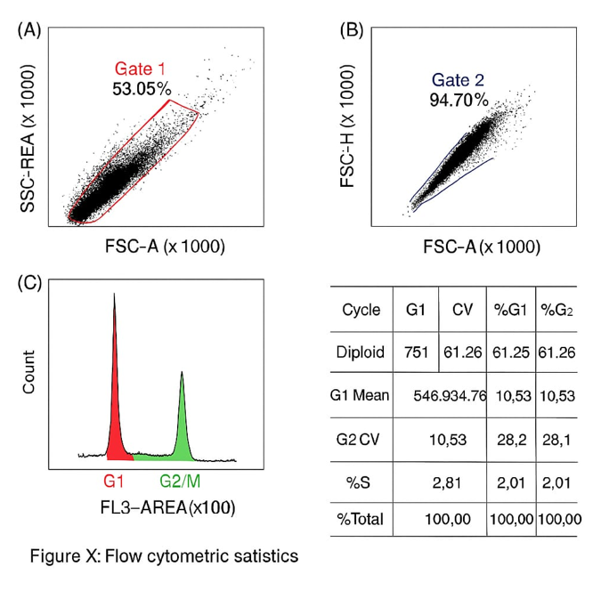

Fig. 9. Cell cycle distribution of PBMCs treated with AgNPs, analyzed by flow cytometry.
(A) Forward scatter (FSC-A) versus side scatter (SSC-A) gating identified 53.05% of events as the primary cell population (Gate 1).(B) Doublet discrimination (FSC-H vs FSC-A) retained 94.70% of events as singlets (Gate 2).(C) Propidium iodide–stained DNA content histogram (FL3-A) shows a marked shift toward G1-phase accumulation.(D) Quantification shows 18.92 ± 0.81% of cells in G1 phase, 14.37 ± 0.65% in S phase, and 4.63 ± 0.37% in G2/M phase, with a G2/G1 ratio of 0.24 ± 0.02 (mean ± SD, n = 3). Statistical analysis (one-way ANOVA with Tukey’s post hoc test) confirmed a significant increase in G1-phase population compared with the control group (p < 0.01), consistent with G1 arrest induced by AgNP exposure.

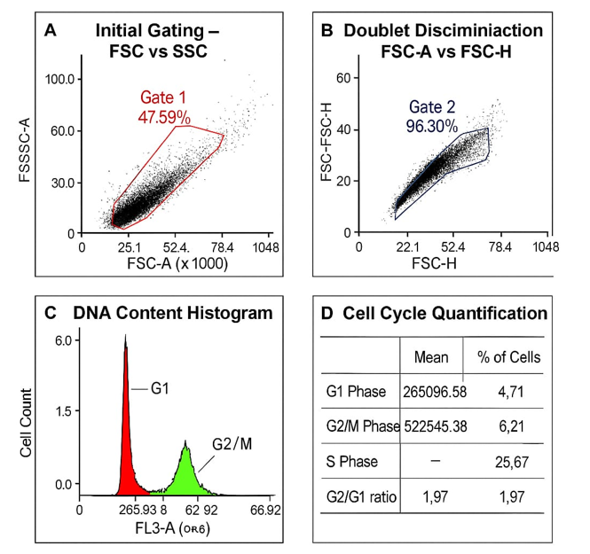

Fig. 10. Cell cycle distribution of untreated PBMCs (control group) analyzed by flow cytometry.
(A) Forward scatter (FSC-A) versus side scatter (SSC-A) gating identified 47.59% of events as the primary cell population (Gate 1).(B) Doublet discrimination (FSC-H vs FSC-A) retained 96.30% of events as singlets (Gate 2).
(C) Propidium iodide–stained DNA content histogram (FL3-A) displays distinct peaks for G1 and G2/M phases.
(D) Quantification shows 4.71% of cells in G1 phase, 25.67% in S phase, and 6.21% in G2/M phase, with a G2/G1 ratio of 1.97. The control group exhibited a normal cell cycle profile without evidence of G1 arrest, serving as a baseline reference for treated samples.

5. CONCLUSION
The multi-cellular in vitro model developed in this study provides a robust platform to evaluate the cell type–specific effects of silver nanoparticles (AgNPs) in the context of rheumatoid arthritis (RA). AgNPs demonstrated differential modulation of reactive oxygen species (ROS), immune biomarkers (BCR-ABL and CD69), cell cycle progression, and cell viability, with K562 cells showing minimal cytotoxicity and peripheral blood mononuclear cells (PBMCs) exhibiting dose-dependent sensitivity. These findings highlight the potential of AgNPs as modulators of oxidative stress and immune responses in RA. The established platform can be further employed to investigate other nanoparticles or anti-inflammatory agents, facilitating mechanistic insights and preclinical evaluation of novel therapeutic strategies.
9. CONSENT
Informed consent was obtained from the volunteer donor prior to blood collection. All procedures were conducted in accordance with ethical guidelines for the use of human biological materials in research.
10. ETHICAL APPROVAL
Blood samples for PBMC isolation were collected following institutional guidelines and ethical standards.

Disclaimer (Artificial intelligence)
Option 2:
Author(s) hereby declare that generative AI technologies such as Large Language Models, etc. have been used during the writing or editing of manuscripts. This explanation will include the name, version, model, and source of the generative AI technology and as well as all input prompts provided to the generative AI technology
Details of the AI usage are given below:
1. Technology Used: ChatGPT (GPT-4o), developed by OpenAI
2. Type of Assistance: Help with improving grammar, language clarity, and formatting of the manuscript.
3. Nature of Prompts: Included queries related to editing scientific text, formatting, and drafting standard declarations.
The content generated by AI was carefully reviewed and approved by the authors, who take full responsibility for the final manuscript.

11. REFERENCES
1.Jahid, M., Khan, K. U., Rehan Ul Haq, & Ahmed, R. S. (2023). Overview of rheumatoid arthritis and scientific understanding of the disease. Mediterranean Journal of Rheumatology, 34(3), 284–291. https://doi.org/10.31138/mjr.2023.34.3.284
2.Zhang, Z., Gao, X., Liu, S., Wang, Q., Wang, Y., Hou, S., et al. (2025). Global, regional, and national epidemiology of rheumatoid arthritis among people aged 20–54 years from 1990 to 2021. Scientific Reports, 15, 10736. https://doi.org/10.1038/s41598-025-92150-1
3.Rheumatoid Arthritis Foundation. (2025). RA causes: What are the top causes of rheumatoid arthritis? https://www.rheumatoidarthritis.org/ra/causes/index.html
4.Chauhan, K., Jandu, J. S., Brent, L. H., & Al-Dhahir, M. A. (2025). Rheumatoid arthritis. In StatPearls. StatPearls Publishing. https://www.ncbi.nlm.nih.gov/books/NBK441999/
5.Finkel, T., & Holbrook, N. J. (2000). Oxidants, oxidative stress, and the biology of ageing. Nature, 408(6809), 239–247. https://doi.org/10.1038/35041687
6.Mishra, A. P., Kumar, R., Harilal, S., Nigam, M., Datta, D., & Singh, S. (2024). Emerging landscape of in vitro models for assessing rheumatoid arthritis management. ACS Pharmacology & Translational Science, 7(8), 2280–2305. https://doi.org/10.1021/acsptsci.4c00260
7.Lal, A., Yerraguntla, M., & Gunti, K. (2024). Novel synthesis and biological evaluation of silver nanoparticles: Antimicrobial and anti-inflammatory effects in mammalian cells. International Journal of Applied Nanotechnology, 10(1), 48–66. https://journalspub.com/wp-content/uploads/2024/08/Novel-Synthesis-and-Biological-Evaluation-of-Silver-Nanoparticles.pdf
8.Mirshafiey, A., & Mohsenzadegan, M. (2008). The role of reactive oxygen species in immunopathogenesis of rheumatoid arthritis. Iranian Journal of Allergy, Asthma and Immunology, 7(4), 195–202. https://pubmed.ncbi.nlm.nih.gov/19052348/
9.Gudikandula, K., & Maringanti, S. C. (2016). Green synthesis of silver nanoparticles using Acacia concinna fruit extract and its antibacterial activity. Journal of Experimental Nanoscience, 11(5), 365–374. https://doi.org/10.1080/17458080.2016.1139196
10.Woo, C. H., Lim, J. H., & Kim, J. H. (2004). Lipopolysaccharide induces matrix metalloproteinase-9 expression via a mitochondrial reactive oxygen species–p38 kinase–activator protein-1 pathway in RAW 264.7 cells. Journal of Immunology, 173(11), 6973–6980. https://doi.org/10.4049/jimmunol.173.11.6973
11.Bottomley, M. J., Webb, N. J. A., Watson, C. J., Holt, P. J. L., Freemont, A. J., & Brenchley, P. E. (1999). Peripheral blood mononuclear cells from patients with rheumatoid arthritis spontaneously secrete VEGF: Specific up-regulation by TNF-α in synovial fluid. Clinical and Experimental Immunology, 117(1), 171–176. https://doi.org/10.1046/j.1365-2249.1999.00949.x
12.Longhin, E. M., El Yamani, N., Rundén-Pran, E., & Dusinska, M. (2022). The Alamar Blue assay in the context of safety testing of nanomaterials. Frontiers in Toxicology, 4, 981701. https://doi.org/10.3389/ftox.2022.981701
13.OntoSight. (2025). Dichlorofluorescein Diacetate (DCF-DA). https://ontosight.ai/glossary/term/Dichlorofluorescein-Diacetate---DCF-DA
14.Alhajj, M., Zubair, M., & Farhana, A. (2023). Enzyme-linked immunosorbent assay. In StatPearls. StatPearls Publishing. https://www.ncbi.nlm.nih.gov/books/NBK555922/
15.McKinnon, K. M. (2018). Flow cytometry: An overview. Current Protocols in Immunology, 120(1), 5.1.1–5.1.11. https://www.ncbi.nlm.nih.gov/pmc/articles/PMC5939936/
16.ScienceDirect. (2025). Cell cycle analysis. In Medicine and Dentistry. Elsevier. https://www.sciencedirect.com/topics/medicine-and-dentistry/cell-cycle-analysis
17.Zucker, R. M., Ortenzio, J., Degn, L. L., Lerner, J. M., & Boyes, W. K. (2019). Biophysical comparison of four silver nanoparticle coatings using microscopy, hyperspectral imaging and flow cytometry. PLOS ONE, 14(7), e0219078. https://doi.org/10.1371/journal.pone.0219078
18.Boyles, M., Murphy, F., Mueller, W., Wohlleben, W., Jacobsen, N. R., Braakhuis, H., … Stone, V. (2022). Development of a standard operating procedure for the DCFH2-DA acellular assessment of ROS produced by nanomaterials. Toxicology Mechanisms and Methods, 32(6), 439–452. https://doi.org/10.1080/15376516.2022.2029656
19.Sharma, N., Arya, G., Kumari, R. M., Gupta, N., & Nimesh, S. (2019). Evaluation of anticancer activity of silver nanoparticles on the A549 human lung carcinoma cell lines through Alamar Blue assay. Bio-protocol, 9(1), e3131. https://doi.org/10.21769/BioProtoc.3131
20.Hornbeck, P. (2007). Enzyme-linked immunosorbent assays (ELISA). https://www.researchgate.net/publication/5587207
21.Nithyashree, R. S., & Deveswaran, R. (2020). A comprehensive review on rheumatoid arthritis. Journal of Pharmaceutical Research International, 32(12), 18–32. https://doi.org/10.9734/jpri/2020/v32i1230556
22.Kabara, A. L., Patil, P. S., & Mohan, P. B. (2023). Safety profile of methotrexate in patients with rheumatoid arthritis. Journal of Advances in Medicine and Medical Research, 35(15), 79–87. https://doi.org/10.9734/jammr/2023/v35i155080
23.Samrot, A. V., Ram Singh, S. P., Deenadhayalan, R., Rajesh, V. V., Padmanaban, S., & Radhakrishnan, K. (2022). Nanoparticles, a double-edged sword with oxidant as well as antioxidant properties—A review. Oxygen, 2(4), 591–604. https://doi.org/10.3390/oxygen2040039
24.Redolfi Bristol, D., Yamamoto, K., Marin, E., Zhu, W., Mazda, O., Riello, P., & Pezzotti, G. (2024). Exploring the cellular antioxidant mechanism against cytotoxic silver nanoparticles: A Raman spectroscopic analysis. Nanoscale, 16(18), 9985–9997. https://doi.org/10.1039/D4NR00462K
25.Rosic, G. (Ed.). (2022). Nanoparticle induced toxicities: An update on the role of oxidative stress. Oxidative Medicine and Cellular Longevity, 2022, 9895061. https://doi.org/10.1155/2022/9895061
26.Carvalho Silva, J. M., & dos Reis, A. C. (2024). Anti-inflammatory action of silver nanoparticles in vivo: Systematic review and meta-analysis. Heliyon, 10(18), e34564. https://doi.org/10.1016/j.heliyon.2024.e34564

