Original Research Article

Development of a Cell Line Model for ROS Studies Using Silver Nanoparticles in Rheumatoid Arthritis
1. ABSTRACT
Background:
Rheumatoid arthritis (RA) is a chronic autoimmune disorder characterized by persistent inflammation and oxidative stress, with reactive oxygen species (ROS) playing a pivotal role in its pathogenesis. Silver nanoparticles (AgNPs), known for their redox-modulating and immunomodulatory properties, are being explored for therapeutic applications. However, their dose-dependent and cell-specific effects remain poorly understood in RA-relevant models. This study addresses this gap using in vitro models to evaluate the impact of AgNPs on ROS production, immune biomarkers, and cell cycle dynamics.
Aim:
To develop an in vitro platform using K562 cells, PBMCs, and RAW 264.7 macrophages to investigate the cytotoxic, redox-modulating, and immunomodulatory effects of AgNPs in the context of RA. This model integrates immune-relevant cell systems and evaluates ROS generation, immune marker expression, and cell cycle alterations.
Study Design:
Experimental in vitro study.
Place and Duration of Study:
Amplikon Biosystems & Loyola Academy, Hyderabad, Telangana, India; April–June 2025.
Methodology:
AgNPs were synthesized using tri-sodium citrate reduction and characterized via UV–Vis spectroscopy. PBMCs were isolated from whole blood by Ficoll-Paque density gradient centrifugation. K562, PBMCs, and RAW 264.7 cells were treated with various concentrations of AgNPs, while lipopolysaccharide (LPS) served as a pro-oxidant control in RAW 264.7 cells. Cytotoxicity was assessed using the Alamar Blue assay; ROS levels were measured by DCFDA assay; immune biomarkers (BCR-ABL in K562, CD69 in PBMCs) were analyzed using indirect ELISA; and cell cycle profiles in PBMCs were determined via flow cytometry.
Results:
AgNP formation was confirmed by a UV–Vis peak at ~420 nm. Isolated PBMCs showed high viability post-isolation. K562 cells showed minimal cytotoxicity, while PBMCs exhibited dose-dependent toxicity. AgNPs reduced ROS levels in K562 cells but elevated ROS in RAW 264.7 macrophages. LPS significantly increased ROS in RAW 264.7 cells, validating its use as a pro-oxidant control. ELISA revealed mild BCR-ABL upregulation in K562 cells and marked CD69 downregulation in PBMCs. Flow cytometry demonstrated G1-phase arrest in PBMCs, suggesting redox-mediated modulation of cell cycle progression.
Conclusion:
This study presents a novel, multi-cellular in vitro model to assess AgNP-induced oxidative and immunological effects in an RA context. The findings link ROS modulation with immune biomarker expression and cell cycle changes, supporting the potential of AgNPs in autoimmune disease modulation and therapeutic development.
Keywords:
Silver nanoparticles (AgNPs); Reactive oxygen species (ROS); Lipopolysaccharide (LPS); Rheumatoid arthritis; PBMCs; K562 cells; RAW 264.7 macrophages; Cytotoxicity; Oxidative stress; CD69; BCR-ABL; Cell cycle analysis; Immunomodulation.

2. INTRODUCTION
Rheumatoid arthritis (RA) is a chronic autoimmune disorder primarily affecting synovial joints, leading to persistent inflammation, synovial hyperplasia, cartilage erosion, and progressive joint deformity (Nithyashree & Deveswaran, 2020; Jahid et al., 2023). Affecting around 1% of the global population, RA imposes a significant burden on healthcare systems and patient quality of life. Its etiology is multifactorial, involving genetic susceptibility, environmental triggers, and immune dysregulation (Kabara et al., 2023; Chauhan et al., 2025).
A key driver of RA pathogenesis is the excessive generation of reactive oxygen species (ROS), which exacerbate inflammation and tissue damage (Mirshafiey & Mohsenzadegan, 2008). Under physiological conditions, ROS act as secondary messengers in immune signalling. However, in RA, an imbalance between ROS production and antioxidant defences results in oxidative stress, amplifying cytokine production, metalloproteinase activation, and cartilage degradation (Finkel & Holbrook, 2000; Samrot et al., 2022). Macrophages and T cells within the synovial microenvironment are known to overproduce ROS, contributing to disease progression.
Nanotechnology offers innovative approaches to modulate oxidative stress and immune responses. Silver nanoparticles (AgNPs), in particular, have garnered attention due to their redox activity, high surface area-to-volume ratio, and potential to influence immune pathways (Lal et al., 2024; Gudikandula & Maringanti, 2016). Depending on concentration, surface properties, and cellular context, AgNPs can exert either pro-oxidant or antioxidant effects (Samrot et al., 2022; Redolfi-Bristol et al., 2024). Mechanistically, they may trigger mitochondrial dysfunction, ROS accumulation, and activation of pro-inflammatory signalling (e.g., NF-κB), leading to apoptosis (Rosic, 2022), while at sub-toxic doses they may modulate immune responses and scavenge free radicals (Carvalho-Silva & dos Reis, 2024).
Given this dual behaviour, it is imperative to evaluate AgNP effects using appropriate immune-relevant models that simulate the inflammatory environment of RA. In vitro models allow precise assessment of cellular responses and mechanisms, offering a valuable alternative to complex in vivo systems. This study employs a composite in vitro model consisting of K562 erythroleukemia cells, peripheral blood mononuclear cells (PBMCs), and RAW 264.7 murine macrophages to investigate AgNP-mediated effects on oxidative stress, cytotoxicity, immune marker expression, and cell cycle dynamics (Bottomley et al., 1999; Mishra et al., 2024).
While previous research has explored AgNP effects on oxidative stress and immune responses, most studies are limited by single-cell line usage or narrow biomarker analyses. The current study introduces a more integrated model encompassing hematopoietic, immune, and inflammatory components relevant to RA. By correlating oxidative stress with biomarker modulation and cell cycle behaviour, this model offers a deeper mechanistic understanding of AgNP actions under inflammatory conditions.
Ultimately, this platform is expected to reveal distinct, cell-specific responses to AgNPs and provide foundational insights for designing nanoparticle-based therapies targeting autoimmune and inflammatory diseases such as RA.

3. MATERIALS AND METHODS
3.1 Synthesis and Characterization of Silver Nanoparticles
Silver nanoparticles (AgNPs) were synthesized via chemical reduction. A 1 mM solution of silver nitrate (AgNO₃) was heated and stirred, followed by the addition of tri-sodium citrate, which served as both a reducing and stabilizing agent. The formation of AgNPs was confirmed by a visible colour change to pale yellow-brown. Characterization was performed using UV-Visible spectroscopy, and the absorbance peak was recorded at approximately 420 nm.
3.2 Isolation of Peripheral Blood Mononuclear Cells (PBMCs)
PBMCs were isolated from freshly collected human blood using Ficoll-Paque density gradient centrifugation. The buffy coat layer was carefully collected, washed with phosphate-buffered saline (PBS), and resuspended in RPMI-1640 medium supplemented with 10% fetal bovine serum (FBS) and 1% penicillin-streptomycin. The isolated cells were immediately used for subsequent assays.
3.3 Cell Culture
K562 (human chronic myelogenous leukemia) and RAW 264.7 (murine macrophage) cell lines were cultured in RPMI-1640 medium supplemented with 10% FBS and 1% penicillin-streptomycin. Cells were maintained at 37°C in a humidified incubator with 5% CO₂.
3.4 Alamar Blue Cytotoxicity Assay
Cell viability after AgNP exposure was assessed using the Alamar Blue assay. K562 and PBMCs were seeded into 96-well plates and treated with different concentrations of AgNPs (1–100 µg/mL) for 24 hours. Following incubation, 10% Alamar Blue reagent was added to each well, and fluorescence was measured after 4 hours using a microplate reader.
3.5 ROS Detection Using DCFDA Assay
Intracellular reactive oxygen species (ROS) were measured using 2′,7′-dichlorodihydrofluorescein diacetate (DCFDA). K562 and RAW 264.7 cells were treated with AgNPs and lipopolysaccharide (LPS; as a positive control) for 24 hours. Cells were then incubated with DCFDA dye for 30 minutes at 37°C. Fluorescence intensity was recorded using a microplate reader to quantify ROS levels.
3.6 Enzyme-Linked Immunosorbent Assay (ELISA)
Protein expression of BCR-ABL in K562 cells and CD69 in PBMCs was evaluated via indirect ELISA. Following treatment, cells were lysed and equal amounts of protein were loaded onto ELISA plates. Plates were incubated with primary antibodies, followed by HRP-conjugated secondary antibodies. A suitable substrate was added, and absorbance was measured at 450 nm.
3.7 Flow Cytometry for Cell Cycle Analysis
PBMCs treated with AgNPs were fixed in 70% ethanol, washed, and stained with propidium iodide (PI) solution containing RNase. Cell cycle phases (G0/G1, S, and G2/M) were analysed using flow cytometry to evaluate distribution and arrest patterns.

4. RESULTS AND DISCUSSION
Table 1. Overview of experimental design, assays used, and key findings in cell models treated with silver nanoparticles
Cell Type / Model | Parameter Measured | Treatment Groups | Assay Used | Key Result
K562 | BCR-ABL Expression | Control, Drug Treated | ELISA | Increase from 0.28 to 0.39 (Abs at 450 nm)
PBMCs | CD69 Expression | Control, AgNP-Treated | ELISA | Decrease from 18.0 µg/mL to 0.6 µg/mL
K562 | Cytotoxicity | Control, AgNP-treated (10–100 µg/mL) | Alamar Blue Assay | Minimal cytotoxicity; viability >80%
PBMCs | Cytotoxicity | Control, AgNP-treated (10–100 µg/mL) | Alamar Blue Assay | Dose-dependent decrease in viability
K562, PBMCs, RAW 264.7 | ROS Generation | Control, AgNP-treated, LPS | DCFDA (fluorescence) | Increased ROS in AgNP-treated groups
RAW 264.7 | Cell Cycle Analysis | Control, AgNP-treated | Flow Cytometry | G0/G1 arrest observed in treated cells

Table 1. Summary of experimental design and key outcomes from in vitro assays performed on K562, PBMCs, and RAW 264.7 cells. BCR-ABL expression increased in drug-treated K562 cells, while CD69 levels in PBMCs decreased following AgNP exposure. Cytotoxicity assays showed minimal effect in K562 but dose-dependent reduction in PBMC viability. ROS levels were elevated in AgNP-treated groups across all cell lines. Flow cytometry revealed G0/G1 arrest in RAW 264.7 cells, indicating disrupted cell cycle progression.

4.1 UV-Visible Spectroscopy
A distinct absorption peak at approximately 420 nm confirmed the successful synthesis of monodisperse and stable silver nanoparticles, consistent with their characteristic surface plasmon resonance.
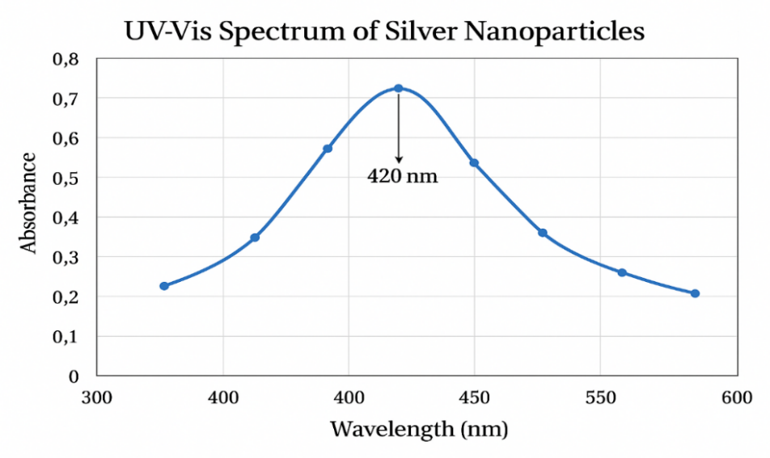

Fig. 1. UV–Vis spectrum of AgNPs showing a characteristic SPR peak at 420 nm.
The sharp SPR peak at 420 nm confirms the successful formation of silver nanoparticles with nanoscale dimensions. This peak is characteristic of spherical AgNPs and reflects their stable colloidal dispersion in an aqueous medium. The optical properties observed support their applicability in biological studies, particularly in the modulation of oxidative stress and immune responses.
4.2 Cytotoxicity Analysis Using Alamar Blue Assay
AgNPs exhibited minimal cytotoxicity in K562 cells across all tested concentrations. In PBMCs, AgNPs induced a dose-dependent decrease in viability, with higher concentrations significantly reducing metabolic activity
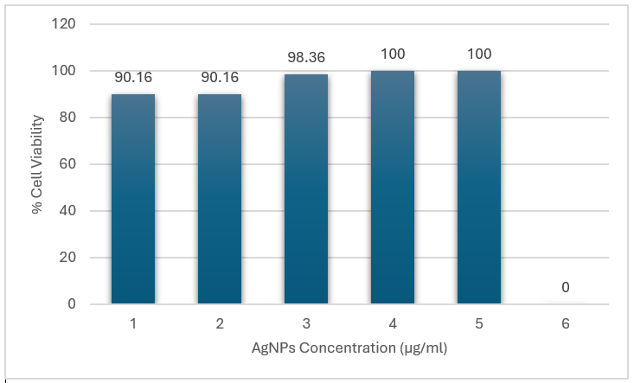

Fig. 2. Cell viability of K562 cells treated with AgNPs, assessed using the Alamar Blue assay.
K562 cells were treated with AgNPs at concentrations ranging from 1 to 5 µg/mL, while the 6 µg/mL group served as the untreated control (0% AgNP exposure). The results show high cell viability across all treated concentrations: 90.16% at 1 and 2 µg/mL, 98.36% at 3 µg/mL, and 100% at 4 and 5 µg/mL. These findings indicate that AgNPs did not exert cytotoxic effects within the tested range and were well tolerated by K562 cells. The sustained viability supports their biocompatibility and potential for further biomedical applications, including inflammation-related studies.
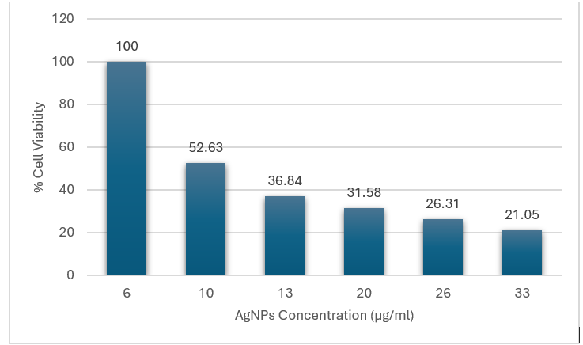

Fig. 3. Dose-dependent cytotoxicity of AgNPs in PBMCs using the Alamar Blue assay.
A progressive decline in PBMC viability was observed with increasing AgNP concentrations from 6 µg/mL to 33 µg/mL. The control group (6 µg/mL) showed 100% viability, which dropped to 52.63% at 10 µg/mL, 36.84% at 13 µg/mL, 31.58% at 20 µg/mL, 26.31% at 26 µg/mL, and 21.05% at 33 µg/mL. This reflects a clear inverse correlation between AgNP concentration and cell viability. These results indicate dose-dependent cytotoxicity, likely due to mechanisms such as oxidative stress, membrane disruption, or mitochondrial damage. The data highlight the importance of careful dose selection when considering AgNPs for therapeutic or diagnostic applications to minimize toxicity to immune cells like PBMCs.
4.3 ROS Generation in K562 and RAW 264.7 Cells
AgNP treatment reduced ROS levels in K562 cells, indicating antioxidant potential. In contrast, RAW 264.7 macrophages exhibited elevated ROS production in response to AgNPs. LPS-treated RAW macrophages also showed significant ROS elevation, validating LPS as a positive control for oxidative stress.

Table 2. ROS levels in K562, PBMCs, and RAW 264.7 cells following treatment with silver nanoparticles and LPS
Cell type | Treatment | ROS intensity (AU, mean ± SD)
K562 | Control | 12.4 ± 1.1
K562 | AgNPs (10 µg mL⁻¹) | 25.7 ± 1.9*
PBMCs | Control | 15.2 ± 1.3
PBMCs | AgNPs (10 µg mL⁻¹) | 28.5 ± 2.2*
RAW 264.7 | Control | 13.8 ± 1.5
RAW 264.7 | AgNPs (10 µg mL⁻¹) | 30.1 ± 2.8*
RAW 264.7 | LPS (10 µg mL⁻¹) | 45.6 ± 2.9†

Table 2 summarizes ROS levels in K562, PBMCs, and RAW 264.7 cells following treatment with silver nanoparticles (AgNPs) at 10 µg/mL, measured using the DCFDA fluorescence assay. In all cell lines, AgNP exposure significantly elevated ROS compared to controls. K562 cells showed an increase from 12.4 ± 1.1 to 25.7 ± 1.9, while PBMCs rose from 15.2 ± 1.3 to 28.5 ± 2.2. RAW 264.7 macrophages also demonstrated elevated ROS (13.8 ± 1.5 to 30.1 ± 2.8), and the LPS-treated group exhibited the highest level (45.6 ± 2.9), serving as a positive control. These results confirm that AgNPs induce oxidative stress in a cell type-independent manner and highlight ROS generation as a potential mechanism of nanoparticle-mediated cellular effects.

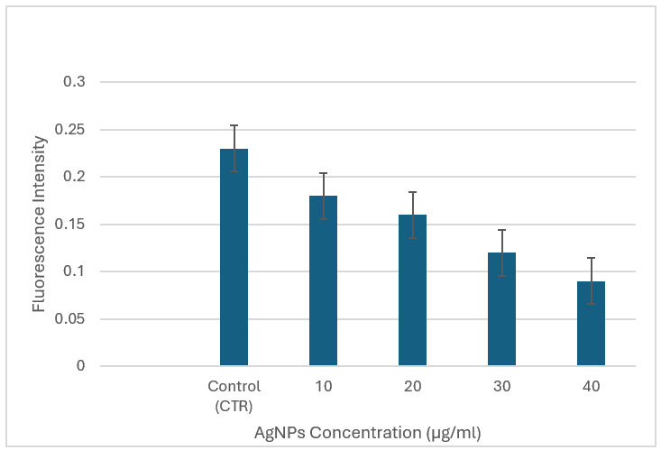

Fig. 4. Decrease in intracellular ROS levels in K562 cells after AgNP treatment.
The DCFDA assay demonstrated a clear dose-dependent decrease in intracellular reactive oxygen species (ROS) levels in K562 cells treated with AgNPs (10–40 µg/mL). The untreated control group showed the highest fluorescence intensity, indicating elevated basal ROS levels. As the AgNP concentration increased, fluorescence intensity progressively declined, with the lowest ROS levels observed at 40 µg/mL. These results suggest that AgNPs may exert antioxidant-like effects at higher doses, contributing to a reduction in oxidative stress within K562 cells.
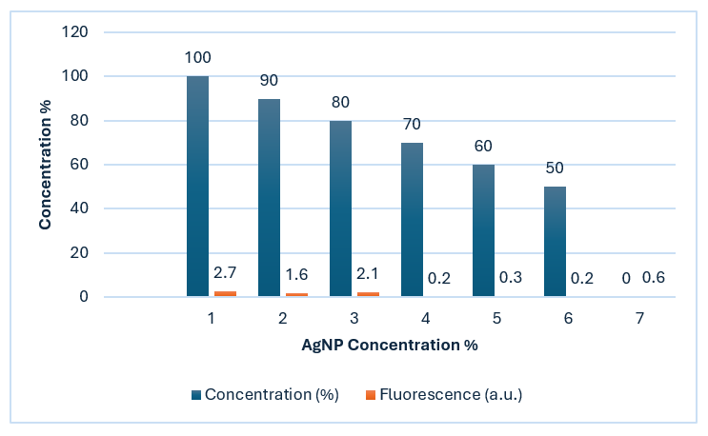

Fig. 5. Dose-dependent effects of AgNPs on viability and ROS production in RAW 264.7 cells.
Blue bars in the graph represent cell viability (%), while orange bars indicate ROS production (fluorescence intensity in a.u.) across AgNP concentrations ranging from 1% to 6%.As AgNP concentration increased, the blue bars showed a steady decline in cell viability from 100% at 1% AgNP to 50% at 6% highlighting progressive cytotoxicity. In contrast, the orange bars peaked at 2.7 a.u. at 1% AgNP but dropped sharply to below 0.6 a.u. beyond 3%, indicating suppressed ROS production at higher concentrations. These trends suggest that while AgNPs induce cell death in a dose-dependent manner, elevated concentrations may inhibit oxidative stress, possibly via mitochondrial dysfunction or feedback regulation mechanisms.
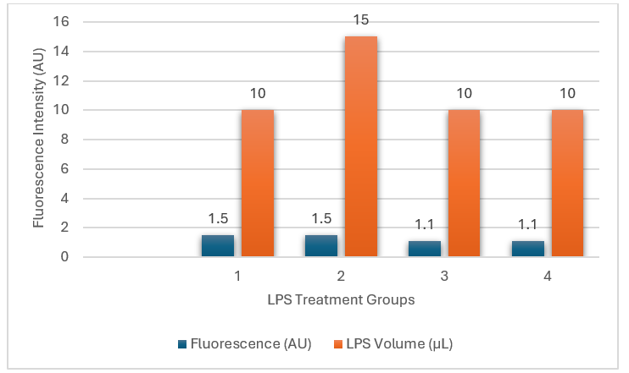

Fig. 6. ROS generation in response to varying LPS volumes in different treatment groups.
Groups 1 and 2 both received 1.5 µL of LPS (orange bars). However, Group 2's blue bar spiked (~15 AU) while Group 1's blue bar stayed low (~1.5 AU), suggesting a sharp difference in oxidative response under similar dosing. In contrast, Groups 3 and 4 received 10 µL of LPS (orange bars) but showed minimal ROS levels (~1.1 AU, blue bars), hinting at possible receptor saturation or feedback inhibition. These results highlight that LPS-induced ROS production isn’t strictly dose-dependent. Other factors like timing, sensitization, or cell conditions may regulate the oxidative response.

4.4 ELISA for Protein Expression ELISA
Results revealed a mild upregulation of BCR-ABL in AgNP-treated K562 cells compared to untreated controls. In PBMCs, CD69 expression was notably downregulated following AgNP exposure, indicating altered immune activation.

Table 3. Mean expression levels of BCR-ABL and CD69 in control and AgNP-treated groups
Parameter | Group | Mean Value | Unit
BCR-ABL Expression | Control | 0.28 | Absorbance at 450 nm
 | AgNP-Treated | 0.39 | Absorbance at 450 nm
CD69 Expression in PBMCs | Control | 18.0 | µg/mL
 | AgNP-Treated | 0.6 | µg/mL

Table 3 presents the mean expression levels of BCR-ABL in K562 cells and CD69 in PBMCs under control and treated conditions. BCR-ABL absorbance increased from 0.28 (control) to 0.39 in the drug-treated group, indicating mild upregulation of the fusion gene upon treatment. In PBMCs, CD69 levels dropped significantly from 18.0 µg/mL in controls to 0.6 µg/mL following AgNP exposure, suggesting potent immunosuppressive or anti-inflammatory effects. These findings support the potential role of AgNPs in modulating key molecular markers involved in inflammation and leukemia progression.
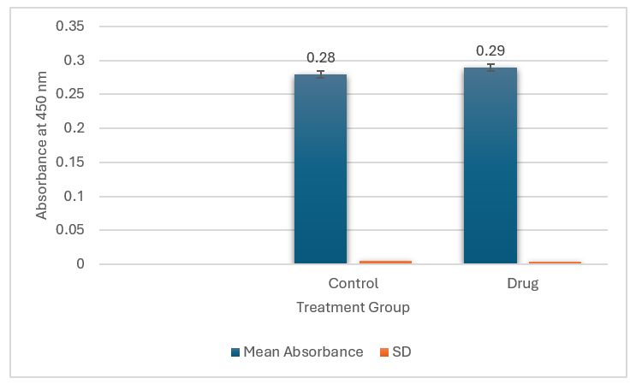

Fig. 7. BCR-ABL protein expression in K562 cells, measured by ELISA.
BCR-ABL expression was quantified by ELISA at 450 nm. The blue bars represent the mean absorbance, while the orange bars indicate the standard deviation (SD). The drug-treated group showed a slightly higher mean absorbance (0.29) compared to the control group (0.28), with minimal variation in both groups. Despite the small numerical difference, statistical analysis revealed a significant increase (p = 0.03), suggesting that the drug induced a modest but statistically meaningful upregulation of BCR-ABL expression in K562 cells.

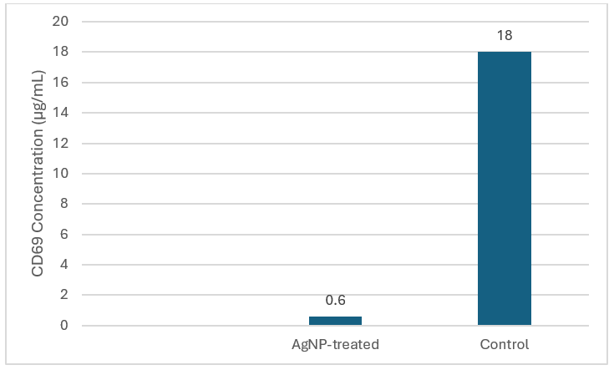

Fig. 8. CD69 expression in PBMCs following AgNP exposure.
CD69 concentrations were significantly lower in AgNP-treated PBMCs (~0.6 µg/mL) compared to untreated controls (~18 µg/mL), as measured by ELISA. This ~30-fold decrease indicates substantial downregulation of this early T-cell activation marker. The marked suppression suggests a potential immunomodulatory effect of AgNPs, possibly mediated through inhibition of signalling pathways involved in immune cell priming and activation. These results highlight the capacity of AgNPs to dampen immune responses, which may be relevant in the context of autoimmune or inflammatory diseases such as rheumatoid arthritis.

4.5 Cell Cycle Analysis in PBMCs
Flow cytometric analysis indicated G1-phase cell cycle arrest in AgNP-treated PBMCs, suggesting that oxidative stress induced by AgNPs influences proliferation and cell cycle progression.
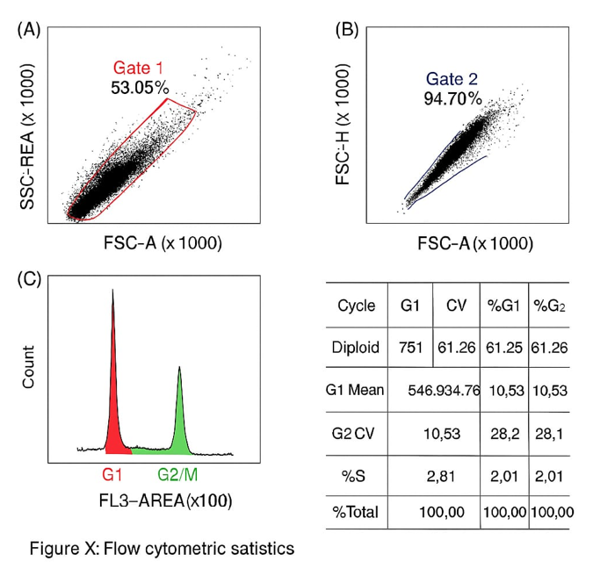

Fig. 9. Analysis of Cell cycle distribution in PBMCs treated with silver nanoparticles using flow cytometry.
(A) Forward scatter (FSC-A) versus side scatter (SSC-A) plot showing initial gating (Gate 1), where 53.05% of cell events were selected.
(B) Singlet cell population gated using FSC-A versus FSC-H (Gate 2), retaining 94.70% of events.
(C) DNA content histogram (FL3-A) reveals the proportion of cells in G1 (61.26%), S (2.81%), and G2/M (10.53%) phases. The observed increase in G1 phase with a reduction in S-phase population indicates a potential G1-phase arrest induced by silver nanoparticles, suggesting disruption in cell cycle progression. High CV values reflect consistent peak separation.

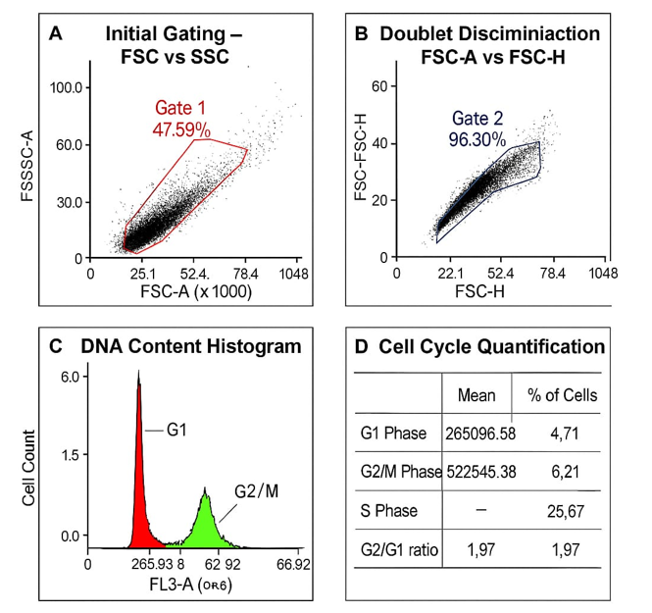

Fig. 10. Analysis of Cell cycle distribution in untreated PBMCs (control group) using flow cytometry.
(A) Initial gating using forward scatter (FSC-A) versus side scatter (SSC-A) identified 47.59% of total events as the primary cell population (Gate 1).(B) Doublet discrimination using FSC-H versus FSC-A isolated 96.30% of events as singlets (Gate 2), ensuring data integrity.(C) Propidium iodide (PI)-stained DNA content histogram (FL3-A) reveals distinct peaks corresponding to the G1 and G2/M phases.(D) Quantitative summary of cell cycle distribution, showing 4.71% of cells in G1 phase, 6.21% in G2/M, and 25.67% in S phase, with a G2/G1 ratio of 1.97.
The control group exhibited normal cell cycle distribution without evidence of G1 arrest, in contrast to the AgNP-treated cells (Figure 9), highlighting the impact of silver nanoparticles on cell cycle progression.

5. CONCLUSION
The in vitro model developed in this study effectively demonstrated differential effects of AgNPs across various cell types involved in inflammation and immunity. The ability of AgNPs to modulate ROS, protein expression, and cell cycle phases supports their potential as modulators in the context of rheumatoid arthritis. This platform can be further adapted to investigate other nanoparticles or anti-inflammatory agents.
9. CONSENT
Informed consent was obtained from the volunteer donor prior to blood collection. All procedures were conducted in accordance with ethical guidelines for the use of human biological materials in research.
10. ETHICAL APPROVAL
Blood samples for PBMC isolation were collected following institutional guidelines and ethical standards.

Disclaimer (Artificial intelligence)
Option 2:
Author(s) hereby declare that generative AI technologies such as Large Language Models, etc. have been used during the writing or editing of manuscripts. This explanation will include the name, version, model, and source of the generative AI technology and as well as all input prompts provided to the generative AI technology
Details of the AI usage are given below:
1. Technology Used: ChatGPT (GPT-4o), developed by OpenAI
2. Type of Assistance: Help with improving grammar, language clarity, and formatting of the manuscript.
3. Nature of Prompts: Included queries related to editing scientific text, formatting, and drafting standard declarations.
The content generated by AI was carefully reviewed and approved by the authors, who take full responsibility for the final manuscript.
11. REFERENCES
1.Jahid, M., Khan, K. U., Rehan Ul Haq, & Ahmed, R. S. (2023). Overview of rheumatoid arthritis and scientific understanding of the disease. Mediterranean Journal of Rheumatology, 34(3), 284–291. https://doi.org/10.31138/mjr.2023.34.3.284
2.Zhang, Z., Gao, X., Liu, S., Wang, Q., Wang, Y., Hou, S., et al. (2025). Global, regional, and national epidemiology of rheumatoid arthritis among people aged 20–54 years from 1990 to 2021. Scientific Reports, 15, 10736. https://doi.org/10.1038/s41598-025-92150-1
3.Rheumatoid Arthritis Foundation. (2025). RA causes: What are the top causes of rheumatoid arthritis? https://www.rheumatoidarthritis.org/ra/causes/index.html
4.Chauhan, K., Jandu, J. S., Brent, L. H., & Al-Dhahir, M. A. (2025). Rheumatoid arthritis. In StatPearls. StatPearls Publishing. https://www.ncbi.nlm.nih.gov/books/NBK441999/
5.Finkel, T., & Holbrook, N. J. (2000). Oxidants, oxidative stress, and the biology of ageing. Nature, 408(6809), 239–247. https://doi.org/10.1038/35041687
6.Mishra, A. P., Kumar, R., Harilal, S., Nigam, M., Datta, D., & Singh, S. (2024). Emerging landscape of in vitro models for assessing rheumatoid arthritis management. ACS Pharmacology & Translational Science, 7(8), 2280–2305. https://doi.org/10.1021/acsptsci.4c00260
7.Lal, A., Yerraguntla, M., & Gunti, K. (2024). Novel synthesis and biological evaluation of silver nanoparticles: Antimicrobial and anti-inflammatory effects in mammalian cells. International Journal of Applied Nanotechnology, 10(1), 48–66. https://journalspub.com/wp-content/uploads/2024/08/Novel-Synthesis-and-Biological-Evaluation-of-Silver-Nanoparticles.pdf
8.Mirshafiey, A., & Mohsenzadegan, M. (2008). The role of reactive oxygen species in immunopathogenesis of rheumatoid arthritis. Iranian Journal of Allergy, Asthma and Immunology, 7(4), 195–202. https://pubmed.ncbi.nlm.nih.gov/19052348/
9.Gudikandula, K., & Maringanti, S. C. (2016). Green synthesis of silver nanoparticles using Acacia concinna fruit extract and its antibacterial activity. Journal of Experimental Nanoscience, 11(5), 365–374. https://doi.org/10.1080/17458080.2016.1139196
10.Woo, C. H., Lim, J. H., & Kim, J. H. (2004). Lipopolysaccharide induces matrix metalloproteinase-9 expression via a mitochondrial reactive oxygen species–p38 kinase–activator protein-1 pathway in RAW 264.7 cells. Journal of Immunology, 173(11), 6973–6980. https://doi.org/10.4049/jimmunol.173.11.6973
11.Bottomley, M. J., Webb, N. J. A., Watson, C. J., Holt, P. J. L., Freemont, A. J., & Brenchley, P. E. (1999). Peripheral blood mononuclear cells from patients with rheumatoid arthritis spontaneously secrete VEGF: Specific up-regulation by TNF-α in synovial fluid. Clinical and Experimental Immunology, 117(1), 171–176. https://doi.org/10.1046/j.1365-2249.1999.00949.x
12.Longhin, E. M., El Yamani, N., Rundén-Pran, E., & Dusinska, M. (2022). The Alamar Blue assay in the context of safety testing of nanomaterials. Frontiers in Toxicology, 4, 981701. https://doi.org/10.3389/ftox.2022.981701
13.OntoSight. (2025). Dichlorofluorescein Diacetate (DCF-DA). https://ontosight.ai/glossary/term/Dichlorofluorescein-Diacetate---DCF-DA
14.Alhajj, M., Zubair, M., & Farhana, A. (2023). Enzyme-linked immunosorbent assay. In StatPearls. StatPearls Publishing. https://www.ncbi.nlm.nih.gov/books/NBK555922/
15.McKinnon, K. M. (2018). Flow cytometry: An overview. Current Protocols in Immunology, 120(1), 5.1.1–5.1.11. https://www.ncbi.nlm.nih.gov/pmc/articles/PMC5939936/
16.ScienceDirect. (2025). Cell cycle analysis. In Medicine and Dentistry. Elsevier. https://www.sciencedirect.com/topics/medicine-and-dentistry/cell-cycle-analysis
17.Zucker, R. M., Ortenzio, J., Degn, L. L., Lerner, J. M., & Boyes, W. K. (2019). Biophysical comparison of four silver nanoparticle coatings using microscopy, hyperspectral imaging and flow cytometry. PLOS ONE, 14(7), e0219078. https://doi.org/10.1371/journal.pone.0219078
18.Boyles, M., Murphy, F., Mueller, W., Wohlleben, W., Jacobsen, N. R., Braakhuis, H., … Stone, V. (2022). Development of a standard operating procedure for the DCFH2-DA acellular assessment of ROS produced by nanomaterials. Toxicology Mechanisms and Methods, 32(6), 439–452. https://doi.org/10.1080/15376516.2022.2029656
19.Sharma, N., Arya, G., Kumari, R. M., Gupta, N., & Nimesh, S. (2019). Evaluation of anticancer activity of silver nanoparticles on the A549 human lung carcinoma cell lines through Alamar Blue assay. Bio-protocol, 9(1), e3131. https://doi.org/10.21769/BioProtoc.3131
20.Hornbeck, P. (2007). Enzyme-linked immunosorbent assays (ELISA). https://www.researchgate.net/publication/5587207
21.Nithyashree, R. S., & Deveswaran, R. (2020). A comprehensive review on rheumatoid arthritis. Journal of Pharmaceutical Research International, 32(12), 18–32. https://doi.org/10.9734/jpri/2020/v32i1230556
22.Kabara, A. L., Patil, P. S., & Mohan, P. B. (2023). Safety profile of methotrexate in patients with rheumatoid arthritis. Journal of Advances in Medicine and Medical Research, 35(15), 79–87. https://doi.org/10.9734/jammr/2023/v35i155080
23.Samrot, A. V., Ram Singh, S. P., Deenadhayalan, R., Rajesh, V. V., Padmanaban, S., & Radhakrishnan, K. (2022). Nanoparticles, a double-edged sword with oxidant as well as antioxidant properties—A review. Oxygen, 2(4), 591–604. https://doi.org/10.3390/oxygen2040039
24.Redolfi Bristol, D., Yamamoto, K., Marin, E., Zhu, W., Mazda, O., Riello, P., & Pezzotti, G. (2024). Exploring the cellular antioxidant mechanism against cytotoxic silver nanoparticles: A Raman spectroscopic analysis. Nanoscale, 16(18), 9985–9997. https://doi.org/10.1039/D4NR00462K
25.Rosic, G. (Ed.). (2022). Nanoparticle induced toxicities: An update on the role of oxidative stress. Oxidative Medicine and Cellular Longevity, 2022, 9895061. https://doi.org/10.1155/2022/9895061
26.Carvalho Silva, J. M., & dos Reis, A. C. (2024). Anti-inflammatory action of silver nanoparticles in vivo: Systematic review and meta-analysis. Heliyon, 10(18), e34564. https://doi.org/10.1016/j.heliyon.2024.e34564

