Original Research Article

Modulation of *Aspergillus aflatoxiformans* biosynthetic potentials by co-cultureapproach for enhanced production of bioactive molecules

**ABSTRACT**

**Aims:**Endophytic fungi are known to reside within the internal tissues of plants. Hyptis suaveolens is a medicinal plant cultivated in Nigeria for its therapeutic potential. Endophytic fungi are producers of important bioactive compounds with several biological activities.

**Study design:**In the present study, endophytic fungi were isolated from the leaf blade and midrib of a healthy leaf of Hyptis suaveolens and identified using internal transcribed spacer (ITS-rDNA) sequence analysis and subjected to modulation studies

**Methodology:**The biosynthetic gene clusters of the pure fungi were subjected to modulation by both the co-culture technique and fermentation on local rice, and then extracted using ethyl acetate. The secondary metabolites were extracted using ethyl acetate, and the fungal crude extract was subjected to antioxidant and antimicrobial activities using the diphenyl picrylhydrazyl and agar well diffusion techniques, respectively. The biosynthesized secondary metabolites were monitored using phytochemical analysis.

**Results:**The endophytic fungus was identified as Aspergillus aflatoxiformans. At various concentrations, all the modulated fungal extracts showed interesting microbial growth inhibition, observed to the concentration dependent as well as broad-spectrum in action. The minimum inhibitory concentrations and inhibition zones ranged between 0.25 and 2 mg/mL and 2 to 13 mm, respectively.  *Escherichia coli* and *Staphylococcus aureus* were the two most susceptible bacterial. Also, all the modulated extracts showed potent antioxidant capacities at 80µg/mL. The presence of flavonoids and terpenoid in the modulated extracts may be responsible for the observed activities.

**Conclusion:** The data obtained from this study highlight the presence and induction of biosynthetic gene clusters present in Aspergillus aflatoxiformans needed for drug development.

**KEYWORDS:** *Aspergillus aflatoxiformans*, Hyptis suaveolens, co-culture, Secondary metabolites, Antioxidant activity, Antimicrobial activity.

1. **INTRODUCTION**

“The search for novel pharmacologically active microbial natural products is pivotal in the global fight against the growing problems associated with chemotherapy(treatment), such as antibiotic resistance, toxicity, and side effects associated with some medications. Natural products are naturally derived metabolites and/or by-products from microorganisms (especially endophytic fungi), plants, or animals” (Guedes et al, 2024). “These metabolites exhibit diverse structural and pharmacological properties.

Endophytes are defined as microorganisms that live in plant tissues without causing any apparent negative effects to the host plant” (Joo et al, 2021). “Endophytes have been considered rich sources for natural products since they produce an array of chemically diverse secondary metabolites. They can biosynthesize medicinally important “phytochemicals”, originally believed to be produced only by their host plants” (Jha et al, 2023).

“Endophytes are abundant in different natural sources such as plants, soil, and water, and studies are continuously emanating on their ability to biosynthesize secondary metabolites that protect plants from pathogens that cause diseases, especially in the field of agriculture” (Fadiji et al, 2020).

“There is a need for a deep understanding of the mechanisms employed by endophytes in the production of important bioactive secondary metabolites necessary for new drug development. Endophyte-host relationships have shown that the majority of the fungi in this category are beneficial endophytes, capable of producing chemically dissimilar compounds that offer protection to the host plant, and are useful for the development of novel therapeutic agents. The host diversity of endophytes is majorly controlled by the direct impact and/or effects of location, and climatic conditions of the host plant on putative biosynthetic gene clusters that may be present in an inactive form. Often, the most frequently isolated endophytes from the tissues of the plants are fungi, but sometimes greater numbers of bacteria are isolated” (Fadiji et al, 2020).

Endophytic microorganisms, particularly fungi and bacteria, have been found to produce a wide range of secondary metabolites with antibacterial properties. For example, studies by Silva et al, (2022) and Strobel (2018) have reported the isolation of endophytic fungi from medicinal plants producing antibiotics effective against multidrug-resistant bacteria. Examples include Ochromycinone  from endophytic Streptomyces spp., which have been shown to have antimicrobial activities against broad-spectrum antimicrobial activities against B. subtilis and Pseudomonas aeruginosa, (Malfent et al, 2024). Streptomyces has been identified as a producer of variety of structurally diverse natural products such as aminoglycosides, macrolides, glycopeptides, tetracyclines, terpenes, and ansamycins. For example, Streptomyces-derived bioactive natural products have detected in the fermentation product of Streptomyces hygroscopicus (Alam *et al*, 2022).

Currently, available data show that there is an increase in resistance by both clinical and non-clinical isolates to antibiotics, increased toxicity, and undesirable side effects to existing chemotherapeutic agents compared to the data on the isolation and development of new therapeutic agents. As such, there is a need for new molecules that are highly effective, possess low toxicity, and are cheap to address the current health challenges.

The potential of modulating/enhancing the biosynthetic potentials of endophytic fungi for the purpose of finding new drugs that may be effective candidates for treating existing and newly developed diseases in humans is great. This forms the basis for this study, which is to provide insights into the possibilities of fungal biosynthetic gene clusters and the usefulness of Endophytic fungi as a reliable source of bioactive compounds necessary for combating resistance, cancer, and providing assistance and relief in all aspects of the human condition.

1. **MATERIALS AND METHODS**

**2.1 PLANT MATERIAL**

Healthy leaves of Hyptis suaveolens were collected in November 11, 2023 at 1:20 pm from a farm land located in School of Pharmacy Agulu, Anambra state, Nigeria and were identified by a plant taxonomist of the Department of Pharmacognosy and Traditional Medicine, Nnamdi Azikiwe University Awka-Nigeria, where a voucher specimen will be collected and samples deposited. The samples will be analyzed within 2 hours of collection (Fig 1).

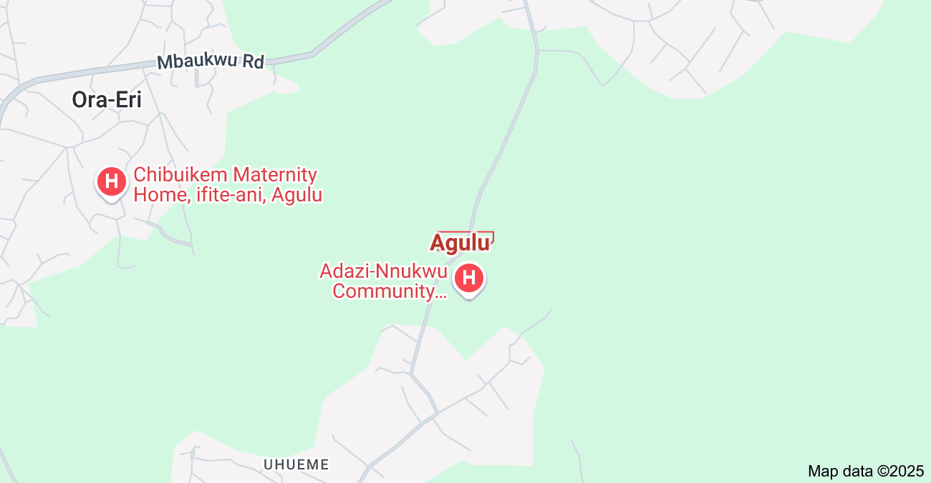 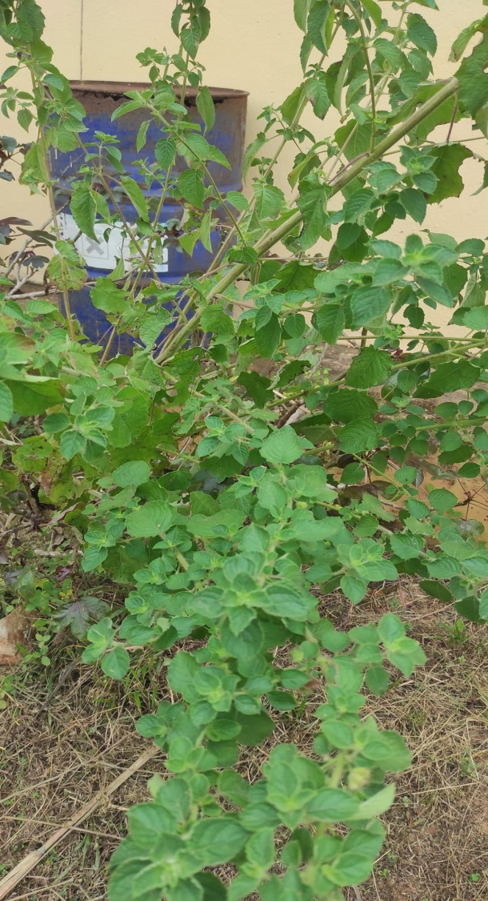

Fig 1: Map of Agulu town in Anambra State Nigeria and Hyptis suaveolens plant growing

**2.2 TEST ORGANISMS**

Multidrug (MDR) resistant isolates of Staphylococcus aureus, Pseudomonas aeruginosa, Salmonella sp. Escherichia coli, and Candida albicans, were used for the antimicrobial evaluation. All the organisms were obtained from Pharmaceutical Microbiology and Biotechnology Laboratory, Nnamdi Azikiwe University, Awka, Nigeria. Purified plates of each of the microbial isolates were obtained by culturing on their respective selective media. Biochemical tests were performed to authenticate and confirm the identity of the isolates as described by Cheesbrough (2009). Fresh plates of the test organism were made from the isolated cultures obtained on their respective agar slants. Discrete colonies of fresh cultures of the different bacterial and fungal isolates were then picked and suspended in 5 mL Nutrient broth (for bacteria) and Sabouraud dextrose agar (for fungi), in well-labeled sterile Bijou bottles, and incubated for 24 h at 37ºC for the bacteria and 48 h at 25ºC for fungi before antimicrobial susceptibility testing. The bacteria and fungal stock cultureswere maintained in sterile nutrient and sabouraud dextrose broths respectively.

**2.3 CULTIVATION AND ISOLATION OF ENDOPHYTIC FUNGI**

Using the method described by (Okezie et al., 2022) with slight modifications. All the harvested leaves were washed thoroughly in running tap water followed by sterile double distilled water before processing. To eliminate epiphytic microorganisms, all the samples were subjected to four step surface sterilization which includes washing under a running tap water-ethanol-sodium hypochlorite-distilled water. The samples were washed in running tap water. The samples were further immersed in 70% ethanol for 3 minutes and washed twice with distilled water. The samples were again immersed in sodium hypochlorite solution (4%) for 5 minutes and washed thoroughly thrice in distilled water and then rinsed in 70% ethanol for 3 minutes, before a final rinse in sterilized double distilled water. Then the samples were dried in the laminar flow on a sterile filter paper. Sterile knife was used to cut the samples to approximately 1 cm in length. Segments (a total of 30 at three to six segments per Petriplate) of samples were inoculated on previously sterilized media incorporated with chloramphenicol 500 mg/L. The cut end of the material was made to contact the media. The Petri dishes were properly sealed using parafilms then incubated at 25oC and the plates were checked on alternate days. After 7 days, the hyphal tips of actively growing fungi from the plant material were then subcultured to other sterile MEA plates and were incubated for nearly 5-7 days, and the purity of the cultures were checked periodically. Subculturing was done at an interval of two weeks to maintain the pure cultures.

**2.3.1 PURIFICATION OF FUNGI ISOLATE**

To prepare inocula for fermentation studies, cultivation of hyphal/mycelium to obtain pure cultures is done. Here, the hyphal tips of fungi, emerging out of the previously subcultured fungal is further subcultured by picking the hyphal tip and placing on a fresh MEA and incubated at 25oC for 7 days. All transfers were made aseptically. This was done to ensure the purity of isolates. After the period of inoculation, it was found that the root, leaf blades, and mid-ribs of the plant under study gave three, and two (for each of leaf blade and mid-rib) respectively making a total of seven fungi isolated during this research.

**2.3.2 MOLECULAR CHARACTERIZATION**

Taxonomic identification of the axenic fungal strain was achieved by DNA amplification and sequencing of the fungal ITS region as described by Okezie et al., (2022).

**2.4 MODULATION OF BIOSYNTHESIS OF SECONDARY METABOLITES**

**2.4.1MODULATION BY FUNGI-FUNGI AND FUNGI-BACTERIA CO-CULTIVATION APPROACH**

In this study, the isolated fungus Aspergillus aflatoxiformans was co-cultured (fermented) with an unknown fungus (B+G); a Lactobacillus sp. (C+G); alone (B); and with Curvulariapseudorobusta (G) using rice medium as the substrates in seperate 100 mL Erlenmeyer flask. Each of the fermentation flasks was inoculated with the respective organism(s), then incubated at 22ºC for 21 days and then extracted with ethyl acetate.

**2.4.2 EXTRACTION OF FUNGAL METABOLITES**

The fermentation process was stopped by the addition of the extraction solvent (ethyl acetate) and each of the fermented medium in the sterile Erlenmeyer flasks was made homogeneous. Here, fungal biomass, including the medium were cut into small lumps using a sterile glass rod and the mixture was homogenized with 500 mL of ethyl acetate in 1L Erlenmeyer flasks and shook occasionally for 2 days and then filtered using whatman filter paper (size: 188 mm).  The filtrate was concentrated at 50℃ under reduced pressure using a rotary evaporator. The concentrated extract was further left to evaporate to dryness in a desicator containing sodium hydroxide (Fig 2). Then, the corresponding extracts were weighed and their respective percentage yield recorded in milligram. After evaporation, the dried fungal extracts were reconstituted in dimethyl sulphoxide (DMSO) and subjected to biological studies.

**2.4.3 RECOVERED EXTRACTS**

**EXTRACT B+G (P):** co-culture of Aspergillus aflatoxiformans and unidentified fungus

**EXTRACT C+G (R):** co-culture of Aspergillus aflatoxiformans and bacteria (Lactobacillus sp.)

**EXTRACT B:** monoculture of Aspergillus aflatoxiformans

**EXTRACT G:** co-culture of Aspergillus aflatoxiformans and Curvulariapseudorobusta

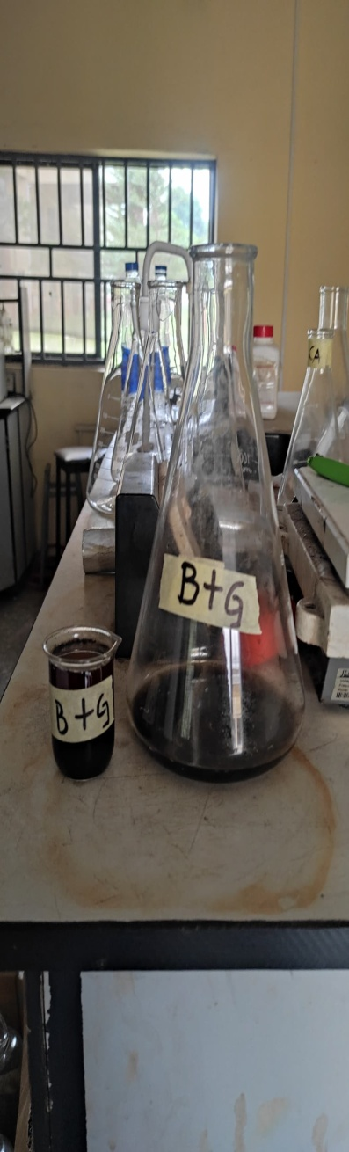 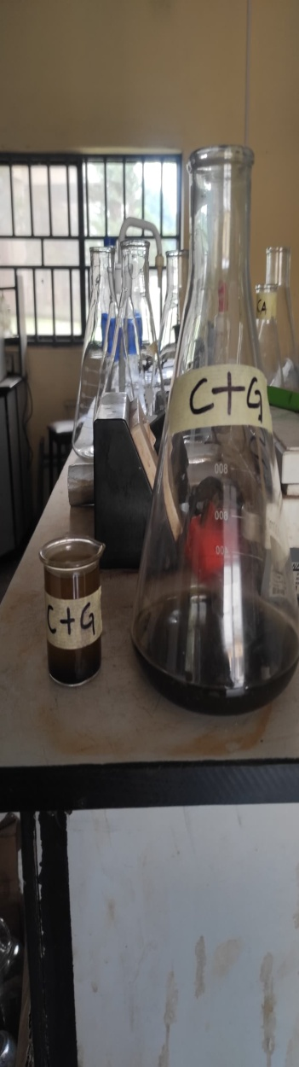 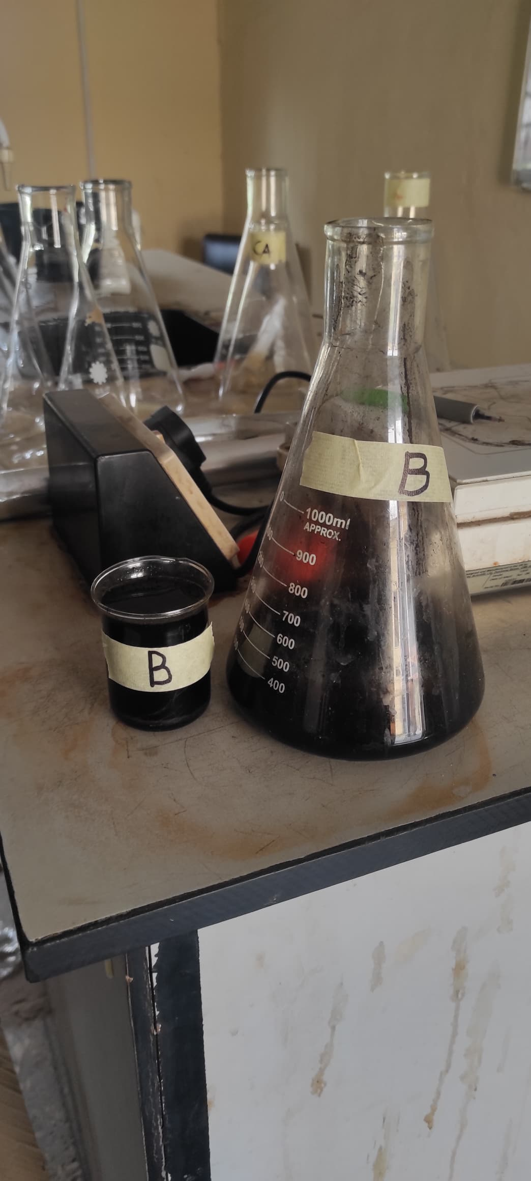 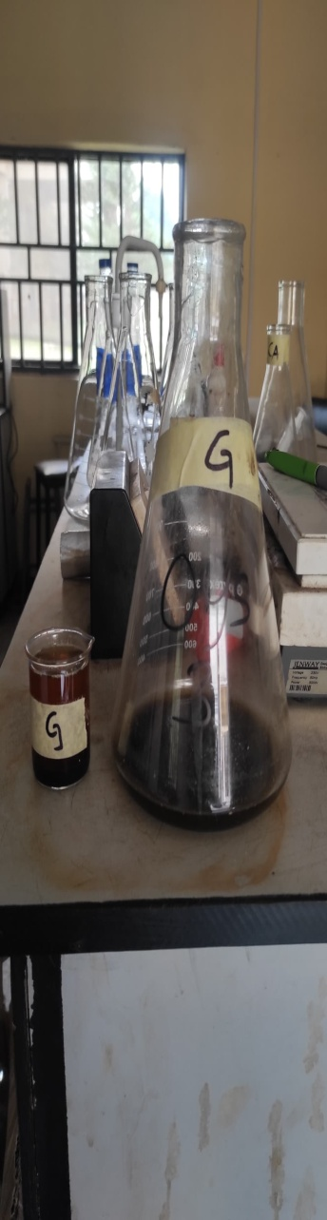

Fig 2: Crude ethyl acetate extracts [(**B+G (P);** **C+G (R); B, and G]** recovered from the co-culture

**2.5 ASSESSMENT OF CO-CULTURE MODULATION EFFECT**

**2.5.1 ANTIMICROBIAL ASSAY (POST-MODULATION)**

Each crude extract from the fermentation post-modulation was tested for antimicrobial activity against: Multidrug (MDR) resistant isolates of Staphylococcus aureus, Pseudomonas aeruginosa, Salmonella sp. Escherichia coli and Candida albicans.

**2.5.2 PREPARATION OF BACTERIAL EXTRACTS AND ANTIMICROBIAL ASSAY**

Here, stock concentrations (2 mg/mL) of each of the modulated extracts were made by weighing 4 mg of each of the crude extracts and reconstituting in 2 mL of DMSO. Thereafter, two-fold serial dilutions were made from each of the stock concentrations to get graded concentrations (1, 0.5, 0.25, and 0.625 mg/mL) of each of the extracts. The antimicrobial assay for each of the modulated extract was carried out using the agar well diffusion assay as previously described by Okezie et al., (2022). A 0.5 McFarland standard bacterial and fungal suspensions (approximately 1-2 x 10^8cfu/mL) of each of the test isolates were prepared and these formed the stock solutions used in the agar well diffusion assays as outlined below.

Using a sterile swab stick, each of the standardized bacterial and fungal suspensions was inoculated onto previously sterilized Mueller-Hinton Agar and Sabouraud Dextrose Agar plates respectively. A sterile cork borer was used to make five wells (8 mm in diameter) on each of the MHA and SDA plates. Aliquots of 80 μL of each extract dilutions, reconstituted in DMSO at concentrations of 1, 0.5, 0.25 and 0.625 mg/mL, and were applied in each of the wells in the culture plates. Ciprofloxacin (10 µg/mL) and Fluconazole (5 µg/mL) served as the positive control against the bacteria and fungi organisms respectively. The cultures were incubated at 37ºC for 24 hr (for bacteria) and 25ºC for 48 h (for fungi) plates respectively. The antimicrobial potential for each extract was determined by measuring the zone of inhibition around each well(excluding the diameter of the well). The experiment was done in triplicate against each organism.

**2.5.3 MEASUREMENT OF ANTIOXIDANT PROPERTY (DPPH METHOD)**

The antioxidant activity of the modulated extracts was studied using the slightly modified method of free radical scavenging as described by Okezie et al., (2022) using ascorbic acid as a reference antioxidant. Free radical scavenging properties of the extracts against 2,2-diphenyl-1-picryl hydrazyl (DPPH) radical were measured at 490 nm, as an index to their antioxidant activity. The samples were reacted with the stable DPPH radical in a methanol solution. The reaction mixture consisting of 25 µL of the stock, 25 µL of DPPH (0.1 mol/L) and 150 µL of methanol solution, were added into their respective wells in the microtitter and plate then incubated at 27ºC for 30 min.

After this incubation period, the absorbance of the mixtures was measured at 490 nm using UV vis spectrophotometer (06452; USA). The percentage of antioxidant activity (AA%) of each of the extracts was determined.

The anti-oxidative capacities of the extracts were compared with those of ascorbic acid. The experiment was done in triplicate for each substance. Free radical scavenging activities were expressed as the percentage inhibition of each extract and calculated using the following formula:

Activities were expressed as the percentage inhibition of each extract and calculated using the following formula:

%inhibition = ABn-ABt× 100

ABt 1

Where: ABn: Absorbance of negative control; ABt: Absorbance of test sample

Where:

*–* AA% – the percentage of antioxidant activity,

– Ao– absorbance in the presence of the extract (test),

– A1– absorbance in the presence of the positive control (Ascorbic Acid).

**2.6 CHEMICAL ANALYSIS OF MODULATED EXTRACTS (POST-MODULATION)**

The powdered samples will be screened for phytochemical constituents using standard protocols (Ghosh*et al.,* 2020).

1. **RESULTS AND DISCUSSIONS**

**3.1 CHARACTERIZATION OF ENDOPHYTIC FUNGUS**

Following taxonomic identification protocol for DNA amplification accompanied by sequencing of the fungal ITS region, the endophytic fungus was identified as *Aspergillus aflatoxiformans*. The resultant data of the fungal DNA sequenced was deposited in the NCBI database (GenBank) with accession number NR_171606.1.

FASTA SEQUENCE;

ACGAGGGAAGGGTTCTAGCGAGCCAACCTCCCACCCGTGTTTACTGTACC

TTAGTTGCTTCGGCGGGCCCGCCATTCATGGCCGCCGGGGGCTCTCAGCC

CCGGGCCCGCGCCCGCCGGAGACACCACGAACTCTGTCTGATCTAGTGAA

GTCTGAGTTGATTGTATCGCAATCAGTTAAAACTTTCAACAATGGATCTC

TTGGTTCCGGCATCGATGAAGAACGCAGCGAAATGCGATAACTAGTGTGA

ATTGCAGAATTCCGTGAATCATCGAGTCTTTGAACGCACATTGCGCCCCC

TGGTATTCCGGGGGGCATGCCTGTCCGAGCGTCATTGCTGCCCATCAAGC

ACGGCTTGTGTGTTGGGTCGTCGTCCCCTCTCCGGGGGGGACGGGCCCCA

AAGGCAGCGGCGGCACCGCGTCCGATCCTCGAGCGTATGGGGCTTTGTCA

CCCGCTCTGTAGGCCCGGCCGGCGCTTGCCGAACGCAAATCAATCTTTTT

CCAGGTTGACCTCGGATCAGGTAGGGATACCCGCTGAACTTAAGCATATC

AATA

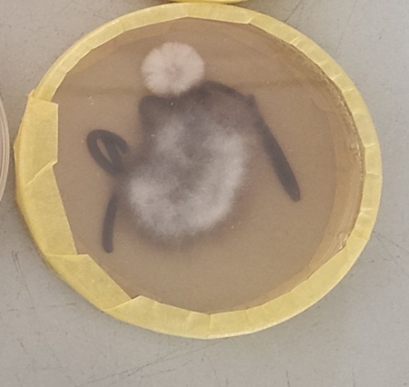

Fig 3: Axenic culture of *Aspergillus aflatoxiformans* growing on malt extract agar

**Table 1: Antimicrobial activities of extract of B+G (P) co-culture against the test organisms**

|  |  |  |  |  |  |
| --- | --- | --- | --- | --- | --- |
| **Concentration**  **(mg/ml)** | **Test organisms/ inhibition zone diameter (mm)** | | | | |
| *S. aureus* | *P. aeruginosa* | *Salmonella* | *E. coli* | *C. albicans* |
| 2 | 9±0 | 11±0 | 8±0 | 7±0 | 13±0 |
| 1 | 6±0 | 9±0.7 | 2±0 | 6±0.7 | 7±0.7 |
| 0.5 | 0±0 | 9±0.7 | 0±0 | 0±0 | 6±0.7 |
| 0.25 | 0±0 | 4±0 | 0±0 | 0±0 | 5±0 |
| 0.125 | 0±0 | 0±0 | 0±0 | 0±0 | 0±0 |
| Pos. control | 0 | 8 | 0 | 7 | 0 |

Key: *S. aureus: Staphylococcus aureus; P. aeruginosa; Pseudomonas aeruginosa; Salmonella spp; E. coli: Escherichia coli; C. albicans: Candida albicans;* Pos ctrl: Positive controls: Ciprofloxacin 5.6mg/ml, Fluconazole 35mg/ml

**Table 2: Antimicrobial activities of extract of C+G (R) co-culture against the test organisms**

|  |  |  |  |  |  |
| --- | --- | --- | --- | --- | --- |
| **Concentration**  **(mg/ml)** | **Test organisms/ inhibition zone diameter (mm)** | | | | |
| *S. aureus* | *P. aeruginosa* | *Salmonella* | *E. coli* | *C. albicans* |
| 2 | 9±0.7 | 10±0 | 4±0 | 7±0 | 8±0 |
| 1 | 9±0.7 | 6±0 | 2±0 | 4±0.7 | 6±0 |
| 0.5 | 7±0 | 0±0 | 0±0 | 3.5±0.7 | 4±0 |
| 0.25 | 3±0 | 0±0 | 0±0 | 2±0 | 0±0 |
| 0.125 | 0±0 | 0±0 | 0±0 | 0±0 | 0±0 |
| Pos. control | 0 | 8 | 0 | 7 | 0 |

Key: *S. aureus: Staphylococcus aureus; P. aeruginosa; Pseudomonas aeruginosa; Salmonella spp; E. coli: Escherichia coli; C. albicans: Candida albicans*; Pos ctrl: Positive controls: Ciprofloxacin 5.6mg/ml, Fluconazole 35mg/ml

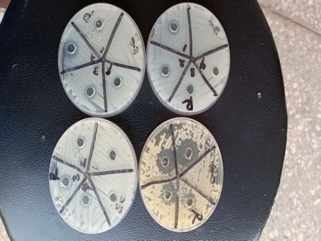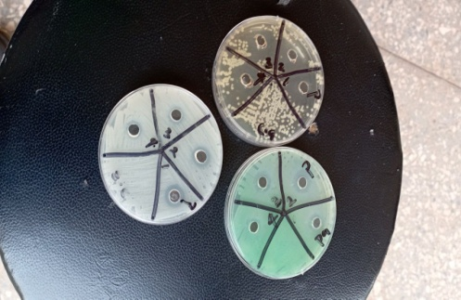

Fig 4: Microbial growth Inhibition zones produced by B+G (P) and C+G (R) crude extracts against *Escherichia coli* (E.c); *Candida albicans* (A.c) and *Pseudomonas aeruginosa* (P.a)

**Table 3: Antimicrobial activities of extract of B (*Aspergillus aflatoxiformans*) monoculture against the test organisms**

|  |  |  |  |  |  |
| --- | --- | --- | --- | --- | --- |
| **Concentration**  **(mg/ml)** | **Test organisms/ inhibition zone diameter (mm)** | | | | |
| *S. aureus* | *P. aeruginosa* | *Salmonella* | *E. coli* | *C. albicans* |
| 2 | 6±0.7 | 5±0 | 0±0 | 5±0 | 10±0 |
| 1 | 6±0.7 | 3±0 | 0±0 | 4±0 | 9±0 |
| 0.5 | 5±0 | 0±0 | 0±0 | 3±0 | 8±0.7 |
| 0.25 | 4.5±0.7 | 0±0 | 0±0 | 2±0 | 6±0 |
| 0.125 | 0±0 | 0±0 | 0±0 | 0±0 | 0±0 |
| Pos. control | 0 | 8 | 0 | 7 | 0 |

KEY: *S. aureus: Staphylococcus aureus; P. aeruginosa; Pseudomonas aeruginosa; Salmonella spp; E. coli: Escherichia coli; C. albicans: Candida albicans;*Pos ctrl: Positive controls: Ciprofloxacin 5.6mg/ml, Fluconazole 35mg/ml

**Table 4: Antimicrobial activities of extract of G monoculture against the test organisms**

|  |  |  |  |  |  |
| --- | --- | --- | --- | --- | --- |
| **Concentration**  **(mg/ml)** | **Test organisms/ inhibition zone diameter (mm)** | | | | |
| *S. aureus* | *P. aeruginosa* | *Salmonella* | *E. coli* | *C. albicans* |
| 2 | 2±0 | 7±0 | 6±0 | 7.5±0.7 | 6±0.7 |
| 1 | 0±0 | 7.5±0.7 | 4±0.7 | 5±0 | 6±0.7 |
| 0.5 | 0±0 | 4±0 | 4±0.7 | 3.5±0.7 | 4±0.7 |
| 0.25 | 0±0 | 3±0.7 | 2±0 | 0±0 | 2±0 .7 |
| 0.125 | 0±0 | 0±0 | 0±0 | 0±0 | 0±0 |
| Pos. control | 0 | 8 | 0 | 7 | 0 |

Key: *S. aureus: Staphylococcus aureus; P. aeruginosa; Pseudomonas aeruginosa; Salmonella spp; E. coli: Escherichia coli; C. albicans: Candida albicans;*Pos ctrl: Positive controls: Ciprofloxacin 5.6mg/ml, Fluconazole 35mg/ml

**Table 5: Antioxidant activity of extract of B+G (P) co-culture**

|  |  |  |
| --- | --- | --- |
| **Concentration (mg/ml)** | **Extract B+G** | **Ascorbic acid** |
| Mean Absorbance / %  inhibition | Mean absorbance / %  inhibition |
| 100 | 0.355(78.8) | 0.168(94) |
| 80 | 0.525(63.3) | 0.179(93) |
| 60 | 0.695(48.1) | 0.205(90) |
| 40 | 0.865(32.7) | 0.220(88) |
| 20 | 1.035(17.4) | 0.29(82) |

**Table 6: Antioxidant activity of extract of C+G (R) co-culture**

|  |  |  |
| --- | --- | --- |
| **Concentration (mg/ml)** | **Extract C+G** | **Ascorbic acid** |
| Mean Absorbance / %  inhibition | Mean absorbance / %  Inhibition |
| 100 | 0.252(88) | 0.168(94) |
| 80 | 0.422(72.7) | 0.179(93) |
| 60 | 0.592(57.4) | 0.205(90) |
| 40 | 0.762(42) | 0.220(88) |
| 20 | 0.932(27) | 0.29(82) |

**Table 7: Antioxidant activity of extract of B monoculture**

|  |  |  |
| --- | --- | --- |
| **Concentration (mg/ml)** | **Extract B** | **Ascorbic acid** |
| Mean Absorbance / %  inhibition | Mean absorbance / %  Inhibition |
| 100 | 0.38(76.5) | 0.168(94) |
| 80 | 0.55(61.2) | 0.179(93) |
| 60 | 0.72(45.8) | 0.205(90) |
| 40 | 0.89(30.5) | 0.220(88) |
| 20 | 1.06(15) | 0.29(82) |

**Table 8: Antioxidant activity of extract of G monoculture**

|  |  |  |
| --- | --- | --- |
| **Concentration (mg/ml)** | **Extract G** | **Ascorbic acid** |
| Mean Absorbance / %  Inhibition | Mean absorbance / %  Inhibition |
| 100 | 0.219(91) | 0.168(94) |
| 80 | 0.302(83.5) | 0.179(93) |
| 60 | 0.396(75) | 0.205(90) |
| 40 | 0.566(59.7) | 0.220(88) |
| 20 | 0.736(44.4) | 0.29(82) |

**Tab 9: Secondary metabolites detected**

|  |  |  |  |  |  |  |  |  |  |
| --- | --- | --- | --- | --- | --- | --- | --- | --- | --- |
| **Samples** | **Alkaloid** | **Saponin** | **Tannin** | **Flavonoid** | **Steroid** | **Terpenoid** | **Cardiac glycoside** | **protein** | **Carbohydrate** |
| C+G | - | - | - | + | - | ++ | ++ | - | + |
| B+G | - | - | - | + | - | + | + | - | + |
| B | - | - | - | + | - | ++ | ++ | + | + |
| G | - | - | - | - | - | + | + | - | + |

The evaluation of the effect of the co-culture technique was achieved using the agar diffusion method of antimicrobial evaluation and the DPPH antioxidant assay technique. All the crude extracts C+G, B+G, B, G recovered from the modulation experiments inhibited at least one of the test bacteria and fungi studied, with the maximum and minimum IZD of 13mm and 2mm, respectively (Table 1- 4; Fig 4). Also, the active samples demonstrated broad-spectrum microbial growth inhibition in a concentration-dependent manner. Thus, as the concentration increased, the inhibition of the susceptible test organism also increased (Table 1- 4; Fig 4). The modulated crude extracts also produced reduced MIC against each of the susceptible organisms, which ranged from 0.25 to 2 mg/mL.

   Among the tested modulated crude extracts, the Extract recovered from the co-culture of (C+G) Aspergillus aflatoxiformans with an unknown fungus had the best antimicrobial activity, inhibiting all the tested microorganisms. (Tab 1). The result of this study showed that S. aureus, P. aeruginosa, and E. coli were the most sensitive bacteria showing sensitivity to all the modulated extracts with an MIC that ranged between 0.25 – 2mg/ml (Tab 1-4, Fig 4). While salmonella spp was the most resistant organism, resisting the effects of the extract (B) Aspergillus aflatoxiformans monoculture at the tested concentrations as seen in (Tab. 3). Also all the modulated crude extracts produced significant inhibition against Candida albicans (Tab 1-4; Fig 4) with a maximum and minimum IZD ranging from 13- 2mm respectively with an MIC of 0.25 – 2mg/ml (Tab 1-4; Fig 4). The antimicrobial result showed that Extracts (C+G) Aspergillus aflatoxiformans co-cultured with Lactobacillus demonstrated the best activity inhibiting the Gram-positive test bacteria S. aureus.

   Similarly, Mozhiyarasi et al., (2016) observed a broad spectrum of activity demonstrated by the extract of fungus isolated from Hyptissuaveleonsagainst Staphylococcus aureus, Escherichia coli, and Pseudomonas aeruginosa with inhibition zone diameters ranging from 6 – 14mm.

   In this work, the Gram-positive organism S. aureus was more susceptible to the modulated fungal extracts than the Gram-negative bacteria. This is in line with the study “Antimicrobial Potential of Extracts of *Hyptis suaveolens* leaves Extract on some selected gram positive isolates” by Comfort and Giwa, (2017), who observed that the Gram-positive bacteria were susceptible to the extracts, and it was more pronounced at higher concentrations, making it a dose or concentration-dependent procedure. The observed difference in susceptibilities of the test organisms to the fungal extracts may be due to the cell wall permeability, and/or structural differences between these microorganisms. The susceptibility (death) to phenolic compounds such as hydroxybenzoic acid and its derivatives by Gram-positive bacteria may be due in part to the lipopolysaccharide components present in the cell, which are responsible for the high susceptibility to phenolic compounds. Most endophytic fungal cultures have yielded a wide range of bioactive compounds with diverse biological activities. Thus, the antimicrobial activities recorded in this work may be attributed to several bioactive secondary metabolites induced by the co-culture of the organisms. This is in line with previously detected secondary metabolites observed to possess antimicrobial activities such as phenolics, alkaloids, saponins, terpenoids, limonoids, polyacetylenes and secoiridoids (Allemailem, 2021).

  Furthermore, the antimicrobial potentials of endophytic fungi extracts have been attributed to several other bioactive seconddary metabolites detected by HPLC analyses, including catechin-o-3,4-dimethylgallate (Kaya *et al*., 2019); p-Hydroxybenzoic acid (Okezie et al.,2022), protocatechuic acid (Xicanet al.,2013). Studies have shown that these compounds such as Catechin-o-3 gallate, protocatechuic acid and p-Hydroxybenzoic acid possess antimicrobial activities. Also, Micafungin, produced by Coleophomaempetri, an endophytic fungus, was reported to have antifungal activity (Liu et al., 2024).

    “Antioxidants are compounds that can donate electrons to free radicals and terminate free radical-mediated reactions before oxidative damage can occur to biomolecules” (Lüet al., 2010). In this study, antioxidant activities were recorded for all the modulated extracts (C+G, B+G, B, G). The antioxidant activities decreased as the concentration decreased, thus making it concentration-dependent. At 80µg/mL, each of the extracts demonstrated good antioxidant activity in comparison with the standard ascorbic acid (Tab 5-8).

    “Ascorbic acid, as a control, is widely recognized for its potent antioxidant properties. Its ability to scavenge free radicals and neutralize reactive oxygen species (ROS) has been extensively studied” (Padayatty& Levine, 2016). Ascorbic acid acts as a reducing agent, donating electrons to stabilize and neutralize free radicals, thereby protecting cells from oxidative damage (Jacob et al., 2002). In this work, it can be seen that ascorbic acid had a good antioxidant activity at the tested concentrations. Notwithstanding, the crude extracts also possessed good antioxidant properties, although not observed for all the concentrations as compared to ascorbic acid.

     The metabolites present in these extracts are responsible for their antioxidant properties. The crude extracts were tested for the presence of alkaloids, saponins, tannins, flavonoids, steroids, terpenoids, cardiac glycosides, proteins, and carbohydrates. The presence of any of these metabolites is indicative of its antioxidant activity. The antioxidant activities recorded by each of the co-cultured extracts could be a result of the combined effects of the metabolites present in it (terpenoids, cardiac glycosides, and carbohydrates), each contributing to the antioxidant activity through different mechanisms. Although carbohydrates are not typically considered antioxidants, certain carbohydrate-rich compounds like polysaccharides and oligosaccharides found in plant extracts can indirectly contribute to antioxidant activity. They may act as reducing agents, donate electrons to stabilize free radicals, and exhibit metal-chelating properties (Nemzer et al., 2019). Terpenoids and cardiac glycosides scavenge free radicals and inhibit oxidative damage, contributing to their oxidative activity (Masyita et al., 2022).

The results from this study suggest the use of a co-culture approach for the modulation of novel active principles as lead compounds in developing antimicrobial and antioxidant agents.

1. **CONCLUSION**

**The results of this study show that the endophytic fungus studied is a potential and reliable source of bioactive metabolites necessary for the biosynthesis of new antimicrobial agents for use as chemotherapy and further justify the presence of inactive putative biosynthetic gene clusters and the use of the co-culture technique in the activation of these genes and subsequent enhancement of secondary metabolites production. The results of this study provide useful information on the possible modulation of the biosynthetic genes cluster of pathogenic fungi for the production of pharmacologically important secondary metabolites and validate the co-culture approach as a reliable alternative in bioprospecting natural products.**

**DISCLAIMER (ARTIFICIAL INTELLIGENCE)**

Author(s) hereby declare that NO generative AI technologies such as Large Language Models (ChatGPT, COPILOT, etc.) and text-to-image generators have been used during the writing or editing of this manuscript.

**REFERENCES**

1. Guedes BN, Krambeck K, Durazzo A, Lucarini M, Santini A, Oliveira MBPP, Fathi F, Souto EB. Natural antibiotics against antimicrobial resistance: sources and bioinspired delivery systems. Braz J Microbiol. 2024 Sep;55(3):2753-2766. doi: 10.1007/s42770-024-01410-1
2. Fadiji, A. E., & Babalola, O. O. Exploring the potentialities of beneficial endophytes for improved plant growth. Saudi journal of Biological sciences. 2020;27(12), 3622-3633.
3. Joo, H. S., Deyrup, S. T., & Shim, S. H. Endophyte-produced antimicrobials: a review of potential lead compounds with a focus on quorum-sensing disruptors. Phytochemistry Reviews. 2021; 20, 543-568.
4. Jha P, Kaur T, Chhabra I, Panja A, Paul S, Kumar V, Malik T. Endophytic fungi: hidden treasure chest of antimicrobial metabolites interrelationship of endophytes and metabolites. Front Microbiol. 2023; 11;14:1227830. doi: 10.3389/fmicb.2023.1227830.
5. Silva D.P.D., Cardoso M.S., Macedo A.J. Endophytic Fungi as a Source of Antibacterial Compounds-A Focus on Gram-Negative Bacteria. Antibiotics (Basel), 2022;11(11):1509.
6. Strobel, G. Harnessing endophytes for industrial micriobiology. Current Opinion on Microbiology. 2018; 45, 199-204.
7. Malfent F., Zehl M., Kirkegaard R.H., Oberhofer M., Zotchev S.B. Genomes and secondary metabolomes of *Streptomyces* spp. isolated from *Leontopodium nivale* ssp. *alpinum*. Front Microbiol. 2024; 15:1408479
8. Alam K., Mazumder A., Sikdar S., Zhao YM., Hao J., Song C., Wang Y., Sarkar R., Islam S., Zhang Y., Li A. *Streptomyces*: The biofactory of secondary metabolites. Front Microbiol. 2022.
9. Cheesbrough. District Laboratory Practice in Tropical Countries, Second Edition

Part II, Cambridge University press. 2009; Pg 62-70.

1. Ugochukwu. M. Okezie, Peter M. Eze, Festus B. C. Okoye, Charles O. Esimone. Orthosporin, a major component of the fermentation product of Lasidiplodiathebromae an edophytic fungus of Musa paradisiaca as a potential antimicrobial agent. Notulae Scientia Biologicae. 2022; Vol.14.2. DOI:10.15835/nsb14211084.
2. Ghosh P, Das C, Biswas S, Nag SK, Dutta A, Biswas M, Sil S, Hazra L, Ghosh C, Das S, Saha M, Mondal N, Mandal S, Ghosh A, Karmakar S, Chatterjee S. Phytochemical composition analysis and evaluation of in vitro medicinal properties and cytotoxicity of five wild weeds: A comparative study. F1000Res. 2020; 2;9:493. doi: 10.12688/f1000research.22966.1.
3. Mozhiyarasi, P., & Anuradha, R. A study on phytochemical analysis and antimicrobial activity of Hyptissuaveolens (L.)poit. Journal of Chemical and pharmaceutical Research. 2016; 8(6), 438-442.
4. Comfort, Ojo Omolara, and Giwa Holy Johnson. “Antimicrobial Potential of Extracts of HyptisSuaveolens (L) Poit. Leaves on Some Gram Positive Bacterial Isolates”. Journal of Advances in Medical and Pharmaceutical Sciences. 2017; 12 (4):1-11. <https://doi.org/10.9734/JAMPS/2017/32562>.
5. Allemailem KS. Antimicrobial Potential of Naturally Occurring Bioactive Secondary Metabolites. J Pharm Bioallied Sci. 2021; 13(2):155-162. doi: 10.4103/jpbs.JPBS_753_20
6. Kaya Z, Yayla M, Cinar I, Atila NE, Ozmen S,  Bayraktutan Z,  Bilici D.

Epigallocatechin-3-gallate (EGCG) exert therapeutic effect on acute inflammatory otitis media in rats. Int J PediatrOtorhinolaryngol. 2019; 124:106-110.

1. Xican Li, Xiaozhen Wang, Dongfeng Chen, Shuzhi Chen. Antioxidant Activity and Mechanism of Protocatechuic Acid in vitro. Functional Foods in Health and Disease. 2011; 7:232-244.
2. Liu Y., Wang B., Zhang X., Men P., Gu M., Zhou Y., Hu W., Wang Z., Wang M., Huang X., Lu X. Improving the production of micafungin precursor FR901379 in *Coleophoma empetri* using heavy-ion irradiation and its mechanism analysis. Mycology, 2024;16(2):941-955.
3. Lü JM, Lin PH, Yao Q, Chen C. Chemical and molecular mechanisms of antioxidants: experimental approaches and model systems. J Cell Mol Med. 2010; 14(4):840-60. doi: 10.1111/j.1582-4934.2009.00897.x.
4. Padayatty, S.J., & Levine, M. Vitamin C: The known and the unknown and Goldilocks. Oral Diseases. 2016; 22(6), 463-493.
5. Jacob RA. Sotoudeh G. Vitamin C function and status in chronic disease. Nutr Clin Care. 2002; 5(2):66-74. doi: 10.1046/j.1523-5408.2002.00005.x
6. Nemzer B.V., Kalita D., Yashin A.Y., Nifantiev N.E., Yashin, Y.I. Invitro Antioxidant Activities of Natural Polysaccharides: Anoverview. Journal of Food Research. 2019; 8: 6.
7. Masyita A., Mustika Sari R., Dwi Astuti A., Yasir B., Rahma Rumata N., Emran T.B., Nainu F., Simal-Gandara J. Terpenes and terpenoids as main bioactive compounds of essential oils, their roles in human health and potential application as natural food preservatives. Food Chem X. 2022; 19:13:100217.
8. Chika C Abba, Ogechi O Anyanwu, Somtochukwu R Ewuzie, Chukwubuikem C Okolo, Blessing O Umeokoli, Ugochukwu M Okezie and Ike V Ezenwa. Evaluation of antimicrobial and antioxidant activities of endophytic fungi isolated from leaves of Acioa barteri (Hook F. ex. Oliv). Journal of Pharmacognosy and Phytochemistry 2025; 14(3): 405-412