Exploring the Convergence of Artificial Intelligence and Biotechnology: A Global Bibliometric Analysis from 2000 to 2025

Abstract
The convergence of artificial intelligence (AI) and biotechnology is revolutionizing scientific research and innovation, enabling transformative applications across healthcare, agriculture, and environmental sustainability. This study presents a comprehensive bibliometric analysis of global research at the intersection of biotechnology and AI from 2000 to 2025. The objective is to evaluate publication trends, identify prolific authors and institutions, map collaborative networks, and highlight emerging research themes shaping the field. Data were retrieved from the Dimensions.ai database, filtered for articles indexed in Scopus and Web of Science, using a well-defined set of keywords. For analysis, we utilized VOSviewer (v1.6.20) and R programming (via the Bibliometrix package, version 2024.12.1, with the Biblioshiny interface) to perform quantitative assessments and generate visualizations of co-authorship, country-wise contributions, citation networks, and keyword co-occurrences. The results reveal a sharp increase in publications—particularly after 2016—with the United States, China, and the United Kingdom leading in output and international collaboration. Influential institutions include Harvard University, the Chinese Academy of Sciences, and MIT. Keyword analysis highlights key research domains such as precision medicine, CRISPR-based gene editing, AI-assisted drug discovery, and integrative bioinformatics. Network visualizations show dynamic collaboration clusters and evolving research foci, transitioning from early bioinformatics work to contemporary applications in personalized medicine and clinical diagnostics. Importantly, the inclusion of data up to 2025 reveals new research directions that were underrepresented in previous bibliometric studies, including AI integration in sustainable bioprocessing, bioethics-aware clinical decision models, and environmental biotechnology. These emerging trends underscore the rapid evolution of the field and highlight the need for a current and forward-looking bibliometric perspective. This study emphasizes the importance of cross-border collaborations and calls for robust ethical and regulatory frameworks to ensure responsible innovation. The findings offer valuable insights for researchers, funding agencies, and policymakers aiming to support and guide future advancements in this transformative domain.
Keywords: Artificial Intelligence, Biotechnology, Bibliometric Analysis, Machine Learning, Bioinformatics, Research Trends.

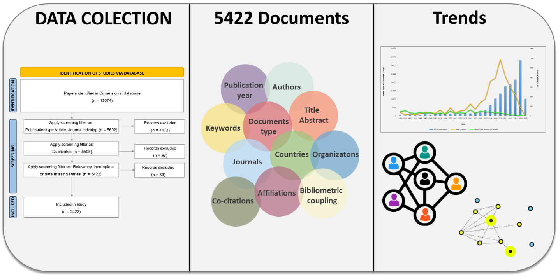
Graphical Abstract

- Introduction
The convergence of AI and biotechnology has transformed the landscape of scientific research, healthcare, and industrial applications (da Silva, 2024). AI-driven technologies such as machine learning (ML), deep learning (DL), and natural language processing (NLP) have provided unprecedented insights into complex biological systems, accelerating advancements in genomics, drug discovery, personalized medicine, and synthetic biology (Khan et al., 2023; Peng & Rajjou, 2024; Serrano et al., 2024). The ability of AI to process vast amounts of biological data with speed and accuracy has positioned it as an indispensable tool for innovation in biotechnology (Oliveira, 2019). The integration of AI into the life sciences has led to a paradigm shift, enabling researchers to overcome limitations associated with traditional experimental methodologies.
Biotechnology is a multidisciplinary field that harnesses biological processes for industrial and medical applications, ranging from pharmaceuticals and agriculture to environmental science and synthetic biology (Yan et al., 2023). The complexity of biological systems and the vast amounts of data generated from high-throughput sequencing, proteomics, and metabolomics necessitate advanced computational approaches (Krumsiek et al., 2016). AI has emerged as a key enabler in this domain, facilitating the extraction of meaningful patterns from large datasets and enhancing predictive modeling capabilities. Machine learning algorithms have been instrumental in deciphering genetic codes, predicting protein structures, and designing novel biomolecules with improved functional properties (Notin et al., 2024). For instance, AI-driven generative models such as AlphaFold have significantly advanced our understanding of protein folding, a problem that has perplexed scientists for decades(Jumper et al., 2021). The ability to accurately predict protein structures has far-reaching implications in drug design, enzyme engineering, and understanding disease mechanisms at the molecular level (Kuhlman & Bradley, 2019). Similarly, AI-based predictive modeling has enhanced drug repurposing strategies, reducing the time and cost associated with traditional drug discovery pipelines (Choudhury et al., 2022). The integration of AI with computational chemistry and molecular docking simulations has streamlined lead identification, enabling researchers to identify promising therapeutic compounds more efficiently (Bhatia et al., 2024).
The advent of next-generation sequencing (NGS) has revolutionized genomics, generating massive datasets that require sophisticated analytical tools for interpretation (Tripathi et al., 2016). AI algorithms have been instrumental in identifying genetic variants associated with diseases, enabling early diagnosis and precision medicine approaches (Quazi, 2022). Deep learning techniques have improved the accuracy of variant calling, facilitating the identification of single nucleotide polymorphisms (SNPs) and structural variations that contribute to complex disorders (Alzahrani & Alharithi, 2024). Moreover, AI has accelerated the development of personalized medicine by integrating multi-omics data, electronic health records, and real-world evidence (Chen et al., 2025). Predictive models based on AI can classify patients into subgroups based on their genetic profiles, allowing for tailored therapeutic interventions. AI-powered clinical decision support systems leverage patient-specific data to recommend optimized treatment strategies, minimizing adverse drug reactions and improving patient outcomes (Taherdoost & Ghofrani, 2024).
Synthetic biology aims to redesign biological systems for novel applications, such as biofuel production, biosensor development, and tissue engineering (Yang et al., 2022). AI has played a crucial role in optimizing synthetic biology workflows by guiding the rational design of genetic circuits and metabolic pathways (Kumar et al., 2022). Computational models powered by AI can predict gene interactions, optimize gene expression levels, and suggest modifications to enhance product yields (Taguchi & Turki, 2024). In metabolic engineering, AI-driven approaches have been used to design microbial strains capable of producing high-value biochemicals (Imamoglu, 2024). By integrating omics data with metabolic flux analysis, AI models can identify bottlenecks in biosynthetic pathways and suggest engineering strategies to enhance production efficiency (Cheng et al., 2023). Furthermore, AI has facilitated the automation of laboratory workflows, enabling high-throughput screening of genetically modified organisms (GMOs) for desired traits (Sheikh et al., 2024).
AI has also revolutionized agricultural biotechnology by improving crop breeding, pest management, and precision farming (Aziz et al., 2025; S.s. et al., 2024; Zhang et al., 2025). Predictive analytics powered by AI can assess soil health, monitor crop growth, and detect diseases in plants at an early stage. Deep learning models trained on satellite imagery and drone data provide real-time insights into agricultural productivity, allowing farmers to make data-driven decisions to optimize resource utilization (Paul et al., 2022). Genomic selection, a powerful tool in plant and animal breeding, has been enhanced by AI algorithms that analyze genetic markers and predict desirable traits with high accuracy (Xu et al., 2022). By integrating phenotypic and environmental data, AI models can accelerate the breeding process, leading to the development of high-yield, stress-tolerant crop varieties (Rai, 2022). Additionally, AI-driven robotic systems have automated tasks such as planting, harvesting, and weed detection, reducing labour costs and enhancing agricultural sustainability (Javaid et al., 2023).
Environmental biotechnology focuses on leveraging biological systems to address environmental challenges, such as waste management, pollution control, and bioremediation (Arora & Fatima, 2024). AI has contributed to this field by optimizing microbial consortia for biodegradation, predicting pollutant dispersion patterns, and enhancing wastewater treatment processes (Kuppan et al., 2024). Machine learning models trained on ecological datasets can assess the impact of environmental stressors on biodiversity and predict ecosystem responses to climate change (Briscoe et al., 2023). AI-driven bioinformatics tools have been instrumental in metagenomic analysis, enabling researchers to characterize microbial communities and identify novel enzymes with industrial applications (Huo & Wang, 2024). By integrating AI with synthetic biology, scientists have engineered microbial strains capable of breaking down plastic waste and converting organic matter into biofuels (Long et al., 2025). These advancements hold significant promise for sustainable environmental solutions and circular bioeconomy initiatives.
Despite the transformative potential of AI in biotechnology, several challenges must be addressed to fully realize its benefits. One of the primary challenges is the quality and availability of biological datasets (Holzinger et al., 2023). AI models rely on large, well-curated datasets for training, and inconsistencies in data quality can lead to biased or inaccurate predictions. Additionally, the interpretability of AI models remains a concern, as deep learning algorithms often function as "black boxes" with limited transparency in decision-making processes (Hassija et al., 2024). Ethical considerations surrounding AI in biotechnology also require careful attention. The use of AI in genomic research raises concerns about data privacy, consent, and potential misuse of genetic information (Balagurunathan & Sethuraman, 2024). Ensuring robust ethical frameworks and regulatory oversight is essential to prevent unintended consequences and promote responsible AI deployment in biotechnological applications.
Given the rapid evolution of AI in biotechnology, it is crucial to systematically analyze the trends, challenges, and future directions of this interdisciplinary domain. Bibliometric analysis serves as a powerful tool to assess the research landscape, providing quantitative insights into publication trends, influential authors, leading institutions, and thematic research clusters (Donthu et al., 2021). By evaluating citation networks and keyword distributions, bibliometric studies help in identifying emerging research fronts and potential gaps in the field. This study employs a bibliometric approach to comprehensively examine the applications and impact of AI in biotechnology. By analyzing scholarly literature, we aim to map the research trajectory, highlight major contributions, and identify prevailing challenges that need to be addressed. Furthermore, the study explores future directions, offering valuable insights for researchers, policymakers, and industry stakeholders seeking to harness AI-driven innovations for biotechnological advancements.
This study aims to examine the literature on AI integration in biotechnology from 2000 to 2025 through bibliometric analysis. The objective is to gain insights into the evolution and impact of AI within the biotechnology sector, a field that has garnered increasing attention and significance. To achieve this, the research will address specific questions regarding publication trends, key contributors, prevalent research themes, and emerging areas within this interdisciplinary domain.
- How has the publication trend of AI in biotechnology evolved?
- Which countries are dominant in the integration of AI in biotechnology?
- What are the most productive organizations or institutions in this research area?
- Who are the most influential authors contributing to AI in biotechnology?
- Which are the most highly cited papers in AI-driven biotechnology research?
- What are the leading journals publishing research on AI in biotechnology?
- What challenges are most frequently discussed in AI-biotechnology research?

2. Methods
- Data sources and search strategies
The original data used in this study were downloaded from the Dimension.ai database (https://www.dimensions.ai/). The data were exported on Mar 24, 2025, with criteria: '("Biotechnology" OR "Biotech" OR "Bioengineering" OR "Genetic Engineering" OR "Biomedical" OR "nanobiotechnology") AND ("Artificial Intelligence" OR "Machine Learning" OR "Deep Learning" OR "Neural Networks" OR "AI in Biology" OR "AI in Medicine") AND ("Application*" OR "Trend*" OR "Innovation*" OR "Challenge*" OR "Future Direction*" OR "Opportunities")' The search was conducted within the title and abstract fields for articles published between 2000 and 2025, limited to journals indexed in Scopus or Web of Science. These parameters were designed to capture a comprehensive set of relevant articles at the intersection of AI and biotechnology. The criteria and process for literature selection in this study are detailed in Figure 1. Since all original data were obtained from publicly available databases, an ethical review was not required.
- Data analysis
The Bibliometrix R package (version 2024.12.1), VOSviewer (version 1.6.20) and Microsoft Excel (version 2024) were used to analyse the publication trends, journal distribution, highly cited publications, collaboration and distribution of countries/regions, institutions, keyword occurrences and authors.

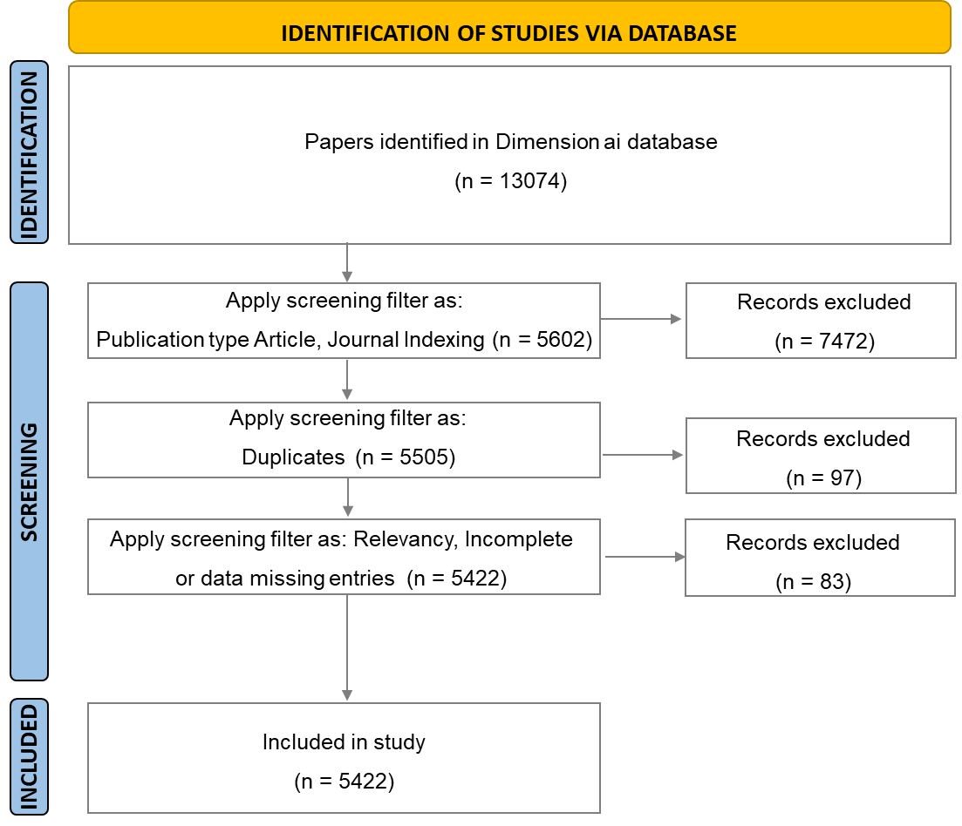
Figure 1: The flow chart of literature selection in this study.

- Results and Discussion
  - General analysis
In the present study, a total of 5422 publications analysed the integration of AI in biotechnology. The annual growth pattern indicates a notable acceleration in research activity over the past decade. For instance, publication output grew from 230 in 2018 to 622 in 2021, and further to 1,163 in 2024, reflecting an exponential rise. As illustrated in Figure 2. The bibliometric analysis of AI applications in biotechnology highlights a remarkable growth in research activity over the past two decades, particularly after 2015. While the early years (2000–2015) saw a steady but moderate research output, the field experienced exponential growth from 2016 onward, reaching 230 publications in 2018, 622 in 2021, and peaking at 1163 in 2024. This rapid increase reflects the expanding role of AI in revolutionizing biotechnology, driven by advancements in computational power, machine learning algorithms, and increased interdisciplinary collaboration. The total number of citations peaked in 2020 at 33,758, indicating that research conducted in earlier years significantly shaped the field. Although the total citations and mean citations per article have shown a declining trend in recent years, this can be attributed to the time-dependent nature of citation accumulation, where more recent publications require time to gain recognition and influence. Furthermore, the increasing number of studies suggests that AI applications in biotechnology are diversifying into new areas, providing opportunities for further innovation.
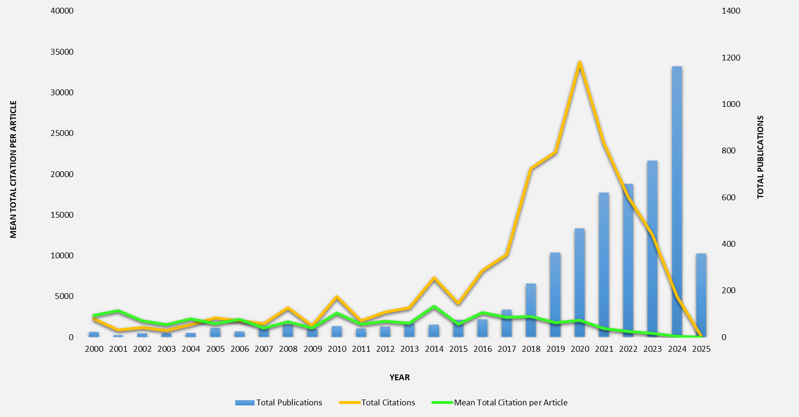
Figure 2: Number of publications related to AI and biotechnology from 2000 to 2025
  - Influential Countries in AI and biotechnology
The analysis of influential countries in AI applications in biotechnology reveals key global research trends, highlighting both the quantity and impact of contributions from different countries. The United States dominates the field with 1,639 publications (30.23%), nearly one-third of all research output, and has the highest total citations (89,193), indicating its pivotal role in shaping the discourse on AI-driven biotechnology. Despite China being the second-largest contributor with 1,196 articles (22.06%), its citation impact (28.68 citations per article) is significantly lower than that of leading Western nations, suggesting that while China excels in research volume, its influence in shaping high-impact scientific discourse may be lower. India, ranking third (507 articles, 9.35%), also exhibits a relatively lower citation impact (20.30 citations per article), implying that its research, while growing, may still be in an emerging phase with room for improvement in international visibility and influence.
European countries demonstrate a strong presence in high-quality research. The United Kingdom (455 articles, 8.39%) and Germany (359 articles, 6.62%) have impressive citation impacts of 61.04 and 63.06, respectively, suggesting that their research is not only abundant but also influential. Switzerland stands out with one of the highest average citations per article (62.61) despite contributing only 132 publications (2.43%), highlighting its strength in producing groundbreaking and widely recognized research. Similarly, Canada (233 articles, 4.30%) maintains a strong research impact with an average of 50.09 citations per article. These numbers indicate that while Europe produces fewer publications than the United States and China, its research is consistently high in quality and global influence.
Singapore emerges as a particularly noteworthy case. Despite having only 92 publications (1.70%), it boasts the highest citation impact (70.89 citations per article), signifying that its research is not only cutting-edge but also widely referenced. This suggests that Singaporean research institutions are highly focused on quality and international collaboration, making their contributions particularly influential. Countries such as South Korea (192 articles, 3.54%), Australia (175 articles, 3.23%), and France (146 articles, 2.69%) also play a significant role, with solid citation impacts between 37 and 44 citations per article, further emphasizing the global nature of AI-driven biotechnology research. On the other hand, emerging contributors like Saudi Arabia (171 articles, 3.15%), Spain (171 articles, 3.15%), and Pakistan (111 articles, 2.05%) exhibit moderate citation rates, indicating growing but less internationally influential research as listed and illustrated in Table 1 and Figure 3.
Overall, this analysis underscores a clear distinction between research quantity and impact. While countries like the United States and China lead in publication volume, nations such as Switzerland, Singapore, and the United Kingdom excel in producing highly cited, impactful research. The findings highlight the importance of fostering international collaborations, emphasizing research quality over quantity, and integrating AI advancements with biotechnological applications to ensure meaningful scientific progress. As AI continues to revolutionize biotechnology, strategic investments in high-impact research and cross-border partnerships will be crucial in shaping the future of this interdisciplinary field.
Table 1: Top 20 countries in terms of total number of publications.
Sr. No. | Country | No. of Articles | Percentage (%) | Total citations | Average citation per item
1 | United States | 1639 | 30.23 | 89193 | 54.4192
2 | China | 1196 | 22.06 | 34296 | 28.6756
3 | India | 507 | 9.35 | 10293 | 20.3018
4 | United Kingdom | 455 | 8.39 | 27772 | 61.0374
5 | Germany | 359 | 6.62 | 22638 | 63.0585
6 | Italy | 240 | 4.43 | 9621 | 40.0875
7 | Canada | 233 | 4.30 | 11671 | 50.0901
8 | South Korea | 192 | 3.54 | 7241 | 37.7135
9 | Australia | 175 | 3.23 | 6765 | 38.6571
10 | Saudi Arabia | 171 | 3.15 | 4104 | 24.0000
11 | Spain | 171 | 3.15 | 5797 | 33.9006
12 | France | 146 | 2.69 | 6462 | 44.2603
13 | Switzerland | 132 | 2.43 | 8265 | 62.6136
14 | Japan | 119 | 2.19 | 4417 | 37.1176
15 | Turkey | 115 | 2.12 | 5483 | 47.6783
17 | Pakistan | 111 | 2.05 | 4004 | 36.0721
18 | Netherlands | 105 | 1.94 | 4396 | 41.8667
19 | Singapore | 92 | 1.70 | 6522 | 70.8913
20 | Taiwan | 92 | 1.70 | 2217 | 24.0978

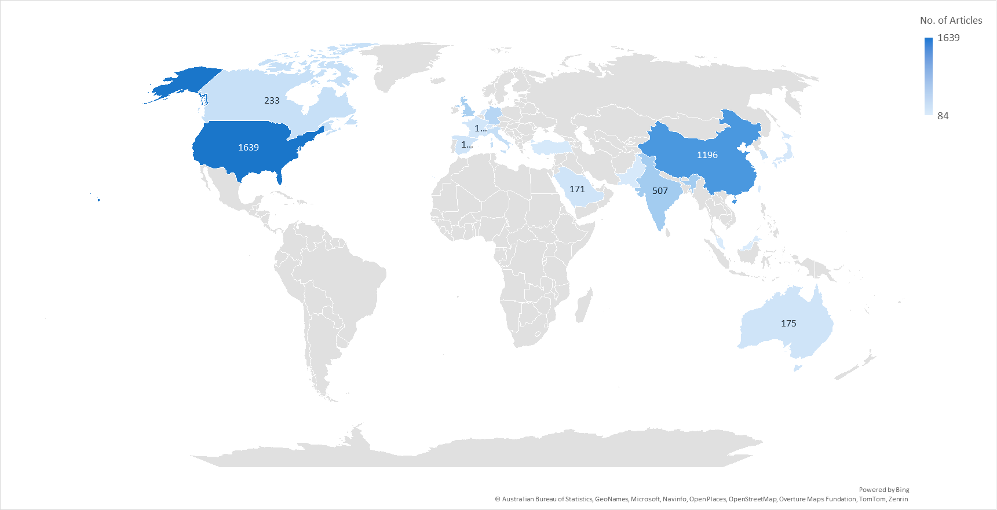
A
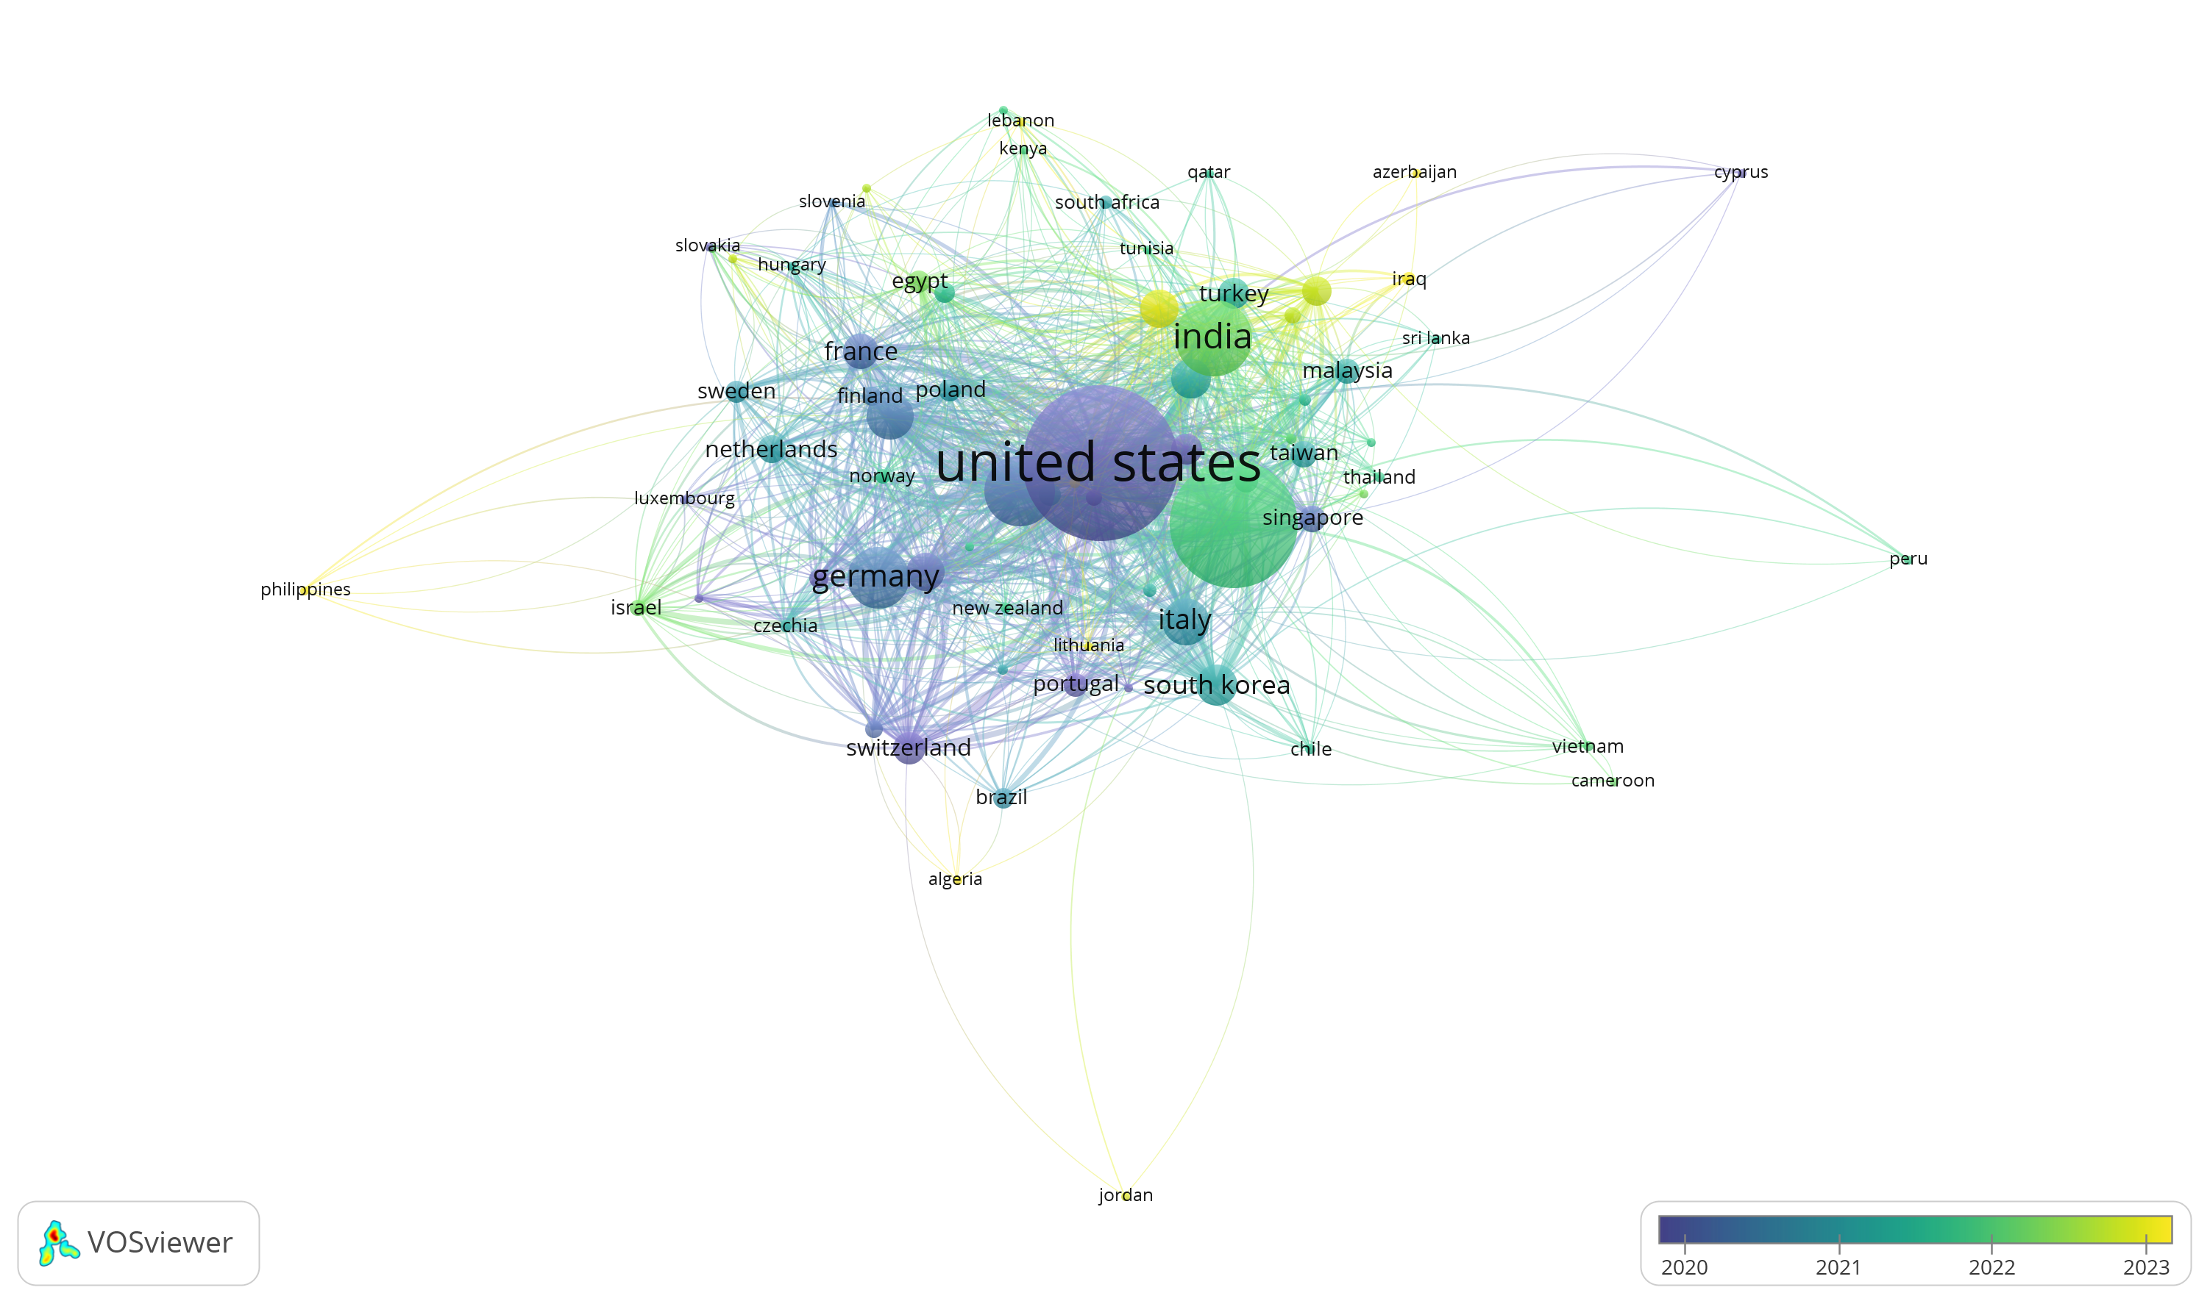
B
Figure 3: A-Top influential countries in AI and biotechnology and B- Collaboration network among the countries based on the number of publications
  - Influential Organization in AI and Biotechnology
The graphical representation of affiliation-based publication analysis highlights the leading research institutions contributing significantly to the scientific literature on AI in biotechnology. As illustrated in Figure 4, Among the top contributors, the University of California emerges as the most prolific, with 1,131 published articles, followed closely by University College Cork (1,078) and Jiangnan University (917). This high output reflects the strong research infrastructure, interdisciplinary initiatives, and global collaborations fostered by these institutions. The list showcases a diverse geographical distribution, encompassing major academic and research hubs across North America, Europe, and Asia. Chinese institutions, including Shanghai Jiao Tong University, Sun Yat-sen University, Zhejiang University, and Fudan University, prominently feature in the top ranks, underlining China’s rapidly growing influence in global research. North American universities such as Harvard Medical School, University of Toronto, McMaster University, and University of Alberta also contribute substantially, indicating the continued dominance of Western institutions in scientific advancement. Furthermore, the presence of institutions like Sichuan Agricultural University and China Agricultural University emphasizes the importance of agricultural research in addressing global challenges such as food security and sustainability. Medical research is also well represented, with contributions from renowned centres like Baylor College of Medicine and Washington University School of Medicine. Overall, this analysis underscores the critical role of leading academic institutions in driving high-impact, interdisciplinary research and highlights the evolving landscape of global scientific collaboration and knowledge production.
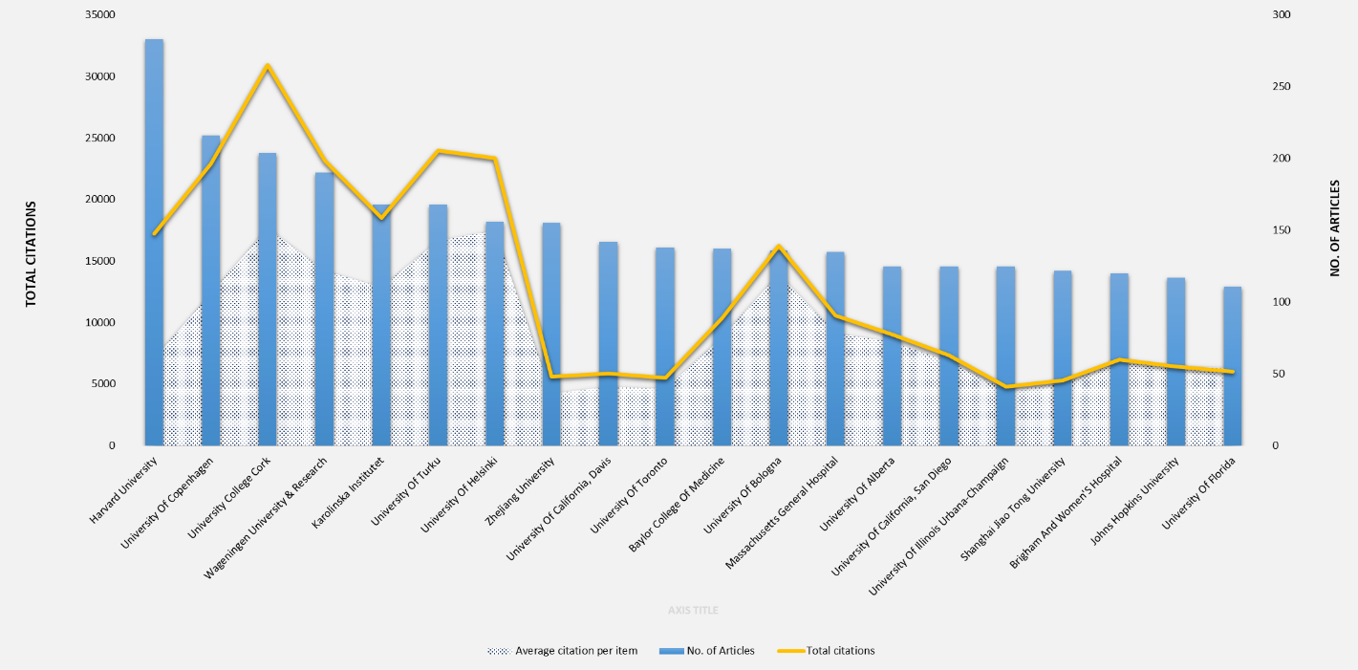
A
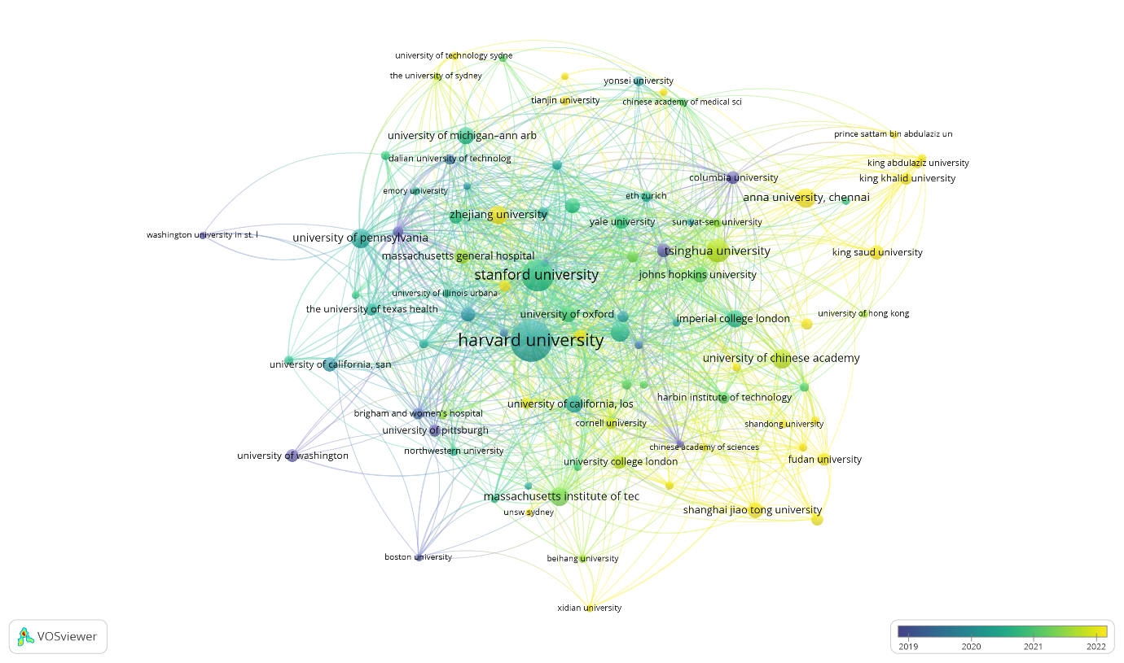
B
Figure 4: A-Influential Organization in AI in biotechnology and B- Collaboration network among the organization based on the number of publications
  - Influential Authors in AI and biotechnology
The bibliometric analysis of influential authors in AI applications within biotechnology provides valuable insights into key contributors shaping the field. As listed in Table 2 When ranked by the number of publications, Zhiyong Lu emerges as the most prolific researcher, with 28 articles and 1,693 total citations, reflecting his sustained and significant contributions to the domain. Other significant contributors, such as Jian Wang (14 articles) and Hua Xu (13 articles), have also demonstrated substantial research output, though their citation impact is relatively lower, suggesting that while they have contributed extensively, their influence in terms of research impact may be more specialized or developing. Interestingly, when ranked by total citations, a different set of researchers emerged as the most impactful. Fei Wang leads with 2,972 total citations across 10 articles, achieving an exceptionally high average citation per article (297.20), followed closely by Xiaoqian Jiang, who has amassed 2,239 citations with the same number of publications. These high citation numbers indicate that their work has had a profound influence on the AI-biotechnology intersection, possibly pioneering methodologies or widely adopted frameworks in the field. Aydogan Ozcan (1,356 citations) and Robert Leaman (1,164 citations) also stand out with significantly high average citations per article (123.27 and 129.33, respectively), suggesting that their research is not only innovative but also widely referenced within the scientific community. Several authors exhibit both high productivity and strong citation impact, positioning them as pivotal figures in AI-driven biotechnology. Riccardo Bellazzi (8 articles, 921 citations, avg. 115.13 citations/article) and Sophia Ananiadou (8 articles, 850 citations, avg. 106.25 citations/article) exemplify this trend, indicating a balance between research output and influence. Similarly, Chih-Hsuan Wei (12 articles, 889 citations, avg. 74.08 citations/article) and Hongfang Liu (12 articles, 580 citations, avg. 48.33 citations/article) demonstrate a strong presence in both publication volume and impact, reinforcing their significance in the field illustrated in Figure 5.
These findings highlight the distinction between research productivity and research impact. While some authors, such as Zhiyong Lu, lead in total publications, others, such as Fei Wang and Xiaoqian Jiang, have made fewer but highly influential contributions. The presence of researchers with exceptionally high citation averages, such as Jiang and Wang, suggests that breakthrough studies or foundational methodologies in AI applications in biotechnology have been concentrated among a select group of scholars. Moving forward, fostering interdisciplinary collaborations and increasing citation impact through high-quality, innovative research will be crucial in advancing the field.
Table 2: Influential Authors in AI and Biotechnology.
As per the number of articles

Rank | Influential Authors | No. of Articles | Total citations | Average citation per item
1 | Lu, Zhiyong | 28 | 1693 | 60.46
2 | Wang, Jian | 14 | 261 | 18.64
3 | Xu, Hua | 13 | 385 | 29.62
4 | Lin, Hongfei | 12 | 264 | 22.00
5 | Liu, Hongfang | 12 | 580 | 48.33
6 | Wei, Chih-Hsuan | 12 | 889 | 74.08
7 | Yang, Zhihao | 12 | 261 | 21.75
8 | Ozcan, Aydogan | 11 | 1356 | 123.27
9 | Wang, Wei | 11 | 399 | 36.27
10 | Chen, Wei | 10 | 858 | 85.80
11 | Jiang, Xiaoqian | 10 | 2239 | 223.90
12 | Liu, Yang | 10 | 341 | 34.10
13 | Wang, Fei | 10 | 2972 | 297.20
14 | Wang, Lei | 10 | 290 | 29.00
15 | Leaman, Robert | 9 | 1164 | 129.33
16 | Shen, Li | 9 | 294 | 32.67
17 | Xing, Lei | 9 | 352 | 39.11
18 | Ananiadou, Sophia | 8 | 850 | 106.25
19 | Baumbach, Jan | 8 | 230 | 28.75
20 | Bellazzi, Riccardo | 8 | 921 | 115.13
As per the number of citations

Rank | Influential Authors | No. of Articles | Total citations | Average citation per item
1 | Wang, Fei | 10 | 2972 | 297.20
2 | Jiang, Xiaoqian | 10 | 2239 | 223.90
3 | Lu, Zhiyong | 28 | 1693 | 60.46
4 | Ozcan, Aydogan | 11 | 1356 | 123.27
5 | Leaman, Robert | 9 | 1164 | 129.33
6 | Bellazzi, Riccardo | 8 | 921 | 115.13
7 | Wei, Chih-Hsuan | 12 | 889 | 74.08
8 | Chen, Wei | 10 | 858 | 85.80
9 | Ananiadou, Sophia | 8 | 850 | 106.25
10 | Liu, Hongfang | 12 | 580 | 48.33
11 | Wang, Wei | 11 | 399 | 36.27
12 | Xu, Hua | 13 | 385 | 29.62
13 | Xing, Lei | 9 | 352 | 39.11
14 | Liu, Yang | 10 | 341 | 34.10
15 | Shen, Li | 9 | 294 | 32.67
16 | Wang, Lei | 10 | 290 | 29.00
17 | Lin, Hongfei | 12 | 264 | 22.00
18 | Wang, Jian | 14 | 261 | 18.64
19 | Yang, Zhihao | 12 | 261 | 21.75
20 | Baumbach, Jan | 8 | 230 | 28.75
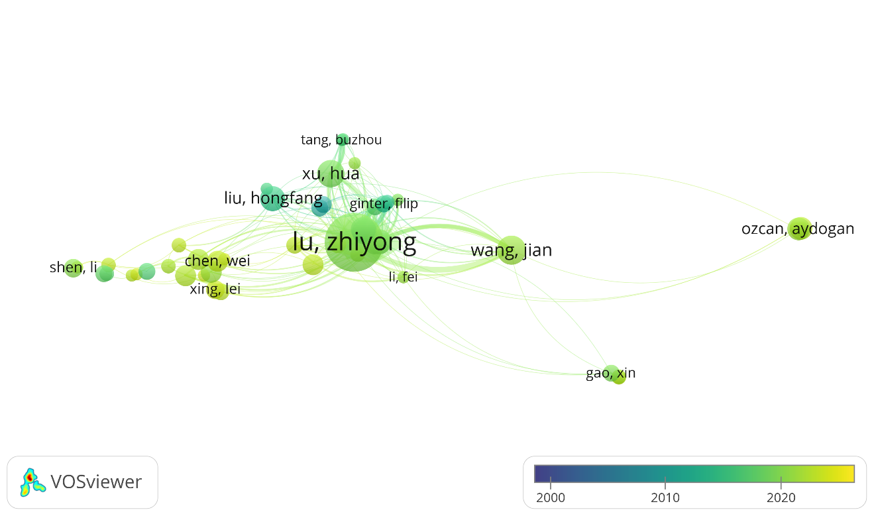
A
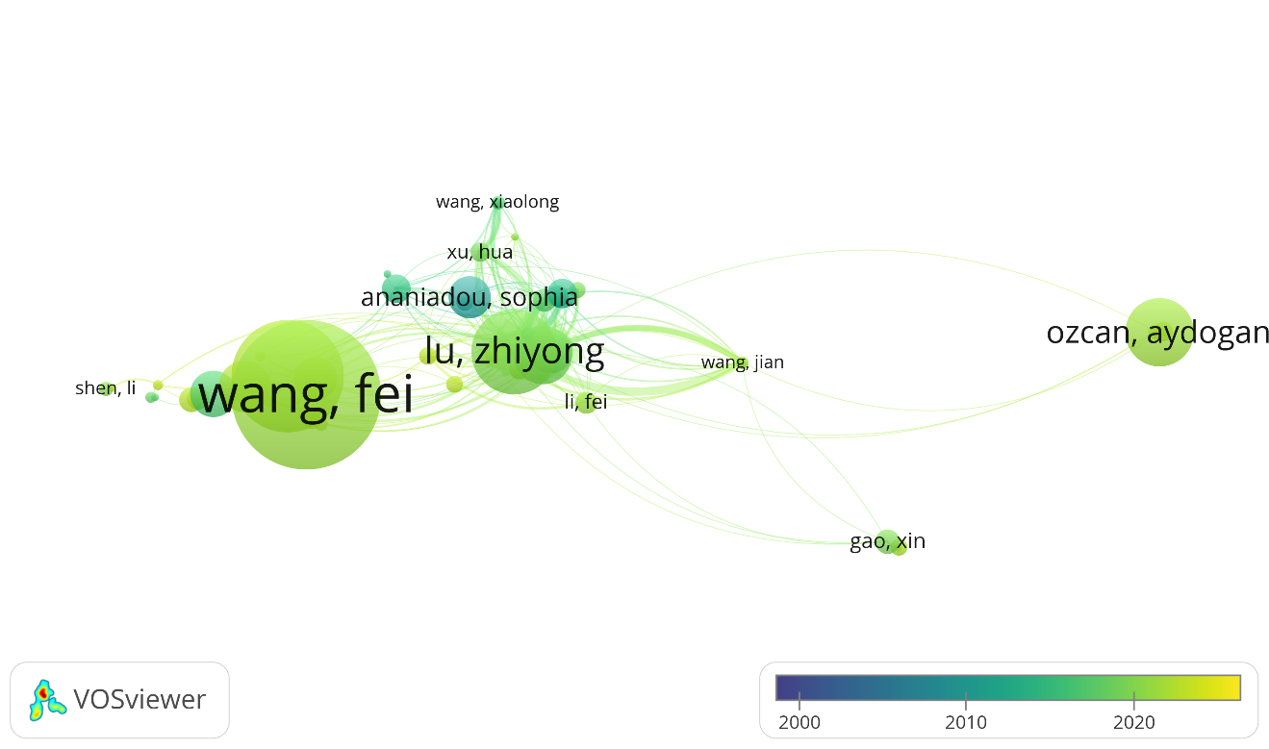
B
Figure 5: Collaboration network among the influential authors in terms of number of articles (A) and terms of number of citations (B)

- Top Journals in AI and biotechnology
The analysis of top publishing sources in the domain of AI and biotechnology from 2000 to 2025 reveals a highly dynamic and multidisciplinary research landscape. Among the 20 leading journals as listed in Table 3, BMC Bioinformatics stands out with the highest number of publications (114), reflecting its longstanding role as a foundational platform for bioinformatics research where AI tools are frequently integrated. However, despite its high volume, its average citation per article (36.32) is surpassed by several journals, highlighting that quantity does not necessarily equate to impact. In contrast, Briefings in Bioinformatics exhibits the highest average citation per article (90.93) and a robust CiteScore (13.2), indicating that while it publishes fewer papers (83), the research it disseminates is highly influential and widely cited—suggesting a strong emphasis on review articles and cutting-edge methodologies that resonate across disciplines. Bioinformatics and Nature Communications, with average citations of 50.45 and 52.82 respectively, also rank among the most impactful sources, supported by their exceptionally high H-indices (486 and 577, respectively). These journals serve as critical nodes for high-quality, interdisciplinary research that bridges AI algorithms with complex biological systems, particularly in areas such as systems biology, omics data integration, and predictive modeling. AI in Medicine also demonstrates remarkable impact (average citation 57.2), reflecting its strategic focus on AI-driven healthcare applications, including diagnostics, medical imaging, and decision support systems. These high-impact journals are consistently ranked in the top quartile (Q1), underscoring their reputational strength and scientific influence.
The presence of computationally intensive journals such as Computers in Biology and Medicine, IEEE Access, and the IEEE Journal of Biomedical and Health Informatics highlights the growing technical sophistication within the field, where algorithmic innovation and data-driven insights are central to advancing biotechnology. While some journals such as Sensors and Multimedia Tools and Applications have comparatively lower citation metrics, their inclusion signals the expanding frontiers of AI in domains like biosensor technology, wearable diagnostics, and real-time monitoring systems. The diversity of SNIP and SJR values across these sources also points to differing scopes, audience reach, and editorial strategies. For instance, Nature Communications and Briefings in Bioinformatics show both high SJR and SNIP scores, indicating broad international visibility and methodological rigor, while journals like Applied Sciences and IEEE/ACM Transactions on Computational Biology and Bioinformatics offer more niche, technically focused platforms that nonetheless contribute meaningfully to AI-biotech discourse.
Table 3: Top sources in AI and biotechnology
Sr. No. | Sources | No. of Articles | Total citations | Average citation per article | CiteScore | SJR | SNIP | H-Index | Journal Rank
1 | BMC Bioinformatics | 114 | 4140 | 36.3158 | 5.7 | 1.005 | 0.821 | 251 | Q1
2 | Bioinformatics | 87 | 4389 | 50.4483 | 11.2 | 2.574 | 1.547 | 486 | Q1
3 | Briefings in Bioinformatics | 83 | 7547 | 90.9277 | 13.2 | 2.143 | 1.497 | 159 | Q1
4 | IEEE Access | 80 | 1557 | 19.4625 | 9.8 | 0.96 | 1.44 | 290 | Q1
5 | Journal of Biomedical Informatics | 79 | 3895 | 49.3038 | 8.9 | 1.16 | 1.622 | 168 | Q1
6 | Scientific Reports | 78 | 1399 | 17.9359 | 7.5 | 0.9 | 1.182 | 347 | Q1
7 | IEEE Journal of Biomedical and Health Informatics | 60 | 2133 | 35.55 | 13.6 | 1.964 | 1.948 | 168 | Q1
8 | Sensors | 56 | 1084 | 19.3571 | 7.3 | 0.786 | 1.247 | 273 | Q1
9 | PloS One | 55 | 1416 | 25.7455 | 6.2 | 0.839 | 1.084 | 467 | Q1
10 | Applied Sciences | 54 | 1136 | 21.037 | 6.4 | 0.277 | 0.5 | 162 | Q2
11 | Computers In Biology and Medicine | 51 | 2113 | 41.4314 | 11.7 | 1.481 | 1.706 | 142 | Q1
12 | IEEE/ACM Transactions on Computational Biology and Bioinformatics | 40 | 573 | 14.325 | 7.5 | 0.794 | 0.982 | 96 | Q2
13 | Multimedia Tools and Applications | 40 | 774 | 19.35 | 7.2 | 0.801 | 1.245 | 116 | Q1
14 | Journal of the American Medical Informatics Association | 39 | 1872 | 48 | 14.5 | 2.123 | 1.972 | 184 | Q1
15 | Nature Communications | 39 | 2060 | 52.8205 | 24.9 | 4.887 | 3.01 | 577 | Q1
16 | Computer Methods and Programs in Biomedicine | 38 | 1829 | 48.1316 | 5.9 | 0.731 | 1.3 | 150 | Q1
17 | Artificial Intelligence in Medicine | 35 | 2002 | 57.2 | 15 | 1.723 | 2.189 | 118 | Q1
18 | PloS Computational Biology | 32 | 1406 | 43.9375 | 7.1 | 1.652 | 1.085 | 227 | Q1
19 | Biomedical Signal Processing and Control | 30 | 629 | 20.9667 | 9.8 | 1.284 | 1.651 | 125 | Q1
20 | BMC Medical Informatics and Decision Making | 29 | 1591 | 54.8621 | 7.2 | 1.002 | 1.304 | 107 | Q1
Note: Citescore, SJR, and SNIP were sourced from Scopus and Journal ranking was sourced from Scimago.
Taken together, the journal landscape underscores a convergence of AI and biotechnology research across informatics, computational biology, medicine, and applied sciences. The data reflect not only where foundational and transformative work is published but also provide strategic insights for researchers aiming to maximize visibility, citations, and cross-disciplinary engagement. This diversified yet interconnected journal ecosystem is crucial for sustaining innovation and translating AI-driven discoveries into tangible biotechnological solutions.
- Co-citation analysis in AI and biotechnology
The co-citation analysis in the field of AI and biotechnology reveals the most influential scientific journals shaping the research landscape. The results listed in Table 4 and Figure 6 highlight a strong concentration of citations in a few key sources, with Bioinformatics (4,566 citations), Nature (4,455 citations), and Lecture Notes in Computer Science (4,411 citations) emerging as the most frequently co-cited journals. This indicates that AI applications in biotechnology are deeply rooted in computational biology, high-impact scientific research, and applied computer science methodologies. The prominence of Scientific Reports (4,293 citations) further suggests that interdisciplinary research, particularly studies bridging AI and life sciences, is gaining substantial recognition.
The clustering pattern in the co-citation network provides deeper insights into the structural organization of research domains. The majority of high-impact journals, such as Bioinformatics, Nature Communications, Science, Nucleic Acids Research, and Proceedings of the National Academy of Sciences, belong to a dominant cluster that focuses on bioinformatics, genomics, and computational biology. A separate computational AI cluster consists of sources such as Lecture Notes in Computer Science, IEEE Transactions on Medical Imaging, and Journal of Biomedical Informatics, emphasizing the role of AI-driven computational approaches in biomedical applications. Additionally, an emerging cluster featuring Advanced Materials and Sensors indicates the growing integration of AI with materials science and biosensing technologies, which are crucial for developing next-generation biomedical devices and diagnostic tools.
The total link strength metric, which quantifies the extent of co-citation relationships among sources, is highest for Nature Communications (341,357) and Nature (336,498), underscoring their role as central hubs in the dissemination of AI-driven biotechnology research. These journals act as bridges between different scientific disciplines, facilitating cross-domain integration of AI methodologies in biological and biomedical sciences. The strong co-citation patterns observed for Briefings in Bioinformatics (1,495 citations) and IEEE Transactions on Medical Imaging (1,944 citations) further suggest the increasing significance of AI in specialized applications, such as machine learning-driven genomic data analysis and advanced medical imaging technologies.
These findings underscore the dynamic evolution of AI in biotechnology, where computational biology, biomedical informatics, and interdisciplinary research play a pivotal role in advancing the field. The presence of material science and sensor-related journals in the co-citation network highlights an emerging trend toward AI-driven innovations in bioengineering and medical diagnostics. Future research in this domain is likely to benefit from enhanced interdisciplinary collaboration, integrating AI expertise with biological sciences, materials engineering, and biomedical technologies to address complex challenges and unlock novel applications in biotechnology.
Table 4: Top 20 sources of co-citation analysis.
Sr. No. | Sources | Cluster | Links | Total link strength | Citations
1 | Bioinformatics | 3 | 495 | 279280 | 4566
2 | Nature | 3 | 504 | 336498 | 4455
3 | Lecture notes in computer science | 1 | 503 | 200957 | 4411
4 | Scientific reports | 4 | 504 | 319227 | 4293
5 | Nature communications | 3 | 504 | 341357 | 3715
6 | Nucleic acids research | 3 | 487 | 245151 | 3622
7 | Science | 3 | 504 | 256559 | 3125
8 | Plos one | 1 | 504 | 188596 | 2860
9 | Proceedings of the national academy of sciences of the United States of America | 3 | 504 | 234226 | 2809
10 | BMC Bioinformatics | 3 | 494 | 150880 | 2616
11 | Nature Methods | 3 | 503 | 152250 | 2005
12 | IEEE transactions on medical imaging | 1 | 479 | 101142 | 1944
13 | Advanced materials | 2 | 495 | 188902 | 1699
14 | Nature Biotechnology | 3 | 503 | 140369 | 1683
15 | Journal of Biomedical Informatics | 1 | 477 | 77616 | 1646
16 | IEEE Access | 1 | 504 | 86889 | 1642
17 | Briefings in bioinformatics | 3 | 490 | 105249 | 1495
18 | Sensors | 1 | 504 | 88645 | 1490
19 | Journal of the American Medical Informatics Association | 1 | 444 | 62973 | 1424
20 | Cell | 3 | 500 | 115885 | 1413

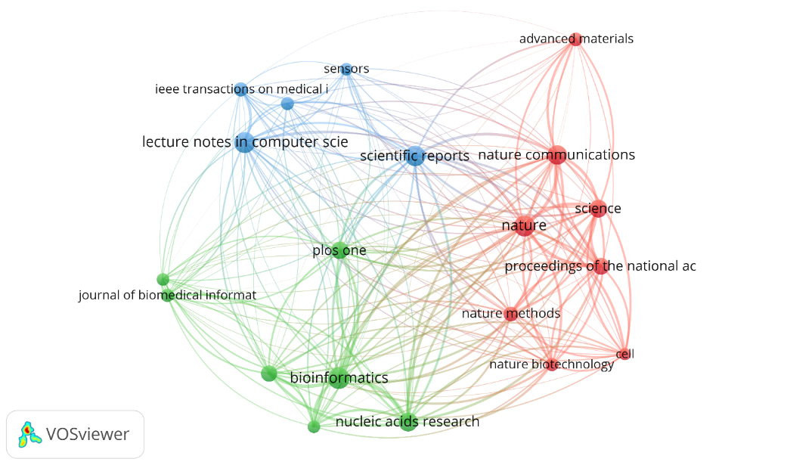
Figure 6: Collaboration network of co-citation of sources
- Bibliometric Coupling
Bibliometric coupling is a technique in bibliometric analysis used to evaluate the similarity between two documents based on the number of references they share. This method is especially useful for uncovering thematic relationships among recent publications, even when they do not directly cite each other. Bibliometric coupling occurs when two documents cite the same third document, suggesting they may address related topics. Consequently, this approach facilitates the analysis of connections between publications and offers insights into the significance and positioning of documents within a research network (Kessler, 1963). In the context of AI applications in biotechnology, bibliometric coupling analysis reveals the interconnectedness of scholarly contributions, highlighting influential documents, sources, authors, institutions, and countries that shape this interdisciplinary field. By examining these elements, the study identifies the most impactful research and emerging trends that are driving AI-driven innovations in biotechnology.
- Document-Level Bibliometric Coupling
Document-level bibliometric coupling reveals key studies that serve as foundational references in AI applications in biotechnology. As mentioned in Table 5 and Figure 7, the most influential document in the dataset is Nam (2022), exhibiting the highest total link strength (2097), indicating its pivotal role in connecting AI-driven methodologies with biotechnological advancements. Other highly coupled documents, such as Xing (2017) and Ching (2018), have received substantial citations (352 and 1746, respectively), signifying their long-term impact on AI integration in biomedical research. The high citation count of Ching (2018) suggests that this work has contributed significantly to the conceptual framework of AI applications in genomics, drug discovery, and precision medicine.
Table 5: Document-Level Bibliometric Coupling
Sr. No. | Documents | Total link strength | Citations
1 | Nam (2022) | 2097 | 8
2 | Xing (2017) | 2028 | 352
3 | Ching (2018) | 1898 | 1746
4 | Klauschen (2023) | 1888 | 48
5 | Seo (2020) | 1869 | 221
6 | Jo (2018) | 1863 | 185
7 | Jiang (2023) | 1837 | 25
8 | Cao (2018) | 1756 | 527
9 | Punn (2022B) | 1737 | 136
10 | Rabbi (2022) | 1701 | 18
11 | Eitel (2021) | 1691 | 45
12 | De Haan (2019) | 1677 | 127
13 | Liu (2021B) | 1672 | 129
14 | Riordon (2018) | 1601 | 184
15 | Kaur (2021A) | 1591 | 37
16 | Choi (2017) | 1566 | 62
17 | Watson (2022) | 1563 | 22
18 | Ibtehaz (2019) | 1548 | 1667
19 | Li (2025B) | 1530 | 2
20 | Von Chamier (2019) | 1524 | 96
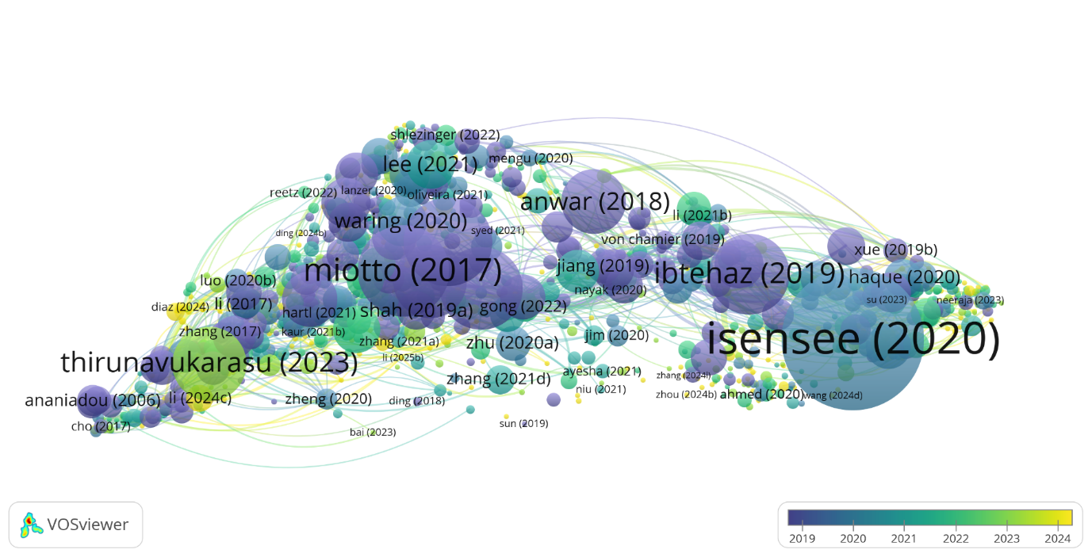
Figure 7: Document-level bibliometric coupling network
Recent publications, such as Klauschen (2023) and Seo (2020), demonstrate the growing application of deep learning models and computational frameworks in biotechnology, particularly in clinical diagnostics and bioinformatics. The inclusion of newer documents in the top 20 highlights the rapid evolution of AI technologies in the field, emphasizing the continuous development of machine learning-based analytical tools for biological data processing. These results confirm that AI in biotechnology is a dynamic and evolving domain, with foundational research influencing emerging methodologies in precision medicine, computational biology, and automated healthcare solutions.
- Source-Level Bibliometric Coupling
Analyzing source-level bibliometric coupling identifies the primary journals and academic platforms where AI-biotechnology research is published. The most influential sources include Briefings in Bioinformatics, BMC Bioinformatics, and IEEE Access, all of which exhibit the highest link strength and document contributions as listed in Table 6 and illustrated in Figure 8. These journals serve as crucial platforms for disseminating research on AI applications in bioinformatics, computational genomics, and biomedical informatics. The strong coupling strength of Computers in Biology and Medicine and the Journal of Biomedical Informatics further highlights the intersection of AI-driven computational techniques with medical and biological sciences.
Table 6: Source-Level Bibliometric Coupling.
Sr. No. | Sources | Document | Total link strength | Citations
1 | Briefings In Bioinformatics | 26051 | 83 | 7547
2 | BMC Bioinformatics | 19210 | 114 | 4140
3 | IEEE Access | 17278 | 80 | 1557
4 | Computers In Biology and Medicine | 16079 | 51 | 2113
5 | Journal Of Biomedical Informatics | 14433 | 79 | 3895
6 | IEEE Journal of Biomedical Health Informatics | 13348 | 60 | 2133
7 | Bioinformatics | 12649 | 87 | 4389
8 | Applied Sciences | 10691 | 54 | 1136
9 | Scientific Reports | 10642 | 78 | 1399
10 | Sensors | 8735 | 56 | 1084
11 | Computer Methods and Programs in Biomedicine | 8241 | 38 | 1829
12 | Plos One | 7937 | 55 | 1416
13 | Artificial Intelligence Review | 7431 | 16 | 830
14 | IEEE/ACM Transactions on Computational Biology and Bioinformatics | 7372 | 40 | 573
15 | Neurocomputing | 7254 | 17 | 688
16 | Nature Communications | 6702 | 39 | 2060
17 | IEEE Transactions on Medical Imaging | 6666 | 23 | 2125
18 | Artificial Intelligence in Medicine | 6622 | 35 | 2002
19 | Database | 6533 | 25 | 717
20 | Multimedia Tools and Applications | 6253 | 40 | 774
The dominance of these sources suggests that AI-driven biotechnology research is concentrated in highly specialized journals with a focus on computational methods for analyzing biological data. This finding aligns with the increasing adoption of AI in genomics, drug discovery, and clinical diagnostics, where computational models enhance the accuracy and efficiency of biological analyses. The presence of Nature Communications and Scientific Reports among the most coupled sources indicates that AI-driven biotechnology research is also gaining recognition in high-impact interdisciplinary journals, broadening its reach within the scientific community.
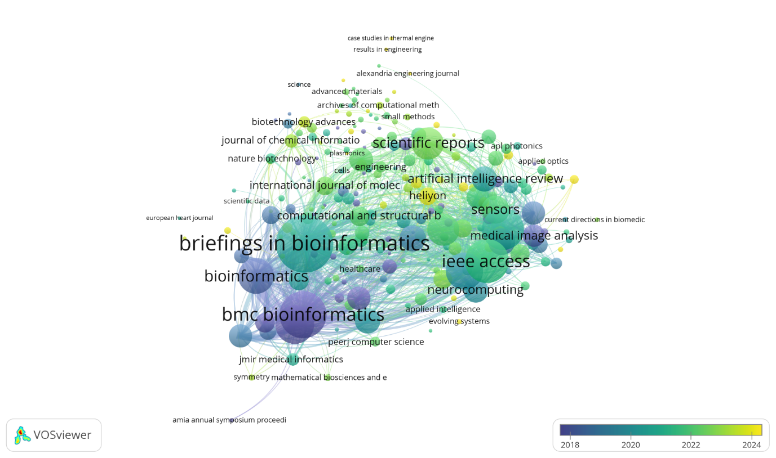
Figure 8: Source-Level Bibliometric Coupling network
- Author-Level Bibliometric Coupling
The author-level analysis identifies leading researchers who have significantly contributed to AI applications in biotechnology. As mentioned in Table 7, Lu Zhiyong emerges as the most influential researcher with the highest total link strength (7187), reflecting his extensive contributions to biomedical text mining and AI-driven knowledge discovery in healthcare. Other highly coupled authors, such as Wei, Chih-Hsuan and Leaman, Robert, are known for their work on AI applications in natural language processing for biomedical research, particularly in automated literature analysis and medical text classification.
Table 7: Author-Level Bibliometric Coupling
Sr. No. | Author | Total link strength | Document | Citations
1 | Lu, Zhiyong | 7187 | 28 | 1693
2 | Wei, Chih-Hsuan | 3854 | 12 | 889
3 | Leaman, Robert | 3540 | 9 | 1164
4 | Wang, Jian | 3340 | 14 | 261
5 | Chen, Qingyu | 3004 | 8 | 243
6 | Yang, Zhihao | 2955 | 12 | 261
7 | Lin, Hongfei | 2914 | 12 | 264
8 | Xu, Hua | 2788 | 13 | 385
9 | Wang, Fei | 2633 | 10 | 2972
10 | Zeng, Xiangxiang | 2146 | 8 | 366
11 | Luo, Ling | 1989 | 5 | 66
12 | Ozcan, Aydogan | 1888 | 11 | 1356
13 | Wang, Lei | 1492 | 10 | 290
14 | Peng, Yifan | 1357 | 7 | 390
15 | Zhu, Yongjun | 1323 | 5 | 235
16 | Ginter, Filip | 1315 | 8 | 441
17 | Rivenson, Yair | 1289 | 5 | 976
18 | Tang, Buzhou | 1265 | 6 | 214
19 | Pyysalo, Sampo | 1264 | 8 | 453
20 | Kang, Jaewoo | 1254 | 6 | 319
Additionally, Wang, Jian and Chen, Qingyu have contributed extensively to AI-based data analytics in genomics and computational drug discovery. The strong bibliometric coupling among these researchers suggests a highly interconnected research network focused on developing AI methodologies for biological data processing, predictive analytics, and precision medicine as illustrated in Figure 9. The presence of both established and emerging researchers in the top 20 indicates a healthy research ecosystem, with senior scientists mentoring the next generation of AI-biotechnology experts.
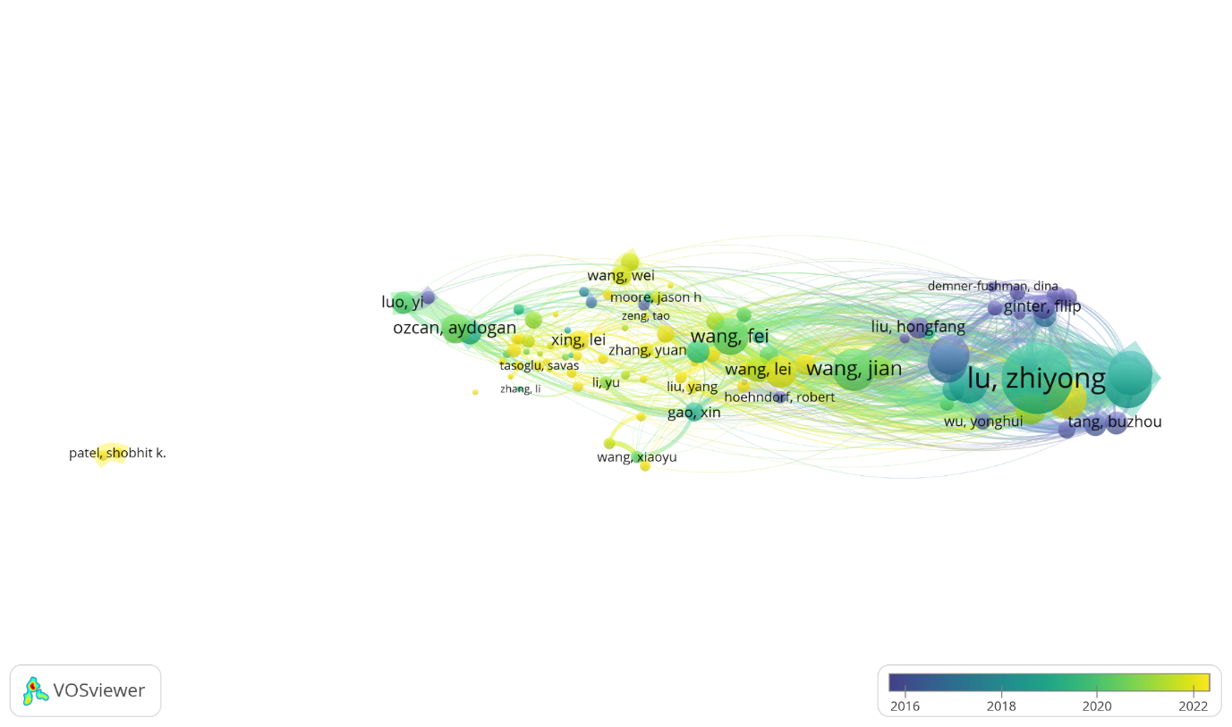
Figure 9: Author-level bibliometric coupling network
- Organization-Level Bibliometric Coupling
Institutional-level bibliometric coupling identifies the most active research organizations contributing to AI applications in biotechnology. As listed in Table 8, Harvard University (79,997 link strength) and Stanford University (64,832 link strength) are the leading institutions, reflecting their dominance in AI-driven biomedical research. These institutions have pioneered the integration of AI with genomics, bioinformatics, and computational biology, driving major innovations in disease prediction, personalized medicine, and drug development.
Table 8: Organization-Level Bibliometric Coupling
Sr. No. | Organization | Total link strength | Document | Citations
1 | Harvard University | 79997 | 111 | 8534
2 | Stanford University | 64832 | 85 | 9784
3 | Tsinghua University | 44745 | 61 | 3880
4 | Imperial College London | 38187 | 46 | 1296
5 | Massachusetts Institute of Technology | 35145 | 50 | 4009
6 | University Of Pennsylvania | 33527 | 51 | 3158
7 | University Of California, Los Angeles | 32445 | 45 | 2253
8 | University Of Michigan–Ann Arbor | 32197 | 45 | 3378
9 | Zhejiang University | 31160 | 50 | 1771
10 | University Of Oxford | 29928 | 41 | 2705
11 | University College London | 29283 | 36 | 1156
12 | University Of Toronto | 27468 | 49 | 3146
13 | Massachusetts General Hospital | 27105 | 40 | 1856
14 | Central South University | 26512 | 30 | 910
15 | Shanghai Jiao Tong University | 25938 | 42 | 856
16 | University Of Chinese Academy Of Sciences | 25811 | 52 | 1844
17 | University Of Cambridge | 25669 | 38 | 3421
18 | Nanyang Technological University | 24602 | 40 | 3094
19 | Hunan University | 24083 | 31 | 1221
20 | Fudan University | 23715 | 35 | 1019
Other key contributors include Tsinghua University and Imperial College London, which have made significant advancements in deep learning applications for biotechnology. MIT, with its expertise in computational modeling and AI-based drug discovery, also ranks among the top institutions. The strong presence of these universities underscores the role of interdisciplinary collaboration between AI researchers and biotechnologists in advancing the field as displayed in Figure10. Furthermore, the prominence of institutions from North America, Europe, and Asia suggests a globalized research landscape where AI-biotechnology innovations are being developed across multiple geographic regions.
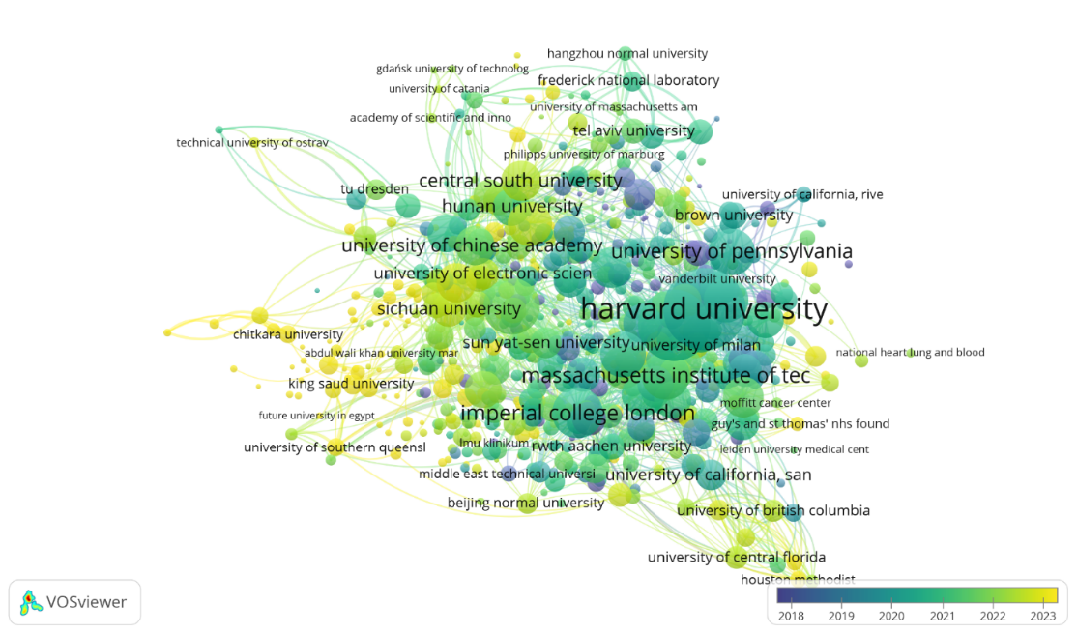
Figure 10: Organization-Level Bibliometric Coupling Network
- Country-Level Bibliometric Coupling
Country-level bibliometric coupling provides insights into the geographic distribution of AI-biotechnology research. As listed in Table 9, the United States leads with the highest total link strength (535,321) and citations (89,193), reaffirming its position as the global leader in AI-driven biotechnology. The US dominance is attributed to its strong research infrastructure, funding initiatives, and collaborations between academia and industry. China, with a total link strength of 427,469 and 34,296 citations, follows as the second-largest contributor, reflecting its rapid advancements in AI-based biomedical research, particularly in deep learning applications for medical diagnostics and bioinformatics.
Table 9: Country-Level Bibliometric Coupling
Sr. No. | Organization | Total link strength | Document | Citations
1 | United States | 535321 | 1639 | 89193
2 | China | 427469 | 1196 | 34296
3 | United Kingdom | 227961 | 455 | 27772
4 | Germany | 184272 | 359 | 22638
5 | India | 162841 | 507 | 10293
6 | Italy | 120154 | 240 | 9621
7 | Canada | 117337 | 233 | 11671
8 | South Korea | 95767 | 192 | 7241
9 | Australia | 82153 | 175 | 6765
10 | France | 76657 | 146 | 6462
11 | Spain | 70878 | 171 | 5797
12 | Switzerland | 63154 | 132 | 8265
13 | Singapore | 54660 | 92 | 6522
14 | Japan | 54641 | 119 | 4417
15 | Saudi Arabia | 48983 | 171 | 4104
16 | Pakistan | 46007 | 111 | 4004
17 | Netherlands | 43293 | 105 | 4396
18 | Turkey | 42812 | 115 | 5483
19 | Denmark | 40236 | 69 | 4553
20 | Portugal | 40063 | 78 | 3069
European countries such as the United Kingdom and Germany also demonstrate strong bibliometric coupling, indicating their significant role in AI-driven life sciences research. India emerges as a growing research hub, reflecting its increasing contributions to AI in healthcare and genomics. The presence of these countries among the top 20 highlights the global nature of AI-biotechnology research, with emerging economies gradually increasing their impact in this domain. Figure 11 illustrates the bibliometric coupling network among the top 20 countries.
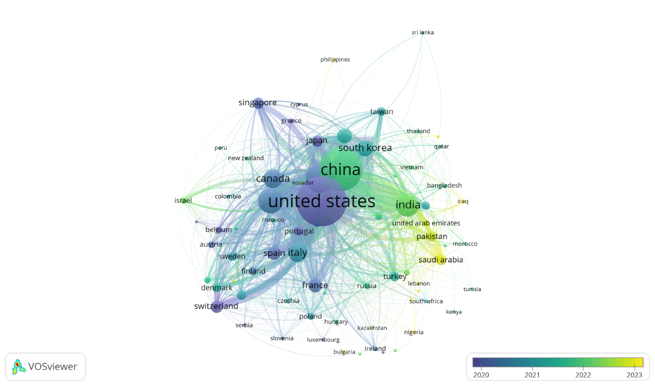
Figure 11: Country-Level Bibliometric Coupling Network
- Keywords co-occurrence in title and abstract
The bibliometric analysis of AI in biotechnology reveals a rapidly evolving research landscape characterized by significant advancements in machine learning, deep learning, and biomedical applications. The co-occurrence network visualization and keyword frequency data highlight the central role of "algorithm," "model," "dataset," and "technology" in shaping AI-driven biotechnological innovations. These terms indicate a strong research focus on predictive modeling, computational biology, and biomedical imaging, where AI is increasingly employed for disease detection, genomic analysis, and drug discovery. The presence of "biomedical application," "detection," and "biomedical imaging" in interconnected clusters further underscores AI’s transformative impact on medical diagnostics and personalized medicine, particularly through convolutional neural networks and artificial neural networks.
The temporal gradient in the VOSviewer diagram suggests that newer research trends are emerging, with keywords like "feature," "parameter," and "deep learning" gaining prominence in recent studies. This indicates a shift towards more sophisticated AI models for biological data interpretation and automated decision-making. The integration of AI into bioprocess automation, smart medical devices, and industrial biotechnology is further reflected in terms like "development," "device," and "industry," highlighting AI’s role in streamlining laboratory workflows and optimizing biomanufacturing processes. Moreover, the growing emphasis on "environment," "sustainability," and "future" suggests that AI is increasingly applied in green biotechnology, biofuel production, and environmental monitoring, positioning it as a key enabler of sustainable and precision-driven biotechnological solutions.
Despite these advancements, the analysis also identifies critical challenges. The presence of "risk," "response," and "gap" points to the necessity for robust, interpretable, and ethically responsible AI models. Additionally, terms such as "review," "survey," and "publication" indicate an ongoing discourse on the regulatory, ethical, and reproducibility concerns surrounding AI implementation in biotechnology as displayed in Figure 12. Ensuring the reliability and transparency of AI-driven solutions remains a fundamental priority, particularly in applications involving healthcare, genomics, and synthetic biology. Addressing these challenges will require a concerted effort to develop standardized validation techniques, interdisciplinary collaboration frameworks, and regulatory policies to enhance AI’s trustworthiness and impact in biotechnology.
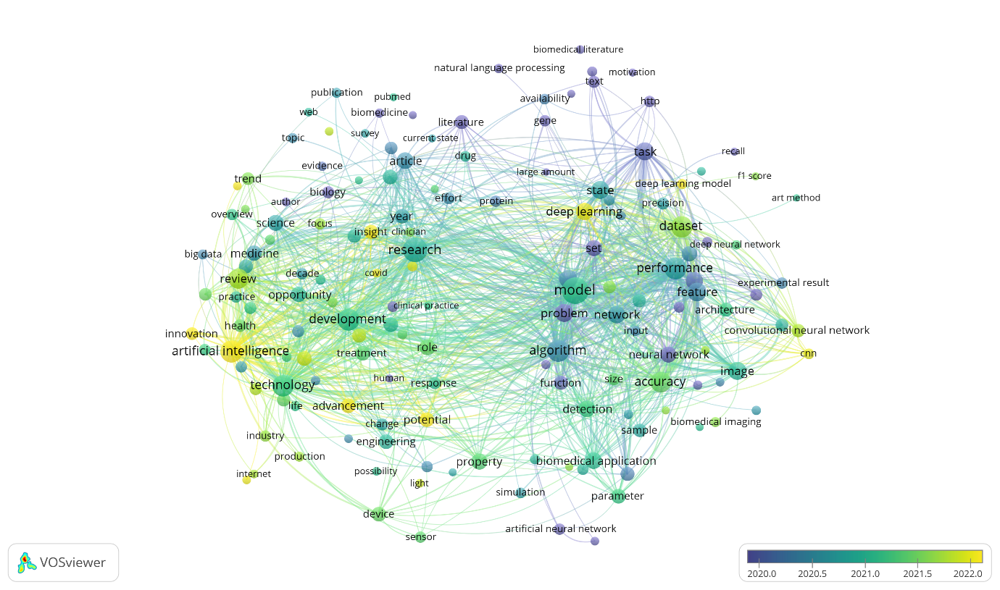
Figure 12: Keywords co-occurrence network

4. Ethical and Societal Implications
The integration of AI in biotechnology raises critical ethical challenges that demand rigorous regulatory frameworks and societal engagement. While existing regulations such as the General Data Protection Regulation (GDPR) and Health Insurance Portability and Accountability Act (HIPAA) provide foundational guidelines for data privacy, they often fall short in addressing AI-specific risks, such as algorithmic bias in genomic analyses or the exploitation of sensitive health data by third-party platforms (Edemekong et al., 2025).For instance, biased training datasets may perpetuate healthcare disparities by underrepresenting minority populations, while opaque AI models ("black boxes") hinder accountability in clinical decision-making. Societal implications extend to genetic discrimination, where AI-driven insights into predispositions for diseases could influence insurance coverage or employment opportunities, exacerbating inequalities. Furthermore, cross-border data sharing for collaborative research conflicts with jurisdictional disparities in privacy laws, complicating global innovation. To mitigate these risks, a harmonized regulatory approach is imperative, combining technical standards for algorithmic transparency (e.g., explainable AI), stringent consent protocols for biometric data, and international agreements to govern ethical AI deployment. Interdisciplinary collaboration among policymakers, ethicists, and technologists is essential to balance innovation with societal trust, ensuring AI-driven biotechnology advances equitably and responsibly.

Conclusion
This bibliometric analysis underscores the transformative impact of artificial intelligence on biotechnology, highlighting a marked increase in research activity between 2000 and 2025. Key areas of application include drug discovery, genomics, diagnostics, synthetic biology, and systems biology, where AI methodologies such as machine learning, deep learning, and natural language processing are increasingly integrated. The analysis identifies leading countries, institutions, authors, and journals contributing to the field, along with emerging themes such as precision medicine, CRISPR-based gene editing, and sustainable bioprocessing. Despite these promising developments, challenges remain. Issues related to data standardization, model interpretability, ethical concerns, and integration with experimental workflows must be addressed to ensure responsible advancement. Additionally, while this study provides a macro-level view of research trends, it does not assess the real-world implementation or clinical utility of the AI applications discussed. Looking ahead, future research should prioritize the development of transparent and generalizable AI frameworks, foster cross-disciplinary collaboration, and support regulatory mechanisms to ensure ethical deployment. Expanding bibliometric analyses to include qualitative insights and non-English literature may also offer a more comprehensive view. This study serves as a valuable reference for researchers, funding bodies, and policymakers seeking to navigate and shape the evolving landscape of AI-driven biotechnology.
Limitations of the study
Similar to other bibliometric studies, this research also has some limitations. Firstly, regarding the data source, this study relied on dimension.ai databases for bibliometric analysis. While these databases are widely recognized for their extensive coverage of biomedical and interdisciplinary research, they do not encompass all relevant literature. Second, bibliometric analyses are inherently dependent on keyword selection and search strategies, which may result in the exclusion of pertinent studies due to variations in terminology or indexing inconsistencies. Third, while the study provides quantitative insights into publication trends, research collaborations, and thematic evolution, it lacks qualitative assessments of the actual impact, effectiveness, or ethical considerations of AI applications in biotechnology. Additionally, citation-based metrics do not always reflect the real-world influence of scientific contributions, as highly cited articles may not necessarily represent the most innovative or practically significant advancements. Finally, the dynamic nature of AI research, characterized by rapid technological advancements and evolving applications, means that the trends identified in this study may change in the near future, necessitating periodic updates and further longitudinal assessments.
However, bibliometric analysis provides insights into research trends, collaborations, and thematic developments at a macro level but does not explore the specific technical advancements, ethical considerations, or real-world impact of AI applications in biotechnology. Despite these potential limitations, bibliometric analysis remains a powerful tool for evaluating the intellectual landscape, identifying emerging trends, and guiding future research directions. Therefore, we are confident that the results presented in this study offer valuable insights into the intersection of AI and biotechnology.

COMPETING INTERESTS DISCLAIMER:
Authors have declared that they have no known competing financial interests OR non-financial interests OR personal relationships that could have appeared to influence the work reported in this paper.

Disclaimer (Artificial intelligence)

Option 1:

Author(s) hereby declare that NO generative AI technologies such as Large Language Models (ChatGPT, COPILOT, etc.) and text-to-image generators have been used during the writing or editing of this manuscript.

Option 2:

Author(s) hereby declare that generative AI technologies such as Large Language Models, etc. have been used during the writing or editing of manuscripts. This explanation will include the name, version, model, and source of the generative AI technology and as well as all input prompts provided to the generative AI technology

Details of the AI usage are given below:
1.
2.
3.

- References
Alzahrani, A. A., & Alharithi, F. S. (2024). Machine learning approaches for advanced detection of rare genetic disorders in whole-genome sequencing. Alexandria Engineering Journal, 106, 582–593. https://doi.org/10.1016/j.aej.2024.08.056
Arora, N. K., & Fatima, T. (2024). Environmental sustainability and biotechnology: Opportunities and challenges. Environmental Sustainability, 7(2), 115–119. https://doi.org/10.1007/s42398-024-00317-9
Aziz, D., Rafiq, S., Saini, P., Ahad, I., Gonal, B., Rehman, S. A., Rashid, S., Saini, P., Rohela, G. K., Aalum, K., Singh, G., Gnanesh, B. N., & Nabila Iliya, M. (2025). Remote sensing and artificial intelligence: Revolutionizing pest management in agriculture. Frontiers in Sustainable Food Systems, 9, 1551460. https://doi.org/10.3389/fsufs.2025.1551460
Balagurunathan, Y., & Sethuraman, R. R. (2024). An Analysis of Ethics-Based Foundation and Regulatory Issues for Genomic Data Privacy. Journal of The Institution of Engineers (India): Series B, 105(4), 1097–1107. https://doi.org/10.1007/s40031-024-01058-3
Bhatia, N., Khan, M. M. U., & Arora, S. (2024). The Role of Artificial Intelligence in Revolutionizing Pharmacological Research. Current Pharmacology Reports, 10(6), 323–329. https://doi.org/10.1007/s40495-024-00367-x
Briscoe, N. J., Morris, S. D., Mathewson, P. D., Buckley, L. B., Jusup, M., Levy, O., Maclean, I. M. D., Pincebourde, S., Riddell, E. A., Roberts, J. A., Schouten, R., Sears, M. W., & Kearney, M. R. (2023). Mechanistic forecasts of species responses to climate change: The promise of biophysical ecology. Global Change Biology, 29(6), 1451–1470. https://doi.org/10.1111/gcb.16557
Chen, Y.-M., Hsiao, T.-H., Lin, C.-H., & Fann, Y. C. (2025). Unlocking precision medicine: Clinical applications of integrating health records, genetics, and immunology through artificial intelligence. Journal of Biomedical Science, 32(1), 16. https://doi.org/10.1186/s12929-024-01110-w
Cheng, Y., Bi, X., Xu, Y., Liu, Y., Li, J., Du, G., Lv, X., & Liu, L. (2023). Machine learning for metabolic pathway optimization: A review. Computational and Structural Biotechnology Journal, 21, 2381–2393. https://doi.org/10.1016/j.csbj.2023.03.045
Choudhury, C., Arul Murugan, N., & Priyakumar, U. D. (2022). Structure-based drug repurposing: Traditional and advanced AI/ML-aided methods. Drug Discovery Today, 27(7), 1847–1861. https://doi.org/10.1016/j.drudis.2022.03.006
da Silva, R. G. L. (2024). The advancement of artificial intelligence in biomedical research and health innovation: Challenges and opportunities in emerging economies. Globalization and Health, 20(1), 44. https://doi.org/10.1186/s12992-024-01049-5
Donthu, N., Kumar, S., Mukherjee, D., Pandey, N., & Lim, W. M. (2021). How to conduct a bibliometric analysis: An overview and guidelines. Journal of Business Research, 133, 285–296. https://doi.org/10.1016/j.jbusres.2021.04.070
Edemekong, P. F., Annamaraju, P., Afzal, M., & Haydel, M. J. (2025). Health Insurance Portability and Accountability Act (HIPAA) Compliance. In StatPearls. StatPearls Publishing. http://www.ncbi.nlm.nih.gov/books/NBK500019/
Hassija, V., Chamola, V., Mahapatra, A., Singal, A., Goel, D., Huang, K., Scardapane, S., Spinelli, I., Mahmud, M., & Hussain, A. (2024). Interpreting Black-Box Models: A Review on Explainable Artificial Intelligence. Cognitive Computation, 16(1), 45–74. https://doi.org/10.1007/s12559-023-10179-8
Holzinger, A., Keiblinger, K., Holub, P., Zatloukal, K., & Müller, H. (2023). AI for life: Trends in artificial intelligence for biotechnology. New Biotechnology, 74, 16–24. https://doi.org/10.1016/j.nbt.2023.02.001
Huo, D., & Wang, X. (2024). A new era in healthcare: The integration of artificial intelligence and microbial. Medicine in Novel Technology and Devices, 23, 100319. https://doi.org/10.1016/j.medntd.2024.100319
Imamoglu, E. (2024). Artificial Intelligence and/or Machine Learning Algorithms in Microalgae Bioprocesses. Bioengineering, 11(11), Article 11. https://doi.org/10.3390/bioengineering11111143
Javaid, M., Haleem, A., Khan, I. H., & Suman, R. (2023). Understanding the potential applications of Artificial Intelligence in Agriculture Sector. Advanced Agrochem, 2(1), 15–30. https://doi.org/10.1016/j.aac.2022.10.001
Jumper, J., Evans, R., Pritzel, A., Green, T., Figurnov, M., Ronneberger, O., Tunyasuvunakool, K., Bates, R., Žídek, A., Potapenko, A., Bridgland, A., Meyer, C., Kohl, S. A. A., Ballard, A. J., Cowie, A., Romera-Paredes, B., Nikolov, S., Jain, R., Adler, J., … Hassabis, D. (2021). Highly accurate protein structure prediction with AlphaFold. Nature, 596(7873), 583–589. https://doi.org/10.1038/s41586-021-03819-2
Kessler, M. (1963). An experimental study of bibliographic coupling between technical papers (Corresp.). IEEE Transactions on Information Theory, 9(1), 49–51. https://doi.org/10.1109/TIT.1963.1057800
Khan, W., Daud, A., Khan, K., Muhammad, S., & Haq, R. (2023). Exploring the frontiers of deep learning and natural language processing: A comprehensive overview of key challenges and emerging trends. Natural Language Processing Journal, 4, 100026. https://doi.org/10.1016/j.nlp.2023.100026
Krumsiek, J., Bartel, J., & Theis, F. J. (2016). Computational approaches for systems metabolomics. Current Opinion in Biotechnology, 39, 198–206. https://doi.org/10.1016/j.copbio.2016.04.009
Kuhlman, B., & Bradley, P. (2019). Advances in protein structure prediction and design. Nature Reviews Molecular Cell Biology, 20(11), 681–697. https://doi.org/10.1038/s41580-019-0163-x
Kumar, P., Sinha ,Rajeshwari, & and Shukla, P. (2022). Artificial intelligence and synthetic biology approaches for human gut microbiome. Critical Reviews in Food Science and Nutrition, 62(8), 2103–2121. https://doi.org/10.1080/10408398.2020.1850415
Kuppan, N., Padman, M., Mahadeva, M., Srinivasan, S., & Devarajan, R. (2024). A comprehensive review of sustainable bioremediation techniques: Eco friendly solutions for waste and pollution management. Waste Management Bulletin, 2(3), 154–171. https://doi.org/10.1016/j.wmb.2024.07.005
Long, B., Zhang, F., Dai, S. Y., Foston, M., Tang, Y. J., & Yuan, J. S. (2025). Engineering strategies to optimize lignocellulosic biorefineries. Nature Reviews Bioengineering, 3(3), 230–244. https://doi.org/10.1038/s44222-024-00247-5
Notin, P., Rollins, N., Gal, Y., Sander, C., & Marks, D. (2024). Machine learning for functional protein design. Nature Biotechnology, 42(2), Article 2. https://doi.org/10.1038/s41587-024-02127-0
Oliveira, A. L. (2019). Biotechnology, Big Data and Artificial Intelligence. Biotechnology Journal, 14(8), 1800613. https://doi.org/10.1002/biot.201800613
Paul, K., Chatterjee, S. S., Pai, P., Varshney, A., Juikar, S., Prasad, V., Bhadra, B., & Dasgupta, S. (2022). Viable smart sensors and their application in data driven agriculture. Computers and Electronics in Agriculture, 198, 107096. https://doi.org/10.1016/j.compag.2022.107096
Peng, S., & Rajjou, L. (2024). Advancing plant biology through deep learning-powered natural language processing. Plant Cell Reports, 43(8), 208. https://doi.org/10.1007/s00299-024-03294-9
Quazi, S. (2022). Artificial intelligence and machine learning in precision and genomic medicine. Medical Oncology, 39(8), 120. https://doi.org/10.1007/s12032-022-01711-1
Rai, K. K. (2022). Integrating speed breeding with artificial intelligence for developing climate-smart crops. Molecular Biology Reports, 49(12), 11385–11402. https://doi.org/10.1007/s11033-022-07769-4
Serrano, D. R., Luciano, F. C., Anaya, B. J., Ongoren, B., Kara, A., Molina, G., Ramirez, B. I., Sánchez-Guirales, S. A., Simon, J. A., Tomietto, G., Rapti, C., Ruiz, H. K., Rawat, S., Kumar, D., & Lalatsa, A. (2024). Artificial Intelligence (AI) Applications in Drug Discovery and Drug Delivery: Revolutionizing Personalized Medicine. Pharmaceutics, 16(10), Article 10. https://doi.org/10.3390/pharmaceutics16101328
Sheikh, M., Iqra, F., Ambreen, H., Pravin, K. A., Ikra, M., & Chung, Y. S. (2024). Integrating artificial intelligence and high-throughput phenotyping for crop improvement. Journal of Integrative Agriculture, 23(6), 1787–1802. https://doi.org/10.1016/j.jia.2023.10.019
S.s., V. C., S., A. H., & Albaaji, G. F. (2024). Precision farming for sustainability: An agricultural intelligence model. Computers and Electronics in Agriculture, 226, 109386. https://doi.org/10.1016/j.compag.2024.109386
Taguchi, Y. -h, & Turki, T. (2024). Novel artificial intelligence-based identification of drug-gene-disease interaction using protein-protein interaction. BMC Bioinformatics, 25(1), 377. https://doi.org/10.1186/s12859-024-06009-9
Taherdoost, H., & Ghofrani, A. (2024). AI’s role in revolutionizing personalized medicine by reshaping pharmacogenomics and drug therapy. Intelligent Pharmacy, 2(5), 643–650. https://doi.org/10.1016/j.ipha.2024.08.005
Tripathi, R., Sharma ,Pawan, Chakraborty ,Pavan, & and Varadwaj, P. K. (2016). Next-generation sequencing revolution through big data analytics. Frontiers in Life Science, 9(2), 119–149. https://doi.org/10.1080/21553769.2016.1178180
Xu, Y., Zhang, X., Li, H., Zheng, H., Zhang, J., Olsen, M. S., Varshney, R. K., Prasanna, B. M., & Qian, Q. (2022). Smart breeding driven by big data, artificial intelligence, and integrated genomic-enviromic prediction. Molecular Plant, 15(11), 1664–1695. https://doi.org/10.1016/j.molp.2022.09.001
Yan, X., Liu, X., Zhao, C., & Chen, G.-Q. (2023). Applications of synthetic biology in medical and pharmaceutical fields. Signal Transduction and Targeted Therapy, 8(1), 1–33. https://doi.org/10.1038/s41392-023-01440-5
Yang, Y., Chaffin, T. A., Ahkami, A. H., Blumwald, E., & Stewart, C. N. (2022). Plant synthetic biology innovations for biofuels and bioproducts. Trends in Biotechnology, 40(12), 1454–1468. https://doi.org/10.1016/j.tibtech.2022.09.007
Zhang, Y., Huang, G., Zhao, Y., Lu, X., Wang, Y., Wang, C., Guo, X., & Zhao, C. (2025). Revolutionizing Crop Breeding: Next-Generation Artificial Intelligence and Big Data-Driven Intelligent Design. Engineering, 44, 245–255. https://doi.org/10.1016/j.eng.2024.11.034

