Original Research Article

EXPERIMENTAL AND ANALYTICAL STUDY ON STRUCTURAL BEHAVIOUR OF RC BEAMS RETROFITTED WITH A HYBRID SYSTEM OF CFRP, GFRP, MAS PLATES, AND CONCRETE JACKETING

Abstract
This study examines the flexural performance of reinforced concrete (RC) beams retrofitted with a first-time hybrid system comprising CFRP laminates, GFRP bars, mechanical anchorage plates, and concrete jacketing. Although similar retrofitting methods are increasingly adopted, detailed analyses in line with BS code provisions remain limited. The research addresses this gap through four-point bending tests, examining crack behaviour, failure modes, load–deflection behaviour, and comparisons between experimental results and analytical predictions based on BS code provisions. Five beams were used as controls and five beams used as the retrofitted beams. Beams A, B, C, and D shared a concrete compressive strength of 37.03 MPa, whereas beam E has a strength of 26.77 MPa. Tension reinforcement was varied between two 12 mm diameter bottom bars and three 12 mm bars. The ratio of the retrofitted beam to the unretrofitted beam ultimate loads were recorded as 140 %, 158 %, 154 %, 144 %, and 146 % for the beams A, B, C, D, and E respectively, indicating a significant increase as a result of the strengthening. A novel formula for estimating the flexural moment capacity of this first-time hybrid retrofitted beam is proposed and validated against experimental and analytical results. This novel combination of the hybrid retrofitting system significantly increased the flexural moment of the RC beam. The mean ratio of experimental to analytical moments is 0.94, with a variance of 0.00541, indicating strong agreement. The proposed novel hybrid retrofitting system and novel formula demonstrate high accuracy to the experimental results which helps to pre-empt the experimental moments before they are conducted. Also, the novel formula is suitable for application to beams with similar hybrid retrofitting configurations to significantly strengthen the flexural moment capacity of the RC beams.

Keywords: carbon fibre reinforced polymer (CFRP), glass fibre reinforced polymer (GFRP), mechanical anchorage system (MAS) plates, Numerical analysis, Concrete jacketing

1. Introduction
Reinforced concrete is a versatile material that has variety of uses in the construction industry. It can be moulded into different shapes and when correct detailing is adhered to, major cracks can be mitigated. The problem with plain concrete is the development and formation of tensile cracks beyond the neutral axis from the extreme fibres of the tensile region, that is where the reinforcement comes in to have the tensile stresses effectively transferred to. During revisions of structural design codes, structures are reviewed and, in some cases, retrofitting or strengthening is needed to bring back the structures to a more enhanced strength. Also, strengthening is needed when an existing structure is fatigued and has exceeded the design life, as such can no longer be structurally fit. Furthermore, structures are strengthened when they need to be upgraded for instance adding more floors to the existing. In this case, the members need to be strengthened to be able to support the additional floors introduced.
The introduction of the retrofitting elements is essential to improve upon the tensile capabilities of the reinforced concrete (RC) beam. The glass fibre reinforced polymer (GFRP) bar is not susceptible to corrode and is very strong in tension. The carbon fibre reinforced polymer (CFRP) laminate is a thin material that is used for strengthening RC beams, columns, bridge girders and the advantage of this material is its lightweight and high strength. Also its high resistance to corrosion makes it environmentally friendly (Singh et al., 2023; Solahuddin & Yahaya, 2023). The retrofitting layer is essential in improving the resistance to crack formation.
Liu et al. (2023a) researched into the flexural performance of RC beams strengthened with CFRP and engineered cementitious composites (ECC), arriving at the conclusion that combining the CFRP with the ECC improves ductility, toughness, and reduces the propagation of cracks. The combined effect of the RC concrete and ECC with regards to the flexural strength of the hybrid beam is 89.23 % at the initial crack load and 42.73 % at the peak load (Zhang et al., 2023). CFRP laminates increase the durability and design life of RC beams, resisting corrosion and when applied well, the performance is optimized bringing about a good interaction of the concrete and the CFRP (Douier et al., 2023). Another technique which utilized the CFRP ropes as transverse reinforcement improved the flexural performance of deep beams (Chalioris et al., 2018) and slender beams (Nikoloutsopoulos et al., 2023). In other research works, two beams in which strengthening with steel bars and CFRP bars but without concrete jacketing produced a minor increase (9%) in flexural capacity, but two other beams that were strengthened with CFRP bars demonstrated substantial improvements of 97.6% and 133% due to the inclusion of concrete jacketing and mechanical anchorage systems (MAS) (Alkhateeb & Hejazi, 2022). The use of CFRP bars significantly increased flexural bearing capacities by 127.83% (lapped bars) and 169.36% (continuous bars) compared to unreinforced beams (Sun et al., 2023a). The ultimate load of the geopolymer concrete (GPC) beam increased by 23% compared to the RC beam. Strengthening with CFRP strips led to increases of 57%, 69%, and 79% for the respective strengthened beams (Eisa et al., 2023). Basalt FRP (BFRP) and CFRP strips effectively enhance the ultimate capacity of the reinforced concrete beams. However, BFRP strips, despite their lower stiffness, led to more significant deformation under the same load compared to CFRP strips, resulting in a lower maximum load capacity (Grzesiak et al., 2023).
In terms of durability and long term performance, the CFRP tendons when used in concrete beams cast with recycled aggregates maintained the structural integrity over longer periods with small degradation, enhancing the longevity of the beams ( Liu et al., 2023b). Zhu et al. (2023) employed an electrochemical impedance for evaluating the bond integrity existing between the concrete and CFRP which easily identified the potential failures and brought about timely interventions to curb the long-term damage to RC beams (Zhu et al., 2023). The stiffness of the beams strengthened with CFRP and ECC was improved by a maximum of 47.3 % for the specimens tested (Liu et al., 2023a).
In the aspect of shear strengthening, Nawaz et al. (2023) used CFRP stirrups in increasing the shear strength of the concrete beams, also emphasizing on optimal configuration to enhance strength. Medeiros da Costa et al.(2023) utilized the near surface mounted (NSM) CFRP laminates in fire damaged beams thereby restoring their shear strengths (Medeiros da Costa et al., 2023). The presence of web openings reduces the shear strength of beams significantly, Kumari and Nayak (2021) concluded that a reduction in shear strength of un-strengthened beams with web openings by up to 72% is realized when compared to solid beams. Also, the researchers studied beams strengthened with both externally bonded glass fiber reinforced polymer (EB-GFRP) fabrics and gas actuated fasteners (GAF) and showed a substantial improvement in shear strength compared to their un-strengthened beams, even as the opening size was increased. Elghandour et al. (2023) researched into shear capacity of T-section beams and found them to be greater than that of R-section beams, particularly at different shear span-to-depth ratios (a/d), for shear span ratios less than 2.5, the shear capacity of T-section beams exceeded that of R-section beams by up to 25%. Abed & Al-Sulayfani (2023) compared circular and square openings and found that beams with square openings exhibited greater strength reductions compared to those with circular openings of similar sizes (Abed & Al-Sulayfani, 2023). Hasan et al. (2023) concluded that cutting the bottom arm of stirrups significantly reduced the shear capacity of RC beams. The maximum load for beams with deficient stirrups (cut stirrups) was found to be substantially lower, approximately 15.8% less than that of beams with normal stirrups (Hasan et al., 2023).
In specimens with ultra-high ductile concrete (UHDC) in the tension zone, multiple narrow cracks developed rather than wide concentrated cracks, indicating better ductility and deformation capacity of the UHDC compared to ordinary concrete (Sun et al., 2023b). Basalt FRP (BFRP) reinforced ECC beams exhibited greater ductility and superior crack control compared to reinforced concrete beams by quantifying the extent to which ECC mitigates crack development and enhances ductility (Cai et al., 2017). Al-Rousan (2023) documented increased cracking intensity and severity with higher temperatures forming thermal cracks as temperatures rose. Kankam’s (2003) demonstrated that reinforced concrete beams that had been initially stressed with bolted end plates exhibited complete crack closure upon the removal of applied loads, indicating that the initial compressive stresses induced in the concrete effectively managed the tensile stresses generated during loading. In contrast, the unstressed control beams had cracks that remained open throughout the cyclic loading process, demonstrating a lack of effective control over tensile stresses during loading cycles (Kankam, 2003). Liu et al. (2023b) researched into the effect of recycled aggregate concrete (RAC) replacement ratio on prestress loss and found that it is relatively minor, with an increase from 0% to 50% resulting in only a 10% or 17% rise in prestress loss (Liu et al., 2023b).
Wu et al.(2023) researched effective bonding strategies between concrete and GFRP as critical for good performance of the retrofitting layer. The bond behaviour of FRP composites attached to concrete substrates using the externally bond reinforcement on grooves (EBROG) method was influenced by the concrete strength, groove number and dimensions, environmental conditions (temperature, humidity), type of adhesives used, bond length and type of loading (monotonic or dynamic) (Sanginabadi et al., 2022).
The varying structure of fibrous composites makes them difficult to machine consistently. The material properties vary based on the fibre orientation and distribution, leading to unpredictable behavior during drilling (Geier et al., 2023). During drilling, the individual fibers may break or pull out, leading to additional surface imperfections and a decrease in the mechanical integrity of the composite material (Jagadeesh et al., 2023). Ze et al. (2023) researched into exploration of non-conventional drilling methods such as high-speed drilling, electrical discharge machining, laser machining, and vibration-assisted drilling which yielded better results in terms of minimizing drilling-induced damages. A group of researchers conducted extensive reviews on the application of CFRP composites in structural elements, examining key performance parameters such as fatigue behavior, corrosion resistance, stiffness, strength, and temperature effects (Vijayan et al., 2023).
In this study, the strengthening of reinforced concrete beam is done with a hybrid retrofitting system comprising: GFRP bar, CFRP laminate, MAS plates with expandable anchorage bolts, and concrete jacketing. This is a novel combination that has not been carried out previously. Previous works done by other researchers have used some of these retrofitting elements but not all of them. The effects of the flexural behaviour of using these hybrid retrofitting elements on some failure modes, crack analysis, and the load-deflection curves of the reinforced concrete beams are analysed. The experimental first crack and failure loads of both the unretrofitted and hybrid retrofitted beams are analysed with the theoretical loads form the provisions of the BS 8110 code of practice. A new formula for estimating the flexural moment capacity of the hybrid retrofitted beam is proposed and validated by both experimental and analytical results.

2. Methodology
2.1. Materials and Methods
2.1.1 Retrofitting materials
2.1.1.1 CFRP
The CFRP is a composite material comprising carbon fibres and plastic. The material is an essential component in the retrofitting layer. The material is generally lightweight, has high strength, and has high resistance to corrosion (Liu et al., 2020). The tensile strength of the CFRP laminate is 738.1 N/mm² from the manufacturer but an effective strength is used in the formula derivation based on some assumptions.

2.1.1.2 GFRP
The GFRP bar is also a composite material made from glass fibres and plastic. The bar is lightweight, does not corrode, and is highly resistant to electric conduction when compared to steel reinforcement. It can be rolled into coils and transported relatively easier than the bulky nature of steel. The GFRP fails generally by rupturing and delamination of the fibre strands (Boateng et al., 2024). Delamination is also observed in impact scenarios and can significantly reduce the fatigue life of GFRP composites. Delamination represents a prevalent failure mechanism in Glass Fiber Reinforced Polymer (GFRP), primarily attributed to the material's heterogeneous composition and the existence of voids. This failure mode can be triggered by manufacturing and processing operations, such as drilling, which induce defects that may propagate under cyclic loading conditions (Beigi et al., 2024; Vieira et al., 2018). The tensile strength of the GFRP used for this research from the manufacturer is 900 N/mm² (Boateng et al., 2024). Also, an effective strength is used in the derivation of the formula.

2.1.2 Description of beams
Ten beams were cast in which five were reinforced concrete beams to serve as control and the remaining five were hybrid retrofitted beams. The control beams in which the concrete compressive strength was 37.03 MPa for beams A to D and 26.77 MPa for beam E are presented in Table 1. The hybrid retrofitted beams are described in the Table 2. The material strengths for the steel reinforcement in tension and compression are both 250 N/mm².
Table 1 Description of control beams
Control Beam id | Overall depth, h | Effective depth, d | Span to effective depth ratio, L/d | Area of tension steel, As | Area of compression steel, As' | Ratio of tension steel, ρ | Ratio of compression steel, ρ'
Control Beam id | mm | mm | Span to effective depth ratio, L/d | mm² | mm² | % | %
A1 | 225 | 204.71 | 8.79 | 175.83 | 94.83 | 0.69 | 0.37
B1 | 200 | 179.71 | 10.02 | 175.83 | 94.83 | 0.78 | 0.42
C2 | 175 | 154.71 | 11.63 | 175.83 | 94.83 | 0.91 | 0.49
D1 | 200 | 179.71 | 10.02 | 263.74 | 94.83 | 1.17 | 0.42
E2 | 200 | 179.71 | 10.02 | 175.83 | 94.83 | 0.78 | 0.42
Table 2 Description of hybrid retrofitted beams
Retrofitted Beam id | H | b | tcfrp | tcc | bcfrp | φgfrp | Acfrp | Agfrp | MAS plates
Retrofitted Beam id | mm | mm | mm | mm | mm | mm | mm² | mm² | no.
AR02 | 225 | 125 | 0.35 | 35 | 75 | 12.48 | 26.25 | 122.33 | 2
BR02 | 200 | 125 | 0.35 | 35 | 75 | 12.48 | 26.25 | 122.33 | 2
CR01 | 175 | 125 | 0.35 | 35 | 75 | 12.48 | 26.25 | 122.33 | 2
DR02 | 200 | 125 | 0.35 | 35 | 75 | 12.48 | 26.25 | 122.33 | 2
ER03 | 200 | 125 | 0.35 | 35 | 75 | 12.48 | 26.25 | 122.33 | 2

The longitudinal section of the unretrofitted beam is given in Fig. 1 a) where top and bottom reinforcements consisted of nominal 10 mm and 12 mm bars respectively, and shear stirrups were from 8 mm bars. The stirrups spacing was 200 mm and the cover to reinforcement was 15 mm. The effective span of beam was 2000 mm. The transverse cross-sections used for the unretrofitted beams are shown in Fig. 1 where Fig. 1 b) is for the beams, A1, B1, C2, and E2, whilst the Fig. 1 c) is for the beam D1.
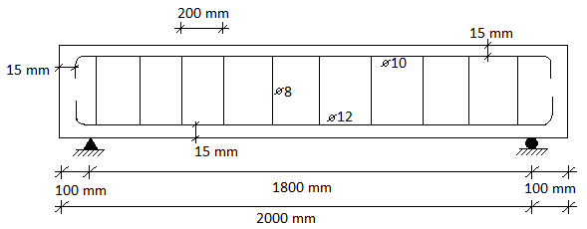
a) Longitudinal section of beam
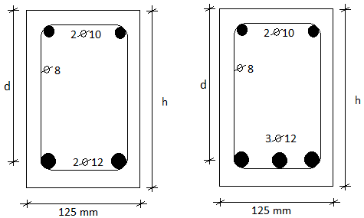
b) 2 bottom rebars (beams A1, B1, C2, E2) c) 3 bottom rebars (beam D1)
Fig. 1 Longitudinal and cross-sectional details of unretrofitted reinforced concrete beam

Five beams were prepared for the retrofitted layer to be applied on the day of testing of the unretrofitted beams. CFRP laminates of 0.35mm thickness were cut to a width of 75mm. One layer or ply of laminate was applied for each of the 5 beams that were retrofitted.

2.2 Testing of beams
The loading scheme configuration is illustrated in Fig. 2 where the four-point flexural test was employed. The hydraulic load actuator was lowered onto a rigid steel spreader beam which rested on two load points on the beam. A digital dial gauge was tarred and fixed in the stand which was then positioned centrally beneath the soffit of the beam to record deflections.

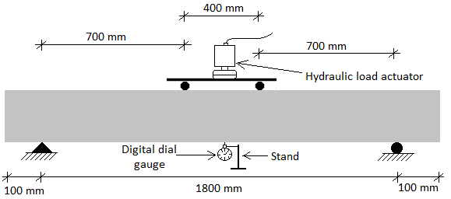

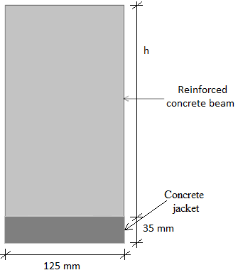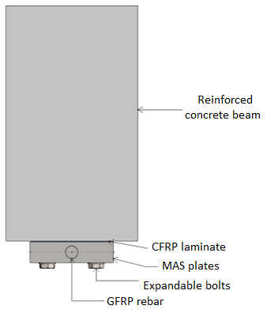
Fig. 2 Test setup

The cross-section of the hybrid retrofitted beam is shown in the Fig. 2. The figure shows the unretrofitted beam and the concrete that covers the retrofitted layer, which is the concrete jacket. The cross-section reveals the CFRP laminate, MAS plates, GFRP bar, and the expandable bolts.

2.3 Preparation of beams
The epoxy resin was mixed according to the specified proportion of 2:1 (epoxy: hardener). The mixture was complete for application on the beam substrate when a uniform colouration was achieved (Fig. 3a). The well-mixed epoxy resin was then applied on the soffit of the beam, after which the CFRP laminate was attached. A roller was used to press the laminate firmly in position to eliminate any air pockets that might be present between the interface of the laminate and the epoxy resin. Natural fibres (Fig. 3b) were used to cast the

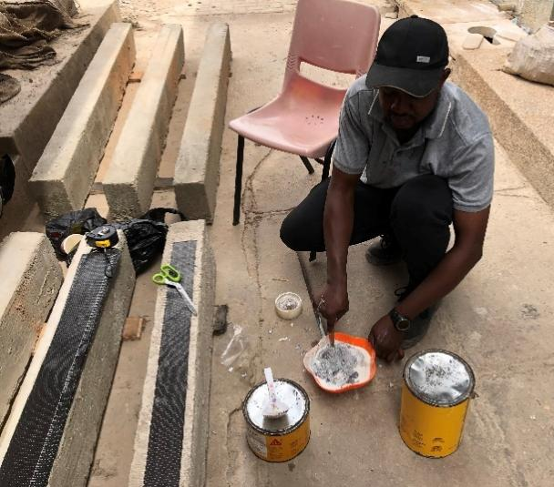
a) Mixing of epoxy resin b) Natural fibres
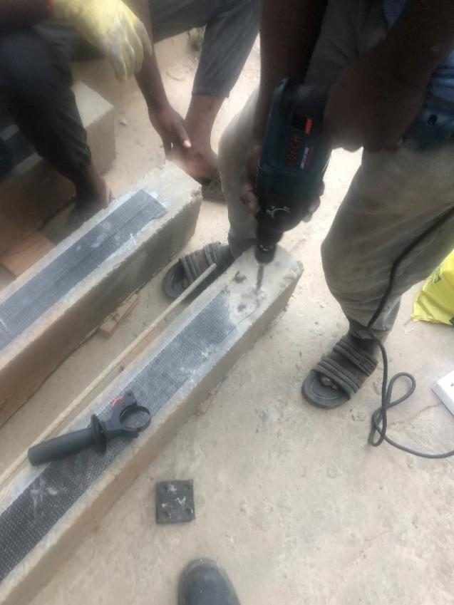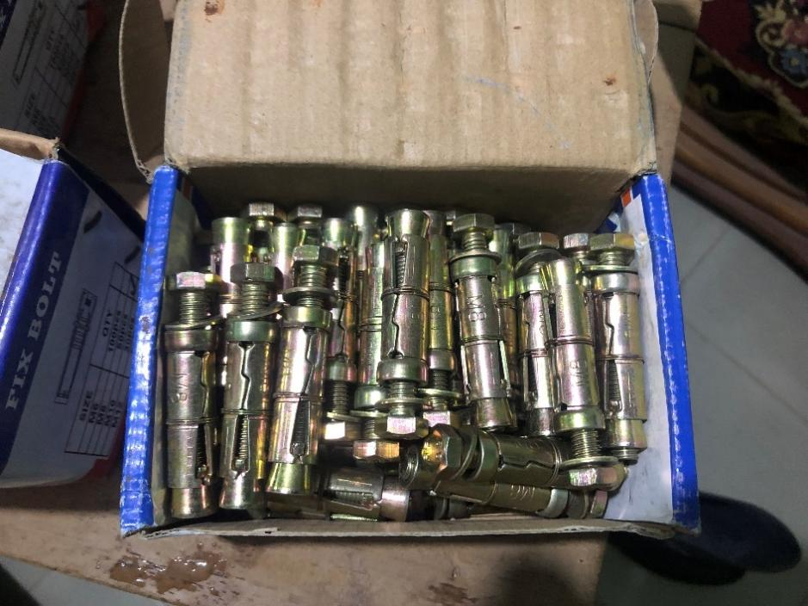
c) Drilling of beams d) Expandable bolts
Fig. 3 Preparing the retrofitted layer
concrete jacketing to enhance the tensile capabilities of the concrete cast. The fibre volume fraction was 2 %. The MAS plates were connected to the beam substrate by means of attaching expandable bolts to them and this was achieved by drilling with the help of the power drill machine as shown in Fig. 3c. The M8 expandable bolt used in the study are shown in Fig. 3d. After the holes were drilled, 2 split halves of the MAS plates of 10 mm thickness each were placed on the beam to align with the drilled holes, making a total of 20 mm in thickness of the MAS plates.

Fig. 4 a) shows the retrofitted beam that has the MAS plates with the expandable bolts fixed in position. The GFRP bar was placed in the central groove in the MAS plates in between the 2 halves before the expandable bolts were inserted. The expandable bolts were then tightened with the spanner till the connection was tightly fixed. The concrete jacketing was then cast onto the retrofitted elements. The concrete jacketing was compacted with the aid of the poker vibrator to remove the air pockets from the concrete which was uniformly spread across the retrofitted elements as shown in Fig. 4 b).

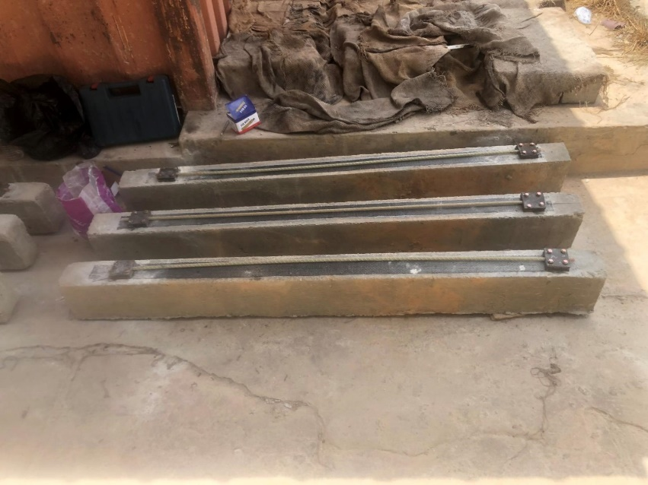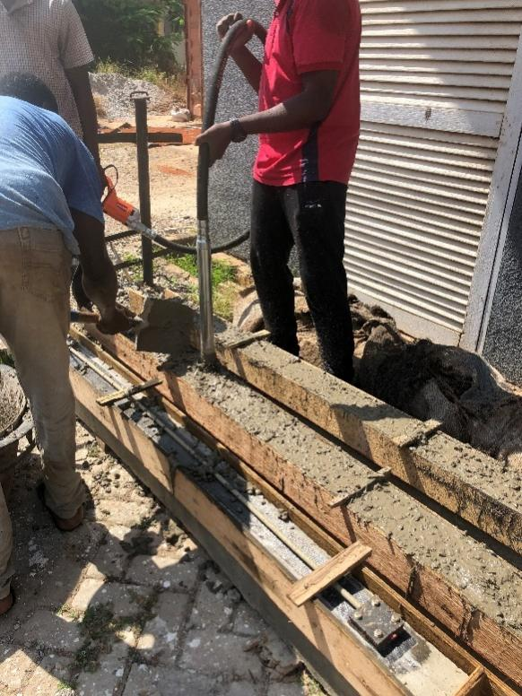
a) Mas plates assembly b) Casting of concrete jacketing
Fig. 4 Assembly and casting of retrofitted layer

After the concrete jacketing was cast, the formworks were removed the next day, jute sacks placed on the beams and regular watering was carried out daily to cure the beams. The beams were left for the 28 days maturity, and painted white prior to testing. The concrete jacket ensured that the retrofitted elements were not exposed to the environment to induce corrosion, wear, tear, or abrasion from external sources. Fibres were introduced in the casting of this layer to enhance the tensile capabilities with a fibre volume fraction of 2 %. The retrofitted layer comprised the CFRP laminate which was attached to the RC beam substrate. Two mechanical anchorage system (MAS) plates were used near both ends of the retrofitted beams. The split halves of the MAS plates worked better in the strengthening of RC beams than the solid plates with grooves cut through them (Alkhateeb & Hejazi, 2022), as such the split halves were used in this study. The MAS plates served to firmly grip the GFRP bar in position and then the expandable bolts held the MAS plates in position, fastening the connection.
During the casting phase, the unretrofitted and retrofitted beams were both cast initially together. The unretrofitted beams were tested and at the same time the retrofitted beams were prepared and waited for the maturity of the concrete jacket for 28 days, after which the retrofitted beams were also tested to failure.

2.4 Control specimens
Cubes (150 mm x 150 mm x 150 mm), cylinders (150 mm x 300 mm) and prisms (100 mm x 100 mm x 500 mm) were cast to determine the compressive strength, splitting tensile strength and the modulus of rupture of the concrete, respectively. Workability and consistency of the concrete was measured by the slump test which gave a value of approximately 75mm.

3.0 Testing of Materials
3.1 Sieve Analysis of Aggregates
The aggregates were dried in the oven for 24 hours as shown in Fig. 5 (a). The coarse aggregates were sorted with the quartering device to have a relatively equal amount of sample to be analysed and one part of the sorted samples was used in the sieve analysis Fig. 5 (b).

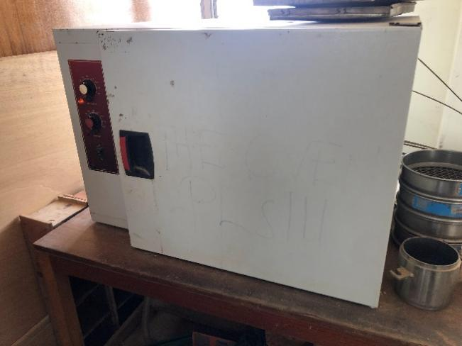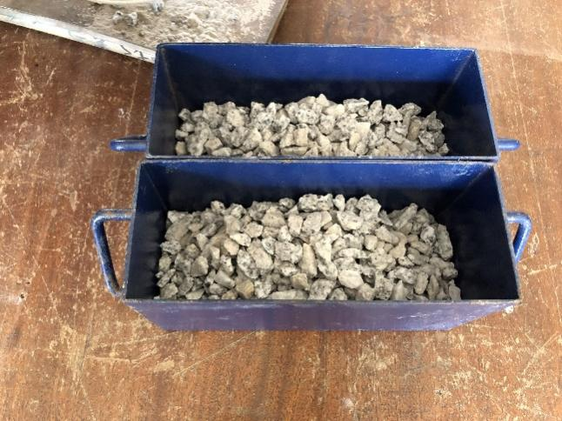
a) Oven b) Sorting of coarse aggregate
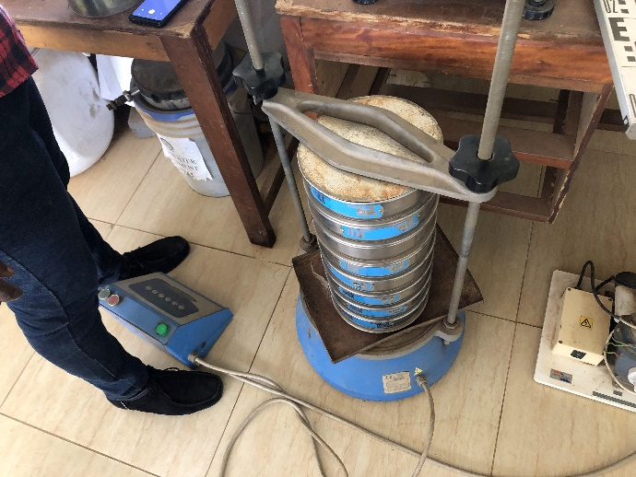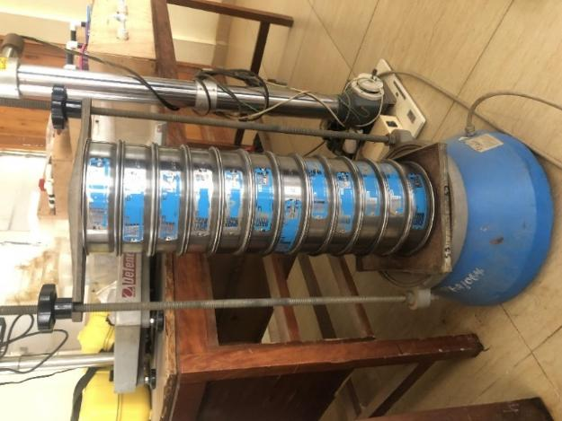
c) Coarse aggregates analysis d) Fine aggregate analysis
Fig. 5 Preparation of aggregates for testing

The sieves used for the particle size distribution for the coarse aggregates were: 19 mm, 18 mm, 16 mm, 13.2 mm, 11.2 mm, 9.50 mm, 8.00 mm, 6.70 mm, 5.60 mm, 4.75 mm, and 3.35 mm (Fig. 5c). The total weight of the coarse aggregates was 1.624 kg. The sieve analysis test for the fine aggregates has 15 sieves: 6.700 mm, 4.750 mm, 3.350 mm, 2.800 mm, 2.360 mm, 1.180 mm, 0.600 mm, 0.500 mm, 0.425 mm, 0.355 mm, 0.250 mm, 0.150 mm, 0.106 mm, 0.090 mm, and 0.075 mm (Fig. 5d). The total weight of the fine aggregates is 1 kg. The sieve analysis for the aggregates was in accordance with the standard sieve sizes of (ISO3310-1, 2000).

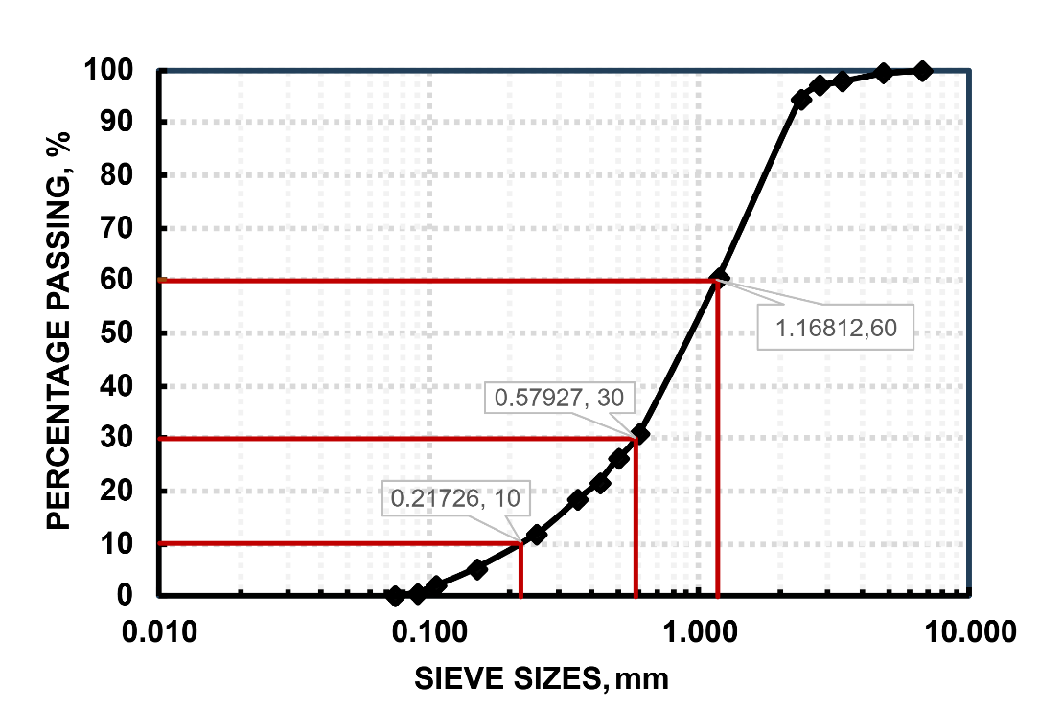
a) Fine aggregates
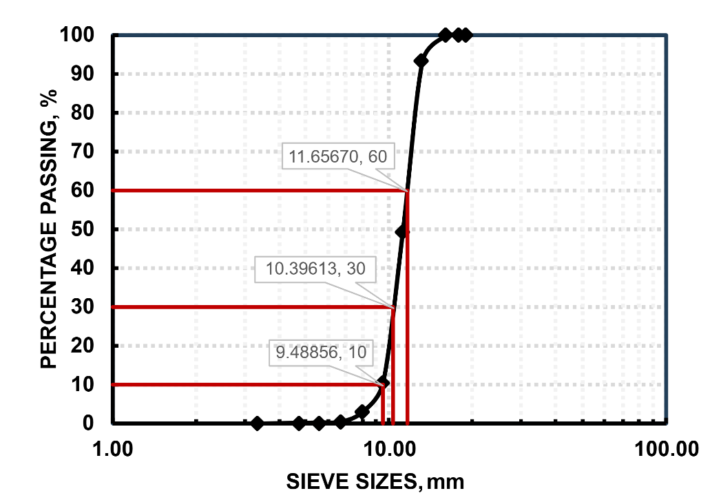
b) Coarse aggregates
Fig. 6 Fine and coarse aggregates particle size distribution

Fig. 6 a) shows the particle size distribution curve which is a semi-log graph of the fine aggregates and the curve displays a well graded sand. The coefficient of uniformity is 5.377 as shown in Table 3 which is an indication of a well-graded soil which is of the range and the coefficient of curvature for the fine aggregates has a value of 1.322 which is a well-graded soil of the range .
The error of the sieve analysis of the coarse aggregates was 0.002 kg which is acceptable.
The particle size distribution curve of the coarse aggregates as shown in Fig. 6 b), the coefficient of uniformity is 1.229 as shown in Table 3 which indicates that the aggregates are of a single size aggregate particle which is compared to the value of , and the coefficient of curvature is 0.977, which compares to a value of range indicating a single size sample. The curve for the coarse aggregates shows a sharp ascent as against a gradual ascent in the case of the well-graded curve of the fine aggregates and this hovers around 10 mm which is the nominal size used for the experimental casting of the coarse aggregates. The error margin of the sieve analysis of the fine aggregates was 0.007 kg which is acceptable.

Table 3 Aggregates coefficient of uniformity and curvature
Coarse aggregates |  | Fine aggregates
Cu | Cc | Cu | Cc
1.229 | 0.977 | 5.377 | 1.322

4. Analysis and Discussion
4.1 Crack patterns and failure modes of beams
Figures 7 through to 11 present the failure modes and crack patterns of both unretrofitted and hybrid retrofitted beams. Fig. 7 compares Beam A1 (unretrofitted) with Beam AR02 (hybrid retrofitted). In Beam A1, the compression zone did not crush at failure; cracks initiated in the tensile region and propagated through the neutral axis toward the compression zone but remained relatively mild, with no significant crack openings. Its failure was governed primarily by flexural cracks, accompanied by some shear cracking. Since A1 was unretrofitted, debonding was not observed. In contrast, Beam AR02 exhibited a complete collapse characterized by a prominent diagonal crack running from the tensile to the compressive zone. Additional cracks also initiated at the interface between the retrofitted layer and the RC beam, indicating debonding, with a maximum crack width of 10 mm (Table 4). The dominant failure modes of AR02 were flexural cracking, diagonal shear cracking, and debonding, with diagonal shear cracks being the critical cause of failure.

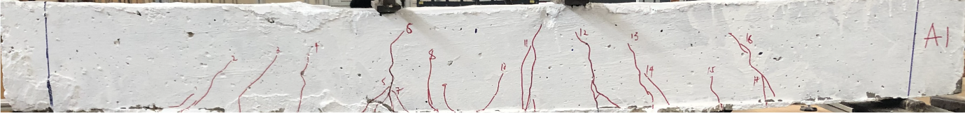
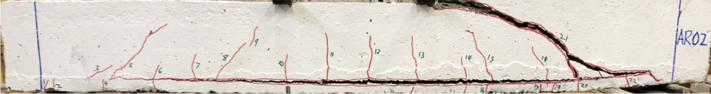
Fig. 7 Failure modes and crack patterns of beams A1 and AR02

Fig. 8 illustrates the failure and crack patterns of beams B1 (unretrofitted) and BR02 (hybrid retrofitted). Beam B1 developed small cracks extending from the tensile region toward the compression zone, with no significant crack openings at failure. Its failure was governed primarily by flexural cracks. In contrast, Beam BR02 showed flexural cracks accompanied by interlocking shear cracks. Some cracks initiated not only from the extreme tensile fibres but also from the interface between the retrofitted layer and the RC beam. The compression zone did not completely crush. The observed failure modes were flexural cracking, diagonal shear cracking, and debonding, with debonding identified as the critical cause of failure. The maximum debonding crack width was 7 mm (Table 4).

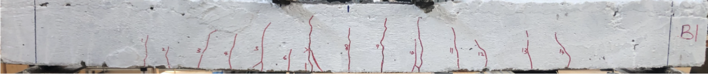
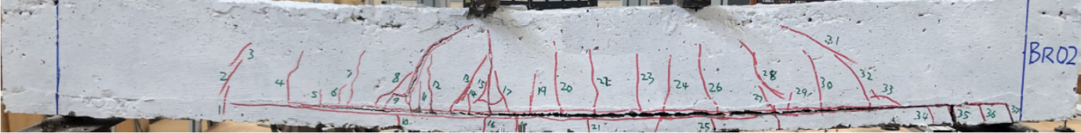
Fig. 8 Failure modes and crack patterns of beams B1 and BR02

Fig. 9 presents the failure modes and crack patterns of beams C2 (unretrofitted) and CR02 (hybrid retrofitted). In beam C2, cracks propagated from the tensile region toward the compression zone, approaching the extreme fibres. Its failure was primarily governed by flexural cracking, accompanied by some shear cracks. Beam CR02, on the other hand, exhibited cracks predominantly originating from the retrofitting layer, without extending to the extreme compression fibres. The observed failure modes included flexural cracking, diagonal shear cracking, and debonding of the retrofitted layer, with a maximum debonding crack width of 8 mm (Table 4).

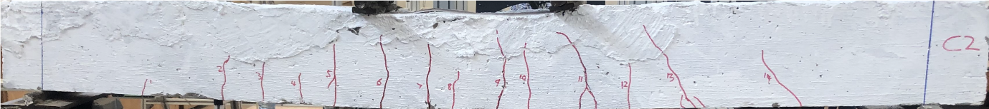
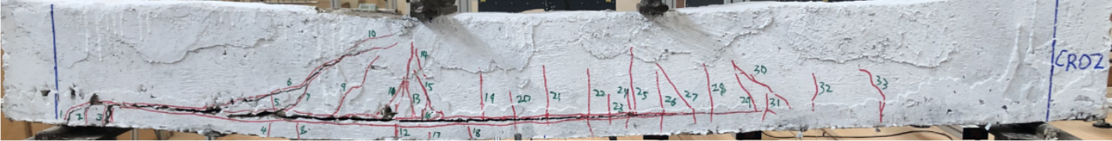
Fig. 9 Failure modes and crack patterns of beams C2 and CR02

Fig. 10 shows the failure modes and crack patterns of beams D1 (unretrofitted) and DR02 (hybrid retrofitted). Beam D1 developed relatively few cracks compared to the other unretrofitted beams. Most cracks remained close to the neutral axis, with only a diagonal shear crack extending toward the extreme compression fibres, which governed the ultimate failure. The failure modes were therefore identified as flexural and shear cracking, with diagonal shear as the critical cause. In beam DR02, fewer cracks were observed comparatively, occurring mainly away from the loading points. The failure of the retrofitted beam was characterized by flexural cracks, diagonal shear cracks, and debonding. The dominant mode was diagonal shear, which extended through the compression zone, accompanied by widening of the crack. Additional micro-cracks were noted within the retrofitting layer. The maximum debonding crack width was 7 mm (Table 4).

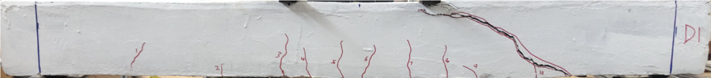
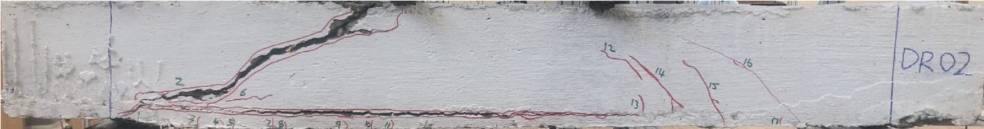
Fig. 10 Failure modes and crack patterns of beams D1 and DR02

Fig. 11 illustrates the failure modes and crack patterns of beams E2 (unretrofitted) and ER03 (hybrid retrofitted). Beam E2 developed narrow flexural cracks in the tensile zone that propagated into the compression region above the neutral axis but did not reach the extreme compression fibres. Its failure was governed by flexural and diagonal shear cracking, with the latter being the critical cause. In beam ER03, flexural cracks originated both from the interface of the retrofitting layer and from the extreme fibres of the retrofitted section, while diagonal shear cracks extended from the tensile fibres of the retrofitted layer to the extreme compression zone. At failure, a dominant diagonal shear crack propagated through the retrofitted layer near the bottom support and reached the compression flange, which was identified as the principal cause of failure. The maximum debonding crack width was 7 mm (Table 4).

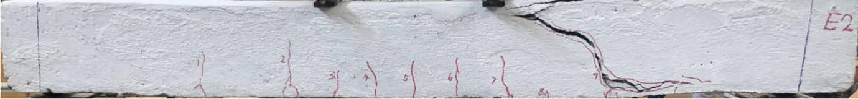
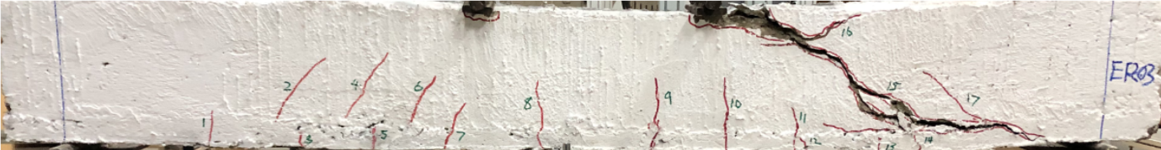
Fig. 11 Failure modes and crack patterns of beams E2 and ER03

Table 4 Failure modes of beams
Beam id | Failure | Main cause of failure | Max debonding
Beam id | modes | Main cause of failure | Crack width, mm
A1 | Flexural - shear | Flexural | -
AR02 | Flexural - diagonal shear - debonding | Diagonal shear | 10
B1 | Flexural | Flexural | -
BR02 | Flexural - diagonal shear - debonding | Debonding | 7
C2 | Flexural - shear | Flexural | -
CR02 | Flexural - diagonal shear - debonding | Debonding | 8
D1 | Flexural - diagonal shear | Diagonal Shear | -
DR02 | Flexural - diagonal shear - debonding | Diagonal shear | 7
E2 | Flexural - diagonal shear | Diagonal shear | -
ER03 | Flexural - diagonal shear - debonding | Diagonal shear | 7

4.2 Crack number and crack length
Fig. 12 presents the distribution of crack numbers recorded under and away from the load points. Under the load points in Fig. 12(a), the number of cracks generally decreased in the retrofitted beams compared to their unretrofitted counterparts, except for beams BR02 and CR02, which recorded higher crack numbers. At failure, CR02 exhibited the highest number of cracks (13), followed by BR02 with 12. Notably, these two beams were also the only specimens to develop shear cracks under the load points, accounting for the observed anomaly. Away from the load points Fig. 12(b), the retrofitted beams consistently developed more cracks than the unretrofitted beams. Across all specimens, flexural cracks were more prevalent than shear cracks.

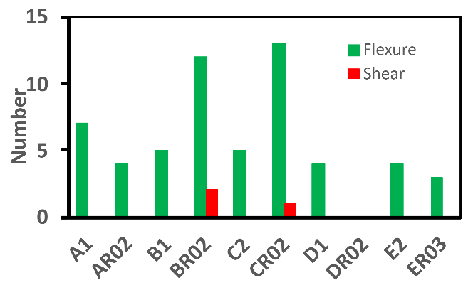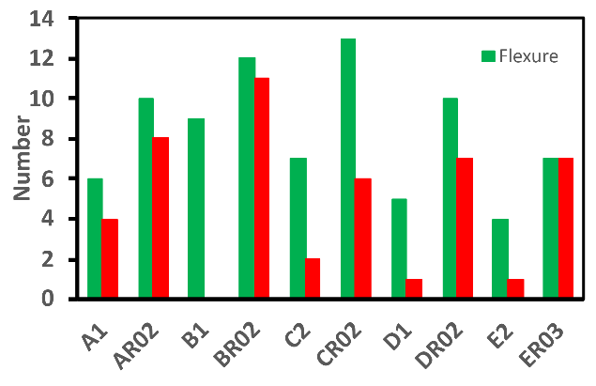
a) Under load region b) Away from load region
Fig. 12 Crack numbers

Fig. 13 illustrates the relationship between crack lengths at failure. The largest crack lengths were generally greater in the retrofitted beams than in the unretrofitted beams, with the exception of beam AR02, which reached a peak of approximately 700 mm at complete failure. The beams that failed in diagonal shear exhibited the longest cracks, reflecting the severity of this failure mode. In contrast, the average and smallest crack lengths were slightly lower in the retrofitted beams compared to their unretrofitted counterparts. Among these measures, the average crack length provides the most reliable basis for interpreting the crack length relationship, followed by the smallest crack lengths.

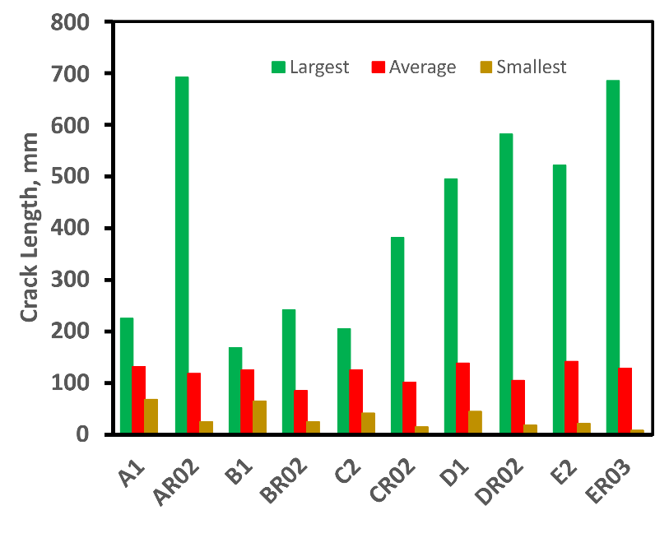
Fig. 13 Crack lengths of beams

  - Crack spacing and maximum crack width
The relationship of crack spacing at failure is shown in Fig. 14. Beams that failed in diagonal shear exhibited the largest crack spacing, as a single dominant diagonal shear crack replaced the multiple flexural cracks that would typically form in that region. For beams A and B, the largest crack spacing decreased after retrofitting, while from beams C to E the spacing increased, with beam DR02 recording the highest value. In contrast, both the average and smallest crack spacings consistently decreased in the retrofitted beams compared to their unretrofitted counterparts. Among these measures, average crack spacing provides the most reliable representation of the crack spacing behaviour, followed by the smallest crack spacing.

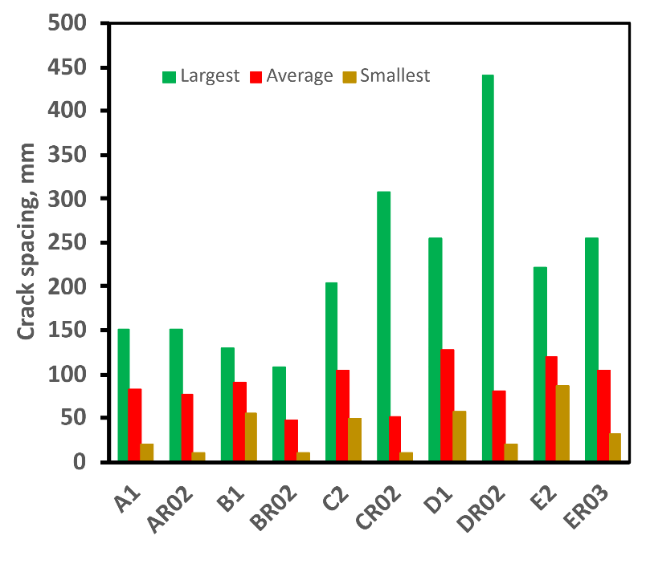
Fig. 14 Crack spacing of beams
Fig. 15 illustrates the relationship between maximum crack widths at failure. The widest cracks were consistently associated with beams that failed in diagonal shear. Overall, the retrofitted beams exhibited larger maximum crack widths than their unretrofitted counterparts at ultimate failure. Specifically, beam AR02 recorded widths ranging from 1–15 mm, BR02 from 1–3 mm, CR02 from 1–5 mm, DR02 from 1–31 mm, and ER03 from 1–30 mm. This is due to the fact that, the retrofitting elements, especially the GFRP bars have failure characterized by larger deflection upon deformation due to lower modulus of elasticity (Boateng et al., 2024) thus an increase in the crack width in the retrofitted beams.

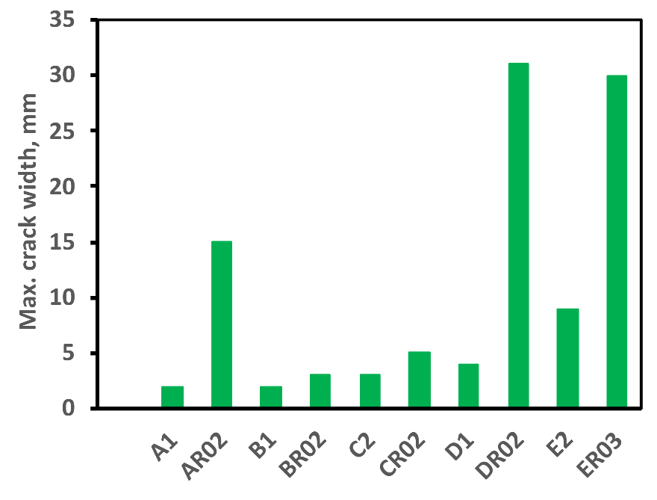
Fig. 15 Maximum crack width of beams

4.4 Load - deflection relationships
The load - deflection curves of the unretrofitted or control beams are shown in Fig. 16. Beam D1 had the highest load at complete collapse of the beam, and beam A1 following closely. Beam C2 was next in line, followed by beam E2 and then beam B1 with loads of 32 kN, 30 kN, 26 kN, 26 kN, and 24 kN respectively. It is evident that beam D1 with an increased area of tension steel is able to sustain the highest load.
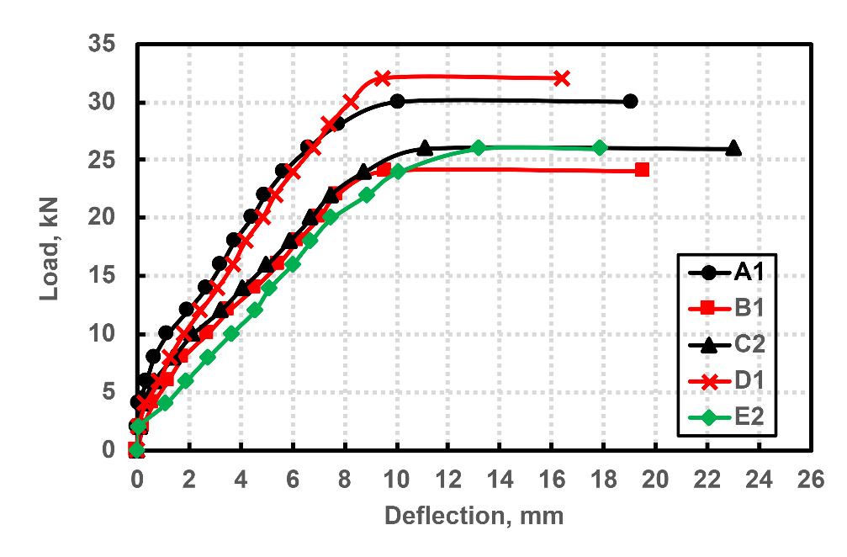
Fig. 16 Load-deflection curves of unretrofitted beam

The load - deflection curves of beam group A, illustrated in Fig. 17 show that beam A1 exhibited a linearly elastic behaviour initially from the origin, turned later inelastic after cracking and finally branched off at failure. It is evident in Fig. 17 that the retrofitted beam AR02 showed linearly increasing elastic curve, further than the unretrofitted beam but this curve also changed to inelastic till at a breaking point where a further increase in the load collapsed the beam abruptly, thus failing by shear. The retrofitted beam load-deflection curve is higher than the unretrofitted curve.

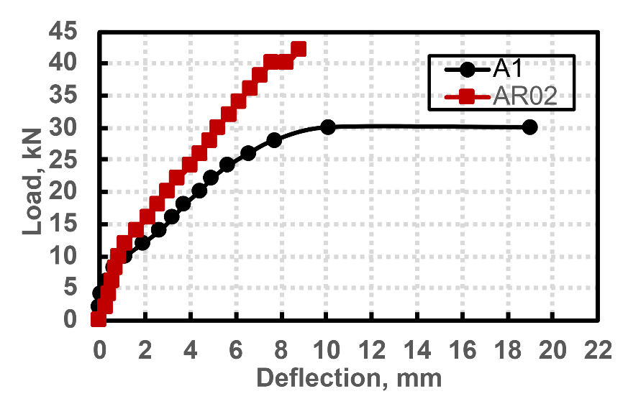
Fig. 17 Load-deflection curves of A1 and AR02

Fig. 18 displays the load - deflection curves for beams B1 and BR02. There is a brief linear elastic trend in beam B1, followed by an inelastic range after cracking of the beam until failure. The retrofitted beam BR02 had an initial higher linear elastic curve than the unretrofitted beam, then after cracking, turned into inelastic until failure. The retrofitted beam also exhibited greater stiffness than the unretrofitted beam. The failure beam BR02 was characterised by debonding and as such was not abrupt.

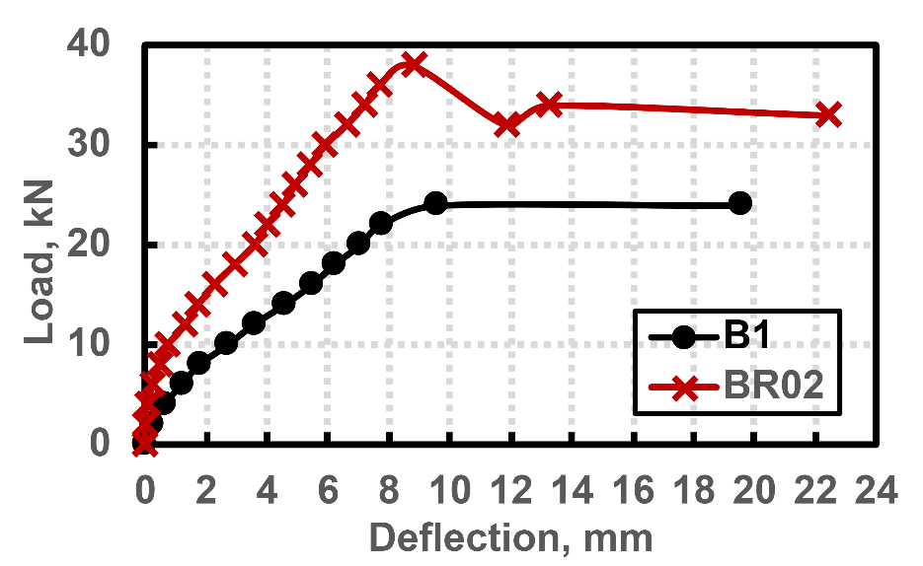
Fig. 18 Load-deflection curves of B1 and BR02

Fig. 19 represents the load-deflection relationship for beams C2 and CR02 where it can be observed that the retrofitted beam exhibited greater stiffness. The unretrofitted beam followed a similar pattern as the other unretrofitted beams already discussed. The load-deflection curve of beam CR02 upon reaching the ultimate load, declined gradually and failed through debonding of the retrofitted layer unlike beam AR02 that failed abruptly in diagonal shear.

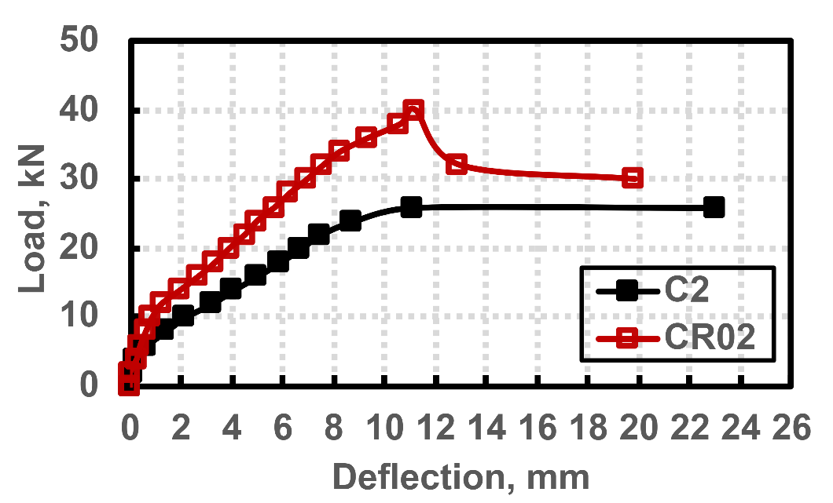
Fig. 19 Load-deflection curves of C2 and CR02

The load-deflection relationship for beams D1 and DR02 are shown in Fig. 20. Beam D1 exhibited a short elastic range and relatively long inelastic range to failure. Beam DR02 exhibited a stiffer response, although with an even shorter elastic range than the unretrofitted beam. The inelastic behaviour of beam DR02 continued to failure which was characterized by shear. The failure mode for beam DR02 was similar to AR02.

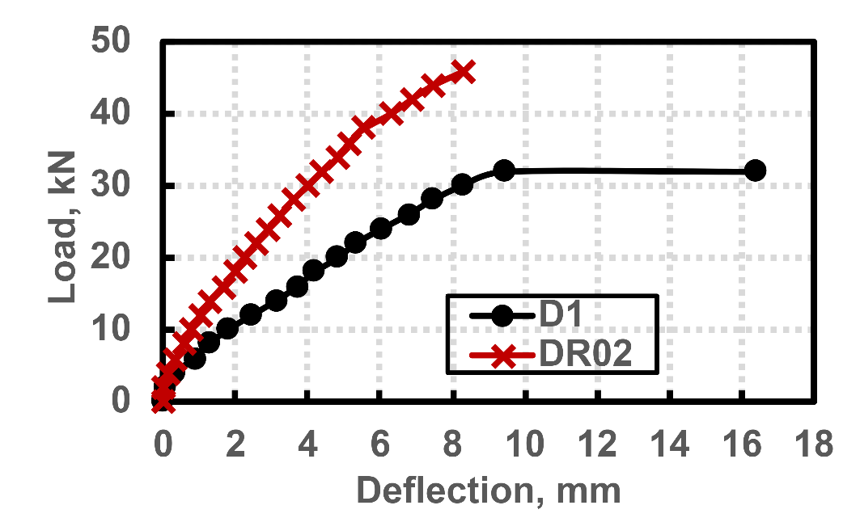
Fig. 20 Load-deflection curves of D1 and DR02

Fig. 21 illustrates the load-deflection curves for beams E2 and ER03. For beam E2, the relationship is elastic although of shorter range than beam D1. The curve moved gradually into inelastic until beam failure. Beam ER03 had a longer elastic rage which turned off into the inelastic, but beyond the maximum load the curve decreased until instantaneous failure by shear in the beam.

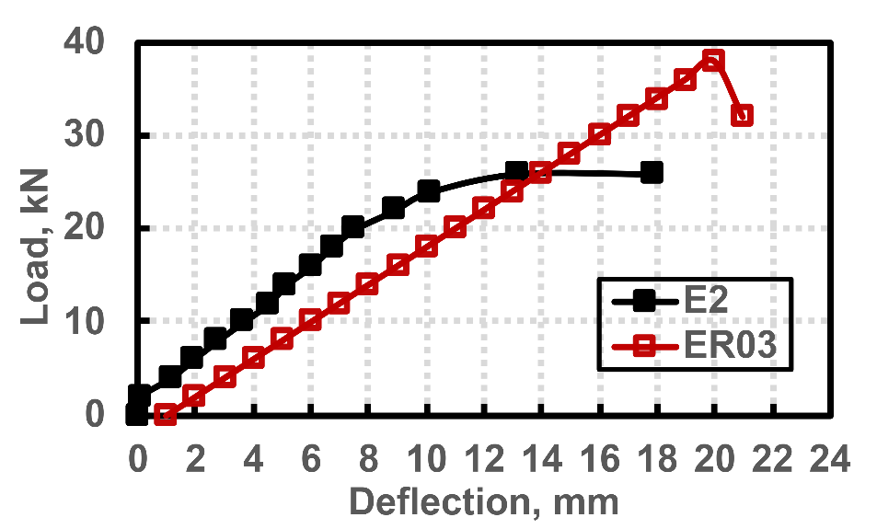
Fig. 21 Load-deflection curves of E2 and ER03

5 Numerical Analysis
5.1 Theoretical failure – code provisions
BS8110 (2000) gives guidelines in the design of concrete structures. The numerical model is on the basis that the concrete section is not cracked at the tensile zone. When there are cracks, the stresses at the cracked fibres of the sections are transferred to the steel reinforcements at that section.
The following assumptions are used in the hybrid retrofitted model:
- Plane sections before bending remain plane after bending.
- The concrete in the reinforced concrete does not resist any tension but only compression.
- The concrete jacketing is made from concrete with natural fibres present to resist tension.
- The steel reinforcement resists both compressive and tensile stresses.
- The CFRP laminate and GFRP bar resist tensile stresses.
- There is sufficient bonding of the CFRP to the substrate of the reinforced concrete.
- There is sufficient grip of the GFRP bar in the MAS plates.

There is the tendency of debonding of the retrofitted layer from the reinforced concrete beam, as such the numerical model cannot reach the ultimate loads per the beam theory analysis, as such the need to have effective strengths for the retrofitting elements used. Concrete prisms were cast for determining the modulus of rupture. The specimens were tested under three- point flexural test. The equations used in the numerical analysis in Table 5 are as follows:
Modulus of rupture 1
Cracking moment 2
Failure load of beam 3
Moment of resistance of beam based on failure in compression: 4
Moment of resistance of beam based on yielding of steel bars in tension: 5
Shear resistance failure of beam:
6
where B is the breadth of the concrete prism or beam, D is the overall depth of the concrete prism or beam, b is the breadth of the concrete beam, d is the effective depth of the tension steel, d’ is the inset to compression steel, As is the area of tension steel reinforcement, As’ is the area of compression steel reinforcement, fcu is the compressive strength of concrete, fy is the design strength of the steel reinforcement, P is the failure load of the concrete prism, L is the effective length of the concrete prism or beam, Sv is the spacing between links or stirrups, Asv is the area of shear reinforcement corresponding to the leg of stirrups, and the ν_{c} is the design concrete shear stress.
The retrofitted beams upon loading to failure or complete collapse give the ultimate load which is Pult-r. The theoretical failure load (Pult') based on the unstressed cross-section is given by the critical failure load as shown in the Table 5. The assumptions of the steel yielding first, concrete crushing first, or shear failure first are analyzed and the least failure load chosen as the governing or critical load, Pult’. It is observed that the ratio of experimental load (P_{ult}) of the control beam or unretrofitted beam to the theoretical critical load (Pult') is of a minimum of 162 % with beam B1 due to the close difference of both values and a maximum of 205 % with beam C2 because of the big difference between both values. However, the ratio of the experimental failure load (Pult-r) of the retrofitted beam load to the numerically predicted critical failure load (Pult') reaches a minimum of 248 % with beam AR02 due to the close gap between their loads and a maximum of 315 % with the beam CR01 due to wider difference in the failure load. The ratio of the experimental first crack load (Pcr) of the control to the theoretical first crack load (Pcr') of the control ranges from 62% to 93% with the highest value of 93 % in beam D1. From values of the ratio of the experimental first crack load (Pcr) of the unretrofitted beam to its experimental ultimate load (P_{ult}), it is observed that the cracks are initiated for a considerable duration before the ultimate failure occurs. The highest ratio is in beam A1, recording a value of 47 %. The ratio of the experimental first crack load (Pcr) to the ultimate retrofitted load (Pult-r) shows a wider gap than that of the unretrofitted beams. The lowest value is 20 % while the highest is at 33 %. The ratio of the theoretical crack load to the experimental ultimate load records a minimum value of 38 % found in beam C2 while the highest is at 54 % in beams A1 and B1. The theoretical crack load (Pcr') in comparison to the experimental first crack load (Pcr) is higher because the theoretical is the idealized condition where the minor errors from mensuration, environmental and human factors, presence of greater defects in actual beams compared to small MOR control prisms do not play a part. The ratio of the retrofitted ultimate load to the unretrofitted ultimate load (Pult-r/P_{ult}) records values greater than 1 which indicates the enhanced strengths of the retrofitted beams. The lowest value is at 140 % for beam A1 while the highest is at 158 % for beam B1, indicating that retrofitting of beams can greatly enhance their load carrying capabilities.

Table 5 Theoretical and experimental failure loads of beams
Beam Id. | Theoretical cracking load of control, Pcr' (kN) | Exp. First crack load of control, Pcr (kN) | Exp. Failure load of control, Pult (kN) | Exp. Failure load of retrofitted beam, Pult-r | Theoretical failure load based on unstressed section, Pult' (kN) |  |  | 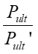 | 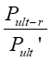 | 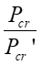 | 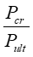 | 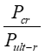 | 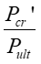 | 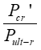 | 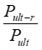
 |  |  |  |  | Steel yielding | Concrete crushing | Shear failure
A1 | 16.32 | 14.0 | 30.0 | 42 | 16.91* | 92.60 | 19.23 | 1.77 | 2.48 | 0.86 | 0.47 | 0.33 | 0.54 | 0.39 | 1.40
B1 | 12.89 | 8.0 | 24.0 | 38 | 14.80* | 71.83 | 17.31 | 1.62 | 2.57 | 0.62 | 0.33 | 0.21 | 0.54 | 0.34 | 1.58
C2 | 9.87 | 8.0 | 26.0 | 40 | 12.69* | 53.63 | 15.48 | 2.05 | 3.15 | 0.81 | 0.31 | 0.20 | 0.38 | 0.25 | 1.54
D1 | 12.89 | 12.0 | 32.0 | 46 | 22.17 | 71.83 | 18.36* | 1.74 | 2.51 | 0.93 | 0.38 | 0.26 | 0.40 | 0.28 | 1.44
E2 | 12.89 | 10.0 | 26.0 | 38 | 14.80* | 54.37 | 16.73 | 1.76 | 2.57 | 0.78 | 0.38 | 0.26 | 0.50 | 0.34 | 1.46
Note: * denotes the governing failure load Pult’ (kN)

5.2 Flexural moment capacity
The hybrid retrofitted beam is designed to enhance the flexural strength of the reinforced concrete beam. The cross-section of the retrofitted beam is shown in Fig. 22 with the strain distribution diagram. The strain is observed to be triangular both in compression and tension. The positions of the individual strains of the various components of the retrofitted layer in the beam are illustrated in the figure. In BS8110 (2000), the strain of concrete ε_{c}, is specified as 0.0035.

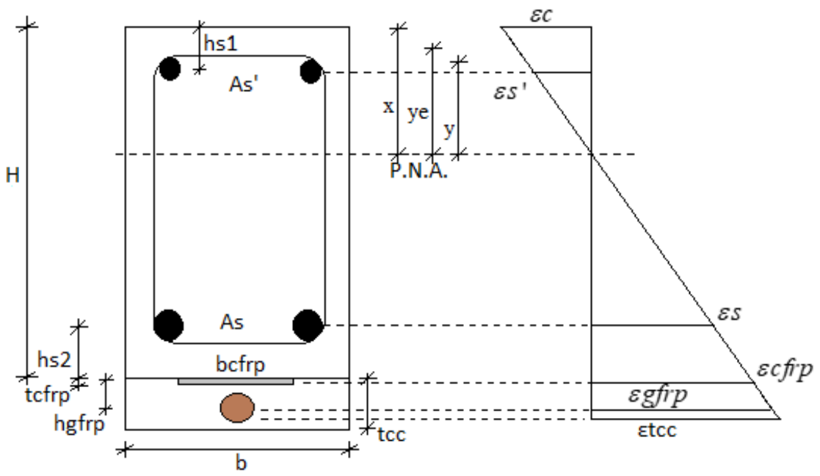
Fig. 22 Strain block diagram of hybrid retrofitted beam

The stress block diagram of the flexural moment capacity of the retrofitted beam is illustrated in Fig. 23. In this figure, the compressive forces are that of the steel reinforcement and the concrete in compression. The contributing tensile forces are those of the bottom steel reinforcement, CFRP laminate, GFRP bar, and the concrete jacketing. The respective lever arms for the stresses are as shown in the figure. The only contribution of the MAS plates in the numerical model is in providing a strong grip for the GFRP bar, as such the plates are not included in the numerical formulation. The expandable bolts used in fixing the plates in position within the reinforced concrete beam have a good bond initially but at increased loads, the bolts can be yanked out in some cases. Anchorage efficiency is improved as tensile stresses are effectively transferred from the loading system through the GFRP bars into the surrounding concrete via the mechanical grip of the anchorage. Also, the grooved surfaces of the MAS plates prevent bond slip, ensuring stable load transfer, while the redistribution of stresses along the GFRP minimizes localized stress concentrations outside the anchorage–bar interface. The use of MAS plates is associated with some limitations. Their fabrication and installation can be complex and costly, particularly when cutting and precise on-site assembly are required as extra components are needed. The additional self-weight of the plates contributes to an increase in the overall weight of the beam, which may be undesirable in lightweight structural applications. Moreover, localized stress concentrations at the anchorage–bar interface can lead to crushing of the GFRP bars, compromising their tensile capacity. Finally, the steel plates may present a potential durability concern, as they are susceptible to corrosion if not adequately protected.

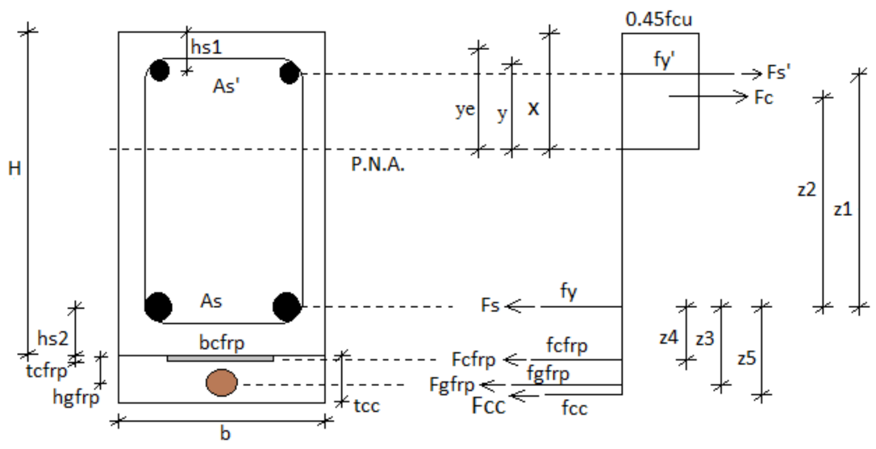
Fig. 23 Stress block diagram of hybrid retrofitted beam

5.2.1 Plastic neutral axis
The plastic neutral axis denotes the region in the cross-section of the beam where the compressive and tensile stresses are zero, as such the region of neutrality of forces. Zhang et al. (2023) adopted the reduced moment approach and had favourable results, as such this approach was introduced in the formulation of the flexural moment capacity equation that is used in estimating the hybrid retrofitted beam behaviour.
7
where is the strain of concrete, is the strain of GFRP, x is the plastic neutral axis, H is the overall depth of beam, and is the height of the soffit of reinforced concrete beam to the centroid of GFRP bar.
8
The strain of the concrete, at the extreme compression fibre under the condition of only steel reinforcement is 0.0035 corresponding to a height of x. The strain of the concrete section at the height x when the contribution of the strain from the GFRP bar is factored into equation 8 is given as ε_{c}, thus the height of y at a strain of ε_{c} is given in equation 9. The effective heights as illustrated by Zhang et al. (2023) are shown in Fig. 24, where the height from the neutral axis to the extreme compression fibre is x, the height from the neutral axis to the ε_{c} is y and the effective height y_{e} is given as the sum of y to the median of x and y.

9
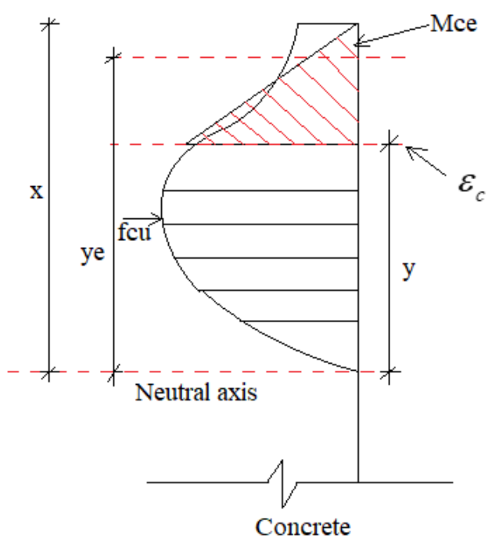
Fig. 24 Reduced moment effective heights (Zhang et al., 2023)

(Zhang et al., 2023)
where y_{e} is the effective height of concrete and y the height of concrete at ε_{c}
(Zhang et al., 2023)
According to Zhang et al. (2023), the effective components are able to reduce the compressive strength to bring correlation to the real strength scenario.
f_{CE} is the effective compressive strength, fc is the compressive strength
10
It can be observed from the experimental tests discussed earlier that the failure by debonding was prevalent in the retrofitted beams, and as such the beams did not reach their full strength of the tensile capacities of the CFRP and the GFRP. Thus, the effective strength of 300 N/mm² is used for the CFRP laminate while the effective strength of the GFRP bar is taken as 550 N/mm². None of the CFRP laminate failed by rupturing. The GFRP bar also did not fail by rupturing as is normally observed in concrete beams reinforced with GFRP bars instead of steel reinforcement. The CFRP laminate and GFRP bar did not reach the full strength of rupture in the experimental testing, as such the effective strengths are used in the analytical computations. Tang et al. (2020) investigated the effects of sustained loading in conjunction with wetting-drying cycles on the debonding behaviour of materials. Their findings indicated that debonding significantly degraded bond strength by 8.36% and yielding capacity by 14.29%(Tang et al., 2020)(Tang et al., 2020)(Tang et al., 2020)(Tang et al., 2020)(Tang et al., 2020). The bond strength reduction for different types of FRP-adhesive-to-concrete bonded joints after 110 months of exposure to wet-dry cycling environment was CFRP plate with Sika 30 (3%), CFRP sheet with SW-3 C (9%), CFRP plate with Araldite 106 (36%), and GFRP sheet with Sika 330 (48%) (Hao et al., 2024). The CFRP laminate and the GFRP bar strengths were reduced to effective strengths to account for the loss of strength due to debonding in the interfacial connection between the concrete beam and the retrofitting layer.
CFRP reduced strength: 11
GFRP reduced strength: 12

13
Where:
14
hs1 is the depth from centroid of compression steel to the extreme compression fibre, hs2 is the depth from the extreme tension fibre of the reinforced concrete beam to the centroid of the tension steel, z1 is a lever arm
15
z2 is a lever arm
16
z3 is a lever arm
17
z4 is a lever arm
18
z5 is a lever arm
The plastic moment of the hybrid retrofitted beam is proposed as follows:
19

Table 6 gives the comparison between the analytical and the experimental moments. The beams have varying heights, thus contributing to the changes in the lever arms z1 and z2, but due to the fixed heights of the retrofitting layer the lever arms at the remaining lever arms are unchanged. The distance of the plastic neutral axis extending above the centre of the beam is given as k. It is observed to be highest in beam AR02 with a value of 87.83 mm, decreasing till in beam CR02 with a value of 62.83 mm. The value increases again to 70.59 mm then finally reduces to 65.88 mm. The effective height, ye is observed to reduce gradually from AR02 to CR02 then increased from DR02 to ER03.
The analytical moments from Table 6 are observed to align with the experimental moments. The ratios of the analytical moment to the experimental moment are 102 %, 101 %, 85 %, 91 %, and 91 % in beams AR02, BR02, CR02, DR02, and ER03, respectively. This signifies the close relationship that the estimated analytical moments have with the experimental moments, thus validating the new formula. The mean of the ratio of the two moments is given as 0.94 and the variance is 0.00541.

Table 6 Comparison between the analytical and experimental moments
Beam id | k | εc | y | ye | fce | z1 mm | z2 mm | z3 mm | z4 mm | z5 mm | Me (kNm) | Ma (kNm) | Ma/Me
AR02 | 87.83 | 0.19 | 0.46 | 12.56 | 24.40 | 175.73 | 193.38 | 35.69 | 25.52 | 42.84 | 14.7 | 14.99 | 1.02
BR02 | 75.33 | 0.21 | 0.41 | 12.54 | 24.40 | 150.73 | 168.39 | 35.69 | 25.52 | 42.84 | 11.9 | 13.42 | 1.13
CR02 | 62.83 | 0.25 | 0.35 | 12.51 | 24.40 | 125.73 | 143.41 | 35.69 | 25.52 | 42.84 | 14.0 | 11.86 | 0.85
DR02 | 70.59 | 0.26 | 0.40 | 14.91 | 24.40 | 150.73 | 167.21 | 35.69 | 25.52 | 42.84 | 16.1 | 14.58 | 0.91
ER03 | 65.88 | 0.31 | 0.39 | 17.25 | 14.38 | 150.73 | 166.03 | 35.69 | 25.52 | 42.84 | 13.3 | 12.13 | 0.91
k is distance of neutral axis extending above centre of beam, Me represents the experimental moment, and Ma represents the analytical moment

Fig 25 illustrates the graphical representation of the relationship between the two moments. It is observed that the moments cluster along the middle line and the values are within the error margins.

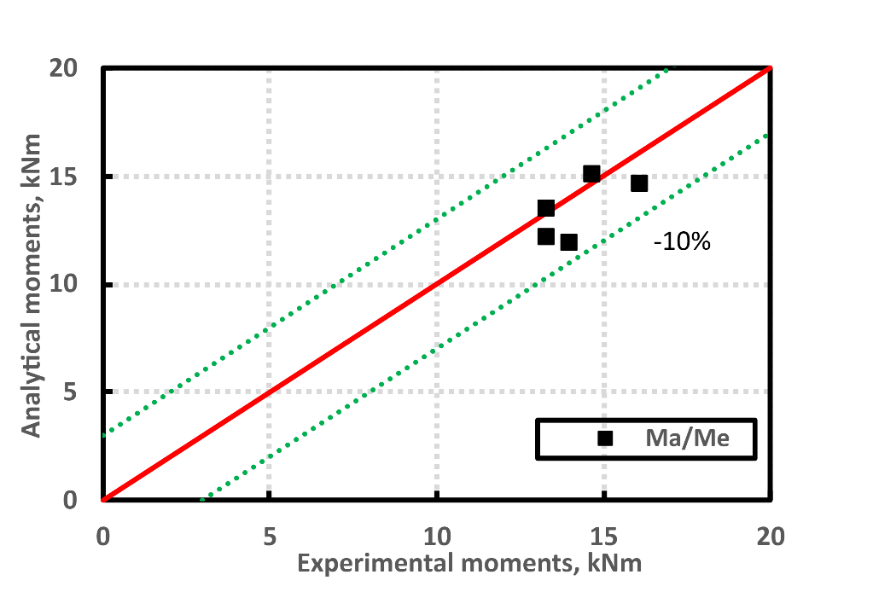
Fig. 25 Relationship between analytical and experimental moments.

5.3 Limitations and Future Work

The limitations of the experimental program are briefly discussed. While the CFRP laminate bonded effectively to the concrete substrate up to failure, debonding of the concrete jacket was observed in the retrofitted beams, reducing their ultimate load capacity. In addition, bolts within the MAS plates were dislodged in some specimens at ultimate loading. The hybrid retrofitting system was not evaluated under long-term durability conditions, nor were the beams subjected to temperature variations or corrosion-induced conditions to assess their flexural performance.
Future studies should therefore focus on retrofitted beams of similar configurations, with emphasis on seismic performance, durability under corrosive and temperature variation conditions, long-term durability, and ways to reduce the debonding.

6. Conclusion
This paper presents results of experimental research that was conducted to investigate the flexural behaviour of hybrid retrofitted beams using CFRP laminates, GFRP bars, MAS plates, and concrete jacketing with natural fibres. The effects of crack numbers, crack lengths, crack spacings, maximum crack-widths, crack pattern, load-deflection relationship, and failure modes of the unretrofitted and retrofitted beams were discussed. The British Standard code provisions for the unstressed, unretrofitted RC beam was used to compare with the retrofitted RC beams. Furthermore, the formulation of a flexural moment capacity equation is derived to predict the retrofitted RC beams. The following conclusions can be drawn:
- The failure modes of the unretrofitted beams were characterized with flexural (beams A, B, C) and diagonal shear (beams D, E). However, due to the increase in flexural capacity of the retrofitted beams, the failures were debonding (beams B, C) and diagonal shear (beams A, D, E). The retrofitted beams all experienced debonding with the maximum debonding crack width as 10 mm (beam A), 8 mm (beam C), and 7 mm (beams B, D, E). Thus, the beam with depth 225 mm developed the highest debonding, while all the 200 mm beams developed 7 mm debonding width.
- The highest number of cracks recorded reached 13 (beam CR02) under the load points, directly followed by beam BR02 with a number 12. It can be observed also that there was an anomaly in the trend for the beams BR02 and CR02 being the only beams that recorded shear cracks under the load points. In both flexure and shear, the crack number away from the load points was observed in the retrofitted beams to be more than their unretrofitted beams, most of which were micro cracks which gave an indication of a ductile member. The number of flexural cracks was more than those in shear for all the beams in both under and away from the load points, and also, the retrofitted beams recorded higher values than the unretrofitted beams.
- With regard to largest crack lengths, the retrofitted beams were observed to have crack lengths that were more than the unretrofitted beams. In ascending order, the largest lengths are from beam A through beam E, with the exception of the retrofitted beam A (AR02) which peaked around 700 mm. These largest lengths could be attributed to the beams that failed in diagonal shear. In terms of the average crack lengths, it was evident that the retrofitted beams had crack lengths that were slightly lower than their unretrofitted beams and the same could be observed in the smallest crack lengths. This shows that the retrofitting closed the gaps of the crack lengths. The average crack lengths gave a better representation than the largest lengths.
- The average crack spacing generally increased from beams A to D, then decreased to beam E. The retrofitted beams recorded lower values than the unretrofitted, signifying the importance of strengthening of the RC beam which closed the spacing of the cracks. The maximum crack widths increased from beam A to beam E. The retrofitted beams had higher crack widths than the unretrofitted beams due to the failure in diagonal shear that widened the cracks.
- The load-deflection relationship for the unretrofitted beams revealed that beam D was the highest curve followed by beams A, C, E, B. The retrofitted beams had higher load deflection curves than the unretrofitted beams in all the scenarios.
- The ratio of the experimental load of the unretrofitted beam to the theoretical critical load reached a minimum of 162 % with beam B1 due to the close difference between both values and a maximum of 205 % with beam C2 because of the big difference between both values. The ratio of the experimental retrofitted beam load to the numerical critical failure load reachedd a minimum of 248 % with beam AR02 due to the close gap between their loads and a maximum of 315 % with the beam CR01 due to wider difference in the failure load. In comparison with Alkhateeb & Hejazi (2022) who found a 133 % improvement with their type of retrofitting, this type of retrofitting works better.
- The analytical equation derived to compute the flexural moment capacity of the retrofitted beam closely aligns with the experimental moments. The ratio of the analytical moments to the experimental moments varied as 102 %, 101 %, 85 %, 91 %, and 91 % for beams A, B, C, D, and E respectively. The mean of the ratio of the two moments is given as 0.94 and the variance was 0.00541, thus the close correlation among the values. This validates the new formula proposed for this hybrid retrofitting technique.
- The new formula for flexural moment capacity of the hybrid retrofitted beam is based on experimental and theoretical work of the hybrid retrofitting elements, GFRP bar, CFRP laminate, and concrete jacketing. The MAS plates are needed solely to ensure a firm grip on the GFRP bar as such it is not used directly in the formulation of the equation. The results from the new formula indicate that the new formula can accurately estimate the flexural moment capacity of the hybrid retrofitted beam.

Disclaimer (Artificial intelligence)
Authors hereby declare that NO generative AI technologies such as Large Language Models (ChatGPT, COPILOT, etc.) and text-to-image generators have been used during the writing or editing of this manuscript.

7. References
- Abed, H. S., & Al-Sulayfani, B. J. (2023). Experimental and analytical investigation on effect of openings in behavior of reinforced concrete deep beam and enhanced by CFRP laminates. Structures, 48, 706–716. https://doi.org/10.1016/j.istruc.2023.01.013
- Al-Rousan, R. Z. (2023). Impact of Internal CFRP strips on the flexural behavior of heat-damaged reinforced concrete beams. Heliyon, 9(6). https://doi.org/10.1016/j.heliyon.2023.e17145
- Alkhateeb, M. Y., & Hejazi, F. (2022). Reinforced concrete beams externally strengthened by CFRP rods with steel plate, anchorage bolts, and concrete jacketing. Structures, 46, 1994–2013. https://doi.org/10.1016/j.istruc.2022.11.024
- Beigi, A., Lay, A. B., & Najafabadi, M. A. (2024). Acoustic emission-based delamination investigation in drilled GFRP under mixed tensile and bending cyclic loading. Journal of Reinforced Plastics and Composites, 2024. https://doi.org/10.1177/07316844241279721.
- Boateng, G. O., Kankam, C. K., Mansar, E. C., Afrifa, R. O., Kwarteng, F., Ohene-Coffie, F., & Kpo, S. A. K. (2024). Evaluating the Mechanical Properties of Fiberglass-reinforced Polymer Bar. Journal of Engineering Research and Reports, 26(7), 150–160. https://doi.org/10.9734/jerr/2024/v26i71200
- BS8110, P. 1. (2000). Structural Use of Concrete. In British Standard Institution (Vol. 4, Issue 1).
- Cai, J., Pan, J., & Zhou, X. (2017). Flexural behavior of basalt FRP reinforced ECC and concrete beams. Construction and Building Materials, 142. https://doi.org/10.1016/j.conbuildmat.2017.03.087
- Chalioris, C. E., Kosmidou, P.-M. K., & Papadopoulos, N. A. (2018). Investigation of a New Strengthening Technique for RC Deep Beams Using Carbon FRP Ropes as Transverse Reinforcements. Fibers. https://doi.org/10.3390/fib6030052/(/journal/fibers)
- Douier, K., Hawileh, R., Abdalla, J. A., Al Nuaimi, N., & Ghous Sohail, M. (2023). Durability performance of RC beams strengthened with CFRP laminates and galvanized steel mesh bonded with epoxy and mortar systems. Structures, 55, 338–353. https://doi.org/10.1016/j.istruc.2023.06.024
- Eisa, A. S., Ahmed, M. H., Demjan, I., & Katunský, D. (2023). Experimental investigation on the behavior of fly-ash based geopolymer reinforced concrete beams strengthened with CFRP. Heliyon, 9(7). https://doi.org/10.1016/j.heliyon.2023.e17674
- Geier, N., Patra, K., Anand, R. S., Ashworth, S., Balázs, B. Z., Lukács, T., Magyar, G., Tamás-Bényei, P., Xu, J., & Davim, J. P. (2023). A critical review on mechanical micro-drilling of glass and carbon fibre reinforced polymer (GFRP and CFRP) composites. In Composites Part B: Engineering (Vol. 254). Elsevier Ltd. https://doi.org/10.1016/j.compositesb.2023.110589
- Grzesiak, S., Schultz-Cornelius, M., & Pahn, M. (2023). Experimental and analytical evaluation of externally bonded BFRP and CFRP strips on the load-bearing behaviour of reinforced concrete structures using distributed fibre optic sensing. Construction and Building Materials, 400. https://doi.org/10.1016/j.conbuildmat.2023.132452
- Hao, Z., Zeng, J., Chen, G., & Dai, J. (2024). Durability of FRP-to-concrete bonded joints subjected to 110 months accelerated laboratory and field exposure. Engineering Structures, 305. https://doi.org/https://doi.org/10.1016/j.engstruct.2024.117681
- Hasan, M. A., Akiyama, M., Kojima, K., & Izumi, N. (2023). Shear behavior of reinforced concrete beams repaired using a hybrid scheme with stainless steel rebars and CFRP sheets. Construction and Building Materials, 363. https://doi.org/10.1016/j.conbuildmat.2022.129817
- ISO3310-1. (2000). Test sieves - Technical requirements and testing. Part 1: Test sieves of metal wire cloth. In International Organization for Standardization, Technical-Committee, ISO/TC24.
- Jagadeesh, P., Mavinkere Rangappa, S., Suyambulingam, I., Siengchin, S., Puttegowda, M., Binoj, J. S., Gorbatyuk, S., Khan, A., Doddamani, M., Fiore, V., & Cuadrado, M. M. M. (2023). Drilling characteristics and properties analysis of fiber reinforced polymer composites: A comprehensive review. In Heliyon (Vol. 9, Issue 3). Elsevier Ltd. https://doi.org/10.1016/j.heliyon.2023.e14428
- Kankam, C. K. (2003). Structural behaviour of bolted end-plated reinforced concrete beams. Materials and Design, 3069(December). https://doi.org/10.1016/S0261-3069(03)00037-2
- Liu, D., Qin, F., Di, J., & Zhang, Z. (2023). Flexural behavior of reinforced concrete (RC) beams strengthened with carbon fiber reinforced polymer (CFRP) and ECC. Case Studies in Construction Materials, 19. https://doi.org/10.1016/j.cscm.2023.e02270
- Liu, X., Sun, Y., Wu, T., & Liu, Y. (2020). Flexural cracks in steel fiber-reinforced lightweight aggregate concrete beams reinforced with FRP bars. Composite Structures, 253(June), 112752. https://doi.org/10.1016/j.compstruct.2020.112752
- Liu, X., Yu, W., Huang, Y., Yang, G., You, W., Gao, L., & Song, J. (2023). Long-term behaviour of recycled aggregate concrete beams prestressed with carbon fibre-reinforced polymer (CFRP) tendons. Case Studies in Construction Materials, 18. https://doi.org/10.1016/j.cscm.2022.e01785
- Medeiros da Costa, L., Ancelmo de Carvalho Pires, T., & Jéferson Rêgo Silva, J. (2023). Shear strengthening of fire-damaged reinforced concrete beams using NSM CFRP laminates. Engineering Structures, 287(July), 1–25. https://doi.org/10.1016/j.engstruct.2023.116175
- Nawaz, W., Elchalakani, M., Yehia, S., Pham, T. M., Ayough, P., & Nie, S. (2023). The effect of CFRP strip stirrups on the shear strength of SCC high strength lightweight concrete beams. Structures, 47, 709–724. https://doi.org/10.1016/j.istruc.2022.11.026
- Nikoloutsopoulos, N., Sotiropoulou, A., & Passa, D. (2023). Deep embedment and NSM techniques for shear strengthening of reinforced concrete slender beams with cFRP ropes. Materials Today: Proceedings. https://doi.org/10.1016/j.matpr.2023.07.254
- Sanginabadi, K., Yazdani, A., Mostofineja, D., & Czaderski, C. (2022). Bond behavior of FRP composites attached to concrete using EBROG method_ A state-of-the-art review - ScienceDirect. Composite Structures, 299(116060). https://doi.org/10.1016/j.compstruct.2022.116060
- Singh, M. K., Tewari, R., Zafar, S., Rangappa, S. M., & Siengchin, S. (2023). A comprehensive review of various factors for application feasibility of natural fiber-reinforced polymer composites. Results in Materials, 17. https://doi.org/10.1016/j.rinma.2022.100355
- Solahuddin, B. A., & Yahaya, F. M. (2023). A state-of-the-art review on experimental investigation and finite element analysis on structural behaviour of fibre reinforced polymer reinforced concrete beams. In Heliyon (Vol. 9, Issue 3). Elsevier Ltd. https://doi.org/10.1016/j.heliyon.2023.e14225
- Sun, Y., Fu, W., Chen, X., Zhang, Z., Yu, W., & Li, S. (2023). Theoretical and experimental investigations into flexural behavior of existing reinforced concrete beams strengthened by CFRP bars. Journal of Building Engineering, 77. https://doi.org/10.1016/j.jobe.2023.107528
- Sun, Y., Ji, J. H., Zhu, H., Dong, Z. Q., Zhang, P., Yan, M., & Soh, C. K. (2023). Flexural behaviours of pretensioned prestressed concrete-UHDC composite beams reinforced with CFRP bars. Composite Structures, 322. https://doi.org/10.1016/j.compstruct.2023.117385
- Tang, W., Li, S., Lu, Y., & Li, Z. (2020). Combined effects of wetting–drying cycles and sustained load on the behaviour of FRP-strengthened RC beams. Engineering Structures, 213(March), 110570. https://doi.org/10.1016/j.engstruct.2020.110570
- Vieira, P. R., Carvalho, E., J. Vieira, & Filho, R. D. T. (2018). Experimental fatigue behavior of pultruded glass fibre reinforced polymer composite materials. Composites Part B: Engineering, 3(2), 91–102. https://doi.org/10.1016/J.COMPOSITESB.2018.03.040
- Vijayan, D. S., Sivasuriyan, A., Devarajan, P., Stefanska, A., Wodzynski, L., & Koda, E. (2023). Carbon fibre-reinforced polymer (CFRP) composites in civil engineering application—a comprehensive review. Buildings, 13(1509). https://doi.org/10.3390/buildings13061509
- Zhang, Z., Wu, X., Zhang, J., Sun, Q., Tian, P., & Hu, G. (2023). Numerical investigation on the flexural behavior of GFRP reinforced concrete beams with CFRP grid-reinforced engineered cementitious composites. Engineering Structures, 288(August), 1–28. https://doi.org/10.1016/j.engstruct.2023.116163
- Zhu, M., Li, X., Deng, J., & Peng, S. (2023). Electrochemical impedance based interfacial monitoring for concrete beams strengthened with CFRP subjected to wetting–drying cycling and sustained loading. Construction and Building Materials, 366. https://doi.org/10.1016/j.conbuildmat.2022.130238

