IN-SILICO-BASED INVESTIGATION OF THE INHIBITORY POTENTIAL OF COMPOUNDS OBTAINED FROM HIGH PERFORMANCE LIQUID CHROMATOGRAPHY ANALYSIS OF TOBACCO AGAINST β-SECRETASE-1

Abstract
Alzheimer’s disease (AD) has been a huge health threat to the human community from time immemorial, especially among individuals who are at an advanced age. Over the years, there has been no specific therapeutic regimen to cure the disease; however, the available drugs can only manage its symptoms, necessitating the development of better therapeutic regimens.
This study aims to investigate the inhibitory potential of phytochemical constituents of Tobacco plant (Nicotiana tabacum) obtained by High Performance Liquid Chromatography (HPLC) analysis against βeta-secretase-1 using an in-silico-based approach.
Herein, we used an in-silico-based approach involving virtual screening-based molecular docking and Molecular Dynamics (MD) simulation studies to investigate the inhibitory potential of compounds obtained from HPLC analysis of Tobacco plant against βeta-secretase-1.
Our molecular docking campaign revealed that nicotelline had a higher binding affinity for the receptor than the standard compound (AZD 3293). A MD simulation run of 100 nanoseconds (ns) demonstrated that Nicotelline had better overall stability and a lesser fluctuation degree than AZD 3293. Our molecular docking and MD simulation studies demonstrated that Nicotelline can putatively bind to the active site of βeta-secretase-1 and inhibit the biological action of the enzyme more than AZD 3293, suggesting Nicotelline as a promising drug candidate.
In conclusion, further studies (preclinical, clinical, and toxicity) are needed to evaluate and confirm the therapeutic potential of Nicotelline against βeta-secretase-1 towards the development of therapy for AD.
Keywords: Tobbaco; beta-secretase-1; Alzheimer’s disease; toxicity; nicotelline.

INTRODUCTION
Alzheimer’s disease (AD) is a pathological condition that adversely affects the brain and is widespread among the elderly (Gunes et al., 2022). The disease is characterized by irreversible, slow, but progressive loss of physiological functions of the brain, which consequently results in dementia - a gradual decrease in cognitive function and thinking ability (Murphy and LeVine, 2010; Breijyah and Karaman, 2020; Abubakar et al., 2022). AD has been reported as one of the five leading life-threatening diseases in developed countries (Gunes et al., 2022). One of the key factors contributing to the life-threatening attribute of AD is the fact that its symptoms do not manifest during its earlier stages until several years later (Gunes et al., 2022), making it very complicated to treat.
The degree of economic and social burden posed by AD is very high (Chen et al., 2017). It was reported that up to $355 billion was spent on the care of patients suffering from AD in 2021 alone (Abubakar et al., 2022). More so, the epidemiology of AD is very high, with the present number of AD patients being about 50 million globally, a number predicted to rise by 20% annually and also expected to reach approximately 152 million by 2050 (Breijyah and Karaman, 2020). There are a few risk factors associated with AD; these include family history or genetic background, environmental factors, head injuries, and advanced age—the most predisposing factor of the disease (Breijyah and Karaman, 2020; Abubakar et al., 2022). According to the statistical report from the Alzheimer’s Association (2021), it was revealed that the number of U.S. citizens aged 65 years or older who are suffering from AD was more than 6 million, a number projected to reach about 13.8 million by 2060. Furthermore, epidemiological studies reported that up to 33% of the U.S. population who are aged 85 years or more (the population projected to rise by 300% in 2050) will develop AD (Jaul and Barron, 2017; Rajan et al., 2021).
The etiology of AD stems from the accumulation of senile plaques and abnormally-folded tau proteins (P-Tau) in neurofibrillary tangles. This intracellular deposition of misfolded proteins, together with the accumulated senile protein, results in the pathogenesis of AD and its progression (Rueeger et al., 2012; Sun et al., 2015; Chen et al., 2017; Stockman et al., 2020). The senile plaques are formed as a result of the accumulation of amyloid beta (Aβ) within the brain region (Murphy and Levine, 2010).
Aβ is a product of the enzymatic actions of β-Secretase-1 and γ-Secretase (Murphy and LeVine, 2020). β-Secretase-1 is responsible for the cleavage of a large protein called Amyloid Precursor Protein Precursor (APP) in the amyloidogenic pathway (Rueeger et al., 2012; Sun et al., 2015). APP is an evolutionarily conserved transmembrane glycoprotein characterized by its N- and C-terminal regions (Sun et al., 2015). The cleavage of the APP via the amyloidogenic pathway involves the initial action of γ-Secretase on APP, releasing a soluble fragment of sAPPα and a C-terminal fragment (CTFB), C99, which serves as a substrate for γ-Secretase. The γ-Secretase cleaves the C99, resulting in the production of Aβ and the intracellular domain of APP (AICD) (Venugopal et al., 2008; Sun et al., 2015; Wolfie, 2019).
In the brains of healthy individuals, the normal physiological functions of the secretase enzymes are regulated; however, this is not the case in elderly individuals, especially those who are patients with AD, as there is disruption in the homeostasis of the secretase enzymes. Although the APP is processed by these enzymes, however, the insoluble form of the Aβ peptide is produced in AD patients, which accumulates and consequently leads to the occurrence of senile plaques (Stockman et al., 2020; Sehar et al., 2022).
There has been no precise or specific therapeutic regimen for treating AD; however, there are few available drugs for the management of its symptoms (Breijyah and Karaman, 2020; Gunes et al., 2022). Therefore, the medical needs of AD patients remain unmet. For this reason, it is highly crucial to investigate the pathogenesis of AD in order to develop a therapeutic regimen to cure the disease.
In this study, we investigated the inhibitory potential of phytochemical constituents of Tobacco plant (Nicotiana tabacum) identified by high-performance liquid chromatography (HPLC) analysis against β-Secretase-1 using an in-silico-based approach involving molecular docking and molecular dynamics (MD) simulations. We hypothesize that targeting this enzyme will hinder or reverse the progression of AD, as the production and accumulation of Aβ into senile plaques would be hindered.
STATEMENT OF THE PROBLEM:
Smokeless tobacco (SLT), street drugs and cigarettes are freely sold and used openly without any restriction or regulation. Yet, they are acclaimed to kill users in their millions every year without any legislation passed against their use. It is therefore pertinent to verify the trend of toxicity of SLT products with a view to revealing the inherent dangers in the continuous use of these drugs. There is a paucity of information and data on the toxicities of SLT drugs on the users in Nigeria unlike the nicotine in the tobacco smoke.
Methodology
The aim of this study was to investigate the inhibitory potential of phytochemical constituents of Tobacco plant (Nicotiana tabacum) obtained by High Performance Liquid Chromatography (HPLC) analysis against βeta-secretase-1 using an in-silico-based approach.
Sample Collection
The tobacco plant (Nicotiana tabacum) sample was collected from Irare local government, Oye-Ekiti, Ekiti State, Nigeria.
Sample Identification
The tobacco plant (Nicotiana tabacum) was identified by Prof Ogunkunle, a qualified botanist in the department of Pure and Applied Biology, Ladoke Akintola University of Technology, Ogbomosho.
Sample Preparation
The tobacco plant (Nicotiana tabacum) collected was subjected to the necessary preparation processes. These preparation processes are crucial in achieving an accurate outcome of phytochemical constituents of the plant sample. It also preserves the biological function of the plant and the intended use of the plant sample (Abubakar and Haque, 2020). The preparation processes involve drying, grinding, and sieving of the plant sample, which are then followed by the extraction procedure (Sasidharan et al., 2011; Tegelberg et al., 2018; Stéphane et al., 2022).
Drying of plant sample
The plant sample was air-dried at room temperature for 21 days between May-June, 2021. The air-drying technique was employed as it is a common stabilization technique in preserving vital qualities and bio-active compounds of the plant sample (Tegelberg et al., 2018; Nurhaslina et al., 2022). It also aids in prevention of the plant sample from enzymatic degradation such as hydrolysis of glucoside (Stéphane et al., 2022).

Grinding of sample
The air-dried plant sample was ground into powdered form using Excella mixing blender. This grinding process is very crucial as it reduces the particle size of the plant sample, thereby improving the extraction efficiency (Alsaud and Farid, 2020). Furthermore, it is crucial in obtaining a homogenous sample material, increase the analytical kinetics, and also provides an improved interaction between the sample material and the solvent molecules due to high surface area per volume ratio of the ground sample material. The grinding process was properly carried out to ensure that no potential phytochemical constituent was lost, distorted or destroyed (Sasidharan et al., 2011).
Sieving of plant sample
The ground plant sample was sieved. This was done so that sample material with the lowest particle sizes (lowest diameter) are collected for further process, which is crucial as sample material material with reduced sizes offer an increased surface contact with the extraction solvent, thereby increasing the extraction efficiency (Deli et al., 2019; Alsaud and Farid, 2020). This was achieved by sieving the sample material using a mesh of 200nm diameter. The sieved particles are collected in a container while the unsieved particles i.e., particles with diameter larger than that of the sieve were subjected to further grinding. This process was repeated until a uniform sample size was achieved. The sieved sample material was then stored in an appropriate container.
Extraction
There are a few extraction methods available for demonstrating the constituents of plant sample, however, High Performance Liquid Chromatography (HPLC) was the extraction method employed in this study. The HPLC extraction technique was preferred due to the fact that it separates mixture based on charge, size, and shape. This concept is crucial in obtaining the accurate quality and quantity of the phytochemical constituents present in the plant sample. Furthermore, it has the potential of separating both organic and inorganic constituents of a given mixture (Abubakar and Haque, 2020). The choice of solvent used was acetonitrile, an aprotonic, moderately polar organic solvent (Rudakov et al., 2018). Acetonitrile was preferred as the solvent compound because it has the potential of dissolving both hydrophobic and hydrophilic compounds (Reimers and Hall, 1999). Furthermore, it is a solvent that has been reported to be highly compatible with HPLC (Rudakov et al., 2018).
Quantitative analysis of the compounds present in tobacco plant was carried out by HPLC on Agilent 1100 HPLC system which composed of two quaternary pumps with a degasser, a thermo-statted column compartment, a variable wavelength detector, auto sampler and 1100 ChemStation software.
10g of the ground sample and 20 mL of acetonitrile for extraction were measured into amber bottle and filtered. Afterwards, it was left to stand and the extract was stabilized with ethyl acetate. It was then shaken vigorously for 30 minutes after which the aqueous end was ran off while the organic solvent end was collected in a 25 mL standard flask which was then filled up with distilled water. The sample analysis was carried out on Ultimate C18 column (250 mm × 4.6 mm I.D., 5 μm) at a column temperature of 30°C. The mobile phase used was a mixture of 10 mmol/L phosphate buffer (pH4.0): methanol (25:75, v/v) at a rate of 1.0 mL/min. Injection volume was 10 μL and UV detection was at 326 nm. Each analysis was repeated three times.
Next, both quantitative and qualitative determination of phytochemical constituents of the plant extract was carried out and the results obtained were represented in Table 2 and Table 3 respectively.
METHOD VALIDATION
Validation was done using ICH guidelines. R² ⁽Linearity index) = 0.967, while %RSD (% Relative standard deviation), which is reproducibility and precision was 1.7. Limit of detection (LOQ) is 1.5 ng/ml for Tannins to 31.3 ng/ml for the Alkaloids. Limit of Detection (LOD) was between 0.9 – 1.1ng/ml.
PHYTOCHEMICAL SCREENING
Chemical tests were carried out on the extract using standard procedure to identify the constituents as described by Sofowora (1993), Trease and Evans (1989) and Harbone (1973).
Test for Taninns: 1ml of extract was boiled in 20ml of water in a test-tube and then filtered. A few drops of 0.1% ferric chloride was added and observed green or a blue – black coloration which confirms the presence of tannin.
Test for Phlobatannins: Deposition of a red precipitate when 2ml of extract of each plant sample was boiled with 1% aqueous hydrochloric acid was inferred as evidence for the presence of phlobatannins.
Test for Saponin: About 5ml of the extract was boiled in 20ml of distilled water in a water bath and filtered. 10ml of the filtrate was mixed with 5ml of distilled water and shaken vigorously for a stable persistent froth. The frothing was mixed with 3 drops of olive oil and shaken vigorously, then observed for the formation of emulsion which confirms a positive presence of Saponin.
Test of Flavonoids: 3ml of 1% Aluminum chloride solution was added to 5ml of each extract. A yellow coloration was observed indicating the presence of flavonoids. To further confirm, 5ml of dilute ammonia solution were added to the above mixture followed by addition of concentrated H₂SO₄. A yellow coloration disappeared on standing. The yellow coloration which disappeared on standing indicates a positive test for flavonoids.
Test for Steroids: 2ml of acetic anhydride was added to 2ml extract of each sample followed by careful addition of 2ml H₂SO₄. The color changed from violet to blue, indicating the presence of steroids.
Test for Terpenoids (Salkowski test): Five ml of each extract was mixed with 2ml of chloroform, and 3ml of concentrated H₂SO₄ was carefully added to form a layer. A reddish brown coloration of the interface was formed. This indicted the presence of terpenoids.
Test for Cardiac Glycosides and Cardenolides (Keller – Killani test): Five ml of each extracts was treated with 2ml of glacial acetic acid containing one drop of ferric chloride solution. This was underplayed with 1ml of concentrated sulphuric acid. A brown ring at the interface indicates a deoxy sugar characteristics of cardenolides which confirms a positive presence of cardenolides. A violet-green ring appeared below the brown ring in the acetic acid layer, indicating the presence of glycoside.
Test for Alkaloids: 1ml of the extract was stirred with 5ml of 1% aqueous HCL on a steam bath and filtered while hot. Distilled water was added to the residue and 1ml of the filtrate was treated with a few drops of Mayer’s reagent (Potassium mercuric-iodide solution). A cream color was formed, indicating the presence of alkaloids.
Test for Anthraquinone: 5ml of extract was mixed with 10ml Benzene, filtered and 5ml of 10% NH3 solution was added to the filtrate. The mixture was shaken and violet color in the ammoniac (lower) phase was observed, this indicated the presence of anthraquinones.
Test for Chalcones: 2ml of ammonia solution were added to 5ml of plant extract. A reddish color was formed, indicating the presence of chalcones.
Test for Phenol: 5ml of the extract was pipette into a 30ml test tube, then 10ml of distilled water was added. 2ml of ammonium hydroxide solution and 5 ml of concentrated amyl alcohol were also added and left to react for 30min. A bluish-green color was observed, indicating the presence of phenol.
Ligand preparation
In this study, our ligands were properly prepared in order for the docking software to have ligand structures with the correct atom types and the best atom types, which are crucial to getting precise and accurate docking results. The ligands used in this study were the 22 compounds obtained from the HPLC analysis of Tobacco plant (Shang et al., 2014) (Table 1) and a standard compound that was reported as an inhibitor of βeta-secretase-1 (Chen et al., 2017). This ligand preparation process was achieved using the LigPrep panel of the Maestro Schrodinger Suite, a streamlined software designed for computational modeling for small-molecule drug discovery (Lu et al., 2021). The ligands were downloaded from the PUBCHEM database (a free-to-use database containing more than 96 billion chemical entities and supported by the U.S. National Library of Medicine) in the Structure-Data-File (SDF) format and imported into the LigPrep panel. The panel was prompted to execute some functions using relevant functionalities within the panel. The functions include: Desault, which was activated so that all counter ions are eliminated from the ligand molecules and retain only the parent ion; Tautomer generation: this was activated so that possible tautomers are generated for each ligand molecule, giving rise to the generation of ligand variants with better chemical functions than the parent ligands; OPLS4 force field—this was activated because it is the accurate force field needed to obtain the best docking poses, conformational analysis, as well as binding energies (Lu et al., 2021); Ionization: this was activated so that the possible ionization state of ligands could be generated and was specified to be a pH of 7.0 +/- 2.0 using the Epik parameter. The Epik was preferred because, aside from being able to generate reasonable ligand states, it can also calculate the penalty needed for the quantification of energy required to generate each state.
Protein Preparation
The therapeutic target used for this study was human β-Secretase-1 (PDB ID: 3VF3 [Figure 1]). This protein was downloaded from the Protein Data Bank (PDB), a repository of data used in the field of biological sciences (Berman et al., 2000). The purpose of the protein was to serve as the receptor, the active site to which the ligands bind. The active site was defined using the SiteMap panel of the Maestro software program. The SiteMap panel was tasked with identifying the top-ranked potential binding sites using more restrictive hydrophobicity and cropping site maps at 4 Å from the nearest site point. These parameters were needed so that the panel could generate the best druggable binding pockets. The panel generated five binding pockets. The first binding pocket was preferred as the active site for our virtual screening campaign because it had the largest volume (approximately 626 Å) compared to other binding sites generated. This concept is in accordance with the study of Nayal and Honig (2006), who reported that the binding site with the largest volume is usually the primary binding pocket (active site). More so, our selected binding pocket had the highest SiteScore and Dscore of 1.036 Å and 1.017 Å, respectively, which were the highest relative to the other binding pockets. Both parameters are vital determinants of the best binding pockets, as reported by Vidler et al. (2012).
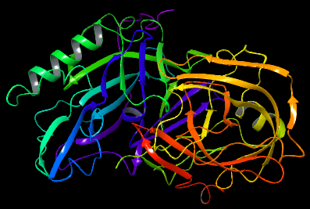
Figure 1: Diagrammatic representation of 3D crystallographic structure of βeta Secretase-1 (PDB ID: 3VF3)
Next, the crystal structure of the protein was prepared. This was done so that the docking software could have the best crystallographic structure of the protein without any interfering molecules that could disrupt the virtual screening campaign from giving the best results. The protein preparation was achieved using the Protein Preparation Workflow of the Maestro software program. The structure of the protein was reviewed, and all heteroatomic components, such as metal ions and water molecules, were removed. The A-chain of the protein structure was retained for the molecular docking campaign. Afterwards, the protein structure was pre-processed. In this step, all missing hydrogen atoms were replaced, and bond orders were assigned. The hydrogen bond was assigned, and any overlapping hydrogen atoms were then optimized, after which the protein was finally cleaned up.
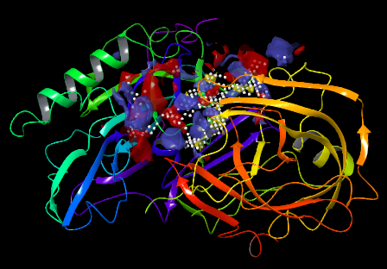
Figure 2: Diagrammatic representation of 3D crystallographic structure of β Secretase-1 showing its predicted active site.
Molecular Docking
Molecular Dynamics (MD) simulation
In this study, we conducted a molecular dynamics (MD) simulation to evaluate the degree of stability of compounds, including our hit compound, Nicotelline, with a PUBCHEM ID of CID_68123, and the standard compound, AZD 3293, with a PUBCHEM ID of CID_57404290, both in complex with the receptor. Performing the MD simulation is of high importance as it serves as an important complement to gaining a deeper insight into the atomistic details of interactions (Ramamohan et al., 2022) that were observed during the molecular docking stage of the experimental process.
We carried out the MD simulations of the BACE-1-ligand and βeta secretase-1-standard complexes using GROMACS 2022.3 (Van Der Spoel et al., 2005). The parametrization of both the protein and ligand molecules was done using the CHARMM36 force field. We solvated each complex in a cubic box of TIP3P water molecules, and the system was neutralized by adding counter-ions. The system energy was minimized using the steepest descent algorithm, and the NVT and NPT ensembles were used for equilibration. All simulations were carried out on a high-performance computing cluster, and the data were analyzed using custom Python scripts and visualized using PyMOL and VMD software. Our MD simulations were performed at a timescale of 100 nanoseconds (ns), after which the trajectories obtained for the four parameters; Root Mean Square Deviation (RMSD), Root Mean Square Fluctuation (RMSF), Radius of Gyration (ROG), and Solvent Accessible Surface Area (SASA) from the simulation runs were analyzed using GROMACS tools.

RESULTS.
The aim of this study was to identify hit compounds with higher degree of inhibitory potential against βeta secretase-1, the enzyme responsible for the cleavage of APP in the amyloidogenic pathway, than AZD 3293 (CID_57404290).
High Performance Liquid Chromatography (HPLC)
The result obtained from the HPLC analysis demonstrated that 22 compounds (Table 1) were present in the tobacco plant. These 22 compounds (which are represented together with their retention time on Table 4) were downloaded from PUBCHEM database, and used for the In-Silico studies.
Table 1: List of 22 chemical compounds obtained from HPLC of tobacco plant with their PUBCHEM ID and 3D structures.
Compound name | PUBCHEM ID (CID) | 3D structure
4-Hydroxybenzaldehyde | 126 | 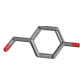
Ajmalicine | 441975 | 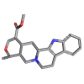
Anabasine | 2181 | 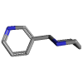
Estradiol | 5757 | 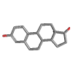
Anatabine | 11388 | 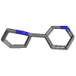
Anethole | 637563 | 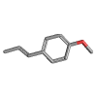
Catechin | 9064 | 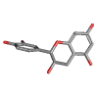
Catechol | 289 | 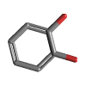
Chlorogenic acid | 1794427 | 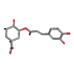
Cotinine | 854019 | 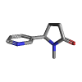
Guaiacol | 460 | 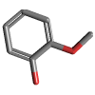
Harmine | 5280953 | 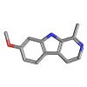
Nicotelline | 68123 | 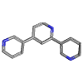
Nicotianine | 12313328 | 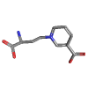
Nicotine | 89594 | 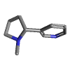
Nornicotine | 412 | 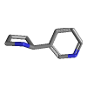
Protocatechuic acid | 72 | 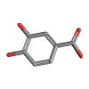
P-salicylic acid | 135 | 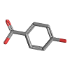
Pyridine | 1049 | 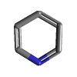
Cembrene | 6430770 | 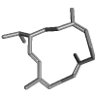
Vanillic acid | 8468 | 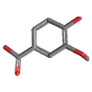
Vanillin | 1183 | 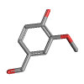

Table 2: Quantitative determination of phytochemical constituents of tobacco plant
SAMPLE | % TANNIN | % SAPONIN | % FLAVONOIDS | % PHENOL | % STEROIDS | % TERPENES | % ALKALOIDS
TOBACCO LEAVES | 0.0015 | 0.1790 | 0.0018 | 0.1570 | 0.0027 | 0.0016 | 0.3130

Table 3: Qualitative determination of phytochemical constituents of Tobacco leaves extract
PHYTOCHEMICAL CONSTITUENTS | OBSERVATION | REMARK
ALKALOIDS | +++ | AA
TANNIN | ++ | MA
PHLOBATANNIN | - | CA
SAPONIN | +++ | AA
FLAVONOIDS | ++ | MA
ANTHRAQUINONES | - | CA
STEROIDS | ++ | MA
TERPENES | ++ | MA
CARDENOLIDES | - | CA
PHENOL | +++ | AA
CHALCONES | - | CA
CARDIAC GLYCOSIDES | + | TA

KEYWORDS: AA = Appreciable Amount; MA = Moderate Amount; TA = Trace Amount; CA = Completely Absent.

Table 4: Representation of compounds identified by HPLC analysis of tobacco plant (Nicotiana tabacum) and their retention time
COMPOUNDS | RENTENTION TIME
ESTRADIOL | 4.400
GUAIACOL | 8.166
P-SALICYLIC ACID | 8.433
ANETHOLE | 9.750
CEMBRENE | 10.933
NICOTINE | 11.216
CHLOROGENIC ACID | 12.116
NORNICOTINE | 12.950
4-HYDROXYBENZALDEHYDE | 13.900
CATECHIN | 14.500
CATECHOL | 15.150
PROTOCATECHUIC ACID | 15.783
VANILLIN | 16.300
VANILLIC ACID | 17.033
NICOTELLINE | 17.383
NICOTIANINE | 18.083
TABACINE | 18.433
TABACININE | 19.433
HARMINE | 19.833
PYRIDINE | 20.383
ANABASINE | 20.783
ANATABINE | 21.3833

Molecular Docking
Our molecular docking campaign revealed that the 22 phytochemical compounds of Tobacco plant and the standard compound (AZD 3293) bound to the active site of the receptor, and their respective binding energies were ranked (Table 5). From these 22 phytochemical constituents, three compounds (Nicotelline, Chlorogenic Acid, and Estradiol) had better binding energies (-7.70 kcal/mol, -7.61 kcal/mol, and -7.60 kcal/mol) for the receptor than AZD 3293 (-6.47 kcal/mol), respectively.The docked ligands were observed to bind to the active site of the protein, a site critical to its biological/enzymatic functions, and form molecular interactions with the catalytic residues. Nicotelline formed three hydrogen bond interactions with Thr 72, Gln 73, and Gly 217 and seven hydrophobic interactions with Leu 30, Tyr 71, Phe 108, Ile 110, Trp 115, Ile 213, and Val 319. This reiterates the degree of putative binding of Nicotelline to the active site of βeta secretase-1 (Figure 3). Chlorogenic acid demonstrated four hydrogen bond interactions with Thr 72, Ile 126, Arg 128, and Thr 218, and exhibited nine hydrophobic interactions with Leu 30, Val 69, Pro 70, Tyr 71, Ala 127, Ile 118, Thr 185, Ile 126, and Val 319 (Figure 4).

Table 5: Tabular representation of docked compounds and their binding energy
Compound name | PUBCHEM CID | Binding energy (kcal/mol)
Nicotelline | CID_68123 | -7.70
Chlorogenic acid | CID_1794427 | -7.61
Estradiol | CID_5757 | -7.60
AZD3293 | CID_57404290 | -6.47
Ajmalicine | CID_441975 | -5.85
Anabasine | CID_2181 | -6.44
Anatabine | CID_11388 | -6.44
Anethole | CID_637563 | -4.74
Catechin | CID_9064 | -7.27
Catechol | CID_289 | -5.38
Cembrene | CID_6430770 | -5.59
Cotinine | CID_854019 | -5.94
Guaiacol | CID_460 | -5.09
Harmine | CID_5280953 | -6.23
Nicotianine | CID_12313328 | -4.65
Nicotine | CID_89594 | -6.05
Nornicotine | CID_412 | -6.86
Protocatechuic acid | CID_72 | -6.21
P-salicylic acid | CID_135 | -5.60
Pyridine | CID_1049 | -4.98
Vanillic acid | CID_8468 | -5.80
Vanillin | CID_1183 | -5.67
4-Hydroxybenzaldehyde | CID_126 | -5.39

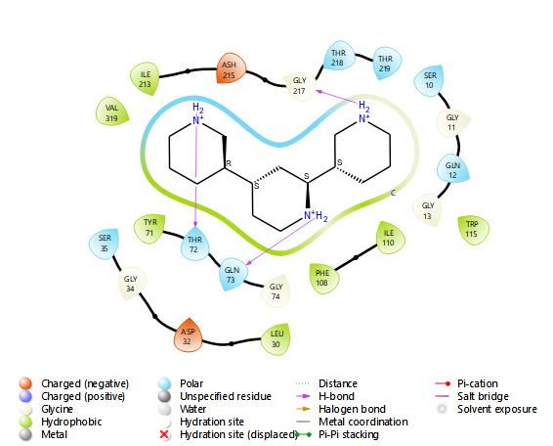
Figure 3: Diagrammatic representation of 2D interaction between Nicotelline and receptor

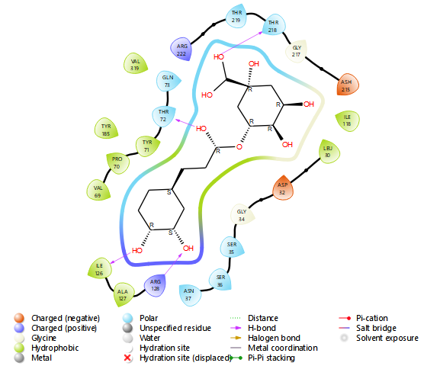
Figure 4: Diagrammatic representation of 2D interaction between Chlorogenic acid and receptor

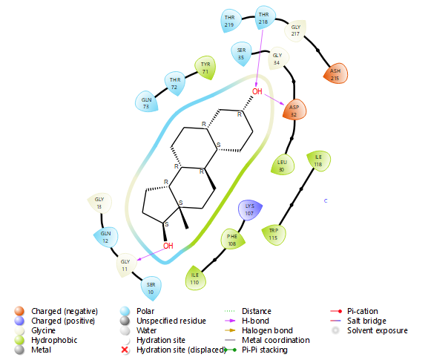
Figure 5: Diagrammatic representation of 2D interaction between Estradiol and receptor

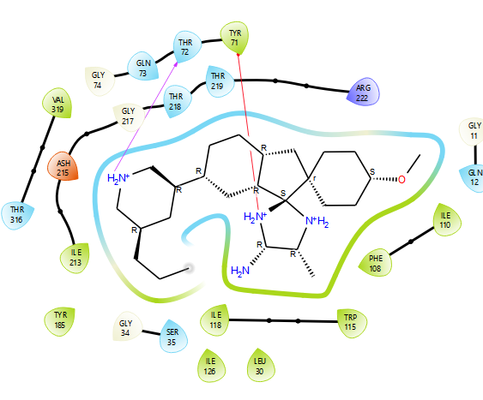
Figure 6: Diagrammatic representation of 2D interaction between standard compound (AZD 3293) and receptor

Molecular Dynamics (MD) simulation
In this study, Molecular Dynamics (MD) Simulations of two complexes; 3VF3-Nicotelline and 3VF3-AZD3293 were carried out on a timescale of 100 nanoseconds (ns), and the analysis of the trajectories was done using GROMACS tools for the calculation of RMSD, RMSF, ROG, and SASA.
Root Mean Square Deviation (RMSD)
In MD simulation, the Root Mean Square Deviation (RMSD) of a complex represents a measure of the average distance present between the atoms of the complex at two different points in time. In this study, it was deemed essential to compute the RMSD of our protein-ligand complexes after the runs of the MD simulation because it could provide an understanding of the dynamics and behavior of the protein-ligand complexes over the given time scale (100 nanoseconds) Figure 7 represents the superimposed RMSD graph spectra of the complexes subjected to simulation runs.

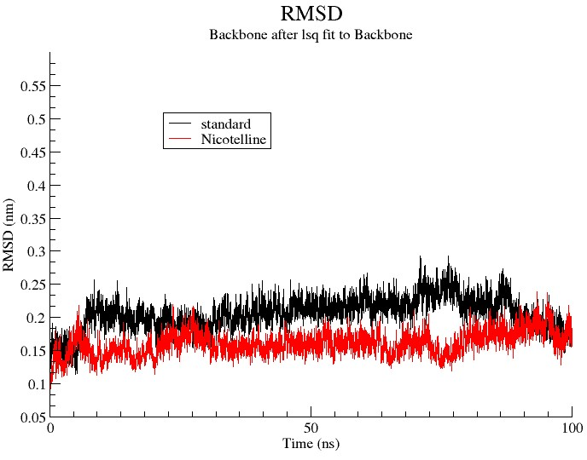
Figure 7: Schematic diagram of the superimposed RMSD graph spectra of the complexes subjected to MD simulation.

Root Mean Square Fluctuation (RMSF)
Figure 8 represents the superimposed RMSF graph spectra of the complexes subjected to the MD simulation run at a time scale of 100 ns. The computed average RMSF values obtained from the simulation for Nicotelline-3VF3 and the standard compound AZD 3293-3VF3 were 0.150 nm and 0.100 nm, respectively.
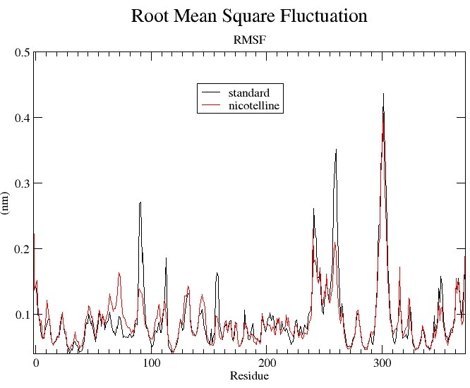
Figure 8: Schematic diagram of the superimposed RMSF graph spectra of the complexes subjected to MD simulation.
Radius of Gyration (ROG)

Figure 9 represents the superimposed graph spectrum of ROG of the Nicotelline-3VF3 complex as well as the standard-3VF3 complex. The average ROG values observed for Nicotelline and the standard compound were 2.120 nm and 2.140 nm, respectively.

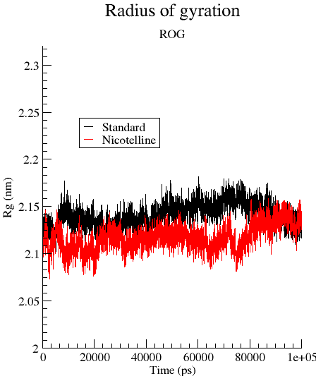
Figure 9: Schematic diagram of the superimposed ROG graph spectra of the complexes subjected to MD simulatio

Solvent Accessible Surface Area (SASA)
Figure 10 represents the superimposed SASA graph spectra of the complexes of both Nicotelline and AZD 3293 complexes that were subjected to a MD simulation run. According to the SASA graph spectrum, the SASA tones of Nicotelline and AZD 3293 were comparable; conversely, the SASA tone for Nicotelline was slightly lower (177.5 nm²) than that of the standard compound (177.7 nm²).

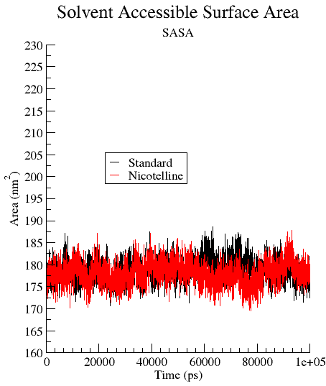
Figure 10: Schematic diagram of the superimposed SASA graph spectra of the complexes subjected to MD simulation

DISCUSSION.
The discrepancies in the number of compounds isolated from the same samples by HPLC and GC-FID simply suggested the number of volatile compounds inherent in the same samples analyzed by both methods. For instance, Tobacco leaves yielded 10 compounds by HPLC, while GC-FID of the same sample produced 23 compounds. Chewing Tobacco under HPLC generated 8 compounds while GC-FID of the same sample produced 21 compounds. Benue street snuff presented 17 compounds from the HPLC analysis and 23 compounds were identified by GC-FID profiling. The Kano street snuff subjected to HPLC scrutiny showed 19 compounds while the GC-FID method revealed 25 compounds. The additional compounds in each case were considered to be probably volatile and not detected under the HPLC scrutiny but detected by GC-FID. Therefore, HPLC profiling is more resolute while GC-FID analysis is more inclusive.
Based on the results obtained from our molecular docking study, it was observed that the three hit compounds (Nicotelline, Chlorogenic acid, and Estradiol) demonstrated higher binding affinities for the active site of the receptor than AZD3293. This suggested that the hit compounds have the potential to bind the active site and inhibit the biological activity of the enzyme (βeta secretase-1) better than AZD 3293. This is because the biological/enzymatic action of βeta Secretase-1 relies heavily on the active site.
Furthermore, the molecular interactions between our hit compounds (Nicotelline, Chlorogenic acid, and Estradiol) and the receptor were better than those observed between AZD 3293 and the receptor. This suggested that there is a higher probability of the hit compounds demonstrating a higher degree of biochemical effects than AZD 3293 when developed as a therapeutic regimen against βeta secretase-1. Interestingly, hydrogen bond (HBONDS) interaction represents a key determinant of the degree of molecular interaction between a drug molecule and therapeutic target (Wade and Goodford, 1989). As observed from our molecular docking, the three hit compounds (Nicotelline (3 HBONDS), Chlorogenic acid (4 HBONDS), and Estradial (3 HBONDS) had a higher H-BOND interaction than AZD 3293 (1 HBOND). This suggests that our hit compounds are likely to demonstrate better biochemical effects than the standard compound. This suggestion is correlated with the studies of Patil et al. (2010) and Dhakal et al. (2022), who reported that HB interaction is fundamental, enhances stability, and is crucial to effective binding of protein and ligand.
In this study, a molecular docking-based virtual screening campaign was carried out to predict the binding affinities and the inter-molecular interactions of the ligand molecules at the active site of the receptor. The prepared crystal structure of the enzyme, Human βeta Secretase-1, was used as the receptor. Glide, a software program that is part of Maestro, was used as the docking software. This docking tool was tasked with restricting the docking process to the reference position only, i.e., the active site of the protein (that was generated initially using the SiteMap panel (Figure 2). This was done so that the docking process could focus on the active site only rather than wandering around the whole protein surface, which might slow the docking process and adversely affect its accuracy. The Glide tool was also tasked with generating up to five binding poses per ligand structure; this required a choice of the best pose among the generated poses. The precision functionality of the Glide tool was configured to Standard Precision (SP). This was preferred because it uses about 10–20 seconds for sampling each ligand molecule during the docking process, enhancing the accuracy of the docking process. This is understood to have a significant effect on the docking result, as reported by Sastry et al. (2013). Lastly, the ligand sampling functionality of the Glide was configured to Flexible so that the receptor can be in a flexible state during the docking process. This mode of sampling was used because it improves results. This is in accordance with the study conducted by Sastry et al. (2013), who reported that flexibility improves docking results. After these configurations, the docking process was run for the ligands, including a standard compound (AZD 3293). After the docking process was completed, the degree of binding affinity, represented by the binding energy (-kCal/mol), was ranked automatically by the Glide too, and the binding poses of the molecular interaction of the ligand-protein complexes were also generated. To have a better understanding and insight into the interaction between each ligand molecule and the receptor, we carried out the analysis and visualization of the ligand-protein complex structures using the Ligand Interaction window of the Maestro software program.
This is a computational parameter that measures the Root Mean Square distance existing between the center of mass of a protein and its group of atoms. It is necessary to determine the ROG of a protein-ligand complex, as it is crucial in evaluating the stability of the protein structure in a biological system (Oyedele et al., 2023). Furthermore, the ROG parameter depicted the degree of compactness of atoms within the protein molecule (Khoutoul et al., 2016).
The RMSD is usually used for evaluating the degree of stability and quality of bonds existing between complexes over a particular time scale (Liu et al., 2017). By calculating the RMSD value, the tendency of the protein-ligand complex to remain in the bound state throughout the simulation run can be evaluated (Adelusi et al., 2022). As represented in Figure 7, the average RMSD value of Nicotelline-3VF3 was observed to be 0.150 nm, which implies a profound degree of stability of the complex. This is in contrast to the standard compound AZD 3293-3VF3, which was observed to exhibit a higher average RMSD value of 0.210 nm. Based on the average RMSD values of both Nicotelline and the standard compound (AZD 3293), it can be inferred that Nicotelline can remain more stable at the receptor surface in the physiological system if developed into a therapeutic regimen against AD than the standard compound (AZD 3293) (Oyedele et al., 2023). Also, it can be inferred from this observation that Nicotelline has a higher tendency to demonstrate a better biochemical effect when developed into a therapeutic regimen against AD than AZD 3293.
In MD simulation, the Root Mean Square Fluctuation (RMSF) represents a parameter that aids in the identification of key amino acid residues involved in the strongest molecular interactions between a protein and ligand (Lee et al., 2012; Oyedele et al., 2023). Furthermore, the RMSF values of a given complex are a representation of the degree of deviation of an atom from its average position throughout the run of the MD simulation (Lee et al., 2012). More so, the RMSF is a measure of the atomic mobility of the alpha-carbon (Cα) atoms of a protein molecule. Evaluating the RMSF value of a given complex is crucial because it provides a deeper insight into the degree of stability and flexibility of a protein structure. Rigid or flexible regions can be determined by calculating the RMSF values for the atoms of the protein.
Regions that demonstrate higher RMSF values were understood to be more flexible and to possess higher structural movement relative to other regions of the protein structure, while regions with lower RMSF values were understood to be less flexible and to possess lower structural movement relative to other regions of the protein structure (Lee et al., 2012). From the observation in figure 8, we inferred that Nicotelline-3VF3 had a lower residual fluctuation than the standard compound, AZD 3293-3VF3. Thus, it was inferred that nicotine can have more stability at the receptor surface when developed into a drug molecule than AZD 3293. Furthermore, the biochemical activity of Nicotelline was expected to be better than that of AZD 3293. Interestingly, this observation demonstrated a positive correlation with the results obtained from the RMSD and molecular docking campaigns, both indicating that Nicotelline can be a better drug molecule against AD than AZD 3293.
Figure 9 was an indication that the atoms of the receptor were more compact and stable during their interaction with Nicotelline than they were when interacting with AZD 3293. Interestingly, the ROG value was in correlation with the RMSD and RMSF parameters, where Nicotelline was observed to demonstrate a higher degree of stability and a lower degree of fluctuation than the standard compound, suggesting that Nicotelline is a promising drug candidate that can be developed into a therapeutic regimen for the treatment of AD. Moreover, these observations suggested that nicotine was likely to demonstrate a better biochemical effect than AZD 3293.
SASA is characterized by the degree to which the atoms of a protein molecule can form contact with a solvent in a biological system. It is considered a key and decisive factor when evaluating the stability of a protein (Ali et al., 2014). It is understood that there is an inverse relationship between the SASA value of a protein-ligand complex and the compactness and stability of the protein structure when bound to a ligand. This is an indication that a reduced SASA value of a protein-ligand complex represents a relative structural shrinkage of the protein-ligand complex due to the effect of the solvent surface charges to which the complex was exposed, demonstrating a high degree of compactness and stability of the protein conformation, while an increased SASA value of a protein-ligand complex demonstrates a relative structural expansion of the protein-ligand complex, indicating a reduced level of stability and compactness of the protein structure when bound to the ligand (Zaki et al., 2022). Figure 9 suggested that nicotine could be a better drug candidate than AZD 3293. Interestingly, since all observations from this study suggested that Nicotelline can be a better drug candidate than AZD 3293, we inferred that there is a higher probability of Nicotelline exhibiting a better biochemical effect on the treatment of AD when developed into a therapeutic regimen than AZD 3293. Therefore, our study demonstrated that the three hit compounds (Nicotelline, Chlorogenic Acid, and Estradiol) have promising potential as better drug candidates for the treatment of AD than AZD3293; though, further studies (pre-clinical, clinical, and toxicity) are needed to further evaluate and confirm the potency and related toxicities of the hit compounds.
This observation suggested the degree of binding of chlorogenic acid to the active site of βeta secretase-1. Estradiol exhibited 3 hydrogen bond interactions with Gly 11, Asp 32, and Thr 218, and demonstrated 6 hydrophobic interactions with Leu 30, Tyr 71, Phe 108, Ile 110, Ile 118, and Trp 115 (Figure 5). This advocateed the degree of binding demonstrated by estradiol as an inhibitor of the protein target. The standard compound (AZD3293) formed a single hydrogen bond interaction with Thr 72 and exhibited 10 hydrophobic interactions with Leu 30, Tyr 71, Phe 108, Ile 110, Trp 115, Ile 118, Ile 126, Tyr 185, Ile 213, and Val 319 (Figure 6). This suggests that, although AZD3293 bound and interacted with the active site of the receptor, the degree of binding and interaction of this compound was lower as compared to the hit compounds.

Conclusion
In this study, an In-Silico-based approach involving molecular docking and MD simulations was used to investigate the inhibitory potential of phytochemical constituents of Tobacco plant (identified by HPLC analysis), and a standard compound (AZD 3293) against βeta Secretase-1. Our molecular docking and MD simulations revealed three hit compounds (Nicotelline, Chlorogenic acid, and Estradiol) with better binding affinities (-7.70 kca/mol, -7.61 kca/mol, and -7.60 kca/mol respectively) and molecular interactions (HBOND and Hydrophobic interactions) than AZD 3293. Of these three compounds, Nicotelline was identified as the lead compound and, together with AZD 3293, was further evaluated at 100 ns of MD simulation run. Nicotelline demonstrated better trajectory parameters (RMSD, RMSF, ROG, and SASA) than AZD 3293. As observed from these molecular docking and MD simulations, it was inferred that Nicotelline has the potential of being a better drug candidate than AZD 3293. Additionally, the efficacy and potency of Nicotelline is expected to be higher than that of AZD 3293. Although, our In-silico-based investigation revealed Nicotelline as the lead compound with better inhibitory potential against βeta Secretase-1 than AZD 3293, yet, this In-Silico-based approach is inadequate to ascertain or confirm (Nicotelline) as a therapeutic regimen against AD, necessitating the need for further investigatory studies (preclinical, and clinical, and toxicity).

Disclaimer (Artificial intelligence)

Option 1:

Author(s) hereby declare that NO generative AI technologies such as Large Language Models (ChatGPT, COPILOT, etc.) and text-to-image generators have been used during the writing or editing of this manuscript.

Option 2:

Author(s) hereby declare that generative AI technologies such as Large Language Models, etc. have been used during the writing or editing of manuscripts. This explanation will include the name, version, model, and source of the generative AI technology and as well as all input prompts provided to the generative AI technology

Details of the AI usage are given below:
1.
2.
3.

REFERENCES
ALZHEIMER’S ASSOCIATION REPORT (2021). Alzheimer's disease facts and figures. Alzheimer's & dementia. The Journal of the Alzheimer's Association, 17(3), 327–406. https://doi.org/10.1002/alz.12328.
Abdul-Quddus Kehinde Oyedele, Nurudeen Abiodun Owolabi, Tope Tunji Odunitan, Abosede Ajibare Christiana, Rukayat Olajumoke Jimoh, Azeez, A., Maryam Bello-Hassan Titilayo, Abiola Sarah Soares, Adedayo Toluwani Adekola, Teslim Oluwaseyi Abdulkareem, Samson Olabode Oyelekan, Mojeed Ayoola Ashiru, Ibrahim Olajide Gbadebo, Habeebah Eyinade Olajumoke, Ibrahim Damilare Boyenle, & Abdeen Tunde Ogunlana. (2023). The discovery of some promising putative binders of KRAS G12D receptor using computer-aided drug discovery approach. Informatics in Medicine Unlocked, 37, 101170–101170. https://doi.org/10.1016/j.imu.2023.101170.
Abdul-Quddus Kehinde Oyedele, Temitope Isaac Adelusi, Abdeen Tunde Ogunlana, Adeyemi, R., Opeyemi Emmanuel Atanda, Musa Oladayo Babalola, Mojeed Ayoola Ashiru, Isong Josiah Ayoola, & Ibrahim Damilare Boyenle. (2022). Integrated virtual screening and molecular dynamics simulation revealed promising drug candidates of p53-MDM2 interaction. Journal of Molecular Modeling, 28(6). https://doi.org/10.1007/s00894-022-05131-w.
Abubakar, A., & Haque, M. (2020). Preparation of medicinal plants: Basic extraction and fractionation procedures for experimental purposes. Journal of Pharmacy and Bioallied Sciences, 12(1), 1–10. https://doi.org/10.4103/jpbs.jpbs_175_19.
Abubakar, M. B., Sanusi, K. O., Ugusman, A., Mohamed, W., Kamal, H., Ibrahim, N. H., Khoo, C. S., & Kumar, J. (2022). Alzheimer’s Disease: An Update and Insights Into Pathophysiology. Frontiers in Aging Neuroscience, 14(1), 742408. https://doi.org/10.3389/fnagi.2022.742408.
Adelusi, T. I., Oyedele, A.-Q. K., Boyenle, I. D., Ogunlana, A. T., Adeyemi, R. O., Ukachi, C. D., Idris, M. O., Olaoba, O. T., Adedotun, I. O., Kolawole, O. E., Xiaoxing, Y., & Abdul-Hammed, M. (2022). Molecular modeling in drug discovery. Informatics in Medicine Unlocked, 29, 100880. https://doi.org/10.1016/j.imu.2022.100880.
Ali, S. A., Hassan, M. I., Islam, A., & Ahmad, F. (2014). A review of methods available to estimate solvent-accessible surface areas of soluble proteins in the folded and unfolded states. Current Protein & Peptide Science, 15(5), 456–476. https://doi.org/10.2174/1389203715666140327114232.
Alsaud, N., & Farid, M. (2020). Insight into the Influence of Grinding on the Extraction Efficiency of Selected Bioactive Compounds from Various Plant Leaves. Applied Sciences, 10(18), 6362. https://doi.org/10.3390/app10186362.
Berman, H. M., Westbrook, J., Feng, Z., Gilliland, G., Bhat, T. N., Weissig, H., ... & Bourne, P. E. (2000). The protein data bank. Nucleic acids research, 28(1), 235-242.
Breijyeh, Z., & Karaman, R. (2020). Comprehensive Review on Alzheimer’s Disease: Causes and Treatment. Molecules, 25(24), 5789. https://doi.org/10.3390/molecules25245789.
Chen, G., Xu, T., Yan, Y., Zhou, Y., Jiang, Y., Melcher, K., & Xu, H. E. (2017). Amyloid beta: structure, biology and structure-based therapeutic development. Acta Pharmacologica Sinica, 38(9), 1205–1235. https://doi.org/10.1038/aps.2017.28.
Deli, M., Ndjantou, E. B., Ngatchic Metsagang, J. T., Petit, J., Njintang Yanou, N., & Scher, J. (2019). Successive grinding and sieving as a new tool to fractionate polyphenols and antioxidants of plants powders: Application to Boscia senegalensis seeds, Dichrostachys glomerata fruits, and Hibiscus sabdariffa calyx powders. Food Science & Nutrition, 7(5), 1795–1806. https://doi.org/10.1002/fsn3.1022.
Dhakal, A., McKay, C., Tanner, J. J., & Cheng, J. (2022). Artificial intelligence in the prediction of protein–ligand interactions: recent advances and future directions. Briefings in Bioinformatics, 23(1). https://doi.org/10.1093/bib/bbab476.
Fotsing Yannick Stéphane, F., Kezetas Jean Jules, B., El-Saber Batiha, G., Ali, I., & Ndjakou Bruno, L. (2021). Extraction of Bioactive Compounds from Medicinal Plants and Herbs. Pharmacognosy - Medicinal Plants [Working Title]. https://doi.org/10.5772/intechopen.98602.
Gunes, S., Aizawa, Y., Sugashi, T., Sugimoto, M., & Rodrigues, P. P. (2022). Biomarkers for Alzheimer’s Disease in the Current State: A Narrative Review. International Journal of Molecular Sciences, 23(9), 4962. https://doi.org/10.3390/ijms23094962.
Gyu Rie Lee, Shin, W.-H., Shin, S., & Seok, C. (2012). Conformational Sampling of Flexible Ligand-binding Protein Loops. Bulletin of the Korean Chemical Society, 33(3), 770–774. https://doi.org/10.5012/bkcs.2012.33.3.770.
Harborne J.B. (1973). Phytochemical Methods: A Guide to Modern Techniques of Plant Analysis. Chapman A &Hall London. 279.
Heinrich Rueeger, Rainer Martin Lueoend, Rogel, O., Rondeau, J.-M., Henrik Möbitz, Rainer Machauer, Jacobson, L. H., Matthias Staufenbiel, Sandrine Desrayaud, & Neumann, U. P. (2012). Discovery of Cyclic Sulfone Hydroxyethylamines as Potent and Selective β-Site APP-Cleaving Enzyme 1 (BACE1) Inhibitors: Structure-Based Design and in Vivo Reduction of Amyloid β-Peptides. Journal of Medicinal Chemistry, 55(7), 3364–3386. https://doi.org/10.1021/jm300069y.
Jaul, E., & Barron, J. (2017). Age-Related Diseases and Clinical and Public Health Implications for the 85 Years Old and Over Population. Frontiers in Public Health, 5(335). https://doi.org/10.3389/fpubh.2017.00335.
Khoutoul, M., Morad Lamsayah, Fawzia Faleh Al-blewi, Nadjet Rezki, Mohamed Reda Aouad, Mouslim Messali, & Rachid Touzani. (2016). Liquid–liquid extraction of metal ions, DFT and TD-DFT analysis of some 1,2,4-triazole Schiff Bases with high selectivity for Pb(II) and Fe(II). Journal of Molecular Structure, 1113, 99–107. https://doi.org/10.1016/j.molstruc.2016.02.046.
Liu, K., Watanabe, E., & Kokubo, H. (2017). Exploring the stability of ligand binding modes to proteins by molecular dynamics simulations. Journal of Computer-Aided Molecular Design, 31(2), 201–211. https://doi.org/10.1007/s10822-016-0005-2.
Lu, C., Wu, C., Ghoreishi, D., Chen, W., Wang, L., Damm, W., Ross, G. A., Dahlgren, M. K., Russell, E., Von Bargen, C. D., Abel, R., Friesner, R. A., & Harder, E. D. (2021). OPLS4: Improving Force Field Accuracy on Challenging Regimes of Chemical Space. Journal of Chemical Theory and Computation, 17(7), 4291–4300. https://doi.org/10.1021/acs.jctc.1c00302.
Madhavi Sastry, G., Adzhigirey, M., Day, T., Annabhimoju, R., & Sherman, W. (2013). Protein and ligand preparation: parameters, protocols, and influence on virtual screening enrichments. Journal of Computer-Aided Molecular Design, 27(3), 221–234. https://doi.org/10.1007/s10822-013-9644-8.
Murphy, M. P., & LeVine, H. (2010). Alzheimer’s Disease and the Amyloid-β Peptide. Journal of Alzheimer’s Disease, 19(1), 311–323. https://doi.org/10.3233/jad-2010-1221.
Nayal, M., & Honig, B. (2006). On the nature of cavities on protein surfaces: Application to the identification of drug-binding sites. Proteins: Structure, Function, and Bioinformatics, 63(4), 892–906. https://doi.org/10.1002/prot.20897.
Nurhaslina, C. R., Andi Bacho, S., & Mustapa, A. N. (2022). Review on drying methods for herbal plants. Materials Today: Proceedings, 63, S122–S139. https://doi.org/10.1016/j.matpr.2022.02.052.
Patil, R., Das, S., Stanley, A., Yadav, L., Sudhakar, A., & Varma, A. K. (2010). Optimized Hydrophobic Interactions and Hydrogen Bonding at the Target-Ligand Interface Leads the Pathways of Drug-Designing. PLoS ONE, 5(8), e12029. https://doi.org/10.1371/journal.pone.0012029.
Poornima Ramamohan, István Furó, & Wohlert, J. (2022). Timescales for convergence in all-atom molecular dynamics simulations of hydrated amorphous xylan. Carbohydrate Polymers, 286, 119263–119263. https://doi.org/10.1016/j.carbpol.2022.119263.
Rajan, K. B., Weuve, J., Barnes, L. L., McAninch, E. A., Wilson, R. S., & Evans, D. A. (2021). Population estimate of people with clinical Alzheimer’s disease and mild cognitive impairment in the United States (2020–2060). Alzheimer’s & Dementia, 17(12). https://doi.org/10.1002/alz.12362.
Reimers, J. R., & Hall, L. E. (1999). The Solvation of Acetonitrile. Journal of the American Chemical Society, 121(15), 3730–3744. https://doi.org/10.1021/ja983878n.
Rudakov, O. B., Rudakova, L. V., & Selemenev, V. F. (2018). Acetonitrile as tops solvent for liquid chromatography and extraction. Journal of Analytical Chromatography and Spectroscopy, 1(2). https://doi.org/10.24294/jacs.v1i2.883.
Sasidharan, S., Chen, Y., Saravanan, D., Sundram, K. M., & Yoga Latha, L. (2011). Extraction, isolation and characterization of bioactive compounds from plants' extracts. African journal of traditional, complementary, and alternative medicines : AJTCAM, 8(1), 1–10.
Sehar, U., Rawat, P., Reddy, A. P., Kopel, J., & Reddy, P. H. (2022). Amyloid Beta in Aging and Alzheimer’s Disease. International Journal of Molecular Sciences, 23(21), 12924. https://doi.org/10.3390/ijms232112924.
Shang, S. Z., Duan, Y. X., Zhang, X., Pu, J. X., Sun, H. D., Chen, Z. Y., ... & Chen, Y. K. (2014). Phenolic amides from the leaves of Nicotiana tabacum and their anti-tobacco mosaic virus activities. Phytochemistry Letters, 9, 184-187.
https://www.sciencedirect.com/science/article/pii/S1874390014001104
Sofowora, A. (1993). Medicinal Plants and Traditional Medicines in Africa. Chichester John Willey & Sons New York. 256.
Stockmann, J., Verberk, I. M. W., Timmesfeld, N., Denz, R., Budde, B., Lange-Leifhelm, J., Scheltens, P., van der Flier, W. M., Nabers, A., Teunissen, C. E., & Gerwert, K. (2020). Amyloid-β misfolding as a plasma biomarker indicates risk for future clinical Alzheimer’s disease in individuals with subjective cognitive decline. Alzheimer’s Research & Therapy, 12(1). https://doi.org/10.1186/s13195-020-00738-8.
Sun, X., Chen, W.-D., & Wang, Y.-D. (2015). β-Amyloid: the key peptide in the pathogenesis of Alzheimer’s disease. Frontiers in Pharmacology, 6. https://doi.org/10.3389/fphar.2015.00221.
Tegelberg, R., Virjamo, V., & Julkunen-Tiitto, R. (2018). Dry-air drying at room temperature - a practical pre-treatment method of tree leaves for quantitative analyses of phenolics? Phytochemical Analysis, 29(5), 493–499. https://doi.org/10.1002/pca.2755.
Trease, G.E., Evans, W.C. (1989). A Text-book of Pharmacognosy. Bailliere Tindall Ltd, London. 53.
Van Der Spoel, D., Lindahl, E., Hess, B., Groenhof, G., Mark, A. E., & Berendsen, H. J. C. (2005). GROMACS: Fast, flexible, and free. Journal of Computational Chemistry, 26(16), 1701–1718. https://doi.org/10.1002/jcc.20291.
Venugopal, C., Demos, C., Jagannatha Rao, K., Pappolla, M., & Sambamurti, K. (2008). Beta-Secretase: Structure, Function, and Evolution. CNS & Neurological Disorders - Drug Targets, 7(3), 278–294. https://doi.org/10.2174/187152708784936626.
Vidler, Lewis R., Brown, N., Knapp, S., & Hoelder, S. (2012). Druggability Analysis and Structural Classification of Bromodomain Acetyl-lysine Binding Sites. Journal of Medicinal Chemistry, 55(17), 7346–7359. https://doi.org/10.1021/jm300346w.
Wade, R. C., & Goodford, P. J. (1989). The role of hydrogen-bonds in drug binding. Progress in clinical and biological research, 289, 433–444.
Wolfe, M. S. (2019). Structure and Function of the γ-Secretase Complex. Biochemistry, 58(27), 2953–2966. https://doi.org/10.1021/acs.biochem.9b00401.
Zaki, A. A., Ashour, A., Elhady, S. S., Darwish, K. M., & Al-Karmalawy, A. A. (2022). Calendulaglycoside A showing potential activity against SARS-CoV-2 main protease: Molecular docking, molecular dynamics, and SAR studies. Journal of traditional and complementary medicine, 12(1), 16-34.

