**Tuna Bone Waste *(Thunnus sp.)* as a Hydroxyapatite Source: Synthesis and Characterization for Biomaterial Applications**

**Abstract**

Tuna fish bone waste, a by-product of fish processing, exhibits promising potential for conversion into hydroxyapatite (HA), a high-value biomaterial with medical applications. This study successfully synthesized HA from tuna bone waste through a combined approach of calcination (900°C, 10 hours) and wet precipitation using (NH₄)₂HPO₄ at a Ca/P ratio of 1.67. The process achieved a conversion efficiency of 33.97%, producing HA with 81.7% phase purity along with a secondary whitlockite phase (18.3%) attributed to low pH conditions and Mg²⁺ ion presence. Comprehensive characterization revealed: (1) a hexagonal HA crystal structure with lattice parameters a = 9.424 Å and c = 6.879 Å (XRD analysis), and (2) spherical small particles (200-1000 nm) displaying agglomeration tendencies (SEM observation). The synthesized material demonstrates suitable characteristics for biomedical applications including bone grafts and tissue engineering scaffolds. This research presents an eco-friendly strategy for valorizing fishery waste while decreasing reliance on costly synthetic HA sources. Future studies should focus on optimizing the synthesis process to enhance both yield and purity.

**Keywords:** Hydroxyapatite, tuna fish bone, calcination, wet precipitation, biomaterial

**Introduction**Tuna fish bone waste represents a significant by-product of fish processing that remains largely underutilized (Sayana and Sirajudheen, 2017). Annually, millions of tons of fish bone waste are generated by the fisheries industry, most of which is discarded or processed into low-value animal feed. However, fish bones are rich in inorganic compounds such as calcium phosphate, which can be converted into high-value materials. Hydroxyapatite (HA), a form of calcium phosphate, is the primary inorganic component of human bones and teeth, endowing it with excellent biocompatibility. The synthesis of HA from fish bone waste offers a sustainable solution to mitigate environmental impacts while producing economically valuable biomaterials (Caruso et al., 2020).

HA has been widely applied in medical fields, including bone and dental implants, as well as tissue engineering scaffolds, due to its osteoconductive and bioactive properties. It promotes new bone cell growth without eliciting immune rejection. Additionally, HA serves as a drug delivery carrier and enhances the osseointegration of metal implants through surface coatings. Commercial synthetic HA remains expensive due to complex chemical processes, necessitating alternative sources like fish bone waste to reduce production costs (Sadat-Shojai et al., 2013).

Tuna bones are particularly advantageous due to their high mineral content (calcium and phosphate) and microporous structure, which facilitates extraction. Compared to other HA sources (e.g., bovine bones or shells), tuna bones are more abundant as industrial waste and yield homogeneous, nanocrystalline HA particles with superior mechanical and biological performance. Studies also indicate that fish bone-derived HA exhibits high purity with minimal pathogen contamination risks (Ma et al., 2021).

HA synthesis from fish bones typically involves calcination, deproteinization, and chemical precipitation. Calcination at 600–900°C removes organic compounds while crystallizing calcium phosphate phases. This method was selected for its key advantages: (1) production of high-purity HA through controlled heating, which eliminates collagen and lipids without harmful residues; (2) transformation of calcium phosphate into stable HA with a Ca/P ratio (~1.67) matching natural human bone; (3) cost-effectiveness and scalability for industrial production; and (4) retention of natural porosity, enhancing osteoconductivity for biomedical applications (Kongsri et al., 2013).

HA characterization includes crystallinity analysis (XRD) and surface morphology evaluation (SEM). XRD identifies crystalline phases, verifies purity, and calculates crystal size via Scherrer equation analysis, with ideal results matching standard HA diffraction patterns (JCPDS 09-0432). SEM reveals particle morphology, distribution, and porosity—critical for assessing biomedical suitability, such as cell adhesion or drug release. Together, these techniques provide comprehensive structural and morphological data (Ozawa & Suzuki, 2002).

Tuna bone-derived HA holds promise for bone grafts, dental composites, and orthopedic implant coatings, reducing reliance on costly synthetic materials or limited human donors. Emerging applications include calcium ion delivery systems for hard tissue regeneration, aligning with circular economy principles that upcycle waste into value-added products (Kang et al., 2023).

This study aims to synthesize and characterize HA from tuna bone waste, evaluating its potential as a sustainable, low-cost biomaterial. By addressing both fishery waste management and medical material needs, the findings could advance marine resource utilization in maritime nations like Indonesia.

**Methodology**

The research methodology was systematically conducted through the following stages:

**1.Raw Material Preparation**  
The initial stage began with the collection of fresh tuna fish bones from Kramat Jati Market in East Jakarta. The bones underwent thorough cleaning using running water to remove residual flesh, fat, and other impurities, with the washing process repeated until completely clean. The cleaned bones were then air-dried at room temperature for 24 hours before being pulverized into fine powder using a mortar and pestle to achieve uniform particle size.

**2. Calcination Process**  
The bone powder was subjected to calcination in a furnace at 900°C for 10 hours to eliminate organic components and transform the material into calcium oxide (CaO). After cooling to room temperature, the calcined product was reground to ensure homogeneity and facilitate subsequent reactions. This high-temperature treatment effectively converted the bone's calcium phosphate into a more reactive form while maintaining its essential mineral composition.

**3. Hydroxyapatite Synthesis Preparation**  
Prior to synthesis, all equipment was properly prepared, including the calibration of digital balances. Precise measurements were taken, with 2.83 grams of CaO powder and 3.97 grams of (NH₄)₂HPO₄ weighed to maintain the crucial Ca/P molar ratio of 1.67:1, which is essential for producing stoichiometric hydroxyapatite. This ratio was carefully controlled to match the natural composition of biological apatite.

**4. Wet Precipitation Synthesis**  
The synthesis process involved preparing two solutions: Solution A containing the CaO powder dissolved in 100 mL deionized water, and Solution B consisting of (NH₄)₂HPO₄ dissolved separately in another 100 mL deionized water. Using a burette and magnetic stirrer setup, Solution B was gradually added to Solution A at a controlled flow rate of 10 mL/min while maintaining constant stirring at 350 rpm for 100 minutes to ensure proper mixing and reaction. The mixture was then covered and allowed to age for 24 hours at room temperature to promote complete crystal formation and maturation.

**5. Purification and Drying**  
The resulting white precipitate underwent multiple washing cycles with deionized water to remove any residual ions or impurities, followed by filtration using filter paper. The purified precipitate was then dried in an oven at 110°C for 3 hours to obtain the final hydroxyapatite powder. For enhanced crystallinity, selected samples underwent additional calcination at 900°C for 5 hours.

**6. Material Characterization**  
The synthesized hydroxyapatite was comprehensively characterized using X-ray diffraction (XRD) to confirm crystalline phase purity by comparing diffraction patterns with the standard JCPDS 09-0432 database, and scanning electron microscopy (SEM) to examine surface morphology and particle size distribution. These analyses provided critical data on the material's structural properties and quality assurance for potential biomedical applications.

**Results and Discussion**

**A. Hydroxyapatite Efficiency**

The hydroxyapatite (HAp) synthesis in this study was carried out in two primary stages. The first stage involved calcining tuna fish bones at 900°C for 10 hours to produce CaO powder, while the second stage consisted of HAp synthesis via wet precipitation by reacting the calcined CaO with (NH₄)₂HPO₄ at a stoichiometric Ca/P ratio of 1.67. From 2.83 grams of CaO and 3.97 grams of (NH₄)₂HPO₄, 2.31 grams of HAp were obtained, resulting in a conversion efficiency of 33.97%. The relatively low efficiency may be due to several factors, including evaporation losses during heating, material loss during standard filter paper filtration, and potential unidentified side reactions. To enhance synthesis efficiency, process optimization—particularly in selecting more effective filtration methods and maintaining strict control over reaction conditions—is necessary. These results suggest that while tuna fish bones hold potential as an alternative calcium source for HAp synthesis, further refinement is needed to improve process efficiency.

**Table 1.** Quantitative data of HA synthesis results

| **Parameter** | **Value** |
| --- | --- |
| Initial CaO mass | 2.83 g |
| (NH₄)₂HPO₄ mass | 3.97 g |
| Obtained HAp mass | 2.31 g |
| Conversion efficiency | 33.97% |

**B. Crystal Structure Analysis by X-Ray Diffraction (XRD)**

XRD characterization of hydroxyapatite (HAp) synthesized from tuna fish bones revealed a characteristic diffraction pattern with prominent peaks at 2θ = 25.9°, 31.7°, 32.8°, 46.7°, and 49.5° (Figure 1). Quantitative phase analysis identified two crystalline phases: 81.7% HAp and 18.3% whitlockite. The minor whitlockite phase formation was attributed to suboptimal synthesis conditions, particularly low pH (<6,4) (Kazacova et al., 2021) and Mg ion substitution from the bone matrix. Notably, the presence of whitlockite enhanced the material's mechanical strength without compromising its biocompatibility.

**Table 2.** Crystallographic Parameters from XRD Analysis

| **Parameter** | **Hydroxyapatite (HAp)** | **Whitlockite** |
| --- | --- | --- |
| Phase Percentage | 81.7% | 18.3% |
| Crystal Structure | Hexagonal | Trigonal |
| Space Group | P63/m | R3c |
| Lattice Parameters (Å) | a = 9.424; c = 6.879 | a = 10.337; c = 37.068 |
| Unit Cell Volume (Å³) | 529.086 | 3430.2 |
| Formation Cause | - | Low pH, Mg ions |
| Biomedical Benefit | Biocompatible | Enhanced strength |

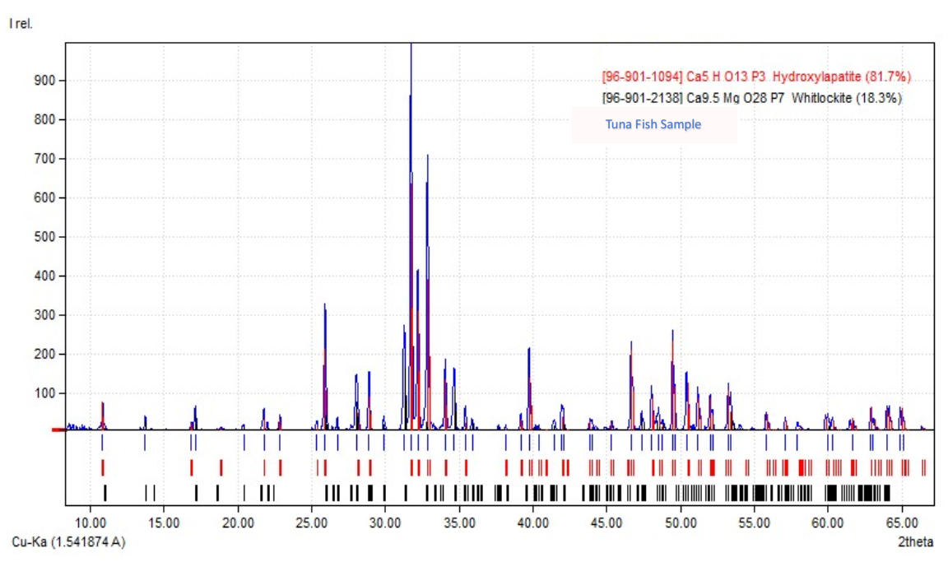

**Figure 1.** XRD pattern of hydroxyapatite synthesized from calcined tuna bone-derived CaO (10-hour calcination).

These findings demonstrate that tuna bones are a viable calcium source for HAp synthesis, though further optimization of synthesis parameters (pH, temperature, reaction time) is required to minimize whitlockite formation. The resulting material meets biomedical application requirements while offering improved mechanical properties.

**C. Morphological Characterization Results Using SEM**

Morphological analysis via Scanning Electron Microscopy (SEM) revealed that the synthesized hydroxyapatite (HAp) from tuna fish bones formed nanoparticles with distinct characteristics. At varying magnifications (2,500×, 5,000×, and 10,000×), the HAp particles exhibited spherical morphology with pronounced agglomeration tendencies. Particle sizes ranged from 200-1000 nm, with the majority (60 nm -300 µm) meeting nano-material criteria. These findings align with Arsad et al. (2010) regarding HAp's agglomerative properties, though our particle sizes exceeded the 210-410 nm range reported by Binnaz and Koca (2009). This discrepancy likely stems from differences in synthesis methods and natural raw material characteristics.

Clinically, the observed spherical nano-morphology offers significant advantages for biomedical applications, particularly in enhancing biocompatibility and drug delivery system potential. The detected agglomeration represents a common nano-material phenomenon that can be mitigated through further synthesis optimization.

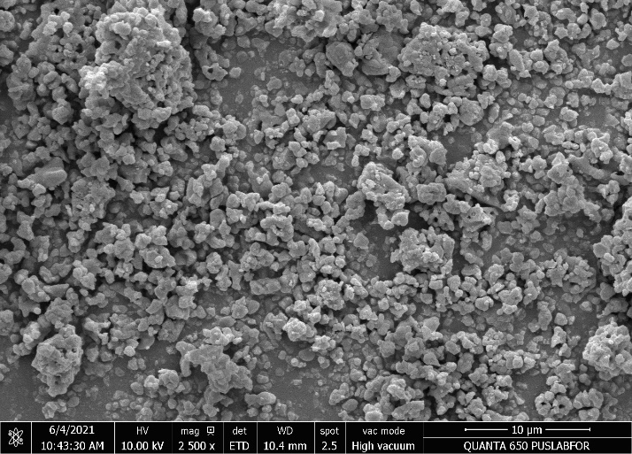

**Figure 2.** 2,500× magnification: Displays particle agglomeration patterns

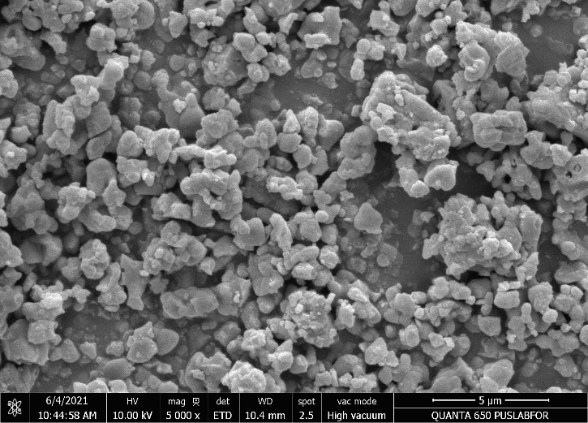

**Figure 3.** 5,000× magnification: Reveals spherical morphology details

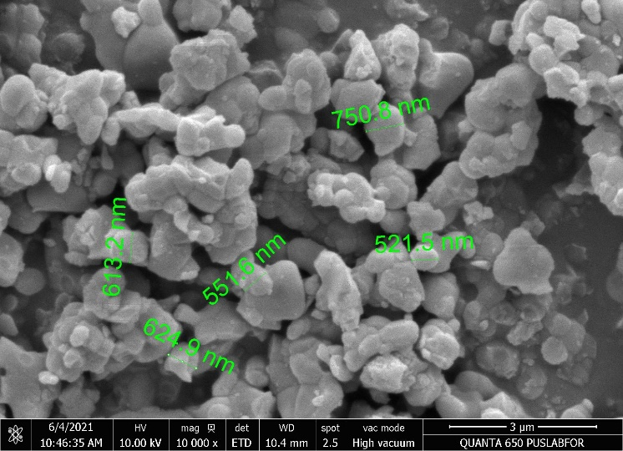

**Figure 4.** 10,000× magnification: Demonstrates individual particle dimensions

**Conclusion**

This study confirms the potential of tuna fish bones as an alternative source for hydroxyapatite (HAp) synthesis through calcination and wet precipitation methods. Characterization results showed that the synthesized HAp achieved 33.97% conversion efficiency with 81.7% phase purity, containing 18.3% whitlockite as a minor phase. Morphological analysis revealed nano-sized spherical particles (200-1000 nm) with some agglomeration, yet still suitable for biomedical applications. The research not only offers a sustainable solution for fishery waste utilization but also opens opportunities for developing locally sourced implant materials. For future work, optimization of synthesis parameters is needed to improve efficiency and product purity, along with more comprehensive biological testing to validate clinical performance. These findings provide an important foundation for biomedical material development while supporting circular economy principles in the fisheries industry.This study confirms the potential of tuna fish bones as an alternative source for hydroxyapatite (HAp) synthesis through calcination and wet precipitation methods. Characterization results showed that the synthesized HAp achieved 33.97% conversion efficiency with 81.7% phase purity, containing 18.3% whitlockite as a minor phase. Morphological analysis revealed nano-sized spherical particles (200-1000 nm) with some agglomeration, yet still suitable for biomedical applications. The research not only offers a sustainable solution for fishery waste utilization but also opens opportunities for developing locally sourced implant materials. For future work, optimization of synthesis parameters is needed to improve efficiency and product purity, along with more comprehensive biological testing to validate clinical performance. These findings provide an important foundation for biomedical material development while supporting circular economy principles in the fisheries industry.

**Disclaimer (Artificial intelligence)**

Author(s) hereby declare that NO generative AI technologies such as Large Language Models (ChatGPT, COPILOT, etc.) and text-to-image generators have been used during the writing or editing of this manuscript.

**References**

1. Yoruc, A. Binnaz Hazar dan Yeliz koca, “Double Step Stirring: A Novel Method for Precipitation of Nano-sized Hydroxyapatite Powder”. Digest Journal of Nanomaterials and Biostructures, 4 no. 1 (2009). H. 73-81.
2. Kazakova G, Safronova T, Golubchikov D, Shevtsova O, Rau JV. Resorbable Mg2+-Containing Phosphates for Bone Tissue Repair. Materials (Basel). 2021 Aug 26;14(17):4857. doi: 10.3390/ma14174857. PMID: 34500951; PMCID: PMC8432688.
3. M. S. M. Arsad, P. M. Lee and Lee Kong Hung, "Morphology and particle size analysis of hydroxyapatite micro- and nano-particles," *2010 International Conference on Science and Social Research (CSSR 2010)*, Kuala Lumpur, Malaysia, 2010, pp. 1030-1034, doi: 10.1109/CSSR.2010.5773682.
4. Kang, M.S.; Park, R.; Jo, H.J.; Shin, Y.C.; Kim, C.-S.; Hyon, S.-H.; Hong, S.W.; Oh, J.; Han, D.-W. Spontaneous Osteogenic Differentiation of Human Mesenchymal Stem Cells by Tuna-Bone-Derived Hydroxyapatite Composites with Green Tea Polyphenol-Reduced Graphene Oxide. *Cells* **2023**, *12*, 1448. https://doi.org/10.3390/cells12111448
5. Kongsri, S., Janpradit, K., Buapa, K., Techawongstien, S., & Chanthai, S. (2013). Nanocrystalline hydroxyapatite from fish scale waste. Chemical Engineering Journal, *215-216*, 522-532.
6. Ozawa, M., & Suzuki, S. (2002). Microstructural development of natural hydroxyapatite originated from fish‐bone waste through heat treatment. Journal of the American Ceramic Society, 85(5), 1315-1317.
7. Ma CC, Wang XC, Tao NP. (2021) Hydroxyapatite From the Skull of Tuna (*Thunnus obesus*) Head Combined With Chitosan to Restore Locomotive Function After Spinal Cord Injury. Front Nutr. 2021 Aug 23;8:734498. PMID: 34497824; PMCID: PMC8419224. <https://doi.org/10.3389/fnut.2021.734498> .
8. Sadat-Shojai, M., Khorasani, M. T., Dinpanah-Khoshdargi, E., & Jamshidi, A. (2013). Synthesis methods for nanosized hydroxyapatite. Acta Biomaterialia, *9*(8), 7591-7621. <https://doi.org/10.1016/j.actbio.2013.04.012>
9. Caruso G, Floris R, Serangeli C, Di Paola L. Fishery Wastes as a Yet Undiscovered Treasure from the Sea: Biomolecules Sources, Extraction Methods and Valorization. Mar Drugs. 2020 Dec 7;18(12):622. doi: 10.3390/md18120622. PMID: 33297310; PMCID: PMC7762275.
10. Sayana, K. S., & Sirajudheen, T. K. (2017, January). By-products from tuna processing wastes-an economic approach to coastal waste management. In Proceedings of the international seminar on coastal biodiversity assessment (pp. 411-420).