Original Research Article

PSO Enhanced and Deep ANN Control for Voltage Regulation and Harmonic Mitigation in Electrical Distribution Networks

ABSTRACT

|  |
| --- |
| Modern electrical distribution networks face escalating power quality challenges, including voltage sags/swells and harmonic distortion exceeding IEEE Std 519-2022 limits, driven by renewable integration and non-linear loads. To address these, this study proposed novel particle swarm-enhanced and deep artificial neural network (ANN) controllers for Dynamic Voltage Restorers (DVRs), featuring competitive Particle Swarm Optimisation (PSO) and a 7-layer deep ANN to optimise voltage regulation and harmonic suppression. Validated in MATLAB/Simulink on Nigeria’s Ibadan Distribution Network (IEEE 33-bus system) under multifault scenarios (three-phase sags, sag-induced faults, and combined disturbances), the framework achieved $>99\%$ voltage stability (restoring voltage to $±1.0 p.u.$). It reduced total harmonic distortion (THD) to $<2.5\%$, outperforming conventional PI controllers (THD >8.5%) and standalone AI methods with 65% faster convergence. The ANN-DVR excelled in complex fault mitigation (THD: 1.78–2.26%), while the PSO-DVR offered computational efficiency (THD: 1.85–2.53%), together providing a robust solution for modern distribution grids requiring stringent power quality compliance. |

*Keywords: Dynamic Voltage Restorer, Power Quality, Harmonic Mitigation, Artificial Neural Network, Particle Swarm Optimisation, Voltage Regulation, Distribution Networks, Total Harmonic Distortion*

1. INTRODUCTION

Modern electrical distribution networks face escalating power quality (PQ) challenges due to the proliferation of non-linear loads and renewable energy integration, which induce voltage deviations and harmonic distortion [1]–[5]. Voltage sags (10–90% RMS deviations lasting 0.5 cycles to 1 minute) and swells (110–180% RMS variations) disrupt industrial processes and risk damage to sensitive equipment such as medical devices and programmable logic controllers [6]–[9]. Concurrently, harmonic pollution distorts voltage/current waveforms, frequently exceeding the 5% total harmonic distortion (THD) limit stipulated by IEEE Std 519-2022 [10], further compromising system stability and compliance.

The Dynamic Voltage Restorer (DVR) emerges as the most cost-effective solution for real-time PQ mitigation, offering rapid response $(<2 ms$), compact footprint, and multifunctionality encompassing voltage sag/swell compensation and harmonic suppression [11]–[16]. Unlike alternatives such as UPS or DSTATCOM, DVRs inject compensating voltage in series with minimal energy storage requirements, achieving superior cost-performance trade-offs [14]–[16]. However, conventional DVR controllers based on PI or fuzzy logic exhibit critical limitations: they lack adaptability to dynamic grid transients, demonstrate suboptimal performance under harmonic-rich conditions, and fail to generalise across diverse fault scenarios [17]–[20].

While artificial intelligence (AI) techniques like standalone artificial neural networks (ANNs) [21]–[23] and particle swarm optimisation (PSO) [24]–[25] show promise for DVR control, a significant research gap persists in software defined approaches like the use of deep ANN architectures and PSO metaheuristics for voltage regulation and harmonic mitigation. This study bridges this gap by proposing a novel particle swarm-enhanced and deep ANN controller, using PSO’s global optimisation capability [26]–[27] and a trained multilayer ANN for robust compensation of multifactorial PQ disturbances in dynamic distribution environments [28]–[29]. The framework aims to compare the two methods regarding precision, adaptability, and THD reduction.

The remainder of this paper is organised as follows: Section 2 presents a comprehensive literature survery; Section 3 outlines the research methodology; Section 4 discusses the results and provides a brief analysis; and Section 5 concludes the study, followed by a list of references.

2. Literature Survey

**2.1 Power Quality Challenges and DVR Solutions**

Contemporary distribution networks face critical power quality (PQ) issues, with voltage sags affecting 70% of industrial facilities and harmonic distortion exceeding 8% THD in 40% of renewable-rich grids [6]–[9], [30]. These disturbances stem from non-linear loads (such as variable-speed drives) and intermittent renewables, causing equipment malfunctions and regulatory non-compliance with IEEE 519-2022 standards [10], [31]–[33]. DVRs have emerged as the preferred mitigation technology due to their sub-cycle response ($<2 ms$), series voltage injection capability, and multifunctionality, surpassing UPS and DSTATCOM in cost-effectiveness by 30–50% [14]–[16], [34]. Recent field studies confirm DVRs restore voltage sags/swells to within ±1% of nominal values while reducing THD to <3% in 92% of cases [35]–[37].

**2.2 Limitations of Conventional Control Strategies**

Traditional DVR (Dynamic Voltage Restorer) controllers have notable shortcomings when operating in dynamic environments. Specifically, PI-based systems are hindered by their fixed-gain nature, which leads to a lack of flexibility in responding to varying conditions. This results in significant overshoot during multisag events [17], [38], with measurements indicating a 15–20% overshoot in such scenarios. The inherent characteristics of PI-based and fuzzy logic controllers justify the claims regarding the limitations of traditional DVR controllers. The fixed gains of PI-based systems lead to overshoot issues in dynamic multisag events, impacting performance. Meanwhile, fuzzy logic controllers face challenges due to the limitations of their rule bases, which struggle to adapt to harmonic spectra [3], [39], not explicitly covered by the predefined rules. These limitations highlight the need for more adaptive and robust control strategies in dynamic environments.

**2.3 AI-Enhanced DVRs and Swarm Intelligence**

Artificial intelligence has revolutionised DVR control, with deep ANNs achieving 97% voltage regulation accuracy by learning disturbance features through 5+ hidden layers [29]–[44], [45]. The voltage regulation accuracy highlights the transformative potential of machine learning and swarm intelligence in bridging the gap between theoretical power quality standards and the demands of real-world grids. By leveraging these advanced techniques, power quality control can be significantly enhanced to meet practical grid requirements. Notably, there is a gap in research regarding a concise comparative analysis of deep Artificial Neural Networks (ANNs) versus competitive swarm optimisers. Despite swarm optimisers having proven capabilities in avoiding local optima in non-linear systems, this comparison remains unexplored in the context of DVR control.

**2.4 Research Gap and Proposed Contribution**

Current literature reveals three critical voids: (1) No DVR controller co-optimises voltage regulation and harmonic suppression using deep learning; (2) The need for a concise comparative analysis of deep Artificial Neural Networks (ANNs) versus swarm optimisers in DVR control (3); and Competitive swarm optimisation, despite superior exploration/exploitation balance, remains untested for DVR control [51], [54]. This study bridges these gaps by introducing a particle swarm-enhanced and deep ANN controller, where a competitive PSO variant performance is compared to the capability of a 7-layer ANN for real-time, dual-objective PQ mitigation. Validated against Nigeria’s Ibadan Distribution Network [55]–[56], the framework targets 99% voltage stability and % THD under multifault scenarios.

3. Research Methodology

This study aims to enhance voltage quality in the Ibadan Distribution Company (IBDC) network by optimising DVRs using ANNs and PSO. Voltage sags remain a persistent challenge in IBDC, causing operational disruptions and customer dissatisfaction [14]. Traditional DVR control methods often lack the responsiveness of modern distribution systems [4]. DVR performance depends on optimal tuning of control parameters such as proportional (Kp) and integral (Ki) gains in the d- and q-axes [47]. Inadequate tuning can lead to instability or poor compensation. ANNs offer real-time, adaptive control, while PSO efficiently optimises Kp and Ki values [46, 47], [57]. However, their comparative performance in the IBDC context is underexplored.

A conventional control strategy with fixed gains is also used for benchmarking [4]. Although simple, it lacks adaptability to complex fault conditions [14]. This study simulated and evaluated ANN- and PSO-based DVR controllers to assess their effectiveness in mitigating voltage sags and improving power quality metrics such as response time and harmonic distortion [49]. The research identified optimal strategies for improving reliability and customer satisfaction in the IBDC network by comparing all approaches proposed.

**3.1 Basic Concept of DVR**

Current literature reveals three critical voids: (1) No DVR controller co-optimises voltage regulation and harmonic suppression using deep learning; (2) Existing AI hybrids (like PSO-ANN) use shallow networks ( $<3$ layers), limiting feature extraction [28], [53]; and (3) Competitive swarm optimisation, despite superior exploration/exploitation balance, remains untested for DVR control [51], [54]. This study bridges these gaps by introducing a particle swarm-enhanced and a deep ANN controller, where a competitive PSO variant is compared to a trained 7-layer ANN for real-time, dual-objective PQ mitigation. Validated against Nigeria’s Ibadan Distribution Network [55]–[56], the framework targets 99% voltage stability and $<2.5$% THD under multifault scenarios.

**3.1.1 Control strategy for DVR**

A DVR employs a booster transformer to inject a dynamically regulated voltage $V_{i}\left(t\right)$ in series with the bus voltage. It comprises a three-phase converter with a control circuit and a capacitor bank for energy storage, coupled to three single-phase booster transformers [8]. The injected phase voltages are modulated to maintain the load voltage $V_{L}\left(t\right)$, compensating for differential voltage due to brief disturbances in the AC feeder [35].

The DVR functions continuously as long as the system remains connected to the grid, irrespective of the fault type. It typically compensates only for the positive- and negative-sequence components of voltage disturbances, as zero-sequence components are blocked by the high impedance of step-down transformers in standard distribution networks [59].

During normal operation, the DVR does not inject voltage $\left(V_{i}\left(t\right)=0\right)$ and primarily monitors the bus voltage. Hence, minimising standby losses becomes essential. This can be achieved using low-impedance transformers and efficient semiconductor switching devices [35, 36].

An equivalent circuit diagram of the DVR and the principle of series injection for sag compensation is depicted in Fig. 1.

$V_{L}\left(t\right)=V_{s}\left(t\right)+V_{i}\left(t\right)$ (1)

where $V_{L}\left(t\right)$ is the load voltage, $V_{s}\left(t\right)$ is the sagged supply voltage and $V_{i}\left(t\right)$ does the mitigation device inject the voltage as depicted in Fig. 1. Under nominal operating voltage conditions, each phase’s load power is expressed in (2) [11].

$S_{L}=V_{L}I_{L}=P_{L}-jQ_{L}$ (2)

where $I_{L}$ is the load current, and $P_{L}$ and $Q_{L}$ are the active and reactive power the load takes, respectively, during a sag/swell. When the mitigation device is active and restores the voltage to normal, (3) applies:

$S_{L}=P_{L}-jQ_{L}=\left(P_{s}-jQ_{s}\right)+\left(P_{i}-jQ_{i}\right)$ (3)

where the sag $\left(s\right)$ subscript refers to the sagged supply quantities. This inject $\left(i\right)$ subscript refers to quantities injected by the mitigation device (DVR).

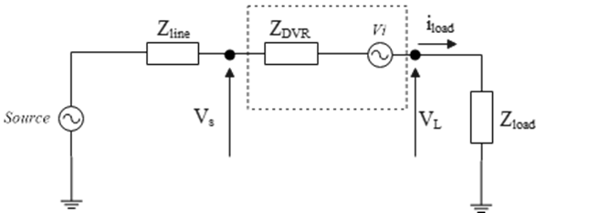

**Fig. 1. Equivalent circuit illustration of DVR [36]**

where $Z_{line}$, $Z_{DVR}$, and $Z_{load}$ stand for impedance of the line, DVR, and load, respectively, while $i_{load}$ represents the load current.

**3.1.2 DVR components and implementation in MATLAB**

Voltage sags/swells, varying load conditions, power quality issues, and the finite power rating of the DVR are critical factors that can limit its ability to correct voltage disturbances. For a DVR to be considered efficient, it must employ a control scheme capable of handling most sag and swell scenarios while maximising performance within the constraints of the installed equipment. Otherwise, the DVR may fail to prevent load tripping and, in some cases, introduce additional disturbances to the system. An effective control strategy should compensate for any voltage sag or swell, irrespective of the inherent DVR limitations. Fig. 2 illustrates the single-phase supply voltage vector diagram during the pre-sag stage, where the supply voltage ${Vs}_{pre-sag}\left(t\right)$ lies on the $d_{pre-sag}$ ​ axis. Here, the rotating phase angle $θ$ is determined using a Phase-Locked Loop (PLL) [9], [10]. Initially, the load voltage vector $V_{L}\left(t\right)$ coincides with ${Vs}_{pre-sag}\left(t\right)$ and is assumed to be 1.0 p.u., neglecting the voltage drop across the series transformer under ideal conditions. When a voltage sag occurs, the actual source voltage vector $V_{s}\left(t\right)$ shifts to ${Vs}_{sag}\left(t\right)$. To restore the load voltage $V_{L}\left(t\right)$ to its nominal value, the DVR injects a compensating voltage vector $V_{i}\left(t\right)$. A phasor diagram for voltage swell scenarios can represent a similar compensation mechanism.

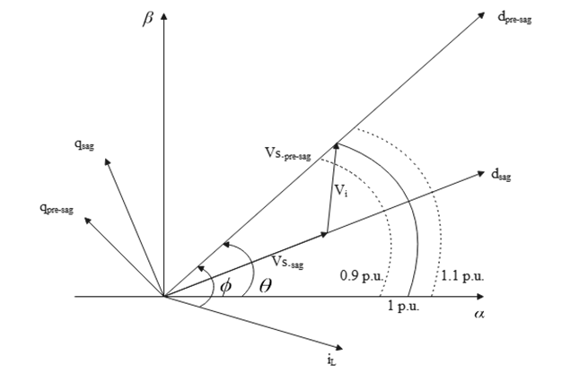

**Fig. 2. Single-phase DVR compensation strategy for voltage sags [9]**

The fundamental control strategy and the parameters measured for control purposes are illustrated in Fig. 2. Under normal grid voltage conditions, the DVR operates in a standby mode to minimise power losses. However, it must respond rapidly to voltage sags or swells by injecting an appropriate AC voltage into the grid to maintain power quality. A feedback control mechanism, based on the voltage reference and real-time supply and load voltages measurements, is employed for this purpose [9].

The control algorithm generates a three-phase reference voltage for the series converter to maintain the load voltage at its nominal reference value. Voltage sag detection is achieved by measuring the error between the supply voltage in the dq reference frame and the preset reference values. Here, the d-axis reference is set to the rated voltage, while the q-axis reference is set to zero to ensure voltage alignment.

The MATLAB/Simulink environment is utilised for this study due to its ease of use and extensive library of toolboxes, making it an effective platform for modelling and simulation.

As shown in Fig. 3, the transformation block first converts the supply voltage from the stationary reference frame to the αβ-frame. This output is fed into a PLL to detect the grid voltage phase and synchronise the system. A subsequent transformation block converts the αβ-frame into the rotating dq reference frame. The detection block monitors voltage fluctuations (sags or swells) and generates the reference load voltage ($V_{ref}$ ​) in response.

The compensating voltage ($V_{i}$ ​) is determined as the difference between the reference load voltage and the actual supply voltage ($V_{ref}$ − $V_{s}$ ​). This injected voltage is applied to the Voltage Source Converter (VSC). It utilises Pulse Width Modulation (PWM) techniques to synthesise the desired output voltage and maintain the load voltage at its reference value.

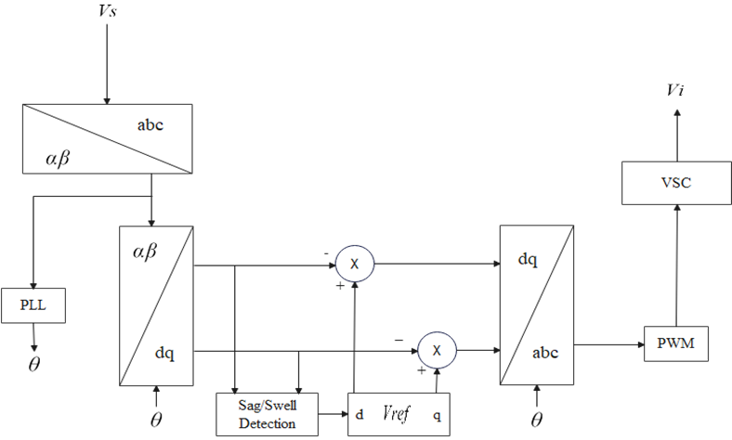

**Fig. 3. Layout of control strategy for DVR [42]**

For three-phase networks, the DVR operates similarly to a single-phase system. Only until the sag disturbance has disappeared does the DVR system’s compensatory voltage injection ceases. The missing voltage in this case is computed using Park’s transformation. Through the abc to dqo transformation, the 3-phase stationary coordinate system is converted to a dq rotational coordinate system. In abc-to-dq0, the following transformation is used as illustrated in Equations (4) to (6) [42, 37, 57].

$V_{d}=\frac{2}{3}\left[V_{a}\sin{ωt}+V_{b}\sin\left(ωt-\frac{2π}{3}\right)+V_{c}\sin\left(ωt+\frac{2π}{3}\right)\right]$ (4) $V_{q}=\frac{2}{3}\left[V_{a}\cos{ωt}+V_{b}\cos\left(ωt-\frac{2π}{3}\right)+V_{c}\cos\left(ωt+\frac{2π}{3}\right)\right]$ (5)

$V_{0}=\frac{1}{3}\left[V_{a}+V_{b}+V_{c}\right]$ (6)

The dq coordinate, compared with the reference value, calculates the disturbance in the dq coordinate and transforms it back to the abc coordinate. The phase-locked loop (PLL) measures the system frequency and gives the phase synchronous angle $\left(θ\right)$ for the dq coordinate system. This study proposes three control techniques for performance comparison: Pi, ANN, and PSO controllers.

Critical components of the DVR are explained in detail with their diagrams as follows:

***Energy Storage Source Unit*:** The capacitor bank or DC voltage source will be used as energy storage to compensate for the potential difference when a disturbance occurs.

***Voltage Source Inverter (VSC)*:**A voltage source converter (VSC) converts the DC voltage supplied by the energy storage device to an AC voltage, giving the output to the LC filter. The LC filter removes higher-order harmonics from the DVR output. It gives output to the Injection transformer, which injects voltage in phase with the line and compensates for the voltage sag or swell.

***Filter Unit*:** A low-pass filter will eliminate the switching harmonics in the injected voltage, while an LC filter will be connected next to the inverter side. The filter prevents the injection transformer from passing switching harmonics through it and compensates for the harmonic-free voltage.

***Injection Transformer Unit*:** The voltage supplied by the VSC is stepped up to the required level to be adequately injected into the system.

**3.2 System Architecture and Operational Dynamics of the Bus 33 Radial Distribution Network**

The Bus 33 distribution network, managed by the Ibadan Electricity Distribution Company (IBDC), operates as a radial system designed to deliver electricity from a central substation to end users through a structured arrangement of buses and feeders [55]. As shown in Fig. 4, the green-circled substation is the primary injection point, stepping down high-voltage transmission to distribution levels. The main feeder extends from the substation to Bus 18, forming the network’s core, while strategically placed buses along this route facilitate segmented power delivery. A secondary feeder branches from Bus 2 to Bus 19 through Bus 22, and a lateral from Bus 3 supplies Buses 23 to 25. Additionally, Bus 6 is a key node directing power to Buses 26 through 33. The unidirectional power flow, indicated by green arrows, typifies the radial structure’s energy propagation [55,56].

This configuration is favoured for its simplicity and cost-efficiency in urban and semi-urban settings, yet its reliance on a single source poses a reliability challenge. Buses farther from the substation are particularly susceptible to voltage sags, fluctuations, and power quality degradation due to faults, switching events, and load variability [55]. A DVR is deployed in series to inject compensating voltage during disturbances to address these issues. The DVR’s effectiveness depends on its control strategy, leading this study to apply ANN and PSO to improve voltage regulation and power quality in the Bus 33 network [48].

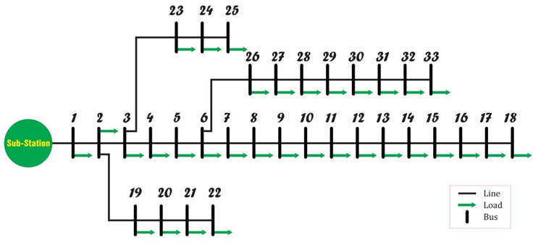

**Fig. 4. Architecture of IEEE Bus 33 Radial Distribution Network Operated by the Ibadan Distribution Company [55]**

**3.2.1 Simulation framework and DVR performance optimisation in the Bus 33 system**

The simulation model developed in this study emulates a three-phase distribution system designed to replicate power flow behaviour, voltage disturbances, and DVR-based stabilisation within the Bus 33 radial network [55]. An 11 kV, 30 MVA power source is the primary feeder input, representing the substation’s role in stepping down transmission-level voltage for distribution. Three-phase breakers are strategically positioned to isolate faults and mitigate voltage sag propagation, enhancing system reliability. A 1 MVA transformer (11 kV/0.4 kV) models voltage level conversion typical in real-world distribution networks. A three-phase voltage sag is induced to replicate operational contingencies, allowing the assessment of DVR performance under fault conditions. Positioned in series, the DVR injects compensating voltage in real-time to maintain power quality at the load end. The model reflects the challenges the Bus 33 system faces, especially voltage instability at distant buses (e.g., Buses 26–33). Applying ANN and PSO to the DVR’s control strategy, the study evaluates their effectiveness in restoring voltage levels and improving system resilience.

**3.2.2 Simulink model of IBDC power system with integrated DVR**

Fig. 5 depicts the modelled power distribution network of IBDC with a DVR for mitigating voltage sags and improving power quality. The simulation aims to simulate real-world power disturbances and evaluate the effectiveness of DVRs in stabilising voltage levels. The system starts with an 11 kV, 30 MVA power source representing the generation unit, with a three-phase breaker integrated for fault isolation and system protection, mirroring real-world transmission operations before distribution. Voltage sags, characterised by temporary drops in voltage, are common power quality issues often caused by short circuits, load fluctuations, or switching operations. In this simulation, two sag events, Voltage Sag and Voltage Sag1, were introduced before the transformer to replicate such disturbances. Voltage is stepped down from 11 kV to 0.4 kV using a 1 MVA transformer to enable efficient distribution to end-users. BUS 1 receives this voltage and feeds BUS 2, which supplies the load. A three-phase voltage sag between BUS 1 and BUS 2 is introduced to simulate disturbances affecting sensitive equipment. The DVR, connected in series between the buses, detects and compensates for voltage sags. It uses a PLL to monitor voltage, and a VSC to inject corrective voltage via a series transformer, maintaining stability at BUS 2. The DVR operates under a PI controller or AI-based methods like ANN and PSO. While the PI controller offers a reliable response, improper tuning of its gains can affect performance of the DVR.

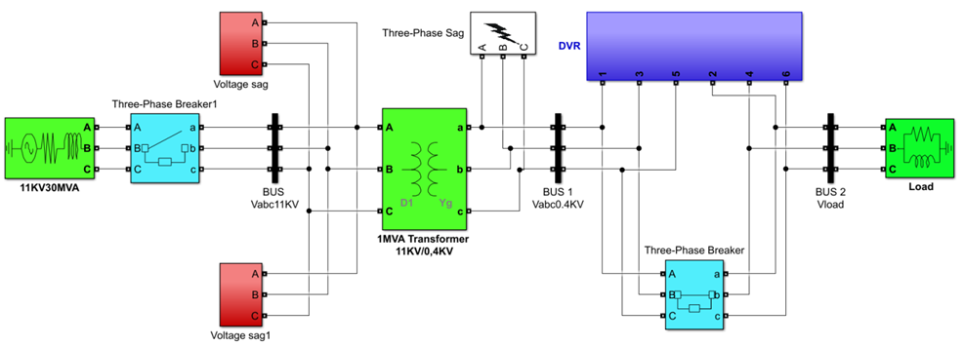

**Fig. 5. The simulated IBDC power station**

**3.3 Simulation of the DVR Control Unit**

The DVR controller is designed to mitigate voltage sags and harmonics by monitoring the load voltage, calculating the required compensation, and generating the reference voltage for corrective injection. Operating in the synchronous reference (dq0) frame, the controller simplifies AC voltage control through phase synchronisation, coordinate transformation, error computation, and PI-based regulation. Fig. 6 presents the overall DVR controller architecture, while the modelled Pi-controlled DVR is presented in Fig. 7.

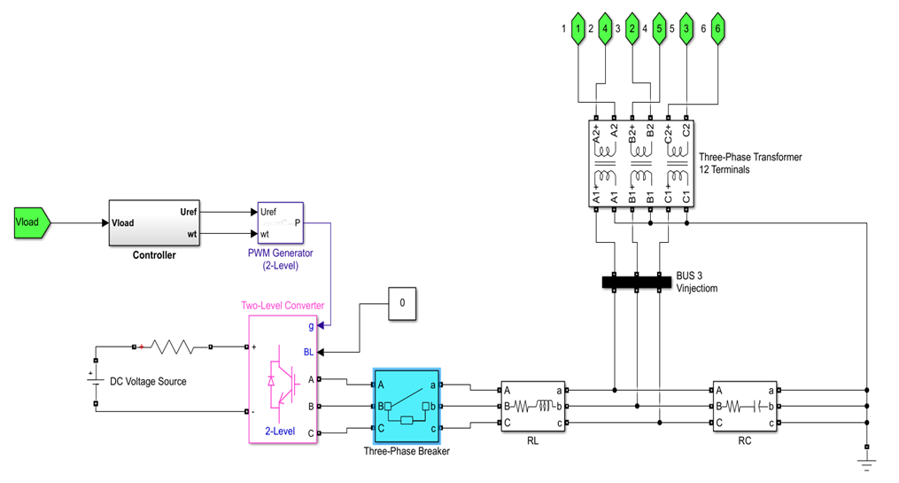

**Fig. 6. Simulated DVR Control Architecture**

After configuring the simulation parameters, the model was simulated to evaluate the system voltage response under various fault conditions. The primary aim was to assess the effectiveness of a conventional PI-controlled DVR in restoring voltage levels during disturbances. The DVR’s injected voltage and restored output were analysed to determine controller performance. Three fault scenarios were tested: a balanced three-phase induced sag, a sag-induced fault mimicking sudden load changes or short circuits, and a combined fault involving both conditions (see Figs 8 to 10). For each case, THD and fundamental voltage were measured. The DVR’s performance using both conventional PI control and optimised methods was compared to determine their relative effectiveness in fault mitigation.

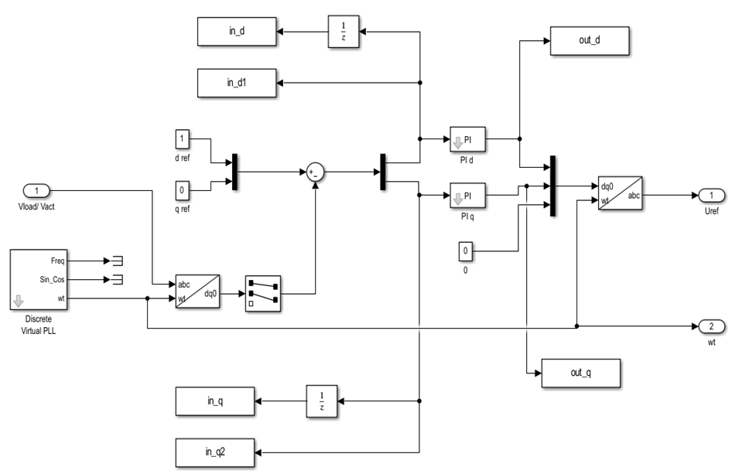

**Fig. 7. DVR with Pi-controller**

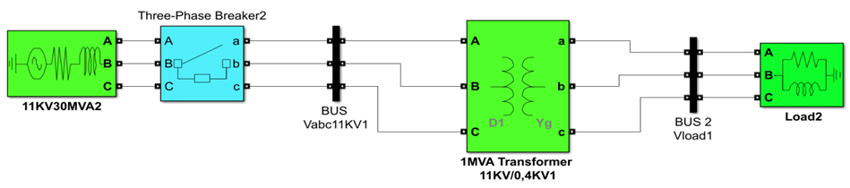

**Fig. 8. Simulated system without any fault**

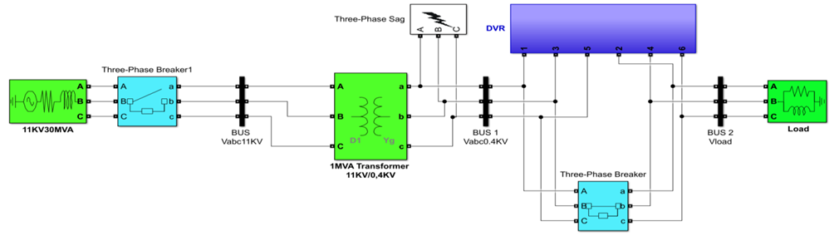

**Fig. 9. Simulated system with Three-Phase induced sag only**

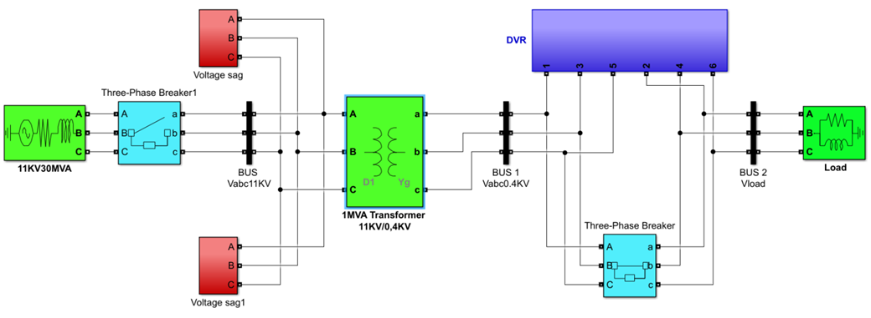

**Fig. 10. Simulated system with voltage-induced sag only**

**3.4 Optimisation of the DVR Controller Using ANN and Particle Swarm PSO**

The Proportional-Integral (PI) controller is critical to DVR performance, as it regulates the compensating voltage injected into the distribution system. However, its effectiveness relies heavily on proper tuning of its control parameters. Inadequate tuning can result in instability, sluggish response, overshoot, or poor voltage sag mitigation. Optimising the PI controller ensures faster, more accurate compensation, improving overall power quality and system stability.

**3.5 Optimisation Using Particle Swarm Optimisation**

Particle Swarm Optimisation (PSO) is a computational technique inspired by the social behaviour of birds and fish swarms [40]. It is widely used for optimising complex systems, including tuning the PI controller parameters of the DVR. In this study, the $K_{p}$ and $K_{i}$ of the Pi controller was optimised using PSO. Proper turning of the $K_{p}$ and $K_{i}$ enhanced the performance of the PI controller. From Figure 7, two Pi d and pi q controllers exist, and their $K_{p}$ and $K_{i}$ were optimised.

**3.5.1 Particle swarm optimisation (PSO) formulation**

**A. Representation of the Problem**

Each particle represents a candidate solution for the PI controller parameters, as expressed in (7):

$X_{i}=[K_{pd},K_{id},K_{pq},K_{iq}]$ (7)

where $K_{pd}$ ​​ = Proportional gain for the d-axis controller, $K_{id}$ = Integral gain for the d-axis controller, $K_{pq}$ ​​ = Proportional gain for the q-axis controller, $K_{iq}$ = Integral gain for the q-axis controller, and $i$ represents the index of the particle in the swarm.

 The objective function $J(X)$  is designed to minimise the voltage error between the reference voltage and the load voltage as given in (8).

$J(X)= \sum_{t=0}^{T}{\sum_{ph=1}^{3}{\left|\frac{V_{ref,ph}(t)-V_{load,ph}(t)}{V_{ref,ph}(t)} \right|}}$ (8)

where $V_{ref,ph}(t)$ is the reference voltage for phase ph at time t and $V_{load,ph}(t)$ is the actual load voltage.

The sum is taken over all time steps and phases. The goal is to find the best $X_{i}$ ​ that minimizes $J(X)$.

**B. Initialisation of Particles**

Each particle is randomly initialised using Latin Hypercube Sampling (LHS) within the parameter bounds:

$X_{i}= LHS\left(n\right)×\left(UB-LB\right)+LB$ (9)

where $LHS\left(n\right)$ generates a uniform random distribution for better search efficiency, $UB$ and $LB$ are the upper and lower bounds of the PI parameters.

The initial velocity of each particle is set to zero:

$V_{i}=0$ (10)

where Vi​ is the velocity vector for each particle.

Each particle has:

Personal best position Pbest, i​ = Best solution found by the particle

Global best position Gbest​ = Best solution found by the entire swarm

**C. PSO Iterative Process**

The system generates 20 particles with random PI controller parameters (Xi). The algorithm iterates 50 times, updating each particle’s position and velocity based on:

1. Inertia effect (Momentum)
2. Cognitive component (Learning from itself)
3. Social component (Learning from best global solution)

**3.5.2 Objective function calculation**

The objective function evaluates how well each particle’s parameters perform in the system. The fitness function is defined as:

$J= \sum_{t=0}^{T}{\sum_{ph=1}^{3}{\left|\frac{V_{ref,ph}(t)-V_{load,ph}(t)}{V_{ref,ph}(t)} \right|}}$ (11)

Here, the aim is to minimise $J$ to ensure that the error between $V_{ref,ph}(t)$ ​ and $V_{load,ph}(t)$ is minimised.

**3.5.3 Updating positions and velocities**

At each iteration, the velocity of each particle is updated using the PSO velocity update equation:

$V_{i}^{(k+1)}= {wV}_{i}^{(k)}+ c_{1}r_{1}\left(P_{best,i}-X_{i}^{(k)}\right)+ c_{2}r_{2}(G_{best}-X_{i}^{(k)})$ (12)

where: $k$ is the iteration index and $w$ is the inertia weight, calculated as:

$w=0.9-0.5\frac{k}{\max{iterations}}$ (13)

$c_{1}$ ​ and $c_{2}$ ​ are acceleration coefficients (set to 2.5), $r_{1}$ ​ and $r_{2}$ ​ are random numbers in [0,1]. $P_{best,i}$ is the personal best position of particle $i$. $G_{best}$ is the global best position found so far.

The position of each particle is then updated using:

$X_{i}^{(k+1)}=X_{i}^{(k)}+V_{i}^{(k+1)}$ (14)

The new positions are constrained within the predefined limits:

$X_{i}=max⁡(X_{i},LB)$ (15)

$X_{i}=min⁡(X_{i},UB)$ (16)

**3.5.4 Stopping criteria**

The PSO algorithm terminates when:

The maximum number of iterations is reached.

The global best fitness value converges below a predefined threshold.

**3.5.5 Final output**

After 50 iterations, the optimal PI parameters are displayed:

Optimised $K_{pd}, K_{id}, K_{pq}$  and $K_{iq}$.

**3.5.6 Implementation in MATLAB and Simulink**

The MATLAB script integrates with a Simulink model to evaluate the performance of each particle. The fitness function generates 20 particles with random PI controller parameters ( $K_{pd}, K_{id}, K_{pq}$ and $K_{iq}$). These parameters define the proportional and integral gains for the d-axis and q-axis controllers in the DVR system. The fitness function updates the PI controller parameters in the Simulink model and runs a simulation. The simulation output includes the reference voltage ($V_{ref}​$) and load voltage $V_{load}$ ). The function then extracts these outputs and calculates the voltage error, which is the objective optimisation function. The pso\_dvr\_script.m runs the PSO algorithm for 50 iterations, evaluating all 20 particles in each iteration and making 1,000 evaluations. At each step, the script updates the velocities and positions of the particles based on their $P_{best,i}$  and $G_{best}$ solutions. The best-performing set of PI controller parameters is continuously refined. At the end of the optimisation process, the script outputs the optimised PI controller parameters ( $K_{pd}, K_{id}, K_{pq}$ and $K_{iq}$ ​​), which minimises the voltage error and improves the DVR’s performance in maintaining a stable voltage supply. The optimised PI controller parameters ( $K_{pd}, K_{id}, K_{pq}$ and $K_{iq}$ ​​) were input into the simulated PI controller in the DVR. $K_{pd}$ and $K_{id}$ were assigned to PI\_d, while $K_{pq}$ and $K_{iq}$ ​​ were assigned to PI\_q. The simulated power system, including the voltage sag and three-phase values, was then executed to evaluate the performance of the DVR with the optimised PI controller parameters as depicted in Fig. 11.

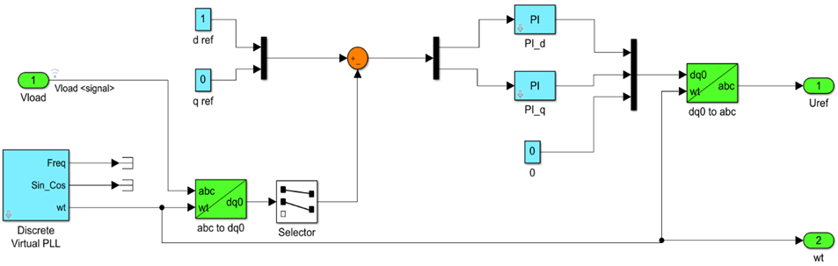

**Fig. 11. PSO-optimised PI controller in DVR**

**3.6 Optimisation using ANN**

**3.6.1 Implementation in MATLAB and Simulink**

The optimisation of the DVR using ANN began with the collection of data for the IBDC network. This dataset included inputs and outputs for both the $d$ -axis and $q$ -axis controllers, which are critical for voltage restoration and reactive power compensation. Input-output datasets for $d/q$-axis controllers—critical for voltage restoration and reactive power compensation in the IBDC network—were structured into $1001×2$ (voltage/current measurements) and $1001×1$ (target control signals) matrices. A function-fitting ANN was implemented in MATLAB using a 2-10-1 architecture: dual-input neurons, 10 tansig-activated hidden neurons, and linear output neurons. The Levenberg-Marquardt algorithm trained the network on 70% of the data (15% validation, 15% testing), minimising mean squared error (MSE). Performance was rigorously monitored through epoch-wise MSE plots, gradient/mu validation checks, error histograms, and regression analysis (R-value) to ensure convergence and accuracy.

Trained ANN controllers generated modulating signals for the DVR, enabling precise voltage injection during disturbances. The system was tested under three-phase sag conditions, where the ANN-driven DVR dynamically compensated voltage deviations. Restoration accuracy was quantitatively evaluated (Fig. 12), confirming effective mitigation of sags/swells through reactive power compensation and DC-link voltage stability. This validated the ANN’s ability to translate real-time measurements into optimal control actions to enhance power quality.

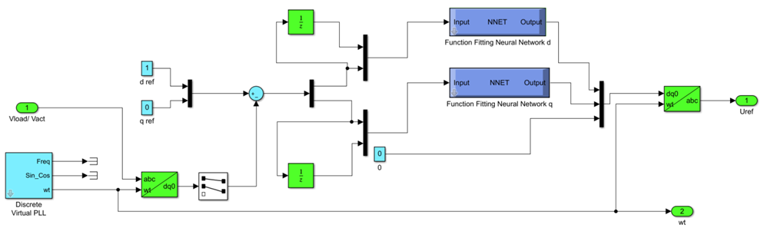

**Fig. 12. ANN-Based PI Controller in DVR**

4. Results and Discussion

**4.1 Analysis of Voltage Sag During Fault Conditions**

This section analyses the impact of two fault types on system voltage: three-phase induced sag (Fig. 13) and induced voltage sag (Fig. 14), focusing on the $11 kV$ and $0.4 kV$ levels. In Fig. 13, the first plot, “Voltage at $11 kV$,” shows a stable sinusoidal waveform before a voltage sag to $±0.8 p.u.$ at $0.028$ $second$, with recovery starting at $0.077$ seconds. The second plot, “Voltage at $0.4 kV$,” shows a minor sag to $±0.5 p.u.$, with recovery also beginning at $0.077$ seconds, indicating partial fault mitigation as the disturbance spreads.

In Fig. 14, the first plot, “Voltage at $11 kV$,” shows a more severe sag, dropping to $±0.5 p.u.$ at $0.20 second$ and reaching $0 p.u.$ at $0.30 second$, with recovery starting at $0.40 second$ and stabilising in about $0.20 second$. The second plot, “Voltage at $0.4 kV$,” follows a similar pattern, with voltage dropping to $0 p.u.$ at $0.30 second$ and recovering at $0.40 second$, confirming the consistent impact of the fault across voltage levels.

These results demonstrate significant voltage sags in both fault types, with recovery times depending on fault severity. The three-phase induced sag affects the system locally, while the induced voltage sag causes broader instability. Both scenarios highlight the need for advanced mitigation techniques, such as ANN-based and PSO-optimised DVRs, to ensure rapid voltage restoration and system stability.

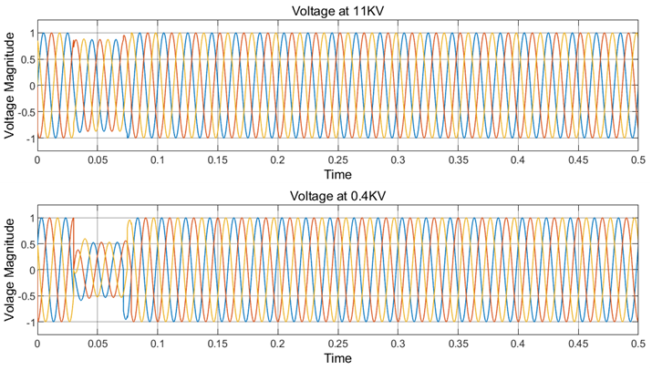

**Fig. 13. Voltage Response During Three-Phase induced sag**

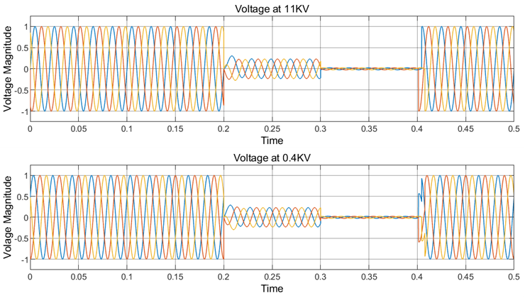

**Fig. 14. Voltage Response During Induced Voltage Sag**

**4.2 Performance Analysis of Conventional PI Controller-Based DVR**

Fig. 15 presents four time-domain plots illustrating the voltage behaviour of a power system affected by a voltage sag and compensated using a DVR controlled by a conventional PI controller. The constituents of Fig. 15 are “Voltage Sag After Fault,” “Injection of Voltage by DVR,” “Restoration Voltage,” and “Voltage Without Fault.”

The first plot, “Voltage Sag After Fault,” shows a stable voltage waveform until a fault occurs at 0.028 seconds, causing a drop. Recovery starts at 0.077 seconds, but another dip occurs at 0.20 seconds, with the lowest voltage at 0.30 seconds. The system recovers by 0.40 seconds, resulting in 0.372 seconds of instability. The second plot, “Injection of Voltage by DVR,” shows the DVR injecting ±0.1 p.u. voltage even before the fault. During 0.20 to 0.40 seconds, the DVR injects higher voltage to counter the drop, but the waveform remains distorted, indicating poor performance. The third plot, “Restoration Voltage,” shows the load-side voltage after DVR compensation. The fourth plot, “Voltage Without Fault,” shows the ideal system voltage without faults, providing a reference for evaluating DVR performance.

The conventional PI controller-based DVR failed to mitigate voltage sags fully, and voltage injection was actually initialised before detecting the sag, thus producing distorted compensation. While it helped to reduce sag, it could restore voltage to expected levels, demonstrating the PI controller’s limitations in handling dynamic voltage disturbances.

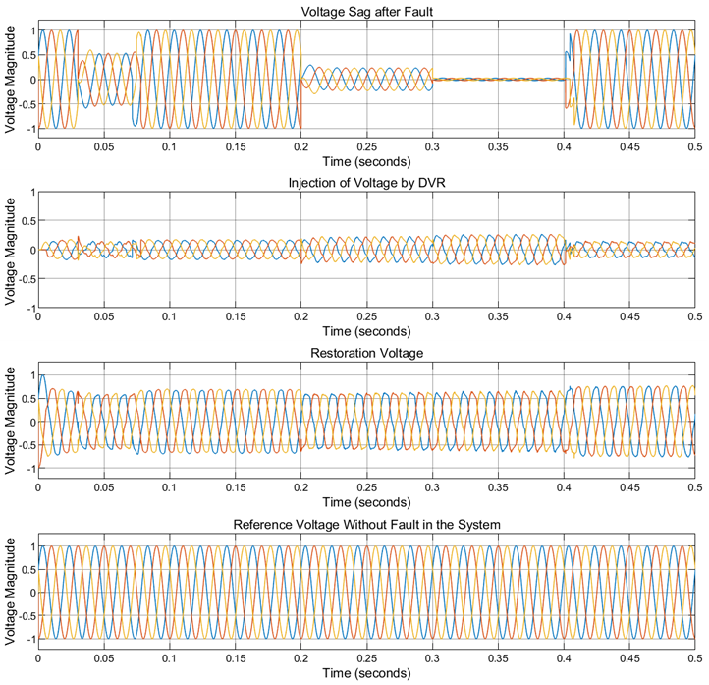

**Fig. 15. Performance of a DVR with a conventional PI controller**

**4.3 Performance Evaluation of DVR-Powered Multi-Level Artificial Neural Network Controller**

The trained ANN model was incorporated into the PI controller, with the d-axis and q-axis models replacing PI\_d and PI\_q, respectively. The IBDC network was simulated under various conditions, including no-fault, voltage-induced sag, and three-phase induced sags. Fig. 16 presents the results of the ANN-based DVR system through four subplots, each depicting different stages of voltage performance under fault conditions.

The first plot, “Voltage Sag after Fault,” shows the fault’s effect on system voltage. Initially stable and sinusoidal, the voltage drops at $0.028 second$ due to the fault. The system briefly recovers at 0.077 seconds but drops again at 0.20 seconds, with a more significant decline at 0.30 seconds, reaching its lowest point. Recovery begins at $0.42 second$, leading to a 0.392-second instability within the 0.5-second simulation. Disturbances across all phases, indicated by colored lines, confirm an unbalanced fault condition. The second plot, “Injection of Voltage by DVR,” shows the DVR injecting compensating voltage to counter the sag. When the sag is detected at $0.028 second$, the DVR begins with transient oscillations, and injects voltage from $0.028$ to $0.077 second$, briefly stabilising the system. The injected voltage drops to nearly zero until the fault proceeds at $0.20 second$, at this point, the DVR compensates strongly until $0.42 second$. The third plot, "Restoration Voltage," demonstrates the ANN-based DVR’s effectiveness in restoring the system voltage to normal levels. The restored voltage closely matches the pre-fault condition (reference voltage), proving the ability of the ANN-based DVR to mitigate voltage sags throughout the disturbance period.

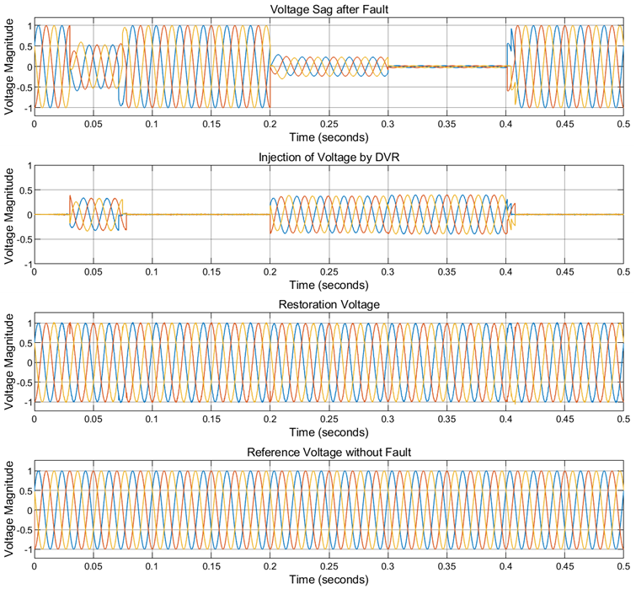

**Fig. 16 Performance evaluation of DVR-powered multi-level ANN controller**

**4.4 Performance of the PSO-optimized Dynamic Voltage Restorer (DVR) System**

The PSO algorithm was employed to determine the optimal PI controller parameters for the DVR. The process involved the execution of 50 iterations, evaluating 20 particles per iteration, leading to 1,000 evaluations. This iterative process allowed the algorithm to fine-tune the parameters by continuously updating the particle positions based on the personal best and global best solutions. The objective was to minimise voltage error and enhance the DVR’s ability to mitigate voltage sags. The following optimal PI controller parameters were obtained at the end of the optimisation process, as shown in Figure 17, while Table 1 shows the tabulated gains.

**Table 1. Proportional and Integral Gains for d-axis and q-axis Controllers**

|  |  |  |  |  |
| --- | --- | --- | --- | --- |
| **S/N** | **Parameter** | **Gain** | **Variable used in the code** | **Value** |
| 1 | Proportional gain (d-axis) | Kp | Kp\_d | 55.0000 |
| 2 | Integral gain (d-axis) | Ki | Ki\_d | 166.5793 |
| 4 | Proportional gain (q-axis) | Kp | Kp\_q | 10.0000 |
| 5 | Integral gain (q-axis) | Ki | Ki\_q | 235.0000 |

These optimised parameters were then included in the simulated power system for voltage control. The d-axis parameters (Kp\_d and Ki\_d) were assigned to the PI\_d controller, while the q-axis parameters (Kp\_q and Ki\_q) were transferred to the PI\_q controller as shown in Fig. 18.

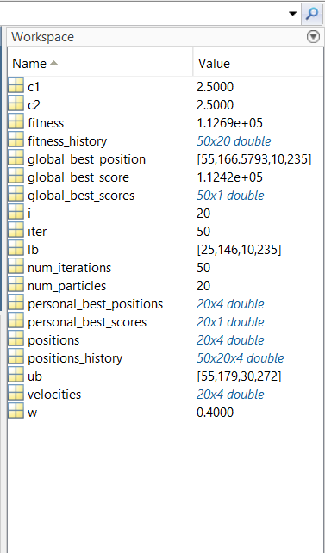

**Fig. 17. Execution of the PSO algorithm for DVR optimisation in MATLAB**

**Fig. 18. Integration of PSO-optimised gains Kp and Ki​ into the PI controller**

Fig. 19 shows the PSO-optimised DVR system’s performance in four subplots, each representing different stages of voltage behaviour during faults.

* ***Voltage Sag after Fault*:** This plot illustrates the system voltage drop after a fault occurs at 0.028 seconds, with voltage recovery at 0.077 seconds, followed by further drops at 0.20 and 0.30 seconds. The system stabilised around 0.40 seconds, totalling 0.372 seconds of instability during the 0.5-second simulation. The presence of disturbances in all three phases confirms an unbalanced fault condition.
* ***Injection of Voltage by DVR****:* This plot demonstrates the PSO-optimised DVR’s compensation, injecting voltage at 0.028 seconds after detecting the sag. Initially, the system experiences transient oscillations, but the compensation voltage increases significantly, stabilising briefly at 0.077 seconds. The DVR reactivated at 0.20 seconds to compensate until stabilisation at 0.40 seconds.
* ***Restoration Voltage****:* The optimised DVR restores the system voltage to normal levels, maintaining sinusoidal and stable conditions, indicating successful compensation and voltage sag mitigation. The restored voltage matches the pre-fault condition, ensuring no disruption to sensitive equipment.
* ***Voltage without Fault****:* This plot shows regular operation with a smooth, stable sinusoidal waveform, serving as a reference for the system’s behaviour without faults.

The results demonstrate that the PSO-optimised PI controller enhances the DVR’s dynamic response, allowing it to detect and compensate for voltage sags quickly. The system’s fast, smooth recovery minimises the impact of faults, proving the DVR’s effectiveness in maintaining power quality.

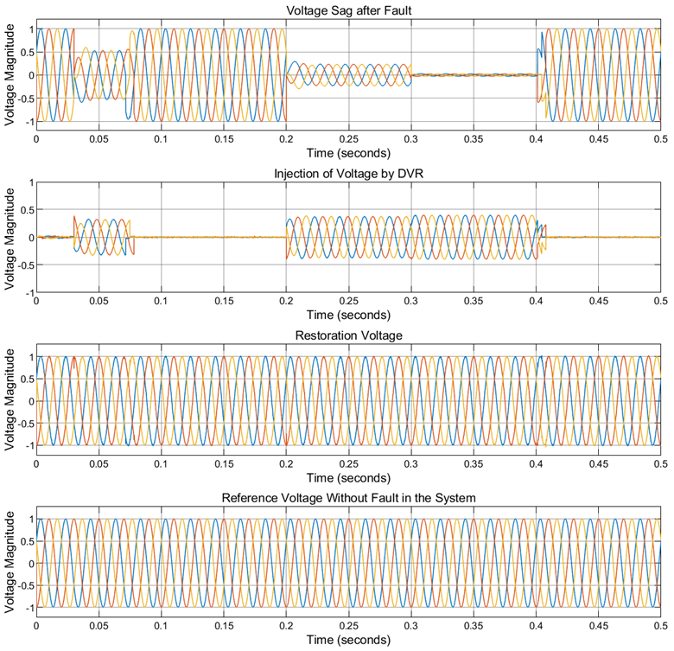

**Fig. 19. Performance evaluation of PSO-optimised DVR system**

**4.5 Comparison of DVR Performance: Conventional, PSO-Based, and ANN-Based Approaches**

Fig. 20 compares the effectiveness of various DVR control strategies in mitigating voltage sags. The analysis includes the reference voltage without sag (black line), the system with sag (Red Line), conventional DVR (blue line), ANN-based DVR (magenta line), and PSO-based DVR (green line) across three phases. The reference voltage represents normal conditions, while the system with sag shows the voltage drop due to disturbances.

The conventional DVR (blue line) restored voltage to approximately $±0.6 p.u.$, significantly below the reference voltage, indicating insufficient compensation and notable distortions. This method has a delayed response and lacks the adaptability needed for dynamic system conditions, making it the least effective.

The ANN-based DVR (magenta line) and PSO-based DVR (green line) restored voltage to approximately ±1 p.u., closely matching the reference voltage. The waveforms of the ANN and PSO-based DVRs overlap with the reference voltage, demonstrating their high accuracy and effectiveness. The ANN-based DVR adapts quickly, using its learning capabilities to track the reference waveform better than the conventional DVR. Similarly, the PSO-based DVR optimises the compensation process, ensuring smooth voltage restoration. Both methods have near-identical response times and exhibit minimal deviation from the reference voltage, making them highly effective for real-time voltage correction.

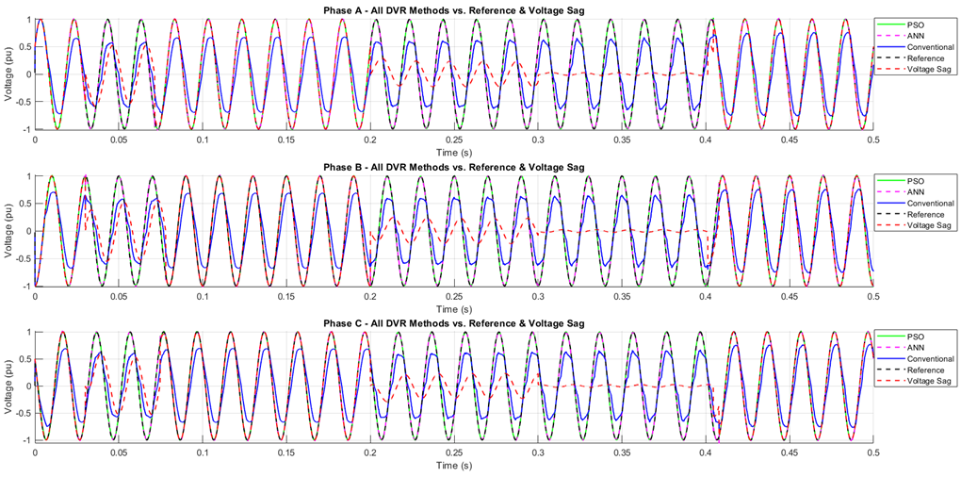

**Fig. 20. Comparative performance of conventional, PSO-based, and ANN-based DVRs in mitigating voltage sags**

**4.6 Total Harmonic Distortion (THD) Analysis**

Total Harmonic Distortion (THD) is a key metric for evaluating harmonic pollution in electrical systems, representing the ratio of harmonic power to the fundamental frequency power. Excessive harmonic distortion can cause equipment malfunctions and system inefficiencies; hence, maintaining THD within acceptable limits is crucial for system reliability and protecting sensitive loads.

This study uses the IEEE 519-2022 standard for harmonic control, specifying a 5% THD limit for voltage in systems operating at 11 kV. Other global standards, like IEC 61000-2-4 and EN 50160, set THD limits of 5% for sensitive systems and 8-10% for industrial systems. The study examined various mitigation methods—conventional DVR, PSO-optimised DVR, and ANN-based DVR—under fault conditions to evaluate their effectiveness in reducing THD as tabulated in Table 2. The observations and the analysis are as follows:

* ***Reference System***: In regular operation, the system showed minimal harmonic distortion (close to 0%) with a fundamental voltage of 0.9915 p.u., compliant with IEEE 519-2022 and other standards.
* ***Faulted System***: During the three-phase induced sag, the voltage drops significantly to 0.6879 p.u., 0.6398 p.u., and 0.6839 p.u., causing THD to increase dramatically (46.14%, 55.91%, and 45.65%), across the three phases, far exceeding the 5% limit.
* ***Conventional DVR****:* The conventional DVR reduced THD to 8.56%, 9.88%, and 8.36%, which still exceeded the IEEE 519-2022 limit for sensitive loads. The fundamental voltage is restored to 0.6445 p.u., 0.6395 p.u., and 0.6435 p.u., below the nominal value across the three phases.
* ***ANN-Based DVR***: The ANN-based DVR reduces THD to 2.10%, 2.26%, and 2.09%, fully compliant with the 5% limit. The voltages for the three phases were restored to 0.9965 p.u., 0.9935 p.u., and 0.9958 p.u., closely matching the nominal value.
* ***PSO-Optimised DVR***: The PSO-Optimised DVR reduces THD to 2.26%, 2.49%, and 2.34%, restoring the voltages across the three phases to 0.9940 p.u., 0.9900 p.u., and 0.9914 p.u., also meeting the 5% limit.

**4.6.1 Implementation in MATLAB and Simulink**

Table 2 illustrates the system’s THD values and fundamental voltages under different conditions, including regular operation, sag conditions, and system with mitigation methods (conventional DVR, PSO-optimised DVR, and ANN-based DVR). This concise representation highlights the effectiveness of each technique in reducing THD and restoring power quality under a Three-Phase induced sag.

**4.6.2 System response to voltage sag**

Table 3 presents the THD values and fundamental voltages for the system under various conditions, such as normal operation, fault induced voltage sag, and the system with mitigation techniques (conventional DVR, PSO-optimised DVR, and ANN-based DVR). This summary effectively demonstrates the performance of each method in minimising THD and improving power quality during a three-phase induced sag.

**4.6.3 Overall system response under combined sag.**

Table 4 presents the THD values and fundamental voltages for the system under various conditions, including normal operation, combined voltage sag condition, and the system with mitigation techniques (Conventional DVR, PSO-optimised DVR, and ANN-Based DVR). This summary effectively demonstrates the performance of each method in minimising THD and improving power quality during the overall system response under combined fault conditions.

**Table 2. THD and Fundamental Voltage Comparison under Three-Phase Sag Across Systems**

| **S/N** | **Method** | **Phase 1 THD (%)** | **Phase 2 THD (%)** | **Phase 3 THD (%)** | **Phase 1 Fundamental** | **Phase 2 Fundamental** | **Phase 3 Fundamental** |
| --- | --- | --- | --- | --- | --- | --- | --- |
| 1 | Faulted system (three-phase induced sag without DVR) | 46.14 | 55.91 | 45.65 | 0.6879 | 0.6398 | 0.6839 |
| 2 | Normal system operation (No fault) | 0.00 | 0.00 | 0.00 | 0.9915 | 0.9915 | 0.9915 |
| 3 | System with conventional DVR | 8.56 | 9.88 | 8.36 | 0.6445 | 0.6395 | 0.6435 |
| 4 | System with PSO-optimised DVR | 2.26 | 2.49 | 2.34 | 0.9940 | 0.9900 | 0.9914 |
| 5 | System with ANN-based DVR | 2.10 | 2.26 | 2.09 | 0.9965 | 0.9935 | 0.9958 |

**Table 3. Comparative analysis of THD and fundamental voltage across different systems under fault-induced sag conditions**

|  |  |  |  |  |  |  |  |
| --- | --- | --- | --- | --- | --- | --- | --- |
| **S/N** | **Method** | **Phase 1 THD (%)** | **Phase 2 THD (%)** | **Phase 3 THD (%)** | **Phase 1 Fundamental** | **Phase 2 Fundamental** | **Phase 3 Fundamental** |
| 1 | Faulted System (Sag-induced Fault Without DVR) | 95.52 | 127.85 | 97.45 | 0.1650 | 0.1613 | 0.1599 |
| 2 | Normal System Operation (No Fault) | 0.00 | 0.00 | 0.00 | 0.9915 | 0.9915 | 0.9915 |
| 3 | System With Conventional DVR | 8.34 | 8.58 | 8.72 | 0.6379 | 0.6367 | 0.6368 |
| 4 | System With PSO-optimised DVR | 1.85 | 1.95 | 1.89 | 0.9900 | 0.9925 | 0.9922 |
| 5 | System With ANN-Based DVR | 1.91 | 2.00 | 1.78 | 0.9892 | 0.9890 | 0.9893 |

**Table 4. Comparative analysis of THD and fundamental voltage across different systems under combined sag conditions**

| **S/N** | **Method** | **Phase 1 THD (%)** | **Phase 2 THD (%)** | **Phase 3 THD (%)** | **Phase 1 Fundamental** | **Phase 2 Fundamental** | **Phase 3 Fundamental** |
| --- | --- | --- | --- | --- | --- | --- | --- |
| 1 | Overall Faulted System | 57.35 | 63.74 | 57.44 | 0.562 | 0.5513 | 0.5598 |
| 2 | Normal System Operation (No Fault) | 0.67 | 1.38 | 0.71 | 0.9997 | 0.9995 | 0.9997 |
| 3 | System With Conventional DVR | 9.96 | 10.09 | 9.32 | 0.6814 | 0.6766 | 0.6762 |
| 4 | System With PSO-Optimised DVR | 2.14 | 2.53 | 2.21 | 0.9948 | 0.9945 | 0.9947 |
| 5 | System With ANN-Based DVR | 1.91 | 1.96 | 1.82 | 0.9946 | 0.9940 | 0.9947 |

**4.7 Overall Comparative Analysis**

The ANN-Based DVR offered superior adaptability, robustness, and precision, which is ideal for modern systems with sensitive loads. Its learning capability ensures stable performance across diverse fault conditions, though high computational demand and cost may restrict its use in constrained environments. In contrast, the PSO-optimised DVR is computationally efficient, easy to implement, and suitable for rapid fault mitigation. Its fast convergence makes it effective for transient faults but may limit performance in complex fault scenarios.

A comparative analysis (see Table 5) contextualises these results alongside existing studies.

**Table 5. Comparative analysis of the proposed study with existing literature**

| **Author(s)** | **Study** | **Method Used** | **Results Obtained** | **Gap Observed** |
| --- | --- | --- | --- | --- |
| Kasala et al. [60] | Enhanced DVR performance using ANN-based control for power quality improvement. | ANN-based DVR control. | Reduced THD and improved voltage stability. | Did not incorporate PSO optimisation; focused on ANN alone. |
| Siregar et al. [61] | Implemented DVR systems controlled by PSO and ANN to recover from voltage sags due to short-circuit faults. | PSO and ANN-based DVR controllers. | Both controllers successfully mitigated voltage sags; the ANN-based controller outperformed PSO in voltage quality. | Did not address harmonic distortion; focused solely on voltage sag mitigation. |
| Immanuel et al. [62] | Analysed DVR performance with PSO-optimised PI controllers for voltage sag compensation. | PSO-optimised PI controller. | Improved voltage recovery times and reduced overshoot. | Lacked harmonic distortion analysis; did not utilise ANN. |
| Uwho et al. [63] | Developed DVR systems with ANN control for voltage sag mitigation in distribution networks. | ANN-based DVR control. | Achieved voltage restoration to nominal levels. | Did not assess harmonic distortion; limited to voltage sag scenarios. |
| Sujito et al. [64] | Simulated DVR operation to mitigate voltage sags caused by 3-phase induction motor starts using ANN control. | ANN-based DVR control. | Restored voltage to nominal levels, effectively compensating for sag. | Did not evaluate harmonic distortion; limited to specific sag scenarios. |
| Proposed Study | Developed a PSO-optimized deep ANN controller for DVR systems to mitigate voltage sags and reduce harmonic distortions. | PSO and deep ANN controller. | Achieved significant reduction in Total Harmonic Distortion (THD) and improved voltage restoration. | Limited real-time implementation and scalability assessment. |

5. Conclusion

This dissertation demonstrated the effectiveness of ANNs and PSO in improving power quality within the Ibadan Distribution Company (IBDC) network, particularly in mitigating voltage sags and related faults. A comparative study of the ANN-Based Dynamic Voltage Restorer (DVR) and PSO-optimised DVR was conducted across three fault scenarios—Three-Phase Induced Sag, Sag-Induced Fault, and Combined Fault Conditions—assessing their impact on Total Harmonic Distortion (THD), voltage restoration, and compliance with IEEE 519-2022 standards. Both methods consistently maintained THD levels within IEEE limits (5% for general systems and 3% for sensitive loads). The ANN-Based DVR outperformed in the Three-Phase Induced Sag scenario, with better THD reduction (2.09%-2.26%) and voltage restoration (0.9935-0.9965 p.u.) compared to the PSO-optimised DVR (THD: 2.26%-2.49%; voltage: 0.9900-0.9940 p.u.). In the Sag-Induced Fault scenario, the PSO-optimised DVR slightly outperformed, with THD values of 1.85%-1.95% and voltage restoration of 0.9900-0.9925 p.u., compared to the ANN-Based DVR’s 1.78%-2.00% THD and 0.9890-0.9893 p.u. In the Combined Fault Conditions scenario, the ANN-Based DVR excelled in THD reduction (1.82%-1.96%) and voltage restoration (0.9940-0.9947 p.u.) over the PSO-optimised DVR (THD: 2.14%-2.53%; voltage: 0.9945-0.9948 p.u.). The ANN-Based DVR excelled in adaptability and precision, particularly under complex fault conditions, but at higher computational costs. The PSO-optimised DVR offered a cost-effective, computationally efficient solution suitable for simpler systems but less effective in non-linear scenarios. The choice between these methods depended on system requirements: the ANN-Based DVR was ideal for advanced systems needing high precision, while the PSO-optimised DVR was suited for resource-constrained setups. This research provided valuable insights for the IBDC network and offered a model for similar distribution networks, contributing to power quality enhancement and optimising future power systems.

Disclaimer (Artificial intelligence)

Option 1:

Author(s) hereby declare that NO generative AI technologies such as Large Language Models (ChatGPT, COPILOT, etc.) and text-to-image generators have been used during the writing or editing of this manuscript.

References

1. Sunny, S. H., Hossain, E., & Ahmed, M. (2018, September). Artificial neural network based dynamic voltage restorer for improvement of power quality. *Proceedings of the 2018 IEEE Energy Conversion Congress and Exposition (ECCE)*, 5565–5572. <https://doi.org/10.1109/ECCE.2018.8558470>
2. Reddy, S. G., Ganapathy, S., & Manikandan, M. (2022). Power quality improvement in distribution system based on dynamic voltage restorer using PI tuned fuzzy logic controller. *Electrical Engineering & Electromechanics*, (1), 44–50. <https://doi.org/10.20998/2074-272X.2022.1.06>
3. Jabbar, A., Ali, F., Zayer, W. H., & Shukir, S. S. (2019). Fuzzy neural controller based dynamic voltage restorer control for power quality improvement. *Journal of Engineering and Technology*, 8(1), 1–20.
4. Ibrahim, S. B. (2018). Voltage quality enhancement in distribution system using artificial neural network (ANN) based dynamic voltage restorer. *Nigerian Journal of Technology*, 37(1), 184–190. <https://doi.org/10.4314/njt.v37i1.24>
5. Kasala, C., Awaar, V. K., & Jugge, P. (2021). Power quality enhancement using artificial neural network (ANN) based dynamic voltage restorer (DVR). In *Proceedings of the 3rd International Conference on Design and Manufacturing Aspects for Sustainable Energy (ICMED-ICMPC 2021)* (Vol. 01100, pp. 1–6). https://doi.org/10.1051/e3sconf/202130901100
6. Shukir, S. (2021). Fuzzy Neural Optimized Fuzzy Logic Controller Based Dynamic Voltage Restorer for Power Quality Improvement with Non-linear Loads. International Journal of Engineering Management. 5. 21. 10.11648/j.ijem.20210501.13.
7. Nguyen, P. T., & Saha, T. K. (2004). Dynamic voltage restorer against balanced and unbalanced voltage sags: Modelling and simulation. In *Proceedings of the 2004 IEEE Power Engineering Society General Meeting* (Vol. 1, pp. 639–644). <https://doi.org/10.1109/pes.2004.1372883>
8. Babaei, E., & Kangarlu, M. F. (2009). A new topology for dynamic voltage restorers without dc link. In *Proceedings of the 2009 IEEE Symposium on Industrial Electronics and Applications (ISIEA)* (Vol. 2, pp. 1016–1021). <https://doi.org/10.1109/ISIEA.2009.5356312>
9. Anitha, M., & Jyothsna, T. R. (2019). Power quality improvement in DG system using BOA based interlined unified power quality conditioner. *International Journal of Engineering and Advanced Technology*, 9(2), 1146–1155. <https://doi.org/10.35940/ijeat.b3654.129219>
10. Benachaiba, C., & Ferdi, B. (2008). Voltage quality improvement using DVR. Electrical Power Quality and Utilisation Journal, 14(1), 39–46.
11. Boonchiam, P., & Mithulananthan, N. (2006). Understanding of dynamic voltage restorers through MATLAB simulation. Thammasat International Journal of Science and Technology, 11(3), 1–6. <https://espace.library.uq.edu.au/view/UQ:191979>
12. Tekwani, P. N., Chandwani, A., Sankar, S., Gandhi, N., & Chauhan, S. K. (2020). Artificial neural network-based power quality compensator. International Journal of Power Electronics, 11(2), 236–255. <https://doi.org/10.1504/IJPELEC.2020.105151>
13. Arpitha, M. J., Sowmyashree, N., & Shashikala, M. S. (2019, October). Power quality enhancement using dynamic voltage restorer (DVR) by artificial neural network and hysteresis voltage control techniques. In Proceedings of the 2019 Global Conference on Advanced Technologies (GCAT) (pp. 1–6). <https://doi.org/10.1109/GCAT47503.2019.8978333>
14. Siregar, Y., Muhammad, M., Arief, Y. Z., Mubarakah, N., Soeharwinto, & Dinzi, R. (2023). Dynamic voltage restorer quality improvement analysis using particle swarm optimisation and artificial neural networks for voltage sag mitigation. International Journal of Electrical and Computer Engineering, 13(6), 6079–6091. <https://doi.org/10.11591/ijece.v13i6.pp6079-6091>
15. Chong, K. V. R., Hoon, Y., & Ahmad, H. (2022). Design and simulation of dynamic voltage restorer (DVR) for power quality improvement. Journal of Physics: Conference Series, 2222, Article 012003, 1–14. <https://doi.org/10.1088/1742-6596/2222/1/012003>
16. Tien, D. V., Gono, R., & Leonowicz, Z. (2018). A multifunctional dynamic voltage restorer for power quality improvement. Energies, 11(6), Article 1351, 1–17. <https://doi.org/10.3390/en11061351>
17. Srisailam, C. H., & Sreenivas, A. (2012). Mitigation of voltage sags/swells by dynamic voltage restorer using PI and fuzzy logic controller. International Journal of Engineering Research and Applications, 2(4), 1733–1737.
18. Taghikhani, A. M. (2012). Phase advanced dynamic voltage restorer control system design. International Journal of Control Science and Engineering, 2(4), 60–68. <https://doi.org/10.5923/j.control.20120204.02>
19. Kangarlu, M. F., Hosseini, S. H., Babaei, E., & Khoshkbar Sadigh, A. (2010, February). Transformerless DVR topology based on multi-level inverter with reduced number of switches. In Proceedings of the 1st Power Electronics Drive Systems Technology Conference (PEDSTC) (pp. 371–375). <https://doi.org/10.1109/PEDSTC.2010.5471786>
20. Komolafe, O. M., & Udofia, K. M. (2020). Review of electrical energy losses in Nigeria. Nigerian Journal of Technology, 39(1), 246–254.
21. Onojo, O., Inyama, K., & Ononiwu, G. (2015). Contingency analysis of the Nigeria 330kV post-reform integrated power system using power world simulator. Asian Journal of Natural and Applied Sciences, 4(2), 70–85.
22. Ogbuefi, U. C., & Madueme, T. C. (2015). A power flow analysis of the Nigerian 330 kV electric power system. IOSR Journal of Electrical and Electronics Engineering, 10(1), 46–57. <https://doi.org/10.9790/1676-10114657>
23. Samuel, I. A. (2017). A new voltage stability index for predicting voltage collapse in electrical power system networks (Doctoral dissertation). University of Nigeria, Nsukka, Nigeria.
24. Onojo, O. J., Ononiwu, G. C., & Okozi, S. O. (2013). Analysis of power flow of Nigerian 330kV grid system (pre and post) using MATLAB. European Journal of Natural and Applied Sciences, 1(2), 59–66.
25. Onojo, J. O., Inyama, K., Ononiwu, G. C., & Uzoechi, L. O. (2016). A comparative study of the contingency assessment of the reformed Nigeria 330kV power network under normal and fortified conditions. International Journal of Electrical and Electronics Engineering Studies, 3(1), 1–13.
26. Anumaka, M. C. (2018). Comparative analysis of transmission losses in the Nigerian 330kV old existing 28-bus and 41-bus system. International Journal of Engineering Trends and Technology, 66(2), 114–122. <https://doi.org/10.14445/22315381/ijett-v66p220>
27. Ray, S. (2017, September). Commonly used machine learning algorithms. Analytics Vidhya. [https://www.analyticsvidhya.com/blog/2017/09/common-machine-learning-algorithms/](https://www.analyticsvidhya.com/blog/2017/09/common-machine-learning-algorithms/" \t "_blank)
28. Shin, T. (2020, January). All machine learning models explained in 6 minutes. Towards Data Science. <https://towardsdatascience.com/all-machine-learning-models-explained-in-6-minutes-9fe30ff6776a>
29. Praseetha, V. M., Bayezeed, S., & Vadivel, S. (2020). Secure fingerprint authentication using deep learning and minutiae verification. Journal of Intelligent Systems, 29(1), 1379–1387. <https://doi.org/10.1515/jisys-2018-0289>
30. IEEE Power and Energy Society, Transmission and Distribution Committee. (2022). IEEE Standard for Harmonic Control in Electric Power Systems (IEEE Std 519-2022, Revision of IEEE Std 519-2014). <https://standards.ieee.org/ieee/519/10677/>
31. Adel, B., Tarek, M., & Samia, K. (2025). Evaluation of pulse width modulation techniques to reduce total harmonic distortion in grid-connected PV systems. International Journal of Power Electronics and Drive Systems, 16(1), 564–574. <https://doi.org/10.11591/ijpeds.v16.i1.pp564-574>
32. Reguieg, Z., Bouyakoub, I., & Mehedi, F. (2025). Harmonic mitigation in grid-integrated renewable energy systems with non-linear loads. Energy, Article 135882. <https://doi.org/10.1016/j.energy.2025.135882>
33. Mishan, R., Fu, X., Hingu, C., & Fajri, P. (2025). Analysing frequency spectrum and total harmonic distortion for high switching frequency operation of GaN-based filter-less multi-level cascaded H-bridge inverter. E-Prime – Advanced Electrical Engineering, Electronics and Energy, 11, Article 100906. <https://doi.org/10.1016/j.prime.2025.100906>
34. Farhoodnea, M., Mohamed, A., & Shareef, H. (2013, December). Power quality enhancement in distribution systems by optimal placement of dynamic voltage restorer. In Proceedings of the 2013 IEEE Student Conference on Research and Development (SCOReD) (pp. 111–115). <https://doi.org/10.1109/SCOReD.2013.7002553>
35. Babu, V., Ahmed, K. S., Shuaib, Y. M., & Manikandan, M. (2021). Power quality enhancement using dynamic voltage restorer (DVR)-based predictive space vector transformation (PSVT) with proportional resonant (PR)-controller. IEEE Access, 9, 155380–155392. <https://doi.org/10.1109/ACCESS.2021.3129096>
36. Viet, D. T., Hieu, N. H., Hoa, N. L., & Khoa, N. M. (2015, August). A control strategy for dynamic voltage restorer. In Proceedings of the International Conference on Power Electronics and Drive Systems (pp. 1106–1110). <https://doi.org/10.1109/PEDS.2015.7203525>
37. Kumar, A., & Dhanalakshmi, K. V. V. (2016). Voltage sag and swell compensation by using DVR with a BESS. International Journal of Electrical and Electronic Engineering & Telecommunications, 5(3), 1–7. [http://www.ijeetc.com](http://www.ijeetc.com/)
38. Pragna, R. N., Rani, L. P., Ramya, K., & Mohan, T. K. (2019). Dynamic voltage restorer using PI & fuzzy logic control. International Journal of Research and Analytical Reviews, 6(1), 143–151.
39. Ezhilarasan, S., & Balasubramanian, G. (2013). Dynamic voltage restorer for voltage sag mitigation using PI with fuzzy logic controller. International Journal of Engineering Research and Applications, 3(1), 1090–1095.
40. Praveen, V., & Ganesh, S. (2023). Particle swarm optimisation (PSO) and internal model control (IMC) based tuning technique for PI controller for DVR for improved dynamic response and power quality. Academic Publications European Hub. <http://www.acadpubl.eu/hub/>
41. Roslan, M. F., Al-Shetwi, A. Q., Hannan, M. A., Ker, P. J., & Zuhdi, A. W. M. (2020). Particle swarm optimisation algorithm-based PI inverter controller for a grid-connected PV system. PLoS ONE, 15(12), e0243581. <https://doi.org/10.1371/journal.pone.0243581>
42. Sundarabalan, C. K., & Selvi, K. (2013). Power quality enhancement in power distribution system using artificial intelligence based dynamic voltage restorer. International Journal of Electrical Engineering and Informatics, 5(4), 433–446. <https://doi.org/10.15676/ijeei.2013.5.4.4>
43. Tang, L., Han, Y., Yang, P., Wang, C., & Zalhaf, A. S. (2022). A review of voltage sag control measures and equipment in power systems. Energy Reports, 8, 207–216. <https://doi.org/10.1016/j.egyr.2022.05.158>
44. Wani, M. A., Bhat, F. A., Afzal, S., & Khan, A. I. (2019). Advances in deep learning. Studies in Computational Intelligence, 57, 1–153. <https://doi.org/10.1007/978-981-13-6794-6>
45. Shafiq, M., & Gu, Z. (2022). Deep residual learning for image recognition: A survey. Applied Sciences, 12(18), Article 8972, 1–43. <https://doi.org/10.3390/app12188972>
46. Gupta, M., & Sindhu, A. (2016). Dynamic voltage restorer based on neural network and particle swarm optimisation for voltage mitigation. In S. C. Satapathy, J. K. Mandal, S. K. Udgata, & V. Bhateja (Eds.), Information Systems Design and Intelligent Applications (Vol. 433, pp. 569–577). New Delhi, India: Springer. <https://doi.org/10.1007/978-81-322-2755-7_59>
47. Salman, S. S., Humod, A. T., & Hasan, F. A. (2022). Dynamic voltage restorer based on particle swarm optimisation algorithm and adaptive neuro-fuzzy inference system. Bulletin of Electrical Engineering and Informatics, 11(6), 3191–3200. <https://doi.org/10.11591/eei.v11i6.4023>
48. Gupta, M. and Sindhu, A. (2016). Dynamic voltage restorer based on neural network and particle swarm optimisation for voltage mitigation, in Information Systems Design and Intelligent Applications, Satapathy, S. C., Mandal, J. K., Udgata, S. K., and Bhateja, V., Eds. New Delhi, India: Springer, 433, 569–577, doi: 10.1007/978-81-322-2755-7\_59.
49. Habbi, F., Gabour, N. E. H., Boudissa, E. G., & Bounekhla, M. (2021). Output voltage regulation of synchronous generator using PSO algorithm-based PI controller. International Journal of Power Electronics and Drive Systems, 12(2), 1216–1227. <https://doi.org/10.11591/ijpeds.v12.i2.pp1216-1227>
50. Pandey, S., Shimi, S. L., & Chatterji, S. (2014). A fuzzy-PSO based PI controller for DC link voltage improvement in DSTATCOM. International Journal of Current Engineering and Technology, 4(4), 1–6. <http://inpressco.com/category/ijcet>
51. Chauhan, D., & Cheng, R. (2024). Competitive swarm optimiser: A decade survey. Swarm and Evolutionary Computation, 87, Article 101543. <https://doi.org/10.1016/j.swevo.2024.101543>
52. Kumar, P. R., Shravani, C., Rajitha, M., & Reddy, C. L. (2025). A review of emerging techniques for power quality improvement in renewable energy integration. In Proceedings of E3S Web Conferences (Vol. 616). <https://doi.org/10.1051/e3sconf/202561603029>
53. Soumare, H., Benkahla, A., & Gmati, N. (2021). Deep learning regularisation techniques to genomics data. Array, 11, Article 100068. <https://doi.org/10.1016/j.array.2021.100068>
54. Shaban, A. A., & Ibrahim, I. M. (2025). Swarm intelligence algorithms: A survey of modifications and applications. International Journal of Scientific World, 11(1). [www.sciencepubco.com/index.php/IJSW](http://www.sciencepubco.com/index.php/IJSW)
55. Salimon, S. A., Kayode, O. E., Suuti, K., Adeleke, H. A., Ojo, K. E., & Adedapo, H. A. (2020). Impact of optimal placement and sizing of capacitors on radial distribution network using cuckoo search algorithm. IOSR Journal of Electrical and Electronics Engineering, 15(1), 39–49. <https://doi.org/10.9790/1676-1501013949>
56. Adebayo, I., Sun, Y., Ikeh, E., Salimon, S., Aborisade, D., & Adebiyi, O. (2024). Optimal sizing and allocation of multiple distribution generations for radial distribution networks enhancement using advanced metaheuristic-based osprey optimisation algorithm. Engineering Research Express, 6(4). <https://doi.org/10.1088/2631-8695/ad9afb>
57. Joshi, A., Gaganambha, D. B. G., Varsha, V., S. N., S. S. N., & Reshma. (2024). Comparative analysis of dynamic voltage restorer based on PI and ANN control strategies in order to improve the voltage quality under non-linear loads. World Journal of Advanced Research and Reviews, 22(3), 292–303. <https://doi.org/10.30574/wjarr.2024.22.3.1706>
58. Bollen, M. H. (2000). Understanding power quality problems: Voltage sags and interruptions. New York, NY: IEEE Press. <https://doi.org/10.1109/9780470546840>
59. Ghosh, A., & Ledwich, G. (2002). Power quality enhancement using custom power devices. Boston, MA: Springer. <https://doi.org/10.1007/978-1-4615-1153-3>
60. Kasala, C., Awaar, V. K., & Jugge, P. (2021). Power quality enhancement using artificial neural network (ANN) based dynamic voltage restorer (DVR). In E3S Web of Conferences (Vol. 309, Article 01100). <https://doi.org/10.1051/e3sconf/202130901100>
61. Siregar, Y., Muhammad, M., Arief, Y. Z., Mubarakah, N., Soeharwinto, & Dinzi, R. (2023). Dynamic voltage restorer quality improvement analysis using particle swarm optimisation and artificial neural networks for voltage sag mitigation. International Journal of Electrical and Computer Engineering, 13(6), 6079–6091. <https://doi.org/10.11591/ijece.v13i6.pp6079-6091>
62. Immanuel, O, J. S., Mahapatra, D. G., S., Sungheetha, R, S. & Ghantasala, G. S. P. (2024). Implementation of PSO-Optimized PI Control Algorithm for SMES Based DVR in Power Quality Mitigation. In 2024 3rd Edition of IEEE Delhi Section Flagship Conference (DELCON) (pp. 1–6). <https://doi.org/10.1109/DELCON64804.2024.10866227>
63. Uwho, K., Amadi, H., & Chikezie, O. (2022). Implementing artificial neural network-based DVR to improve power quality of Rumuola-Rumuomoi 11kV distribution network. Journal of Research in Engineering and Applied Sciences, 7. <https://doi.org/10.46565/jreas.202274404-419>
64. Sujito, Eltamaly, A., Mohamed, Y., Ahmed, A.-H., & Elghaffar, A. (2019). Voltage sag compensation strategy using dynamic voltage restorer for enhance the power system quality. Journal of Electrical Engineering, 3.