AMELIORATIVE EFFECTS OF A HERBAL DRINK JIGSIMUR ON PARAQUAT-INDUCED NEPHROTOXICITY IN WISTAR RATS

Abstract
Introduction: Paraquat is a widely used but highly toxic herbicide known to induce multi-organ damage, especially nephrotoxicity, through the generation of reactive oxygen species (ROS) and oxidative stress. Jigsimur, a polyherbal preparation derived primarily from Aloe ferox, is traditionally used in Africa for treating inflammatory and degenerative diseases, though scientific validation of its efficacy remains limited. This study aimed to investigate the potential reno-protective and ameliorative effects of Jigsimur in a rat model of paraquat-induced nephrotoxicity. With increasing concerns about environmental toxins and their impact on renal health, the search for safe and effective natural remedies has intensified. This study investigated the potential reno-ameliorative effects of Jigsimur—a herbal drink derived from Aloe ferox—on paraquat-induced kidney damage in Wistar rats.
Methodology: Thirty adult Wistar rats (100–130 g) were randomly assigned to five groups (n = 6). Group A (negative control) received food and water only, while Group B (positive control) was administered 20 mg/kg of paraquat without treatment. Group C received 200 mg/kg of Jigsimur alone. Groups D and E were administered 20 mg/kg paraquat and subsequently treated with Jigsimur at 200 mg/kg and 400 mg/kg, respectively. Paraquat was administered once daily for two weeks, while Jigsimur treatment lasted for four weeks via oral gavage. Blood was collected via ocular puncture for biochemical analysis (urea, uric acid, creatinine), and kidneys were harvested and fixed in 10% formal saline for histological assessment.
Results: Paraquat exposure led to significant elevations in serum urea, uric acid, and creatinine levels, indicating renal dysfunction. Jigsimur treatment significantly reduced these markers (p < 0.05) and improved body weight. Histological evaluation revealed marked renal damage in the paraquat-only group, while Jigsimur-treated groups exhibited comparatively milder alterations, supporting its renoprotective potential.
Conclusion: The findings highlight Jigsimur's promising therapeutic potential in mitigating pesticide-induced nephrotoxicity.
Keywords: Jigsimur herbal mixture, nephrotoxicity, oxidative stress, Paraquat, reno-ameliorative

1.0 INTRODUCTION
The kidneys are vital organs essential for maintaining homeostasis in the human body. They perform critical physiological roles including blood filtration, waste excretion, electrolyte regulation, acid-base balance, and blood pressure control (Tortora & Derrickson, 2017). On a daily basis, the kidneys filter approximately 120 to 150 quarts of blood, forming urine that facilitates the removal of metabolic waste and toxins from the body (Hall, 2020). Due to their constant exposure to blood-borne substances, the kidneys are particularly vulnerable to toxic insults. When toxic agents—such as drugs, chemicals, or pesticides—cause structural or functional damage to the kidneys, the condition is referred to as nephrotoxicity, which can manifest as acute kidney injury (AKI) or progress to chronic kidney disease (Ofoego et al., 2019; Perazella, 2019; Naughton, 2008; Tervaert et al., 2010).
Paraquat (1,1’-Dimethyl-4,4’-bipyridinium dichloride) is a widely used, non-selective herbicide known for its potent cytotoxic and oxidative properties (Kamel, 2013; Senthil Kumar et al., 2021; Dinis-Oliveira et al., 2008). It is known to exert its toxic effects primarily through the generation of reactive oxygen species (ROS) (Ofoego et al., 2021). Once paraquat enters the body—most commonly through ingestion—it is rapidly absorbed and distributed to highly perfused organs, particularly the lungs and kidneys. Inside cells, paraquat undergoes a process known as redox cycling, whereby it is reduced by NADPH-dependent reductases to form an unstable paraquat radical. This radical then reacts with molecular oxygen to regenerate the parent compound while simultaneously producing reactive oxygen species (ROS), including superoxide anions (O₂⁻), hydrogen peroxide (H₂O₂), and hydroxyl radicals (•OH). These ROS lead to oxidative damage of cellular components such as lipids, proteins, and DNA, contributing to cellular dysfunction and death (Dinis-Oliveira et al., 2008; Sies, 2017). In the kidneys, paraquat is actively transported into proximal tubular epithelial cells via organic cation transporters (OCTs), where it promotes the accumulation of reactive oxygen species (ROS). This leads to lipid peroxidation, protein oxidation, DNA fragmentation, mitochondrial dysfunction, and ultimately cellular apoptosis (Dinis-Oliveira et al., 2008; Hirooka et al., 2010; Sies, 2017).
Jigsimur is derived from the sap of Aloe ferox, a succulent native to South Africa. Registered with Nigeria’s NAFDAC, it is marketed for health benefits including immune enhancement, detoxification, anti-inflammatory action, and organ support, particularly for the liver and kidneys. Phytochemical analysis of A. ferox reveals a rich profile of flavonoids, phenolics, anthraquinones, tannins, alkaloids, saponins, and sterols, compounds widely recognized for their antioxidant and anti-inflammatory activities (Johnson & Dike, 2024; Nalimu et al., 2021; Loots et al., 2007). Moreover, leaf gel extracts of A. ferox have demonstrated strong free radical scavenging activity, as demonstrated by DPPH, ABTS, and FRAP assays (Loots et al., 2007). Nonetheless, despite in vitro evidence, there is still limited in vivo or clinical data supporting Jigsimur’s efficacy in conditions such as renal disease.

2.0 METHODOLOGY

2.1 Animal handling
Fifty-six adult male Wistar rats weighing between 113grams and 189grams for both toxicity test (26 rats) and main research (30 rats) were acquired from the Animal House of the College of Health Sciences and Technology, Nnamdi Azikiwe University. The animals were housed in standard plastic cages with access to clean drinking water and commercial pellet feed. They were maintained under a 12-hour light/dark cycle in a controlled environment and acclimatized for 14 days before the start of the experiment. Animal care and experimental procedures complied with the guidelines provided by the National Research Council (2011).

2.2 Procurement of Chemicals and Preparation of Stock solution
Paraquat in the form of Paraquat Dichloride (276g/1) solution was procured from an Agro-allied division of New Market Owerri, Imo State, Nigeria. Two liters of Jigsimur was purchased from a government approved herbal store at Oguta Road City Centre in Onitsha, Onitsha North Local Government Area, Anambra State. A stock solution of Jigsimur was prepared by drying 1 ml of the herbal concoction using a thermostatic oven, yielding 0.0040 g (4.0 mg) of dry residue. This corresponds to a concentration of 40 mg/ml, indicating that each milliliter of solution procured contained 40 mg of solid extract.

2.3 Acute Toxicity Assessment
The acute oral toxicity of Jigsimur herbal extract and paraquat was evaluated using the method described by Lorke (1983). The experimental protocol involved administering single graded doses of the substances to groups of Wistar rats, followed by a 24-hour observation period for signs of toxicity and mortality, and continued monitoring for 14 days.
For Jigsimur, no signs of behavioral abnormalities, toxicity, or mortality were observed in any of the test animals, even at the highest dose of 5000 mg/kg body weight. This indicates that Jigsimur has an oral LD₅₀ greater than 5000 mg/kg, suggesting that it is practically non-toxic, in line with the Globally Harmonized System (GHS) of Classification and Labelling of Chemicals, which classifies substances with LD₅₀ > 5000 mg/kg as Category 5 (lowest toxicity) or unclassified for acute toxicity (United Nations, 2019).
In contrast, paraquat administration resulted in toxicity signs and mortality at significantly lower doses. The estimated oral LD₅₀ for paraquat was found to be approximately 122 mg/kg, classifying it under GHS Category 2 for acute oral toxicity, which includes substances with LD₅₀ values between 50 and 300 mg/kg body weight (United Nations, 2019).

2.4 Experimental protocol and animal grouping
After two weeks of acclimatization and completion of toxicity tests for Jigsimur, the animals were randomly divided into five groups: A, B, C, D, and E, with six rats in each group (n = 6). Group A served as the normal control and received only standard feed and distilled water throughout the experiment. Group B acted as the positive control and was administered 20 mg/kg of paraquat daily for two weeks without any subsequent treatment. Groups C received 200 mg/kg of Jigsimur daily for four weeks while D, and E were the treatment groups, all initially exposed to 20 mg/kg of paraquat daily for two weeks to induce nephrotoxicity. Following this, Group D received 200 mg/kg of Jigsimur daily for four weeks, and Group E received 400 mg/kg of Jigsimur daily for the same duration.

2.5 Animal sacrifice, organ harvesting and collection of blood samples
Twenty- four hours after the last administration, the rats were euthanized with Ketamine doses after which blood samples were collected via ocular puncture for biochemical (urea and uric acid) analysis and the kidneys harvested and immediately weighed before transferring into 10% formal saline for proper fixing for histological processing and histopathological analysis.
2.6 Estimation of Serum Urea, Uric Acid and Creatinine
Serum Urea concentration was determined using urease-Berthelot colorimetric method as described in the Randox kit manual. In this method, urease enzyme hydrolyzes urea to produce ammonia and carbon dioxide. The ammonia released reacts with hypochlorite and phenol in the presence of a catalyst to form a blue-coloured indophenol complex, which is measured spectrophotometrically at 578 nm. The intensity of the colour is directly proportional to the urea concentration in the serum sample (Randox Laboratories, 2017).
Serum uric acid levels were estimated using the uricase–peroxidase (uricase–POD) colorimetric method according to the instructions provided in the Randox kit manual. In this procedure, uricase enzyme oxidizes uric acid to allantoin and hydrogen peroxide (H₂O₂). The generated hydrogen peroxide then reacts with 4-aminophenazone and phenol under the catalytic action of peroxidase to produce a red-colored quinoneimine dye, which is measured spectrophotometrically at 520 nm. The color intensity is directly proportional to the uric acid concentration in the sample (Randox Laboratories, 2019).
Serum creatinine concentration was estimated using the Jaffe colorimetric method, following the protocol provided in the Randox commercial kit. This method is based on the reaction between creatinine and picric acid in an alkaline medium, resulting in the formation of a red-orange colored complex (creatinine–picrate complex). The intensity of the color formed is measured spectrophotometrically at 510 nm, and is directly proportional to the concentration of creatinine in the serum sample (Randox Laboratories, 2016).
All assays were performed using a visible range spectrophotometer, and results were recorded in mg/dL. The procedures were conducted in accordance with the manufacturer’s protocols.

2.7 Histopathological Analysis of Kidney Tissue
The fixed Kidney tissues went through various histological processes. They were dehydrated through ascending grades of ethanol, cleared in xylene, and embedded in paraffin wax. Using a rotary microtome, tissue sections of approximately 5 μm thickness were obtained and mounted on clean glass slides. The sections were stained with hematoxylin and eosin (H&E) for general histological evaluation.
Microscopic examination was conducted under light microscopy to assess renal architecture and detect pathological changes. Parameters evaluated included glomerular morphology, Bowman’s space integrity, tubular epithelial cell degeneration, inflammatory cell infiltration, and interstitial fibrosis. Photomicrographs of representative fields were captured for documentation and comparison across experimental groups.

2.8 Statistical Analysis
Data of weekly Animal body weights, kidney weights (relative) and biochemical parameters was analyzed using the statistical package of social sciences (SPSS) software version 21.0 (SPSS) Inc. Chicago and Microsoft. Statistical analysis of variance was carried out using student T-test and one way ANOVA (SPSS 21.0). Values obtained was recorded in mean+ standard deviation. A value of p< 0.05 was used as the level of significance.

3.0 RESULTS

3.1 Body weight Observations
Table 1.0 shows body weight data analyzed using Student dependent T-test. Result shows that all experimental animals gained weight when their initial weight was compared to their final weight.

Table 1.0 Body weight changes

 |  | MEAN | ±SEM | WD | P-value | T-Value
Group A (Control) | Initial weight (g) | 113.60 | ±4.00 | 52.40 | 0.033* | -3.19
Group A (Control) | Final weight (g) | 166.00 | ±2.90
Group B (20mg/kg of paraquat only) | Initial weight (g) | 128.20 | ±3.22 | 40.80 | 0.477 | 0.84
Group B (20mg/kg of paraquat only) | Final weight (g) | 169.00 | ±9.22
Group C (200mg/kg Jigsimur) | Initial weight (g) | 135.40 | ±1.75 | 43.60 | 0.016* | -3.99
Group C (200mg/kg Jigsimur) | Final weight (g) | 179.00 | ±6.87
Group D (20mg of paraquat + 200mg of Jigsimur | Initial weight (g) | 144.00 | ±1.30 | 40.75 | 0.003* | -6.74
Group D (20mg of paraquat + 200mg of Jigsimur | Final weight (g) | 184.75 | ±12.41
Group E (20mg of paraquat + 400mg of Jigsimur) | Initial weight (g) | 150.20 | ±1.91 | 38.80 | 0.008* | -4.86
Group E (20mg of paraquat + 400mg of Jigsimur) | Final weight (g) | 189.00 | ±00
Data was analyzed using T-test, and values considered significant at p<0.05. SEM: Standard error of mean. WD: Weight difference (* = significant when initial weight was compared with final weight).

3.2 Effects of paraquat and Jigsimur on Uric acid levels
Fig 1.0 is the chart showing the mean serum uric acid levels across the experimental groups. There was a significant increase in Group B compared to Group A (control). A significant decrease was observed in Groups C and D compared to Group B (p < 0.05).

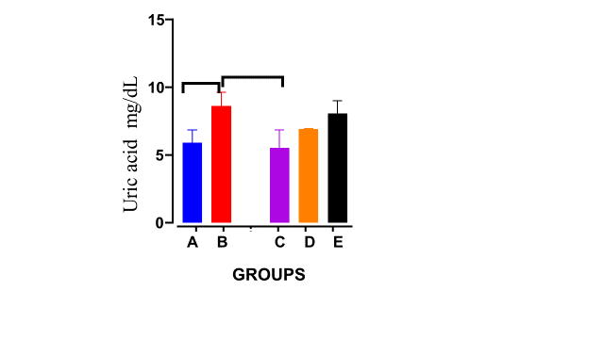
Fig 1.0 Effects of paraquat and Jigsimur on Uric acid levels

3.3 Effects of paraquat and Jigsimur on Urea levels
Figure 2.0 displays the mean serum urea levels across the five experimental groups. Group B shows a significant increase in urea concentration compared to Group A (control). Group C also shows a significant decrease compared to Group B. However, Group E shows a significant decrease in urea levels compared to Group C (p < 0.05).

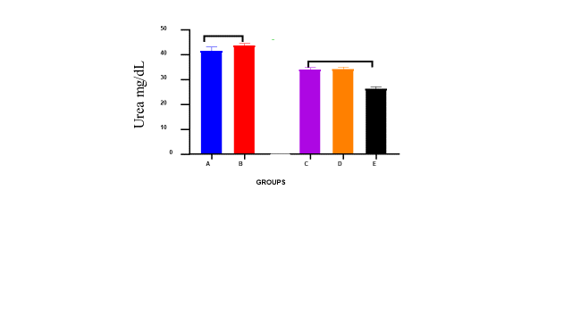
Fig 2.0 Effects of paraquat and Jigsimur on Urea levels

3.4 Effects of paraquat and Jigsimur on Creatinine levels
Group B (paraquat-only) showed elevated creatinine (0.50 mg/gL) compared to the negative control Group A (0.30 mg/gL) and Group C (0.35 mg/gL) (that received only Jigsimur) indicating renal impairment. However, Groups D, and E (treated with Jigsimur) showed reduced levels (0.33, and 0.32 mg/gL respectively), suggesting a dose-dependent reno-protective effect of Jigsimur as shown in fig 3.0.

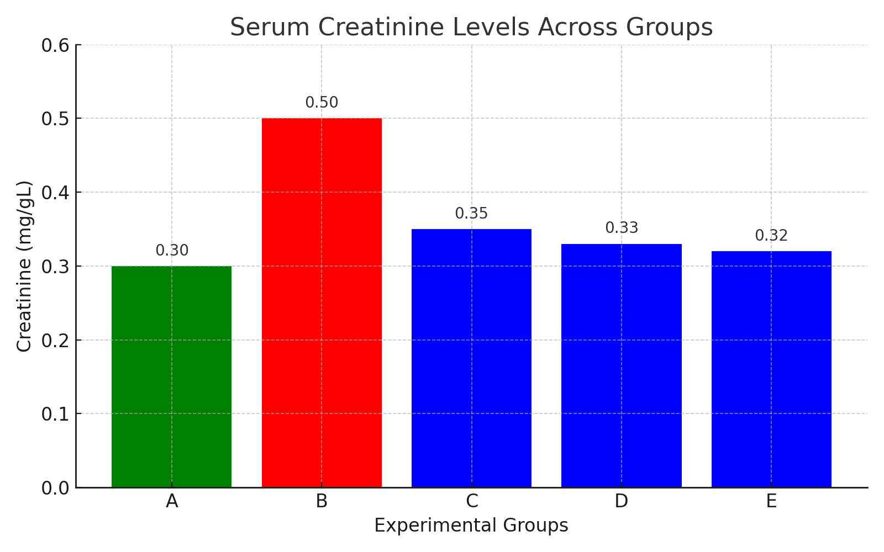
Fig 3.0 Effects of paraquat and Jigsimur on Urea levels

3.5 Histological findings

Extensive fatty degeneration (clear vacuolated spaces in renal tubules), inflammatory infiltration surrounding glomerulus and tubules, disturbed architecture (damaged tubules, possible tubular necrosis) were all observable in the paraquat-only group (Group B). However, in the Jigsimur treated groups, fewer fatty changes (noted by vacuolated cytoplasm), less severe inflammatory infiltration, tubular arrangement (appears relatively better preserved) and lower density of necrotic features compared to the Group B, reflects partial renal recovery post-paraquat exposure as shown in plates 1 - 5.

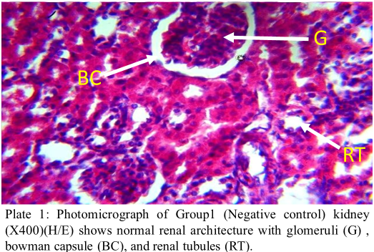

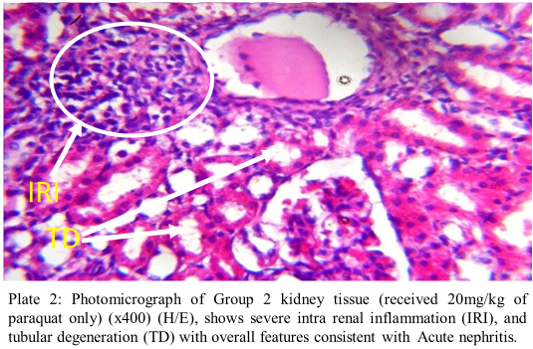

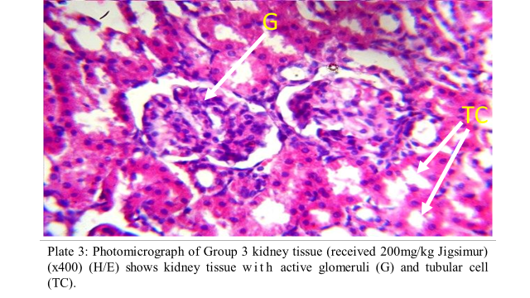

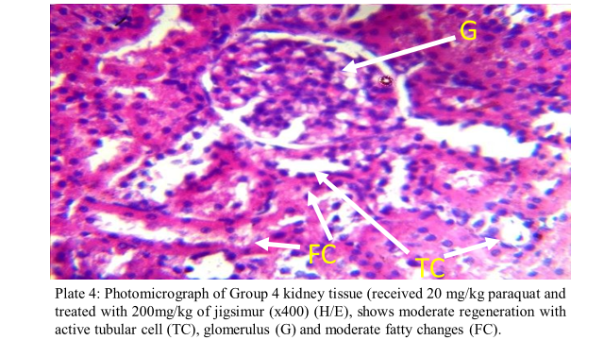

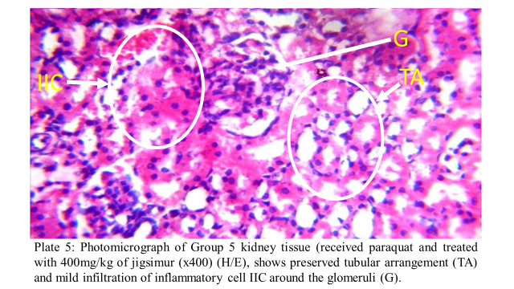

4.0 DISCUSSION
Evaluation of body weight changes in this study showed that although weight gain was observed in all groups, the paraquat-only group exhibited a significantly attenuated increase compared to the control. This finding aligns with previous research indicating that paraquat exposure impairs weight gain and organ development in experimental animals (Takenaka et al., 2002; Food Safety Commission of Japan, 2022; Ofoego et al., 2020). In contrast, Groups C (that received only Jigsimur), and Groups D, and E, which received post-treatment with Jigsimur, showed significant increases in body weight compared to their initial values. This suggests a potential restorative effect of the herbal mixture, particularly at moderate and high doses, likely mediated by its nutrient-rich composition and systemic antioxidant activity (Nalimu et al., 2021; Loots et al., 2007).

Biochemically, serum analysis revealed that paraquat administration led to significant elevations in uric acid and urea levels in Group B, indicative of renal impairment. These elevations align with clinical observations where elevated uric acid is a predictor of Acute Kidney Injury (AKI) and mortality following paraquat intoxication (Kim et al., 2011) and with experimental studies showing paraquat causes increased plasma urea in rats due to renal tubular damage (Gawarammana & Buckley, 2011). These results are consistent with known mechanisms of paraquat toxicity, which involve the generation of reactive oxygen species (ROS) through mitochondrial redox cycling, leading to an imbalance between oxidants and antioxidants (Dinis-Oliveira et al., 2008; Sies, 2017).

In Group D, uric acid levels decreased significantly compared to Group B, while Group E showed a marked reduction in urea levels compared to Group C, suggesting a dose-dependent reno-protective effect of Jigsimur. This protective effect may be attributed to the rich antioxidant and polyphenolic content of Aloe ferox, the main constituent of Jigsimur, which has been reported to enhance the activity of endogenous antioxidant enzymes such as superoxide dismutase (SOD), catalase (CAT), and reduced glutathione (GSH), thereby mitigating oxidative stress and preserving renal function (Saka et al., 2020; Loots et al., 2007). Although lower doses of Jigsimur significantly reduced uric acid levels in paraquat-exposed rats, the higher dose in Group E did not show further reduction, suggesting a possible saturation or reduced efficacy at higher concentrations. In contrast, the same higher dose in Group E significantly lowered urea levels, indicating a dose-dependent protective effect on renal function that appears more pronounced for urea metabolism than for uric acid regulation.
Serum creatinine is a key indicator of kidney function. Group A (negative control) showed normal levels (0.30 mg/dL), while Group B (paraquat-only) exhibited elevated creatinine (0.50 mg/dL), suggesting impaired renal filtration due to paraquat-induced oxidative damage (Kim et al., 2011; Dinis-Oliveira et al., 2008). This aligns with evidence that paraquat generates reactive oxygen species (ROS), leading to tubular injury (Gawarammana & Buckley, 2011). Groups C that received only Jigsimur had lower creatinine value (p < 0.05) when compared to Group B (0.35 mg/dL). Post-treatment with Jigsimur in D (0.33 mg/dL), and E (0.32 mg/dL) resulted in dose-dependent reductions, indicating reno-protective effects. Aloe ferox, the key constituent of Jigsimur, contains flavonoids and polyphenols known to combat ROS and support renal repair (Loots et al., 2007; Nalimu et al., 2021). These results suggest Jigsimur can mitigate paraquat-induced nephrotoxicity, potentially by restoring antioxidant balance and cellular integrity (Josiah et al., 2020).

Histological analysis provided further confirmation of biochemical findings. Kidneys from Group B exhibited severe tubular degeneration, fatty changes, and intense intra-renal inflammation—hallmarks of acute nephritis. These alterations reflect paraquat’s ability to generate oxidative stress, disrupt membrane integrity, activate inflammatory cascades via nuclear factor-kappa B (NF-κB), and trigger apoptosis through mitochondrial cytochrome c release and caspase activation (Zheng et al., 2021; Jia et al., 2022). In contrast, Jigsimur-treated groups (C–E) displayed progressive histological restoration: Group C histology similar to that of normal/negative control (Group A), while Groups D and E demonstrated active glomeruli and tubular cells with reduced fatty vacuolation and minimal inflammation, indicating effective tissue repair. This corresponds with studies showing flavonoids and anthraquinones from plant extracts confer cytoprotection and anti-inflammatory effects—attenuating renal damage via antioxidant enzyme induction and suppression of pro-inflammatory signaling (Frontiers, 2018; Josiah et al., 2020; Ezeagu and Ofoego. 2025; Ofoego et al., 2025).

Taken together, the improvements in physical appearance, body weight, serum biomarkers, and kidney tissue structure suggest that Jigsimur may counteract paraquat-induced nephrotoxicity. This protective effect likely stems from its rich phytochemical profile particularly polyphenols, flavonoids, saponins, and essential minerals which are known to stabilize cell membranes, inhibit lipid peroxidation, and enhance antioxidant enzyme activity (Safe et al., 2021; Khare, 2008).

4.1 CONCLUSION
This study demonstrated that paraquat induces significant nephrotoxicity in rats, as evidenced by reduced weight gain, elevated serum urea and uric acid levels, and marked histological damage to renal tissues. Post-treatment with Jigsimur herbal mixture, at doses of 200 mg/kg and 400 mg/kg, effectively attenuated these toxic effects. The observed improvements in biochemical markers, renal histology, and overall physical condition suggest that Jigsimur exhibits reno-protective properties likely mediated through its antioxidant, anti-inflammatory, and cytoprotective constituents. These findings validate the traditional claims of Jigsimur’s efficacy in supporting renal health and highlight its potential as a natural therapeutic agent in managing pesticide-induced kidney injury. However, further studies, including mechanistic analyses and controlled clinical trials, are recommended to fully establish its therapeutic efficacy and safety profile in humans.
Ethical approval
Ethical approval for this research was obtained from the Ethics Committee of Nnamdi Azikiwe University (NAU/AREC/2024/0111).
Disclaimer (Artificial Intelligence)
Author(s) hereby declare that NO generative AI technologies such as Large Language Models (ChatGPT, COPILOT, etc) and text-to-image generators have been used during writing or editing of this manuscript.

Competing Interests
We (Authors) hereby declare no known competing financial interests, non-financial interests, or personal relationships that influenced this work.

COMPETING INTERESTS DISCLAIMER:
Authors have declared that they have no known competing financial interests OR non-financial interests OR personal relationships that could have appeared to influence the work reported in this paper.

References
- Chen, J., Su, Y., Lin, F., Iqbal, M., Mehmood, K., Zhang, H., & Shi, D. (2021). Melatonin attenuates paraquat-induced nephrotoxicity through modulating oxidative stress, inflammation, and apoptosis in rats. Ecotoxicology and Environmental Safety, 220, 112711. https://doi.org/10.1016/j.ecoenv.2021.112711
- Dinis Oliveira, R. J., Duarte, J. A., Sánchez Navarro, A., Remião, F., Bastos, M. L., & Carvalho, F. (2008). Paraquat poisonings: Mechanisms of lung toxicity, clinical features, and treatment. Critical Reviews in Toxicology, 38(1), 13–71. https://doi.org/10.1080/10408440701669959
- Dinis Oliveira, R. J., Duarte, J. A., Sánchez Navarro, A., Remião, F., Bastos, M. L., & Carvalho, F. (2008). Paraquat poisonings: Mechanisms of lung toxicity, clinical features, and treatment. Critical Reviews in Toxicology, 38(1), 13–71. https://doi.org/10.1080/10408440701669959
- Dinis Oliveira, R. J., Remião, F., Duarte, J. A., Ferreira, R., Sánchez Navarro, A., Bastos, M. L., & Carvalho, F. (2006). P glycoprotein induction: An antidotal pathway for paraquat induced lung toxicity. Free Radical Biology and Medicine, 41(8), 1213–1224. https://doi.org/10.1016/j.freeradbiomed.2006.06.012
- Ezeagu, D. K., & Ofoego, U. C. (2025). Ripe banana peel extract: A natural protector of testicular health in experimental models. International Journal of Reproduction, Contraception, Obstetrics and Gynecology, 14(7), 2074–2082. https://doi.org/10.18203/2320-1770.ijrcog20251951
- Food Safety Commission of Japan. (2022). Paraquat (pesticides). Food Safety, 10(4), 140–147. https://doi.org/10.14252/foodsafetyfscj.D-22-00012
- Frontiers. (2018). Flavonoids in kidney health and disease. Frontiers in Physiology, 9, 394. https://doi.org/10.3389/fphys.2018.00394
- Gawarammana, I. B., & Buckley, N. A. (2011). Medical management of paraquat ingestion. British Journal of Clinical Pharmacology, 72(5), 745–757. https://doi.org/10.1111/j.1365-2125.2011.03955.x
- Hall, J. E. (2020). Guyton and Hall Textbook of Medical Physiology (14th ed.). Elsevier.
- Hirooka, Y., Imaoka, T., Terashima, H., Murayama, T., Nakano, K., & Kiyota, H. (2010). Involvement of organic cation transporter in paraquat-induced cytotoxicity in kidney cells. Toxicology and Applied Pharmacology, 249(1), 21–31. https://doi.org/10.1016/j.taap.2010.08.015
- Jia, C., Zhang, Z., Wang, J., & Nie, Z. (2022). Silymarin protects the rats against paraquat-induced acute kidney injury via Nrf2. Human & Experimental Toxicology, 41(1), 1–8. https://doi.org/10.1177/09603271221074334
- Johnson, J. T., & Dike, P. (2024). Effect of Jigsimur on serum inflammatory markers and renal indices of Wistar rats with streptozotocin-induced diabetes mellitus. International Journal of Advanced Biochemistry Research, 8(9), 690–695. https://doi.org/10.33545/26174693.2024.v8.i9i.2258
- Josiah, S. S., Crown, O. O., Akinmoladun, A. C., & Adegboye, O. A. (2020). Renoprotective property of the flavonoid-rich extract of Kigelia africana fruits on gentamicin-induced nephrotoxicity in rats. Comparative Clinical Pathology, 29(4), 815–828. https://doi.org/10.1007/s00580-020-03140-w
- Kamel, F. (2013). Epidemiology. Paths from pesticides to Parkinson's. Science, 341(6147), 722–723. https://doi.org/10.1126/science.1243619
- Khare, C. P. (2008). Indian medicinal plants: An illustrated dictionary. Springer Science & Business Media.
- Kim, J.-H., Gil, H.-W., Yang, J.-O., Lee, E.-Y., & Hong, S.-Y. (2011). Serum uric acid level as a marker for mortality and acute kidney injury in patients with acute paraquat intoxication. Nephrology Dialysis Transplantation, 26(6), 1846–1852. https://doi.org/10.1093/ndt/gfq632
- Loots, D. T., van der Westhuizen, F. H., & Botes, L. (2007). Aloe ferox leaf gel phytochemical content, antioxidant capacity, and possible health benefits. Journal of Agricultural and Food Chemistry, 55(17), 6891–6896. https://doi.org/10.1021/jf071110t
- Loots, D. T., van der Westhuizen, F. H., & Botes, L. (2007). Aloe ferox leaf gel phytochemical content, antioxidant capacity, and possible health benefits. Journal of Agricultural and Food Chemistry, 55(17), 6891–6896. https://doi.org/10.1021/jf071110t
- Lorke, D. (1983). A new approach to practical acute toxicity testing. Archives of Toxicology, 54(4), 275–287.
- Nalimu, F., Oloro, J., Kahwa, I., & Ogwang, P. E. (2021). Review on the phytochemistry and toxicological profiles of Aloe vera and Aloe ferox. Future Journal of Pharmaceutical Sciences, 7(1), 145. https://doi.org/10.1186/s43094-021-00296-2
- National Research Council. (2011). Guide for the care and use of laboratory animals (8th ed.). The National Academies Press.
- Naughton, C. A. (2008). Drug-induced nephrotoxicity. American Family Physician, 78(6), 743–750.
- Ofoego, U. C., Eze, E. D., Nweke, E. O., Obiesie, I. J., Mbagwu, I. S., Okafor, E. C., & Rabiu, M. (2021). Allium cepa (onion) extract enhances and protects testicular function and architecture against paraquat-induced oxidative damage. International Journal of Life Science and Pharma Research, 11(1), 194–203. https://doi.org/10.22376/ijpbs/lpr.2021.11.1.L194-203
- Ofoego, U. C., Mbagwu, S. I., Ekwujuru, E. U., Obiesie, I. J., Madu, C. P., & Ofoego, A. N. (2020, August). Maydis Stigma (corn silk) extract protects the functionality and histoarchitecture of the testis against paraquat-induced toxicity. International Journal of Agriculture and Biological Sciences, 15(4), 111–122. https://doi.org/10.5281/zenodo.12549242
- Ofoego, U. C., Nwachukwu, C. F., Obinwa, B. N., Ekwujuru, E. U., Ofoego, A. N., & Ezeagu, D. K. (2025). Hepatoprotective effects of Solanum macrocarpon leaf extract against paraquat-induced liver toxicity in Wistar rats. Journal of Advances in Medicine and Medical Research, 37(3), 268–277. https://doi.org/10.9734/jammr/2025/v37i35763.
- Ofoego, U. C., Nweke, E. O., & Nzube, O. M. (2019). Ameliorative effect of ethanolic extract of Cucumis sativus (cucumber) pulp on alloxan-induced kidney toxicity in male adult Wistar rats. Journal of Natural Sciences Research, 9(4), 12–18. https://doi.org/10.7176/JNSR
- Perazella, M. A. (2019). Drug-induced acute kidney injury: Diverse mechanisms of tubular injury. Current Opinion in Critical Care, 25(6), 550–557. https://doi.org/10.1097/MCC.0000000000000653
- Randox Laboratories. (2016). Creatinine (Jaffe) – colorimetric method. Product Insert. Crumlin, UK: Randox Laboratories Ltd.
- Randox Laboratories. (2017). Urea (Berthelot) – colorimetric method. Product Insert. Crumlin, UK: Randox Laboratories Ltd.
- Randox Laboratories. (2019). Uric Acid (enzymatic) – colorimetric method. Product Insert. Crumlin, UK: Randox Laboratories Ltd.
- Safe, S., Jayaraman, A., Chapkin, R. S., Howard, M., Mohankumar, K., & Shrestha, R. (2021). Flavonoids: Structure-function and mechanisms of action and opportunities for drug development. Toxicological Research, 37(2), 147–162. https://doi.org/10.1007/s43188-020-00080-z
- Senthil Kumar, K. J., Gokila Vani, M., Wang, C. S., & Chen, C. Y. (2021). Paraquat-induced oxidative stress and dysfunction in zebrafish embryos: A potential model for Parkinson’s disease. Biomedicine & Pharmacotherapy, 133, 110957. https://doi.org/10.1016/j.biopha.2020.110957
- Sies, H. (2017). Hydrogen peroxide as a central redox signaling molecule in physiological oxidative stress: Oxidative eustress. Redox Biology, 11, 613–619. https://doi.org/10.1016/j.redox.2016.12.035
- Takenaka, A., Annaka, H., Kimura, Y., Aoki, H., & Igarashi, K. (2002). Reduction of paraquat-induced oxidative stress in rats by dietary soy protein isolate. Bioscience, Biotechnology, and Biochemistry, 67(2), 278–283. https://doi.org/10.1271/bbb.67.278
- Tervaert, T. W. C., Mooyaart, A. L., Amann, K., Cohen, A. H., Cook, H. T., Drachenberg, C. B., ... & Bajema, I. M. (2010). Pathologic classification of diabetic nephropathy. Journal of the American Society of Nephrology, 21(4), 556–573. https://doi.org/10.1681/ASN.2010010010
- Tortora, G. J., & Derrickson, B. (2017). Principles of anatomy & physiology (15th ed.). John Wiley & Sons.
- United Nations. (2019). Globally Harmonized System of Classification and Labelling of Chemicals (GHS) (8th revised ed.). United Nations Publications.

