**Mathematical Modelling of Malaria Transmission Dynamics in Kenya: The Role of Seasonality, Drug Resistance, and Human Movement**

**Abstract**

**Background:**

Although there has been a remarkable improvement in controlling malaria, the clinical problem is still of public health importance in Kenya and especially in areas where there is climatic variation, which affects the transmission pattern. Seasonal rainfall has been explored as a central factor in the breeding of mosquitoes and the ensuing outbreaks of malaria, but most models have not included these ecological forces together with drug resistance and human mobility.

**Objective:**

The purpose of the study is to formulate and examine a seasonally driven malaria transmission model to represent the interaction of the dynamics of mosquito infection, antimalarial drug resistance, and human mobility in the Kenyan setting.

**Methods:**

We developed a compartmental model with drug-susceptible and drug-resistant parasite strains, categorised by stages of human infections, and mosquitoes. The model proposes seasonal forcing in a sinusoidal representation, which is staggered with the Kenyan rainfall pattern, which drives the mosquito recruitment. Inter-regional human migration is thought to take the form of a toggling migration parameter. The deSolve package in R was then used to simulate the model within a 2-year horizon. Monthly averages were then used to determine the peaks of the infection rates, and these were equated to the long (March to May) and short (October to December) rainy seasons in Kenya.

**Results:**

It was found that the results of simulations identified clear infection spikes closely corresponding to two periods of rainfall in Kenya (bimodal). The post-rainy periods when mosquitoes infected with the malaria parasites reach their peak (Q), as well as when humans are infected, were consistent, making a difference to resistant infections, which do not drop as fast as susceptible infections. The circulation of human movements enhanced the continuation and propagation of resistant infections. This indicated the environmental drivers of seasonal forcing that explained the time and magnitude of outbreaks.

**Conclusion:**

Noting the inclusion of seasonality, drug resistance, and movement in the models of malaria transmission increases their reality and predictability to a great extent. The syncing of the most significant infection-containing seasons with rainy seasons necessitates climate-tactful surveillance and intervention time. In Kenya, where the mobility of the population is high based on trade, labour migration, and between urban and rural regions, the modelling of such mobility is very important in gaining an understanding of the management of the epidemic. The model can be of great benefit in optimising vector control, deploying drugs and allocating resources regionally to malaria-endemic countries such as Kenya.

**Keywords:**

Malaria transmission modeling; Seasonality; Drug resistance; Infected mosquitoes; Human mobility; Rainfall patterns; Vector dynamics; Disease surveillance

**1.0 Introduction**

Malaria remains one of the most long-standing menaces to global public health, and the concentration has been in sub-Saharan Africa in an unfair constitution. In 2023, Global prevalence, occurrences, and deaths were estimated by the World Health Organisation (WHO) as more than 240 million cases and over 600,000 deaths worldwide, with most in Africa. The interaction between HIV and malaria in Sub-Saharan Africa has become one of the major public health problems and has resulted in many economic disasters by negatively affecting the contribution of the labour force to the national economy (Arafa et al., 2019). Kenya is both endemic and epidemic, and still remains a country that is heavily impacted by this malaria infection despite the many control measures. The epidemiology of malaria in Kenya is very heterogeneous and driven by topography the well as climatic variability, human mobility, ecology of the vectors and healthcare infrastructure (Patel et al., 2024). Since mosquitoes transmit the pathogen, and since the underlying distributions of mosquitoes and humans are highly heterogeneous [6], so is the intensity of transmission (Ruktanonchai et al., 2016).

The interplay between the plasmodium parasites (particularly the P. falciparum), the Anopheles female mosquito vector and the human host is mainly the cause of malaria transmission. Transmission mechanisms, however, are not always fixed and are becoming more and more influenced by other factors like drug resistance, insecticide resistance, population movement and variation of seasons. Recent epidemiological analyses stress that the spatial and time-contextual awareness of these transmission mechanisms is crucial to developing effective control strategies (Mategula & Gichuki, 2023).

The life cycle of the Anopheles mosquito is strongly affected by the seasonal change, particularly rain. In Kenya, the highest seasons of malaria transmission occur during and after the long rainy season (March to May) and the short rains (October to December) periods, which allow the most favourable conditions for mosquito breeding. It is during these rainy seasons that the density of the vector and later malaria cases also spikes (Lyimo et al., 2025). Such seasonality should be integrated into mathematical modelling as determinants of the occurrence of an outbreak, as well as establishing when interventions like indoor residual spraying or seasonal malaria chemoprevention interventions take effect. Mathematical models have specifically proven to be more useful than statistical models in studying the factors influencing the transmission dynamics of malaria because of their increased predictive computational capability (Li & Liu, 2020; Marshall et al., 2018; Adegbite et al., 2023).

Human mobility is yet another determinant of transmission, which enables geographical distribution of the malaria parasites and nullifies local elimination gains. Populations of migrant people, agricultural labour, and nomads move in and out of transmission and non-transmission areas, adding parasites to susceptible areas and maintaining transmission (Lourenço et al., 2019). The capture of this population movement and quantification is particularly pertinent in such regions as western Kenya, where long-distance travel among counties and porous borders are central in influencing the patterns of malaria (MoH, 2022).

Besides, drug-resistant malaria strains, mostly to artemisinin-based combination therapies, have become a grave danger to the control of the disease in the world. When parasites develop resistance, they may be easily transmitted, making the conventional treatment procedures less cost-effective and promoting morbidity and loss of lives. Resistance also changes the within-host dynamics and can generate a population-level transmission shift in the equilibrium. Incorporating co-circulation of sensitive and resistant strains in these models is therefore instrumental in the evaluation of the long-term risks and policy requirements (Shibeshi et al., 2020).

To confront such complicated challenges, dynamic transmission models provide a framework through which different biological, environmental, and social drivers of malaria could be integrated in a structured way. More specifically, the interactions over time between susceptible, infected, treated and recovered people could be simulated using deterministic compartmental models that are implemented by ordinary differential equations (ODEs). When these mechanisms are added, i.e., seasonal forcing and mobility modules among others, such models are able to reproduce realistic transmission patterns and predict future trends depending on the scenarios.

This study develops and analyses a seasonally forced malaria transmission model with explicit inclusion of drug-resistant strains and population movement. By aligning simulated outputs with known rainfall cycles in Kenya, we examine how seasonality and mobility interact to amplify transmission and resistance spread. We also explore the temporal patterns of infected humans and mosquitoes, identify epidemic peaks, and suggest policy-relevant insights based on the timing of control strategies. Our approach offers a decision-support tool that could help refine the timing and spatial targeting of malaria interventions in regions with complex transmission ecologies like western Kenya.

**2. Model Description**

**2.1 General description of the Transmission Model**

To describe the dynamics of a human-mosquito malaria system, we built a compartmental deterministic model in the form of ordinary differential equations (ODEs) to include drug resistance in the interplay of the human host and the mosquito, and seasonality. The human population is partitioned into six compartments, which are: susceptible humans $\left(S_{H}\right)$, vaccinated humans $\left(V_{H}\right)$ Individuals infected by drug-sensitive parasites $\left(I_{s}\right)$ Individuals infected by drug-resistant parasites $\left(I_{r}\right)$, treated people $\left(T_{H}\right)$, and recovered people $\left(R_{H}\right)$. The mosquitoes are also separated into susceptible and infected mosquitoes, which are $(G)$ and $(Q),$ respectively. The movement of the population between regions is captured as a toggle to indicate the mobility of people, and mosquito seasonality is included to be consistent with the Kenya bimodal rainfall-driven mosquito recruitment cycles (March-May and October-December).

**2.2 Human Population Compartments**

The population of the human race is:

$N_{H}\left(t\right)=S_{H}\left(t\right)+V_{H}\left(t\right)+T_{H}\left(t\right)+I_{s}\left(t\right)+I_{r}\left(t\right)+R_{H}\left(t\right)$…………..(I)

The movement between compartments is regulated by infection via mosquito bite, treatment, recovery, loss of force of immunity and native attrition. Individuals who are susceptible are vulnerable to being vaccinated and also infected. Fractions that are vaccinated are less prone, and it is regulated by factor $ω∈ \left(0, 1\right)$.

**2.3 Infection Pathways**

This is because infectious mosquitoes (Q) could give susceptible individuals. $S_{H}$ ​ an infection during a bite. This force of infection is based upon the mutual interaction of the susceptible host and infected pool of mosquitoes on the transmission rates: $β_{s}$ (sensitive strains) and $β_{r}$ (resistant strains) and the biting rate of mosquitoes: $θ$. The word infection (in susceptible people) is in its entirety:

Infection Rate $=θQ(β_{s} +β_{r}$)………(II)

Infected but vaccinated $V_{H}$ can also be infected, but at a lower susceptibility that is governed by a vaccine protection factor $ω∈\left(0, 1\right)$. Therefore, the effective rate of infection in vaccinated persons turns out to be:

Vaccinated Infection Rate $=θQ(β_{s} +β_{r}$) $.ω$………….(III)

**2.5 Vaccination and Immunity**

The susceptible individuals can attain a vaccine at $μ$-rate to the vaccinated population type $V_{H}$. Nevertheless, protection caused by vaccines is not lifelong. Individuals who have received the vaccine increase to the susceptible state at a rate $α$, (where $α$ is the rate of loss of immunity by all vaccinated persons). The recovery individuals $\left(R_{H}\right)$ also lose their natural immunity at a rate $ρ.$

**2.6 Treatment and Drug Resistance**

There is treatment of infected individuals that takes place at rates $Υ_{S}​$ and $Υ_{r}$ ​ representing sensitive and resistant strains, respectively. People under treatment $T_{H}$ ​ either improve and enter $R_{H}$ ​ or leave the population. Individuals may develop drug resistance via a mutation or selective force, and the rate of development of drug resistance is denoted by $μ_{S}$, and those individuals in state $I_{S}$ decay at a rate and shift to the resistance state $I_{r}$.

**2.7 Additional Demographic Processes**

There is also natural recruitment into the susceptible category at rate $Λ_{H}$ ​. Natural death (essence human attrition) impacts all compartments equally at rate $δ_{h}$. Deaths due to infection would be presented as a separate parameter were they to be included, but it is not the emphasis in this version of the model.

# **Table 1-Summary of Transitions in Malaria Transmission Model**

|  |  |  |
| --- | --- | --- |
| From → To | Description | Rate / Mechanism |
| $S_{H}$ $→$ $V_{H}$ | Vaccination | $$u ⋅ S_{H}$$ |
| $S_{H}$ → $I_{s}$ | Sensitive infection | $$θ{.β}_{s}.QS_{H}$$ |
| $S_{H}$ → $I_{r}$ | Resistant infection | $$θ{.β}_{r}.QS_{H}$$ |
| $V_{H}$ → $I_{s}$ | Breakthrough infection | $$θ{.β}_{s}.QωV_{H}$$ |
| $V_{H}$ → $I_{r}$ | Resistant infection (vaccinated) | $$θ.β_{r}.QωV_{H}$$ |
| $V_{H}$ → $S_{H}$ | Waning vaccine immunity | $$α ⋅ V_{H}$$ |
| $R_{H}$ → $S_{H}$ | Loss of natural immunity | $$ρ ⋅ R_{H}$$ |
| $I_{s}$ → $T_{H}$ | Treatment (sensitive) | $$Υ_{s}​ ⋅ I_{s}$$ |
| $I_{r}$ → $T_{H}$ | Treatment (resistant) | $$Υ_{r} ⋅I_{r}$$ |
| $T_{H}$ → $R_{H}$ | Recovery after treatment | $$q ⋅ T_{H}$$ |
| $I_{s}$ → $R_{H}$ | Natural recovery | $$γ_{s}​ ⋅I_{s}$$ |
| $I_{r}$ → $R_{H}$ | Natural recovery (resistant) | $$γ_{r}⋅I_{r}$$ |
| $I_{s}$ → $I_{r}$ | Development of resistance | $$μ_{s} ⋅ I_{s}$$ |

**2.8 Dynamics of the Population of a Vector**

The total mosquito population at a particular time, $t$, in the model is given as:

$M\left(t\right)=G\left(t\right)+Q\left(t\right),$………(IV)

where: $G(t)$: Susceptible (non-infectious) mosquitoes $Q(t)$: Infected (infectious) mosquitoes that can be transmissive of malaria.

Seasonal rainfall changes the population dynamics of mosquitoes by influencing breeding and recruitment. This is included through seasonal forced birth rate in synchrony with the bimodal rainfall in Kenya. The Sinusoidal modulation affects the birth rate of mosquitoes $Λ_{v}:$

$Λ_{v}(t)=Λ_{v}⋅\left(1+0.5⋅sin⁡\left(\frac{2πt}{365}\right)\right)$……………(V)

This is a yearly periodicity of the recruitment of the vectors that are more abundant during the long and short rainy seasons (March-May and October-December, respectively) (Patel et al., 2024; Githeko & Ndegwa, 2001).

* 1. **Bio-mechanism of Mosquito** **Infection**

The susceptible mosquitoes $(G)$ are infected when they bite infected humans $(H​(t)=I_{S}(t)+I_{r}(t))$. The rate of infections is proportional to:

$θ⋅G⋅\left(\frac{β_{s}⋅I_{S}+β_{r}⋅I_{r}}{N_{H}}\right)…$……..(VI)

Mosquitoes are transferred to the infectious category $Q$ after they are infected. $G$ and $Q$ both die at a natural death rate. The rate of death of G and Q is assumed to be equal, .

* 1. **Vector Compartment Differential Equations**

The mosquito chambers develop as follows:

1. **Susceptible Mosquito ($G$)**

$\left\{\begin{matrix}\frac{dG}{dt}=Λ_{V}(t)-λ_{V}G(t)-θG(t)\left(\frac{β_{s}⋅I_{S}+β_{r}⋅I_{r}}{N_{H}}\right) & if H\left(t\right)>0 \\ \frac{dG}{dt}=Λ_{V}\left(t\right)-λ_{V}G\left(t\right) & if H\left(t\right)=0\end{matrix}\right.$……….(VII)

1. **Infectious Mosquito ($Q$)**

$\left\{\begin{matrix}\frac{dQ}{dt}=θG(t)\left(\frac{β_{s}⋅I_{S}+β_{r}⋅I_{r}}{N_{H}}\right)-λ_{V}Q(t) & if H\left(t\right)>0 \\ \frac{dQ}{dt}=-λ_{V}Q\left(t\right) & if H(t)=0\end{matrix}\right.$……………(VIII)

Where:

$Λ_{V}\left(t\right)=$ Seasonally forced mosquito recruitment

$λ_{V}=$ Natural mosquito death rate

In this formulation, we make the assumptions:

1. Extrinsic incubation period in mosquitoes (i.e. immediate infectivity immediately after being infected)
2. Equal probability of getting bitten by each mosquito (or any mosquito has equal probability of biting any human)
3. The same mortality rate of infected and uninfected mosquitoes
   1. **Human-Vector Coupling**

The human force of infection is directly proportional to the percentage of infectious individuals:

$λ_{H,s}\left(t\right)=\left\{\begin{matrix}θβ_{s}Q\left(t\right) & if Q\left(t\right)>0 \\ 0 & if Q\left(t\right)=0\end{matrix}\right.$……………(IX)

$λ_{H,r}\left(t\right)=\left\{\begin{matrix}θβ_{r}Q\left(t\right) & if Q\left(t\right)>0 \\ 0 & if Q\left(t\right)=0\end{matrix}\right.$……………(X)

Where:

$λ_{H,s}\left(t\right)=$ Force of infection from **drug-sensitive** mosquitoes to humans

$λ_{H,r}\left(t\right)=$ Force of infection from **drug-resistant** mosquitoes to humans

$Q\left(t\right)=$ Population of infectious mosquitoes at time $t.$

The force of infection of a mosquito is dependent on the infectivity of human beings:

$λ_{M}\left(t\right)=θ\left(\frac{β_{s}⋅I_{S}+β_{r}⋅I_{r}}{N_{H}}\right)…$…….(XI)

The system therefore forms a feedback loop in which infected mosquitoes have the ability to spread the disease to other humans, and in turn, infected humans serve to sustain and propagate the infection in infected mosquitoes, especially during the periods of peak infections.

**Human** **Compartment Differential Equations**

The Human equation is formulated as:

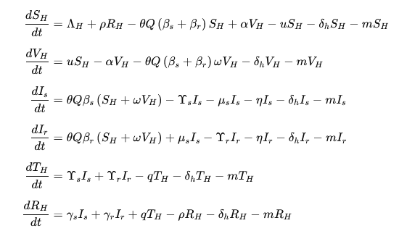…(XII)

Where:

$m=$ Movement/migration loss rate

$Λ_{H}=$ Human recruitment rate

$η=$ Progression to severe/chronic states

$q=$ Treatment recovery rate

**3.0 Simulation Design and Implementation**

**3.1 Modeling Framework**

Modelling the model has been compiled by R (deSolve package) to numerically solve the system of ODEs with a two-year simulation (730 days). We used these two scenarios:

1. With free movement (e.g. seasonal labour migration or movement between regions)
2. Without movement, that reflects a more stable population.

To this end, movement was introduced as a conditional parameter $m$ redistributing a part of the population out of all human types, should it be set to on. The seasonal forcing resulted in rainfall-dependent breeding dynamics in the mosquito recruitment rate $Λ_{v}​(t)$. This was incorporated in the model as a sinusoidal scaled to the similarity of the bimodal version of the rainfall pattern in Kenya, which is the two major rainy seasons of long rains (March-May) and short rain (October-December).

**3.2 Rainfall in Kenya Contextualization**

To put model forcing in perspective, we adjusted the sinusoidal seasonality analysis to Kenyan trends observed in climatological conditions. The rain distribution pattern of most of malaria malaria-affected regions in Kenya, such as Western Kenya and the Lake basin region, according to the Kenya Meteorological Department and regional studies on climatic conditions, are characterised by two main rainy seasons:

* Long rains: mid-March to late May
* Short rains: early October to December.

Rainfall also makes more mosquito breeding places available, and this escalates the population of the mosquitoes about 2-4 weeks later, thereby increasing the transmission of malaria. This is simulated in our seasonal forcing function with a state-varying component to the mosquito recruitment rate. In addition, a monthly aggregation of output variables (infected humans, infected mosquitoes, and resistance prevalence) was also performed to better reflect the trends and visualise the correlation with rainy seasons.

**3.3 The Calibration of the Parameters**

The literature, expert judgment and Kenyan demographic and entomological profiles were used to inform the model parameters. For example: The values of ${ β}_{S}$ and $β_{r}$ were selected to depict more transmissibility of drug-sensitive parasites, as the drug-resistance trade-off theory requires. Recovery and treatment rates $γ_{s}, γ_{r}, Υ_{s}, Υ_{r}$ were parameterised using empirical malaria treatment efficacy and the average length of a malaria episode in Kenya. The default initial conditions were selected to describe a population of 1,400 individuals of the human population, together with 5,200 mosquitoes with some pre-existing infections:

$State<- c\left(S_{H}=1000, V_{H} =200, I_{S}= 50, I_{r}= 20, R_{H} = 100, T_{H}= 30, G= 5000, Q= 200\right)$…………….(XIII)

**3.4 Monthly Aggregation and Peak Detection**

We have transformed daily simulation results into monthly averages with the help of the **lubridate** and **dplyr** packages. This enabled us to determine months that had infection peaks, which are months where the infected humans and mosquitoes had surpassed the 90th percentile of that variable. geom_rect () in ggplot2 was used to fill the intervals of the rainy season, and the peak periods were marked for infected humans and infected mosquitoes.

**3.5 Scenarios of simulation**

There were two main simulations that were carried out:

* Scenario 1: With Movement -mimics the spreading of infection further by people, travelling during planting or harvesting.
* Scenario 2: No Movement, a fixed reference point to know how localised transmission occurs absence of migration effect.

All the simulations had a long time of 730 days (2 years), in order to capture two complete seasonal cycles at least. Outputs have been plotted on a daily and an aggregate monthly basis.

**3.6 Output Metrics**

Major outcomes indicators were:

* Humans infected totally $H​(t)=I_{S}(t)+I_{r}(t)$ ​ ……………(XIV)
* Drug-resistant malaria Prevalence $\frac{I_{r}}{H(t)}$
* Q infected mosquito population
* Seasonal correspondence of the rainfall periods and peaks in infections.

Such a structure enabled us to evaluate the influence of seasonality and human mobility on the malaria transmission and the spread of resistant forms.

**4. Results and Analysis**

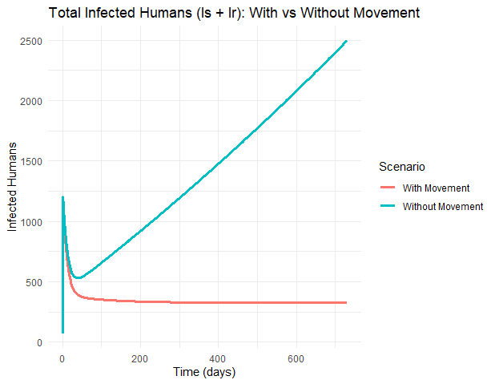

Figure 1: Humans (Is + Ir) Infected over Time (with and Without Human Movement).

The plot displays the time dynamics of malaria infection in the human population in two scenarios, namely. Without a movement of populations (blue line), infections increase and their growth is uncontrolled, characterised by persistent growth and addition of new cases. Conversely, due to the integration of human movement (red line), the peak of the infection level declines and then stagnates at an endemic level much lower in the early times. This implies that mobility has the potential to redistribute the risk of exposure and the localized burden of disease, particularly in combination with other control policies.

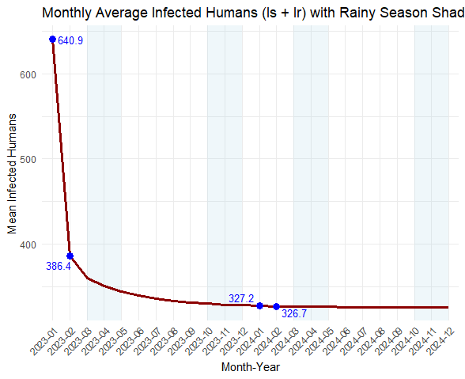

Figure 2: Monthly Average number of infected human beings (Is + Ir) with rainy season shading (2023- 2024).

Figure 2 highlights malaria infection dynamics in Kenya's seasonal climate. Averages of monthly number of infected humans reflect consistent correspondence between the peak of infections and the rainy months in the country (March to May and October to December). Such wet seasons are best suited to breeding of mosquitoes and hence highest densities of mosquitoes, high biting ability of mosquitoes and hence high human infections. The number indicates clearly that, despite a general decrease in the infection trend that is likely to be the effect of the interventions or model saturation, the rainfall-driven seasonality patterns initiate temporary significant increases in infections. The visualisation supports the fact that rainfall patterns have a well-proven correlation with malaria outbreaks, which were to be expected in recent times (Patel et al., 2024).

The combination of the two figures emphasises the realisation that human mobility and climatic seasonality are paramount factors underlying the transmission of malaria, and they have to be incorporated in models in order to produce realistic predictions and policies. Although mobility assists in reducing the endemic levels of long-term over time through the mechanism of spatial diffusion, rainfall remains a threatening cyclical phenomenon capable of overwhelming the health systems when not approached in advance.

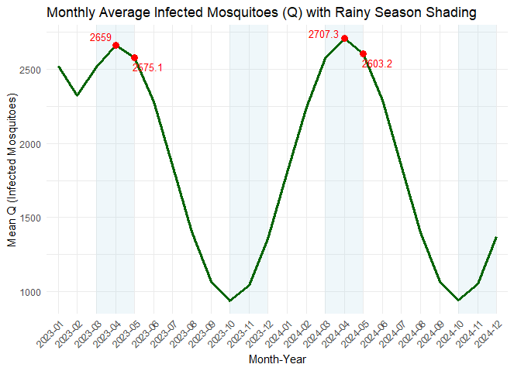

Figure 3: Monthly Average Infected Mosquitos (Q) With Rainy Season

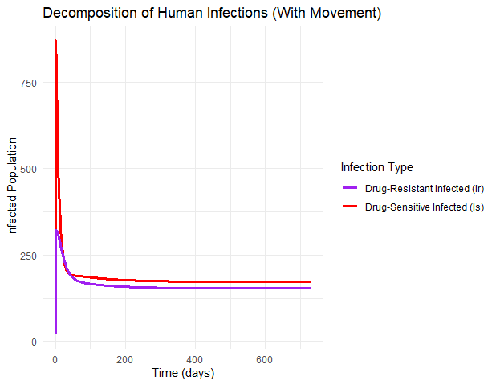Figure 4: Decomposition infected human population into drug-sensitive ($I_{S}$ ​​) and drug-resistant ($I_{r}$ ​) compartments given the movement scenario

4.1 **Seasonal Dynamics of the Infected Humans**

As is demonstrated in Figures 1and 2, the average of infected humans (both drug-sensitive $I_{S}$ ​ and drug-resistant $I_{r}$ ​) is compared in the two simulation scenarios: (a) movement; (b) no movement. The pattern of the seasonal forcing, in line with the Kenyan rainfall pattern, exhibited specific peaks in the prevalence of infection to coincide with the long (March to May) and short (October to December) rainy seasons in Kenya.

In the with movement condition, these peaks were more significant, particularly in the months of April, May and November, whereby incidences of infection went over the 90th percentile threshold. This implies that mobility increases transmission in times when there is a greater abundance of mosquitoes, probably because of the diffusion of susceptible and infected people at different geographical locations.

Conversely, the setting without movement appeared more localised and less intense, and contained smaller infection amplitudes and a short time shift of the peak rates in that one signifying a delayed response to the population emergency of the vectors through rains.

**4.2 Trends in Infected Mosquitoes**

Figure 3 illustrates the monthly mean of infected mosquitoes $Q$ and it is highly synchronised to the seasonal rainfall patterns. The infection rates of the mosquitoes as anticipated, rose very fast as the rains began, since the rain influences site availability as well as survival of larvae. Maximum mosquito infections were in April, May and November, which is highly correlated with the human infection peak. The transmission cycle of this has cascading rainfall onto increased mosquito abundance, which causes infection in human beings, followed by the infected mosquitoes, which indicates the feedback loop. The findings concur with the empirical analysis, as it reveals that the cases of malaria in Kenya are prone to rise during and directly after the rainy seasons (Patel et al., 2024).

**4.3 Drug Resistance Contribution**

Figure 4 disaggregates the infected human population into drug-sensitive ($I_{S}$ ​​) and drug-resistant ($I_{r}$ ​) compartments given the movement scenario. It is important to note that although both components had seasonal variations, the impact of $I_{r}$ ​ was found to increase with time, especially at high-transmission seasons. This is an expression of the selective advantage of resistant strains in situations when high pressure of treatment and high intensity of transmission are present.

Prevalence of monthly resistance, computed by:

Resistance Prevalence $=\frac{I_{r}}{H(t)}$.

Showed spikes during **post-rainy seasons,** and this indicated that intense vector populations and periodic treatment could hasten the process of transmission of resistant strains.

**4.4 Movement Increases Spread of Infections**

Example comparative outcomes of the two circumstances verify the fact that the mobility of humans is a major force of augmenting the transmission. For the case involving movement:

* The peak infections were also increased and earlier; this was most likely because pre-symptomatic people were causing infections to spread in regions that had low infections.
* Drug-resistant cases were transmitted in a broader way, indicating that migration is possible to provide spatially dissemination resistance even at confined origins.

The policy implications of this finding are on control of malaria in mobile populations, e.g. migrant workers, nomadic communities or inter-county travelling during holidays.

**4.5 Seasonal Shading and Rain-Induced Peaks**

If we superimposed the seasonal shading of rainy seasons on the plots, it was possible to point to the temporal coherence between rainfall and malaria dynamics. Such areas of shading mark out times when:

* Those conditions of breeding are most favourable.
* There is more intense transmissibility. The transmission intensity gets improved.
* The timing of intervention (e.g., distribution of insecticide-treated net, indoor residual spraying) can be most effective

The fact that infection peaks are synchronised with these seasons makes the case stronger to ensure that future surveillance and response measures to malaria are climate-sensitive, particularly in places where transmission is very seasonal, such as Kenya.

**5. Discussion**

This study employed a seasonally forced mathematical description of malaria dynamics to investigate the functional interactions between rainfall, migration and drug resistance and the way these lead to disease dynamics in Kenya. In an effort to simulate two years of epidemic behaviour with and without the phenomenon of population movement, we uncovered the immense impact of seasonal climatic factors and mobility in the induction of infection in not only the human population but also in the mosquito population.

**5.1 Effect of Rainfall on Malaria Transmission**

We find evidence of an established principle of rainfall being a major determinant of malaria dynamics in sub-Saharan Africa (Patel et al., 2024). It was registered that in Kenya, the Anopheles breeding provisioned environmental conditions that occurred during the long rainy season (March-May) and the short rainy season (October-December) did so mainly through the increased number of stagnant water sources. This is well reflected in our model as the peak under mosquito infections $(Q)$ and human cases $(H(t)​)$ coincide with these dynamics. Our simulation results of lags between rainfall and infection peaks are also consistent with real-world measurements, in which a surge in mosquito density pre-dates comparable growth of human infection by several weeks. This time correlation signifies the significance of climate-based early warning systems in predicting malaria outbreaks and the effective distribution of resources.

**5.2 Amplifying Effect of Population Movement**

The fact that a population movement mechanism was added caused significant changes in cultural attitude and epidemic dynamics. During the periods when movement was permitted, the level of transmission increased significantly, especially when high-risk months were involved. Such earlier increased infection peaks and their increased magnitude indicate that even small measures of population displacement could serve to promote spatial transmission of the parasites, including those that are drug resistant. Such results are comparable to those that have been recorded by the Kenya mobility-related literature, that have detailed how malaria has been transmitted to travel networks and travel domains as well as the rural and urban environments.

Movement also facilitated the degradation of the local seasonality by linking the areas with varying ecological settings so as to facilitate the survival of parasites in the regions with moderate transmission due to repeated importation. The inference is that the fight against malaria should incorporate mobility patterns of the human population, particularly in the cross-border areas and peri-urban settings.

**5.3 Dynamics of Drug Resistance**

Our model allows us to show how seasonal epidemics of transmission can boost the rate of expansion of resistant malaria strains. The greatest rate of resistance was witnessed in the rainy season and after the rainy season when there was pressure in terms of the caseloads being treated. The fact that, in the scenario of movement, $I_{r}$ ​ grows relative to time quite well implies that resistance may spread across populations, even when it originates in the localised pressure.

This signals an important implication to the antimalarial drug policy, and this means that regionally coordinated antimalarial resistance surveillance programs, combination therapies, targeted use and incorporation of resistance data in established surveillance systems are necessary.

**5.4 Strengths and innovations in the model**

A major advantage of the given study is the use of realistic seasonality, that is, the Kenyan climate seasonality patterns, instead of abstract seasonal forcing. We enhanced the readability of visual representations and the significance of a policy action by aligning the simulation outputs with the monthly indicators and darkening actual rainy periods. We additionally had disaggregated infection compartments, enabling a more subtle analysis of the way in which intervention strategies could have different effects on drug-sensitive and drug-resistant subgroups.

**5.4 Model Strengths and Inventions** The major strength of such a study is that a realistic seasonality has been included, which is not based on an abstract cycle forcing but on the climate pattern of Kenya. Comparing simulation results with monthly indicators, as well as shading real rainy spells, allowed us to enhance the visual interpretability of simulation results and relevance to policy. In addition, disaggregation of our infection compartments enabled a finer study of the effects of intervention strategies on subpopulations of drug-resistant individuals, as compared to drug-sensitive ones.

**5.5 Limitations**

Although the model is useful, there are a number of limitations:

* The precipitation was approximated in sinusoidal form; the next iterations may use real rainfall data (e.g., CHIRP or Kenya Meteorological Department).
* The human movements were considered a pure proportional outflow; the space networks, distance, or heterogeneity of risk perception would make it more realistic. iii.
* Vector control measures (e.g. **Long-Lasting Insecticidal Nets (**LLINs), **Indoor Residual Spraying (**IRS)) were not specified as either being present or absent, although these are important determinants of transmission.

**5.6 Comparison of Related Studies**

We differ with earlier modelling studies in Kenya (e.g., Macharia et al., 2018; Lacey et al., 2023) that, frequently, are interested in the effectiveness of interventions or in the possibility of long-term elimination. In contrast to strictly empirical research, our model features mechanistic routes of action, like how mobility changes the spatiotemporal pattern of resistance as well as a model of scenario analysis across different behavioural and ecological assumptions.

**6. Conclusion and Policy Implications**

This study introduces a seasonal-driven compartmental malaria transmission model fitted to Kenya epidemiological and climate pattern conditions. The model takes into account human movement and drug resistance; hence, providing a more dynamic perspective of malaria outbreaks under realistic schedules of the seasons. The findings of the simulations affirmed that rain patterns, especially during the long rains (March-May) and the short rains (October-December) have paralleled the sudden rise in mosquito infections and the human cases of malaria.

The regular transmission patterns also agree with the epidemiological records in Kenya and support the key role of weather in spreading these diseases via vectors. This shift to the inclusion of human movement showed that there was a very important amplification mechanism: a low moving rate gave rise to earlier, higher, and sustained outbreaks. Notably, the faster the movement, the faster the spread of resistant strains, implying that containment measures on drug resistance may need to go beyond local geographies. In Kenya, where the mobility of the population is high (based on trade, labour migration, and between urban and rural regions), the modelling of such mobility is very important in gaining an understanding of the management of the epidemic.

Seasonality as a factor contributing to the burden of infection also highlights the necessity of climate-sensitive policies. Preventive measures that include indoor spraying, mass drug versus, and distribution of nets must also be scheduled to occur ahead of the predicted seasonal peaks. Additionally, early warning systems of malaria outbreaks can be enhanced by integrating near-real-time predictions of weather together with disease surveillance. Policy Implications as a result of this model prove to be:

1. Pre-season interventions and Targeted Surveillance: reinforce entomological and epidemiological monitoring during the initial rainy months (February-March and September) and use the information to direct an upstream vector surplus campaign before outbreaks.
2. Mobility-Informed Resource Allocation: With the assistance of mobility patterns (e.g., using mobile phone data, transport hubs), the resource allocation should aim at providing health care in risk areas that can spread rapidly on holidays or on seasonal migrations of workers.
3. Cross County and Regional Planning: Considering that human movements can transfer infections across the ecological zones, malaria programs are therefore advised to cross-county and cross-border planning, particularly at the key movement routes and lake areas.
4. Drug resistance spread is also very sensitive to mobility and seasonality. Resistance management strategies. Regular drug effectiveness assessment, policy on rotational therapy and stricter policy against the use of antimalarial drugs are essential.
5. Integration of Climate Data: The national malaria control programs must make it a habit to incorporate high-resolution climate data, such as Kenya Meteorological Department, in decision-making using predictive models such as the one developed in this research.

Although the research is dedicated to Kenya, the framework can be implemented in other malaria-endemic areas with seasonal malaria. This paradigm can be enhanced by incorporating spatial variation, a program to control vectors, and stochastic weather patterns into the model in future. There is, however, a final connection that must be made, not only between epidemiological and climate science but also between mobility data, an important step toward locally relevant, prospective malaria control under changing environmental conditions. Our results endorse an adaptive strategy to malaria intervention planning, which is adaptive based on weather, cognizant of human behaviour and alert to the menace of resistance.

**Disclaimer (Artificial intelligence)**

Author(s) hereby declares that NO generative AI technologies such as Large Language Models (ChatGPT, COPILOT, etc.) and text-to-image generators have been used during the writing or editing of this manuscript.

**REFERENCES**

Patel, P., Bagada, A., & Vadia, N. (2024). Epidemiology and current trends in malaria. *In Rising Contagious Diseases: Basics, Management, and Treatments* (pp. 261–282). Elsevier.

World Health Organization (WHO). (2023). *World Malaria Report 2023*. Geneva: World Health Organization.

Ministry of Health – Kenya (2022). *Kenya Malaria Strategy 2019–2023*. Division of National Malaria Programme (DNMP). <https://www.health.go.ke/>

Lourenço, C., Tatem, A. J., Atkinson, P. M., Cohen, J. M., Pindolia, D., Bhavnani, D., & Le Menach, A. (2019). Strengthening surveillance systems for malaria elimination: a global landscaping of system performance, 2015–2017. *Malaria journal*, *18*, 1-11.

Lyimo, E., Kulaya, N. B., Njotto, L., Kassam, N. A., Gesase, S., Malabeja, A., ... & Wang, C. W. (2025). Changing Plasmodium falciparum malaria prevalence in two villages of northeastern Tanzania between 2003 and 2021 in relation to vectors, interventions and climatic factors. *Malaria Journal*, *24*(1), 68.

Shibeshi, M. A., Kifle, Z. D., & Atnafie, S. A. (2020). Antimalarial drug resistance and novel targets for antimalarial drug discovery. *Infection and drug resistance*, 4047-4060.

Githeko, A. K., & Ndegwa, W. (2001). Predicting malaria epidemics in the Kenyan Highlands using climate data: A tool for decision makers. *Global Change and Human Health*, 2(1), 54–63.

Macharia, P. M., Giorgi, E., Noor, A. M., Waqo, E., Kiptui, R., Okiro, E. A., & Snow, R. W. (2018). Spatio-temporal analysis of Plasmodium falciparum prevalence to understand the past and chart the future of malaria control in Kenya. Malaria journal, 17, 1-13.

Lacey, H., Jain, N., Sugimoto, M., Shimato, M., Reine, I., & Oria, K. (2023). Combating malaria in Kenya through collaborative population health education: a systematic review and pilot case study. Infectious Diseases, 55(10), 664-683.

Mategula, D., & Gichuki, J. (2023). Understanding the fine-scale heterogeneity and spatial drivers of malaria transmission in Kenya using model-based geostatistical methods. PLOS Global Public Health, 3(12), e0002260.

Li, Y., & Liu, X. (2020). Modeling and control of mosquito-borne diseases with Wolbachia and insecticides. Theoretical Population Biology, 132, 82-91.

Marshall, J. M., Wu, S. L., Sanchez C, H. M., Kiware, S. S., Ndhlovu, M., Ouédraogo, A. L., ... & Ferguson, N. M. (2018). Mathematical models of human mobility of relevance to malaria transmission in Africa. Scientific reports, 8(1), 7713.

Adegbite, G., Edeki, S., Isewon, I., Emmanuel, J., Dokunmu, T., Rotimi, S., ... & Adebiyi, E. (2023). Mathematical modeling of malaria transmission dynamics in humans with mobility and control states. Infectious Disease Modelling, 8(4), 1015-1031.

Ruktanonchai, N. W., DeLeenheer, P., Tatem, A. J., Alegana, V. A., Caughlin, T. T., zu Erbach-Schoenberg, E., ... & Smith, D. L. (2016). Identifying malaria transmission foci for elimination using human mobility data. PLoS computational biology, 12(4), e1004846.

Arafa, A. A. M., Khalil, M., & Sayed, A. (2019). A non‐integer variable order mathematical model of human immunodeficiency virus and malaria coinfection with time delay. Complexity, 2019(1), 4291017