**Original Research Article**

**Relationship between profile of ornamental nursery owners and their entrepreneurial behaviour****: An ex-post-facto research study**

**Abstract**

**Focus of the study/aims/objectives**

The study investigates the relationship between the profile of ornamental nursery owners and their entrepreneurial behaviour.

**Research design**

The *ex-post facto* research design was used.

**Sample size and sampling techniques**

The present study was conducted during the year 2022-23 in four *talukas* of the Navsari district of South Gujarat namely Khergam, Chikhli, Gandevi and Vansda. A sample size of 100 respondents was obtained by random selection of 25 respondents from each selected *taluka*. The data were collected through personal interview method.

**Instrument for data collection**

The data were collected using interview schedule.

**Validity & reliability**

The appropriate techniques and scales were used for the measurement of all the variables included in the study.

**Method of data analysis**

Correlation co-efficient, stepwise multiple regression and path coefficient analysis were used to identify and analyse the relationship among variables.

**Findings**

The correlation co-efficient revealed a negative and significant association between age and entrepreneurial behaviour. Conversely, education, landholding, annual income, social participation, mass media exposure, material possession and extension contact showed positive and significant relations with entrepreneurial behaviour. While, family size, occupation and farming experience exhibited non-significant correlations. Further, stepwise multiple regression analysis highlighted that education, social participation and mass media exposure collectively accounted for 48.80 per cent variation in the entrepreneurial behaviour of ornamental nursery owners. Additionally, path analysis highlighted that education, followed by social participation had the highest positive and significant direct effect on entrepreneurial behaviour. Mass media exposure, followed by material possession exerted the highest positive indirect effect. In contrast, farming experience, followed by age had the highest negative total indirect effect on entrepreneurial behaviour. Moreover, the study further revealed that mass media exposure, followed by material possession had an indirect effect on entrepreneurial behaviour through education and mass media exposure, respectively.

**Conclusion**

Education followed by social participation and mass media exposure have highest contribution in development of entrepreneurial behaviour.

**Recommendation/implication**

Education, social participation and mass media exposures’ influence must be taken into consideration for entrepreneurial behaviour development programmes/trainings/projects.

**Keywords:** Entrepreneurial Behaviour, Relationship, Correlation Co-efficient, Regression, Path analysis

**Introduction**

Entrepreneurship is a driving force behind the establishment and expansion of businesses, significantly impacting the prosperity of both regions and nations. Entrepreneurs possess a distinct way of thinking that differentiates them from non-entrepreneurs. Their thought processes can also vary depending on the specific situation or decision-making environment. Entrepreneurs are often called to make critical decisions in highly volatile and uncertain environments, where the stakes are considerable, time is a constraint, and personal investment runs deep. They need to be adaptable, resourceful, and possess strong leadership qualities to build and manage a successful venture in a dynamic business landscape. Entrepreneurs perform various actions to initiate and maintain their enterprise in the marketplace. Entrepreneurs try to exploit the available market opportunities to earn some profit. This process could be temporary or prolonged in the form of new ventures (Dangi *et al.,* 2014 and Talwas and Kaur, 2019). Entrepreneurial behaviour encompasses a range of characteristics and actions. Entrepreneurs demonstrate certain actions, attitudes and strategic orientations while being involved in entrepreneurial activities. Profile of entrepreneurs likely to influence their entrepreneurial behaviour. Personal characters, socio-economic conditions, level of education, farming experience, resources possession, cultural background, *etc.,* are likely to shape their entrepreneurial behaviour. Therefore, this study aim to understand the relationship between the profile of nursery owners and their entrepreneurial behaviour.

**Methodology**

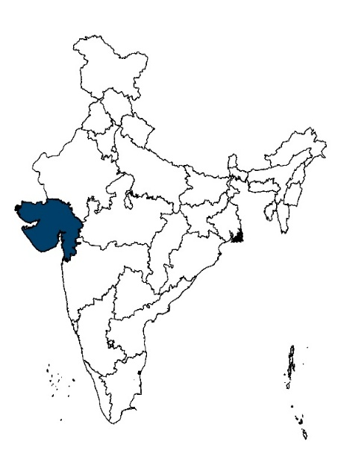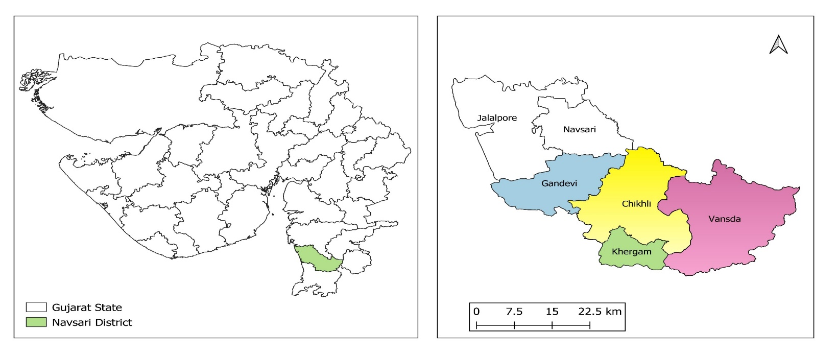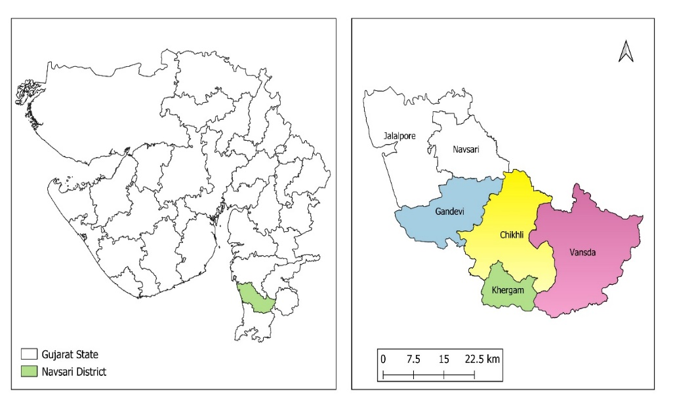

Navsari district

Gujarat State

Taluka boundary

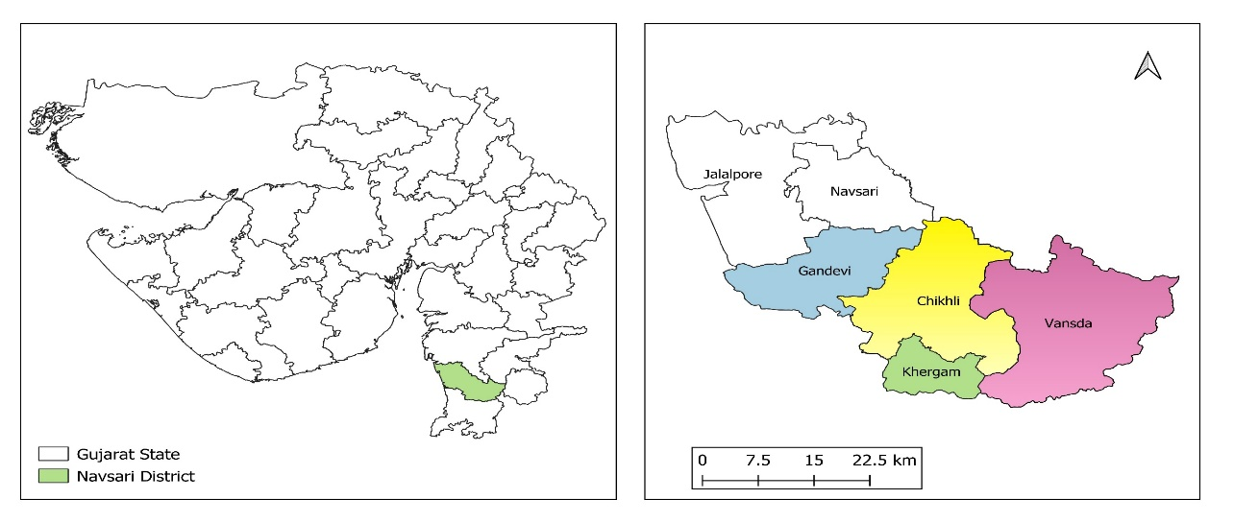

**Fig. 1: Map of the study area indicating India, Gujarat state and Navsari district of South Gujarat region**

The present study was conducted using an *ex-post-facto* research design during the year 2022-23 in the Navsari district of South Gujarat. South Gujarat has seven districts namely Surat, Navsari, Valsad, The Dangs, Tapi, Bharuch and Narmada among them only Navsari district was purposively selected based on the greater number of nurseries in this area. The Navsari district has six *talukas* namely Navsari, Chikhli, Gandevi, Vansda, Khergam and Jalalpore among them Khergam, Chikhli, Gandevi and Vansda *talukas* were purposively selected due to a greater number of nurseries in these *talukas*.

Among each selected *talukas* 25 respondents were randomly selected. Thus, a total of 100 sample size was obtained for the present study.



**Fig. 2: Operational structure of selection of respondents**

For the present study age (X1), family size (X2), education (X3), landholding (X4), farming experience (X5), annual income (X6), occupation (X7), social participation (X8), mass media exposure (X9), material possession (X10) and extension contact (X11) were selected as independent variables. On the other hand, the entrepreneurial behaviour was the dependent variable (Y). The data were collected using the personal interview method. To ascertain the relationship between the independent variables and dependent variable, correlation coefficient was used.

In the actual condition, no variable occurs independently without the influence of other variables. The stepwise multiple linear regression method was used to determine the most significant independent variables to include in a multiple linear regression model. It involves a systematic process of including or excluding variables based on their statistical significance or contribution to the model’s performance.

The path analysis was used to assess the causal influences of a set of independent variables on the dependent variable. Direct effects and total indirect effects can be known of individual independent variables on the dependent variable. Additionally, the substantial effect among the independent variables can also be determined.

**Results and Discussion**

**Table 1: Correlation co-efficient and path analysis of independent variables and entrepreneurial behaviour**

|  |  |  |  |  |  |
| --- | --- | --- | --- | --- | --- |
| Sr. No. | Independent variables | Correlation Co-efficient (r) | Path analysis | | |
| **Direct effect** | **Total indirect effect** | **Substantial indirect effect through** |
| 1. | Age (X1) | -0.408** | -0.126NS | -0.282 | 0.012 (X11) |
| 2. | Family size (X2) | -0.002NS | -0.08NS | 0.077 | 0.066 (X8) |
| 3. | Education (X3) | 0.569** | 0.312** | 0.257 | 0.116 (X9) |
| 4. | Landholding (X4) | 0.443** | 0.121NS | 0.321 | 0.111 (X9) |
| 5. | Farming experience (X5) | -0.076NS | -0.07NS | -0.006 | 0.085 (X8) |
| 6. | Annual income (X6) | 0.414** | 0.079NS | 0.335 | 0.118 (X9) |
| 7. | Occupation (X7) | 0.142NS | -0.008NS | 0.15 | 0.041 (X9) |
| 8. | Social participation (X8) | 0.397** | 0.223* | 0.174 | 0.102 (X9) |
| 9. | Mass media exposure (X9) | 0.617** | 0.239NS | 0.378 | 0.152 (X3) |
| 10. | Material possession (X10) | 0.394** | 0.022NS | 0.372 | 0.137 (X9) |
| 11. | Extension contact (X11) | 0.32** | -0.043NS | 0.363 | 0.133 (X9) |
| **Significant at 1 Percentage level of probability  * Significant at 5 Percentage level of probability  NS Non-significant | | | Residual: 0.4492 | | |

Table 1 indicates a significant negative correlation between age and entrepreneurial behaviour which reveals that younger individuals exhibit more entrepreneurial behaviour, while older individuals show less entrepreneurial behaviour. This contrast might be attributed to the younger generation’s ability to quickly learn new things, acquire new skills and mobilize resources for entrepreneurial pursuits. The declining mental adaptability of the older generation may hinder their capacity to learn new things and embrace novel knowledge. Moreover, ageing can lead to a skeptical outlook on new opportunities. The findings of the study are in accordance with the study of Bohalman *et al.* (2017) and Kautonen *et al.* (2014). According to Kautonen *et al.,* (2014), age inherently affect entrepreneurial behaviour. Older individuals avoid being entrepreneurs due to risk aversion. Also, younger individuals are more likely to start a new firm than older individuals.

The family size had a negative and non-significant relation with entrepreneurial behaviour. Researchers have many arguments regarding the relation and contribution of family size to entrepreneurial behaviour. Some contend that family size may hinder entrepreneurial performance, while others argue that it offers support to entrepreneurs. However, in this study, the family size had no influence on entrepreneurial behaviour. which is similar to the findings of Bhojani (2019), Singh *et al.* (2021) and Kharlukhi and Jha (2021).

The relationship between education and entrepreneurial behaviour was positive and significant. This indicates that educated people are more prone to become entrepreneurs. According to Majid *et al.* (2022), Education can be seen as a crucial component of the learning process for entrepreneurship. In this study, the inclination of educated people tends towards becoming entrepreneurs rather than being wage-employed. This might be attributed to the fact that education equips individuals with the skills, knowledge and mindsets needed to navigate the challenges of entrepreneurship. There is a growing recognition of entrepreneurship as a viable and rewarding career path for educated individuals. The findings are in line with the findings of Gurjar *et al.* (2020), Jamir and Jha (2020), Singh *et al.* (2021) and Shreedutt and Mazhar (2022).

The study further unfolds significantly positive correlation between landholding and entrepreneurial behaviour. This indicates as the landholding increases the entrepreneurial behaviour also increases. This might be because more land-holding can provide more resource base, diversification opportunities, capital access and economic security. Also, landholding can encourage individuals to try out new things. Individuals with fewer resources usually stick to their traditional way of doing things rather than trying out new ways of earning. The findings of the study are in line with the findings of Gupta *et al.* (2019), Bhojani (2019) and Shreedutt and Mazhar (2022).

A negative and non-significant association was observed between the farming experience and entrepreneurial behaviour. This indicates that farming experience had no influence on entrepreneurial behaviour. The result could be coupled with the observation that 63.00 per cent of respondents were in the young age category suggesting a potential interplay of factors influencing the study results. The youthfulness of respondents may contribute to a higher inclination towards entrepreneurship potentially overshadowing the impact of farming experience. According to Chaudhary and Audretsch (2021), older individuals will rely on their previous work experience and interactions. Individuals possesing extensive farming experience could exhibit a great inclination towards risk aversion. Experience farmers may favour stability over change. The findings of the study are in line with the findings of Gupta *et al.* (2019), Kharlukhi and Jha (2021) and Jha (2023).

The annual income was positive and significantly related to entrepreneurial behaviour. This indicates entrepreneurs are associated with increased annual income. There could be two possible explanations for this result. First, individuals with greater annual incomes possess the financial capacity to take risks and initiate new ventures. Second, entrepreneurship itself may be the contributing factor to their elevated annual income, as successful business endeavours lead to increased profits. The findings of the study are in concurrence with Jamir and Jha (2020), Singh *et al.* (2021) and Jha (2023).

The occupation exhibited a positive and non-significant relation with entrepreneurial behaviour. this indicates that occupation had no influence on entrepreneurial behaviour. This outcome could be attributed to either the study’s limited sample size or the occupational homogeneity observed, where 72.00 per cent of respondents exclusively belong to a single category (ornamental nursery only) of occupation. The findings agreed with the findings of Raina *et al.* (2016) and Kharlukhi and Jha (2021).

Social participation was found to be positive and significantly correlated to entrepreneurial behaviour. As levels of social participation increase, there is a corresponding increase in entrepreneurial behaviour. According to Chaudhary and Audretsch (2021), social networks can help individuals acquire necessary resources and information for engaging in entrepreneurial activity. Engaging in social participation has the potential to broaden an individual’s networks, facilitate the exchange of information, provide access to resources, offer insights into market dynamics and contribute to motivational influences. These factors collectively can nurture entrepreneurial behaviour. The findings of the study are in agreement with the findings of Gurjar *et al.* (2017) and Wanole (2018).

Mass media exposure was positively and significantly related to entrepreneurial behaviour. The results indicates that entrepreneurial behaviour increases as exposure to the mass media increases. According to Laguia and Moriano (2019), mass media can promote entrepreneurial practices and encourage entrepreneurship in society. This result might be attributed to the fact that exposure to mass media increases awareness and knowledge regarding market opportunities and business strategies. Additionally, mass media serves as a source of information about available resources and funding opportunities potentially influencing individuals to engage in entrepreneurial activities. The findings of the study are similar to the findings of Bhojani (2019) and Singh *et al.* (2021).

A positive and significant relationship found between material possession and entrepreneurial behaviour which reveals that these two increases correspondingly. The association between material possession and entrepreneurial behaviour may share similarities with the relationship between landholding and entrepreneurial behaviour. The accumulation of more materials contribute to an enhanced capacity for risk-taking and more efficient execution of entrepreneurial activities. Therefore, the increase in entrepreneurial behaviour appears to align with the increase in material possessions. The findings are in conformity with the findings of Pawar (2016), Bhojani (2019) and Bhaskar *et al.* (2020a).

The extension contact had a positive and significant relationship with the entrepreneurial behaviour. The concurrent increase in entrepreneurial behaviour with extension contact suggests that individuals or entities who actively participate in extension activities which could involve receiving guidance, information or support from external sources are more likely to demonstrate entrepreneurial behaviour. Extension contact could encompass knowledge transfers, resource accessibility, skill development and network building, resembling to mass media exposure and social participation characteristics. The findings of the study are in congruence with the findings of Zinzala (2018), Kharlukhi and Jha (2021) and Shreedutt and Mazhar (2022).

**Table 2: Stepwise multiple regression analysis of independent variables and entrepreneurial behaviour**

|  |  |  |  |  |  |
| --- | --- | --- | --- | --- | --- |
| Sr. No. | Independent variable | Partial regression coefficient (b) | Standard error | Multiple Correlation Coefficient ‘R’ | Adjusted R2 |
|  | (Constant) | 17.954 | 4.126 | 0.710 | 0.488 |
| 1. | Education (X3) | 3.97** | 0.897 |
| 2. | Social participation (X8) | 3.809** | 1.628 |
| 3. | Mass media exposure (X9) | 0.978** | 0.244 |
| **Significant at 1 Percentage level of probability | | | | | |

As a result of stepwise regression analysis, the following model was obtained:

Y = 17.954 + (3.97)X3 + (3.809)X8 + (0.978)X9

Where,

Y= Entrepreneurial behaviour A = The intercept *i.e.,* 17.954

bi = Regression coefficient, i = 1,2,3…..,n X3 = Education

X8 = Social participation X9 = Mass media contact

Table 2 reveals that out of eleven independent variables three independent variables namely education, social participation and mass media exposure collectively had 48.80 per cent variation on the entrepreneurial behaviour of ornamental nursery owners. This finding conveys that these three variables together explain or influence almost half (48.80 %) of the entrepreneurial behaviour. Therefore, these three variables are important and have a notable impact on understanding and predicting the entrepreneurial behaviour of respondents. As we have already separately discussed the probable reason for these three factors’ association with entrepreneurial behaviour. Moreover, the findings of Table 2 highlight that the synergy of these three variables may create a more comprehensive and impactful influence on entrepreneurial behaviour. The partial regression coefficient (b) pointed out that one unit change in education, social participation and mass media was associated with 3.97, 3.809 and 0.978 units of significant increase in entrepreneurial behaviour, respectively. The residual value depicts unexplained variance or error in the model, highlighting the portion of dependent variable remains unaccounted for by the independent variables included in the model.

The findings of path analysis in Table 1 illustrate that education followed by social participation exerted the highest positive and significant direct effect on entrepreneurial behaviour. Additionally, mass media exposure followed by material possession had the highest positive total indirect effect on entrepreneurial behaviour. On the other hand, farming experience followed by age had the highest negative total indirect effect on entrepreneurial behaviour. Also, the effect of these variables on entrepreneurial behaviour was channelized through other factors as depicted in Table 1. The study unveils that mass media exposure followed by material possession put forth the highest substantial indirect effect on entrepreneurial behaviour through education and mass media exposure, respectively.

**Conclusion**

Younger individuals are more prone towards entrepreneurship. This is a good indicator as most of the current population in India is at a young age. Further, individuals having more landholding and material possession are more likely to launch new ventures as they have more resources. Furthermore, entrepreneurs are associated with higher incomes. Moreover, individuals having social participation, mass media exposure and extension contact are more prone towards new ventures as they frequently interact with various information sources. Education is the most important factor notably associated with entrepreneurial behaviour followed by social participation and mass media exposure. These variables also exert their effect indirectly through other variables. In conclusion study highlights the education, social participation and mass media exposure as most important variables to influence the entrepreneurial behaviour.

COMPETING INTERESTS DISCLAIMER:

Authors have declared that they have no known competing financial interests OR non-financial interests OR personal relationships that could have appeared to influence the work reported in this paper.

Disclaimer (Artificial intelligence)

Option 1:

Author(s) hereby declare that NO generative AI technologies such as Large Language Models (ChatGPT, COPILOT, etc.) and text-to-image generators have been used during the writing or editing of this manuscript.

Option 2:

Author(s) hereby declare that generative AI technologies such as Large Language Models, etc. have been used during the writing or editing of manuscripts. This explanation will include the name, version, model, and source of the generative AI technology and as well as all input prompts provided to the generative AI technology

Details of the AI usage are given below:

1.

2.

3.

**References**

# Bhaskar, M. U.; Rao, M. S. and Gopal, P. V. S. (2020a). A study on association of profile characteristics with entrepreneurial behaviour of commercial floriculture nursery owners in Kadiyam. *Current Journal of Applied Science and Technology, 39*(11): 66-75.

Bhojani, S. V. (2019). *Entrepreneurial behaviour of the cattle owners in Anand districts*. [*Thesis M.Sc. (Agri.)],* Anand Agricultural University, Anand. 125 p.

Chowdhury, F. and Audretsch D. B. (2021). A dynamic relationship between entrepreneurial orientation and entrepreneurial activity. *Journal of International Entrepreneurship*,*19*: 339–356.

Dangi, K. L.; Sisodia, S. S.; Chauhan, P. S. and Ranawat, Y. (2014). “*Textbook of entrepreneurship development*”, Agrotech Publishing Academy, Udaipur, Rajasthan, India.

Gupta, R. K.; Saha, A.; Tiwari, P. K.; Dhakre, D. S. and Gupta, A. (2019). Entrepreneurial behaviour of tribal dairy farmers in Balrampur district of northern hill region of Chhattisgarh. *Indian Journal of Extension Education, 55*(4): 25-30.

Gurjar, R. S.; Gour, C. L.; Dwivedi, D. and Badodiya, S. K. (2017). Entrepreneurial behaviour of potato growers and constraints faced by farmers in production and marketing of potato and their suggestion.  *Plant Archives, 17*(1): 427-432.

Jamir, T. and Jha, K. K. (2020). Entrepreneurial behaviour of king chilli growers in Peren district, Nagaland, India. *International Journal of Current Microbiology and Applied Sciences, 9*(3): 1783-1791.

Jha, K. K. (2023). Entrepreneurial behaviour of ginger growers-an analysis. *International Journal of Research Publications and Reviews, 4*(1): 6-10.

Kautonen, T., Down, S., & Minniti, M. (2014). Ageing and entrepreneurial preferences. *Small Business Economics*, *42*, 579-594.

Kharlukhi, C. and Jha, K. K. (2021). Entrepreneurial behaviour of horticultural farmers in East Khasi Hills and Ri-Bhoi districts of Meghalaya. *International Journal of Current Microbiology and Applied Sciences, 10*(4): 575-582.

Laguia, A and Moriano, J. A. (2019). Perceived representation of entrepreneurship in the mass media and entrepreneurial intention. *International Entrepreneurship and Management Journal,* *17*: 401–421.

Majid, J.; Mary, P. R.; Prashanth, K.; Meharunisa, S. and Gurumayum, K. (2022). Role of education in the field of entrepreneurship, management and technology. *Journal of Positive School Psychology*, *6*(8): 1985-1992.

Naik, R. P. and Helen, S. (2018). Socio-economic factors affecting entrepreneurial behaviour of agripreneurs of KAU technology. *Agriculture Update*, *13*(4): 384-389.

Pawar, L. D. (2016). *Entrepreneurial behaviour of potato growers’ in block Chhindwara district Chhindwara (M.P.)*. [*Thesis M.Sc. (Agri.)*]*,* Jawaharlal Nehru Krishi Vishwa Vidyalaya, Jabalpur, Madhya Pradesh. 86 p.

Raina, V.; Bakshi, P. and Khajuria, S. (2016). Entrepreneurial behaviour of dairy farmers. *Journal of Animal Research,* *6*(5): 1-7.

Regina, A.; Okoye, G. C. and Felix, U. (2021). Audience perception of mass media role in entrepreneurial education in South-East Nigeria. *International journal of research culture society., 5*(5): 92-98.

Shreedutt N. T. and Mazhar S. H. (2022). Entrepreneurial behaviour of rose growers in Prayagraj district of Uttar Pradesh. *Internation Journal of Applied and Natural Sciences, 11*(1):53-58.

Singh, S.; Mishra, B. P.; Ojha, P. K.; Kalia, A.; Shukla, G.; Gupta, B. K.; Verma, A. P. and Mishra, D. (2021). Entrepreneurial behaviour and constraint analysis SHG members of National Rural Livelihood Mission (NRLM) in Banda district (U.P.). *Journal of Extension Systems*, *37*(2): 76-80.

Talwas, D. and Kaur, K. (2019). Ornamental nursery production to enhance the growth of farming sector. *Bulletin of Environment, Pharmacology and Life Sciences, 9*(1): 01-12.

Wanole, S. N.; Bande, K. D.; Holkar, S. C. and Mardane, R. G. (2018). Relational analysis of entrepreneurial behaviour of banana growers. *International Journal Chemical Studies*, *6*(3): 2407-2411.

Zinzala, R. K. (2018). *Entrepreneurial behaviour of young cotton growers of Surat District in South Gujarat*. [*Thesis M.Sc. (Agri.)*], Navsari Agricultural University, Navsari. 165 p.