Adoption of Climate-Smart Agriculture Innovations in Drought-Prone Regions: A Global Bibliometric Review over twenty years (2016–2025)

Abstract:
The 21st century has seen rapid changes in global climate, and agriculture, being strongly dependent on local weather and natural resources, is thus one of the most affected sectors. The adoption of Climate-Smart Agriculture (CSA) innovations is indispensable in promoting drought resilience, but their uptake appears inconsistent in the vulnerable regions. This paper aims to systematically characterise the global research landscape concerning the adoption of CSA for drought adaptation, based on available evidence. The bibliometric review of the adoption research in drought-prone areas (107 Scopus-indexed articles ranging from 2016 to 2025) is performed in this study. In this paper, we ask five research questions on publication trends, geographic and institutional contributions to the field of DCSR, and an overview of key themes and knowledge gaps. Findings tell a story of an annual increase in publications by 31.8%, of which nearly half involve international collaboration (48.6%). Good technical performance of the ICT tools is reported in drought-prone regions by institutes like ICAR-CRIDA (India), KNUST (Ghana), and CIAT (Colombia). Research clusters are related to: (1) barriers in socio-technical adoption, such as access to extension and credit; (2) intersections between society and environmental systems, for example, drought-food security linkages; and to a lesser extent (3) the geography of SSA-Asia focus that leaves little space for Latin America. Key challenges persist, including significant gaps in gender inclusion, policy integration, and market connectivity. The type of research that has the highest impact is often too removed from the immediate local context in which it will be applied, and suggests that knowledge systems need to be better embedded in regions. This paper contributes to policy and research by supporting community-led CSA practices, South-South learning networks, and national resilience assessments. An innovation ecosystem, globally informed but locally grounded, will be crucial to the diffusion of CSA amongst drought-vulnerable smallholders. This review concludes that for decision makers to scale up Climate-Smart Agriculture (CSA), a locally rooted and globally connected innovation system is needed within which their constituents are encouraged.

Keywords:
Bibliometric Analysis, Climate-Smart Agriculture (CSA), Climate Change, Drought, Innovation Adoption, Smallholder Resilience.

1.0 Introduction

In a time where progress concerning climate change worsens as the global issue of our times, public policy transformation and adjustments are pivotal contenders in the pursuit of sustainable development. At the same time, policy must be more imaginatively fine-tuned to accommodate new manifestations of climate change, many of which are attached to an increasingly recognizable series of altered weather patterns (associated with widespread flooding, drought conditions, wildfires, and stronger tropical storms), as well as higher sea levels. Such shifting environmental demands for climate-aware policies (Suprayitno et al., 2024). Agriculture (based on local weather and natural resources) is one of the most critical challenges for dealing with the effects of climate change in this century (Natarajan et al., 2022; Parolini, 2022). It is one of the most prevalent and damaging forms of stress associated with a changing climate, affecting stability for global food security. Drought events, known for their long dry periods with low rainfall and water shortages, have a severe effect on agriculture, especially in rainfed cropping systems (Bal et al., 2022; Santini et al., 2022). Caution zones include Sub-Saharan Africa, South Asia, and the drylands of Latin America (Blicharska et al., 2024), representing some of the most vulnerable areas due to high dependency on seasonal rains for both staple crop production and rural livelihoods. The inevitable rise in GHTs and their intensified implications, together with other climate extremes, have urged global policies to maintain sustainable agriculture best practices that not only contribute towards sustainability but simultaneously drive resilience (Fazekas et al., 2022; Srivastav et al., 2021).
The vision of this compromise is embedded in Climate-Smart Agriculture (CSA) (Wijerathna-Yapa & Pathirana, 2022; Kabato et al., 2025), which disparately consolidates efforts to achieve three main foci of Cropping Systems intensification: sustainably increasing agricultural productivity and building resilience to climate change while simultaneously mitigating greenhouse gas emissions. CSA is an approach that can address the related challenges of mitigating greenhouse gas emissions, enhance climate change resilience, and reducing poverty in developing countries by simultaneously increasing crop yields and farmers' incomes. Climate-smart agriculture practices have considerably increased productivity, resilience to climate change, and mitigation in many agro-ecological zones (Bhanuwanti et al., 2024). However, CSA is as much a new technology as it is an integrated package of mostly well-known and context-specific practices, including drought-resistant cultivars, conservation tillage, agroforestry, water harvesting, precision irrigation, and climate service information (Wilkinson, 2023). Strategically applied, such innovations are essential for drought-ready farms to mitigate risks of crop failure and livelihood insecurity (Vasavi et al., 2025). The current agricultural development policies, strategies, and technologies are misfiring in the context of a global effort to mitigate climate change trends overseas (present and future), not only offering poor prospects, but they also seem to impose an untenable burden on smallholder farmers to adapt to climate change. Climate change is interlinked with agriculture in three critical ways: 1) Food Insecurity due to Climate Change: Considering that smallholder farmers are directly dependent on crop yield and productivity, climate change factors create havoc in advance, ultimately leading to food insecurity for smallholder farmers. Second, the agriculture sector must establish climate-change-adapted food systems while reducing livelihood vulnerability to climate change. Three, agriculture is a top-three contributor to greenhouse gas (GHG) emissions — responsible for 13, 44, and 82 per cent of global carbon dioxide, methane, and nitrous oxide emissions, respectively (Teklu et al.,2022).
While increasing amounts of political, scientific, and donor attention are being paid to CSA, on-ground uptake remains poor, especially in drought-prone areas. This very region stands most to gain from it (Mpala & Simatele, 2024). While many possible factors may drive or inhibit the adoption of CSA technologies, literature indicates several that are interrelated. These include socio-demographic factors (age, gender, education), asset possessions and endowments, institution-household relations (land tenure arrangements, extension access), economic stressors (e.g., credit availability, input affordability), and contextual influences (agro-ecological reality on the ground or cultural narratives). Additionally, adoption is not a one-size-fits-all process; it varies locally from the community perspective and county to county, greatly depending on case specifics, what the foster family can accommodate, etc. Finally, even in the presence of evidence, this complexity makes it challenging to scale interventions. It demands nuanced knowledge on the drivers and barriers to commitment, particularly where drought pressure triggers this in extremis (Grainger et al., 2021).
Although more and more works have begun to investigate the adoption of CSA in general, there is also a lack of systematic reviews on evidence about interlinkages between CSA and drought adaptation (Totin et al., 2018). Some existing reviews of the literature either concentrate on general issues about CSA or are limited to specific geographical areas and/or methodological approaches. As a result, the existing evidence bases on integrating CSA in drought is scattered and partial. This gap may constrain the development of measures that are more compatible with the socio-ecological behaviour of drought-prone regions by researchers, policymakers, and practitioners.
To address this fragmentation, a bibliometric approach offers a reliable and evidence-based way to identify and describe global research trends concerning CSA adoption under drought conditions, fill thematic gaps, and map academic relationships that can help us pursue a more integrated understanding of CSA adoption for this purpose.
Thus, the systematic and bibliometric review is a valuable analytical tool for condensing material, identifying clusters of subjects, locating leading contributing parties, and discovering new areas of research. A scientometric analysis of publication trends, citation patterns, co-authorship networks, and keyword co-occurrences can deliver a more accurate quantitative evaluation of the intellectual structure within the field (Klarin, 2024). Combined with the qualitative findings from a systematic literature review, this methodology affords a complete account of both the scoping and review assessment on the CSA research related to drought adaptation.
To fill this gap above, the current paper follows a systematic review and it focuses on drought that is considered as a CSA adopter in the period 2016–2025. Specific aims: Research questions that will be answered

RQ1: What does the literature have to say about the acceptance of Climate-Smart Agriculture technologies in drought-stricken areas?
RQ2: In which authors, institutions, and countries have active distributions that predominate in CSA adoption investigations of drought-prone areas?
RQ3: What are the main findings, problems, and methodological foci of CSA adoption studies in drought-prone regions?
RQ4: What are the leading journals and publication venues for CSA adoption research in drought contexts?

This paper is meant to be a comprehensive review of the questions below and aims at characterising systematically all available evidence about the global research landscape with a focus on CSA adoption for drought adaptation. It will help determine future research agendas, advise the design of policies, and target development programs for enhancing the resilience of some of the most water-stressed smallholder farming communities worldwide.

2.0 Literature Collection

2.1. Collection of Bibliographic Data
A rigorous search strategy was employed to retrieve information from the Scopus Database. As of 17 May 2025, the set of 107 records was retrieved by running an advanced search with the keyword "adoption AND climate AND smart AND agriculture AND drought" in Titles, Abstracts, and Keywords, covering the period from 2016 to 2025.

2.2. Analysis and Visualisation of Data
To assess publication productivity and impact in the CSA field, a bibliometric analysis was undertaken. These basic metrics were calculated from the Main Information of the Data, Publication Trend Analysis, Most Relevant Sources and Authors, Top Countries, Manuscripts by Citation and Keyword Analysis with some bibliometric programs such as R and R Studio and Excel (Mahedi et al., 2025; Md Shahriar Kabir et al., 2025). With the help of this quantitative review, we have demarcated the changes in CSA and sorted out major clusters/grip areas across the world. As expected, the bibliometric measures were a good indicator of academic importance concerning particular changes in the field. How the data was presented was key in exploring the bibliometric and qualitative findings. Visualisation tools like Excel and R Studio, we also created network maps to see the trends for Keywords and Citation (Uddin, 2022). Graphs of time series allowed mapping changes in the number of publications and topic areas each year. These graphical depictions helped in understanding the complexity and clarity of inter-linkage among different related studies. These visualisations contribute significantly to the story by illustrating and emphasizing the trends and relationships in CSA research.

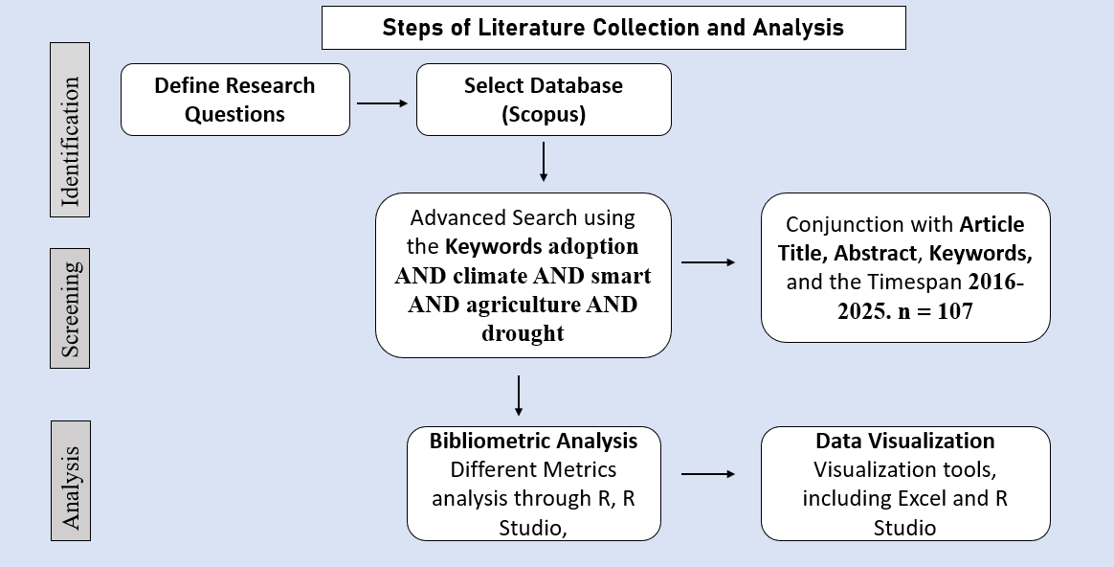
Figure 1. Steps of Literature Collection and Analysis

3.0 Findings of the Analysis

3.1 Description of the Data
Table 1 describes the summary of the bibliometric dataset of 107 documents on Climate-Smart Agriculture (CSA) adoption in drought-prone areas from 2016 to 2025. We used data from 76 sources, consisting of peer-reviewed journals, books, and conference proceedings. Interestingly, the growth rate of CSA innovations for drought adaptation is strong and increasing at an annual rate of 31.8% as shown. It is a young field with an average document age of 2.8 years, demonstrating that research activity belongs to recent knowledge and still well-updated literature. These documents have been cited an average of 23.14 times per publication, demonstrating their impact within the academic realm and growth in visibility on CSA issues to a broader scientific audience.

Table 1. Information summary on retrieved CSA studies (2016–2025)
Description | Results
Timespan | 2016:2025
Sources (Journals, Books, etc.) | 76
Documents | 107
Annual Growth Rate % | 31.8
Document Average Age | 2.8
Average citations per doc | 23.14
Keywords Plus (ID) | 473
Author's Keywords (DE) | 365
Authors | 428
Authors of single-authored docs | 5
Single-authored docs | 5
Co-Authors per Doc | 4.4
International co-authorships % | 48.6

Keyword analysis revealed that the study covered subjects of 473 Keywords Plus (ID) and 365 DES DE_AUTHOR, probably due to content across different thematic categories or the spectrum of multidisciplinarity. In all, 428 unique authors contributed to the 107 publications for a mean of 4.4 co-authors per document; an indication that research efforts are highly collaborative and often span numerous disciplines. Of the papers we analyzed, only five were single-authored documents, further underlining the ethos of collaboration that pervades research in CSA. Moreover, the proportion of international co-authorships is appreciable (48.6%), indicating nearly half of the studies entailed cross-country collaboration that is crucial in interlinked problems associated with climate change and drought adaptation. Consequently, the indicators also demonstrate that this is a research field in rapid global expansion with increasing collaboration and recognition.

3.2 Publication Progression
Figure 2 shows the prediction about how the number of published articles that explore factors affecting adoption of Climate-Smart Agriculture (CSA) innovations for drought, published from 2016 to 2025. The infographic demonstrates an upward trajectory of research trends for the last decade. In 2016, only one article was published, which shows the dawn of interest towards this topic. The number rose to three articles in 2017 and five in 2018. It saw a significant increase in 2019 with 11 publications.
Nevertheless, it decreased slightly to six articles in 2020. In 2021, the number of publications continued to decline, with 13 articles, and has now increased slightly again in 2022, with six published articles. A total of 16 articles were published in the year 2023, being the peak in our research output, within this upward trend in publication and a sense that a plateau occurred in 2024 (n = 34). Over time, the research was followed up and updated, with 12 publications being published by 2025, indicating a continued strong interest in the topic. This trend corresponds with a rising interest in the scholarly literature paying attention to CSA innovations as crucial approaches for drought adaptation, showing that this field is also gaining additional recognition by academic society.

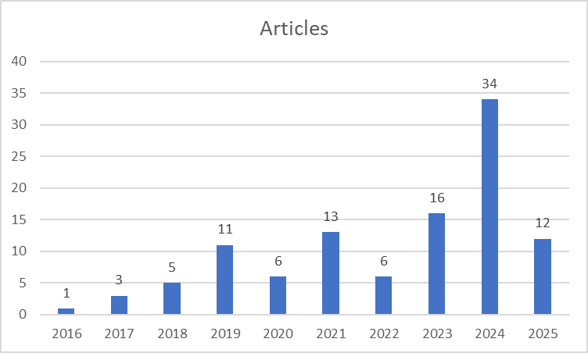
Figure 2. Annual Scientific Publications

3.3 Top Relevant Sources
This section presents a summary of the significant academic references that have published findings on variables affecting farmers' decisions to adopt CSA innovations for drought adaptation (Table 2). This table lists the ten most relevant journals and publications, along with the number of their articles. The top journal, Mitigation and Adaptation Strategies for Global Change, has published five papers, making it the most productive channel within this topic. The Climate Risk Management, Frontiers in Sustainable Food Systems and Land Use Policy, as well as the journal Sustainability (Switzerland), are following with four contributions. It is a leading journal in the area of water research and an important topic for climate adaptation strategies, sustainable agriculture, etc. The importance of Agricultural Systems and Climate Change Management in the intersection of agriculture with climate resilience is indicated next as committed to three articles from each. Finally, international works that give a broader perspective of the matter and experience such as the African Handbook of Climate Change Adaptation, which is this type of books that has provided two core studies in the debate are crucial for providing another set of numbers but still allow proper comparison with already disclosed investigations (Agriculture and Food Security; Climate Resilience and Sustainability) also presented similar articlescounts. These sources were distributed across disciplines as might be expected for an interdisciplinary research sector on CSA adoption. However, they underscored the importance of these types of sources in developing a knowledge base about innovative agricultural practices that can be used to adapt to drought.

Table 2. Top 10 relevant sources
Rank | Sources | Articles
1 | MITIGATION AND ADAPTATION STRATEGIES FOR GLOBAL CHANGE | 5
2 | CLIMATE RISK MANAGEMENT | 4
3 | FRONTIERS IN SUSTAINABLE FOOD SYSTEMS | 4
4 | LAND USE POLICY | 4
5 | SUSTAINABILITY (SWITZERLAND) | 4
6 | AGRICULTURAL SYSTEMS | 3
7 | CLIMATE CHANGE MANAGEMENT | 3
8 | AFRICAN HANDBOOK OF CLIMATE CHANGE ADAPTATION: WITH 610 FIGURES AND 361 TABLES | 2
9 | AGRICULTURE AND FOOD SECURITY | 2
10 | CLIMATE RESILIENCE AND SUSTAINABILITY | 2

3.4 Top Relevant Affiliations
Table 3 illustrates the Top institutions on research on the adoption of Climate-Smart Agriculture (CSA) innovations for drought adaptation. Taken together, these data underscore the significant contribution of academic and research institutions around the world in driving this field forward. The first rank is occupied by Kwame Nkrumah University of Science and Technology, contributing 14 papers, indicating a high participation level in CSA research. Two ICAR-associated institutes have fewer papers, but demonstrate significant inputs in dryland agriculture and climate resilience, with the Central Research Institute for Dryland Agriculture (CRIDA) featuring as 13th and 11th (two mentions); The International Centre for Tropical Agriculture (CIAT) also stands out, with 11 articles awarded to one listing and eight another, illustrating its international leadership in tropical agricultural research. This is followed by the University of KwaZulu-Natal with 10 publications, highlighting a great deal of regional activity in CSA studies. Next, Ariana with nine articles, Baba Ghulam Shah Badshah University & CSIR-Crops Research Institute each had 8 articles, and ICAR-National Bureau of Plant Genetic Resources, as well as ICRISAT, published 7 articles. The distribution of this output illustrates the joint and international participation in research efforts focused on empowering the dissemination of CSA innovations to reduce the risk from drought.

Table 3. Most Relevant Affiliations
Rank | Affiliation | Articles
1 | KWAME NKRUMAH UNIVERSITY OF SCIENCE AND TECHNOLOGY | 14
2 | INDIAN COUNCIL OF AGRICULTURAL RESEARCH (ICAR) - CENTRAL RESEARCH INSTITUTE FOR DRYLAND AGRICULTURE (CRIDA) | 13
3 | ICAR- CENTRAL RESEARCH INSTITUTE FOR DRYLAND AGRICULTURE (CRIDA) | 11
4 | INTERNATIONAL CENTER FOR TROPICAL AGRICULTURE (CIAT) | 11
5 | UNIVERSITY OF KWAZULU-NATAL | 10
6 | ARIANA | 9
7 | BABA GHULAM SHAH BADSHAH UNIVERSITY | 8
8 | CSIR-CROPS RESEARCH INSTITUTE | 8
9 | INTERNATIONAL CENTRE FOR TROPICAL AGRICULTURE (CIAT) | 8
10 | INTERNATIONAL CROPS RESEARCH INSTITUTE FOR THE SEMI-ARID TROPICS (ICRISAT) | 7
A further four articles are from Centurion University of Technology and Management (12, 3 %) and the University of California (12, 3 %), suggesting that both CSR research agenda pushers include emerging as well as global players. Same affiliation (ICAR-CRIDA) is mentioned twice under the two different names (13 articles and 11 articles), which may warrant standardisation of the affiliation name. In aggregate, all results display a fairly distributed but topically coherent network of institutions, and show a strong central influence among the South Asia and Sub-Saharan Africa regions prone to drought. They play a critical role in setting research priorities, undertaking field-based research, and driving policy discussions across CSA innovation adoption. This is a shining example of the regional academic leadership and international collaboration that is needed to support climate resilience through science-based agriculture innovation.

3.5 Corresponding Author’s Countries
Table 4 represents the number of published articles, and it elaborates on country-specific contributions about research on the adoption of Climate-Smart Agriculture (CSA) innovations as a strategy for drought adaptation with special reference to SCPs and MCPs. This is followed by India with 19 publications (13 SCPs, 6 MCPs), representing a 31.6% share of global partnerships. Ethiopia and Nigeria exhibit higher levels of collaboration with morbidity care paper (MCP) percentages of 62.5% and 66.7%, though at a smaller sample size (8 & 6). Kenya has the exact same pattern, 50% of its six articles are collaborative.

Table 4. Corresponding Author’s Country and Publications
Country | Articles | SCP | MCP | MCP %
INDIA | 19 | 13 | 6 | 31.6
ETHIOPIA | 8 | 3 | 5 | 62.5
GHANA | 8 | 5 | 3 | 37.5
KENYA | 6 | 3 | 3 | 50
NIGERIA | 6 | 2 | 4 | 66.7
SOUTH AFRICA | 6 | 5 | 1 | 16.7
UNITED KINGDOM | 4 | 1 | 3 | 75
USA | 4 | 3 | 1 | 25
AUSTRALIA | 3 | 1 | 2 | 66.7
CHINA | 3 | 0 | 3 | 100

There are eight papers from Ghana with a MCP proportion of 37.5%, whilst South Africa's six articles have a lower MCP percentage of 16.7%, showing greater representation of indigenous research (Table 3). The UK has the highest level of international cooperation (75%, or three out of four graded articles classified as MCPs) among non-African countries. To a much smaller extent, the United States and Australia cooperate at 25% and 66.7%, respectively. The country contributed collaboratively to them all, in particular as these were all MCPs indicating that China has played an important role in global research alliances. These data reveal the multidimensional and global nature of research initiatives aimed at improving CSA innovations for adaptation, including different levels of international collaboration between nations.

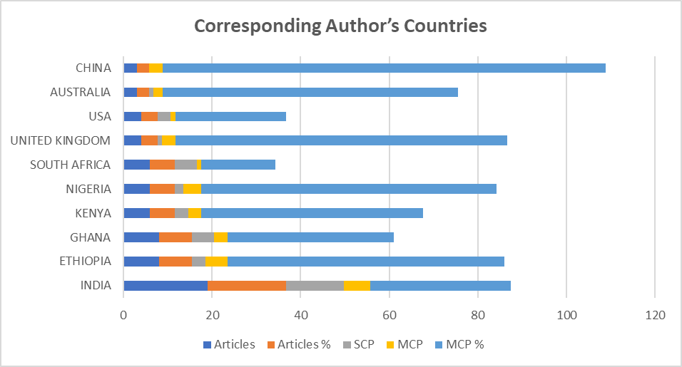
Figure 3. Corresponding Author’s Countries with their Publications

3.6 Most Globally Cited Countries in the Scopus Database
Total citations (TC) and average article citations are shown for the top contributing nations to Climate-Smart Agriculture (CSA) in drought adaptation; Figure 4. India occupies an unmovable position in the first place with 533 citations along its articles, reaching an average of 28.10 citations per article as proof of the weight and impact that this country's sponsored research accumulates over time (Table 12). Ethiopia, the smallest of the three countries in terms of sample size (48), still has a great impact with an average of 39.10 citations per article. Indeed, the Netherlands had 298 citations and the highest average article citation count (149.00), suggesting that a few highly cited works captured so much attention. On the other hand, Germany (61.30) and Australia (46.00) have a much larger academic impact than the U.S. Colombia is highlighted with 103 citations and an outstanding normalized citation rate of 103.00 per paper, implying the publication of 1 basic document (i.e., a book). The biggest citation strengths were between Zimbabwe (39.00) and China (23.00), averaging an average of 31.12. On the other hand, Ghana and South Africa have higher average citation rates of 17.00 and 14.00, respectively, despite also being active in publishing (Table 1).
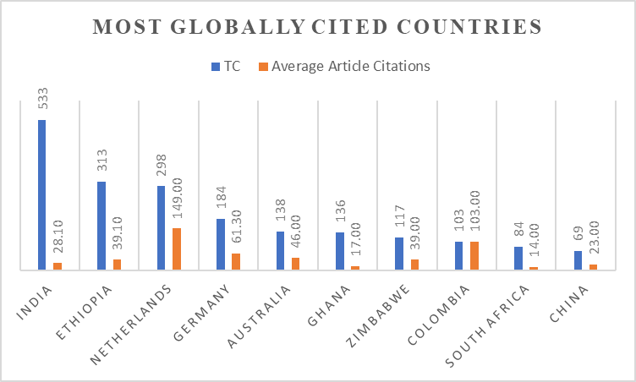
Figure 4. Most Globally Cited Countries

3.7 Words' Frequency over Time
A bifurcated view of phrase frequencies within the literature corpus is shown in Fig. 5, with marked-up endpoints illustrating conceptual primacy in the Climate-Smart Agriculture (CSA) adoption for drought adaptation analyses. Panel A The Term (category) primarily reflects core technical and agronomic themes, comprised of "AGRICULTURAL TECHNOLOGY" (a state-of-the-art focus), "TECHNOLOGY ADOPTION" (interventions addressing adoption constraints and opportunities), "AGRICULTURE" (widespread contextual allusions), and "ZEA MAYS" (maize-focused case studies amore commonly assumed elucidation set, being a model crop for drought resilience). The Year category (Panel B) uncovers new driving forces and impacts, with "DROUGHT" showing the highest total count (stress on water scarcity in the analysis), followed by "CLIMATE CHANGE" (placing drought within wider climatic transitions) "FOOD SECURITY" (linking adjustments to nutritional outcomes), ALTERNATIVE AGRICULTURE, CONSTANTLY evolving sustainable methods) and, MAIZE, SOLIDIFYING crop-specific focus). A stark increase is observed in the use of the terms "DROUGHT" and "TECHNOLOGY ADOPTION," which demonstrates, from an academic perspective, a trending interest towards Climate-Smart Agriculture (CSA) solutions that could be impactful in water-stressed zones. At the same time, however, comparative frequencies are suggestive of important thematic relationships—most notably between drought intensity and technology adoption or food co-benefits.

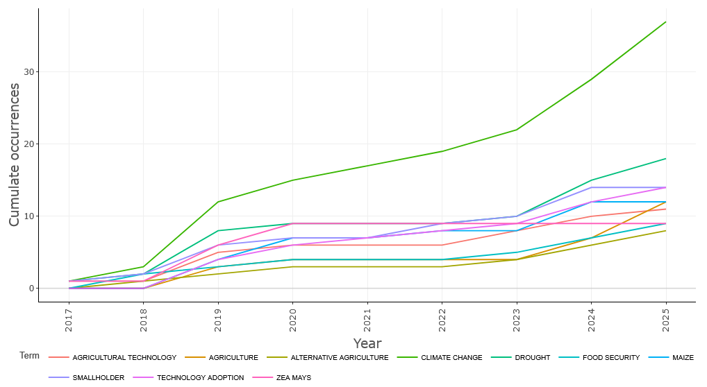
Figure 5. Words’ Frequency over Time

3.8 Word Cloud
All the most common phrases in academic literature related to the subject of climate-smart agriculture (CSA) technologies and their adoption in drought-prone areas are shown in a word cloud visualisation as Part 6 above. The most basic of all, but no doubt the most important, is "climate change," because if CSAs want to be taken seriously by those working in this field, they must at least recognise that the natural world behaves differently in a warming climate. This is followed by keywords like drought, technology adoption, smallholder, agricultural technology, agriculture, and food security, which are important areas of interest in the subject area.
A smallholder focus is emphasised in research on CSA adoption, especially in climate-stress vulnerable areas. Technology adoption Agricultural technology- The presence of these terms in a significant portion of the studies highlights that various aspects of the uptake process and facilitators to CSA practices are a key focus. Maize, "zeamays," "farming system," and "crop yield" were the few key words used regarding drought adaptation based on the specific agricultural settings and results of the study.
Citations to geographical entities such as "India," "Zimbabwe," "Ghana," "Pakistan," and "Malawi" illustrate regional emphasis in recent work, with Sub-Saharan Africa and South Asia having some of the most considerable drought impacts. Other main categories are "agricultural extension" and "livestock". At the same time, the relative importance of pastures for goats and cattle predominates. Other common targets are described as highly relevant given they were possible solutions that could be accessed to promote resilience," adaptive management," " alternative agriculture". A word cloud shown in Fig. 6 summarizes the main themes, drivers, technologies, and geographies emerging from the literature on CSA innovation uptake, providing a brief but comprehensive landscape context to this systematic review study.

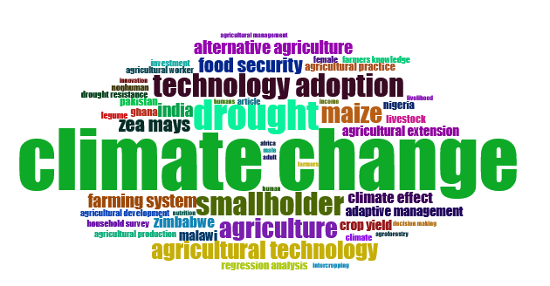
Figure 6. Word Cloud of this Research

4.0 Discussion

A review of multifaceted literature about trends in the state of Community-Smart Agriculture (CSA) technologies for dry areas. The bibliometric study has identified many important patterns and thematic goals that have emerged within the academic discourse over the last decade. The growth of CSA research has been increasingly steep, with an annual increase rate of 31.8%, indicating a growing awareness of the necessity of agricultural adaptation to climate stressors. The recent average age of the papers (2.8 years) indicates the rapid response to environmental problems and continuing evolution of this field. A high citation average of 23.14 citations per document confirms the importance and impact of this research topic on the broader scientific community.
A high tendency to undertake research in collaboration is observed, with an average of 4.4 co-authors per paper, and 48.6% of papers showing international co-authorships (Table 1 ). This emphasizes the global nature and transdisciplinarity of research on CSA adoption, which necessitates cross-boundary and cross-disciplinary information exchange. The rare number of single-authored papers points to a move away from individualistic research toward collaborative academic work in confronting the wicked problems associated with climate change. The publishing pattern (Figure 2) can help to illustrate the academic interest in this research, and we see a marked increase over time with an apex in 2024. The marginal declines in 2020 and 2022 could be attributed to exogenous shock events, such as the COVID-19 pandemic. The rise in the trend reflects an increasing commitment to CSA technologies as an adaptive strategy, especially in water-scarce regions [61]. Source analysis (Table 2), the research on CSA uptake remains within a variety of the highest-ranking sustainability, policy, and climate adaptation journals. Well-known journals such as Mitigation and Adaptation Strategies for Global Change and Climate Risk Management have become multidisciplinary publishing areas for promoting discussions on Clim-Smart Agriculture (CSA). This distribution reflects that CSA research is interdisciplinary, involving agricultural science, environmental studies, development policy, and socioeconomics.
Most notable are the institutional contributions (Table 3), with ICAR-CRIDA (India) and KNUST (Ghana) research institutions from South Asia and Sub-Saharan Africa, respectively, having a strong and prominent presence in that regard. These were locations of extreme drought vulnerability that somewhat explain their academic role and leadership. The repetition of the name of institutions (e.g., ICAR-CRIDA at two different places) points towards the need for harmonisation of metadata in bibliometric datasets, which is a typical point when we map affiliations. The associated author results (Table 4 and Figure 3) support the concentration of CSA research within the Global South, with a particular emphasis on India, Ethiopia, Nigeria, and Kenya. High MCP (Multiple Country Publication) proportions, especially in Ethiopia (62.5%) and China (100%), were an indicator for global collaboration, which is vital for the generation of context-adapted and widely implemented CSA approaches. In contrast, countries such as South Africa have fewer MCPs, indicative of a more nationally driven research agenda that may reflect a strong national capacity.
The citation data (Figure 4) provided a better picture of the variability in research impact across countries. Although there are fewer publications, their average citation per article is exceptionally high in countries such as the Netherlands and Colombia, which may indicate that they have made a profound contribution or an impactful technique may be driving the CSA adoption frameworks. The strengths of India in terms of the quantum of publication and citation frequency highlight the pivotal place that it enjoys in a global dialogue on CSA.
A historical and conceptual examination of keyword frequencies (Figure 5) illustrates the increased relevance of "drought" and "technology adoption" in current literature, reflecting a growing recognition of climate change impacts on water availability and agricultural productivity. The use of crop-specific terminology, e.g., "maize" and "Zea mays," reveals a focus on these crops as primary subjects in examining CSA effectiveness.
The word cloud (Fig. 6) indicates the major themes covered so far in our selected papers: climate change, drought, smallholders, food security, and agricultural technology. Language regarding adaptive management, extension services, and regional case studies (India, Zimbabwe, Ghana) all serve to highlight the CSA study's situational and pragmatic emphasis.
Results indicated that research on CSA adoption in:
a) Rapidly expanding and increasingly collaborative;
The reasons for GM technology are a) inspired by the organizations, and b) have an impact on drought-prone nations.
c) targeted at smallholder farmers, technology innovations, and food security outcomes;
d) Participation in Global Dialogue based on some 'highly regarded' and influential foundational texts.
They concluded that ongoing support was needed for international collaborations, for data to be made more standard in research output, and through policies aimed at joining scientific knowledge and its local use. Future studies should investigate socio-economic, institutional, and behavioural factors of CSA adoption with elasticity parameters, especially in locations under intense climate change pressure (Kifle et al., 2022; Manono et al., 2025).
Of course, we also note the limitations of this bibliometric approach. In the first place, the analysis is restricted to Scopus database, which -albeit fairly comprehensive– might have missed relevant studies published in regional journals or other languages than English. Secondly, the bibliometric indicators (e.g., citation counts, keyword co-occurrence) prioritise quantity over depth and are likely to miss the complex socio-cultural influences on CSA adoption. Due to differences in author affiliations and keyword tagging, third-party data can also be duplicated or misrepresented. Finally, network visualisations show trends, but they do not demonstrate causal relationships because(post oc propter hoc). While significant, these limitations also underline the necessity of elaborating on bibliometric findings with qualitative insights and case studies in the field.

5.0 Conclusions

Climate-Smart Agriculture (CSA) was proposed to increase resilience of farming systems to climatic instability. Nevertheless, the study background section in this paper emphasizes an empirical and scientific gap for how CSA is adopted and integrated, as a socio-technological package with a focus on drought. The new decade of analysis predicted by 2025 within the literature is becoming rapidly equalized, but still provides an unequal playing field. A bibliometric analysis of 107 articles shows substantial growth (31.8% per year) and international cooperation (48.6% multi-country publications), underlining the urgency of climate resilience in agriculture. The field is represented through significant leadership of institutions and countries in drought-prone continents (e.g., Kwame Nkrumah University of Science and Technology, Ghana; ICAR-CRIDA, India; CIAT, Colombia), providing a lively context for regional solutions. Table 1: Thematic analysis summarizing some of the important stakeholders, scientific advances (e.g., Zea mays cultivars), socioeconomic facilitators (e.g., extension services, access to credit), and co-benefits with a statement on how they relate to food security. These results are also followed by some common linkages and terms such as "India", "Zimbabwe", "Malawi", which correspond to the excellent water scarcity of these countries, in South Asia and Sub-Saharan Africa, respectively, revealing important gaps in Latin America and arid regions.
Notwithstanding advancements, significant constraints remain. One reason for this might be that the most common method in the assessment of adoption is household surveys, which have, to date, dominated over hybrid techniques (e.g., mixed-methods) to understand better detailed adoption constraints (e.g., gender aspects/cultural attitudes). This leads to thematic imbalances, where we see over-representation of themes such as 'agricultural technology' and 'drought resistance', yet underrepresentationof the policy environment, market linkages, and gender balance — aspects which are crucial for scaling up solutions (Fig. 5). The gap between research impact and local relevance is evident: high-impact publications from The Netherlands (mean 149 citations per article) or Colombia (103) stress theoretical models, while practitioner-oriented studies from drought laden Ethiopia and Nigeria receive disproportionately less attention despite their regional importance. Finally, it is difficult to synthesize the bibliometric information due to four reasons, such as differences in affiliations (for instance, multiple entries for ICAR-CRIDA), fragmented data leading to implementation of quality control, and potential lack of uniformity in reporting of references being made.
In nearly a decade of research on CSA interventions in drought-prone areas, this study provides a novel contribution by systematically mapping the existing literature using bibliometric methods. It synthesises fragmented evidence, showcases local agency and exposes systemic deficiencies, as well as identifies practical steps towards aligning innovation ecosystems with locally relevant resilience priorities. These insights are vital for informing policy interventions and further academic inquiry in climate-resilient agriculture.
Overall, this review underscores that to policy actors, the operationalization of CSA must build on integrated innovation ecosystems, and such systems should be locally based but globally coordinated. Key actions advancing such a scenario include opportunities for a focus on directing investments towards practices validated in context, such as water harvesting and agroforestry in community-managed landscapes; promoting knowledge exchange through South learning networks (e.g. through India-Africa collaborations for drought-resistant seeds); and embedding 'resilience impact assessments' within national agricultural policies as an entry point to applying CSA more widely. To move beyond the ideology of effective adaptation to drought, we will need to reorient our understanding of innovation from a focus on technology to more holistic resilience frameworks that combine research and policy work with social mobilization.

COMPETING INTERESTS DISCLAIMER:
Authors have declared that they have no known competing financial interests OR non-financial interests, OR personal relationships that could have appeared to influence the work reported in this paper.

6.0 References

- Bal, S. K., Sandeep, V. M., Kumar, P. V., Rao, A. V. M. S., Pramod, V. P., Manikandan, N., Rao, Ch. S., Singh, N. P., & Bhaskar, S. (2022). Assessing impact of dry spells on the principal rainfed crops in major dryland regions of India. Agricultural and Forest Meteorology, 313, 108768. https://doi.org/10.1016/j.agrformet.2021.108768
- Bhanuwanti, Dar, K. A., Singh, L., Saad, A. A., Rai, U., Tanwar, H., & Khatoon, A. (2024). Climate Smart Agriculture: Innovating Sustainable Practices for a Changing Climate. Journal of Scientific Research and Reports, 30(11), 568–576.
- Blicharska, M., Haddad, F., Riccardi, T., & Smithers, R. J. (2024). Global presumed drylands: Drivers, pressures, state, impacts, responses. Journal of Environmental Planning and Management, 1–28. https://doi.org/10.1080/09640568.2024.2351424
- Fazekas, A., Bataille, C., & Vogt-Schilb, A. (2022). Achieving net-zero prosperity: How governments can unlock 15 essential transformations. https://shs.hal.science/halshs-03742125
- Grainger, S., Murphy, C., & Vicente-Serrano, S. M. (2021). Barriers and Opportunities for Actionable Knowledge Production in Drought Risk Management: Embracing the Frontiers of Co-production. Frontiers in Environmental Science, 9, 602128. https://doi.org/10.3389/fenvs.2021.602128
- Kabato, W., Getnet, G. T., Sinore, T., Nemeth, A., & Molnár, Z. (2025). Towards Climate-Smart Agriculture: Strategies for Sustainable Agricultural Production, Food Security, and Greenhouse Gas Reduction. Agronomy, 15(3), 565. https://doi.org/10.3390/agronomy15030565
- Kifle, T., Ayal, D. Y., & Mulugeta, M. (2022). Factors influencing farmers adoption of climate smart agriculture to respond climate variability in Siyadebrina Wayu District, Central highland of Ethiopia. Climate Services, 26, 100290. https://doi.org/10.1016/j.cliser.2022.100290
- Klarin, A. (2024). How to conduct a bibliometric content analysis: Guidelines and contributions of content co‐occurrence or co‐word literature reviews. International Journal of Consumer Studies, 48(2). https://doi.org/10.1111/ijcs.13031
- Mahedi, M., Pervez, A. K. M. K., Rahman, S. M. M., Sheikh, Md. M., & Shaili, S. J. (2025). Emerging Trends in Livelihood Diversification in Rural Communities: A Bibliometric and Systematic Review. Asian Journal of Agricultural Extension, Economics & Sociology, 43(4), 162–177. https://doi.org/10.9734/ajaees/2025/v43i42727
- Manono, B. O., Khan, S., & Kithaka, K. M. (2025). A Review of the Socio-Economic, Institutional, and Biophysical Factors Influencing Smallholder Farmers’ Adoption of Climate Smart Agricultural Practices in Sub-Saharan Africa. Earth, 6(2), 48. https://doi.org/10.3390/earth6020048
- Md Shahriar Kabir, Md Mahedi, A K M Kanak Pervez, Md Jahangir Alam, & Shabrin Jahan Shaili. (2025). Bibliometric analysis of “precision agriculture” in the Scopus database. World Journal of Advanced Research and Reviews, 25(3), 1087–1098. https://doi.org/10.30574/wjarr.2025.25.3.0733
- Mpala, T. A., & Simatele, M. D. (2024). Climate-smart agricultural practices among rural farmers in Masvingo district of Zimbabwe: Perspectives on the mitigation strategies to drought and water scarcity for improved crop production. Frontiers in Sustainable Food Systems, 7, 1298908. https://doi.org/10.3389/fsufs.2023.1298908
- Natarajan, N., Newsham, A., Rigg, J., & Suhardiman, D. (2022). A sustainable livelihoods framework for the 21st century. World Development, 155, 105898. https://doi.org/10.1016/j.worlddev.2022.105898
- Parolini, G. (2022). Weather, climate, and agriculture: Historical contributions and perspectives from agricultural meteorology. WIREs Climate Change, 13(3). https://doi.org/10.1002/wcc.766
- Santini, M., Noce, S., Antonelli, M., & Caporaso, L. (2022). Complex drought patterns robustly explain global yield loss for major crops. Scientific Reports, 12(1). https://doi.org/10.1038/s41598-022-09611-0
- Srivastav, A. L., Dhyani, R., Ranjan, M., Madhav, S., & Sillanpää, M. (2021). Climate-resilient strategies for sustainable management of water resources and agriculture. Environmental Science and Pollution Research, 28(31), 41576–41595. https://doi.org/10.1007/s11356-021-14332-4
- Suprayitno, D., Iskandar, S., Dahurandi, K., Hendarto, T., & Rumambi, F. J. (2024). Public policy in the era of climate change: adapting strategies for sustainable futures. Migration Letters, 21(S6), 945-958.
- Teklu, A., Simane, B., & Bezabih, M. (2022). Effectiveness of climate-smart agriculture innovations in smallholder agriculture system in Ethiopia. Sustainability, 14(23), 16143.
- Totin, E., Segnon, A. C., Schut, M., Affognon, H., Zougmoré, R. B., Rosenstock, T., & Thornton, P. K. (2018). Institutional Perspectives of Climate-Smart Agriculture: A Systematic Literature Review. Sustainability, 10(6), 1990. https://doi.org/10.3390/su10061990
- Uddin, M. S., Pervez, A. K., Kabir, M. S., & Mahedi, M. (2022). The Trend of Agribusiness Research Worldwide: A Bibliometric Analysis Based on the Scopus Database.
- Vasavi, S., Anandaraja, N., Murugan, P. P., Latha, M. R., & Pangayar Selvi, R. (2025). Challenges and strategies of resource poor farmers in adoption of innovative farming technologies: A comprehensive review. Agricultural Systems, 227, 104355. https://doi.org/10.1016/j.agsy.2025.104355
- Wijerathna-Yapa, A., & Pathirana, R. (2022). Sustainable Agro-Food Systems for Addressing Climate Change and Food Security. Agriculture, 12(10), 1554. https://doi.org/10.3390/agriculture12101554
- Wilkinson, A. (2023). Social-Ecological Systems Analysis and Perceptions of Change in Agriculture, Food and Farm Systems in Southern Alberta and Yukon Territory. Graduate Studies. https://doi.org/10.11575/PRISM/41949

