Assessment the drinking water quality of different upazila of Shariatpur district, Bangladesh

ABSTRACT
Aims: Numerous human and environmental factors, such as soil composition, agricultural runoff, heavy metals, arsenic, bacteria, and too-dissolved particles, have affected the drinking water quality in the Shariatpur District in central Bangladesh. In order to address this problem, the main objective of this work is to evaluate the drinking water quality in Shariatpur District utilizing significant attributes.
Study design: Experimental work.
Place and duration of study: This study was conducted in Z.H.Sikder University of Science and Technology, Department of Civil Engineering, Shariatpur, Dhaka, Bangladesh, between September 2024 to June 2025.
Methodology: A total of 49 water samples were collected from tube wells in seven administrative areas and analyzed for key chemical parameters, including pH, total dissolved solids (TDS), total suspended solids (TSS), total solids (TS), electrical conductivity (EC), salinity and alkalinity. pH, TDS, and EC of water samples were measured by a digital Adwa AD-100 pH tester and a digital Adwa AD-32 TDS meter respectively. TSS was determined by filtration method. While carbonate and bicarbonate were determined by titration method. Salinity was determined from the value of TDS.

Results: The results revealed moderate spatial variability. Most samples exhibited pH levels within the neutral to slightly alkaline range, suggesting stable water chemistry. However, several locations, especially in char regions such as Kalmir Char, Goriber char and Muktarer Char, displayed elevated TDS and TSS values, exceeding the Bangladesh national standards. Salinity and EC, was the significant issues in many parts of the district, especially in char areas, Bhedarganj Upazila and Damudya Upazila where values exceeded 3500ppm and 3,000 µS/cm respectively. In case of alkalinity, majority of sites falling within the high category to moderate levels but damudya upazila predominantly shows high alkalinity, with a peak measurement of 232 mg/L recorded in Damudiya Paurashava.
Conclusion: This research contributes new regional water quality data to the field of environmental engineering and supports evidence-based approaches for the development of policies aimed at improving public health and environmental sustainability.

Keywords: Drinking Water, Alkalinity, Total Dissolved Solid, TSS, Electrical conductivity, environmental sustainability.

- INTRODUCTION
A basic human right, safe drinking water is also essential for maintaining public health, economic stability, and social well-being [1]. Beyond satisfying thirst, clean water is necessary for hygiene, cooking, and disease prevention. The availability of safe drinking water directly relates to the reduction of waterborne diseases and the overall improvement of community health. Drinking water from an improved water source that is located on premises, available when needed, and free from faecal and priority chemical contamination [2]. Despite global advancements in sanitation systems and water purification technologies, millions of people especially in underdeveloped nations, continue to struggle for access to safe and clean drinking water. The global water and sanitation crisis remains a pressing concern, with 2 billion people lacking safely managed drinking water and 3.6 billion people lacking safely managed sanitation [3]. The United Nations (UN) World Water Development Report warns of an imminent global water crisis, exacerbated by climate change, population growth, and unsustainable water use [4]. Bangladesh, a country largely dependent on surface water and groundwater sources, faces significant challenges regarding water quality. The groundwater aquifer is contaminated by mixing higher amounts of arsenic and iron, bicarbonate content, saline water (to the coastal districts), and Total Dissolved Solids (TDS) [5]. Direct disposal of industrial organic pollutants [6] and sewage into rivers by municipalities causes water pollution, which deteriorates water quality. For example, methyl orange, which is widely used in various industries, can cause several health issues including jaundice, tissue necrosis, vomiting, etc. [7].
While the nation has made remarkable progress in improving water access, problems associated with both natural and human-induced contamination remain unresolved [8]. Many regions, including rural districts like Shariatpur, continue to suffer from chemical contamination, high dissolved solids, and general water pollution. Under these conditions, continuous monitoring and evaluation of drinking water quality have become essential to ensure compliance with national and international safety standards. In Shariatpur District, the main sources of drinking water are groundwater and surface water. The local population faces health risks from pollutants such as heavy metals, arsenic, microbial pathogens, and excessive levels of dissolved solids.
This study focuses on assessing the drinking water quality in Shariatpur District using key physicochemical parameters to address these issues. The parameters examined include pH, electrical conductivity (EC), total dissolved solids (TDS), total suspended solids (TSS), total solids (TS), Salinity and alkalinity. Each parameter plays a vital role in identifying potential sources of contamination and evaluating the suitability of water for human consumption [9]. The goal is to support environmentalists, public health officials, and policymakers in addressing water safety concerns. A comparative analysis of the collected data with both national and international water quality standards is a critical component of this work.

- MATERIALS AND METHODS

  - Chemicals
All chemicals and reagents used to carry out the research work were of reagent grade.
  - The Study Area and water sampling
Shariatpur District is bounded on the north by Munshiganj District, Barisal District on the south, Chandpur District on the east, Madaripur District on the west. Main rivers are Padma, Meghna, Palong, Jayanti, Kirtinasha, and Dharmaganj. Area of Shariatpur district is 1,181.00 km² [10]. The study was conducted in seven
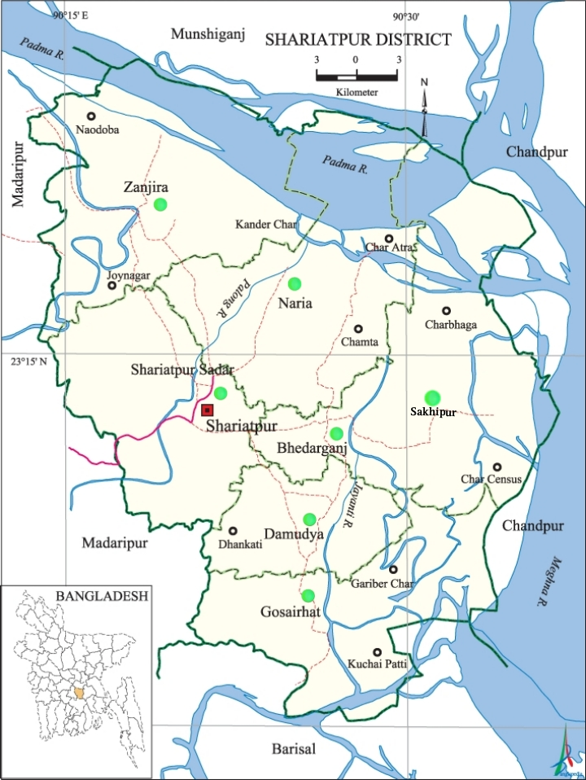

Fig. 1. Map of Shariatpur District showing the study areas.

locations (e.g. Naria Upazila, Shariatpur Sadar Upazila, Bhedarganj Upazila, Damudya Upazila, Gosairhat Upazila, Gosairhat Upazila, Zanjira Upazila and Sakhipur Police Station) of Shariatpur Districts (fig. 1). A total of 49 water samples were collected from tube wells in seven administrative areas and analyzed for key chemical parameters, including pH, total dissolved solids (TDS), total suspended solids (TSS), total solids (TS), electrical conductivity (EC), and alkalinity.

2.3 Analytical methods
pH, TDS, and EC of water samples were measured by a digital Adwa AD-100 pH tester and a digital Adwa AD-32 TDS meter respectively. TSS was determined by filtration method. While carbonate and bicarbonate were determined by titration method [11]. Salinity was determined from the value of TDS, as described by the [12]. These parameters of water samples indicate pollution or contamination that will affect drinking water use [13].
2.4. Calculation Method
2.4.1. Determination of pH
The pH level of the collected water samples was measured using a calibrated digital Adwa AD-100 pH tester (Romania) in the laboratory. Before measurement, the instrument was calibrated using standard buffer solutions of pH 4.0, 7.0, and 10.0 to ensure accuracy. Each sample was poured into a clean beaker, and the electrode was immersed in the water. The readings were allowed to stabilize before being recorded. After each measurement, the electrode was rinsed with distilled water to avoid cross-contamination. The procedure was repeated for all samples, and the pH values were noted for analysis.

2.4.2. Determination of Total Dissolved Solids (TDS)
The total dissolved solids of the collected water samples were measured using a digital Adwa AD-32 TDS meter (Romania) in the laboratory. Each water sample was transferred into a clean beaker, and the probe of the calibrated TDS meter was immersed in the sample. The readings were allowed to stabilize before being recorded. After each measurement, the probe was rinsed with distilled water to prevent contamination between samples. The procedure was repeated for all collected samples, and the TDS values were documented for further analysis.
2.4.3. Determination of Total Suspended Solids (TSS)
First, 50 ml of sample water was poured into a beaker from which 10 ml was taken in a measuring cylinder. Took a filter paper and weighted, and then used it to filter 10 ml sample water. The wetted filter paper was then dried entirely in the woven at 103 °C for 24 h. Finally, the weight of the dried filter paper was taken. The differences between these two weights represent the value of TSS of the water [14]. Following formula was used to calculate TSS:
TSS (mg/l) = $\left(A-B\right)×1000÷Volume of the sample water$
Where,
- A = Final weight of filter paper
- B=Initial weight of filter paper

2.4.4. Determination of Total Solids
= Suspended Solids + Dissolved Solids
2.4.5. Determination of Electrical Conductivity
The electrical conductivity (EC) of the water samples was measured using the Adwa AD31 meter (Romania) in the laboratory. After calibrate the meter, the electrode was rinsed with distilled water to remove any remaining calibration solution. For the measurement of the sample, a clean beaker was filled with the water sample, and the electrode was completely immersed. The sample was gently stirred to eliminate any air bubbles that could affect the accuracy of the readings. The EC reading was allowed to stabilize for 15–30 seconds, after which the value was recorded in either µS/cm or mS/cm, as displayed on the meter. The temperature reading was also recorded when required for the measurement.
2.4.6. Determination of Alkalinity
For the measurement of bicarbonate, 50 ml of water (10 ml sample water and 40 ml distilled water) was taken in a 250 ml conical flask where 2–3 drops of phenolphthalein were then added. The appearance of pink color indicated the presence of carbonate. The content so prepared was titrated against 0.02 N H₂SO₄ until the color disappeared because of alkali carbonate being converted to bicarbonate. Then, 2–3 drops of methyl red indicator solution were added to the colorless solution to give yellow color, which was again titrated against 0.02 N H₂SO₄ until rosy red color developed. Carbonate (CO₃²⁻) and bicarbonate (HCO₃⁻) were calculated using following equations.
CO₃²⁻ (mg/L) = $Volume of H2SO4 \left(2x\right)×N×30×1000÷$
$$Volume of water sample taken$$

HCO₃⁻ (mg/L) = $Volume of H2SO4×N×61×1000÷$
$$Volume of water sample taken$$
Where,
- N is the normality of H₂SO_{4,}
- X is the volume of H₂SO₄ required for phenolphthalein at end point,
- Therefore, total alkalinity = CO₃²⁻(mg/l) + HCO₃⁻(mg/l).

2.4.7. Salinity
Salinity was measured from the value of TDS by using following the formula:
Salinity ≈ $TDS \left(\frac{mg}{L}\right)÷0.55$
The conversion factor 0.55 was used for determining the salinity of the water. This value ranges from 0.5 to 0.7 depending on the water source. For drinking water, 0.55 was used for determining salinity.

- RESULTS AND DISCUSSION
A comprehensive overview of the current state of drinking water quality in the area is intended to be provided, along with the identification of areas of concern in relation to national and international water quality standards. Concerns for public health may be raised due to observed variations in several parameters, including pH, alkalinity, total dissolved solids (TDS), total suspended solids (TSS), total solids (TS), and electrical conductivity (EC). These findings are elaborated in the following sections and are compared with the standards set by the World Health Organization (WHO) [15] and the Department of Public Health Engineering (DPHE) of Bangladesh. By analyzing these results from a broader perspective, a better understanding of the region’s water safety challenges can be achieved, thereby supporting informed decision-making for effective water resource management.
3.1. Physical and Chemical assessment
3.1.1. pH
The pH of drinking water is a critical factor for both human health and environmental sustainability. It indicates the acidity or alkalinity of the water and influences its chemical, physical, and microbiological characteristics, as well as its potential impact on human health and aquatic life. Among the selected areas, the maximum samples of Bhedarganj, Damudya, Gosairhat, and Shariatpur Sadar shows high pH value (7.2 to 8.3) indicating a relatively more alkaline condition compared to other areas. In contrast, the samples from Naria Upazila, Zanjira Upazila and Sakhipur Police Station shows lower pH value (7.1-7.7) falls within the slightly alkaline range (Figure 2). The standard level of pH for drinking water is 6.5–8.5 [16]. Similar results were found in Pakistan where the pH level of bottled water ranges from 7.35 to 7.95 [17].The overall pH values across all sampling sites suggesting that the water quality throughout the study area is predominantly neutral to mildly alkaline.
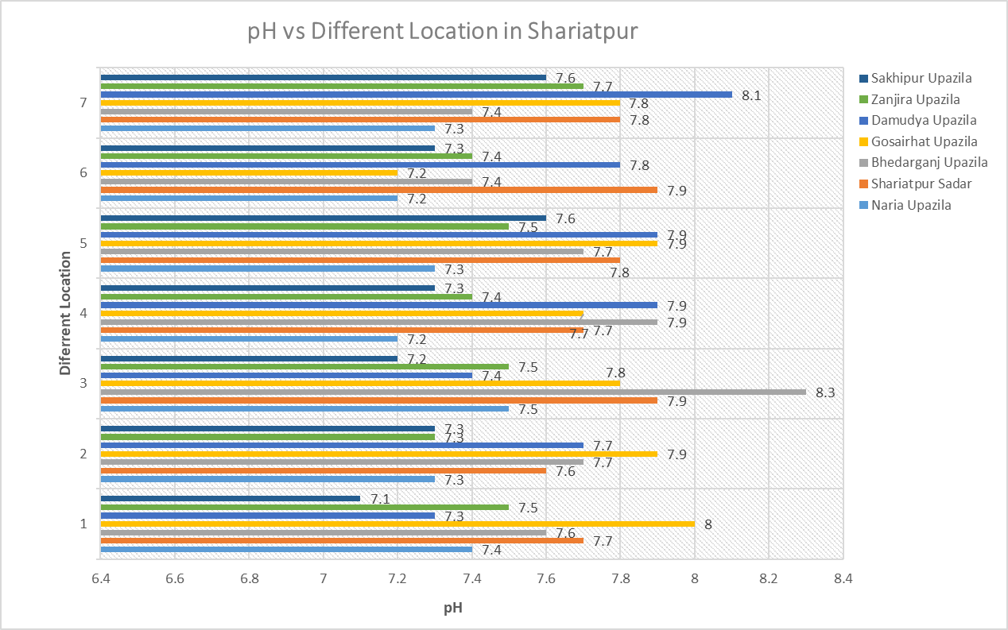
Fig. 2. pH values of the experimental samples

3.1.2 Total dissolve solid (TDS)
The Total Dissolved Solids (TDS) level in drinking water refers to the total amount of minerals, salts, and other substances dissolved in it. While TDS itself isn't a single contaminant, it can be an indicator of water quality, with high levels potentially signaling the presence of harmful substances and affecting taste. This study assesses the levels of Total Dissolved Solids (TDS) in drinking water across various upazilas in Shariatpur District (Figure 3). According to ECR 1997, the standard level of TDS is 1000 mg/l [16].

In Naria Upazila, most samples fall within the fair category, with TDS values ranging from 706 to 880 ppm, remaining below the national limit but Kalmir Char (1,525 ppm) and Muktarer Char (1,614 ppm) exceed the acceptable threshold, rendering the water unacceptable for drinking.
The water samples from Shariatpur sadar Upazila exhibits TDS levels between 376 and 719 ppm indicating good water quality. In Bhedarganj Upazila, water quality is largely compromised. Bhedarganj Paurashabha (1,277 ppm), Arshi Nagar (1,965 ppm), and Mahisar (1,966 ppm) significantly exceed the 1,000-ppm limit, classifying them as unacceptable. Other two Rambhadrapur (1,106 ppm) and Digar Mahiskhali (945 ppm) approaches the upper threshold of acceptability. Only Narayanpur (386 ppm) meets the good water quality standard.
In Gosairhat Upazila, the overall water quality is favorable except Gariber Char (1,439 ppm) exceeds the national limit and is deemed unacceptable. Maximum water samples from Damudya Upazila shows good to fair category. But samples from Dhankati (1,127 ppm) are classified as poor, while Islampur (1,362 ppm) and Damudya Paurashabha (2,000 ppm) are considered unacceptable. All sampled sites in Zanjira Upazila exhibit good water quality, with TDS values ranging from 324 ppm (Joynagar) to 577 ppm (Dhalikandi) well below the national standard. Water quality of Sakhipur Upazila, shows good to fair category. Only one sample from, Anando Bazar (1,253 ppm) exceeds the threshold limit and is deemed unacceptable. Reasons for Increased TDS in drinking water in these regions may be agricultural runoff; fertilizers, pesticides, and animal waste from farms wash into water sources, adding nitrates, phosphates, and organic matter that raise TDS.
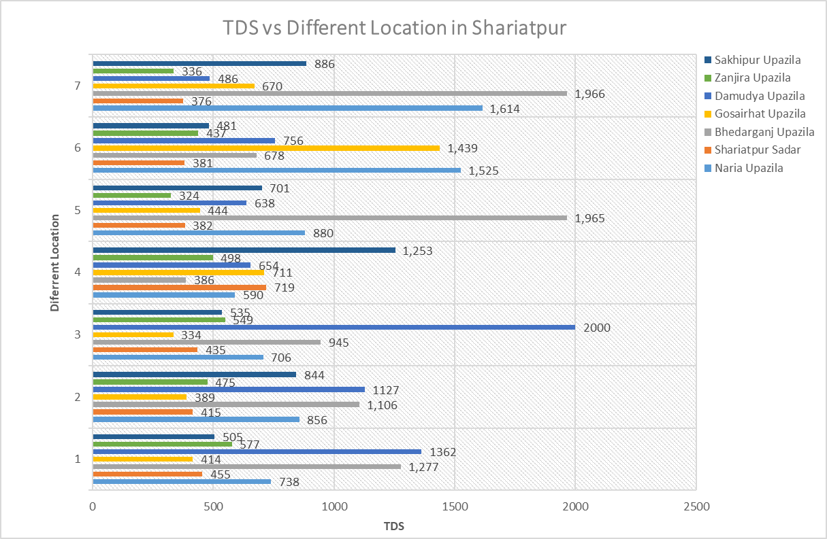
Fig. 3. TDS values of the experimental samples

3.1.3 Total Suspend Solids (TSS)
Total Suspended Solids (TSS) in drinking water refers to the amount of solid particles, both organic and inorganic; those are suspended in the water and can be trapped by a filter. High TSS levels can make water appear cloudy or turbid and may negatively impact aquatic life and human health.
The Total Suspended Solids (TSS) data collected from various upazilas in Shariatpur District (figure 4) reveals that the majority of water sources exhibit TSS levels well within the recommended limit of 10mg/L for drinking water, as advised by Nur-E-Alam et al., 2016, [16]. This indicates generally good water quality across the region, with only a few exceptions such as Kalmir Char (6.20 ppm) and Gariber Char (5.80 ppm) exceed this standard, while Sener Char (5.00 ppm) reaches the maximum acceptable threshold. Increased TSS in Drinking Water in shariatpur may be because of the following two reasons: Wastewater Discharge; means untreated or poorly treated municipal or industrial wastewater may contain solids like food particles, sludge, or chemical precipitates and runoff from farms may contain animal waste, feed particles, or disturbed soil, all contributing to TSS in nearby water bodies.
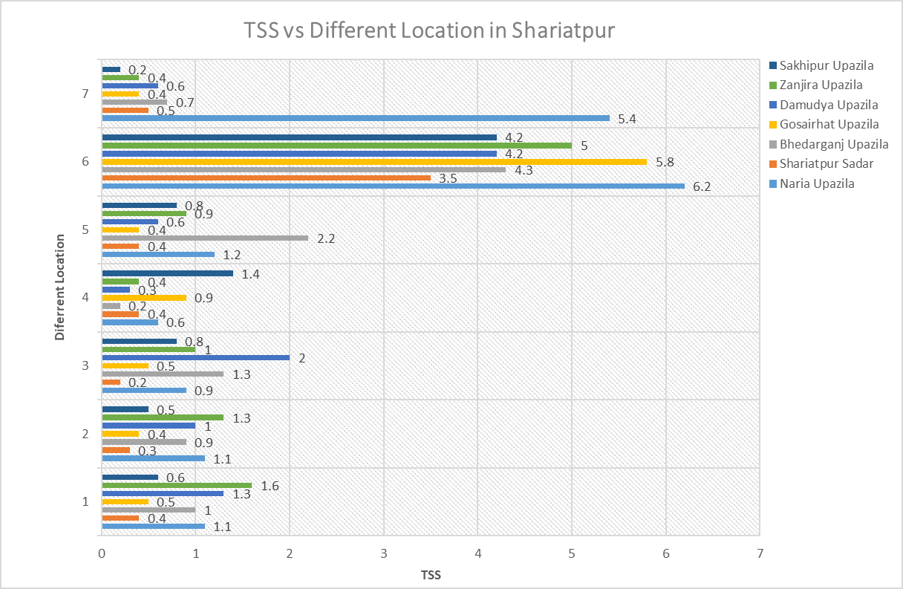

Fig. 4. TSS values of the experimental samples
3.1.4 Total solid (TS)
Total solids are dissolved solids plus suspended and settle able solids in water. When compared across the entire district, Damudiya Paurashabha in Damudya Upazila recorded the highest TS concentration (2,002 ppm), followed closely by Arshi Nagar (1,967.20 ppm) and Mahisar (1,966.70 ppm) in Bhedarganj Upazila. In contrast, the lowest TS values were observed in Joynagar (324.90 ppm) in Zanjira Upazila and Kodalpur (334.50 ppm) in Gosairhat Upazila. Overall, Zanjira Upazila exhibited the most consistently low TS levels, suggesting relatively good water quality in terms of solid content (Figure 5). Conversely, Damudya and Bhedarganj Upazilas showed higher variability and elevated concentrations, indicating possible localized sources of contamination or environmental influences contributing to higher solid loads in drinking water.
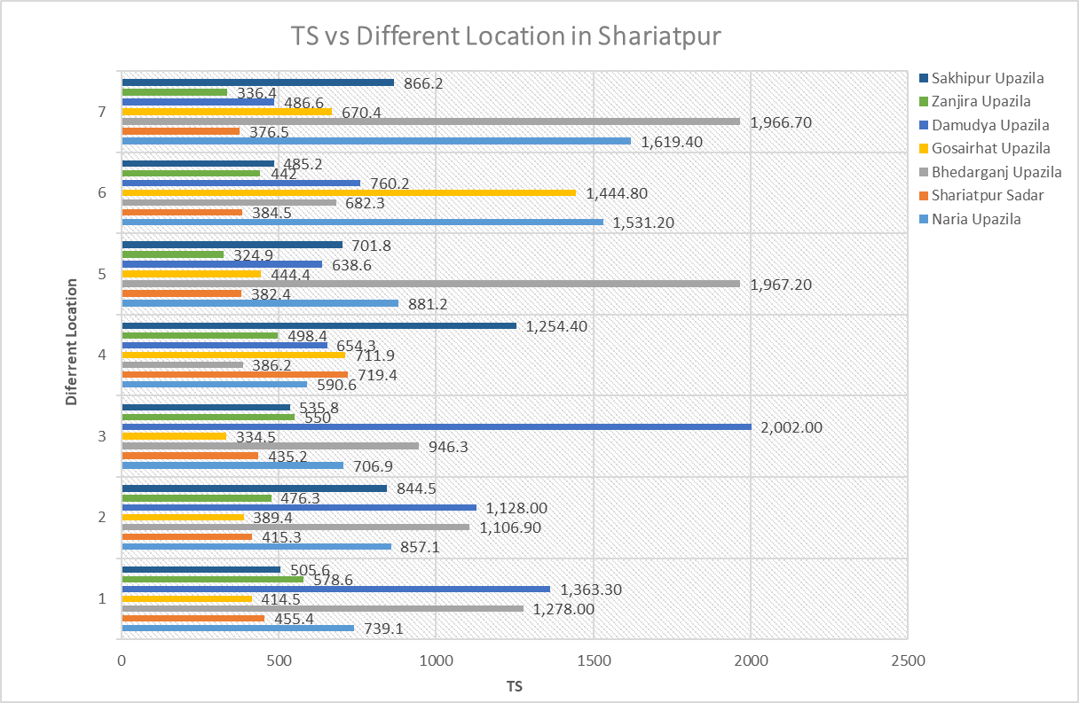

Fig. 5. TS values of the experimental samples

3.1.5. Electrical Conductivity
The electrical conductivity of drinking water is a measure of its ability to conduct an electrical current, and it's directly related to the amount of dissolved ions (like salts and minerals) present. Pure water has very low conductivity, while water with dissolved salts and minerals has higher conductivity. EC means the higher presence of salts as well as dissolved solids [18].

The findings indicate that different salts and minerals are the widespread issue across the study area, with notably high EC recorded in several locations, particularly in the char regions, where EC values exceed 2,000 μS/cm. These extreme EC levels were observed in areas such as Kalmir Char, Muktarer Char, Chikandi, Tulasar, Gariber Char, Islampur, Dhankati, and South Sakhipur (Figure 6). Increased Electrical Conductivity in Drinking Water in Shariatpur may be of the following reasons: Fertilizers (rich in nitrates, phosphates, potassium, etc.) and salts used in irrigation can leach into groundwater or surface water, raising EC and in colder climates, road salt (mostly sodium chloride) used for de-icing can runoff into water systems during snowmelt, increasing salinity.

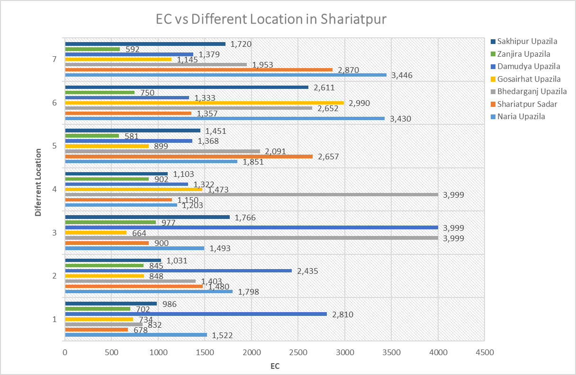
Fig. 6. Electrical conductivity values of the experimental samples.

3.4. Alkalinity
Alkalinity is primarily a way of measuring the acid neutralizing capacity of water. In other words, its ability to maintain a relatively constant pH. The possibility to maintain constant pH is due to the hydroxyl, carbonate and bicarbonate ions present in water. The ability of natural water to act as a buffer is controlled in part by the amount of calcium and carbonate ions in solution. Carbonate ion and calcium ion both come from calcium carbonate or limestone. So water that comes in contact with limestone will contain high levels of both Ca⁺⁺ and CO₃²⁻ ions and have elevated hardness and alkalinity.
The analysis of drinking water alkalinity across various upazilas reveals substantial variability in water quality, with alkalinity levels ranging from moderate to very high across different regions (Figure 7). In Naria Upazila, alkalinity levels span from 84 mg/L (moderate) to 216 mg/L (very high), indicating significant intra-regional variation. Bhedarganj Upazila similarly exhibits diverse alkalinity levels, with areas such as Digar Mahiskhali and Narayanpur recording very high alkalinity values (exceeding 200 mg/L). In contrast, Gosairhat Upazila demonstrates a relatively consistent pattern, with the majority of sites falling within the high category, though some areas report moderate levels. Damudya Upazila predominantly shows high alkalinity, with a peak measurement of 232 mg/L recorded in Damudiya Paurashava. Zanjira Upazila presents a mix of moderate and high alkalinity levels. Meanwhile, Sakhipur Police Station shows the greatest range, with several locations exceeding 200 mg/L, placing them in the very high category. Alkalinity in drinking water of shariatpur can increase for several human activities; such as:
- Water Treatment Practices: Some water utilities add chemicals like sodium bicarbonate or lime (calcium hydroxide) to adjust pH and prevent pipe corrosion—this raises alkalinity.
- Agricultural Runoff: Fertilizers and lime used on fields can leach into water supplies, increasing bicarbonate or hydroxide levels.
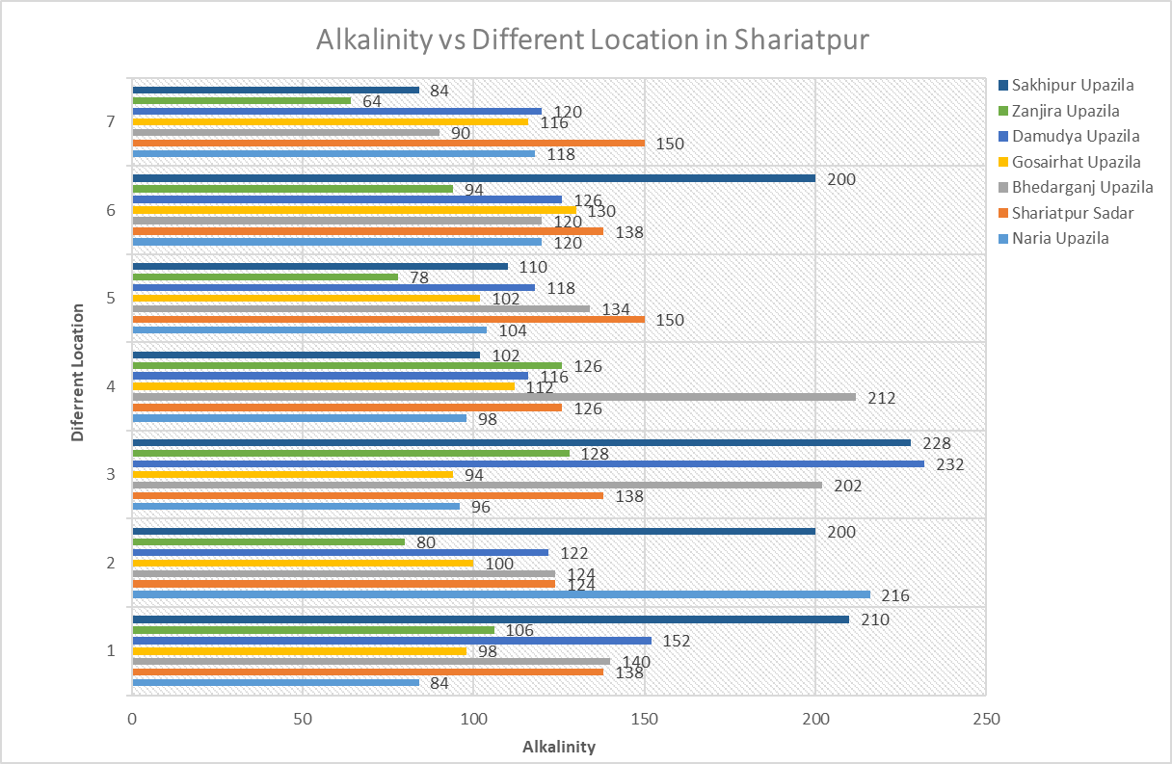
Fig. 7. Alkalinity values of the experimental samples

3.5 Salinity
Salinity in drinking water refers to the presence of dissolved salts, primarily sodium chloride, which can affect taste, health, and suitability for various uses. High salinity can make water unpalatable, and in some cases, pose health risks, particularly for those with hypertension or other conditions sensitive to salt intake. It also poses hazards for the environment as well as affecting agriculture and infrastructure and therefore, the wider economy. The salinity standard for drinking water in Bangladesh is 0.6 ppt [19].

The data obtained across various upazilas reveal significant variability in water salinity levels, with the majority of regions exhibiting elevated salinity (Figure 8). This poses a substantial challenge for potable water. In Naria Upazila, most samples exceed the allowable limit, with ranging from 1073 to 1600 ppm, but Kalmir Char (2773 ppm) and Muktarer Char (2935 ppm) shows very high salinity rendering the water unacceptable for drinking.
The water samples from Shariatpur sadar Upazila exhibits salinity levels between 683 and 790 ppm indicating good water quality. Only Mohammadpur shows 1307 ppm salinity, which exceed the allowable limit. In Bhedarganj Upazila, water quality is largely compromised. Bhedarganj Paurashabha (2322 ppm), Rambhadrapur (2011), Digar Mahiskhali (1718 ppm), Arshi Nagar (3572 ppm), and Mahisar (3574 ppm) significantly exceed the 1,000-ppm limit, classifying them as unacceptable. Only Narayanpur (702 ppm) meets the good water quality standard.
In Gosairhat Upazila, the overall water quality is favorable except Gariber Char (2616 ppm) exceeds the national limit and is deemed unacceptable. Maximum water samples from Damudya Upazila shows good to fair category. But samples from Dhankati (2049 ppm), Islampur (2477 ppm) and Damudya Paurashabha (3636 ppm) are considered unacceptable. All sampled sites in Zanjira Upazila exhibit good water quality, with salinity values ranging from 589 ppm (Joynagar) to 1049 ppm (Dhalikandi) well below the national standard. Water quality of Sakhipur Upazila, shows good to fair category. Only three samples from, Anando Bazar (2278 ppm), Bepari Kandi (1534ppm), and South Tarabuniya (1610ppm) exceeds the threshold limit and is deemed unacceptable.

Fig. 8. Salinity values of the experimental samples

- CONCLUSION
The research successfully identified significant water quality issues in specific locations, particularly related to high salinity, alkalinity and excessive TDS, TSS levels in certain tube wells. The results also suggest that the water quality in some areas of Shariatpur District, particularly in the char regions, does not meet the drinking water standards set by national guidelines, and appropriate interventions are needed to address these challenges: continued monitoring of tube wells, salinity management, water treatment solutions and community awareness and engagement.
The findings of this study underscore the importance of ensuring that tube well water meets safe drinking water standards. By providing a clear understanding of water quality across multiple upazilas, the research informs future strategies for water treatment and the development of policies aimed at improving public health and environmental sustainability. Moreover, the research serves as a valuable reference for environmental engineers and policymakers who are working to address similar water quality challenges in other rural areas of Bangladesh.

Disclaimer (Artificial intelligence)

Option 1:

Author(s) hereby declare that NO generative AI technologies such as Large Language Models (ChatGPT, COPILOT, etc.) and text-to-image generators have been used during the writing or editing of this manuscript.

Option 2:

Author(s) hereby declare that generative AI technologies such as Large Language Models, etc. have been used during the writing or editing of manuscripts. This explanation will include the name, version, model, and source of the generative AI technology and as well as all input prompts provided to the generative AI technology

Details of the AI usage are given below:
1.
2.
3.

REFERENCES

- UNICEF & World Health Organization. (2021). Progress on household drinking water, sanitation and hygiene 2000–2020: Five years into the SDGs.
- UN-Water. Summary progress update 2021: SDG 6 – water and sanitation for all. https://www.unwater.org/sites/default/files/app/uploads/2021/12/SDG-6-Summary-Progress-Update-2021_Version-July-2021a.pdf
- Abney, S. E., Bright, K. R., McKinney, J., Ijaz, M. K., & Gerba, C. P. (2021). Toilet hygiene—review and research needs. Journal of Applied Microbiology, 131(6), 2705-2714.
- UN World Water Development Report 2023, UN-Water. (n.d.). https://www.unwater.org/publications/un-world-water-development-report-2023 (accessed October 23, 2023).
- Rahman, M. A., & Islam, M. N. (2018). Scarcity of safe drinking water in the South-West Coastal Bangladesh. Journal of environmental science and natural resources, 11(1-2), 17-25.
- Muhammad, A. N., Naseem, A. K., Chao, C., Syed, S. A. S., Tayyaba, N., & Muhammad A. et al. (2020). Surface induced growth of ZIF-67 at Co-layered double hydroxide: Removal of methylene blue and methyl orange from water, Applied Clay Science,Volume 190,p-105564,ISSN 0169-1317, https://doi.org/10.1016/j.clay.2020.105564.
- Nazir, M.A., Najam, T., Zarin, K., Shahzad, K., Javed, M.S., & Jamshaid, M., et al. (2023). Enhanced adsorption removal of methyl orange from water by porous bimetallic Ni/Co MOF composite: a systematic study of adsorption kinetics. International Journal of Environmental Analytical Chemistry, 103(16), pp.4841-4856.
- Ganguli, S., Rifat, M. A. H., Das, D., Islam, S., & Islam, M. N. (2021). Groundwater pollution in Bangladesh: A review. Grassroots Journal of Natural Resources, 4(4), 115-145.
- Akter, T., Jhohura, F. T., Akter, F., Chowdhury, T. R., Mistry, S. K., Dey, D., ... & Rahman, M. (2016). Water Quality Index for measuring drinking water quality in rural Bangladesh: a cross-sectional study. Journal of Health, Population and Nutrition, 35(1), 4.
- Islam, M., Howlader, M. S. A., & Uddin, M. S. (2020). A Survey of medicinal plants used by traditional healers and indigenous people of Shariatpur District, Bangladesh. J. adv. Botany Zool., 7(4), 1-7.
- Thomas, J. F. J., & Lynch, J. J. (1960). Determination of carbonate alkalinity in natural waters. Journal‐American Water Works Association, 52(2), 259-268.
- Government of South Australia Salinity and drinking water: SA Health Available at: https://www.sahealth.sa.gov.au/wps/wcm/connect/public+content/sa+health+internet/public+health/water+quality/salinity+and+drinking+water#:~:text=less%20than%20600%20mg%2FL,L%20is%20regarded%20as%20unacceptable.
- Omer, N. H. (2019). Water quality parameters. Water quality-science, assessments and policy, 18, 1-34.
- Rajvaidya, N., & Markandey, D. K. (1998). Advances in Environmental Science and Technology. APH Publishing Corporation.
- World Health Organization. (2017). Guidelines for drinking-water quality: Fourth edition incorporating the first addendum.
https://www.who.int/water_sanitation_health/publications/dwq-guidelines-4th- edition/en/
- Nur-E-Alam, S. M., Moniruzzaman, S. M., Rasheduzzaman, M., & Baten, S. A. (2016). Characterization of selected industrial effluent and their effects on Narod river of Natore, Bangladesh. In Proceedings of the 3rd International Conference on Civil Engineering for Sustainable Development (ICCESD 2016), 12∼ 14 February 2016. KUET Khulna, Bangladesh.
- Nazir, M.A., Yasar, A., Bashir, M.A., Siyal, S.H., Najam, T., & Javed, M.S., et al. (2020). Quality assessment of the noncarbonated-bottled drinking water, comparison of their treatment techniques. International journal of environmental analytical chemistry, 102(19), 1-12, DOI:10.1080/03067319.2020.1846732.
- Meride, Y., Ayenew, B. (2016). Drinking water quality assessment and its effects on residents health in Wondo genet campus, Ethiopia. Environ. Syst. Res. 5 (1), 1–7.
- Chakraborty, R., et al. (2019). Health implications of drinking water salinity in coastal areas of Bangladesh. Int. J. Environ. Res. Publ. Health 16 (19), 3746.

