***Original Research Article***

**Understanding X-ray Crystallographic Diffraction of L-Menthol by Rietveld Refinement: Insight into Structural Symmetry and Lattice Volume**

ABSTRACT

|  |
| --- |
| Highlighted the recent advances in the mechanism of crystallographic bibliography of L-Menthol crystals and to provide an overview of its application explored as well as its structural symmetry and lattice volume performance. The crystallographic analysis was explored by the X-ray diffraction (XRD) technique, and the surface morphology of L-Menthol crystals was depicted by polarized microscopic examination. The materials are composed of 100 % L-Menthol crystals and calculated lattice parameters a=b= 21.29Å, c= 6.038Å and angles α=β= 90° and γ= 120° for the hexagonal crystal system by Rietveld refinement. The crystallite sizes were calculated in Williamson-Hall plot 55.2 nm, Monshi-Scherrer model 58.3 nm, Size-strain plot model 66.1 nm, and Halder-Wagner model 62.5 nm; and the Scherrer model expressed at 63.03 nm. The calculated crystal strain is 0.256 %. The lower crystal strain suggests high stability of the phase in L-Menthol and mechanical properties. Lowering lattice volume 2371.126 Å³ in a structure typically refers to reducing the amount of material used to create a lattice structure of L-Menthol, often while maintaining or improving desired mechanical properties. The crystals exhibit a well-defined, hexagonal morphology with smooth, flat surfaces and sharp edges, which is characteristic of hexagonal L-Menthol crystals revealed by microscopic examination. |

*Keywords:*X-ray Crystallography, Rietveld Refinement, L-Menthol, Structural Symmetry, Lattice Volume.

**1.0 Introduction**

Menthol (C10H20O) has a molecular weight of 156, is a naturally occurring cyclic terpene alcohol of plant origin, which gives plants of the Mentha species their distinctive smell and flavor. It was first isolated as a crystalline principle by the Dutch botanist Gambius [1]. However, Shimoyama asserted that the peppermint plant, the primary source of menthol, has been cultivated in Japan for medicinal purposes [1]. In the present day, menthol consumption is staggering, and exceeds 7000 tons annually, with a raw product value approaching $300 million [2]. Its use is multifold and includes oral hygiene products, confectionery, pharmaceuticals, cosmetics, pesticides and as a flavoring agent, to name but a few [2-3]. With regards to its medicinal purposes, menthol is currently available in both prescribed and over-the-counter (OTC) medications for a host of conditions, including gastrointestinal disorders, common cold and respiratory conditions, and musculoskeletal pain [3]. Additionally, its use in dermatology is widespread, where it is often incorporated into topical antipruritic, antiseptic, analgesic, and cooling formulations [4]. Despite menthol’s use since antiquity, the mechanism by which it can impart a cooling sensation when applied topically to the skin or mucous membrane remained a mystery until recently [5]. Although almost five years have passed since the discovery of a common receptor for menthol and low temperature, many dermatologists [6-7] are still unaware of menthol's underlying target [8-9]. Menthol and related cooling compounds, such as coolant agents, are widely used in products ranging from common cold medications to tubes of toothpaste, confectionery, cosmetics and pesticides [10]. The purpose of this study is to highlight the recent advances in the mechanism of crystallographic action of L-Menthol and to provide an overview of its application in industry and commercialization level, as well as its structural symmetry and lattice volume performance that could dominating the production and quality of the product.

**2.0 Materials and Methods**

The supplied chemicals of menthol [L-Menthol: (1R, 2S, 5R)-5-methyl-2-propan-2-ylcyclohexan-1-ol] were procured from Jolly Chemicals, Dhaka-1205, Bangladesh. The menthol crystals are kept in a desiccator to avoid moisture and other contamination. It's stored in a cool, dry place away from direct heat and sunlight. The investigation only research and development (R & D) purposes.

**3.0 Characterization**

**3.1 X-ray Diffraction**

The crystallographic bibliography of the synthesized powdered sample is collected from an XRD by a Smart Lab SE, [Rigaku, Japan] instrumentation [11]. The minimum voltage required is 20.0 kV to operate the instrument. A copper X-ray tube (CuKα, λ= 1.54060 Å) is used [12] to generate characteristic X-rays while keeping the voltage at 40.0 kV and the current at 50.0 mA. Inside the tube, a high voltage energy falls on the tungsten (W) filament, resulting in a thermionic emission which further falls on the Cu anode to create characteristic rays [13]. Initially, the produced rays are continuous with low intensity, known as Bremsstrahlung X-rays, which further convert to characteristic X-rays with high intensity upon increasing the voltage [14]. The chiller temperature is maintained at about 23.0 ℃ with a continuous water flow rate of 4.6-4.8 L/minute to support the copper X-ray tube [15]. Characteristic Kα rays are generated from the K shell of the Cu material and pass through a Beryllium (Be) window. To obtain the desired characteristic rays, a nickel-based Kβ filter is used [16], which passes the Kα rays, hindering the passage of Kβ rays. Bragg-Brentano (BB) geometry and standard operation mode are used for all experiments, and a silicon reference is used to calibrate the machine [17]. The investigation is carried out using a 1D scan mode with a duration of 10º/ minute and a step size of 0.01º. The scan range was 5.0 to 100.0º with an incident ray angle of 2.5º and a length slit of 10.0 mm in the absence of light. The rays fall on the lattice plane of the sample and give its crystallographic information through constructive interference [18]. The Hypix-400 horizontal detector detects the amplified information after passing through another Kβ filter, a parallel slit analyzer (PSA), and a solar slit of 2.5º. Hypix-400 detector detects the point with 400 numbers, 100µm2 pixel area, each having 1 pixel= 106 times detection capacity [19]. A theta-theta goniometer system is incorporated in the overall procedure. The obtained data are analyzed using Smart Lab Studio II software with the ICDD PDF5+ database, and the Scherrer equation [20-21] is applied to calculate the crystallite size, as well as the d-spacing, by Bragg's law [22]. The structural symmetry was explored using VESTA [visualization for electronic structural analysis] software [23-24].

**3.2 Structural Morphology**

The microscopic analysis was conducted using a Nikon ECLIPSE E200 [Japan] microscope equipped with a DeltaPix [Denmark] camera [25]. A polarized microscopic examination was performed with a Nikon SMZ745T [Japan] stereo microscope fitted with a DeltaPix [Denmark] camera. A scale (250 μm) is displayed in the lower right corner of each image and named with the respective magnification levels [26].

**4.0 Results and Discussion**

**4.1 X-ray Crystallographic Phase Analysis**

The X-ray pattern showed the diffraction phenomenon of L-Menthols crystals. The main diffraction was observed at 8.207º at the predominant (110) planes. The total diffraction observed at 8.207, 9.894, 12.573, 14.493, 14.715, 16.710, 17.010, 19.267, 20.758, 22.010, 23.587, 24.258, 24.859, 26.421, 29.075, 31.190, 32.530, 33.342, 33.986, 41.820 and 44.820º Bragg positions concerning the (110), (200), (210), (300), **(**101), (111), (201), (400), (301), (410), (221), (311), (330),(420), (501), (430), (511), (601), (440), (312), (522) and (721) plane [ICDD Card No: 00-037-1957] respectively illustrated in Fig. 1. The Fig. 1 also explored the highest main three diffraction at 8.207, 14.715 and 24.258º Bragg position corresponding to the (110), (101) and (330) plane respectively.

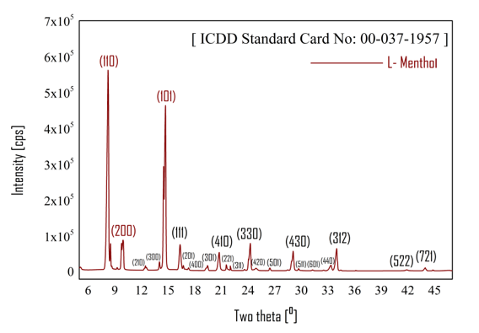

**Fig. 1.** X-ray diffractogram of L-Menthol.

The diffraction pattern also revealed that the maximum peak height was observed at 263746, 312139 and 52603 cps corresponding to (1at10), (101) and (330) plane at 8.207, 14.715 and 24.258º Bragg position. Table 1 explores the bibliography of the crystal grain of L-Menthol. The crystallite sizes were calculated by the Scherrer equation [27]. The calculated average crystallite size of L-Menthol was 63.03 nm. The average crystallite sizes explored the formation of nanocrystals [28] of the L-Menthol lattice.

**Table 1.** Crystal grain size analysis of L-Menthol.

|  |  |  |  |  |  |  |
| --- | --- | --- | --- | --- | --- | --- |
| 2Ө | FWHM (º) | d (nm) | Height (cps) | Intensity (cps) | plane | D (nm) |
| 8.207 | **0.211** | **0.1076** | **263746** | **62238** | **(110)** | **39.40** |
| 9.894 | 0.178 | 0.8932 | 48845 | 10086 | (200) | 46.70 |
| 12.573 | 0.105 | 0.7034 | 4174 | 655 | (210) | 79.20 |
| 14.493 | 0.071 | 0.6106 | 147533 | 12175 | (300) | 118.40 |
| 14.715 | **0.180** | **0.6015** | **312139** | **65487** | **(101)** | **46.60** |
| 16.710 | 0.105 | 0.5301 | 7989 | 950 | (111) | 80.10 |
| 17.010 | 0.440 | 0.5208 | 1801 | 899 | (201) | 19.10 |
| 19.267 | 0.170 | 0.4603 | 4672 | 860 | (400) | 48.70 |
| 20.758 | 0.206 | 0.4275 | 34672 | 8477 | (301) | 40.90 |
| 21.660 | 0.350 | 0.4100 | 2252 | 1035 | (410) | 24.00 |
| 22.010 | 0.039 | 0.4035 | 11966 | 607 | (221) | 217.70 |
| 23.587 | 0.092 | 0.3769 | 2583 | 343 | (311) | 91.90 |
| 24.258 | **0.180** | **0.3666** | **52603** | **10645** | **(330)** | **47.30** |
| 24.859 | 0.303 | 0.3578 | 4527 | 2195 | (420) | 20.00 |
| 26.421 | 0.114 | 0.3370 | 6241 | 839 | (501) | 74.80 |
| 29.075 | 0.150 | 0.3068 | 40069 | 7296 | (430) | 57.20 |
| 31.190 | 0.190 | 0.2866 | 847 | 207 | (511) | 46.40 |
| 32.530 | 0.130 | 0.2750 | 1268 | 194 | (601) | 65.80 |
| 33.342 | 0.262 | 0.2685 | 10586 | 3238 | (440) | 33.00 |
| 33.986 | 0.212 | 0.2635 | 43860 | 10852 | (312) | 40.90 |
| 41.820 | 0.240 | 0.2158 | 2141 | 855 | (522) | 37.70 |
| 44.820 | 0.081 | 0.2020 | 2306 | 228 | (721) | 111.0 |

The peak illustration observed the 2θ= 8.207, 14.715 and 24.258º Bragg positions corresponding to the (110), (101) and (330), where the highest diffraction orders for constructive interference [29] of the sample in Fig. 2. Peak shifting in XRD refers to a change in the peak position, specifically the 2θ value, in an XRD diffraction pattern. This shift can be either towards lower or higher 2θ values, indicating changes in the interplanar spacing (d-spacing) within the crystal structure. The standard ICCD data showed 8.195, 14.227 and 23.979º which means the maximum peak shifted to the right, that means the d-spacing decreased [30] against the standard ICDD [ICDD Card No: 00-037-1957]. The L-Menthol d-spacing values are 0.1076, 0.6015 and 0.3666 nm, which are lower than standard ICDD [ICDD Card No: 00-037-1957].

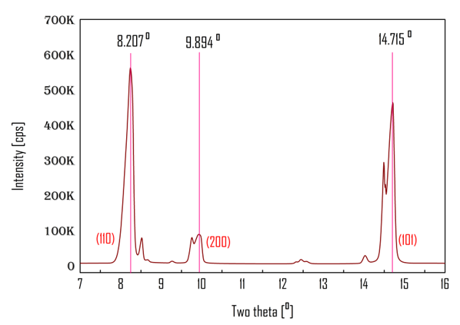

**Fig. 2.** Diffraction peak illustration of L-Menthol.

The compactness of crystals was increased, which explored the brittleness of crystals lattice of L-Menthol. A decreasing standard deviation indicates that the diffraction data points in a set are becoming more clustered around the mean (average) value, suggesting less variability or spread in the diffraction data in the crystal lattice [31]. The peak profiling of the sample is tabulated in Table 2. In XRD, peak profiling refers to the analysis of the shape, width, and intensity of diffraction peaks to gain insights into the microstructure of a crystalline L-Menthol. Essentially, it involves examining how the intensity of diffracted X-rays varies as a function of the diffraction Bragg angle, revealing information about crystallite size, lattice strain [32], and other structural imperfections of the crystals.

**Table 2.** Peak profiling and comparisons study of L-Menthol.

|  |  |  |  |  |  |  |
| --- | --- | --- | --- | --- | --- | --- |
| Peak profiling by theta (Ө) | | | | | | |
| 2Ө | **Ө** | **1000×sin2Ө** | | **Reflection** | **Remark** | |
| 8.207 | 4.103 | 5.11 | | (110) | 12+12+02= 2 | |
| 14.715 | 7.357 | 16.39 | | (101) | 12+02+12= 2 | |
| 24.258 | 12.129 | 44.147 | | (330) | 32+32+02= 18 | |
| Peak profiling by d-spacing | | | | | | |
| 2Ө | **d (Å)** | **1000/d2** | | **Reflection** | **Remark** | |
| 8.207 | 1.076 | 863.72 | | (110) | 12+12+02= 2 | |
| 14.715 | 6.015 | 27.639 | | (101) | 12+02+12= 2 | |
| 24.258 | 3.666 | 74.407 | | (330) | 32+32+02= 18 | |
| Comparison study against ICDD standard [ICDD Card No: 00-037-1957] | | | | | | |
| 2Ө (exp.) | **2Ө (std.)** | **Norm. I (exp.)** | **Norm. I (std.)** | **Crystallinity (%) [exp.]** | | **Crystallinity (%) [std.]** |
| 8.207 | 8.195 | 38.0 | 100.0 | 64.82 | | 71.94 |
| 14.715 | 14.227 | 100.0 | 15.0 |
| 24.258 | 23.979 | 16.26 | 24.0 |

In Table 2, the peak profiling values by theta were 5.11, 16.39, and 44.147, were explored the constructive interference of the diffraction planes, and peak profiling values by d-spacing were 863.72, 27.639, and 74.407, with the same performance as the study. In XRD, percentage crystallinity refers to the proportion of a material that exists in a well-defined, ordered, crystalline structure, as opposed to an amorphous, disordered state [33]. XRD patterns of crystalline materials exhibit sharp, high-intensity peaks, while amorphous materials show broad, low-intensity halos. The percentage of crystallinity is determined by analyzing the relative areas of these crystalline peaks and the amorphous halo in the XRD pattern. The calculated percentage of crystallinity for standard (71.49 %) and L-Menthol (64.82 %) shows a more uniform crystal lattice that was formed.

**4.2 Average Crystallite Size Calculation**

The average crystallite size can be calculated using the Scherrer equation, which relates the broadening of X-ray diffraction peaks to the size of the crystallites. The equation is: D = Kλ/ (βcosθ). Where, D: Average crystallite size (often in nanometers or Angstroms), K: Scherrer constant, typically around 0.94 for spherical crystallites with hexagonal symmetry, λ: Wavelength of the X-ray radiation used, β: full width at half maximum (FWHM) of the diffraction peak in radians and θ: Bragg angle of the diffraction peak (in radians or degrees, but consistent with the angle unit used for β) [19, 34]. The calculated average crystallite size of L-Menthol was 63.03 nm by the Scherrer equation.

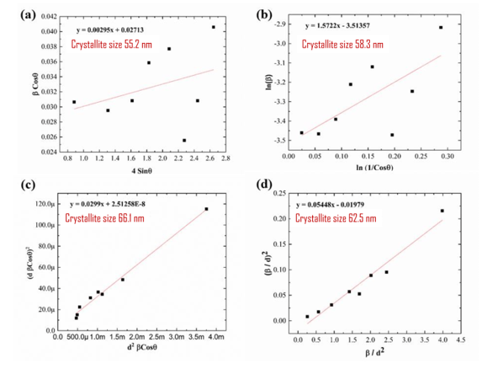

**Fig. 3.** Average crystallite size calculation of L-Menthol by using (a) Williamson-Hall plot, (b) Monshi-Scherrer model, (c) Size-strain plot model, (d) Halder-Wagner model.

Another, identical four model was also explored to calculate the crystallite sizes were in Williamson-Hall plot 55.2 nm, Monshi-Scherrer model 58.3 nm, Size-strain plot model 66.1 nm, and Halder-Wagner model 62.5 nm.

**4.3 Rietveld Refinement by WPPF method**

Quantitative phase analysis using the whole powder pattern fitting (WPPF) method determines the proportions of different crystalline phases in a sample by analyzing its XRD pattern. The method relies on the principle that diffraction intensity is directly related to the abundance of each phase in the mixture. WPPF is a powerful tool because it doesn't require calibration curves and can be applied to a variety of materials, including those with unknown crystal structures [35]. WPPF is a technique used in XRD to analyze the composition of multi-phase materials. The materials are composed of 100% L-menthol crystals, as shown in Table 3 and Fig. 4.

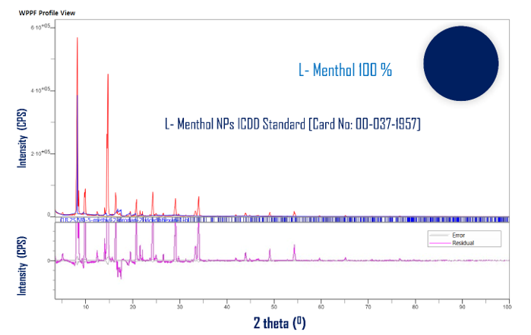

**Fig. 4.** Quantitative analysis of L-Menthol by WPPF method.

It involves fitting a theoretical diffraction pattern, calculated from structural parameters of known phases, to the experimentally observed XRD pattern. This fitting process refines parameters like lattice constants, peak shapes, and the amount of each phase present. The factor considering Rwp= 67.89 %, Rp= 56.77 %, S= 9.9299 and X2= 98.6031 for a good fit (GOF) value. The gof explored the accuracy of the refinement. The calculated lattice parameters a=b= 21.29Å, c= 6.038Å and angles α=β= 90° and γ= 120° for the hexagonal crystal system.

Table 3. Rietveld Refinement by WPPF method.

|  |  |  |  |  |  |  |
| --- | --- | --- | --- | --- | --- | --- |
| Quantitative analysis of L-Menthol by WPPF method | | | | | | |
| Lattice parameters | Rp (%) | Rwp (%) | χ² and S | Weight fraction (%) | Strain (%) | Lattice volume (Å³) |
| α=β= 90.0°,γ= 120°; a=b= 21.29Å, c = 6.038Å | 67.89 | 56.77 | 98.6031 and 9.9299 | 100 | 0.256 | 2371.126 |

The calculated crystal strain is 0.256 %. The lower crystal strain suggests high stability of the phase in L-Menthol and mechanical properties [36]. It’s also calculated that the lattice volume of L-Menthol was 2371.126 Å³.

**4.4 Structural Symmetry Analysis**

In Fig. 5(a), the L-menthol crystallographic structure is depicted in a ball-and-stick model, illustrating the unit cell structure, with carbon, hydrogen, and oxygen represented in green, pink, and blue, respectively. This perspective shows the bonding and how the molecules are connected sequentially along the crystallographic directions [37]. The lattice constant (the size of a unit cell) can change due to various factors, such as temperature or applied pressure. Analyzing these changes helps in understanding the material's response to external stimuli. In structural design, lattice structures are often optimized to achieve specific volume fractions (the ratio of solid material to the overall volume). The crystal is of hexagonal symmetry of space group P31 with lattice parameters a=b= 21.29Å, c= 6.038Å and angles α=β= 90° and γ= 120°. Fig. 5(b) shows the same structure in the CPK (space-filling) model. The emphasis of this figure is on the radius of Van der Waals’ contacts and the close packing of atoms in the structure. The unit cell slices shown in Fig. 5(c) and 5(d) display transparent purple planes marking the (110) and (200) planes of the crystal, respectively.

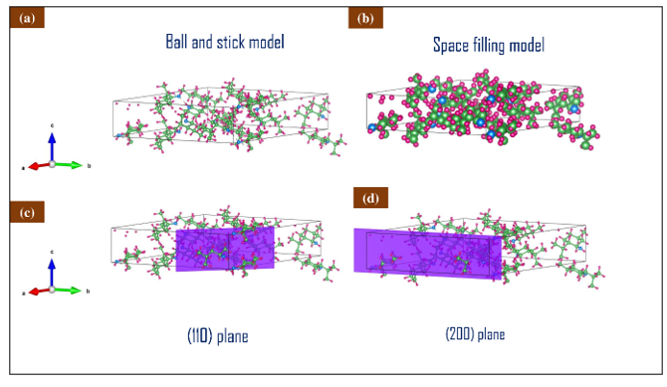

**Fig. 5.** Structural symmetry analysis of L-Menthol.

These projections are useful to study the molecular layers and some possible intermolecular arrangements above and below these layers. The crystallographic zone axes a (red), b (green), and c (blue) are shown together with the models to assist in the explanation of the lattice position and isotropy concerning symmetry in the structural investigation [38]. Together, these illustrations capture and define the three-dimensional (3D) arrangement and packing features of L-menthol.

**4.5 Lattice Volume Analysis**

Lattice volume analysis typically refers to the study of the volume and its variations within a lattice structure of L-menthol. This can involve analyzing how the volume of individual unit cells changes, how the overall volume of a lattice structure changes under stress, or how volume fractions are distributed [39] within a lattice in L-menthol. It is a crucial aspect of understanding the behavior and properties of lattice structures, especially when designed for specific applications.

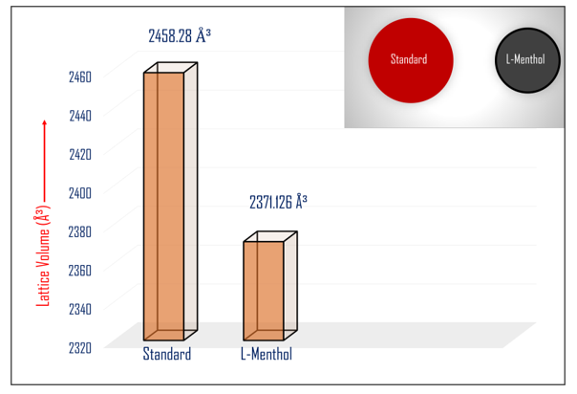

**Fig. 6.** Lattice volume comparison of L-Menthol.

This is important for creating lightweight yet strong structures of L-menthol. Some lattice structures have varying volume fractions throughout the L-menthol structure, creating gradients that can be tailored for specific mechanical properties. For example, some designs of L-menthol might have higher volume fractions in areas of high stress and lower volume fractions elsewhere. The calculated lattice volume of L-Menthol was 2371.126 Å³, which is lower than the ICDD standard [ICDD Card No: 00-037-1957]. Lowering lattice volume in a structure typically refers to reducing the amount of material used to create a lattice structure of L-Menthol, often while maintaining or improving desired mechanical properties [40]. This can be achieved through various methods like topology optimization [50-51], which intelligently removes unnecessary material from the structure while preserving its key functionalities.

**4.6 Crystal Morphology Analysis**

Fig. 7 shows stereo microscopic images of L-Menthol crystals. The images were manually focused to clearly define the crystal contours and interiors from a geometrical perspective. The red line in the figure represents the scale bar (250 μm) for size reference at each magnification level. The crystals exhibit a well-defined, hexagonal morphology with smooth, flat surfaces and sharp edges, which is characteristic of hexagonal L-Menthol crystals.

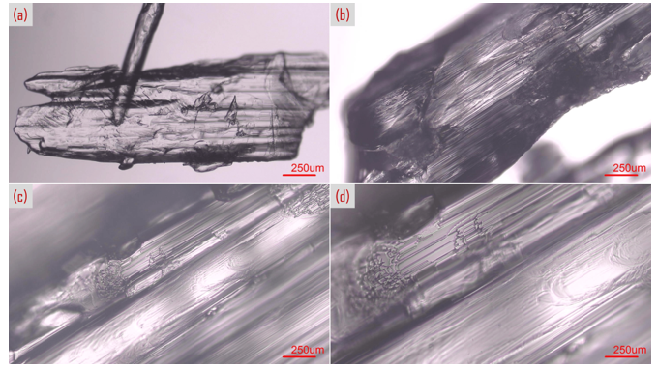

**Fig. 7.** Surface morphology of L-Menthol crystals.

This overview demonstrates a relatively uniform crystallite size distribution and a clear external shape and the crystal facets and interfacial junctions become more prominent in Fig. 7. Some surface irregularities and inclusions are noticeable, indicating slight imperfections and possible microstructural features within the crystals [41, 52]. Additionally, the individual grains appear more discrete, offering better insight into crystal boundaries [53, 54]. Fine granular features and micro-pitting are visible across the surface, indicating possible impurities or growth anomalies.

**4.7. Application of L-Menthol**

L-Menthol, a naturally occurring compound that exhibits a wide range of applications across pharmaceutical, cosmetic, food, tobacco, and industrial sectors due to its characteristic cooling sensation and pleasant minty aroma [42]. One of its significant properties is its antimicrobial activity, which makes it effective as an antibacterial agent in Fig. 8. It is commonly incorporated into topical formulations and hygiene products to prevent microbial contamination and promote skin health. L-menthol possesses antimicrobial properties that help inhibit the growth of certain bacteria and fungi. It is commonly used in topical ointments and personal care products to maintain hygiene and reduce microbial contamination [43]. In the area of oral care, L-menthol is widely used in products such as toothpaste and mouthwash for its refreshing flavor and ability to soothe minor oral and throat discomfort [44]. It also plays a role in the tobacco industry, where it is added to mentholated cigarettes to reduce the harshness of smoke and provide a cooling sensation during inhalation [45]. In the food industry, L-menthol serves as a flavoring agent in mint-flavored candies, chewing gums, and beverages, enhancing consumer appeal with its distinct freshness [46]. L-menthol is also valued for its analgesic properties and is often used in topical analgesics (like balms and patches) for temporary pain relief. The cooling effect can relieve muscle soreness, sprains, and minor aches. Its ability to stimulate cold-sensitive receptors in the skin results in a cooling effect that temporarily numbs the area, offering relief from discomfort [47]. Additionally, in organic chemistry, L-menthol acts as a chiral auxiliary, aiding in the stereoselective synthesis of optically active compounds, which is particularly useful in pharmaceutical drug development [48, 55]. In the personal care and cosmetics industry, L-menthol is incorporated into skincare products such as creams and lotions to deliver a cooling and soothing effect, especially in after-sun products or those designed for irritated skin.

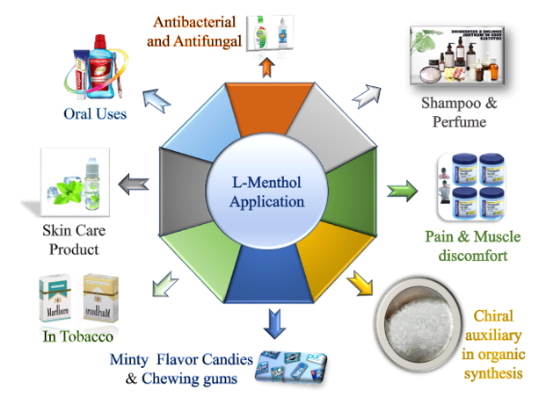

**Fig. 8.** Functional application of L-Menthol.

It is also used in shampoos to provide a refreshing sensation and scalp relief, often marketed for its invigorating properties. Furthermore, in the fragrance industry, it is employed in perfumes and colognes to introduce a crisp, minty note that enhances the overall scent profile [49].

**Conclusion**

Highlight the recent advances in the mechanism of crystallographic bibliography of L-Menthol and to provide its structural symmetry and lattice volume performance main focus of this investigation. The crystallographic analysis was explored by the XRD technique and the surface morphology of L-Menthol crystals was depicted by polarized microscopic examination. The L-Menthol crystals material are composed of 100 % and calculated lattice parameters a=b= 21.29Å, c= 6.038Å; α=β= 90° and γ= 120° for the hexagonal crystal system. The crystallite sizes were calculated in Williamson-Hall plot 55.2 nm, Monshi-Scherrer model 58.3 nm, Size-strain plot model 66.1 nm, and Halder-Wagner model 62.5 nm, but in the Scherrer model expressed as 63.03 nm. The calculated crystal strain is 0.256 % and the lattice volume is 2371.126 Å³. The lower crystal strain suggests high stability of the phase in L-Menthol and mechanical properties. Lowering lattice volume in a structure typically refers to reducing the amount of material used to create a lattice structure of L-Menthol. The crystals exhibit a well-defined, hexagonal morphology with smooth, flat surfaces and sharp edges, which is characteristic of hexagonal L-Menthol crystals revealed by microscopic examination. L-Menthol, a naturally occurring compound that might exhibit a wide range of applications across pharmaceutical, cosmetic, food, tobacco, and industrial sectors due to its characteristic cooling sensation and pleasant minty aroma.

**Data availability**

Data is available on request

**Acknowledgement**

The authors' heartfelt thanks to Dr. Shirin Akter Jahan, PSO, BCSIR, Bangladesh access to the PC, software and other appliances.

**Disclaimer (Artificial intelligence)**

Author(s) hereby declare that NO generative AI technologies such as Large Language Models (ChatGPT, COPILOT, etc.) and text-to-image generators have been used during the writing or editing of this manuscript.

**Reference**

[1]. Menthol. Wikimedia 2007 January 31 [cited 2007 Feb 10]; Available from: URL: http://en.wikipedia.org/wiki/Menthol.

[2]. Croteau RB, Davis EM, Ringer KL, Wildung MR. (-)-Menthol biosynthesis and molecular genetics. Naturwissenschaften 2005;92:562-77.

[3]. Eccles R. Menthol and related cooling compounds. J Pharm Pharmacol 1994;46:618-30.

[4]. Goldscheider A. Ueber specische Wirking des menthols. Arch Anat Physiol Abt Leipzig 1886. pp. 555-8.

[5]. Harris B. Menthol: a review of its thermoreceptor interactions and their therapeutic applications. Int J Aromather 2006;16: 117-31.

[6]. McKemy DD, Neuhausser WM, Julius D. Identification of a cold receptor reveals a general role for TRP channels in thermo-sensation. Nature 2002;416:52-8.

[7]. Peier AM, Moqrich A, Hergarden AC, Reeve AJ, Andersson DA, Story GM, et al. A TRP channel that senses cold stimuli and menthol. Cell 2002;108:705-15.

[8]. Caterina MJ, Schumacher MA, Tominaga M, Rosen TA, Levine JD, Julius D. The capsaicin receptor: a heat-activated ion-channel in the pain pathway. Nature 1997;389:816-24.

[9]. Caterina MJ. Transient receptor potential ion channels as participants in thermosensation and thermoregulation. Am J Physiol Regul Integr Comp Physiol 2007;292:R64-76.

[10]. Eccles, R. (1994). Menthol and related cooling compounds. *Journal of Pharmacy and Pharmacology*, *46*(8), 618-630.

[11]. Bishwas, R. K., Alam, M. A., & Jahan, S. A. (2025). Crystallographic and morphological characterization of high-crystalline α-alumina nanoparticles: A comprehensive X-ray diffraction and transmission electron microscopy study. *Chemical Physics Letters*, 142245.

[12]. Rahaman, M. A., Islam, M. T., Aman, S., Rahman, M. M., Ahmad, A., Tama, R. T., ... & Alam, M. A. (2025). Crystallographic Phase Bibliography and Quantitative Phase Analysis of TiO2 Nanocrystals: A Rietveld Refinement Insight. *Next Research*, 100469.

[13]. Alam, M. A., Shishir, M. K. H., Sarkar, D., Bishwas, R. K., & Jahan, S. A. (2025). X-ray line diffraction study of preferred oriented hexagonal zincite nanocrystals: A crystallographic investigation. *Journal of Crystal Growth*, 128230.

[14]. Islam, M. T., Aman, S., Bayzid, T., Rahaman, M. A., Podder, U., Khan, G. A., & Alam, M. A. (2025). Crystal Growth Behavior of Nanocrystal Anatase TiO2: A Rietveld Refinement in WPPF Analysis. *Chemistry of Inorganic Materials*, 100108.

[15]. Bayzid, T., Shishir, M. K. H., Akand, M. S., Sohage, M. S. P., Alam, M. A., Karim, M. M., ... & Khan, G. M. A. (2025). Crystallographic analysis of silk sericin-stabilized zinc oxide nanoparticles with enhanced antimicrobial and photocatalytic properties. *Inorganic Chemistry Communications*, *178*, 114481.

[16]. Bishwas, R. K., Alam, M. A., & Jahan, S. A. (2025). Sustainable synthesis of nano-crystalline α-alumina from waste food packaging for efficient azithromycin removal. *Journal of Industrial and Engineering Chemistry*.

[17]. Rahaman, M. H., Rayhan, A., Khan, G. A., Alam, M. A., Alam, S. N., Islam, M. T., & Rahman, M. A. (2025). Hydrolytic degradation studies of bio-composites of poly (L-lactic acid)/Oligo (L-lactic acid) grafted and non-grafted microcrystalline cellulose. *Next Materials*, *8*, 100615.

[18]. Aidid, A. R., Shishir, M. K. H., Rahaman, M. A., Islam, M. T., Mukta, M., & Alam, M. A. (2025). Powder X-ray line diffraction pattern profiling of anatase-quartz binary oxide: A crystallographic investigation. *Next Materials*, *8*, 100571.

[19]. Islam, M. T., Rahaman, M. A., Ahmed, S., Khatun, M. T., Aman, S., Bayzid, T., ... & Alam, M. A. (2025). Effect of Isopropyl Peptization on Surface Particle Growth of Sol-Gel Derived Anatase: X-ray Crystallographic Analysis and Revealed on Transmission Electron Microscopy. *South African Journal of Chemical Engineering*.

[20]. Islam, M., Islam, M. T., Shishir, M. K. H., Rahaman, M. A., Ahmed, S., Sadia, S. I., & Alam, M. A. (2025). X-ray crystallographic structural Profiling of Polyvinyl Alcohol (PVA) caped Nickel Oxide Nanoparticle. *Nano Trends*, *10*, 100106.

[21]. Ahmed, S., Shishir, M. K. H., Islam, M. T., Rahaman, M. A., Aman, S., Aidid, A. R., ... & Alam, M. A. (2025). Crystallinity integration of anatase (TiO2) nanocrystal by whole powder pattern fitting (WPPF) method: A Rietveld refinement study. *Results in Materials*, *26*, 100673.

[22]. Alam, M. A., Ahmed, S., Bishwas, R. K., Sarkar, D., & Jahan, S. A. (2025). Crystal growth behavior interpret of co-precipitated derived nickel oxide (NiO) nanocrystals. *Nano-Structures & Nano-Objects*, *42*, 101494.

[23]. Ahmed, S., Alam, M. A., Sadia, S. I., Bishwas, R. K., Hasanuzzaman, M., & Jahan, S. A. (2025). Stoichiometry low-temperature dynamics crystal growth interpret of zinc oxide hexagonal nanocrystals. *Next Materials*, *7*, 100636.

[24]. Ray, G., Haque, I., Ahmed, T., Hasan, M. M., Salma, M. M., Hossain, M. K., ... & Akhtar, U. S. (2025). Synthesis of Carbon-Capturing NaX Zeolite from Rice Husk Ash: Evaluation of Its Adsorption Properties. *ACS Sustainable Resource Management*, *2*(4), 662-672.

[25]. Shishir, M. K. H., Islam, M. M., Islam, M. T., Rahaman, M. A., Mustak, M. H., Mostafa, M. G., & Alam, M. A. (2025). Crystallographic Benchmarking of Powder X-ray Line Diffraction Pattern Profiling of Monoclinic Sucrose Nanocrystal. *Results in Surfaces and Interfaces*, 100595.

[26]. Sachchu, M. M. H., Anik, F. K., Ahmed, S., Aman, S., Podder, U., Sayeem, N. R., ... & Alam, M. A. (2025). Crystallographic Investigation of PVA@ PLA Nanocomposite Film by X-ray Diffraction: Insight from High-Resolution TEM. *Journal of Engineering Research and* Reports, 27(3), 310-327.

[27]. Alam, M. A., Munni, S. A., Mostafa, S., Bishwas, R. K., & Jahan, S. A. (2023). An investigation on synthesis of silver nanoparticles. Asian Journal of Research in Biochemistry, 12(3), 1-10.

[28]. Alam, M. A., Mostafa, S., Bishwas, R. K., Sarkar, D., Tabassum, M., & Jahan, S. A. Low Temperature Synthesis and Characterization of High Crystalline 3c-Ag Nanoparticle. Available at SSRN 4446717.

[29]. Alam, M. A., Mobashsara, M. T., Sabrina, S. M., Bishwas, R. K. B., Debasish, D. S., & Shirin, S. A. J. (2023). One-pot low-temperature synthesis of high crystalline cu nanoparticles. Malaysian Journal of Science and Advanced Technology, 122-127.

[30]. Alam, M. A., Tabassum, M., Mostofa, S., Bishwas, R. K., Sarkar, D., & Jahan, S. A. (2023). The effect of precursor concentration on the crystallinity synchronization of synthesized copper nanoparticles. Journal of Crystal Growth, 621, 127386.

[31]. Bishwas, R. K., Mostofa, S., Alam, M. A., & Jahan, S. A. (2023). Removal of malachite green dye by sodium dodecyl sulfate modified bentonite clay: Kinetics, thermodynamics and isotherm modeling. Next Nanotechnology, 3, 100021.

[32]. Alam, M. A., Bishwas, R. K., Mostofa, S., & Jahan, S. A. (2024). Low-temperature synthesis and crystal growth behavior of nanocrystal anatase-TiO2. Materials Letters, 354, 135396.

[33]. Hasan, M. R., Abdur, R., Alam, M. A., Aziz, S., Sujan, A., Islam, D., ... & Hossain, M. (2024). + exploring the effects of different parameters on the incorporation of K ions in eggshell derived CaO reveals highly variable catalytic efficiency for biodiesel conversion. South African Journal of Chemical Engineering, 47(1), 67-74.

[34]. Mobarak, M. B., Pinky, N. S., Mustafi, S., Chowdhury, F., Nahar, A., Akhtar, U. S., ... & Alam, M. A. (2024). Unveiling the reactor effect: a comprehensive characterization of biochar derived from rubber seed shell via pyrolysis and in-house reactor. RSC advances, 14(41), 29848-29859.

[35]. Tabassum, M., Alam, M. A., Mostofa, S., Bishwas, R. K., Sarkar, D., & Jahan, S. A. (2024). Synthesis and crystallinity integration of copper nanoparticles by reaction medium. Journal of Crystal Growth, 626, 127486.

[36. ]Kobir, M. M., Tabassum, S., Ahmed, S., Sadia, S. I., & Alam, M. A. Crystallographic benchmarking on diffraction pattern profiling of polymorphs-TiO2 by WPPF for Pigment and Acrylic paint, Archives Curr. Res. Int. 24 (1)(2024) 62–70.

[37]. Ahamed, M. S., Ali, M. S., Ahmed, S., Sadia, S. I., Islam, M. R., Rahaman, M. A., & Alam, M. A. (2024). Synthesis of silver nanomaterials capping by fruit-mediated extracts and antimicrobial activity: A critical review. International Research Journal of Pure and Applied Chemistry, 25(1), 45-60.

[38]. Shishir, M. K. H., Sadia, S. I., Ahmed, S., Aidid, A. R., Rana, M. M., Hasan, M. M., ... & Alam, M. A. (2024). Transmission electron microscopic and X-ray diffraction based study of crystallographic bibliography demonstrated on silver, copper and titanium nanocrystals: state of the art statical review. Asian Journal of Applied Chemistry Research, 15(3), 1-19.

[39]. Alam, M. A., Bishwas, R. K., Mostofa, S., Sarkar, D., & Jahan, S. A. (2024). X-ray crystallography derived diffraction properties of cuprite crystal as revealed by transmission electron microscopy. Physics Open, 20, 100228.

[40]. Alam, M. A., Bishwas, R. K., Mostofa, S., & Jahan, S. A. (2024). Crystallographic phase stability of nanocrystalline polymorphs TiO2 by tailoring hydrolysis pH. South African Journal of Chemical Engineering, 49(1), 73-85.

[41]. Alam, M. A., Bishwas, R. K., Mostofa, S., & Jahan, S. A. (2024). Impact on preferred orientation and crystal strain behavior of nanocrystal anatase-TiO2 by X-ray diffraction technique. South African Journal of Chemical Engineering, 49, 348-352.

[42]. G. P. P. Kamatou, I. Vermaak, A. M. Viljoen, and B. M. Lawrence, “Menthol: A simple monoterpene with remarkable biological properties,” *Phytochemistry*, vol. 96, pp. 15–25, Dec. 2013, doi: 10.1016/J.phytochem.2013.08.005.

[43]. M. Moghtader, “African Journal of Plant Science In vitro antifungal effects of the essential oil of Mentha piperita L. and its comparison with synthetic menthol on Aspergillus niger,” vol. 7, no. 11, pp. 521–527, 2013, doi: 10.5897/AJPS2013.1027.

[44]. D. J. Rowe, “Chemistry and Technology of Flavours and Fragrances,” *Chemistry and Technology of Flavours and Fragrances*, pp. 1–336, Mar. 2009, doi: 10.1002/9781444305517.

[45]. G. Ferris Wayne and G. N. Connolly, “Application, function, and effects of menthol in cigarettes: A survey of tobacco industry documents,” *Nicotine & Tobacco Research*, vol. 6, no. Suppl_1, pp. S43–S54, Feb. 2004, doi: 10.1080/14622203310001649513

[46]. G. P. P. Kamatou, I. Vermaak, A. M. Viljoen, and B. M. Lawrence, “Menthol: A simple monoterpene with remarkable biological properties,” *Phytochemistry*, vol. 96, pp. 15–25, Dec. 2013, doi: 10.1016/J.phytochem.2013.08.005.

[47]. Z. Li, H. Zhang, Y. Wang, Y. Li, Q. Li, and L. Zhang, “The distinctive role of menthol in pain and analgesia: Mechanisms, practices, and advances,” *Front Mol Neurosci*, vol. 15, p. 1006908, Oct. 2022, doi: 10.3389/fnmol.2022.1006908/xml.

[48]. M. Emura and H. Matsuda, “A green and sustainable approach: Celebrating the 30th anniversary of the asymmetric l-menthol process,” *Chem Biodivers*, vol. 11, no. 11, pp. 1688–1699, Nov. 2014, doi: 10.1002/CBDV.201400063;wgroup:string:publication.

[49]. Y. Park, K. Choi, H. Kim, J. Lee, G. Park, and J. Kim, “Sulforaphane, l-menthol, and dexpanthenol as a novel active cosmetic ingredient composition for relieving hair loss symptoms,” *Cosmetics*, vol. 8, no. 3, p. 63, Sep. 2021, doi: 10.3390/cosmetics8030063/s1.

[50]. Shishir, M. K. H., Afrin, S., Sachchu, M. M. H., Eva, T. N., Tabassum, S., Ahmed, S., ... & Alam, M. A. (2024). Crystalline Copper Nanomaterials for Advanced Ceramic: A Comprehensive Review for Functional Ceramic Coating Approaches. Asian Journal of Advanced Research and Reports, 18(8), 13-34.

[51]. Ahmed, S., Shishir, M. K. H., Sadia, S. I., Al-Reza, S. M., Sachchu, M. M. H., Aidid, A. R., ... & Alam, M. A. (2024). Crystallographic phase biographs of copper nanocrystalline material: A statistical perspective review. Nano-Structures & Nano-Objects, 39, 101275.

[52]. Sadia, S. I., Shishir, M. K. H., Ahmed, S., Alam, M. A., Al-Reza, S. M., Afrin, S., ... & Jahan, S. A. (2024). Green synthesis of crystalline silver nanoparticle by bio-mediated plant extract: A critical perspective analysis. Nano-Structures & Nano-Objects, 39, 101272.

[53]. Al-Mahmud, M. R., Shishir, M. K. H., Ahmed, S., Tabassum, S., Sadia, S. I., Sachchu, M. M. H., ... & Alam, M. A. (2024). Stoichiometry crystallographic phase analysis and crystallinity integration of silver nanoparticles: A Rietveld refinement study. Journal of Crystal Growth, 643, 127815.

[54]. Sadia, S. I., Shishir, M. K. H., Ahmed, S., Aidid, A. R., Islam, M. M., Rana, M. M., ... & Alam, M. A. (2024). Crystallographic biography on nanocrystalline phase of polymorphs titanium dioxide (TiO2): A perspective static review. South African Journal of Chemical Engineering, 50(1), 51-64.

[55]. Alam, M. A., Sadia, S. I., Shishir, M. K. H., Bishwas, R. K., Ahmed, S., Al-Reza, S. M., & Jahan, S. A. (2025). Crystallinity integration and crystal growth behavior study of preferred oriented (111) cubic silver nanocrystal. Inorganic Chemistry Communications, 173, 113834.