Commentaries / Opinion Articles
Enhancing Asphalt Performance with Waste Cooking Oil and Rubber Powder Composite: A Sustainable Approach for High-Temperature Conditions

Abstract: In order to investigate the effect of rubber powder on the performance of waste cooking oil modified asphalt, this paper carries out the conventional performance tests such as penetration, softening point, ductility and other tests, as well as dynamic shear rheological (Dynamic Shear Rheological (DSR)) test and high temperature mechanical properties of the matrix asphalt, modified asphalt with waste cooking oil, and modified asphalt composite with waste cooking oil/rubber powder. The test results show that the addition of rubber powder significantly improves the softening point and ductility properties of waste cooking oil-modified asphalt while increasing the degree of penetration, and the DSR test results show that the rutting factor of the waste cooking oil/rubber powder composite modified asphalt is significantly higher than that of the base asphalt and waste cooking oil-modified asphalt under the same temperature conditions, indicating that it has a better performance of high-temperature deformation resistance. Practically, this composite modification approach holds substantial potential for application in high-temperature regions, where it can improve pavement durability and reduce maintenance costs. Environmentally, the utilization of waste cooking oil and rubber powder contributes to resource recycling, mitigating the environmental burdens associated with their disposal and aligning with sustainable development goals.Therefore, improving the high-temperature performance of waste cooking oil-modified asphalt by adding rubber powder has good application prospects and practical feasibility.
Keywords: road materials; waste cooking oil; rubber powder; modified bitumen; high temperature performance
- Introduction
Huge traffic construction needs to consume a large amount of petroleum asphalt, and petroleum asphalt as a non-renewable resource, the shortage of resources is increasingly obvious, looking for asphalt alternative materials is a big idea to solve the problem. In order to alleviate the phenomenon of frequent damage to asphalt pavement, so that the new road can better meet the demand for traffic, the use of catering industry and machinery manufacturing waste oil to replace part of the asphalt, not only can it be used to replace the asphalt, but also can be used as a substitute.
The use of waste oil from the catering industry and machinery manufacturing industry to replace part of the asphalt not only reduces the consumption of petroleum resources, reduces the cost of road construction materials and improves economic efficiency, but also realises the use of resources and responds to the ecological concept of green environmental protection and sustainable development. In recent years, two kinds of waste materials, waste cooking oil and waste rubber powder, have a wide range of sources. China's annual output of waste cooking oil is up to about 4 million tonnes, and the annual output of waste tyre rubber is up to about 20 million tonnes. A large number of waste materials if not properly handled, will not only cause landfill problems, but also will seriously pollute the environment so it will be recycled as pavement materials is an effective waste treatment approach, has a certain engineering value.
Waste oils share similar chemical compositions with petroleum asphalt and contain a high proportion of light fractions, making them suitable as asphalt modifiers. Existing studies indicate that incorporating waste vegetable oil or waste lubricating oil can significantly improve the low-temperature performance of asphalt, while high-temperature performance may be negatively affected [1-2].Villanueva[3] et al. reported that waste lubricating oil enhances asphalt's low-temperature cracking resistance, although the improvement is limited. Azahar[4] used waste cooking oil to modify base asphalt and found that it increases penetration and softening point, while also providing moderate enhancement of high-temperature rutting resistance and temperature sensitivity. Dedenne C.D.[5] observed that modifying aged asphalt with waste lubricating oil significantly improves the water stability of the asphalt mixture. Asli[6] demonstrated that when the dosage of waste cooking oil is 3–4%, the conventional physical properties of aged asphalt can almost recover to pre-aging levels. Gong et al.[7] added bio-oil to aged asphalt, determined the optimal amount of bio-oil blending through the asphalt conventional physical property tests, and analysed the microstructure of the modified asphalt and the original asphalt through microscopic testing, the test results show that the bio-oil's low molecular weight, added to make up for the loss of the light components of the aged asphalt, alleviating the aggregation of the polar components, which led to the enhancement of the dispersion of the asphalt agglomerates.Ji et al. [8] conducted bending beam rheological tests on aged asphalt rejuvenated with waste corn oil and soybean oil. Through analysis of variance, they found that the viscosity and creep stiffness of the aged asphalt decreased, while the vegetable oil rejuvenators enhanced the fatigue resistance and low-temperature cracking resistance of the aged asphalt. Their research further indicated that this improvement might result from the favorable interaction between the aged asphalt and the abundant linoleic acid in vegetable oils [9]. Additionally, higher dosages of vegetable oil were associated with higher low-temperature grades and lower viscosity of the rejuvenated asphalt. When waste cooking oil (WCO) was incorporated into aged asphalt, the intensity of absorption peaks corresponding to some functional groups in the rejuvenated asphalt changed; however, no chemical reaction occurred between WCO and the asphalt [10]. Zhang et al.[11] indicated that waste cooking oil combined with rubber powder and other solid wastes shows potential to improve asphalt performance and promote resource recycling, though long-term service performance and economic feasibility require further investigation. Xie[12] et al. confirmed that incorporating waste plastics into asphalt not only enhances high-temperature stability and rutting resistance but also contributes to resource recycling and environmental benefits, while low-temperature performance and long-term durability remain to be further evaluated.
Physical properties test and high and low temperature rheological properties test found that the modified asphalt has good low temperature performance, but the high temperature performance has deteriorated.
Rubber powder as a typical polymer elastomer material, mainly from waste tyres, has good elasticity, high temperature resistance and stable physicochemical properties, and its application in asphalt can not only significantly improve the high temperature stability and rutting resistance of asphalt, but also improve its low-temperature flexibility and anti-cracking properties. The three-dimensional network structure of rubber powder can enhance the viscoelasticity of the internal structure of asphalt, delay the aging process, and improve the overall durability of the material. In order to improve the comprehensive performance of modified asphalt at high and low temperatures, the synergistic application of rubber powder and waste cooking oil in matrix asphalt is expected to achieve complementary optimisation of performance, not only to give the asphalt better mechanical properties, and the study of the mechanism of the role of rubber powder in the modified asphalt with waste cooking oil and its effect on the performance of the asphalt, has important engineering significance and application value. Based on this paper, waste cooking oil and rubber powder are added to the matrix asphalt; then, waste cooking oil/rubber powder composite recycled asphalt is prepared; finally, the influence law of the composite regenerant on the high-temperature mechanical properties of aged asphalt is analysed by the Dynamic Shear Rheology (DSR) test system to explore the mechanism of the role of the high-temperature performance enhancement in the regeneration process.
2. Test material
2.1 Base asphalt
In this paper, the A grade 70# road petroleum asphalt provided by Zhengzhou Municipal Engineering Corporation (Asphalt Paving Company) was used, and its conventional indexes were tested in accordance with the relevant test protocols [13], as shown in Table 1.
Table.1 Matrix asphalt technical indicators
Pilot project | Test results | Technical requirement | Test Methods
Penetration of a needle（25℃，100g，5s）/（10⁻¹mm） | 68.9 | 60～80 | T0640
Softening point/℃ | 50.1 | ≥45.0 | T0606
Ductility（5cm/min，10℃）/cm | 18.4 | ≥15 | T0605

2.2 Waste cooking oil
In this paper, the waste cooking oil used for frying is rapeseed oil after repeated frying of catering, with the appearance of yellow liquid, and the main technical indexes are shown in Table 2.
Table.2 Matrix asphalt technical indicators
Pilot project | Test results | Unit (of measure)
Colour | Yellow liquid | -
Density（25℃） | 0.925 | g/cm3
Stickiness（25℃） | 0.114 | Pa·S
Moisture Content | 0.02 | %

2.3 Rubber powder
In this paper, 50 mesh waste tyre rubber powder is used, which is provided by Hebei Kexu Building Materials Co.
Table.3 Technical index of rubber powder
Pilot Project | Relative Density | Extras（%） | Mineral Content（%） | Metal Conten（%） | Rubber Hydrocarbon Content  （%）
Test results | 1.2 | 2.6 | 3.8 | 0.06 | 62
3.Preparation of modified bitumen asphalt
3.1 Pre-treatment of waste cooking oil
Firstly, the collected waste cooking oil was left to settle for 24 hours to remove the large particles of suspended matter and the impurities deposited at the bottom, and then the upper clarified portion was filtered to remove the residual solid particles through the filter. The filtered waste oil was placed in a constant temperature heating device and heated at 120 ℃ for 30 to 60 minutes to fully evaporate the water and volatile impurities, and to prevent it from drastically vaporising or causing foaming during the mixing process with the asphalt. After the treatment, the waste cooking oil was cooled to room temperature and sealed for storage.
3.2 Preparation of modified bitumen from waste cooking oil
Heat the base bitumen to 120 - 140°C to give it good flowability for subsequent operations. Stirring is required during the heating process to ensure uniform heating and avoid local overheating resulting in changes in asphalt properties. Add the pre-treated waste cooking oil into the preheated base asphalt slowly at a ratio of 8%, stirring while adding, and the stirring speed is controlled at 300 - 500r/min, so that the two are initially mixed evenly, and the mixing process lasts for 10 - 15 minutes. In order to promote the full reaction between the waste cooking oil and asphalt, add a catalyst which is generally 0.5% - 1% of the asphalt mass, and keep the stirring speed at 500 - 800r/min, and the reaction time is controlled at 1 - 3 hours.
3.3 Preparation of waste cooking oil/rubber powder modified asphalt
The base asphalt was heated to 160±5°C to make it fully molten, and then it was modified according to the ratio of 8% waste cooking oil and 15% waste tyre rubber powder. Firstly, the pre-treated rubber powder was gradually added to the asphalt, using a high-speed shear set at 4000 r/min and 180±2°C for 40 minutes to ensure that the rubber particles were fully dissolved and dispersed. Subsequently, the dehydrated and filtered used cooking oil was slowly mixed in, and the shear rate was adjusted to 2000 r/min, and the mixing was continued for 30 min to ensure the homogeneity of the system.
- Analysis of test results
  - Testing of three major indicators
According to the test protocol for three different types of asphalt for the test of conventional performance, the test results are shown in Table 4 below.
Table.4 Basic performance indexes of matrix asphalt and composite modified asphalt
Pilot project | Penetration of a needle  (25℃，100g，5s)/(10⁻¹mm) | Ductility(5cm/min，10℃)/cm | Softening point(℃)
Matrix asphalt | 25.6 | 1.0 | 59.7
Waste cooking oil modified asphalt | 68.7 | 51.2 | 50.1
Waste Cooking Oil/Rubber Powder Composite Modified Asphalt | 68.5 | 54.8 | 55.7
As presented in Table 4, the penetration values of base asphalt, waste cooking oil-modified asphalt, and waste cooking oil/rubber powder composite modified asphalt are 25.6 (0.1mm), 68.7 (0.1mm), and 68.5 (0.1mm), respectively. After adding waste cooking oil to the asphalt, its penetration degree is significantly increased compared with the base asphalt, which indicates that the addition of waste cooking oil reduces the consistency of the asphalt; while after adding rubber powder, its penetration degree changes slightly compared with the waste cooking oil modified asphalt, basically maintaining a similar level. This shows that the waste cooking oil/rubber powder composite modification can play a certain role in adjusting the consistency of asphalt, enabling the asphalt to maintain a relatively stable state in this performance.​
From the perspective of ductility data, the ductility of base asphalt, waste cooking oil modified asphalt, and waste cooking oil/rubber powder composite modified asphalt are 1.0cm, 51.2cm, and 54.8cm respectively. The ductility of base asphalt is low, indicating that its ductility in low-temperature environments is poor and it is prone to fracture; after adding waste cooking oil, the ductility of asphalt is significantly improved, which shows that waste cooking oil can effectively improve the low-temperature ductility of asphalt; and on the basis of waste cooking oil modification, adding rubber powder further increases the ductility to 54.8cm, which indicates that the composite effect of waste cooking oil and rubber powder can better improve the ductility of asphalt at low temperatures and enhance its crack resistance.​
Looking at the softening point data again, the softening points of base asphalt, waste cooking oil modified asphalt, and waste cooking oil/rubber powder composite modified asphalt are 59.7℃, 50.1℃, and 55.7℃ respectively. The base asphalt has a relatively high softening point, indicating that it has good stability under high-temperature conditions; after adding waste cooking oil, the softening point decreases, indicating that its high-temperature stability is reduced; but after adding rubber powder, the softening point rises compared with the waste cooking oil modified asphalt, reaching 55.7℃, which indicates that the addition of rubber powder can, to a certain extent, make up for the decrease in high-temperature stability caused by the addition of waste cooking oil, and improve the high-temperature performance of the composite modified asphalt.​
To sum up, adding waste cooking oil and rubber powder to the base asphalt can effectively improve the comprehensive performance of the asphalt while improving its low-temperature ductility and balancing its high-temperature stability and consistency.​
  - Dynamic shear rheology test
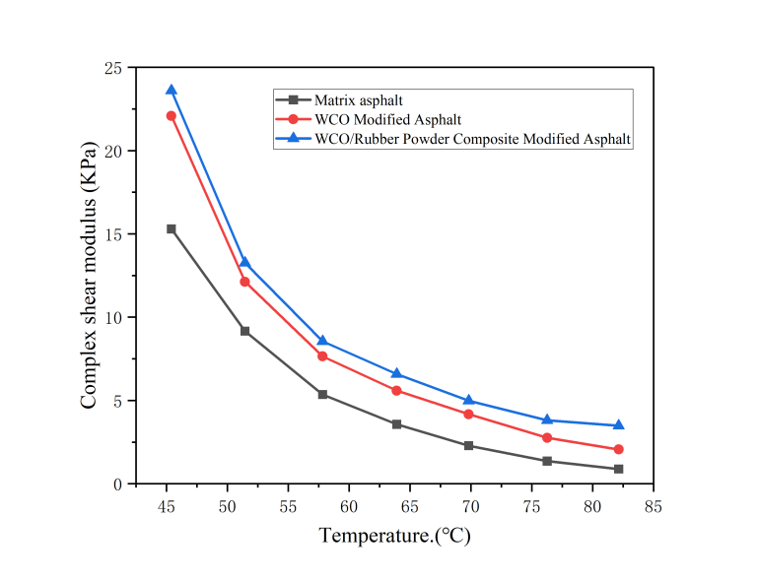
Fig. 1 Complex shear modulus diagram
Figure 1 shows the trend of complex shear modulus (G*) of matrix asphalt, WCO-modified asphalt and WCO/rubber powder composite modified asphalt at different temperatures. As the temperature increases, the complex shear modulus of the three kinds of asphalt shows a significant decrease, indicating that the increase in temperature leads to a decrease in the viscoelasticity of the asphalt material, and its resistance to deformation is weakened. At the same temperature, the complex shear modulus of WCO/rubber powder composite modified asphalt is the highest, followed by WCO modified asphalt, and matrix asphalt is the lowest. This indicates that under the same conditions, the composite modified asphalt has higher stiffness and load carrying capacity, which is conducive to improving the rutting resistance at high temperatures.The higher modulus of WCO modified asphalt compared with matrix asphalt suggests that the waste cooking oil rejuvenator can replenish the light components lost in the aged asphalt and improve the structure of asphalt, which in turn improves the stiffness. The further incorporation of rubber powder, through its polymer network structure in the asphalt to form a reinforcing support, significantly improve the overall stiffness and elastic recovery properties of the material, so that the composite modified asphalt in the range of 46-82 ℃ to maintain a high modulus level.
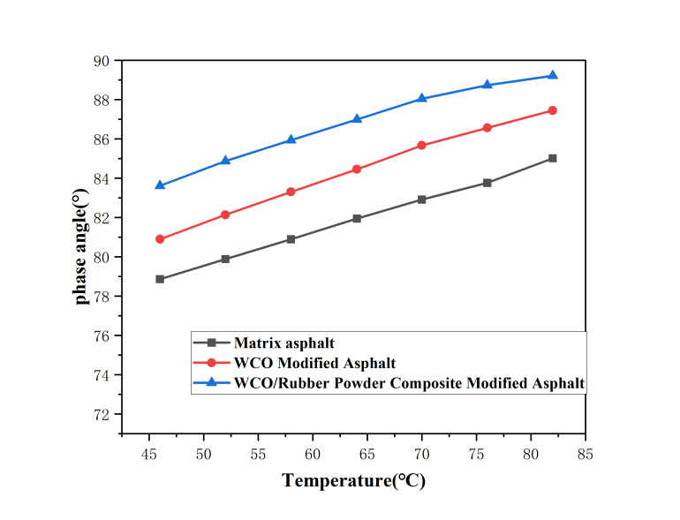
Fig. 2 Phase angle-temperature relationship graph
Fig. 2 shows the variation patterns of phase angle (δ) of matrix asphalt, WCO modified asphalt and WCO/rubber powder composite modified asphalt at different temperatures. With the increase of temperature, the phase angle of the three kinds of asphalt are upward trend, indicating that the increase of temperature makes the asphalt viscoelastic characteristics from elastic dominant to viscous dominant gradually change, and the material mobility is enhanced. At the same temperature, the phase angle of WCO/rubber powder composite modified asphalt is the lowest, followed by WCO modified asphalt, and matrix asphalt is the highest, which indicates that the composite modified asphalt still maintains high elasticity composition at high temperatures, and the viscous proportion of the material is low, which helps to resist the permanent deformation and improve the stability at high temperatures.The phase angle of WCO modified asphalt is lower than that of matrix asphalt, which suggests that the introduction of the waste cooking oil regeneration agent improves the flexibility of asphalt, and the viscous proportion of material increases the flexibility of asphalt. flexibility of the asphalt while being able to enhance the elasticity performance of the asphalt to some extent. After the rubber powder is further incorporated, its polymer chain structure forms a three-dimensional network in the asphalt system, which significantly improves the elastic recovery ability of the asphalt, further reduces the phase angle, and counteracts the viscosity enhancement effect brought about by the increase in temperature. In addition, the synergistic effect of WCO and rubber powder can effectively regulate the asphalt viscoelastic equilibrium relationship, in order to enhance the low-temperature flexibility and cracking resistance of recycled asphalt on the basis of improving the high-temperature rutting resistance, for asphalt pavements in high temperature and heavy-duty traffic conditions to provide a strong support for the application.
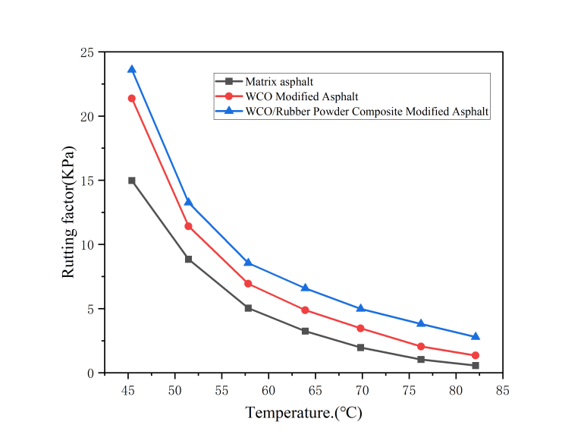
Fig. 3 Rutting factor-temperature relationship
The figure demonstrates the rutting factor (G*/sinδ) change rule of matrix asphalt, WCO modified asphalt and WCO/rubber powder composite modified asphalt at different temperatures. Overall, the rutting factors of the three asphalts decreased significantly with increasing temperature, indicating that the high-temperature rutting resistance of asphalt materials decreases with increasing temperature, showing typical temperature sensitivity characteristics. At the same temperature, the overall rutting factor of matrix asphalt is higher than that of WCO-modified asphalt, while the rutting factor of WCO/rubber powder composite-modified asphalt is in between the two, and shows a relatively high rutting factor in the middle and low temperature section (45-65°C), which suggests that the composite-modified asphalt has a better high-temperature rutting resistance performance in this temperature range. This is mainly attributed to the fact that the incorporation of waste cooking oil (WCO) reduces the stiffness and viscoelastic structure of the asphalt while improving its low-temperature fluidity, leading to a decrease in the high-temperature rutting resistance. The introduction of rubber powder effectively improves the stiffness and viscoelastic energy storage capacity of the asphalt system through the formation of an elastic skeleton and network structure, compensating for the lack of high-temperature performance brought about by the incorporation of WCO, so that the composite modified asphalt in the medium and high temperature zone shows better rutting resistance.
6. Concluding remarks
(1) In comparison to waste cooking oil (WCO)-modified asphalt and base asphalt, the WCO/rubber powder composite-modified asphalt demonstrates notable improvements in key performance indicators. Specifically, its softening point is significantly elevated, which directly reflects enhanced resistance to high-temperature deformation—a critical attribute for asphalt materials used in high-temperature climates or heavy-traffic areas. Meanwhile, the ductility of the composite-modified asphalt is improved to a measurable extent, indicating better flexibility and crack resistance at lower temperatures, which helps mitigate pavement brittleness and fatigue damage. In terms of penetration, the composite-modified asphalt shows a slight reduction relative to the base asphalt, suggesting a moderate increase in hardness that balances the material’s overall stability without compromising workability. Quantitatively, the softening point of the WCO/rubber powder composite-modified asphalt is 5% higher than that of rubber powder-modified asphalt and 13.5% higher than that of base asphalt, underscoring the synergistic effect of WCO and rubber powder in enhancing thermal stability.
(2) Dynamic shear rheological (DSR) analysis further reveals the mechanical superiority of the WCO/rubber powder composite-modified asphalt. By comparing the complex modulus (G*) and phase angle (δ) between base asphalt and the composite-modified asphalt under identical temperature conditions, distinct trends emerge: the base asphalt exhibits the smallest G* (indicating weaker resistance to shear deformation) and the largest δ (suggesting a more viscous, less elastic behavior), whereas the composite-modified asphalt displays the largest G* and the smallest δ. A larger G* signifies greater stiffness and shear resistance, while a smaller δ indicates a higher proportion of elastic behavior in the material’s response to shear stress. Collectively, these results confirm that the incorporation of WCO and rubber powder enhances the composite-modified asphalt’s ability to withstand high-temperature shear forces, thereby improving its resistance to permanent deformation (e.g., rutting) compared to the base asphalt.
(3) A systematic analysis of rutting factors (G*/sinδ) across a range of temperatures (52°C, 58°C, 64°C, 70°C, 76°C, 82°C, and 88°C) in DSR tests provides further evidence of the composite modification’s efficacy. The results indicate that as temperature increases—a condition known to exacerbate asphalt softening and deformation—the rutting factor of the WCO/rubber powder composite-modified asphalt remains consistently higher than that of both rubber powder-modified asphalt and base asphalt under all tested temperature conditions. This trend is particularly significant at elevated temperatures (e.g., 76°C and above), where the composite-modified asphalt’s rutting factor is markedly superior, demonstrating its enhanced capacity to resist rutting in extreme thermal environments. These findings clearly validate that the addition of WCO, when combined with rubber powder, plays a pivotal role in improving the asphalt’s high-temperature stability and rutting resistance, thereby expanding its applicability in demanding pavement scenarios.

Disclaimer (Artificial intelligence)

Option 1:

Author(s) hereby declare that NO generative AI technologies such as Large Language Models (ChatGPT, COPILOT, etc.) and text-to-image generators have been used during the writing or editing of this manuscript.

Option 2:

Author(s) hereby declare that generative AI technologies such as Large Language Models, etc. have been used during the writing or editing of manuscripts. This explanation will include the name, version, model, and source of the generative AI technology and as well as all input prompts provided to the generative AI technology

Details of the AI usage are given below:
1.
2.
3.

References
- Chen M, Leng B, Wu S, et al. Physical,chemical and rheological properties of waste edible vegetable oil rejuvenated asphalt binders[J]. Construction and Building Materials, 2014, (65): 286-298.
- Chen M, Xiao F, Putman B, et al. High temperature properties of rejuvenating recovered binder with rejuvenator, waste cooking and cotton seed oils[J]. Construction and Building Materials, 2014, (65): 63-68.
- Villanueva V A ,Ho H S ,Zanzotto Z L . Asphalt modification with used lubricating oil [J]. Canadian Journal of Civil Engineering,2008,35(2): 31-35.
- Azahar,etal. Chemical modification of waste cooking oil to improve the physical and rh
eological properties of asphalt binder[J]. Construction and Building Materials,2016(26): 218-226.
[5] Dedenne C D.Investigation of using waste engine oil blended with reclaimed asphalt ma
terials to improve paverment reyelbility[D]. Houghton(MI):Michigan Technological Univ
ersity.2011.
[6]Asli H ,Ahmadinia E ,Zargar M , et al. Investigation on physical properties of waste c
ooking oil Rejuvenated bitumen binder[J]. Construction and Building Materials,2012,(3
- : 398-405
[7] Gong M ,Yang J ,Zhang J , et al. Physical–chemical properties of aged asphalt rejuvena
ted by bio-oil derived from biodiesel residue[J]. Construction and Building Materials,20
16,105: 35-45.
[8] JI J， YAO H， SUO Z， et al. Effectiveness of vegetable oils as rejuvenators for aged asphalt binders［J］. Journal of Materials in Civil Engineering，2017，29 （3）： D4016003.
[9] Suo Zhi， JI Jie， MAN Qi， et al. Performance evaluation of regenerated asphalt with vegetable oil ［J］. Journal of Beijing University of Technology, 2016， 42 （7） : 1062- 1065.
[10] Luo Y F， ZHANG K. Review on performance of asphalt and asphalt mixture with waste cooking oil［J］. Materials, 2023, 16（4）: 1341.
[11] Zhang, H., et al. (2023). Performance evaluation of waste cooking oil and rubber powder composite modified asphalt. Construction and Building Materials, 371, 130811.
[12] Xie, J., et al. (2022). Sustainable use of waste plastics in asphalt pavement: A review on material properties, environmental impact and circular economy. Journal of Cleaner Production, 362, 132331.
[13] Ministry of Transport of the People's Republic of China. Test Methods of Bitumen and Bituminous Mixtures for Highway Engineering: JTG E20-2011 [S]. Beijing: People's Communication Press, 2011.

