Opinion Article

Structural Optimization of Reinforced Concrete Bifurcation Pipes Based on Particle Swarm Genetic Hybrid Algorithm

Abstract
With the increasing construction of large-scale hydropower stations and pumped storage power stations, reinforced concrete branch pipes, as a key part of the water conveyance structure, their stability is crucial to the safety of the power stations. Traditional optimization design of branch pipes mostly relies on engineers' experience or optimizations for specific parts, and the application of intelligent algorithms is relatively limited. However, the development of computer technology has made it possible to optimize structures by combining intelligent algorithms. This paper aims to provide a more effective optimization scheme for reinforced concrete branch pipes. The particle swarm genetic hybrid algorithm is adopted, and an optimization platform is built by combining ANSYS and Matlab software. Parametric modeling of branch pipes is carried out through APDL language, and a fitness function is constructed based on stress conditions to screen the population. Verified by CEC standard test functions, the hybrid algorithm exhibits excellent performance in optimization accuracy, ability to escape local optima, and global optimization capability. In practical engineering applications, the volume of the optimized branch pipe is reduced, the concrete consumption is decreased, and the stress and displacement results meet the design specifications. The research shows that the particle swarm genetic hybrid algorithm effectively solves the problems of premature convergence of genetic algorithms and the tendency of particle swarm algorithms to fall into local optima. It provides new ideas and methods for the design optimization of reinforced concrete branch pipes and has important guiding significance for related engineering practices.

Introduction

With the increasing construction of large-scale hydroelectric power stations, especially pumped storage power stations, it is common to adopt schemes of combined water supply and grouped water supply to reduce construction costs and excavation of earth and rock. This requires the use of larger diameter power intake tunnels and bifurcation pipes. Bifurcation pipes, as important components of water transmission structures for hydroelectric and pumped storage power stations, directly affect the safety and stability of these stations[1]. As the requirements for structural performance become increasingly diverse, the application of structural optimization in various fields is becoming more common. The size, load, boundary, and mechanism of joint load-bearing with surrounding rock of reinforced concrete bifurcation pipes are extremely complex, so seeking safe and reasonable designs has become the goal of designers[2]. Currently, optimization studies on reinforced concrete bifurcation pipes mainly use traditional optimization methods[3]. Engineers usually rely on their theoretical knowledge and rich practical design experience to optimize through comparative selection of schemes, or optimize specific parts of bifurcation pipes, such as rounding at the bifurcation point or improving bifurcation angles to address stress concentration issues in certain areas of the pipes[4]. However, the application of intelligent optimization algorithms in structural optimization is limited, mainly due to long optimization cycles, heavy workloads, difficulty in finding economically and safely designed solutions, and inability to fully exploit the performance of bifurcation pipe materials. With the development of science and technology, the demand for bifurcation pipes is increasing, and traditional design methods are no longer able to meet engineering needs[5].

With the advancement of technology and the continuous evolution of computers, it has become possible to optimize structures through the combination of intelligent algorithms. The improvement in computer performance allows finite element software to calculate models with higher precision and more complex structures, while also enabling large-scale computation. Therefore, optimization of actual engineering structures based on intelligent algorithms can be better realized. In recent years, intelligent algorithms have been widely used in the field of structural optimization. Common intelligent algorithms include genetic algorithms, particle swarm algorithms, simulated annealing algorithms, and whale algorithms. With continuous research and improvement of algorithms, more and more improved algorithms are gradually emerging and being applied, ushering in the era of intelligent optimization in structural optimization research[14]. The optimization of structures using intelligent algorithms mainly focuses on optimizing structural dimensions, topological structures, shape optimization, optimization design of composite material laminates, and other structural optimization problems[7]-[9]. Combining intelligent algorithms to optimize the structure of reinforced concrete bifurcation pipes generally involves joint simulation using programming software and finite element analysis software, achieving secondary development of finite element software. Programming software such as Python and Matlab can be used to compile and improve intelligent algorithms, and finite element software is called for calculation through compiled programs. The results of finite element software calculations serve as reference criteria to determine the rationality of optimization results[10].
In order to provide reasonable optimization solutions for reinforced concrete bifurcation pipes, this paper takes a certain pumped storage project as an example and combines an improved genetic algorithm to optimize the dimensions of the bifurcation pipe structure. Ansys APDL language is used to perform parameterized modeling of bifurcation pipes, extract suitable parameters, and achieve automatic input and output of parameters. Matlab is used to write the improved genetic algorithm, and Ansys batch processing mode is called for calculation through programming, thereby optimizing the structure of bifurcation pipes[11]. Through analysis of the optimization results, a theoretical solution is provided for the optimization design of bifurcation pipe structures.
1. Improved Genetic Algorithm Implementation
Genetic Algorithm (GA) and Particle Swarm Optimization (PSO) are two classic evolutionary computation algorithms that have received widespread attention from researchers worldwide since their proposal, and much fruitful research has been conducted on these two algorithms[12].
1.1 Introduction to Genetic Algorithm (GA) and Particle Swarm Optimization (PSO)
Both GA and PSO algorithms simulate the evolutionary process in nature to solve optimization problems. GA algorithm is simple and easy to use, often used for function optimization, data mining, etc., but individuals have no memory, and the convergence speed is slow. PSO algorithm is based on a simple principle and has memory function, suitable for combinatorial optimization, sensor networks, etc., but it is prone to local optima and has a small search range. They can complement each other, utilizing GA's global search and PSO's convergence speed to improve algorithm performance[13].
1.2 Particle Swarm Genetic Hybrid Algorithm

1.2.1 Fitness Function

Evaluating the quality of individuals through a fitness function is crucial in traditional genetic algorithms. The choice of the fitness function is closely related to the objective function. In the initial stages of the algorithm, there may be a very small number of individuals with extremely high fitness values. If traditional selection methods are used, these individuals will reproduce in large numbers and dominate the population, potentially leading to the premature elimination of other individuals with good fitness values. This can result in a decrease in population diversity, which in turn can cause the algorithm to converge prematurely.
This paper primarily establishes the objective function based on stress conditions, used to determine whether the generated new individuals meet the requirements. The fitness function is as follows:

$$\begin{aligned}S_{l}>G\left(x\right) 丨丨 S_{y}>F\left(x\right)，V=3000\#（1）\end{aligned}$$
$$\begin{aligned}S_{l}<G\left(x\right) 丨丨 S_{y}<F\left(x\right)，V={Volu}_{max}\#\left(2\right)\end{aligned}$$

In the formula, $S_{l}$represents the maximum tensile stress obtained from finite element calculations, $S_{y}$ represents the maximum compressive stress obtained from finite element calculations, $G\left(x\right)$represents the tensile limit of concrete, $F\left(x\right)$ represents the compressive limit of concrete, ${Volu}_{max}$ represents the volume of elements generated for each optimization result, and V represents the numerical value of the volume output after determination by the fitness function. If the maximum compressive stress and tensile stress obtained from the finite element model generated by Ansys software exceed the compressive and tensile limits of concrete after calculation, and are determined by the fitness function, then V is set to output the maximum value (the maximum value is set based on specific circumstances, taken as 3000 here); if the maximum tensile stress and maximum compressive stress obtained from the newly generated finite element model are within the bearing range of concrete, then V is set to output the volume of elements of the finite element model.

1.2.2 Crossover Operation
Through crossover operation, gene exchange occurs between parent individuals, generating a large number of new individuals and cultivating new optimal individuals. This paper uses single-point crossover operation with binary encoding. By judging the similarity, different crossover operations are applied to different individuals. Let$X_{i}$ and $X_{j}$be two parent individuals undergoing crossover, and calculate their similarity[14]. Any optimization problem adopts binary encoding, with the encoding space being {0,1}. The formula for calculating the similarity between individuals $X_{i}$ and $X_{j}$is as follows:
$$\begin{aligned}D\left(i,j\right)=\sum_{m=1}^{n}{\frac{\left(d_{m}\left(i,j\right)\right)}{n}}\#\left(3\right)\end{aligned}$$
Where n represents the length of binary encoding, and $d_{m}\left(i,j\right)$ represents whether the values of individuals i and j are the same at position m. It is assumed that if the values of individuals i and j are the same at position m, it is 1, otherwise, it is 0. If individuals i and j have many identical positions, it is not difficult to calculate that the corresponding value of D(i，j) will also be relatively large[15].
When the similarity D between individuals i and j is greater than the predetermined similarity threshold, it indicates that individuals i and j are similar to a large extent. In this case, the ordinary crossover operation may not be very effective, and the probability of generating new individuals is relatively small. Therefore, the method of crossing the first k bits of individual i with the last k bits of individual j is adopted, where k（k$∈$rand（i，n））, as shown in Figure1:

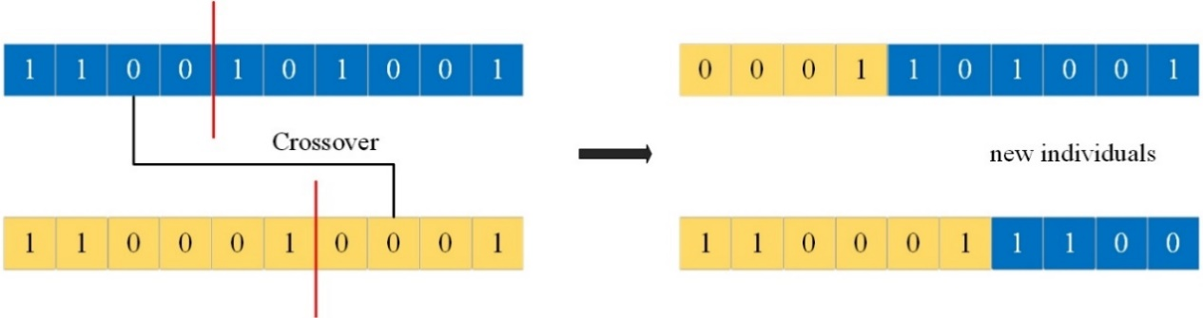
Fig.1 Crossover Diagram

On the contrary, when the similarity D between individuals i and j is less than the predetermined threshold, it indicates that there is a significant difference between individuals i and j. In this case, the single-point crossover method is used to generate new individuals, as shown in Figure 2:

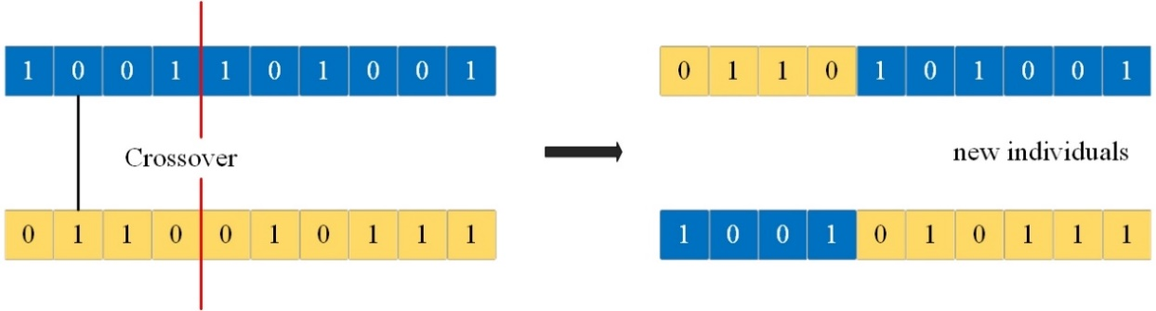
Fig.2 Single-Point Crossover

1.2.3 Improvement of Velocity Update Model
The hybrid algorithm proposed in the paper combines genetic algorithm with particle swarm algorithm, with genetic algorithm as the main component, and mutation operation replacing the update method of the particle swarm algorithm. This algorithm includes both the selection and crossover operations of genetic algorithm and the self-cognition and social cognition of particle swarm algorithm for individual updates[16]. For any population ${POP}_{i}$, assuming that up to the i-th generation, the total number of eligible data generated before the i-th generation is $S_{i}$, then the mutation influence factor of individuals in the subpopulation ${POP}_{i}$, denoted as $ρ_{i}$, is given by $ρ_{i}=1-δ_{i}$, where $δ_{i}$ represents the population improvement rate.
Population Improvement Rate[17]: When the population evolves to the i-th generation, the number of optimal individuals generated before the i-th generation in any population j is denoted as $N_{ji}$. The total number of optimal individuals generated before the i-th generation across the entire population is given by:
$$\begin{aligned}N_{i}=\sum_{j=i}^{n}{N_{ij}}\#\left(4\right)\end{aligned}$$
Therefore, the population improvement rate of population 𝑚m is given by:
$$\begin{aligned}δ_{i}=\frac{N_{I}}{\sum_{i=1}^{n}{N_{i } }}\#\left(5\right)\end{aligned}$$
From equations (4) and (5), we can infer that the more excellent individuals generated, the higher the population improvement rate, and accordingly, the smaller the mutation influence factor, leading to a more stable population. Conversely, if fewer excellent individuals are generated, resulting in a lower population improvement rate, the mutation influence factor will be larger, making the population less stable and more prone to mutation.
To incorporate the population improvement rate into the update step instead of the traditional inertia weight factor in particle swarm algorithm, the specific updating method is as follows:
$$\begin{aligned}V_{i}\left(t+1\right)=ρ_{i}V_{i}\left(t\right)+c_{1}r_{1}\left({POP}_{best}^{i}-X_{i}\left(t\right)\right) \\ +c_{2}r_{2}\left(G_{best}^{i}-X_{i}\left(t\right)\right)\#\left(6\right)\end{aligned}$$
$$\begin{aligned}X_{i}\left(t+1\right)=X_{i}\left(t\right)+V_{i}\left(t+1\right) \#\left(7\right)\end{aligned}$$
From equations (6) and (7), it can be observed that the updating speed of individuals in the subpopulation is directly proportional to the population improvement rate. The level of population improvement rate directly affects the updating speed of particles.
1.3 Algorithm Flow
The algorithm flowchart is shown in the following figure:
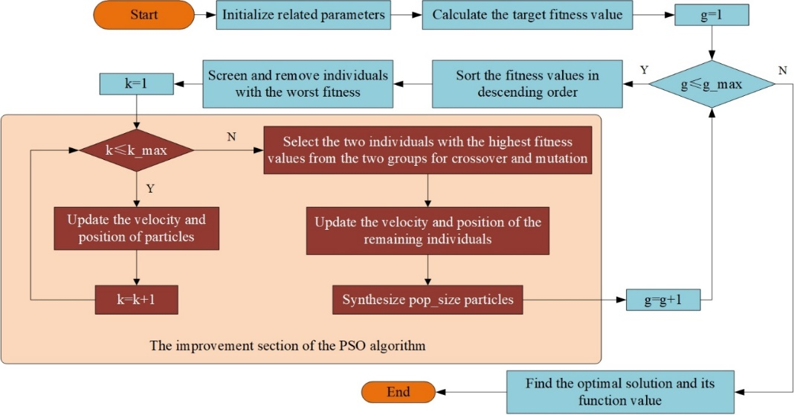
Fig.3 GA-PSO Algorithm Flowchart
1.4 Advantages of the algorithm
The GA-PSO algorithm is a new improved algorithm achieved by combining the advantages of GA algorithm, such as genetic operations, diverse population, and suitability for global search, with the advantages of PSO algorithm, such as easy implementation and fast convergence speed. It addresses the drawbacks of GA algorithm, including individual lack of memory, blind and directionless genetic operations, and long convergence time, as well as the drawbacks of PSO algorithm, such as susceptibility to premature convergence to local optima, low population diversity, and limited search range. This enhancement aims to improve algorithm performance and enhance its optimization capability.
The GA-PSO algorithm exhibits stronger optimization capability compared to traditional PSO and GA algorithms. It requires less convergence time, maintains greater population diversity, explores a wider search space, and can avoid premature convergence to local optima. The advantages of the algorithm are illustrated in Figure 4.
Fig.4 The advantages of the algorithm are illustrated
1.5 Algorithm Testing
To verify that the particle swarm genetic hybrid algorithm has better performance compared to particle swarm algorithm and genetic algorithm, three standard CEC test functions, Sphere, Griewank, and Rastrigin, are selected to evaluate the algorithm's optimization accuracy, ability to escape local optima, and global optimization ability. The expressions for the three functions are as follows:
$F_{1}$: Sphere Function
$$\begin{aligned}f\left(x\right)=\sum_{i}^{N}{{x_{i}}^{2}}\#\left(8\right)\end{aligned}$$
The independent variable$x_{i}$ of the Sphere function takes values in the range: -100<$x_{i}$<100. This function has a unique global minimum, and when x=（0,0，···，0）, the function achieves the global minimum $f_{1}\left(x\right)=0$. Selecting this function is to test the optimization accuracy of the algorithm.
$F_{2}$: Griewank Function
$$\begin{aligned}f\left(x\right)=\frac{1}{4000}\sum_{i}^{N}{{x_{i}}^{2}-\prod_{i}^{N}{cos\left(\frac{x_{i}}{\sqrt{i}}\right)+1}}\#\left(9\right)\end{aligned}$$
The independent variable $x_{i}$ of the Griewank function takes values in the range: -600 <$x_{i}$ < 600. This function contains numerous local extreme values throughout its data distribution, but it has a global minimum $f_{2}\left(x\right)=0$. It represents a complex multimodal complexity problem, so selecting this function aims to test the algorithm's ability to escape local optima and continue searching.
$F_{3}$: Rastrigin Function
$$\begin{aligned}f\left(x\right)=\sum_{i}^{N}{\left[{x_{i}}^{2}-10\cos\left(2πx_{i}\right)+10\right]}\#\left(10\right)\end{aligned}$$
The independent variable $x_{i}$ of the Rastrigin function takes values in the range: -5.12 < $x_{i}$ < 5.12. The function has a global minimum of 0 at x=（0,0，···，0）. It is a nonlinear multimodal function with numerous local minima, making it challenging to find the global minimum. Therefore, using this function can test the algorithm's global optimization ability. After comparison, it can be seen that the hybrid algorithm combining genetic algorithm and particle swarm optimization can greatly enhance its global optimization performance, and the improved particle swarm-genetic hybrid algorithm can still further improve its performance based on this foundation.The test results of the algorithm are shown in the following figure 4-6:

Fig.5 Comparison of Evolutionary Curves for Sphere Function
Fig.6 Comparison of Evolutionary Curves for Griewank Function
Fig.7 Comparison of Evolutionary Curves for Rastrigin Function

2.Parameterized Modeling and Establishment of Optimization Platform
2.1 Parameterized Modeling of Branch Pipes
Establishing a branch pipe model requires determining the parameters of its control body shape based on different branch pipe structural forms, allowing for changes in the size and shape of the branch pipe through these control parameters. In this paper, parameterized modeling of the branch pipe is achieved through Ansys APDL language programming. APDL language is easy to modify and facilitates parameterization and process analysis tasks, serving as the basis for secondary development of Ansys software. Through APDL language, Ansys software can be integrated with programming software such as Matlab for joint simulation.
Taking the diversion pipes of a large-scale pumped storage power station as an example, this paper mainly designs parameters including the branch pipe diameters $R_{1}$ and $R_{2}$, main pipe radii $R_{3}$、$R_{4}$、$R_{5}$, branch pipe wall thicknesses $t_{1}$, $t_{2}$, main pipe wall thicknesses $t_{3}$, $t_{4}$, $t_{5}$, branching angle J, and the truncation angles of the pipe section $J_{1}$ to $J_{5}$ as shown in the figure below:

Fig.8 Diverter pipe plan view
Fig.9 The cross-sectional diagram of the diverter pipe

2.2 Implementation Method of Particle Swarm Genetic Hybrid Algorithm Combined with ANSYS
First, call up the operating path under the ANSYS BANCH mode, then write a program in Matlab to call up the operating path of the ANSYS batch processing mode to perform finite element calculations, thereby achieving the automatic solution of the parameterized model. The specific steps are shown in Figure 9.

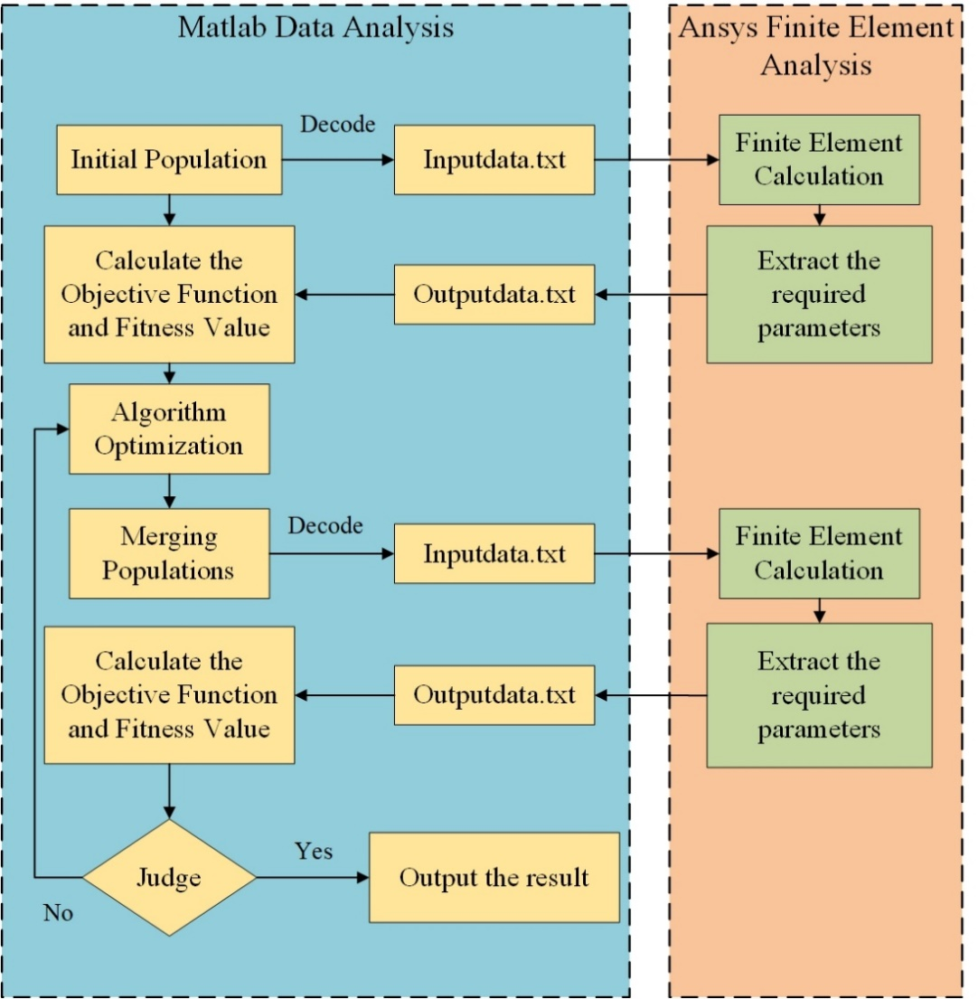
Fig.10 Diagram of Optimization Steps

3. Reinforced Concrete Branch Pipe Structural Optimization
3.1 Project Overview
This paper focuses on the structural optimization of reinforced concrete tailwater branch pipes of a certain pumped storage power station, where the rock thickness ranges from approximately 371m to 403m, and the tailwater branch pipes are lined with C30 concrete. The structural optimization design calculations are carried out under normal operating conditions, considering the effect of rock self-weight. The gap between the reinforced concrete branch pipe and the rock mass is filled with grouted concrete, assuming no gap exists between the branch pipe and the rock mass, and assuming that the concrete lining will not crack. The structural optimization design calculations under normal operating conditions only consider the self-weight of surrounding rock and branch pipes, as well as the geostress from secondary excavation and internal water pressure, without considering external water pressure.
3.2 Selection of Branch Pipe Parameters
The optimized parameters mainly include the wall thickness of the main section of the branch pipe and the branching angle of the branch pipe. Since there are 5 main sections of the branch pipe, there are 6 parameters for optimization (5 wall thicknesses and the branching angle). According to the "Design Specification for Hydraulic Tunnels," the branching angle of the branch pipe is selected within the range of 50° to 90°, and the wall thickness of the branch pipe is selected within the range of 0.5m to 1.0m.
In practical engineering, C30 concrete lining is used, therefore, the stress control standards in this optimization design all use the ultimate compressive and tensile strength of C30 concrete as control standards. The tensile stress control standard is calculated based on the finite element equivalent stress method, where the tensile force borne by the reinforcement is equivalent to the tensile strength of the concrete, and the corresponding design value of concrete tensile strength is increased to 7MPa. Considering that the reinforcement mainly bears tensile stress, its bearing of compressive stress is not significant, and the corresponding compressive strength of concrete remains unchanged. Under this stress constraint condition, the optimized branch pipe meets the requirements of the design specification after calculation.
The extracted parameters are optimized through a pre-written program, and the selection range for parameter optimization is as shown in Table 1:

Table 1 The optimization ranges for the parameters
Optimization parameters | Pipe wall thickness | Branching angle
Selection range | 0.5m~1.0m | 50°~90°

By writing a program, 200 sets of parameters are randomly generated within the ranges of 0.5m to 1.0m and 50° to 90° respectively, serving as the initial population. The minimum values are 0.5m, 0.5m, 0.5m, 0.5m, 0.5m, and 50°, while the maximum values are 1m, 1m, 1m, 1m, 1m, and 90°.
3.3 Optimization Results and Analysis
The average distances between each generation are shown in the following figure 11:

Fig.11 Average distance between individuals

Figure 10 illustrates the average distance between individuals in each generation, which is an important indicator of population diversity. From the graph, it can be observed that the average distance between individuals gradually decreases and tends to zero after the 10th generation. This indicates that the differences between individuals in the population are gradually diminishing during the genetic process. Additionally, it suggests that the optimal value is within the selected 25 generations, and further iterative calculations are unnecessary.
The fitness values for each generation are depicted in Figure 11:

Fig.12 Fitness value

From Figure 11, it can be observed that the optimal fitness value for each generation is consistently around 1150. The average fitness value decreases steadily with an increase in the number of population iterations. After the fifth generation, the optimal fitness value remains almost the same for each subsequent generation. The best fitness value among all individuals is 1126.16. Fitness value represents the unit volume of the reinforced concrete branch pipe model, where smaller fitness values indicate "better" individuals in the population.
3.4 Finite Element Calculation Results
This study aims to minimize the volume of the reinforced concrete branch pipe lining as the objective function, with stress constraints as the main constraints. The optimization range for pipe wall thickness is 0.5m to 1.0m, and for branching angle is 50° to 90°. A total of 200 sets of data were randomly generated as the initial population, and 25 generations of genetic optimization were performed, resulting in 5000 sets of data, as shown in Table 2.

Table 2 Data illustration table
Optimize the area | Minimum value combination | The rest of the data is randomly generated by the algorithm | Maximum value combination
Pipe wall thickness | 0.5m | …… | 1.0m
Pipe wall thickness | 0.5m | …… | 1.0m
Pipe wall thickness | 0.5m | …… | 1.0m
Pipe wall thickness | 0.5m | …… | 1.0m
Pipe wall thickness | 0.5m | …… | 1.0m
Branching angle | 50° | …… | 90°

As the number of iterations increases, the cross-sectional dimensions of the reinforced concrete branch pipe begin to stabilize, and the average distance between populations in each generation gradually decreases. This indicates that the sizes generated by the initial random population are optimized over time, and both the smallest and largest data gradually converge. Subsequently, after evaluating the finite element calculation results, combinations that do not meet the requirements are discarded, resulting in the optimal solution.
From Figure 12, it can be observed that the thickness of the pipe significantly decreases and the branching angle decreases noticeably after optimization. Before optimization, the unit volume was 1798.68, and after optimization, the unit volume is 1126.16, representing a 37.39% reduction in concrete usage. This significant reduction in concrete usage not only reduces material consumption but also decreases excavation of rock and soil.

13-A

13-B

Fig.13 Comparison Chart of Parameters Before and After Optimization
The stress-strain distribution pattern of the surrounding rock and branch pipe is generally consistent before and after optimization. After excavation, the entire surrounding rock is almost entirely in a compressive stress state, with only a small tensile stress area appearing at the bottom of the excavation in the bifurcation zone. Additionally, there is a phenomenon of stress concentration in the bifurcation zone, with the maximum compressive stress reaching -45.76 MPa and -55.84 MPa before and after optimization, respectively. The displacement generated at the top of the chamber is relatively large, directed towards the interior of the chamber, with the extreme displacement occurring at the top of the chamber. The displacement before and after optimization is 0.0026 m and 0.0022 m, respectively. After parameter optimization, the pipe wall becomes significantly thinner, reducing the excavation volume of the chamber. As the excavation radius of the chamber decreases, the displacement at the top of the chamber after excavation also decreases. There is a certain relationship between the displacement of the surrounding rock and the excavation radius of the chamber.
Before and after optimization, the main pipe and branch pipe of the bifurcated pipe are primarily under compression. The maximum compressive stress after optimization is 8.54 MPa, which is much lower than the compressive limit of C30 concrete. Only the crotch of the pipe is under tension, with a tensile stress of 5.04 MPa, which is within the structural tolerance. The maximum displacement of the reinforced concrete bifurcated pipe before optimization is 0.0035 m, and the maximum displacement of the bifurcated pipe structure after optimization is 0.0049 m. According to the "Design Code for Hydraulic Tunnels," the maximum displacement of the optimized bifurcated pipe is within the specified range.
Conclusion
Branch pipes play a crucial role in hydroelectric and pumped storage power stations, serving as core structures in water conveyance systems. The safety and stability of branch pipes directly impact the operational safety of the entire power station. This study aimed to enhance the design and optimization of reinforced concrete branch pipes.
Using ANSYS APDL language for parametric modeling, a finite element model of reinforced concrete bifurcated pipes was established. A MATLAB program was developed to facilitate secondary development of ANSYS, enabling MATLAB to invoke ANSYS batch mode for finite element analysis. This setup facilitated structural optimization through algorithms.
The optimization algorithm employed a particle swarm genetic hybrid algorithm, which combines particle swarm optimization with genetic algorithms. This hybrid approach substituted genetic operations with particle swarm optimization, leveraging the strengths of particle swarm optimization to enhance genetic algorithms. This improvement notably increased computational efficiency, effectively addressing the long convergence time of genetic algorithms and the premature convergence issues typical of particle swarm optimization, which often leads to local optima.
In comparison to traditional particle swarm and genetic algorithms, the particle swarm genetic hybrid algorithm demonstrated superior performance in structural optimization. Its excellent performance was validated through optimization functions, highlighting the advantages of the enhanced algorithm.
Utilizing the optimization platform with improved genetic algorithms, significant reduction in volume of reinforced concrete bifurcated pipes was achieved. Comparative finite element analyses verified the stability of the optimized structure, confirming the feasibility of the optimization program. The reduced volume of the structure indicated decreased excavation and concrete usage, thereby enhancing the project's economic viability.
This study provides novel insights and methodologies for the design and optimization of reinforced concrete bifurcated pipes using the improved algorithm. Practical engineering validation demonstrated the effectiveness and utility of the algorithm, offering valuable references and guidance for engineering practices in related fields.

Statements and Declarations

Ethics approval and consent to participate Not applicable.

Consent for publication Not applicable.

Availability of data and materials The main references for this thesis include the following papers: DOI：10.1155/2015/948584

COMPETING INTERESTS DISCLAIMER:
Authors have declared that they have no known competing financial interests OR non-financial interests OR personal relationships that could have appeared to influence the work reported in this paper.

Disclaimer (Artificial intelligence)

Option 1:

Author(s) hereby declare that NO generative AI technologies such as Large Language Models (ChatGPT, COPILOT, etc.) and text-to-image generators have been used during the writing or editing of this manuscript.

Option 2:

Author(s) hereby declare that generative AI technologies such as Large Language Models, etc. have been used during the writing or editing of manuscripts. This explanation will include the name, version, model, and source of the generative AI technology and as well as all input prompts provided to the generative AI technology

Details of the AI usage are given below:
1.1
2.1
3.1

References
- Wang, J., Yang, H., & Wang, M. (2021). Stability analysis of surrounding rock for underground high-pressure reinforced concrete branch pipe structures. Yunnan Water Power, 37(07), 97-100.
- Ren, T., Zhang, L., Wang, W., & Xu, S. (2020). Three-dimensional finite element structural analysis of reinforced concrete branch pipes at the bottom of the tailwater surge chamber. Hydropower and Pumped Storage, 6(04), 71-77.
- Cheng, D., Su, K., & Shi, Y. (2015). Optimization of reinforced concrete branch pipe structures. Advances in Science and Technology of Water Resources, 35(01), 89-94.
- Y. Wang, K. Su, H.-g. Wu, Z.-d. Qian, Flow Characteristics of Large Hydropower Bifurcation Under Structure Rounding Optimization, International Journal of Civil Engineering 15(4A) (2017) 515-529.
- Su, C., et al., Optimization Design and Application of Underground Reinforced Concrete Bifurcation Pipe. Mathematical Problems in Engineering, 2015. 2015: p. 1-7.
- Lin Shijie, Dong Chen, Chen Mingzhi, et al. A Review of Novel Swarm Intelligence Optimization Algorithms [J]. Computer Engineering and Applications, 2018, 54(12): 1-9.
- Duan, J.G., et al., Controller of Fatigue Testing Machine for Aerospace Thermal Connections based on Improved NSGA-III Algorithm. Arabian Journal for Science and Engineering, 2022. 47(2): p. 1873-1883.
- Wang, Y.Q., et al., Shape Optimization of Single-Curvature Arch Dam Based on Sequential Kriging-Genetic Algorithm. Applied Sciences-Basel, 2019. 9(20): p. 12.
- Aldwaik, M. and H. Adeli, Advances in optimization of highrise building structures. Structural and Multidisciplinary Optimization, 2014. 50(6): p. 899-919.
- Zhou, Z. H., Liu, R. T., Zhu, Z. H., Gong, W., & Yu, Z. W. (2021). Vehicle travel analysis of long-span railway suspension bridge based on ANSYS-MATLAB co-simulation. Journal of Traffic and Transportation Engineering, 21(02), 117-128.
- Liu, Y. M., Liu, D. Y., & Liu, S. H. (2013). Optimization of dead load cable force of cable-stayed bridge based on MATLAB and ANSYS co-simulation. Journal of Chongqing Jiaotong University (Natural Science Edition), 32(06), 1111-1114+1194.
- Papazoglou, G. and P. Biskas, Review and Comparison of Genetic Algorithm and Particle Swarm Optimization in the Optimal Power Flow Problem. Energies, 2023. 16(3): p. 25.
- Feng, L., Cai, C., Qi, C., et al. (2005). Research progress on the comparison of PSO and GA and their hybrid algorithms. Control Engineering of China, (S2), 93-96.
- Ma, H.P., et al., A comprehensive survey on NSGA-II for multi-objective optimization and applications. Artificial Intelligence Review, 2023: p. 54.
- Yang, H. X., Liu, Z. W., Wang, J., Wang, X. S., & Xie, P. H. (2010). An improved hybrid particle swarm optimization algorithm. Computer Applications, (06), 1516-1518.
- Wang, D.S., D.P. Tan, and L. Liu, Particle swarm optimization algorithm: an overview. Soft Computing, 2018. 22(2): p. 387-408.
- Hanoon, A. N., Jaafar, M. S., Hejazi, F., & Abdul Aziz, F. N. (2017). Energy absorption evaluation of reinforced concrete beams under various loading rates based on particle swarm optimization technique. Engineering Optimization, 49(9), 1483-1501.

