Contamination of Surface Water around Coal Mining Sites in Ankpa Local Government Area, Kogi State, Nigeria

***Original Research Article***

.

ABSTRACT

|  |
| --- |
| **Aims:** This study was conducted to evaluate the impact of coal mining activities on surface water quality around coal mining sites in Ankpa Local Government Area (LGA), Kogi State in June, 2024.  **Methodology:** A total of 36 water samples (12 samples each from upstream, midstream and downstream) were collected using 1-liter plastic container, preserved in ice-chest and transported to the laboratory for analysis. Heavy metals (Aluminum – Al, Iron - Fe, Chromium - Cr, and Zinc - Zn) and microbial analysis were conducted using standard laboratory procedures. Data collected was analyzed for descriptive statistics using GENSTAT Discovery Software.  **Results:** Among the heavy metals analyzed, Al concentrations were within the lowest range (0.83 to 0.86 mg/L) but higher than secondary maximum contaminant level (SMCL). Conversely, the concentration of Fe across all sites were highest (6.55 to 6.61 mg/L). The chromium levels were within 1.85 to 1.95 mg/L which is higher than the WHO provisional guideline value of total chromium. Zinc levels across the sites were relatively stable (3.93 to 3.96 mg/L). Higher deposition of coliform were at the downstream while bacteria growth was only observed in the midstream. Salmonella spp, Shigella spp, and Enterobacter spp were recorded in all the sampling sites. At the upstream, the coliform count was 6.0 x 10⁵ cfu/ml, which was the lowest. At midstream, the coliform count was 4.0 x 10⁶ cfu/ml while downstream had values of 5.6 x 10⁶ cfu/ml. There was no bacterial growth at the upstream and downstream using nutrient agar and MacConkey agar.  **Conclusion:** The findings underscore the need for regular water quality monitoring, environmental remediation efforts, and enhanced community engagement to mitigate the environmental and public health risks posed by coal mining activities in coal mining sites in Ankpa LGA, Kogi State, Nigeria. |

*Keywords: Coal mining, Surface water, Contamination, Microbial analysis, Heavy metals.*

1. INTRODUCTION

Coal resources are considered an essential conventional energy source and an important factor in developing the national economy. Nigeria as a case study holds enormous coal reserves, which is estimated about 2 billion metric tons. Coal mines has been a source of employment for many Nigerians, and it also served as a dependable energy sources for both industrial and domestic users. However, in quest to harvest this mineral, human activity has exerted immense impacts on the environment. The main activities of coal mining (exploration, development, extraction, concentration, processing, refinement and deactivation) have a variety of impacts which include soil damage, air pollution and water contamination. Osseini *et al*. (2024) reported harmful levels of air quality index (155.8-156.4 and 151-200 during wet season and dry season respectively) in communities (Ika and Odele) situated 500-meter radius of Ika-Ogboyaga and Okaba mining sites, Kogi East, Nigeria. Similarly, the study of Ahmad and Ameh (2024) on ambient air quality in coal mining communities of Ika-Ogboyaga and Odele in Ankpa, Kogi East, Nigeria revealed air pollution with associated health risks rising from air pollution index (API) - PM2.5 = 153.6 and PM10 = 68.3. The study of Ahmad and Rabiu (2024) pointed out that coal mining activities within Ika-Ogboyaga and Okaba, Kogi East, Nigeria contaminates surface waters in the region with significant impact on water quality parameters such as total dissolved solids, salinity, total hardness, biological oxygen demand (BOD), chemical oxygen demand (COD), nitrates.

About 55 % of the world’s population are presently exposed to clean water scarcity no less than one month each year compared with 47 % faced with water quantity aspects only (Jones et al., 2024). This exposure to clean water scarcity both currently and in the future are typically highest in developing countries especially in sub-Saharan Africa that are affected by a combination of water quantity and quality aspects. Developing efficient strategies to mitigate and avert water contamination requires the understanding of the multidimensional nature of the natural and anthropogenic factors contributing to water pollution (Nwokediegwu et al., 2024). Contamination of water system is of global concern due to the potential toxicity of metals from mines and their deleterious effects on the biota (Kumar et al., 2019). Rivers and lakes can act both as sinks and secondary sources of metals for the adjacent marine environment while river inputs are the dominant transport pathway of metals from the land to the sea. Leachate from coal waste heaps causes pollution of surface and groundwater by acid mine drainage which includes the dissolving and seepage of heavy metals into ground and surface water (Kamble and Kumbhar, 2019). Heavy metals that enter water ecosystems are ultimately adsorbed into the sediments, and may bio-accumulate to benthic organisms and subsequently to the food chain (Orata and Sifuna, 2023). Areas that coals have been explored but not rehabilitated are a source of water pollution (Burger and Zipper. 2018). This is mainly because of acid mine drainage (AMD), due to pyrite oxidation (FeS2). These abandoned sites often have coal tailings, which are ore waste of coal mines, and are typically a mud-like material. Previous research reported by Park et al. (2019) have shown that coal tailings are a potential source of AMD. Acid mine drainage is the chemical process where sulfide-bearing minerals are oxidized to create acidic conditions in effluents. Heavy metals such as Lead (Pb), cadmium (Cd), chromium (Cr), manganese (Mn) to mention in few are examples of toxic metals when consumed above the permissible level can lead to lingering ailments such as kidney problem, high blood pressure, liver crises, and skin irritation (Jamshaid et al., 2018). Coal miners can suffer health problems from the inhalation of hazardous substances like coal micro-particles, nanoparticles including its by-products (Gasparotto and Martinello, 2021). Such diseases include pneumoconiosis- black lung disease, silicosis, emphysema and chronic bronchitis, thrombosis, atherosclerosis, cardiac hypertrophy, tuberculosis, hearing loss, decline in semen volume and seminal viscosity, and other occupational diseases (Finkelman et al., 2021; Wen et al., 2021).

* 1. **Aim of Study**

The aim of the study was to assess microbial and heavy metal contamination of surface water in coal mining sites in Ankpa local government area (LGA), Kogi State, Nigeria.

2. material and methods

2.1 Study location

The study locations were surface water around coal mining sites (Ika Ofugo road, Ika Odokpono, and Ika Ogboyaga) in Enjema District, Ankpa LGA, Kogi State, Nigeria (Fig. 1).

**2.2 Sample Collection**

A total of thirty-six (36) water samples (12 samples each from upstream, midstream and downstream) with 1-liter plastic container, preserved in ice-chest and was transported to the laboratory.

**2.3 Laboratory Analysis**

The laboratory determination of heavy metals (Al, Fe, Cr, and Zn) was by atomic absorption spectrometric and microbial analysis (total plate count, total coliform count and E. coli) was completed using standard methods of APHA/AWWA/AWEF (2012).

**2.4 Statistical Analysis**

Data collected was analyzed for descriptive statistics (mean, grand mean, and standard error of mean) using GENSTAT Discovery Software.

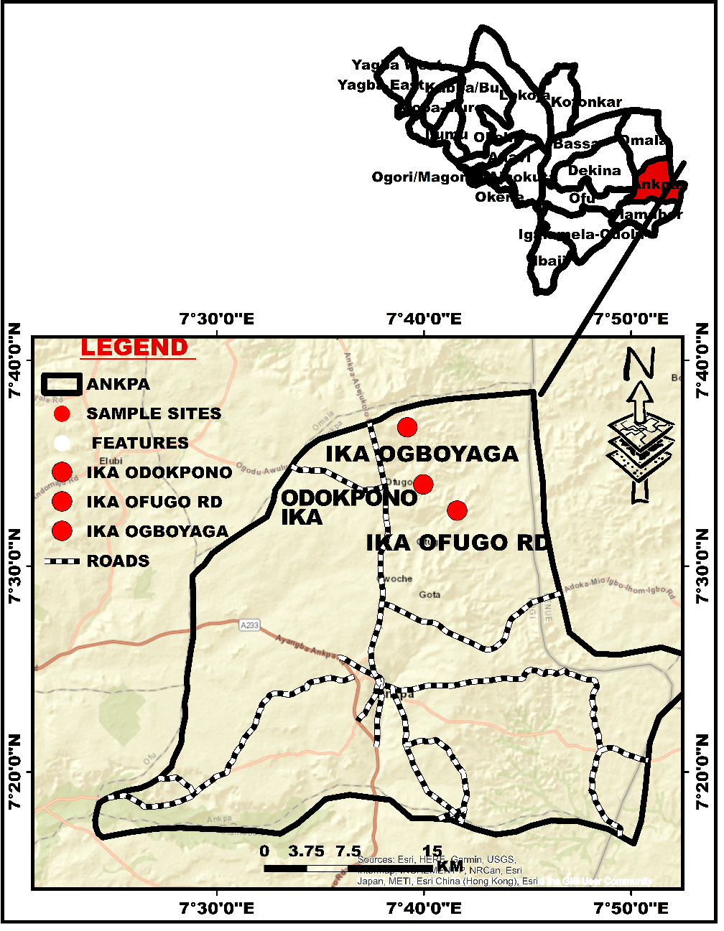

**Fig. 1: Map of Study Area**

3. results

**3.1 Heavy metal contamination of Surface Water in Coal Mining Sites in Ankpa Local Government Area, Kogi State, Nigeria**

Table 1 shows the concentrations of heavy metals (Iron (Fe), Zinc (Zn), Chromium (Cr), and Aluminum (Al) in surface water at three sampling sites: Upstream, Midstream, and Downstream in coal mining areas in Ankpa Local Government Area, Kogi State. The concentration of iron is relatively high across all sites, ranging from 6.55 mg/L to 6.61 mg/L. Zinc concentrations are fairly consistent, ranging from 3.93 mg/L to 3.96 mg/L. Chromium levels show a slight variation, with concentrations ranging from 1.85 mg/L to 1.95 mg/L. while aluminum concentrations are the lowest among the metals, ranging from 0.83 mg/L to 0.86 mg/L.

**Table 1. Heavy metal contamination of Surface Water in Coal Mining Sites in Ankpa Local Government Area, Kogi State, Nigeria**

|  |  |  |  |  |
| --- | --- | --- | --- | --- |
| **Sampling Site** | **Fe** | **Zn** | **Cr** | **Al** |
| **Mg/L** | | | |
| Upstream | 6.61 | 3.96 | 1.95 | 0.86 |
| Midstream | 6.58 | 3.93 | 1.85 | 0.83 |
| Downstream | 6.55 | 3.95 | 1.92 | 0.84 |
| Grand mean | 6.58 | 3.94 | 1.90 | 0.84 |
| Standard Error of Mean | 0.013 | 0.005 | 0.017 | 0.005 |

**2.2 Mean Coliform count Agar of surface water in coal mining sites in Ankpa Local Government Area, Kogi State, Nigeria**

Table 2 shows the mean coliform count in colony-forming units per milliliter (cfu/ml) for surface water at three different locations (Upstream, Midstream, and Downstream) in coal mining areas within Ankpa Local Government Area, Kogi State. At the upstream, the coliform count was seen to be 6.0 x 10⁵ cfu/ml, which was the lowest. While at the midstream, the coliform count increases significantly to 4.0 x 10⁶ cfu/ml. Furthermore, downstream was seen to have a coliform count slightly lower than midstream with a value of 5.6 x 10⁶ cfu/ml.

**Table 2. Mean Coliform count Agar of surface water in coal mining sites in Ankpa Local Government Area, Kogi State, Nigeria**

|  |  |
| --- | --- |
| **Location** | **Coliform count Agar (cfu/ml)** |
| Upstream | 6.0 x 105 |
| Midstream | 4.0 x 106 |
| Downstream | 5.6 x 106 |

**2.3 Mean Total Bacteria of Surface Water in Coal Mining Sites in Ankpa Local Government Area, Kogi State, Nigeria**

The mean total bacterial count in colony-forming units per milliliter (cfu/ml) for surface water at three different locations (upstream, midstream, and downstream) in coal mining areas within Ankpa Local Government Area, Kogi State is presented in Table 3. At the upstream and downstream, Nutrient Agar was observed to have No bacterial growth while the MacConkey Agar also detected No bacterial growth respectively. However, the midstream was seen the Nutrient Agar detected the bacterial count to be 1.96 x 10⁶ cfu/ml and MacConkey Agar, bacterial count to be 3.1 x 10⁵ cfu/ml.

**Table 3. Mean Total Bacteria of Surface Water in Coal Mining Sites in Ankpa Local Government Area, Kogi State, Nigeria**

|  |  |  |
| --- | --- | --- |
| Location | **Nutrient Agar(CfU/ml)** | **MacConkey Agar cfu/ml** |
| Upstream | No growth | No growth |
| Midstream | 1.96 x 106 | 3.1 x 105 |
| Downstream | No growth | No growth |

**2.4 Bacteria occurrence in Surface Water in Coal Mining Sites in Ankpa Local Government Area, Kogi State**

Table 4 provides information on the occurrence of specific bacteria in surface water at three locations (Upstream, Midstream, and Downstream) in coal mining areas within Ankpa Local Government Area, Kogi State. From the results, it was observed that *Enterobacter spp*. was found at all three locations (Upstream, Midstream, and Downstream). *E. coli* was not found in the upstream and midstream areas but detected in downstream. *Salmonella spp*. was detected to be present at all three locations. *Bacillus spp.* was detected only in the upstream area. *Lactobacillus spp*. was found in midstream and downstream areas but absent upstream. However, *Shigella spp*. was found in all three locations.

**Table 4. Bacteria occurrence in Surface Water in Coal Mining Sites in Ankpa Local Government Area, Kogi State, Nigeria**

|  |  |  |  |
| --- | --- | --- | --- |
| **Presumptive Bacteria Isolated** | **Upstream** | **Midstream** | **Downstream** |
| *Enterobacter spp* | + | + | + |
| *E.coli* | - | - | + |
| *Salmonella spp* | + | + | + |
| *Bacillus spp* | + | - | - |
| *Lactobacillus spp* | - | + | + |
| *Shigella spp* | + | + | + |

3. discussion

3.1 Heavy metal concentrations

Among the heavy metals analyzed, aluminum concentrations were within the lowest range (0.83 to 0.86 mg/l). This consistent with the findings of Bakyayita et al. (2019) that lower levels of aluminum are typically found in surface water compared to other heavy metals. Naturally, the concentrations of aluminum in waters is low. However, mineralogical and physicochemical and mineralogical factors such as the dissolving of minerals in soils by acid rain and subsequent transport to water sources can increase the levels of aluminum in surface waters. It is also possible that the coal mining in the region would contribute to acidic nature of the surface waters. The WHO (1998) pointed out that the values of dissolved aluminum in waters with near-neutral pH can normally be within 0.001 to 0.05 mg/l but can increase to within 0.5 to 1 mg/l in more acidic waters or water high in organic matter. The secondary maximum contaminant level (SMCL) for al is 0.1 to 0.2 mg/l (WHO, 2004). Conversely, the concentration of iron across all sites were highest (6.55 to 6.61 mg/l). This consistency in elevated iron levels across upstream, midstream, and downstream suggests a significant impact from mining activities as high iron concentrations are commonly associated with mining effluents (Cao et al., 2024). Generally, the iron concentrations of soils of the mining sites and non-mining areas of the study location have been reported to be 5.95 mg/l and 5.94 mg/l respectively (Ahmad et al., 2025). This implies that coal mining operations including acid mine drainage have no impact on the concentration of iron in the study locations. Although, no guideline value for iron in drinking-water is proposed, 2 mg/l may not give negative health problems (WHO, 2003). The chromium levels (1.85 to 1.95 mg/l) were higher than the WHO (2003) provisional guideline value of total chromium of 0.05 mg/l. The mining of coal including the disposal of its waste around the mining sites would have contributed to the release of chromium into the surface waters. Also, the contamination of the surface waters by chromium can be as a result of mobilization of chromium from surrounding rocks and soils by acid mine drainage. Zinc levels in the surface waters around the coal mining sites were relatively stable (3.93 to 3.96 mg/l). Similar concentration of zinc (3.99 g/l) was reported for soils in mining sites of the study location (Ahmad et al., 2025). Nonetheless, values of zinc concentration above 3 mg/l in drinking-water may constitute health hazards.

3.2 Coliform bacteria contamination

The mean coliform counts in surface water at the coal mining sites show a significant increase from upstream to downstream. coliform counts increased substantially at the midstream site to 4.0 x 10⁶ cfu/ml and further increased to 5.6 x 10⁶ cfu/ml at the downstream site. this pattern suggests potential contamination or pollution sources impacting the water quality progressively from upstream to downstream. elevated coliform levels in mining areas can be associated to poor sanitation/waste management practices, acid mine drainage from mining sites (Azad et al., 2024; Ashong et al., 2025).

The occurrence of specific bacteria varied by location. *Enterobacter spp.* was detected at all sites indicating its widespread presence in the environment. *E. coli* was found only at the downstream site, which could point to fecal contamination or other sources of *E. coli* in the downstream areas. *Salmonella spp*. was present in all three locations highlighting its persistence in the aquatic environment. *Bacillus spp*. was detected only at the upstream site, suggesting that this bacterium may be more prevalent in less contaminated areas or where environmental conditions favor its growth (Santos et al., 2019). *Lactobacillus spp.* was found in the midstream and downstream areas but absent in upstream, possibly reflecting shifts in microbial communities due to contamination. *Shigella spp.* was observed at all locations, indicating its widespread and potential for causing health problems.

4. Conclusion

The results from this study suggest that most heavy metals (Al, Fe, and Cr) analysed were above the permissible limits. Higher deposition of coliform was observed at the downstream while bacteria growth was only observed in the midstream. Salmonella spp, Shigella spp, and Enterobacter spp were recorded in all the sampling sites. The findings from this research points out the need for regular water quality monitoring programs to track heavy metal concentrations and bacterial levels in the surface water of the coal mining areas studied. On the other hand, there should be stricter pollution control measures, environmental remediation efforts, and enhanced community engagement to mitigate the environmental and public health risks posed by coal mining activities in Ankpa LGA, Kogi State, Nigeria.

COMPETING INTERESTS DISCLAIMER:

Authors have declared that they have no known competing financial interests OR non-financial interests OR personal relationships that could have appeared to influence the work reported in this paper.

Disclaimer (Artificial intelligence)

Option 1:

Author(s) hereby declare that NO generative AI technologies such as Large Language Models (ChatGPT, COPILOT, etc.) and text-to-image generators have been used during the writing or editing of this manuscript.

Option 2:

Author(s) hereby declare that generative AI technologies such as Large Language Models, etc. have been used during the writing or editing of manuscripts. This explanation will include the name, version, model, and source of the generative AI technology and as well as all input prompts provided to the generative AI technology

Details of the AI usage are given below:

1.

2.

3.

References

Ahmad, H. A., & Ameh, U. (2024). Investigating ambient air quality in the coal mining communities of Ika-Ogboyaga and Odele in Ankpa, Kogi East, Kogi State, Nigeria. International Journal of Environmental Research and Earth Science, 3(4).

Ahmad, H. A., Rabiu, M. (2024). Physico-chemical properties of surface water quality under the coal mining belt of Kogi State. Ethiopian Journal of Environmental Studies & Management, 17(3).

Ahmad, H. A., Rabiu, M., & UC, A. (2025). Assessing the impacts of coal mining on soil quality in Kogi East, Nigeria. International Journal of Plant & Soil Science, 37(1), 88-97.

APHA-AWWA-WEF (2012). Standard Methods for the Examination of Water and Wastewater. 22nd Edition. Washington 3-61 to 3-64, method 3500-Al.

Ashong, G. W., Kwaansa-Ansah, E. E., Ababio, B. A., Yagra, E. A., & Antwi, G. (2025). Pollution profiling and quality assessment of Bonsa River, Tarkwa Nsuaem, Ghana; Toxic element, Ecotoxicology, Health risk assessment, and Multivariate analysis. Environmental Challenges, 18, 101078.

Azad, M. A. A., Chiddiq, A. B., Miah, M. R., & Sabbir, M. H. R. (2024). Temporal assessment of water and soil quality near Barapukuria coal mine, Bangladesh. Heliyon, 10(23).

Bakyayita, G. K., Norrström, A. C., & Kulabako, R. N. (2019). Assessment of levels, speciation, and toxicity of trace metal contaminants in selected shallow groundwater sources, surface runoff, wastewater, and surface water from designated streams in Lake Victoria Basin, Uganda. Journal of Environmental and public health, 2019(1), 6734017.

Burger, J. A., and Zipper, C. E. (2018). How to restore forests on surface-mined land.

Cao, J., Guo, Z. H., Xu, R., Cai, W. J., & Xiao, X. Y. (2024). Source quantitative identification and control for preferential contaminants in stream sediments from an abandoned lead/zinc mine. Journal of Central South University, 31(4), 1107-1120.

Finkelman, R. B., Wolfe, A., and Hendryx, M. S. (2021). The future environmental and health impacts of coal. Energy Geoscience, 2(2), 99-112.

Gasparotto, J., & Martinello, K. D. B. (2021). Energy Geoscience. Energy, 2, 113e120.

Jamshaid, M., Khan, A. A., Ahmed, K., and Saleem, M. (2018). Heavy metal in drinking water its effect on human health and its treatment techniques-a review. Int. J. Biosci, 12(4), 223-240.

Jones, E. R., Bierkens, M. F., & van Vliet, M. T. (2024). Current and future global water scarcity intensifies when accounting for surface water quality. Nature Climate Change, 14(6), 629-635.

Kamble, P. H., & Kumbhar, J. S. (2019). An overview of the impact of coal mining on water resources. Int. J. Sci. Res. in Multidisciplinary Studies, 5, 12.

Kumar, V., Thakur, R. K., and Kumar, P. (2019). Assessment of heavy metals uptake by cauliflower (Brassica oleracea var. botrytis) grown in integrated industrial effluent irrigated soils: A prediction modeling study. Scientia horticulturae, 257, 108682.

Nwokediegwu, Z. Q. S., Daraojimba, O. H., Oliha, J. S., Obaigbena, A., Dada, M. A., & Majemite, M. T. (2024). Review of emerging contaminants in water: USA and African perspectives. *International Journal of Science and Research Archive*, *11*(1), 350-360.

Orata, F., & Sifuna, F. (2023). Uptake, bioaccumulation, partitioning of lead (Pb) and cadmium (Cd) in aquatic organisms in contaminated environments. Lead Mercury Cadmium Aquat. Environ, 166, 181.

Osseini, U. E., Muhammed, R., Edicha, J. A., & Hassan, S. M. (2024). Comparative Analysis of Indoor Air Quality in Coal Mining Communities During Wet and Dry Seasons in the Coal Mining Belt of Kogi East, Nigeria. African Journal of Environmental Sciences and Renewable Energy, 15(1), 01-23.

Park, I., Tabelin, C. B., Jeon, S., Li, X., Seno, K., Ito, M., and Hiroyoshi, N. (2019). A review of recent strategies for acid mine drainage prevention and mine tailings recycling. Chemosphere, 219, 588-606.

Santos, M. S., Nogueira, M. A., & Hungria, M. (2019). Microbial inoculants: reviewing the past, discussing the present and previewing an outstanding future for the use of beneficial bacteria in agriculture. Amb Express, 9(1), 205.

Wen, S., Lin, Z., Zhang, Y., Lv, F., Li, H., Zhang, X., and Zhang, H. (2021). The epidemiology, molecular, and clinical of human adenoviruses in children hospitalized with acute respiratory infections. Frontiers in Microbiology, 12, 629971.

World Health Organization (WHO, 1997). Aluminium. Geneva, World Health Organization, International Programme on Chemical Safety (Environmental Health Criteria 194).

WHO (2003) Chromium in drinking-water. Background document for preparation of WHO Guidelines for drinking-water quality. Geneva, World Health Organization (WHO/SDE/WSH/03.04/4).

WHO (2004). Guidelines for drinking-water quality (Vol. 1). World health organization.