**Original Research Article**

**Evaluating and Assessing Scientific Trends and Impact of Diabetic Nephropathy Research: A Scientometric Analysis**

***Abstract:***Diabetic nephropathy (DN), a leading microvascular complication of diabetes mellitus, continues to impose a growing global health burden. This study aims to examine the research output, global contributions, impact indicators, collaboration networks, and evolving research trends in DN literature published between 2020 and 2024. A refined dataset of 4,255 Scopus-indexed documents was analysed using Microsoft Excel, VOSviewer, and Biblioshiny for bibliometric mapping, co-authorship visualization, keyword clustering, and trend detection. DN research exhibited an annual growth rate of 11.07%, with dominant output from China and rising international collaboration. However, citation metrics revealed a decline in Average Citations per Publication, reflecting a widening gap between volume and impact. Highly cited studies emphasized molecular therapies and precision diagnostics. Thematic maps revealed dominant clusters on oxidative stress, inflammation, and diabetic kidney disease, alongside emerging topics like bioinformatics and gut microbiota. This study presents a comprehensive visualization of DN’s knowledge landscape, identifying key contributors, global partnerships, and thematic trajectories.

***Key Words:***

Scientometric Analysis, Diabetic Nephropathy (DN), Diabetic Kidney Diseases, Scientific Research Trends. Collaboration Networks

1. **INTRODUCTION:**

The global escalation of diabetes prevalence has inevitably brought with it a surge in associated complications like diabetic nephropathy (DN), which has become a principal contributor to end-stage renal disease (ESRD) worldwide (Alicic et al., 2017). As one of the most serious microvascular outcomes of diabetes mellitus, DN significantly elevates both morbidity and mortality rates among affected individuals, underscoring the urgent need for timely diagnosis and effective intervention strategies (Thomas et al., 2015). In recent years, the growing scientific interest in biomarker discovery has brought precision medicine to the forefront of DN research. Biomarkers aimed at early detection and disease progression have gained traction for their potential to refine prognosis and personalize treatment. In tandem with these advances, there has been a marked shift toward the use of scientometric approaches to understand the evolving landscape of DN research better.

Scientometrics—through the use of bibliometric indicators and statistical methodologies—offers a structured, data-driven means of mapping research output, collaboration networks, and intellectual structure (Donthu et al., 2021). The interdisciplinary nature of DN studies has grown markedly, integrating insights from nephrology, molecular biology, pharmacology, and computational health sciences (Moral-Muñoz et al., 2020). With the advent of analytical tools such as VOSviewer and Biblioshiny—both supported in the R programming environment—researchers are now better equipped to visualize co-authorship dynamics, keyword co-occurrence, and citation networks (van Eck & Waltman, 2010; Aria & Cuccurullo, 2017). VOSviewer excels in generating bibliometric network maps, while Biblioshiny facilitates interactive and exploratory data analysis, enabling a more nuanced and visually enriched investigation. However, despite these thematic investigations, there remains a notable absence of comprehensive scientometric analyses that leverage both VOSviewer and Biblioshiny simultaneously. To address this gap, the present study aims to provide a global scientometric assessment of diabetic nephropathy literature, synthesizing contributions from 2020 to 2024. By mapping intellectual structure, highlighting prolific contributors, and identifying thematic frontiers, this research seeks to inform future academic inquiry and guide strategic investments in diabetic kidney disease research.

1. **OBJECTIVES OF THE STUDY**
2. To study the research output and growth of Diabetic Nephropathy research during the study period.
3. To identify and examine the top contributions based on authors, institutions, and countries.
4. To evaluate the impact of diabetic nephropathy research using appropriate scientific indicators.
5. To visualize co-authorship and collaboration patterns using pertinent visualization tools.
6. To analyse the current research themes and emerging trends of diabetic nephropathy research.
7. **RESEARCH METHODOLOGY**

A comprehensive scientometric analysis was conducted by retrieving literature on Diabetic Nephropathy and Diabetic Kidney Disease from 2020 to 2024. An initial dataset of 4,905 records from the Scopus database was refined using inclusion filters for article types (articles, reviews, book chapters, conference papers), publication stage (final), and language (English), and identified 4,255 scholarly documents. These records were exported and processed in Microsoft Excel for preliminary sorting and frequency tabulation. Subsequent bibliometric mapping and network visualizations were developed using R's Biblioshiny interface and VOSviewer, enabling in-depth analysis of co-authorship, citation networks, keyword co-occurrence, and thematic evolution within the research landscape.

1. **ANALYSIS, INTERPRETATION, AND DISCUSSION**
2. **Descriptive Bibliometric Profile of Diabetic Nephropathy Research (2020–2024)**

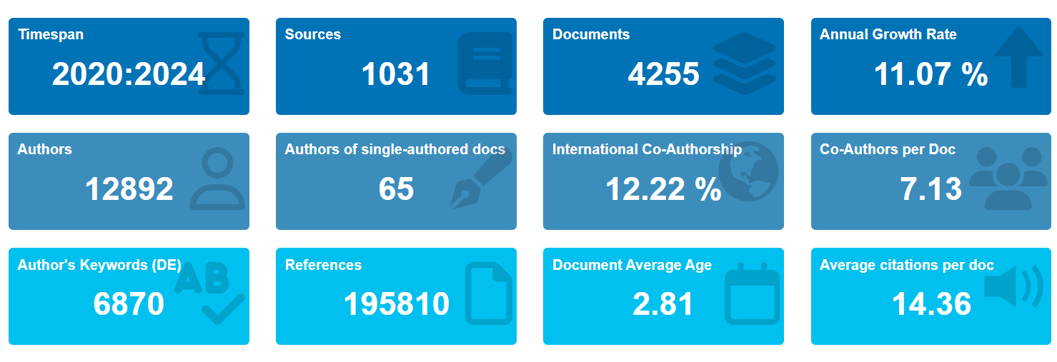

**Fig 1: Main Information of Diabetic Nephropathy Research**

From the figure, a bibliometric analysis of 4,255 publications (2020–2024) on diabetic nephropathy and diabetic kidney disease demonstrates a rapidly evolving research domain, with an annual growth rate of 11.07%. The data reveal contributions from 1,031 distinct sources and 12,892 authors, averaging 7.13 co-authors per document, indicating high collaboration intensity. Although international co-authorship accounts for only 12.22%, it signals emerging global engagement. The inclusion of 6,870 author keywords and 195,810 references reflects significant thematic diversity and citation depth. An average of 14.36 citations per publication and a mean document age of 2.81 years underscore the field’s recency and academic relevance.

1. **Trend and Impact Analysis of Diabetic Nephropathy Research (2020–2024)**

|  |  |  |  |  |  |  |  |
| --- | --- | --- | --- | --- | --- | --- | --- |
| **Year** | **Total Publications (N)** | **% of Total Publications** | **Total Citations** | **% of Citations** | **ACPP** | **ACPY** | **Citable Years** |
| 2020 | 665 | 18.14 | 12,954 | 35.77% | 17.53 | 2.92 | 6 |
| 2021 | 769 | 21.90 | 11,301 | 31.21% | 12.67 | 2.53 | 5 |
| 2022 | 928 | 18.53 | 6,474 | 17.88% | 8.52 | 2.13 | 4 |
| 2023 | 881 | 18.42 | 4,053 | 11.19% | 5.44 | 1.81 | 3 |
| 2024 | 1012 | 23.01 | 1,433 | 3.96% | 1.53 | 0.76 | 2 |

**Table 1: No. of Scientific Literature and Citations**

**Fig 2: Productivity vs. Impact Divergence Analysis**

The integrated assessment of the Figure 2 chart and the following Table 1 reveals a pronounced divergence between research output and citation impact in diabetic nephropathy studies over the five years. Publication volume increased consistently—from 665 in 2020 to 1,012 in 2024, reflecting growing academic interest. However, Total Citations and ACPP (Average Citations per Publication) show a marked decline, with citations dropping from 12,954 to 1,433 and ACPP plummeting from 17.53 to 1.53. Simultaneously, ACPY (Average Citations per Year) steadily decreased. This indicates that while the field is expanding in quantity, the scholarly impact per study is weakening, possibly due to saturation, delayed citation cycles, or reduced novelty in contributions. The visual and numerical evidence together underscore a classic case of productivity-impact imbalance, a well-recognized phenomenon in scientometric trend analysis.

1. **Highly Cited Scientific Literature on Treatment of Diabetic Nephropathy**

|  |  |  |  |  |  |  |
| --- | --- | --- | --- | --- | --- | --- |
| **Title of Scientific Literature** | **Source Title** | **Authors** | **Pub.**  **Year** | **Total Citations** | **Citations**  **Per Year** | **IF (2024)** |
| Diabetic Nephropathy: Challenges in Pathogenesis, Diagnosis, and Treatment | BioMed Research International | Samsu, N. | 2021 | 598 | 119.60 | 2.6 |
| An updated overview of diabetic nephropathy: Diagnosis, prognosis, treatment goals and latest guidelines | Diabetes, Obesity and Metabolism | [Selby](https://dom-pubs.pericles-prod.literatumonline.com/authored-by/Selby/Nicholas+M.), N.M. & [Taal](https://dom-pubs.pericles-prod.literatumonline.com/authored-by/Taal/Maarten+W.), M.W. | 2020 | 469 | 78.17 | 5.4 |
| Inhibition of ferroptosis by up-regulating Nrf2 delayed the progression of diabetic nephropathy | [Free Radical Biology and Medicine](https://www.sciencedirect.com/journal/free-radical-biology-and-medicine) | Li Shuangwen. et al. | 2020 | 307 | 61.40 | 7.1 |
| Diabetic Nephropathy: An Overview | Springer Nature Link | [Sagoo, M.K. & Gnudi, L.](javascript:;) | 2020 | 276 | 46.00 | 7.1 |
| SGLT2 Inhibition Mediates Protection from Diabetic Kidney Disease by Promoting Ketone Body-Induced mTORC1 Inhibition | Cell Metabolism | Tomita. I. et al. | 2020 | 273 | 45.50 | 27.7 |
| Dietary Fiber Protects against Diabetic Nephropathy through Short-Chain Fatty Acid–Mediated Activation of G Protein–Coupled Receptors GPR43 and GPR109A | Journal of the American Society of Nephrology (JASN) | LI, Y.J. et al. | 2020 | 246 | 41.00 | 10.3 |
| Lipotoxicity and Diabetic Nephropathy: Novel Mechanistic Insights and Therapeutic Opportunities | International Journal of Molecular Sciences | Opazo-Rios, L. et al. | 2020 | 243 | 40.50 | 4.9 |
| Metformin alleviates oxidative stress and enhances autophagy in diabetic kidney disease via AMPK/SIRT1-FoxO1 pathway | [Molecular and Cellular Endocrinology](https://www.sciencedirect.com/journal/molecular-and-cellular-endocrinology) | Ren, Huiwen. et al. | 2020 | 243 | 40.50 | 3.8 |
| Clinical efficacies, underlying mechanisms and molecular targets of Chinese medicines for diabetic nephropathy treatment and management | [Acta Pharmaceutica Sinica B](https://www.sciencedirect.com/journal/acta-pharmaceutica-sinica-b) | Tang, G. et al. | 2021 | 233 | 46.60 | 14.8 |
| Pathogenic Pathways and Therapeutic Approaches Targeting Inflammation in Diabetic Nephropathy | International Journal of Molecular Sciences | Rayego-Mateos, S. et al. | 2020 | 231 | 38.50 | 4.9 |

**Table 2: Highly Cited Scientific Literature**

Table 2 demonstrates that the highly cited literature on the treatment of diabetic nephropathy from 2020 to 2024 reveals several influential works shaping current understanding. The most cited study, Samsu (2021), addresses multifaceted challenges in pathogenesis and clinical management, amassing 598 citations and leading in citation rate (119.6/year), despite its appearance in a modest-impact journal (IF 2.6). In contrast, Tomita et al. (2020) and Li Y.J. et al. (2020) published in high-impact journals like Cell Metabolism and JASN, respectively, underscore mechanistic insights such as mTORC1 inhibition and receptor-mediated protection. Mechanistic studies, including ferroptosis inhibition (Li et al., 2020) and AMPK/SIRT1 signaling (Ren et al., 2020), signal a paradigm shift towards molecular-targeted therapies. The presence of comprehensive reviews (Selby & Taal, 2020; Sagoo & Gnudi, 2020) further indicates continued demand for synthesized clinical guidance in this evolving field.

1. **Top 10 Most Productive Authors**

|  |  |  |  |  |
| --- | --- | --- | --- | --- |
| **Authors** | **No, of Publications** | **Affiliation** | **H index** | **TC** |
| [Liu, Fang.](https://www.scopus.com/authid/detail.uri?authorId=7005202765&origin=resultsAnalyzer&zone=authorName) | 36 | West China Hospital of Sichuan University, Chengdu, China | 31 | 4,165 |
| Liu, Zhansuo | 27 | [Zhengzhou University](https://www.scopus.com/pages/organization/60018554), Zhengzhou, China | 48 | 8,347 |
| Sun, Lin | 27 | The Second Xiangya Hospital of Central South University, Changsha, China | 50 | 10,100 |
| Yang, Ming | 22 | The Second Xiangya Hospital of Central South University, Changsha, China | 32 | 4,037 |
| Zhang, Junlin | 22 | West China Hospital of Sichuan University, Chengdu, China | 18 | 971 |
| Liu, Dongwei | 21 | [Zhengzhou University](https://www.scopus.com/pages/organization/60018554), Zhengzhou, China | 27 | 1,896 |
| Wu, Yucheng | 20 | West China Hospital of Sichuan University, Chengdu, China | 16 | 589 |
| Jin, Juan. | 18 | Zhejiang Provincial Hospital of Chinese Medicine, Hangzhou, China | 21 | 2,107 |
| Li, Ping | 17 | China-Japan Friendship Hospital, Beijing, China | 33 | 3,279 |
| Cooper, Mark Emmanuel | 16 | Monash University, Melbourne, Australia | 129 | 76,649 |

**Table 3: Top 10 Most Productive Authors**

The author productivity table highlights dominant contributions from Chinese institutions, with Fang Liu (36 papers) being the most prolific, though her impact (h-index 31, 4,165 citations) is moderate. Sun Lin and Liu Zhansuo, each with 27 publications, demonstrate exceptional influence, with h-indices of 50 and 48, and over 10,000 and 8,000 citations, respectively. Mark Emmanuel Cooper stands apart internationally, contributing only 16 papers yet achieving an outstanding h-index of 129 and 76,649 citations, reflecting foundational global influence. Overall, the data reveals a blend of quantity-led domestic scholarship and high-impact, interdisciplinary international leadership.

1. **Thematic Map of Diabetic Nephropathy Research**

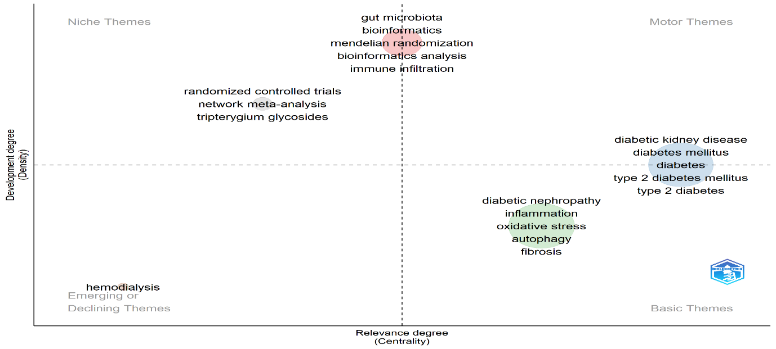

**Fig 3: Thematic Map of Author keywords**

The thematic mapping of diabetic nephropathy research offers a structured overview of the field's intellectual landscape by categorizing themes according to centrality and density. The Motor Themes quadrant, characterized by high centrality and density, includes terms such as diabetic kidney disease and type 2 diabetes, reflecting well-integrated and actively evolving domains. Basic Themes like oxidative stress and inflammation are foundational yet methodologically fragmented. Niche Themes, including gut microbiota and bioinformatics, represent specialized, internally cohesive topics with limited external linkage. The Emerging or Declining Themes quadrant, represented by hemodialysis, may signify either diminishing relevance or early-stage research opportunities

1. **Co-Occurrence analysis of keywords of Diabetic Nephropathy Research**

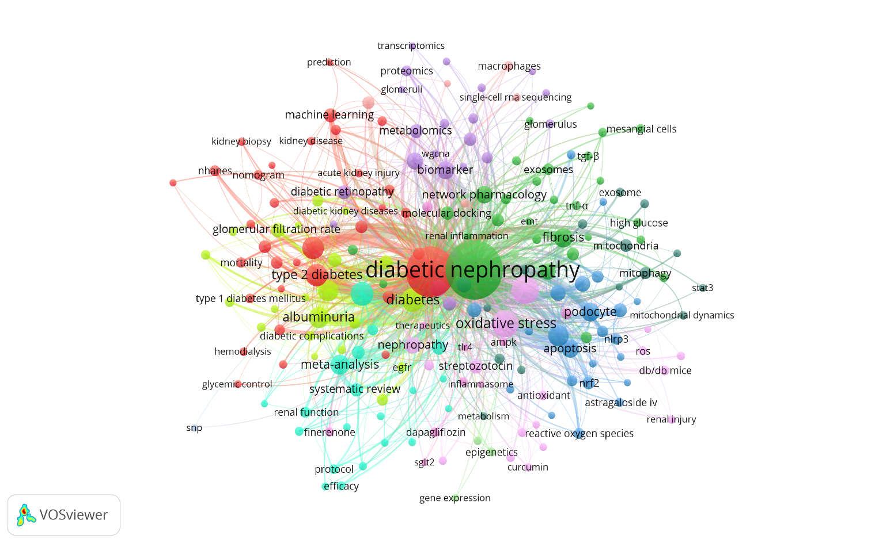

**Fig 4: Network Map of Co-Occurrence analysis of keywords**

In Figure 4, a bibliometric map visualizes 201 high-frequency keywords (≥10 occurrences) clustered into 12 thematic groups, reflecting research trends in diabetic nephropathy. Node size represents keyword frequency, while line thickness signifies co-occurrence strength. “Diabetic nephropathy” dominates (2068 occurrences; link strength: 1335), closely linked to “diabetes mellitus,” “oxidative stress,” “inflammation,” and “chronic kidney disease.” These form the core metabolic-inflammatory axis. Subclusters highlight autophagy, apoptosis, fibrosis, and podocyte dysfunction. “Albuminuria” and “type 2 diabetes mellitus” act as clinical bridges. The structure reveals a dynamic interplay of pathophysiological, clinical, and therapeutic domains central to advancing diabetic kidney disease research.

1. **Co-authorship network with authors of Diabetic Nephropathy Research**

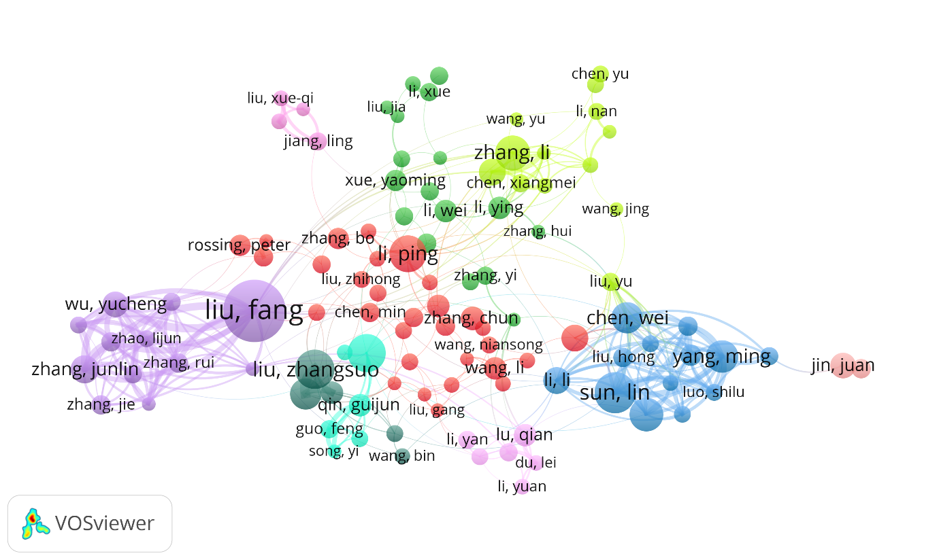

**Fig 5: Network Map of Co-authorship analysis of keywords**

In Figure 5, the co-authorship network maps 118 prolific researchers (≥10 documents; ≥5 citations) across 10 distinct clusters, interconnected by 362 collaborative links and a cumulative link strength of 1469. Node size reflects publication volume, while proximity and link thickness denote collaborative intensity. “Liu, Fang” emerges as the most central figure (44 docs; 261 citations; link strength: 85), followed by “Wu, Yucheng,” “Zhang, Junlin,” and “Wang, Yiting,” indicating tightly-knit sub-networks with robust co-authorship bonds. Notably, “Zou, Yutong” leads in citations (443), reflecting high-impact contributions. This map illustrates the fragmented yet dynamic landscape of collaboration in diabetic nephropathy research.

1. **Collaboration among the Countries of Diabetic Nephropathy Research**

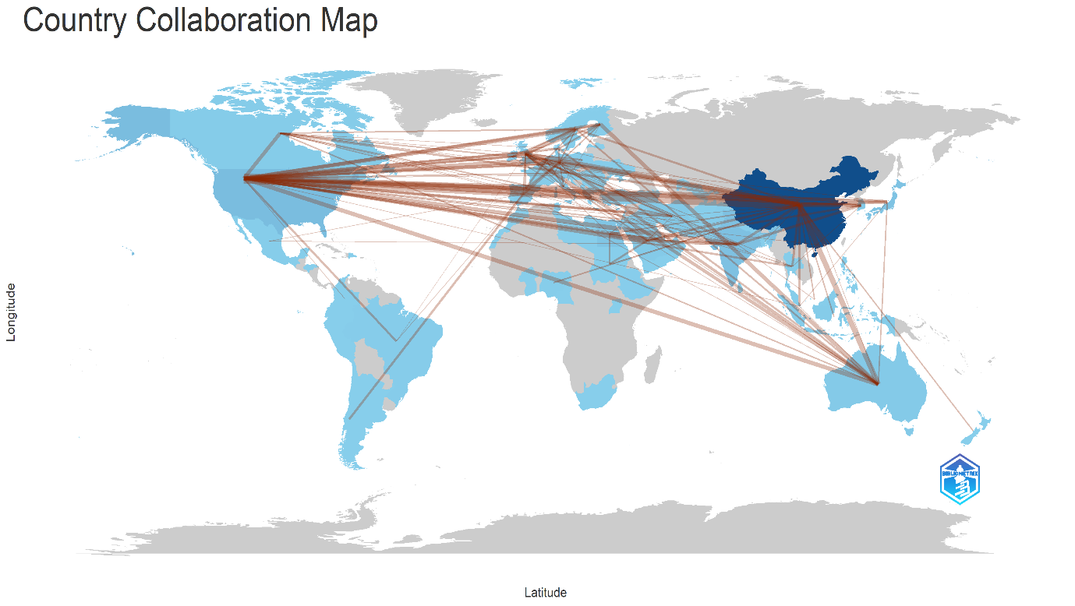

**Fig 6: Country Collaboration Map**

The country collaboration map for diabetic nephropathy research reveals a robust global research network, with China serving as the central hub of international cooperation. Its dense connectivity with regions across North America, particularly the United States, and widespread ties to Europe, Australia, and parts of Southeast Asia, underscores China’s leadership in fostering transnational scientific exchange. The frequency and strength of these collaborative lines suggest that much of the high-impact work in this domain is co-authored across borders, enabling access to shared resources, diverse patient populations, and multidisciplinary expertise. Notably, connections to Germany, the United Kingdom, India, and Japan highlight enduring academic partnerships, while emerging links with countries in South America and Africa signal a slow but growing expansion of inclusive research outreach. This map exemplifies the increasing globalization of diabetic nephropathy scholarship, where collective scientific intelligence transcends geography to confront shared clinical challenges**.**

1. **Bibliographic coupling of documents of Diabetic Nephropathy Research**

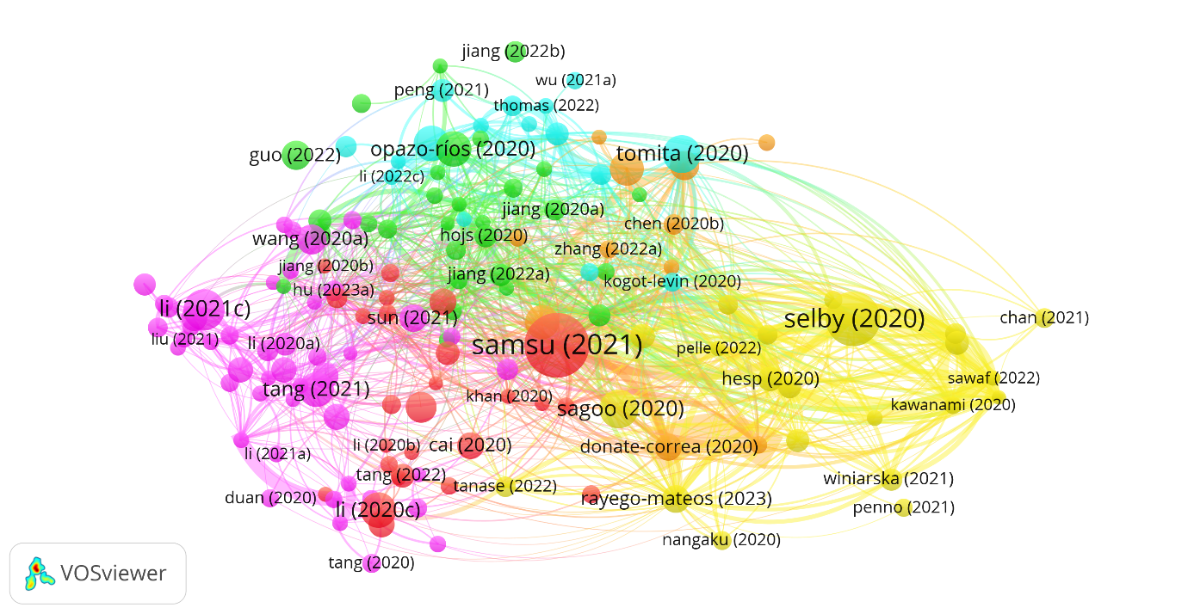

**Fig 7: Network Map of Bibliographic coupling of documents**

In Figure 7, bibliographic coupling of 151 highly cited documents (≥65 citations) reveals six distinct clusters, 2,222 links, and a cumulative link strength of 3,966—indicating strong intellectual convergence in diabetic nephropathy literature. The largest node, Samsu (2021) (171 citations; link strength 53), anchors the red cluster, suggesting a central role in mechanistic or review-based synthesis. The yellow cluster, led by Selby (2020) and Donate-Correa (2020), reflects high interconnectivity and strong citation coherence (link strength: 101), likely representing clinical or therapeutic consensus papers. Meanwhile, Sugahara (2021) and Chen (2020a), despite fewer citations, exhibit significant structural relevance in the pink and orange clusters. Barutta (2022) and Pelle (2022) (140 and 124 citations, respectively) highlight the growing scholarly traction of recent contributions. This map reflects an evolving yet tightly integrated research landscape.

1. **Bibliographic coupling of Authors of Diabetic Nephropathy Research**

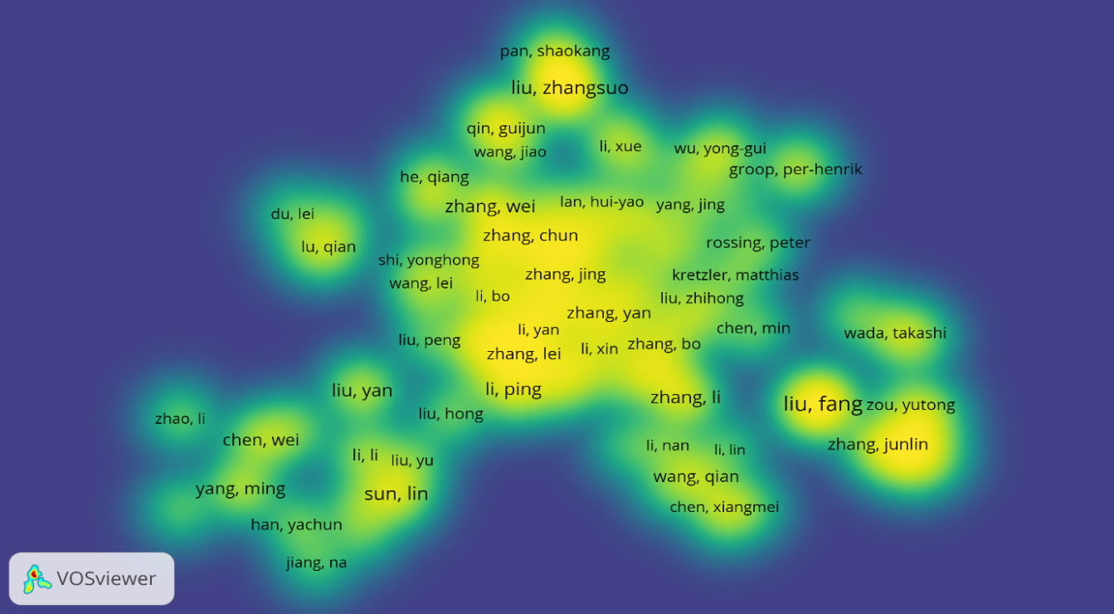

**Fig 8: Density Map of Bibliographic coupling of authors**

In the density visualization (Figure 8), the intellectual topology of 118 prolific authors—each contributing ≥10 documents and receiving ≥2 citations—unfolds across 8 interconnected clusters, comprising 6,891 links and an extraordinary total link strength of 282,367. Denser yellow regions highlight authors with the highest integrative prominence. Sun, Lin (cluster: yellow-green) emerges as the densest node (link strength: 5954), underscoring a central role in bridging subdomains. Yang, Ming and Han, Yachun also occupy high-density zones, suggesting broad citation connectivity. Liu, Fang and Li, Li, although dispersed across adjacent clusters, display notable link strengths (3339 and 3420, respectively), reflecting sustained collaborative visibility. Blue and green outer gradients denote peripheral yet growing contributors.

1. **Co-citation analysis of documents of Diabetic Nephropathy Research**

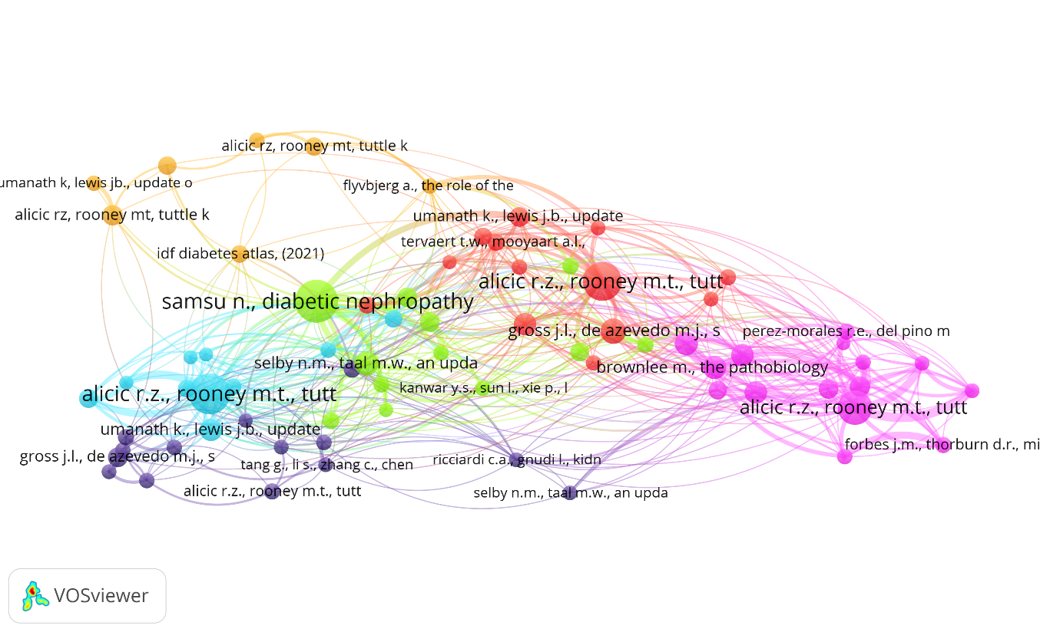

**Fig 9: Network Map of Co-citation analysis of documents**

In Figure 9, co-citation analysis of 71 highly referenced documents (≥20 citations) reveals 6 interconnected clusters, with 510 links and a total link strength of 863—indicating moderate but thematically cohesive influence. The turquoise cluster centers on Alicic, Rooney, and Tuttle (2017), which dominates with over 250 combined citations across citation variants, underscoring its seminal status in defining diabetic kidney disease challenges and directions. The magenta cluster—anchored by Brownlee (2005) and Forbes (2008)—focuses on molecular mechanisms like oxidative stress and unifying pathways of diabetic complications. Meanwhile, Samsu (2021) in green reflects contemporary synthesis, and Selby & Taal (2020) in blue emphasizes evolving guidelines. This network encapsulates foundational knowledge converging with modern clinical insights, bridging mechanisms, and therapeutic directions.

1. **Co-citation analysis of sources of Diabetic Nephropathy Research**

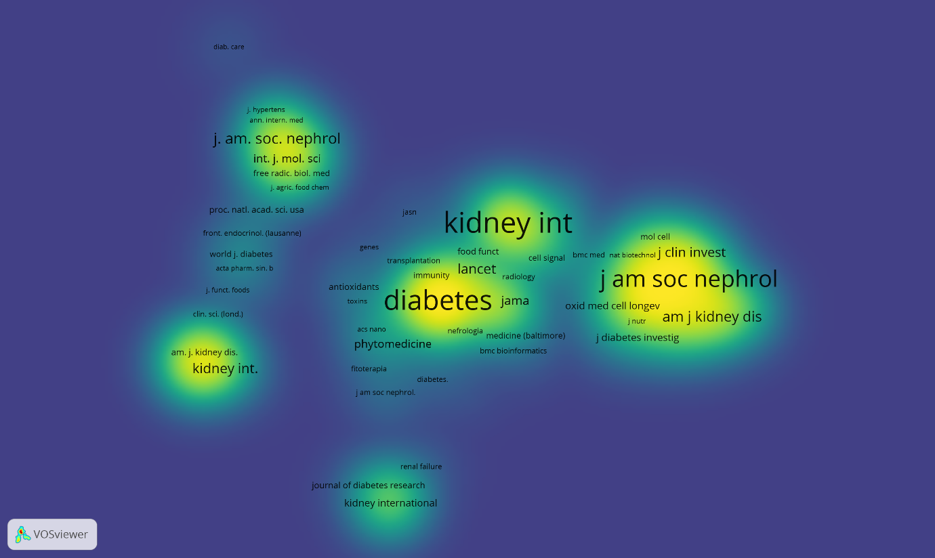

**Fig 10: Density Map of Co-citation analysis of sources**

In Figure 10, the source co-citation density map visualizes 626 journals (≥50 citations), forming 5 clusters, 111,179 links, and a total link strength of 3,253,339. The most intense zones—colored in bright yellow—center around Kidney International (5318 citations; link strength: 82,833), Diabetes (4834; 64,293), and J Am Soc Nephrol (3468; 57,480), indicating their dominance as intellectual hubs in diabetic nephropathy research. The green and cyan clusters represent emerging interdisciplinary nodes, including Int J Mol Sci and Plos One, reflecting molecular and open-access fronts. Diabetes Care and N Engl J Med contribute high-impact clinical insights, while Lancet and Nature serve as bridges across nephrology and systemic medicine. This map showcases a dense, multidisciplinary scholarly ecosystem fueling innovation in renal-diabetic pathophysiology.

1. **CONCLUSION**

This study conducted a detailed scientometric evaluation of diabetic nephropathy research from 2020 to 2024, highlighting publication growth, citation trends, collaboration networks, and thematic directions. While research productivity has increased, citation impact has declined, indicating a possible saturation or need for innovation. Core topics remain focused on oxidative stress, inflammation, and renal fibrosis, while emerging areas include gut microbiota, bioinformatics, and ferroptosis. Notably, China leads in output and collaboration strength. These insights suggest future investigations should prioritize interdisciplinary strategies and global partnerships to revitalize research impact and address evolving clinical and molecular challenges in diabetic kidney disease.

Disclaimer (Artificial intelligence)

Option 1:

Author(s) hereby declare that NO generative AI technologies such as Large Language Models (ChatGPT, COPILOT, etc.) and text-to-image generators have been used during the writing or editing of this manuscript.

Option 2:

Author(s) hereby declare that generative AI technologies such as Large Language Models, etc. have been used during the writing or editing of manuscripts. This explanation will include the name, version, model, and source of the generative AI technology and as well as all input prompts provided to the generative AI technology

Details of the AI usage are given below:

1.

2.

3.

**REFERENCES**

1. Alicic, R. Z., Rooney, M. T., & Tuttle, K. R. (2017). Diabetic kidney disease: Challenges, progress, and possibilities. *Clinical Journal of the American Society of Nephrology*, *12*(12), 2032–2045. <https://doi.org/10.2215/CJN.11491116>
2. Aria, M., & Cuccurullo, C. (2017). Bibliometrix: An r-tool for comprehensive science mapping analysis. *Journal of Informetrics*, *11*(4), 959–975. <https://doi.org/10.1016/j.joi.2017.08.007>
3. Donthu, N., Kumar, S., Mukherjee, D., Pandey, N., & Lim, W. M. (2021). How to conduct a bibliometric analysis: An overview and guidelines. *Journal of Business Research*, *133*, 285–296. <https://doi.org/10.1016/j.jbusres.2021.04.070>
4. Jia, Y., Gu, Y., Wang, L., Jiang, N., Yu, X., & Tian, H. (2025a). Critical analysis of hot topics in diabetic nephropathy related experimental research: A bibliometric analysis from 2018 to 2024. *Journal of Tissue Viability*, *34*(1), 100854. <https://doi.org/10.1016/j.jtv.2025.100854>
5. Mitu, L. G., Repanovici, A., & Pantea, I. (2024). Scientometric analysis of research trends in nano patches for insulin monitoring: Insights from web of science using vosviewer. *2024 E-Health and Bioengineering Conference (EHB)*, 1–4. <https://doi.org/10.1109/EHB64556.2024.10805620>
6. Moral-Muñoz, J. A., Herrera-Viedma, E., Santisteban-Espejo, A., & Cobo, M. J. (2020). Software tools for conducting bibliometric analysis in science: An up-to-date review. *El Profesional de La Información*, *29*(1). <https://doi.org/10.3145/epi.2020.ene.03>
7. Sadatmoosavi, A., Tajedini, O., Esmaeili, O., Zadeh, F. A., & Khazaneha, M. (2021). Emerging trends and thematic evolution of breast cancer: Knowledge mapping and co-word analysis. *JMIR Cancer*, *7*(4), e26691. <https://doi.org/10.2196/26691>
8. Shao, Y. (2022). Bibliometric study of trends in the diabetic nephropathy research space from 2016 to 2020. *Oxidative Medicine and Cellular Longevity*, *2022*(1), 8050137. <https://doi.org/10.1155/2022/8050137>
9. Shao, Y., & Shi, X. (2023). Bibliometric analysis and visualization of research progress in the diabetic nephropathy field from 2001 to 2021. *Oxidative Medicine and Cellular Longevity*, *2023*, 1–16. <https://doi.org/10.1155/2023/4555609>
10. Shen, J., Chen, J., Feng, L., & Feng, C. (2022). A scientometrics analysis and visualisation of diabetic foot research from 1955 to 2022. *International Wound Journal*, *20*(4), 1072–1087. <https://doi.org/10.1111/iwj.13964>
11. Su, Z., Liu, L., Zhang, J., Guo, J., Wang, G., & Zeng, X. (2025). A scientometric visualization analysis of the gut microbiota and gestational diabetes mellitus. *Frontiers in Microbiology*, *16*. <https://doi.org/10.3389/fmicb.2025.1485560>
12. Thomas, M. C., Brownlee, M., Susztak, K., Sharma, K., Jandeleit-Dahm, K. A. M., Zoungas, S., Rossing, P., Groop, P.-H., & Cooper, M. E. (2015). Diabetic kidney disease. *Nature Reviews Disease Primers*, *1*(1), 15018. <https://doi.org/10.1038/nrdp.2015.18>
13. Van Eck, N. J., & Waltman, L. (2010). Software survey: VOSviewer, a computer program for bibliometric mapping. *Scientometrics*, *84*(2), 523–538. <https://doi.org/10.1007/s11192-009-0146-3>
14. Wang, N., Li, X., Weng, H., Zhang, Y., Li, Q., Luo, X., Chen, Y., & Dong, Y. (2025). A bibliometric study of global trends in diabetic nephropathy and intestinal flora research. *Frontiers in Microbiology*, *16*. <https://doi.org/10.3389/fmicb.2025.1577703>
15. Wang, Q., Zhu, Q., & Li, N. (2023). A scientometric analysis and visualization of scientific research and technology innovation in needle-free insulin injection from 1974 to 2022. *Clinical Therapeutics*, *45*(9), 881–888. <https://doi.org/10.1016/j.clinthera.2023.06.025>
16. Xu, R., Shao, X., Qiao, H., Yan, H., & Xue, Y. (2024). Research trends in the relationship between vitamin D and type 2 diabetes mellitus: A 20-year bibliometric and visualization analysis. *Frontiers in Endocrinology*, *15*, 1421953. <https://doi.org/10.3389/fendo.2024.1421953>
17. (N.d.-a). Retrieved July 3, 2025, from <https://www.semanticscholar.org/paper/Global-trends-and-performances-in-diabetic-studies%3A-Xiao-Tang/0f46211216174338638719c645c1d46ed85fd087>
18. (N.d.-b). Retrieved July 3, 2025, from <https://www.semanticscholar.org/paper/Scientometric-Study-of-Research-in-Information-in-Mohammadi-Roshandel/ad2a78c0b7247207fa8af50c540188e00326ff3a>