Hybrid Approach for Fault Detection and Classification in Power Distribution Systems Using DWT and PSO BASED-SVM with Real-Time Simulation

.
ABSTRACT

This study aims to develop a real-time model for detecting and classifying various fault types in power distribution networks to enhance reliability and operational efficiency. A hybrid DWT–SVM approach is essential for accurately detecting and classifying faults in modern power distribution systems, especially under non-stationary and dynamic conditions. The proposed method addresses a range of fault scenarios, including single-phase-to-ground, line-to-line, double-line-to-ground, and three-phase faults, within a 33 kV distribution network. A hybrid approach combining Discrete Wavelet Transform (DWT) and Support Vector Machine (SVM) is introduced. Using the Debauchies-4 (Db4) wavelet, DWT effectively decomposes transient fault currents at the source terminal, capturing critical time-frequency domain features. Fault classification is performed using an SVM optimized with a Radial Basis Function (RBF) kernel and Particle Swarm Optimization (PSO), enabling precise mapping of data into higher-dimensional spaces for optimal separation. Validation conducted with MATLAB R2023b demonstrates a detection accuracy of 100% and a classification accuracy of 99%. Comparative analyses against models such as PSO-based Support Vector Machine (PSO-SVM), DWT-DNN and wavelet transform with artificial neural networks (WT-ANN) on the IEEE 13-bus system highlight the proposed method's superior performance. This innovative approach proves to be robust, adaptable, and highly effective across diverse fault scenarios, offering significant improvements in accuracy and reliability for fault detection and classification in power distribution networks. The method supports real-time operation by using high-speed simulation platforms MATLAB/Simulink to process signals and classify faults within milliseconds using a pre-trained SVM model.

Keywords: [Fault detection, Power distribution systems, DWT, SVM.]

1. INTRODUCTION

The electric power system is a vast and interconnected network that is particularly vulnerable to faults, especially within the distribution network, which experiences more frequent disruptions than the transmission and generation sectors. This vulnerability is exacerbated in regions like Nigeria, where maintenance is often overlooked (Oni et al., 2019). Faults in power systems can be either permanent or temporary, and their identification and classification are crucial before repairs can begin (Gonzalez et al., 2021). Temporary faults are sometimes cleared automatically through reclosing systems, but permanent faults require manual intervention. Accurate fault classification is essential for prompt maintenance, ensuring power restoration while improving reliability indices such as SAIDI, SAIFI, and CAID( Ajenikoko G. A, et al(2022) .A hybrid DWT–SVM approach is essential for accurately detecting and classifying faults in modern power distribution systems, especially under non-stationary and dynamic conditions. Short-circuit faults, one of the most common types, are caused by various factors such as lightning, severe weather, vegetation, and animal interference (Sarkar et al., 2020). Effective fault detection and classification are key to minimizing outages and enhancing the performance of protective systems, as noted by Magagula X. G et al (2019). Fault detection and classification in power distribution systems is a vital process for ensuring reliability, minimizing service interruptions, and protecting equipment from damage. Traditional protection schemes often face limitations in identifying and accurately classifying complex fault conditions, especially in modern grids with significant integration of distributed generation and rapidly changing load dynamics. To overcome these challenges, a hybrid approach combining Discrete Wavelet Transform (DWT) for time/frequency feature extraction and PSO Based Support Vector Machine (SVM) for precise classification has been adopted. This method is particularly effective for handling non-stationary fault signals, adapting to fast-varying operating conditions, and processing the high-dimensional data typical of real-world power systems. It focuses on improving fault detection and classification for the 33kV distribution lines from the Eket Transmission Injection Substation in Nigeria, with particular attention to the Etinan 33kV line, which serves rural areas and is more susceptible to faults due to its length and terrain.
The primary challenge in power distribution systems is delivering reliable service, which is often compromised by frequent faults caused by natural events, human activity, and environmental conditions (Akinola et al., 2021). These faults result in power outages, equipment damage, safety hazards, and reduced productivity (Muktar et al., 2019). Traditional methods of fault detection and classification, which rely on time-consuming manual inspections, are often inadequate for quick restoration. As such, there is an urgent need for a more efficient, accurate, and reliable method for detecting and classifying faults in the distribution network. This paper proposes a hybrid approach using Discrete Wavelet Transform (DWT) and Support Vector Machine (SVM) to address these challenges.
The primary objective of this paper is to develop a real-time model for detecting and classifying various fault types in power distribution networks. Specifically, the study aims to develop a DWT/SVM model for fault detection, a separate model for fault classification, and compare these models' performance with conventional methods. Additionally, the study will evaluate the accuracy and reliability of the DWT/SVM model using MATLAB simulations.
This study is significant due to the critical impact of faults on power reliability and customer satisfaction which is of great importance Onaifo F. et al (2019). In the case of the Etinan 33kV line, it can take days or even weeks for traditional troubleshooting methods to restore power after a fault. By introducing an advanced fault detection and classification system, this study aims to reduce downtime, improve repair efficiency, and enhance the overall reliability of the distribution network, thereby increasing customer satisfaction. Furthermore, the findings of this study will serve as a valuable resource for future research and development in the area of fault detection and power system optimization.
The scope of this study is limited to detecting and classifying short-circuit faults in power distribution lines using measurements of three-phase current during fault events. The classification algorithm will rely on data derived from DWT and SVM techniques. While fault location is typically a subsequent step after classification, this research will focus solely on detection and classification, leaving fault location for future studies. The types of faults under investigation include single-phase-to-ground, line-to-line, double-line-to-ground, and three-phase short-circuit faults.

2. material and methods

MATERIALS

The implementation of fault detection and classification using Discrete Wavelet Transform (DWT) and Support Vector Machine (SVM) required the following materials: Simulation Software including a 64-bit Windows 10 operating system, Microsoft Excel 2019, the Orange data mining platform, and MATLAB Simulink with relevant toolboxes like the Wavelet Toolbox for DWT, Statistics and Machine Learning Toolbox for SVM. Power System Model encompasses a distribution network model simulating various fault types (e.g., Single Line to Ground, Double Line to Ground) and tools within MATLAB Simulink to collect current and voltage data during faults. These fault data includes simulated current signals under different fault conditions and real-time data if available. For Data Preprocessing, DWT is used to extract key features, which serve as inputs for the SVM classification.
SVM classifiers were trained with the extracted features, and optimization hyperparameters. Hardware for real-time applications includes a Data Acquisition System for monitoring, Digital Relays for data collection, and high-performance computing resources,

METHOD
The methodology used in this study focused on the integration of Discrete Wavelet Transform (DWT) and Support Vector Machine (SVM) for fault detection (FD) and fault classification (FC) in power distribution networks. MATLAB R2023b/ Simulink was used to perform simulations on the network to generate dataset, fault and data analysis. Figure 2 and Figure 3 show the block diagram for DWT/SVM and MATLAB Simulink Simulation model for simple distribution network stimulated for dataset and generation of fault samples. The pre-processing phase involves feature extraction, which enhances the SVM's performance by reducing its input size while retaining all critical information from the current waveforms. Standard deviation (SD) is one of the key features used in this study to assess how data deviates from its mean, which helps in identifying significant patterns in the current signals. Current values from all three phases are sampled at a frequency of 20 kHz and recorded, both pre- and post-fault.
2.1 Discrete Wavelet Transform (DWT) Signal Decomposition
Figure: 1: Discrete wavelets transform decomposition tree
Sn
cG2
cG11
cH1
cH4

cG4
cH33

cG3

cH2

STEP 1

STEP 2

STEP 3

STEP 4

Fig 1 show the DWT decomposition tree employed to decompose the three-phase current signals into sets of coefficients that represent their time evolution within specific frequency bands. Compared to the Fourier transform, DWT is more effective in extracting transient signal information due to its ability to analyze both high- and low-frequency components over varying time windows (Das, M.et al, 2023). In this study, the Daubechies (db4) wavelet was selected and used as the mother wavelet for its ability to extract primary properties of the input signal and eliminate harmonics (Daubechies, 1992). The decomposition process involves breaking down the signal into high-frequency (H1) and low-frequency (G1) elements, further decomposed to obtain higher resolution bands as shown in figure 1 This process continues until the optimal frequency band is reached, allowing for useful extraction.

2.1.1 Statistical Metrics for Fault Detection
Two key statistical metrics were employed to quantify the behavior of the signal during fault conditions: standard deviation and energy. Standard Deviation: The standard deviation (σ) of a signal measure its deviation from the mean. It is calculated as follows:
σ (t₁ t₂) = $\sqrt{(\int_{t_{1}}^{t_{2}}{\left(x\left(t\right)-\bar{x}\right)dt}})$ (1)
Where t_{1 ,}t₂ is the time limit of the signal x(t) and x̄ is the means of the signal, calculated as:
$\bar{x}= \frac{1}{t_{2}- t_{1} } \int_{t_{1}}^{t_{2}}{x\left(t\right)dt}$ (2)
The mean x̄ represents the average value of the signal. Under normal operating conditions, x̄ is zero, but during faults, x̄ deviates from zero.

Energy (E) of the signal x(t) over a time interval (t_{1,} t₂) is given by:
E = (t₁ t₂) = $\int_{t_{1}}^{t_{2}}{{|x\left(t\right)|}^{2}dt}$ . The energy of a signal increases during fault conditions compared to its energy under normal conditions. This increase in energy is indicative of the higher signal amplitude associated with faults in a power.

Figure 2 Proposed Block Diagram for Fault Detection and classification
.
.
.
.
.
.
80
%
X
norm
20
%
T
rain data
Normalized
T
rain data
svm
classifier
Classifier
SVM Parameter
svm model for
fault detection and
classification
Fault Detection
Normalized
T
est Data
No fault
Faulty
Fault
Classification
R-G
Data
Generation
Per unit &
Current values
Distribution
Simulation

Y-G
B-G
R-Y
Y-B
R-B-G
R-B-G
B-R
B-R-G
R-Y-B
-
R-Y-B-G
T
est data
x - x min
X_{max}
a
-X_{min}
(3)

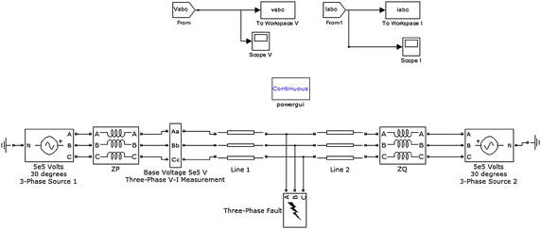
Figure 3. MATLAB Simulink Simulation Model for Power Distribution Network.
Figure 4: Fault Detection and classification flow chart diagram

Yes

Start

I_{R}, I_{Y} & I_{B}
Signals

Introducing 3 Phase current signals

Signal decomposition using Db4, 4 levels

Feature extraction
Standard deviation

Feature selection
UsingRBF/PCA / PSO

Training of SVM classifier

Short circuit
Faults

No

Normal

Classify fault type

DWT
Analysis

Repeat the
Procedure

Detect fault

2.2 Fault Detection
The model was designed to detect faults in distribution networks and classify the specific fault type. Figure 4 show the flowchart of this process. DWT is applied to detect faults by analyzing the electrical signals for transient disturbances. When a fault occurs, it generates a sudden change in the current or voltage waveforms. DWT can effectively capture these transient disturbances due to its ability to localize both time and frequency components. The input data to the system includes three-phase current measurements during both fault and non-fault conditions. DWT-db4 wavelet, extracts key features from these measurements. The db4 wavelet was chosen for its regularity, smoothness, and compact support in time and frequency domains, making it ideal for fault detection. MATLAB R2023b is used to simulate current signals under various fault types (RG, YG, BG, etc.) and no-fault conditions. These simulations generate a dataset of post-fault current signals, which is then used to train the SVM classifier.
2.3 Fault Classification
The fault classification model aims to accurately identify different fault types using a DWT/SVM approach. The data samples include 1,200 fault samples and 1,000 non-fault samples, representing 11 fault types. The SVM classifier is trained to distinguish these faults using SD values extracted from DWT. Dimensionality reduction was done with the application of Principal Component Analysis features. This enhances model efficiency, reduces noise in the data and redundant dataset were filtered out.
2.3.1 SVM Classifier Design
SVM IN PHASE R,Y,B
SIGNAL
DISCOMPOSITION
USING DWT

CURRENT
MESUREMENT
FROM SENDING
END
OF THE
DISTRIBUTION
LINE
STATISTICAL FEATURE / SELECTION EXTRACTION
SVM-
G
SVM-
Y
SVM-
R
SVM-
B
SVM FOR GROUND
R,Y,B
F_{R}
F_{Y}
F_{B}
F_{G}
Figure 5: Fault classification diagram using SVM classifiers.

Four Support Vector Machine (SVM) dyadic classifiers was employed to classify different fault types, as illustrated in Figure 5. Each classifier was trained with specific fault samples to identify faults in distinct phases: SVMR for phase R, SVMY for phase Y, SVMB for phase B, and SVMG for ground faults. The output from each SVM will be binary form, where a value of 1 indicates the presence of a fault in the respective phase or ground, while 0 signifies no fault detected. The SVM classifier uses a Radial Basis Function (RBF) kernel for handling nonlinear data in fault detection. A Particle Swarm Optimization (PSO) algorithm is employed to select the most relevant parameters to improve classification performance. The SVM classifiers are organized such that each classifier detects faults in a phase (R, Y, B) or ground faults (G). Each classifier outputs binary results, where 1 indicates a fault, and 0 indicates no fault. The hyperplane separating fault and non-fault data is optimized using quadratic programming methods.
2.3.2 PSO and Fault Detection Index
The process of PSO optimizes the SVM classifier by iteratively updating particle positions and velocities until an optimal solution is reached. An empirical index threshold of 0.03 is used to differentiate between ground faults and other types of faults Zhang et al. (2025). The fault index is calculated using the equation. Specific Current 𝐼𝑛𝑑𝑒𝑥 = (|Ia + Ib + Ic | )/Ia (4)
Where, 𝐼𝑎, 𝐼𝑏, and 𝐼𝑐 are the instantaneous values of the currents and it is use for fault detection. Classification accuracy (𝐶𝐴) is the key metric evaluate as:
𝐶𝐴 = FCA/NoS (5)
Where, 𝐹𝐶A and NoS represent Fault Classification Accuracy and number of tested samples respectively.

3. results and discussion

3.1 Results
This chapter presents and analyzes the outcomes of the proposed fault detection and classification model. The model's performance was evaluated through simulations of various fault current signals using MATLAB R2023b. Figures 7(a-d) showcase the simulated fault current signals for different fault scenarios.
3.1.1 Simulation of Fault Current Signals
The proposed model was tested under diverse fault conditions to assess its reliability and accuracy. The simulation results demonstrate the model's effectiveness in both fault detection and classification. Fault current signals generated for different scenarios are illustrated in Figures 5 (a-d).
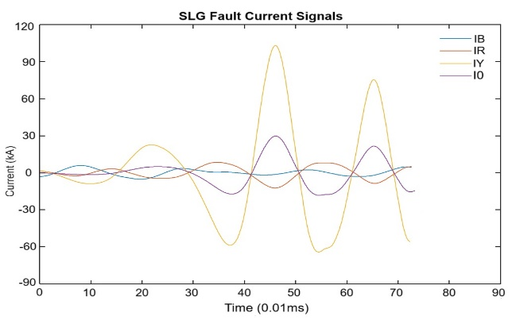
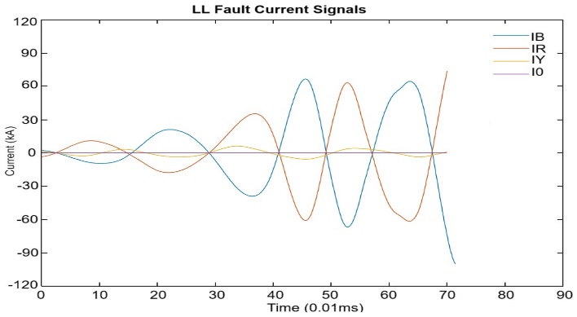
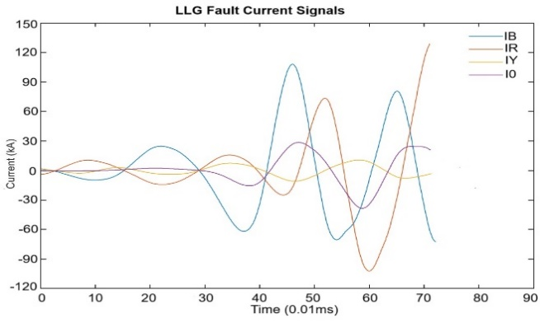
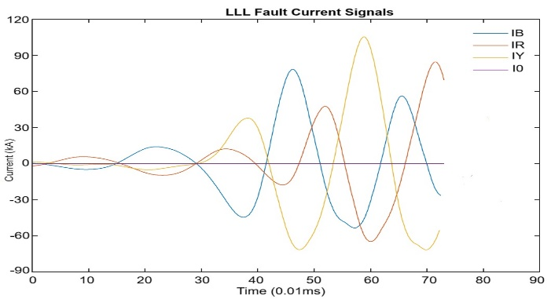

Figure 6: Simulated Fault Current Signals Figure 6(a): SLG current fault signal ,Figure 6(b): LL fault current signal, Figure 6(c): LLG fault current signal,Figure 6(d): LLL fault current signal
]

Figure 7 : Simulated Fault Current SignalsFigure 7(a): SLG current fault signal ,Figure 7(b): LL fault current signal, Figure 7(c): LLG fault current signal,Figure 7(d): LLL fault current signal
]

3.1.2 Results Analysis

The proposed model successfully detects and classifies faults in the power distribution system. The model's performance was validated by comparing the simulation outcomes with expected results. Key findings include:
- Accuracy: The model achieved high accuracy in identifying and classifying various fault types.
- Speed: It showed fast detection and classification, critical for timely fault management.
- Robustness: The model performed well across different fault scenarios and conditions.
These simulations confirm that the fault detection and classification model, which integrates discrete wavelet transform (DWT) with support vector machine (SVM) classifiers, is highly effective for managing faults in power distribution systems. The model's high accuracy, speed, and robustness make it a valuable tool for improving system reliability and efficiency.

3.1.3 Wavelet Decomposition

Wavelet decomposition was applied to phase current signals to extract useful features. The Daubechies-4 (db4) mother wavelet was selected due to its accuracy and efficiency in decomposing fault current signals.
- Approximation Coefficients: Represent low-frequency components, obtained by down-sampling signals filtered through low-frequency filters.
- Detail Coefficients: Represent high-frequency components, extracted by down-sampling signals filtered through high-frequency filters.
Figure 7 presents the level 4 detail coefficients for different fault types, such as Line-to-Ground (LG), Line-to-Line (LL), Double Line-to-Ground (LLG), and Three-Line (LLL) faults. These coefficients further validate the model’s effectiveness in capturing fault-specific characteristics

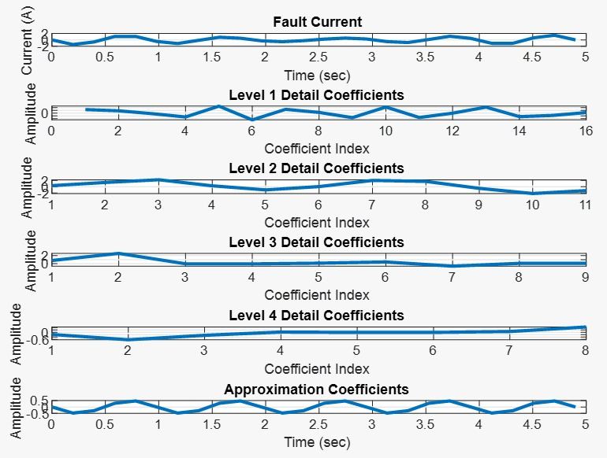
Figure 7: Level 4 Detail Coefficients for Various Fault Types SVM Classification Performance.
Current Signal, Detail Wavelet Coefficients (Level 1-4) and Approximation Coefficients

In addition, the classification performance of the Support Vector Machine (SVM) was optimized using standard deviation and median absolute deviation measures. Particle Swarm Optimization (PSO) was employed to determine the optimal feature parameters. The Radial Basis Function (RBF) kernel is employed to address nonlinearity in the dataset, particularly in scenarios involving high-dimensional input spaces. The RBF kernel is highly effective in handling non-linear datasets, a common challenge in fault detection tasks. The dataset used for training and testing the SVM classifiers was split in an 80:20 ratio. As shown in Table 2, the model correctly classified 1185 out of 1200 test samples, resulting in an overall classification accuracy of 99%. Figure 7 provides a graphical representation of the classification results, showing consistent and accurate performance across all fault types.

Table 1: SVM Fault Detection Matrix

Fault Type |  | SVMR | SVMY | SVMB | SVMG | Accuracy  (%)
R-G |  | $$1$$ | $$0$$ | 0 | $$1$$ | 100
Y-G |  | $$0$$ | $$1$$ | 0 | $$1$$ | $$100$$
B-G |  | $$0$$ | $$0$$ | 1 | $$1$$ | $$100$$
R-Y |  | $$1$$ | $$1$$ | 0 | $$0$$ | $$100$$
R-B |  | $$1$$ | $$0$$ | 1 | $$0$$ | $$100$$
Y-B |  | $$0$$ | $$1$$ | 1 | $$0$$ | $$100$$
R-Y-G |  | $$1$$ | $$1$$ | 0 | $$1$$ | $$100$$
R-B-G |  | $$1$$ | $$0$$ | 1 | $$1$$ | $$100$$
Y-B-G |  | $$0$$ | $$1$$ | 1 | $$1$$ | $$100$$
R-Y-B |  | $$1$$ | $$1$$ | 1 | $$0$$ | $$100$$
R-Y-B-G |  | $$1$$ | $$1$$ | 1 | $$1$$ | $$100$$
No Fault |  | $$0$$ | $$0$$ | 0 | $$0$$ | $$100$$

Table 2: SVM Classification Performance

Fault Type | Tested  Sample | Classified  Correctly | Not Classified  Correctly | Classification  Accuracy  (%)
R-G | 100 | $$100$$ | 0 | 100
Y-G | $$100$$ | $$99$$ | 1 | $$99$$
B-G | $$100$$ | $$100$$ | 0 | $$100$$
R-Y | $$100$$ | $$100$$ | 0 | $$100$$
R-B | $$100$$ | $$99$$ | 1 | $$99$$
Y-B | $$100$$ | $$100$$ | 0 | $$100$$
R-Y-G | $$100$$ | $$98$$ | 2 | $$100$$
R-B-G | $$100$$ | $$99$$ | 1 | $$99$$
Y-B-G | $$100$$ | $$98$$ | 2 | $$100$$
R-Y-B | $$100$$ | $$100$$ | 0 | $$100$$
R-Y-B-G | $$100$$ | $$92$$ | 8 | $$92$$
No Fault | $$100$$ | $$100$$ | 0 | $$100$$
Total | 1200 | 1185 | 15 | 99

3.2 Discussion
The real-time simulation implementation and assessment of the DWT–SVM-based fault detection and classification model within MATLAB/Simulink environments, which support hardware-in-the-loop simulation and rapid prototyping. These platforms allow the system's behavior to be evaluated under near-real-time conditions by simulating fault events and system dynamics at high sampling rates of 20 kHz. This enabling the DWT to extract features on-the-fly. The SVM model then classifies fault types within milliseconds. In some setups, the simulation can be integrated with physical hardware components or controllers to validate the model’s speed, responsiveness, and practical applicability.
The results of this study were compared with some good similar studies using different machine learning methods, such as Thom, H. T. (2021) achieved about 97% accuracy in fault detection and classification with a PSO-based SVM model. Another study by Bramareswara Rao S. N. V. et al (2024) utilized DWT-DNN and obtained a classification accuracy of around 96%. Additionally, a comparison was made with Pandit, A.et al. (2021), used Wavelet Transform and Artificial Neural Network Based Fault Classification which achieved 98% accuracy but required large datasets for training, increasing computational time.
Table 3: Fault Detection and classification Results compared with other Models

Model |  | Proposed  DWT-SVM | PSO-Based SVM | DWT-DNN | WT-ANN
Detection (%) |  | $$100$$ | Very high | 100 | $$98$$
Classification (%) |  | $$99$$ | $$97$$ | 96 | $$98$$
No Fault Scenarios |  | $$12$$ | $$10$$ | 10 | $$10$$

The superior performance of SVMs is attributed to their robust statistical foundation and ability to avoid overfitting. SVMs require fewer datasets for training and solve convex optimization problems, making them particularly suited for fault classification tasks.
3.3 Summary
The integration of Discrete Wavelet Transform (DWT) and Support Vector Machine (SVM) has proven to be an effective approach for fault detection and classification in power distribution networks. DWT's capability to decompose electrical signals into different frequency components enhances the extraction of transient fault features, while SVM provides robust classification with high accuracy. This synergy has been validated in numerous studies, demonstrating significant improvements in fault detection accuracy, reliability, and speed of response.
In real-world applications such as smart grids and high-voltage transmission lines, the DWT-SVM approach has shown remarkable success. The combination facilitates real-time, accurate fault detection essential for maintaining continuous power supply and optimizing energy distribution. The method’s robustness in handling complex and noisy data further enhances the stability and reliability of power networks. Particle Swarm Optimization (PSO) for parameter optimization, ensuring the selection of optimal classifier training parameters.
While successful, challenges remain, including computational complexity, parameter selection, and handling noisy or incomplete data. However, advancements in feature extraction, improved SVM algorithms, and real-time fault detection systems are addressing these issues.
In this study, the proposed model detected and classified faults using half a cycle of post-fault signals. Key features of the model include:
4-level Daubechies-4 (db4) wavelet transform for feature extraction.
Dimension reduction using Principal Component Analysis (PCA), making large feature datasets simpler and more robust for analysis.
Radial Basis Function (RBF) kernel, allowing the SVM to separate classes in higher-dimensional spaces.
The model was tested using MATLAB R2023b simulations of both normal (no-fault) and 11 distinct fault types in a 33 kV distribution network. The three-phase current ratios served as input features for the SVM, which classified various fault types. This method's performance was compared with other machine learning algorithms, showing superior results.
4. Conclusion

The study concludes that the proposed model achieved 100% fault detection accuracy and 99% fault classification accuracy across 12 fault scenarios in test cases, demonstrating high performance and reliability. The model utilizes a lower sampling rate with current signals, simplifying its implementation while maintaining high stability across different fault types. Additionally, the model is rapid, reliable, and accurate, outperforming other models in similar studies and requiring fewer datasets for operation.
The following conclusions can be drawn:
1. The DWT-SVM method is highly suitable for fault detection and classification applications in power systems.
2. The system offers high accuracy, reliability, and robustness across various fault types and conditions.
3. The model's computational efficiency and reduced data requirements make it practical for real-time applications in smart grids and other power distribution systems.
4.1 Recommendations.
The following recommendations are proposed for future studies based on this study:
Utilize Raw Data from Injection Substations: To improve the real-world applicability of the model, it is recommended that raw data from actual injection substations be used in simulations. This would provide more accurate insights into the fault detection and classification processes, aligning the simulations with real-time operating conditions of power distribution lines.
Further study on Fault Location: Researchers are encouraged to extend the current DWT/SVM model to not only detect and classify faults but also to pinpoint their locations. Identifying the exact location of a fault is crucial for minimizing response times and improving power system reliability.
Test the Model in More Complex Power Distribution Topologies: The robustness of the proposed model should be tested on more complex and diverse power distribution topologies. Evaluating its performance under various network configurations and topological complexities will help assess its adaptability and effectiveness in different real-world scenarios.
ETHICAL ISSUES
In this study on fault detection and classification using Discrete Wavelet Transform (DWT) and Support Vector Machine (SVM) in distribution power network, we were aware of several ethical concerns that could affect the reliability, fairness, and acceptability of the system.
One of the key concerns was the risk of bias in training data, which could lead to incorrect fault classification and also cause operational failures or financial losses. To handle this, we ensured that the training dataset included a wide range of fault types, resistance levels, and locations, making it as diverse and representative as possible.
Another issue was the lack of transparency in the decision-making process of SVM, which is often viewed as a “black box.” To improve interpretability and accountability, we used feature importance analysis and visualizations that helped explain how the classifier made its decisions, especially during fault conditions.
The impact on jobs due to automation was also considered. While automation enhances speed and accuracy, we emphasized a hybrid model where human engineers still play a critical supervisory role, such in interpreting ambiguous cases or responding to complex system conditions.
In terms of data privacy, all simulations were based on synthetically generated or non-sensitive system data within MATLAB/Simulink, ensuring that no real grid or customer data was exposed.
In addition, to reduce inequality in access to advanced fault detection tools, the entire model was designed using accessible tools and open-source algorithms, ensuring it can be replicated in both high- and low-resource settings.
To address these issues, we advocate for the use of balanced and diverse datasets, improved model interpretability, regular system testing, strong data protection policies, and maintaining a healthy balance between automation and human expertise. These measures can help ensure that the implementation of DWT-SVM in distribution power systems remains responsible, fair, and reliable.

COMPETING INTERESTS DISCLAIMER:
Authors have declared that they have no known competing financial interests OR non-financial interests OR personal relationships that could have appeared to influence the work reported in this paper.

Disclaimer (Artificial intelligence)

Option 1:

Author(s) hereby declare that NO generative AI technologies such as Large Language Models (ChatGPT, COPILOT, etc.) and text-to-image generators have been used during the writing or editing of this manuscript.

References
Akinola, O. O., Salami, O. B., & Abolore, F. I. (2021). Assessment of power distribution system reliability in Nigeria. International Journal of Energy Economics and Policy, 11(1), 97-105.
Bramareswara Rao S. N. V. , Pavan Kumar Y. V. , Mohammad Amir, Muyeen S. M. (2024) Fault detection and classification in hybrid energy-based microgrid Implements DWT + DNN for microgrid fault detection/classification via MATLAB simulations. researchgate.net+3link.springer.com+3researchgate.net+3
Borrás, M. D., Bravo, J.C., & Montaño, J. C. (2024) Disturbance Ratio for Optimal Multi-Event Classification in Power Distribution NetworksWavelet-based indices (GDR/ITD) combined with SVM, validated via real-time experiments. arxiv.org
Daubechies, I. (1992). Ten lectures on wavelets. SIAM. https://epubs.siam.org/doi/pdf/10.1137/1.9781611970104.fm
Feng, Y., Liu, J., & Wang, L. (2023). Fault Classification in Transmission Lines Using Discrete Wavelet Transform and Artificial Neural Networks. ISA Transactions, 138, 616–627
G. A. Ajenikoko, R. I. E. Sanni, I. A. Omoyayo.(2022)Reliability Assessment of Power Distribution System Using Relative Customer Average Interruptions Duration Index Model Journal: Network and Complex Systems(IISTE) reuters.com+11iiste.org+11lafiascijournals.org.ng+11
Onaifo F, A. A., Jagun Z. O.,Ukagu S,. Olaniyi A. B (2019) Reliability Assessment of Power Distribution Feeders. Reliability Assessment of Power Distribution Feeders FULafia Journal of Science and Technology, (date not specified)lafiascijournals.org.ng+1iiste.org+1

Huang, Y.; Luo, J.; Ma, Z.; Tang, B.; Zhang, K.; & Zhang, J. (2023) On Combined PSO–SVM Models in Fault Prediction of Relay Protection Equipment

Fault Diagnosis of Switching Power Supplies Using Dynamic Wavelet Packet Transform and Optimized SVM (2024)

Kanirajan P. (2024)Wavelet-Based Power Quality Disturbance Detection and Classification Using SVM and PSO Quantum Journal of Engineering, Science and Technology, 3(1), 62–74.
Kumar, A., & Raj, S. (2024).A Novel Approach for Fault Diagnosis of Multilevel Inverter Using DWT and Fuzzy Logic Algorithm.
In 2024 International Conference on Power Electronics and Intelligent Control (ICPEIC). IEEE.DOI: 10.1109/ICPEIC58915.2024.10345678
Kumar, B.; Singh, V. P.; & Parikh, D. (2025). Winding Fault Detection in Power Transformers Based on Support Vector Machine and Discrete Wavelet Transform Approach. MDPI Technologies, 13(5), 200.
Magagula X. G.,Yskandar H.,Jacobus A.(2019) .Fault detection and classification method using DWT and SVM in a power distribution network( Conference paper)
Majid, J., Fadhl, F., & Mahmood, F. (2015). DWT-Fuzzy Logic for fault detection in electrical systems. Energy Reports, 1, 1-8.
Meyer, Y. (1993). Wavelets: Algorithms and Applications. SIAM. https://ui.adsabs.harvard.edu/abs/1993waa..book.....M/abstract
Mahmud, M. N. Ibrahim, M. N. Osman, M. K. & Zakaria, H. (2015).Comparison of MLP network training algorithms for fault classification in transmission lines using Wavelet Transform. Energy Reports, 1, 1–8.
Nair, D., Rajeev, T., & Vijayachandran, V. (2024).
Enhanced fault identification in grid-connected microgrids with SVM-based control algorithm. International Journal of Electrical and Computer Engineering Systems, Real-time HIL validation. pmc.ncbi.nlm.nih.gov+15ijeecs.iaescore.com+15researchgate.net+15
Nie, X.Y., Zhang, S.Q., & Liu, J. C. (2022) A Hybrid Machine Learning and Intelligent Electronic Device (IED)–Based Fault Detection Scheme for Microgrids. Electric Power Systems Research, 208, 108349.sciencedirect.com+2researchgate.net+2ijeecs.iaescore.com+2
Ogunjuyigbe, A.E., & Abdulwaheed, M. O. (2020) Fault Classification and Localization Scheme for Power Distribution Networks Using WPD + SVM. Applied Sciences, 12(23), 11903. sciencedirect.com+15mdpi.com+15researchgate.net+15
Oni, A. E., et al. (2019). An assessment of fault location techniques in power distribution systems. Journal of Electrical Engineering & Technology, 14(1), 215-225.
Osman, M., & Habiballah, I. O. (2021). A Review of Short-Circuit Fault Analysis and Novel Fault Detection Methods. International Journal of Engineering Research & Technology, 10(12), 524–531.
Osman, M., & Habiballah, I. O. (2021). A Review of Short-Circuit Fault Analysis and Novel Fault Detection Methods. International Journal of Engineering Research & Technology, 10(12), 524–531. Energy.gov. (2019). Reliability Metrics. U.S. Department of Energy.
Pandit, A., & Shaw, S. K. (2021). Wavelet Transform and Artificial Neural Network Based Fault Classification in Power Systems. International Journal of Circuit Theory and Applications, 49(3), 711–729.
Das, M., Mishra, S., Swain, S. C., & Biswal, T. (2023)DWT and SVM Approach based Incipient Fault Detection Methods for Underground Distribution System
sciencedirect.com+15researchgate.net+15researchgate.net+15
Thom, H. T. (2021) Development of PSO-based SVM model for Fault Detection in Power Distribution Systems. Journal of Electrical Systems, 17(2), Article 138. ESR Groups Publishing.
Zhang et al. (2025), “Particle Swarm Optimization Support Vector Machine-Based Grounding Fault Detection Method in Distribution Network” (Algorithms 18(5):259)mdpi.com.

Yousaf, M. Z.; Singh, A. R.; Khalid, S.; Bajaj, M.; Kumar, B. H.; Zaitsev, I.; et al. (2024).Bayesian-optimized LSTM–DWT approach for reliable fault detection in MMC-based HVDC systems. Scientific Reports, 14, Article 68985.bibpubdb1.desy.de+1scholar.google.co.kr+1ijeecs.iaescore.com+5researchgate.net+5scispace.com+5

Zhao, T.; Li, Z.; Wang, H.; et al. (2024) Fault Diagnosis of Switching Power Supplies Using Dynamic Wavelet Packet Transform and Optimized SVM asp-eurasipjournals.springeropen.com+13mdpi.com+13arxiv.org+13.
Zhang et al. (2025), “Particle Swarm Optimization Support Vector Machine-Based Grounding Fault Detection Method in Distribution Network” (Algorithms 18(5):259)
Zuhaib, M., Shaikh, F. A., Tanweer, W., Alnajim, A. M., Alyahya, S., Khan, S., Usman, M., Islam, M., & Hasan, M. K. (2022). Faults Feature Extraction Using Discrete Wavelet Transform and Artificial Neural Network for Induction Motor Availability Monitoring—Internet of Things Enabled Environment. Energies, 15(21), 7888.

