A case report of acute leukemia revealed by white-centered retinal hemorrhages (Roth spots)

.
ABSTRACT
Aims: This study report a rare case of acute leukemia revealed by white-centered retinal hemorrhages (Roth spots), emphasizing their diagnostic value in systemic malignancies.
Presentation of Case:
A 17-year-old male with no significant medical history was admitted for systemic symptoms including fever, weight loss, and a pulmonary infection. Within 24 hours, he developed sudden bilateral visual loss. Ophthalmologic evaluation revealed severely reduced visual acuity (hand motion) in both eyes. Anterior segment examination and intraocular pressure were normal. Fundus examination showed multiple bilateral, white-centered retinal hemorrhages, associated with superficial and deep macular and peripapillary hemorrhages. Fluorescein angiography revealed blocked fluorescence due to the hemorrhages. Laboratory tests demonstrated leukocytosis (32,200/mm³), anemia (Hb 10.7 g/dL), and thrombocytopenia (86,000/mm³). Bone marrow aspiration confirmed the diagnosis of acute leukemia. The patient was referred to a specialized center and received systemic chemotherapy, resulting in complete remission.
Discussion:
White-centered retinal hemorrhages (Roth spots) are a key ocular sign that can be an early indicator of acute leukemia, warranting prompt systemic evaluation.
Conclusion: This case emphasizes the diagnostic value of a thorough ophthalmological examination. White-centered retinal hemorrhages can be a key early sign of acute leukemia, warranting urgent systemic evaluation.

Keywords: Acute leukemia, Roth spots, Retinal hemorrhage, Ocular manifestations

1. INTRODUCTION

Acute leukemias are a heterogeneous group of hematological malignancies characterized by the clonal proliferation of undifferentiated hematopoietic precursor cells. Without rapid diagnosis and appropriate treatment, they progress swiftly and are life-threatening conditions (Pui et al, 2008; Estey & Döhner, 2006). Although their clinical presentation is typically dominated by signs of bone marrow failure such as anemia, infections, and bleeding, extramedullary involvement including ocular manifestations is not uncommon.
The eye can serve as a site of both primary leukemic infiltration and secondary complications due to hematologic abnormalities. These ocular signs, although frequent, are often underestimated or misinterpreted, and may precede systemic symptoms in rare cases (Kincaid & Green, 1983). Among the most notable findings are retinal hemorrhages, including white-centered retinal hemorrhages, which may reflect vascular fragility from thrombocytopenia or direct leukemic infiltration (Sharma et al., 2004). These manifestations can offer an early diagnostic clue in otherwise non-specific systemic presentations.
Despite this, ocular involvement remains underreported as an initial sign of leukemia in literature. This case report illustrates a rare presentation of acute leukemia initially revealed by bilateral, white-centered retinal hemorrhages, highlighting the critical role of the ophthalmologist in the early detection of systemic malignancies.

2. PRESENTATION OF CASE

We report the case of a 17-year-old child with no particular medical history who was hospitalized in the internal medicine department for general impairment with fever, weight loss, anorexia, and pulmonary infection and who subsequently had a sudden bilateral decrease in visual acuity for the last 24 hours. A complete ophthalmologic examination showed a visual acuity reduced to HM (hand motion). The anterior segment examination was unremarkable. The dilated examination of the fundus finds bilateral white-centered retinal hemorrhages associated with multiple superficial and deep-retinal and pre-retinal hemorrhages in the macular and peripapillary regions (Figure 1). Fundus fluorescein angiography shows a blocked fluorescence due to retinal hemorrhages (Figure 2). The biological examinations show a leukocytosis at 32 200 elts / mm3 with anemia (Hb = 10.7g/dl) and thrombocytopenia (PLT = 86000 / mm). The myelogram confirms the diagnosis of acute leukemia by highlighting the presence of leukoblastosis. The extension assessment was negative.The child is cared for in a specialized service and recieved chemotherapy with complete remission.

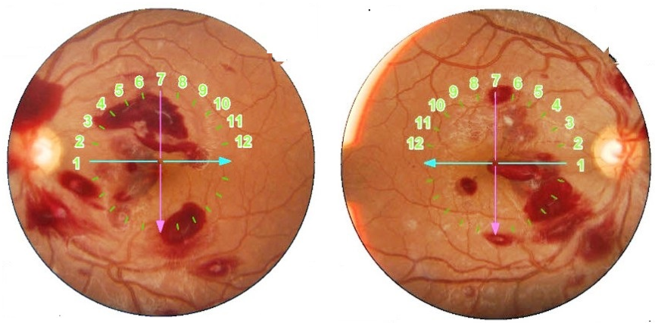
Fig. 1. Superficial and deep diffuse retinal hemorrhages with Roth stains.

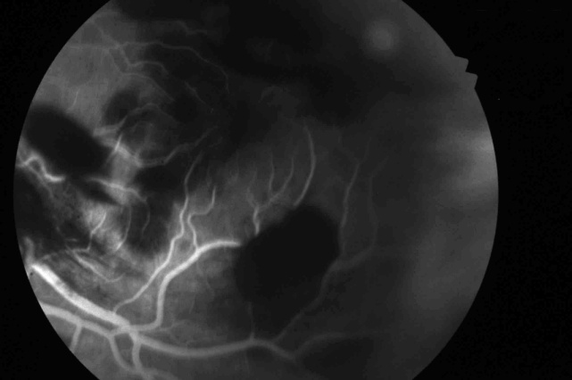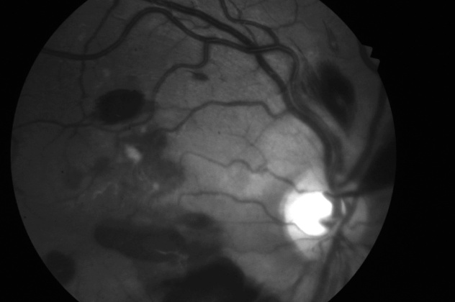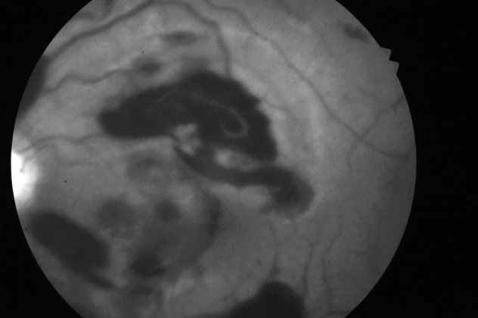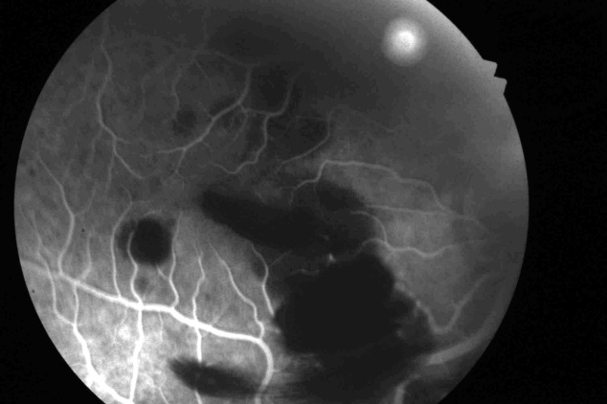

Fig. 2. Fluorescein angiography: mask effect in relation to retinal hemorrhages.

3. discussion

Ocular manifestations in acute leukemia are frequent and multiple with incidence ranging from 9% to over 80% (Karkhaneh et al., 2018). Chorioretinal involvement is the most visually significant of these ocular manifestations and is mainly due to two consequences of the disease: primary leukemic infiltration or secondary to hematological abnormalities, the latter being more common ( Eyewiki, 2023; Sharma et al, 2004).
White-centered retinal hemorrhage, also known as the Roth spot, is most often a manifestation of retinal capillary rupture and extrusion of blood followed by coagulation, that will form the central white platelet-fibrin thrombus, but sometimes it is due to true leukemic infiltrates, which is a sign of bad prognosis (Schachat AP et al 1989).Recent literature emphasizes their correlation with hematologic parameters, such as severe thrombocytopenia or hyperleukocytosis (Laimon et al, 2024).
Ghanbarnia et al described a striking case of leukemic retinopathy presenting simultaneous bilateral subhyaloid hemorrhage and subarachnoid hemorrhage in acute monocytic leukemia, illustrating the potential for severe and multifocal hemorrhagic manifestations in the disease (Ghanbarnia et al, 2022).
Anterior segment involvement is rare and generally occurs via infiltration of the iris and ciliary body, leading to iridocyclitis or nodular iris changes (Kincaid & Green, 1983).
Orbital locations lead to eyelid edema, sometimes ecchymotic and painful exophthalmos (Zimmerman LE et al,1964). Optic nerve infiltration is more rarely observed and is a medical emergency often leading to irreversible vision loss; it was found histologically in 18% of cases in necropsy studies. The vitreous localization is rarely reported in the literature; it is due to vitreous invasion via the optic nerve or hematogenously. In our observation, no other ocular manifestations were found.

4. Conclusion

This case highlights white-centered retinal hemorrhage as a potentially revealing sign of acute leukemia. A thorough ophthalmologic examination in patients with sudden bilateral visual loss may facilitate early diagnosis of life-threatening hematologic malignancies. Prompt recognition and systemic evaluation are essential to initiate appropriate treatment and improve prognosis.

CONSENT
All authors declare that ‘written informed consent was obtained from the patient for publication of this case report and accompanying images.
DATA AVAILABILITY
Not applicable
ETHICAL APPROVAL
As per international standards or university standards written ethical approval has been collected and preserved by the author(s).
COMPETING INTERESTS
Authors have declared that no competing interests exist.
Disclaimer (Artificial intelligence)
Authors hereby declare that NO generative AI technologies such as Large Language Models (ChatGPT, COPILOT, etc.) and text-to-image generators have been used during the writing or editing of this manuscript.

References

Pui CH, Robison LL, Look AT. Acute lymphoblastic leukaemia. Lancet.2008;371(9617):1030-43.
DOI: 10.1016/S0140-6736(08)60457-2
Estey EH, Döhner H. Acute myeloid leukaemia. Lancet. 2006;368(9550):1894-907.
DOI: 10.1016/S0140-6736(06)69780-8
Kincaid MC, Green WR. Ocular and orbital involvement in leukemia. Surv Ophthalmol. 1983;27(4):211-32.
DOI: 10.1016/0039-6257(83)90123-3

Sharma T, Grewal J, Gupta S, Murray PI. Ophthalmic manifestations of acute leukaemias: the ophthalmologist's role. Eye (Lond). 2004;18(7):663-72.
DOI: 10.1038/sj.eye.6700735
Karkhaneh R, Mirshahi R, Rajabi MB, et al. Ophthalmic manifestations of acute leukemia: A prospective study. Int Ophthalmol. 2018;38(1):229-36.
DOI: 10.1007/s10792-016-0425-y
Schachat AP, Markowitz JA, Guy J, Burke PJ, Karp JE. Ocular manifestations of leukemia. Arch Ophthalmol. 1989;107(5):697-700.
DOI: 10.1001/archopht.1989.01070010715031
Zimmerman LE. Ocular manifestations of leukemia: a review of 675 cases. Trans Am Acad Ophthalmol Otolaryngol. 1964;68:474-95.
PubMed Link
Ghanbarnia M, Sedaghat S, Rasoulinejad SA. Leukemic retinopathy presenting as concurrent bilateral subhyaloid hemorrhage and subarachnoid hemorrhage in a patient with acute monocytic leukemia: a case report. J Med Case Rep. 2022;16(1):466.
DOI: 10.1186/s13256-022-03649-4
Laimon DN, Sakr DH, Atef B, et al. Highlights of ophthalmological manifestations in newly diagnosed acute leukemia: a correlation with hematological parameters. Ann Hematol. 2024;103:3519–3533.
DOI: 10.1007/s00277-024-05861-2
American Academy of Ophthalmology. Retinal Manifestations of Leukemia - Leukemic Retinopathy [Internet]. Eyewiki; 2023 [updated 2023 Jan 15; cited 2024 Jul 15].
Available from: https://eyewiki.org/Retinal Manifestations of Leukemia Leukemic Retinopathy

