Spider Silk as a Next Generation Biomaterial: Advances in Biomedical and Tissue Engineering Applications

ABSTRACT
Spider silk has emerged as one of the most remarkable natural protein fibres with exceptional mechanical and biological properties positioning it as a highly promising biomaterial in biomedical and tissue engineering. Its unique combination of high tensile strength, elasticity, toughness, biocompatibility and slow degradation distinguishes it from other biopolymers such as collagen, polylactic acid and gelatin. Historically employed for wound healing and suturing, spider silk has now advanced into modern applications including tissue scaffolds, wound dressings, drug delivery systems and reconstructive medicine. Recent progress in molecular biology and recombinant DNA technology has enabled artificial synthesis of silk proteins with customizable properties. Furthermore, novel functionalization such as antimicrobial activity, self-healing behaviour and facilitation of biomineralization have broadened its biomedical potential. Despite these advances, barriers remain in replicating the natural spinning process, achieving cost-effective production and ensuring clinical translation. This review provides a comprehensive overview of the production strategies, structural and functional properties and emerging biomedical applications of spider silk with emphasis on its role in regenerative medicine and tissue engineering highlighting future challenges and opportunities for its clinical adoption.
Keywords: Spider silk, recombinant proteins, biomaterials, tissue engineering, drug delivery
1. Introduction
Spider silk is a fascinating natural protein fibre spun by spiders that has received a lot of interest as a significant biomaterial in biomedical and tissue engineering. More than 40,000 spider species have been recognized, with an estimated number of more species yet to be discovered. All true spider spins at least one type of silk, and some species produce many types based on their glands (Dong et al., 2020). Spider silk, one of the most durable natural materials created by living beings is mostly made up of proteins, making it biocompatible and ecologically beneficial (Kim et al., 2020). Its amino acid composition is dominated by glycine and alanine residues, which play a crucial role in determining its structural and mechanical properties (Roomer et al., 2008).
Spider silk has exceptional mechanical strength, fatigue resistance, high energy absorption, biocompatibility, and a slow biodegradation rate. These qualities have made it an exceptional biopolymer with applications in a variety of sectors, most notably tissue engineering. Spider silk fibres have a range of qualities, including low density, great expandability and tensile strength. For example, MaSp1 fibres have a high tensile strength, yet flagelliform silk has extraordinary flexibility (Salehi et al., 2020).
Historically, spider silk has been used in medicine since ancient times. It was applied as an astringent to stop bleeding (Gu et al., 2020), and its first documented clinical use dates back to the 18th century when it was employed for suturing. In modern times, silk has been increasingly studied as a biomaterial due to its excellent biocompatibility, toughness, and ability to support tissue regeneration, particularly in bone and ligament repair (Hsia et al., 2011). By-products of spider silk are also advantageous, being non-toxic, low in immunogenicity, and easily eliminated from the body.
The versatility of spider silk has further broadened its biomedical applications, ranging from sutures and wound dressings to breast reconstruction, cosmetics, and the treatment of gynaecological conditions (Foppiani et al., 2023). More recently, silk-based biomaterials have been investigated for their antibacterial and antimicrobial potential, though tailoring these effects in tissue scaffolds remains under study (Schafer et al., 2023). Spider silk proteins have also been demonstrated to mediate biomineralization processes (Ma et al., 2023), and innovative self-healing biomaterials have been created using them (Chen et al., 2023), paving the way for smart biomaterials.
In comparison to other biopolymers such as collagen, polylactic acid, fibrin, alginate, and gelatin, spider silk exhibits superior performance due to its ability to reduce inflammatory responses and provide scaffolding that facilitates cell adhesion and growth. Furthermore, spider silk has been processed into films, matrices, nanospheres, hydrogels, and other formats for biomedical applications. The recombinant production of spider silk proteins in various host organisms has accelerated recent advancements, allowing artificial repetition of amino acid sequences and tailoring of secondary structures to improve performance (Bakhshandeh et al., 2021).
Despite these advantages, early research on medical applications of spider silk was limited due to difficulties in harvesting large quantities from natural sources. However, recent progress in molecular biology and recombinant DNA technology has overcome these barriers, enabling large-scale production and even chemical and genetic modification of spider silk proteins (Bowen et al., 2018). These advances have significantly expanded its applicability in regenerative medicine, reconstructive surgery, and drug delivery systems.

2. Structure and properties of spider silk
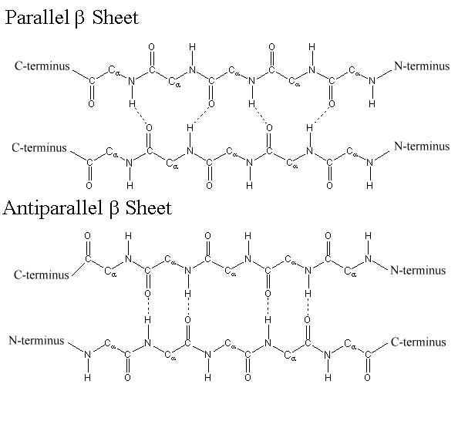
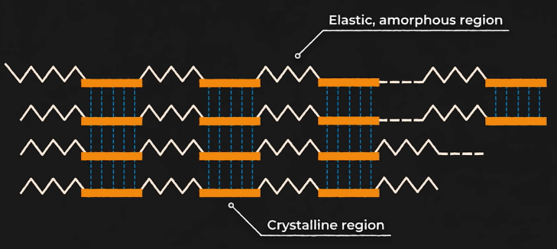
A) B)

Fig. 1: A) Amorphous and crystalline regions of spidroin protein B) parallel and antiparallel beta sheet arrangement of crystalline regions in spidroin protein

Spidroins are proteins that make up spider silk and have a common primary structure. They are large proteins, up to 350 kDa per monomer (Ko et al., 2001). They are made up of repeating domains that contain both amorphous and crystalline regions. The amorphous regions are elastic and made up of glycine-rich spirals, while the crystalline regions are less ordered and made up of alanine-rich regions that fold into crystalline β-sheets. The ratio of crystalline to amorphous regions affects the strength and elasticity of spider silk. For example, Major ampullate silk, which is used to build the frame of a spider's web, has a high number of crystalline structures, while Flag silk is more flexible and has almost exclusively amorphous regions (Fig. 1A) (Gu et al., 2020).
“The crystal part of spider silk, which is made up of highly durable layered β-sheets and also the fine structure consisting of uniaxially oriented protein molecules (Osaki et al., 1985), provides superb tensile strength” (Kim et al., 2020, Liu et al., 2005). “Tensile strength depends on the molecular interactions of hydrogen bonds. The thermal stability, modulus, and tensile strength of the sheets improve as the number of hydrogen bonds in the β-sheets increases. The key difference between parallel and antiparallel beta pleated sheets is that in parallel beta pleated sheets, polypeptide strands run in the same direction, while in antiparallel beta pleated sheets, neighbouring strands run in opposite directions (Fig. 1B)”(Gu et al., 2020).
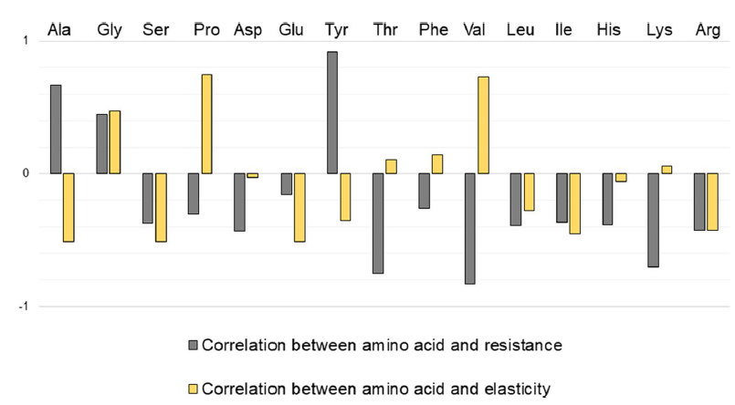

Fig. 2: Correlation between amino acid composition and mechanical properties of spider silks Araneus diadematus and Nephila clavipes.
“The main domain consists of 100 repeats of the glycine and polyalanine amino acid sequences, accounting for approximately 60-90% of the fibres” (Eisoldt et al., 2012). “The degree of crystallinity, which determines the strength and stiffness of the fibres are determined by the number of alanine blocks in the main domain. On the other hand, Glycine residues play an important role in the expandability and resilience of the fibres” (Kummerlen et al., 1996).
Gu et al. (2020) reported that the dragline silk is mainly based on glycine, alanine, proline and Tyrosine amino acids. Increase in glycine, alanine and tyrosine increase the mechanical resistance of dragline silk. Whereas, increase in glycine and proline increases the elasticity of fibre (Hu et al., 2006) (Fig. 2).

3. Different glands producing spider silk
Lewis (2006) reported that “Orb-web weaving spiders have seven glands in their abdomen, including the minor ampullate, the major ampullate, the aggregate, the flagelliform, the pyriform, the aciniform and the cylindriform glands that produce and secrete silks in liquid form, which immediately solidify after secretion (Fig. 3). The minor ampullate gland secretes auxiliary spiral fiber, but the major ampullate gland secretes dragline silk, which is extremely strong and forms the nest's primary threads. The aggregation gland secretes fibres, resulting in a sticky watery covering. The flagelliform gland secretes fibres, which form the centre of the capture spiral. The pyriform gland secretes fibres that serve as joint and connection cements, whilst the aciniform gland secretes fibres that are used to wrap prey and create the delicate inner silk of the egg sack. Finally, the cylindriform gland secretes fibres that form the hard outer silk of the egg sack”.
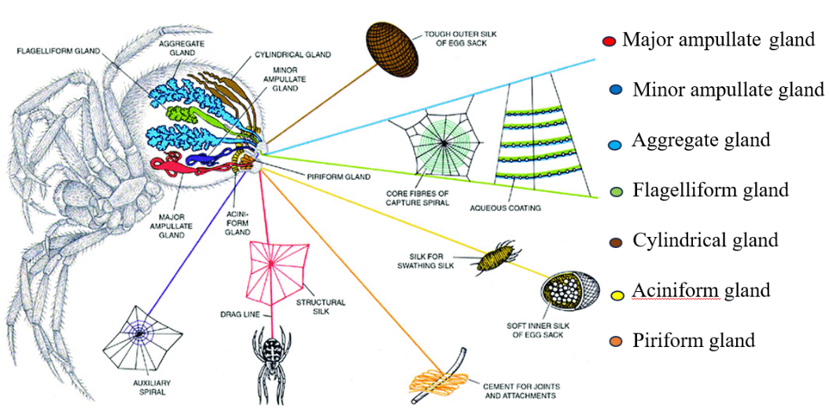

Fig. 3: Different types of spider silk producing glands
Table 1. Function and composition of different types of spider silk (Gu et al., 2020)
Glands | Type of Spider Silk | Composition | Function
Aggregate | Aqueous cement | ASG1, ASG2 | Prey capture, sticky attachment
Pyriform | Core fiber of capture spiral | PySp1, PySp2 | Attachment
Tubuliform /  Cylindrical | Egg-case silk | TuSp1, ECP-1, ECP-2 | Reproduction
Flagelliform | Spiral silk | Flag | Prey capture
Aciniform | Capture silk | AcSp1 | Wrapping captured prey
Minor Ampullate | Dragline silk, framework silk | MiSp1, MiSp2 | web reinforcement
Major Ampullate | Dragline silk, framework silk, radial silk | MaSp1, MaSp2 | Web frame, radii

Spider silk is produced by specialized glands each secreting proteins with unique compositions and functions. The major ampullate gland secretes MaSp1 and MaSp2 proteins generating dragline silk that is exceptionally strong per unit weight, even surpassing steel, with a composition rich in glycine (37%) and alanine (18%). The flagelliform gland produces the capture spiral silk, which is sticky, highly extensible and tough, containing glycine (44%), proline (21%) and notable proportions of small side chains (56%) and polar residues (17%). The pyriform silk (PySp1) forms attachment discs that anchor silk to substrates while the aciniform silk (AcSp1) is used to wrap and immobilize prey. The cylindriform gland secretes tubuliform silk (TuSp1) which provides protective egg sacs and the aggregate gland produces a glycoprotein coating (AgSF1, AgSF2) that enhances prey capture by rendering the capture spiral sticky (Table 1).
4. Production of recombinant spider silk
“Biotechnological fabrication has enabled novel techniques to create spider silk proteins from different sources such as bacteria, plants, yeasts, cells or mammals resulting in cost-effective and reliable fabrication” (Ramezaniaghdam et al., 2022). The most widely utilized proteins are taken from sequences recovered from Nephila clavipes and Araneus diadematus (Salehi et al., 2020).
Recombinant protein production involves the following steps (Heidebrecht and Scheibel, 2013):
- Determining the sequence of nucleotides in natural DNA (isolation of the desired
Sequence that encodes the target protein)
- Designing recombinant DNA
- Selection of the vector that will enable the transmission of the desired sequence
- Transmission of the vector into the host’s organism (bacteria, yeast, plants, insect cells,
Mammalian cells and transgenic animals)
- Cultivation / production of proteins in the host organism
- Isolation of the obtained proteins
“Developing spider silk proteins from bacteria is difficult due to the proteins' large molecular weight and extensive repetitive sections containing high quantities of glycine and alanine. However, recent studies utilizing E. coli have attempted to address this issue by employing alternate approaches that use the intein system to build protein sub units. This has resulted in the development of chimera fibres with outstanding mechanical characteristics”. (Bowen et al., 2018). “Using mammalian or insect cell cultures to create structural proteins is not practicable. However, scientists have had some success expressing spider silk protein in specific types of cells, such as bovine mammary epithelial cells, hamster kidney cells” (Lazaris et al., 2002), African green monkey kidney cells (Grip et al., 2006), and silkworm neural cells (Zhang et al., 2008) (Fig. 4).

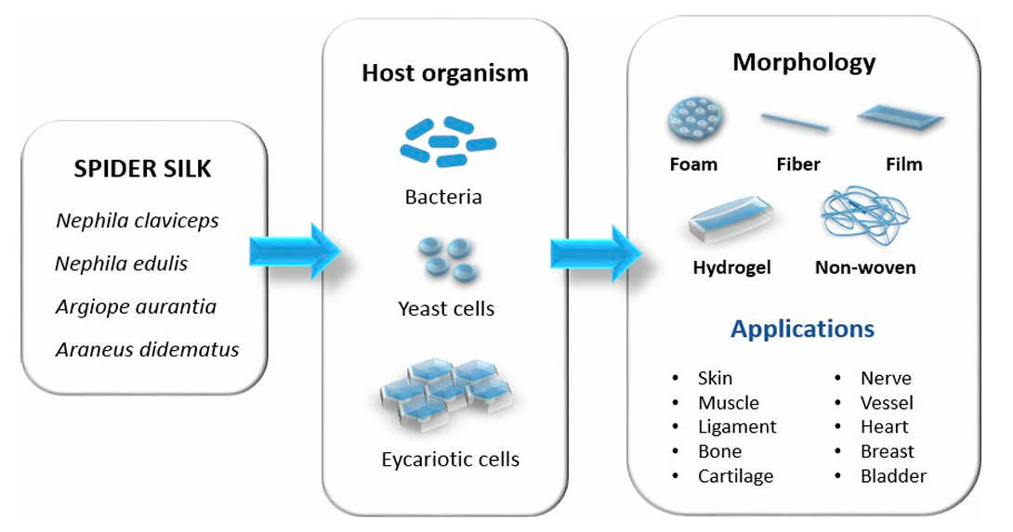
Fig. 4: Schematic representation of the recombinant spider silk protein production, sources and possible biomaterials. (Salehi et al., 2020).

Table 2: Mechanical properties of dragline silks derived from spiders in comparison to some other materials.
Material | Tensile strength (MPa) | Extensibility (%) | Toughness (M J m⁻³)
Natural N. clavipes dragline spidroin | 1215 ± 233 | 17.2 ± 3.5 | 111.2 ± 30
Natural A. diadematus major ampullate silk | 1100 | 27 | 160
Natural N. edulis dragline spidroin | 1300 ± 100 | 39 ± 6 | -
Natural A. trifsaciata aciniform spidroin (AcSp1) | 687 ± 56 | 86 ± 3 | 376 ± 39
Natural flagelliform silk (A. diadematus, A. sericatus, A. argentata) | 500 -1300 | 119-270 | 75-283
Recombinant A. diadematus ADF3 | 64.6 ± 26 | 10.8 ± 3.1 | -
Recombinant N. clavipes MaSp1 | 508 ±108 | 15 ± 5 | -
Bombyx mori silk | 600 | 18 | 70
Bone | 160 | 3 | 40
Collagen | 150 | 12 | 7.5
Kevlar – 49 | 3600 | 2.7 | 50
High tensile steel | 1500 | 0.8 | 6

Different mechanical properties of dragline silks from different species of spiders, recombinant spider silk fibres, as well as Kevlar and Steel (two artificial materials with outstanding mechanical properties) are presented in Table 2.
Natural spider silks, particularly N. edulis dragline silk and A. diadematus major ampullate silk exhibit remarkable tensile strength (1300 MPa and 1100 MPa respectively) and extensibility, resulting in high toughness values that surpass many synthetic materials. flagelliform silks stand out for their extraordinary extensibility (up to 270 %) making them among the toughest natural fibres known. Compared to conventional materials like bone, collagen, Kevlar and steel, spider silks achieve a unique balance of strength and extensibility with toughness values. Overall, the data emphasize spider silk’s exceptional potential as a biomaterial, combining strength, flexibility and energy absorption in a way unmatched by most natural and synthetic materials (Table 2).
5. Biomedical and tissue engineering applications:
“Tissue engineering is an interdisciplinary science that creates biological replacements to repair, preserve and improve tissue function or a whole organ” (Allmeling, 2008; Bakhshandeh, 2017). “Biomaterials that can replicate the intended extra cellular matrix properties or stimulate favourable cell differentiation are critical for progress in this field” (Oftadeh, 2018). “Biomaterials utilized in tissue engineering must have unique traits such as biodegradability, biocompatibility, support for cell adhesion, growth, proliferation, and differentiation, as well as acceptable mechanical properties” (Mombini, 2019). “Spider silk is an acceptable biomaterial and might be an excellent alternative for tissue engineering and regenerative medicine” (Dinjaski, 2017). “Silk fibre implants have also been one of the most popular therapeutic options in recent decades” (Li, 2015). Some applications of spider silks in several types of engineered tissues and implants are discussed as follows.
5.1 Skin regeneration and Wound healing
“In the past, natural spider silk was used to cover wounds and assist the healing process” (Liebsch et al., 2018) and “today, extensive study has been done on spider silk dressings alone or in conjunction with other materials such as silkworm silk, demonstrating its ability to treat wounds from burns” (Chouhan et al., 2019).
Baoyong et al. (2010) presented “the application of recombinant spider silk materials as wound dressings and tested the material in rat models. Spider silk porosity films/membranes constructed of pNSR-16 and pNSR-32 (both of which include RGD sequences) were investigated for their ability to cover severe second-degree burn wounds. Collagen was utilized as a control, and 60 Sprague-Dawley (SD) rats were observed at 3, 5, 7, 14, and 21 days. The wound healing rate, histopathology, and amounts of hydroxyproline production were investigated. Interestingly, materials containing recombinant spider silk proteins pNSR-16 and pNSR-32 performed significantly better than the control groups, with greater expression of bFGF observed on days 7, 14, and 21. The higher concentration of hydroxyproline (the main amino acid in collagen) in healed wounds indicated effective skin regeneration in the targeted groups”.
Chouhan et al. (2019) and Liu et al. (2019) reported that “recombinant spider silk proteins were genetically engineered with a fibronectin motif to improve cell attachment. Silkworm fibroin was processed into nano fibre mats and microporous scaffolds which were then covered with recombinant spider silk fusion protein (FN-4RepCT (FN-4RC)). Third degree burn wounds in a rat model were treated using functionalized microporous silk scaffolds. After 14 days of therapy, functionalized acellular scaffolds outperformed the commercially available DuoDERM dressing patch and untreated wounds in terms of wound healing speed”.
5.2 Bone regeneration
“Spider silk is a suitable choice as three dimensional scaffold in bone, tendon and cartilage tissue engineering due to its elastic properties and strength among synthetic and natural polymers” (Gellynck et al., 2008).
Schacht and Scheibel (2014) created “engineered spider silks using the two most abundant proteins found in the dragline silks of the European garden spider (Araneus diadematus) ADF3 and ADF4. The engineered silk protein analogues (eADF3 and eADF4, respectively) can be produced through an industrially viable fermentation process in Escherichia coli bacteria. The repeating backbone sequence of eADF4 analogues contains many glutamic acid residues which can be chemically modified or bind to cations, like normal medicines” (Hardy et al., 2014).
Materials constructed of recombinant spider silk proteins in the study given by Hardy et al. (2016) could be biomineralized, and those materials produced an increased level of alkaline phosphatase activity in human mesenchymal stem cells cultivated on the substrates. Because the spider silk used had numerous carboxylic acid moieties, calcium ions were able to bind and aid mineralization. When a composite polymer solution comprising eADF4(C16) and poly(butylene terephthalate) (PBT) or poly(butylene terephthalate-co-poly(alkylene glycol) terephthalate) (PBTAT) was processed into films, calcium carbonate was preferentially deposited on the eADF4(C16) phase instead of synthetic polymer.
“The Major ampullate spidroin 1 (MaSp1) protein class along with the BSP fusion protein, induces calcium-phosphate deposition as well as good adhesion of mesenchymal stem cells (which significantly contributed to their differentiation) and noticeable type 2 collagen synthesis in cartilage cells (Fig. 5)” (Gomes et al., 2011). Wang et al. (2023) revealed that “precision tweaking of the biomineralization parameters resulted in the controlled integration of hydroxyapatite onto native spider silk while retaining acceptable mechanical capabilities. Natural bio-based nanomaterials provide excellent scaffold characteristics for bone tissue creation and cartilage regeneration. However, therapeutic uses of silk-based scaffolding are still in the works and will require clinical studies before receiving official regulatory approval”.

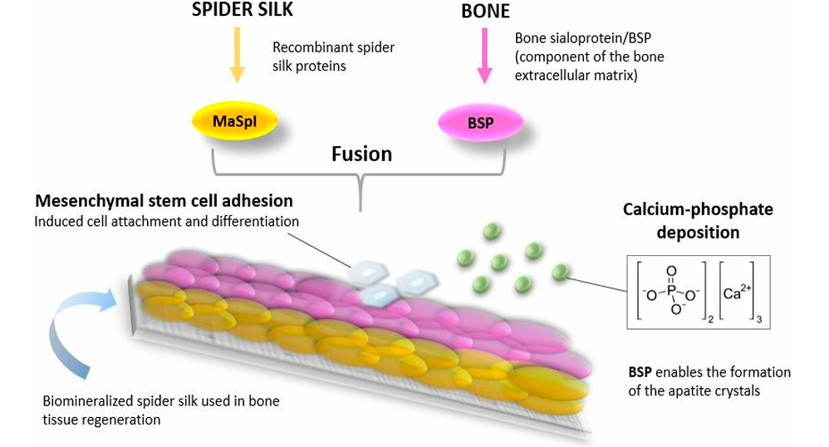
Fig. 5. Use of spider silk protein (major ampullate spidroin protein) in the fabrication of scaffolds (Gomes et al., 2011)
5.3 Nerve regeneration
“Implanting biodegradable and biocompatible scaffolds as nerve guidance conduits (NGCs) is one of the treatment techniques for facilitating axonal regeneration after peripheral nerve injury. Spider silk has been shown to regulate cell proliferation, migration and peripheral nerve regeneration. Axon regeneration in peripheral nerve injury can be accelerated by implanting particular biodegradable guidance channels that can guide cells while they are present. Spider silk threads were acceptable for human neuron culture and research demonstrated their excellent adhesion, cell body migration, differentiation and neurite (axon) extension which resembled ganglion structures. After ten months, axons regenerated with myelination showing that Schwann cells moved through the constructions (Fig. 6)” (Roloff et al., 2014).
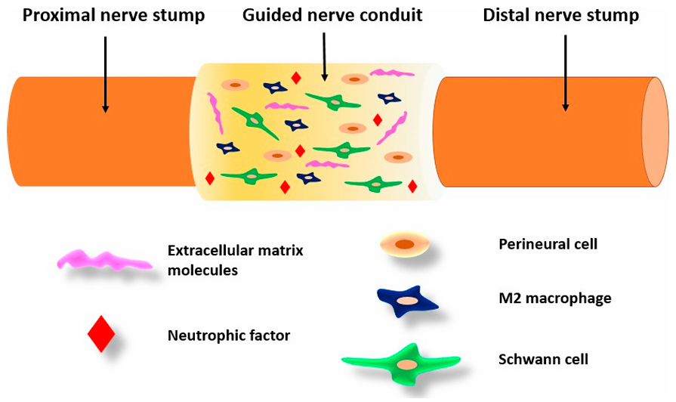

Fig. 6: Peripheral nerve tissue engineering.

Pawar et al. (2019) and Aigner et al. (2020) reported the development of NGCs using recombinant spider silk eADF4(C16) materials. Pawar et al. (2019) found that fibres formed of eADF4(C16) nonwoven electro spun meshes loaded with microfluidics can generate collagen fibres. Aigner et al. (2020) took a different technique, fabricating NGCs from self-rolling films to allow for the encapsulation of PC-12 neuronal cells together with supporting microenvironments. Lewicka et al. (2019) investigated the interaction of stem cells and neural progenitors with recombinant spider silk. Cells cultivated on spider silk surfaces were able to differentiate into neuronal and astrocytic cells in a similar way to cells cultured on polystyrene plates with fibronectin coats. The study also found that the 3D porous foam structure formed of 4RepCT improved NSC adhesion, survival, and differentiation into astrocytes in 3D.
Stadlmayr et al. (2024) made “comparative analysis of various spider silks in regard to nerve regeneration, its material properties and schwann cell response. The study investigated cell adhesion and morphology on three spider silk fibres Trichonephila inaurata, Phidippus regius and Nuctenea umbratica. Rat stem cells (rSCs) were seeded onto the fibres and incubated for two weeks. The morphology of the cells was assessed using DAPI-stained nuclei and immunofluorescence staining for the rSC marker SOX10 showed a rSC culture purity above 99% on different silk fibres. The proliferation rate was found to be similar across all silks with a higher rate observed on T. inaurata fibres compared to P. regius. No significant differences were found between rSCs on P. regius and N. umbratica fibres. The study concluded that all three native spider silk fibres support proper adhesion and proliferation of rSCs”.
5.4 Antimicrobial material development
“Biofilm development, particularly among antimicrobial resistant strains is a significant issue in healthcare settings. Researchers are interested in creating materials that selectively restrict microbial attachment to surfaces while encouraging mammalian cell development. In nature certain spider silks have developed to resist germs which might be exploited in biomaterials. Most spider silk webs can withstand microbial omnipresence and remain resistant to microbial decomposition for years, regardless of environmental impacts such as humidity, temperature, and location, despite being composed of proteins and thus amino acids, which would be a valuable source of nutrition for microbes” (Wright & Goodacre, 2012).
Zha et al., (2019) and Zhang et al., (2019) reported that “the bacterial infestation and decomposition of spider silk is inhibited by bacteriostatic or microbe repellent properties rather than by anti-bacterial means. The study further hypothesized that the complex network of interconnected crystalline and non-crystalline structures might prevent accessibility of nitrogen which is necessary for bacterial growth”.
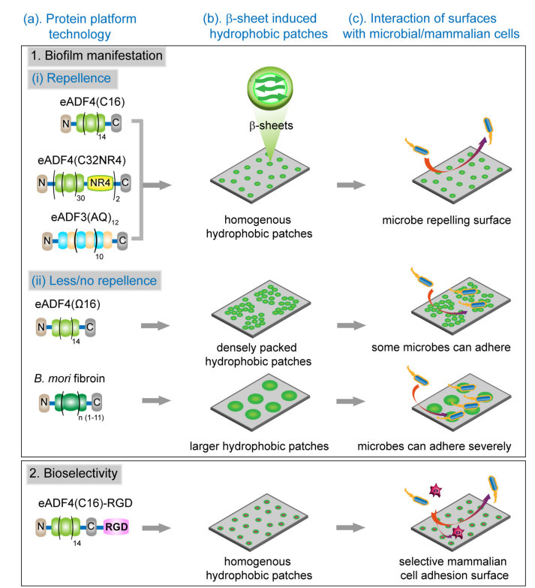

Fig. 7: Schematic illustration of the microbial behavior on silk materials with (1) repellent/non-repellent and (2) bio selective surfaces. (Kumari et al., 2020)
Kumari et al. (2020) engineered “spider silk-based 2D and 3D materials to prevent microbial infestation. Different recombinant spider silk proteins based on the consensus sequences of Araneus diadematus dragline silk proteins (fibroin 3 and 4) were processed into 2D-patterned films and 3D-hydrogels. The used protein platform technology (Fig. 7a), confirmed the correlation of adhesion of microorganisms with the presence of hydrophobic patches (Fig. 7b, and c). As shown schematically, based on the primary sequence, hydrophobic patches can be engineered due to either intermolecular charge-charge repulsion as in eADF4(C16) and eADF4 (C32NR4) or a volume effect of the amorphous region in eADF3 (AQ)12. In contrast, the absence of charge in eADF4(X16) induces a denser and less homogeneous packing of nano ß-crystallites, creating new anchoring sites for microbes. On the mesoscale, microbial cell attachment most readily occurs on surfaces which are rougher, more hydrophobic, and positively charged. RGD-modified spider silk with homogeneous hydrophobic patches showed repellence of microbes but allowed selective mammalian cell adhesion and proliferation”.

5.5 Artificial blood vessel construction
One of the causes of cardiovascular diseases is improper vascular function or dysfunction, so the replacement of blood vessels can be a successful medication for these types of diseases. Xiang et al. (2018) made “a vascular hybrid of spider silk/PCL/gelatin using electrospinning and implanted in rats for in vivo studies. The scaffold showed excellent hemocompatibility and host cell growth, without genotoxicity or inflammatory factor releases, making it a suitable candidate for small diameter vascular tissues. The study demonstrated its potential for vascular tissue engineering.”
Dastagir et al. (2020) created “blood vessel-like constructions using native spider silk as a framework. C2C12 and ST1.6R cells were seeded on scaffold surfaces and cultured in a bioreactor with pulsatile flow (max. ~135 mmHg and min. ~90 mmHg). Constructed grafts were compared to human blood vessels and cell-seeded scaffolds produced without a bioreactor. The results show that the manufactured vessel mimics normal blood vessels in terms of morphology, function, and biomarker expression. Spider silk scaffolds appear to provide an ideal and sturdy foundation for vessel construction” (Fattahi, 2021).
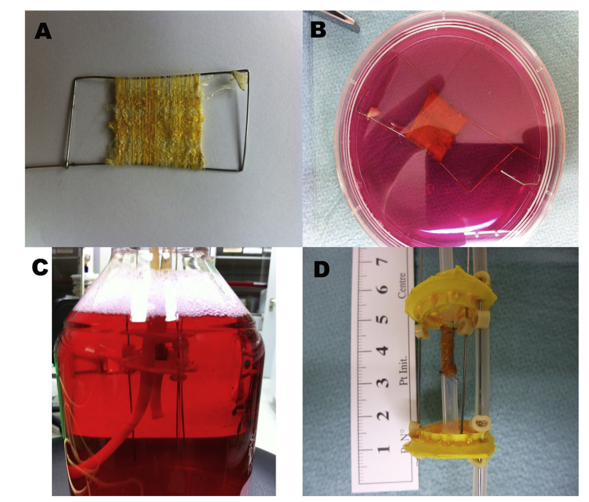

Fig. 8: Construction of the bioreactor. A) Preparation of spider silk scaffolds. B) Co-culturing of C2C12 and ST1.6R cells on both sides of spider silk scaffolds. C) Induction of pulsatile flow in constructed blood vessels using bioreactor. D) Tissue-engineered vascular graft after 3 weeks of induction. (Dastagir et al., 2020)

Table 3. Mechanical properties of TEV and native human artery.
 | Compliance mean value (% per 100mmHg) | Burst Pressure mean value (mmHg) | Tensile test mean value (N/m²)
TEV | 12.1 | 675 | 3.3
Human artery | 11.5 | 3196 | 5.1

The study focuses on the development of a tissue engineering device (TEV), which consists of a dense layer of cells (C2C12 and ST16R) on both sides of the matrix. The TEV has a confluent endothelium to prevent thrombosis and dense muscular layers to stabilize the vessel and control its calibre. The vascular construct is stable enough to resist at least 675 mmHg pressure, with a low burst pressure compared to native arteries (3196 mmHg). The TEV has a similar compliance (12.1% per 100 mmHg) to internal mammary arteries (11.5% per 100 mmHg). However, it breaks down after a tension of 3.3 *105 N/m2. Further experiments in-vitro, such as dynamic compliance, kink radius, and in-vivo tests, will be helpful in investigating the mechanical properties and density of TEVs (Table 3).
5.6 Drug delivery
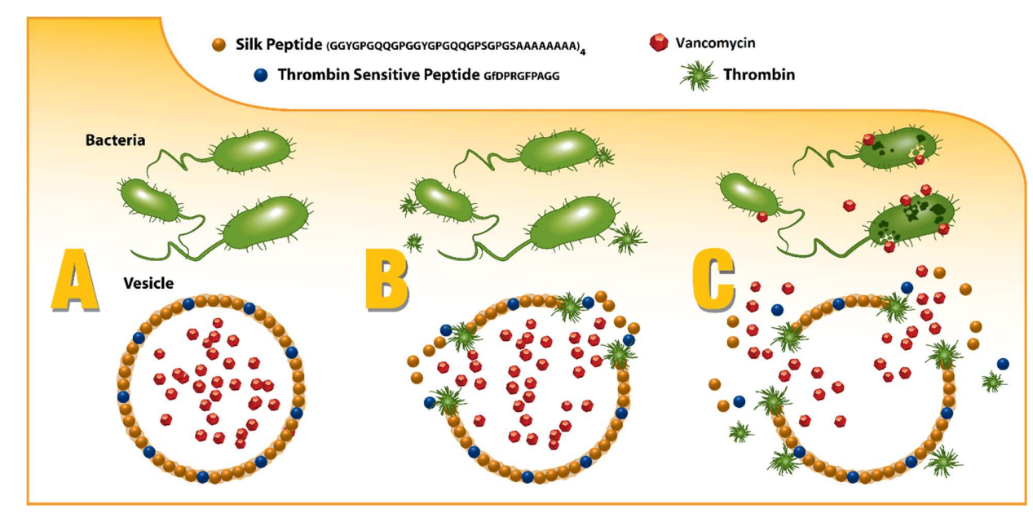
“Soft porous natural materials represent very suitable materials for drug delivery systems, and silk-based biomaterials have shown different possibilities for tailoring such systems” (Babu and Suamte, 2024). Spider silk, a hydrophobic biological material exhibits all of the desirable qualities for drug release (Liu et al., 2005). pH, ion type and concentration all have a role in the drug delivery properties of synthetic spider silk (Werner and Meinel, 2015). Recombinant spider silk is homogenous and easy to produce; these characteristics make it an appropriate delivery agent or diagnostic tool in the biopharmaceuticals (Schacht and Scheibel, 2014).
Fig. 9: Graphical representation of the infection responsive release of the drug triggered by bacterial enzyme. (Mulinti et al., 2021)
The spherical morphologies of recombinant spider silk (namely eADF4 (c16), MaSp1, and MaSp2) are more desirable for biopharmaceutical delivery. The eADF4 (c16) protein generates colloidally stable particles with negative charges at physiological pH. One of the features of eADF4 (c16) is its delayed breakdown rate, which allows for regulated medication secretion. This protein's sub microparticles can appropriately transport tiny positively charged molecules (Lammel et al., 2011).
Mulinti et al. (2021) developed “plug-and-play” motif structure where spidroins can be directly engineered to not only incorporate the thrombin-sensitive peptide element, but also to promote self-assembly into drug encapsulating micelles and microcapsules that can release their drug payload only in the presence of infection as depicted (Fig. 9).
The study evaluated the release profile of drug loaded nanospheres under various conditions to assess infection responsive drug release. The cumulative release of the drug from silk/TSP conjugate particles was recorded as 84.4 % when exposed to Staphylococcus aureus (SA) media, 18.9 % in the absence of media and 15.6 % and 17.5 % when exposed to SA and buffer media respectively. Plain silk particles did not show infection responsive release, but they were leaky. The release profile was also determined in the presence of S. epidermidis media with a drug release of 20.8 %, slightly higher than control particles (Fig. 10).
It was determined that the formulation releases the drug only against infection media from S. aureus. To establish a drug release profile, the dialysis tubing method was used, and the sample was analyzed by UV spectroscopy. It showed that the maximum release of the drug (85%) was achieved within 12 h, with the release slowly declining over time, giving an almost bell-shaped curve. The cumulative drug release of the formulation is represented in Fig. 11.

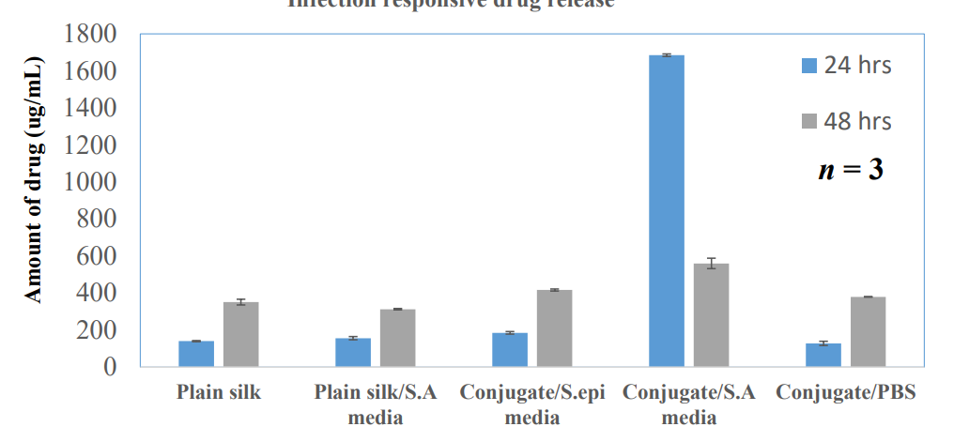

Fig. 10: In-vitro infection responsive release of the drug loaded particles against different media.
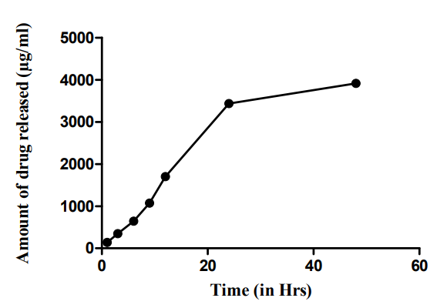

Fig. 11: In-vitro drug release profile of the drug loaded conjugate nanospheres in the presence of S.A media

6. Future Perspectives
The integration of spider silk with nanotechnology, bioactive molecules and smart material systems holds promise for creating next generation biomaterials with enhanced therapeutic functionality. Interdisciplinary research linking molecular biology, materials science and clinical medicine will be essential to overcome current translational barriers. Furthermore, long term in-vivo studies, regulatory validations and cost effective production methods are critical to advance spider silk from experimental prototypes to widely adopted clinical applications. With sustained global research efforts, spider silk has the potential to evolve from a natural wonder into a cornerstone material for regenerative medicine and advanced healthcare solutions.

7. Conclusion
Spider silk has emerged as an excellent natural biomaterial, characterized by unique mechanical, biocompatible and biodegradable features making it very promising for biomedical and tissue engineering applications. Its remarkable tensile strength, elasticity and versatility provide it a promising contender for applications in wound healing, drug delivery, nerve regeneration, cardiovascular implants and scaffold design in tissue engineering. Recognized for its inherent strength and sustainability, spider silk has notable benefits like biodegradability and compatibility with various drug delivery methods, therefore promoting regeneration in nerves, bone, cartilage, muscle, tendon, skin and vascular tissues. Recent advancements in recombinant DNA technology, protein engineering and synthetic biology enabled the development of spider silk based biomaterials, overcoming the constraints of natural silk extraction. However, challenges such as large scale production, repeatability, nano structural characterization and long term in-vivo validation persist. To assure safety and efficacy future research should focus on improving bio fabrication processes, functionalization methodologies and conducting thorough clinical studies. Spider silk has enormous potential to evolve into a key material for next generation biomedical implants and regenerative therapies, bridging the gap between laboratory innovation and clinical translation.

Disclaimer (Artificial intelligence)
Author(s) hereby declare that NO generative AI technologies such as Large Language Models (ChatGPT, COPILOT, etc) and text-to-image generators have been used during writing or editing of manuscripts.

8. References:
Aigner, T. B., Haynl, C., Salehi, S., O’Connor, A., & Scheibel, T. (2020). Nerve guidance conduit design based on self-rolling tubes. Mater. Today Bio., 7, 100042.
Allmeling, C., Jokuszies, A., Reimers, K., Kall, S., Choi, C. Y., Brandes, G., Kasper, C., Scheper, T., Guggenheim, M., & Vogt, P. M. (2008). Spider silk fibres in artificial nerve constructs promote peripheral nerve regeneration. Cell Prolif., 41(3), 408-420.
Babu, P. J., & Suamte, L. (2024). Applications of silk-based biomaterials in biomedicine and biotechnology. Eng. Regen., 5, 56-69.
Bakhshandeh, B., Nategi, S. S., Gazani, M. M., Dehghani, Z., & Mohammadzadeh, F. (2021). A review on advances in the applications of spider silk in biomedical issues. Int. J. Bio. Macromol., 192, 258-271.
Bakhshandeh, B., Zarrintaj, P., Oftadeh, M. O., Keramati, F., Fouladiha, H., Sohrabi-Jahromi, S., & Ziraksaz, Z. (2017). Tissue engineering; strategies, tissues, and biomaterials. Biotech. Genet. Eng. Rev., 33(2), 144-172.
Baoyong, L., Jian, Z., Denglong, C., & Min, L. (2010). Evaluation of a new type of wound dressing made from recombinant spider silk protein using rat models. Burns, 36(6), 891-896.
Bowen, C. H., Dai, B., Sargent, C. J., Bai, W., Ladiwala, P., Feng, H., Huang, W., Kaplan, D. L., Galazka, J. M., & Zhang, F. (2018). Recombinant spidroins fully replicate primary mechanical properties of natural spider silk. Biomacromolecules, 19(9), 3853-3860.
Chen, W., Wang, R., Yu, S., Chen, J., Kao, Y., Wang, T., Chang, P., Sheu, H., Chen, S., Liu, W., et al. (2023). Self-healable spider dragline silk materials. Adv. Funct. Mater., 33(43), 2303571.
Chouhan, D., Lohe, T. U., Thatikonda, N., Naidu, V., Hedhammar, M., & Mandal, B. B. (2019). Silkworm silk scaffolds functionalized with recombinant spider silk containing a fibronectin motif promotes healing of full-thickness burn wounds. ACS Biomater. Sci. Eng., 5(9), 4634-4645.
Dastagir, K., Dastagir, N., Limbourg, A., Reimers, K., Straus, S., & Vogt, P. M. (2020). In-vitro construction of artificial blood vessels using spider silk as a supporting matrix. J. Mech. Behav. Biomed. Mater., 101, 210-219.
Dinjaski, N., Plowright, R., Zhou, S., Belton, D. J., Perry, C. C., & Kaplan, D. L. (2017). Osteoinductive recombinant silk fusion proteins for bone regeneration. Acta Biomaterialia, 49, 127-139.
Dong, Q., Fang, G., Huang, Y., Hu, L., Yao, J., Shao, Z., Ling, S., & Chen, X. (2020). Effect of stress on the molecular structure and mechanical properties of supercontracted spider dragline silks. J. Mater. Chem. B, 8(1), 168-176.
Eisoldt, L., Thamm, C., & Scheibel, T. (2012). The role of terminal domains during storage and assembly of spider silk proteins. Biopolymers, 97(6), 355-361.
Fattahi, F. S. (2021). Nanoscience and nanotechnology in fabrication of scaffolds for tissue regeneration. Int. Nano Lett., 11(1), 1-23.
Foppiani, J. A., Weidman, A., Alvarez, A. H., Valentine, L., Devi, K., Kaplan, D. L., & Lin, S. J. (2023). Clinical use of non-suture silk containing products: A systematic review. Biomimetics, 8(2), 45.
Gellynck, K., Verdonk, P. C., Van Nimmen, E., Almqvist, K. F., Gheysens, T., Schoukens, G., Van Langenhove, L., Kiekens, P., Mertens, J., & Verbruggen, G. (2008). Silkworm and spider silk scaffolds for chondrocyte support. J. Mater. Sci.: Mater. Med., 19(11), 3399-3409.
Gomes, S., Leonor, I., Mano, J., Reis, R., & Kaplan, D. (2011). Spider silk-bone sialoprotein fusion proteins for bone tissue engineering. Soft Matter, 7, 4964-4973.
Grip, S., Rising, A., Nimmervoll, H., Storckenfeldt, E., McQueen-Mason, S. J., Pouchkina-Stantcheva, N., Vollrath, F., Engström, W., & Fernandez-Arias, A. (2006). Transient expression of a major ampullate spidroin 1 gene fragment from Euprosthenops sp. in mammalian cells. Cancer Genomics Proteomics, 3(2), 83-87.
Gu, Y., Yu, L., Mou, J., Wu, D., Zhou, P., & Xu, M. (2020). Mechanical properties and application analysis of spider silk bionic material. e-Polymers, 20(1), 443-457.
Hardy, J. G., Pfaff, A., Leal-Egaña, A., Müller, A. H. E., & Scheibel, T. R. (2014). Glycopolymer functionalization of engineered spider silk protein-based materials for improved cell adhesion. Macromol. Biosci., 14(7), 936-942.
Hardy, J. G., Torres-Rendon, J. G., Leal-Egaña, A., Walther, A., Schlaad, H., Cölfen, H., & Scheibel, T. R. (2016). Biomineralization of engineered spider silk protein-based composite materials for bone tissue engineering. Materials, 9(7), 560.
Heidebrecht, A., & Scheibel, T. (2013). Recombinant production of spider silk proteins. In A. Laskin, S. Sariaslani, & G. M. Gadd (Eds.), Adv. App. Microbio., (Vol. 82, pp. 115-153). Academic Press.
Hsia, Y., Gnesa, E., Tang, S., Jeffery, F., Geurts, P., Zhao, L., Franz, A., & Vierra, C. (2011). Identification and synthesis of novel biomaterials based on spider structural silk fibers. App. Phys. A, 105(2), 301-309.
Hu, X., Vasanthavada, K., Kohler, K., McNary, S., Moore, A. M. F., & Vierra, C. A. (2006). Molecular mechanisms of spider silk. Cell. Mol. Life Sci. CMLS, 63(17), 1986-1999.
Kim, Y., Choi, H., Baek, I., & Na, S. (2020). Spider silk with weaker bonding resulting in higher strength and toughness through progressive unfolding and load transfer. J. Mech. Behav. Biomed. Mater., 108, 103773.
Ko, F. K., Kawabata, S., Inoue, M., Niwa, M., Fossey, S., & Song, J. W. (2001). Engineering properties of spider silk. In MRS Proceedings (Vol. 702, p. DD3.3). Cambridge University Press.
Kumari, S., Lang, G., Desimone, E., Spengler, C., Trossmann, V. T., Lucker, S., Hudel, M., Jacobs, K., Kramer, N., & Scheibel, T. (2020). Engineered spider silk-based 2D and 3D materials prevent microbial infestation. Mater. Today, 41, 21-33.
Kummerlen, J., Van Beek, J., Vollrath, F., & Meier, B. (1996). Local structure in spider dragline silk investigated by two-dimensional spin-diffusion nuclear magnetic resonance. Macromolecules, 29(8), 2920-2928.
Lammel, A., Schwab, M., Hofer, M., Winter, G., & Scheibel, T. (2011). Recombinant spider silk particles as drug delivery vehicles. Biomaterials, 32(8), 2233–2240.
Lazaris, A., Arcidiacono, S., Huang, Y., Zhou, J. F., Duguay, F., Chretien, N., Welsh, E. A., Soares, J. W., & Karatzas, C. N. (2002). Spider silk fibers spun from soluble recombinant silk produced in mammalian cells. J. Sci., 295(5554), 472–476.
Lewicka, M., Rebellato, P., Lewicki, J., Uhlén, P., Rising, A., & Hermanson, O. (2019). Recombinant spider silk protein matrices facilitate multi-analysis of calcium-signaling in neural stem cell-derived AMPA-responsive neurons.
Lewis, R. V. (2006). Spider silk: Ancient ideas for new biomaterials. Chem. Rev., 106(9), 3762-3774.
Li, G., Li, Y., Chen, G., He, J., Han, Y., Wang, X., & Kaplan, D. L. (2015). Silk-based biomaterials in biomedical textiles and fiber-based implants. Adv. Healthc. Mater., 4(8), 1134-1151.
Liebsch, C., Bucan, V., Menger, B., Köhne, F., Waldmann, K. H., Vaslaitis, D., Vogt, P. M., & Kuhbier, J. W. (2018). Preliminary investigations of spider silk in wounds in vivo—Implications for an innovative wound dressing. Burns, 44(7), 1829-1838.
Liu, X., Miller, A. L., Park, S., George, M. N., Waletzki, B. E., Xu, H., Terzic, A., & Lu, L. (2019). Two-dimensional black phosphorus and graphene oxide nanosheets synergistically enhance cell proliferation and osteogenesis on 3D printed scaffolds. ACS App. Mater. Interfaces, 11(26), 23558-23572.
Liu, X., Sun, Q., Wang, H., Zhang, L., & Wang, J.-Y. (2005). Microspheres of corn protein, zein, for an ivermectin drug delivery system. Biomaterials, 26(1), 109-115.
Liu, Y., Shao, Z., & Vollrath, F. (2005). Relationships between supercontraction and mechanical properties of spider silk. Nature Materials, 4(12), 901-905.
Ma, L., Sun, Y., Cheng, Q., Yang, Z., Wang, J., Xu, Z., Yang, M., & Shuai, Y. (2023). Silk protein-mediated biomineralization: From bioinspired strategies and advanced functions to biomedical applications. ACS App. Mater. Interfaces, 15(27), 33191–33206.
Mombini, S., Mohammadnejad, J., Bakhshandeh, B., Narmani, A., Nourmohammadi, J., Vahdat, S., & Zirak, S. (2019). Chitosan-PVA-CNT nanofibers as electrically conductive scaffolds for cardiovascular tissue engineering. International Journal of Biological Macromolecules, 140, 278-287.
Mulinti, P., Shreffler, J., Hasan, R., Dea, M., & Brooks, A. E. (2021). Infection responsive smart delivery of antibiotics using recombinant spider silk nanospheres. Pharmaceutics, 13(9), 1135-1153.
Oftadeh, M. O., Bakhshandeh, B., Dehghan, M. M., & Khojasteh, A. (2018). Sequential application of mineralized electroconductive scaffold and electrical stimulation for efficient osteogenesis. J. Biomed. Mater. Res. Part A, 106(5), 1200-1210.
Osaki, S. (1985). Chemistry of spider’s thread. J. Synth. Org. Chem. Jpn., 43(9), 828-835.
Pawar, K., Welzel, G., Haynl, C., Schuster, S., & Scheibel, T. (2019). Recombinant spider silk and collagen-based nerve guidance conduits support neuronal cell differentiation and functionality in vitro. ACS App. Bio. Mater., 2(11), 4872-4880.
Ramezaniaghdam, M., Nahdi, N. D., & Reski, R. (2022). Recombinant spider silk: Promises and bottlenecks. Front. Bioeng. Biotechnol., 10, 835637.
Roloff, F., Straut, S., Vogt, P. M., Bicker, G., & Radtke, C. (2014). Spider silk as guiding biomaterial for human model neurons. BioMed. Res. Int., 2014, 906819.
Roomer, L., & Scheibel, T. (2008). The elaborate structure of spider silk: Structure and function of a natural high performance fiber. Prion, 2(4), 154-161.
Salehi, S., Koeck, K., & Scheibel, T. (2020). Spider silk for tissue engineering applications. Molecules, 25(3), 737.
Schacht, K., & Scheibel, T. (2014). Processing of recombinant spider silk proteins into tailor-made materials for biomaterials applications. Curr. Opin. Biotech., 29, 62-69.
Schafer, S., Aavani, F., Köpf, M., Drinic, A., Stürmer, E. K., Fuest, S., Grust, A. L. C., Gosau, M., & Smeets, R. (2023). Silk proteins in reconstructive surgery: Do they possess an inherent antibacterial activity? A systematic review. Wound Repair Regen., 31(1), 99-110.
Stadlmayr, S., Peter, K., Millesi, F., Rad, A., Wolf, S., Mero, S., Zehl, M., Mentler, A., Gusenbauer, C., Konnerth, J., & Schniepp, H. C. (2024). Comparative analysis of various spider silks in regard to nerve regeneration: Material properties and Schwann cell response. Adv. Healthc. Mater., 13(8), 2309-2321.
Wang, F., Gu, Z., Yin, Z., Zhang, W., Bai, L., & Su, J. (2023). Cell unit-inspired natural nano-based biomaterials as versatile building blocks for bone/cartilage regeneration. J. Nanobiotech., 21, 293.
Werner, V., & Meinel, L. (2015). From silk spinning in insects and spiders to advanced silk fibroin drug delivery systems. Eur. J. Pharm. Biopharm., 97, 392-399.
Wright, S., & Goodacre, S. L. (2012). Evidence for antimicrobial activity associated with common house spider silk. BMC Res. Notes, 5, 326.
Xiang, P., Wang, S.-S., He, M., Han, Y.-H., Zhou, Z.-H., Chen, D.-L., Li, M., & Ma, L. Q. (2018). The in vitro and in vivo biocompatibility evaluation of electrospun recombinant spider silk protein/PCL/gelatin for small caliber vascular tissue engineering scaffolds. Colloids and Surfaces B: Biointerfaces, 163, 19-28.
Zha, R. H., et al. (2019). Universal nanothin silk coatings via controlled spidroin self-assembly. Biomater. Sci., 7, 683-695.
Zhang, S., et al. (2019). Nitrogen inaccessibility protects spider silk from bacterial growth. J. Exp. Bio., 22(22), jeb214981. https://doi.org/10.1242/jeb.214981
Zhang, Y., Hu, J., Miao, Y., Zhao, A., Zhao, T., Wu, D., Liang, L., Miikura, A., Shiomi, K., Kajiura, Z., et al. (2008). Expression of EGFP-spider dragline silk fusion protein in BmN cells and larvae of silkworm showed the solubility is primary limit for dragline proteins yield. Mol. Biol. Rep., 35, 329-335.

