"Development of a Low-Cost, AI-Enhanced IoT Home Automation System with Adaptive Energy Management and Predictive Maintenance"
Abstract
Today modern homes are increasingly transition from manual systems to automated ones with remote control capabilities as automation technology develops. Conventional home electronic appliance access is strict and requires the user to physically attend to many appliance locations before they can be used. This can be stressful for the elderly and disabled and only offers a limited level of operating ease for everyone. To improve the flexibility of a user's remote access to home appliances, the products' wireless connection features become crucial. Furthermore, as technology advances in the modern period, a growing number of individuals get dependent on automated gadgets that they perceive to be able to improve and simplify their lives, particularly in the workplace. By meeting these requirements, the Internet of Things (IoT) improves people's quality of life. This project, an Internet of Things-based smart home lighting system using an ESP32 microcontroller, is designed to make life easier for people, especially for those who are disabled. The major objective of developing a mobile IoT app-based portable home automation system is to provide remote access and control of household appliances and electronics. The project controls the ON and OFF of electrical appliances using an ESP32 and an Internet of Things remote application server and overall response times are relatively consistent but vary slightly depending on the time of day and the specific test, with the system performing slightly better in the afternoon and night compared to the morning that is there is a lot of traffic on the network service provider in the morning for the system to perform better when compared to performance in the afternoon and night.

Keywords: ESP32 microcontroller, Internet of Things, Smart home lighting, wireless communication, IoT remote application.
1. Introduction
New discoveries and technologies are desperately needed in today's modern society to make daily tasks easier. Almost every element of the house may be managed and communicated with by one special system; home automation. The term "home automation" refers to the integration of all domestic appliances and amenities. The majority of home electrical appliances can be controlled by a microcontroller, but for this to happen, the appliances must be connected to one another in order for each one to establish communication with the others. Because home automation systems have so many benefits, like centralized appliance control, comfort and convenience, cost savings, energy conservation, security, and safety, their use in daily life is only increasing. Users can live better thanks to home automation systems (Pujaria et al., 2020).
Wi-Fi (wireless fidelity) is a wireless technology that uses radio frequency to transmit data through the air. The home automation system can be achieved via Wi-Fi enabled devices where mobile phones are used, but more importantly to this work is our connection over the Internet, a technology known as the Internet of Things (IoT). The initial speed of Wi-Fi is between 1 and 2 Mbps. Data is transmitted via Wi-Fi using the 2.4 GHz frequency spectrum. It puts frequency division multiplexing technology concepts into practice. Wi-Fi technology has a range of 40–300 feet. The Internet of Things, or IoT, is a concept in which every gadget is given an IP address, which anybody may use to identify that object online. Recent technological advancements have made it possible to use wireless controlling environments like Bluetooth and WiFi, which has allowed many gadgets to be able to communicate with one another. There are now many distinct kinds of connections thanks to the development of wireless technology; each of these connections has specific requirements and uses.
Wi-Fi is one of the most widely used connections that are frequently used in HAS (Home automation System) projects. The capabilities of Wi-Fi are more than sufficient for this job. Moreover, the cost of the system will be lowered because the majority of electronics and gadgets have built-in Wi-Fi adapters. An ESP32 DEV KIT V1 microcontroller is used in this project as the controlling device for the automation. We also used the Arduino IoT cloud infrastructure in this project, which allows for the connection of several devices, the sharing of real-time data between them, and the monitoring of that data via a straightforward user interface from any location. We plan to integrate an ESP32 Wi-Fi module with an 8-channel relay module. This would enable us to control lights, fans, and other electrical appliances by sending ON/OFF commands from either the computer dashboard or the dashboard of our mobile phone on the Arduino IoT cloud platform.

2. Related Works:
A growing body of research has explored the development of automated systems for home use, aiming to improve efficiency, security, and user convenience. Several notable contributions in this area are discussed below.
Abdulraheem et al. (2020) developed a system that utilised environmental sensors to monitor parameters such as temperature, humidity, and light intensity within the home environment. These readings were processed by a microcontroller, enabling real-time decision-making and the automation of household devices. The system emphasised energy efficiency and adaptability to varying user preferences, demonstrating the potential of sensor-driven automation for sustainable living.
Al-Gburi and Abdul-Rahaim (2022) implemented a home automation solution using an Arduino Uno board, a Wi-Fi module, and a suite of sensors and actuators. The design prioritised scalability, allowing for seamless expansion to incorporate additional devices and security features. This flexibility, coupled with its cost-effectiveness, makes it suitable for gradual adoption in both small and large residential settings.
Pujari et al. (2020) developed an IoT-based integrated smart home automation system that combined hardware and cloud services to provide seamless control of household devices. The system architecture featured a NodeMCU microcontroller for device control, a Firebase real-time database for data storage and synchronisation, and an Android mobile application for user interaction. The NodeMCU, built on the ESP8266 Wi-Fi module, enabled direct internet connectivity, allowing devices to be managed from anywhere with an internet connection. Firebase ensured instant updates between devices and the app, while also providing a reliable backend without the need for a dedicated local server. The mobile app offered a user-friendly interface for turning devices on or off, setting schedules, and receiving real-time status updates. This system demonstrated strong interoperability between hardware and cloud platforms, reducing latency in command execution and enabling scalability for additional devices and services in the future (Pujari et al., 2020).
Salman Iqbal et al. (2021) designed a system comprising four primary components: a Raspberry Pi controller, environmental and motion sensors, home devices (actuators), and an Android application for user interaction. The Raspberry Pi served as the central processing hub, offering both computational power and the ability to integrate various programming libraries for automation logic. This architecture underscored the benefits of modularity in home automation systems.
Ali et al. (2020) developed a cost-effective home automation framework that leverages the ThingSpeak cloud platform in conjunction with an Arduino Uno microcontroller equipped with an ATmega328P chip. The Arduino was programmed to collect environmental and control data from sensors and transmit them to the ThingSpeak platform via the internet. ThingSpeak provided real-time updates and visualisation, enabling users to monitor and manage their home appliances through either a mobile application or a web interface. A notable strength of their system was its integration with an open IoT platform, which facilitates scalability and interoperability with a variety of IoT devices. This approach also eliminated the need for expensive proprietary software, making it suitable for low-cost smart home deployments (Ali et al., 2020).
Stolojescu-Crisan et al. (2021) implemented their solution using an ESP8266EX Wi-Fi module as a sensor node and Raspberry Pi 4 boards for processing and device control. The ESP8266 gathered data such as temperature, humidity, and light intensity, transmitting it wirelessly to the Raspberry Pi for decision-making and automation control.
Banjo Oluwafemi et al. (2022) designed a smart home automation system incorporating components such as the ATmega328P microcontroller, GSM SIM900 module, relays, PIR sensors, and an MQ2 gas sensor. The microcontroller served as the system’s central processing unit, while the GSM module provided remote communication capabilities, enabling SMS-based alerts and control functions.
Kadali et al. (2020) proposed an innovative home automation architecture that integrates chatbot technology and voice assistant capabilities to enhance user interaction. The system employed a Raspberry Pi 3B+ as the central processing unit, running the Raspbian operating system. The Python NLTK library was used for natural language processing (NLP) to interpret and respond to user queries, while the Python GPIO library facilitated direct hardware control of connected devices. The chatbot component was developed using the Telegram Bot API, enabling remote interaction through a messaging interface. In addition, the voice assistant function allowed hands-free control of appliances using speech commands. This dual-mode interaction system significantly improved accessibility for users, particularly those with mobility limitations, and demonstrated the potential of combining NLP and IoT for creating more intuitive home automation environments (Kadali et al., 2020).
Malhotra et al. (2019) introduced a gesture-controlled home automation system designed to be both cost-effective and user-friendly. Their approach leveraged hand gesture recognition as the primary input method, enabling users to control household appliances without the need for physical switches, mobile applications, or voice commands. The system employed sensors capable of detecting specific hand movements, which were then processed by a microcontroller to trigger corresponding appliance actions. This method proved especially beneficial for users with speech impairments or physical disabilities that limit traditional input methods. Additionally, the gesture-based interface eliminated the need for constant device contact, potentially reducing the spread of germs—a feature that gained heightened relevance during the COVID-19 pandemic. By focusing on affordability and simplicity, the authors demonstrated that advanced control mechanisms could be implemented in low-cost smart home solutions without sacrificing functionality (Malhotra et al., 2019).
Meshram et al. (2022) developed an Arduino Uno-based system with a 4-channel 5V relay module and an HC-05 Bluetooth module for short-range wireless control. Their approach targeted low-cost automation solutions where internet connectivity might be limited, ensuring local control via Bluetooth-enabled devices.
Manojkumar (2022), said the quest for a low-cost, AI-enhanced IoT home automation system that blends adaptive energy management with predictive maintenance finds strong support in the literature, where researchers consistently underscore the transformative potential of integrating machine learning, edge computing, and IoT sensing to deliver affordable, efficient, and proactive smart-home solutions. for example, Ponce Ruiz, Vasquez, and Villalta Jadan (2023) demonstrate that embedding a multi-layer LSTM-based predictive energy management model within an IoT-enabled smart-building framework significantly improves forecast accuracy of energy consumption and outperforms classical regression and tree-based models in key statistical metrics such as MAE and RMSE, thereby underscoring the value of deep-learning techniques for managing residential energy use (Ponce Ruiz et al., 2023). Complementing this, an empirical case study by researchers at MDPI illustrates how an ANN model, trained on temporal, environmental, and usage data, can predict electricity usage and costs with high reliability while triggering threshold-based alerts to guide consumers in shifting loads and reducing spending illustrating a potent form of adaptive energy management (Abdulrahman 2016)
Further reinforcing the predictive maintenance dimension, Haque et al. (2024) conducted a systematic review of AI algorithms and IoT sensor technologies in industrial automation contexts and found that machine learning and deep learning approaches, including CNNs and LSTMs, improved failure prediction accuracy by 30–60%, reduced maintenance expenses by up to 50%, and extended equipment uptime significantly, while IoT-enabled real-time monitoring contributed to a 15–35% decrease in unnecessary maintenance actions—indicating a clear path to transposing these benefits into home automation systems (Haque et al., 2024) . In the domain of smart buildings, Merabet et al. (2021) surveyed AI-assisted control techniques focused on balancing thermal comfort and energy efficiency in HVAC systems and concluded that AI-based pattern recognition, predictive control, and optimization could meaningfully reduce energy use, although scalability and real-world data volume remain limiting factors—highlighting both the promise and practical challenges of deploying AI in residential environments (Merabet et al., 2021). From a renewables and energy-sector perspective, the MDPI overview of predictive maintenance and anomaly detection in energy management emphasizes that smart AI systems, fed by IoT sensor data streams, can dramatically curb unexpected downtimes and optimize asset performance, yielding up to 12% reduction in unplanned outages and 15% improvements in operating margins thereby offering compelling evidence that data-driven maintenance systems enhance reliability and efficiency in energy-rich, data-intensive contexts (MDPI, 2023).

3. Design Approach
Design methodology of this system has two major parts, the software and hardware design. The hardware is designed by arranging smartphones, micro-controller ESP32 DEV KIT V1, Power supply, 8- channel relays, whereas software design includes the Arduino IoT cloud software application and the program or source code that is written and uploaded in the microcontroller. The appliances are controlled using relays via Wi-Fi. The activation of the home appliances is achieved by using the remote-control app. on the smartphone. Fig. 1 shows the block diagram of android application using Wi-Fi and ESP32 microcontroller for home automation via the Arduino IoT cloud platform.
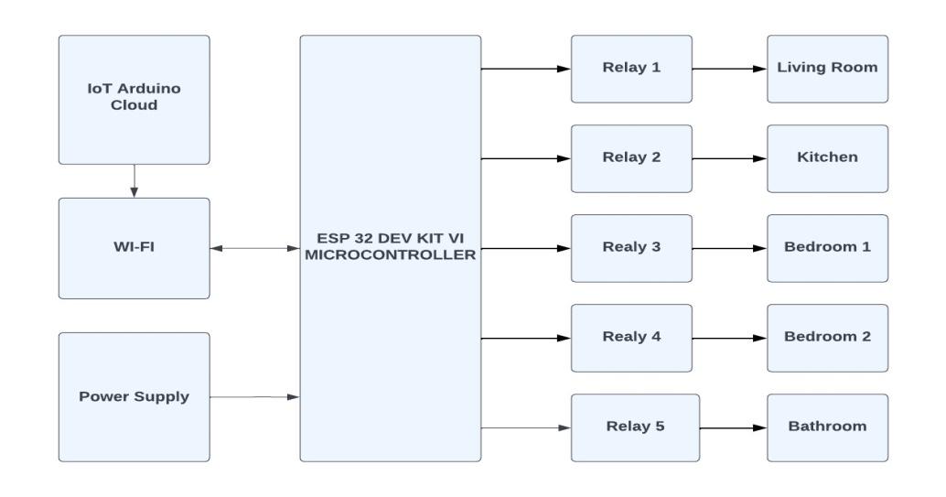
Fig. 1: Block diagram of the design

3.1 The Hardware
The hardware part of the system entails basically the following units. These units are:
- The Input Unit which covers mainly the processes that is followed in setting up the input environment i.e., Arduino IoT remote control app. via the smartphone being used.
- The Processing Unit which focuses on the ESP32 microcontroller and,
- The Output Unit which entails the relays and the connected loads

3.2 Software
The software part of this system consist the written C++ programming language that actually defines the operations of each button on the smartphone “Arduino Remote Control” application. This program is written using the Arduino Web Editor. The Arduino Web Based Editor is a cloud-based application that is supported by any operating system with a web browser. It is used to write and upload programs to Arduino compatible boards, such as the micro-controller ESP32 DEV KIT V1 and the interface in fig. 2 shows Arduino IoT cloud dashboard. The microcontroller receives data from the smartphone, and processes the data sent with already written and uploaded program. Although using the main Arduino IDE provides a more powerful and feature-rich platform than the Arduino web editor, the Arduino web editor is a good option for beginners and users who needs a simple and easy-to-use platform.

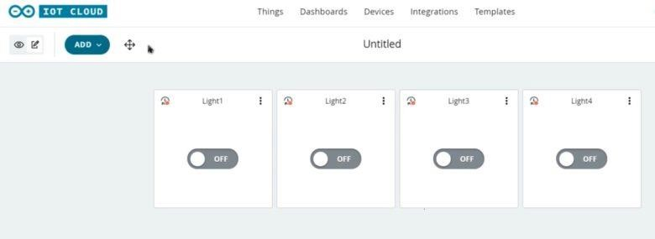

Fig. 2: Arduino IoT Cloud Dashboard

4. Result & Discussion
While building this system, the breadboard, Veroboard, and a mobile device were tested at both low and high temperatures. It was discovered that the components were functioning as intended. The speed at which the system responds to commands is determined in part by the system reaction time when a command signal is delivered through the mobile phone, for example, to switch on the lightbulb. To determine the average system performance time, this test is run several times a day across a distance of less than and greater than one km in the morning, noon, and evening using a stop watch. Both at above and below one kilometre in distance, the system functioned successfully. Table 1 displays the response time of the lightbulb when it is activated, and Fig. 3 shows a chart with the system's response times in the morning, afternoon, and night.

Table 1: Response time of home appliance

Time Test 1(sec) Test 2 (sec) Test (sec) Signal Signal Average Response Response Time (sec)
Below 1km Above 1km
Morning 0.86 0.83 0.75 ON ON 0.81
Afternoon 0.71 0.75 0.81 ON ON 0.75
Night 0.83 0.75 0.79 ON ON 0.79

Fig. 3: Representation of the response time in a chart

The chart shows the response times of a bulb across three tests (Test 1, Test 2, and Test 3) conducted at different times of the day (Morning, Afternoon, and Night). It shows that in the morning, Test 1 has the highest response time because the microcontroller has not been on for more than 8 hours while Test 3 has the lowest. In the afternoon, Test 1 has the lowest response time and Test 3 has the highest. At night, Test 1 again shows the highest response time with Test 2 having the lowest. Overall, response times are relatively consistent but vary slightly depending on the time of day and the specific test, with the system performing slightly better in the afternoon and night compared to the morning that is there is a lot of traffic on the network service provider in the morning for the system to perform better when compared to performance in the afternoon and night. And Fig. 4 and Fig. 5 represented front and back view images of the prototype system.

4.1 Integrity Test (Using different passwords and SSID)
Different service set identifier (SSID) was created with the same password “password” but the system microcontroller did not connect with it. Another scenario was created by creating same SSID but different password, the system was also unable to connect to this network. A perfect connection was established when the same SSID and Password as specified in the program was used.

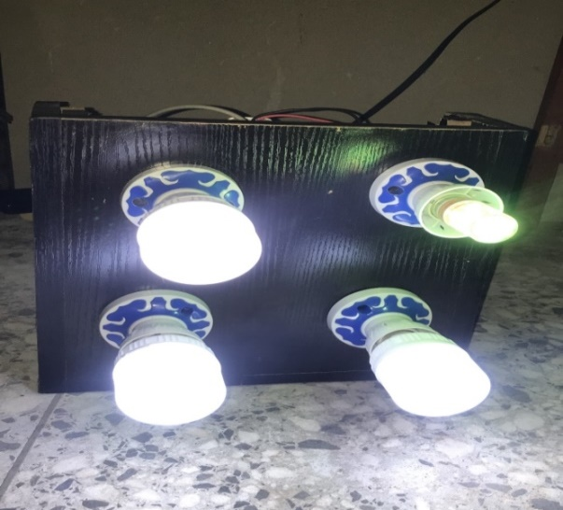

Fig. 4: Front view image of the prototype system

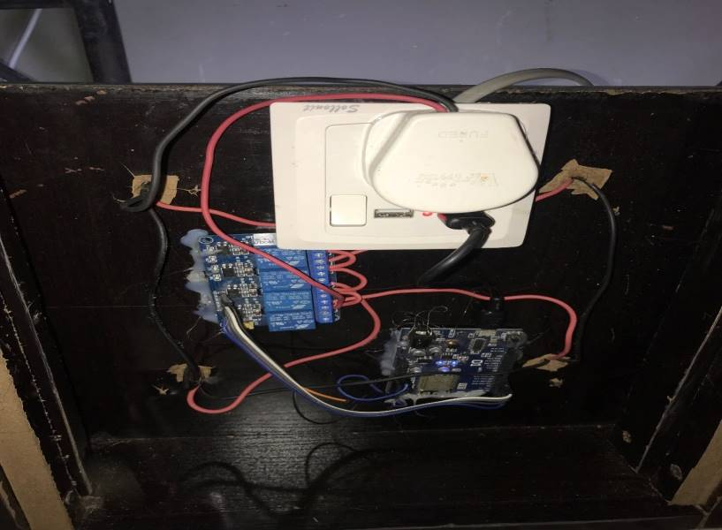

Fig. 5: Back view image of the prototype system

5. Conclusion
A system which can monitor and control multi devices at home using IoT based ESP32 microcontroller was presented. The fabrication of an IoT-based home automation lighting system using the ESP32 microcontroller is a highly effective approach to modernizing home environments. By combining hardware and software development with IoT technology, this project offers a practical solution that enhances user convenience, promotes energy efficiency, and can be adapted to various applications in smart home automation.
The project successfully demonstrates the potential of IoT-based solutions to revolutionize home automation. By leveraging the capabilities of the ESP32 microcontroller, the system provides a cost-effective, scalable, and flexible solution for modern smart homes. Additionally, the using of internet access that can control from far away can ease people in controlling appliances if they are absent from home and to ease disable people. The system's versatility, cost-effectiveness, and ability to integrate with other smart home devices make it a compelling solution for modern smart homes.

COMPETING INTERESTS DISCLAIMER:
Authors have declared that they have no known competing financial interests OR non-financial interests OR personal relationships that could have appeared to influence the work reported in this paper.

Disclaimer (Artificial intelligence)
Option 1:
Author(s) hereby declare that NO generative AI technologies such as Large Language Models (ChatGPT, COPILOT, etc.) and text-to-image generators have been used during the writing or editing of this manuscript.
References
Abdulraheem, A. S., Salih, A. A., Sadeeq, M. A. M., Salim, N. O. M., Abdulla, A. I., Abdullah, H., Khalifa, F. M., & Saeed, R. A. (2020). Home Automation System based on IoT Cloud Computing Resources Impacts on Heavy-Load Parallel Processing Approaches View project Handover in a mobile wireless communication network-A Review Phase View project Home Automation System based on IoT (Vol. 62). https://www.researchgate.net/publication/342561938
Abdulrahman, T. A., Isiwekpeni, O. H., Surajudeen-Bakinde, N. T., & Otuoze, A. O. (2016). Design, specification
and implementation of a distributed home automation system. Procedia Computer Science, 94, 473-478.
https://www.sciencedirect.com/science/article/pii/S1877050916318233
Al-Gburi, M. K., & Abdul-Rahaim, L. A. (2022). Secure smart home automation and monitoring system using internet of things. Indonesian Journal of Electrical Engineering and Computer Science, 28(1), 269–276. https://doi.org/10.11591/ijeecs.v28.i1.pp269-276
Ali, M., Nazim, Z., Haroon, M., Azeem, W., Javed, K., Tariq, M., & Hussain, A. (2020). An IoT based Approach for Efficient Home Automation with ThingSpeak. In IJACSA) International Journal of Advanced Computer Science and Applications (Vol. 11, Issue 6). www.ijacsa.thesai.org
Banjo Oluwafemi, I., Olawale Bello, O., & Dorcas Obasanya, T. (2022). DESIGN AND IMPLEMENTATION OF A SMART HOME AUTOMATION SYSTEM. https://doi.org/10.22159/ijet.2022v10i1.46883
Haque, R., Bajwa, A., Siddiqui, N. A., & Ahmed, I. (2024). Predictive maintenance in industrial
automation: A systematic review of IoT sensor technologies and AI algorithms. American Journal of Interdisciplinary Studies, 5(1), 1–30. https://doi.org/10.63125/hd2ac988 ajisresearch.com
Iqbal, S., Sharif, Z., Shahid, M. A., & Abbas, M. Z. (2021). Internet-of-Things based Smart Home Automation System using Android Phone. Sir Syed University Research Journal of Engineering & Technology (SSURJET), 11(2).
Kadali, B., Prasad, N., Kudav, P., & Deshpande, M. (2020). Home Automation Using Chatbot and Voice Assistant. ITM Web of Conferences, 32, 01002. https://doi.org/10.1051/itmconf/20203201002

Manojkumar, P., Suresh, M., Ayub Ahmed, A. A., Panchal, H., Rajan, C. A., Dheepanchakkravarthy, A., ... &
Sadasivuni, K. K. (2022). A novel home automation distributed server management system using Internet of Things. International Journal of Ambient Energy, 43(1), 5478-5483.
https://www.tandfonline.com/doi/abs/10.1080/01430750.2021.1953590
Malhotra, M., Mittal, R., & Jain, M. (2019). A Gesture Controlled and Cost Effective - Home Automation System. International Journal of Scientific Research in Computer Science, Engineering and Information Technology, 1033–1038. https://doi.org/10.32628/cseit1952267
Meshram, K., Meshram, K., Mekhe, R., Meshram, Y., Meshram, A., & Narule, Y. (2022). Home Automation Using Arduino. International Journal for Research in Applied Science and Engineering Technology, 10(12), 948– 951. https://doi.org/10.22214/ijraset.2022.47912.
Merabet, G. H., Essaaidi, M., Ben Haddou, M., Qolomany, B., Qadir, J., Anan, M., Al-Fuqaha, A., et al.
(2021). Intelligent building control systems for thermal comfort and energy-efficiency: A systematic review of artificial intelligence-assisted techniques. arXiv. arXiv
Ponce Ruiz, D., Vasquez, R. A. D., & Villalta Jadan, B. (2023). Predictive energy management in
Internet of Things: Optimization of smart buildings for energy efficiency. Journal of Intelligent Systems and Internet of Things, 10(2), 08–17. https://doi.org/10.54216/JISIoT.100201 americaspg.com
Pujari, U., Patil, P., Bahadure, N., & Asnodkar, M. (2020). International Conference on Communication and Information Processing Internet of Things based Integrated Smart Home Automation System. https://ssrn.com/abstract=3645458.
Stolojescu-Crisan, C., Crisan, C., & Butunoi, B. P. (2021). An iot-based smart home automation system. Sensors, 21(11). https://doi.org/10.3390/s21113784

