Epidemiological Profile of Femur Fracture Victims In The Last Five Years at a Referral Hospital In Ananindeua, Pará, Brazil

.
ABSTRACT
Aims: This study aimed to describe the epidemiological profile of patients with femoral fractures treated at a referral hospital in Ananindeua, Pará, Brazil, between 2019 and 2023.
Study design: A descriptive, retrospective, and quantitative study.
Place and Duration of Study: The study was conducted using data from a referral hospital in Ananindeua, located in the Metropolitan Region of Belém, Pará, covering the period from January 2019 to December 2023.
Methodology: Secondary data were obtained from the Department of Informatics of the Unified Health System (DATASUS), through the TABNET platform. Variables analyzed included year of hospitalization, sex, age group, length of hospital stay, and mortality rate. Data were organized in spreadsheets and analyzed descriptively using absolute and relative frequencies.
Results: The analysis revealed a higher prevalence of femoral fractures among elderly individuals, especially females. Most cases were concentrated in older age groups, with a considerable length of hospital stay observed among patients. A variation in the number of hospitalizations was noted throughout the study period, along with the presence of hospital mortality associated with the condition.
Conclusion: The study highlights the vulnerability of the elderly population, particularly women, to femoral fractures. The findings reinforce the importance of preventive public health measures, early intervention strategies, and improved care for the aging population. The use of DATASUS proved to be an effective tool for epidemiological surveillance and healthcare planning.

Keywords: Femoral fractures; Epidemiological profile; Elderly health, Referral Hospital
1. INTRODUCTION

Femur fractures are serious injuries that compromise the continuity of the largest, strongest, longest and heaviest bone in the human body. These fractures represent an important clinical and social challenge due to their high incidence and the associated complications due to their fundamental role in supporting body weight (Amaral et al., 2023).
The location and type of femoral fracture can vary in its sub-classifications, such as transtrochanteric, neck, diaphyseal and distal fractures affecting the femoral condyle. Each type of fracture has its own specific characteristics which influence the patient's treatment and prognosis.
These fractures can occur in different age groups, from children to the elderly, and are often related to high-energy trauma such as car accidents, falls and sports accidents. However, they can also occur as a result of pathological conditions such as osteoporosis in elderly patients (Amaral et al., 2023).
The approach to femur fractures involves a careful assessment of the type of fracture, the patient's age, pre-existing medical conditions and the mechanism of injury in order to determine the best treatment plan. Surgery is often necessary to ensure stability and promote proper bone healing, thus reducing short- and long-term complications (Junior et al., 2022).
It is essential that health professionals all over the world are up to date on the best practices in the management of femoral fractures, with a view not only to the patient's functional recovery, but also to preventing complications and promoting effective rehabilitation.
It is worth emphasizing the great importance of the role played by the multi-professional team in the care of patients affected by this fracture. On admission, the patient should be seen primarily by a doctor specializing in traumatology and orthopedics to confirm the diagnosis. Until they are discharged from hospital, these patients will be seen by different health professionals (Antunes; Sá; Nabais, 2023).
Within the multi-professional team, the role of nursing stands out, with nurses and nursing technicians actively involved in the patient's rehabilitation in direct and indirect ways, such as administering pain-relieving medication, dressings and bed baths for bedridden patients. Nursing also acts directly in surgical rehabilitation and indirectly as professionals who work in the CME (Sterile Materials Center). Nurses are one of the main agents in the recovery of patients affected by femoral fractures (Junior et al., 2022).
Given the context presented, this study aims to analyze the epidemiological profile of patients with femur fractures in a referral hospital in the municipality of Ananindeua-PA from 2019 to 2023.
2. methodology

This is a descriptive and quantitative study, carried out using data collected through targeted searches on the platform of the Department of Information Technology of the Unified Health System - DATASUS/TABNET.
This study used data from patients with femur fractures at a referral hospital in the municipality of Ananindeua-Pará. Ananindeua is a municipality in the Brazilian state of Pará, located in the Metropolitan Region of Belém. It is the second most populous municipality in the state and the third in the Northern Region of Brazil, surpassed only by the capitals Manaus and Belém (Instituto Brasileiro de Geografia e Estatística, 2022).
Inclusion criteria were data on patients with femur fractures who had been admitted to the referral hospital in the municipality of Ananindeua-PA in the last 5 years and patients who had died from femur fractures at the referral hospital in the municipality of Ananindeua-PA. Incomplete data, duplicates, data reported outside of Ananindeua, and data referring to years prior to those delimited in the study were excluded.
Data was collected between September and October 2024, through the Health Information System, under Epidemiology and Morbidities, in the SUS Hospital Morbidity item (SIH/SUS). Next, the option “General, by place of hospitalization - from 2008 onwards” was selected, along with the state of Pará. Among the variables researched on DATASUS/TABNET, those considered strategic for drawing up a sociodemographic profile of the patients admitted to the referral hospital in the municipality of Ananindeua-PA over the last 5 years were used, such as Sex, Age Group, Color/Race; Deaths; and Character of care.
The data obtained was tabulated in the Microsoft Excel program and analyzed using quantitative descriptive statistics. The data taken from the platform was filtered, organized and tabulated in spreadsheets, where the information was organized. The software also helped to create graphs and tables to better characterize the results.
This study took into account the precepts of the norms for research with human beings established by the National Health Council resolution 466/12, since it aims to guarantee the ethics of the research process, it will not be necessary to obtain authorization from the Ethics Council to carry out the research, since the information will be from secondary sources.
3. results and discussion

The results presented here concern femur fracture notifications at a trauma referral hospital in the municipality of Ananindeua-PA from 2019 to 2023, reported on SIH/SUS.
Analysis of the data provided by DATASUS reveals a significant pattern in hospitalizations. In total, 3,456 cases were recorded, distributed relatively constantly over the years. The number of hospitalizations per year can be seen in Graph 1.
Graph 1 - Rate of hospitalizations due to femur fractures at the Metropolitan Emergency and Urgency Hospital, in Ananindeua-PA between 2019 and 2023.
Source: DATASUS/TABNET, 2024.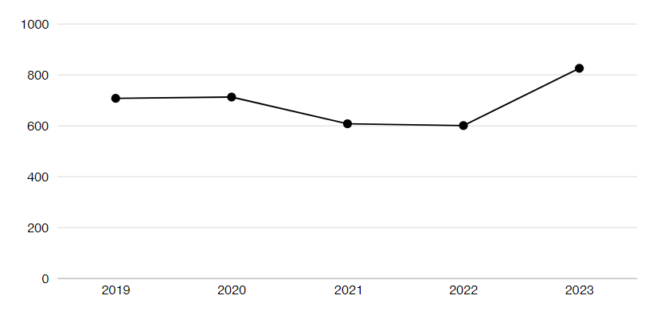
Source: DATASUS/TABNET, 2024.
In 2019, there were 708 hospitalizations, corresponding to 20.49% of the total, while in 2020 the number was 713 hospitalizations, representing 20.63%. In the following years, there was a slight drop, with 608 hospitalizations in 2021, representing 17.59% of the total, and 601 hospitalizations in 2022, representing 17.39% of the total. In 2023, there was a significant increase, with 826 hospitalizations, corresponding to 23.90% of the total.
These data suggest relative stability in the first four years, with a noticeable drop in 2021 and 2022, followed by a significant increase in 2023. The variation in hospitalizations may reflect the impact that the COVID-19 pandemic has had on hospitalizations for femur fractures between 2019 and 2023. During the height of the pandemic, many elective procedures were suspended or postponed to free up beds and resources for COVID-19 patients.
This may explain the drop in hospitalizations for femur fractures in 2021 and 2022, when hospitals prioritized urgent cases, leaving revision or scheduled surgeries for a later date. As a report by the World Health Organization (WHO, 2020) points out, this period has directly affected health services, compromising the diagnosis and treatment of diseases. The report also points out that approximately 75% of the countries surveyed reported interruptions in essential health services, mainly due to the reallocation of resources to face COVID-19, movement restrictions and the population's fear of seeking medical services during the pandemic.
The significant increase in cases in 2023 is linked to the resumption of elective surgeries, which were postponed in previous years, as pointed out by the Ministry of Health (2024). After the interruption of these surgeries during the pandemic years, the National Queue Reduction Program (PNRF) launched in 2023, was one of the main initiatives to speed up the process of recovering elective procedures in Brazil. Over the course of the year, more than 648,700 surgeries were performed, exceeding the target of 500,000 elective surgeries, with a 60% reduction in SUS waiting lists. The program was essential in reducing the queue of more than 1 million patients waiting for surgery, significantly improving access to essential treatments in various regions of Brazil (Brazil, 2024).
Of the 3,456 hospitalizations for femur fractures recorded between 2019 and 2023, 1,209 were elective, representing 34.98%, while 2,247 were emergency, corresponding to 65.02%. An analysis of elective admissions shows that there were 238 in 2019, 275 in 2020, 239 in 2021, 215 in 2022 and 242 in 2023. Emergencies followed suit, with 470 in 2019, 438 in 2020, 369 in 2021, 386 in 2022, and a significant increase to 584 in 2023, as can be seen in Graph 2.
Graph 2 - Rate of elective and emergency hospitalizations due to femur fracture at the Metropolitan Emergency and Urgency Hospital, in Ananindeua-PA between 2019 and 2023.
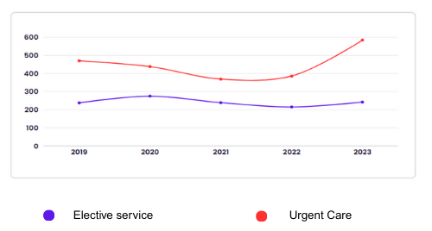
Source: DATASUS/TABNET, 2024.
This increase in emergency hospitalizations in 2023 may suggest an increase in cases of serious accidents or falls, possibly associated with the greater vulnerability of the elderly population after the pandemic period. On the other hand, the relatively stable behavior of elective operations, with small variations over the years, may indicate that, despite the challenges posed by COVID-19, scheduled care has managed to maintain a lower impact in relation to emergency cases. This behavior may indicate that, even with the pressure on health services, the planning of elective surgeries has managed to minimize the impact of COVID-19 (Silva; Day & Bandeira, 2024).
In addition, the rates for types of care suggest that femur fractures can occur both in situations of severe and urgent trauma and in conditions that allow for prior treatment planning, such as revision surgeries or planned interventions.
The prevalence of emergency care reflects the seriousness and unpredictability of many cases of femur fracture, often associated with traffic accidents or falls, especially in the elderly. On the other hand, the significant number of elective treatments suggests that the hospital is well structured to deal with planned cases, which may be associated with treatment of late complications (Ribeiro, 2024).
Graph 3 shows the number of hospitalizations resulting from femur fractures by age group. Based on the graph presented, we can see that the distribution shows that the highest concentration of cases occurred in the 20-29 age group, with 815 (23.6%) hospitalizations, representing the highest incidence of fractures. This was followed by the 30 to 39 age group, with 562 (16.3%) hospitalizations, and the 40 to 49 age group, with 410 (11.9%) cases.
Graph 3 – Rate of hospitalizations due to femur fracture by age group (2019 – 2023)
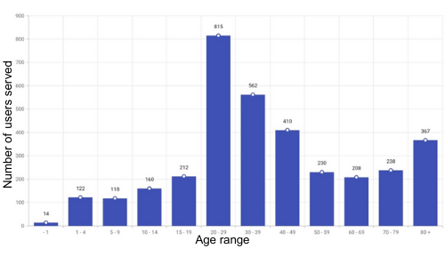
Source: DATASUS/TABNET, 2024.
Older age groups, such as those aged 80 and over, also had a significant number of hospitalizations, which may be due to bone fragility and the increased risk of falls in the elderly. However, the distribution suggests that the young-adult population, especially between the ages of 20 and 29, is the most affected by femur fractures, which may be related to high-energy trauma, such as traffic accidents or high-impact physical activities (Miranda et al., 2022). This contradicts scientific studies (Bernardes et al., 2024) which state that most femur fractures occur in elderly patients.
Younger age groups, such as those under 1 year old and between 1 and 14 years old, had a low incidence of hospitalizations, which indicates that these groups are less exposed to risk factors that lead to femur fractures. This distribution points to a need for specific interventions for different age groups. While the elderly population requires measures to prevent falls and bone fragility, the 20-29 age group could benefit from policies to prevent trauma, especially related to accidents (Gutzeit et al., 2022).
Regarding the distribution of hospitalizations for femur fractures between men and women between 2019 and 2023, of the total of 3,456 cases, 2,396 hospitalizations (69.3%) were of male patients, while 1,060 hospitalizations (30.7%) were of female patients, as can be seen in graph 4.
Graph 4 – Rate of hospitalizations due to femur fracture by sex (2019 – 2023)
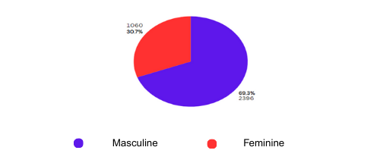
Source: DATASUS/TABNET, 2024.
It can be seen that most hospitalizations occurred among men. This disparity may be linked to factors such as greater exposure to risky activities, accidents at work and sports, which increase the likelihood of fractures. This suggests a need for prevention policies focused on male behavior, especially in higher-risk environments, due to their greater susceptibility to high-energy trauma (Guedes; Biguelini; Gomes; 2022).
This finding is in line with research such as the study by Miranda et al. (2022), carried out in Salvador, Bahia, between 2008 and 2021, which revealed that, in total, 60.43% of cases of femur fractures occurred in men, while 39.57% were in women. In 2021, 1,173 cases were recorded in men and 1,048 in women. For the authors, this difference can be explained by occupational and leisure factors that expose men to a greater risk of trauma. Another national study, which analyzed hospitalizations for femur fractures in Brazil from 2020 to 2023, also found that men account for a higher proportion of cases, suggesting that this is a consistent trend in various regions of the country (Bernardes et al., 2024).
Although the number of female hospitalizations is lower, women still account for a significant proportion of cases. This may be associated with factors such as osteoporosis, especially in older women. According to Ribeiro et al. (2024) post-menopausal bone fragility increases due to the accelerated loss of bone mass, which significantly increases the risk of fractures, highlighting the importance of health interventions focused on women in this age group.
Graph 5 shows the number of hospitalizations for femur fractures according to race/color between 2019 and 2023. The majority of hospitalizations correspond to self-declared brown individuals, amounting to 3,416 visits, which represents (98.8%) of the total. This is followed by a significantly smaller number of admissions for other races/colors: 17 white individuals (0.49%), 13 black (0.38%), 2 yellow (0.06%), and 8 cases with no information (0.23%). This concentration of care for brown individuals may reflect the demographic composition of the population treated at the Metropolitan Urgency and Emergency Hospital in Ananindeua-PA, where the study was carried out, or it may also be related to socioeconomic issues, which influence both exposure to risk factors and access to health services.
Graph 5 – Rate of hospitalizations due to femur fracture by race (2019 – 2023)
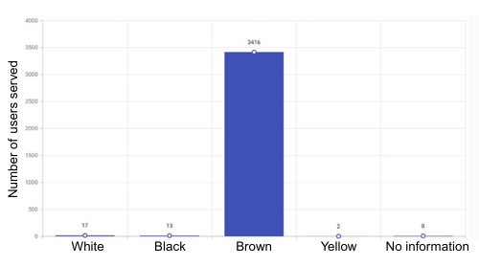
Source: DATASUS/TABNET, 2024.
Furthermore, as pointed out by Ribeiro et al. (2024), this reflects both demographics and the specific health challenges faced by the brown community. Socio-economic factors, such as limited access to preventive medical care, contribute to this high incidence of hospitalizations. In addition, the prevalence of conditions such as osteoporosis and greater exposure to risk factors, such as hazardous work environments, exacerbate this population's vulnerability to fractures and other health complications.
Graph 6 – Mortality rate due to femur fracture at the Metropolitan Emergency Hospital, in Ananindeua-PA, between 2019 and 2023.
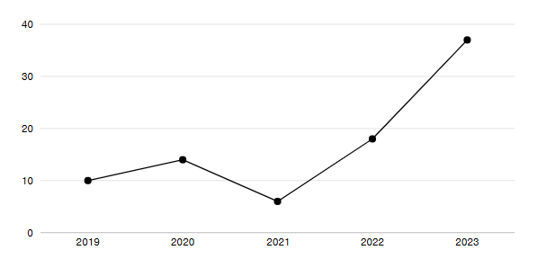
Source: DATASUS/TABNET, 2024.
The mortality data for the municipality of Ananindeua between 2019 and 2023 shows a total of 85 deaths, and the percentages for each year reveal important trends. In 2019, 10 deaths were recorded, representing 11.8% of the total. In 2020, the number of deaths rose to 14, equivalent to 16.5%, possibly reflecting the impacts of the COVID-19 pandemic (WHO, 2020). However, 2021 showed a significant drop, with only 6 deaths, or 7.1% of the total.
From 2022 onwards, there was a significant increase, with 18 deaths (21.2%), followed by an even greater jump in 2023, with 37 deaths, which represents 43.5% of the total recorded in the period. This sharp increase in the last year is alarming and calls for a deeper investigation into the factors involved, such as possible failures in the health system, the prolonged impact of the pandemic or the lack of adequate access to health services.
As can be seen in Graph 7, the mortality data related to femur fractures at the Metropolitan Urgency and Emergency Hospital of Ananindeua, between 2019 and 2023, show a significant concentration of deaths in the age group of 80 years and over. This group accounted for 70% of total deaths, with 33 of the 47 deaths recorded. The graph shows that mortality increases significantly with advancing age, while the younger age groups have much lower numbers, with only one death in the 10-10 age group.
Graph 7 – Mortality rate by age due to femur fracture at the Metropolitan Emergency Hospital, in Ananindeua-PA, between 2019 and 2023
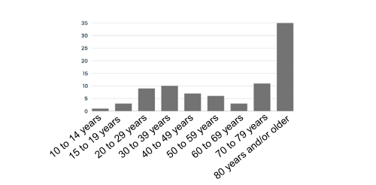
Source: DATASUS/TABNET, 2024.
This data reflects the vulnerability of the elderly to complications arising from fractures, which can include infections and loss of mobility, especially when access to health care is limited. According to Ribeiro et al. (2024) this population is especially vulnerable due to the bone fragility associated with ageing.
4. Conclusion

An analysis of data on hospitalizations for femur fractures at the Metropolitan Urgency and Emergency Hospital in Ananindeua, Pará, between 2019 and 2023, reveals important trends about the impact of these injuries on the local population. Over the period, 3,456 hospitalizations were recorded, with a relatively constant distribution between the years, except for a drop in 2021 and 2022, possibly attributed to the COVID-19 pandemic.
The split between elective and emergency hospitalizations reflects the varied nature of femur fractures. Although the majority of cases are of an emergency nature (65.02%), there is a significant share of elective international transactions (34.98%), providing the hospital's capacity to deal with planned cases, even in the midst of crises such as the pandemic.
The increase in emergency hospital admissions in 2023 points to an increase in serious trauma, such as traffic accidents and falls, especially in vulnerable populations such as the elderly. The distribution by age group contradicts some academic assumptions, revealing that the highest incidence of fractures occurred among young adults (20 to 29 years old), indicating that accident prevention policies are urgently needed for this age group.
Another relevant finding is the gender disparity: 69.3% of hospitalizations occurred in men, indicating greater male exposure to risk factors, such as accidents at work and high-impact sports. This reinforces the need for preventive policies specific to male behavior. However, the specific number of female hospitalizations, especially in elderly women, underlines the importance of interventions focused on bone health, such as prevention of post-menopausal osteoporosis.
The analysis also highlighted the issue of race, with a predominance of hospitalizations of self-declared brown people (98.8%). This suggests a relationship between socio-economic factors and greater exposure to risk conditions and difficulties in accessing preventive care. Public policies should be aimed at tackling these inequalities and improving access to preventive healthcare for vulnerable populations.
Finally, mortality data reflects the seriousness of femur fractures, especially in elderly populations. The stabilization of the number of deaths over the years, with a slight variation, points to the efficiency of emergency treatments and the impact of elective surgeries, despite the challenges posed by the pandemic. However, the mortality associated with these fractures continues to require increased attention.
In short, the research indicates the need for strategic interventions aimed at preventing accidents in young adults, strengthening health policies for the elderly, and expanding access to preventive care, especially in low-income traffic and greater social vulnerability.
The study has some limitations that affect the full interpretation of the results. Firstly, as it is based on secondary data from DATASUS, the analysis is subject to possible inconsistencies and limitations in the completeness of the information, especially in variables with underreporting. The absence of detailed clinical data, such as the specific type of fracture and comorbidities, limits the understanding of additional factors that could influence the outcomes and severity of hospitalizations. In addition, the COVID-19 pandemic, especially in 2021 and 2022, has affected the flow of care, distorting hospitalization trends and making it difficult to make consistent comparisons with other years. Another limitation is that the analysis only focused on one reference hospital, restricting the generalization of the findings to other regions.
As recommendations, we suggest improving hospital records with detailed clinical information on the type of fracture, comorbidities and risk factors, for future more comprehensive analyses. Carrying out studies in other hospitals in Pará and neighboring regions would be essential in order to compare patterns and obtain a broader view, which could serve as a basis for more effective public health policies. Including socioeconomic variables in future studies would help to understand the influence of these factors on the incidence and outcomes of femur fractures, allowing for more targeted interventions.

Consent
As per international standards or university standards, patient(s) written consent has been collected and preserved by the author(s).

DISCLAIMER (ARTIFICIAL INTELLIGENCE)
Author(s) hereby declare that NO generative AI technologies such as Large Language Models (ChatGPT, COPILOT, etc) and text-to-image generators have been used during writing or editing of manuscripts.

References

- Amaral A. G. S., Conceição A. B. S., Vestemberg C. V., Cardoso L. C. F., Lameira R.P., & Ferreira W. X. (2023). Socioeconomic impact and epidemiological profile of hospitalizations of elderly people due to femur fracture in the public system in Ananindeua, Pará. Research, society and development.

- De Oliveira, D. M. et al. (2021). Physiotherapeutic intervention in the postoperative period of femur fracture in the elderly: a literature review. Multidebates, 5 (3), 149-156.

- Estrela, F. M. et al. (2021). Systematization of nursing care for patients with femoral neck fractures: experience report. Arq. ciências saúde UNIPAR, p. 231-235.

- Filho Ip, et al. (2019). Predictive Factors of Death after Surgery for Treatment of Proximal Femoral Fracture. Rev. bras. Ortop, 54(4): 402-407.

- Gomes L. S. M. (2019). Early diagnosis of periprosthetic hip joint infection – current status, advances and perspectives. Rev. bras. ortop., 54(4), 368-376.

- Guerra M.T. E, et al. (2017). One-year mortality of elderly patients with hip fracture treated surgically at a hospital in southern Brazil. Rev. bras. Ortop, 52(1), 17-23.

- Gutzeit, E. M. et al. (2022). Assessment of the profile of victims of femur fractures treated at an emergency hospital in the western Brazilian Amazon. Research, Society and Development, 11 (4), e44311426580-e44311426580.

- Guedes, G. Ga., Biguelini, M. F., & Gomes, E. C. Z. (2023). EPIDEMIOLOGICAL PROFILE OF ADULTS HOSPITALIZED FOR FEMUR FRACTURE IN THE SOUTHERN REGION OF BRAZIL, BETWEEN 2019 AND 2022. Revista Ibero-Americana de Humanidades, Ciências e Educação, 9, (11), 3880-3889.

- Junior W. F et al. (2022). Epidemiological profile of patients with proximal femur fracture undergoing surgical treatment. Revista eletrônica acervo saúde. | ISSN 2178-2091.

- Linhares J.E., et al. (2019). Work capacity and functional aging: systemic analysis of literature using PROKNOW-C (Knowledge Development Process - Constructivist). Ciência & Saúde Coletiva, 24(1), 53-66.

- Martins N. P. R, et al. (2020) Quality of life of older adults admitted to a Medical Clinic Unit of a Public Hospital in Brazil. Rev Esc Enferm USP.

- Miranda, L. V. A. (2022). Overview of the epidemiological profile of femur fractures: incidence of hospitalizations in the period 2008-2021 in Salvador-Bahia. International Journal of Development Research, 12 (3), 54605-54608.

- Petros R.S.B, et al. (2019). Influence of proximal femur fractures on autonomy and mortality of elderly patients undergoing osteosynthesis with cephalomedullary nail. Rev. bras. ortop., São Paulo, 52(1), 57-62.

- Pinto I.P, et al. (2019). Does Early Surgical Fixation of Proximal Femoral Fractures in Elderly Patients Affect Mortality Rates? Rev. bras. Ortop, 54(4), 392-395.

- Rezende, L. César Brito et al. Epidemiological profile of elderly individuals with proximal femur fractures undergoing surgical treatment. Brazilian Journal of Health Review, 4 (6), 28421-28429, 2021.

- Silva N. T. F, et al. Profile of older adult victims of trauma cared for in the emergency care unit of a teaching. Ciênc Cuid Saúde. 2018; 7(2):1-8.

- Silva K. R. da, et al. (2020). Epidemiological profile of elderly patients treated in an emergency room. Rev enferm UFPE on line. 2020.
- Santos, M. E. L.et al. (2021. Nursing interventions during the immediate postoperative period for elderly patients with proximal femur fractures. VIII congresso internacional de envelhecimento humano.

- Silva, J. F. da; Day, C. B., & Bandeira, A. G.. (2024). Vulnerability of the elderly to Covid-19: an approach to community health services. Physis: Revista de Saúde Coletiva, 34 (1), e34048.

- Soares, D.S., et al. (2019). Analysis of factors associated with falls with femur fracture in the elderly: a case-control study. Rev. bras. Geriatria e Gerontologia, 18(2), 239-248.

- Travassos, C., Laguardia, J.; Marques P. M.; Mota, J. C. (2006). Racial inequalities in access to and use of health services in Brazil: analysis of data from the 2003 World Health Survey. Cadernos de Saúde Pública, 22 (6),1590-1600.

