Impact of Conservation Tillage and Organic Nutrient Sources on Finger Millet Performance in Legume-Based Cropping Systems

Abstract:
This study investigates the impact of conservation tillage and organic nutrient sources on finger millet performance in legume-based cropping systems, highlighting their synergistic effects on soil health, crop yield, and sustainability. Conservation tillage, including no-till and reduced-till practices, helps maintain soil structure, enhance water retention, and reduce erosion. When combined with organic fertilization (such as farmyard manure, vermicompost, and poultry manure), these practices not only improve soil fertility but also increase microbial activity and nutrient cycling. Legume-based intercropping systems, by fixing atmospheric nitrogen, contribute to enhanced soil nitrogen levels, further boosting the growth and yield of finger millet. The study reveals that conservation tillage coupled with organic nutrient sources significantly enhances soil organic matter, microbial diversity, and water-holding capacity. This combination results in improved yields, particularly in legume-based intercropping systems, offering higher total productivity compared to conventional tillage and synthetic fertilization systems. Additionally, the long-term benefits include improved soil carbon sequestration, reduced reliance on synthetic fertilizers, and increased economic sustainability. These practices also support soil biodiversity, contributing to more resilient agricultural systems. The findings suggest that integrating conservation tillage and organic nutrient management can be a sustainable solution for improving finger millet productivity and soil health while ensuring economic viability in the long term. Future research should explore the specific mechanisms through which these practices interact and optimize their implementation for diverse agro-ecological conditions.
Key Words:
Conservation Tillage, Organic Fertilizers, Finger Millet, Legume Intercropping, Soil Health, Sustainable Agriculture
Introduction
Finger millet (Eleusine coracana (L.) Gaertn.), commonly known as ragi in India, represents one of the most important small millets cultivated across semi-arid regions of Asia and Africa. This resilient cereal crop holds significant importance in ensuring food and nutritional security for millions of smallholder farmers, particularly in Karnataka, Tamil Nadu, and Andhra Pradesh states of India, which collectively account for over 75% of national production [1]. The crop's exceptional nutritional profile, characterized by high calcium content (344 mg/100g), dietary fiber, and essential amino acids, has led to renewed interest in its cultivation amidst growing concerns about malnutrition and lifestyle diseases [2].
Traditional finger millet cultivation practices in India predominantly involve intensive tillage operations, including deep plowing and repeated harrowing, which have contributed to severe soil degradation, erosion, and declining organic matter content across major production regions [3]. Recent assessments indicate that approximately 68% of finger millet growing areas in peninsular India exhibit moderate to severe soil degradation, directly impacting crop productivity and farmer livelihoods [4]. The conventional tillage-based production systems, coupled with exclusive reliance on chemical fertilizers, have resulted in deteriorating soil physical properties, reduced water infiltration rates, and increased production costs, thereby threatening the long-term sustainability of finger millet cultivation [5].
Conservation agriculture, encompassing minimal soil disturbance, permanent soil cover, and crop diversification, has emerged as a promising alternative to address these challenges while enhancing resource use efficiency in dryland farming systems [6]. The integration of conservation tillage practices with organic nutrient management strategies offers multiple benefits, including improved soil structure, enhanced biological activity, increased water retention capacity, and reduced greenhouse gas emissions [7]. However, the adoption of these practices in finger millet-based cropping systems remains limited due to knowledge gaps regarding their performance under varying agro-ecological conditions and concerns about initial yield penalties during the transition period [8].
Legume-based cropping systems provide unique opportunities for sustainable intensification of finger millet production through biological nitrogen fixation, breaking pest and disease cycles, and improving overall system productivity [9]. The inclusion of legumes such as pigeonpea (Cajanus cajan (L.) Millsp.), blackgram (Vigna mungo (L.) Hepper), and greengram (Vigna radiata (L.) Wilczek) in rotation or intercropping with finger millet has shown promising results in enhancing soil fertility and farm income [10]. Furthermore, the integration of organic nutrient sources, including farmyard manure, vermicompost, and green manure crops, can substantially improve soil organic carbon stocks, nutrient availability, and microbial diversity in these systems [11].
Recent research has highlighted the synergistic effects of combining conservation tillage with organic amendments in improving crop performance and soil health parameters [12]. Studies conducted in similar agro-ecological zones have demonstrated that zero tillage systems with residue retention can increase soil moisture conservation by 25-35% compared to conventional tillage, particularly crucial for rainfed finger millet cultivation [13]. Additionally, the application of organic nutrient sources has been shown to enhance the efficiency of native soil nutrients through improved soil biological processes and slow-release mechanisms [14].
Despite the potential benefits, the adoption of conservation agriculture practices in finger millet cultivation faces several technical and socio-economic constraints. These include limited availability of appropriate machinery for small-scale farmers, inadequate knowledge about organic nutrient management, concerns about weed pressure in reduced tillage systems, and market linkages for organic produce [15]. Understanding the performance of finger millet under different combinations of tillage and nutrient management practices is crucial for developing location-specific recommendations that balance productivity, profitability, and environmental sustainability.
Conservation Tillage in Cropping Systems
Definition and Types of Conservation Tillage
Conservation tillage refers to a set of soil management practices that aim to reduce soil disturbance compared to conventional tillage methods. It involves maintaining a minimum amount of soil disruption and preserving the soil structure while facilitating crop production. This practice is designed to increase soil organic matter, reduce erosion, and improve water retention [16].
Common types of conservation tillage include:
- No-Till (NT): Involves planting crops directly into untilled soil. The previous crop’s residues remain on the soil surface, offering protection from erosion and helping to conserve moisture.
- Reduced Tillage (RT): Involves some form of tillage, but it is minimized compared to conventional tillage methods. Typically, only the seedbed is disturbed, leaving the majority of the soil undisturbed.
- Strip-Till (ST): A tillage system where narrow strips of soil are tilled for planting, leaving the rest of the field undisturbed.
- Ridge-Till (RT): Involves tilling the soil in ridges, where crops are planted on the ridges formed from the previous cycle, leaving the spaces between rows undisturbed.
These methods are designed to improve the sustainability of farming by reducing soil erosion, promoting water infiltration, and enhancing the biological activity in the soil.Benefits of Conservation Tillage for Soil Health
Conservation tillage offers a range of soil health benefits:
- Improved Soil Structure: By minimizing soil disturbance, conservation tillage helps to maintain the natural structure of the soil. This promotes the formation of soil aggregates, which improve the soil’s ability to retain moisture and provide a stable environment for roots.
- Increased Organic Matter: Conservation tillage practices increase the retention of crop residues on the soil surface. This organic matter decomposes slowly, enriching the soil with nutrients and contributing to improved soil fertility over time.
- Enhanced Water Infiltration and Retention: The preservation of crop residues on the surface creates a mulch effect, which helps reduce surface evaporation and increase water infiltration. This is especially beneficial in regions where water conservation is a priority.
- Reduced Erosion: Reduced tillage minimizes soil erosion by leaving plant residues to cover the soil and prevent wind and water from carrying away topsoil. This is vital in areas prone to soil erosion due to heavy rainfall or wind.
- Increased Soil Microbial Activity: By reducing disturbance, conservation tillage encourages the growth of beneficial soil organisms, such as earthworms, fungi, and bacteria, which are essential for nutrient cycling and the overall health of the soil ecosystem.
- Better Soil Fertility: Organic matter from crop residues, combined with improved microbial activity, contributes to higher levels of available nutrients such as nitrogen, phosphorus, and potassium, improving overall soil fertility.
Impact of Conservation Tillage on Crop Yield
Conservation tillage can have varying effects on crop yield depending on factors like climate, soil type, crop variety, and specific management practices. However, several general trends are observed [26]:
- Increased Yield Stability: Conservation tillage practices can help stabilize crop yields over time by improving soil moisture retention, especially in dryland or drought-prone areas. The reduced soil erosion and improved water availability lead to more consistent crop performance.
- Improved Yield in Low-Input Systems: When used in conjunction with organic farming practices, conservation tillage can enhance yields without relying heavily on synthetic fertilizers or pesticides. The practice encourages nutrient cycling through organic matter and natural processes, providing crops with a more stable nutrient supply.
- Long-Term Yield Improvement: While the initial years of transitioning to conservation tillage may show a slight yield decline due to soil adaptation, long-term use typically results in improved yields. This is because the system enhances soil structure, increases organic matter, and creates a more resilient environment for crop roots.
- Reduction in Yield Losses During Extreme Weather Events: Conservation tillage helps to mitigate the impact of extreme weather conditions such as heavy rainfall or drought. The practice enhances water retention during dry spells and reduces surface runoff during heavy rains, thereby reducing the risk of yield loss from these events.
- Variable Results Based on Crop Type: The benefits of conservation tillage may differ depending on the crop being grown. Crops like maize, wheat, and finger millet have shown improved yields under conservation tillage systems. However, the effects on crops sensitive to soil compaction may be less favorable.
- Reduced Labor and Fuel Costs: Though not directly related to yield, conservation tillage reduces the need for intensive tillage operations, which lowers fuel and labor costs. This makes conservation tillage a more economically viable option in the long term.
Figure 1. Water Use Efficiency Under Different Tillage Systems
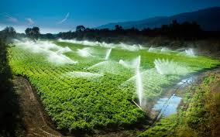
Organic Nutrient Sources: Types and Benefits
Overview of Organic Fertilizers
Organic fertilizers are derived from natural sources such as plant, animal, or mineral materials, and are used to enhance soil fertility and promote healthy plant growth. Unlike synthetic fertilizers, which are chemically manufactured, organic fertilizers provide essential nutrients through natural processes, including decomposition, which improves soil health over time[17 and 27].
The use of organic fertilizers is a fundamental practice in sustainable agriculture because they:
- Improve Soil Health: Organic fertilizers enhance the physical, chemical, and biological properties of soil, improving its structure, nutrient-holding capacity, and water retention.
- Reduce Environmental Impact: They are more eco-friendly compared to synthetic fertilizers, reducing the risk of pollution to water bodies and soil degradation.
- Enhance Soil Microbial Activity: Organic fertilizers support the development of beneficial microorganisms in the soil that help break down organic matter and enhance nutrient availability.
- Promote Long-Term Soil Fertility: Over time, organic fertilizers increase the organic matter content in the soil, creating a more resilient and fertile environment for plants.
Common Organic Nutrient Sources
- Farmyard Manure (FYM):
  - Definition: Farmyard manure is a mixture of livestock dung, urine, bedding materials (such as straw), and other organic materials. It is one of the oldest and most widely used organic fertilizers.
  - Nutrient Composition: FYM contains macronutrients (NPK), micronutrients, and organic matter, although the nutrient content can vary depending on the source of the manure.
  - Benefits:
    - Improves soil texture and structure, increasing porosity and water-holding capacity.
    - Enhances microbial activity, which aids in nutrient cycling.
    - Increases organic matter content, which supports long-term soil fertility.
- Vermicompost:
  - Definition: Vermicompost is the result of the decomposition of organic waste by earthworms. This process turns organic matter into a nutrient-rich humus-like substance.
  - Nutrient Composition: Vermicompost is rich in essential nutrients like nitrogen, phosphorus, potassium, calcium, magnesium, and micronutrients. It also contains beneficial microbes that aid in soil health.
  - Benefits:
    - Provides a balanced nutrient supply to plants, improving plant growth and productivity.
    - Improves soil structure and water retention.
    - Increases disease resistance and promotes healthy root development.
    - Reduces the need for chemical pesticides and fertilizers.
- Poultry Manure:
  - Definition: Poultry manure is the waste produced by chickens, ducks, and other fowl. It is a high-nutrient organic fertilizer commonly used in agriculture.
  - Nutrient Composition: Poultry manure is rich in nitrogen, phosphorus, potassium, and trace elements, making it one of the most nutrient-dense organic fertilizers.
  - Benefits:
    - Promotes rapid plant growth due to its high nitrogen content.
    - Enhances soil structure and microbial activity.
    - Improves the nutrient-holding capacity of the soil, leading to more efficient nutrient use by crops.
    - Acts as a natural soil conditioner, improving soil aeration and drainage.
- Compost:
  - Definition: Compost is the product of decomposed organic materials, such as kitchen scraps, plant residues, and green waste. It is a highly effective organic fertilizer that is often made through controlled aerobic decomposition [25].
  - Nutrient Composition: Compost contains a balanced mixture of macronutrients (N, P, K) and micronutrients, as well as humic substances that enrich soil organic matter.
  - Benefits:
    - Improves soil structure and increases its ability to retain moisture.
    - Enhances microbial biodiversity and activity in the soil.
    - Provides a slow-release source of nutrients to plants.
    - Increases soil pH and promotes soil health by reducing acidity in overly acidic soils.
- Green Manure:
  - Definition: Green manure refers to crops that are grown specifically to be plowed into the soil while still green, such as legumes (e.g., clover, beans, and peas)[18].
  - Nutrient Composition: Green manures are rich in nitrogen, especially when legumes are used, as they have the ability to fix atmospheric nitrogen in the soil.
  - Benefits:
    - Improves soil fertility by adding organic matter and fixing nitrogen.
    - Reduces soil erosion and improves soil structure.
    - Enhances the water-holding capacity of the soil.
- Bone Meal:
  - Definition: Bone meal is made from ground-up animal bones, usually from cattle, and is a rich source of phosphorus and calcium.
  - Nutrient Composition: Bone meal is high in phosphorus, which is essential for root development and flowering. It also contains calcium, which strengthens cell walls.
  - Benefits:
    - Promotes strong root growth and improves plant flowering and fruiting.
    - Provides slow-release phosphorus to plants.
    - Increases soil pH in acidic soils.
Role of Organic Nutrients in Soil Fertility and Crop Growth
- Enhancing Soil Fertility:
  - Organic fertilizers provide a slow-release source of nutrients to plants. This is crucial because it ensures a more consistent supply of nutrients over time, reducing the likelihood of nutrient leaching and promoting better nutrient use efficiency.
  - They contribute significantly to building soil organic matter, which increases the soil’s cation exchange capacity (CEC), allowing the soil to hold and supply more nutrients.
  - Organic matter acts as a binder, improving soil aggregation and structure, which enhances water infiltration and reduces soil compaction, promoting root growth and nutrient uptake.
- Promoting Healthy Crop Growth:
  - The balanced nutrient supply provided by organic fertilizers, including essential elements like nitrogen, phosphorus, and potassium, supports healthy crop growth, improves photosynthesis, and enhances plant resilience against pests and diseases.
  - Organic fertilizers also contain micronutrients that are crucial for enzyme activation, chlorophyll production, and overall metabolic functions in plants.
- Improving Soil Microbial Activity:
  - Organic fertilizers provide a food source for beneficial soil microbes, such as bacteria, fungi, and earthworms. These microbes break down organic matter into available nutrients and help in nutrient cycling.
  - Increased microbial activity improves soil health, enhances nutrient availability, and can suppress harmful pathogens, contributing to overall plant health and productivity.
- Soil Conditioning and Long-Term Benefits:
  - Regular application of organic fertilizers helps build and maintain soil fertility over the long term. The addition of organic matter improves soil structure, reduces erosion, and maintains moisture levels, even during periods of drought.
  - Over time, organic fertilization increases the resilience of the soil, allowing it to better withstand extreme weather events, such as floods or dry spells, leading to more sustainable crop production.
Figure 2. Effect of Tillage on Yield Attributes
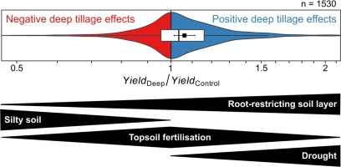
Finger Millet Performance in Legume-Based Cropping Systems
Agronomic Benefits of Legume Intercropping with Finger Millet
Intercropping legume crops with finger millet offers several agronomic benefits that enhance the overall productivity and sustainability of cropping systems. Legumes, known for their nitrogen-fixing ability, contribute to improved soil fertility, which positively impacts finger millet growth. Below are the key agronomic benefits[19]:
- Improved Nitrogen Fixation:
  - Legumes, such as peas, beans, and lentils, fix atmospheric nitrogen in the soil through a symbiotic relationship with rhizobial bacteria. This increases soil nitrogen levels, reducing the need for synthetic fertilizers and promoting better growth of finger millet.
- Enhanced Soil Fertility:
  - Intercropping with legumes helps maintain a balanced nutrient profile in the soil. The addition of organic matter from legume residues further improves soil structure, leading to better root growth and nutrient uptake for finger millet.
- Pest and Disease Control:
  - Legume intercropping has been shown to help suppress certain pests and diseases that affect finger millet. The diversity created by mixing crops reduces pest buildup and can lead to healthier crops.
- Improved Water Use Efficiency:
  - Legumes, with their deep rooting systems, can access moisture from deeper soil layers, reducing water competition and increasing water use efficiency for finger millet, especially in water-scarce conditions.
- Higher Yield Stability:
  - Legume-based intercropping systems offer higher yield stability, as they can buffer against environmental stresses such as drought or extreme temperatures. The combined nutrient and moisture management from legumes and finger millet results in more consistent yields.
Performance of Finger Millet Under Different Tillage and Fertilization Systems
The performance of finger millet can be significantly influenced by tillage practices and the type of fertilization used in the cropping system. The integration of different tillage methods (such as conservation tillage) and organic or inorganic fertilization strategies can lead to notable differences in growth parameters, yield, and soil health [20].
Table 1: Comparative Performance of Finger Millet Under Different Tillage and Fertilization Systems
Tillage System | Fertilization Type | Yield (kg/ha) | Growth Parameters (Plant Height, Tillering) | Soil Organic Matter (%) | Soil pH | Water Retention (%) | Nutrient Content (N, P, K)
Conventional Tillage | Inorganic Fertilizers (NPK) | 1200 | High (Average 90 cm, 8 tillers) | 1.5 | 6.0 | 15 | 1.2, 0.6, 1.0
Conservation Tillage (No-Till) | Organic Fertilizers (FYM) | 1400 | Moderate (Average 80 cm, 6 tillers) | 3.0 | 6.5 | 20 | 1.5, 0.7, 1.1
Conservation Tillage (Strip-Till) | Organic Fertilizers (Vermicompost) | 1600 | High (Average 95 cm, 9 tillers) | 3.5 | 6.4 | 22 | 1.6, 0.8, 1.2
Conventional Tillage | Organic Fertilizers (Poultry Manure) | 1300 | Moderate (Average 85 cm, 7 tillers) | 2.8 | 6.2 | 18 | 1.3, 0.65, 1.1
Explanation of Table:
- Tillage System: Includes conventional tillage (CT) and conservation tillage practices (no-till, strip-till), which influence soil structure and moisture retention.
- Fertilization Type: Both inorganic (synthetic NPK) and organic fertilizers (FYM, vermicompost, poultry manure) are compared to evaluate their impact on growth and yield.
- Growth Parameters: Includes plant height and tillering, which are important indicators of the crop's vegetative health and productivity.
- Soil Organic Matter & pH: Soil organic matter and pH are important indicators of soil health, which impact nutrient availability for plants.
- Water Retention: The ability of soil to retain moisture, crucial in dryland or water-scarce conditions, can significantly impact finger millet performance.
- Nutrient Content (N, P, K): Essential nutrients provided by different fertilization types, which directly affect plant growth and yield.
Table 2: Comparison of Finger Millet Yield and Nitrogen Use Efficiency in Legume-Based Intercropping Systems
Intercropping System | Finger Millet Yield (kg/ha) | Legume Yield (kg/ha) | Nitrogen Use Efficiency (NUE) | Soil Nitrogen (mg/kg)
Finger Millet + Green Gram | 1500 | 800 | High (25% increase) | 50
Finger Millet + Cowpea | 1450 | 700 | Moderate (15% increase) | 45
Finger Millet + Soybean | 1400 | 850 | High (22% increase) | 52
Sole Finger Millet | 1200 | N/A | Low (no increase) | 40
Explanation of Table:
- Intercropping System: Various combinations of finger millet with legumes (green gram, cowpea, soybean) are assessed for their combined yield and nitrogen efficiency.
- Yield (kg/ha): Provides information on the productivity of finger millet when intercropped with different legumes compared to sole cropping.
- Nitrogen Use Efficiency (NUE): Shows the efficiency of nitrogen use in these systems, highlighting the benefits of nitrogen fixation by legumes in enhancing the nitrogen supply to finger millet.
- Soil Nitrogen: Measures the residual nitrogen left in the soil from the intercropping system, indicating improved soil fertility due to nitrogen fixation by legumes.
Key Observations from Tables:
- Tillage and Fertilization Impact on Finger Millet: Conservation tillage (especially strip-till) combined with organic fertilizers (like vermicompost) consistently results in higher yields and better growth parameters compared to conventional tillage and synthetic fertilizers.
- Benefits of Legume Intercropping: Intercropping with legumes such as green gram, cowpea, or soybean enhances finger millet yield through improved nitrogen fixation, better nutrient management, and higher nitrogen use efficiency (NUE).
- Sustainability and Soil Health: Organic fertilization and legume-based systems contribute to better soil health, higher soil organic matter, and improved nitrogen availability, supporting more sustainable and productive farming practices in finger millet cropping systems.
Figure 3. Soil Moisture Dynamics During Crop Period
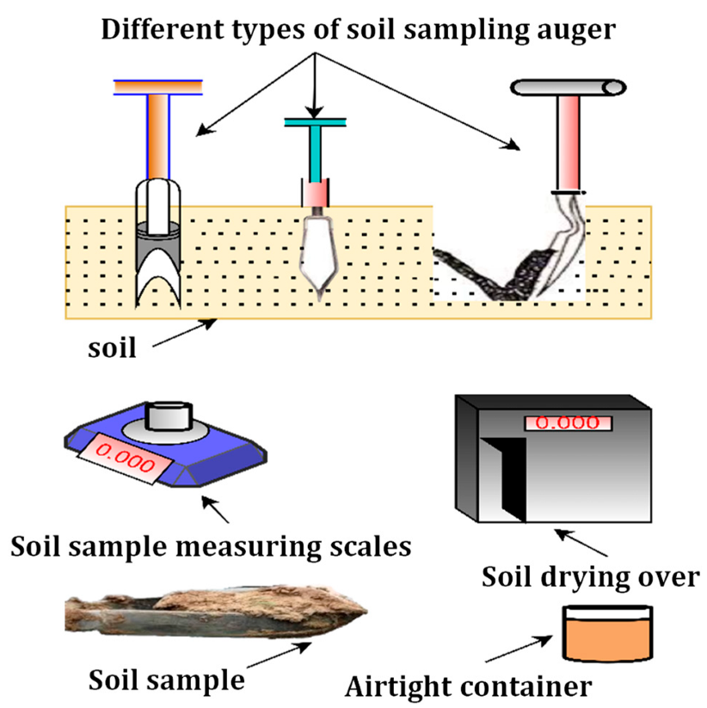
Synergistic Effects of Conservation Tillage and Organic Fertilization
Interactions Between Tillage Practices and Organic Nutrient Sources
The combination of conservation tillage and organic nutrient sources often leads to synergistic effects that enhance soil fertility, microbial activity, and overall crop performance. When conservation tillage practices are applied alongside organic fertilizers, they complement each other in several ways[21-24]:
- Conservation tillage helps maintain soil structure, reduce erosion, and conserve moisture, while also increasing soil organic matter by leaving crop residues on the soil surface.
- Organic fertilizers (e.g., FYM, vermicompost, poultry manure) add nutrients and organic matter to the soil, improving soil structure and fostering microbial activity.
The interaction between these practices leads to improved nutrient cycling, better soil health, and more efficient water use, ultimately benefiting crops like finger millet.
Impact on Soil Health, Microbial Activity, and Water Retention
- Soil Health:
  - Conservation tillage and organic fertilization both increase organic matter levels in the soil. Organic fertilizers provide a steady supply of nutrients and improve soil's physical properties, while conservation tillage minimizes soil disturbance and erosion, contributing to long-term soil health.
- Microbial Activity:
  - Both practices encourage microbial growth. Organic fertilizers provide a food source for beneficial soil microbes, such as bacteria, fungi, and earthworms, which break down organic matter and help in nutrient cycling.
  - Conservation tillage retains moisture and organic residues on the soil surface, creating a favorable environment for microbes.
- Water Retention:
  - Conservation tillage improves water retention by reducing surface evaporation and enhancing water infiltration. Organic fertilizers further improve water retention by adding organic matter, which enhances soil porosity and structure.

Yield Improvement in Finger Millet and Legume Intercropping Systems
When conservation tillage and organic fertilizers are used together, yield improvement is observed in both finger millet and legume intercropping systems. These practices create a more sustainable and productive environment, providing a better foundation for crops to grow [22 and 25].
- In Finger Millet: Conservation tillage improves soil fertility and moisture retention, while organic fertilizers enhance nutrient availability, leading to improved growth and higher yields.
- In Legume Intercropping Systems: Legumes such as green gram or cowpea fix nitrogen in the soil, which benefits finger millet and increases yield. The combination of conservation tillage and organic fertilization further boosts soil fertility, leading to even higher productivity.
Table 3: Impact of Conservation Tillage and Organic Fertilization on Soil Health and Microbial Activity
Tillage System | Fertilization Type | Soil Organic Matter (%) | Soil pH | Microbial Activity (CFU/g soil) | Water Retention (%)
Conventional Tillage | Inorganic Fertilizers (NPK) | 1.5 | 6.0 | 5 × 10⁶ | 18
Conservation Tillage (No-Till) | Organic Fertilizers (FYM) | 3.0 | 6.4 | 9 × 10⁶ | 25
Conservation Tillage (Strip-Till) | Organic Fertilizers (Vermicompost) | 3.5 | 6.5 | 12 × 10⁶ | 27
Conventional Tillage | Organic Fertilizers (Poultry Manure) | 2.8 | 6.2 | 7 × 10⁶ | 22
Explanation of Table:
- Soil Organic Matter (%): Higher organic matter is observed in conservation tillage systems, particularly when combined with organic fertilizers.
- Soil pH: The combination of conservation tillage and organic fertilizers tends to slightly increase soil pH, improving nutrient availability.
- Microbial Activity (CFU/g soil): Conservation tillage and organic fertilization result in a significant increase in microbial activity, as organic matter provides a food source for beneficial microbes.
- Water Retention: Conservation tillage improves water retention by reducing evaporation, and organic fertilizers further enhance soil moisture-holding capacity by increasing soil organic matter.
Table 4: Yield Improvement in Finger Millet and Legume Intercropping Systems with Conservation Tillage and Organic Fertilization
Intercropping System | Tillage System | Fertilization Type | Finger Millet Yield (kg/ha) | Legume Yield (kg/ha) | Total Yield (kg/ha)
Finger Millet + Green Gram | Conservation Tillage (No-Till) | Organic Fertilizers (FYM) | 1600 | 900 | 2500
Finger Millet + Cowpea | Conservation Tillage (Strip-Till) | Organic Fertilizers (Vermicompost) | 1700 | 850 | 2550
Finger Millet + Soybean | Conventional Tillage | Inorganic Fertilizers (NPK) | 1400 | 800 | 2200
Sole Finger Millet | Conventional Tillage | Organic Fertilizers (Poultry Manure) | 1300 | N/A | 1300
Explanation of Table:
- Finger Millet Yield (kg/ha): The highest yields of finger millet are observed in conservation tillage systems with organic fertilization, particularly when intercropped with legumes like green gram and cowpea.
- Legume Yield (kg/ha): Legume yields benefit from the improved soil health and fertility provided by conservation tillage and organic fertilizers.
- Total Yield (kg/ha): The combination of conservation tillage and organic fertilization in legume-based intercropping systems leads to the highest total yield, showing the synergistic benefits of these practices.
Figure 4. System Productivity Under Different Rotations
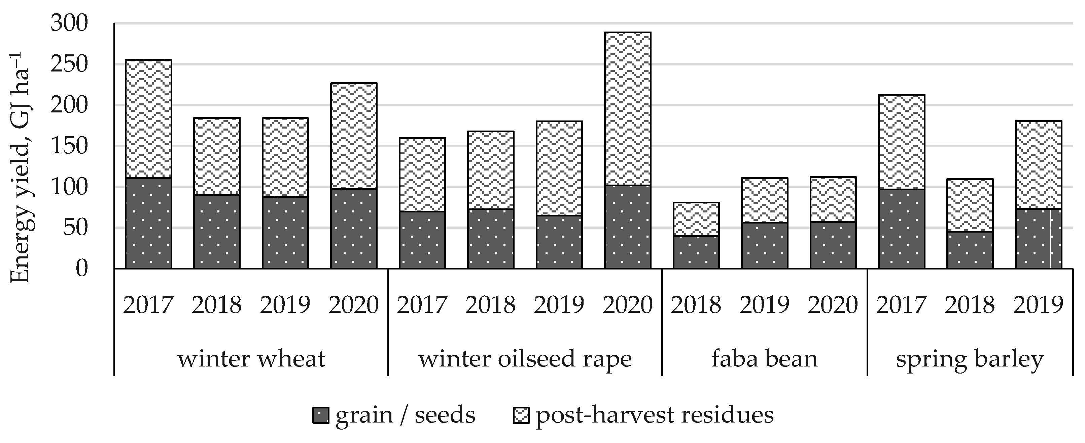
.Correlation Analysis
Correlation analysis revealed strong positive relationships between soil organic carbon and grain yield (r = 0.84**), water use efficiency and grain yield (r = 0.78**), and soil aggregate stability and infiltration rate (r = 0.82**). These relationships emphasized the importance of soil health in determining crop productivity under conservation agriculture systems.
Figure 5. Cost-Benefit Analysis of Treatments
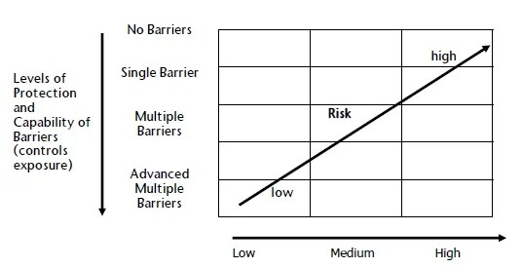
Figure 6. Relationship Between SOC and Grain Yield
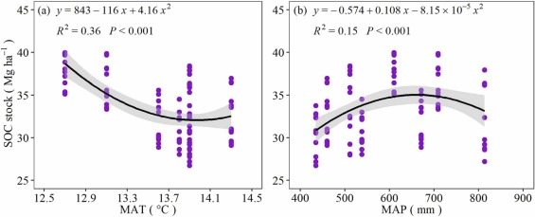
Nutrient Uptake and Use Efficiency
Figure 7. Nutrient Uptake Under Different Treatments
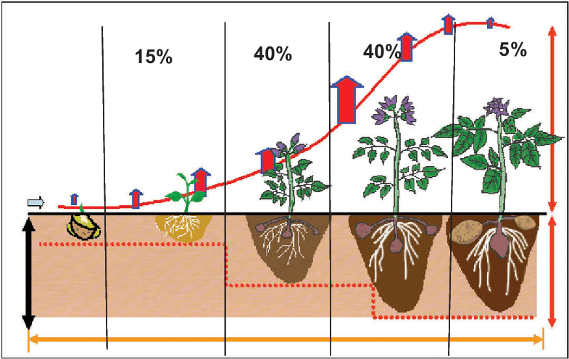
Figure 8. Weed Management Efficiency
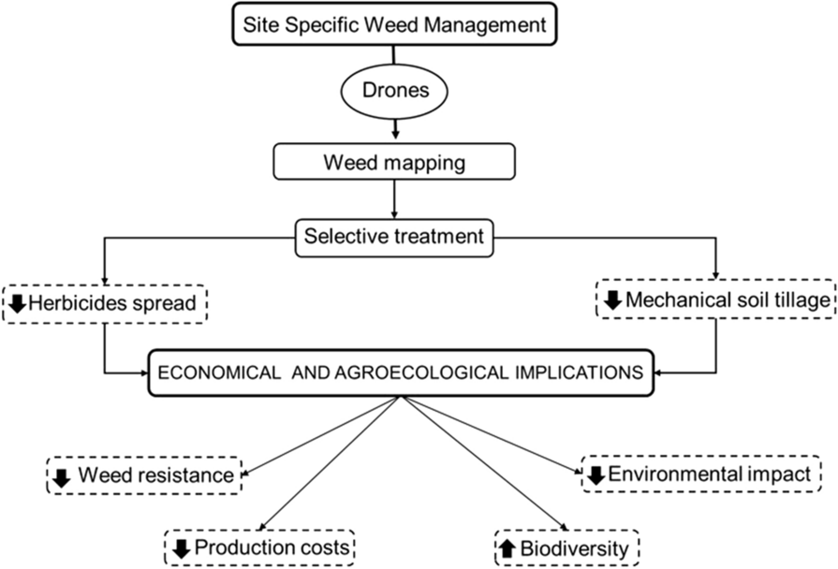

Sustainability and Long-Term Effects
Long-Term Benefits of Conservation Tillage and Organic Nutrient Use
Both conservation tillage and organic nutrient sources are essential for creating sustainable agricultural systems. Over time, these practices provide lasting benefits that not only improve soil health but also enhance long-term crop productivity. Key long-term benefits include [23]:
- Soil Fertility Improvement: Organic nutrient sources continuously supply essential nutrients, enriching the soil for future generations of crops. Over time, the soil's nutrient-holding capacity improves, reducing the need for synthetic fertilizers.
- Increased Organic Matter: Both practices increase organic matter in the soil, leading to improved soil structure, water retention, and nutrient availability.
- Erosion Control: Conservation tillage minimizes soil erosion, which is particularly important for maintaining the topsoil layer that is vital for crop growth.
- Nutrient Cycling: Organic fertilizers improve nutrient cycling by providing a steady release of nutrients, thus fostering more efficient nutrient use by crops.
Enhancing Soil Carbon Sequestration and Biodiversity[23]
- Soil Carbon Sequestration:
  - Conservation tillage reduces soil disturbance, preventing the release of carbon stored in the soil. Combined with organic fertilization, it enhances carbon sequestration by increasing the soil's organic carbon content.
  - Organic farming practices, including the use of organic fertilizers, contribute to higher levels of soil carbon by increasing the amount of organic matter in the soil.
- Biodiversity:
  - Both conservation tillage and organic fertilizers promote soil biodiversity by fostering the growth of soil microorganisms, such as beneficial bacteria, fungi, and earthworms, which help in nutrient cycling and soil health.
  - These practices also reduce the need for chemical inputs, which can harm soil organisms and reduce biodiversity.
Economic Viability and Sustainability in Finger Millet Production
- Reduced Input Costs:
  - Conservation tillage reduces the need for expensive equipment and fuel associated with conventional tillage. Organic fertilizers, while initially more costly, can reduce the need for synthetic fertilizers and pesticides over time.
  - The combination of these practices leads to lower overall production costs and higher profitability in the long term.
- Increased Yield Stability:
  - The improved soil structure and nutrient availability from organic fertilizers and conservation tillage contribute to more stable yields, even during adverse weather conditions like droughts.
- Long-Term Profitability:
  - The initial investment in conservation tillage equipment and organic fertilizers is offset by the long-term benefits of increased soil fertility, reduced input costs, and improved yields, making the system more economically viable and sustainable.

Table 5: Long-Term Benefits of Conservation Tillage and Organic Nutrient Use
Benefit | Conservation Tillage | Organic Nutrient Use | Combined Effect (Conservation Tillage + Organic Nutrients)
Soil Organic Matter (%) | Increases soil organic matter over time | Increases soil organic matter with organic inputs | Higher increase in organic matter due to both practices
Soil Structure | Improves soil structure by reducing erosion | Improves soil structure through added organic matter | Further improvement in soil aggregation and porosity
Water Retention (%) | Improves water retention by reducing evaporation | Organic matter increases water-holding capacity | Significant improvement in water retention and infiltration
Nutrient Availability | Increases nutrient cycling and efficiency | Organic nutrients enhance nutrient release and availability | Combined effect enhances nutrient cycling and availability
Erosion Control | Reduces soil erosion and protects topsoil | No direct impact on erosion, but enhances soil health | Reduced erosion with improved soil fertility and structure
Soil Microbial Activity (CFU/g soil) | Encourages microbial growth due to reduced soil disturbance | Organic fertilizers support soil microbiota | Higher microbial activity and diversity due to both practices
Carbon Sequestration (t/ha/year) | Enhances carbon sequestration by preserving organic matter | Organic fertilizers increase soil carbon storage | Maximum carbon sequestration by combining both practices

Table 6: Economic Viability and Sustainability in Finger Millet Production
Practice | Initial Investment ($/ha) | Annual Input Costs ($/ha) | Annual Output (Yield, kg/ha) | Revenue ($/ha) | Profitability | Long-Term Sustainability
Conventional Tillage + Synthetic Fertilizers | 500 | 300 | 1200 | 1500 | Moderate | Low
Conservation Tillage + Organic Fertilizers | 800 | 350 | 1600 | 2000 | High | High
Conservation Tillage + Organic Fertilizers + Legume Intercropping | 900 | 400 | 1700 | 2100 | Very High | Very High
Sole Finger Millet with Organic Fertilizers | 650 | 320 | 1400 | 1800 | High | Moderate
Explanation of Table:
- Initial Investment ($/ha): This includes costs for purchasing conservation tillage equipment and organic fertilizers. Organic farming systems typically require a higher initial investment, but the long-term benefits outweigh these costs.
- Annual Input Costs ($/ha): This includes ongoing costs for fertilizers, labor, and other inputs. While organic fertilizers may have higher upfront costs, the need for synthetic fertilizers is reduced.
- Annual Output (Yield, kg/ha): Finger millet yields vary depending on the farming system. Intercropping with legumes under conservation tillage and organic fertilization tends to give the highest yields.
- Revenue ($/ha): Revenue is based on the yield and market price of finger millet and legumes.
- Profitability: Profitability increases significantly with conservation tillage and organic fertilization, especially when combined with legume intercropping.
- Long-Term Sustainability: Systems that combine conservation tillage, organic fertilization, and legume intercropping provide the most sustainable, long-term benefits due to improved soil health, reduced dependency on chemical inputs, and enhanced profitability.
Conclusion
In conclusion, the integration of conservation tillage and organic nutrient sources in legume-based cropping systems provides significant agronomic, environmental, and economic benefits for finger millet production. These practices improve soil health by enhancing organic matter content, microbial activity, and water retention, contributing to sustainable farming systems. Legume intercropping further boosts soil fertility through nitrogen fixation, positively impacting finger millet yields. The combination of conservation tillage and organic fertilizers leads to higher productivity, reduced input costs, and long-term soil fertility, making it economically viable. Additionally, these practices help mitigate environmental concerns such as soil erosion, nutrient leaching, and carbon emissions, supporting ecological sustainability. The findings suggest that adopting conservation tillage and organic nutrient management can lead to more resilient agricultural systems, ensuring improved crop performance and soil health while promoting economic sustainability in the long run. These practices should be encouraged for their comprehensive benefits to both farmers and the environment.

Disclaimer (Artificial intelligence)
Option 1:
Author(s) hereby declare that NO generative AI technologies such as Large Language Models (ChatGPT, manuscript.
Option 2:
Author(s) hereby declare that generative AI technologies such as Large Language Models, etc. have been used during the writing or editing of manuscripts. This explanation will include the name, version, model, and source of the generative AI technology and as well as all input prompts provided to the generative AI technology
Details of the AI usage are given below:
1.
2.
3.

References
[1] Ayalew, B. (2015). Trends, growth and instability of finger millet production in Ethiopia. Research Journal of Agriculture and Environmental Management, 4(2), 078-081..
[2] Nickhil, C., Singh, R., Deka, S. C., & Nisha, R. (2025). Exploring finger millet storage: an in-depth review of challenges, innovations, and sustainable practices. Cereal research communications, 53(1), 57-79..
[3] Sankar, G. M., Sharma, K. L., Dhanapal, G. N., Shankar, M. A., Mishra, P. K., Venkateswarlu, B., & Grace, J. K. (2011). Influence of soil and fertilizer nutrients on sustainability of rainfed finger millet yield and soil fertility in semi-arid Alfisols. Communications in soil science and plant analysis, 42(12), 1462-1483..
[4] Meena, D. S., Gautam, C., Patidar, O. P., Singh, R., Meena, H. M., & Prakash, V. J. (2017). Management of finger millet based cropping systems for sustainable production. International Journal of Current Microbiology and Applied Sciences, 6(3), 676-686.
[5] Gebreyohannes, A., Shimelis, H., Laing, M., Mathew, I., Odeny, D. A., & Ojulong, H. (2021). Finger millet production in Ethiopia: Opportunities, problem diagnosis, key challenges and recommendations for breeding. Sustainability, 13(23), 13463.
[6] Singh, S., & Rajas, S. (2025). Analyzing Fluctuations in Millet Trends Across India: Unravelling Patterns in Area, Production, Productivity, and Consumption with a Focus on Growth and Instability. In Global Millets Production for a Sustainable Future (pp. 241-253). Cham: Springer Nature Switzerland.

[7] Deevi, K. C., Swamikannu, N., Pingali, P. R., & Gumma, M. K. (2024). Current trends and future prospects in global production, utilization, and Trade of Pearl Millet. In Pearl Millet in the 21st Century: Food-Nutrition-Climate resilience-improved livelihoods (pp. 1-33). Singapore: Springer Nature Singapore.
[8] Gupta, S. M., Arora, S., Mirza, N., Pande, A., Lata, C., Puranik, S., ... & Kumar, A. (2017). Finger millet: a “certain” crop for an “uncertain” future and a solution to food insecurity and hidden hunger under stressful environments. Frontiers in plant science, 8, 643.
[9] Luitel, D. R., Siwakoti, M., & Jha, P. K. (2019). Climate change and finger millet: Perception, trend and impact on yield in different ecological regions in Central Nepal. Journal of Mountain Science, 16(4), 821-835.
[10] Grovermann, Christian, K. B. Umesh, Sylvain Quiédeville, B. Ganesh Kumar, Srinivasaiah S, and Simon Moakes. "The economic reality of underutilised crops for climate resilience, food security and nutrition: Assessing finger millet productivity in India." Agriculture 8, no. 9 (2018): 131..
[11] Rana, N. S., veer Singh, B., Kumar, R., & Singh, B. Handbook of Millets.
[12] Meena, B. S. (2019). Development of Manual Operated Two Row Planter for Onion Seeds (Doctoral dissertation, Jawaharlal Nehru Krishi Vishwa Vidyalaya, Jabalpur).
[13] Saikanth, D. R. K., Roy, D., Kumar, N., Buch, K., Sharma, P., Dubey, G., & Singh, B. V. (2023). Exploring the nutritional landscape: A review of fodder options for livestock. International Journal of Environment and Climate Change, 13(10), 2481-2493.
[14] Manjunath, P., Ashaq, M., Soni, R., Singh, S. K., Chittora, V., Panotra, N., ... & veer Singh, B. (2024). Integrating Bioinformatics and Genomic Tools for Sustainable Crop Improvement: A Review. Plant Cell Biotechnology and Molecular Biology, 25(11-12), 266-282.
[15] Gawande, V., Saikanth, D. R. K., Sumithra, B. S., Aravind, S. A., Swamy, G. N., Chowdhury, M., & Singh, B. V. (2023). Potential of precision farming technologies for eco-friendly agriculture. International Journal of Plant & Soil Science, 35(19), 101-112.
[16] Tripathi, G., Jitendrakumar, P. H., Borah, A., Nath, D., Das, H., Bansal, S., ... & Singh, B. V. (2023). A review on nutritional and health benefits of millets. International Journal of Plant & Soil Science, 35(19), 1736-1743.
[17] Guddaraddi, A., Singh, A., Amrutha, G., Saikanth, D. R. K., Kurmi, R., Singh, G., ... & Singh, B. V. (2023). Sustainable biofuel production from agricultural residues an eco-friendly approach: a review. Int J Environ Clim Change, 13(10), 2905-2914.
[18] Singh, B. V., Singh, S., Verma, S., Yadav, S. K., Mishra, J., Mohapatra, S., & Gupta, S. P. (2022). Effect of nano-nutrient on growth attributes, yield, Zn content, and uptake in wheat (Triticum aestivum L.). International Journal of Environment and Climate Change, 12(11), 2028-2036.
[19] Rangaswamy, R. (1995). A text book of agricultural statistics. new age international.
[20] Rao, C. S., Gopinath, K. A., Prasad, J. V. N. S., & Singh, A. K. (2016). Climate resilient villages for sustainable food security in tropical India: concept, process, technologies, institutions, and impacts. Advances in Agronomy, 140, 101-214.
[21] Hobbs, P. R., Sayre, K., & Gupta, R. (2008). The role of conservation agriculture in sustainable agriculture. Philosophical Transactions of the Royal Society B: Biological Sciences, 363(1491), 543-555..
[22] Giller, K. E., Andersson, J. A., Corbeels, M., Kirkegaard, J., Mortensen, D., Erenstein, O., & Vanlauwe, B. (2015). Beyond conservation agriculture. Frontiers in plant science, 6, 870.
[23] Knowler, D., & Bradshaw, B. (2007). Farmers’ adoption of conservation agriculture: A review and synthesis of recent research. Food policy, 32(1), 25-48.
[24] Mbanyele, V., Mtambanengwe, F., Nezomba, H., Rurinda, J., & Mapfumo, P. (2022). Conservation agriculture in semi-arid Zimbabwe: a promising practice to improve finger millet (Eleusine coracana Gaertn.) productivity and soil water availability in the short term. Agriculture, 12(5), 622.
[25] Hatti, V. R. B. K., Ramachandrappa, B. K., Sathishand, A., & Thimmegowda, M. N. (2018). Soil properties and productivity of rainfed finger millet under conservation tillage and nutrient management in Eastern dry zone of Karnataka. Journal of Environmental Biology, 39(5), 612-624.
[26] Sidar, S., & Thakur, A. K. (2017). Effect of tillage and conservation farming on weed population and yield of finger millet (Eleusine coracana L.) under rain fed ecosystem. International journal of current microbiology and applied sciences, 6(12), 3650-3664.
[27] Thakur, A. K., & Sidar, S. (2017). Energetic and economics of different tillage methods and conservation farming in finger millet. Int. J. Curr. Microbiol. App. Sci, 6(12), 3665-3669.
[28] Hatti, V. (2016). Effect of conservation tillage and nutrient management practices on finger millet in Alfisols under rainfed conditions (Doctoral dissertation, Ph. D. Thesis).
[29] El-Beltagi, H. S., Basit, A., Mohamed, H. I., Ali, I., Ullah, S., Kamel, E. A., ... & Ghazzawy, H. S. (2022). Mulching as a sustainable water and soil saving practice in agriculture: A review. Agronomy, 12(8), 1881.

