Advancements & Challenges in Unmanned Ground Vehicles

Abstract
This paper reviews the advancements and challenges in Unmanned Ground Vehicles (UGVs), tracing their evolution from early research to modern applications. We synthesize recent progress in mobility platforms, including wheeled, tracked, and legged systems, and their use in military, agricultural, and disaster response missions. The review highlights key technological enablers for UGV autonomy, such as advanced perception systems that fuse data from LiDAR, cameras, and radar. We also examine the role of artificial intelligence, particularly deep learning for perception and reinforcement learning for navigation. Furthermore, the paper addresses the increasing importance of modularity, interoperability standards like JAUS, and the use of UGV swarms. Despite this progress, significant challenges persist, including reliable off-road autonomy, localization in GPS-denied environments, and ensuring cybersecurity. The paper concludes by outlining critical areas for future research to achieve more resilient, intelligent, and collaborative UGV systems.
Keywords: Unmanned Ground Vehicles, Modern applications, Agricultural, Artificial intelligence

1 Introduction
Unmanned Ground Vehicles (UGVs) have undergone significant evolution over the past few decades, transitioning from rudimentary tele-operated systems to highly autonomous platforms capable of performing complex tasks across a variety of domains. Early prototypes like SHAKEY (1966) and the Autonomous Land Vehicle (ALV) set foundational concepts for robot autonomy and mobility [1, 2]. Over time, UGVs have expanded their operational scope to sectors including military reconnaissance and logistics, agricultural automation, disaster response, infrastructure inspection, and search-and-rescue missions [3–6].
This review aims to systematically map the technological progress and emerging trends in UGVs by analysing 50 significant peer-reviewed papers published between 2007 and 2025. Key areas of focus include platform design and mobility, sensor technologies and perception, autonomy and intelligence, interoperability standards, and real-world applications. We also identify current challenges and potential future directions to guide researchers and practitioners in this rapidly evolving field.

2. Platform Design & Mobility
2.1 Locomotion Modes
Unmanned Ground Vehicles employ various locomotion mechanisms to navigate diverse and often challenging terrains. The most common configurations are wheeled, tracked, and legged platforms, each with its unique advantages and limitations.
- Wheeled UGVs are typically favoured for their high speed, energy efficiency, and mechanical simplicity. They excel on flat or moderately rough terrain but face limitations on extremely uneven or soft ground [7,8].
- Tracked UGVs provide enhanced traction and obstacle surmounting ability. For instance, the THeMIS platform demonstrates capabilities including slope navigation up to 60%, side slopes of 30%, overcoming obstacles up to 0.9 meters, and speeds up to 20 km/h, making them suitable for off-road and military missions [9,10].
- Legged UGVs, although still primarily in research phases, mimic animal locomotion to traverse highly uneven and complex terrains inaccessible to wheeled or tracked vehicles. They offer potential advantages in mobility and adaptability but require sophisticated control algorithms and pose mechanical challenges [11,12].
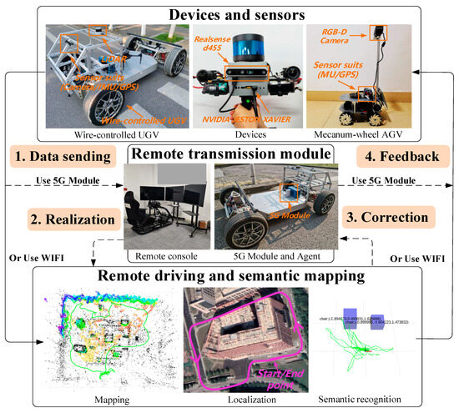

Fig 1. Schematic of a UAV–UGV collaborative application. Dashed lines represent real-time data exchange via the proposed dual-channel architecture.

2.2 Modular Architectures
Modularity has become a prominent trend in UGV design, emphasizing flexibility and rapid reconfiguration. Modular systems enable the quick swapping of payloads and sensors to tailor the vehicle for specific missions. In agriculture, for example, platforms often consist of commercial wheeled bases with plug-and-play modules for tasks such as spraying, monitoring, and harvesting [13,14].
Standardized mechanical and electrical interfaces, alongside software-defined controls, allow autonomous detection and configuration of payloads, reducing setup time and improving operational efficiency [15–17].
2.3 Power & Propulsion
Powertrain selection is critical in balancing endurance, stealth, noise, and energy efficiency. Hybrid diesel-electric powertrains, such as those employed by THeMIS, provide extended operational time (~15 hours in hybrid mode) while allowing purely electric silent operation for shorter durations (~1.5 hours) [18,19]. Pure electric UGVs offer reduced acoustic and thermal signatures but face limitations in energy density, impacting mission duration and payload capacity.

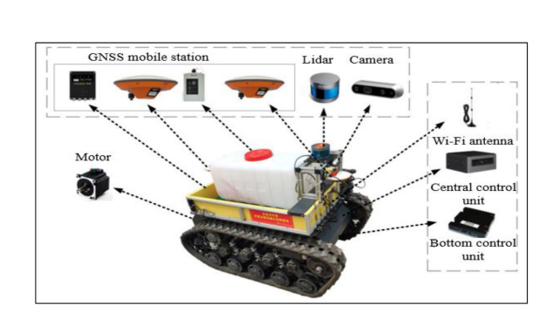

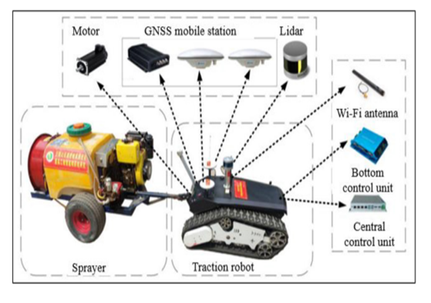
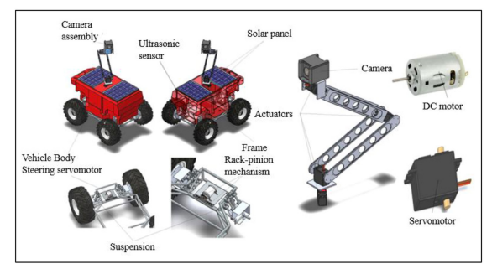
Fig. 2. Agricultural UGV Payload Swap: Demonstrates modular payload exchange on a wheeled base for crop spraying, soil sampling, and plant health monitoring.

Table 1: Comparison of UGV Powertrain Types
Powertrain Type | Endurance | Noise | Complexity | Applications
Battery Electric | 1-3 hours | Low | Low | Indoor, short missions
Hybrid Diesel-Electric | 10-20 hours | Medium | Medium | Military, long missions
Fuel Cell | 20 + hours | Low | High | Experimental, remote ops

3. Sensor Suite & Perception
3.1 Sensor Technologies
UGVs rely on a diverse array of sensors to perceive and understand their environment, enabling navigation, obstacle avoidance, and mission-specific tasks. Commonly integrated sensors include:
- LiDAR (Light Detection and Ranging): Provides high-resolution 3D point clouds for environment mapping and obstacle detection. Its precision in measuring distances makes it crucial for Simultaneous Localization and Mapping (SLAM) and traversability analysis [20, 21].
- Cameras: RGB and infrared cameras deliver visual data for object recognition, terrain classification, and situational awareness. Stereo vision cameras enhance depth perception [22].
- Radar: Particularly effective in adverse weather and occluded environments due to its long-range and all-weather capabilities, radar complements LiDAR, which can be hindered by fog, dust, or rain [23, 24].
- Ultrasound: Useful for close-range obstacle detection and collision avoidance, especially in constrained environments [25].
- Inertial Measurement Units (IMUs): Provide orientation and acceleration data, critical for dead reckoning and stabilizing motion estimation [26].
- GPS/RTK: Global Positioning System, augmented with Real-Time Kinematic positioning, enables precise global localization, though it can be unreliable or unavailable in GPS-denied environments such as indoors or urban canyons [27].
- Radio-based Ranging (RFID, UWB): Emerging techniques use radio signals for localization where GPS signals are weak or denied [28].
3.2 Radar vs LiDAR
The choice between radar and LiDAR involves trade-offs:
- Radar systems are robust in poor visibility and can penetrate obstacles such as foliage and dust, making them suitable for outdoor and battlefield conditions [29].
- LiDAR offers finer spatial resolution, beneficial for detailed mapping and object recognition in structured or semi-structured environments but is more sensitive to environmental conditions [30].
Hybrid systems employing sensor fusion combine these strengths to improve robustness and reliability.
3.3 Traversability Analysis
Traversability estimation, essential for path planning and safe navigation, leverages multisensor data. Techniques combine appearance features from cameras, geometric data from LiDAR, and radar returns to classify terrain types such as rock, soil, vegetation, or water [31]. Machine learning algorithms, particularly convolutional neural networks (CNNs), enhance terrain classification accuracy and adapt to new environments [32].
3.4 Localization Advances
Localization technologies continue to evolve to address GPS-denied scenarios. Radio-frequency (RF)-based localization using ultra-wideband (UWB) or 5G cellular networks offers promising alternatives for precise positioning [33]. Combining these with visual-inertial odometry and SLAM techniques enables resilient navigation in complex environments [34].
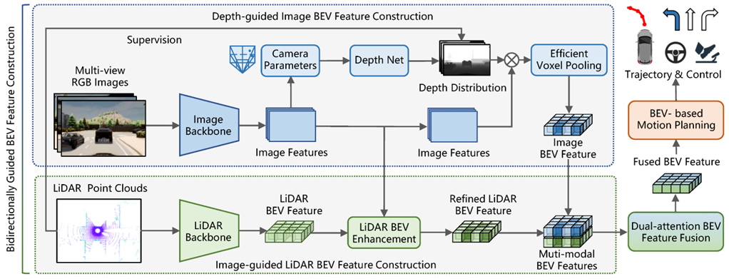

Fig. 3. Sensor Fusion Pipeline: Depicts integration of LiDAR, radar, camera, and IMU data streams into a unified environmental map used for navigation and obstacle avoidance.

Table 2: Sensor Types, Advantages and Limitations for UGVs
Sensor Type | Advantages | Limitations | Typical Use Cases
LiDAR | High spatial resolution | Costly, weather-sensitive | Terrain mapping, obstacle avoidance
Radar | All-weather operation | Lower resolution | Adverse weather, occlusions
Cameras | Rich visual data | Lighting/weather sensitive | Object classification, scene understanding
Ultrasound | Low-cost, short-range | Limited range, noise-sensitive | Indoor obstacle avoidance
IMU | Inertial navigation | Drift over time | Pose estimation, stabilization
GPS/RTK | Global absolute positioning | Unreliable indoors/urban canyons | Outdoor navigation
RF-based | Indoor/GPS-denied localization | Lower accuracy, infrastructure needed | Indoor tracking

4. Autonomy & Intelligence
4.1 Perception and Planning
The core of UGV autonomy lies in its ability to perceive the environment and plan safe, efficient paths. Advanced perception techniques leverage deep learning models such as convolutional neural networks (CNNs) and recurrent neural networks (RNNs) to enhance object detection, scene understanding, and semantic segmentation from sensor data [35, 36]. These models improve the accuracy and robustness of simultaneous localization and mapping (SLAM), enabling UGVs to build reliable maps in complex and dynamic environments [37].
Path planning algorithms integrate terrain traversability data with mission objectives. Classical approaches like A* and D* have evolved to incorporate machine learning and reinforcement learning (RL), allowing UGVs to adapt their navigation strategies dynamically based on learned experience [38]. Recent developments include the use of deep reinforcement learning (DRL) to handle complex decision-making under uncertainty [39].
4.2 Reinforcement Learning & Cooperative Control
Reinforcement learning, particularly DRL, has gained traction for enabling UGVs to learn optimal behaviours through trial-and-error interaction with the environment. DRL enables adaptive control policies for navigation, obstacle avoidance, and energy management [40]. For example, in multi-agent systems, DRL facilitates cooperative behavior between UAVs and UGVs for coordinated missions such as disaster response, where UGVs may autonomously recharge drones or relay communications [41, 42].
4.3 Swarm Intelligence
Swarm intelligence frameworks leverage decentralized AI models to coordinate multiple UGVs (and UAVs) operating as a cohesive unit. This approach increases system robustness, scalability, and flexibility. Swarm algorithms inspired by natural systems—such as ant colony optimization and particle swarm optimization—enable efficient task allocation, formation control, and distributed sensing [43, 44]. Modular payload control enhances swarm adaptability by allowing individual units to switch roles dynamically [45].

4.4 On-Board Computation
Advances in embedded computing platforms have been critical in realizing real-time autonomous functions onboard UGVs. High-performance System-on-Chips (SoCs) such as NVIDIA Jetson Nano and Orin, Google Coral TPUs, and other ARM-based AI accelerators provide the computational horsepower required for running deep neural networks and SLAM algorithms in real time while respecting power and thermal constraints [46, 47]. This facilitates deployment in field conditions without relying extensively on remote processing.

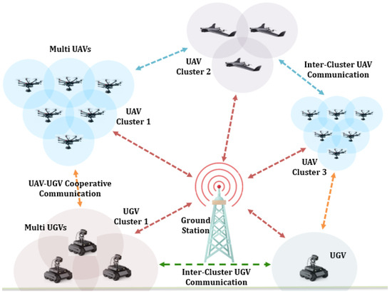
Fig 4. Communication Framework for Cooperative Multi-UAV and Multi-UGV Systems.
5. Interoperability & Standardization
5.1 UGV Interoperability Profiles (IOPs) & DoD Standards
Interoperability is critical for enabling diverse UGV systems, sensors, and payloads to work together seamlessly, especially in military and multi-vendor environments. The U.S. Department of Defense (DoD) has promoted the adoption of interoperability profiles based on the Joint Architecture for Unmanned Systems (JAUS) standard [48]. JAUS defines messaging protocols and service interfaces that facilitate modular system integration, command and control, and data sharing across heterogeneous platforms [49].
Implementing JAUS-based interoperability profiles allows different UGVs and their subsystems to be integrated into larger networked systems, enhancing mission flexibility and reducing development costs. It supports plug-and-play capabilities, enabling rapid adaptation to mission requirements by swapping payloads or sensors with minimal software reconfiguration [50].
5.2 European Initiatives: iMUGS and Standardization Efforts
In Europe, the Integrated Modular Unmanned Ground System (iMUGS) project represents a concerted effort to standardize UGV platforms across member nations. Based on the versatile THeMIS platform, iMUGS aims to develop interoperable hardware and software frameworks, ensuring compatibility and operational coherence across different national forces and industrial suppliers [51].
The iMUGS initiative emphasizes open architectures, standardized interfaces (mechanical, electrical, and software), and common control frameworks. These standards are vital for enabling cross-border cooperation, reducing vendor lock-in, and fostering a competitive market for modular UGV technologies [52]. Additionally, ongoing collaboration with NATO standardization groups furthers harmonization in allied operations [53].
5.3 Challenges in Standardization
Despite these advances, achieving universal interoperability remains challenging due to proprietary systems, varying hardware constraints, and evolving mission requirements. Lack of widely adopted universal protocols hinders seamless plug-and-play across manufacturers. Moreover, cybersecurity and secure communications protocols are essential considerations in standard development to protect against threats [54].
To address these issues, current research advocates for layered interoperability approaches combining open standards with adaptable middleware and common data models. Enhanced certification processes and industry-government partnerships are also critical for accelerating adoption [55].

6. Applications & Deployment
6.1 Military Operations
Unmanned Ground Vehicles have become indispensable in modern military operations, performing roles ranging from intelligence, surveillance, and reconnaissance (ISR) to logistics support and armed engagement. Platforms like the THeMIS and Type-X UGVs have been deployed in conflict zones such as Ukraine and NATO exercises, demonstrating capabilities in navigating hazardous environments while carrying sensor payloads or weapon systems [56, 57]. The integration of autonomous navigation with rugged mobility allows these UGVs to perform patrols, convoy escort, casualty evacuation, and supply transport, reducing risk to personnel [58].
Additionally, armed UGV variants equipped with remotely operated weapon stations provide force multiplication and precise firepower while maintaining operator safety. Military deployments have emphasized modular payloads to enable rapid mission adaptation and cooperation with aerial drones for multi-domain operations [59].
6.2 Agriculture
Agricultural UGVs leverage autonomy and AI-powered sensing to enhance crop monitoring, soil analysis, and precision spraying. Systems incorporate high-resolution multispectral cameras, LiDAR, and soil sensors to collect detailed plant health data, enabling targeted interventions that improve yield and reduce resource usage [60, 61]. The use of GPUs and TPUs onboard allows real-time image processing and anomaly detection, critical for early disease identification and nutrient management [62].
Modular designs permit swapping tools such as seed planters, weeders, and harvesters, supporting diverse agricultural tasks with a single base platform. These UGVs contribute to sustainable farming practices by minimizing chemical use and labour costs [63].

6.3 Construction and Infrastructure Inspection
Autonomous UGVs equipped with robotic arms and advanced sensors have been deployed in construction and infrastructure inspection to enhance safety and efficiency. These UGVs can perform obstacle removal, material transport, and site surveying in constrained environments that are unsafe or inaccessible for humans [64]. Equipped with LiDAR, cameras, and radar, they facilitate detailed structural inspections, detecting cracks, corrosion, and deformation with high precision [65].
Furthermore, UGVs assist in tunnel inspection, pipeline monitoring, and bridge assessment, providing continuous and reliable data to support maintenance and prevent catastrophic failures [66].
6.4 Disaster Response and Search & Rescue
UGVs working in tandem with UAVs have transformed disaster response by enabling rapid area coverage, persistent monitoring, and coordinated task sharing. These systems can navigate debris, collapsed structures, and hazardous environments to locate survivors, deliver supplies, and map disaster zones [67]. Real-time data streaming from onboard sensors supports situational awareness for rescue teams [68].
Hybrid UAV-UGV teams optimize coverage: UAVs provide aerial overviews while UGVs conduct ground-level searches and operate heavy payloads. Autonomous coordination algorithms ensure efficient mission execution with minimal human intervention [69].

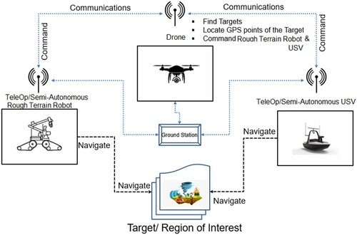

Fig. 5. Disaster Response UAV-UGV Coordination: Highlights collaborative search and rescue operations using aerial and ground robotic teams.

Table 3: Representative UGV Applications
Application Domain | Key UGV Examples | Primary Payloads & Sensors | Deployment Challenges
Military | THeMIS, Type-X | EO/IR cameras, radar, manipulator arms | Rugged terrain, security
Agriculture | Small Robot Company UGVs | Hyperspectral cameras, RTK-GPS | Field navigation, weather
Construction & Inspection | Clear path Husky, Boston Dynamics Spot | LiDAR, robotic arms, ultrasonic sensors | Confined spaces, real-time mapping
Disaster Response & SAR | PackBot, ANYmal | Thermal, gas sensors, cameras | Complex terrain, long ops
Urban Delivery | Starship Technologies UGV | Cameras, GPS, obstacle avoidance | Urban navigation, pedestrian safety

7. Challenges & Research Gaps
7.1 Sensor Fusion Complexity
One of the most significant challenges in UGV development is the integration of heterogeneous sensor data to create accurate environmental models for navigation and decision-making. UGVs typically combine LiDAR, radar, cameras, ultrasonic sensors, inertial measurement units (IMUs), and GPS. Each sensor has distinct strengths and weaknesses: LiDAR provides high-resolution 3D spatial data, radar excels in adverse weather, and cameras deliver rich visual context [70].
However, fusing these disparate data streams requires sophisticated synchronization, calibration, and filtering techniques to mitigate noise, latency, and sensor drift. Real-time fusion algorithms, often based on Bayesian filtering or deep learning, are computationally intensive and must balance accuracy with onboard processing constraints [71]. Research is ongoing into adaptive sensor fusion frameworks that dynamically weight sensor inputs depending on environmental conditions [72].
7.2 Robust Off-road Autonomy
Operating in unstructured, off-road environments presents a core mobility and perception challenge. Terrains featuring soft soil, vegetation, uneven surfaces, rocks, and water require UGVs to possess advanced traversability analysis and adaptive locomotion [73]. While wheeled and tracked platforms perform well on moderate terrain, legged robots offer potential for extreme environments but remain less mature [74].
Durability and reliability are paramount; exposure to dust, moisture, and mechanical stress demands rugged hardware and fault-tolerant control systems. Terrain classification using sensor fusion combined with machine learning has improved navigation, but unexpected obstacles and dynamic conditions still challenge autonomy [75].
7.3 Scalable AI in Constrained Hardware
Real-time perception, planning, and control require running heavy AI workloads on limited onboard computer resources. Balancing the demand for sophisticated neural networks with energy consumption and heat dissipation constraints is a continuing challenge [76]. Current solutions include edge AI accelerators like NVIDIA Jetson Orin and Google Coral TPUs, but optimizing models for embedded deployment without losing accuracy is non-trivial [77].
Furthermore, intermittent communication and the need for autonomy in GPS-denied or network-denied environments compel UGVs to perform AI inference locally, increasing computational requirements. Research into lightweight models, model pruning, and quantization is critical for future UGV intelligence [78].
7.4 Interoperability Barriers
Despite progress in standardization, lack of universally accepted protocols and middleware continues to impede seamless interoperability. Diverse proprietary systems often require custom adapters, increasing integration costs and complexity. Cybersecurity concerns further complicate protocol openness, as secure communications must be ensured across networks [79].
Efforts to develop open-source frameworks and layered middleware architectures aim to address these barriers, but industry-wide adoption remains limited. Bridging this gap is essential for collaborative missions involving heterogeneous robotic teams [80].

Table 4: Key Challenges and Research Directions
Challenge | Description | Research Directions | Impact on UGV Deployment
Sensor Fusion Complexity | Integrating multi-sensor data in real-time | Probabilistic fusion, deep sensor fusion | Improves perception reliability
Off-road Autonomy | Navigation in unstructured, dynamic terrains | Terrain-adaptive planning, rugged hardware | Expands operational environments
Scalable AI | Running efficient AI on power-limited hardware | Model compression, edge AI hardware | Extends mission endurance
Interoperability | Lack of universal standards and APIs | Development/adoption of JAUS, iMUGS | Enables modular, multi-vendor systems
Ethical & Regulatory | Legal, privacy, and societal concerns | Policy development, ethical AI | Facilitates safe public adoption

Conclusion
Unmanned Ground Vehicles (UGVs) have undergone remarkable evolution from rudimentary tele-operated platforms to sophisticated autonomous systems capable of complex missions across military, agricultural, industrial, and disaster-response domains. This review has synthesized advances in platform design, sensor integration, autonomy algorithms, interoperability frameworks, and diverse applications, highlighting key trends and ongoing challenges.
Sensor fusion combining LiDAR, radar, cameras, and IMUs has significantly improved environmental perception and terrain traversability. Deep learning models, reinforcement learning, and swarm intelligence are enabling greater autonomy, cooperative multi-robot operations, and adaptive mission planning. Modular architectures and plug-and-play payload systems enhance operational flexibility, while emerging edge AI hardware facilitates onboard processing despite constrained power and compute resources.
However, significant challenges remain, including the complexity of real-time heterogeneous sensor fusion, achieving reliable off-road mobility, balancing scalable AI workloads with hardware constraints, and overcoming interoperability barriers due to fragmented standards. Research continues to address these gaps through novel algorithms, resilient localization in GPS-denied environments, and evolving standardization efforts.
Looking forward, the integration of AI-enabled modularity, decentralized swarm systems, advanced edge AI chips, and enhanced interoperability protocols will drive UGV capabilities to new levels. These developments promise not only increased operational effectiveness but also broader adoption across commercial and public safety sectors.
In summary, while hurdles persist, the convergence of sensor technology, artificial intelligence, and system architecture innovations positions UGVs as a pivotal technology in the landscape of autonomous robotics. Continued multidisciplinary research and collaboration will be essential to fully realize their transformative potential.

Future Trends & Recommendations
8.1 AI-Enabled Modularity
Future UGVs will increasingly adopt modular architectures enhanced by AI for automatic payload recognition, configuration, and adaptive control. This plug-and-play approach will allow rapid reconfiguration of sensors, manipulators, or mission-specific tools without extensive manual recalibration, streamlining deployment in diverse operational scenarios [81]. AI algorithms will dynamically optimize payload parameters, communication links, and power management based on real-time mission needs, enhancing versatility and responsiveness [82].
8.2 Swarm Systems & Decentralized Control
Swarm robotics, involving coordinated groups of UAVs and UGVs, represents a transformative trend especially for defense, disaster management, and large-area monitoring [83]. Decentralized AI algorithms enable robust, scalable collaboration without reliance on centralized control, improving fault tolerance and adaptability. Future research focuses on swarm behavior models that allow UGVs to autonomously allocate tasks, share sensory data, and adjust formation based on environmental cues [84].
The synergy between aerial and ground robots will expand mission capabilities, for example, with UGVs recharging UAVs or providing mobile command centers during extended operations [85].
8.3 Edge AI & Low-Power High-Performance Chips
Advances in edge AI hardware will empower UGVs with real-time perception and decision-making capabilities while minimizing energy consumption. Emerging ARM-based high-TOPS processors like Qualcomm Snapdragon X Elite, alongside Intel and AMD’s embedded offerings, promise powerful yet energy-efficient platforms tailored for embedded AI workloads [86]. Combined with techniques such as model pruning and quantization, these chips will enable sophisticated autonomy even in resource-constrained environments [87].
This trend will support persistent, long-duration missions with onboard data processing, reducing dependence on cloud connectivity and improving security and latency.
8.4 Enhanced Interoperability Standards
To overcome current fragmentation, ongoing evolution of interoperability protocols such as the Unmanned Ground Vehicle Interoperability Profile (UGV IOP) and European initiatives like iMUGS aim to establish common standards for communication, control, and data exchange across heterogeneous robotic systems [88]. Greater industry and governmental collaboration will help reduce vendor lock-in, facilitating multi-vendor deployments and cooperative multi-robot missions [89].
Efforts will also emphasize cybersecurity, ensuring secure, authenticated interoperability to protect against adversarial threats [90].
8.5 Resilient Autonomy in GPS-Denied Environments
Robust localization and navigation in GPS-denied or degraded environments will be critical for many UGV applications. Future systems will integrate advanced RF-based localization, 5G/6G connectivity, and multi-sensor SLAM approaches to maintain situational awareness [91]. Machine learning models trained to infer terrain and environment dynamics will further improve autonomous decision-making in complex, unknown settings [92].
Such resilient autonomy will be pivotal in subterranean, urban, or contested military environments.

Disclaimer (Artificial intelligence)
Option 2:
Author(s) hereby declare that generative AI technologies such as Large Language Models, etc. have been used during the writing or editing of manuscripts. This explanation will include the name, version, model, and source of the generative AI technology and as well as all input prompts provided to the generative AI technology
Details of the AI usage are given below:
1. GPT
2. Gemini
3. perplexity

References
[1] Nilsson, N.J., 1969. "Shakey the robot," Technical Report, SRI International.
[2] Thorpe, C.E., et al., 1991. "Vision and navigation for the Carnegie-Mellon Navlab," IEEE Transactions on Pattern Analysis and Machine Intelligence, 13(4), pp. 362-383.
[3] Niu, H. and Chen, Y., 2023. The unmanned ground vehicles (ugvs) for digital agriculture. In Smart Big Data in Digital Agriculture Applications: Acquisition, Advanced Analytics, and Plant Physiology-Informed Artificial Intelligence (pp. 99-109).
[4] Mondal, M.S., Ramasamy, S., Humann, J.D., Dotterweich, J.M., Reddinger, J.P.F., Childers, M.A. and Bhounsule, P., 2024, June. A robust uav-ugv collaborative framework for persistent surveillance in disaster management applications. In 2024 International Conference on Unmanned Aircraft Systems (ICUAS) (pp. 1239-1246).
[5] Liu, K., 2022, October. Robust industrial uav/ugv-based unsupervised domain adaptive crack recognitions with depth and edge awareness: From system and database constructions to real-site inspections. In Proceedings of the 30th ACM international conference on multimedia (pp. 5361-5370).
[6] Criollo, L., Mena-Arciniega, C. and Xing, S., 2024. Classification, military applications, and opportunities of unmanned aerial vehicles. Aviation, 28(2), pp.115-127.
[7 Ni, J., Hu, J. and Xiang, C., 2021. A review for design and dynamics control of unmanned ground vehicle. Proceedings of the Institution of Mechanical Engineers, Part D: Journal of Automobile Engineering, 235(4), pp.1084-1100.
[8] Ni, J., Hu, J. and Xiang, C., 2018. An AWID and AWIS X-by-wire UGV: Design and hierarchical chassis dynamics control. IEEE Transactions on Intelligent Transportation Systems, 20(2), pp.654-666.
[9] Švásta, A. and Furch, J., 2023. Evaluation of Existing Unmanned Ground Vehicles Construction and Basic Preconditions for their Design. Advances in Military Technology, 18(1), pp.151-168.
[10] Zhou, X., Yu, X., Zhang, Y., Luo, Y. and Peng, X., 2020. Trajectory planning and tracking strategy applied to an unmanned ground vehicle in the presence of obstacles. IEEE Transactions on Automation Science and Engineering, 18(4), pp.1575-1589.
[11] McGhee, R.B. and Iswandhi, G.I., 2007. Adaptive locomotion of a multilegged robot over rough terrain. IEEE transactions on systems, man, and cybernetics, 9(4), pp.176-182.
[12] Mohamed, A., El-Gindy, M. and Ren, J., 2018. Advanced control techniques for unmanned ground vehicle: literature survey. International journal of vehicle performance, 4(1), pp.46-73.
[13] Quaglia, G., Visconte, C., Scimmi, L.S., Melchiorre, M., Cavallone, P. and Pastorelli, S., 2020. Design of a UGV powered by solar energy for precision agriculture. Robotics, 9(1), p.13.
[14] Gadekar, A., Kataria, K., Aher, J., Deshmukh, P., Fulsundar, S., Barve, S. and Patel, V., 2023. Recent developments in modular unmanned ground vehicles: A review. Asia-Pacific Journal of Science and Technology, 29(01), pp.1-11.
[15] Mangas, A.G., Alonso, F.J.S., Martínez, D.F.G. and Díaz, F.D., 2022. WoTemu: An emulation framework for edge computing architectures based on the Web of Things. Computer Networks, 209, p.108868.
[16] Pradhan, M., Tiderko, A. and Ota, D., 2017, May. Approach towards achieving interoperability between military land vehicle and robotic systems. In 2017 International Conference on Military Communications and Information Systems (ICMCIS) (pp. 1-7).
[17] Patel, N., Choromanska, A., Krishnamurthy, P. and Khorrami, F., 2017, September. Sensor modality fusion with CNNs for UGV autonomous driving in indoor environments. In 2017 IEEE/RSJ International Conference on Intelligent Robots and Systems (IROS) (pp. 1531-1536).
[18] Angelopoulos, V., 2008. The THEMIS mission. Space Science Reviews, 141(1), pp.5-34. [19] Zhang, T., 2016. UGV developments in 2020–2030 in terms of technologies. DIGITAL INFANTRY BATTLEFIELD SOLUTION, p.66.
[20] Liu, S., Atia, M.M., Karamat, T.B. and Noureldin, A., 2015. A LiDAR-aided indoor navigation system for UGVs. The Journal of Navigation, 68(2), pp.253-273.
[21] Maset, E., Scalera, L., Beinat, A., Visintini, D. and Gasparetto, A., 2022. Performance investigation and repeatability assessment of a mobile robotic system for 3D mapping. Robotics, 11(3), p.54.
[22] Brophy, T., Mullins, D., Parsi, A., Horgan, J., Ward, E., Denny, P., Eising, C., Deegan, B., Glavin, M. and Jones, E., 2023. A review of the impact of rain on camera-based perception in automated driving systems. IEEE Access, 11, pp.67040-67057.
[23] Peng, X., Tang, M., Sun, H., Bierzynski, K., Servadei, L. and Wille, R., 2025. 4D mmWave Radar for Sensing Enhancement in Adverse Environments: Advances and Challenges. arXiv preprint arXiv:2503.24091.
[24] Qian, C., Xu, Y., Shi, X., Chen, J. and Li, L., 2025. AF-RLIO: Adaptive Fusion of Radar-LiDAR-Inertial Information for Robust Odometry in Challenging Environments. arXiv preprint arXiv:2507.18317.
[25] Yépez-Ponce, D.F., Montalvo, W., Guamán-Gavilanes, X.A. and Echeverría-Cadena, M.D., 2025. Route Optimization for UGVs: A Systematic Analysis of Applications, Algorithms and Challenges. Applied Sciences, 15(12), p.6477.
[26] Yi, X., Pan, S. and Xu, F., 2025. Improving Global Motion Estimation in Sparse IMU-based Motion Capture with Physics. ACM Transactions on Graphics (TOG), 44(4), pp.1-16.
[27] McElroy, J.S., Strickland, M., Nunes, L.R.T., Magni, S., Fontani, M., Fontanelli, M. and Volterrani, M., 2025. Robotic mowing technology in turfgrass management: Past, present, and future. Crop Science, 65(3), p.e70081.
[28] Kramarić, L., Jelušić, N., Radišić, T. and Muštra, M., 2025. A Comprehensive Survey on Short-Distance Localization of UAVs. Drones, 9(3), p.188.
[29] Garcia-Atutxa, I., Calvo-Soraluze, H., Barrio, E.D. and Villanueva-Flores, F., 2025. The strategic and technological impact of radar in World War II. History of science and technology, 15(1), pp.62-78.
[30] Zheng, Z., Wei, T., Xu, B., Hou, J. and Yu, L., 2025. Enhanced 3D LiDAR-inertial SLAM for large-scale outdoor environments using local ground constraints. Measurement, p.118173.
[31] Bekhti, M.A., Kobayashi, Y. and Matsumura, K., 2014, December. Terrain traversability analysis using multi-sensor data correlation by a mobile robot. In 2014 IEEE/SICE International Symposium on System Integration (pp. 615-620).
[32] Li, Y., Zhu, B., Zhao, J. and Liu, Y., 2025. Terrain classification method based on fusion of vision and vehicle dynamics for UGV. Expert Systems with Applications, 279, p.127495.
[33] Zhou, B., Liu, Z. and Su, H., 2024. 5G networks enabling cooperative autonomous vehicle localization: A survey. IEEE Transactions on Intelligent Transportation Systems, 25(11), pp.15291-15313.
[34] Servières, M., Renaudin, V., Dupuis, A. and Antigny, N., 2021. Visual and visual‐inertial slam: State of the art, classification, and experimental benchmarking. Journal of Sensors, 2021(1), p.2054828.
[35] Juyal, A., Sharma, S. and Matta, P., 2021, June. Deep learning methods for object detection in autonomous vehicles. In 2021 5th International Conference on Trends in Electronics and Informatics (ICOEI) (pp. 751-755).
[36] Chen, D., Zhuang, M., Zhong, X., Wu, W. and Liu, Q., 2023. RSPMP: Real-time semantic perception and motion planning for autonomous navigation of unmanned ground vehicle in off-road environments. Applied Intelligence, 53(5), pp.4979-4995.
[37] Wang, Y., Tian, Y., Chen, J., Xu, K. and Ding, X., 2024. A survey of visual SLAM in dynamic environment: The evolution from geometric to semantic approaches. IEEE Transactions on Instrumentation and Measurement, 73, pp.1-21.
[38] Wang, C., Wang, J., Shen, Y. and Zhang, X., 2019. Autonomous navigation of UAVs in large-scale complex environments: A deep reinforcement learning approach. IEEE Transactions on Vehicular Technology, 68(3), pp.2124-2136.
[39] Zhu, K. and Zhang, T., 2021. Deep reinforcement learning based mobile robot navigation: A review. Tsinghua Science and Technology, 26(5), pp.674-691.
[40] Zhang, J., Yu, Z., Mao, S., Periaswamy, S.C., Patton, J. and Xia, X., 2020. IADRL: Imitation augmented deep reinforcement learning enabled UGV-UAV coalition for tasking in complex environments. IEEE Access, 8, pp.102335-102347.
[41] Munasinghe, I., Perera, A. and Deo, R.C., 2024. A comprehensive review of uav-ugv collaboration: Advancements and challenges. Journal of Sensor and Actuator Networks, 13(6), p.81.
[42] Zhong, Y., Kuba, J.G., Feng, X., Hu, S., Ji, J. and Yang, Y., 2024. Heterogeneous-agent reinforcement learning. Journal of Machine Learning Research, 25(32), pp.1-67.
[43] Khaldi, B. and Cherif, F., 2015. An overview of swarm robotics: Swarm intelligence applied to multi-robotics. International Journal of Computer Applications, 126(2), pp.31-37.
[44] Ronchieri, E. and Innocenti, M., 2007, November. Decentralized control of a swarm of unmanned aerial vehicles. In AIAA Guidance, Navigation and Control Conference and Exhibit (p. 6457).
[45] Costello, B.C., Davies, E., Strickland, L. and Rogers, J.D., 2016, August. A modular mobile robotic system for cooperative payload manipulation. In 2016 IEEE International Conference on Automation Science and Engineering (CASE) (pp. 573-578).
[46] Satyakumar, S., Srinivasarao, T., Kumar, V.A., Venkatarao, P. and Rao, K.T., 2025. Real Time Emotion Detection with Jetson Orin Nano. In Algorithms in Advanced Artificial Intelligence (pp. 628-633).
[47] Sacks, J., Mahajan, D., Lawson, R.C., Khaleghi, B. and Esmaeilzadeh, H., 2018, June. Robox: an end-to-end solution to accelerate autonomous control in robotics. In 2018 ACM/IEEE 45th Annual International Symposium on Computer Architecture (ISCA) (pp. 479-490).
[48] Rowe, S. and Wagner, C.R., 2008. An introduction to the joint architecture for unmanned systems (JAUS). Ann Arbor, 1001, p.48108.
[49] English, R.W., 2009. The joint architecture for unmanned systems, a set of SAE interoperability standards (No. 2009-01-3250).
[50] Smuda, B., 2005, May. Software wrappers for rapid prototyping JAUS-based systems. In Unmanned Ground Vehicle Technology VII (Vol. 5804, pp. 718-726).
[51 Akimoto, T. and Ogata, T., 2012. A narratological approach for narrative discourse: Implementation and evaluation of the system based on Genette and Jauss. In Proceedings of the Annual Meeting of the Cognitive Science Society (Vol. 34, No. 34).
[52] Yoon, S. and Bostelman, R., 2019, June. Analysis of automatic through autonomous-unmanned ground vehicles (A-UGVs) towards performance standards. In 2019 IEEE International Symposium on RObotic and SEnsors Environments (ROSE) (pp. 1-7).
[53] Al Shibli, M., 2015. Towards global unification of UAS standardization: Regulations, systems, airworthiness, aerospace control, operation, crew licensing and training. International Journal of Unmanned Systems Engineering., 3(2), p.32.
[54] Mathiassen, K., Schneider, F.E., Bounker, P., Tiderko, A., Cubber, G.D., Baksaas, M., Główka, J., Kozik, R., Nussbaumer, T., Röning, J. and Pellenz, J., 2021. Demonstrating interoperability between unmanned ground systems and command and control systems. International journal of intelligent defence support systems, 6(2), pp.100-129.
[55] Cuadros Zegarra, E., Barrios Aranibar, D. and Cardinale, Y., 2024. IoRT-Based Middleware for Heterogeneous Multi-Robot Systems. Journal of Sensor and Actuator Networks, 13(6), p.87.
[56] Michalski, K. and Nowakowski, M., 2020. The use of unmanned vehicles for military logistic purposes. Zeszyty Naukowe Szkoły Głównej Gospodarstwa Wiejskiego w Warszawie. Ekonomika i Organizacja Logistyki, (5 [4), pp.43-57.
[57] Jurado, R.D.A., Reina, B.J.V., Suárez, M.Z., Moreno, F.P., Arnaldo, C.G. and Valdés, R.M.A., 2025. AI-Driven Real-Time Interference Detection in Manned-Unmanned Aircraft Communications: Concept of Operations and Integration. Aerospace Science and Technology, p.110722.
[58] Hussain, T.S., Cerys, D., Montana, D., Vidaver, G. and Berliner, J.E., 2005, June. Tactical UGV navigation and logistics planning. In Proceedings of the 7th annual workshop on Genetic and evolutionary computation (pp. 184-186).
[59] Moseley, M.B., Grocholsky, B.P., Cheung, C. and Singh, S., 2009, April. Integrated long-range UAV/UGV collaborative target tracking. In Unmanned Systems Technology XI (Vol. 7332, pp. 30-40).
[60] Sahu, B., 2024. Artificial Intelligence and Automation in Smart Agriculture: A Comprehensive Review of Precision Farming, All-Terrain Vehicles, IoT Innovations, and Environmental Impact Mitigation. Int. J. Sci. Res. IJSR, 13(11), pp.656-665.
[61] Vlachopoulos, O., Leblon, B., Wang, J., Haddadi, A., LaRocque, A. and Patterson, G., 2021. Evaluation of crop health status with UAS multispectral imagery. IEEE Journal of Selected Topics in Applied Earth Observations and Remote Sensing, 15, pp.297-308.
[62] Katikaridis, D., Moysiadis, V., Tsolakis, N., Busato, P., Kateris, D., Pearson, S., Sørensen, C.G. and Bochtis, D., 2022. UAV-supported route planning for UGVs in semi-deterministic agricultural environments. Agronomy, 12(8), p.1937.
[63] Xu, R. and Li, C., 2022. A modular agricultural robotic system (MARS) for precision farming: Concept and implementation. Journal of Field Robotics, 39(4), pp.387-409.
[64] Czarnowski, J., Dąbrowski, A., Maciaś, M., Główka, J. and Wrona, J., 2018. Technology gaps in human-machine interfaces for autonomous construction robots. Automation in Construction, 94, pp.179-190.
[65] Xiao, Y., Pan, X., Tavasoli, S., Azimi, M., Bao, Y., Farsangi, E.N. and Yang, T.T., 2023. Autonomous inspection and construction of civil infrastructure using robots. In Automation in construction toward resilience (pp. 1-26).
[66] Zhang, X., Shukla, A., Al Ali, A. and Karki, H., 2018, November. A smart robotic system for non-contact condition monitoring and fault detection in buried pipelines. In Abu Dhabi International Petroleum Exhibition and Conference (p. D021S026R003). SPE.
[67] Baumgärtner, L., Kohlbrecher, S., Euler, J., Ritter, T., Stute, M., Meurisch, C., Mühlhauser, M., Hollick, M., von Stryk, O. and Freisleben, B., 2017, October. Emergency communication in challenged environments via unmanned ground and aerial vehicles. In 2017 IEEE Global Humanitarian Technology Conference (GHTC) (pp. 1-9).
[68] Messaoudi, K., Baz, A., Oubbati, O.S., Rachedi, A., Bendouma, T. and Atiquzzaman, M., 2024. UGV charging stations for UAV-assisted AoI-aware data collection. IEEE Transactions on Cognitive Communications and Networking, 10(6), pp.2325-2343.
[69] Arbanas, B., Ivanovic, A., Car, M., Orsag, M., Petrovic, T. and Bogdan, S., 2018. Decentralized planning and control for UAV–UGV cooperative teams. Autonomous Robots, 42(8), pp.1601-1618.
[70] Walker, R.J. and Harris, C.J., 1993. A multi-sensor fusion system for a laboratory based autonomous vehicle. IFAC Proceedings Volumes, 26(1), pp.107-112.
[71] Liu, Y., Xu, W., Dobaie, A.M. and Zhuang, Y., 2018. Autonomous road detection and modeling for UGVs using vision-laser data fusion. Neurocomputing, 275, pp.2752-2761.
[72] Malawade, A.V., Mortlock, T. and Faruque, M.A.A., 2022, July. EcoFusion: Energy-aware adaptive sensor fusion for efficient autonomous vehicle perception. In Proceedings of the 59th ACM/IEEE Design Automation Conference (pp. 481-486).
[73] Naranjo, J.E., Clavijo, M., Jiménez, F., Gomez, O., Rivera, J.L. and Anguita, M., 2016, June. Autonomous vehicle for surveillance missions in off-road environment. In 2016 IEEE Intelligent Vehicles Symposium (IV) (pp. 98-103).
[74] Cheng, X., Shi, K., Agarwal, A. and Pathak, D., 2024, May. Extreme parkour with legged robots. In 2024 IEEE International Conference on Robotics and Automation (ICRA) (pp. 11443-11450).
[75] Xiaotian, G., Xiaohong, G., Huijuan, M., Feifei, S. and Xuemei, L., 2019. Comparison of machine learning methods for land use/land cover classification in the complicated terrain regions. Remote Sensing Technology and Application, 34(1), pp.57-67.
[76] Ramasubramanian, A.K., Mathew, R., Preet, I. and Papakostas, N., 2022. Review and application of Edge AI solutions for mobile collaborative robotic platforms. Procedia CIRP, 107, pp.1083-1088.
[77] Akkad, G., Mansour, A. and Inaty, E., 2023. Embedded deep learning accelerators: A survey on recent advances. IEEE Transactions on Artificial Intelligence, 5(5), pp.1954-1972.
[78] Sanida, T., Sideris, A., Tsiktsiris, D. and Dasygenis, M., 2022. Lightweight neural network for COVID-19 detection from chest X-ray images implemented on an embedded system. Technologies, 10(2), p.37.
[79] Shafik, W., Matinkhah, S.M. and Shokoor, F., 2023. Cybersecurity in unmanned aerial vehicles: A review. International Journal on Smart Sensing and Intelligent Systems, 16(1).
[80] Mohamed, N., Al-Jaroodi, J. and Jawhar, I., 2008, September. Middleware for robotics: A survey. In 2008 IEEE Conference on Robotics, Automation and Mechatronics (pp. 736-742).
[81] Pandy, G., Pugazhenthi, V.J., Murugan, A. and Jeyarajan, B., 2025. AI-Powered Robotics and Automation: Innovations, challenges, and pathways to the future. European Journal of Computer Science and Information Technology, 13(1), pp.33-44.
[82 Ni, J., Hu, J. and Xiang, C., 2021. A review for design and dynamics control of unmanned ground vehicle. Proceedings of the Institution of Mechanical Engineers, Part D: Journal of Automobile Engineering, 235(4), pp.1084-1100.
[83 Schranz, M., Umlauft, M., Sende, M. and Elmenreich, W., 2020. Swarm robotic behaviors and current applications. Frontiers in Robotics and AI, 7, p.36.
[84] Elkilany, B.G., Abouelsoud, A.A., Fathelbab, A.M. and Ishii, H., 2021. A proposed decentralized formation control algorithm for robot swarm based on an optimized potential field method. Neural Computing and Applications, 33(1), pp.487-499.
[85] Arbanas, B., Ivanovic, A., Car, M., Orsag, M., Petrovic, T. and Bogdan, S., 2018. Decentralized planning and control for UAV–UGV cooperative teams. Autonomous Robots, 42(8), pp.1601-1618.
[86] Ramasubramanian, A.K., Mathew, R., Preet, I. and Papakostas, N., 2022. Review and application of Edge AI solutions for mobile collaborative robotic platforms. Procedia CIRP, 107, pp.1083-1088.
[87] Zhang, Z. and Li, J., 2023. A review of artificial intelligence in embedded systems. Micromachines, 14(5), p.897.
[88] Pradhan, M., Tiderko, A. and Ota, D., 2017, May. Approach towards achieving interoperability between military land vehicle and robotic systems. In 2017 International Conference on Military Communications and Information Systems (ICMCIS) (pp. 1-7).
[89] Valori, M., Scibilia, A., Fassi, I., Saenz, J., Behrens, R., Herbster, S., Bidard, C., Lucet, E., Magisson, A., Schaake, L. and Bessler, J., 2021. Validating safety in human–robot collaboration: Standards and new perspectives. Robotics, 10(2), p.65.
[90] Tanimu, J.A. and Abada, W., 2025. Addressing cybersecurity challenges in robotics: A comprehensive overview. Cyber Security and Applications, 3, p.100074.
[91] Alghamdi, S., Alahmari, S., Yonbawi, S., Alsaleem, K., Ateeq, F. and Almushir, F., 2025, February. Autonomous Navigation Systems in GPS-Denied Environments: A Review of Techniques and Applications. In 2025 11th International Conference on Automation, Robotics, and Applications (ICARA) (pp. 290-299).
[92] Krecht, R., Suta, A., Tóth, Á. and Ballagi, Á., 2023. Towards the resilience quantification of (military) unmanned ground vehicles. Cleaner Engineering and Technology, 14, p.100644.

