Assessment of some Selected Traditional weeding tools for Safe Ergonomic practices

ABSTRACT
Weeding is a critical agricultural activity essential for maintaining crop health and optimizing yield by eliminating competition from unwanted plants. In India, manual weeding remains the predominant practice due to its cost-effectiveness and environmental sustainability compared to chemical herbicides. This study explores the use of various traditional hand tools for weeding, focusing on their design, the postures assumed during their use, and the ergonomic challenges faced by workers. Observational analysis and video documentation reveal that prolonged squatting, bending, and repetitive movements during manual weeding lead to significant physical strain and musculoskeletal issues among agricultural workers. The findings highlight the urgent need for ergonomic interventions to minimize worker discomfort and improve productivity. This paper provides insights into traditional weeding practices, their implications on worker health, and the potential benefits of redesigning tools to enhance safety, comfort, and efficiency in agricultural settings.
Keywords: Manual Weeding practices, ergonomic challenges, musculoskeletal disorders, traditional farming, worker safety, postural analysis, sustainable agriculture

INTRODUCTION
Agriculture in India is a vital sector that contributes significantly to the country's economy. With a large percentage of the population engaged in agricultural activities, India has a diverse range of crops being cultivated across different regions (Mbatha,2020; Smolińska, 2019). One important aspect of agriculture in India is the weeding activity.
Weeds are unwanted plants in agriculture fields which grow along with the main crop (Woyessa, 2022; Scavo& Mauromicale, 2020). They are strong and dominating competitors for crops and these unsown plant species hinder the growth of the intended crops (Radicetti and Mancinelli, 2021). From an agronomical perspective, the term "weed" refers to any plant that is not intentionally sown or propagated by the farmer but requires management to prevent interference with crop or livestock production Schonbeck, (2011). Interestingly, even "volunteer crops" like buckwheat, rye, Japanese millet, corn, or soybean can become weeds when they self-seed and emerge in a different part of the crop rotation where they are no longer desired (Scavo and Mauromicale, 2020). The presence of weeds can significantly impact crop growth and yield by reducing nutrient availability and hindering sunlight penetration. Therefore, farmers in India employ various weeding techniques to ensure the optimal growth of their crops.
One of the commonly used weeding practices in Indian agriculture is manual weeding (Singh et al., 2022; Cordeau,2022). In India, manual weeding is predominantly done by farmers themselves or by hired laborers. Farmers use various tools like hoes, sickles, or hand weeder to uproot the weeds from the soil manually (Hershey, 2017). This method is preferred over chemical herbicides due to its cost-effectiveness and the minimal risk of environmental pollution. Additionally, manual weeding allows farmers to closely inspect their crops for any signs of diseases or nutrient deficiencies.
Although manual weeding can be a labor-intensive process, it is an important aspect of sustainable agriculture (Liu et al., 2023). It not only helps in maintaining crop health but also contributes to the overall well-being of the farming community. By practicing manual weeding, farmers in India are able to protect their crops and ensure a bountiful harvest (Rao and Chauhan, 2015).
METHODOLOGY
Research Design
This study adopted a descriptive observational research design to systematically examine the ergonomic aspects of manual weeding practices in agriculture. The primary objective was to analyze the physical demands and biomechanical stresses experienced by farm workers during routine weeding activities, with particular emphasis on posture, tool design, and movement patterns. By directly observing workers in real-world field conditions, the study aimed to generate authentic and context-specific ergonomic insights that could inform tool modifications and intervention strategies.
A non-intrusive observational approach was chosen to ensure that the natural work patterns of participants remained unaffected by the presence of researchers. The investigation focused on identifying risk factors associated with musculoskeletal disorders (MSDs), which are prevalent in agricultural tasks due to repetitive motions, awkward postures, and prolonged static positions.
To evaluate postural risks, the Rapid Entire Body Assessment (REBA) method was employed. REBA is a standardized ergonomic evaluation tool developed for assessing whole-body postures, considering the combined effects of limb position, force exertion, load handling, coupling quality, and movement frequency. Its application in this study allowed for quantifying postural strain during weeding, enabling the classification of risks into different levels ranging from negligible to high, which in turn guided the identification of priority areas for ergonomic intervention.
Data Collection Process
The data collection was carried out in three integrated stages. First, direct field observations were conducted while farm workers engaged in their routine weeding activities. Observers recorded qualitative notes on tool type, grip style, frequency of rest breaks, and work pace. Second, still photography was used to capture key postures from multiple angles, ensuring accurate analysis of body segment positions. Third, video recordings were taken to document dynamic movements, enabling frame-by-frame posture assessment and better evaluation of task repetitions and transitions.
Captured images and videos were later analyzed in a controlled setting to assign REBA scores for each observed posture. The scoring process involved assessing trunk, neck, legs, upper arms, lower arms, and wrist positions, combined with load, force, and coupling factors. The final REBA scores indicated the urgency of ergonomic interventions, with higher scores signifying more severe postural risks.
Study Area and Participants
The study was conducted in agricultural fields characterized by limited mechanization and a reliance on traditional weeding tools. A purposive sampling technique was employed to select farm workers actively engaged in manual weeding. Participants were chosen based on their direct involvement in the task, ensuring relevant and accurate data collection.

RESULT AND DISCUSSION

Weeding activity in agricultural fields
Agriculture in India is a vital sector that contributes significantly to the country's economy. With a large percentage of the population engaged in agricultural activities, India has a diverse range of crops being cultivated across different regions. One important aspect of agriculture in India is the weeding activity.
Weeds are unwanted plants in agriculture fields which grow along with the main crop. They are strong and dominating competitors for crops and these unsown plant species hinder the growth of the intended crops (Radicetti and Mancinelli, 2021). From an agronomical perspective, the term "weed" refers to any plant that is not intentionally sown or propagated by the farmer but requires management to prevent interference with crop or livestock production Schonbeck, (2011). Interestingly, even "volunteer crops" like buckwheat, rye, Japanese millet, corn, or soybean can become weeds when they self-seed and emerge in a different part of the crop rotation where they are no longer desired (Scavo and Mauromicale, 2020). The presence of weeds can significantly impact crop growth and yield by reducing nutrient availability and hindering sunlight penetration. Therefore, farmers in India employ various weeding techniques to ensure the optimal growth of their crops.
One of the commonly used weeding practices in Indian agriculture is manual weeding. In India, manual weeding is predominantly done by farmers themselves or by hired laborers. Farmers use various tools like hoes, sickles, or hand weeder to uproot the weeds from the soil manually. This method is preferred over chemical herbicides due to its cost-effectiveness and the minimal risk of environmental pollution. Additionally, manual weeding allows farmers to closely inspect their crops for any signs of diseases or nutrient deficiencies.
Although manual weeding can be a labor-intensive process, it is an important aspect of sustainable agriculture. It not only helps in maintaining crop health but also contributes to the overall well-being of the farming community. By practicing manual weeding, farmers in India are able to protect their crops and ensure a bountiful harvest.
Table 1: Information on hand tools and implements used in performance of weeding activity in agricultural fields
Features | Using Posture | Specifications
- Khurpi  A traditional hand tool used in agriculture, features a blade with a tang and a sturdy handle. The blade, typically made from medium to high carbon steel, is designed with a slightly curved edge to efficiently cut through weeds. Its tang extends into the handle, ensuring stability and durability during use. | Squatting | 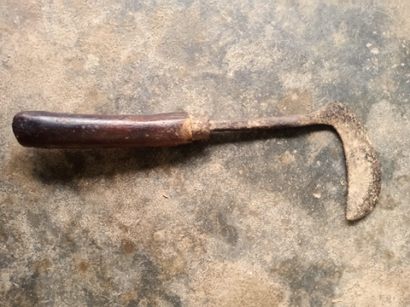  Length of the handle - 10-12 cm, Handle diameter -2.5-3 cm
- Sickle  The Sickle, also known as a Khurpi, is a widely used handheld tool available in different sizes and shapes. Primarily employed for weeding, it features a sharp, curved metal blade attached to a wooden handle. Crafted from medium to high carbon steel, its design facilitates a push-pull action while working. | Squatting | The overall length -31 cm  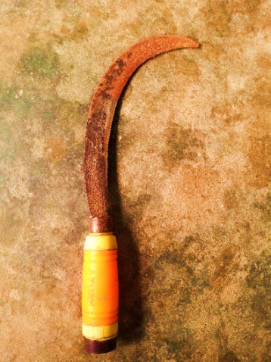  Plain edge arc length - 20-25 cm. Width of the blade - 3.7 cm
- Hand Shovel:  The hand shovel is a valuable tool for weeding in gardening and agriculture. Its blade, designed with a curved edge for effective soil penetration, allows precise weed uprooting. | Squatting | 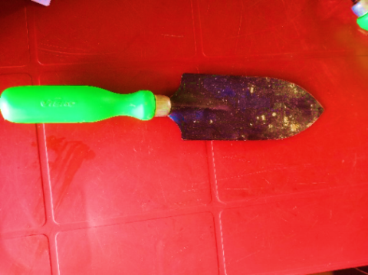  Handle length - 17 cm,  Blade length - 10.5 cm  Blade width- 3.5 cm
- Weeding hook:  The weeding hook is equipped with a V-shaped blade, specifically designed for precise weed removal in gardening and agriculture. This unique blade shape enables users to effectively target weeds at their base. | Squatting | Handle length - 13 cm,  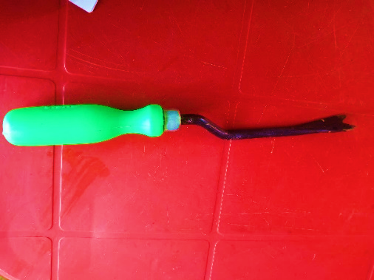  Blade measures 16.5 cm in length and 3.5 cm in width
- Traditional root picker  A regionally adapted hand tool used primarily in the northeastern parts of India, the Traditional Root Picker is designed with a compact, slightly curved blade sharpened for precise soil penetration. It is particularly effective for targeting weed roots in narrow crop rows or sloped terrain. Its ergonomic shape supports better control during weeding, reducing strain during repetitive movements. | Squatting | Handle length - 14.5 cm  blade measures 9.5 cm in length and 2.6 cm in width.  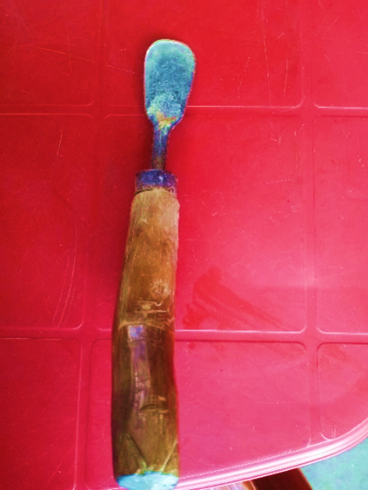
- Hoe (Powrah):  The hoe, an essential tool in agriculture and gardening, features a blade attached to a long handle. The blade is usually flat or slightly curved, designed to break up soil, remove weeds, and shape planting rows. The handle provides leverage and control during hoeing tasks. | Standing cum forward bending | 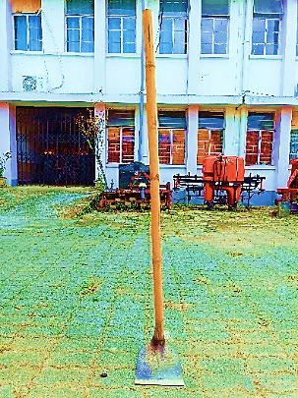  Handle height -162.82 cm, diameter - 4 cm. The blade dimensions measure 17 cm in width and 19 cm in length.

Posture assumed during weeding task
The posture of workers during tasks is influenced by the demands of the job, the working environment, and the design of the tools they use. Occasional unnatural postures are not typically a cause for concern. However, holding unnatural postures for extended periods should raise alarm. When the body remains in one position for too long, or repetitive gestures are made, the body naturally adjusts, leading some muscles to tighten while others weaken. Over time, this imbalance can place strain on certain joints, causing pain and potentially leading to work-related health issues. Workers involved in weeding often experience high static postural loads due to the restrictive nature of the work methods and tools. These postures were studied and analysed through observation, still photography, and video analysis.
The postural analysis clearly demonstrate that the workers assume a variety of abnormal postures at work. From the illustrations and description (presented in Table 2 and Fig 1) revealed that squatting with slight forward bending, flexion at the neck, back and at the knees with the movement of both the hands were assumed while performing the weeding task by small hand tools. For hand hoe workers assumed a standing cum forward bending posture with movement of both the hands.
Muscle movement with shoulder adduction, shoulder flexion, extension of fingers, abduction and adduction of hands, flexed and pronated wrist of both hands was found among the workers during weeding. Similar postures with legs (flexed legs) in slow dynamic motion and arms stretched forward were also found to be assumed by respondent while caring out the weeding task. Standing and slight forward bending posture was assumed by workers while using hoe for weeding.

Table. 2 Analysis of different postures assumed by the respondents while performing weeding activity with different hand tools.

Hand tools | Types of posture | Illustration | Description
- Hand Shovel | Squatting cum bending | 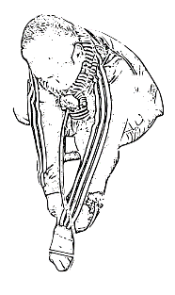 | Workers assume a low squatting posture with forward bending of the upper body while performing weeding tasks with these hand tools. The tool is typically held in the dominant (right) hand, used for scraping or digging, while the non-dominant (left) hand assists in gathering or removing uprooted weeds. This posture involves prolonged knee flexion, forward neck tilt, and repetitive wrist and shoulder movements, contributing to physical strain, especially in the lower back, knees, and upper
- Weeding hook | Squatting cum bending | 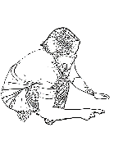
- Khurpi | Squatting cum bending | 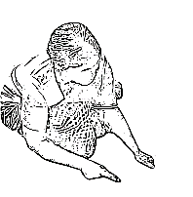
- Sickle | Standing cum bending | 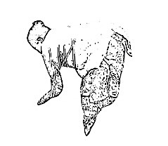 | The worker bends her whole body in a standing posture and hold the weeds in left hand while cutting it using the tool held in right hand
- Hoe (Powrah) | Standing cum bending | 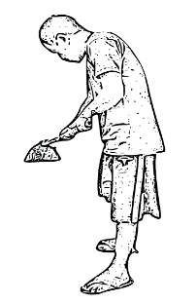 | The worker stands with slight forward bending and holding the tool in both hands for removing the weeds
- Traditional root picker | Standing cum bending | 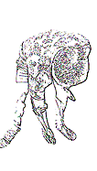 | The worker bends his whole body in a standing posture and remove the weeds using tool held in right hand and keeps his left hand on left thigh for support

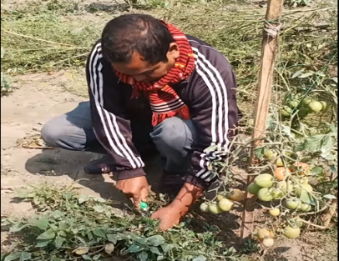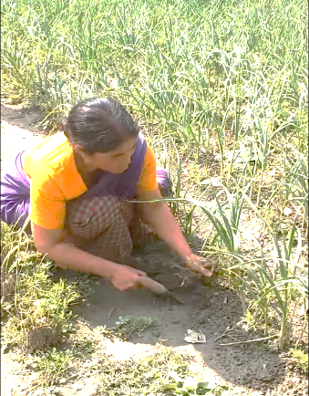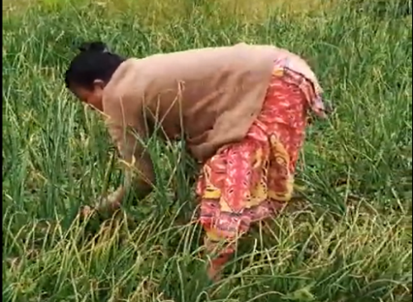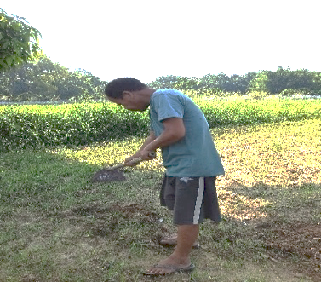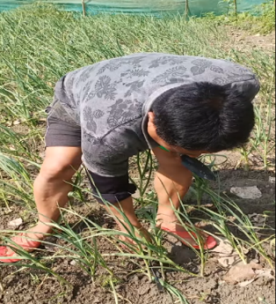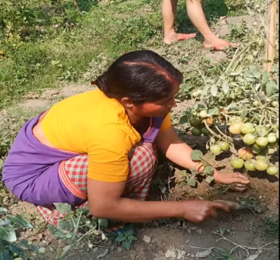Figure 1: POSTURES ASSUMED BY THE RESPONDENTS WHILE PERFORMING WEEDING ACTIVITY WITH DIFFERENT HAND TOOL
- Hand Shovel

(b) Khurpi

(c) Sickle

(d) Hoe (Powrah)
(e) Traditional root picker
(f) Weeding hook

Problems faced by the respondents while using different hand tools used for weeding activity
In agriculture, hand tools and manual work accessories play a crucial role in aiding farmers with various tasks. These tools are designed for manual operation, offering flexibility and convenience in small-scale agricultural fields. They help farmers efficiently perform tasks like digging, planting, weeding, and harvesting. However, the frequent and strenuous use of these tools can cause issues for workers, such as muscle and joint strain, particularly during long working hours. This can lead to musculoskeletal disorders and chronic pain. Additionally, poor posture while using hand tools often results in back and neck pain, with these issues worsening if the tools are not ergonomically designed. (Table 3).
During the study, respondents reported experiencing several challenges while using various traditional hand tools for weeding. A common concern was the requirement of prolonged bending or squatting postures, which caused discomfort and fatigue in the lower back, knees, and legs. Many participants highlighted that improper handle length and excessive tool weight forced them to adopt awkward body positions, increasing the risk of musculoskeletal strain. Small or poorly contoured handles often resulted in an uncomfortable grip, leading to palm soreness, blisters, and reduced efficiency over time. Additionally, tools with dull or poorly aligned blades required greater force to cut through weeds, further increasing physical exertion. The repetitive nature of the task, combined with the need to exert force, led to early onset of fatigue in the hands, forearms, and shoulders. Some workers also mentioned that soil conditions and weed density significantly affected tool performance, making the work more labor-intensive. These problems not only slowed the pace of weeding but also negatively impacted the overall comfort, safety, and productivity of the workers, highlighting the need for ergonomic improvements in tool design.

Table 3: Problem faced by farmers while using hand tools
Name of tools | Problems faced by workers in using different hand tools
Hoe (Powrah) | This is the most common tool used in weeding activities. Using a hoe requires significant force. The constant bending and stooping required to effectively use a hoe can lead to strain and discomfort in the back, neck, and shoulders.  These postures may also cause unexpected injuries like carpal tunnel syndrome, musculoskeletal disorder and lower back injuries.
Weeding hook | Weeding hook requires a continues squatting and bending posture to reach the weeds, which leads to strain on workers back, neck and shoulders. This continuous bending and crouching can result in musculoskeletal disorders and chronic pain.
Sickle | Sickle requires a bending posture. However, the bend position during longer periods creates tension of certain muscles thus results in quicker tiredness and soreness in the lower back and necks of the workers.
Hand Shovel | Squatting and bending posture assumed by workers for a longer period of time causes strain on certain muscles, resulting in back and neck pain.
Khurpi | Khurpi, a handheld tool with a small blade, requires workers to bend down and maintain a crouched position for extended periods of time. This repetitive action puts a strain on the workers' backs, causing discomfort and potential long-term health issues.

CONCLUSION
Weeding remains a cornerstone of Indian agriculture. While traditional manual tools such as hoes, sickles, and khurpis are integral to weed control, their usage imposes substantial ergonomic burdens on farm workers. This study provides a focused ergonomic assessment of specific hand tools traditionally used in Indian agriculture, offering detailed insights into the posture-related strain associated with each tool. Rather than simply identifying the presence of musculoskeletal disorders (MSDs), it emphasizes how tool design and posture interact to impact worker health.
The findings underline the urgent need to rethink tool ergonomics—specifically by minimizing bending requirements, improving grip design, and adapting tool dimensions to reduce musculoskeletal stress. Moreover, educating workers on posture correction and task alternation techniques can help reduce fatigue and injury risks. Future research should prioritize developing low-cost, ergonomically optimized tools tailored to the needs of small-scale Indian farmers to promote long-term health and agricultural sustainability.
Disclaimer (Artificial intelligence)
Author(s) hereby declare that NO generative AI technologies such as Large Language Models (ChatGPT, COPILOT, etc.) and text-to-image generators have been used during the writing or editing of this manuscript.
Acknowledgement
We would like to express our sincere appreciation to Department of Family Resource Management and Consumer Science, AAU Jorhat, Department of Food Science and Nutrition, AAU Jorhat and Department of Agricultural Statistics, AAU Jorhat for assisting us throughout the study.

References
Cordeau, S. (2022). Conservation agriculture and agroecological weed management. Agronomy. 12(4): 867.
Liu, C., Yang, K., Chen, Y., Gong, H., Feng, X., Tang, Z., & Qi, L. (2023). Benefits of mechanical weeding for weed control, rice growth characteristics and yield in paddy fields. Field Crops Research. 29(3): 108-852.
Mbatha, M. W. (2020). The Agricultural Sector in Improving the Country’s Economy. Journal of African Foreign Affairs. 7(2): 77-93.
Radicetti, E., & Mancinelli, R. (2021). Sustainable Weed Control in the Agro-Ecosystems. Sustainability. 13(15): 8639. https://doi.org/10.3390/su13158639
Scavo, A. and Mauromicale, G. (2020). Integrated Weed Management in Herbaceous Field Crops. Agronomy. 10: 466.
Schonbeck, M., and Tillage, B. (2011). Principles of sustainable weed management in organic cropping systems. In Workshop for Farmers and Agricultural Professionals on Sustainable Weed Management. 3: 1-24. Clemson, SC, USA: Clemson University.
Singh, M., Kukal, M. S., Irmak, S., & Jhala, A. J. (2022). Water use characteristics of weeds: A global review, best practices, and future directions. Frontiers in Plant Science. 12: 794090.
Smolińska, K. (2019). The role of Agriculture in the national economy of China and India–a longterm analysis. Roczniki (Annals). (3).
Woyessa, D. (2022). Weed control methods used in agriculture. American Journal of Life Science and Innovation, 1(1): 19-26.
Hershey, C. (2017). Mechanical weeding options: 5.1 Manual hand tools. In Achieving sustainable cultivation of cassava Volume 2 (pp. 304-311). Burleigh Dodds Science Publishing.
Rao, A N and Chauhan, B S (2015) Weeds and Weed Management in India - A Review. In: Weed Science in the Asian Pacific Region. Indian Society of Weed Science, Hyderabad, pp. 87-118. ISBN 9788193197806

