**A Review on Blockchain for Traceability and Transparency in Sericulture Supply Chains**

**Abstract**

The sericulture industry, despite its cultural and economic importance, remains constrained by fragmented supply chains, limited traceability, and opaque practices that undermine sustainability and authenticity. As global markets increasingly demand verifiable, ethically sourced textiles, blockchain technology emerges as a promising tool for enabling transparency, traceability, and trust. This review explores the role of blockchain and its integration with Internet of Things (IoT), Artificial Intelligence (AI), and smart contracts in transforming the silk supply chain—from mulberry cultivation and silkworm rearing to reeling, dyeing, and retail. Through the documentation of use cases, pilot projects, and policy developments, the paper identifies how blockchain-enabled systems can mitigate fraud, improve farmer livelihoods, ensure quality certification, and support environmentally responsible practices. Real-world implementations in India and China, along with initiatives by global luxury brands, demonstrate its growing relevance. The review also discusses associated challenges, including infrastructure gaps, digital literacy, regulatory constraints, and scalability issues, and proposes mitigation strategies through capacity building, consortium funding, and standardization frameworks. Finally, it outlines future research directions for tailoring blockchain to sericulture-specific needs. Some pilot projects in India and China show the transformational nature of blockchain were observed high price premiums and low payment delay is witnessed. This review links technology frameworks to implementation at grass root level with strategic implications of sustainable digital transformation in the silk sector and offers a roadmap for digitizing silk value chains, positioning blockchain as a foundational technology for sustainable and ethical sericulture.

**Keywords: Blockchain, Sericulture, Smart Contracts, Sustainable Supply Chains, Traceability**

**1. Introduction**

Sericulture is a traditional agro-based industry centered on the cultivation of mulberry and the rearing of silkworms for silk production. It plays a vital socio-economic role in rural areas of countries such as India, China, and Thailand, generating employment and income for millions of smallholder farmers (International Sericultural Commission, 2024a). Despite its significance, the sericulture supply chain is characterized by fragmentation, informal trade practices, and lack of transparency. The journey of silk—from mulberry fields to luxurious textiles—is often opaque and poorly documented, raising concerns over sustainability, authenticity, and fair-trade compliance (Rokhade et al., 2021). Most existing traceability systems in the sericulture sector rely on paper-based documentation or rudimentary digital tools, leading to inconsistent data, miscommunication among stakeholders, and susceptibility to fraud. Quality degradation, unfair pricing, and unethical labor practices further exacerbate the problem. These inefficiencies not only hinder the sector’s competitiveness in international markets but also undermine consumer trust, especially as global buyers increasingly demand ethically sourced and environmentally verified products.

Emerging digital technologies offer promising solutions. Among them, blockchain stands out as a disruptive innovation capable of transforming supply chain governance. Originally developed to support decentralized cryptocurrencies (Nakamoto, 2008), blockchain has evolved into a robust platform for recording, verifying, and sharing transactional data securely across distributed networks. In agriculture and textile domains, it is being explored for enabling end-to-end visibility, automating contracts, ensuring data integrity, and reducing transaction costs (Casino et al., 2019; Yao & Zhang, 2022). In sericulture, applying blockchain technology—especially when integrated with Internet of Things (IoT) devices—can provide real-time traceability, monitor silkworm health, track cocoon processing stages, and document quality parameters at each node of the chain. These features can significantly improve transparency and operational efficiency. IoT-enabled sensors, QR codes, and mobile data inputs can feed into blockchain systems to create immutable records of rearing practices, environmental conditions, and product movement (Zhang et al., 2017). Such mechanisms allow for verification of claims related to organic certification, labor rights, and sustainability standards.

With growing emphasis on ethical production and climate-resilient livelihoods, the modernization of sericulture value chains has become imperative. Blockchain can facilitate a shift from informal, trust-based networks to formal, data-driven and auditable systems. By doing so, it empowers small-scale producers with digital identities, enables fair pricing through smart contracts, and fosters collaboration among value chain actors. These applications not only support traceability but also open avenues for impact investing, compliance monitoring, and inclusive innovation. Moreover, the technology provides a foundation for industry-wide platforms that could integrate various stakeholders—farmers, government agencies, certification bodies, financial institutions, and end consumers—into a unified ecosystem. Transparency in pricing, timely access to market data, and proof of authenticity can enhance the overall value of silk, positioning it competitively in high-value ethical markets.

This review aims to explore how blockchain and associated technologies can enhance traceability and transparency within sericulture supply chains. It draws insights from interdisciplinary literature across agriculture, information systems, textile studies, and development economics to map the potential and challenges of blockchain implementation in this niche yet significant sector. Emphasis is placed on practical frameworks, pilot implementations, stakeholder dynamics, and policy considerations for sustainable scaling. The following sections delve into the fundamentals of blockchain, its role in agricultural traceability, and its specific applications in sericulture. Case studies, current challenges, and enabling environments are discussed, followed by recommendations for future innovation and governance strategies. By bridging technical discourse with ground-level realities, the discussion presents a comprehensive roadmap for enhancing trust, accountability, and sustainability in silk value chains through digital transformation.

**2. Global Sericulture Landscape**

Silk, often referred to as the “queen of textiles,” is one of the most luxurious and sought-after natural fibres globally. Despite technological advances in synthetic alternatives, the demand for silk has remained steady due to its unique luster, texture, and cultural value in fashion, interior design, and traditional garments. The global sericulture landscape is characterized by sharp regional asymmetries in production and consumption. According to the International Sericultural Commission (2024b), China and India together account for over 94% of global raw silk output, whereas countries like Italy, Japan, and the United States dominate high-end silk consumption and processing. This dual structure—where Asian nations supply and Western economies consume—frames much of the modern-day sericulture economy.

China remains the world’s largest producer and exporter of raw silk, underpinned by decades of policy support, research investments, and the development of vertically integrated mega-clusters that efficiently combine mulberry cultivation, silkworm rearing, cocoon processing, and silk weaving (Wang & Yang, 2022). These clusters enable traceability, quality assurance, and cost-effectiveness. In contrast, India’s sericulture sector is largely decentralized, involving millions of smallholder farmers, each contributing a small share to national output. While this structure offers employment benefits and rural resilience, it poses significant challenges in terms of standardization, traceability, and market competitiveness.

Emerging producers such as Uzbekistan, Vietnam, Thailand, and Brazil also contribute to the global silk market, though at smaller scales. These countries often target niche markets or serve regional demand. Brazil, for instance, has gained recognition for its eco-friendly silk initiatives supported by sustainable practices and environmental certification programs (Hassan et al., 2025). Thailand, on the other hand, continues to focus on traditional hand-woven silk, which appeals to premium craft-based markets.

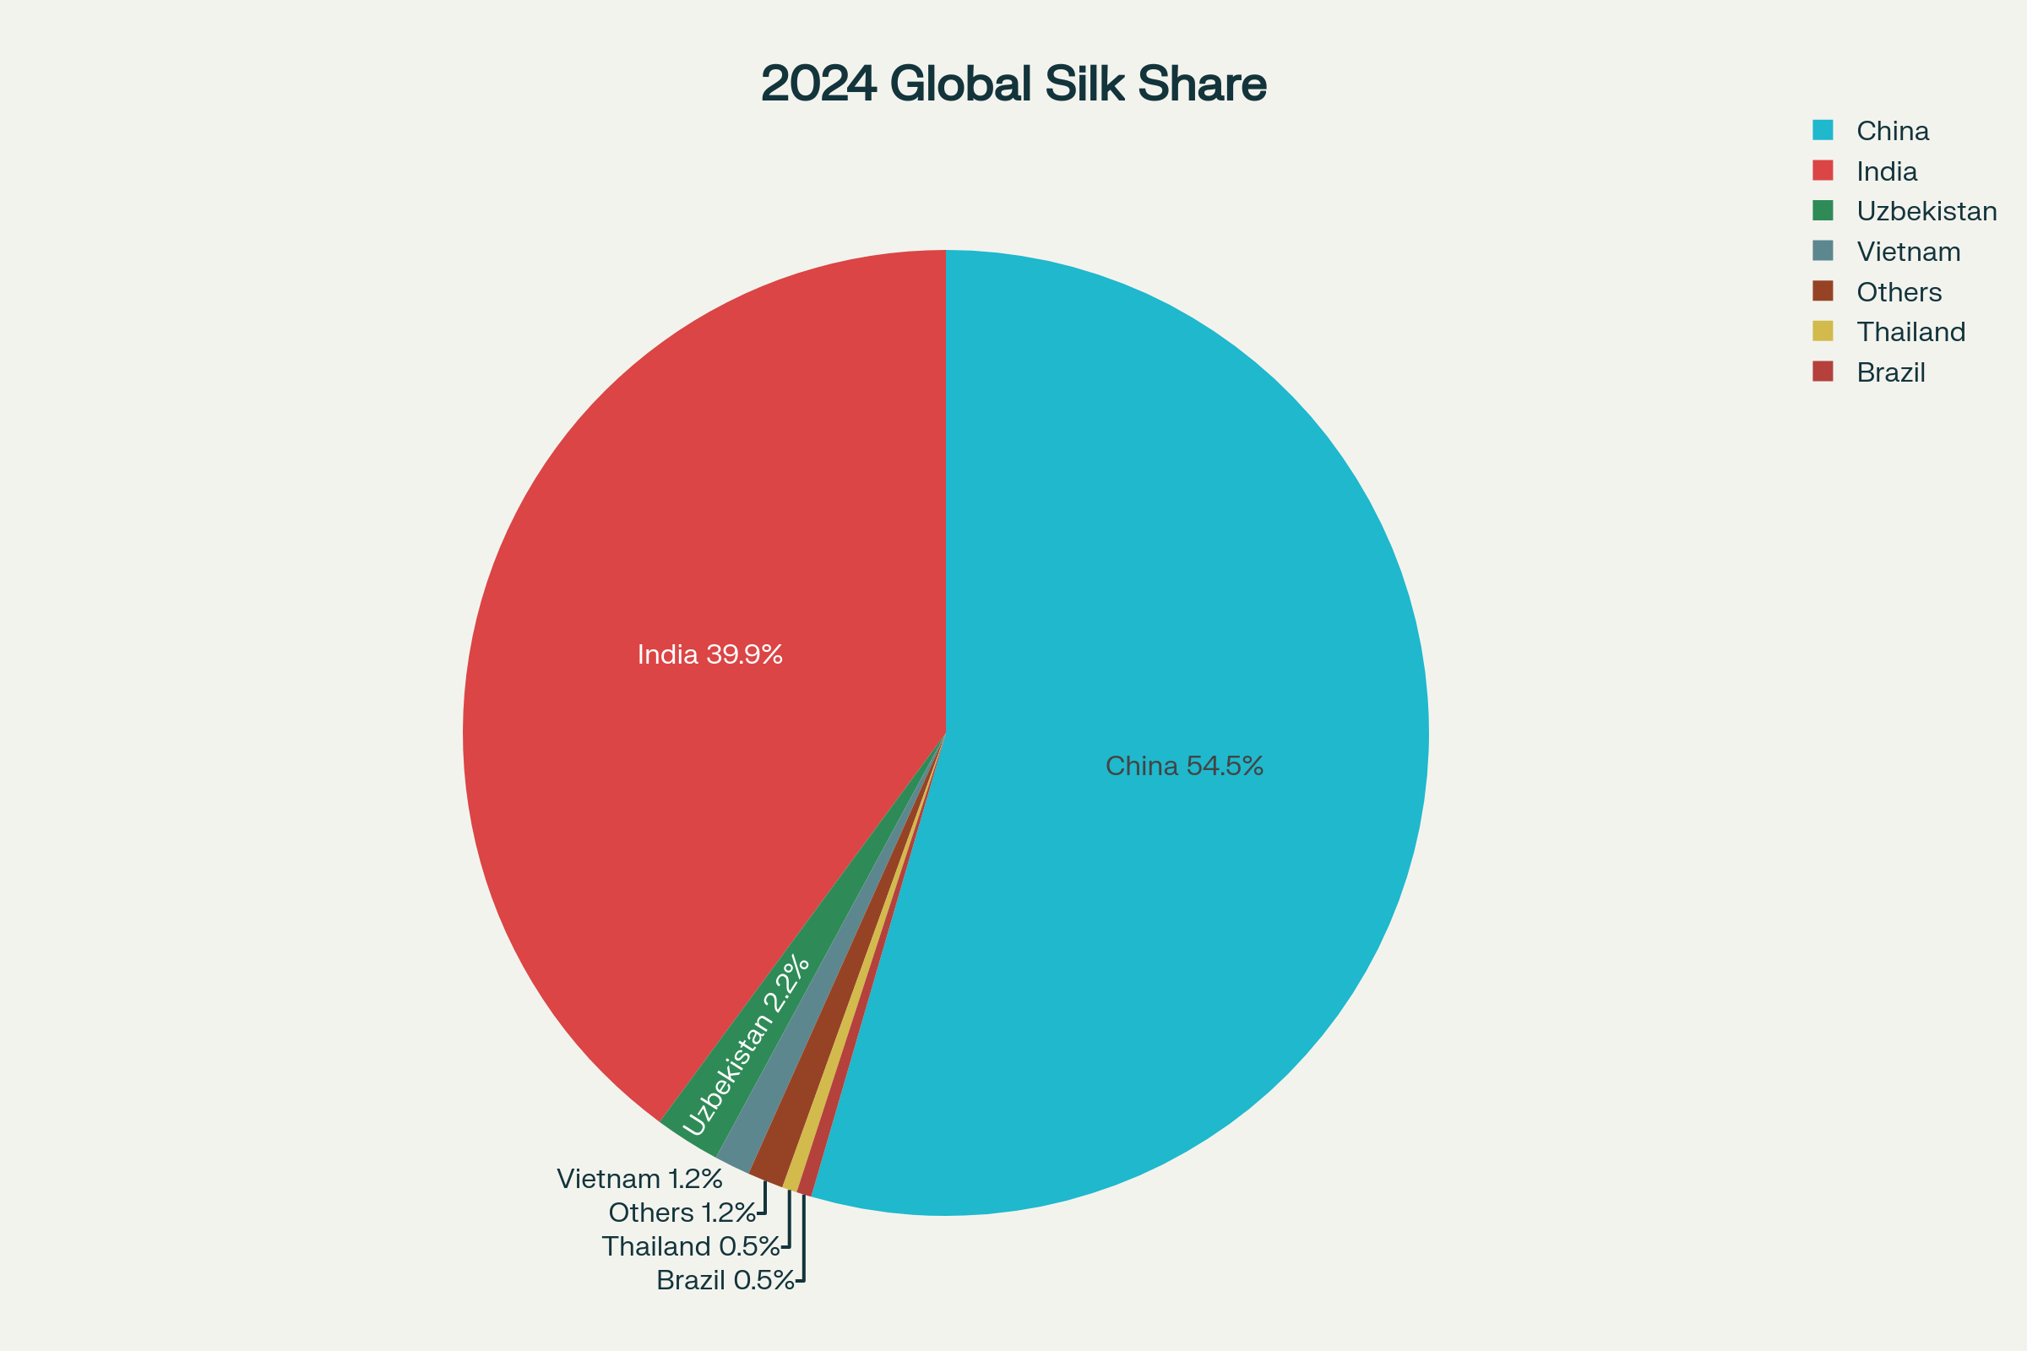

(Source: International Sericultural Commission, 2024b)

Fig. 1: 2024 Global silk share

**2.1 Production Trends**

Recent production trends in the global sericulture industry reflect both geographic concentration and fibre type diversification. Mulberry silk remains the dominant variety, accounting for over 90% of the total global output. However, countries like India also produce significant quantities of wild silk variants, such as Tasar, Muga, and Eri, which are valued for their texture and climate-resilient rearing systems. Table 1 provides a snapshot of the leading raw silk producers based on 2022 production volumes and their projected 2024 market shares.

**Table 1: Summarizes recent output figures and fibre types.**

|  |  |  |  |
| --- | --- | --- | --- |
| **Country** | **2022 Production (MT)** | **2024 Market Share %** | **Primary Silk Type** |
| China | 50,000 | 54.5 | Mulberry |
| India | 36,582 | 39.9 | Mulberry / Tasar |
| Uzbekistan | 2,037 | 2.2 | Mulberry |
| Vietnam | 1,067 | 1.2 | Mulberry |
| Thailand | 435 | 0.5 | Mulberry |
| Brazil | 425 | 0.5 | Mulberry |
| Others | 1,454 | 1.2 | Mixed |

(Source: International Sericultural Commission, 2024b)

The dominance of China is not only numerical but structural. Its sericulture sector benefits from innovation-led cluster development, use of advanced rearing technologies, and strong backward and forward linkages within the silk value chain (Wang & Yang, 2022). India, despite being the second-largest producer, faces significant challenges due to fragmented supply chains, low mechanization, and limited access to market intelligence. The coexistence of both mulberry and non-mulberry silks in India presents additional traceability and certification challenges, particularly in international trade.

In countries like Uzbekistan and Vietnam, silk production is undergoing a transformation driven by foreign investments and regional partnerships, with a growing focus on export-oriented sericulture. Brazil, though smaller in output, is increasingly recognized for its sustainable silk practices, integrating environmental certifications that appeal to global eco-conscious consumers (Hassan et al., 2025).

As global silk consumption patterns evolve, there is a rising demand for traceable, ethically produced silk that meets sustainability benchmarks. Luxury brands and consumers alike seek assurances about the origin, production practices, and labor conditions associated with silk production. These expectations, combined with the diverse and often opaque nature of sericulture value chains, underscore the urgent need for digital traceability solutions such as blockchain.

**3. Challenges in Sericulture Supply Chains**

The sericulture supply chain is complex, labour-intensive, and inherently fragmented. It comprises a sequential flow of eight key stages: (1) mulberry cultivation, (2) silkworm rearing, (3) cocoon harvesting and marketing, (4) silk reeling, (5) twisting, dyeing, and processing, (6) textile manufacturing, (7) distribution and logistics, and (8) retail and consumer interaction. Each of these stages involves multiple actors and processes that are often poorly integrated and lack standardization, resulting in significant inefficiencies and information asymmetries. One of the most pressing issues is the continued reliance on manual and paper-based record-keeping or siloed digital systems. These traditional methods hinder real-time tracking and provenance verification across the supply chain. For example, silkworm rearers often keep handwritten logs of temperature, humidity, and feeding schedules, while cocoon traders manually maintain purchase records. Such fragmented data silos prevent the formation of a unified traceability framework, limiting the ability to verify quality, origin, and production practices.

The lack of reliable provenance information is a major challenge, particularly in international markets where traceability standards are increasingly stringent. Consumers and brands now demand assurance that silk products are ethically sourced, free from exploitation, and compliant with environmental standards. However, without digital systems that trace the silk’s journey from mulberry field to finished fabric, it is virtually impossible to guarantee authenticity or sustainability (Hatibaruah, 2022). This opacity creates opportunities for fraudulent practices, including the mixing of synthetic filaments with natural silk, mislabelling of inferior silk grades, and price manipulation by intermediaries. Moreover, the lack of standardization across the sericulture ecosystem poses serious quality assurance issues. Grading of cocoons and reeled silk is often done manually, based on subjective assessments, which leads to inconsistencies and disputes. Poor quality control mechanisms at the reeling and dyeing stages further exacerbate the issue, leading to wastage, customer dissatisfaction, and reputational damage for brands that cannot verify the integrity of their supply chains.

Another key challenge is the highly fragmented structure of stakeholder participation. Farmers, rearers, cocoon traders, reelers, dyers, weavers, logistics providers, wholesalers, and retailers usually operate as independent entities with limited coordination or data sharing. The absence of centralized or interoperable information systems restricts their ability to collaborate or respond dynamically to market signals. This disjointed structure particularly affects smallholder farmers and reelers, who often lack access to reliable market prices, demand forecasts, or digital identity systems, leaving them vulnerable to exploitation and economic marginalization (Das et al., 2021b). Furthermore, the physical nature of silk production presents additional traceability hurdles. Unlike products with embedded barcodes or serial numbers, raw silk lacks intrinsic identifiers that can be used for real-time tracking. Once silk threads are blended, dyed, or woven into fabrics, distinguishing their origin or production history becomes nearly impossible without a reliable traceability system in place.

Environmental and social compliance monitoring is also hindered in traditional sericulture chains. Critical data on pesticide use in mulberry cultivation, silkworm health conditions, reeling wastewater disposal, and labor conditions are rarely recorded or verified systematically. As global brands align with sustainability benchmarks such as the Sustainable Apparel Coalition’s Higg Index or ISO 14001 standards, these gaps create compliance risks for exporters and supply chain actors in sericulture-producing countries. Additionally, inefficiencies in distribution and logistics due to lack of digitization cause delays and inflate operational costs. Real-time inventory tracking, order fulfillment, and delivery verification are almost non-existent in rural sericulture clusters, limiting responsiveness to both domestic and export market demands.

In essence, the sericulture supply chain faces deep-rooted challenges related to data fragmentation, lack of transparency, quality assurance gaps, and fragmented stakeholder interactions. These issues not only undermine operational efficiency but also erode trust across the value chain—from producers to consumers. In light of these challenges, digital transformation, particularly through the use of blockchain and Internet of Things (IoT) technologies, offers a promising pathway to enhance traceability, accountability, and trust in the sericulture ecosystem.

**4**. **Blockchain Fundamentals and Applications**

Blockchain technology, originally conceptualized to support cryptocurrencies, has evolved into a versatile digital infrastructure with wide-ranging applications in supply chain management, including agriculture and textiles. At its core, blockchain is a distributed digital ledger that records transactions across multiple nodes in a cryptographically secured and sequential manner (Polge et al., 2021). Each transaction is grouped into a "block," which is then linked to the previous block, forming an immutable "chain" of data. This structure provides decentralization, immutability, transparency, and auditability—key attributes that align well with the needs of complex and fragmented industries like sericulture.

A notable feature of blockchain is the use of smart contracts—self-executing computer protocols that automatically enforce and execute contractual terms once predefined conditions are met. Introduced by Szabo (1997), smart contracts can automate key transactions such as the release of payments to silk farmers upon delivery of verified cocoon weights or quality grades, reducing the need for intermediaries and manual verification. Table 2 presents how this core characteristics of blockchain translate into specific benefits for the sericulture supply chain.

**Table 2: Generic blockchain traits to sericulture benefits.**

|  |  |
| --- | --- |
| **Characteristic** | **Sericulture Benefit** |
| Decentralization | Eliminates single intermediaries and power asymmetries |
| Immutability | Prevents retrospective data tampering on cocoon grades |
| Transparency | Allows consumers to scan QR codes and view rearing data |
| Traceability | Enables farm-to-fabric product passports |
| Smart contracts | Auto-releases farmer payments upon verified cocoon weight |
| Consensus mechanisms | Validates transactions without costly third-party audits |

(Source: Casino et al., 2019; Szabo, 1997; Azizi et al., 2021)

**4.1. Enhancing Traceability**

Blockchain enables comprehensive traceability by recording every transaction and transformation step in the silk production process—from the mulberry field to the final garment. Each actor in the value chain (e.g., farmers, reelers, traders, weavers, and retailers) can upload verifiable data to the blockchain ledger. For instance, mulberry growers may record fertilization schedules and pesticide usage, while silkworm rearers can log temperature conditions, disease incidences, and harvest dates. Subsequently, cocoon buyers can document purchase weights and prices, silk reelers can enter thread counts and processing details, and textile manufacturers can trace dye sources and weaving information (Bhosle & Mohite, 2023). This layered, tamper-proof documentation builds a comprehensive digital profile—often referred to as a "product passport"—that traces the history, quality, and origin of each silk item. This not only improves supply chain visibility but also facilitates regulatory compliance, especially in export markets that require detailed traceability.

**Table 3: Comparative of blockchain versus traditional traceability, used in the sericulture industry**

| **Parameter** | **Traditional Traceability** | **Blockchain-Enabled Traceability** |
| --- | --- | --- |
| **Record-Keeping Method** | Paper-based logs or siloed spreadsheets maintained by individual stakeholders | Distributed digital ledger shared across all stakeholders |
| **Data Accuracy** | Prone to human error, manipulation, and inconsistent updates | Automated, tamper-proof entries with time-stamping and cryptographic hashing |
| **Transparency** | Low visibility across the value chain; farmers and buyers rely on intermediaries | High transparency; all authorized parties can view supply chain events in real time |
| **Traceability Scope** | Limited to partial chain (farm to local trader) | End-to-end from mulberry field to finished silk garment |
| **Fraud and Adulteration Risk** | High; difficult to detect synthetic silk mixing or false labeling | Low; immutable records enable verification of origin and product authenticity |
| **Quality Assurance** | Manual inspection; delayed dispute resolution | Sensor-based IoT data (temperature, humidity, weight) linked to blockchain |
| **Payment Processing** | Manual and delayed; dependent on middlemen | Automated smart contracts for instant and conditional payments |
| **Scalability** | Difficult to scale beyond local clusters | Scalable to national and international supply chains with standardized protocols |
| **Regulatory Compliance** | Requires physical audits and third-party verification | Facilitates automated compliance reports and verifiable certifications |
| **Consumer Engagement** | Minimal; consumers rarely access origin details | QR-code storytelling enables consumers to verify origin, sustainability, and ethics |

**4.2. Improving Transparency and Authenticity**

One of blockchain’s most transformative features is its ability to enhance transparency and verify authenticity. Consumers can access supply chain data by simply scanning QR codes attached to silk products. These codes link to blockchain-verified information about farm locations, farmer identities, rearing conditions, processing techniques, environmental certifications, and even labour standards. This transparency builds trust in the product, empowers ethical consumption, and enables brands to demonstrate compliance with sustainability metrics such as organic certification or fair-trade sourcing. In a market increasingly driven by conscious consumers, transparency becomes a key competitive differentiator. For artisanal silk and heritage varieties like Muga or Eri, such authentication tools can add premium value while protecting against counterfeiting and mislabelling.

**4.3. Reducing Fraud and Adulteration**

The sericulture industry is vulnerable to various forms of fraud and adulteration, including the mixing of synthetic fibres with natural silk, mislabelling of silk grades, and counterfeiting of certified products. These malpractices erode market trust, impact export quality, and disadvantage ethical producers. Blockchain can play a pivotal role in fraud reduction by ensuring verifiable provenance. When every transaction—from cocoon procurement to dyeing and weaving—is digitally recorded and timestamped, it becomes virtually impossible to introduce unverified materials without detection. Moreover, automated alerts and audit trails built into blockchain systems can flag inconsistencies, enabling real-time monitoring and faster corrective action. This aspect is particularly useful for regulators and certification bodies, who often struggle with verifying product claims and enforcing compliance across distributed rural production zones.

**4.4 Fostering Inclusive Finance and Fair Trade**

Beyond traceability and fraud mitigation, blockchain also supports financial inclusion and fair-trade mechanisms in sericulture. Smart contracts can be configured to automatically release payments to farmers upon fulfilment of quality or quantity benchmarks, reducing delays and dependence on intermediaries. This ensures fair and timely compensation, which is critical in a sector where many producers operate at subsistence levels. Blockchain-based platforms can also facilitate decentralized finance (DeFi) tools such as microloans, crop insurance, and credit scoring based on historical transaction records stored on-chain. These innovations can empower smallholder silk producers, especially women and tribal communities, by providing them access to capital and reducing exploitation.

**5. Blockchain-Enabled Sericulture Framework**

The integration of blockchain technology into the sericulture supply chain offers a transformative approach to addressing longstanding inefficiencies, enhancing trust, and driving transparency across all stages of silk production. Traditional systems are largely paper-based, fragmented, and opaque, leading to frequent instances of misreporting, fraud, and delayed payments. A blockchain-enabled framework, when combined with Internet of Things (IoT) sensors and smart contracts, can create a secure, verifiable, and automated environment for every actor in the sericulture value chain. A comparative analysis between traditional and blockchain-based systems highlights the improvements in operational efficiency, traceability, and stakeholder accountability (Fig. 1).

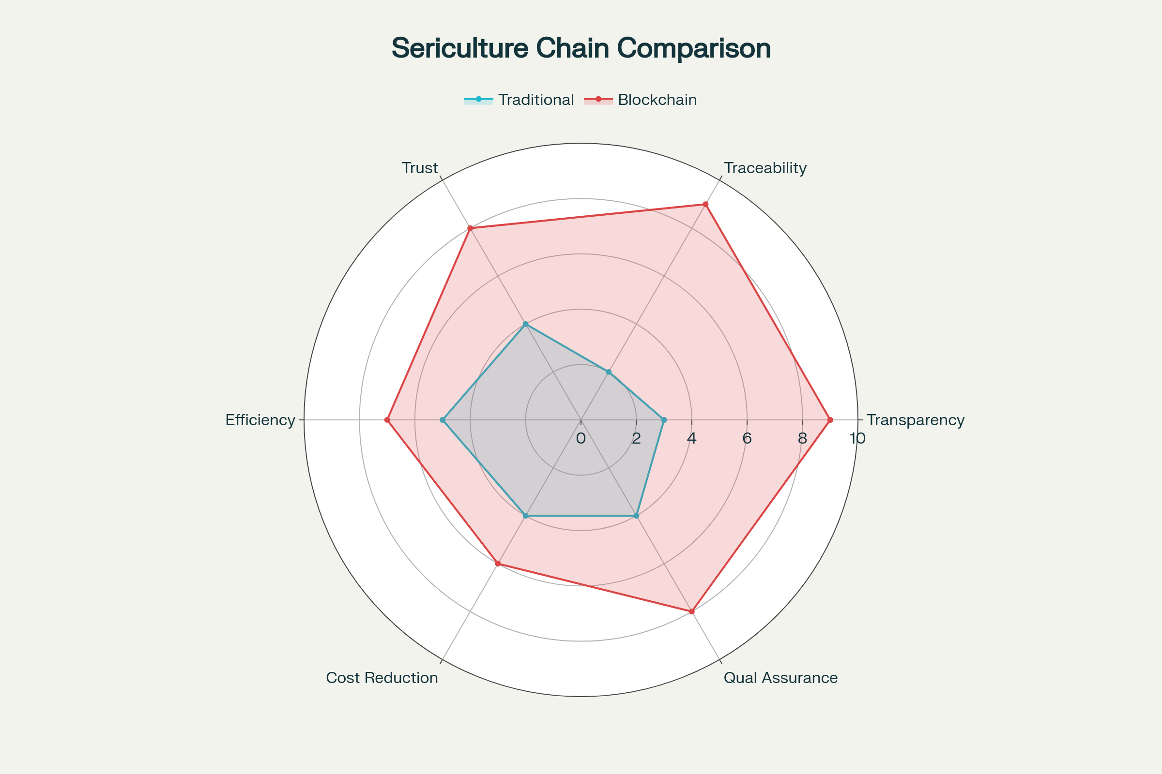

**Fig. 2: Comparative Benefits Analysis: Traditional vs Blockchain-Enabled Sericulture Supply Chains**

(Source: Adapted from Casino et al., 2019; Szabo, 1997; Azizi et al., 2021)

**5.1 Design of a Blockchain-Enabled Sericulture System**

A blockchain-enabled sericulture system is a hybrid digital-physical architecture in which every operational activity, from mulberry cultivation to retail garment sales, is mirrored by corresponding digital events on the blockchain. These events include process documentation, sensor data input, and blockchain anchoring, forming an immutable chain of custody for each product unit.

**Blockchain Process Flow in Sericulture**

An example of a process flow in a blockchain-enabled sericulture supply chain might include the following:

1. **Mulberry Cultivation:** Farmers record crop inputs, pesticide usage, and harvest details via a mobile app. IoT sensors validate field temperature and moisture levels.
2. **Silkworm Rearing:** Environmental conditions (temperature, humidity) are logged automatically through sensors. Disease incidents or feed changes are manually reported.
3. **Cocoon Procurement:** Weighing machines transmit cocoon weights in real-time. A smart contract validates weight and releases payment to the farmer.
4. **Silk Reeling and Processing:** Tensile strength and yarn thickness are recorded and linked to batch codes.
5. **Weaving and Dyeing:** Certification and compliance data (e.g., eco-friendly dyes) are hashed and recorded.
6. **Distribution and Retail:** Product is tagged with a QR code linking to its digital profile. Consumers verify origin and quality before purchase.

Such a system not only strengthens supply chain resilience but also boosts farmer incomes by reducing intermediaries and ensuring real-time, condition-based payments. Additionally, it supports regulatory compliance and enhances the global competitiveness of Indian silk products (Tripathi et al., 2021).

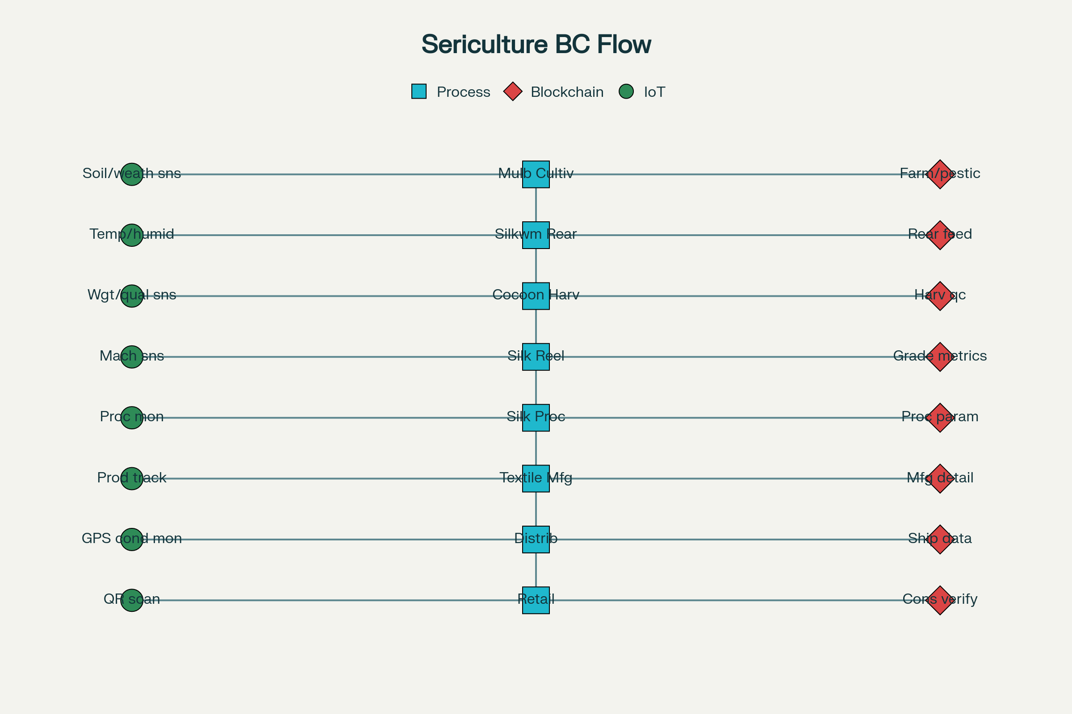

**Fig. 3: Blockchain-Enabled Sericulture Supply Chain Process Flow**

**(Source: Mwewa et al., 2025)**

This design encompasses the following key components:

* **Process Blocks (Rectangles):** These represent physical and operational activities in the supply chain. Examples include silk reeling, dyeing, weaving, and packaging.
* **IoT Data Capture (Circles):** Sensors placed at key points (e.g., cocoon drying chambers, reeling machines) capture real-time data on temperature, humidity, tensile strength, and weight. These values are vital for assessing silk quality and ensuring standardization (Kaur et al., 2022).
* **Blockchain Write Events (Diamonds):** Critical data points (e.g., cocoon grade, payment confirmation, organic certification) are hashed and written onto the blockchain. These entries are time-stamped, verifiable, and accessible to authorized stakeholders via secure digital identities.

This architecture enables digital provenance, where each silk product is associated with a unique digital identity linked to its physical characteristics and production history. By integrating QR codes, the final consumer can trace the silk product's journey from farm to fabric, validating sustainability claims, origin, and ethical sourcing.

**6. Technology Stack & Integration**

The full potential of blockchain in sericulture supply chains can only be realized through seamless integration with other enabling technologies. A multi-layered technology stack—comprising blockchain, Internet of Things (IoT), Artificial Intelligence (AI), and mobile platforms—can digitize and automate operations from field to fabric, offering a robust infrastructure for traceability, predictive analytics, and smart contract execution.

**6.1. Integration with IoT, AI, and Mobile Platforms**

The convergence of IoT and blockchain ensures the credibility of the data fed into the blockchain ledger. IoT sensors embedded at critical stages of the sericulture process can autonomously record environmental and operational parameters, which are then immutably stored on the blockchain. For example, soil moisture sensors in mulberry fields or temperature-humidity sensors in rearing houses provide real-time, accurate inputs that support compliance verification and environmental sustainability claims (Jambukar & Dawande, 2020). Meanwhile, AI algorithms enhance supply chain intelligence by analyzing large datasets collected from sensors and historical records. This enables early detection of anomalies such as silkworm disease outbreaks, inefficiencies in reeling machinery, or logistics disruptions. Predictive analytics models can also estimate cocoon yields or market demand trends, aiding both farmers and processors in decision-making.

Mobile platforms and edge computing interfaces allow real-time interaction with the blockchain ecosystem, especially for smallholder farmers and reeling units with limited access to high-end computing resources. Through mobile dashboards, farmers can upload data, verify transactions, access pricing information, and receive automated payments triggered by smart contracts. The table below summarizes how sensor technologies, when integrated with blockchain, provide specific value at each supply chain stage:

**Table 4: IoT sensors enrich blockchains with trustworthy primary data.**

|  |  |  |
| --- | --- | --- |
| **Stage** | **Sensor Suite** | **Blockchain Value** |
| Mulberry fields | Soil-moisture, pH | Proof of organic farming |
| Rearing houses | Temp-humidity | Animal-welfare compliance |
| Reeling machines | Vibration, RPM | Predictive maintenance records |
| Logistics | GPS, cold-chain tags | Anti-counterfeiting and ETA calc |

(Source: Mwewa et al., 2025)

Such technology fusion transforms the sericulture supply chain into an intelligent, responsive, and transparent ecosystem—rebuilding stakeholder trust, improving quality assurance, and enabling global competitiveness for ethically sourced silk.

**7. Case Studies and Real-World Pilots**

The implementation of blockchain in sericulture is no longer a speculative venture—pilot projects across Asia have started validating its impact on transparency, trust, and income distribution within the silk value chain. These initiatives provide actionable models for scaling blockchain in sericulture-intensive regions.

In India, the Central Silk Board (CSB) has initiated blockchain feasibility assessments for enhancing silk traceability and branding through digital platforms. This pilot effort, aligned with the Silk Mark initiative, aims to empower consumers to verify the authenticity and ethical origins of silk products using QR-code-based digital certificates (Central Silk Board, 2023b). By linking rearing, reeling, dyeing, and weaving stages to a tamper-proof ledger, CSB envisions higher value realization for genuine producers and the mitigation of market dilution from adulterated or synthetic blends.

In Karnataka, smart-contract pilots integrated with cocoon auction markets resulted in significant benefits. A field study conducted in 2021 revealed a 12% increase in price premiums for verified cocoon batches and a 35% reduction in payment delays, as smart contracts ensured automatic disbursement upon verification of cocoon quality and weight (Central Silk Board, 2023a). These outcomes not only improved farmer confidence but also streamlined administrative procedures at sericulture marketing centres.

Meanwhile, in China, blockchain is being explored for automating silk reeling process traceability and inventory tracking. Government-supported incubators have partnered with tech companies to log reeling machine data directly onto blockchain platforms using IoT sensors, ensuring transparency and defect accountability (Wang & Yang, 2022).

On a global scale, luxury fashion brands such as LVMH, Gucci, and Prada have piloted blockchain-based provenance systems for high-value textiles. These systems allow customers to access the entire product lifecycle—from raw material sourcing to factory-level processing—using blockchain-verified digital passports (World Economic Forum, 2021). The success of these projects underscores the replicability of blockchain models for the silk industry, where authenticity, sustainability, and heritage craft validation are central to value addition. These real-world pilots demonstrate that blockchain integration is not only technically feasible but economically beneficial. They serve as critical case studies for scaling up blockchain-based transparency tools in the broader sericulture ecosystem.

**8. Economic, Environmental, and Social Impacts**

Blockchain technology offers transformative potential across the sericulture sector, not only in operational optimization but also in improving economic viability, environmental accountability, and social equity. The integration of blockchain-based transparency and automation into silk supply chains contributes to a paradigm shift toward fairer, greener, and more inclusive systems.

**8.1 Enhancing Farmer Livelihoods**

Traditional sericulture markets in regions like Karnataka are often plagued by delays in payments and price asymmetries that disadvantage smallholder farmers. Blockchain-enabled smart contracts offer a direct solution to these challenges. In a pilot initiative conducted in Karnataka, India, smart contracts led to a 12% increase in the price premium received by farmers and a 35% reduction in payment delays (Rokhade et al., 2021). These contracts are designed to trigger automatic fund transfers once pre-agreed quality or weight conditions are met, bypassing bureaucratic and intermediary hold-ups. By enabling traceable records of transaction histories and cocoon quality metrics, blockchain also offers farmers the digital evidence needed to access financial services, credit, and insurance products—an essential step toward rural financial inclusion (Schuetz & Venkatesh, 2019). Furthermore, the elimination of middlemen ensures that a greater share of final value reaches primary producers, improving economic security for rural households.

**8.2 Promoting Environmental Sustainability**

Environmental sustainability is a key concern in the sericulture sector, particularly in light of the growing demand for eco-friendly textiles. Blockchain can record lifecycle data on carbon emissions, helping brands quantify their Scope 3 emissions, which are otherwise difficult to audit due to supply chain opacity. As more fashion brands adopt science-based emission targets, these capabilities will become increasingly essential for participating in international markets. Additionally, IoT-integrated blockchain systems can log real-time data on pesticide application, water use, and organic input compliance, providing the transparency necessary for third-party organic and eco-certifications (Yao & Zhang, 2022). This benefits both producers—who can charge a premium for certified products—and environmentally conscious consumers. The transparency of such systems also supports waste minimization and energy efficiency during reeling and dyeing processes. By analyzing blockchain-anchored data, manufacturers can optimize operations for lower emissions and water consumption, aligning with sustainability goals and environmental governance regulations.

**8.3 Supporting Welfare and Ethical Compliance**

The ethical dimensions of sericulture are gaining prominence globally, especially among consumers who prioritize animal welfare and labor rights. Blockchain’s ability to establish a verifiable chain of custody supports the certification of Ahimsa (peace) silk, which is produced without killing the silkworm during the reeling process (Hill, 2023). This innovation allows ethical producers to differentiate themselves in the market and appeal to a growing base of conscientious consumers. From a labor welfare perspective, blockchain-based systems can record and validate fair wage payments, working hours, and contract terms. In a sector where a significant portion of the labor force is composed of women, many of whom are informally employed, blockchain helps formalize labor documentation and ensure compliance with social protection norms.

Governments and non-governmental organizations can also leverage these records to implement targeted welfare interventions, such as subsidized health insurance, maternity benefits, or education support for sericulture workers and their families. These data-driven social programs are more transparent and traceable, minimizing leakages and ensuring that support reaches its intended beneficiaries. In sum, blockchain’s application in sericulture is not confined to digital innovation—it represents a holistic transformation of the value chain. By improving market access, enabling climate accountability, and safeguarding social standards, blockchain empowers stakeholders across the silk ecosystem. Its convergence with IoT and AI will further magnify these benefits, offering a scalable blueprint for digital sustainability in agriculture-based industries.

**9. Challenges, Risks, and Mitigation Strategies**

Despite its promising potential, the implementation of blockchain technology in the sericulture sector is not without significant challenges. These range from technical and infrastructural barriers to socio-economic and regulatory hurdles. To harness the full value of blockchain for sericulture supply chains, a comprehensive understanding of these obstacles—and strategic mitigation—is essential.

**9.1. Key Challenges**

One of the foremost impediments to blockchain deployment in sericulture is the high initial capital expenditure (CAPEX) associated with setting up the infrastructure. Developing blockchain platforms, integrating IoT sensors, training users, and maintaining networks require significant investment. For resource-constrained rural economies and smallholder-dominated value chains like Indian sericulture, these costs can be prohibitive unless subsidized by governments, cooperatives, or private consortiums (Saha et al., 2024).

A second key issue is the lack of digital infrastructure in many rural sericulture clusters, including inconsistent internet connectivity, poor mobile penetration, and insufficient access to cloud platforms. This digital divide hampers real-time data entry and limits the effectiveness of blockchain-based traceability systems (Rokhade et al., 2021).

Digital literacy is another critical challenge. Most primary stakeholders in sericulture, including farmers, rearers, and reelers, may lack the technical know-how to use blockchain platforms. The interface complexity, language limitations, and the abstract nature of blockchain concepts contribute to user resistance. Without targeted capacity-building initiatives, the adoption of blockchain may exacerbate digital exclusion.

Scalability and interoperability also present notable hurdles. Fragmented technology ecosystems across sericulture regions make it difficult to ensure seamless data flow between supply chain stakeholders. Additionally, many pilot projects use proprietary platforms that lack compatibility with broader industry systems, limiting large-scale deployment.

Lastly, regulatory and data governance issues remain a significant concern. Blockchain relies on immutable, shared records—yet in many countries, data sharing is governed by strict privacy laws that conflict with blockchain’s transparency ideals. The absence of sector-specific data-sharing frameworks impedes implementation in highly regulated agricultural sectors like sericulture (Pakseresht et al., 2024).

**9.2 Barriers, Risks and Mitigation Strategies**

A structured mitigation plan is essential to address these issues (Table 4).

**Table 5: Key barriers and associated mitigation solutions.**

|  |  |
| --- | --- |
| **Barrier** | **Mitigation Strategy** |
| High initial CAPEX | Implement consortium-based funding models involving government, private silk brands, and NGOs; adopt phased roll-outs starting with high-volume markets to ensure ROI. |
| Data-entry authenticity (garbage-in) | Use IoT-enabled automation for real-time, sensor-based data collection (temperature, GPS, humidity); introduce third-party blockchain audits for critical control points. |
| Skills deficit in rural clusters | Leverage government schemes like Silk Samagra-2 to run training workshops, digital extension services, and local capacity-building programs. |
| Interoperability | Adopt global traceability frameworks such as GS1 EPCIS standards for uniform data structuring and integration across platforms. |
| Privacy of trade secrets | Implement zero-knowledge proofs (ZKPs) to protect sensitive data while ensuring verification; use private channels in Hyperledger Fabric to restrict access to commercially sensitive transactions. |

(Source: Saha et al., 2024; Pakseresht et al., 2024)

These strategies require a multi-stakeholder approach, involving technologists, policymakers, and end-users. For example, collaborative digital sandboxes involving state sericulture boards and private blockchain developers can test systems in controlled environments, refine data governance models, and create open-source toolkits tailored for sericulture.

Furthermore, incentivization mechanisms—such as subsidies, certification benefits, or access to premium markets—can motivate smallholders to participate despite initial apprehensions. Public-private partnerships (PPPs) will be instrumental in scaling blockchain adoption by combining technical expertise with field-level outreach and local governance. While the road to blockchain-enabled sericulture is complex and fraught with barriers, these challenges are not insurmountable. With the right policy frameworks, funding mechanisms, and inclusive training models, blockchain can become a scalable and inclusive tool for revolutionizing transparency, trust, and equity across the sericulture value chain.

**10. Policy Landscape and Standardization**

The successful deployment of blockchain in sericulture supply chains depends significantly on enabling policies and the evolution of global standards. Policymakers worldwide are increasingly recognizing the importance of digital traceability in textile and agricultural value chains, with sericulture standing to benefit from this momentum.

In India, the Silk Samagra-2 scheme (2021–2026), launched by the Ministry of Textiles, explicitly includes provisions for integrating digital technologies such as blockchain to enhance transparency and traceability across silk production stages. Notably, pilot projects are being initiated under this scheme to test blockchain-enabled quality certification and provenance validation systems in major silk-producing regions like Karnataka, Assam, and Tamil Nadu (Central Silk Board, 2023a). These pilots aim to boost global market acceptance of Indian silk by aligning with international certification standards.

At the international level, ISO/TC 329, a technical committee under the International Organization for Standardization (ISO), is currently drafting global standards for blockchain and distributed ledger technologies in the textile and apparel sectors. These standards are expected to provide interoperable frameworks for data structure, chain-of-custody models, and compliance verification protocols, enabling blockchain solutions to scale across borders and platforms (ISO, 2024).

Simultaneously, regulatory initiatives in developed markets are catalyzing the demand for immutable traceability. The European Union’s Digital Product Passport (DPP) legislation, scheduled to come into force by 2030, will likely mandate end-to-end provenance tracking for luxury and high-impact fibers—including silk—using digital identifiers embedded within product life cycles (European Commission, 2023). This regulation is expected to push exporters and brands toward blockchain-backed systems that can ensure verifiable sustainability claims, material origins, and ethical production practices. The alignment of national schemes like Silk Samagra-2 with international efforts such as ISO/TC 329 and the EU DPP initiative creates a promising policy landscape. These frameworks, combined with public–private collaboration, will serve as foundational enablers for the standardized adoption of blockchain in sericulture supply chains.

**11. Limitation**

While blockchain technology offers significant potential for transforming sericulture supply chains, several limitations must be acknowledged before large-scale adoption can be realized. These limitations span technical, economic, organizational, and regulatory dimensions, often compounded by the socio-economic realities of rural silk production systems.

**High Initial Investment and Maintenance Costs:** Implementing blockchain requires substantial upfront capital for developing digital infrastructure, integrating IoT sensors, and ensuring network maintenance. In rural sericulture clusters, where smallholder farmers and artisanal reelers dominate, these costs are often prohibitive without consortium funding or government subsidies. Additionally, ongoing expenses related to system upgrades, cloud storage, and cybersecurity increase the total cost of ownership.

**Limited Digital Infrastructure and Connectivity:** The effectiveness of blockchain relies heavily on reliable internet access, mobile penetration, and electricity supply. Many sericulture-producing regions in India and Southeast Asia suffer from inadequate rural connectivity, making real-time data logging and verification difficult. Network latency or downtime can disrupt the continuous traceability chain, undermining the integrity of blockchain systems.

**Data Authenticity and “Garbage-In, Garbage-Out” Problem:** While blockchain ensures immutability, it cannot inherently verify the truthfulness of input data. If fraudulent or inaccurate data—such as misreported cocoon weights or falsified organic claims—enters the system, blockchain merely preserves the incorrect record permanently. IoT-enabled automation and third-party audits are therefore essential to ensure initial data authenticity.

**4. Interoperability and Scalability Challenges:** Most blockchain pilot projects in agriculture remain fragmented and localized, with limited interoperability across platforms. Integrating multiple actors—farmers, traders, government agencies, certification bodies, and brands—requires standardized protocols and alignment with international frameworks like GS1 or ISO/TC 329 for textile traceability. Without such harmonization, scaling solutions beyond local pilots remains difficult.

**Regulatory and Policy Constraints:** The decentralized nature of blockchain can create conflicts with existing data privacy laws and trade secrecy requirements. Many countries lack sector-specific regulations for digital traceability, leading to uncertainties in data ownership, liability, and cross-border compliance. Regulatory ambiguity discourages private investment and slows adoption. While blockchain offers transformative potential, its real-world implementation in sericulture is constrained by cost, infrastructure, data quality, and regulatory gaps. Overcoming these limitations requires public–private partnerships, capacity building, pilot-based scaling, and robust governance frameworks to ensure that blockchain adoption is both inclusive and sustainable.

**12. Conclusion**

Blockchain technology holds transformative potential for sericulture by addressing core issues such as traceability, transparency, fraud prevention, and fair-trade compliance. Through the integration of smart contracts and IoT-enabled data capture, blockchain empowers smallholder farmers, enhances product authentication, and creates new economic opportunities through verified sustainability practices. This digital infrastructure enables end-to-end visibility in the silk value chain, facilitating consumer trust, regulatory compliance, and premium market access. Pilot initiatives in India and abroad affirm the technology’s feasibility, showcasing tangible improvements in price realization, payment timelines, and brand credibility. However, challenges including high capital costs, rural digital divides, and interoperability limitations persist, requiring strategic mitigation through phased implementation, capacity building, and policy alignment. Government schemes like Silk Samagra-2, combined with international standardization efforts, create a supportive ecosystem for blockchain adoption. The future of blockchain in sericulture lies in developing context-specific applications, ethical AI integration, and human-centered design that respect both technological constraints and socio-cultural richness. This review underscores that blockchain is not merely a digital tool but a catalyst for inclusive innovation in sericulture, capable of transforming fragmented rural networks into transparent, efficient, and sustainable global value chains.

**13. Future Research Directions**

The integration of blockchain into sericulture supply chains holds transformative potential, yet several research and development gaps remain unaddressed. Addressing these gaps is essential for scalable, inclusive, and context-specific implementation, especially in developing countries where sericulture is practiced at the grassroots level.

First, there is a pressing need to develop lightweight and scalable consensus algorithms suited for agricultural micro-transactions. Traditional consensus mechanisms like Proof-of-Work (PoW) or Proof-of-Stake (PoS) are often resource-intensive and unsuitable for rural contexts. Rokhade et al. (2021) proposed a novel "Proof-of-Transaction" (PoT) model that could validate transactions based on real-world agricultural activities, thereby aligning better with the operational dynamics of sericulture clusters.

Second, future frameworks should explore blockchain integration with voluntary carbon markets. By recording verifiable on-chain data—such as organic mulberry cultivation, reduced pesticide use, and eco-friendly rearing practices—sericulture producers can generate tradable carbon credits. These credits could create an additional revenue stream and incentivize sustainable practices within rural ecosystems.

Third, deploying AI models on top of blockchain-stored sericulture data offers exciting possibilities for predictive analytics. Ethical AI applications could identify early signs of silkworm disease outbreaks, recommend optimal harvesting windows, and even suggest market-timed reeling schedules. However, such implementations must respect data privacy and incorporate governance frameworks that prioritize farmers' agency.

Consumer engagement is another frontier that requires innovative solutions. Human-centred UX designs for QR code storytelling interfaces can help end-users access the rich, intangible heritage behind silk products—such as traditional weaving techniques, local biodiversity, and artisan narratives. These platforms can increase market value while preserving cultural knowledge.

Moreover, there is a lack of blockchain frameworks tailored specifically to sericulture. Most existing platforms are designed generically and may not meet the nuanced needs of silk value chains, which involve biological cycles, artisanal labor, and smallholder fragmentation. Custom platforms, potentially developed under public–private partnerships, should incorporate modular features for traceability, quality certification, and payment automation.

Affordable and accessible mobile applications are essential to bring blockchain into the hands of farmers. Such apps should allow simple data input (e.g., cocoon weights, disease symptoms) through visual or voice interfaces, compatible with low-bandwidth environments.

Finally, impact assessments—both environmental and socio-economic—are urgently needed to quantify the long-term effects of blockchain adoption in sericulture. Paired with well-defined regulatory guidelines, these insights will shape equitable and scalable digital traceability ecosystems.

Government bodies like the Central Silk Board must therefore include blockchain within broader digitization agendas and promote interdisciplinary collaboration across academia, industry, and farmer groups to shape the next-generation silk economy.

**DISCLAIMER (ARTIFICIAL INTELLIGENCE)**

Author(s) hereby declare that NO generative AI technologies such as Large Language Models (ChatGPT, COPILOT, etc) and text-to-image generators have been used during writing or editing of this manuscript.

**References**

Bhosle, K. & Mohite, A. (2023) Blockchain Technology For Implementing Silk Production System. International Journal of Creative Research Thoughts, 11(12): 31-34.

Bhosle, K. V., & Mohite, A. P. (2023). Blockchain technology for implementing silk production system. International Journal of Creative Research Thoughts, 11(12), 467–474. <https://doi.org/10.6084/m9.figshare.23312673>

Casino, F., Dasaklis, T. K., & Patsakis, C. (2019). A systematic literature review of blockchain-based applications: Current status, classification and open issues. Telecommunications Systems, 71(1), 1–32. https://doi.org/10.1007/s11235-018-0481-5

Central Silk Board. (2023a). Note on Sericulture: Functioning of Central Silk Board & Performance of Indian Silk Industry. Ministry of Textiles, Government of India. <https://texmin.nic.in/sites/default/files/NoteOnSericulture-April_2023%20English.pdf>

Central Silk Board. (2023b). Performance of Central Silk Board & Indian Silk Industry (As on 1st January, 2023). Ministry of Textiles, Government of India. <https://texmin.gov.in/sites/default/files/NOTE-ON-SERI-CSB-Jan-2023-English_0.pdfda> Hassan, R., Acerbi, F., Terzi, S., & Rosa, P. (2025). Transitioning the silk industry towards circularity: A thematic analysis of sustainable value chain practices. Sustainable Production and Consumption. <https://doi.org/10.1016/j.spc.2025.03.009>

Dinh, T. T. A., Wang, J., Chen, G., Liu, R., Ooi, B. C., & Tan, K. L. (2017). BLOCKBENCH: A framework for analyzing private blockchains. Proceedings of the 2017 ACM International Conference on Management of Data (pp. 1085–1100). <https://doi.org/10.1145/3035918.3064033>

European Commission. (2024). *Ecodesign for Sustainable Products Regulation (ESPR)*. Regulation (EU) 2024/1781. <https://eur-lex.europa.eu/legal-content/EN/TXT/?uri=CELEX:32024R1781>

Hatibaruah, D. (2022). Socio-economic Analysis among the Farmers Engaged in Sericulture Practices in Jorhat District of Assam, India. Asian Journal of Agricultural Extension Economics & Sociology, 36–40. <https://doi.org/10.9734/ajaees/2022/v40i330856>

Hill, H. (2023). 14 Ethical Silk Alternatives. <https://hayden-hill.com/blogs/journal/silk-alternatives>

International Sericultural Commission. (2024a). Global Silk Production Statistics. <https://inserco.org/en/statistics>

International Sericultural Commission. (2024b). World silk production statistics 2023-2024. <https://inserco.org/en/statistics>

Jambukar, A. R., & Dawande, N.A. (2020). IoT based Smart Monitoring and Controlling System for Sericulture. International Journal of Electronics and Communication Engineering, 7(8), 1–4. <https://doi.org/10.14445/23488549/ijece-v7i8p101>

Kaur, A., Singh, G., Kukreja, V., Sharma, S., Singh, S., & Yoon, B. (2022). Adaptation of IoT with Blockchain in Food Supply Chain Management: An Analysis-Based Review in Development, Benefits and Potential Applications. Sensors, 22(21), 8174. <https://doi.org/10.3390/s22218174>

Mwewa, Timothy, Gilbert Lungu, Benson Turyasingura, Yusuf Umer, Agnes Uwimbabazi, Fredrick Kayusi, and Petros Chavula. 2025. “Blockchain Technology: Improving Agricultural Supply Chain Efficiency and Transparency – A Review”. Asian Basic and Applied Research Journal 7 (1):81-93. <https://doi.org/10.56557/abaarj/2025/v7i1159>.

Pakseresht, A., Kaliji, S. A., & Hakelius, K. (2024). Blockchain technology characteristics essential for the agri-food sector: A systematic review. Food Control, 165, 110661. <https://doi.org/10.1016/j.foodcont.2024.110661>

Polge, J., Robert, J., & Le Traon, Y. (2021). Permissioned blockchain frameworks in the industry: A comparison. ICT Express, 7(2), 229–233. <https://doi.org/10.1016/j.icte.2020.09.002>

Rokhade, S., K, G. M., S, M. M., Banu, S., N, J. S., & D, T. (2021). Smart Sericulture system based on IoT and image processing technique. 2022 International Conference on Computer Communication and Informatics (ICCCI), 1-4. <https://doi.org/10.1109/iccci50826.2021.9402322>

Saha, A., Raut, R.D., Kumar, M., Paul, S.K., & Cheikhrouhou, N. (2024). The intention of adopting blockchain technology in agri-food supply chains: evidence from an Indian economy. Journal of Modelling in Management, 19(6), 1959-1988. https://doi.org/10.1108/JM2-10-2023-0238

Schuetz, S., & Venkatesh, V. (2019). Blockchain, adoption, and financial inclusion in India: Research opportunities. International Journal of Information Management, 52, 101936. <https://doi.org/10.1016/j.ijinfomgt.2019.04.009>

Szabo, N. (1997). Formalizing and securing relationships on public networks. First Monday, 2(9). <https://doi.org/10.5210/fm.v2i9.548>

Tripathi, G., Nautiyal, V. T., Ahad, M. A., & Feroz, N. (2021). Blockchain Technology and Fashion Industry-Opportunities and Challenges. In Intelligent systems reference library (pp. 201–220). <https://doi.org/10.1007/978-3-030-69395-4_12>

Wang, Q., & Yang, X. (2022). Analysis on the development of China’s modern silk industry. Asian Social Science, 18(4), 27. <https://doi.org/10.5539/ass.v18n4p27>

World Economic Forum. (2021). We are accelerating blockchain technology across supply chains. <https://www.weforum.org/stories/2021/03/blockchain-supply-chains/>

Yao, Q., & Zhang, H. (2022). Improving agricultural product traceability using blockchain. Sensors, 22(9), 3388. <https://doi.org/10.3390/s22093388>

Zhang, Y., Ren, S., Liu, Y., Sakao, T., & Huisingh, D. (2017). A framework for Big Data driven product lifecycle management. Journal of Cleaner Production, 159, 229–240. <https://doi.org/10.1016/j.jclepro.2017.04.172>