Extending the shelf life of paddy straw mushroom (Volvariella volvacea) with chemical treatment

ABSTRACT: Volvariella volvacea commonly referred as paddy straw mushroom, holds a significant place among edible mushroom and is cultivated using a wide range of substrate. It cultivated primarily in tropical and subtropical regions due to their rapid growth, high nutritional value and consumer preference. These mushrooms are known for their high perishability due to their very short shelf life about 12 hours that limit storage, transportation and distribution, leading to rapid post-harvest deterioration and reduced market availability. The study was conducted in Centre of Tropical Mushroom Research and Training (CTMRT), OUAT, Bhubaneswar, to investigate the potential of various chemical preservatives to enhance the shelf life of these mushrooms. Sodium benzoate (0.05%) and Potassium meta-bisulphite (0.05%) was found effective in enhancing the shelf life of paddy straw mushrooms up to 24 hours and retain the normal colour and odour.
Key words: Paddy straw mushroom (Volvariella volvacea), shelf life, chemical preservatives
- INTRODUCTION
Volvariella volvacea is commonly known as paddy straw mushroom or straw mushroom. It belongs to the family Pluteaceae of Basidomycetes (Singer, 1986). Mushroom can be defined as “a macro fungus with an individual fruiting body and are often seen with eyes and can be picked up by hand” (Chang and Miles, 1992). Mushroom fruiting bodies could be an umbrella shape or of varied shape, size and colour. Mushrooms are heterotrophs in nature. They are Achlorophyllous in nature. They can’t create nutrients by photosynthesis but take it from their surroundings (Palitha, 2011).
Nowadays, mushrooms gain popularity not in India but everywhere in world for its nutrient and medicinal value. It is used as a food, as a drug and as a tonic (Chandra and Chaubey 2017). Mushrooms are good sources of sugars, crude fibers, minerals and contain some essential amino acids. Mushrooms contain 80-90% water, 3% protein, 4% carbohydrates, 0.1% fats, 1% minerals and some quantity vitamins (Tripathy and Sahoo 2010, Zakhary et al. 1984).
Different substrates which are rich in organic matters have been using for mushroom cultivation. Paddy straw mushroom (Volvariella volvacea) are generally known as the rice straw mushroom or the Chinese mushroom. It belongs to the family Platanaceae of the Basidiomycetes (Singer 1991). Paddy straw mushroom is additionally referred to as tropical climate mushroom because it grows in relatively higher temperature. It is an edible mushroom in eastern states like Odisha and West Bengal. This mushroom was 1st cultivated in China in 1822 (Ahlawat and Tewari 2007). It is a fast-growing mushroom under favorable growing conditions. The total crop cycle is completed within 3-4 weeks. This mushroom can utilize the wide selection of cellulosic materials and therefore the C: N ratio needed is 40 to 60, which is quite high as compared to other cultivated mushrooms. Volvariella volvacea can be grown quickly and easily on uncomposted substrates such as paddy straw and cotton waste or other cellulosic organic waste materials (Ahlawat and Tewari 2007). Eastern Indian states comprise of Northeastern region (Arunachal Pradesh, Meghalaya, Manipur, Mizoram, Tripura, Sikkim and Assam), West Bengal, parts of Bihar, Jharkhand and Odisha has good potential and scope for paddy straw mushroom cultivation which is favoured by the wide availability of basic substrate (paddy straw) and the suitable climatic conditions. The high-temperature requirement i.e. 26°C to 30°C for mycelium development and 34 to 37°C for fructification, relative humidity 70-90% also make it, a good choice for adoption in round the year cultivation of mushrooms (Biswas 2014). After the harvest of mushrooms, the leftover mushroom bed is generally used for preparation of vermicompost. Cultivation of paddy straw mushrooms is normally done in outdoor conditions.
In Odisha paddy straw mushroom (Volvariella volvacea) is a widely grown commodity. Paddy straw mushrooms are generally harvested at egg stage and it is considered to have the best flavour and texture but should be consumed within 6 to 8 hours after harvest otherwise browning and shrivelling occurs. Freshly harvested mushrooms are highly perishable because of high moisture content, metabolism and susceptible to enzymatic browning (Nur-Sakinah et. al., 2019). During handling and storage, the tissues of mushroom get damaged and bruising occurs which ultimately triggers the process of browning (Dhalsamant et. al., 2015 and Qian et. al., 2021). The primary reason for browning in mushrooms after harvest is enzymatic oxidation of phenolic compounds. This process is catalysed by the enzyme polyphenol oxidase when it reacts with oxygen, producing quinones that then polymerized into brown pigments. Several factors influence this browning reaction, including the mushroom’s physiological state, mechanical damage and storage conditions (Wang et.al.,2025). Due to all these constraints fresh paddy straw mushroom is marketed only in domestic market. In view of its highly perishable nature, the fresh mushroom needs to be treated to extend its shelf life (Das et. al., 2010 and Minh et. al., 2019). There are many methods to extend the shelf life of mushrooms. The most accepted method for mushrooms is cooling; however, there are other techniques able to complement and strengthen it. Among them, prewash treatment is one.

- MATERIALS AND METHODS
The experiment was designed and carried out during 2021-22 and 2022-23 at Centre of Tropical Mushroom Research and Training (C.T.M.R.T.), Department of Plant Pathology, College of Agriculture, Odisha University of Agriculture and Technology, Bhubaneswar. The experiment was carried out to evaluate different chemicals which can be used for prewash treatment to enhance the shelf life of mushroom. The chemicals used for prewash treatment were Sodium benzoate (0.05%), Calcium chloride (0.5%), Citric acid (0.05%), Acetic acid (0.1%), Tartaric acid (0.375%), Propionic acid (0.2%), Potassium meta-bisulphite (0.05%), Potassium sorbate (0.1%) and compared with untreated control.
Freshly harvested 500g of paddy straw mushroom at egg stage were used for this experiment and 3 replications were followed for each treatment. The chemical solutions were prepared for different treatments using laboratory grade chemicals. The solutions were prepared by dissolving the required chemicals in 1 litre of water. Then the mushrooms were dipped in the solution and taken out immediately and the solution was drained out. The treated mushrooms were spread over the blotting paper to soak the excess water. The mushrooms were kept in the perforated paper bags under normal room temperature. The reduction in weight of the mushrooms was recorded in 6hrs interval at room temperature. Also the observations on colour, texture, appearance, odour and overall acceptability by consumers were recorded following the seven point hedonic scale of grading.
- RESULT
From the analysis, it was revealed that after 6 hours of storage, a little reduction in weight was there in all the treatments. However the highest weight reduction was observed in control (6.3%) followed by Propionic acid (5.06%) and Calcium chloride (4.91%). The least reduction in weight was observed in Tartaric acid (1.38%) which was at par with Sodium benzoate and Potassium sorbate having a reduction of 1.42% and 1.81% respectively after 6 hours of storage (Table 1). There was also no change in colour and texture after 6 hours of storage and also no foul smell in all the treatments.
After 12 hours of storage, the minimum weight reduction (9.5%) was recorded in Sodium benzoate followed by Potassium meta-bisulphite and acetic acid i.e. 14.4% and 20.5% respectively. The maximum weight reduction was recorded in untreated control with 42.4% followed by Calcium chloride treated fruiting bodies i.e. 35.3%. After 18 hours of storage, the minimum weight reduction (26.54%) was recorded in Sodium benzoate followed by Potassium meta-bisulphite i.e. 34.9%. The maximum weight reduction was recorded in untreated control with 68.5%.
After 24 hours of storage, the minimum weight reduction (41.7%) was recorded in Sodium benzoate followed by Potassium meta-bisulphite i.e. 48.37%. The maximum weight reduction was recorded in untreated control with 71.17%. However after 24 hours of storage all the treatments had more than 50% weight reduction except Sodium benzoate and Potassium meta-bisulphite. After 30 hours of storage, 49.8% weight reduction was recorded in Sodium benzoate followed by 56.7% in Potassium meta-bisulphite. After 30 hours of storage the fruiting bodies in all the treatments had got rotten except Sodium benzoate and Potassium meta-bisulphite.

The colour, texture and appearance were also studied in the fruiting bodies and it was observed that in all treatments, fruiting bodies maintained a good appearance up to 12 hours (table 2). It was also observed that Sodium benzoate, Potassium meta-bisulphite and Potassium sorbate helped in maintaining the colour of fruiting bodies as greyish white upto 24 hours whereas in rest the treatments the fruiting bodies became blackish. But the fruiting bodies treated with Calcium chloride, Citric acid, Acetic acid, Tartaric acid, Propionic acid and the untreated fruiting bodies became blackish and slimy after 18 hours of storage. After 18 hours of storage, the fruiting bodies treated with Calcium chloride, Citric acid, Acetic acid, Propionic acid and the untreated were having foul smell. But after 24 hours of storage, the fruiting bodies of all the treatments were having foul smell except Sodium benzoate and Potassium meta-bisulphite. After 30 hours of storage, there was foul smell in all the treatments.
The texture of the fruiting bodies was also affected by the time of storage. After 12 hours of storage the fruiting bodies became soggy in the treatments namely, Calcium chloride, Citric acid, Acetic acid, Tartaric acid, Propionic acid and untreated control. But with the treatment Sodium benzoate, Potassium meta-bisulphite and Potassium sorbate the fruiting bodies remain fresh upto 18 hours of storage. After 24 hours of storage all the fruiting bodies became soggy. However Sodium benzoate @ 0.05% treated fruiting bodies were found to retain the good condition after storage of 24 hours as it had recorded 41.7% reduction in weight and there was no foul smell and can remain consumable.
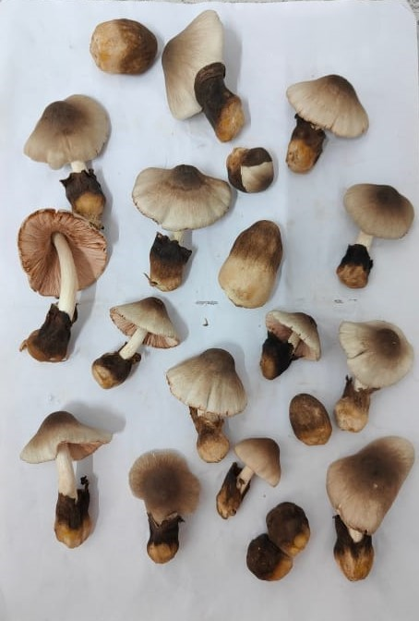 | 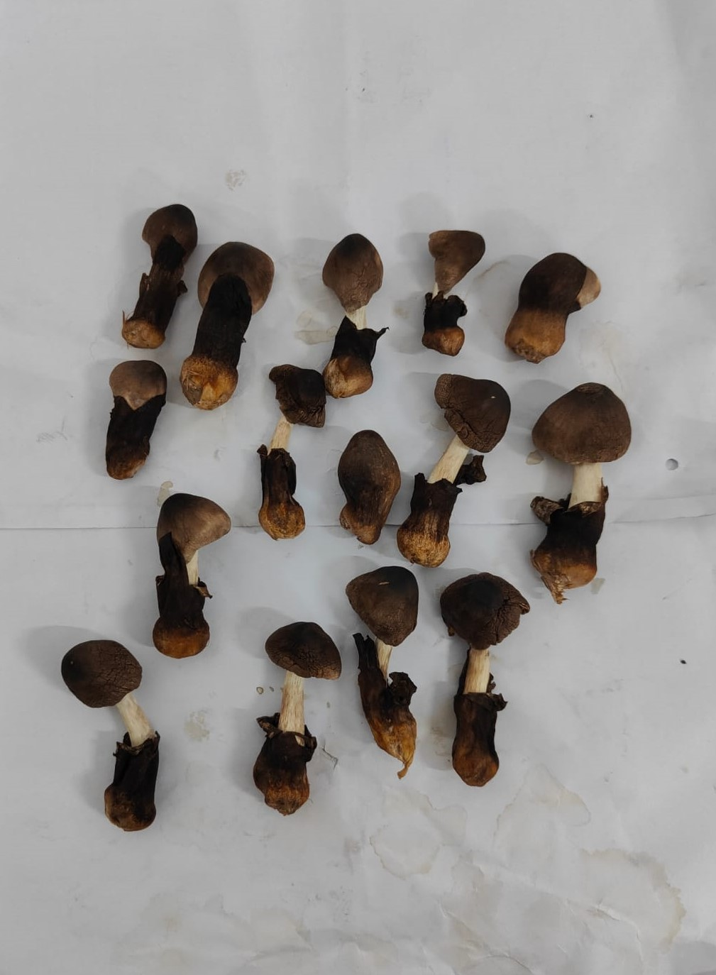 | 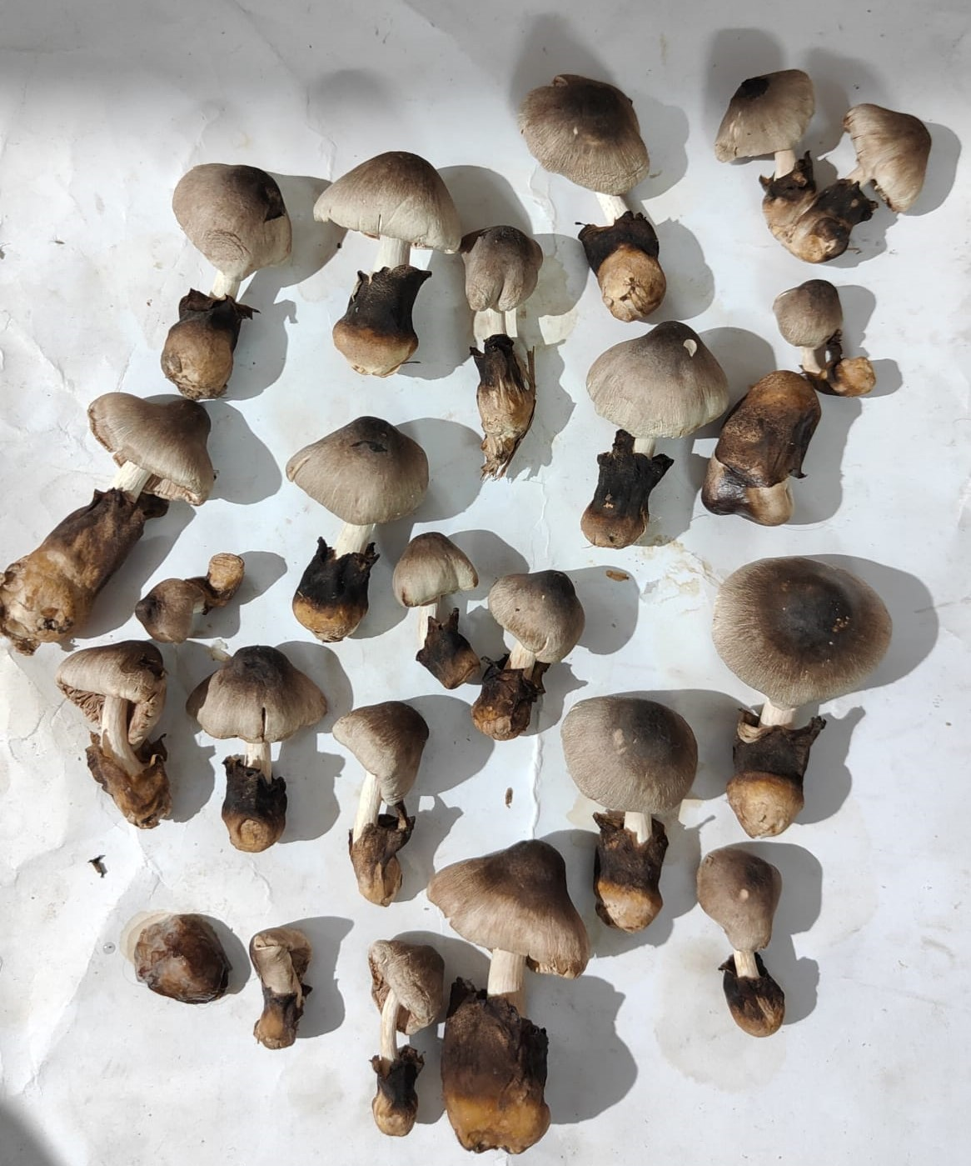
T1: Sodium Benzoate (0.05%) | T2: Calcium chloride (0.5%) | T3: Citric acid (0.05%)
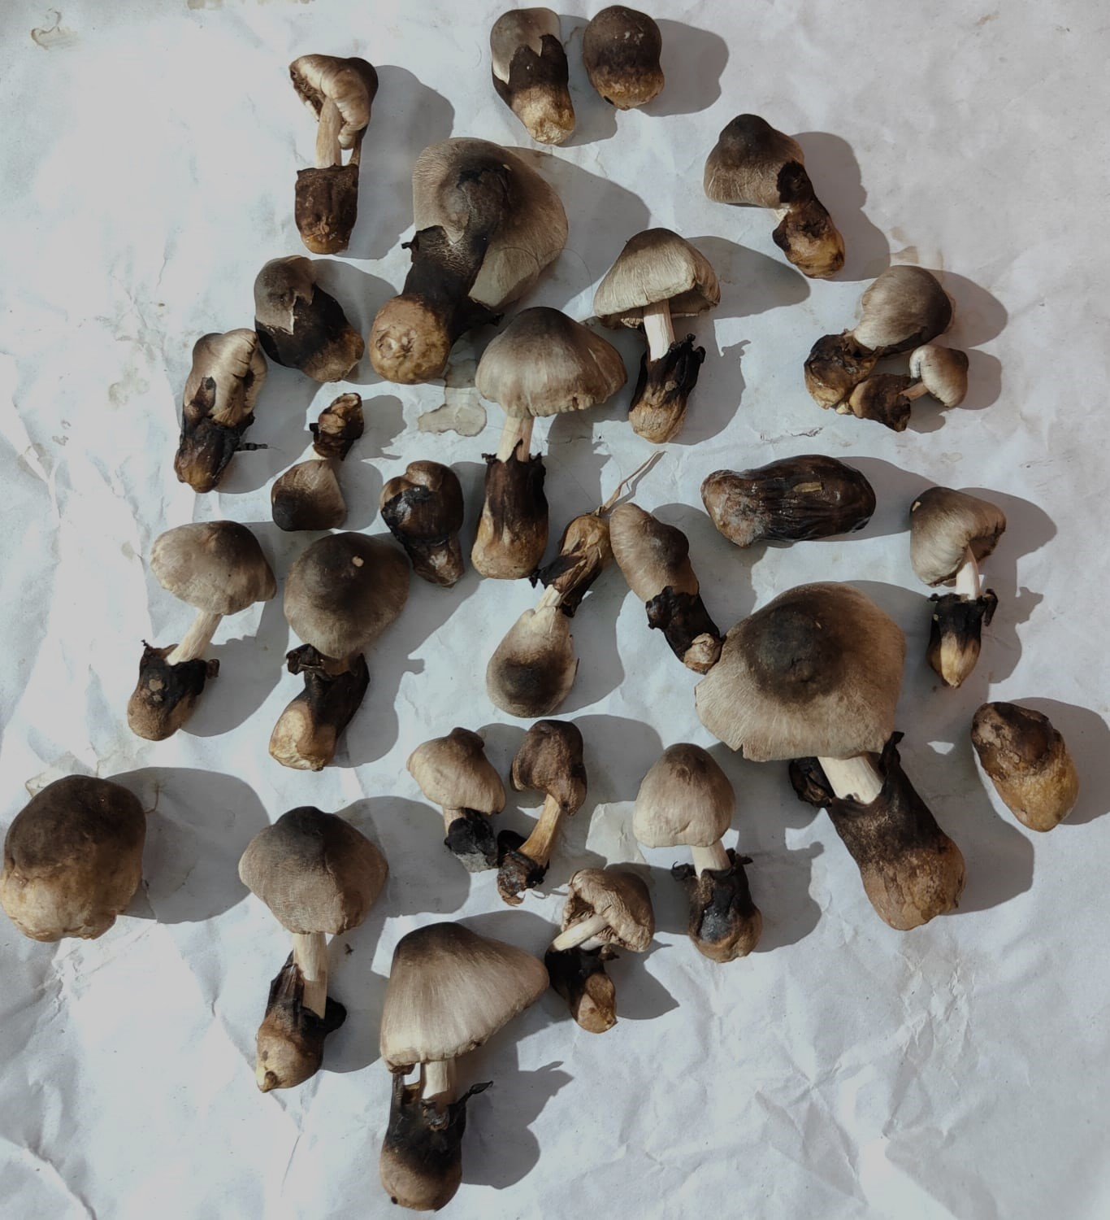 | 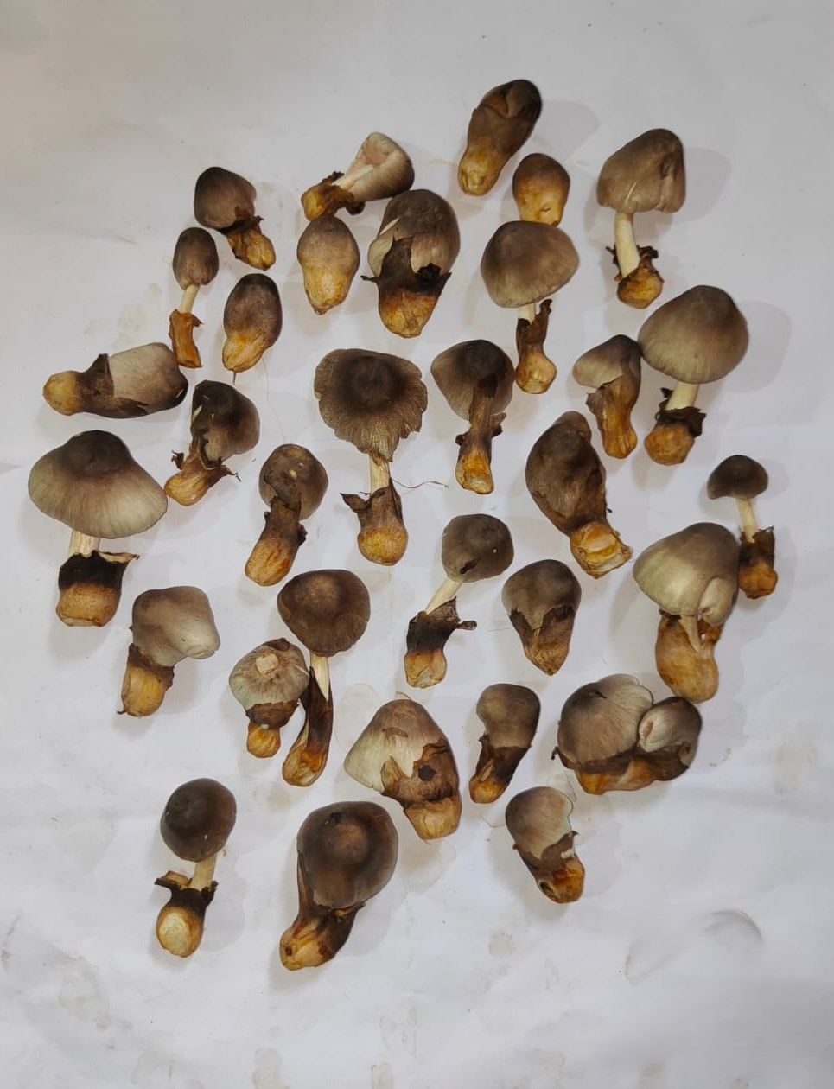 | 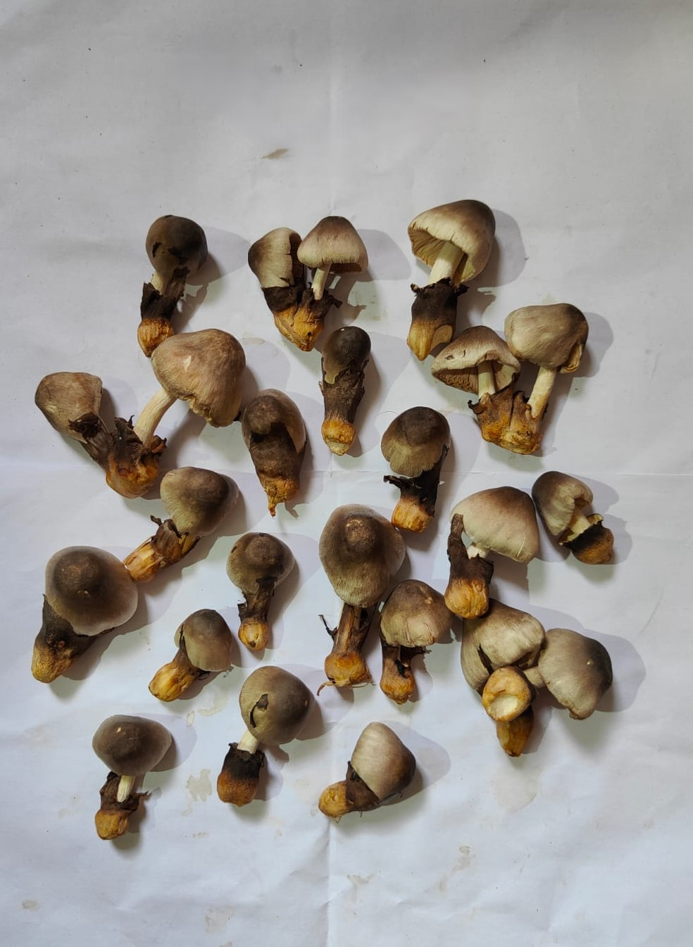
T4: Acetic acid (0.1%) | T5: Tartaric acid (0.375%) | T6: Propionic acid (0.2%)
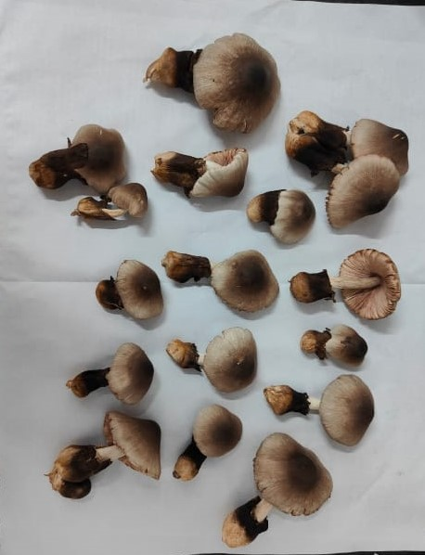 | 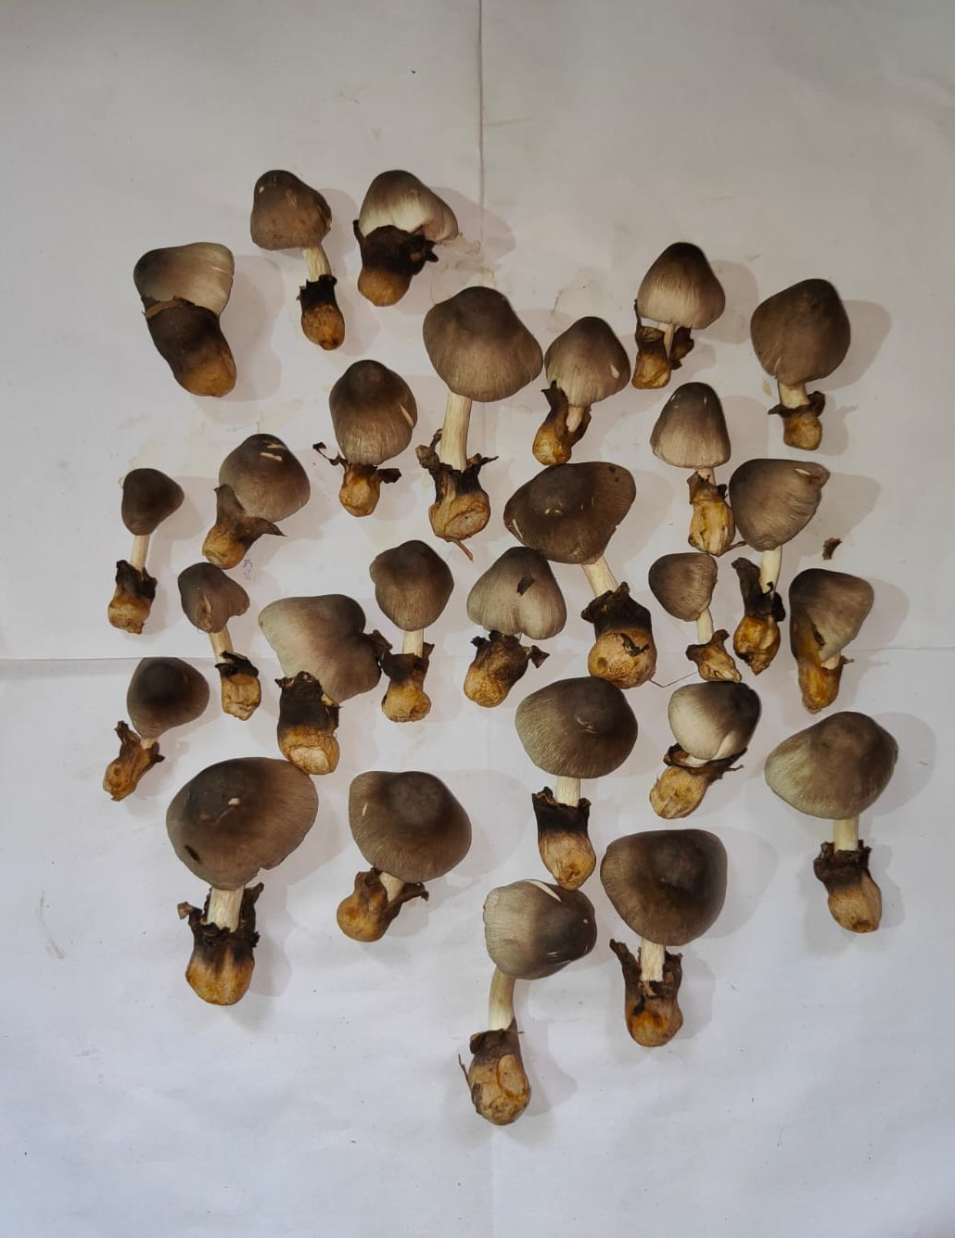 | 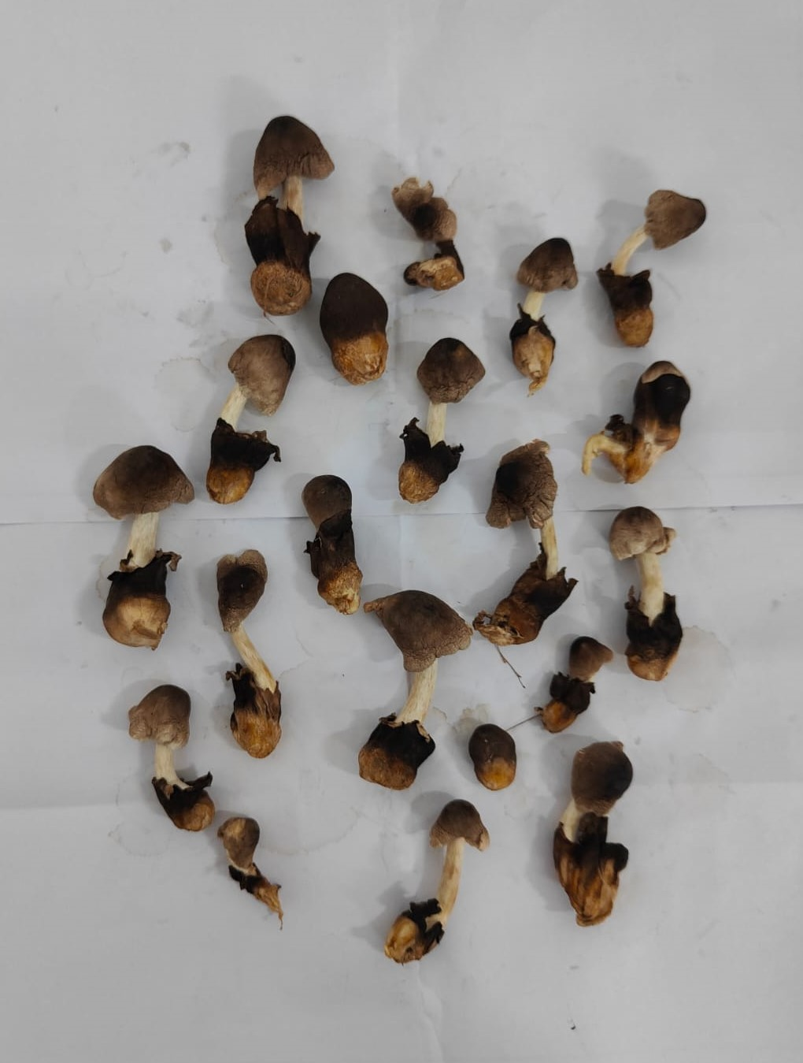
T7: Potassium meta-bisulphite(0.05%) | T8: Potassium sorbate (0.1%) | T9: Control (No treatment)
Fig. 1: Effect of different chemical preservative treatment on paddy straw mushrooms (after 18 hours of storage period)

Table 1: The impact of prewashing treatment on the reduction in weight of harvested mushroom
Treatment | Treatment details | Weight reduction after 6  hours (%) | Weight reduction after 12 hours (%) | Weight reduction after 18 hours (%) | Weight reduction after 24 hours (%) | Weight reduction after 30 hours (%)
T1 | Sodium Benzoate (0.05%) | 1.42 | 9.5 | 26.54 | 41.7 | 49.8
T2 | Calcium chloride (0.5%) | 4.91 | 35.3 | 58.0 | 65.62 | 67.4
T3 | Citric acid (0.05%) | 4.0 | 21.8 | 43.1 | 55.11 | 65.8
T4 | Acetic acid (0.1%) | 3.49 | 20.5 | 41.0 | 54.14 | 61.6
T5 | Tartaric acid (0.375%) | 1.38 | 28.1 | 44.7 | 54.85 | 63.1
T6 | Propionic acid (0.2%) | 5.06 | 32.7 | 48.4 | 57.14 | 66.4
T7 | Potassium meta-bisulphite (0.05%) | 2.32 | 14.4 | 34.9 | 48.37 | 56.7
T8 | Potassium sorbate (0.1%) | 1.81 | 31.4 | 47.3 | 56.36 | 65.5
T9 | Control (No treatment) | 6.3 | 42.4 | 68.5 | 71.17 | 73.0
 | SEM(±) | 0.636 | 1.86 | 3.471 | 3.431 | 5.795
 | CD | 1.91 | 5.58 | 10.4 | 10.29 | 17.37

Table 2: Influence of prewashing treatment on the shelf life of harvested mushroom
Treatments details | Colour after storage period(hours) |  |  |  | Odour after storage period(hours) |  |  |  | Texture  after storage period(hours)
 | 12hr | 18hr | 24hr | 30hr | 12 | 18 | 24 | 30 | 12 | 18 | 24 | 30
T1: Sodium benzoate (0.05%) | Greyish white | Greyish white | Greyish white | Blackish | No Foul smell | No Foul smell | No Foul smell | Foul smell | Fresh | Fresh | Soggy | Soggy
T2: Calcium chloride (0.5%) | Greyish white | Blackish | Blackish | Blackish | No Foul smell | Foul smell | Foul smell | Foul smell | Soggy | Soggy | Soggy | Rotted
T3: Citric acid (0.05%) | Greyish white | Blackish | Blackish | Blackish | No Foul smell | Foul smell | Foul smell | Foul smell | Soggy | Soggy | Soggy | Rotted
T4: Acetic acid (0.1%) | Greyish white | Blackish | Blackish | Blackish | No Foul smell | Foul smell | Foul smell | Foul smell | Soggy | Soggy | Soggy | Rotted
T5: Tartaric acid (0.375%) | Grayish white | Blackish | Blackish | Blackish | No Foul smell | No Foul smell | Foul smell | Foul smell | Soggy | Soggy | Soggy | Rotted
T6: Propionic acid (0.2%) | Greyish white | Blackish | Blackish | Blackish | No Foul smell | Foul smell | Foul smell | Foul smell | Soggy | Soggy | Soggy | Rotted
T7: Potassium meta-bisulphite (0.05%) | Greyish white | Greyish white | Greyish white | Blackish | No Foul smell | No Foul smell | No Foul smell | Foul smell | Fresh | Fresh | Soggy | Soggy
T8: Potassium sorbate (0.1%) | Greyish white | Greyish white | Greyish white | Blackish | No Foul smell | No Foul smell | Foul smell | Foul smell | Fresh | Fresh | Soggy | Soggy
T9: Control (No treatment) | Greyish white | blackish | Blackish | Blackish | Foul smell | Foul smell | Foul smell | Foul smell | Soggy | Soggy | Soggy | Rotted

- DISCUSSION
Many workers like Brennan et. al. (1999), Sharma and Thakur (2019) had reported that browning could be reduced by washing mushrooms in a solution containing 0.1% acetic acid or 0.1% citric acid or 0.05% sodium meta-bisulfite or 0.05% sodium chloride. Rai and Arumuganathan (2008) had also recommended the use of Sodium benzoate and Potassium meta-bisulphite for enhancement of shelf life of different mushroom value added products. Premkumar et. al. (2020) had also conducted the test by using four chemicals, citric acid, ascorbic acid, calcium chloride and sodium meta-bisulphite used for prewashing of oyster mushrooms for 1 minute and they reported that sodium meta-bisulphite is helping in retaining the colour, texture and overall acceptability of mushrooms up to 12days under refrigerated condition.
Sodium benzoate is widely used food preservative known for its inhibiting the growth of bacteria and yeast which may preventing the mushroom fruiting bodies from spoilage caused by the bacterial growth and increasing the shelf life of mushrooms and also checking the production of foul smell of rotting. Potassium meta-bisulphite is also used as a food preservative and also having the antioxidant property. Potassium meta-bisulphite act as a preservative, inhibiting the growth of bacteria and yeast in food and it also helps in preserving the natural colour and flavour of food by preventing oxidation. So in this study the potassium meta-bisulphite may help the mushroom fruiting bodies to increase the shelf life and retain the colour by slowing down the oxidation process in them. So, Sodium benzoate and Potassium meta-bisulphite are suitable for maintaining the physiochemical and organoleptic qualities with an extended shelf life, which has no harmful effects for consumers. These two chemicals are also recognised as safe for food use when used in appropriate amount. From the above study related to shelf life, it was found that prewash of fruiting bodies with sodium benzoate @ 0.05% can enhance the shelf life of mushrooms by protecting them from rotting for up to 24 hours and minimising the reduction in weight (41.70%).

- CONCLUSION
From the present experiment it was observed that Sodium benzoate @ 0.05 % and Potassium meta-bisulphite @ 0.05% both can enhance the shelf life of paddy straw mushroom up-to 24 hours and the mushroom can remain consumable for longer period. This can minimise the economic loss of the mushroom producers and the mushrooms treated with either of these two chemicals can be transported to distant markets and the consumers can also get the good quality paddy straw mushrooms.
DISCLAIMER (ARTIFICIAL INTELLIGENCE)
Authors hereby declared that NO generative AI technologies such as Large Language Models (ChatGPT, COPILOT, etc.) and text-to-image generators have been used during writing or editing of this manuscript.

REFERENCES
Ahlawat, O. P. & Tewari, R. P. (2007). Cultivation technology of paddy straw mushroom (Volvariella volvacea), (Vol. 36). National Research Center for Mushroom.
Biswas, M. K. (2014). Cultivation of paddy straw mushrooms (Volvariella volvacea) in the lateritic zone of West Bengal - a healthy food for rural people. International Journal of Economic Plant, 1 (1): 23-27.
Brennan, M. port, G.L., Pulvirenti, A. & Gormley, R. (1999). The effect of sodium metabisulphite on the whiteness and keeping quality of sliced mushrooms. Lebensmittel- wissenschaft and Technology, 32(7):460-63.
Chandra, D. & Chaubey, K. (2017). Volvariella volvacea: a paddy straw mushroom having some therapeutic and health prospective importance. World Journal of Pharmaceutical Science, 6 (9): 1291-1300.
Chang, S.T. & Miles, P.G. (1992). Mushroom Biology: A New Discipline. Mycologist, 6, 64-65.
Das, P. K., Hassan, M. K. & Akhthe, N. (2010). Efficacy of washing and post harvest treatments on shelf life and quality of oyster mushrooms. Progressive Agriculture, 21(20: 21-29.
Dhalsamant, K., Dash, S. K., Bal, L. M. & Panda, M. K. (2015). Effect of perforation mediated MAP on shelf life of mushroom (Volvariella volvacea). Scientea Horticulturae, 189, 41-50.
Khan, Z., U., Aisikaer, G., Khan, R. U., Bu, J., Jiang, Z., Ni, Z. & Ying, T. ( 2014). Effects of composite chemical pretreatment on maintaining quality in button mushrooms (Agaricus bisporus) during postharvest storage. Postharvest Biology and Technology, 95, 36-41.
Khan, Z. U., Bu, J., Khan, N. M., Khan, R. U., Jiang, Z., Mou, W., Luo, Z., Mao, L. & Ying, T. (2015). Integrated treatment of CaCl₂, citric acid and sorbitol reduces loss of quality of button mushroom (Agaricus bisporus) during postharvest storage. Journal of Food Processing and Preservation, 39(6), 2008-2016.
Minh, N. P. & Hang, L. P. (2019). Several factors affecting to shelf-life of paddy straw mushroom (Volvariella spp.) in preservation.Plant Archives, 19(2).444 - 448.
Nur-Sakinah, M. J., Misran, A., Mahmud T.M.M. & Abdullah, S. (2019). A review: Production and postharvest management of Volvariella volvacea. International Food Research Journal, 26(2): 367-376.
Paliha Rajapakse. (2011). New cultivation technology for paddy straw mushroom (Volvariella volvacea). In Proceedings of the 7th International Conference on Mushroom Biology and Mushroom Products (ICMBMP7), 446-451.
Premkumar, K., Sahana, S. & Perera, M.A.P.M. (2020). Extension of the shelf-life of minimal processed Oyster mushrooms with chemical treatments. African Journal of Food Science and Technology, 11(3):1-7.
Qian, X., Hou, Q., Liu, J., Huang, Q., Jin, Z., Zhou, Q., Jiang, T. & Zheng, X.( 2021). Inhibition of browning and shelf life extension of button mushroom (Agaricus bisporus) by ergothioneine treatment, ScientiaHorticulturae, 288, 110385.
Rai, R. D. & Arumuganathan, T. (2008). Post-harvest technology of mushrooms in Chambaghat, India: National Research Centre for Mushroom, Indian Council of Agricultural Research, 7-29.
Reyes, K. C., Villalobos-Carvajal, R. & Beldarrain-Iznaga, T. (2021). Fresh mushroom preservation techniques. Foods, 10(9), 2126.
Singer, R. (1986). The Agaricales in modern taxonomy, 4th ed. Bishan Singh Mahendra Pal Singh, Dehra Dun, 1-198
Sharma, R. L. & Thakur, M. P. (2019). Effect of different chemical preservatives for enhancing shelf life of sporophores of Pleurotus florida. International Journal of Chemical Studies, 7(1): 1805-1810.
Tripathy, A. & Sahoo, T.K. (2010). Yield evaluation of paddy straw mushrooms (Volvariella spp.) on various lignocellulosic wastes. International Journal of Applied Agriculatural Research, 5 (3): 317-326.

Wang, B., Wang, T., Yun, J., Qu, Y., Wang, X., Zhao, F. & Yao, L. (2025). Enzymatic browning of button mushrooms during postharvest cold chain circulation. Food Bioscience, 63(1): 105622.
Zakhary, J. W., El-Mahdy, A. R., Abo-Bakr, T. M. & El Tabey-Shehata, A. M. (1984). Cultivation and chemical composition of the paddy-straw mushroom (Volvariella volvaceae). Food chemistry, 13(4) : 265-276.

