# Gerontological Implications of Artificial Sweeteners Marketed in India: A Comprehensive Review

## ABSTRACT

|  |
| --- |
| In our instances, humans frequently use synthetic and non-nutritive sweeteners (AS and NNS) in place of sugar. They do this because these sweeteners taste very sweet but have little energy. Groups like the FDA say it's ok to apply commonplace sweeteners, which include aspartame, saccharin, sucralose, neotame, and acesulfame-K, in foods intended to help with weight and diabetes. Even though many human beings use these sweeteners, some worry about how they could have an effect on health. Studies show that those sweeteners can alter gut microorganism mess with blood sugar manipulation, and make human beings feel less complete. This method could have a link to metabolic syndrome, weight problems, and other fitness troubles. Also, a few assume they may cause autoimmune problems, thyroid troubles, and inflammatory bowel disease. This can be genuine for youngsters’ pregnant women and those with long-lasting ailments. Despite being promoted as wholesome options, there is not an awful lot solid proof to back up the use of those sweeteners to cure long-term conditions or useful a resource in weight reduction, partly due to the lack of comprehensive studies on the subject. Emerging substitutes, such as uncommon sugars, seem promising due to their little consequences on metabolism; nonetheless, manufacturing barriers now hinder their great adoption. In locations like India, where the use of AS and NNS is noticeably limited, mild use is considered safe. It is crucial to elevate public attention and conduct a greater study in order to better recognise their long-term consequences and encourage healthier choices. |

*Keywords: Artificial sweeteners; gerontology; health implications; India, market analysis; ageing population; non-nutritive sweeteners; metabolic health; chronic diseases; sugar alternatives.*

**ABBREVIATIONS**

*AS : Artificial Sweeteners*

*NNS : Non-Nutritive Sweetener*

*GI : Gerontological Implications*

*T2DM : Type 2 Diabetes Mellitus*

*CVD : Cardiovascular Disease*

*BMI : Body Mass Index*

*FDA : Food and Drug Administration*

*FSSAI : Food Safety and Standards Authority of India*

*WHO : World Health Organisation*

*RDA : Recommended Dietary Allowance*

**1. INTRODUCTION**

Due to its extremely sweet property and low, close to negligible calorie content, AS, NNS, commonly referred to has become in demand as a sugar substitute(Liauchonak et al. 2019). Thereby, recognized by international organizations like FDA, FAO, FSSAI, these products have been coming along with our favorite baked sweets, beverages, and diabetic dietary food items, frequently (Lewis [no date]) Given the well-known fitness risks related to immoderate sugar intake, which include weight problems, diabetes, and heart ailment, they are usually considered a higher alternative to sugar (Mahmoud et al. 2024). AS are now a part of modern-day diets for the reason that the WHO endorsed that sugar consumption should make up between five and 10% of total calories (Motwani et al. 2024). Despite its apparent advantages, there has been a protection. Long-term users are more vulnerable to the development of type 2 diabetes, obesity, and cardiovascular issues due to changes in gut flora, insulin resistance, and glucose metabolism (Yang et al. 2021).Therefore, further research has shown potential links to various problems, such as metabolic diseases, gastrointestinal disorders, and maybe malignancies, raising doubts about their safety (Aron-Wisnewsky et al. 2021; Sasidharan Pillai et al. 2024). Worldwide, the prevalence of type 2 diabetes (T2DM) and diabetes in general is expected to increase dramatically by 2045 (Ikwuka et al. 2023).Patients with type 2 diabetes and other metabolic disorders are often advised to use artificial sweeteners instead of sugar (Schiano et al. 2021). However, research has shown that these substitutes have a range of effects on the human body, sometimes even negative ones, particularly on metabolic pathways and gut flora (Li et al. 2024). A wide range of artificial sweeteners, along with their uses and safety aspects, have been thoughtfully explored in earlier studies (Chattopadhyay et al., 2014).

**2. ARTIFICIAL SWEETENERS**

**Saccharin:** The first artificial sweetener was developed in 1879 from petroleum and is considered to be 200–700 times sweeter than sucrose, or common sugar (Mooradian et al. 2017a). Artificial sweeteners, also referred to as non-nutritive, are often present in beverages and health-oriented food products and are a low-calorie substitute for sugar (Mooradian et al. 2017b). The FDA has carefully evaluated the safety of these sweeteners by evaluating the evidence from animal toxicity studies, daily intake levels, and total exposure (Roberts 2016). Moreover, the European Food Safety Authority (EFSA) ensures that no health risk, among others, cancer risk, is associated when these sweeteners are used within the Acceptable Daily Intake (ADI) guidelines (Bayram and Ozturkcan 2022).

The ADI is the maximum quantity of sweetener that a person can safely ingest each day for the rest of their lives, as determined by the FDA(Castle et al. 2024). In animal studies, the ADI is typically 100 times lower than the level of the dangerous chemical. A sweetener is tested by the FDA to make sure its EDI is lower than the ADI, indicating that it is safe to eat (Tran et al. 2021)**.**

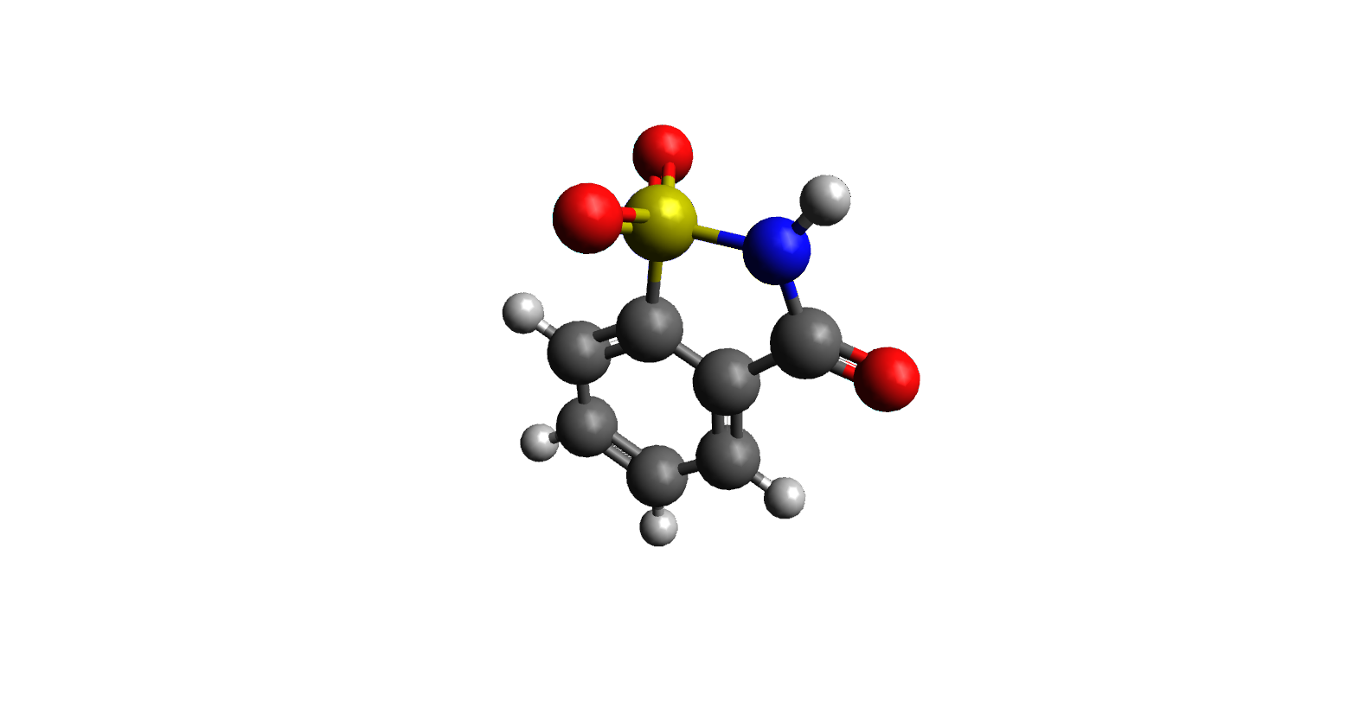

**Fig. 1. 3D structure of Saccharin**

**Aspartame:** Aspartame, which was approved in 1974, has four calories per gram and is around 200 times sweeter than sugar.If aspartame is produced in accordance with established rules and consumed within authorised levels, it is safe for the general public to consume, according to FDA statistics(Czarnecka et al. 2021).Since the approval of aspartame, the scientific community has continuously backed this view. However, people with phenylketonuria, a rare inherited metabolic disease, should either stay away from aspartame entirely or use it sparingly (Burh et al. 2021). The World Health Organisation, which includes the International Agency for Research on Cancer, and the Food and Agriculture Organisation's Joint.

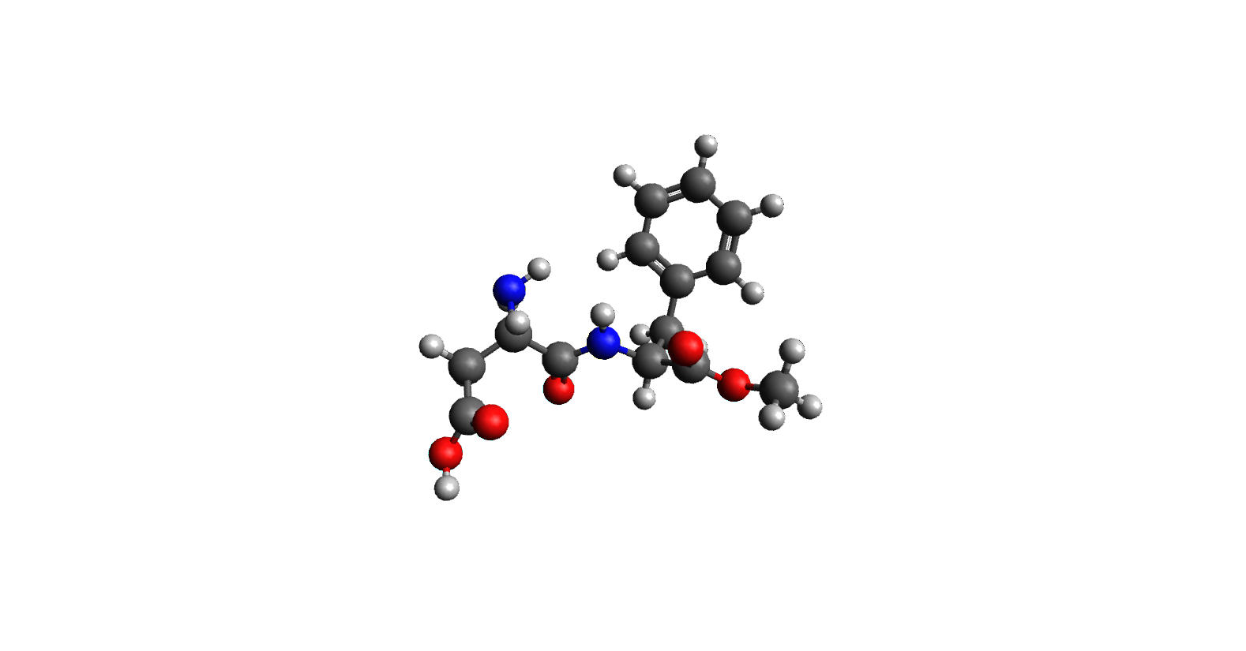

**Fig. 2. 3D structure of Aspartame**

The Expert Committee on Food Additives are two of the major health organisations that have looked into the purported health risks associated with aspartame (Ali et al. 2019). The IARC has classified aspartame as "possibly carcinogenic to humans" (Group 2B) due to the lack of evidence that it can cause cancer in humans**.**(Zhu et al. 2024a)However, JECFA states that a healthy daily intake of aspartame is 40 milligrams per kilogram of body weight. Despite being separate entities, the totality of these evaluations provides a comprehensive study of the health hazards and benefits of aspartame use(Zhu et al. 2024b).

**Cyclamate:** Because of this research, the use of sodium cyclohexyl sulfamate, sometimes known as cyclamate, in diet foods and beverages was banned in the 1950s and 1960s, which was first identified in 1937, was a common low-calorie sweetener in the US. The FDA prohibited the use of cyclamate and its salts, such as sodium, calcium, magnesium, and potassium, after animal research in the 1970s revealed that cyclamate may be carcinogenic (Clemens et al. 2023).Because of this research, the use of sodium cyclohexyl sulfamate, sometimes known as cyclamate, in diet foods and beverages was prohibited in the United States due to its carcinogenic properties(Puttegowda et al. 2024).

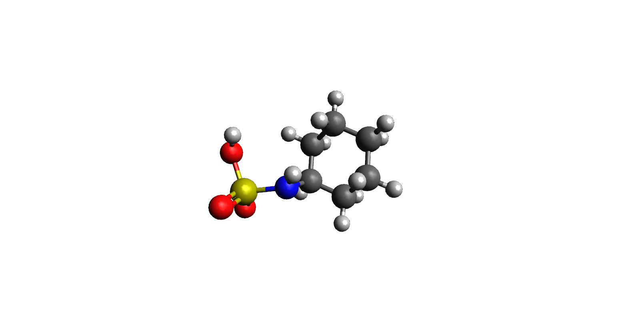

**Fig. 3. 3D structure of Cyclamate**

**Advantame:** With the exception of meat and poultry, Advantame is a versatile sweetener and flavour enhancer that was most recently approved by the FDA in 2014 (Acunha et al. 2016).Aspartame and vanillin are combined to create Advantame, which is stable in the presence of heat and contributes less phenylalanine than aspartame(Newbould et al. 2021a). Since it is not linked to PKU (phenylketonuria), it will not need to have extra warning labels on its package (Newbould et al. 2021b).

**Rare Sugars:** In nature, monosaccharides and their derivatives are uncommon. However, it is now possible to produce these sugars on a commercial scale due to recent advances in large-scale biosynthesis (Bilal et al. 2018a).L-glucose, D-allose, D-psicose, D-tagatose, xylitol, and L-ribose are examples of these uncommon sugars. Of them, D-tagatose (TAG) and D-psicose (PSI) have each been recognised as generally recognised as safe (GRAS). Since these sugars are not metabolised by the body and are not counted toward caloric intake, they offer sweetness without having a high calorie content (Clemens et al. 2016a). Because there is no set Acceptable Daily Intake for these sugars, individuals with diabetes find them more appealing (Evert et al. 2014).

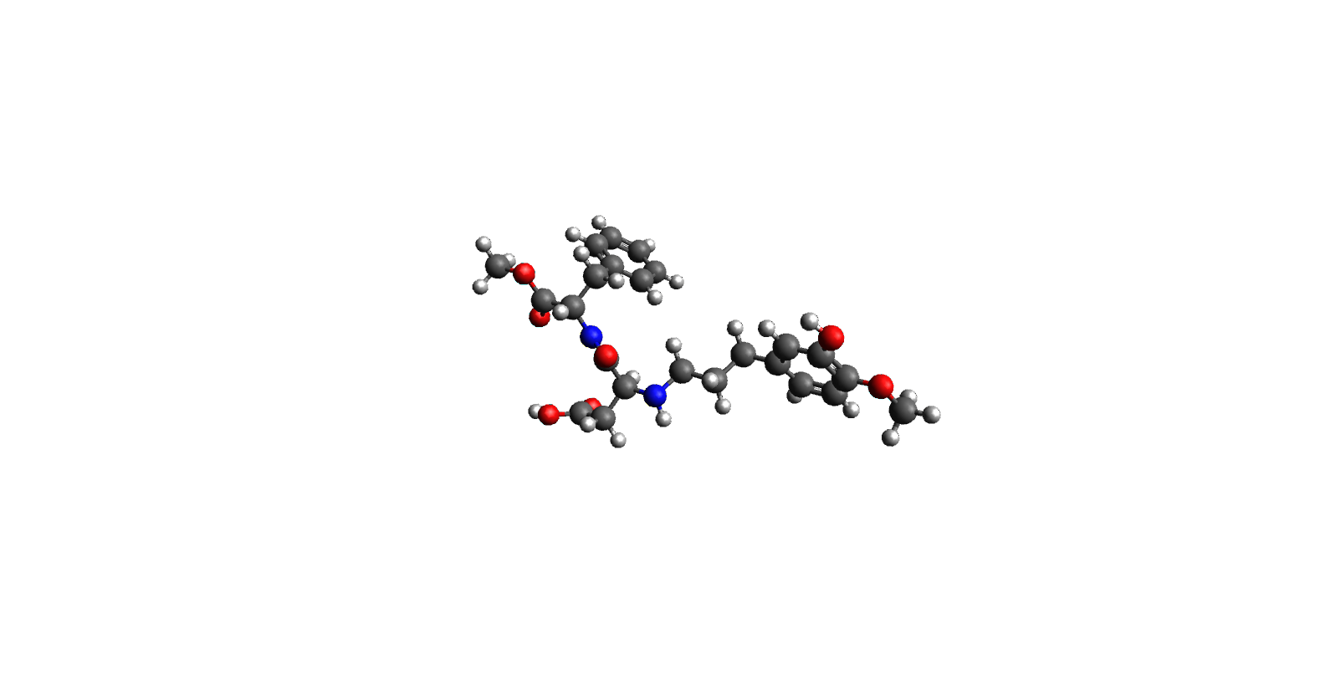

**Fig. 4. 3D structure of Advantame**

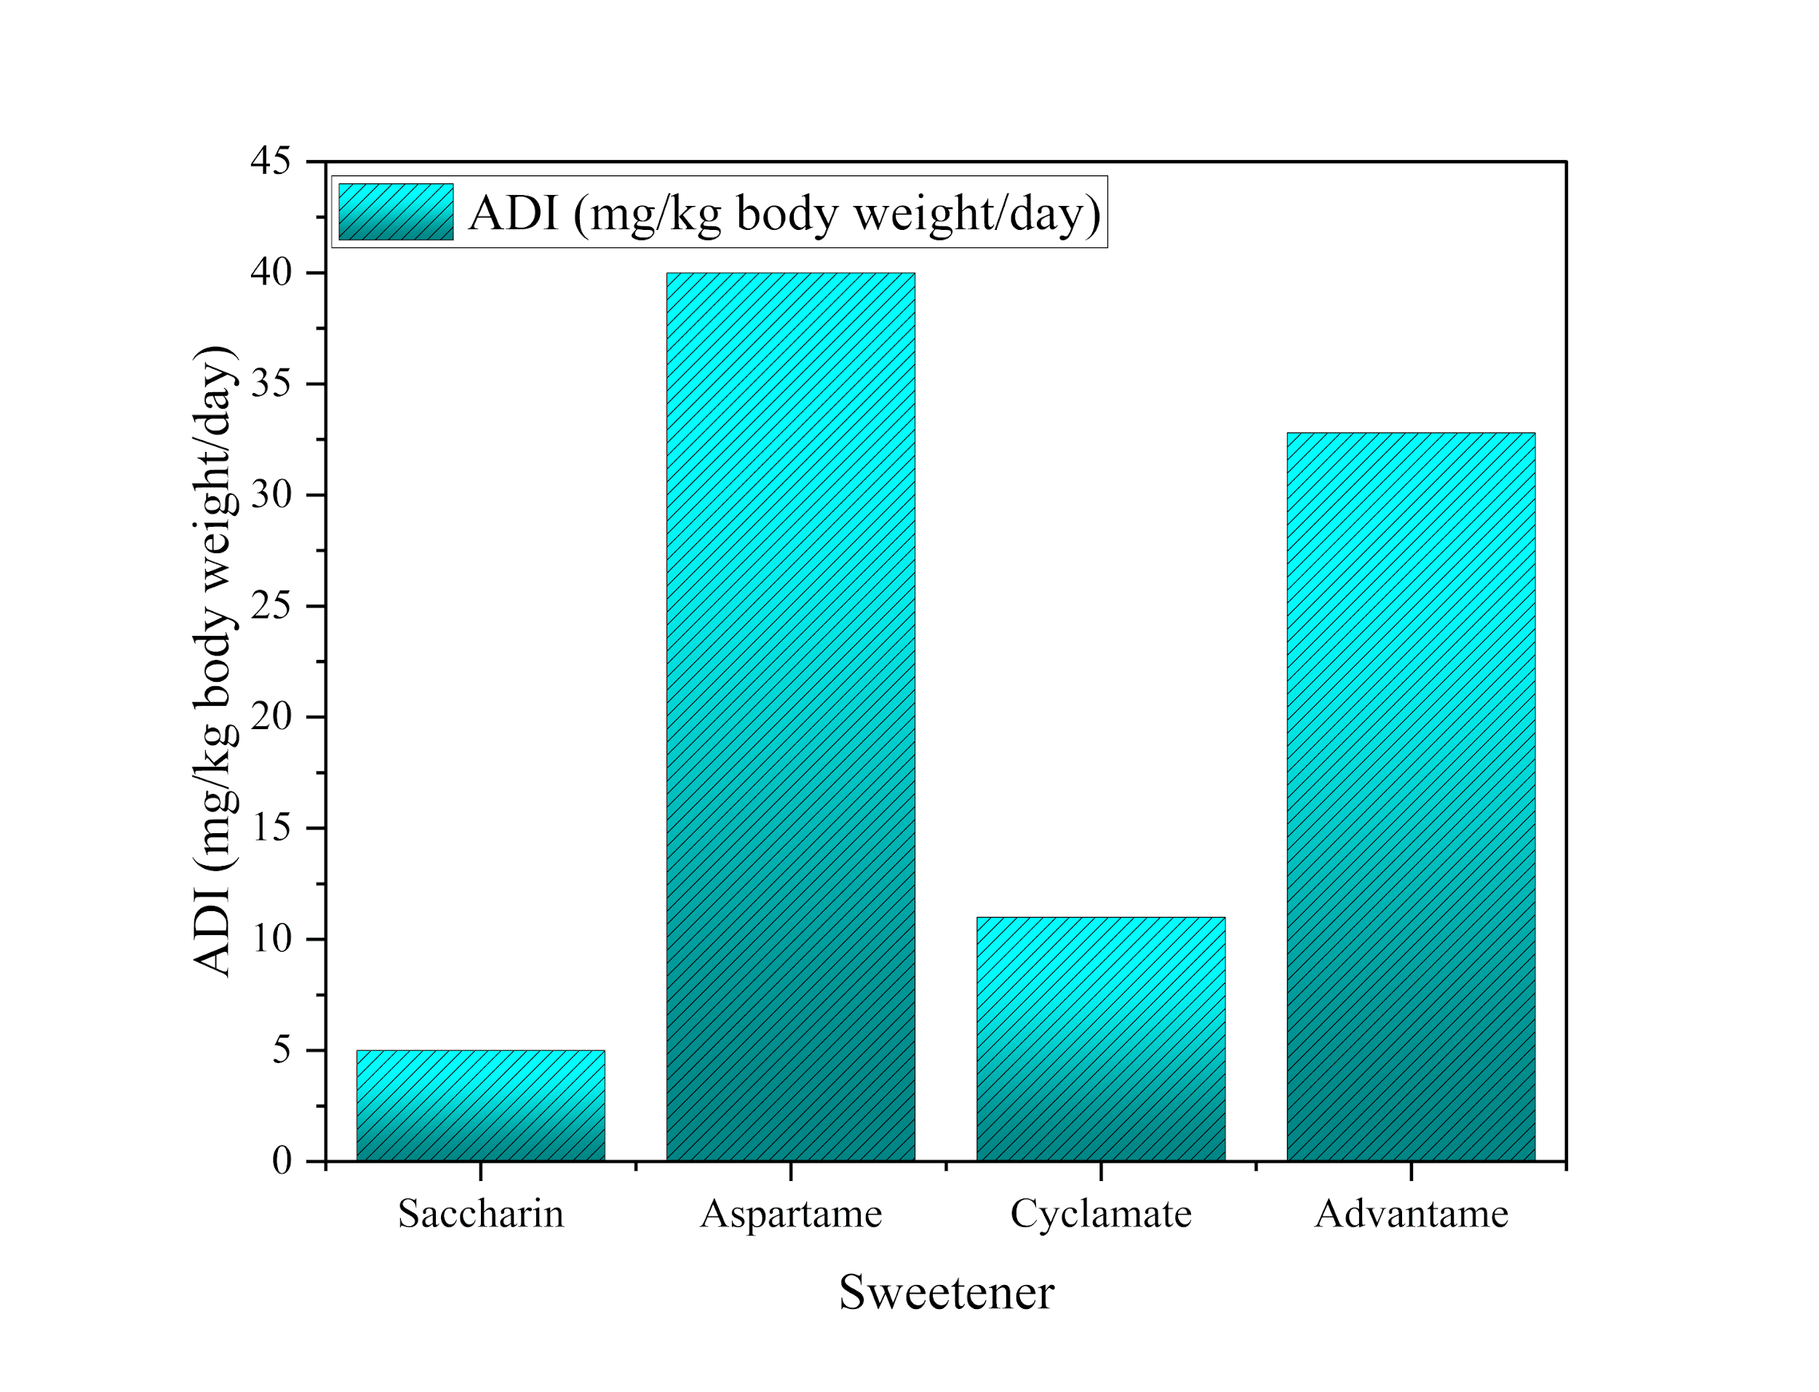

**Fig. 5. Safe Consumption Levels of Artificial Sweeteners and Rare Sugars: Comparing Acceptable Daily Intake (ADI) Values Across Common Sweeteners (More et al. 2021a).**

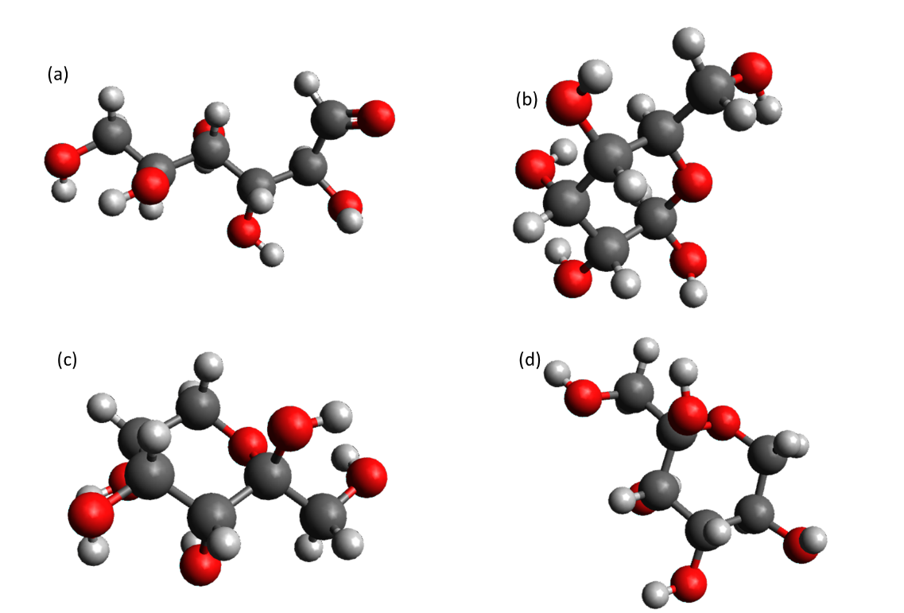

**Fig. 6. Some rare sugars 3D conformation (a) L-glucose, (b) D-allose, (c) D-psicose, (d) D-tagatose**

**Table 1. Summarises the approval and usage of the mentioned artificial sweeteners in the Indian market (Gopalakrishnan et al. 2024)**

|  |  |  |
| --- | --- | --- |
| **Sweetener** | **Approval Status in India (FSSAI)** | **Common Uses** |
| **Saccharin** | Approved | Diet soft drinks, sugar-free chewing gums, and tabletop sweeteners |
| **Aspartame** | Approved | Diet beverages, sugar-free desserts, chewing gums, and tabletop sweeteners |
| **Cyclamate** | Not Approved | Used in diet beverages and low-calorie foods in countries where permitted |
| **Advantame** | Not Approved | Beverages, dairy products, confectionery (in countries where permitted) |
| **Rare Sugars** | Limited Approval | Baked goods, dairy products, and beverages (used in regions with necessary approval) |

When combined with carbohydrates, PSI and TAG appear to considerably lower postprandial blood glucose increases, according to human studies (Barclay et al. 2021). This is a huge benefit for people with increased blood glucose levels. There may be further health advantages linked to the uncommon sugars, including lowering pro-inflammatory cytokine levels, maintaining gut flora, and enhancing lipid profiles (Bagheri et al. 2022). According to one study that has even ventured into investigating their effects on gut health, PSI can help prevent fructose-induced Non-Alcoholic Fatty Liver Disease by encouraging the growth of beneficial bacteria like Lactobacillus. Because of these advantages, unusual sugars are being considered more and more as a possible substitute for the traditional sweeteners depicted in Fig. 5 (More et al. 2021a).

**3. GERONTOLOGICAL CONSIDERATIONS**

**Altered Taste Perception:** People's sense of taste tends to deteriorate with age, primarily as a result of diminished smell and taste buds (Sergi et al. 2017). The elderly may find food unattractive due to their inability to taste some flavours, especially sweetness, which could result in low nutrient intake**.**(Lorenz et al. 2022)Traditional sugars have the ability to counteract this, increasing the risk of obesity, type 2 diabetes, and heart disease in older persons (Mozaffarian, 2016).Artificial sweeteners, which are produced from saccharin, aspartame, or advantame, provide sweetness to a food without significantly increasing its calorie content (More et al. 2021b). These are safe, according to regulatory bodies, and the daily allowances are clearly stated. Second, advantame and aspartame cause very little change in blood sugar levels (Iizuka 2022). Older adults at risk for metabolic disease or with a history of diabetes benefit from them (LeRoith et al. 2019). It is possible to level and improve the lipid profile and blood sugar content because unusual sugars D-psicose and D-tagatose are metabolised differently than regular sugars.(Bilal et al. 2018b) Although these substitute sugars typically have no negative effects, they can occasionally upset your stomach. The long-term consequences of artificial sweeteners need to be studied, particularly in elderly adults(Malik et al. 2019).

**Increased Risk of Chronic Disease:** Obesity, type 2 diabetes, heart disease, and hypertension are a few of these chronic illnesses. Poor diet, inactivity, and the metabolic changes that typically accompany ageing are all linked to these illnesses(Booth et al. 2017).Due to factors including changing taste, diminished appetite, and a slowed metabolism, most elderly people find it difficult to maintain a healthy diet (Yannakoulia et al. 2018). This could eventually cause them to eat more meals that are high in calories but low in nutrients. In order to overcome these challenges, many older adults strive to establish good eating habits, such as choosing whole, unprocessed foods, reducing added sugars and saturated fats, and increasing fibre. If you lose your sense of taste, though, it could be hard to follow. In this case, artificial sweeteners and rare sugars could be good alternatives. Because they provide the body with fewer calories, some sweeteners help people maintain their weight and avoid the associated health problems. Examples of rare sugars that don't significantly increase caloric intake are cellulose and tagatose. They might also provide other advantages, including better blood glucose regulation and intestinal health. By adding these sweeteners to their diet, older individuals can still enjoy the sweetness while eating fewer calories (Bartolotto 2015). This will lower the chance of long-term health issues, encourage a balanced diet, and enhance blood sugar regulation.

**Medication Interactions:** The nutritional status of elderly individuals might be significantly impacted by polypharmacy (Liu et al. 2024). The chemical sensation of taste is interfered with by the majority of medications provided to older patients, such as hypertension, antidepressants, and several chemotherapy therapies (Wang et al. 2017). This leads to hypogeusia, or decreased taste sensitivity, and dysgeusia, or a warped sense of taste. These alterations frequently result in symptoms including xerostomia, metallic aftertaste, and decreased food enjoyment, which can lower appetite and perhaps cause malnutrition (Garutti et al. 2023). Given the high rates of diabetes and heart disease in the community, some older persons may use these diminished taste perceptions as an invitation to consume more sugary meals. Aspartame, saccharin, and Advantame—which have a saccharine flavour—are the best artificial sweeteners (10.4103/0253-7613.182888). These raise blood sugar levels and provide almost no calories. Incorporating caloric content, less frequent sugars have benefits since their concentration somewhat raises blood glucose levels (Clemens et al. 2016b). These carbohydrates have been demonstrated to lower bad fat, enhance blood glucose homeostasis, and lessen inflammation—all of which may have a beneficial impact on how some medications work. Last but not least, adding rare sugars and artificial sweeteners to older people's diet improves their nutrition, reduces the negative effects of medications on taste perception, and boosts the efficacy of their treatment because there is a lower chance of nutritional deficiencies.

**4. POTENTIAL BENEFITS**

**Metabolic Disturbances:** The artificial sweeteners aspartame, ACE K, sucralose, saccharin, neotame, and advantame are among the most often used substitutes for sugar in food preparation (More et al. 2021c). Aspartame is around 200 times sweeter than sugar and is composed of amino acids and methanol (Makar Abdel Messih 2015). Aspartame is typically found in gum, soft drinks, and desserts. However, the amount included in foods does not supply nearly zero calories, even though its body breaks it down into methanol and amino acids after consumption. Aspartame has two derivatives: neotame and advantame (O’donnell 2012). Advantame is added to various product lines, such as dairy and fruit goods, to add flavour. Neotame is more than 13,000 times sweeter than sugar, but it is calorie-free and non-carcinogenic. Another sweetener that is stable at high temperatures and 200 times sweeter than sugar is ACE K (Mariotti and Lucisano 2014). It is perfect for sauces, desserts, and beverages. To get rid of the bitter aftertaste that occurs with other sweets, it is typically combined with them. The body does not digest these sweeteners after they are consumed. Saccharin, which is 300 times sweeter than sugar and heat stable, was one of the first artificial sweeteners and is frequently added to baked products and soft drinks (Kaur et al. 2024). Sugar is used to make sucrose, which is 600 times sweeter and more heat-stable. Since sucrose is not absorbed by the body and is therefore eliminated virtually unaltered, it does not provide any calories.

**Cognitive Decline:** There has been a scarcity of research on the neurological effects of aspartame (Shaher et al. 2023).Studies in healthy adults indicated no effect of aspartame on reaction time, headaches, hunger, sedation, and brain activity in EEG.(Fowler et al. 2023) Results were mixed for those who tend to experience a migraine, but these studies were not valid because of their weak research design and reliance on subjective, non-validated self-assessments. In children, a study on epilepsy and another on hyperactivity showed no significant effects associated with aspartame (Choudhary and Lee 2018). Current evidence does not indicate that aspartame has significant neurological effects, though there are still restrictions in the quality of the results performed(Gardner and Elkind 2019).

**Cardiovascular Risks:** There is still much disagreement over the research on artificial sweeteners and cardiovascular risk (Lin et al. 2021). The Women's Health Initiative findings indicate that while there was no correlation with hemorrhagic stroke, higher consumption of artificially sweetened beverages was linked to an increased risk of stroke, coronary heart disease, and all-cause mortality. According to research on animals, ACE K may make lipid abnormalities worse, which could lead to atherosclerosis(Debras et al. 2022a). A new study involving 103,388 members of the NutriNet cohort found that consuming artificial sweeteners in general was linked to an elevated risk of cardiovascular disease, whereas ACE K and sucralose were particularly linked to an increased risk of coronary heart disease. Aspartame was not

**Table 2. Key Indian Companies in Artificial Sweeteners**

|  |  |
| --- | --- |
| **Company Name** | **Key Contributions in Artificial Sweeteners** |
| **Dabur India Ltd.** | Offers sweeteners, honey, and stevia-based substitutes for health-conscious consumers. |
| **Zydus Wellness Ltd.** | Produces 'Sugar Free' brand with various sugar alternatives, including artificial sweeteners. |
| **International Prakash Chemicals Pvt. Ltd.** | Specialises in sodium cyclamate, a non-caloric sweetener used in food and beverages. |
| **Blue Circle Organics Pvt. Ltd.** | Leading producer of saccharin, a widely used artificial sweetener, since 1969. |
| **Vishnu Chemicals Ltd.** | Manufacturer of saccharin, supporting the food and beverage industry's demand for artificial sweeteners. |

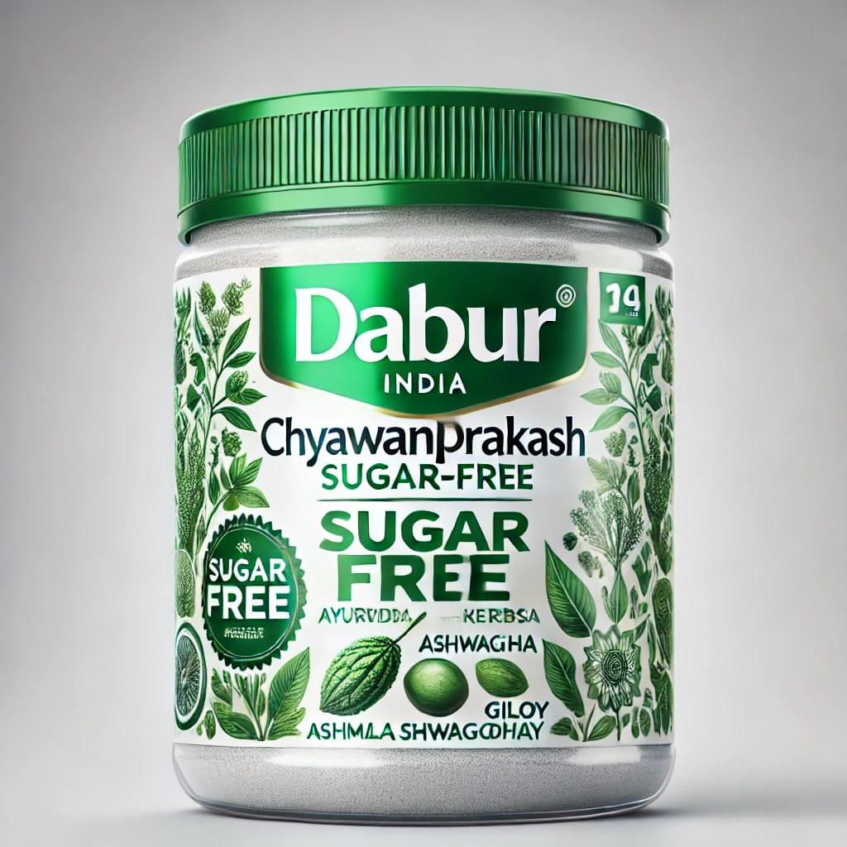 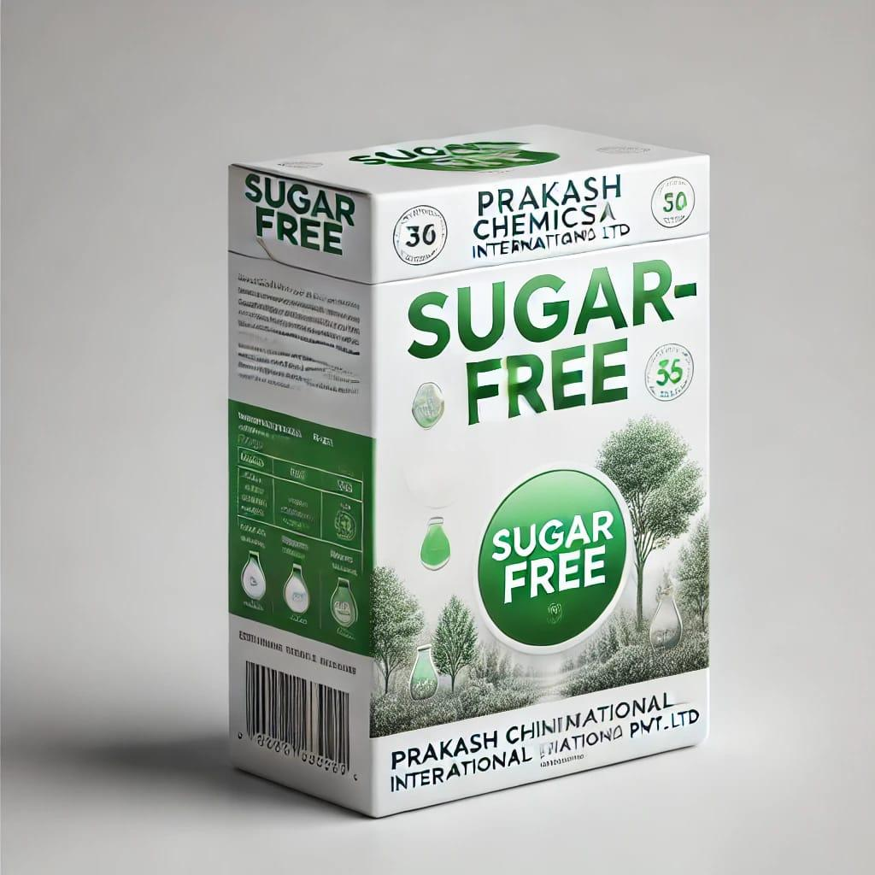 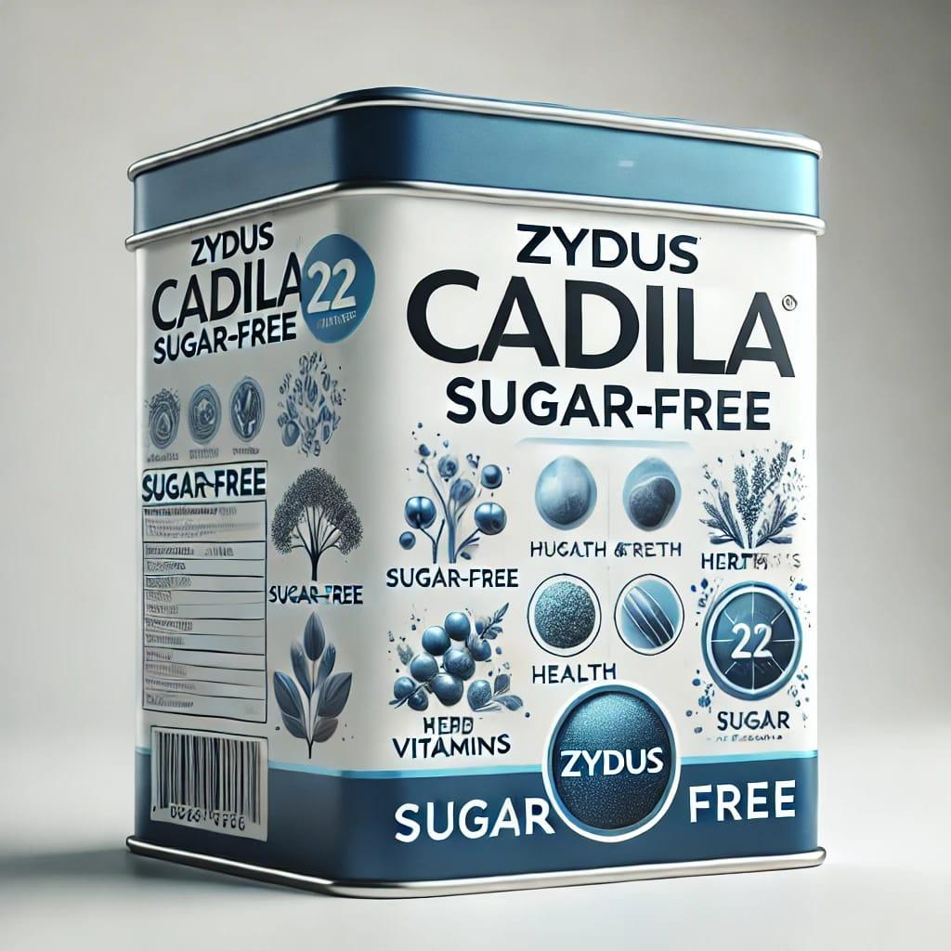

**Fig. 7. Images depicting various artificial sweeteners**

linked to coronary heart disease, but it was linked to an increased risk of cerebrovascular disease(Debras et al. 2022b).

**Cancer Risk:** The results of the 55 studies that were evaluated about the association between the consumption of artificial sweeteners and the risk of cancer varied greatly (del Pozo et al. 2022a).The majority of these have to do with bladder cancer. Saccharin was the sweetener that was examined for this effect more than others, but in order to get a more certain result, very few of them were controlled with any other potentially significant factors, such as environmental toxins (del Pozo et al. 2022b). There was no discernible connection between IS consumption and research on other types of cancer, specifically kidney, intestinal, or brain cancer. But according to a cohort research, men who consume significant amounts of artificially sweetened beverages may be somewhat more susceptible to multiple myeloma and non-Hodgkin lymphoma than women.

**Leading Indian Companies in Artificial Sweeteners:** Several Indian companies are pioneering the use of artificial sweeteners to meet the growing demand for low-calorie and sugar-free products. From stevia-based substitutes to saccharin and sodium cyclamate, these firms are shaping the future of healthier food and beverage options.

**5. CONCLUSION**

Artificial sweeteners (AS) and non-nutritive sweeteners (NNS) have been widely accepted due to the reduced calorie count when replacing natural sugars, potentially reducing weight gain and improving blood glucose control. In fact, a number of products have received approval from the FDA, such as saccharin, sucralose, aspartame, neotame, and cyclamate; yet others, alitame, for example, remain under investigation. Yet with growing popularity comes concerns over their safety. These sweeteners are linked to problems such as interruptions in gut health, metabolic challenge, and, potentially, relations with chronic illness, including autoimmunity or cancer. No-calorie ingredients are often used in blends with other ingredients, and excessive and prolonged consumption past the recommended levels can pose quite a health danger. The natural options, such as stevia, are safer, but not as inexpensive and also more difficult to locate. A lot of ongoing research will have to be conducted before much is known about the long-term effects of such sweeteners. For now, moderation or using them in as few natural sweeteners as possible is a much healthier approach to good health.

**DISCLAIMER (ARTIFICIAL INTELLIGENCE)**

Author(s) hereby declare that NO generative AI technologies such as Large Language Models (ChatGPT, COPILOT, etc) and text-to-image generators have been used during writing or editing of this manuscript.

**REFERENCES**

Acunha, T., Ibáñez, C., García‐Cañas, V., Simó, C., & Cifuentes, A. (2016). Recent advances in the application of capillary electromigration methods for food analysis and Foodomics. *Electrophoresis, 37*(1), 111–141. https://doi.org/10.1002/elps.201500291

Ali, W., Mohammed, S., Abdullah, E., & Salah ElDeen, E. (2019). Aspartame: Basic Information for Toxicologists. *Sohag Medical Journal, 23*(2), 53–57. https://doi.org/10.21608/smj.2019.46212

Aron-Wisnewsky, J., Warmbrunn, M. V., Nieuwdorp, M., & Clément, K. (2021). Metabolism and Metabolic Disorders and the Microbiome: The Intestinal Microbiota Associated With Obesity, Lipid Metabolism, and Metabolic Health—Pathophysiology and Therapeutic Strategies. *Gastroenterology, 160*(2), 573–599. https://doi.org/10.1053/j.gastro.2020.10.057

Bagheri, S., Zolghadri, S., & Stanek, A. (2022). Beneficial Effects of Anti-Inflammatory Diet in Modulating Gut Microbiota and Controlling Obesity. *Nutrients, 14*(19), 3985. https://doi.org/10.3390/nu14193985

Barclay, A. W., et al. (2021). Dietary Glycaemic Index Labelling: A Global Perspective. *Nutrients, 13*(9), 3244. https://doi.org/10.3390/nu13093244

Bartolotto, C. (2015). Does Consuming Sugar and Artificial Sweeteners Change Taste Preferences? *The Permanente Journal, 19*(3), 81–84. https://doi.org/10.7812/TPP/14-229

Bayram, H. M., & Ozturkcan, A. (2022). Intake and risk assessment of nine priority food additives in Turkish adults. *Journal of Food Composition and Analysis, 114*, 104710. https://doi.org/10.1016/j.jfca.2022.104710

Bilal, M., Iqbal, H. M. N., Hu, H., Wang, W., & Zhang, X. (2018a). Metabolic engineering pathways for rare sugars biosynthesis, physiological functionalities, and applications—a review. *Critical Reviews in Food Science and Nutrition, 58*(16), 2768–2778. https://doi.org/10.1080/10408398.2017.1341385

Bilal, M., Iqbal, H. M. N., Hu, H., Wang, W., & Zhang, X. (2018b). Metabolic engineering pathways for rare sugars biosynthesis, physiological functionalities, and applications—a review. *Critical Reviews in Food Science and Nutrition, 58*(16), 2768–2778. https://doi.org/10.1080/10408398.2017.1341385

Booth, F. W., Roberts, C. K., Thyfault, J. P., Ruegsegger, G. N., & Toedebusch, R. G. (2017). Role of Inactivity in Chronic Diseases: Evolutionary Insight and Pathophysiological Mechanisms. *Physiological Reviews, 97*(4), 1351–1402. https://doi.org/10.1152/physrev.00019.2016

Burh, A., Batra, S., & Sharma, S. (2021). Emerging Facts on Chronic Consumption of Aspartame as Food Additive. *Current Nutrition & Food Science, 17*(7), 690–698. https://doi.org/10.2174/1573401317666210122090259

Castle, L., et al. (2024). Scientific opinion on the extension of the authorisation of use of the food additive steviol glycosides (E 960a–d) and the modification of the acceptable daily intake (ADI) for steviol. *EFSA Journal, 22*(11). https://doi.org/10.2903/j.efsa.2024.9045

Chattopadhyay, S., Raychaudhuri, U., & Chakraborty, R. (2014). Artificial sweeteners–a review. *Journal of Food Science and Technology, 51*, 611–621.

Choudhary, A. K., & Lee, Y. Y. (2018). Neurophysiological symptoms and aspartame: What is the connection? *Nutritional Neuroscience, 21*(5), 306–316. https://doi.org/10.1080/1028415X.2017.1288340

Clemens, R. A., Jones, J. M., Kern, M., Lee, S., Mayhew, E. J., Slavin, J. L., & Zivanovic, S. (2016a). Functionality of Sugars in Foods and Health. *Comprehensive Reviews in Food Science and Food Safety, 15*(3), 433–470. https://doi.org/10.1111/1541-4337.12194

Clemens, R. A., Jones, J. M., Kern, M., Lee, S., Mayhew, E. J., Slavin, J. L., & Zivanovic, S. (2016b). Functionality of Sugars in Foods and Health. *Comprehensive Reviews in Food Science and Food Safety, 15*(3), 433–470. https://doi.org/10.1111/1541-4337.12194

Clemens, R., Pressman, P., & Hayes, A. W. (2023). Food additives toxicology. In *History of Food and Nutrition Toxicology* (pp. 87–102). Elsevier. https://doi.org/10.1016/B978-0-12-821261-5.00001-5

Czarnecka, K., Pilarz, A., Rogut, A., Maj, P., Szymańska, J., Olejnik, Ł., & Szymański, P. (2021). Aspartame—True or False? Narrative Review of Safety Analysis of General Use in Products. *Nutrients, 13*(6), 1957. https://doi.org/10.3390/nu13061957

Debras, C., et al. (2022a). Artificial sweeteners and risk of cardiovascular diseases: results from the prospective NutriNet-Santé cohort. *BMJ*, e071204. https://doi.org/10.1136/bmj-2022-071204

Debras, C., et al. (2022b). Artificial sweeteners and risk of cardiovascular diseases: results from the prospective NutriNet-Santé cohort. *BMJ*, e071204. https://doi.org/10.1136/bmj-2022-071204

del Pozo, S., Gómez-Martínez, S., Díaz, L. E., Nova, E., Urrialde, R., & Marcos, A. (2022a). Potential Effects of Sucralose and Saccharin on Gut Microbiota: A Review. Nutrients, 14(8), 1682. https://doi.org/10.3390/nu14081682

del Pozo, S., Gómez-Martínez, S., Díaz, L. E., Nova, E., Urrialde, R., & Marcos, A. (2022b). Potential Effects of Sucralose and Saccharin on Gut Microbiota: A Review. Nutrients, 14(8), 1682. https://doi.org/10.3390/nu14081682

Evert, A. B., et al. (2014). Nutrition Therapy Recommendations for the Management of Adults With Diabetes. *Diabetes Care, 37*(Supplement_1), S120–S143. https://doi.org/10.2337/dc14-S120

Fowler, S. P., Gimeno Ruiz de Porras, D., Swartz, M. D., Stigler Granados, P., Heilbrun, L. P., & Palmer, R. F. (2023). Daily Early-Life Exposures to Diet Soda and Aspartame Are Associated with Autism in Males: A Case-Control Study. *Nutrients, 15*(17), 3772. https://doi.org/10.3390/nu15173772

Gardener, H., & Elkind, M. S. V. (2019). Artificial Sweeteners, Real Risks. *Stroke, 50*(3), 549–551. https://doi.org/10.1161/STROKEAHA.119.024456

Garutti, M., et al. (2023). Nutritional Management of Oncological Symptoms: A Comprehensive Review. *Nutrients, 15*(24), 5068. https://doi.org/10.3390/nu15245068

Gopalakrishnan, N. K., Balasubramanian, B., Kundapur, R., Chaudhary, A., Meyyazhagnan, A., & Pappuswamy, M. (2024). Unraveling connections with artificial sweeteners and their impact on human health: A comprehensive review. *eFood, 5*(5). https://doi.org/10.1002/efd2.184

Iizuka, K. (2022). Is the Use of Artificial Sweeteners Beneficial for Patients with Diabetes Mellitus? The Advantages and Disadvantages of Artificial Sweeteners. *Nutrients, 14*(21), 4446. https://doi.org/10.3390/nu14214446

Ikwuka, A. O., Omoju, D. I., & Mahanera, O. K. (2023). Profiling of clinical dynamics of type 2 diabetes mellitus in patients: a perspective review. World Journal of Current Medical and Pharmaceutical Research, 210–218. https://doi.org/10.37022/wjcmpr.v5i5.294

Kaur, R., Das, R., Tanwar, S., & Sajja, J. (2024). Aspartame and the brain: a systematic review of neurological effects. International Journal of Research in Medical Sciences, 12(8), 2977–2986. https://doi.org/10.18203/2320-6012.ijrms20242229

LeRoith, D., et al. (2019). Treatment of Diabetes in Older Adults: An Endocrine Society* Clinical Practice Guideline. The Journal of Clinical Endocrinology & Metabolism, 104(5), 1520–1574. https://doi.org/10.1210/jc.2019-00198

Lewis, J. I. (n.d.). Food Classifications: Purpose and Application.

Li, P., Qu, R., Li, M., Sheng, P., Jin, L., Huang, X., & Xu, Z. Z. (2024). Impacts of food additives on gut microbiota and host health. Food Research International, 196, 114998. https://doi.org/10.1016/j.foodres.2024.114998

Liauchonak, I., Qorri, B., Dawoud, F., Riat, Y., & Szewczuk, M. R. (2019). Non-Nutritive Sweeteners and Their Implications on the Development of Metabolic Syndrome. Nutrients, 11(3), 644. https://doi.org/10.3390/nu11030644

Lin, C.-H., Li, H.-Y., Wang, S.-H., Chen, Y.-H., Chen, Y.-C., & Wu, H.-T. (2021). Consumption of Non-Nutritive Sweetener, Acesulfame Potassium Exacerbates Atherosclerosis through Dysregulation of Lipid Metabolism in ApoE−/− Mice. Nutrients, 13(11), 3984. https://doi.org/10.3390/nu13113984

Liu, Y., Huang, L., Hu, F., & Zhang, X. (2024). Investigating Frailty, Polypharmacy, Malnutrition, Chronic Conditions, and Quality of Life in Older Adults: Large Population-Based Study. JMIR Public Health and Surveillance, 10, e50617. https://doi.org/10.2196/50617

Lorenz, T., Iskandar, M. M., Baeghbali, V., Ngadi, M. O., & Kubow, S. (2022). 3D Food Printing Applications Related to Dysphagia: A Narrative Review. Foods, 11(12), 1789. https://doi.org/10.3390/foods11121789

Mahmoud, A., et al. (2024). Efficacy of orlistat in obese patients with nonalcoholic fatty liver disease: a systematic review and meta-analysis of randomized controlled trials. Baylor University Medical Center Proceedings, 37(4), 603–612. https://doi.org/10.1080/08998280.2024.2335829

Makar Abdel Messih, N. (2015). The Safety of Aspartame. USURJ: University of Saskatchewan Undergraduate Research Journal, 1(2). https://doi.org/10.32396/usurj.v1i2.48

Malik, V. S., Li, Y., Pan, A., De Koning, L., Schernhammer, E., Willett, W. C., & Hu, F. B. (2019). Long-Term Consumption of Sugar-Sweetened and Artificially Sweetened Beverages and Risk of Mortality in US Adults. Circulation, 139(18), 2113–2125. https://doi.org/10.1161/CIRCULATIONAHA.118.037401

Mariotti, M., & Lucisano, M. (2014). Sugar and Sweeteners. In Bakery Products Science and Technology (pp. 199–221). Wiley. https://doi.org/10.1002/9781118792001.ch11

Mooradian, A. D., Smith, M., & Tokuda, M. (2017a). The role of artificial and natural sweeteners in reducing the consumption of table sugar: A narrative review. Clinical Nutrition ESPEN, 18, 1–8. https://doi.org/10.1016/j.clnesp.2017.01.004

Mooradian, A. D., Smith, M., & Tokuda, M. (2017b). The role of artificial and natural sweeteners in reducing the consumption of table sugar: A narrative review. Clinical Nutrition ESPEN, 18, 1–8. https://doi.org/10.1016/j.clnesp.2017.01.004

More, T. A., Shaikh, Z., & Ali, A. (2021a). Artificial Sweeteners and their Health Implications: A Review. Biosciences Biotechnology Research Asia, 18(2), 227–237. https://doi.org/10.13005/bbra/2910

More, T. A., Shaikh, Z., & Ali, A. (2021b). Artificial Sweeteners and their Health Implications: A Review. Biosciences Biotechnology Research Asia, 18(2), 227–237. https://doi.org/10.13005/bbra/2910

More, T. A., Shaikh, Z., & Ali, A. (2021c). Artificial Sweeteners and their Health Implications: A Review. Biosciences Biotechnology Research Asia, 18(2), 227–237. https://doi.org/10.13005/bbra/2910

Motwani, M. S., Deorukhkar, K. V., Sanwalka, N., Kochrekar, N. S., Pai, A., Mitra, A., & Mandalika, S. (2024). Dietary Macronutrient and Micronutrient Intake Among Corporate Employees Aged 30 to 40 Years Residing in Mumbai, India. Current Research in Nutrition and Food Science Journal, 12(2), 705–726. https://doi.org/10.12944/CRNFSJ.12.2.18

Mozaffarian, D. (2016). Dietary and Policy Priorities for Cardiovascular Disease, Diabetes, and Obesity. Circulation, 133(2), 187–225. https://doi.org/10.1161/CIRCULATIONAHA.115.018585

Newbould, E., et al. (2021a). Accidental Consumption of Aspartame in Phenylketonuria: Patient Experiences. Nutrients, 13(2), 707. https://doi.org/10.3390/nu13020707

Newbould, E., et al. (2021b). Accidental Consumption of Aspartame in Phenylketonuria: Patient Experiences. Nutrients, 13(2), 707. https://doi.org/10.3390/nu13020707

O’Donnell, K. (2012). Aspartame, Neotame and Advantame. In Sweeteners and Sugar Alternatives in Food Technology (pp. 117–136). Wiley. https://doi.org/10.1002/9781118373941.ch6

Puttegowda, S. K. B., Shivaramu, M., Manjunath, B. S., Venkataraman, R., & Nagarajappa, R. B. (2024). Understanding Artificial Sweeteners and Food Colorants—their Impact on Human Health: A Review. Indian Journal of Pharmacy Practice, 18(1), 8–15. https://doi.org/10.5530/ijopp.20250089

Roberts, A. (2016). The safety and regulatory process for low calorie sweeteners in the United States. *Physiology & Behavior, 164*, 439–444. https://doi.org/10.1016/j.physbeh.2016.02.039

Sasidharan Pillai, S., Gagnon, C. A., Foster, C., & Ashraf, A. P. (2024). Exploring the Gut Microbiota: Key Insights Into Its Role in Obesity, Metabolic Syndrome, and Type 2 Diabetes. *The Journal of Clinical Endocrinology & Metabolism, 109*(11), 2709–2719. https://doi.org/10.1210/clinem/dgae499

Schiano, C., Grimaldi, V., Scognamiglio, M., Costa, D., Soricelli, A., Nicoletti, G. F., & Napoli, C. (2021). Soft drinks and sweeteners intake: Possible contribution to the development of metabolic syndrome and cardiovascular diseases. Beneficial or detrimental action of alternative sweeteners? *Food Research International, 142*, 110220. https://doi.org/10.1016/j.foodres.2021.110220

Sergi, G., Bano, G., Pizzato, S., Veronese, N., & Manzato, E. (2017). Taste loss in the elderly: Possible implications for dietary habits. *Critical Reviews in Food Science and Nutrition, 57*(17), 3684–3689. https://doi.org/10.1080/10408398.2016.1160208

Shaher, S. A. A., Mihailescu, D. F., & Amuzescu, B. (2023). Aspartame Safety as a Food Sweetener and Related Health Hazards. *Nutrients, 15*(16), 3627. https://doi.org/10.3390/nu15163627

Tran, N. L., Barraj, L. M., Hearty, A. P., & Jack, M. M. (2021). Tiered intake assessment for low- and no-calorie sweeteners in beverages. *Food Additives & Contaminants: Part A, 38*(2), 208–222. https://doi.org/10.1080/19440049.2020.1843717

Wang, T., Glendinning, J., Grushka, M., Hummel, T., & Mansfield, K. (2017). Drug-Induced Taste Disorders In Clinical Practice And Preclinical Safety Evaluation. *Toxicological Sciences*. https://doi.org/10.1093/toxsci/kfw263

Yang, G., et al. (2021). Role of the gut microbiota in type 2 diabetes and related diseases. *Metabolism, 117*, 154712. https://doi.org/10.1016/j.metabol.2021.154712

Yannakoulia, M., Mamalaki, E., Anastasiou, C. A., Mourtzi, N., Lambrinoudaki, I., & Scarmeas, N. (2018). Eating habits and behaviors of older people: Where are we now and where should we go? *Maturitas, 114*, 14–21. https://doi.org/10.1016/j.maturitas.2018.05.001

Zhu, C., Ji, D., Ma, J., & Da, M. (2024a). Association between Artificial Sweetener-Aspartame Consumption and Colorectal Cancer Risk: Evidence-Based Strategies. *Oncology, 102*(6), 533–543. https://doi.org/10.1159/000534812

Zhu, C., Ji, D., Ma, J., & Da, M. (2024b). Association between Artificial Sweetener-Aspartame Consumption and Colorectal Cancer Risk: Evidence-Based Strategies. *Oncology, 102*(6), 533–543. https://doi.org/10.1159/000534812