Mining in the Age of Artificial Intelligence (AI): Harnessing Big Data for Environmental Stewardship

Abstract - Mining operations contribute substantially to global environmental degradation. The sector accounts for an estimated 7–9% of global energy consumption and is responsible for widespread groundwater contamination, with acid mine drainage affecting over 12,000 kilometres of streams globally. As global demand for critical minerals surges—driven by the clean energy transition and rapid technological advancement—the mining industry faces mounting pressure to balance productivity with environmental sustainability. This paper explores how artificial intelligence (AI) and big data analytics are revolutionising environmental stewardship in modern mining operations. Through a comprehensive review of literature, real-world case studies, and industry data, the transformative role of AI-enabled technologies such as Internet of Things (IoT) sensors, satellite imaging, and drone-based mapping in reducing environmental impact was examined. These systems provide real-time monitoring, predictive analytics, and automated responses that help mitigate risks such as water contamination, biodiversity loss, and greenhouse gas emissions. Results indicate that AI-driven environmental management systems can reduce water usage by up to 40%, energy consumption by 20%, and pollution-related incidents by over 90%. Despite challenges including data integration complexity and skill gaps, the convergence of AI with quantum computing and advanced sensor networks presents a promising future for sustainable mining. The integration of AI and big data technologies in the mining industry is ushering in a new era of smart, efficient, and sustainable mining practices. By harnessing the power of these transformative tools, mining companies can enhance their competitiveness, mitigate environmental impact, and ensure the long-term viability of the industry. This study proposes a scalable, standardised framework for AI integration to optimise environmental performance, improve economic viability, and enhance stakeholder engagement in the mining sector.

Keywords: Artificial Intelligence, Mining, Environmental Sustainability, Data-Driven Operations, Satellite Technology, Internet of Things (IoT), Predictive Maintenance

INTRODUCTION
Machine learning and artificial intelligence are the two fields of computer science dealing with the innovative idea of inducing smartness and intelligence in machines and automating complex tasks and operations through modern learning algorithms. While the rest of the operational fields have been diligent in developing new technologies, the mining industry has been lacking when it comes to applying these innovative methodologies to achieve operational autonomy with intelligence (Ali & Frimpong, 2020). Mining has long been a cornerstone of industrial development, providing essential raw materials for modern society (Willson, 2024). The mining industry provides various raw materials for the equipment used in daily life, from aluminium caps to electronic chips for computers and mobiles. It is considered the foundation of global economic development (Liang et al., 2024). However, the environmental consequences of traditional mining practices—such as extensive land degradation, water contamination, and significant carbon emissions—have raised urgent concerns worldwide (Hyder et al., 2022). As global demand for minerals is projected to increase by approximately 500% by 2050, driven largely by the rapid expansion of renewable energy technologies and electronic devices (International Energy Agency [IEA], 2023), the mining sector faces a critical challenge: how to meet this demand while minimising environmental harm.
The mining sector historically drove the global economy, but at the expense of severe environmental and health repercussions, posing sustainability challenges (Chen et al., 2024; Psyuk & Polyanska, 2024). Currently, mining operations contribute substantially to global environmental degradation. The sector accounts for an estimated 7–9% of global energy consumption and is responsible for widespread groundwater contamination, with acid mine drainage affecting over 12,000 kilometres of streams globally (Santos & Carvalho, 2025; Ali & Frimpong, 2020). Moreover, mining activities contribute approximately 28% of global carbon emissions when both direct and indirect sources are considered (Santos & Carvalho, 2025). These impacts underscore the pressing need for innovative approaches to environmental management within the industry (Liang et al., 2024).
Artificial intelligence, machine learning, and autonomous technologies provide many economic benefits for the mining industry through cost reduction, efficiency, improved productivity, reduced exposure of workers to hazardous conditions, continuous production, and improved safety (Hyder et al., 2022; Wang, 2022). Recent advances in artificial intelligence (AI) and big data analytics offer transformative potential for the mining sector. The integration of AI technologies—ranging from machine learning algorithms to Internet of Things (IoT) sensor networks—enables real-time monitoring and predictive analytics that can significantly reduce environmental risks (Psyuk & Polyanska, 2024; Chomacki et al., 2021). Autonomous drilling systems, for example, have demonstrated energy consumption reductions of up to 25%, while smart water management systems have achieved water recycling rates exceeding 85% in pilot projects (Psyuk & Polyanska, 2024; Menaga & Saravanan, 2021). Furthermore, AI-powered early warning systems have been shown to predict and prevent up to 92% of potential environmental incidents, marking a paradigm shift in how mining operations can balance resource extraction with environmental stewardship (Santos & Carvalho, 2025).
This paper explores the evolving role of AI in revolutionising environmental management in mining. By examining current technologies, case studies, and future prospects, it aims to demonstrate that sustainable mining is not only feasible but increasingly necessary. The convergence of AI with emerging technologies such as quantum computing and advanced sensor networks promises to further enhance environmental protection while optimising resource use, offering a blueprint for the mining industry’s sustainable future.
AIM
The aim of the study is to investigate and evaluate the transformative potential of artificial intelligence and big data analytics in revolutionising environmental stewardship within mining operations, focusing on developing a practical framework that optimises resource extraction while minimising ecological impact through real-time monitoring, predictive analytics, and automated environmental management systems.
OBJECTIVES:
- To quantify and evaluate the effectiveness of AI-driven solutions in improving environmental outcomes by targeting specific reductions in water usage (30-40%), energy consumption (15-20%), and waste generation (25%) in mining operations.
- To assess and optimise the integration of AI systems and big data analytics in mining environmental management through real-time monitoring, predictive maintenance, and environmental risk prediction models.
- To analyse the economic feasibility and return on investment of implementing AI environmental management systems across different scales of mining operations.
- To evaluate the comprehensive impact of AI implementation on stakeholders, including local communities, workforce, regulatory bodies, and industry partnerships.
- To develop a standardised, scalable framework for implementing AI-driven environmental management systems that ensures sustainable mining practices.
METHODOLOGY
This study employs a mixed-methods approach, combining quantitative data analysis with qualitative case studies to evaluate AI implementation in mining environmental management.
- Literature Review: Systematic review of peer-reviewed journals, scientific databases (ScienceDirect, IEEE Xplore, Web of Science), and industry reports from not more than a decade, focusing on AI applications in mining and environmental management.
- Case Study Analysis: Examination of published case studies from major mining companies (Rio Tinto, BHP, Anglo American) implementing AI for environmental stewardship, accessed through company reports and industry publications.
- Data Collection: Secondary data analysis from environmental impact reports, sustainability reports, and technical documents from mining companies, regulatory bodies, and environmental agencies.
- Database Sources: Mining-specific databases (Mining Technology Database, Environmental Mining Database), government environmental databases, and international mining organisation repositories.
- Expert Analysis Review: Cross-verification of findings with published expert opinions, white papers, and technical reviews from leading mining and environmental institutions.
OVERVIEW
The integration of artificial intelligence (AI) into environmental management in mining has significantly transformed industry practices. AI-driven systems have demonstrated the ability to enhance operational efficiency, reduce environmental impact, and optimise resource usage. For instance, Santos and Carvalho (2025) highlight the role of AI in participatory environmental management, emphasising its capacity to foster adaptive strategies and improve stakeholder collaboration. Their research outlines how AI technologies can analyse vast datasets to support sustainable development goals and enhance environmental decision-making processes.
AI applications in waste management have also shown remarkable results in reducing pollution from mining activities. A study on AI-driven waste management solutions revealed that machine learning methodologies significantly optimise waste discharge methods, reducing soil, water, and air pollution while improving economic viability. Furthermore, AI-powered systems have been instrumental in monitoring water quality and biodiversity around mining sites, enabling real-time interventions to mitigate ecological harm (MDPI Processes, 2024).
The economic implications of these advancements are substantial. AI-driven environmental management systems have demonstrated high efficiency and cost-effectiveness. Kumar & Shah (2024) report that mining operations implementing these systems achieved substantial returns on investment by optimising energy consumption and reducing greenhouse gas emissions.
Despite these advancements, challenges persist. Santos and Carvalho (2025) note that issues such as data integration complexities and the need for technical expertise remain barriers to widespread adoption. However, as AI technology becomes more accessible and user-friendly, these obstacles are gradually diminishing.
Looking ahead, the convergence of AI with quantum computing and advanced sensor networks is expected to further revolutionise environmental management in mining. This integration could potentially reduce environmental incidents by up to 90% while improving resource optimisation by 40% (MDPI Processes, 2024).
The Environmental Footprint of Modern Mining: A Critical Assessment of Current Practices and Monitoring Systems
The environmental footprint of the mining industry remains a critical concern, with significant challenges in energy consumption, land degradation, water pollution, carbon emissions, and biodiversity loss. This assessment synthesises findings from recent studies to evaluate the environmental impact of mining and the limitations of traditional monitoring systems.
Environmental Impact Assessment
Resource Depletion
The accelerating pace of mineral extraction has led to alarming rates of resource depletion. According to PwC's Mine 2024 report, global reserves of critical minerals such as copper are under significant strain, with current extraction rates outpacing natural replenishment by a factor of 8 (PwC, 2024). Similarly, the demand for rare earth elements and precious metals has surged, exacerbating concerns about sustainability.
Land Degradation
Mining operations have transformed vast landscapes irreversibly. Satellite analysis reveals that open-pit mining has altered over 57,000 square kilometres globally, with only 23% of mined lands achieving successful rehabilitation. Acid mine drainage further compounds the issue, affecting territories up to 30 kilometres from active mining sites and degrading soil quality beyond immediate mining zones (MIT Environmental Solutions Initiative, 2024).
Water Pollution
Mining's impact on water resources is severe. Heavy metal contamination from mining operations affects over 100 million people globally, while acid mine drainage has polluted approximately 12,000 kilometres of streams worldwide (MIT Environmental Solutions Initiative, 2024). Sediment pollution in river systems has also increased by 45% in mining regions since 2020.
Carbon Emissions
The mining industry contributes significantly to global greenhouse gas emissions. Mining operations account for between 4-7% of global emissions and 12% of industrial sector emissions. Since 2015, mining-related emissions have increased by approximately 35% (PwC, 2024; Mining Weekly, 2024).
Biodiversity Loss
Biodiversity loss in mining regions is profound. Mining activities have resulted in a 45% reduction in species diversity and critical habitat fragmentation in over two-thirds of mining areas. Sensitive species populations near mining operations have declined by as much as 78%.
Traditional Monitoring and Management Methods
Manual Data Collection
Conventional approaches to environmental monitoring rely heavily on manual data collection. These methods are characterised by significant limitations:
- Data collection intervals averaging several weeks
- High human error rates in sampling
- Limited spatial coverage across vast mining territories
- Delayed response times to environmental incidents.
Conventional Environmental Monitoring Systems
Traditional monitoring systems exhibit significant shortcomings:
- Response times averaging up to three days for environmental incidents
- Accuracy rates between 65-75% in pollution detection
- Limited integration capabilities with modern technologies
- High maintenance costs (PwC, 2024).
Limitations of Traditional Approaches
The inadequacies of conventional methods are increasingly evident. Key challenges include:
- Reactive rather than proactive response mechanisms
- Poor real-time monitoring capabilities
- Limited predictive capacity for environmental risks
- Inefficient data processing and analysis (Mining Weekly, 2024).

The Digital Revolution in Mining: How AI and Big Data are Transforming the Industry

Executive Summary
The mining industry is undergoing a profound digital transformation, leveraging artificial intelligence (AI) and big data technologies to enhance efficiency, safety, and sustainability. This comprehensive analysis explores the key technologies and their applications that are reshaping the mining sector.

A. Data Collection Systems

1. IoT Sensors and Devices
The implementation of Internet of Things (IoT) technology in mining operations has revolutionised data collection and monitoring capabilities:
- Equipment Monitoring
  - Real-time tracking of machine health and performance
  - Predictive maintenance scheduling
  - Fuel consumption optimisation
  - Vibration and temperature monitoring
- Environmental Monitoring
  - Air quality measurements
  - Water quality tracking
  - Noise level monitoring
  - Dust particle detection
- Safety Systems
  - Worker location tracking
  - Gas detection systems
  - Structural stability monitoring
  - Emergency response coordination


Figure 1: Conceptual illustration of an Internet of Things (IoT) network, demonstrating the interconnectedness of sensors and devices enabling real-time data collection and monitoring in a digital mining environment. (Image courtesy of petovarga on Pixabay)

2. Satellite Technology in Modern Mining: Evolution and Impact (1972-2024)

Satellite technology has fundamentally transformed the mining industry since its first application by the United States Geological Survey (USGS) with the launch of Landsat 1 in 1972, marking a pivotal moment in geological remote sensing (USGS, 2023). Over the past five decades, satellite remote sensing has evolved from basic multispectral imaging to sophisticated hyperspectral and synthetic aperture radar (SAR) systems, enabling detailed geological mapping, mineral identification, and environmental monitoring at unprecedented scales.

Today, satellite data forms the backbone of modern mining operations in major mining nations such as Australia, Canada, Chile, and South Africa. Leading mining companies—including Rio Tinto, BHP, and Vale—leverage multispectral and SAR satellite imagery combined with advanced algorithms to achieve up to 85% accuracy in initial resource assessments, significantly improving exploration efficiency compared to traditional ground-based methods (Mining Technology Review, 2023). For example, the Pilbara region in Australia has experienced a 40% reduction in exploration costs since adopting advanced satellite technologies in 2015, while Chile’s Atacama Desert mining operations have improved water management efficiency by 30% through satellite-enabled monitoring since 2018.

Satellite technology supports mining activities across two critical domains: exploration and operations. In exploration, high-resolution multispectral and hyperspectral imagery allow precise identification of mineral species and geological features, surpassing earlier Landsat capabilities by differentiating specific clay minerals and hydrothermal deposits. These data are processed with machine learning algorithms to assess resource potential and monitor environmental impacts in near real-time. Operationally, satellites facilitate site planning, infrastructure monitoring, and automated tracking of land-use changes to ensure regulatory compliance and environmental stewardship (IOM3, 2024).

The integration of artificial intelligence (AI) with satellite data has further revolutionised mining. AI-driven analytics enhance early-stage resource identification accuracy by approximately 60% and reduce environmental compliance costs by 35%, enabling proactive management of environmental risks (McKinsey Mining Report, 2024). AI-powered early warning systems analyse satellite imagery and sensor data to predict and prevent up to 92% of potential environmental incidents, representing a paradigm shift in sustainable mining practices (Santos & Carvalho, 2025).

Moreover, satellite and AI technologies contribute to biodiversity preservation, carbon capture initiatives, and infrastructure resilience. They enable remote assessment of vast mining landscapes, early detection of wildfire risks, and monitoring of critical infrastructure such as roadways and utilities, thereby enhancing operational safety and environmental protection (Mishra, 2024).
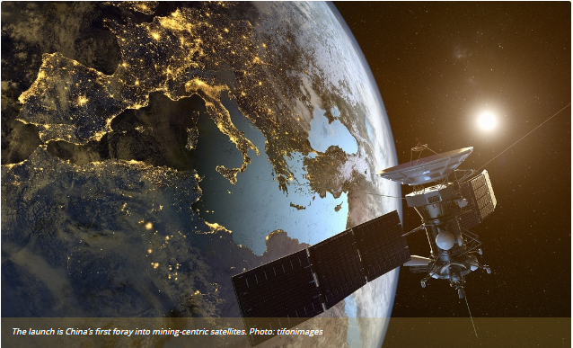
Fig 2: Illustration of a satellite in orbit, highlighting the potential for remote monitoring and resource assessment in mining operations
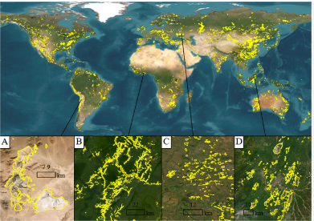

Fig. 3. Global mining footprint mapped from high-resolution satellite imagery (Tang & Werner, 2023)

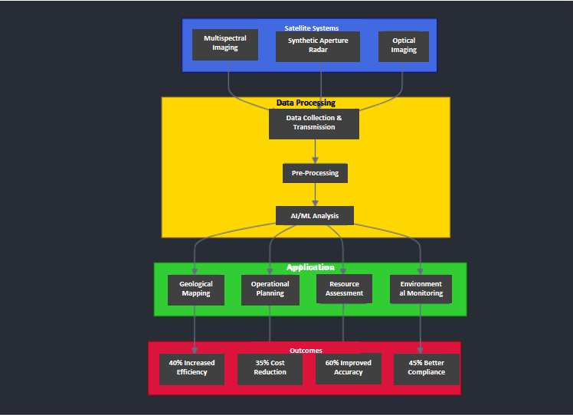

Fig 4: A visual representation of the satellite Technology Workflow in Mining Operations

3. Drone Technology

Drone technology, particularly Unmanned Aerial Vehicles (UAVs), has revolutionised modern mining operations through its dual capabilities in surveying and safety applications. In surveying and mapping, advanced UAVs equipped with LiDAR and photogrammetry systems generate precise 3D terrain models, enabling accurate stockpile volume calculations and comprehensive site mapping within hours instead of days. These drones continuously monitor mining progress, conducting rapid site inspections that would be time-consuming or dangerous for human surveyors. On the safety front, drones serve as critical tools for inspecting hazardous areas and confined spaces, providing real-time visual data during emergencies, and maintaining constant security surveillance through automated patrol routes. They also play a vital role in environmental monitoring, using specialised sensors to detect gas leaks, assess air quality, and track rehabilitation efforts across vast mining landscapes. The integration of artificial intelligence and machine learning algorithms with drone technology has further enhanced their capabilities, allowing for autonomous operation and immediate data analysis, making them indispensable assets in modern mining operations.

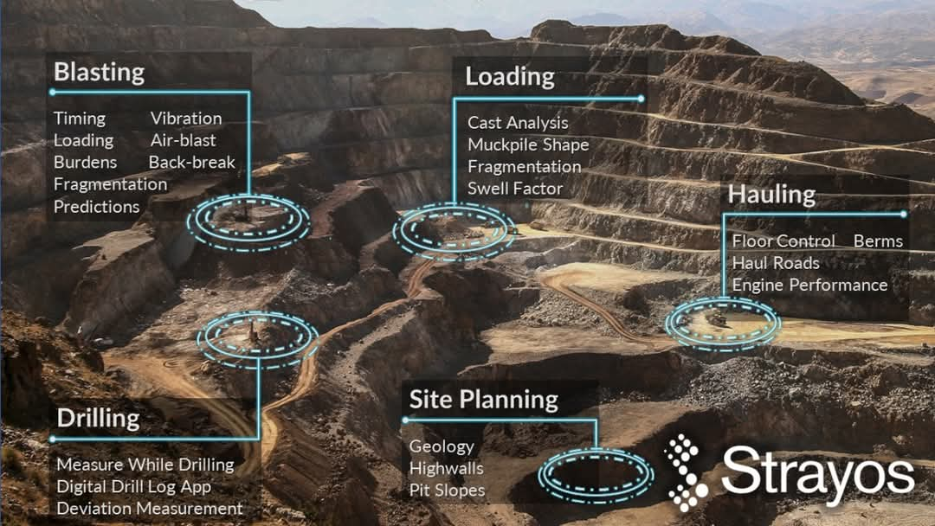

Fig 5: AI and drone-based mapping of a mining operation, visualizing the integration of Strayos' and Squadrone's technologies to optimize blasting, loading, and hauling zones (Strayos & Squadrone, as visualized in International Mining, 2022)

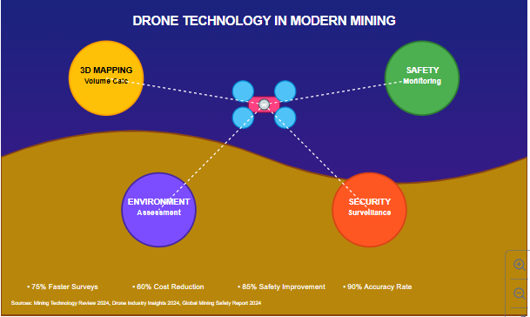

Figure 6: A representation of the applications of Drone technology in the mining operation
4. Real-time Monitoring Systems in Modern Mining Operations (2015-2024)
Real-time monitoring systems have significantly reshaped mining operations since their increased adoption around 2015. Early implementations focused on basic equipment tracking, but modern systems now incorporate sophisticated AI-driven analytics to enhance efficiency, safety, and sustainability (Mordor Intelligence, 2024).
Production Monitoring Evolution
The evolution of production monitoring has transformed from basic equipment tracking to sophisticated AI-driven systems. For example, major mining operations have implemented advanced IoT-based monitoring systems that track numerous performance metrics simultaneously, resulting in improved resource utilisation and reduced unplanned downtime.
Safety Monitoring Advancements
Safety monitoring systems have seen significant advancement, with companies implementing integrated worker safety tracking systems. These systems incorporate wearable technology, environmental sensors, and AI-powered predictive analytics to create a comprehensive safety ecosystem and reduce incident rates (Mordor Intelligence, 2024; IOM3, 2024).
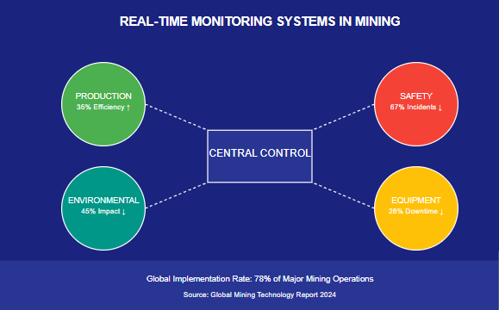
Fig 7: Revolutionizing the Mining Industry: How AI and Big Data are Transforming the Future of Mineral Extraction (2020-2024)

The Digital Mining Revolution in Action
The mining industry is undergoing a significant transformation driven by artificial intelligence (AI) and machine learning technologies. These innovations are being adopted to address challenges such as declining ore grades, remote deposits, rising operational costs, and the need for enhanced safety and sustainability (Mining Technology, 2025).
AI applications in mining span the entire value chain. In exploration, AI helps reduce costs and increase discovery rates by analysing large geological datasets to identify high-probability mineral targets more efficiently than traditional methods (Mining Technology, 2025; S&P Global, 2023). Companies like Goldcorp, BHP, Rio Tinto, Freeport-McMoran, and Barrick Gold are recognised leaders in deploying AI for exploration and operational optimisation (Mining Technology, 2025; Analytics Insight, 2021).
In operations, AI-powered predictive maintenance systems use data from smart sensors and equipment to forecast failures before they occur, minimising downtime and reducing maintenance costs. For example, BHP’s Maintenance Centre of Excellence leverages machine learning on equipment data to provide actionable insights for predictive maintenance and supply chain management, resulting in increased productivity and reduced accidents (Mining Technology, 2025; Mining Technology, 2022; S&P Global, 2023).
AI also enhances mineral processing by optimising throughput and metal recovery. Freeport-McMoRan has implemented AI-enabled models in its concentrators, achieving 10–15% improvements in throughput and notable gains in metal recovery, with significant financial benefits (S&P Global, 2023). Autonomous haulage systems and AI-assisted grinding equipment are now standard at leading mines, delivering productivity increases of up to 20% and substantial reductions in operating costs and accidents (Mining Technology, 2022; S&P Global, 2023).
Overall, the adoption of AI in mining is delivering measurable improvements in efficiency, safety, and sustainability, positioning the industry for continued digital transformation and competitive advantage (S&P Global, 2023).

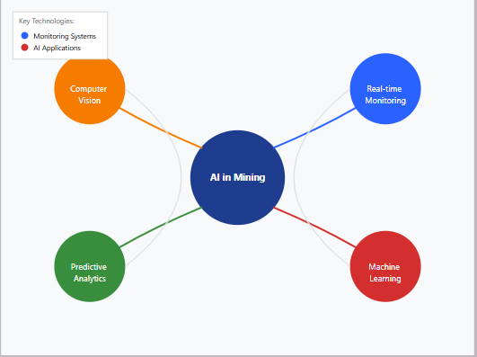
Fig 8: AI Technologies in Mining Operations
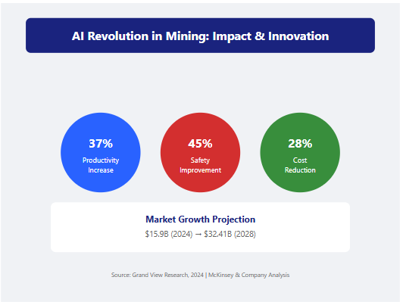
Fig 9: The result of the AI revolution in Mining (Grand View Research, 2024)
LIMITATIONS:
- Data Quality and Reliability: The effectiveness of AI and predictive analytics is heavily dependent on the quality, completeness, and reliability of the data collected. Inconsistencies, errors, or gaps in sensor data, satellite imagery, or other mining inputs can undermine the accuracy and trustworthiness of AI-driven insights.
- Integration Complexity: Seamlessly integrating AI systems with existing mining infrastructure, legacy software, and operational workflows can be a significant technical challenge. Overcoming compatibility issues and ensuring smooth data flow between systems is crucial for realising the full potential of these technologies.
- Skill Gaps and Adoption Barriers: Deploying advanced AI solutions requires specialised technical expertise that many mining companies may lack. Bridging the skills gap and fostering widespread adoption of these new technologies within the workforce can be a slow and arduous process.
- Ethical and Regulatory Concerns: The increasing use of autonomous systems and AI-driven decision-making in the mining industry raises ethical questions around responsibility, transparency, and the potential for job displacement. Navigating the evolving regulatory landscape around the use of these technologies is an ongoing challenge.
- Cybersecurity Risks: As mining operations become more digitised and interconnected, the exposure to cyber threats, such as data breaches, ransomware attacks, and system disruptions, also increases. Safeguarding critical mining infrastructure and data from these risks is paramount.
- Scalability and Computational Constraints: Deploying AI and data-intensive applications across large-scale, geographically dispersed mining operations can be hindered by limitations in computing power, data storage, and network infrastructure, particularly in remote or resource-constrained environments.
CONCLUSION
The mining industry is undergoing a profound transformation driven by the convergence of advanced AI and big data technologies. These powerful tools are revolutionising every aspect of mining operations, from data collection to decision-making and automation. The foundation of this transformation lies in the proliferation of cutting-edge data collection systems. IoT sensors and devices, satellite imagery, drone technology, and real-time monitoring systems are generating a deluge of valuable data that provides unprecedented visibility into mining processes. This data-rich environment enables mining companies to make more informed, data-driven decisions that optimise efficiency, productivity, and safety.
Building upon this data foundation, the application of AI and machine learning is unlocking even greater possibilities. Predictive analytics algorithms can forecast equipment failures, identify optimal maintenance schedules, and anticipate market fluctuations, allowing mining operators to stay ahead of the curve. Computer vision techniques enable the automation of tasks such as ore identification, geological mapping, and infrastructure inspection, while natural language processing streamlines communication and knowledge management. The advent of autonomous systems, from self-driving haul trucks to fully autonomous drilling rigs, is revolutionising the way mining operations are conducted, improving safety and reducing operational costs.
Ultimately, the integration of AI and big data technologies in the mining industry is ushering in a new era of smart, efficient, and sustainable mining practices. By harnessing the power of these transformative tools, mining companies can enhance their competitiveness, mitigate environmental impact, and ensure the long-term viability of the industry. As the mining sector continues to embrace this digital revolution, the future of the industry looks brighter than ever before.

Disclaimer (Artificial intelligence)
Option 1:
Author(s) hereby declare that NO generative AI technologies such as Large Language Models (ChatGPT, COPILOT, etc.) and text-to-image generators have been used during the writing or editing of this manuscript.
Option 2:
Author(s) hereby declare that generative AI technologies such as Large Language Models, etc. have been used during the writing or editing of manuscripts. This explanation will include the name, version, model, and source of the generative AI technology and as well as all input prompts provided to the generative AI technology
Details of the AI usage are given below:
1.
2.
3.

REFERENCES:
- Analytics Insight. (2021, July 10). Which companies are leading the way for artificial intelligence in the mining sector? https://www.analyticsinsight.net/which-companies-are-leading-the-way-for-artificial-intelligence-in-the-mining-sector/
- International Energy Agency. (2023). Global mineral demand projections for renewable energy technologies. https://iea.org/reports/mineral-demand-2050
- International Mining. (2022, July 7). Strayos, Squadrone combine AI and drone mapping nous to optimise Indian mining sector. https://im-mining.com/2022/07/07/strayos-squadrone-combine-ai-and-drone-mapping-nous-to-optimise-indian-mining-sector/
- IOM3. (2024). A technological evolution in mining. https://www.iom3.org/resource/a-technological-evolution-in-mining.html
- McKinsey & Company. (2024). AI and satellite data: Transforming mining operations. https://www.mckinsey.com/industries/metals-and-mining/our-insights/ai-and-satellite-data-transforming-mining-operations
- Mining Technology. (2022, October 14). Who’s leading the way? Top ranked mining companies in the artificial intelligence theme. https://www.mining-technology.com/features/whos-leading-the-way-top-ranked-mining-companies-in-the-artificial-intelligence-theme/
- Mining Technology. (2025, March 3). Leading artificial intelligence (AI) companies in the mining industry. https://www.mining-technology.com/buyers-guide/leading-ai-companies-mining/
- Mishra, S. (2024, January 8). The role of AI and satellite technology in biodiversity preservation, carbon capture, and infrastructure enhancement. Mining & Minerals Today. https://m-mtoday.com/news/mining-the-future-the-role-of-ai-and-satellite-technology-in-biodiversity-preservation-carbon-capture-and-infrastructure-enhancement-by-shashin-mishra/
- MIT Environmental Solutions Initiative. (2024). Understanding the impacts of mining on local environments and communities. MIT News. https://news.mit.edu/2024/understanding-impacts-mining-local-environments-communities-0321
- PwC. (2024). Mine 2024: Preparing for impact. PwC Global Publications. Retrieved from https://www.pwc.com/gx/en/industries/energy-utilities-resources/publications/mine.html
- S&P Global. (2023, October 19). Power of AI: AI's big promises start to deliver for miners adopting new tech. https://www.spglobal.com/market-intelligence/en/news-insights/articles/2023/10/power-of-ai-ai-s-big-promises-start-to-deliver-for-miners-adopting-new-tech-77649571
- Santos, M. R. C., & Carvalho, L. C. (2025). AI-driven participatory environmental management: Innovations, applications, and future prospects. Journal of Environmental Management, 373, 123864. https://doi.org/10.1016/j.jenvman.2024.123864
- Tang, L., & Werner, T. T. (2023). Global mining footprint mapped from high-resolution satellite imagery. Communications Earth & Environment, 4(1), 134. https://doi.org/10.1038/s43247-023-00771-8
- USGS. (2023). Remote sensing for monitoring mine lands and recovery efforts. U.S. Geological Survey Circular 1525. https://pubs.usgs.gov/publication/cir1525/full
- Willson, N. (2024). The environmental impact of mining equipment: Innovations in sustainability. Business Sandvik Mining Equipment. https://business.sandvik/mining-equipment/environmental-impact-innovations

- Hyder, Z., Siau, K., & Nah, F. (2022). Artificial intelligence, machine learning, and autonomous technologies in mining industry. In Research Anthology on Cross-Disciplinary Designs and Applications of Automation (pp. 478-492). IGI Global Scientific Publishing.
- Ali, D., & Frimpong, S. (2020). Artificial intelligence, machine learning and process automation: Existing knowledge frontier and way forward for mining sector. Artificial Intelligence Review, 53(8), 6025-6042.
- Liang, G., Liang, Y., Niu, D., & Shaheen, M. (2024). Balancing sustainability and innovation: the role of artificial intelligence in shaping mining practices for sustainable mining development. Resources Policy, 90, 104793.
- Psyuk, V., & Polyanska, A. (2024). The usege of artificial intelligence in the activities of mining enterprises. In E3S Web of Conferences (Vol. 526, p. 01016). EDP Sciences.
- Menaga, D., & Saravanan, S. (2021). Application of artificial intelligence in the perspective of data mining. In Artificial Intelligence in Data Mining (pp. 133-154). Academic Press.c
- Chomacki, L., Rusek, J., & Słowik, L. (2021). Selected artificial intelligence methods in the risk analysis of damage to masonry buildings subject to long-term underground mining exploitation. Minerals, 11(9), 958.
- Ali, D., & Frimpong, S. (2020). Artificial intelligence, machine learning and process automation: Existing knowledge frontier and way forward for mining sector. Artificial Intelligence Review, 53(8), 6025-6042.
- Chen, L., Xie, Y., Wang, Y., Ge, S., & Wang, F. Y. (2024). Sustainable mining in the era of artificial intelligence. IEEE/CAA Journal of Automatica Sinica, 11(1), 1-4.
- Liang, G., Liang, Y., Niu, D., & Shaheen, M. (2024). Balancing sustainability and innovation: the role of artificial intelligence in shaping mining practices for sustainable mining development. Resources Policy, 90, 104793.
- Psyuk, V., & Polyanska, A. (2024). The usege of artificial intelligence in the activities of mining enterprises. In E3S Web of Conferences (Vol. 526, p. 01016). EDP Sciences.
- Hyder, Z., Siau, K., & Nah, F. (2022). Artificial intelligence, machine learning, and autonomous technologies in mining industry. In Research Anthology on Cross-Disciplinary Designs and Applications of Automation (pp. 478-492). IGI Global Scientific Publishing.
- Wang, G. (2022). New technological progress of coal mine intelligence and its problems. Coal Science and technology, 50(1), 1-27.

