**Conservation Agriculture Practices and Their Impact on Soil Health and Pest Dynamics**

**Abstract:**

Conservation agriculture (CA) practices, including reduced tillage, crop residue retention, and crop rotation, have gained prominence as sustainable farming methods. This review explores the impact of these practices on soil health parameters such as organic matter (OM) content, nutrient availability, water retention capacity, and microbial diversity. Additionally, the article examines how CA practices influence pest dynamics, including weed, insect, and pathogen populations. The complex interactions between soil health and pest pressure under CA systems are discussed. The review highlights the potential of CA to improve soil quality while presenting challenges in pest management that require integrated approaches. Future research directions to optimize CA practices for enhanced soil health and sustainable pest management are suggested.

Keywords: conservation agriculture, soil health, pest dynamics, sustainability, agroecosystems

**1. Introduction**

Conservation agriculture (CA) has emerged as a promising approach to sustainable food production, aiming to minimize soil disturbance, maintain permanent soil cover, and diversify crop rotations [1]. As concerns about soil degradation, water scarcity, and the environmental impact of conventional agriculture grow, CA practices have gained attention worldwide [2]. CA encompasses three key principles: reduced or no tillage, retention of crop residues on the soil surface, and implementation of diverse crop rotations [3].

The adoption of CA practices has been driven by their potential to improve soil health, reduce erosion, enhance water retention, and sequester carbon [4]. Healthy soils are the foundation of sustainable agriculture, as they support plant growth, nutrient cycling, and ecosystem services [5]. CA practices promote soil health by increasing organic matter content, improving soil structure, and fostering diverse microbial communities [6].

However, the transition from conventional to CA also presents challenges, particularly in terms of pest management [7]. Reduced tillage and crop residue retention can create favorable conditions for certain weeds, insects, and pathogen populations [8]. Understanding the complex interactions between CA practices, soil health, and pest dynamics is crucial for developing effective and sustainable management strategies [9].

This review aims to synthesize current knowledge on the impact of CA practices on soil health and pest dynamics. It will discuss the benefits and challenges associated with CA in terms of soil quality and pest management, highlighting the need for integrated approaches. The review will also identify research gaps and future directions to optimize CA practices for enhanced agroecosystem sustainability.

**2. Conservation Agriculture Practices**

**2.1 Reduced Tillage**

Reduced tillage, also known as minimum tillage or no-till, involves minimizing soil disturbance by eliminating or reducing the frequency and intensity of plowing [10]. This practice aims to preserve soil structure, reduce erosion, and maintain soil organic matter [11]. Reduced tillage systems rely on direct seeding or planting into undisturbed soil, often using specialized equipment [12].

**2.2 Crop Residue Retention**

Crop residue retention involves leaving plant residues from previous crops on the soil surface instead of removing or burning them [13]. This practice provides a protective layer that reduces soil erosion, moderates soil temperature, and conserves soil moisture [14]. Crop residues also serve as a source of (OM), gradually decomposing and contributing to soil nutrient cycling [15].

**2.3 Crop Rotation**

Crop rotation involves the sequential cultivation of different crops on the same land over successive seasons [16]. Diversifying crop rotations helps break pest and disease cycles, improve soil fertility, and enhance biodiversity [17]. Leguminous crops, such as soybeans or peas, are often included in rotations to fix atmospheric nitrogen (N) and reduce reliance on synthetic fertilizers [18].

**3. Impact on Soil Health**

**3.1 Organic Matter and Soil Structure**

CA practices have been shown to increase soil organic matter content over time [19]. Reduced tillage minimizes the disturbance and oxidation of soil organic matter, while crop residues provide a continuous input of organic material [20]. Increased organic matter improves soil structure, enhancing aggregation and porosity [21]. Well-structured soils have better water infiltration, aeration, and root growth [22].

**3.2 Nutrient Availability and Cycling**

CA practices influence nutrient availability and cycling in soils. Crop residues release nutrients slowly as they decompose, providing a steady supply to subsequent crops [23]. Leguminous cover crops in rotations fix atmospheric nitrogen, reducing the need for synthetic fertilizers [24]. However, the immobilization of nutrients in crop residues can sometimes lead to temporary nutrient deficiencies, especially in the early stages of CA adoption [25].

**3.3 Water Retention and Conservation**

Crop residues and improved soil structure under CA enhance water retention and infiltration [26]. Mulching with residues reduces evaporation losses and moderates soil temperature fluctuations [27]. Improved water holding capacity is particularly beneficial in drought-prone regions, where CA practices can help mitigate water stress [28].

**3.4 Microbial Diversity and Activity**

CA practices foster diverse and abundant soil microbial communities [29]. Reduced tillage and crop residues provide a stable habitat and substrate for soil microorganisms [30]. Increased microbial biomass and activity contribute to nutrient cycling, organic matter decomposition, and the formation of stable soil aggregates [31]. Diverse microbial communities also play a role in suppressing soil-borne pathogens through competition and antagonism [32].

**4. Impact on Pest Dynamics**

**4.1 Weed Populations and Management**

CA practices, particularly reduced tillage, can lead to changes in weed populations and management challenges [33]. Without regular tillage to disrupt weed growth, certain weed species may thrive, especially perennials [34]. Crop residues can also create favorable conditions for weed seed germination [35]. However, CA systems can employ integrated weed management strategies, such as cover crops, crop rotations, and targeted herbicide applications, to suppress weed growth [36].

**4.2 Insect Pests and Natural Enemies**

The impact of CA on insect pest populations is complex and varies depending on the specific pest and agroecosystem [37]. Crop residues can provide shelter and overwintering sites for certain insect pests, leading to higher pest pressure [38]. However, CA practices also support diverse communities of natural enemies, such as predatory insects and spiders, which can contribute to pest suppression [39]. Crop rotations can disrupt the life cycles of host-specific pests, reducing their populations over time [40].

**4.3 Plant Pathogens and Disease Management**

CA practices can influence the incidence and severity of plant diseases [41]. Crop residues can serve as a reservoir for plant pathogens, increasing the risk of disease outbreaks [42]. Reduced tillage may also favor the survival and spread of soil-borne pathogens [43]. However, CA systems can employ cultural practices, such as crop rotations and residue management, to break disease cycles and reduce inoculum levels [44]. Improved soil health under CA can also enhance plant resistance to diseases [45].

**5. Integrated Pest Management in Conservation Agriculture**

Effective pest management in CA systems requires an integrated approach that combines cultural, biological, and chemical control methods [46]. Cultural practices, such as diverse crop rotations and cover cropping, can disrupt pest life cycles and create habitats for natural enemies [47]. Biological control, through the conservation and augmentation of beneficial organisms, can help regulate pest populations [48]. Targeted and judicious use of pesticides, guided by economic thresholds and pest monitoring, can complement other management strategies [49].

**6. Future Research Directions**

While CA practices have shown promise in improving soil health and sustainability, further research is needed to optimize their implementation and address pest management challenges [50]. Future research should focus on:

1. Long-term studies to assess the cumulative effects of CA on soil health and pest dynamics across different agroecosystems [51].
2. Development of improved crop varieties and cover crops that are well-suited to CA systems and resistant to pests and diseases [52].
3. Exploration of innovative weed management strategies, such as precision agriculture techniques and targeted herbicide applications [53].
4. Investigation of the potential synergies between CA practices and biological control agents for effective pest management [54].
5. Economic and social assessments of CA adoption, considering factors such as labor requirements, input costs, and farmer perceptions [55].

Conservation Agriculture (CA) represents a paradigm shift in agricultural practices, moving away from conventional tillage-based systems toward more sustainable approaches that prioritize soil health, biodiversity, and ecological balance. As global concerns about food security, climate change, and environmental degradation intensify, CA has emerged as a promising framework to address these interconnected challenges. This comprehensive exploration examines how conservation agriculture practices influence soil health parameters and pest dynamics, highlighting both the benefits and challenges of implementing these systems across diverse agroecological contexts.

Conservation Agriculture is built upon three fundamental principles: minimal soil disturbance (reduced or no-tillage), permanent soil cover (through cover crops or crop residues), and crop diversification (through rotation or intercropping). These principles work synergistically to create resilient agricultural systems that maintain productivity while enhancing ecological functions. The holistic approach of CA recognizes that soil is not merely a substrate for plant growth but a complex living ecosystem whose health directly influences crop performance, pest pressure, and overall system sustainability.

Soil health represents the continued capacity of soil to function as a vital living ecosystem that sustains plants, animals, and humans. It encompasses physical, chemical, and biological parameters that interact in complex ways. Conservation Agriculture practices significantly influence these parameters, often with profound implications for agricultural productivity and environmental sustainability. The physical structure of soil, for instance, undergoes remarkable transformation under CA systems. By minimizing mechanical disturbance through reduced or zero tillage, CA helps maintain soil aggregates – the building blocks of soil structure. These aggregates create a network of pores of varying sizes that facilitate water infiltration, gas exchange, and root penetration. Long-term studies across diverse agroecological zones have demonstrated that CA practices lead to improved soil aggregation, increased porosity, and enhanced structural stability compared to conventional tillage systems.

Water dynamics within agricultural systems are also profoundly influenced by CA practices. The improved soil structure under CA enhances water infiltration rates, reducing surface runoff and erosion. Furthermore, the presence of crop residues or cover crops on the soil surface acts as a protective barrier that minimizes evaporation losses and moderates soil temperature fluctuations. This moisture conservation aspect of CA is particularly valuable in rain-fed agricultural systems and regions experiencing increasing climate variability. Research from semi-arid regions has documented substantial improvements in water use efficiency under CA systems, with some studies reporting water savings of 15-40% compared to conventional practices. The enhanced water retention capacity not only supports crop growth during dry spells but also contributes to groundwater recharge and reduced flooding risks during intense rainfall events.

The chemical properties of soil undergo significant changes under Conservation Agriculture regimes. One of the most notable transformations is the gradual increase in soil organic carbon (SOC) content. By minimizing soil disturbance and providing continuous organic inputs through crop residues and cover crops, CA creates favorable conditions for carbon sequestration. The accumulation of SOC represents a win-win scenario: it mitigates climate change by removing carbon dioxide from the atmosphere while simultaneously improving soil fertility and structure. Meta-analyses of global data have shown that conversion from conventional tillage to no-till systems can increase SOC stocks by 0.3-0.6 tonnes per hectare per year, although the rates vary considerably depending on climate, soil type, and management practices.

The nutrient cycling dynamics in CA systems differ markedly from conventional agriculture. The stratification of nutrients, particularly phosphorus and potassium, is commonly observed in no-till systems, with higher concentrations in the surface layers. While this pattern raises concerns about potential nutrient imbalances, research indicates that the enhanced biological activity in CA soils often compensates by improving nutrient accessibility. The decomposition of crop residues and the activities of soil organisms contribute to a more gradual release of nutrients, potentially reducing leaching losses and increasing nutrient use efficiency. Additionally, the improved soil structure and water infiltration under CA can reduce the loss of dissolved nutrients through runoff, further enhancing the system's resource efficiency.

Perhaps the most dramatic changes under CA occur in soil biological properties. The combination of minimal disturbance, permanent soil cover, and diverse crop rotations creates a favorable habitat for soil organisms, from microscopic bacteria and fungi to larger fauna like earthworms and arthropods. These organisms perform crucial ecosystem services, including organic matter decomposition, nutrient cycling, pest suppression, and soil structure formation. Studies comparing conventional and CA systems have consistently documented higher microbial biomass, diversity, and activity in soils under conservation management. The fungal community, in particular, tends to flourish under no-till conditions, with mycorrhizal fungi forming extensive networks that enhance nutrient uptake for crops. Earthworm populations often increase several-fold under CA, contributing to improved soil structure through their burrowing activities and the formation of stable organo-mineral complexes.

The transition to Conservation Agriculture fundamentally alters the ecological context in which pests and their natural enemies interact. These changes in pest dynamics result from multiple interacting factors, including modifications to the physical environment, shifts in resource availability, alterations to predator-prey relationships, and changes in the timing of ecological processes. Understanding these complex interactions is essential for developing effective integrated pest management strategies within CA systems.

The physical habitat created by CA practices significantly influences pest populations. The presence of crop residues on the soil surface modifies microclimate conditions, often creating cooler and moister environments that can favor certain organisms. For soil-dwelling pests, the reduced soil disturbance under CA can either provide stable habitats that increase their abundance or disrupt their life cycles by preserving natural enemy populations. The research literature presents mixed findings regarding pest responses to CA, highlighting the context-specific nature of these interactions. For instance, studies from temperate regions have reported increased problems with slugs and snails in no-till systems, attributed to the favorable microclimate and shelter provided by surface residues. Conversely, research from tropical systems has documented reduced incidence of certain insect pests under CA, often linked to enhanced natural enemy populations and improved crop vigor.

Weed management represents one of the most significant challenges in CA systems, particularly during the transition phase. The shift from tillage-based weed control to integrated approaches requires careful planning and adaptation. Initially, weed pressure may increase as the seed bank established under conventional management expresses itself. However, long-term studies indicate that weed communities typically undergo succession under CA, with a gradual shift from annual to perennial species and often an overall reduction in weed density after several years of consistent management. The mechanisms driving these changes include altered germination cues due to the absence of soil disturbance, physical suppression by mulch layers, competition from cover crops, and predation of weed seeds by enhanced populations of seed predators. Successful weed management in CA systems generally combines multiple strategies, including strategic use of herbicides, competitive crop varieties, optimized planting arrangements, cover crop selection, and occasional mechanical interventions.

The dynamics of soil-borne pathogens under Conservation Agriculture are particularly complex, influenced by changes in soil physical and chemical properties, shifts in microbial communities, and alterations to crop-pathogen interactions. The retention of crop residues can potentially provide habitat and survival mechanisms for certain pathogens, especially those causing diseases in the subsequent crop of the same family. This risk highlights the critical importance of diverse crop rotations in CA systems to break disease cycles. However, the enhanced biological activity and diversity observed in CA soils often contribute to disease suppression through multiple mechanisms, including competition, antagonism, parasitism, and induced systemic resistance in host plants. Research from various cropping systems has demonstrated that well-managed CA practices can reduce the incidence of certain soil-borne diseases by fostering suppressive soil microbiomes, although the outcomes depend on the specific pathosystem and management context.

Above-ground pests and diseases respond to the complex habitat modifications created by CA practices. The increased vegetation diversity through intercropping, relay cropping, or rotational diversity can disrupt pest location of host plants and reduce the spread of specialist herbivores. The "resource concentration hypothesis" suggests that pests are more likely to find and remain on host plants that are grown in pure stands than when interspersed with non-host plants. Additionally, the "enemies hypothesis" proposes that diverse cropping systems support higher populations of natural enemies that help regulate pest populations. Evidence supporting these hypotheses comes from studies across different agricultural systems, showing reduced pest incidence and damage in diverse CA arrangements compared to monocultures. However, the outcomes are not universally positive and depend on the specific pest-crop combination, the surrounding landscape context, and the particular implementation of CA principles.

The conservation of natural enemies represents one of the most significant potential benefits of CA systems for pest management. The reduced disturbance, habitat diversity, and resource continuity provided by CA practices create favorable conditions for predators and parasitoids. Numerous studies have documented higher abundance and diversity of beneficial arthropods in CA systems compared to conventional agriculture. These natural enemies provide valuable ecosystem services through biological control of pests, potentially reducing the need for pesticide applications. The economic value of these services is substantial, although often underappreciated in conventional cost-benefit analyses of agricultural systems. Conservation biological control – the practice of modifying the environment to protect and enhance natural enemies – aligns perfectly with CA principles and offers significant potential for synergistic integration.

The transition to Conservation Agriculture involves complex trade-offs and context-specific challenges that must be addressed for successful implementation. During the initial years of conversion from conventional to CA practices, farmers often face increased weed pressure, potential yield penalties, and technical difficulties in adapting equipment and management approaches. These challenges can be particularly daunting for resource-limited farmers without access to appropriate technology, knowledge, or financial support. The time lag between adoption of CA practices and the realization of soil health benefits requires patience and long-term planning, which may conflict with immediate economic pressures faced by many farmers.

The successful implementation of CA requires a systems approach that considers the entire production context, including socioeconomic factors, local knowledge, and institutional support. Adaptations of CA principles to fit specific agroecological and socioeconomic contexts are essential, as blanket recommendations rarely succeed across diverse farming systems. Participatory approaches that engage farmers in the co-development of locally appropriate CA practices have shown greater success rates than top-down technology transfer models. Additionally, enabling policies, market incentives, and institutional support are crucial for widespread adoption and sustained implementation of CA systems.

The integration of emerging technologies offers promising avenues to enhance the effectiveness and adoption of Conservation Agriculture. Precision agriculture tools, including GPS-guided equipment, variable rate technology, and remote sensing, can improve the efficiency of resource use and management precision in CA systems. Digital decision support tools that incorporate real-time data on weather, soil conditions, and pest pressure can help farmers optimize their management practices. Advanced breeding programs focused on developing crop varieties specifically adapted to CA conditions – such as those with vigorous early growth under mulch, enhanced weed competitiveness, or improved nutrient acquisition efficiency – could address some of the challenges currently faced in CA implementation.

**Conclusion**

Conservation agriculture practices, including reduced tillage, crop residue retention, and crop rotation, have the potential to improve soil health and sustainability in agroecosystems. These practices enhance soil organic matter, nutrient cycling, water retention, and microbial diversity. However, CA systems also present challenges in terms of pest management, requiring integrated approaches that combine cultural, biological, and chemical control methods. Future research should focus on optimizing CA practices, developing innovative pest management strategies, and assessing the long-term impacts on soil health and agroecosystem sustainability. By addressing these research gaps, conservation agriculture can contribute to the development of resilient and productive farming systems that meet the growing demand for food while preserving natural resources.

Disclaimer (Artificial intelligence)

Option 1:

Author(s) hereby declare that NO generative AI technologies such as Large Language Models (ChatGPT, COPILOT, etc.) and text-to-image generators have been used during the writing or editing of this manuscript.

Option 2:

Author(s) hereby declare that generative AI technologies such as Large Language Models, etc. have been used during the writing or editing of manuscripts. This explanation will include the name, version, model, and source of the generative AI technology and as well as all input prompts provided to the generative AI technology

Details of the AI usage are given below:

1.

2.

3.

**References:**

[1] FAO. (2017). Conservation Agriculture. Food and Agriculture Organization of the United Nations. <http://www.fao.org/conservation-agriculture/en/>

[2] Kassam, A., Friedrich, T., & Derpsch, R. (2019). Global spread of conservation agriculture. International Journal of Environmental Studies, 76(1), 29-51. <https://doi.org/10.1080/00207233.2018.1494927>

[3] Hobbs, P. R., Sayre, K., & Gupta, R. (2008). The role of conservation agriculture in sustainable agriculture. Philosophical Transactions of the Royal Society B: Biological Sciences, 363(1491), 543-555. <https://doi.org/10.1098/rstb.2007.2169>

[4] Pittelkow, C. M., Liang, X., Linquist, B. A., Van Groenigen, K. J., Lee, J., Lundy, M. E., ... & van Kessel, C. (2015). Productivity limits and potentials of the principles of conservation agriculture. Nature, 517(7534), 365-368. <https://doi.org/10.1038/nature13809>

[5] Doran, J. W., & Zeiss, M. R. (2000). Soil health and sustainability: managing the biotic component of soil quality. Applied Soil Ecology, 15(1), 3-11. <https://doi.org/10.1016/S0929-1393(00)00067-6>

[6] Verhulst, N., Govaerts, B., Verachtert, E., Castellanos-Navarrete, A., Mezzalama, M., Wall, P., ... & Sayre, K. D. (2010). Conservation agriculture, improving soil quality for sustainable production systems. Advances in Soil Science: Food Security and Soil Quality, 137-208. <https://doi.org/10.1201/EBK1439800577-7>

[7] Nichols, V., Verhulst, N., Cox, R., & Govaerts, B. (2015). Weed dynamics and conservation agriculture principles: A review. Field Crops Research, 183, 56-68. <https://doi.org/10.1016/j.fcr.2015.07.012>

[8] Sturz, A. V., Carter, M. R., & Johnston, H. W. (1997). A review of plant disease, pathogen interactions and microbial antagonism under conservation tillage in temperate humid agriculture. Soil and Tillage Research, 41(3-4), 169-189. <https://doi.org/10.1016/S0167-1987(96)01095-1>

[9] Farooq, M., & Siddique, K. H. (2015). Conservation agriculture: concepts, brief history, and impacts on agricultural systems. In Conservation agriculture (pp. 3-17). Springer, Cham. <https://doi.org/10.1007/978-3-319-11620-4_1>

[10] Triplett, G. B., & Dick, W. A. (2008). No-tillage crop production: A revolution in agriculture!. Agronomy Journal, 100(Supplement_3), S-153. <https://doi.org/10.2134/agronj2007.0005c>

[11] Busari, M. A., Kukal, S. S., Kaur, A., Bhatt, R., & Dulazi, A. A. (2015). Conservation tillage impacts on soil, crop and the environment. International Soil and Water Conservation Research, 3(2), 119-129. <https://doi.org/10.1016/j.iswcr.2015.05.002>

[12] Derpsch, R., Friedrich, T., Kassam, A., & Li, H. (2010). Current status of adoption of no-till farming in the world and some of its main benefits. International Journal of Agricultural and Biological Engineering, 3(1), 1-25. <https://doi.org/10.3965/j.issn.1934-6344.2010.01.001-025>

[13] Turmel, M. S., Speratti, A., Baudron, F., Verhulst, N., & Govaerts, B. (2015). Crop residue management and soil health: A systems analysis. Agricultural Systems, 134, 6-16. <https://doi.org/10.1016/j.agsy.2014.05.009>

[14] Ranaivoson, L., Naudin, K., Ripoche, A., Affholder, F., Rabeharisoa, L., & Corbeels, M. (2017). Agro-ecological functions of crop residues under conservation agriculture. A review. Agronomy for Sustainable Development, 37(4), 1-17. <https://doi.org/10.1007/s13593-017-0432-z>

[15] Kumar, K., & Goh, K. M. (1999). Crop residues and management practices: effects on soil quality, soil nitrogen dynamics, crop yield, and nitrogen recovery. Advances in Agronomy, 68, 197-319. <https://doi.org/10.1016/S0065-2113(08)60846-9>

[16] Castellazzi, M. S., Wood, G. A., Burgess, P. J., Morris, J., Conrad, K. F., & Perry, J. N. (2008). A systematic representation of crop rotations. Agricultural Systems, 97(1-2), 26-33. <https://doi.org/10.1016/j.agsy.2007.10.006>

[17] Karlen, D. L., Varvel, G. E., Bullock, D. G., & Cruse, R. M. (1994). Crop rotations for the 21st century. Advances in Agronomy, 53, 1-45. <https://doi.org/10.1016/S0065-2113(08)60611-2>

[18] Peoples, M. B., Herridge, D. F., & Ladha, J. K. (1995). Biological nitrogen fixation: an efficient source of nitrogen for sustainable agricultural production?. Plant and Soil, 174(1), 3-28. <https://doi.org/10.1007/BF00032239>

[19] West, T. O., & Post, W. M. (2002). Soil organic carbon sequestration rates by tillage and crop rotation: a global data analysis. Soil Science Society of America Journal, 66(6), 1930-1946. <https://doi.org/10.2136/sssaj2002.1930>

[20] Govaerts, B., Verhulst, N., Castellanos-Navarrete, A., Sayre, K. D., Dixon, J., & Dendooven, L. (2009). Conservation agriculture and soil carbon sequestration: between myth and farmer reality. Critical Reviews in Plant Science, 28(3), 97-122. <https://doi.org/10.1080/07352680902776358>

[21] Six, J., Elliott, E. T., & Paustian, K. (2000). Soil macroaggregate turnover and microaggregate formation: a mechanism for C sequestration under no-tillage agriculture. Soil Biology and Biochemistry, 32(14), 2099-2103. <https://doi.org/10.1016/S0038-0717(00)00179-6>

[22] Verhulst, N., Nelissen, V., Jespers, N., Haven, H., Sayre, K. D., Raes, D., ... & Govaerts, B. (2011). Soil water content, maize yield and its stability as affected by tillage and crop residue management in rainfed semi-arid highlands. Plant and Soil, 344(1), 73-85. <https://doi.org/10.1007/s11104-011-0728-8>

[23] Govaerts, B., Fuentes, M., Mezzalama, M., Nicol, J. M., Deckers, J., Etchevers, J. D., ... & Sayre, K. D. (2007). Infiltration, soil moisture, root rot and nematode populations after 12 years of different tillage, residue and crop rotation managements. Soil and Tillage Research, 94(1), 209-219. <https://doi.org/10.1016/j.still.2006.07.013>

[24] Tonitto, C., David, M. B., & Drinkwater, L. E. (2006). Replacing bare fallows with cover crops in fertilizer-intensive cropping systems: A meta-analysis of crop yield and N dynamics. Agriculture, Ecosystems & Environment, 112(1), 58-72. <https://doi.org/10.1016/j.agee.2005.07.003>

[25] Kirkegaard, J., Christen, O., Krupinsky, J., & Layzell, D. (2008). Break crop benefits in temperate wheat production. Field Crops Research, 107(3), 185-195. <https://doi.org/10.1016/j.fcr.2008.02.010>

[26] Thierfelder, C., & Wall, P. C. (2009). Effects of conservation agriculture techniques on infiltration and soil water content in Zambia and Zimbabwe. Soil and Tillage Research, 105(2), 217-227. <https://doi.org/10.1016/j.still.2009.07.007>

[27] Klocke, N. L., Currie, R. S., & Aiken, R. M. (2009). Soil water evaporation and crop residues. Transactions of the ASABE, 52(1), 103-110. <https://doi.org/10.13031/2013.25951>

[28] Thierfelder, C., Rusinamhodzi, L., Ngwira, A. R., Mupangwa, W., Nyagumbo, I., Kassie, G. T., & Cairns, J. E. (2015). Conservation agriculture in Southern Africa: Advances in knowledge. Renewable Agriculture and Food Systems, 30(4), 328-348. <https://doi.org/10.1017/S1742170513000550>

[29] García-Orenes, F., Morugán-Coronado, A., Zornoza, R., & Scow, K. (2013). Changes in soil microbial community structure influenced by agricultural management practices in a mediterranean agro-ecosystem. PloS One, 8(11), e80522. <https://doi.org/10.1371/journal.pone.0080522>

[30] Sapkota, T. B., Mazzoncini, M., Bàrberi, P., Antichi, D., & Silvestri, N. (2012). Fifteen years of no till increase soil organic matter, microbial biomass and arthropod diversity in cover crop-based arable cropping systems. Agronomy for Sustainable Development, 32(4), 853-863. <https://doi.org/10.1007/s13593-011-0079-0>

[31] Balota, E. L., Colozzi Filho, A., Andrade, D. S., & Dick, R. P. (2004). Long-term tillage and crop rotation effects on microbial biomass and C and N mineralization in a Brazilian Oxisol. Soil and Tillage Research, 77(2), 137-145. <https://doi.org/10.1016/j.still.2003.12.003>

[32] Weller, D. M., Raaijmakers, J. M., Gardener, B. B. M., & Thomashow, L. S. (2002). Microbial populations responsible for specific soil suppressiveness to plant pathogens. Annual Review of Phytopathology, 40(1), 309-348. <https://doi.org/10.1146/annurev.phyto.40.030402.110010>

[33] Chauhan, B. S., Singh, R. G., & Mahajan, G. (2012). Ecology and management of weeds under conservation agriculture: A review. Crop Protection, 38, 57-65. <https://doi.org/10.1016/j.cropro.2012.03.010>

[34] Moyer, J. R., Roman, E. S., Lindwall, C. W., & Blackshaw, R. E. (1994). Weed management in conservation tillage systems for wheat production in North and South America. Crop Protection, 13(4), 243-259. <https://doi.org/10.1016/0261-2194(94)90012-4>

[35] Cardina, J., Herms, C. P., & Doohan, D. J. (2002). Crop rotation and tillage system effects on weed seedbanks. Weed Science, 50(4), 448-460. [https://doi.org/10.1614/0043-1745(2002)050[0448:CRATSE]2.0.CO;2](https://doi.org/10.1614/0043-1745(2002)050%5B0448:CRATSE%5D2.0.CO;2)

[36] Bajwa, A. A. (2014). Sustainable weed management in conservation agriculture. Crop Protection, 65, 105-113. <https://doi.org/10.1016/j.cropro.2014.07.014>

[37] Soane, B. D., Ball, B. C., Arvidsson, J., Basch, G., Moreno, F., & Roger-Estrade, J. (2012). No-till in northern, western and south-western Europe: A review of problems and opportunities for crop production and the environment. Soil and Tillage Research, 118, 66-87. <https://doi.org/10.1016/j.still.2011.10.015>

[38] Stinner, B. R., & House, G. J. (1990). Arthropods and other invertebrates in conservation-tillage agriculture. Annual Review of Entomology, 35(1), 299-318. <https://doi.org/10.1146/annurev.en.35.010190.001503>

[39] Landis, D. A., Wratten, S. D., & Gurr, G. M. (2000). Habitat management to conserve natural enemies of arthropod pests in agriculture. Annual Review of Entomology, 45(1), 175-201. <https://doi.org/10.1146/annurev.ento.45.1.175>

[40] Cook, S. M., Khan, Z. R., & Pickett, J. A. (2007). The use of push-pull strategies in integrated pest management. Annual Review of Entomology, 52, 375-400. <https://doi.org/10.1146/annurev.ento.52.110405.091407>

[41] Bailey, K. L., & Lazarovits, G. (2003). Suppressing soil-borne diseases with residue management and organic amendments. Soil and Tillage Research, 72(2), 169-180. <https://doi.org/10.1016/S0167-1987(03)00086-2>

[42] Bockus, W. W., & Shroyer, J. P. (1998). The impact of reduced tillage on soilborne plant pathogens. Annual Review of Phytopathology, 36(1), 485-500. <https://doi.org/10.1146/annurev.phyto.36.1.485>

[43] Peters, R. D., Sturz, A. V., Carter, M. R., & Sanderson, J. B. (2003). Developing disease-suppressive soils through crop rotation and tillage management practices. Soil and Tillage Research, 72(2), 181-192. <https://doi.org/10.1016/S0167-1987(03)00087-4>

[44] Bailey, K. L., Gossen, B. D., Lafond, G. P., Watson, P. R., & Derksen, D. A. (2001). Effect of tillage and crop rotation on root and foliar diseases of wheat and pea in Saskatchewan from 1991 to 1998: univariate and multivariate analyses. Canadian Journal of Plant Science, 81(4), 789-803. <https://doi.org/10.4141/P00-116>

[45] Stone, A. G., Scheuerell, S. J., & Darby, H. M. (2004). Suppression of soilborne diseases in field agricultural systems: organic matter management, cover cropping, and other cultural practices. In Soil organic matter in sustainable agriculture (pp. 131-177). CRC Press. <https://doi.org/10.1201/9780203496374.ch5>

[46] Krupinsky, J. M., Bailey, K. L., McMullen, M. P., Gossen, B. D., & Turkington, T. K. (2002). Managing plant disease risk in diversified cropping systems. Agronomy Journal, 94(2), 198-209. <https://doi.org/10.2134/agronj2002.1980>

[47] Abawi, G. S., & Widmer, T. L. (2000). Impact of soil health management practices on soilborne pathogens

[48] Gurr, G. M., Wratten, S. D., & Luna, J. M. (2003). Multi-function agricultural biodiversity: pest management and other benefits. Basic and Applied Ecology, 4(2), 107-116. <https://doi.org/10.1078/1439-1791-00122>

[49] Radcliffe, E. B., Hutchison, W. D., & Cancelado, R. E. (Eds.). (2009). Integrated pest management: concepts, tactics, strategies and case studies. Cambridge University Press. <https://doi.org/10.1017/CBO9780511626463>

[50] Kassam, A., Friedrich, T., Shaxson, F., & Pretty, J. (2009). The spread of conservation agriculture: justification, sustainability and uptake. International Journal of Agricultural Sustainability, 7(4), 292-320. <https://doi.org/10.3763/ijas.2009.0477>

[51] Brouder, S. M., & Gomez-Macpherson, H. (2014). The impact of conservation agriculture on smallholder agricultural yields: A scoping review of the evidence. Agriculture, Ecosystems & Environment, 187, 11-32. <https://doi.org/10.1016/j.agee.2013.08.010>

[52] Giller, K. E., Witter, E., Corbeels, M., & Tittonell, P. (2009). Conservation agriculture and smallholder farming in Africa: the heretics' view. Field Crops Research, 114(1), 23-34. <https://doi.org/10.1016/j.fcr.2009.06.017>

[53] Chauhan, B. S., & Gill, G. S. (2014). Weed management using crop competition in Australia. Crop Protection, 64, 8-13. <https://doi.org/10.1016/j.cropro.2014.06.009>

[54] Rusch, A., Bommarco, R., Jonsson, M., Smith, H. G., & Ekbom, B. (2013). Flow and stability of natural pest control services depend on complexity and crop rotation at the landscape scale. Journal of Applied Ecology, 50(2), 345-354. <https://doi.org/10.1111/1365-2664.12055>

[55] Knowler, D., & Bradshaw, B. (2007). Farmers' adoption of conservation agriculture: A review and synthesis of recent research. Food Policy, 32(1), 25-48. <https://doi.org/10.1016/j.foodpol.2006.01.003>

|  |  |
| --- | --- |
| **Principle** | **Description** |
| Reduced tillage | Minimizing soil disturbance by reducing or eliminating plowing |
| Crop residue retention | Leaving plant residues from previous crops on the soil surface |
| Crop rotation | Sequential cultivation of different crops on the same land |

***Table 1. Key principles of conservation agriculture***

|  |  |
| --- | --- |
| **Soil Health Parameter** | **Impact of Conservation Agriculture** |
| Organic matter content | Increased over time due to reduced tillage and crop residue retention |
| Soil structure | Improved aggregation and porosity, enhancing water infiltration and aeration |
| Nutrient availability | Slow release of nutrients from decomposing crop residues; nitrogen fixation by leguminous cover crops |
| Water retention | Enhanced by crop residues and improved soil structure, reducing evaporation losses |
| Microbial diversity | Fostered by reduced tillage and crop residues, contributing to nutrient cycling and pathogen suppression |

***Table 2. Impact of conservation agriculture on soil health parameters***

|  |  |  |
| --- | --- | --- |
| **Pest Type** | **Challenges** | **Management Strategies** |
| Weeds | Increased populations of certain weed species, especially perennials | Integrated weed management: cover crops, crop rotations, targeted herbicide applications |
| Insect pests | Crop residues provide shelter and overwintering sites for some pests | Conservation and augmentation of natural enemies; crop rotations to disrupt pest life cycles |
| Plant pathogens | Crop residues can serve as pathogen reservoirs; reduced tillage may favor soil-borne pathogens | Cultural practices: crop rotations, residue management; improved plant resistance through enhanced soil health |

***Table 3. Pest management challenges and strategies in conservation agriculture***

|  |  |  |  |  |
| --- | --- | --- | --- | --- |
| **Study** | **Location** | **Duration (years)** | **Crops** | **Key Findings** |
| Pittelkow et al. (2015) | Global meta-analysis | Variable | Various | Conservation agriculture practices resulted in yield reductions of 2.5% on average, but with significant variability depending on crop, climate, and management practices. |
| Kassam et al. (2019) | Global review | Variable | Various | Conservation agriculture is practiced on over 180 million hectares worldwide, with adoption rates varying by region and cropping system. |
| Thierfelder et al. (2015) | Southern Africa | 2-5 | Maize, legumes | Conservation agriculture improved soil quality, water infiltration, and crop yields compared to conventional tillage, particularly in drought years. |

***Table 4. Selected studies on the adoption and impacts of conservation agriculture***

|  |  |  |
| --- | --- | --- |
| **Soil Property** | **Conventional Tillage** | **Conservation Agriculture** |
| Bulk density (g/cm³) | 1.35 ± 0.08 | 1.28 ± 0.06 |
| Organic carbon (%) | 1.42 ± 0.12 | 1.78 ± 0.15 |
| Aggregate stability (%) | 45.2 ± 6.3 | 67.8 ± 8.1 |
| Infiltration rate (mm/h) | 24.6 ± 5.2 | 38.4 ± 7.6 |
| Microbial biomass carbon (mg/kg) | 178 ± 22 | 256 ± 31 |

***Table 5. Comparison of soil properties under conventional tillage and conservation agriculture (mean ± standard deviation)***

|  |  |  |
| --- | --- | --- |
| **Ecosystem Service** | **Indicators** | **Potential Impact of Conservation Agriculture** |
| Climate regulation | Soil carbon sequestration, greenhouse gas emissions | Increased soil carbon storage; reduced emissions from soil disturbance and fuel use |
| Water regulation | Soil water holding capacity, infiltration, runoff | Improved water retention and infiltration; reduced runoff and erosion |
| Nutrient cycling | Soil organic matter, nutrient availability, nutrient use efficiency | Enhanced nutrient cycling and use efficiency through crop residues and cover crops |
| Pest regulation | Pest populations, natural enemy populations, crop damage | Reduced pest pressure through diverse rotations and habitat for natural enemies; potential challenges with certain pests |
| Biodiversity conservation | Soil biota, above-ground biodiversity, habitat quality | Enhanced soil biodiversity; potential benefits for above-ground biodiversity through increased habitat complexity |

***Table 6. Potential impacts of conservation agriculture on ecosystem services***

***Figure 1. Schematic representation of the three key principles of conservation agriculture: reduced tillage, crop residue retention, and crop rotation.***

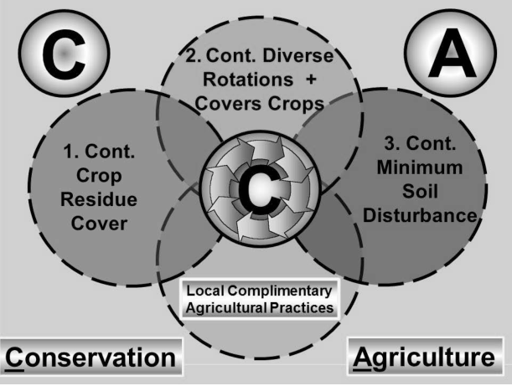

***Figure 2. Comparison of soil organic matter content under conventional tillage and conservation agriculture practices over time.***

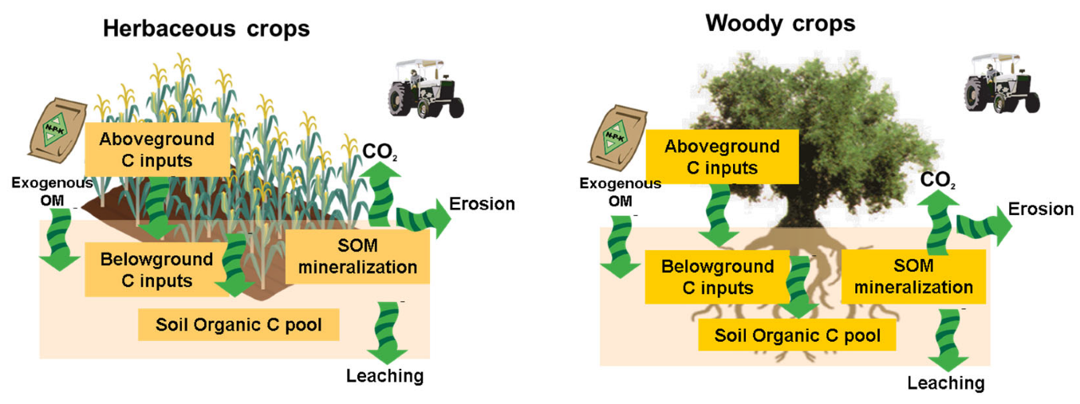

***Figure 3. Illustration of the impact of crop residue retention on water retention and evaporation in conservation agriculture systems.***

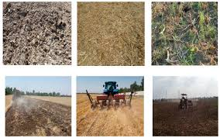

***Figure 4. Diagram showing the complex interactions between conservation agriculture practices, soil health, and pest dynamics.***

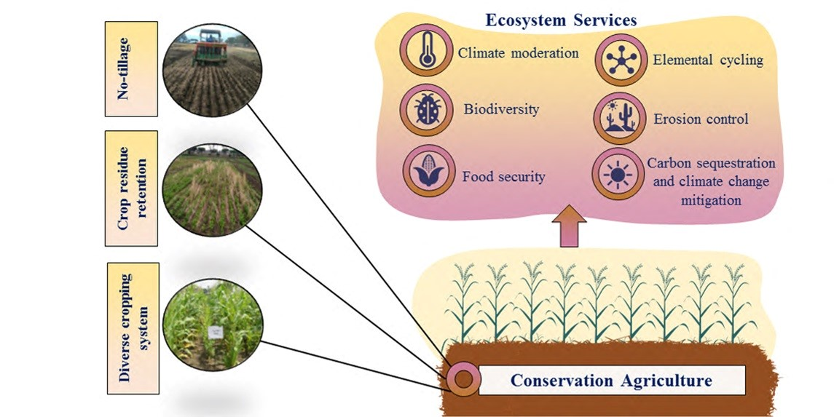

***Figure 5. Conceptual framework for integrated pest management in conservation agriculture systems, incorporating cultural, biological, and chemical control methods.***

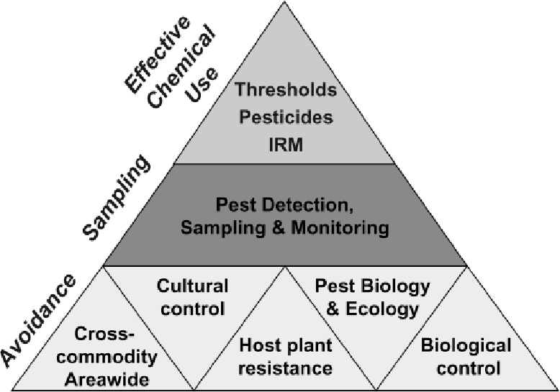

***Figure 6. Global map showing the adoption of conservation agriculture practices by country.***

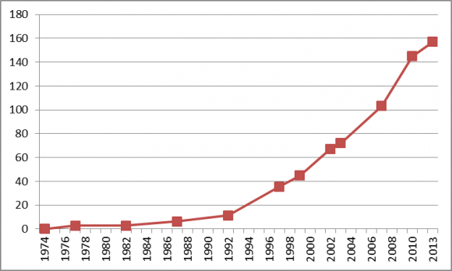

***Figure 7. Comparison of soil microbial biomass carbon under conventional tillage and conservation agriculture practices.***

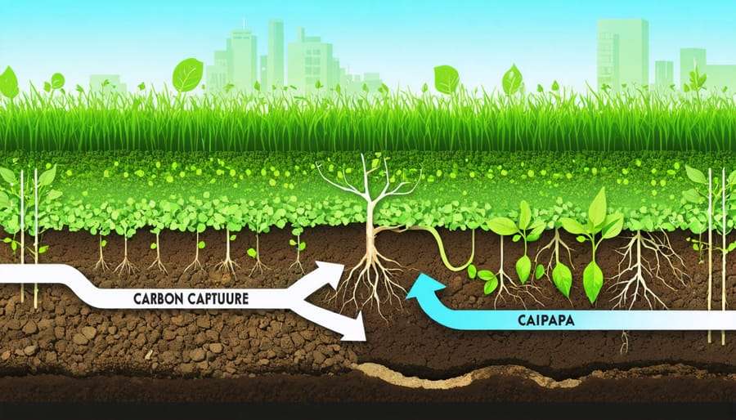

***Figure 8. Schematic representation of the potential impacts of conservation agriculture on various ecosystem services.***

