ORIGINAL RESEARCH ARTICLE
Age and Sex related variations in Hematological profile of Rainbow trout (Oncorhynchus mykiss) from Kashmir Aquaculture Systems

Abstract
Rainbow trout is an important aquaculture species in Himalayas mainly raised for food and sports, yet little is known about their hematological response based on age and sex. The fish hematology is a vital source to know the health status of the fish. The present investigation focused on the age and sex-related changes in the hematological profile of Rainbow trout, Oncorhynchus mykiss. Fish samples were collected from Laribal Trout Fish farm, Kashmir. Blood samples of 224 specimens of trout (both male and female) belonging to 4 age groups 1, 2, 3 & 4 (56 per age group) were collected. Opercular bones were used for estimation of age. Histological examinations were carried out for determination of sex. Estimation of various hematological parameters were carried out using appropriate procedures. The values of Hemoglobin (Hb), Hematocrit (Hct), Total Erythrocyte Count (TEC) were found to increase with increase in age. However, Total Leucocyte Count (TLC) was found to decrease with increase in age. Mean Corpuscular Volume (MCH), Mean Corpuscular Hemoglobin (MCH) and Mean Corpuscular Hemoglobin Concentration (MCHC) also showed variations with age. Males showed higher levels of Hb, Hct, TEC, MCV, MCH and MCHC than the females. Only TLC levels were found higher in females. These findings suggest that fish have different hematological profiles based on age and sex. Therefore, when analyzing the effects of management and environmental factors on Rainbow trout in terms of their hematological profiles, it is crucial to take species age and sex into account.
Keywords: Oncorhynchus mykiss, Age, Sex, Hematology.
- INTRODUCTION
The Rainbow trout, Oncorhynchus mykiss is a cold water fish belonging to family Salmonidae and is an important aquaculture species in temperate climates of Himalayas. Jammu and Kashmir and Himachal Pradesh are leading states in India where rainbow trout farming and seed production have developed significantly (Hassan and Pandey, 2012). Fish, as bioindicator species, plays a vital role in monitoring water quality because they respond with great sensitivity in the aquatic environment (Borkovic et al., 2008). Hematological parameters provide information about the health and physiological status of fish, feeding conditions and water quality within which they live (Fazio et al., 2013). Gaining knowledge about the hemato-biochemical alterations in fish raised in intense environments can enhance fish welfare, productivity, and the standard of culture methods (Fazio, 2019; Uiuiu et al., 2021). Fish blood could be a patho-physiological indicator of entire body function and is thus considered as an important tool in diagnosing the structural and functional status of fish. Blood parameters, however, differ between species and are primarily dependent on the favorable environmental conditions in which the species resides (Ahmed and Sheikh, 2019). Knowledge of hematological parameters is a very important diagnostic tool for evaluating the health status of fishes (Akinrotimi et al., 2009; Zakes et al., 2016).
Fish exist in a most familiar contact with their environment. Any type of change in environment would impact the physiology of fishes. The blood is called to be a minor in which entire important procedures taking part in the organisms are reflected, so blood parameters are utilized to highlight the biological procedures taking place in fish species. By examining how fish react to various environmental and management circumstances, hematology can help us better understand their physiology and create the best possible habitats. Fish blood parameters can be affected by a number of factors, including diet (Camargo et al., 2005), sexual maturity stage (Santos et al., 2009), stress (Neves et al., 2014), water pollution (Brum et al., 2014), parasitism (Figueiredo et al., 2014), sex (Onyia et al., 2013), seasonality and age (Fallah et al., 2014). Furthermore, diseases can be diagnosed and treated using hematological analysis (Ranzani-Paiva et al., 2013). Hematological factors are known to be affected by sex and age (Hrubec et al., 2001; Acharya and Mohanty, 2014; Fallah et al., 2014). It has been reported that growth performances are clearly affected by hematological status of the fish so that fish which exhibited optimum hematological features also have optimum growth performances (Prasad and Mukthiraj, 2011). Numerous investigations have revealed variations in fish hematological parameters based on size or age (Satheeshkumar et al., 2012).
It is important to record changes in blood values associated with age in growing, juvenile and adult fish, as these are typically the stages when fish are raised in aquaculture settings. Most fish are harvested before or as they reach adulthood because weight gain and feed conversion efficiency are greatest prior to sexual maturity. In trout and other teleost fishes, the blood volume is about 3% of their body weight. Evaluation of the hemogram involves measuring the hemoglobin (Hb) concentration, total red blood cell count (RBC), total white blood cell count (WBC), hematocrit values and erythrocyte indices such as mean corpuscular volume (MCV), mean corpuscular hemoglobin (MCH) and mean corpuscular hemoglobin concentration (MCHC). Leukocyte count (WBC) is repeatedly used as indicator of health status in fish (Pradhan et al., 2012). These leukocytes play a key role in the innate immune system and are involved in non-specific defense mechanisms in aquatic organisms, including fish (Prasad and Charles, 2010). Erythrocyte indices have been employed as biomarkers for metal pollution in aquatic environments and are utilized to evaluate the functional state of blood (Shah and Altindag, 2005; Satheeshkumar et al., 2012). Since blood indices can reliably reveal metabolic abnormalities, food deficiencies and chronic stress before they become apparent in a clinical setting, their study has shown to be a helpful approach for assessing the health of farmed animals (Bahmani et al., 2001). In order to ascertain whether members of this species have different hematological baselines, the purpose of this study was to examine the hematological profile in male and female Rainbow trout of varying ages mainly for fisheries management initiatives. The results will give local fisheries and researchers useful information on sustainable trout farming in Himalayas.
- METHODOLOGY
2.1 Sample collection
For this study, 224 specimens (male-112 and female-112) of O. mykiss belonging to 4 age groups 1, 2, 3 & 4 (56 per age group) were collected from Laribal Trout Fish farm- Kashmir for estimation of hematological parameters (Plate 1).
2.2 Blood Collection
Intermittent fasting (12:12hr) fish were captured from the raceways using a hand net during the early morning hours at 9.00 to 10.00 (IST), before the scheduled feeding. Following this, the fish were moved right away to well-ventilated containers containing water from the same source. Live fish were then used to collect blood samples. The blood was collected from fish samples after anaesthetizing the fish with clove oil (Hajek et al., 2006) by puncture of the caudal tail vessels, using 2 ml hypodermal syringe for smaller fishes and 4 ml syringe for bigger fishes (Plate 2).
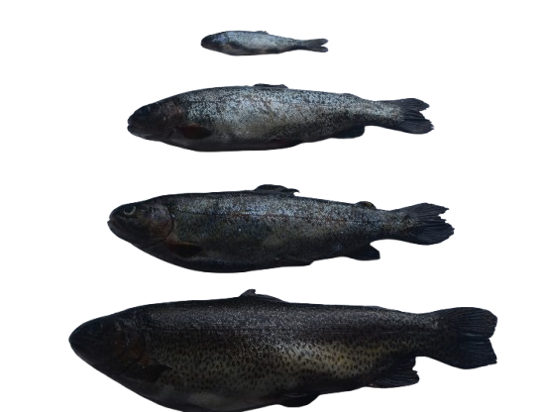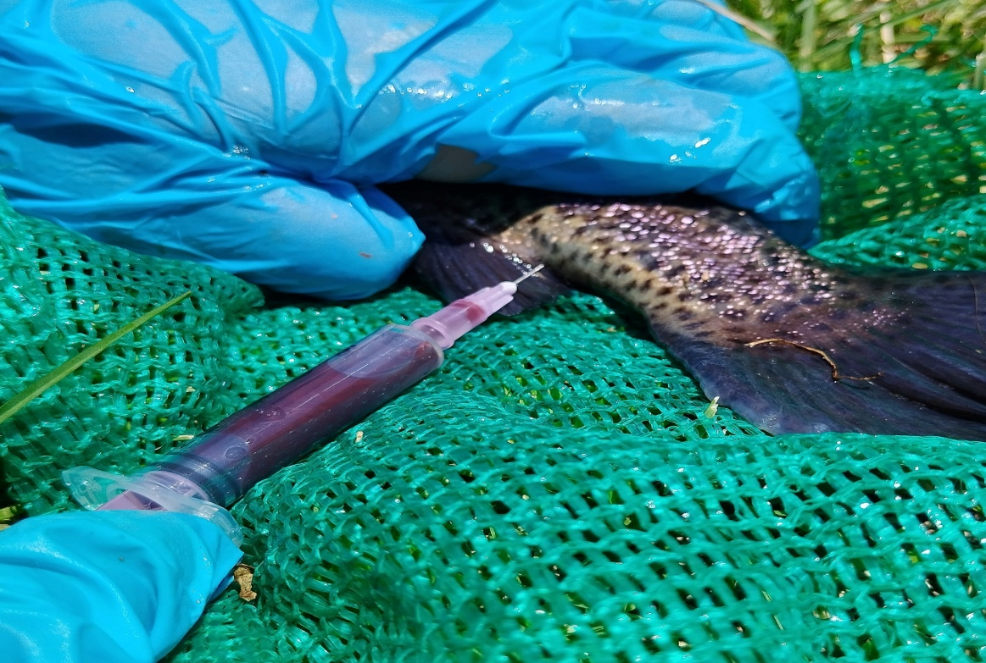
Plate 1: Sample collection Plate 2: Blood collection
2.3 Age determination
The opercular bones of rainbow trout were used for age determination (LeCren, 1947). These bones were taken from fresh fishes and boiled in water for few minutes to clear the tissues attached (Plate 3). Then they were treated with 50% H₂O₂ for about 15 minutes, washed with water and sun dried for 3 days. Annual rings of growth appeared and were counted to indicate age of the fish (Plate 4).
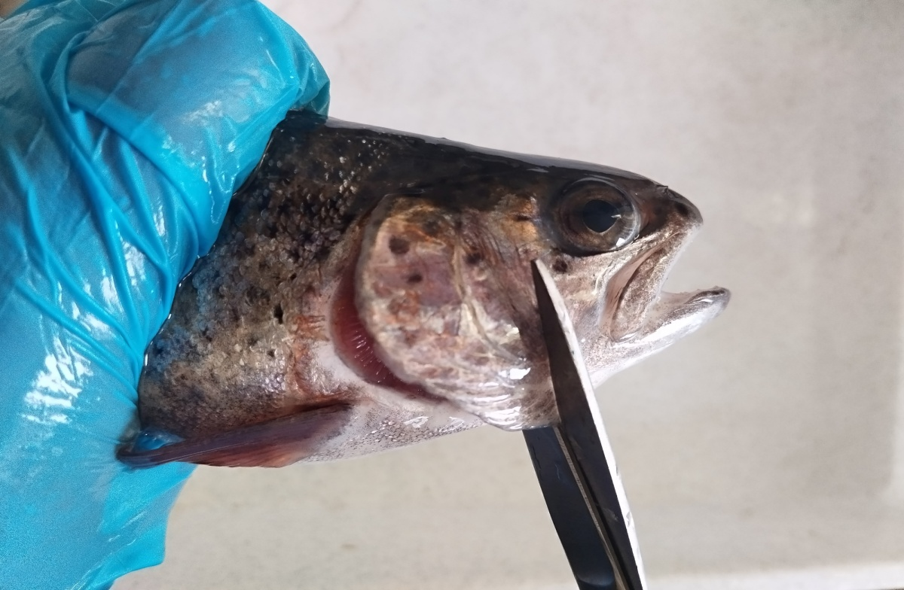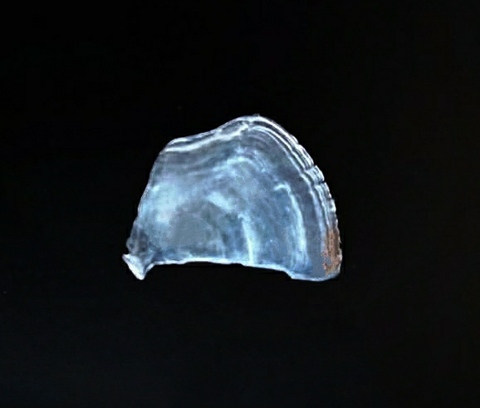
1
3
2
Plate 3: Removal of opercular bone Plate 4: Growth rings on operculum
2.4 Sex determination
Histological examinations were carried out for determining the sex of samples. Preserved gonads were cut into 1-2 mm pieces and washed overnight under a gentle flow of tap water. These samples were then fixed in 10% formalin. After fixation, the samples were washed in 70% alcohol in order to remove the fixative for further tissue processing. These samples were then dehydrated using series of graded ethyl alcohol and then cleared in Xylene. After being cleared, the samples were embedded in the paraffin wax. Tissue sections of about 5-7 µm thickness were cut using a microtome. These sections were stained using hematoxylin and eosin and examined under light microscope for determination of sex (Plate 5 & 6).
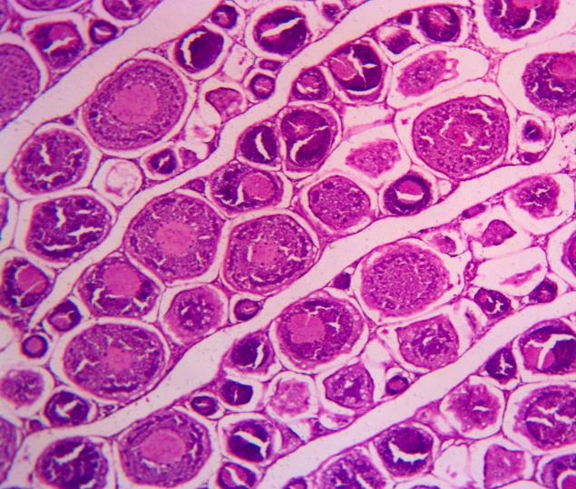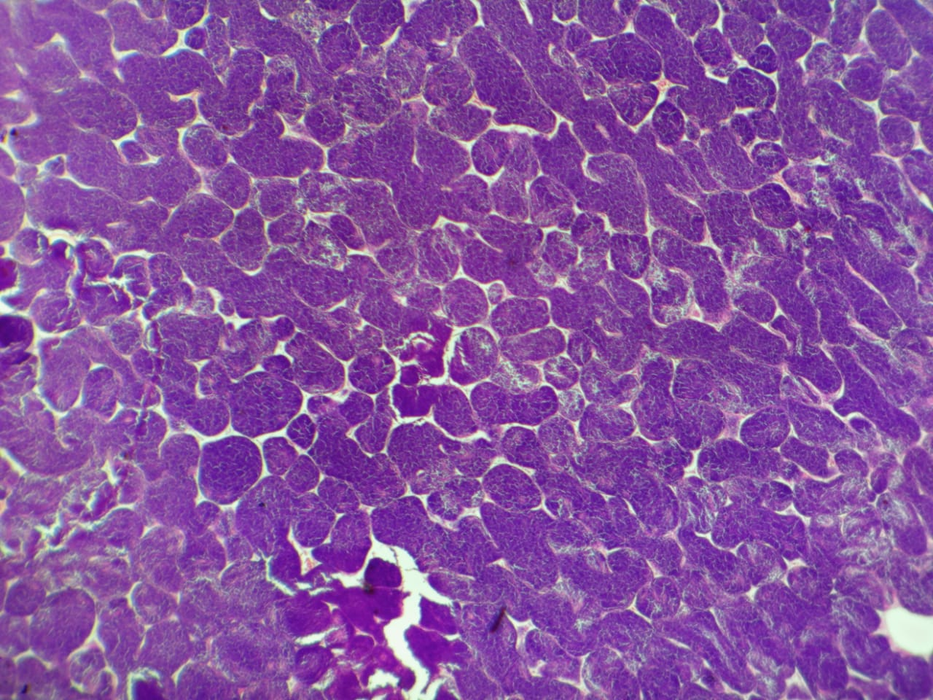
Plate 5: Female Trout fish Plate 6: Male Trout fish
2.5 Hematological profile
Hemoglobin (Hb) was determined by cyanmethemoglobin technique using Drabkin’s reagent as described by Witeska et al. (2016).
Hematocrit Value (Hct) was estimated by Wintrobe’s method as described by Sanyal et al. (2017).
Total Leucocyte count (TLC) was estimated by microdilution method using Haemocytometer as described by Stevenson (1988).
TLC (WBC/mm³) = N× 50
Where, “N” denotes the total number of White blood cells counted in the four squares of counting chamber and 50 is the dilution factor.
Total Erythrocyte Count (TEC) was estimated with the help of microdilution method using hemocytometer as described by Stevens (1997).
TEC (RBC/mm³) = N × 10,000
Where “N” refers to the total number of red blood cells counted in the five squares of the hemocytometer and 10,000 is the dilution factor.
These findings were utilized to compute three red blood cell indices using the following formulas (Dacie and Lewis, 1975): mean corpuscular volume (MCV), mean corpuscular hemoglobin (MCH), and mean corpuscular hemoglobin concentration (MCHC).
MCV (fl) = Hematocrit × 10
Erythrocyte Count
MCH (pg) = Hemoglobin × 10
Erythrocyte Count
MCHC (g/dL) = Hemoglobin × 100
Hematocrit
2.6 Statistical Analysis
The data obtained in the research was tabulated and analyzed using descriptive as well as inferential statistics with the help of standard statistical softwares PAST and MS Excel. The age related variations of the data were examined using one-way analysis of variance (ANOVA). The sex related variations of the data were examined using Z-test (two-tail). Tukey test was used for pairwise comparisons of means in 4 age groups of trout to determine significant variations among different groups.
- RESULTS AND DISCUSSION
Hematological parameters in fish exhibit a wide range of variation, similar to other animals and are influenced by both internal and external factors (Clauss et al., 2008). External factors, such as poor water quality, inadequate stocking density and improper feeding can stress fish and alter their hemogram. Internal factors such as age, sex, genetic makeup, feeding behavior and reproductive status also play a role and are inherent to the fish. Hemoglobin concentration and other blood parameters differ among fish of different age groups, primarily due to variations in metabolic activity and physical exertion.
In this study, hematology of fish O. mykiss comprised hemoglobin (Hb), hematocrit (Hct), total leucocyte count (TLC), total erythrocyte count (TEC), mean corpuscular volume (MCV), mean corpuscular hemoglobin (MCH) and mean corpuscular hemoglobin concentration (MCHC) in different age groups of male and female trout. The results indicated that levels of Hct, Hb and RBC along with secondary red blood cell indices (MCH, MCHC) increased with age, consistent with findings in trout (Nabi et al., 2022) and other fish species (Fazio et al., 2017; Karim et al., 2019). Change in results of hematological parameters in different age groups of male and female are shown in Table 1. The finding of this perusal showed the impact of age and sex on blood parameters of rainbow trout. No significant difference (p>0.05) was observed between hematological parameters of male and female trout as determined by two-pair Z-test. Significant difference (p<0.05) was observed between hematological parameters of 4 age groups as determined by one-way ANOVA. Significant age-related difference (p<0.05) was observed in the hematological parameters of male and female trout as determined by one-way ANOVA. Furthermore, Tukey test (pairwise comparison test) was performed between different age groups (combined) and between different age groups of male and female separately to determine overall significant difference.
Hb (g/dL) was found more in male fish than female, it means males are more active than female. Age related variations in hemoglobin were also reported with Hb showing an increasing trend with age (Fig. 1). The RBC of an organism defines the carrying capacity of dissolved oxygen. The values of Hematocrit (%), TEC (×10⁶/mm³) increased with age with males showing higher values than females (Fig. 2 & 3). WBC is an indiscernible part of circulating blood of vertebrates. The value of TLC (×10³/mm³) in trout decreased with increase in age with females showing higher values than male (Fig. 4). Secondary red blood cell indices (MCV, MCH, MCHC) also showed variations with respect to age and sex (Fig. 5, 6 & 7).
There are certain inherent modifications in the blood profile of fishes after the maturity is attained, so in order to understand the basic hematological profile of fishes, the stages of fishes before reaching sexual maturity are significant (Salman, 2010). Changes in blood values are anticipated as hematopoietic tissues continue to grow and mature in young fish (O’Neill, 1989). Also, fish’s immune system keeps evolving until adulthood (Rijkers and Van Muiswinkel, 1977). When sex differences were taken into account, numerous investigations have revealed that with the exception of TLC, male fish generally exhibit greater values in practically all hematological parameters. These greater values in males may be a virtue to their physiological activeness. The increase in hematocrit levels can be attributed to the significant rise in total RBC count, as these cells are the main component, thus influencing hematocrit levels. Furthermore, hematocrit levels increase as fish become more active (Galagarza et al., 2017). The total leucocyte count was found higher in smaller age groups in comparison to fishes of higher age groups. Similar findings have been reported by other researchers (Blaxhall, 1972; Hrubec et al., 2001).
Charoo et al. (2014) reported that in Rainbow trout Hb and TEC increase significantly with increase in age. Also, in rainbow trout Hb, Hct, MCHC were lower in juvenile fishes as compare to mature adults (McCarthy et al., 1975). In Clarias batrachus (walking catfish), males are more aggressive than females, which may be because of the increased hemoglobin and MCHC levels in males (Acharya and Mohanty 2014). Older fish exhibit higher hemoglobin and hematocrit levels, which are indicative of increased red blood cell formation and increased oxygen transport. Previously, Fazio et al. (2020) reported that red blood cell levels increase significantly in older striped bass, M. saxatalis possibly in response to the increased metabolic activity and energy demand as fish grow in size. Similar findings were observed by Orun and Erdeml (2002) in Longspine scraper, Capoeta trutta where older fish had the greatest hematocrit values, and by Hrubec et al. (2001) in older hybrid tilapia Oreochromis spp. Bahmani et al. (2001) observed that leucocyte counts were greater in young Beluga, Huso huso. Therefore, the increased leucocyte levels that were observed in age-1 fish may be a sign of an immune system requirement and since females showed higher values than males, this response may be driven by age or sex. However, further studies including additional age groups and estimation of water quality parameters of the culture system will be required to better understand these phenomena and ensure that the trout culture system is managed properly.

Table 1: Mean ± S.E values of hematological parameters of Rainbow trout with respect to age and sex.
HEMATOLOGICAL PARAMETERS
Source of variation (n) |  | Hb (g/dL) | Hct (%) | TEC (×10⁶/mm³) | TLC (×10³/mm³) | MCV (fl) | MCH (pg) | MCHC (g/dL)
SEX |  | Mean ± S.E | Mean ± S.E | Mean ± S.E | Mean ± S.E | Mean ± S.E | Mean ± S.E | Mean ± S.E
Male (112) |  | 9.17 ± 0.15 | 35.11 ± 0.35 | 2.33 ± 0.04 | 27.76 ± 0.98 | 156.32 ± 2.69 | 39.96 ± 0.48 | 26.09 ± 0.32
Female (112) |  | 8.89 ± 0.13 | 34.37 ± 0.31 | 2.30 ± 0.04 | 28.46 ± 0.95 | 153.10 ± 2.42 | 39.11 ± 0.48 | 25.87 ± 0.33
p-value |  | >0.05 | >0.05 | >0.05 | >0.05 | >0.05 | >0.05 | >0.05
AGE |  | Mean ± S.E | Mean ± S.E | Mean ± S.E | Mean ± S.E | Mean ± S.E | Mean ± S.E | Mean ± S.E
Age 1 (56) |  | 7.25 ± 0.06ª | 30.72 ± 0.24ª | 1.72 ± 0.44ª | 39.32 ± 0.03^{d} | 182.91 ± 3.98^{c} | 42.80 ± 0.76^{c} | 23.69 ± 0.25ª
Age 2 (56) |  | 8.41 ± 0.06^{b} | 34.47 ± 0.37^{b} | 2.26 ± 0.42^{b} | 33.63 ± 0.03^{c} | 153.96 ± 2.74^{b} | 37.52 ± 0.57ª | 24.54 ± 0.33ª
Age 3 (56) |  | 9.60 ± 0.09^{c} | 36.91 ± 0.34^{c} | 2.58 ± 0.36^{c} | 26.29 ± 0.03^{b} | 143.86 ± 1.89^{ab} | 37.50 ± 0.59ª | 26.15 ± 0.37^{b}
Age 4 (56) |  | 10.85 ± 0.13^{d} | 36.87 ± 0.34^{c} | 2.70 ± 0.35^{d} | 13.22 ± 0.03ª | 138.10 ± 2.13ª | 40.33 ± 0.52^{b} | 29.55 ± 0.43^{c}
p-value |  | < 0.05 | < 0.05 | < 0.05 | < 0.05 | < 0.05 | < 0.05 | < 0.05
AGE & SEX |  | Mean ± S.E | Mean ± S.E | Mean ± S.E | Mean ± S.E | Mean ± S.E | Mean ± S.E | Mean ± S.E
Male | Age 1 | 7.30 ± 0.08ª | 30.50 ± 0.29ª | 1.70 ± 0.04ª | 38.96 ± 0.46ª | 185.10 ± 5.34^{c} | 43.62 ± 0.99^{c} | 23.98 ± 0.34ª
Male | Age 2 | 8.47 ± 0.08^{b} | 35.10 ± 0.52^{b} | 2.25 ± 0.04^{b} | 33.05 ± 0.76^{b} | 157.75 ± 4.47^{b} | 38.00 ± 0.87ª | 24.31± 0.48ª
Male | Age 3 | 9.75 ± 0.14^{c} | 37.229 ± 0.49^{c} | 2.60 ± 0.04^{c} | 26.64 ± 0.52^{c} | 144.15 ± 2.92^{ab} | 37.73 ± 0.77ª | 26.30 ± 0.50^{b}
Male | Age 4 | 11.15 ± 0.16^{d} | 37.618 ± 0.49^{c} | 2.77 ± 0.04^{d} | 12.40 ± 0.48^{d} | 138.26 ± 3.40ª | 40.50 ± 0.74^{ab} | 29.79 ± 0.58^{c}
p-value |  | < 0.05 | < 0.05 | < 0.05 | < 0.05 | < 0.05 | < 0.05 | < 0.05
Female | Age 1 | 7.22 ± 0.08ª | 30.94 ± 0.40ª | 1.75 ± 0.05ª | 39.65 ± 0.75ª | 180.72 ± 5.80^{b} | 41.98 ± 1.15^{b} | 23.40 ± 0.38ª
Female | Age 2 | 8.34 ± 0.09^{b} | 33.839 ± 0.50^{b} | 2.28 ± 0.04^{b} | 34.22 ± 0.35^{b} | 150.18 ± 3.07ª | 37.03 ± 0.75ª | 24.77 ± 0.45^{ab}
Female | Age 3 | 9.46 ± 0.12^{c} | 36.6 ± 0.47^{c} | 2.56 ± 0.04^{c} | 25.95 ± 0.50^{c} | 143.57 ± 2.45ª | 37.27 ± 0.90ª | 26.01 ± 0.55^{b}
Female | Age 4 | 10.55 ± 0.19^{d} | 36.121 ± 0.42^{c} | 2.63 ± 0.03^{c} | 14.04 ± 0.46^{d} | 137.93 ± 2.65ª | 40.15 ± 0.73^{ab} | 29.31 ± 0.64^{c}
p-value |  | < 0.05 | < 0.05 | < 0.05 | < 0.05 | < 0.05 | < 0.05 | < 0.05

Fig. 1: Age and Sex related changes in Hemoglobin in O. mykiss

Fig. 2: Age and Sex related changes in Hematocrit in O. mykiss

Fig. 3: Age and Sex related changes in Total Erythrocyte count in O. mykiss

Fig. 4: Age and Sex related changes in Total Leucocyte count in O. mykiss

Fig. 5: Age and Sex related changes in Mean Corpuscular Volume in O. mykiss

Fig. 6: Age and Sex related changes in Mean Corpuscular Hemoglobin in O. mykiss

Fig. 7: Age and Sex related changes in Mean Corpuscular Hemoglobin Concentration in O. mykiss
CONCLUSION
In conclusion, the study exhibited that hematological parameters are considered as a precious tool for monitoring of fish health. Age and sex related blood analysis is important to set a baseline regarding the health status of fish. These parameters can be used as ground data to assess any impact of stress on the fish by comparing the blood references with the normal fish. Hematological studies on fishes have supposed valuable excellence due to growth accentuation on pisciculture and greater consciousness of pollution in the aquatic ecosystem. Therefore, our findings suggest that age and sex should be taken into account while studying hematological parameters in a lab setting since they may have an impact on the results. Age and sex must be considered in research that examine the impact of survival, reproduction and parasite resistance on hematological variables.
DISCLAIMER (ARTIFICIAL INTELLIGENCE)
Author(s) hereby declare that NO generative AI technologies such as Large Language Models (ChatGPT, COPILOT, etc.) and text-to-image generators have been used during the writing or editing of this manuscript.
REFERENCES
Acharya, G., & Mohanty, P. K. (2014). Haematological and serum biochemical parameters in different sexes of Walking catfish, Clarias batrachus (Linnaeus, 1758). International Journal of Science and Research, 3, 1914-1917.
Ahmed, I., & Sheikh, Z. A. (2019). Hematological and serum biochemical parameters of five freshwater snow trout fish species from river Jhelum of Kashmir Himalaya. India. Comparative Clinical Pathology, 28, 771-782.
Akinrotimi, O. A., Abu, O., Ansa, E. J., Edun, O. M., & George, O. S. (2009). Hematological responses of Tilapia guineensis to acute stress. International Journal of Natural and Applied Sciences, 4, 338-343.
Bahmani, M., Kazemi, R., & Donskaya, P. (2001). A comparative study of some hematological features in young reared sturgeons (Acipenser persicus and Huso huso). Fish Physiology and Biochemistry, 24, 135-140.
Blaxhall, P.C. (1972). The haematological assessment of the health of freshwater fish. Journal of Fish Biology, 4, 593-604.
Borkovic, S. S., Pavlovic, S. Z., Kovacevic, T. B., Stajn, A. S., Petrovic, V. M., & Saicic, Z. S. (2008). Antioxidant defence enzyme activities in hepatopancreas, gills and muscle of Spiny cheek crayfish (Orconectes limosus) from the River Danube. Comparative Biochemistry and Physiology Part C: Toxicology and Pharmacology, 147, 122-128.
Brum, A., Dotta, G., Roumbedakis, K., Goncalves, E. L., Garcia, L. P., Garcia, P., Scussel, V. M., & Martins, M. L. (2014). Hematological and histopathological changes in Silver catfish, Rhamdia quelen (Siluriformes) exposed to clomazone herbicide in the Madre River, Santa Catarina State, southern Brazil. Journal of Environmental Science and Health, 49, 169-175.
Camargo, S. O., Pouey, J. L., & Martins, C. (2005). Parâmetros eritrocitários do jundiá (Rhamdia quelen) submetido à dieta com diferentes níveis de proteína. [Erythrocytic parameters of jundiá (Rhamdia quelen) subjected to diets with different levels of protein.] Ciência Rural, 35, 1406-1411.
Charoo, S. Q., Chalkoo, S, R., & Qureshi, T. A. (2014). Rainbow trout (Oncorhynchus mykiss) blood profile alterations. E-Journal of Science & Technology, 2, 29-35.
Clauss, T. M., Dove, A. D., & Arnold, J. E. (2008). Hematologic disorders of fish. Veterinary Clinics of North America: Exotic Animal Practice, 11, 445–462.
Dacie, J. V., & Lewis, S. M. (1975). Measurement and calculation of size of red cells, practical haematology. Churchill Livingstone, London, 40-43.
Fallah, F., Khara, H., J. Roohi, J., & Boorani, M. (2014). Hematological parameters of pike Esox lucius in relation to different ages and seasons. Comparative Clinical Pathology, 23, 949-953.
Fazio, F. (2019). Fish hematology analysis as an important tool of aquaculture: a review. Aquaculture, 500, 237-242.
Fazio, F., Lanteri, G., Saoca, C., Iaria, C., Piccione, G., Orefice, T., Calabrese, E., & Vazzana, I. (2020). Individual variability of blood parameters in striped bass, Morone saxatilis: possible differences related to weight and length. Aquaculture International, 28, 1665-1673.
Fazio, F., Marafioti, S., Arfuso, F., Piccione, G., & Faggio, C. (2013). Comparative study of the biochemical and hematological parameters of four wild Tyrrhenian fish species. Veterinary Medicine, 58, 576-581.
Fazio, F., Saoca, C., Vazzana, I., & Piccione, G. (2017). Influence of body size on blood hemogram in rainbow trout, Oncorhynchus mykiss (Walbaum, 1792). Open Journal of Veterinary Medicine, 2, 91-94.
Figueiredo, A. B., Tancredo, K. R., Hashimoto, G. S., Roumbedakis, K., Marchiori Nda, C., & Martins, M. L. (2014). Haematological and parasitological assessment of Silver Catfish Rhamdia quelen farmed in southern Brazil. Revista Brazileira de Parasitologia Veterinária, 23, 157-163.
Foresti, F., Volpato, G., Garcia, E., & Caramaschi, E. (1977). Medidas de alguns parâmetros morfológicos e fisiológicos do sangue de bagre (Rhamdia hilarii Valenciennes, 1840) (Pisces: Pimelodidae). [Measurement of some morphological and physiological parameters of the blood of the catfish (Rhamdia hilarii Valenciennes, 1840) (Pisces: Pimelodidae).] Ciência e Cultura, Rio de Janeiro, 29, 580.
Galagarza, O. A., Kuhn, D. D., Smith, S. A., & Hrubec, T. C. (2017). Hematologic and plasma chemistry RIs for cultured Striped catfish (Pangasius hypophthalmus) in recirculating aquaculture systems. Veterinary Clinical Pathology, 46, 457-465.
Hajek, G. J., Kłyszejko, B., & Dziaman, R. (2006). The anaesthetic effect of clove oil on common carp, Cyprinus carpio, L. Acta ichthyological piscatoria, 36(2), 93-97.
Hassan, N., & Pandey, D. N. (2012). Present status of trout fisheries in Jammu and Kashmir. Journal of Pharmacy, 2(5), 35-37.
Hrubec, T. C., Smith, S. A., & Robertson, J. L. (2001). Age-related changes in hematology and plasma chemistry values of hybrid Striped Bass (Morone chrysops × Morone saxatilis). Veterinary Clinical Pathology, 30, 8-15.
Karim, B., Yousria, G., & Wyllia, K. (2019). Influence of total length, sex and seasonal variations on hema-tological parameters in Cyprinus carpio (Linnaeus, 1758) (Pisces Cyprinidae) in Lake Tonga (Algeria). Biodiversity Journal, 10, 593-600.
Kavamoto, E. T., Ranzani-Paiva, M. J. T., & Tokumaru, M. (1983). Hematological studies of the catfish, Rhamdia hilarii (Val. 1840), a teleost, in the mature stage of gonad development. Boletim do Instituto de Pesca, 10, 53-60.
Le Cren, E. D. (1947). The determination of the age and growth of the perch (Perca fluviatilis) from the opercular bone. Journal of Animal Ecology, 16, 188-204.
McCarthy, D. H., Stevenson, J. P., & Roberts, M.S. (1975). Some blood parameters of the rainbow trout (Salmo gairdneri Richardson). The Shasta variety. Journal of Fish Biology, 7, 215-219.
Nabi, N., Ahmed, I., & Wani, G. B. (2022). Hematological and serum biochemical reference intervals of rainbow trout, Oncorhynchus mykiss cultured in Himalayan aquaculture: Morphology, morphometrics and quantification of peripheral blood cells. Saudi Journal of Biological Sciences, 29, 2942-2957.
Neves, M. S., Barbas, A. L., & Fujimoto, R. Y. (2014). Hematology and recovery response in Jacundá, Crenicichla saxatilis (Linnaeus, 1758) after short-term handling stress. Journal of Applied Ichthyology, 30, 42-47.
O’Neill, J. G. (1989). Ontogeny of the lymphoid organs in an Antartic teleost, Harpagifer antarticus (Notothenioidei: Perciformes). Developmental & Comparative Immunology, 13, 25-33.
Onyia, L., Michael, K., & Ekoto, B. (2013). Haematological profile, blood group, and genotype of Heterobranchus bidorsalis. Net Journal of Agricultural Science, 1, 69-72.
Orun, I., & Erdeml, A. U. (2002). A study on blood parameters of Capoeta trutta (Heckel, 1843). Journal of Biological Science, 8, 508-511.
Pradhan, S. C., Patra, K., Sarkar, B., & Pal, A. (2012). Seasonal changes in hematological parameter of Catla catla (Hamilton 1822). Comparative Clinical Pathology, 21, 1473-1481.
Prasad, G., & Charles, S., (2010). Haematology and leucocyte enzyme cytochemistry of a threatened yellow catfish Horabagrus brachysoma (Gunther 1864). Fish Physiology and Biochemistry, 36, 435-443.
Prasad, G., & Mukthiraj, S. (2011). Effect of Methanolic Extract of Andrographis paniculata (Nees) on growth and haematology of Oreochromis mossambicus (Peters) World Journal of Fish and Marine Sciences, 3(6), 473-479.
Ranzani-Paiva, M. J. T., Pauda, S. B., Tavares-Dias, M., & Egami, M. I. (2013). Methods for hematological analysis in fish. Eduem, Maringá, Brazil.
Rijkers, G.T., & Van Muiswinkel, W. B. (1977). The immue system of cyprinid fish, the development of cellular and humoral responsiveness in the rosy barb (Barbus conchonius). In J. B. Solomon and J. D. Horton (Eds.). Developmental Immunology (pp. 233-40).
Salman, R. C., Samina, Q. C., Showkat, A. M., Najar, A. M., & Shammi, Q. J. (2010). Haematology and plasma chemistry values of rainbow trout (Oncorhynchus mykiss). Aquaculture, 11(2), 197-205.
Santos, A. G., Egami, M. I., Ranzani-Paiva, M. J. T., & Juliano, Y. (2009). Hematological parameters and phagocytic activity in Fat Snook (Centropomus parallelus): seasonal variation, sex and gonadal maturation. Aquaculture, 296, 359-366.
Satheeshkumar, P., Ananthan, G., Kumar, D.S., & Jagadeesan, L. (2012). Haematology and biochemical parameters of different feeding behaviour of teleost fishes from Vellar estuary, India. Comparative Clinical Pathology, 21, 1187-1191.
Shah, S. L., & Atinding, A. (2005). Alternation of immunological parameters of each tench (Tinca tinca) after acute and chronical exposure to lethal and sublethal treatments with mercury, cadmium, and lead. Turkish Journal of Veterinary and Animal Sciences, 29, 1163-1158.
Stevens, M. L. (1997). Fundamentals of clinical hematology. Sunders, Philadelphia, P. A.
Stevenson, J. R., & Taylor, R. (1988). Effects of glucocorticoid and anti glucocorticoid hormones on leukocyte numbers and function. International journal of immunopharmacology, 10(1), 1-6.
Uiuiu, P., Latiu, C., Papuc, T., Craioveanu, C., Ihut, A., Sava, A., Raducu, C., Șonea, C., Constantinescu, R., Cocan, D., & Miresan, V. (2021). Multi-approach assessment for stress evaluation in rainbow trout females, Oncorhynchus mykiss (Walbaum, 1792) from three different farms during the summer season. Animals, 11.
Witeska, M., Lugowska, K., & Kondera, E. (2016). Reference values of hematological parameters for juvenile Cyprinus carpio. Bulletin of the European Association of Fish Pathologists, 36(4), 169-180.
Zakes, Z., Demska-Zakes, K., Szczepkowski, M., Rozyn ski, M., & Ziomek, E. (2016). Impact of sex and diet on hematological and blood plasma biochemical profiles and liver histology of pikeperch (Sander lucioperca). Archives of Polish Fisheries, 24, 61-68.

