VOGT KOYANAGI HARADA DISEASE WITH ISOLATED OCULAR INVOLVEMENT: A CASE REPORT
ABSTRACT

Aims: Vogt-Koyanagi-Harada (VKH) disease is a rare autoimmune uveo-meningeal disorder with variable clinical presentations. The aim of this report is to describe a case of purely ocular VKH disease and highlight the role of multimodal imaging and early corticosteroid therapy in its management.
Presentation of Case: We report the case of a 37-year-old woman with no history of systemic illness, ocular trauma, or surgery, who presented with acute bilateral visual loss of 15 days’ duration. Ophthalmic examination revealed light perception in both eyes, with normal anterior segment and intraocular pressure. Fundus examination showed multiple bilateral serous retinal detachments. Fluorescein angiography demonstrated delayed choroidal filling, diffuse pinpoint hyperfluorescent leaks, pooling into multifocal serous retinal detachments, and bilateral optic disc edema. Optical coherence tomography confirmed multilobular serous retinal detachments with intraretinal septa. No extraocular manifestations were present, and laboratory and immunologic work-up were unremarkable. The diagnosis of possible VKH disease (purely ocular form) was made. The patient received three consecutive daily intravenous pulses of methylprednisolone (1 g/day), followed by oral prednisone (1 mg/kg/day) with gradual tapering. Functional recovery was rapid, with visual acuity improving to 10/10 in the right eye and 9/10 in the left eye after two months.
Discussion: Diagnostic criteria for VKH disease have evolved from the early description of Sugiura to the 2001 First International Workshop classification, which recognizes complete, incomplete, and possible forms. Our case illustrates the importance of considering VKH even in the absence of systemic involvement and demonstrates the diagnostic value of multimodal imaging, especially fluorescein angiography and OCT. Early and aggressive corticosteroid therapy remains the cornerstone of management, with immunosuppressive agents reserved for resistant or recurrent forms.
Conclusion: Purely ocular VKH disease is rare and diagnostically challenging in the absence of extraocular signs. However, a high index of suspicion, supported by multimodal imaging, enables early recognition. Prompt initiation of systemic corticosteroid therapy is associated with favorable functional and anatomical outcomes.

Keywords: [Vogt Koyanagi Harada, retinal detachment, pin-points, uveitis]
1. INTRODUCTION
Vogt Koyanagi Harada (VKH) disease is a bilateral autoimmune uveo-meningeal disorder that primarily affects young adults, with a female predominance. Its global distribution is uneven: while VKH is considered a rare cause of uveitis in European populations, its higher prevalence among Asian, Middle Eastern, Indian, and Hispanic groups is thought to reflect specific genetic susceptibilities (Touitou et al., 2005). The disease is mediated by a T-cell–driven autoimmune response targeting melanocytes within uveal tissue, although the precise triggering factor remains unidentified (Greco et al., 2013). According to the criteria established by the First International Workshop (FIW), the diagnosis of VKH is based on a set of clinical and ancillary findings that allow classification into complete, incomplete, or probable forms, the latter encompassing isolated ocular involvement (Read et al., 2001). We report the case of a patient with VKH disease presenting in its purely ocular

2.PRESENTATION OF CASE

A 37-year-old woman, with no history of systemic disease, penetrating ocular trauma, or ocular surgery, was referred to our ophthalmology department for acute bilateral visual loss evolving over 15 days. No extraocular manifestations were reported.
On examination, best-corrected distance visual acuity was reduced to light perception in both eyes. Anterior segment biomicroscopy and intraocular pressure measurements were unremarkable. Fundus examination revealed multiple bilateral central and peripheral serous retinal detachments.
Fluorescein angiography demonstrated delayed choroidal filling with a characteristic “mottled” pattern in the early phase, followed by numerous pinpoint hyperfluorescent leaks progressively pooling into large areas of multifocal serous retinal detachment, associated with bilateral optic disc edema in the intermediate and late phases (Figures 1, 2).

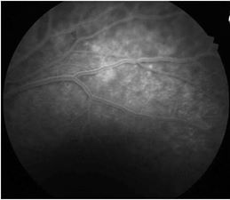

Figure 1: Early phase: delayed choroidal filling with diffuse pinpoint hyperfluorescent spots

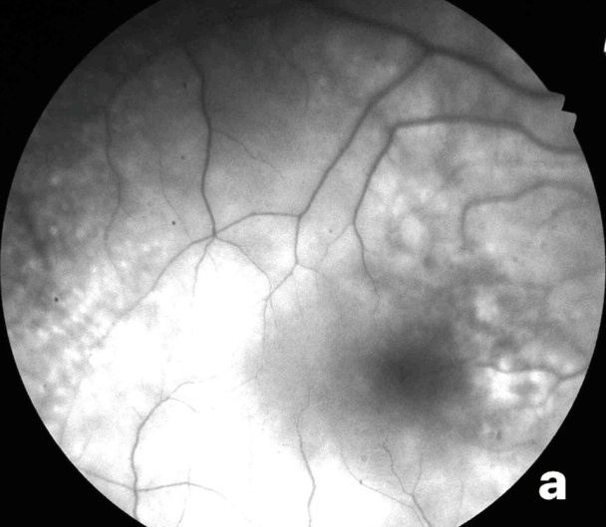
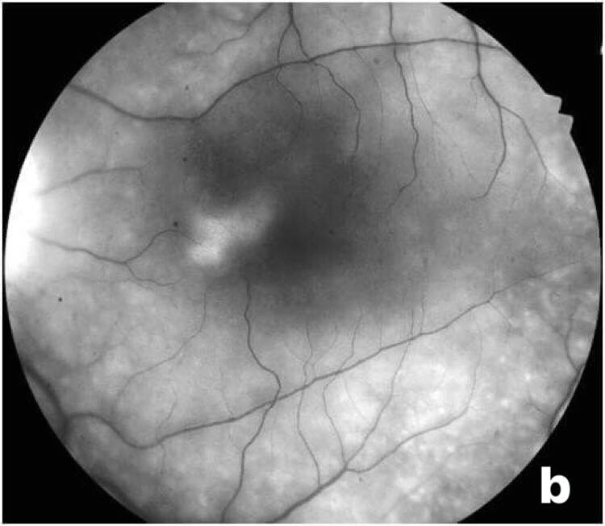

Figure 2: Late phase demonstrating progressive filling of extensive multifocal serous retinal detachments associated with papillary edema. a: right eye; b: left eye.

Spectral-domain optical coherence tomography (OCT) showed multifocal serous retinal detachments with vertical subretinal septa connecting the retinal pigment epithelium to the outer retina, thereby compartmentalizing the subretinal space into multiple cavities, imparting a multilobular cystic appearance (Figure 3).

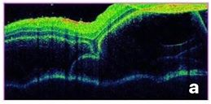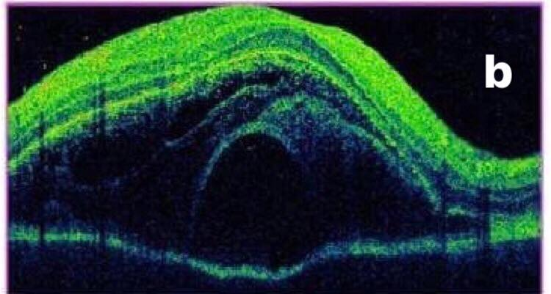

Figure 3: Multifocal serous retinal detachments exhibiting septations, resulting in a multilobular and cystic appearance.

A thorough systemic examination excluded extraocular involvement, including dermatologic, auditory, and neurological signs. Laboratory, infectious, and immunologic work-up results were within normal limits.
Based on these findings, a diagnosis of possible VKH disease defined as purely ocular involvementwas established. The patient received high-dose intravenous corticosteroid therapy (methylprednisolone 1 g/day, administered over 3 hours for three consecutive days on day 0, day 1, and day 2). Clinical evolution was favorable, with rapid functional improvement: visual acuity improved to 1/10 in the right eye and 2/10 in the left eye. OCT performed on day 7 demonstrated anatomic improvement with reduction in central macular thickness and resolution of subretinal fluid. Oral prednisone at 1 mg/kg/day was then initiated, with gradual tapering over six months. Two months after treatment initiation, visual acuity improved to 10/10 in the right eye and 9/10 in the left eye. Both anterior and posterior segment examinations were normal at that time.

3. discussion

Several diagnostic criteria have been proposed to guide the initial assessment of VKH disease, with diagnosis relying on the combination of multiple clinical features. The earliest criteria, described in 1978 by Sugiura, required the presence of three major signs: bilateral anterior uveitis, serous retinal detachment, and cerebrospinal fluid pleocytosis; other manifestations were considered minor (Sugiura, 1978). In 1980, Snyder and Tessler introduced the criteria of the American Uveitis Society (Snyder & Tessler, 1980). These classifications were subsequently revised in 2001 by an international committee of expert ophthalmologists during the First International Workshop on VKH, in order to refine the diagnostic approach. The revised criteria enable classification of VKH into complete, incomplete, and possible forms, the latter including isolated ocular disease (Read et al., 2001).
Overall, the literature reports satisfactory concordance among these classifications. The Sugiura criteria are particularly useful for diagnosing VKH during the acute phase or in cases of recurrence, as patients frequently develop recurrent anterior uveitis. Conversely, the American Uveitis Society and the 2001 revised criteria are more applicable in chronic presentations (Touitou et al., 2005). In our case, the patient’s clinical features fulfilled criteria 1, 2, and 3, supporting the diagnosis of VKH in its purely ocular, or “possible,” form.
Diagnosis of VKH remains essentially clinical, with ancillary investigations aiding recognition in incomplete or atypical cases. In our patient, multimodal imaging was decisive: OCT demonstrated multifocal serous retinal detachments with intraretinal septa imparting a multilobular, cystic appearance, while fluorescein angiography revealed early-phase delayed choroidal filling with diffuse pinpoint hyperfluorescent leaks, and in the late phase, pooling into multifocal serous retinal detachments with associated optic disc edema.
Standard therapy for VKH requires early, aggressive intervention with high-dose systemic corticosteroids, typically followed by prolonged oral administration at 1 mg/kg/day with slow tapering over at least six months (Moorthy et al., 1995). In cases of partial response, repeated intravenous methylprednisolone pulses (1 g/day) should be considered prior to initiating immunosuppressive therapy (Read et al., 2006). Corticosteroid-resistant acute forms and chronic recurrent cases often necessitate additional immunosuppressive and/or immunomodulatory agents (Errera et al., 2011). Such strategies have been shown to shorten disease duration and reduce progression to the chronic convalescent phase (Lai et al., 2009).
In our case, three consecutive daily pulses of intravenous methylprednisolone, followed by oral prednisone at 1 mg/kg/day with gradual tapering, resulted in marked functional and anatomical improvement

4. Conclusion

The purely ocular form of VKH disease is rare, and its diagnosis can be challenging in the absence of extraocular manifestations. Nevertheless, it should be promptly considered in cases of bilateral uveitis associated with multifocal serous retinal detachments. Ancillary investigations, particularly fluorescein angiography, are often essential to confirm the diagnosis. The prognosis is relatively favorable when appropriate and timely treatment is initiated.

CONSENT
All authors declare that ‘written informed consent was obtained from the patient for publication of this case report and accompanying images.
DATA AVAILABILITY
Not applicable
ETHICAL APPROVAL
As per international standards or university standards written ethical approval has been collected and preserved by the author(s).

References

-Touitou V, Escande C, Bodaghi B, Cassoux N, Wechsler B, Lemaitre C, et al. Diagnostic and therapeutic management of Vogt-Koyanagi-Harada syndrome. J Fr Ophtalmol. 2005;28(1):9-16.
-Greco A, Fusconi M, Gallo A, Turchetta R, Marinelli C, Macri GF, et al. Vogt-Koyanagi-Harada syndrome. Autoimmun Rev. 2013;12(10):1033-8.
-Read RW, Holland GN, Rao NA, Tabbara KF, Ohno S, Arellanes-Garcia L, et al. Revised diagnostic criteria for Vogt-Koyanagi-Harada disease: report of an international committee on nomenclature. Am J Ophthalmol. 2001;131(5):647-52.
-Sugiura S. Vogt-Koyanagi-Harada disease. Jpn J Ophthalmol. 1978;22(1):9-35.
-Snyder DA, Tessler HH. Vogt-Koyanagi-Harada syndrome. Am J Ophthalmol. 1980;90(1):69-75.
-Moorthy RS, Inomata H, Rao NA. Vogt-Koyanagi-Harada syndrome. SurvOphthalmol. 1995;39(4):265-92.
-Read RW, Yu F, Accorinti M, et al. Evaluation of the effect on outcomes of the route of administration of corticosteroids in acute Vogt-Koyanagi-Harada disease. Am J Ophthalmol. 2006;142(1):119-24.
-Errera MH, Fardeau C, Cohen D, et al. Effect of the duration of immunomodulatory therapy on the clinical features of recurrent episodes in Vogt-Koyanagi-Harada disease. Acta Ophthalmol. 2011;89(4):e357-66.
-Lai TY, Chan RP, Chan CK, Lam DS. Effects of the duration of initial oral corticosteroid treatment on the recurrence of inflammation in Vogt-Koyanagi-Harada disease. Eye (Lond). 2009;23(3):543-8.

