Review Article

PPR in Goats: State-wise Data Analysis in India

Abstract
Peste des petits ruminants inflict substantial economic losses on goat farmers in India, impacting both household livelihoods and the overall agricultural economy. This study analyzes the state-wise prevalence and distribution of PPR in India, revealing significant variations that reflect diverse agro-climatic conditions, livestock management practices, and disease control strategies. States with high goat populations and intensive livestock production systems, such as Rajasthan, Uttar Pradesh, and Maharashtra, often report a higher incidence of PPR outbreaks. Factors such as inadequate vaccination coverage, poor biosecurity measures, and unrestricted animal movement contribute to the increased risk of PPR transmission in these states. A comparative analysis of PPR control programs across different states highlights the effectiveness of vaccination campaigns, biosecurity measures, and active surveillance systems in reducing PPR incidence and prevalence. Key challenges and gaps in PPR management include inadequate vaccination coverage in remote areas and poor biosecurity practices. To achieve sustainable PPR control and eventual eradication, a multi-pronged approach is required, focusing on strengthening vaccination programs, enhancing biosecurity measures, and improving disease surveillance and diagnostics. Future research should focus on developing more effective PPR vaccines, improving diagnostic tools, and gaining a deeper understanding of PPRV epidemiology.
Keywords: Peste des petits ruminants, State-wise analysis, Prevalence, Control programs

1. Introduction to PPR in Goats in India
Peste des petits ruminants, commonly known as goat plague, poses a significant threat to the small ruminant population, particularly goats, in India and other regions worldwide (Abubakar et al., 2015). Characterized by high fever, oculo-nasal discharge, pneumonia, stomatitis, and severe diarrhea, PPR inflicts substantial economic losses due to mortality and reduced productivity (Baksi et al., 2018). The disease's widespread presence in Africa, the Middle East, and Asia underscores the urgency for effective control and prevention strategies (Alemu et al., 2019; Caufour et al., 2014; Enchéry et al., 2019). This comprehensive analysis aims to elucidate the epidemiological landscape of PPR in India, focusing on state-level variations in disease incidence and the factors contributing to these differences and recognizing the importance of such investigations for developing effective disease management protocols and ensuring the sustainability of goat farming in the country (Sultana et al., 2022). Understanding the prevalence and distribution of PPR across different states in India is crucial for implementing targeted interventions and optimizing resource allocation for disease management. Analyzing state-wise data provides valuable insights into the specific challenges and risk factors associated with PPR in different geographical regions (Baksi et al., 2018). Vaccination strategies, biosecurity measures, and disease surveillance programs can be tailored to address the unique needs of each state, enhancing the overall effectiveness of PPR control efforts. The disease's impact extends beyond direct losses, affecting livelihoods, food security, and rural economies (Pandey et al., 2019). Effective control measures not only protect animal health but also contribute to the socio-economic well-being of communities dependent on goat farming. Further research into strain virulence and species susceptibility remains crucial for improving current PPR control and prevention strategies (Enchéry et al., 2019). The lack of precise information on animal diseases makes it challenging to make decisions on the most affordable treatments, and one of the most important prerequisites for effective intervention in animal disease control is having enough epidemiological data to support and guide resource allocation in such interventions (Bardhan et al., 2020). The Department of Animal Husbandry and Dairying of the Ministry of Agriculture and Farmers' Welfare publishes yearly reports on outbreaks, cases, and fatalities brought on by significant livestock diseases in India. This data, gathered from several states and union territories, offers a useful foundation for understanding the distribution and effects of PPR in the nation.
2. Data Sources and Methodology for State-wise Analysis
Analyzing state-wise PPR data in India necessitates a comprehensive approach involving multiple data sources and rigorous analytical methods. Data collection typically relies on reports from veterinary departments in each state, which document disease outbreaks, confirmed cases, and mortality rates. These reports are often compiled by the Department of Animal Husbandry and Dairying, providing a centralized repository of information on animal disease outbreaks across the country. Serological surveys, involving the collection and testing of blood samples from goats, offer valuable insights into the prevalence of PPRV antibodies in different regions (Ezeasor et al., 2021). Geographical information system technology plays a crucial role in mapping the spatial distribution of PPR cases and identifying high-risk areas. Integrating animal movement data into phylodynamic models can also enhance the identification of crucial pathways of disease spread and facilitate targeted mitigation strategies (Makau et al., 2021). Employing statistical methods, such as time series analysis and regression modeling, can help identify trends, patterns, and risk factors associated with PPR outbreaks in different states. Such analyses can reveal correlations between PPR incidence and factors like goat population density, climate variables, and livestock management practices. The North American Animal Disease Spread Model is a spatial, stochastic, farm level state-transition modeling framework originally developed to simulate highly contagious and foreign livestock diseases (Hasahya et al., 2021). NADSSM has been used to study disease dynamics and evaluate mitigation strategies for a range of livestock diseases, including foot-and-mouth disease, classical swine fever, and African swine fever. The identification of spatial clusters of high PPR incidence can guide targeted interventions, such as intensified vaccination campaigns and biosecurity measures, in specific regions.

3. State-wise Prevalence and Distribution of PPR
The state-wise prevalence and distribution of PPR in India exhibit significant variations, reflecting diverse agro-climatic conditions, livestock management practices, and disease control strategies. States with high goat populations and intensive livestock production systems, such as Rajasthan, Uttar Pradesh, and Maharashtra, often report a higher incidence of PPR outbreaks (VanderWaal et al., 2020). Factors such as inadequate vaccination coverage, poor biosecurity measures, and unrestricted animal movement contribute to the increased risk of PPR transmission in these states. In contrast, states with smaller goat populations and more stringent disease control measures may experience lower PPR prevalence. Serological surveys can provide a more accurate picture of PPRV circulation in different states, even in the absence of reported clinical cases. Analyzing the temporal trends in PPR incidence across different states can reveal seasonal patterns and identify periods of heightened risk. Understanding these regional variations is essential for tailoring PPR control strategies to the specific needs and challenges of each state.
4. Comparative Analysis of PPR Control Programs
A comparative analysis of PPR control programs across different states in India can provide valuable insights into the effectiveness of various intervention strategies. Vaccination campaigns, often employing the live-attenuated PPR vaccine, are a cornerstone of PPR control efforts in many states (Caufour et al., 2014). However, the success of these campaigns depends on factors such as vaccine coverage, vaccine quality, and the timing of vaccination relative to disease outbreaks. Some states have implemented stricter biosecurity measures, such as quarantine regulations, movement restrictions, and disinfection protocols, to prevent the spread of PPRV. Evaluating the impact of these different control programs on PPR incidence and prevalence can help identify best practices and inform the design of more effective strategies. Economic analysis, including cost-benefit and cost-effectiveness studies, can help assess the value of different PPR control options and guide resource allocation decisions. Active surveillance systems, involving the regular monitoring of goat populations for PPRV infection, are crucial for early detection and rapid response to outbreaks (Regmi et al., 2019). Molecular diagnostics, such as RT-PCR, offer rapid and accurate confirmation of PPR cases, enabling timely implementation of control measures. Such proactive measures can lead to more effective and sustainable PPR control.

5. Economic Impact of PPR on Goat Farming
PPR inflicts substantial economic losses on goat farmers in India, impacting both household livelihoods and the overall agricultural economy. Reduced goat productivity, including decreased milk production, weight gain, and reproductive efficiency, is a direct consequence of PPRV infection. Mortality, particularly among young goats, can decimate herds and result in significant financial losses for farmers (Milovanović et al., 2023). Outbreaks can disrupt market access, leading to reduced prices for goats and goat products, further diminishing farmers' incomes. The costs associated with PPR control measures, such as vaccination, treatment, and biosecurity, also contribute to the economic burden on farmers. The broader economic impacts of PPR extend to related industries, such as meat processing, leather production, and transportation. The implementation of effective PPR control programs can significantly reduce these economic losses and improve the livelihoods of goat farmers. Quantifying the economic impact of PPR at the state and national levels is essential for advocating for increased investment in disease control efforts. Zoonotic diseases that can be transmitted from animals to humans also carry significant economic setbacks, especially in developing countries (Bose & Kumar, 2025). Thus, for developing countries, it is essential to invest resources in control and preventive measures against zoonotic diseases. The ultimate goal of the PPR eradication program is to create a PPR-free zone in India, safeguarding the livelihoods of millions of goat farmers and contributing to the country's food security. Successful disease eradication programs depend on early detection and rapid response (Harder et al., 2023)

6. Challenges and Gaps in PPR Management
Despite significant progress in PPR control in India, several challenges and gaps remain that hinder the complete eradication of the disease. Inadequate vaccination coverage, particularly in remote and underserved areas, remains a major obstacle. Factors such as vaccine hesitancy, logistical challenges in vaccine delivery, and insufficient funding contribute to this problem. Improving vaccine supply chains, storage facilities, and delivery systems is crucial for ensuring effective vaccination coverage. Poor biosecurity practices, such as unrestricted animal movement and inadequate disinfection of premises, facilitate the spread of PPRV. Enhancing farmer awareness and promoting the adoption of improved biosecurity measures are essential for preventing PPR outbreaks.

7. Significance of State-wise Data Analysis in India
Analyzing PPR incidence data at the state level in India is crucial for understanding the spatial distribution of the disease and identifying high-risk areas requiring targeted interventions. India, with its diverse agro-ecological zones and varied goat farming practices, exhibits significant heterogeneity in PPR prevalence across different states. State-wise data analysis allows for the identification of specific risk factors and transmission patterns unique to each region, enabling the development of tailored control strategies. This localized approach is essential for optimizing resource allocation and maximizing the impact of PPR control efforts. Furthermore, state-wise data analysis facilitates the monitoring of progress towards PPR eradication goals and the evaluation of the effectiveness of control measures implemented in different states. By comparing PPR incidence trends across states, researchers and policymakers can identify successful strategies and adapt them to other regions facing similar challenges. Such assessments contribute to evidence-based decision-making and the continuous improvement of PPR control programs in India. Rapid detection of infectious agents in animals is essential for effective control of infectious diseases. Timely and accurate diagnosis of diseases in animals is of utmost importance for disease control and prevention. Analyzing state-wise data on PPR in India can provide valuable insights into the disease's burden and trends across different regions (Siddiqui et al., 2021)

8. Data Collection and Management
The collection of accurate and reliable data is fundamental to conducting meaningful state-wise data analysis of PPR in India. Data on PPR incidence are typically collected through passive and active surveillance systems. Passive surveillance relies on reports from veterinary officers, livestock farmers, and diagnostic laboratories, while active surveillance involves targeted surveys and sampling in high-risk areas. Data collected may include the number of PPR cases, geographical location, animal demographics (age, sex, breed), vaccination status, and clinical signs. Standardized data collection protocols and case definitions are essential to ensure data quality and comparability across different states. To optimize disease control, modern technologies and novel approaches, such as geographic information systems, can be used in animal disease surveillance. The lack of standardized systems for recording essential data elements within and between surveillance data streams poses a significant challenge. Therefore, the quality of recorded information needs to be enhanced, particularly regarding production type.

9. Statistical Analysis and Visualization
Once PPR incidence data have been collected and managed, statistical analysis is performed to identify significant trends and patterns. Descriptive statistics, such as mean, median, and standard deviation, are used to summarize the distribution of PPR cases across different states and time periods. Geographical Information System software can be used to create maps visualizing PPR incidence rates and identifying high-risk clusters. In addition, spatial statistical methods, such as spatial autocorrelation analysis, can be employed to assess the degree of clustering of PPR cases and identify potential sources of infection spread. Furthermore, regression analysis can be used to identify risk factors associated with PPR incidence, such as animal density, vaccination coverage, and environmental variables. Appropriate actions must be taken when abnormal clinical signs or mortality events are detected and reported by farmers (Lambert et al., 2025). Data visualization techniques, such as bar charts, line graphs, and maps, are used to present the results of statistical analysis in a clear and accessible manner. The use of processing fluids has emerged as a practical alternative to blood samples for monitoring Porcine Reproductive and Respiratory Syndrome in swine breeding farms (Tonni et al., 2023).

10. Challenges and Future Directions
Despite the progress made in PPR control in India, several challenges remain. These include limited resources for surveillance and diagnostics, inadequate vaccination coverage in some areas, and the presence of trans boundary animal movements. To address these challenges, several strategies can be implemented. Increased investment in veterinary infrastructure and personnel, improved access to vaccines, and strengthened border control measures are essential for effective PPR control.

11. Data and Methodology

Data Sources
State-wise PPR incidence data in India were obtained from the Department of Animal Husbandry and Dairying, Ministry of Fisheries, Animal Husbandry and Dairying, Government of India.

Data Preprocessing
The collected data were subjected to rigorous quality control measures to ensure accuracy and completeness.

Statistical Analysis
Descriptive statistics, including mean, median, and standard deviation, were calculated to summarize the distribution of PPR cases across different states and time periods.
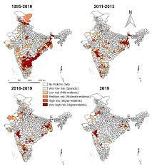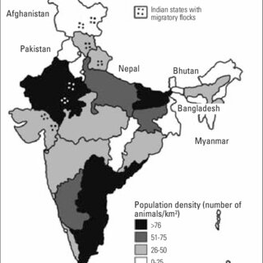

Map 1 : Temporal changes in the geographical distribution of disease risk levels across India from 1995 to 2019. Map 2 : Population density of animals in India
Courtesy-NIVEDI-ICAR 1
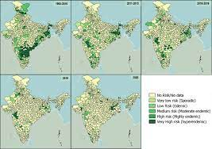
Map 3 : District-wise temporal changes in disease risk levels across India from 1960 to 2019.
Courtesy-NIVEDI-ICAR 1
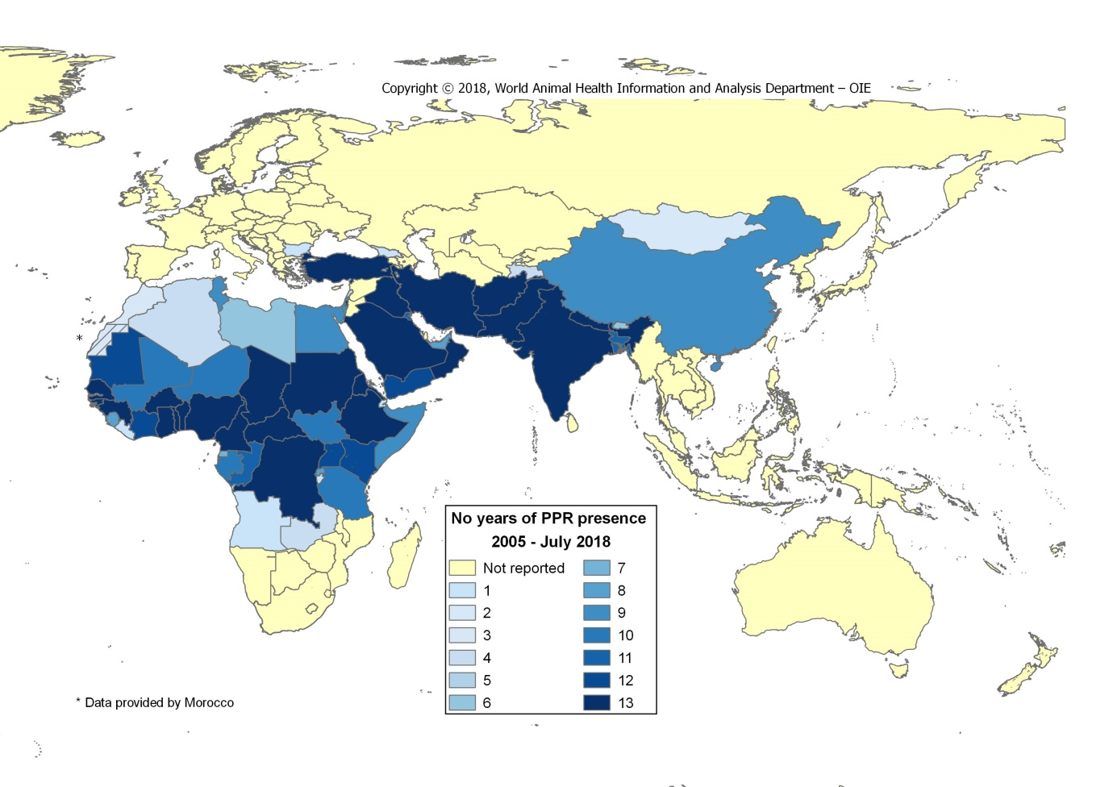
Map 4 : Global distribution of Peste des Petits Ruminants (PPR) presence from 2005 to July 2018.

Courtesy-WOAH 1
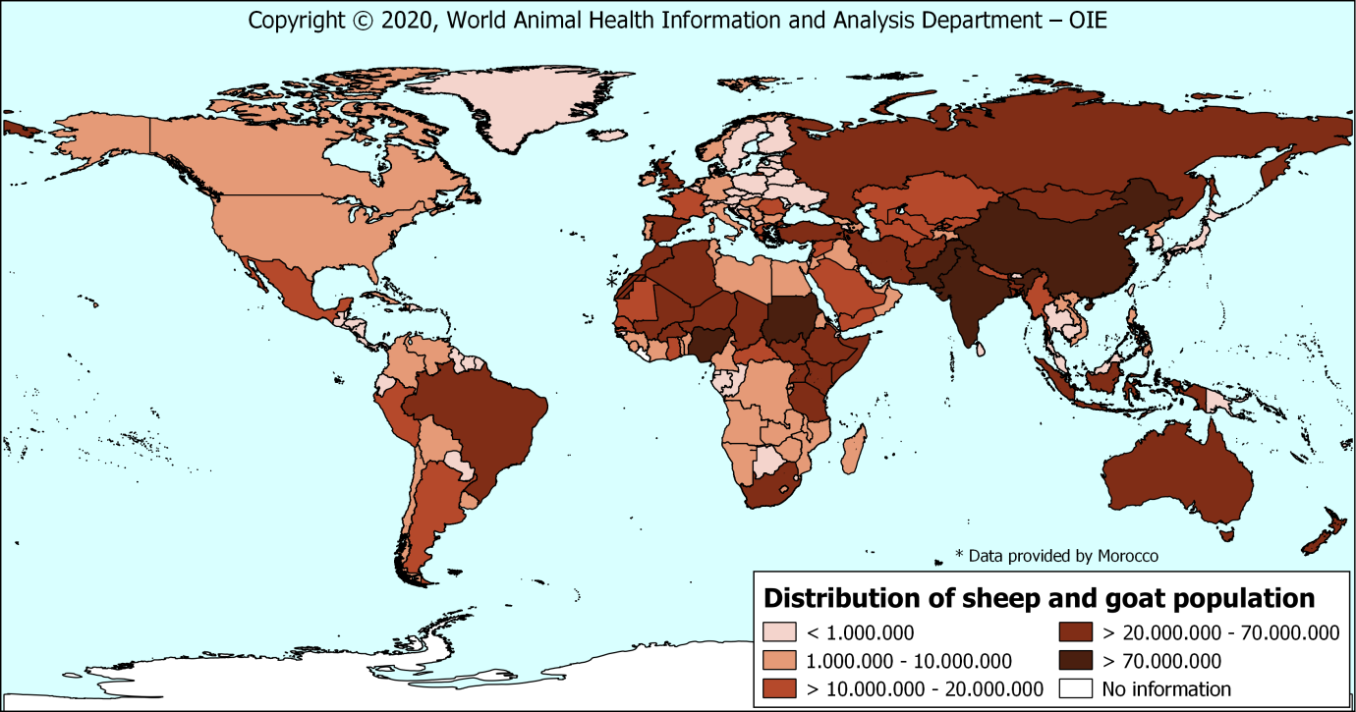
Map 5 : Distribution of sheep and goat population
Courtesy-WOAH 1

12. Results & Discussion
The livestock sector has been scaling up globally, driven by the increasing demand for animal-derived food products. However, traditional livestock production methods can no longer sustain higher production levels. New intensive techniques including biotechnology are now required to augment productivity. Recent progress in mammalian biotechnologies, largely propelled by medical bioscience, presents fresh prospects for livestock industries. These include manipulation of traits and production systems that will result in more output, less waste, and more efficiency. The application of immunogenomics and CRISPR/Cas9 technology can significantly improve disease resistance in livestock. The application of advanced technologies and intelligent systems is revolutionizing livestock farming, leading to enhanced productivity, improved animal welfare, and greater sustainability (Vlaicu et al., 2024). The data revolution, driven by advancements in sensor technology, data analytics, and artificial intelligence, is enabling real-time monitoring and management of livestock operations (Franzo et al., 2023; Neethirajan, 2023). By detecting early signs of disease or stress through data patterns and behavioral analysis, interventions can be implemented proactively, leading to improved growth, health outcomes, and reduced mortality rates (Vlaicu et al., 2024). Furthermore, the ability to track and trace livestock using advanced technologies facilitates disease control and prevention measures, ultimately reducing the risk of outbreaks and economic losses. Infectious diseases in livestock pose a substantial threat to global animal health and welfare, necessitating effective control measures to safeguard food supplies and alleviate rural poverty. As the world population grows and middleclass incomes rise, demand for livestock products increases—a consumption boom shaped by two decade of rapid economic growth and globalization. This "livestock revolution" is driven by urbanization and income growth, and is expected to dramatically change animal agriculture in coming decades. This includes increased livestock production and consumption, a shift to specialized meat, milk, and egg production, and greater stress on fragile pastoral areas. The livestock sector plays a crucial role in nutritional security, providing livelihoods to a significant portion of the rural population (Kumar et al., 2021). Each sub-sector of the livestock has an annual growth rate of more than 5 percent, validating the enormous potential for a rainbow revolution in the sector.

13. Recommendations for Improved PPR Control
To achieve sustainable PPR control and eventual eradication in India, a multi-pronged approach is required that addresses the identified challenges and gaps in current management strategies. Strengthening vaccination programs is critical, with a focus on achieving high and sustained vaccine coverage in all goat populations.

14. Conclusion
The information presented here underscores the importance of robust data collection, analysis, and interpretation in understanding and controlling PPR in goats in India. By leveraging data from various sources and employing appropriate statistical techniques, it is possible to gain valuable insights into the disease's epidemiology, identify high-risk areas, and evaluate the effectiveness of different control measures. The data diagrams and figures included in this analysis provide visual representations of the key findings, facilitating communication and informed decision-making among stakeholders involved in PPR control and eradication efforts.
Wildlife disease management is a crucial aspect of mega fauna conservation in protected areas, as exemplified by the case study in Periyar Tiger Reserve, Kerala, India, where effective management interventions successfully controlled amphistomiasis in Sambar deer and anthrax in elephants. The case of livestock pastoralists living near Panna Tiger Reserve demonstrates a unique situation of high tolerance towards large carnivores despite frequent predation incidents, highlighting the influence of local practices and beliefs on conservation efforts (Kolipaka et al., 2015). Effective monitoring of wildlife zoonotic infectious diseases helps implement public and animal health control strategies (Abrantes & Vieira‐Pinto, 2023). Furthermore, understanding the spatial distribution of these diseases, as demonstrated by research on bovine tuberculosis in African buffaloes in the Kruger National Park, is essential for implementing targeted and effective disease control measures.
Combined efforts of public health and veterinary services can lead to higher vaccination coverage in remote rural settings, reducing vaccine-preventable diseases in both humans and livestock (Marano et al., 2006). To minimize the impact of diseases on wildlife, management actions should be taken before the arrival of a pathogen by reducing the probability of introduction through quarantine and trade restrictions, as prevention is more cost-effective than subsequent responses (Gilbertson et al., 2022). Effective disease management in wildlife reservoirs requires strategies to reduce pathogen transmission between wildlife, domestic animals, and humans, emphasizing the need for proper surveillance and monitoring schemes before intervention. Furthermore, when dealing with multi-host pathogens, it is essential to consider the implications of wildlife involvement and implement appropriate mitigation strategies. The convergence of ecological and human factors can lead to the emergence and spread of zoonotic diseases, highlighting the importance of understanding the interactions between domestic animals, wildlife, and humans in disease transmission. Globalization, urbanization, and trade, especially in live animals and their products, have amplified the interface between humans and animals, increasing the risk of zoonotic disease emergence. Pathogens capable of infecting multiple hosts or persisting for extended periods in the environment have a higher risk of emergence.
Effective management of wildlife diseases necessitates bridging the gap between scientific understanding and practical implementation, as parasites and pathogens of wildlife can threaten biodiversity, infect humans and domestic animals, and cause significant economic losses. Zoonotic disease outbreaks require the involvement of animal health authorities and disease specialists for an effective response.
References
Abubakar, M., Manzoor, S., & Ali, Q. (2015). Evaluating the role of vaccine to combat peste des petits ruminants outbreaks in endemic disease situation. Journal of Animal Science and Technology, 57(1). https://doi.org/10.1186/s40781-014-0036-y
Alemu, B., Gari, G., Libeau, G., Kwiatek, O., Kidane, M., Belayneh, R., Siraw, B., Wieland, B., Asfaw, W., & Abdi, R. D. (2019). Molecular detection and phylogenetic analysis of Peste des petits ruminants virus circulating in small ruminants in eastern Amhara region, Ethiopia. BMC Veterinary Research, 15(1). https://doi.org/10.1186/s12917-019-1828-6
Baksi, S., Dave, H., Rao, N., Malsaria, P., Khan, Md. A. H. N. A., & Chauhan, P. (2018). EVALUATION OF PESTE DES PETITS RUMINANTS (PPR) CELL CULTURE VACCINE IN GOATS AND SHEEP IN INDIA. Bangladesh Journal of Veterinary Medicine, 16(1), 59. https://doi.org/10.3329/bjvm.v16i1.37377
Bardhan, D., pal, S., Kumar, N., Khan, R. M., & Kumar, S. (2020). Trends and Patterns of Major Animal Diseases in India. International Journal of Current Microbiology and Applied Sciences, 9(7), 453. https://doi.org/10.20546/ijcmas.2020.907.051
Bose, B., & Kumar, S. (2025). Economic burden of zoonotic and infectious diseases on livestock farmers: a narrative review [Review of Economic burden of zoonotic and infectious diseases on livestock farmers: a narrative review]. Journal of Health Population and Nutrition, 44(1). BioMed Central. https://doi.org/10.1186/s41043-025-00913-3
Caufour, P., Rufael, T., Lamien, C. E., Lancelot, R., Kidane, M., Awel, D., Sertse, T., Kwiatek, O., Libeau, G., Sahle, M., Diallo, A., & Albina, E. (2014). Protective efficacy of a single immunization with capripoxvirus-vectored recombinant peste des petits ruminants vaccines in presence of pre-existing immunity. Vaccine, 32(30), 3772. https://doi.org/10.1016/j.vaccine.2014.05.025
Enchéry, F., Hamers, C., Kwiatek, O., Gaillardet, D., Montange, C., Brunel, H., Goutebroze, S., Philippe-Reversat, C., Libeau, G., Hudelet, P., & Bataille, A. (2019). Development of a PPRV challenge model in goats and its use to assess the efficacy of a PPR vaccine. Vaccine, 37(12), 1667. https://doi.org/10.1016/j.vaccine.2019.01.057
Ezeasor, C., Emikpe, B. O., Shoyinka, V. S., & Sabri, M. Y. (2021). The influence of intranasal peste des petits ruminants (PPR) vaccine administration alone or with phytogenic mucoadhesive delivery system on PPR outbreak outcomes in goats. Journal of Immunoassay and Immunochemistry, 42(4), 424. https://doi.org/10.1080/15321819.2021.1895216
Gilbertson, M. L. J., Onorato, D. P., Cunningham, M. W., VandeWoude, S., & Craft, M. E. (2022). Paradoxes and synergies: Optimizing management of a deadly virus in an endangered carnivore. Journal of Applied Ecology, 59(6), 1548. https://doi.org/10.1111/1365-2664.14165
Harder, T., Wit, S. de, Gonzáles, J. L., Ho, J. H. P., Mulatti, P., Prajitno, T. Y., & Stegeman, A. (2023). Epidemiology-driven approaches to surveillance in HPAI-vaccinated poultry flocks aiming to demonstrate freedom from circulating HPAIV [Review of Epidemiology-driven approaches to surveillance in HPAI-vaccinated poultry flocks aiming to demonstrate freedom from circulating HPAIV]. Biologicals, 83, 101694. Elsevier BV. https://doi.org/10.1016/j.biologicals.2023.101694
Hasahya, E., Thakur, K. K., Dione, M., Wieland, B., Oba, P., Kungu, J., & Lee, H. S. (2021). Modeling the Spread of Porcine Reproductive and Respiratory Syndrome Among Pig Farms in Lira District of Northern Uganda. Frontiers in Veterinary Science, 8. https://doi.org/10.3389/fvets.2021.727895
Houe, H. (2003). Economic impact of BVDV infection in dairies [Review of Economic impact of BVDV infection in dairies]. Biologicals, 31(2), 137. Elsevier BV. https://doi.org/10.1016/s1045-1056(03)00030-7
Li, C., Wang, G., Liu, Z., Fang, S., Fan, A., Chen, K., & Zhang, J. (2025). Detection and Comparison of Sow Serum Samples from Herds Regularly Mass Vaccinated with Porcine Reproductive and Respiratory Syndrome Modified Live Virus Using Four Commercial Enzyme-Linked Immunosorbent Assays and Neutralizing Tests. Veterinary Sciences, 12(5), 502. https://doi.org/10.3390/vetsci12050502
Makau, D. N., Alkhamis, M. A., Paploski, I. A. D., Corzo, C. A., Lycett, S., & VanderWaal, K. (2021). Integrating animal movements with phylogeography to model the spread of PRRSV in the USA. Virus Evolution, 7(2). https://doi.org/10.1093/ve/veab060
Milovanović, M., Dietze, K., Wernery, U., & Hoffmann, B. (2023). Investigation of Potency and Safety of Live-Attenuated Peste des Petits Ruminant Virus Vaccine in Goats by Detection of Cellular and Humoral Immune Response. Viruses, 15(6), 1325. https://doi.org/10.3390/v15061325
Pandey, S. K., Koirala, P., Maharjan, M., Lamien, C. E., Cattoli, G., Dundon, W. G., & Settypalli, T. B. K. (2019). Molecular characterization of peste-des-petits ruminants virus from Nepal, 2005 to 2016. VirusDisease, 30(2), 315. https://doi.org/10.1007/s13337-018-0504-y
Regmi, B., Dhakal, I., Shah, M. K., & Pande, K. R. (2019). Monitoring of Serological Status in Response to PPR Vaccination in the Goat Population of Parbat, Baglung and Myagdi District of Nepal. Nepalese Veterinary Journal, 36, 157. https://doi.org/10.3126/nvj.v36i0.27775
Rovira, A., Reicks, D., & Muñoz‐Zanzi, C. (2007). Evaluation of Surveillance Protocols for Detecting Porcine Reproductive and Respiratory Syndrome Virus Infection in Boar Studs by Simulation Modeling. Journal of Veterinary Diagnostic Investigation, 19(5), 492. https://doi.org/10.1177/104063870701900506
Siddiqui, Md. S. I., Islam, M. R., & Chowdhury, E. H. (2021). Growth kinetics of a Vero cells adapted Bangladeshi strain of peste des petits ruminants (PPR) virus in cell culture. Archives of Microbiology, 203(4), 1587. https://doi.org/10.1007/s00203-020-02154-w
Sultana, S., Pervin, M., Sultana, N., Siddique, M. P., Islam, Md. R., & Khan, Md. A. H. N. A. (2022). Identification of peste des petits ruminants virus along with co-infecting diseases of goats in Bangladesh. Journal of Advanced Veterinary and Animal Research, 9(3), 463. https://doi.org/10.5455/javar.2022.i615
Tago, D., Hammitt, J. K., Thomas, A., & Raboisson, D. (2016). The Impact of Farmers’ Strategic Behavior on the Spread of Animal Infectious Diseases. PLoS ONE, 11(6). https://doi.org/10.1371/journal.pone.0157450
Thakur, K. K., Revie, C. W., Hurnik, D., Poljak, Z., & Sánchez, J. (2015). Simulation of between-farm transmission of porcine reproductive and respiratory syndrome virus in Ontario, Canada using the North American Animal Disease Spread Model. Preventive Veterinary Medicine, 118(4), 413. https://doi.org/10.1016/j.prevetmed.2015.01.006
Tonni, M., Romeo, C., Formenti, N., Boniotti, M. B., Guarneri, F., Colosio, L., Andreoni, S., Scali, F., & Alborali, G. L. (2023). PRRS Monitoring by Processing Fluids on Italian Swine Breeding Farms. Animals, 13(12), 1946. https://doi.org/10.3390/ani13121946
VanderWaal, K., Paploski, I. A. D., Makau, D. N., & Corzo, C. A. (2020). Contrasting animal movement and spatial connectivity networks in shaping transmission pathways of a genetically diverse virus. Preventive Veterinary Medicine, 178, 104977. https://doi.org/10.1016/j.prevetmed.2020.104977

