Case report

Treatment of hydrocarbon induced acute kidney injury in dog using intermittent hemodialysis

ABSTRACT
Aims: This case report shows the importance of intermittent hemodialysis in successful management of hydrocarbon induced acute kidney injury.
Presentation of Case: A case of 1.5 years old Golden retriever breed dog with history of anorexia, dullness, intermittent vomiting, weight loss, oliguria, melena and coughing since last 6 days was presented in emergency & critical care unit at multispecialty veterinary hospital, Guru Angad Dev Veterinary and Animal Sciences University, Ludhiana, Punjab. On complete history taking, owner reveals that animal was licking engine oil from last 10 days. Laboratory findings revealed that BUN- 210 mg/dL, Creatinine- 13.7 mg/dL, Na- 146 mEq/L, K- 4.7 mEq/L, Cl- 108 mEq/L, P- 16.5 mg/dL and Ca- 13.7 mg/dL. Serum total protein and albumin were 6.1 g/dL and 2.7 g/dL, respectively. Abdominal ultrasound revealed Left kidney enlarged with normal cortico-medullary differentiation (CMD) & right kidney hyperechoic with loss of CMD. Radiographic findings reveals moderate bronchial and interstitial pattern seen in lungs. As the dog was already on fluids and diuretics from past 5 days without any promising results, intermittent hemodialysis (IHD) was preferred as a treatment modality of choice to save dog’s life.
Discussion and conclusions: The dog was put on IHD and after dialysis the dog showed good recovery without any further signs of renal injury even after one year of dialysis.
Keywords: Engine oil, Licking, Acute kidney injury, dog, dialysis.
- INTRODUCTION
Acute kidney injury (AKI) in dogs is characterized by an abrupt onset of renal parenchymal injury. It is frequently linked to acid-base, fluid, and electrolyte imbalances, decreased renal function, and retention of uremic waste products (Langston, 2010). Most commonly implicated etiological factors for AKI in dogs include ischemia, inflammation, various infectious diseases and exposure to nephron-toxicants including drugs (NSAIDs), food (grapes, resins) and chemicals (ethylene glycol). Nevertheless, even with a thorough diagnostic workup, many a times the etiology remains unknown and cannot be used to predict prognosis in a significant number of animals with AKI (Segev et al., 2008). As so, even with extensive care, the rates of morbidity and mortality are still significant (Rimer et al., 2022). AKI's short-term prognosis is influenced by a number of factors, such as treatment options, comorbidities, and the etiology, which affects how reversible the injury is (Segev et al., 2008).
Although, not reported in India, ingestion of petroleum or its products like engine oil, brake oil and fuel additives can also lead to either AKI or chronic kidney disease (CKD) depending upon quantity, exposure time and route of exposure. Aromatic hydrocarbons are present in considerable concentrations in unleaded petrol and its products (Ahmed et al., 2009). Among all the aromatic chemicals found, benzene, toluene, and xylenes (BTX) provide the most risk (Perigo and Prado, 2005; Adami et al., 2006). Here we present a rare case report involving exposure of a dog to engine oil over a period of 8-10 days leading to AKI and successful treatment involving intermittent hemodialysis.
- PRESENTATION OF CASE
A case of 1.5 years old Golden retriever breed dog with history of anorexia, lethargy, 3-4 episodes of vomiting, weight loss, oliguria, melena since past 6 days and coughing from last 3 days was presented in dialysis unit, multispecialty veterinary hospital, Guru Angad Dev Veterinary and Animal Sciences University, Ludhiana, Punjab. Detailed history taking revealed that animal usually having habit of licking engine oil drained from the car from last 20 days and show signs of acute kidney injury from last 7 days. On presentation, the dog was having body condition score of 2 with dull activity level, Rectal temperature-101.4⁰F, Heart rate-138 bpm, Respiration rate-28 per minute, congested mucous membrane, normal lymph nodes and body weight of 27 Kgs. Laboratory findings revealed moderate anemia with poor regeneration, relative lymphocytosis with mild left shift having hemoglobin (Hb): 7.3 g/dL, total leucocyte count (TLC): 5730, neutrophils (N): 50, lymphocytes (L): 48, packed cell volume (PCV): 18.1% and platelet count of 192 x 10³/µL. Renal function profile revealed blood urea nitrogen (BUN): 210mg/dL, creatinine: 13.7mg/dL, sodium (Na): 146mEq/L, potassium (K): 4.7mEq/L, chloride (Cl): 108mEq/L, phosphorus (P): 16.4mg/dL and calcium (Ca): 13.7 mg/dL. Serum total protein and albumin were 6.1g/dL and 2.7g/dL, respectively. Routine urine analysis revealed urine pH: 5.5 and specific gravity of 1.015. The blood report was negative for any hemoprotozoan infection. The arterial blood pressure (Doppler) was 110 mm of Hg. Abdominal ultrasound revealed left kidney enlarged with normal CMD (Figure 1) and right kidney hyperechoic with loss of CMD (Figure 2). Radiographic findings reveal that moderate bronchial and interstitial pattern was seen in lungs (Figure 3). As the dog was already on fluids therapy from past 5 days without any promising results, intermittent hemodialysis (IHD) was preferred as a treatment modality of choice to save dog’s life. After aseptically preparing the site, a dedicated 19 cm 11.5 Fr. double lumen temporary dialysis catheter (DLC) was inserted in left jugular vein to gain vascular access. The catheter tip was carefully placed at the junction of cranial vena-cava and the right atrium in-order to achieve uninterrupted blood flow (Figure 4). The dog was put on IHD using Fresenius medical care (Germany) 4008 S (ng) dialysis workstation and showed good recovery with post-dialysis Hb: 7.0, TLC:6000, N: 60, L: 40, PCV: 18% and platelet count of 125x10³/µl. Renal function profile revealed BUN: 110 mg/dL, Creatinine: 7.6 mg/dL, Na: 144 mEq/L, K:4.2 mEq/L, Cl: 110 mEq/L, P: 08 mg/dL, Ca:12.6 mg/dL, (Table 1). The second and third dialysis session was planned for next 2 consecutive days (Table 1). After 3rd session there was significant improvement seen in animal condition. Post-dialysis medications including proton pump inhibitor, loop diuretic, phosphate binder, Omega-3 and 6 amino acid, and L-carnitine supplementation were continued for next 5 days. On day 6 laboratory tests revealed Hb: 6.4 g/dL, TLC: 8300, N: 88, L: 12, PCV: 17.5%, platelet count: 65 x10³/µl, BUN: 10 mg/dL, creatinine: 1.4 mg/dL, Ca: 11.8mg/dL, TP: 5.9g/dL and albumin: 2.5g/dL. The dog recovered without any further signs of renal injury even after one year of initial presentation.
- DISCUSSION
Acute kidney injury (AKI) in dogs is considered as a life threatening complication that can arise from ingestion of various incriminating agents including hydrocarbons. The hydrocarbons are regularly used in our day to day life in motorbikes as well in cars. The exposure to hydrocarbons causes kidney injury by mechanism of developmental, physiological disruption and oxidative stress. Hydrocarbons found in substances like Caroline, gasoline, solvents and motor oil can cause both direct nephrotoxic damage and systemic effects like oxidative injury, hypotension and hypoxia. This renal injury due to hydrocarbon may be attributed to toxic tubular cell damage and ischemic tubular necrosis, often progressing to oliguria/ anuria along with rapid deterioration of hemato-biochemical parameters (Osweiler, 2011). In the present case, IHD was employed as renal replacement therapy to manage persistent azotemia and metabolic acidosis which was unresponsive to conservational medicinal therapy. Hemodialysis is indicated in veterinary patients suffering from AKI when conservative medicinal therapy fails to yield results leading to life threatening complications (Cooper et al., 2016; Singh et al., 2024 & Singh et al., 2025).

Although most of the hydrocarbons are lipophilic in nature with large volumes of distribution and are poorly dialyzable but the resulting accumulation of metabolic waste products, uremic toxins and electrolytic disturbances resulting from AKI are readily cleared via IHD (Graurer, 2008). Apart from this, IHD also facilitates volume control, mitigates accumulated uremic toxins load and allows for rapid correction of acid-base and electrolyte derangements (Ross et al., 2015). An emerging benefit of IHD is its role in managing oxidative stress which is a key pathophysiological mechanism in ischemic and toxic AKI. Hydrocarbon exposure leads to the generation of reactive oxygen species (ROS) further contributing to renal tubular injury and inflammation. Hemodialysis can indirectly reduce this oxidative burden by filtering out uremic toxins, inflammatory mediators and improving overall hemodynamic and metabolic stability (Goldstein et al.,2011). Humans are susceptible to either acute or chronic toxicity when petroleum is produced, distributed, and used (Bruckner and Warren, 2001). Whereas, pets like dogs may get exposure due to licking of leaked engine oil commonly present in home garages to which they have easy access. Xylene and toluene present in petrol and its products can lead to renal tubular acidosis, azotemia, hematuria, proteinuria and pyuria (Nathanae, 2009).

In this case, three sessions of IHD using a low flux helixone synthetic membrane dialyzer with bicarbonate based dialysate led to progressive stabilization of serum creatinine, BUN, phosphorus and potassium levels. The selection of dialysate and membrane was guided by the need for efficient solute clearance, biocompatibility and patient’s body weight. Also, Hemodynamic stability was maintained throughout the dialysis procedure along with round-the-clock monitoring of patients’ vitals (BP, SpO2, ECG, temperature, respiration rate, heart rate), which is critical in canine hemodialysis ( Singh et al., 2025). Adjunctive therapy included 0.9% NSS, parenteral 7% amino acid solution @ 1.5g/kg/day (Nephrosteril, Fresenius Kabi), furosemide (@ 2mg/kg IV BID after fluids), pantoprazole (@1mg/kg IV OD), L-carnitine (@ 2g slow IV OD), metoclopramide (0.5mg/kg SC BID), and ampicillin (@22mg/kg IM BID). This case report supports the application of IHD in veterinary medicine for the management of hydrocarbon induced AKI and emphasizes the need of dialysis-ready centers with exceptionally trained veterinarians.

- CONCLUSIONS
This study highlights the successful management of hydrocarbon induced AKI with the help of intermittent hemodialysis in dogs and highlights the integration of hemodialysis for renal, toxicological and pharmacokinetic stabilization of companion animals
REFERENCES

Adami G., Larese F., Venier M., Barbieri P., LoCoco F., Reisenhofer E. Penetration of benzene, toluene and xylenes contained in gasoline's through human abdominal skin in vitro. Toxicol In Vitro. 2006;20:1321–1330.
Ahmed H.H., Metwally F.M., Rashad H.M. Toxicity of solvents exposure on the neuroendocrine system in rats: role of amino acids supplementation. Toxicity of Solvents, Rep Opinion. 2009;1:66–83.
Ahmed J, Weisberg LS. Hyperkalemia in dialysis patients. Semin Dial. 2001;14(5):348–356.
Brown, S. A., & Grauer, G. F. (2019). Veterinary nephrology and urology. In Ettinger, S. J., & Feldman, E. C. (Eds.), Textbook of Veterinary Internal Medicine (8th ed.). Elsevier.
Bruckner J.V., Warren D.A. Toxic effects of solvents and vapors. In: Klaassen C.D., editor. Casarette and Doulls toxicology the basic science of poisons. 6th ed. McGraw-Hill Medical; New York (NY): 2001. pp. 869–944.
Cooper, E. S., Labato, M. A., & Langston, C. E. (2016). Renal Replacement Therapies in Small Animals. Veterinary Clinics: Small Animal Practice, 46(6), 1227–1252. https://doi.org/10.1016/j.cvsm.2016.06.005
Cowgill, L. D., & Langston, C. E. (1997). Therapeutic Apheresis and Dialysis in Small Animal Practice. Compendium on Continuing Education for the Practicing Veterinarian, 19, 679–690.
Galli, F., Benedetti, S., Floridi, A., Buoncristiani, U. (2010). Oxidative stress and reactive oxygen species in uremia and hemodialysis: friend or foe? Blood Purification, 30(2), 117–123. https://doi.org/10.1159/000319983
Goldstein, Bernard & Osofsky, Howard & Lichtveld, Maureen. (2011). The Gulf oil spill. The New England journal of medicine. 364. 1334-48. 10.1056/NEJMra1007197.
Grauer, G. F. (2008). Acute renal failure and uremia. In DiBartola, S. P. (Ed.), Fluid, Electrolyte, and Acid-Base Disorders in Small Animal Practice (3rd ed.). Elsevier Saunders.
Langston CE. Acute kidney injury. In: Ettinger SJ, Feldman EC, eds. Textbook of Veterinary Internal Medicine. 8th ed. Philadelphia, PA: Saunders WB; 2010:4650‐4685.
Langston, C. E. (2012). Hemodialysis in Veterinary Medicine. Topics in Companion Animal Medicine, 27(2), 52–60. https://doi.org/10.1053/j.tcam.2012.02.003
Nathanae, J. M. (2009). Toluene toxicity. Portland Veteran Affairs Medical Center, Oregon Health and Science University. Retrieved April 14, 2015.
Osweiler, G. D. (2011). Toxicology. In: Booth, N. H. & McDonald, L. E. (Eds.), Veterinary Pharmacology and Therapeutics. Iowa State University Press.
Perigo J.F., Prado C. Evolution of occupational exposure to environmental levels of aromatic hydrocarbons in service stations. Ann Occup Hyg. 2005;49:233–240.
Rimer D, Chen H, Bar Nathan M, et al. Acute kidney injury in dogs: etiology, clinical and clinicopathologic findings, prognostic markers, and outcome. J Vet Intern Med. 2022;36(2):609‐618.
Ross, S. J., Osborne, C. A., Lulich, J. P. (2015). Update on the medical management of acute renal failure. Journal of the American Animal Hospital Association, 41(1), 15–22.
Segev G, Kass PH, Francey T, et al. A novel clinical scoring system for outome prediction in dogs with acute kidney injury managed by hemodialysis. J Vet Intern Med. 2008;22:301‐308.

Table 1: Comparison of pre-and post-hemato-biochemical parameters in dog undergoing IHD
Parameters | IHD
 | Session I |  | Session II |  | Session III
 | Pre-IHD | Post-IHD | Pre-IHD | Post-IHD | Pre-IHD | Post-IHD
Hb | 7.3 | 7.0 | 7.2 | 7.1 | 7.6 | 6.4
TLC | 5730 | 6000 | 6500 | 6800 | 7700 | 8300
Neutrophil | 50 | 60 | 60 | 70 | 76 | 88
Lymphocyte | 48 | 40 | 40 | 30 | 20 | 12
Monocyte | 0 | 0 | 0 | 0 | 0 | 0
Eosinophil | 2 | 0 | 0 | 0 | 04 | 0
Basophil | 0 | 0 | 0 | 0 | 0 | 0
PCV | 18.1 | 18 | 20 | 20.1 | 20.4 | 17.5
Platelets | 192 | 125 | 155 | 97 | 106 | 65
Total Bilirubin | 0.1 | 0.1 | 0.1 | 0.1 | 0.1 | 0.2
ALT | 27 | 30 | 35 | 38 | 44 | 45
BUN | 210 | 110 | 140 | 50 | 70 | 10
Creatinine | 13.7 | 7.6 | 10 | 2.3 | 4.3 | 1.4
Sodium | 146 | 144 | 142 | 145 | 147 | 142
Potassium | 4.7 | 4.2 | 4.4 | 4 | 3.9 | 4.8
Chloride | 108 | 110 | 111 | 106 | 102 | 108
Phosphorus | 16.4 | 8 | 12 | 6 | 6 | 3
Calcium | 13.7 | 12.6 | 12.5 | 12.7 | 12 | 11.8
Total Protein | 6.1 | 5.9 | 6.1 | 5.8 | 6 | 5.9
Albumin | 2.7 | 2.6 | 2.7 | 2.6 | 2.5 | 2.5

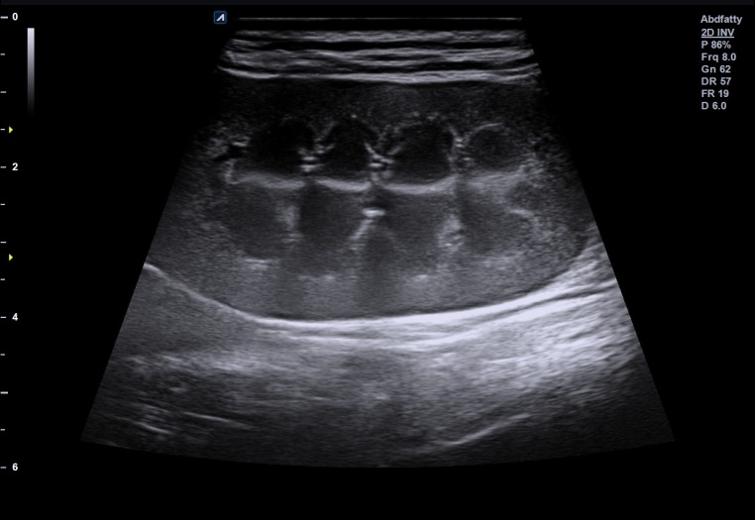 | 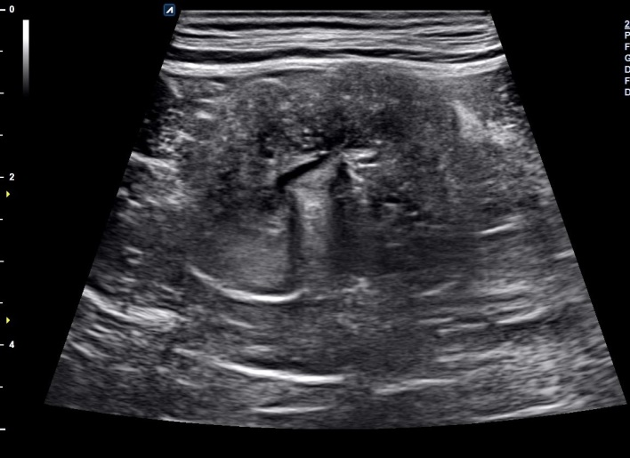
Fig. 1: Maintenance of Corticomedullary differentiation(CMD) in left Kidney | Fig. 2: Complete loss of CMD  in right kidney

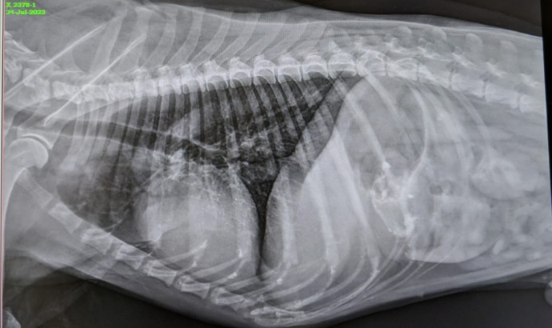
Fig. 3: Lateral radiograph showing mild broncho-interstitial pattern

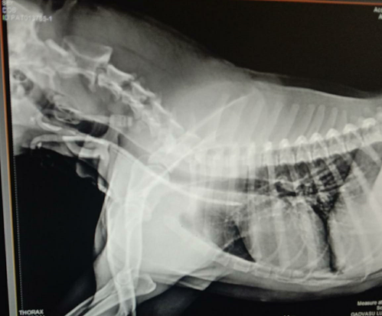
Fig. 4: Thoracic radiograph showing correct placement of double lumen dialysis catheter tip at the junction of cranial vena cava and right atrium.

