Review Article

Mapping the Development and Knowledge Structure of China’s Rural Collective Economy Policy: A Bibliometric Analysis Using R
Abstract
China’s new rural collective economy policy has gained prominence in the last two decades due to its crucial role in promoting rural revitalization and sustainable development. However, there is still a paucity of compiled research synthesizing the scientific research development and knowledge on the operating mode of China's new collective economy policy. Therefore, the paper fills the gap by conducting a bibliometric review and analysis based on 150 articles from the Web of Science database to evaluate the relevant scientific research productivity and operating development pathway mechanisms of the new rural collective economy in China, using the R software package. The results from the bibliometric analysis demonstrate a significant increase in interest in the research field. The scientific productivity of the selected articles published in the topmost prolific journals reached its peak in 2023. The results suggest that more than half of the articles reviewed were published between 2012 and 2024. Critical contributions to the development of knowledge in the field of the new rural collective economy mainly come from top influential authors affiliated with highly ranked Chinese Universities. The results further outline that thematic areas, such as ‘rural collective actions’, ‘collective land shareholdings’, ‘agriculture cooperatives', and social capital, have progressively become research hotspots and critical operating development pathways mechanisms of the new rural collective economy in China. This review highlights the potential of China's new rural collective economy policy to promote sustainable rural development and rural self-governance. It indicates a shift in China’s rural governance, away from direct intervention towards support for local collective actions.
Keywords: Collective economy, collective actions, agriculture cooperatives, collective shareholding, common prosperity
Introduction
In the last 40 years, China’s government has implemented several policies to promote rural development and rural revitalization. However, despite the policies, living in rural communities in China encompasses several challenges such as income inequalities(Umair, Aizhan, Teymurova, & Chang, 2024), relative poverty (Yunhui Wang, Chen, & Li, 2024), farmland abandonment(Song, Li, Xin, & Wang, 2024), and livelihood pressure(X. Yang, Guo, Deng, & Xu, 2021), making rural residents vulnerable. These challenges have stimulated the ever-growing need to explore new rural economic policies to achieve sustained rural development and collective prosperity. Indeed, one key rural development policy implemented in recent times that has attracted the attention of researchers and development actors in China is the ‘new Rural Collective Economy policy’ (Jiang et al., 2023). The new collective economy policy describes the economic development framework where members within the community collectively utilize the collectively owned resources to achieve common prosperity and a better life, particularly through the formation of economic organizations, associations, and cooperation(Yi, Huo, Zhang, & Chen, 2023). The new rural collective economy policy effectively aligns with the modern property rights and management systems while retaining and optimizing the functions of rural economic coordination and public service. The policy has been implemented to consolidate the traditional collective economic development achievements of the Chinese CPC government since 1978. Evidence from a growing body of literature shows that there have been significant improvements in the outcome of the new rural collective economy policy in China. Further Evidence from existing studies reveals that the new rural collective economy has contributed significantly to a well-defined property right, improved farmers’ income structure, and job opportunities, particularly through cooperative production efforts, release of labor, and large-scale production (B. Yang & Mou, 2020). Numerous studies have further confirmed the positive impact of the new rural collective economy, which has contributed to the strengthening of farmers' income, improved productivity, and reduced poverty levels, leading to the revitalization and long-term growth of rural communities.
The operating mode of the rural collective economy has developed over the last two decades, peaking in 2016, where clear property rights, collective shareholding, and transparent land contract systems have been developed. The rural collective economy in China is based on two key elements: collective ownership in agriculture and the operation of collective enterprises by the village. Article 101 of the Civil Code outlines the regulations for rural collective economic organizations, while Article 262 describes the exercise of collective property ownership on behalf of farmers' collectives. These regulations establish three levels of rural collective economic organizations: townships, villages, and villagers' groups. A rural collective economic organization represents a community-centric economic entity that is grounded in collectively owned land and production resources. Its main objective is to advance the rural collective economy through a dual management system that integrates centralized and decentralized approaches, institutionalizing farmer collectives. This institutionalization is distinguished by well-defined goals and purposes, including the design of individual and collective shares to provide public services and effectively manage individual income.
The key principles of this model encompass the universal membership of all villagers in the collective economic organizations, collective ownership of production resources, and a steadfast commitment to achieving common prosperity. This is achieved through Labor-based distribution, robust welfare provisions, and active spiritual and political engagement among villagers, who are dedicated to the ideals of collectivism and socialism. In this economic framework, a recognized village committee is set up to play the governance role of the rural collective organization on behalf of farmer collectives and the village households with a well-structured functional team.
Several authors have made an effort to investigate further the operation of the rural collective economy policy relating to its impact on promoting rural development and revitalization(Deng et al., 2023). Notwithstanding this, the core information regarding operating path mechanisms activated to achieve the desired outcomes of the new rural collective economy policy in China is scattered in limited studies across different bodies of literature and landscapes. There is a paucity of compiled research synthesizing the various knowledge developments in research relating to the operating path mechanisms of the collective economy through which common prosperity, better life, and sustained rural development are achieved. The lack of detailed synthesized information relating to the operating path mechanisms of the new rural policy does not offer a complete picture of how the policy is being implemented; its innovative contributions and functionality align with policy inputs, processes, and outcomes. It is essential to provide synthesized information to help the Chinese government, policymakers, and researchers obtain a comprehensive understanding of the operating path mechanisms and outcomes of the new rural collective economy. This study, therefore, aims to specifically provide an in-depth systematic review combined with a bibliometric analysis of the research developments and knowledge gaps relating to the development operating path mechanisms through rural collective economy policy, and how it is implemented in contributing to collective rural prosperity and sustainable rural development. Hence, the following research questions are addressed through a systematic review combined with a bibliometric analysis:
- What are the annual publication trends in research on rural collective economy policy in China?
- Which authors and institutions are the most influential in publishing research on the rural collective economy in China?
- What are the leading journals in terms of publication volume and academic impact in the field of rural collective economy research in China?
- How have thematic priorities and research trends evolved in the field of rural collective economy studies in China?
- What are the Operating Path Mechanisms of the Rural Collective Economy policy in China?
- What literature gaps can be identified to inform the future research agenda on rural collective economy policy in China?
To answer these questions in the study, a bibliometric analysis was first applied to provide an overview of the existing articles published on the rural collective economy in China, and the growth of scientific research over the last two decades in the research area in China. The study moreover identifies the influential authors’ productivity in terms of citations and H-index, their affiliations, and social network collaborations. The evolution and development of scientific studies on rural collective economy in China were analyzed, and the growing and emerging keywords, the main thematic clusters related to the field of rural collective economy in China, were identified.
Finally, based on the data from the bibliometric analysis, the systematic review was further executed to shed light on the operating path mechanisms of the rural collective economy policy in China by focusing on the specific strategies implemented to achieve collective prosperity and well-being in rural China. The various emerging and innovative operating path mechanisms of the rural collective economy in China, following the outcome of the bibliometric analysis, are discussed in the study. The discussion reflects on the key operational activities implemented to achieve the outcome of the rural collective economy policy in China. To execute the systematic review successfully, a comprehensive survey of existing studies in core journals recorded in the Web of Science database was conducted based on the framework for Preferred Reporting Items for Systematic Reviews and Meta-Analysis (PRISMA), while the R package was utilized for the data analysis of the bibliometric data. Specifically, establishing a specific and holistic view of the operating path mechanisms of the new policy is urgently needed for the CPC central planning committee and Village committee managers, who are the driving forces of the collective rural development, to design rural development intervention programs. The findings from this study further provide new policy perspectives and research directions regarding the new rural collective economy. The remaining sections of the paper are therefore organized as follows: Section 2 presents the review methods and the strategies for selecting and screening published articles records from the Web of Science database. The bibliometric analytical strategy has also been outlined in section 2. Section 3 highlights the results and discussions from the bibliometric analysis and systematic review conducted. Finally, section 4 presents the conclusions, policy implications, research gaps, and emerging areas as directions for future studies.
Method
Strategy and Sources of Literature
The preferred Reporting Items for Systematic Reviews and Meta-Analysis (PRISMA) method has been explored to conduct an objective systematic review focused on the mechanisms of the rural collective economy in China. Several scholars have utilized the PRISMA method as a well-defined strategy for the review of articles (Page et al., 2021). The search for key articles was mainly based on the use of article titles and keyword searches in the online electronic database, specifically the Web of Science. According to (AlRyalat, Malkawi, & Momani, 2019) databases such as Web of Science offer advanced search and ensure high-quality literature records that promote effective extraction of reliable article information. Again, the Chinese Academy of Science recognizes the Web of Science as a reliable and relevant source of studies published in high-quality journals.
Literature search and selection process
Based on the PRISMA framework, the literature selection process involved four stages, namely: identifying the articles for review, screening the studies, determining the study's eligibility, and selecting studies to be included in the systematic review (Page et al., 2021). The PRISMA framework showing the literature selection process has been presented in Figure 1. The survey from previously published studies and reference checking reveals that key works such as rural revitalization, rural collective economy, new collective economy, rural organizations, land transfer, collective property, and common prosperity are mostly used to describe the operation of the rural collective economy in China. As a result, these keywords were used to explore and extract the relevant articles for the review. For instance (‘collective economy’ OR ‘new collective economy’ OR, collective resources ‘Or ‘land resources’ OR collective property rights’ OR ‘community organizations’ OR ‘collective prosperity’ OR ‘common prosperity’) AND (‘community welfare’ OR ‘collective welfare’ OR ‘community revitalization’ OR ‘community development’ OR ‘Poverty alleviation’ OR ‘rural resilience’) AND (‘Rural’ OR ‘countryside’ OR ‘Village’) AND (‘China’).

Criteria for Inclusion and Exclusion of Literature
The two key strategies to ensure the quality of documents and records for the review are the inclusion and exclusion criteria. The systematic review included only articles published from 2012 to 2024 that focused on China. The review primarily focused on the new rural collective economy policy practiced in China(R. Wang & Tan, 2020). Again, the review included studies that focused on the rural collective economy and its related issues. Particularly, articles that focused on the mechanism of the implementation of the new rural collective economy policy in China and its contributions to the common progress and better among the rural communities in China.
The reviewers excluded studies conducted before 2004, which marks the beginning of the formal operation of the new rural collective economy in China. The exclusion process further involves discarding all records for which full-text access is not available to allow for complete evaluation of the documents. Subsequently, documents with incomplete indexing and text that are not relevant to the objectives of the study were excluded. The exclusion process tends to improve the quality of the results and attainment of the research within the scope of rural collective economic development patterns, mechanisms, and emerging areas. Studies that are not published in the English language or do not focus on the rural collective economy in China were excluded. Again, studies that focused on rural collective economy policy in countries other than China were excluded. Articles that do not include information on the rural collective economy and its related issues were moreover excluded.

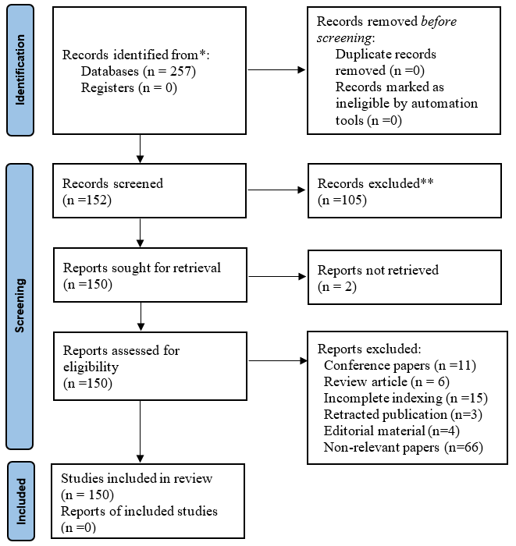
Figure 1: A Flow Diagram of Literature Selection Process (PRISMA)
Strategy for data analysis
The data analysis of the records extracted was conducted using the R Studio tool. The R package has been explored by several scholars for bibliometric analysis, particularly for quantitative research. The R software package has been recommended as the most reliable and powerful statistical software, integrated with several applications utilized for quantitative data analysis(Derviş, 2019). Specifically, the data analyses focused on descriptive statistics and bibliometric analysis. The data analysis of the records extracted was conducted using the R Studio bibliometric tool. The R package has been explored by several scholars for bibliometric analysis, particularly for quantitative research. The R software package has been recommended as the most reliable and powerful statistical software, integrated with several applications utilized for quantitative data analysis (Aria & Cuccurullo, 2017).

Clusters of Co-occurrence
Co-word analysis was performed to describe the content of the records and to develop specific themes for the articles extracted. The analysis was based on co-occurrences of keywords used by different scholars to describe the concepts and contents explored in their articles (Aria & Cuccurullo, 2017). Co-word analysis presented a conceptual digraph and graphical maps used to develop the themes and sub-themes in the study. The clusters of co-occurrences measured the centrality and density of the level of research articles published in the field of study. Centrality is the extent of interaction of a cluster with other clusters, while density describes the internal cohesion of a cluster (Aria & Cuccurullo, 2017). The density and centrality analyses help researchers to identify and categorize clusters in a given sub-period for dynamic analysis.
Thematic Analysis
The thematic analysis describes the groups of themes that evolved across different sub-periods. These themes are presented using thematic maps, which show bipartite graphs with vertices categorized into two disjoined sets while the edges are connected elements extending from one set to another. Moreover, the link between two disjoint sets of clusters in thematic areas defines the keywords, and the thickness of the link is directly proportional to the inclusion index. The inclusion index ranges from 0 to 1. The inclusion index of 1 implies that the words in a given cluster at a sub-period are also included in other clusters and in another period. We considered an inclusion index of 0.1 in this article.
Results
This section presents the results from the bibliometric review and the discussion of the results, as shown in the ensuing sections.

Annual scientific production
The Annual scientific production has been utilized by several scholars, such as to assess the productivity and research intensity within a specific field of research. This study presents the results on Annual scientific production in Figure 2. Based on the final list of 150 articles selected for the study, Figure 2 demonstrates that there is an increased growth of publications relevant to the rural collective economy policy in the last 20 years in China. The upward trend in annual scientific publications involving relevant topics closely linked to the rural collective economy in China, as shown by Figure 2, can be described in terms of three different periods. Period 1 (2004-2014) witnessed an initial developmental stage where research publications involving the rural collective economy remained low, while increasing progressively. In 2018, only 8 articles were published, which represents the highest number of publications per year during this period, while the lowest was only 1 article published in 2004, 2005, 2008, and 2010. The second (Period II) cut-off period (2014-2020) further demonstrated a rapid growth in the research publications. Nonetheless, the results show that more than 86% of the articles were published between 2014 and 2024. This implies a significant increase in interest in research topics related to the new rural collective economy in China, particularly since 2014. Period III (2021-2024) further marks the peak of research productivity and number of publications in the field. In 2023, a total of 29 articles were published, the year with the highest publications in the last 20 years. The results imply that the growing relevance of attention by the scientific community reflects the highest number of publications recorded during the periods of 2021, 2022, and 2023. Figure 2 displays the mean total citation per year (MeanTCperYear) resulting from the analysis of the 150 articles selected. The average total citation per year evaluates the impact of a publication. The results indicate that the year 2007 witnessed the highest average total citation per year (MeanTCperYear =22). In the first decade, the average total citation per year fluctuated steadily while moving above the article production growth. However, in the second decade, the average total citation per year dwindled but remained lower than the article reduction growth.

Figure 2: Annual scientific production

Most Relevant Affiliations
Figure 3 presents the top ten most relevant affiliations for the articles selected for the study. The results show that Zhejiang University was the most relevant affiliation with 35 articles published from 2004 to 2024, followed by Tsinghua University with 26 articles and Renmin University with 14 articles. The Beijing Forestry University, City University of Hong Kong, and Huazhong Agriculture University produced 11 articles each. Other universities such as Nanjing Agriculture University, Peking University, and Sichuan Agricultural University also produced 10 articles respectively. The latest productive affiliation among the top 10 relevant affiliations was Tongji University, with 9 articles produced. Figure 4 further demonstrates the network between authors' affiliations and productive countries.
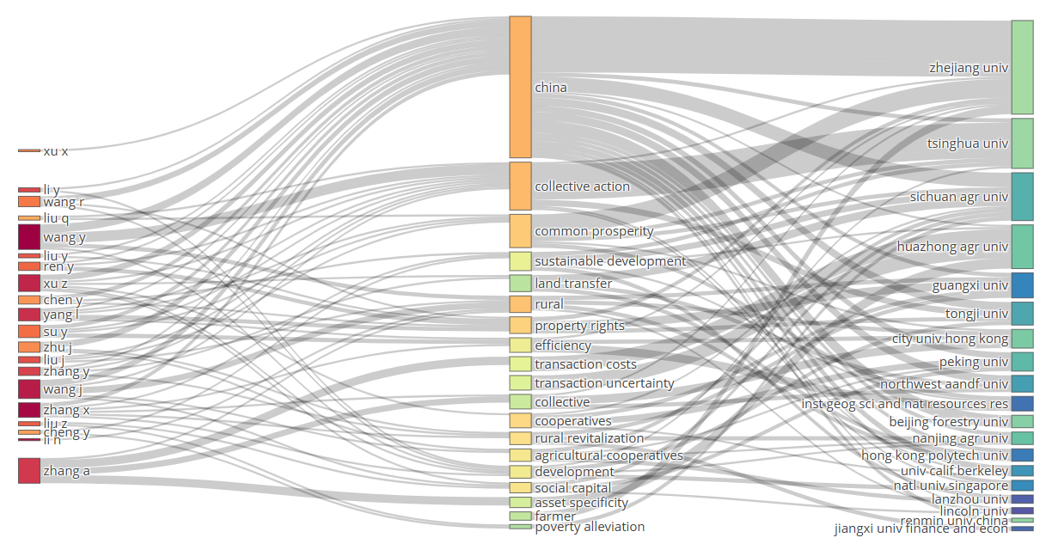 Figure 4: Top 20 most relevant authors’ affiliations
Most Relevant Research Collaborations
The collaboration between researchers offers a common source for cross-fertilization of scientific knowledge and ideas transfer and sharing between different researchers across different institutions and countries. Results from Figure 5 demonstrated the highest collaboration between authors in China and the USA, China and the UK, China and Singapore, China and Germany, China and Canada, as well as Germany and the Netherlands. The graphical outlook shows that authors in China have strong collaborations with other authors across the globe, while the collaboration between China and the USA yielded a high number of articles. UK and Germany, New Zealand and Italy, Sweden and Canada, and the USA and Canada.
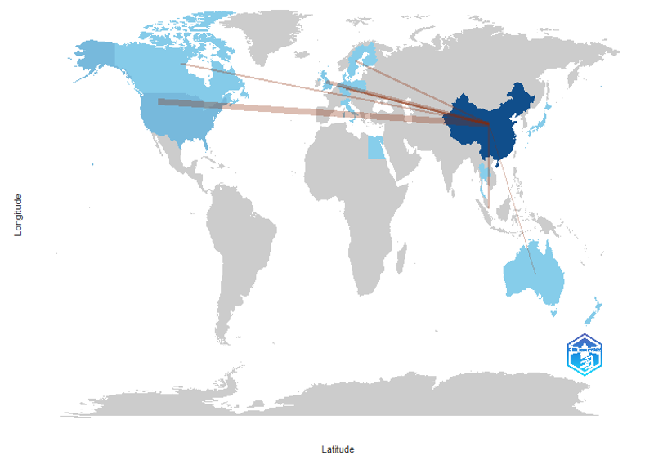
Figure 5: Collaborative world map
Top Productive Journals
Table 1 highlights the top 20 most relevant and productive journals. The Land Use Policy (H-index =10, TC=450, and 13) is ranked first as the most productive and impactful journal with the highest H-index and citations. China Quarterly (H-Index=6, TC=271, N=6) is the second highest prolific journal in the field of rural Collective economy in China. Journals such as Land (3rd) and Sustainability(4th) have the relatively highest number of articles published in the research area despite their low citations and H-indices. Journal of Rural Studies (7th) further remained a relevant and productive journal with 7 articles and 125 citations despite the low H-index.
Table 1: Top 20 Productive Journals
Rank | Journal | H-Index | Total Citation | Articles | Percentage
1 | Land Use Policy | 10 | 450 | 13 | 8.7%
2 | China Quarterly | 6 | 271 | 6 | 4.0%
3 | Land | 6 | 87 | 16 | 10.7%
4 | Sustainability | 6 | 111 | 16 | 10.7%
5 | Habitat International | 5 | 114 | 5 | 3.3%
6 | China Economic Review | 4 | 156 | 4 | 2.7%
7 | Journal of Rural Studies | 4 | 125 | 7 | 4.7%
8 | Urban Studies | 4 | 171 | 4 | 2.7%
9 | Plos One | 3 | 22 | 3 | 2.0%
10 | Agribusiness | 2 | 90 | 2 | 1.3%
11 | Agriculture-Basel | 2 | 8 | 4 | 2.7%
12 | American Journal of Sociology | 2 | 33 | 2 | 1.3%
13 | Annals of Public and Cooperative Economics | 2 | 5 | 3 | 2.0%
14 | China Agricultural Economic Review | 2 | 11 | 2 | 1.3%
15 | China Journal | 2 | 11 | 2 | 1.3%
16 | Cities | 2 | 55 | 2 | 1.3%
17 | Forests | 2 | 22 | 2 | 1.3%
18 | Frontiers In Psychology | 2 | 6 | 3 | 2.0%
19 | International Journal of Environmental Research and Public Health | 2 | 30 | 2 | 1.3%
20 | Journal of Peasant Studies | 2 | 101 | 2 | 1.3%

Co-occurrence keywords
Figure 6 displays the co-occurrence of keywords between the 150 articles selected, while the lines demonstrate the connections between the keywords used in the article and the size of the nodes showing the number of occurrences. The colors reflect the key cluster of the keywords used together in the selected articles. Figure 6 highlights five key clusters indicated by red, blue, green, yellow, and pink. The ‘red Custer’ has the highest co-occurrence keywords, including red clusters (Collective land ownership, rural collective, farmer cooperative, prosperity, common, agricultural cooperatives, common prosperity property rights, and village democracy). The second highest co-occurrence keywords cluster is labeled as ‘yellow’ (Transaction costs, asset specificity, rural collective construction). The keywords, such as Irrigation collective action, common and collective leadership, are labeled as ‘blue cluster’. The ‘green cluster’ is characterized by keywords such as social capital and trust, while the ‘pink cluster’ consists of common prosperity.
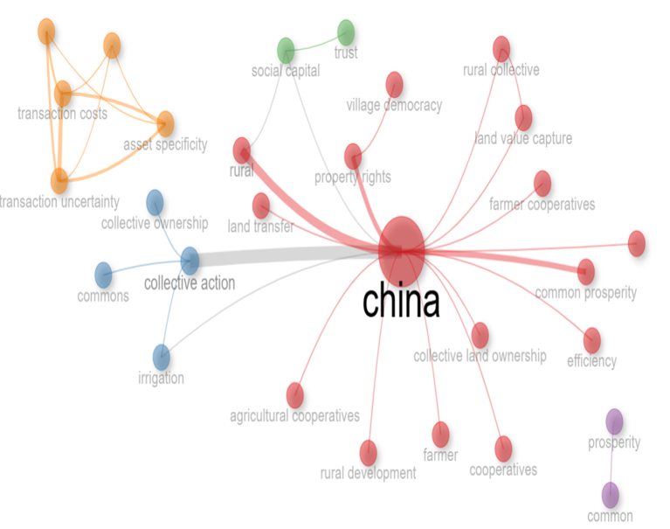
Figure 6: Co-occurrence keywords
The keywords were further mapped using the word cloud, showing the relative size and frequency of the keywords presented in Figure 7. The larger the size of the keyword visualized, the higher the frequency of the keyword appearing in the selected article. The most frequent keywords that appeared in the article include ‘common prosperity’, ‘collective action’, ‘agricultural cooperatives’, ‘property rights’, ‘rural revitalization’, ‘sustainable development’, ‘poverty alleviation’, ‘village democracy’, asset specificity’, collective action dilemma’, rural collectives construction land’.

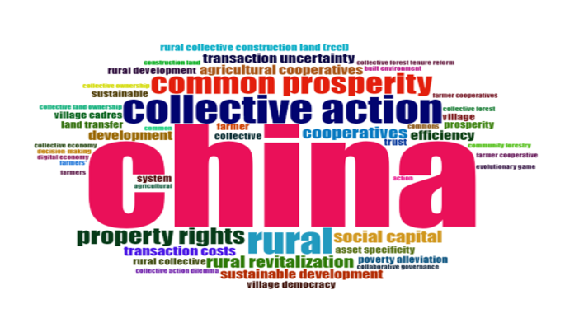

Figure 7: Word Cloud

Evolution of Trending Topics Analysis
The study evaluates the thematic evolution in the articles published from 2004 to 2024, as presented in Figure 8. The results demonstrate the most frequently used key terms that have become trending terms in published articles throughout 2004-2024. Trend topics such as social capital, Collective action, cooperatives, common prosperity, Rural revitalization, agricultural cooperatives, and property rights have been used over time. It was found that the concept of social capital (Tong, Wu, MacLachlan, & Zhu, 2021; Yip et al., 2007; L. Zhou, Zhou, de Vries, Liu, & Sun, 2024) marks the beginning of the increased scientific research interest in the rural collective economy in China. The concept of social capital involving structural, cognitive, or relational social networks, community organizations, community memberships, social supports, and cooperatives has been found to have a strong collective with a collective economy(Yip et al., 2007). Figure 8 further provides trending topics extracted from the analysis. These topics have recently gained the attention of scholars and have been the focus of research in the field of rural collective economy. However, in the recent years, scientific research on rural m collective economy has shifted towards collective actions(Cao, Wang, & Zang, 2023; Yahua Wang & Wang, 2022), agricultural cooperatives(J. Liu, Yang, & Zhang, 2023; Zhu & Wang, 2024) common prosperity(H. Li & Yang, 2023; Y. Zhang, Xu, Jia, Yang, & Wang, 2022) rural revitalization(T. Zhou, Luo, & Zhang, 2024) property right(Y. Yang et al., 2020). The results offer a full picture of the historical and contemporary changes in the trending topics relevant to the rural collective economy in China.

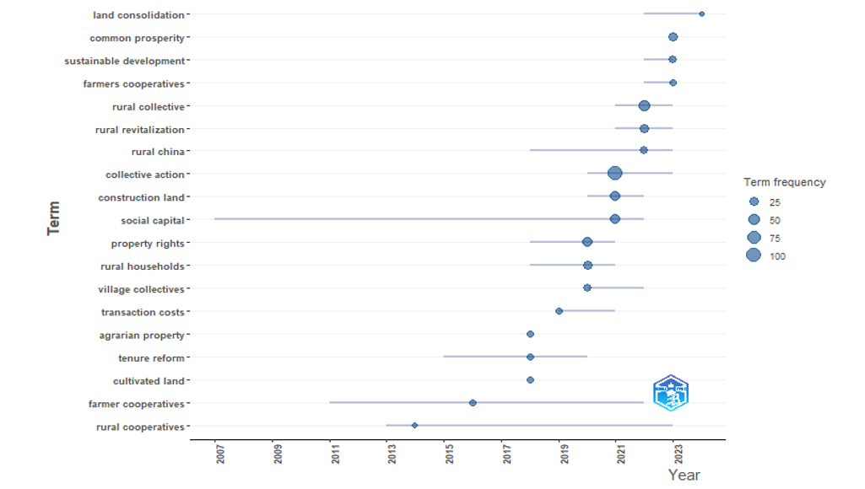
Figure 8: Thematic evolution of trend topics over time

Analysis of Thematic Clusters
The strategic diagram was used to evaluate the thematic clusters emerging from the articles selected. Strategic diagrams display a quadrant with four zones, each representing a cluster of themes that have appeared in various studies at different levels of centrality and density in a given field over time (Callon, Courtial, & Laville, 1991). The Size of clusters is directly related to the quantity of words frequently used and contained in the cluster. The themes in the four zones are classified as motor themes, developed and isolated, basic and transversal, and external themes. In zone 1 (motor themes), the themes with high density and centrality have been regularly researched over a long period. The themes in this cluster are the most relevant, highly connected with existing research concepts, and the most developed area of scientific research. Figure 9 shows that the motor themes include ‘farmer rural collective’, ‘collective forest tenure reform’, ‘village cadres’, ‘agriculture’, ‘social capital’, ‘collective action’, and ‘development’.
Zone 2 (niche themes) includes themes that are already formed in connected networks, highly developed, but less relevant in contributing to the existing literature. Nonetheless, niche themes are likely to become motor themes shortly. The key themes in Zone 2 include ‘Transaction costs’, ‘asset specificity’, ‘transaction uncertainty’, ‘collective forest tenure reform’, ‘community forestry policy’, ‘prosperity ', and digital economy’.
Zone 3 consists of emerging or declining themes that were initially placed in Zone 1 but have since become marginalized due to their minimal contribution to existing literature development. These themes have low development intensity and are less relevant in the current scientific studies in the area. The contributions of these concepts in theoretical literature are less relevant. The theme in zone 3 includes farmer cooperative and fuzzy-set qualitative comparative analysis (fsqca).
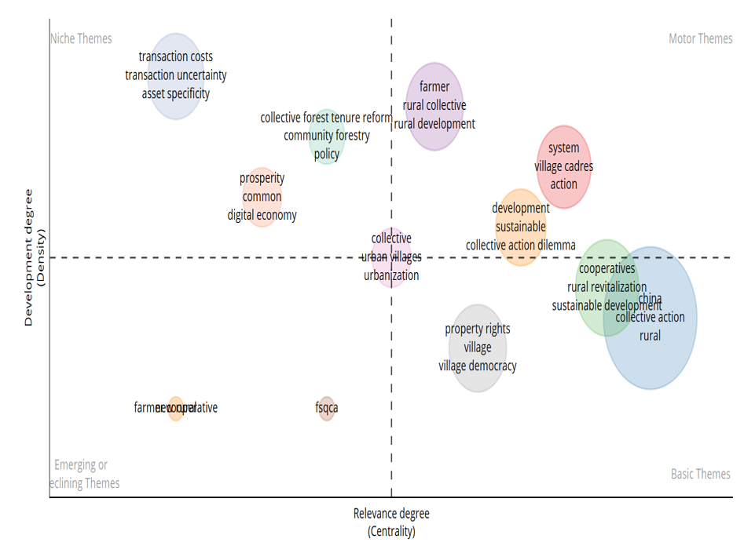
Themes in Zone 4 are considered basic themes with a low degree of development, but are highly relevant to the issues in the existing studies. The themes in this zone evaluate the dynamic analysis by determining their contributions to the research field in the current Period. The focal themes in this zone included ‘Cooperatives’, ‘rural revitalization’, ‘sustainable development’, ‘collective action’, ‘property rights’, and ‘village democracy’.
Figure 9: Strategic diagram showing thematic clusters

Discussion
This section critically analyses the reviewed findings comprehensively. The practical policy and theoretical implications emerging from the results are demonstrated in this section. Further, the study limitations and key research gaps identified in the study are highlighted. Directions for future studies in the field of rural collective economy are subsequently established.
Analysis of growth and thematic evolution of scientific literature on the Rural collective economy policy in China
The results show publications on the subject of rural collective economy have grown in the last two decades, with the highest number of publications occurring in 2018, 2021, and 2023. This period coincided with the Communist Party's 21st general meeting, which marks the beginning of the 5-year rural revitalization strategy and agriculture modernization to achieve sustainable economic development and the strengthening of the new collective economy policy. The results imply that there has been a significant increase in scientific production in recent years. The review offers a critical contribution of strategies, drivers, and mechanisms to achieve sustainable rural revitalization and rural development in a collective sense in China. The authors highlight the important operating paths to empower rural collectives to rethink how to develop their communities with less government intervention. Further, the authors emphasize the importance of government policy to strengthen the implementation of the new rural collective economy policy in China.
Findings from the review further offer the evolution of scientific production in the field from 2004 to 2024. During the early years of rural development in China, the concept of a rural collective economy offered a critical foundation for the framework of achieving collective development among communities in the countryside. The concept of social capital played a significant role in the rural development policies (Tong et al., 2021; Yip et al., 2007; L. Zhou et al., 2024).The initial focus on social capital strengthened the rural communities to organize themselves and collectively address local socio-economic and political challenges in the rural areas. In recent scientific publications in the field of rural collective economy, there is a notable shift in the interests from social capital to collective action, agricultural cooperatives, collective shareholding, and rural revitalization. The evolution of their themes in recent studies offers a diversified approach to addressing the various development dynamics of rural communities in China. For instance, the government policies focused on agriculture cooperatives foster the capacity of the rural collectives to expand their farm size and achieve economies of scale in their agricultural production activities while improving their production outputs and agricultural incomes(J. Liu et al., 2023). There has been a noticeable emerging interest in the concept of collective action as a channel to attain the goals of a new rural collective economy in China(Yahua Wang & Wang, 2022). Collective action offers the power of autonomy, and unity is fostered among the rural collectives to pursue economic activities to improve their economic well-being and alleviate relative poverty. The concept of collective shareholding has gained significant attention in the current Scientific publication in the field of rural collective economic policy in China. Collective shareholding has further created awareness and strengthened the advocacy for collective property rights in the countryside(Y. Yang et al., 2020). This reflects the Chinese cultural and socio-economic characteristics that underscore the unique approach to promoting resilient, sustainable rural development and equity among the rural collectives. Collective shareholding remains one key mechanism to implement the new rural collective economy and rural revitalization as a means to alleviate rural poverty and collective well-being in China.

Analysis of Rural Collective Economy Thematic Clusters
The bibliometric review identified a cluster of motor themes with high density and centrality, which have received increased research attention over a long period. The keywords in this cluster include ‘farmer’, ‘rural development’, ‘village cadres’ actions’, ‘collective action dilemma’, ‘development’, and ‘sustainability’ are highly connected with existing research concepts. They are classified as the most developed area of scientific research in the field of collective economy in China. (Yahua Wang & Wang, 2022) explored the collective action of village commons in building and utilizing public irrigation facilities and the consequential effects of farmland reallocation in China. The study further delved into the varied participation of farmers in the construction, operation, and maintenance of the irrigation systems used by the village commons. Remarkably, the researchers found that the farmland transfer significantly influences both farmers seeking to expand their production and those aiming to optimize land utilization to actively engage in collective action to construct irrigation facilities for the community. Rural collective action is further influenced by factors such as social networks and elite leadership in rural communities(Luo, Lai, Zhang, & Liu, 2024). In addition, (Yahua Wang, Chen, & Araral, 2016) conducted a study on rural collective action and rural migration. According to their research, migration has a statistically significant adverse effect on the collective action of the commons in China. The second cluster is composed of words such as Transaction costs’, ‘asset specificity’ ‘collective forest tenure reform’, and ‘community forestry policy’. This cluster reflects on less relevant but highly developed areas in contributing to the existing literature. (T. Zhang, Huang, & Zhang, 2021) examined the transaction cost in the land sale market in the context of a rural collective economy. Based on the theoretical framework of Williamson's transaction costs, the study found that asset specificity and transaction frequency have a significant influence on the efficiency of the rural collective construction land market. Additionally, the study suggests that detailed transaction rules for land sales and specific land use may lower transaction costs associated with the collective economy.
On the other hand, the third cluster consists of declining themes with minimal contribution to the literature. The most relevant keywords from this cluster include farmer cooperatives. Recent studies in China have revealed that participation in cooperative membership helps farmers overcome limitations in market access and income inequality (Zou & Wang, 2022). (J. Liu et al., 2023) emphasize that farmers' participation in rural cooperatives demonstrated a more pronounced significant dampening effect on the poverty vulnerabilities among smallholder farmers. Further findings from (Cheng & Ding, 2012) reveal that collective ownership and farmer cooperatives have stimulated farmers’ creativity and enthusiasm for working, increased farmers’ incomes, provided them with social security, and helped achieve common prosperity. The fourth cluster, described as the basic theme, is composed of words such as ‘rural cooperatives’, ‘rural revitalization’, ‘sustainable development’, and ‘property rights. Current evidence from literature demonstrates how rural revitalization may be promoted through proper rights and an efficient land market(Kan, 2021). Community participation in cooperative organizations and collective actions has significantly contributed to the rural revitalization agenda and sustainable rural development(J. Wang & Wang, 2024). This cluster focuses on improving the collective well-being of the people, particularly through rural cooperatives, agriculture modernization, and rural revitalization programs(Hairong & Yiyuan, 2016). The cluster emphasizes on significant component of the Chinese government's ambitious policy to revitalize rural communities’ development to alleviate relative poverty and promote life satisfaction among rural farmers in the countryside.

Analysis of the Operating Path Mechanisms of the Rural Collective Economy policy
Based on the article reviewed, the operation of the new rural collective economy policy is characterized by the following mechanisms: Collective action(Gong & Tan, 2021; Y. Li et al., 2023; P. Liu & Ravenscroft, 2017; L. Yang & Ren, 2020) agricultural cooperatives(Zhu & Wang, 2024; Zou & Wang, 2022), social capital(Tong et al., 2021) and collective shareholding(Chen, 2016; Kan, 2019), as discussed in the ensuing sections:
Collective Action
Collective action is a voluntary form of association among individuals with common shared interests and freedom of action who are connected based on proximity of location and social network. Collective action is different from what we term a village collective, understood in the context of China. Collective action is often defined as including actions that foster collective maintenance of resources and active participation to improve group outcomes Results from (Y. Li et al., 2023) who examined the rural collection action as a mechanism to promote rural collective economy development revealed that collective action fuels rural development by improving resource real location and resource-use efficiency with the participation of both elites and non-elites. Innovative collective action designs that leverage a reputation effect to foster reciprocity norms promote the participation of elites while discouraging elite capture. Cao, D., Wang, Y., & Zang, L. (2023). (Cao et al., 2023) examined collective action for the sustainable development of irrigation systems, a key mechanism for contributing to sustainable agriculture development in rural China. Collective action, on the one hand, contributes positively to the collective economy and rural development. on the other hand, some critical factors such as leadership, social capital, and resource dependency affect collective actions among the common. Reflecting on (P. Liu & Ravenscroft, 2017) observation that collective action by village farmers has contributed successfully to the land transfer implementation policy in China. A purposive collective action by the farmers facilitated the efficient implementation of the land transfer policy in China from the perspective of a bottom-up approach, particularly when the conventional top-down land transfer policy Implementation failed. The involvement of local collective action, Land consolidation, and adjustment policies has been recognized as a public good (Gong & Tan, 2021). It is observed that collective action plays a critical role in protecting the collective interests of the village commons by restraining the excessive government intervention in the land consolidation and adjustment policy in rural China. Drawing on a survey of 533 villagers in recent times, (L. Yang & Ren, 2020)examined the collective action towards COVID-19 prevention in the Hena Province in China. Collective action was recognized as an effective mechanism to ensure the successful implementation of preventive measures to control the spread of COVID-19, particularly in areas with weak health systems. Despite the positive influence of collective action on collective and individual health during the COVID-19 pandemic, (L. Yang & Ren, 2020)found that moral obligation and public leadership play a focal role in the prevention and control of COVID-19 through collective action as a mechanism.
Collective Shareholding
Shareholding is a distributive mechanism employed in the operation of a collective economy by dividing the revenue accrued from collective resources and sharing the benefits with members of the village collectives. A recent study by Chen (2016) highlights the two main types of shareholdings within the rural collective economy systems, namely, the cooperative of shareholding and the shareholding land cooperative. The former involves quantifying the total value of all the village collective assets and distributing the shares among members of the village collective organization. On the one hand, the shareholding land cooperative is characterized by the collective action of rural farmers who voluntarily organize and consolidate their farmland contracts to promote large-scale agricultural production, making them shareholders. The shares are distributed to individuals who are indigens of the various villages however, the non-indigens living in the villages are excluded. While the shares cannot be mortgaged, they can be inherited or passed on to family members. Individual shareholders then gain the power and right to participate in the local decision-making process in the regimes locally described as village democracy. Another type of shareholding is the shareholding Land Cooperative, where rural peasants consolidate and collaboratively join their land use together to ensure large-scale agricultural production. This shareholding system increases peasants’ income through dividends and employment opportunities(Ren, Bian, & He, 2017). To effectively achieve the goals of the shareholding cooperatives, an assembly of shareholders, a supreme representative body to make key investment decisions regarding the shares, is established. The assembly then enjoys the power to elect its board of directors and managers of their shares and wealth. As a result, the collective shareholding has been described as the ‘weapon of the weak’(Kan, 2019). The assembly also holds the power to elect members of the board of directors, and the decision-making and management body of the cooperative. Usually, the board of directors consists of nine members, including a chairperson who is the legitimate head of the shareholding cooperative of the village collectives. There is a village committee member and a party secretary managing the affairs of the village development process and local centralized governance. The amount of share of dividends from the collective shares depends on the total revenue to be declared annually by the board of directors. Recent studies have shown that annual dividends have become a significant source of income for most individuals who lack the capabilities to engage in off-farm employment in urban or rural areas. The land cooperative shareholding ensures ‘economies of scale for agricultural production through reconcentration of village land’ (Chen, 2016). In a nutshell, collective shareholding has been utilized as a mechanism to achieve self-governance in rural China. The shareholding system has given villagers new identities as shareholders who have the power to control their incomes, property, leadership, and economic benefits.

Agriculture Cooperatives
Agriculture cooperative is an embodiment of the ‘self-organization’ of farmers towards the realization of rural revitalization as the main goal of the new rural collective economy. Farmer cooperatives have become a mechanism through which farm households form a collective organization by joining their lands and labor resources together to produce on a large scale, gain access to the marketplace, and increase their incomes. Rural collective‐owned cooperatives have significantly improved rural revitalization and sustainable development through effective collective property rights systems, enhanced common prosperity of rural farmers(Jiang et al., 2023), developed an entrepreneurial spirit and resource access capacity(T. Zhou et al., 2024) and farmer subjective-well-being(Qi, Liu, Zhang, & Qi, 2022). The new rural collective economy can rely on cooperative shareholding of village assets and invest collectively in community assets such as land, forests, and collective industry. Farmer cooperatives help to remove market barriers and income inequality. The joining of farm cooperatives has provided an avenue for farmers to significantly improve their household income and obtain economic benefits from their membership. For instance, in rural Nanjing, smallholders’ participation in cooperatives accounted for over 70% jump in farm income compared to the treatment effect of agriculture extension services(Ito, Bao, & Su, 2012). The results from the recent review suggest that farmers’ cooperative enables farmers to effectively integrate modern farming technology applications, such as adopting water-saving irrigation technologies(Zhu & Wang, 2024) into their farming operational activities, which enhances their productive and marketing sales volumes(Shen et al., 2022). Agricultural cooperatives empower rural farmers by providing them with financial and resource support. It coordinates the activities of the farmers and helps them to take collective action. In this view, farmers are able to improve their economic well-being while mitigating the impact of poverty.
Farmer cooperatives in China have promoted land transfers and land contract systems, which have subsequently reduced the rate of cropland abandonment, which is one of the major challenges in the agriculture sector in China (Yan, Hong, Chen, Li, & Liao, 2021). In recent times, the total amount of contracted farmland transfer has increased such that by the end of 2016, about 30.7million ha of farmland which would have been abandoned or less utilized have been transferred(R. Jia & Lu, 2020) mostly to farm cooperatives with significant capital, labor and technology to engage in large scale agricultural production. Evidence from the review further supports the view that the formation of agriculture cooperatives has reduced the likelihood of crop farmland abandonment in China(Ma & Zhu, 2020). Reducing Cropland abandonment implies that resilient food security and environmental sustainability are likely to be guaranteed.
Social Capital
Social capital plays a critical role in the development of the new rural collective economy in China. Several authors show that social networks, norms, trust, and cultural values are relevant in solving several challenges, including land and rural settlement issues, particularly without formal government institutional services. For instance, social capital has contributed significantly to the growth process in a typical collective-led self-organized rural village such as Huanggang village in Shenzhen. Within the urbanizing Huanggang village, land issues and development-related issues are resolved through long-term acquaintances in the rural collectives, particularly due to the endured social and cultural capital, norms, trust, and values within the community(Tong et al., 2021). Previous such as(Yip et al., 2007) have examined organizational membership and trust as structural and cognitive social capital, respectively, as a mechanism in the collective economy to improve the well-being and health of the people. The study found that social capital promotes social networks while facilitating the exchange of social support among the Chinese rural collectives. Organizational membership and trust have been identified to have a strong association with rural collective action in China, which promotes the operation and development of the rural collective economy. Findings from (He, Guo, Deng, & Zhou, 2022) indicate a significant influence of collective social capital on the income level of rural collectives in the case of Liangshan Yi Autonomous Prefecture, a poverty-stricken mountainous area in southwestern China. Social capital is one of the most important livelihood capital for farmers, which can increase the labor productivity of poor households and increase income. Community‐level social capital has been identified to have a significant mechanism for the formation and performance of agricultural cooperatives in rural China. A recent investigation of 50 rural villages in Hebei, China, shows that fostering social networks, intervillage communication, and trust among the rural people offers an effective mechanism to promote cooperative formation and performance in the collective economy(S. Jia & Xu, 2021). Social capital in the form of social networks or resources has become one focal livelihood strategy of rural farmers, particularly under the Chinese rural revitalization strategy in the collective economy framework.

Conclusion
Rural economic organizations have played a significant role in the Chinese rural revitalization, modernization of agriculture, and modernized rural development agenda. Studies related to these relevant contributions of the collective economy and rural revitalization have grown significantly within the last two decades. The systematic review and bibliometrics analysis lend strong evidence to support the previous findings and government policy objectives that agricultural cooperative contributes huge benefits in terms of income and agriculture, productivity to farmers, particularly smallholder farmers. The economic benefits of agricultural cooperative organizations to their members far exceed the impact of extension services. This underscores the widely accepted view that rural collective economic organizations exert an impactful role in the sustainable rural development and economic well-being of the village commons. As a result, the new rural collective economy tends to have significant roles in alleviating poverty, improving common welfare, and rural development in China.
The market-oriented function of the new rural collective economy promotes competitiveness in the market economy. The system also protects farmers' land use rights and capital assets. The collective economic model innovatively transforms shared capital assets into distributive income shares. The village collectives operate a well-organized democratic governance structure based on a strict property proper agreement and land use contract to achieve economies of scale in large-scale agriculture and non-agricultural production activities. Farmers' identity is transformed into shareholders through farmland transfer, reallocation, and cooperative activities. The collective actions and the shareholding cooperative promoted by the new rural collective economy have improved the peasants' income level and enhanced economic well-being, leading to rural revitalization and sustainable development. The new rural collective economy is a mechanism that essentially contributes to collective prosperity and rural economic development. It is an economic model that solidifies the relationships between economic, management, and social functions. The new rural collective economy helps the village collectives strengthen their social networks and participate in community projects and public goods, and services. The governance structure bolsters the democratic systems of governing in the market economy. The fairness and transparency in the governing systems of the new rural collective economic structures save time, cost, and labor in the land transaction processes and collective assets. Additionally, the new rural collective economy utilizes market economy systems while operating within a controlled economy in China.
Theoretical implications
The review makes a significant contribution to the principal-agent theory and the stakeholder theory by analyzing the evolving literature on the key players in the new rural collective economy in China. The study discusses how the new rural collective economic framework contributes to shared prosperity and sustainable rural development through capital transformation, asset market participation, and market competition. It offers a comprehensive understanding of the collective ownership and shareholding systems in this setting, where farmers, local government, and village collectives are the primary landowners, and rural enterprises act as their agents. For example, in the transfer of farmlands, farmers are the primary owners, the local government is the secondary principal, the village collective serves as the tertiary principal, and the enterprises play a crucial role as agents. Throughout the process of circulating collective land assets, farmers have the primary land use right and contract; however, it is the village collective that coordinates and organizes the land transfer market and engages in transactions with rural enterprises. Meanwhile, the local government, as the secondary owner, oversees and supervises the transactions and the distribution of benefits. Furthermore, the review provides a valuable contribution to the stakeholder theory, emphasizing the crucial role of key individuals and groups who invest and take on risks. In the context of the new rural collective economy, farmers play a vital role by investing in agricultural cooperatives, participating in collective actions, and engaging in the shareholding system, all aimed at improving their income and collective well-being. As a crucial stakeholder, the government ensures effective management of collective shares and assets to enhance the prosperity of village collectives. Government investments in public goods and services aim to improve the social, economic, and environmental conditions of the farmers. The flexible structure of government systems allows members to access accurate information, participate in democratic management, and exercise their ownership rights. Shareholders have the freedom to participate in meetings and democratically decide on leadership choices. This review lays a critical foundation for further studies into the new rural collective economy in China, deepening our understanding of transaction costs within the market economy
Practical policy implications
Findings from the article review outline several positive contributions to policy, programs, and interventions for rural collective economy organizations, village democracy, rural revitalization, rural sustainable development, farmers' well-being, and rural development. Moreover, the operation of the new rural collective economy safeguards effective land transfer and land contract management rights. The operation of the collective economy policy has subsequently reduced the transaction costs associated with farmland acquisitions and agricultural production among farmers. The new rural collective economy ensures that farmers can improve their income level through marketization, property income, and non-agricultural employment. Rural farmers can minimize the average costs usually associated with production due to economies of scale and cooperative farming. Large-scale agricultural cooperative production should be continuously promoted to ensure that rural farmers can achieve high output levels. This will further maximize the abilities of the rural farmers to improve income earnings and achieve collective prosperity. Therefore, the new rural collective economy guarantees the smooth flow of factors of production, income growth, and economic well-being in China.
The collective economy arrangement has significantly made governance in the rural areas more democratic as each member within the collective organization has decision-making power, unifies autonomy of voting rights, and is fairly entitled to benefits from the collective shares. The practice of the community-based shareholding collective enterprises empowers the villagers as shareholders, by allowing them to participate in rural governance as they vote, receive their share of collective benefits, and elect the managers of their wealth (Kan, 2019).
Hence this highlights the policy need to consolidate and strengthen the positive contributions of the new rural collective economy in China. The government should improve the governance structure devoid of conflict of interests and role confusion to better protect the property rights of rural collectives. The rural collective organizations must be operated such that, transparency, fairness, and accountability are promoted. Shareholders should have unrestricted access to information flow particularly on economic transactions of collective assets and properties.
The operational capabilities of the new rural collective economic organizations should be improved. The government should establish a sustainable capacity-building framework to consistently organize programs to improve the operations of the collective economic organization particularly in diversifying their revenue sources and engaging in proper strategic planning. Rural collective economic organizations should be strengthened to achieve the expected goals.
In a rural collective economic organization, individual shares are tailored alongside collective shares. This approach not only serves the purpose of providing public services but also empowers individuals to manage their income effectively. It is important to note that rural collective economic organizations are responsible for managing and operating collective property. While these organizations participate in the market, they primarily focus on managing collective property. The key principles of this model include all villages being members of collective economic organizations; the collective ownership of all means of production, including land and village-operated businesses, with the village committee managing ownership on behalf of the villagers; a consistent aim for shared prosperity; and distribution being based on labor, while also providing generous welfare benefits. As a result, the efficiency of leadership is required. Therefore, the government should ensure that the most experienced and responsible leaders are selected to effectively manage rural collective organizations and village committees. It is important to constitute highly talented and skilled village committees and board members to effectively manage these organizations and shareholdings. This will ensure the sustainable growth and performance of the collective economic organizations’ investments and rural assets. Engaging highly skilled personnel to manage the investment of the rural-level organizations creates opportunities for rural farmers to improve their income through non-agricultural employment.
Literature Gaps and Future Research Agenda
The bibliometric analysis and review have revealed several significant research gaps and potential avenues for future exploration. Firstly, the results have shown that it is imperative to broaden the geographical scope of this study to include non-Western developing countries with rural collective economies. This expansion would address crucial issues of rural poverty, unemployment, and collective property. Given the pivotal role of agricultural cooperatives and collective action in enhancing collective well-being, prioritizing research in these areas is essential for tackling rural poverty and fostering economic development in developing countries.
Furthermore, most previous studies have focused on land market transfers, property rights, and asset shareholdings, while there is limited literature on transaction costs and asset specificity. High transaction costs could lead smallholder farmers to be hesitant to join cooperative organizations, which could hinder the promotion of the pro-poor growth strategy of the new rural collective economy in China (Xie, Zhang, Wen, & Bin, 2019).
There are more opportunities in terms of future studies on benefit distribution in the new rural collective economy. There are still limited studies that have critically focused on economic benefits distribution mechanisms such that the stakeholders (farmers, enterprises, rural collectives, and government) interests are maximized. Specifically, future studies may focus on the efficient distribution ratio of the shareholders’ benefits from land assets utilization, and land transfer contracts, among others, under heterogeneous locations within the context of the new rural collective economy as optimal distributions of stakeholders’ benefits would significantly stimulate the interests of participations in the collection actions.
Again, future studies may take the opportunity to delve deeply into the mechanism through which agricultural cooperatives may meet the needs of smallholders while mitigating their poverty status in rural China(Shen et al., 2022). The interests of the farmers participating in the cooperative organizations are key to the sustainability of the cooperative. Therefore, meeting individual needs would have a significant influence on the sustainability and development of rural collective organizations.
Furthermore, the majority of the studies focused on land transfers, property rights, and asset shareholdings, whereas there is a very thin literature relating to transaction costs and asset specificity. High transaction costs may cause smallholder farmers to remain reluctant to participate in the cooperative organizations, which may cease to promote the pro-poor growth strategy of the new rural collective economy in China (Xie et al., 2019). The Coasian transaction cost theory may be adopted to expand the knowledge on the level of transactions, uncertainties, and market constraints as key factors in the operation of the new rural collective economy. Researchers may consider exploring the role of institutional, regulatory, normative, and cognitive institutions in the determination of transaction costs.
Future empirical and theoretical studies may focus on how rural farmers can be empowered to participate fully in collective action in China. Empowering rural farmers, rural collectives, and community organizations could improve their capacity to undertake collective actions to improve their development conditions (Yue, Li, & Zhou, 2023).
Limitation
The review focused on only the Web of Science database, which has wider recognition in the field of scientific and academic research. Nonetheless, including other databases such as Scopus could have yielded additional relevant publications to enrich the topics discussed. Excluding such databases in the study may not provide a complete insight into the emerging operating path mechanisms of the new rural collective economy in China.
Moreover, the search strategy and selection of articles based on PRISMA-2020 were applied, which has the potential to influence the inclusion and exclusion of certain interesting publications. The restrictions set by the search method may have potentially biased the sources of the publication’s documents utilized for the review.
Additionally, the use of the R package for bibliometric analysis, although it has a higher precision and accuracy, yielding consistent results and high-quality output, including other analytical tools such as VOSviewer, could enrich the pictorial quality of the networks. Further studies may consider the combinations of the bibliometric analysis tools to provide greater insights into the review output.
References
AlRyalat, S. A. S., Malkawi, L. W., & Momani, S. M. (2019). Comparing bibliometric analysis using PubMed, Scopus, and Web of Science databases. JoVE (Journal of Visualized Experiments)(152), e58494.
Aria, M., & Cuccurullo, C. (2017). bibliometrix: An R-tool for comprehensive science mapping analysis. Journal of informetrics, 11(4), 959-975.
Callon, M., Courtial, J. P., & Laville, F. (1991). Co-word analysis as a tool for describing the network of interactions between basic and technological research: The case of polymer chemsitry. Scientometrics, 22, 155-205.
Cao, D., Wang, Y., & Zang, L. (2023). The Effects of Land Reallocation on Irrigation Collective Action: Moderating Effects of Informal Organizations and Leadership. Land, 12(7), 1336.
Chen, A. (2016). The politics of the shareholding collective economy in China's rural villages. The Journal of Peasant Studies, 43(4), 828-849.
Cheng, E., & Ding, X. (2012). Building China's New Countryside: Multiple Modes of Collective and Cooperative Economy. Review of Agrarian Studies, 2(1).
Deng, M., Zhang, A., Luo, W., Hu, C., Huang, M., & Cheng, C. (2023). Impact of governance structure of rural collective economic organizations on trading efficiency of collective construction land of China. Land, 12(2), 381.
Derviş, H. (2019). Bibliometric analysis using bibliometrix an R package. Journal of scientometric research, 8(3), 156-160.
Gong, Y., & Tan, R. (2021). Emergence of local collective action for land adjustment in land consolidation in China: An archetype analysis. Landscape and Urban Planning, 214, 104160.
Hairong, Y., & Yiyuan, C. (2016). Debating the rural cooperative movement in China, the past and the present Rural Politics in Contemporary China (pp. 49-75): Routledge.
He, R.-w., Guo, S.-l., Deng, X., & Zhou, K. (2022). Influence of social capital on the livelihood strategies of farmers under China’s rural revitalization strategy in poor mountain areas: A case study of the Liangshan Yi autonomous prefecture. Journal of Mountain Science, 19(4), 958-973.
Ito, J., Bao, Z., & Su, Q. (2012). Distributional effects of agricultural cooperatives in China: Exclusion of smallholders and potential gains on participation. Food policy, 37(6), 700-709.
Jia, R., & Lu, Q. (2020). Land transfer, collective action and the adoption of soil and water conservation measures in the Loess Plateau of China. Natural Hazards, 102, 1279-1304.
Jia, S., & Xu, X. (2021). Community‐level social capital and agricultural cooperatives: Evidence from Hebei, China. Agribusiness, 37(4), 804-817.
Jiang, F., Jiang, Y., Peng, J., Lv, Y., Wang, W., & Zhou, Z. (2023). Effects of rural collective economy policy on the common prosperity in China: based on the mediating effect of farmland transfer. Frontiers in Environmental Science, 11, 1302545.
Kan, K. (2019). A weapon of the weak? Shareholding, property rights and villager empowerment in China. The China Quarterly, 237, 131-152.
Kan, K. (2021). Creating land markets for rural revitalization: Land transfer, property rights and gentrification in China. Journal of Rural Studies, 81, 68-77.
Li, H., & Yang, S. (2023). The road to common prosperity: Can the digital countryside construction increase household income? Sustainability, 15(5), 4020.
Li, Y., Qin, X., Sullivan, A., Chi, G., Lu, Z., Pan, W., & Liu, Y. (2023). Collective action improves elite-driven governance in rural development within China. Humanities and Social Sciences Communications, 10(1), 1-13.
Liu, J., Yang, M., & Zhang, Z. (2023). Can rural cooperatives reduce poverty vulnerability of smallholder households? Evidence from rural Western China. Frontiers in Sustainable Food Systems, 7, 1222455.
Liu, P., & Ravenscroft, N. (2017). Collective action in implementing top-down land policy: The case of Chengdu, China. Land Use Policy, 65, 45-52.
Luo, Y., Lai, B., Zhang, Y., & Liu, J. (2024). Village leadership, social networks and collective actions in indigenous communities: Case of Hani rice terrace social-ecological system in Southwest China. Journal of Rural Studies, 106, 103237.
Ma, W., & Zhu, Z. (2020). A note: reducing cropland abandonment in China–do agricultural cooperatives play a role? Journal of Agricultural Economics, 71(3), 929-935.
Page, M. J., McKenzie, J. E., Bossuyt, P. M., Boutron, I., Hoffmann, T. C., Mulrow, C. D., . . . Brennan, S. E. (2021). The PRISMA 2020 statement: an updated guideline for reporting systematic reviews. bmj, 372.
Qi, W., Liu, F., Zhang, T., & Qi, X. (2022). Can China's new rural cooperative medical system improve farmers' subjective well-being? Frontiers in Public Health, 10, 848539.
Ren, Y., Bian, Y., & He, T. (2017). Characterizing the land shareholding cooperative: A case study of Shanglin village in Jiangsu, China. Sustainability, 9(7), 1175.
Shen, Y., Wang, J., Wang, L., Wu, B., Ye, X., Han, Y., . . . Chandio, A. A. (2022). How do cooperatives alleviate poverty of farmers? Evidence from rural China. Land, 11(10), 1836.
Song, H., Li, X., Xin, L., & Wang, X. (2024). Do farmland transfers mitigate farmland abandonment?——A case study of China's mountainous areas. Habitat International, 146, 103023.
Tong, D., Wu, Y., MacLachlan, I., & Zhu, J. (2021). The role of social capital in the collective-led development of urbanising villages in China: The case of Shenzhen. Urban Studies, 58(16), 3335-3353.
Umair, M., Aizhan, A., Teymurova, V., & Chang, L. (2024). Does the disparity between rural and urban incomes affect rural energy poverty? Energy Strategy Reviews, 56, 101584.
Wang, J., & Wang, Y. (2024). Economic performance of rural collective‐owned cooperatives: Determinants and influence mechanism. Annals of Public and Cooperative Economics, 95(3), 629-653.
Wang, R., & Tan, R. (2020). Patterns of rural collective action in contemporary China: An archetype analysis of rural construction land consolidation. Journal of Rural Studies, 79, 286-301.
Wang, Y., Chen, C., & Araral, E. (2016). The effects of migration on collective action in the commons: Evidence from rural China. World Development, 88, 79-93.
Wang, Y., Chen, Y., & Li, Z. (2024). Escaping poverty: Changing characteristics of China’s rural poverty reduction policy and future trends. Humanities and Social Sciences Communications, 11(1), 1-14.
Wang, Y., & Wang, H. (2022). Effects of farmland use rights transfer on collective action in the commons: Evidence from rural China. Land Use Policy, 120, 106262.
Xie, X., Zhang, A., Wen, L., & Bin, P. (2019). How horizontal integration affects transaction costs of rural collective construction land market? An empirical analysis in Nanhai District, Guangdong Province, China. Land Use Policy, 82, 138-146.
Yang, B., & Mou, X. (2020). Research on rural collective economic development and rural revitalization in new era: Theoretical mechanism, real predicament and achieved breakthrough. Agric. Econ. Manag, 6, 5-14.
Yang, L., & Ren, Y. (2020). Moral obligation, public leadership, and collective action for epidemic prevention and control: Evidence from the corona virus disease 2019 (COVID-19) emergency. International journal of environmental research and public health, 17(8), 2731.
Yang, X., Guo, S., Deng, X., & Xu, D. (2021). Livelihood adaptation of rural households under livelihood stress: Evidence from Sichuan Province, China. Agriculture, 11(6), 506.
Yang, Y., Li, H., Liu, Z., Cheng, L., Abu Hatab, A., & Lan, J. (2020). Effect of forestland property rights and village off-farm environment on off-Farm employment in Southern China. Sustainability, 12(7), 2605.
Yi, S., Huo, Z., Zhang, M., & Chen, F. (2023). An empirical study of new rural collective economic organization in alleviating relative poverty among farmers. Sustainability, 15(19), 14126.
Yip, W., Subramanian, S. V., Mitchell, A. D., Lee, D. T., Wang, J., & Kawachi, I. (2007). Does social capital enhance health and well-being? Evidence from rural China. Social science & medicine, 64(1), 35-49.
Yue, X., Li, Y., & Zhou, L. (2023). The impact of empowerment practice on the rural collective economy: empirical evidence from rural communities in China. Land, 12(4), 908.
Zhang, T., Huang, K., & Zhang, A. (2021). Choice of Rural Collective Construction Land Sales and Rental Markets at the Theoretical Framework of Williamson’s Transaction Costs: Evidence from Nanhai District, Guangdong Province, China. Sustainability, 13(15), 8473.
Zhang, Y., Xu, H., Jia, R., Yang, H., & Wang, C. (2022). Realizing common prosperity: The action logic of social entrepreneurship community mobilization in rural tourism. Elem Sci Anth, 10(1), 00006.
Zhou, L., Zhou, Y., de Vries, W. T., Liu, Z., & Sun, H. (2024). Collective action dilemmas of sustainable natural resource management: A case study on land marketization in rural China. Journal of Cleaner Production, 439, 140872.
Zhou, T., Luo, Z., & Zhang, X. (2024). How do China's villages self‐organize collective land use under the background of rural revitalization? A multi‐case study in Zhejiang, Fujian and Guizhou provinces. Growth and Change, 55(1), e12688.
Zhu, X., & Wang, G. (2024). Impact of agricultural cooperatives on farmers’ collective action: a study based on the socio-ecological system framework. Agriculture, 14(1), 96.
Zou, Y., & Wang, Q. (2022). Impacts of farmer cooperative membership on household income and inequality: Evidence from a household survey in China. Agricultural and Food Economics, 10(1), 17.

