*Policy paper*

**Rice Fallow in North East India-Challenges, Oppurtunities and Policy intervention**

**Abstract**: Rice based cropping System is found in all North Eastern States except Sikkim. But in almost all the states the land has been kept fallow after harvesting of kharif rice. This may be attributed to the factors like planting of long duration rice varieties during kharif season, lack of irrigation water, moisture stress at the time of sowing of rabi crops, stray cattle etc. Despite many challenges of rice fallow, it can be well utilized for the cultivation of short duration pulses and oilseed. Different interventions like resource conservation technologies could be effective in addressing the challenges in rice fallow. Retaining biomulch on the soil surface, making of farm pond, along with suitable establishment techniques, may mitigate severe stress by preserving soil moisture. Practicing zero tillage with minimal soil disturbance and maintaining crop residues can positively influence soil properties, thereby enhancing overall productivity in rice-fallow systems. Besides technological interventions, subsidies on farm input, credit and crop insurance schemes should be taken into consideration for the poor risk prone farmers of NE region for better utilization of rice fallow.

**Key Words: Rice fallow, Zero tillage, Pulse crops, Farm Pond, Crop residue.**

**INTRODUCTION**

Rice fallow refers to the uncultivated land that remains without crop after the harvest of the kharif rice. The primary factors contributing to the fallowing of land during the winter season include insufficient irrigation, delayed harvesting of long-duration rice varieties, moisture stress at the time of sowing of rabi crops due to the early cessation of the monsoon, and disturbances caused by stray cattle (Ali and Kumar 2009). In India, rice fallow encompasses approximately 11.7 million hectares, predominantly (82%) located in the eastern and north eastern states (Pande *et al.* 2012, Kumar *et al*. 2018). The practice of leaving land fallow after the harvest of aman rice is a common trend in the northeastern region as well in Tripura state. Around 35% of the land after the harvesting of kharif rice in Tripura are kept fallow (Source: Deartment of Agriculture & Farmers’ Welfare). The rainfed rice agro-ecosystem of the state plays a crucial role in food production, and there exists significant potential for utilizing residual moisture of these rice fallows to grow short-duration, low-input crops. This approach represents a promising opportunity for the efficient use of resources, fostering sustainable crop intensification, and enhancing land productivity and ultimately cropping intensity. Rice fallows are well-suited for the introduction of short-duration (≤3 months), low-water-consuming grain legumes such as pea, chickpea, lentil, blackgram, greengram, and oilseeds like linseed, safflower, and toria, which can improve the incomes of small farmers and enhance soil health. However, the success of rice fallow cultivation is largely contingent upon the method employed and the rice cultivar used.

**CHALLENGES IN THE RICE FALLOW**

The per capita availability of cultivated land in the northeastern regions is the lowest in the country, measuring at 0.15 hectares (Kumar *et al.* 2016). The majority of agricultural holdings in this area are either marginal or small, and they are highly fragmented, which poses challenges for the adoption of mechanized farming practices. The region receives an annual rainfall of around 2200 mm, which is generally sufficient to satisfy the water requirements of various crops. However, spatial and temporal variations in rainfall patterns and distribution; lead to inconsistencies in agricultural productivity. Rice is the predominant crop, primarily cultivated as transplanted during the rainy season, necessitating puddling operations to create suitable conditions for crop growth. However, puddling results in soil compaction that damages macro-pores and aggregates (Cassman *et al.* 1995). These soils often dry out, developing cracks by the end of the post-kharif season, which leads to insufficient soil moisture to support winter crops. Additionally, ploughing these soils after the rice harvest produces large clods with increased breaking strength, which can diminish the yields of subsequent crops, likely due to restricted root development (Kar and Kumar 2009). Resource-poor farmers in these regions struggle to afford irrigation and fertilizers necessary for raising rabi crop production. Consequently, the cultivation of a second crop following the harvest of kharif transplanted rice relies heavily on the effective utilization of residual soil moisture.

**MAIN REASONS FOR RICE FALLOW IN NORTH EASTERN INDIA**

***Soil moisture stress and lack of irrigation***

Rice-fallow regions typically experience normal to high levels of rainfall during the Kharif season; however, a significant portion of this rainfall is lost due to high runoff and low moisture retention capacity of soil. The compaction of soil following puddle rice cultivation hinders water infiltration, while the formation of deep and wide cracks in the soil after the rice harvest accelerates the evaporation of stored soil moisture. Consequently, soil moisture stress at the time of sowing fallow crops leads to inadequate plant establishment (Kumar *et al*. 2018). Even when crops are successfully established with the residual soil moisture, insufficient winter rainfall during the reproductive phase frequently results in crop failure (Ghosh *et al.* 2016). At this stage, the available soil moisture is depleted, and as the crop progresses to flowering, it faces terminal drought and heat stress (Kumar *et al*. 2018).

***Long duration rice varieties***

In NEH regions, farmers traditionally cultivated long-duration rice varieties that of more than 150 days. This practice leads to delay in the sowing of pulse and oilseed crops, ultimately resulting in reduced yields attributed to terminal drought conditions. Lack of appropriate crop varieties are the main constraints for 90% farmers of this region.

***Soil acidity***

The high acidity of soil in the northeastern region is one of the important factor contributing to the reduced productivity of pulses. Over 80% of the total land area in this region is characterized by acidic soil (Kumar *et al*. 2016). Pulses are particularly sensitive to acidic conditions, which adversely affect biological nitrogen fixation (BNF), microbial diversity, the availability of nutrients to plants, and can be toxic to root systems (Choudhary *et al*. 2014). Strongly acidic soils have been observed in the rice-fallow systems of the northeastern region including Tripura state.

***Terminal drought***

The post-rainy season crops rely on residual soil moisture under rainfed conditions, making them particularly vulnerable to terminal drought, which significantly affects crop yields (Kumar *et al.* 2016). Drought accelerates leaf senescence, reduces net photosynthesis, and hinders the translocation of nutrients from leaves to developing grains. The combination of terminal drought and temperature stress leads to premature ripening and can reduce yields by as much as 50% (Reddy 2009).

***Poor Crop Management***

Rabi crops cultivated in rice fallows are regarded as supplementary crops. Given the risks associated with the successful cultivation of a second crop, including limited soil moisture along with various socio-economic challenges, farmers often neglect essential crop management practices. These practices include selecting suitable varieties, timely sowing, determining optimal seed rates, managing pests, applying rhizobial inoculation, implementing foliar nutrition, and utilizing mechanization.

***Lack of improved varieties and quality seeds***

Crop varieties suitable for rice fallows in various regions have yet to be developed. Consequently, it is essential to recommend those available varieties that possess a comparative advantage. Non availability of quality seeds of the recommended varieties forces farmers to cultivate low-yielding local varieties.

***Socio economic constraints***

The adverse economic conditions and limited purchasing power of the farmers of this region compel them to leave their fields fallow after harvesting of rice. Issues such as fragmented land, labor shortages, non availability of agricultural inputs in time, restricted access to institutional credit, insufficient market opportunities, a lack of knowledge regarding water conservation techniques, and inadequate extension services discourage farmers to take second crop.(Joshi *et al.* 2002).

**POTENTIAL CROPS FOR RICE FALLOWS**

To optimize land use, there are a variety of crops that can be grown in rice fallow systems, depending on factors such as climate, soil, water availability and market demand. The residual moisture left in the soil at the time of rice harvest is often sufficient to raise short-duration pulse and oilseed crops. Further by using short duration rice varieties and timely cultivation of it during kharif season allowed to vacate the land by the end of the October. Cultivation of cool and warm season pulses like pea, moong, lentil, lathyrus etc. as soon as after harvesting of rice crops can increase the system productivity and sustainability of rice crops. Utera or relay cropping can be practiced to make such land more productive. Moreover growing pulses after rice will enrich the soil fertility . Introduction of toria/rapeseed and mustard may be a profitable interventions in rice fallow of North Eastern region as well as in Tripura state.

Currently, due to a significant disparity between the supply and demand for pulses, India is importing a substantial quantity of pulses at elevated prices. To address the increasing demand for pulses, it is essential to incorporate them as a fundamental component in rice-fallow systems, which offers the dual benefits of expanding cultivated area, promoting sustainable production and increase of cropping intensity. A similar situation exists with oilseeds. Therefore, the promotion of pulse and oilseed crops in these fallow lands would enhance the sustainability of rice based cropping system besides increasing the system productivity and incomes of the farming communities of this region (Reddy and Reddy 2010). For the effective utilization of rice-fallows through the integration of pulses and oilseeds, it is necessary to identify location-specific and economically viable techniques by thoroughly understanding the system's ecology and constraints. The appropriate pulses and oilseed crops, along with suitable varieties for the rice fallows of Northeastern India viz a viz Tripura are as follows:

**Table 1 Suitable Pulses and Oilseed Crop for Rice fallows of North East India**

|  |  |
| --- | --- |
| **Crop** | **Varieties** |
| Lentil | HUL-57, WBL-58, WBL-77 |
| Lathyrus | Ratna, Pratek |
| Pea | Arkel Azad, Aman, TRC-P-8 |
| Mungbean | Pusa Bishal, Samrat, TRC-mung |
| Urdbean | PU-31, Tripura Mashkoloi-1 |
| Toria/Mustard & Rapeseed | B-9, NRCHB-101, M-27, TRC toria 1-5-1, TS-38, TS-36 |

(Modified from Ghosh *et.al* 2016 and ICAR, Tripura Centre)

**INTERVENTIONS REQUIRED TO MANAGE RICE FALLOW**

***Technological interventions***

Resource conservation technologies (RCTs) could be effective in addressing challenges in fallow areas. Following the harvest of rice, the reduction in soil moisture content and the subsequent decline in the water table during winter lead to mid and terminal drought conditions during the reproductive phases, adversely affecting yield. Consequently, retaining crop residue on the soil surface, along with suitable establishment techniques, may mitigate severe stress by preserving soil moisture. Implementing zero tillage with minimal soil disturbance and maintaining crop residues can positively influence soil properties, thereby enhancing overall productivity in rice-fallow systems. This approach contributes to lowering cultivation costs and improving input-use efficiency. Simple practices such as seed priming, and the application of 2% urea, diammonium phosphate ( DAP), and micronutrients during the vegetative stages can increase productivity to profitable levels for resource-poor farmers (Kumar et al. 2018). Over and above cultivation of short duration rice varieties is also important to raise pulses and oilseed in residual moisture of rice fallow of North Eastern Region.

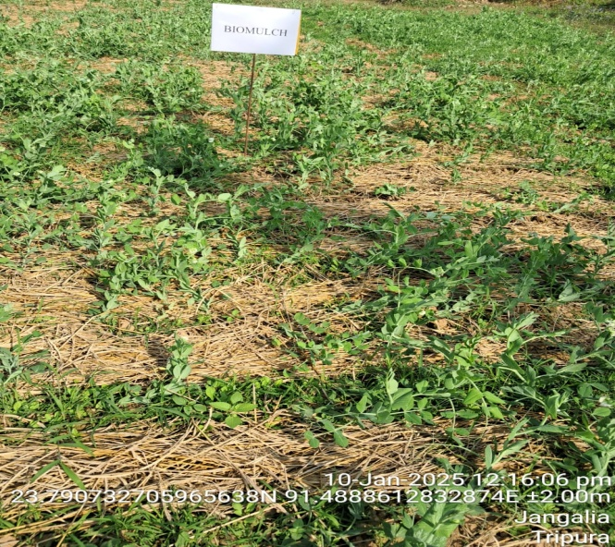 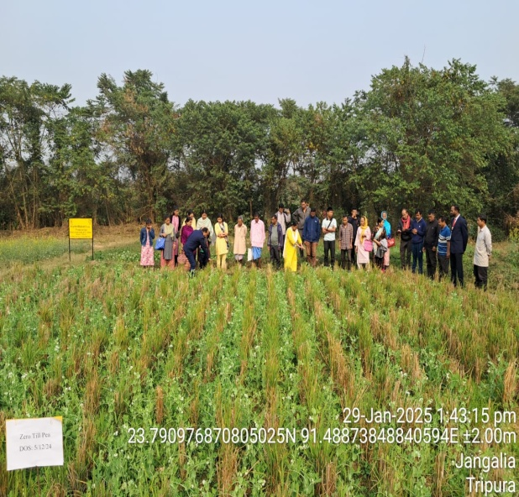

**Fig 1: Biomulch in pea** **Fig 2: Zero tillage pea in rice fallow**

**POLICY INTERVENTIONS**

The following policy interventions required for proper utilization of rice fallow are:

**Creation of community water reservoir**: Soil moisture becomes a limiting factor during winter month despite of sufficient rainfall during kharif season. This is just because of runoff of water. It is essential to establish farm ponds , jalkund and community water reservoirs in the region, with strong support from policy makers. This small structure will help in life saving and supplimental irrigation.

**Quality seeds**: The timely access to high-quality seeds frequently poses a significant challenge, leading to delayed planting and suboptimal yields. Therefore, it is essential to initiate community-based seed production programs that incorporate suitable processing and storage facilities.

**Ensuring timely availability of other critical inputs:** Traditionally, the winter crops on residual soil moisture are grown using local varieties without application of plant nutrients, biofertilizers, fungicides and other agro-chemicals due to their non-availability. Since crop productivity is the driver for area expansion, which in turn is influenced by better crop management, emphasis needs to be placed on timely availability of all critical inputs.

**Rural credit**: Poor socio-economic conditions and purchasing power compel farmers either to skip second crop after rice or resort to no input use. Therefore, subsidies on farm inputs, credit and crop insurance schemes should be implemented.

**Marketing setup**: Marketing plays a key role in encouraging farmers for crop production. Organized market and processing of farm produce is need of the hour.

**CONCLUSION**: The rice fallows of North Eastern Region presents a promising opportunity for expanding the cultivation of short duration pulses and oilseed crops and enhancing the cropping intensity. Effective utilization of these areas can address various social and economic challenges in the region, such as unemployment, labor migration, and low income levels. The cultivation of short duration rice varieties along with advancement and promotion of superior varieties of pulses and oilseeds that are well-suited to the rice fallows across diverse agro-ecological zones of North East India can boost the income and livelihood security of the farming community of this region.

**DISCLAIMER (ARTIFICIAL INTELLIGENCE)**: Author(s) hereby declare that NO generative AI technologies such as Large Language Models (Chat GPT, COPILOT, etc.) and text-to-image generators have been used during the writing or editing of this manuscript.

**References**

Ali, M. and Kumar, S. (2009). Major technological advances in pulses-Indian scenario. Milestones in Food Legumes Research, Government of India. (M. Ali, & S. Kumar, Eds.) Kanpur: Indian Institute of Pulses Research.

Cassman, K. G., De, Datta., S. K., Olk, D. C., Alcantara, J., Samson, M., Descalsota, J and Dizon, M. (1995). Yield decline and nitrogen economy of long-term experiments on continuous irrigated rice systems in the tropics. Lal R, Stewart B A. (Eds.), Soil Management Experimental Basis for Sustainability and Environmental Quality. CRC Press, Boca Raton Fl, pp 181–222.

Ghosh, P. K., Hazra, K. K., Nath, C. P., Das, A. and Acharya, C. L. (2016). Scope, constraints and challenges of intensifying rice (Oryza sativa) fallows through pulses. *Indian Journal of Agronomy* 61 (4th IAC Special Issue): S122–128.

Joshi, P. K., Birthal, P. S. and Bourai, V. A. (2002). Socio-economic constraints and opportunities in rainfed rabi cropping in rice fallow areas of India. International Crops Research Institute for the Semi-Arid Tropics, Patancheru, 2002, pp58.

Kumar, M., Jha, A. K., Hazarika, S., Verma, B. C., Choudhury, B. U., Ramesh, T., Moirangthem, P., Kumar, R., Brajendra, Rajkhowa, D. J., Kumar, A. and Devi, M. H. (2016). Micronutrients (B, Zn, Mo) for improving crop production on acidic soils of northeast India. National Academy Science Letter, DOI 10.1007/s40009- 015-0409-x.

Kumar, R., Mishra, J. and Hans, H. (2018). Enhancing the productivity of rice–fallows of eastern India through the inclusion of pulses and oilseeds. *Indian Farm*, 68(08): 7-10.

Kar, G. and Kumar, A. (2009).Evaluation of post-rainy season crops with residual soil moisture and different tillage methods in rice–fallow of eastern India. *Agricultural Water Management* 96: 931–8.

Pande, S., Sharma, M. and Ghosh, R. (2012). Role of pulses in sustaining agricultural productivity in the rainfed rice-fallow lands of India in changing climatic scenario. Climate change and food Security in India: Proceeding of National Symposium on Food Security in Context of Changing Climate, 30 Oct.-1 Nov. 2010, pp. 53–70.

Reddy, A A. (2009). Pulses Production Technology: Status and Way Forward. Economic Political Weekly 44: 73–80.

Reddy, A. A. and Reddy, G. P. (2010). Supply side Constraints in production of pulses in India: Case study of lentils. *Agricultural Economics Research Review* 23: 129–36.