DEVELOPMENT, EVALUATION AND OPTIMIZATION OF NOVEL DRUG DELIVERY OF ACECLOFENAC FOR MANAGEMENT OF RHEUMATOID ARTHRITIS

Abstract:

Objective: Rheumatoid Arthritis (RA) is a chronic disease which can lead to long term joint damage, joint destruction resulting in chronic pain, loss of function and disability. The present study aimed to formulate the solid lipid nanoparticles (SLNs) of Aceclofenac (ACE). SLNs are considered to be the most effective lipid based colloidal carriers and one of the most popular approaches to improve the oral bioavailability of poorly water soluble drugs.

Methods: Aceclofenac loaded SLNs were formulated by microemulsion method and coated with chitosan (CS) for targeted drug delivery and characterized by various methods such as particle size, polydispersity index and In-vitro drug release in phosphate buffer.

Results: Aceclofenac-SLN formulation variables were optimized through the use of the Box–Behnken design of response surface methodology. The improved formulation had a particle size of 269±2.45 nm, a PDI of 0.217±0.008, and an entrapment efficiency of almost 79.9±2.21. The zeta potential of the Aceclofenac-SLN was 35.7 mV. According to TEM investigation, Aceclofenac-SLNs exhibited a spherical form and ranged in size from 100 nm. Endothermic transitions were visible at 243°C in the ACE DSC curve. With 83.2±1.5% of the drug released from the SLNs in 24 hours, Aceclofenac-SLN showed a regulated release of the drug from the lipid matrix.

Conclusion: As compared to pure drug solutions, the optimized Aceclofenac -SLNs formulations demonstrated sustained drug release up to 24 Hours.

Keywords: Solid lipid nanoparticles, Chitosan, Aceclofenac, Rheumatoid arthritis

1. INTRODUCTION
Almost every area of medicine, including cardiology, ophthalmology, endocrinology, oncology, pulmonology, and immunology, as well as highly specialized fields like gene delivery, brain targeting, tumor targeting, oral vaccine formulations, and others, has greatly benefited from nanoparticles based drug delivery systems.[Manzari et al., 2021] Solid lipid nanoparticles (SLN) are a crucial instrument in the field of nanotechnology for the administration of arthritis treatments because of their simple permeability and high drug loading capacity [Mishra et al. 2018]. The chronic illness known as rheumatoid arthritis (RA) can cause permanent joint damage and destruction, which can cause chronic pain, loss of function, and disability. The immune system reacts to its own antigen because the body is unable to discriminate between foreign and self-antigens in this autoimmune disease. There are three phases to the progression of arthritis, which impacts the skeleton, respiratory system, and heart.[Gibofsky et al., 2012]. According to estimates, the condition affects between 0.3% and 1.0% of people worldwide. [Taylor et al. 2016].
Non-steroidal anti-inflammatory drugs (NSAIDs) have long been used to treat rheumatoid arthritis patients. A variety of formulations, including transdermal patches, pediatric and geriatric formulations, parenteral liquids, oral liquids, tablets, capsules, and topical medicines, have been used historically to treat RA. The aggressive use of disease-modifying anti-rheumatic medications (DMARDs) and immunological therapies that target cells implicated in RA immunopathogenesis has greatly revolutionized RA therapy during the past ten years. [McInnes and Schett 2017, Bemt 2018].
In addition to non-steroidal anti-inflammatory medications like aspirin, celecoxib, aceclofenac, and diclofenac, anti-rheumatic medications such as gold, aceclofenac, penicillamine, leflunomide, sulfasalazine and hydroxychloroquine can be used to treat arthritis. [Emery, 2006, Friedman and Cronstein 2019]. The standard dosage formulations used to treat RA have a number of issues. The primary problems with medications are short half-lives, low bioavailability, poor solubility, and low patient compliance. Drug-associated toxicity has also been connected to other RA therapy types, such as steroids, DMARDs, and NSAIDs [Moura et al. 2018; Aletaha, 2018].
Therefore, the development of affordable and minimally harmful RA treatments is imperative. Newer techniques, such as SLN, are being explored to create innovative dosage forms in order to ensure prolonged and sustained pharmaceutical delivery. [Van den Bemt et al. 2012] It could help reduce drug toxicity as well as issues with the short half-lives, low bioavailability, and poorly soluble nature of medications [Movahedi et al. 2016].
SLNs are unique lipid-based, biocompatible nanocarrier systems that are mostly made up of lipid or modified lipid nanostructures (triglycerides, fatty acids, or waxes) with a diameter range of 10–1000 nm. Therefore, an attempt has been made in this research to develop and enhance SLNs for the successful delivery of aceclofenac in addition to evaluate drug release characteristics, particle size, and entrapment effectiveness. [Uner et al. 2007].
2. MATERIALS AND METHODS
2.1 Study Design
This work was performed to develop, optimize and evaluation of aceclofenac SLN for Anti-RA potential. Before beginning any treatments, a thorough review of the literature on drugs and innovative drug delivery systems for RA was conducted. Additionally, several papers from reputable journals were searched for information on all aspects of current research.
2.2 Materials
Aceclofenac was purchased from Healthy Life Pharma Pvt. Ltd. Mumbai, India. Stearic acid and Tween 80 was received as gift sample from Molychem, Mumbai, India. Dialysis Membrane and Membrane Filter were purchased from Himedia Laboratories Pvt.Ltd, Mumbai, India. Hydrochloric acid, Sodium hydroxide and Methanol were purchased from SD Finechem Limited, Mumbai, India.
2.3 Methods
Selection of suitable lipids and surfactants: Lipids (stearic acid) were chosen based on drug solubility and compatibility. Surfactants were selected based on the literature analysis and their safety profile. Sodium taurocholate and Tween 80 were selected as the Surfactants.
2.1 Physiochemical Characterization of Drug Aceclofenac
Drugs FTIR spectroscopy data, melting point determination, partition coefficient determination, calculation of absorption maxima (λ_{max}), and medication excipient interaction investigations were all used to identify ACE.
2.2 Solubility Study of drugs in different lipids
The drug's solubility in a range of lipids was assessed to identify the lipid with the greatest potential for aceclofenac. A fixed weight (100 mg) of fat was melted in a glass vial. The vial's medication content was progressively increased. The mixture stated before was heated over the lipid's melting point. A translucent solution, which acts as the experiment's endpoint, indicates that the medication has been dissolved into the melting lipid.
2.3 FTIR for Compatibility study
To verify any possible chemical interactions between the medication ACE and polymers such chitosan and stearic acid, FTIR research was performed. The drug was investigated using FTIR by first mixing it with dried KBr and then running spectra between 4000 cm⁻¹ and 400 cm⁻¹ with an FT/IR 4100-TypeA. Subsequent samples of the same drug were compared to the original running spectra when significant peaks associated with the key functional groups were identified.
2.4 Standard calibration curves for Aceclofenac in PBS pH 7.4
The maximum absolute wavelength for aceclofenac was discovered to be 276 nm. Drug sample dilutions of 10 to 50 μg/mL were made in triplicate. Absorbance (y) and concentration (x) are used in a regression analysis to derive the calibration equation and correlation coefficient.
2.5 Formulation of Aceclofenac SLNs by Micro-Emulsion-Based Method:
Using this method, SLNs were produced by magnetically stirring a warm microemulsion dissolved in cold water. Numerous factors set this technology apart from traditional ones, such as its affordability, ease of use, potentially biocompatible components, consistent and well-defined solid nanoparticle production, and exceptionally high drug entrapment efficiencies within SLNs. [Mukherjee et al. 2009].
The SLNs were formulated by using Stearic acid as lipid which acts as internal phase, Soy Lecithin and Tween 80 as surfactants, Sodium taurodeoxycholate as a co-surfactant, Ethanol as water‐miscible solvent, and Distilled water as a continuous phase.
To make SLNs, stearic acid was first melted at a temperature that was 70°C above its melting point (65–70°C). Next, 300 mg of a separate medication, Aceclofenac, which had previously dissolved in ethanol, was added, and the mixture was agitated for 5 minutes before being sonicated for 60 seconds using a 120 W power source. The mixture was agitated for two minutes after the addition of tween 80 and soy lecithin, which act as surfactants. The chitosan was already combined using an in situ approach. After heating an aqueous phase to 80°C, 50 mg of sodium taurodeoxycholate, a co-surfactant, was added to the melted lipid phase. Using a mechanical stirrer, this liquid was swirled for 20 minutes at various rpm. After obtaining the desired warm microemulsion, it was mechanically stirred and disseminated into distilled water. After that, the emulsion was thrice cleaned with distilled water.
2.6 Optimization of Formulation variables of Aceclofenac -SLNs
The response surface methodology was employed to optimize the formulations of the SLNs (RSM). An efficient model's link between the independent variables and their responses, as well as their interactions, is assessed using an RSM Box–Behnken experimental design (BBD). The primary factors influencing the particle size, PDI, drug entrapment effectiveness, and percentage of drug release of the Aceclofenac loaded chitosan nanoparticle (ACE-SLNs) preparations were formulation variables such lipid concentration, surfactants, and homogenization speed.. The details of the design are listed in Table-1. A three-factor, three-level response surface methodology statistical experimental design was used to optimize the formulation variables and the response surface methodology required 17 experiments.
Table 1 Factors showing coded values with fixed goals for responses -
Formulating Aceclofenac-SLNs using BBD
Independent Variables | Symbol | Unit | Coded levels |  |  | Response  (Y1) | Response  (Y2) | Response  (Y3)
Independent Variables | Symbol | Unit | -1 | 0 | +1 | Response  (Y1) | Response  (Y2) | Response  (Y3)
Surfactant Concentration | X₁ | %w/v | 0.5 | 1 | 1.5 | Particle Size Distribution (nm) | PDI | % EE
Homogenization  Speed | X₂ | rpm | 12k | 15k | 18k | Particle Size Distribution (nm) | PDI | % EE
Lipid content | X₃ | mg | 200 | 300 | 400 | Particle Size Distribution (nm) | PDI | % EE
Using Box–Behnken design of response surface methodology a systematic optimization was carried out for estimating the extended effect of formulation variables X₁ (Surfactant Concentration), X₂ (Homogenization Speed), and X₃ (Lipid content) on the responses, Y1 (particle size), Y2 (Poly-dispersity index- PDI), and Y3 (%EE) were recorded.
2.7 Characterization and Evaluation of Aceclofenac SLNs:
2.7.1 Measurement of Particle size distribution
The prepared SLNs' particle sizes (z-average) and particle size distributions (PDI) were determined using photon correlation spectroscopy (PCS). The measurements were carried out using a Zetasizer ZS 90 from Malvern Instruments Ltd. in the UK. Prior to measurements, 10 mL of HPLC grade water was used to dilute 1 mL of the SLN dispersion. In order to find the ideal formulation based on the size of the particles, the average particle size of the SLNs formulation made with various drug and lipid ratios has been examined and optimized. Both the particle z-average diameter and the polydispersity index (PDI) were calculated for each measurement, which was done in triplicate.
2.7.2 Particle shape and morphology
Transmission electron microscopy (TEM; Hitachi H7500, Tokyo, Japan) was used to examine the form and morphology of produced SLNs. The TEM method of microscopic analysis focuses the structure's image using magnetic lenses after sending electrons through nanoparticles. A technique called field emission scanning electron microscopy (FESEM) was used to examine the surface properties and form of nanoparticles. The samples were air-dried on room temperature after being negatively stained with a 1% w/v aqueous solution of phosphotungstic acid, and then they were examined under a microscope at the appropriate magnifications.
2.7.3 Measurement of zeta potential of SLNs
Zeta potential can be utilized to predict long-term stability and improve formulation. About 1 ml of SLN dispersion (Millipore, India) was diluted with 10 ml HPLC grade water for zeta potential determination, and measurements were taken using Zetasizer Ver. 7.01 (Malvern Instruments Ltd., UK). Each measurement was carried out three times.
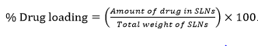
2.7.4 Determination of drug content: To determine the total drug content in the prepared SLNs, 0.1 mL of SLN disperson was extracted in chloroform:ethanol mixture (1:9) volumetrically. Required dilutions were further carried out in ethanol. Estimation of drug content was carried out by using UV spectrophotometric method at a maximum wavelength of 286 nm. The experiment was carried out in triplicate. Drug loading of SLNs was determined by using the following formula:

2.7.5 Determination of entrapment efficiency: By evaluating the concentration of free drug (unentrapped) in the supernatant obtained after centrifuging SLN dispersion, entrapment efficiency (EE) was measured. The SLNs dispersion was centrifuged using an ultra-centrifuge (Thermo Electron LED GmbH, D-37520 Osterode) at a speed of 6000-12000 rpm at a temperature of 4°C. The amount of unentrapped medication was then determined by analyzing the supernatant, and the entrapment efficiency was estimated using the following formula (Eq 2). (Wavikar and Vavia, 2013).
2.7.6 In vitro release studies of drugs from SLNs:
Studies on in vitro release were carried out using a water bath incubator shaker. The molecular weight cutoff for the 12,000–14000 Da pore size dialysis membrane was employed. At intervals of 0.5, 1, 2, 4, 6, 8, 10, 12, 16, 20 and 24 h, an aliquot of 5 ml was taken out. To maintain constant volume, the volume was taken at regular intervals and replaced with fresh medium kept at the same temperature. UV spectrophotometry was used to examine the samples at a wavelength of 276 nm. Utilizing the calibration curve, the concentrations were calculated, and the percent cumulative release was computed. To comprehend the drug release process, the release data was fitted into multiple release kinetic models.
2.7.7 Evaluation of Drug release kinetics:
In order to investigate the mechanism of optimized drug loaded nanoparticle formulations the release data was analyzed with mathematical models such as Zero order kinetic, First order kinetic, Higuchi kinetic, Hixson crowell model and Korsmeyer Peppas model.
2.7.8 Storage Stability Study
To assess the impacts of the temperature and relative humidity (RH) on the formulation, a stability study of the improved ACE-SLNs formulation was conducted under various ICH stability conditions such as 4°C (refrigerator), 25°C/60% RH (CRT- Controlled Room Temperature) and 40°C/75% RH (Accelerated Stability condition) for six months. The samples were evaluated for particle size and EE at time intervals of 0, 2 months and at the end of 4 months.
3 RESULTS AND DISCUSSION
3.1 Physicochemical Characterization of Drug Aceclofenac:
All the physicochemical properties were found to be within range according to the specification. Melting point and partition coefficient value of ACE were matched with the standard value given in the standard monograph (Table 2).
3.2 Solubility Study of drug in different lipids
In case of ACE solubility study, it was soluble in acetone, ethanol and chloroform, sparingly soluble in ethanol and alchohol (Table 3). Aceclofenac is insoluble in water. The solubility study concludes that aceclofenac is a hydrophobic drug.

Table 2 Physiochemical Properties of the Drug Table 3 Solubility Profile of drugs
Characters | Inference | Sr. | Medium | Solubility (mg/ml)
Characters | Aceclofenac | 1 | Water | Poorly soluble
Color | White powder | 2 | 0.1 N Hydrochloric acid | Slightly soluble
Odor | odorless | 3 | pH 6.8 Phosphate buffer | Freely soluble
Nature | crystalline powder | 4 | Ethanol | Sparingly soluble
Melting Point | 147-153ºC | 5 | Stearic acid | Freely soluble
Partition Coefficient | 1.86 ± 0.75 | 6 | Cholesterol | Slightly soluble
 |  | 7 | Witepsol H 32 | Sparingly soluble

3.3 Preliminary Compatibility Study by FT-IR
The FTIR peak of the ACE test sample matched with that of standard spectra, especially in the fingerprint region, thereby confirming the identity of ACE.
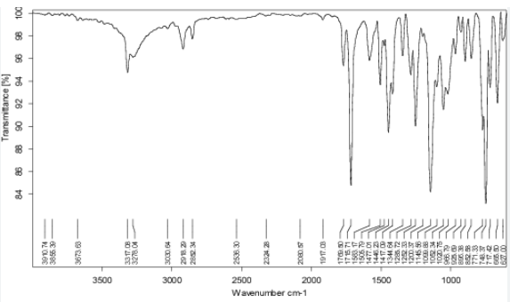
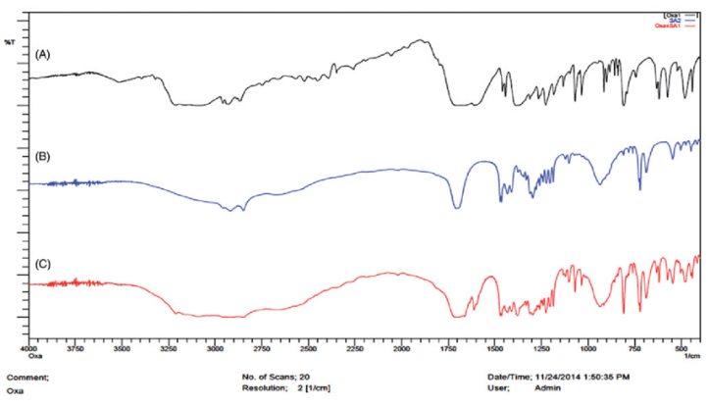
Fig. 1 FT-IR Spectrum of physical mixture of Aceclofenac and polymers
FTIR spectra of (a) Aceclofenac, (b) Chitosan (CS) and Stearic Acid

The functional group peaks of ACE were observed at wavenumbers 3675.8 cm-1(O-H stretch groups), 1645.6 cm-1, 1592 cm-1, 1545 cm-1 (skeletal C-C), 2954.2 & 3078.1 cm-1 (skeletal C-H vibrations). Physical mixture of ACE with chitosan and lipid showed compatibility to each other
Table 4 Interpretation of FTIR spectra of Aceclofenac
Stretching type | Spectra Range  Standard cm⁻¹ | Observed peak cm⁻¹  Drug sample
N-H stretching | 3500-3300 | 3359
O-H stretching | 3100-2550 | 2875.2
C=O stretching | 1850–1550 | 1710.5
C-C stretching for NH | 3000-2800 | 2910.5
O-H in plane bending | 1450-1350 | 1314.8
C-Cl | 850–550 | 715.5

Table 5: Interpretation of FT-IR of mixture of Aceclofenac with Polymers
Stretching type | Spectra Range  Standard cm-1 | Observed peak cm-1  Drug sample
O-H Stretching | 2970-2535 | 2870
N-H Stretching | 3450-3210 | 3340
C-H Stretching (aliphatic) | 3000-2850 | 2980
C-C and C-N Stretching | 1370-1160 | 1203
C=O stretching | 1540–1870 | 1710

3.4 Calibration Curve of Aceclofenac in PBS pH 7.4
The standard plot of Aceclofenac was prepared in triplicate using a range 10-50 μg /ml. Absorbance was measured for each solution at λ_{max} of 276 nm using UV-Visible spectrophotometer, and the curve was plotted between absorbance and concentration of aceclofenac.
Table 6 Calibration curve in Phosphate Buffer pH 6.8
S.  No | Concentration (μg/ml) | Avg. Absorbance PBS pH 6.8 (276nm)
1 | 0 | 0
2 | 10 | 0.098
3 | 20 | 0.225
4 | 30 | 0.31
5 | 40 | 0.405
6 | 50 | 0.49

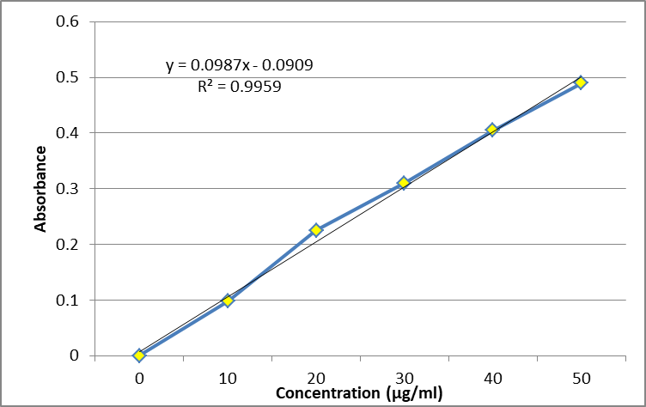
Fig 2 Standard calibration curve of Aceclofenac in Phosphate buffer
3.5 Optimization of Formulation variables of CS-ACE-SLNs
The quadratic model was found to be suitable for %EE as interactions between the factors were found to affect the attribute, whereas a linear model was found to be suitable for particle size and PDI since no effect of interactions between the factors was observed on these attributes.
Table 7 Design Matrix and Runs generated by Design-Expert® software with recorded responses of the runs for optimization of Aceclofenac-SLNs.
 |  | Factor 1 | Factor 2 | Factor 3 | Response 1 | Response 2 | Response 3
Std | Run | A: Surfactant | B:  Speed | C:  Lipid Content | Particle Size (Y1) | PDI | %EE
 |  | Mg/ml | rpm | Mg | nm |  | %
16 | 1 | 1 | 15000 | 300 | 336 | 0.385 | 70.12
10 | 2 | 1 | 18000 | 200 | 372 | 0.425 | 75.65
15 | 3 | 1 | 15000 | 300 | 186 | 0.315 | 71.85
1 | 4 | 0.5 | 12000 | 300 | 212 | 0.275 | 62.74
17 | 5 | 1 | 15000 | 300 | 342 | 0.312 | 80.55
4 | 6 | 1.5 | 18000 | 300 | 196 | 0.254 | 79.35
5 | 7 | 0.5 | 15000 | 200 | 232 | 0.345 | 74.35
7 | 8 | 0.5 | 15000 | 400 | 270 | 0.295 | 74.9
2 | 9 | 1.5 | 12000 | 300 | 306 | 0.386 | 78.12
13 | 10 | 1 | 15000 | 300 | 254 | 0.310 | 74.25
14 | 11 | 1 | 15000 | 300 | 310 | 0.365 | 77.12
11 | 12 | 1 | 12000 | 400 | 254 | 0.285 | 68.25
12 | 13 | 1 | 18000 | 400 | 312 | 0.405 | 62.35
3 | 14 | 0.5 | 18000 | 300 | 325 | 0.316 | 76.86
9 | 15 | 1 | 12000 | 200 | 275 | 0.325 | 71.38
6 | 16 | 1.5 | 15000 | 200 | 245 | 0.267 | 76.4
8 | 17 | 1.5 | 15000 | 400 | 198 | 0.312 | 79.42
The % of drug release, %EE, & particle size of the improved formulation were assessed. Particle size of 268.2±1.8 nm, PDI of 0.324±0.02, and entrapment efficiency of roughly 77.9±1.45 nm were all in good accord with the projected values for the improved formulation. The response parameters have prediction errors of 1.45, 2.4, and 2.1%, with an absolute error of 2.72 percent ± 0.5%. Table 8 and Fig. 3 demonstrate the correlation between the response variables' actual and expected values. These numbers also indicate that the generated models performed well and that the predicted results aligned closely with the measured data.
Table 8: Comparison of the predicted response and the experimentally observed of the optimized Aceclofenac-SLNs
Process | X₁ | X₂ | X₃ | Predicted | Experimental (n=3) | Error (%)
Particle size (Y1) | 200.04 | 0.52 | 15330 | 275.83 | 268.2±1.8 | 2.54
PDI (Y2) | 200.04 | 0.52 | 15330 | 0.332 | 0.324±0.02 | 2.4
EE % (Y3) | 200.04 | 0.52 | 15330 | 80.60 | 77.9±1.45 | 3.22

Table 9 The Criterion for numerical optimization- Aceclofenac-SLNs
Parameter |  |  | Goal |  | Lower Limit |  | Upper Limit |  | Lower Weight |  | Upper Weight |  |  | Importance
A:Surfactant |  |  | is in range |  | 0.5 |  | 1.5 |  | 1 |  | 1 |  |  | 3
B:Speed |  |  | is in range |  | 12000 |  | 18000 |  | 1 |  | 1 |  |  | 3
C:Lipid |  |  | is in range |  | 200 |  | 400 |  | 1 |  | 1 |  |  | 3
Particle Size |  |  | is in range |  | 186 |  | 372 |  | 1 |  | 1 |  |  | 3
PDI |  |  | is in range |  | 0.254 |  | 0.425 |  | 1 |  | 1 |  |  | 3
EE |  |  | maximize |  | 62.35 |  | 80.55 |  | 1 |  | 1 |  |  | 3
Solution
 | Lipid | Surfactant |  | Speed |  | Particle Size |  | PDI |  | %EE |  | Desirability
 | 200.04 | 0.52 |  | 15330 |  | 275.83 |  | 0.332 |  | 80.60 |  | 1.00 | Selected

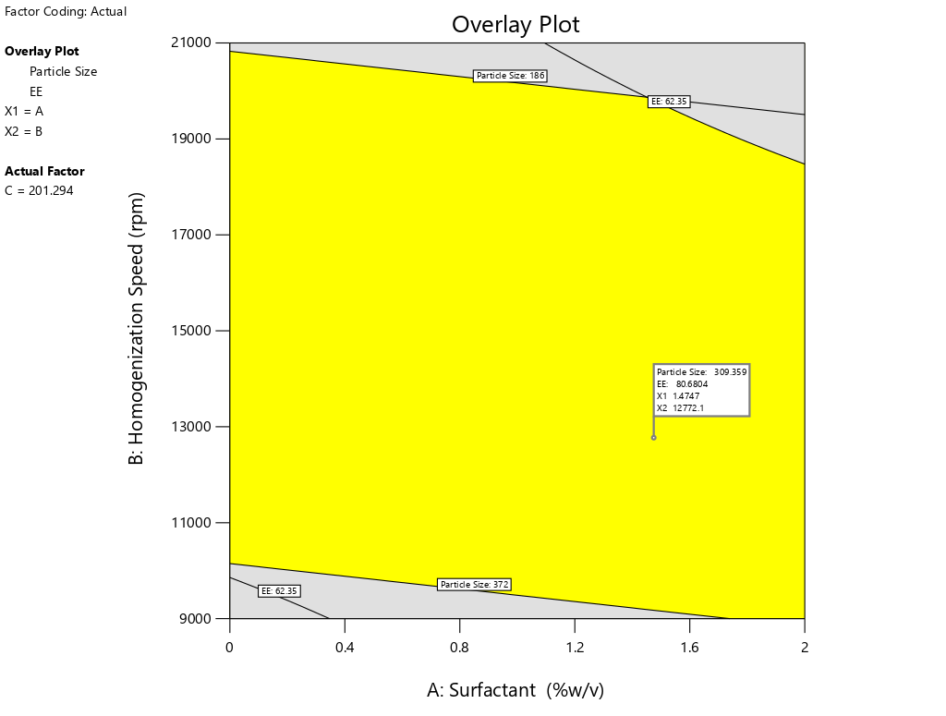
Fig 3. Overlay plot showing the design space for the responses for Aceclofenac-SLN

3.5 Characterization and Evaluation of Aceclofenac Solid Lipid Nanoparticles
3.5.1 Measurement of particle size and distribution
The particle size analyzer measured the diameter of the various formulations according to design, and the results showed that the range of PDI was 0.254-0.425 and the particle size was between 186 and 372 nm. The variation in surfactant and lipid concentrations modifies the size of the particle. The optimized formulation measured 268.2 nm in size, and the overlay plot created by design expert software displayed a poly-dispersity index of 0.324. The ideal speed of homogenization and surfactant integration with polymer is indicated by uniformity in size within a particular range. Figure 4 displayed the optimized formulation's particle size. The improved formulation's mean particle size was determined to be 275.8 nm, and its PDI was discovered to be 0.332. The homogeneous particle size distribution shown by the low PDI value may be the result of using formulation parameters that have been improved.
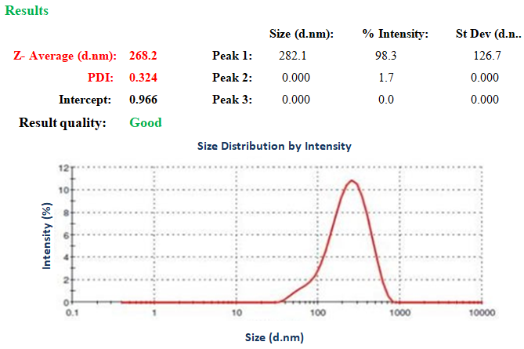
Fig: 4 Particle size distribution of optimized batch of Aceclofenac-SLNs

3.5.2 Measurement of zeta potential of SLNs
Zeta potentials between +10 and –10 mV are used to characterize nanoparticles as roughly neutral. Conversely, nanoparticles in the dispersion medium that have a ZP of greater than +30 mV or less than -30 mV are thought to be extremely stable. The zeta potentials of roughly 28.6 mV displayed in Figure 5 suggest that the formulation is stable. Lipid and Tween 80, which reduce between the particles' electrostatic repulsion and sterically stabilize the NPs by producing a coat around their surface, may be responsible for this.
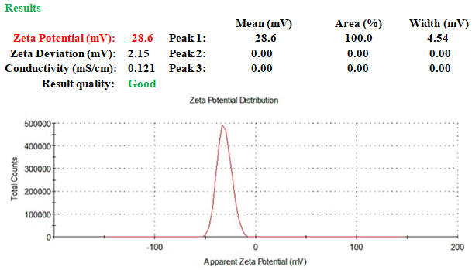
Fig: 5 Zeta potential of optimized batch of Aceclofenac-SLNs
3.5.3 Entrapment efficiency:
The entrapment efficiency in Aceclofenac-SLNs was determined to be 77.9±1.45%. According to the results, ACE in the SLNs had a respectable EE. The probability of ACE partitioning out is increased by its poor water solubility, especially once the lipid solidifies into the crystalline matrix. Cationic SLN were created to improve the EE of specific medicament with less solubility in lipids & water. Thus, the use of stearic acid to increase ACE affinity towards the lipid has enabled the high EE of the medicine in the SLNs.
3.5.4 Particle shape and morphology
TEM analysis verified that the process may be used to prepare particles with desired size and narrower size distributions. Aceclofenac-SLNs had a spherical shape and ranged in size from 100 nm, as shown in Fig. 6. This was done by modifying the ideal parameters for Acecloenac-SLNs preparation. CS, tween, and stearic acid combinations in varying concentrations generate chemically polyelectrolytic complexes that promote the creation of perfectly spherical polymeric nanoparticles.
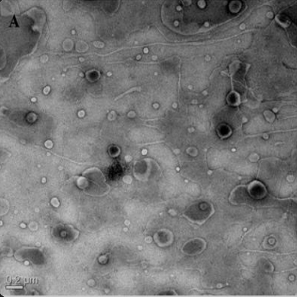
Fig: 6 TEM image of optimized batch of Aceclofenac-SLNs
3.5.5 In vitro release studies of drugs from SLNs:
Based on the outcomes displayed in tables 11 and fig. 7, optimal Aceclofenac-SLNs were released in 7.4 pH phosphate buffers at a rate of 89.6±1.75. The results demonstrate that while the drug release from pure ACE (91.1±2.1) was better, the controlled release profile was not shown since the drug released completely in less than 16 hours. In contrast, the drug release from nanoparticles was good and the controlled release lasted longer than 24 hours.
In the optimized formulation, there was an initial burst release & a protracted release. As seen in Fig. 7, the drug's minimal burst release from the Aceclofenac-SLNs was seen within the first few hours, and this was followed by a protracted release (86.6%) lasting up to 24 hours. The controlled, prolonged release of an incorporated drug in a delivery system is an important characteristic quite often correlated with improved pharmacokinetics and efficacy.
Table 10: Dissolution studies of optimized Aceclofenac-SLNs in various fluids
Time  Hr | % Cumulative Drug Release (% CDR) in  PBS pH 7.4)
 | Aceclofenac-SLNs | Plain Aceclofenac
0.5 | 19.5±0.8 | 17.6±0.78
1 | 27.65±1.22 | 31.5±1.3
2 | 37.8±1.5 | 45.25±1.6
4 | 46.3±0.95 | 59.6±1.1
8 | 59.4±1.3 | 70.1±0.8
12 | 68.1±2.1 | 80.8±1.8
16 | 74.2±1.5 | 91.1±2.1
20 | 82.1±2.25
24 | 89.6±1.75

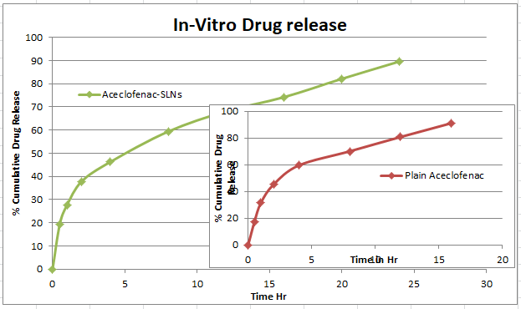
Fig: 7 In-Vitro drug release studies of Plain ACE & optimized ACE-SLNs in PBS

3.5.6 Evaluation of Drug release kinetics
Based on the slope of the pertinent plots, the regression coefficient (R²) and release constant were calculated; the outcomes are listed in Table 11. A comparison analysis of R² values revealed that the improved formulation's drug release kinetics followed zero order. This resulted from the fact that the drug release mechanism from the polymeric nanoparticles was diffusion control, and the plots of cumulative percentage drug release vs time were linear (R² - 0.991).
Table 11: Data fitted to kinetic models for optimized Aceclofenac-SLNs
 | Zero Order (R² ) | First Order  (R² ) | Higuchi  (R² ) | Korsmeyer- Peppas
 |  |  |  | (R² ) | (n)
Aceclofenac-SLNs | 0.991 | 0.961 | 0.981 | 0.968 | 0.45

3.5.7 Storage Stability Study:
The average particle size and entrapment effectiveness of the nanoparticles after four months were found to be 265 nm & 79.25% in low temperature conditions, 263 nm & 78.53% in ambient temp, & 267 nm & 78.9% in 40°±2°C/75% ±5% RH. According to these findings, the Aceclofenac-SLNs were determined to be the most stable. For a period of four months, good stability was observed at the controlled room temp, refrigerated temp (4°±1°C), and accelerated stability condition at 40°±2°C/75% ±5% RH.
4. CONCLUSION
Physiological and FTIR analysis was used to establish the identity and purity of the medication and polymer in the beginning. According to the design approach, ACE-coupled SLNs were effectively synthesized using the micro-emulsion-based method. SLNs were coated with chitosan ligand using the in situ approach to boost their oral bioavailability and perhaps the targeted distribution of the medications at the site of action. The cationic lipid stearic acid was utilized to increase the affinity of negatively charged Aceclofenac towards the lipid phase. The optimized batch was about 300 nm in diameter and had a PDI of 0.324, which was supported by TEM examination and the particle size analysis. For ACE, the EE ranged from 80 to 85 percent. When compared to pure drug solutions, the drug release experiments demonstrated that Aceclofenac-SLNs displayed sustained drug release and followed the zero order model with a Fickian diffusion.
Conflict of Interests:
The authors declare that there is no conflict of interests.

5. REFERENCES:
- Aletaha, D., & Smolen, J. S. Diagnosis and management of rheumatoid arthritis: A review. JAMA, 2018; 320(13), 1360–1372. https://doi.org/10.1001/jama.2018.13103
- Bemt, B. J., Zwikker, H. E., & Van Den Ende, C. H. Medication adherence in patients with rheumatoid arthritis: A critical appraisal of the existing literature. Expert Review of Clinical Immunology, 2012; 8(4), 337–351. https://doi.org/10.1586/eci.12.19
- Chandrashekara S, Patted A. Role of vitamin D supplementation in improving disease activity in rheumatoid arthritis: An exploratory study. Int J Rheum Dis. 2017 Jul;20(7):825-831.
- Doktorovova S, Souto EB, Silva AM. Nanotoxicology applied to solid lipid nanoparticles and nanostructured lipid carriers - a systematic review of in vitro data. Eur J Pharm Biopharm. 2014 May;87(1):1-18
- Egusquiaguirre SP, Igartua M, Hernández RM, Pedraz JL. Nanoparticle delivery systems for cancer therapy: advances in clinical and preclinical research. Clin Transl Oncol. 2012 Feb;14(2):83-93.
- Friedman B, Cronstein B. Aceclofenac mechanism in treatment of rheumatoid arthritis. Joint Bone Spine. 2019 May;86(3):301-307
- Gibofsky A. Overview of epidemiology, pathophysiology, and diagnosis of rheumatoid arthritis. Am J Manag Care. 2012 Dec;18(13 Suppl):S295-302
- Guo Q, Wang Y, Xu D, Nossent J, Pavlos NJ, Xu J. Rheumatoid arthritis: pathological mechanisms and modern pharmacologic therapies. Bone Res. 2018 Apr 27;6:15
- Joseph E, Singhvi G. Multifunctional nanocrystals for cancer therapy: a potential nanocarrier. Nanomaterials for Drug Delivery and Therapy Published by William Andrew publisher, 2019: 91-116
- Manzari MT, Shamay Y, Kiguchi H, Rosen N, Scaltriti M, Heller DA. Targeted drug delivery strategies for precision medicines. Nat Rev Mater. 2021 Apr;6(4):351-370. doi: 10.1038/s41578-020-00269-6.
- McInnes IB, Schett G. Pathogenetic insights from the treatment of rheumatoid arthritis. Lancet. 2017 Jun 10;389(10086):2328-2337
- Mehnert W, Mäder K. Solid lipid nanoparticles: production, characterization and applications. Adv Drug Deliv Rev. 2001 Apr 25;47(2-3):165-96
- Mishra V, Bansal KK, Verma A, Yadav N, Thakur S, Sudhakar K, Rosenholm JM. Solid Lipid Nanoparticles: Emerging Colloidal Nano Drug Delivery Systems. Pharmaceutics. 2018 Oct 18;10(4):191. doi: 10.3390/pharmaceutics10040191.
- Moura M, Lopes L, Silva MT. Use of steroid and nonsteroidal anti-inflammatories in the treatment of rheumatoid arthritis: Systematic review protocol. Medicine (Baltimore). 2018 Oct;97(41):e12658
- Movahedi M, Beauchamp ME. Risk of Incident Diabetes Mellitus Associated With the Dosage and Duration of Oral Glucocorticoid Therapy in Patients With Rheumatoid Arthritis. Arthritis Rheumatol. 2016 May;68(5):1089-98
- Mukherjee S, Ray S, Thakur RS. Solid lipid nanoparticles: a modern formulation approach in drug delivery system. Indian J Pharm Sci. 2009 Jul;71(4):349-58
- Rizvi SAA, Saleh AM. Applications of nanoparticle systems in drug delivery technology. Saudi Pharm J. 2018 Jan;26(1):64-70
- Szopinska SI, Kontny E. The pathogenesis of rheumatoid arthritis in radiological studies. Part I: Formation of inflammatory infiltrates within the synovial membrane. J Ultrason. 2012 Jun;12(49):202-13
- Taylor PC, Moore A, Vasilescu R, Alvir J, Tarallo M. A structured literature review of the burden of illness and unmet needs in patients with rheumatoid arthritis: a current perspective. Rheumatol Int. 2016 May;36(5):685-95.
- Uner M, Yener G. Importance of solid lipid nanoparticles (SLN) in various administration routes and future perspectives. Int J Nanomedicine. 2007;2(3):289-300
- Van den Bemt BJ, Zwikker HE, van den Ende CH. Medication adherence in patients with rheumatoid arthritis: a critical appraisal of the existing literature. Expert Rev Clin Immunol. 2012 May;8(4):337-51

