Climate Smart Intercropping with Emerging Technologies

Abstract-Agriculture is faced with remarkable challenges posed with the aid of climate exchange, along with growing temperatures, irregular rainfall, and extra common occurrences of climate occasions, compromising worldwide meals protection. climate-smart intercropping with emerging technologies offers a sustainable answer by way of improving the efficiency of sources, improving yield balance, and reducing the environmental effect. in this evaluate, the application of precision agriculture, the internet of things (IoT), Artificial intelligence (AI), CRISPR biotechnology, and other advanced equipment in intercropping systems is explored. these technologies facilitate real-time assessment of the fame of the soil, optimization of the choice of plants, and better management of pests and sicknesses. organic manipulate dealers, push-pull technology, and gene-changed crop varieties additionally boom resilience and sustainability. via the mitigation of greenhouse gases, the promotion of biodiversity, and the optimization of water and vitamins, weather-clever intercropping is able to being a vital parent in future meals systems. Technological access to smallholder farmers, the fee of implementation, and the handling of records pose the demanding situations that need to be addressed. in this assessment, the revolutionary capacity of rising technology in intercropping is explored, with emphasis on the capability to build resilient agricultural systems for sustainable food manufacturing.
Keywords- Internet of things (IoT), Artificial intelligence (AI), Climate-Smart Agriculture (CSA), Technologies, Precision Agriculture

INTRODUCTION

Agriculture, the muse of human society, is going through formerly unheard-of problems because of weather change. global food protection is under chance because of agricultural manufacturing disruptions delivered on by using rising temperatures, unpredictable rainfall patterns, and an upward push within the frequency of extreme climate activities. modern tactics that assure sustainability and enhance agricultural resilience are had to meet those issues. amongst them, weather-clever intercropping is a feasible manner to remedy both when paired with new era. developing two or more vegetation together on the same plot of land is referred to as intercropping, and it has lengthy been an exercise in agriculture. It complements the use of resources and lowers the chances of complete crop failure with the aid of leveraging the complimentary connections among plants. Intercropping techniques must exchange, however, to evolve to the desires of a changing environment and increasing population. The layout, tracking, and management of intercropping systems are being revolutionized by way of using cutting-edge modern technologies like as precision agriculture, system learning, and faraway sensing (Masina et al., 2017). actual-time information on weather, crop boom, and soil fitness is furnished thru faraway sensing technology the use of satellites, drones, and sensors. Farmers may use these facts to make nicely-knowledgeable choice on resource allocation, planting schedules, and crop mixtures. In a comparable vein, artificial intelligence and device gaining knowledge of improve prediction fashions, assisting inside the optimization of intercropping plans for precise soil and weather circumstances. by providing inputs like water and nutrients
exactly where and while wished, precision agricultural gear—which include IoT-enabled devices and controlled irrigation structures—similarly enhance aid efficiency (Khanal et al. 2017). Farmers may additionally decrease agriculture's carbon footprint, keep biodiversity, and raise climate variability resilience via incorporating this technology into intercropping structures. The idea of weather-clever intercropping is tested in this review article, with an emphasis on its benefits, problems, and the contribution of technology to the conversion of conventional farming techniques into a framework that is climate resilient. emerging technologies in Intercropping Technological traits have significantly changed traditional farming methods, increasing the effectiveness, scalability, and climatic variability adaptability of intercropping structures. rising technology address some of troubles, inclusive of resource management, crop performance monitoring, and spatial arrangement optimization. net of factors (IoT) so that it will reveal and manage structures in actual time, IoT gadgets construct linked networks with sensors, actuators, and software. Examples of IoT uses for intercropping are irrigation structures that are routinely adjusted in line with the water desires of each crop, Crop microclimate monitoring to prevent ailment or insect outbreaks, combining information from several resources to present a radical photograph of the overall performance of intercropped fields, to manipulate an expansion of agricultural systems, IoT-based totally smart farming platforms such as Agrivi and CropX are being applied (Ray, 2017). by means of facilitating real-time tracking of the microclimates internal intercropped fields, IoT additionally improves the manage of pests and diseases. Farmers are capable of take preventative action when smart sensors identify temperature, humidity, and insect interest and send out early indicators. IoT-based traps with image recognition software, as an instance, can discover pests and notify farmers before infestations get worse, reducing the need for insecticides and fostering ecological stability (Carter, 2023). additionally, Agrivi and CropX, IoT-pushed statistics integration systems, integrate facts from many resources, along with as satellite tv for pc imaging, drones, and soil sensors. these systems provide farmers a radical understanding of intercropped subject overall performance, helping them in allocating assets, making plans planting strategies, and growing usual output. Intercropping turns into greater climate trade resilient whilst IoT devices use system gaining knowledge of algorithms to forecast weather patterns and provide adaptive management techniques. In end, by means of improving information-driven selection-making, pest control, and water efficiency, IoT is revolutionizing climate-clever intercropping. IoT improvements in digital agriculture will in addition improve intercropping structures, increasing resistance to climatic unpredictability, lowering environmental effect, and growing production (Van Lenteren, 2018)(Carter, 2023). CRISPR and Biotechnology Biotechnology and CRISPR era have completely modified agriculture, mainly in relation to weather- clever intercropping systems. by using precisely changing crop genomes, the gene editing approach CRISPR makes it feasible to create flora with desired characteristics like extended nutrient utilization efficiency, insect resistance, and drought resilience. that is mainly essential while intercropping, since it lets in for accelerated tolerance to environmental demanding situations for a selection of plants with exceptional needs. The improvement of drought-tolerant rice and maize cultivars, as an example, using CRISPR makes them best candidates for weather-smart agricultural methods as they can tolerate water shortages (Gajardo, 2023). Moreover, biotechnology is critical for growing the nutritional cost and manufacturing stability of vegetation cultivated in intercropping structures. In intercropping systems, biotech interventions enhance interspecies compatibility by using boosting crop genetic capacity, which raises overall manufacturing. furthermore, the want of chemical inputs is decreased by means of gene-edited plants which might be extra sickness and pest resistant, selling greater environmentally friendly agricultural techniques (Rai et al. 2023). CRISPR and biotechnology paintings together to not simplest remedy weather exchange's problems but additionally offer a technique to expand extra weather-resilient agricultural systems that can continue to provide meals globally however growing environmental variability.

Table-1 Increased Yield Stability and Food Security in Climate-Smart Agriculture (CSA):
Technology | Application in  Intercropping  Systems | Benefits | Reference
CRISPR  Gene Editing | Modifies crop genomes for  desirable traits | Enhances drought & pest resistance, improves nutrient use efficiency | Gomez et al., 2021
Drought-  Tolerant Crops | Develops water-  efficient varieties for intercropping | Increases yield stability under water scarcity | Gomez et al.,  2021)
Pest-Resistant  Crops | Enhances resistance to insects and  diseases | Reduces chemical pesticide use,  improves sustainability | Tian et al., 2022
Nutrient Enhanced Crops | Improves nutritional content of  intercropped species | Addresses malnutrition,  enhances food  security | Tian et al.,  2022)
Biotech for  Compatibility | Optimizes genetic potential for better intercropping synergy | Boosts productivity and resilience | Biotech-enhanced legumes  & cereals (Tian et al., 2022)

Precision Agriculture equipment gear for precision agriculture at the moment are vital for maximizing aid usage and boosting agricultural strategies' sustainability, in particular in weather-clever intercropping systems. those technology, which include soil sensors, drones, satellite tv for pc photographs, and variable price generation (VRT), permit farmers to higher display and manage their plants. Farmers may additionally make properly-informed decisions regarding irrigation, fertilization, and pest control with the aid of the use of drones and satellites to offer actual-time facts on crop health, soil conditions, and environmental factors. Farmers can use satellite tv for pc pictures to music crop development patterns throughout huge regions and see early caution signs of sickness outbreaks or nutrient shortages that could impact intercropped unique (Murugan, 2017). because they are able to measure the temperature, moisture content material, and nutrient levels of the soil, soil sensors are important to precision agriculture. This statistic reduces waste and will increase resource efficiency through helping farmers in making use of fertilizer and water exactly wherein and when wanted. those sensors make certain that each crop in intercropping structures, wherein numerous crops may additionally have varied needs, has the quality growing situations feasible, increasing manufacturing even as decreasing environmental consequences (Sharma, 2023). by means of modifying the costs at which fertilizer, insecticide, and water are implemented primarily based on data acquired from sensors and imaging, variable rate era (VRT) improves resource allocation and encourages sustainable intensification in intercropping structures. via making sure that assets are used correctly, precision agricultural units help farmers increase yields and decorate environmental sustainability.
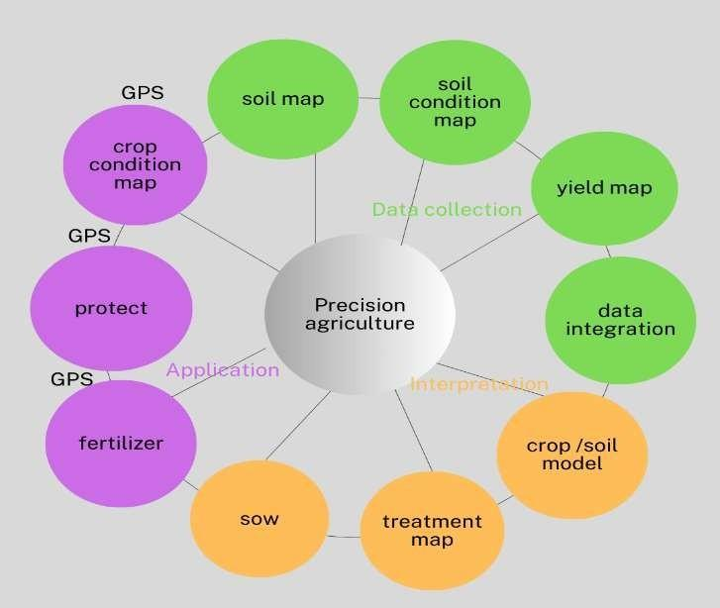
Fig.1: Precision agriculture
artificial Intelligence (AI) and machine learning (ML) through progressed choice-making, aid optimization, and weather trade resistance, weather-clever intercropping—which mixes artificial intelligence (AI) and system gaining knowledge of (ML)—is transforming sustainable agriculture. so as to signify the high-quality crop combos and geographical configurations, AI and ML study large datasets that include soil parameters, weather, and crop developments. AI makes certain that chosen crops supplement each other in useful resource utilization by way of forecasting interspecies interactions, boosting manufacturing and keeping soil health (Alloghani, 2023). furthermore, AI-driven disorder and pest control systems rent imaging era and system learning algorithms to identify early infestation indicators, taking into consideration set off remedies and a lower within the usage of insecticides (Siddique, 2019). additionally, AI improves specific resource management via combining facts from satellite tv for pc images, drones, and internet of things gadgets to maximize using fertilizer, water, and other inputs. AI-pushed pointers assure accurate useful resource allocation, growing performance and minimizing environmental effect, as various vegetation in intercropping structures have distinct desires (Carter, 2023). if you want to compare possible consequences on intercropping systems, AI fashions additionally are expecting extraordinary climatic scenarios. This aids farmers in placing adaptive strategies into practice, such as deciding on crop kinds resistant to drought or editing planting times (Jones,2020). There are still troubles, even though, such as the requirement for information, statistics protection troubles, and ensuring smallholder farmers can access technology. destiny research ought to focus on constructing not pricey answers which can be suitable to diverse agricultural contexts, ensuring information protection, and providing AI equipment which might be clean to use. however, these barriers, AI and ML have large ability to improve sustainability, optimize weather clever intercropping, and assure international meals protection inside the face of climate trade.
II. Benefits of Combining Climate-Smart Intercropping with Technology
1.superior useful resource Use efficiency in climate-smart intercropping structures, where several vegetation is cultivated collectively to optimize yield while lowering environmental impact, superior useful resource use efficiency is a vital element of sustainable agriculture. Making the satisfactory use of power, water, and vitamins while making sure that inputs are applied precisely wherein and whilst they're wanted is known as aid usage performance. Drones, remote sensing, and net of things-primarily based soil moisture sensors are examples of precision agricultural generation which have greatly improved farmers' capacity to efficaciously display and manage sources. to improve crop yield and limit water loss, sensor-primarily based irrigation systems, for example, may measure soil moisture levels in real time and regulate water utility accurately (Carter, 2020). The complementarity of plants, in which exclusive species use water and vitamins at special prices to keep away from competition and maximize soil fertility, is likewise necessary for stepped forward useful resource use performance in intercropping systems. in accordance to investigate, compared to monocropping systems, intercropping systems with strategic crop selection can gain 30–40% more nutrient usage efficiency (Alloghani,2023). furthermore, to growth performance, system learning (ML) algorithms evaluate widespread volumes of farm data to forecast the simplest useful resource allocation plans and optimize planting densities (Gajardo et al,2023). via growing crops that use much less inputs whilst keeping excessive yields, the mixture of biotechnology and CRISPR-primarily based crop advances has also helped to optimize resources (Carter,2020). improved Yield stability and meals protection by the usage of sustainable farming methods that boom climate trade resistance, weather-smart Agriculture (CSA) improves food security and production stability. Crop sorts resistant to drought, precision
farming, soil conservation methods, and included pest manipulate are a few examples of these activities. CSA has been successful in a number of places; for example, in South Asia, greater wheat and rice varieties have produced higher yields no matter shifting weather circumstances (Aryal et al 2020). Conservation agriculture has greatly improved maize manufacturing in sub-Saharan Africa, offering smallholder farmers with meals protection (Thiefelder et al,. 2017). additionally, farmers have been capable of make better decisions way to virtual technology like AI-driven climate forecasting and climate advisory offerings, that have decreased crop losses and ensured constant meals supply (Gebrechorkos,2019).

Table 2: Security in Climate-Smart Agriculture (CSA)
CSA Strategy | Impact on Yield Stability and Food Security | Example/Region
Drought-resistant crop varieties | Improve resilience to water scarcity and extreme weather  conditions | South Asia – Rice and wheat  varieties
Conservation agriculture | Enhances soil health, reduces erosion, and increases productivity | Sub-Saharan Africa –  Maize farming
Precision agriculture | Optimizes input use  (water, fertilizers) for improved efficiency | Various global  applications
Integrated pest management (IPM) | Reduces crop loss due to pests while minimizin chemical inputs | Applied in multiple farming  systems
Agroforestry &  sustainable livestock | Provides diversified food sources, improves soil and ecosystem  stability | Various climate-  sensitive regions
Digital technologies (AI, forecasting,  advisory services) | Helps farmers make informed decisions, reducing climate-related losses | Global application in  CSA

stepped forward weather Resilience enhancing weather resilience is vital to ensuring that humans, companies, and ecosystems can face up to and adapt to climate change-brought on shocks. two examples of nature-based totally solutions which have been tested to be powerful in reducing floods and boosting biodiversity are agroforestry and wetland recuperation (Chausson et al.,2020). The resilience of smallholder farming structures has appreciably greater due to the fact to climate-smart agricultural practices together with conservation tillage and drought-resistant crop sorts (Lipper,2017). moreover, investments in resilient infrastructure, such flood-resistant housing and green city layout, have decreased the vulnerabilities of many metropolitan areas to weather trade (Meerow, 2016). monetary companies which include catastrophe relief funds and climate coverage provide critical support to groups who're at threat during severe climate catastrophes (Surminski,2017). The incorporation of records-driven decision-making, particularly AI-powered weather forecasting, has enabled communities to efficiently put together for and reply to climate hazards (Pickett,2014). Governments and international groups play a critical function in putting into practice coverage frameworks that assist adaptive ability and long-term resilience constructing sports (Adger et al.,2009). in the long run, a combination of collaborative policymaking, scientific innovation, and sustainable practices is the best approach to build weather resilience. discount in Greenhouse gasoline Emissions it's miles essential to decrease greenhouse fuel (GHG) emissions that allows you to slow down weather alternate and maintain environmental sustainability. one of the most effective techniques to significantly decrease carbon dioxide emissions is to transport away from fossil fuels and closer to renewable power resources like sun, wind, and hydropower (IRENA,2019). electricity performance improvements in enterprises, transportation, and homes also make contributions to a reduction in emissions by using reducing power use (IEA,2021). the usage of sustainable farming practices, together with agroforestry, decreased tillage, and methane-reducing animal feed, is important to lowering emissions from the agriculture zone (Smith et al.,2020). moreover, carbon capture and storage (CCS) technology is getting used to remove and store CO₂ from business strategies underground. Carbon pricing, emissions buying and selling packages, and green technology subsidies are a number of the government measures that aid the transition to a low-carbon economy (Nordhaus, 2018). growing public attention and enacting behavioral changes, which includes lowering meat consumption, eliminating trash, and the use of sustainable styles of transportation, also can help reduce emissions (Stehfest et al.,2009). A combination of governmental actions, way of life modifications, and technological advancements are had to lessen greenhouse fuel emissions over the longer term. stronger Biodiversity and atmosphere services Biodiversity has a crucial position in retaining ecological services that aid human wellness, which includes pollination, soil fertility, water purification, and climate manage. Restoring and retaining biodiversity complements those services whilst additionally boosting ecological stability and resilience (Cardinale et al., 2018). by encouraging pollinators and natural pest manipulate, agroforestry, crop diversification, and habitat upkeep enhance biodiversity in agricultural landscapes (Kremen & Merenlender, 2018). because they shop more carbon and are more resistant to illnesses and pests, woodland ecosystems with a excessive species variety are crucial for lowering the outcomes of climate change. by fostering city biodiversity, herbal vegetation and green infrastructure enhance air exceptional and mitigate the effects of urban warmness islands (Tzoulas et al., 2017). Examples of coastal ecosystems that maintain fisheries and guard beaches consist of mangroves and coral reefs, each of which increase nearby economies and biodiversity (Barbier, 2017). but, human activities which include pollution, habitat degradation, and deforestation pose a worldwide risk to biodiversity and ecosystem services (Diaz et al., 2019). Conservation strategies including ecological restoration, included regions, and sustainable landuse practices are vital to stop the loss of biodiversity and decorate the blessings that ecosystems provide (IPBES, 2019). improving biodiversity safety advantages not most effective the environment however also human livelihoods and sustainable improvement. financial blessings and market opportunities technology integration in intercropping systems can result in value financial savings by way of decreasing input expenses and maximizing useful resource use. moreover, the demand for plants grown responsibly is rising, and farmers who use these strategies can be able to reach excessive-quit markets. according to Ng'ang'a et al. (2017), smallholder farmers in rural Tanzania benefited economically from intercropping and crop rotation strategies, which advanced their known well of dwelling.
III. Importance of Water Management in Intercropping
Developing many plants at once is referred to as intercropping, and due to the fact extraordinary plants have specific root structures, evapotranspiration costs, and cover coverings, they've exceptional water needs. Optimizing water distribution amongst companion crops calls for effective water control. lessen competition for moisture within the soil, Use a blend of deep-rooted and shallow-rooted vegetation to boom drought resistance. In areas with heavy rainfall, avoid waterlogging and soil erosion. studies has established that, with appropriate management, intercropping may additionally increase water-use efficiency (WUE) by using as tons as 30% (Maitra et al., 2021). Key Irrigation technologies in Intercropping Micro-irrigation structures, or drip irrigation one of the simplest irrigation techniques for intercropping structures is drip irrigation, which makes use of a machine of emitters and tubing to deliver water directly to the crop root zones. advantages consist of decreasing water loss thru runoff and evaporation, taking into account regulated water application for various crop species, and improving nutrient absorption while paired with fertigation, which is the technique of applying fertilizer through irrigation. Jat and colleagues (2020) Sprinkler Watering Sprinkler irrigation is beneficial for intercropping systems wherein crops have similar water necessities since it replicates herbal rainfall. it's miles regularly applied in cereal and legume row intercropping. blessings, best for a diffusion of soil types and uneven surfaces, minimizes the need for bodily work, aids in regulating soil temperature and humidity, and lessens the outcomes of drought (Sharma,2023). Smart irrigation the use of Sensors Farmers can also improve irrigation schedules by means of using actual-time soil water content material monitoring made viable by using the integration of IoT-enabled soil moisture sensors. benefits, prevents immoderate or insufficient irrigation, able to manipulate water utility using actual-time facts by using connecting to automated irrigation structures. prevents excessive water utilization, growing agricultural water production (Carter,2023). Irrigation in exchange Furrows (AFI) as an alternative than watering all of the furrows right away, exchange furrow irrigation waters every different after a sure c programming language. benefits consist of a 30–50% reduction in water use in comparison to complete furrow irrigation, improves root growth in areas which are vulnerable to drought, stops the accumulation of salt and soil erosion. Ali and pals. (2019) Intercropping's feature inside the management of Pests and sicknesses by means of fostering ecological interactions between numerous crop species, intercropping lessens the stresses of pests and illnesses. the subsequent systems help manipulate diseases and pests:
Interrupting the Behaviour of Pests The volatile organic compounds (VOCs) launched by way of a few companion plants cowl up the aroma of primary vegetation, making it extra difficult for pests to discover their host plant life. for example, because legumes release compounds that deter stem borer infestations, maize-legume intercropping lowers these infestations (Khan et al., 2021). growing Numbers of natural Predators herbal pest population management is facilitated by using the environments that various cropping systems offer for beneficial bugs like ladybugs, parasitic wasps, and spiders. as an instance, intercropping rice and mustard draws predators, which lowers the range of planthoppers (Midega et al., 2017). Minimizing the unfold of disorder certain crops function bodily barriers that stop illnesses from spreading via the air. as an instance, by decreasing the humidity surrounding the plant life, tomato-onion intercropping reduces the threat of fungal infections in tomatoes (Ngugi et al., 2019). climate-clever Pest and ailment management techniques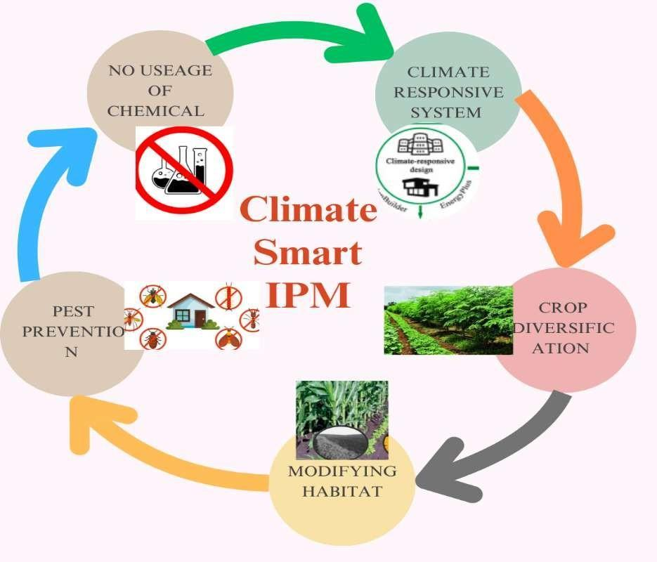

Fig 2 Smart IPM
Push-Pull generation utilising plant-insect interactions, push-pull era is an ecological pest management method that enhances agricultural output. This approach includes planting an attractive or "pull" plant, like Napier grass, round the sector to seize insect pests even as additionally intercropping a first-rate crop, like maize or sorghum, with a repellent or "push" plant, like Desmodium, which discourages insect pests (Khan et al., 2018). Striga, a parasitic plant that decimates cereal plants in sub-Saharan Africa, has been suppressed and stem borers were efficaciously managed with this method (Midega et al., 2017). similarly to controlling pests, push-pull method increases soil fertility with the aid of the usage of Desmodium's nitrogen-fixing traits and producing animal feed, which increases farm sustainability. research reveal that in comparison to standard monocropping, farmers that use push-pull strategies have shown production increases of as much as 200% (Khan et al., 2021). moreover, by way of reducing the want for chemical insecticides, this method lowers production charges and supports environmental sustainability (Hassanali,2020). by boosting crop yields and promoting soil health, pushpull technology, a weather-clever agricultural method, improves food protection and smallholder resistance to climatic unpredictability. Use of Resistant Crop types A key tactic in sustainable agriculture is the deployment of resistant crop kinds, especially whilst coping with the problems due to pests, illnesses, and climate exchange. crops with genetic resilience to biotic and abiotic stressors have been developed way to breeding and biotechnological traits, which has reduced the requirement for chemical inputs whilst keeping consistent yields (Singh et al., 2018). To provide food safety in dry and semi-arid international locations, as an example, drought-resistant rice and maize cultivars were created to undergo water shortage Lobell,2020). In a comparable vein, insect pest resistance offered through genetically changed (GM) plants like Bt cotton and Bt maize significantly lessens the need for chemical pesticides. ailment-resistant cultivars, like overdue blight-resistant potatoes and rustresistant wheat, lessen losses delivered on by way of bacterial and fungal illnesses. moreover, to combat the poor influences of soil degradation and international warming, climate-smart crop cultivars with improved resilience to warmth and salt are getting used. through lessening the effect on the surroundings, slicing production expenses, and enhancing meals protection for smallholder farmers, using resistant crop types will increase agricultural sustainability. To keep resistant durability and handle changing pest and disorder demanding situations in numerous agroecosystems, but, ongoing research and breeding projects are critical. C. biological manage marketers An substitute for chemical insecticides, organic control agents are evidently going on organisms which can be used to control agricultural pests and ailments. consistent with (Hajek,2018), these agents consist of sicknesses, parasitoids, predators, and opposed microbes that naturally lower unsafe pests and pathogens. Aphids and other sap-feeding pests are correctly controlled with the aid of predatory insects like ladybugs (Coccinellidae) and lacewings (Chrysopidae), which reduce crop harm, by way of attacking insect eggs, parasitoids like Trichogramma wasps stop pest outbreaks in vegetation like cotton and maize (Van Lenteren ,2018). by targeting positive insect pests, microbial manipulate strategies which includes Beauveria bassiana and Bacillus thuringiensis (Bt) reduce non-goal influences and hold ecological balance. furthermore, mycorrhizal fungi and plant increase-selling rhizobacteria (PGPR) promote nutrient absorption and make stronger plant resistance against soilborne illnesses (Backer et al.,2018). because they hold beneficial species, enhance soil health, and lessen reliance on pesticides, biological manage strategies assist manipulate pests in a sustainable manner. but, an included pest control (IPM) approach that takes into account variables which include habitat renovation, climatic situations, and bug populace dynamics is necessary for a success implementation. with a purpose to improve weather-clever agriculture and decorate lengthy-term crop resilience, it can be critical to increase the usage of biological control retailers.

Table-3 Climate-Smart Pest and Disease Management Strategies:

Strategy | Description | Benefits | Examples
Biological  Control Agents | Use of predators, parasitoids, and microbial agents to control pests and diseases. | Reduces chemical pesticide use, maintains ecological balance. | Trichogramma wasps, Bacillus
Resistant Crop  Varieties | Development of crops with genetic resistance to pests and diseases. | Reduces yield losses, minimizes pesticide dependence. | Bt cotton,  rust-resistant  wheat.
Push-Pull  Technology | Intercropping  system using repellent and attractant plants to control pests. | Controls pests  naturally,  improves soil fertility, increases yields. | Maize-  Desmodium-  Napier system.
Integrated Pest  Management  (IPM) | Combines  biological, cultural, mechanical, and chemical control methods. | Sustainable, reduces pesticide resistance and residues. | Crop rotation,  pheromone  traps.
Agroecological  Practices | Enhancing biodiversity through polyculture, agroforestry, and habitat conservation. | Strengthens  natural pest control, improves resilience to climate change. | Agroforestry systems, polycropping.
Digital and AI-  Based  Monitoring | Use of sensors, AI, and remote sensing for early pest and disease detection. | Improves precision in pest control, minimizes Overuse of chemicals. | AI pest  detection apps, drone surveillance.
ClimateResilient  Agronomic Practices | Adjusting planting times, crop spacing, and irrigation methods to reduce pest risks. | Minimizes pest outbreaks linked to climate variability. | Climate-smart  irrigation,  adjusted  sowing dates.

Conclusion:
This assessment underscores the transformative ability of weather-smart intercropping while incorporated with rising technology to fight the adverse results of weather trade on agriculture. by way of leveraging improvements along with IoT, precision agriculture, CRISPR biotechnology, and AI, farmers can decorate useful resource performance, optimize crop combos, and enhance resilience towards climate variability. these technology enable real-time monitoring and knowledgeable choice-making, which might be critical for maximizing yields and ensuring meals safety. moreover, climate-clever intercropping fosters biodiversity, mitigates greenhouse gas emissions, and promotes sustainable farming practices. however, demanding situations stay, especially concerning access to era for smallholder farmers and the necessity for robust information control structures. Addressing those issues is critical for harnessing the entire capability of weather-clever intercropping, in the long run contributing to resilient agricultural structures that may preserve international meals production amidst ongoing weather demanding situations.
References
Adger, W. N., Dessai, S., Goulden, M., Hulme, M., Lorenzoni, I., Nelson, D. R. et al., (2009). Are there social limits to adaptation to climate change?. Climatic change, 93, 335-354.
Alloghani, M. A. (2023). AI for sustainable agriculture: a systematic review. Artificial Intelligence and Sustainability, 53-64.
Altieri, M. A., & Nicholls, C. I. (2017). The adaptation and mitigation potential of traditional agriculture in a changing climate. Climatic change, 140, 33-45.
Aryal, J. P., Sapkota, T. B., Khurana, R., Khatri-Chhetri, A., Rahut, D. B. et al., (2020). Climate change and agriculture in South Asia: adaptation options in smallholder production systems. Environment, Development and Sustainability, 22(6), 5045-5075.
Backer, R., Rokem, J. S., Ilangumaran, G., Lamont, J., Praslickova, D., Ricci, E. et al., (2018).
Carter, E. (2023). AI-Driven Precision Agriculture: Enhancing Crop Yield and Resource Efficiency.
Chausson, A., Turner, B., Seddon, D., Chabaneix, N., Girardin, C. A., Kapos, V. et al., (2020). Mapping the effectiveness of nature‐based solutions for climate change adaptation. Global change biology, 26(11), 6134-6155.
Dainese, M., Martin, E. A., Aizen, M. A., Albrecht, M., Bartomeus, I., Bommarco, R et al.. (2019). A global synthesis reveals biodiversity-mediated benefits for crop production. Science advances, 5(10), eaax0121.
Fuss, S., Lamb, W. F., Callaghan, M. W., Hilaire, J., Creutzig, F., Amann, T., & Minx, J. C. (2018). Negative emissions—Part 2: Costs, potentials and side effects. Environmental research letters, 13(6), 063002.
Gajardo, H. A., Gómez-Espinoza, O., Boscariol Ferreira, P., Carrer, H., & Bravo, L. A. (2023). The potential of CRISPR/Cas technology to enhance crop performance on adverse soil conditions. Plants, 12(9), 1892.
Gebrechorkos, S. H., Hülsmann, S., & Bernhofer, C. (2019). Regional climate projections for impact assessment studies in East Africa. Environmental Research Letters, 14(4), 044031.
Hajek, A. E., & Eilenberg, J. (2018). Natural enemies: an introduction to biological control. Cambridge University Press.
Hassanali, A., Khan, Z. R., & Pickett, J. A. (2020). Integrated pest management: The role of push-pull technology. Annual Review of Entomology, 65, 259-275.
IEA (2021). Energy Efficiency 2021. International Energy Agency.
IRENA (2019). Renewable Energy and Climate Change. International Renewable Energy Agency.
Jones, L., & Brown, K. (2020). Climate resilience through AI in farming. Agricultural Systems, 176, 102739.
Khanal, S., Kc, K., Fulton, J. P., Shearer, S., & Ozkan, E. (2020). Remote sensing in agriculture—accomplishments, limitations, and opportunities. Remote sensing, 12(22), 3783.
Kox, T., Lüder, C., Gerhold, L., & Schmid, J. (2018). Anticipating climate risks using artificial intelligence-based early warning systems. Climate Risk Management, 22, 100-112.
Krattinger, S. G., Sucher, J., Selter, L. L., Chauhan, H., Zhou, B., Tang, M., & et al., (2016). The wheat durable, multipathogen resistance gene Lr34 confers partial blast resistance in rice. Plant biotechnology journal, 14(5), 1261-1268.
Lal, R. (2020). Regenerative agriculture for food and climate. Journal of soil and water conservation, 75(5), 123A-124A.
Lipper, L., McCarthy, N., Zilberman, D., Asfaw, S., & Branca, G. (2017). Climate smart agriculture: building resilience to climate change (p. 630). Springer Nature.
Lobell, D. B., Hammer, G. L., McLean, G., Messina, C., Roberts, M. J. et al., (2020). Greater progress on drought adaptation in maize than sorghum. Nature Plants, 6(9), 1038-1045.
Mantzoukas, S., & Eliopoulos, P. A. (2020). Biological control agents as an alternative to chemical pesticides for insect pests. Insects, 11(11), 640.
Meerow, S., Newell, J. P., & Stults, M. (2016). Defining urban resilience: A review. Landscape and urban planning, 147, 38-49.
Murugan, D., Garg, A., & Singh, D. (2017). Development of an adaptive approach for precision agriculture monitoring with drone and satellite data. IEEE Journal of Selected Topics in Applied Earth Observations and Remote Sensing, 10(12), 5322-5328.
Pickett, J. A., Woodcock, C. M., Midega, C. A., & Khan, Z. R. (2014). Push–pull farming systems. Current opinion in biotechnology, 26, 125-132.
Plant growth-promoting rhizobacteria: context, mechanisms of action, and roadmap to commercialization of biostimulants for sustainable agriculture. Frontiers in plant science, 9, 1473.
Rai, G. K., Khanday, D. M., Kumar, P., Magotra, I., Choudhary, S. M., Kosser, R., et al.,(2023). Enhancing crop resilience to drought stress through CRISPR-Cas9 genome editing. Plants, 12(12), 2306.
Ray, P. P. (2017). Internet of things for smart agriculture: Technologies, practices and future direction. Journal of Ambient Intelligence and Smart Environments, 9(4), 395-420.
Sahoo, U., Malik, G. C., Maitra, S., Banerjee, M., Masina, S., Nath, S. et al., (2023). Intercropping system: A climate-smart approach for sustaining food security.
Sharma, S. (2023). Precision Agriculture: Reviewing the Advancements Technologies and Applications in Precision Agriculture for Improved Crop Productivity and Resource Management. Reviews In Food and Agriculture, 4(2), 45-49.
Siddique, T. (2019). Agrobiodiversity for pest management: an integrated bioeconomic simulation and machine learning approach (Master's thesis, University of New Hampshire).
Smith, P., Davis, S. J., Creutzig, F., Fuss, S., Minx, J., Gabrielle, B. et al., (2020). Carbon removal and emission reductions in agriculture and forestry. Nature Climate Change, 10(10), 920-927.
Snyder, W. E. (2019). Give predators a complement: Conserving natural enemy biodiversity to improve biocontrol. Biological control, 135, 73-82.
Stehfest, E., Bouwman, L., Van Vuuren, D. P., Den Elzen, M. G., Eickhout, B., & Kabat, P. (2009). Climate benefits of changing diet. Climatic change, 95(1), 83-102.
Surminski, S., & Thieken, A. H. (2017). Promoting flood risk reduction: The role of insurance in Germany and England. Earth's Future, 5(10), 979-1001.
Tester, M., & Langridge, P. (2018). Breeding technologies to increase crop production in a changing world. Science, 327(5967), 818-822.
Thierfelder, C., Chivenge, P., Mupangwa, W., Rosenstock, T. S., Lamanna, C., & Eyre, J. X. (2017). How climate-smart is conservation agriculture (CA)?–its potential to deliver on adaptation, mitigation and productivity on smallholder farms in southern Africa. Food security, 9(3), 537-560.
Van Lenteren, J. C., Bolckmans, K., Köhl, J., Ravensberg, W. J., & Urbaneja, A. (2018). Biological control using invertebrates and microorganisms: plenty of new opportunities. BioControl, 63, 39-59.

