Journal Name: | Journal of Engineering Research and Reports
Manuscript Number: | Ms_JERR_141858
Title of the Manuscript: | Multi-scale sedimentological and structural characterization of Triassic Siliciclastic systems in the Tim Mersoï Basin (northern Niger)
Type of the Article | Original Research Article

PART 1: Comments
 | Reviewer’s comment  Artificial Intelligence (AI) generated or assisted review comments are strictly prohibited during peer review. | Author’s Feedback (It is mandatory that authors should write his/her feedback here)
Please write a few sentences regarding the importance of this manuscript for the scientific community. A minimum of 3-4 sentences may be required for this part. | - Study on the Triassic siliciclastic systems and characterize the sandstones of this formation from a sedimentological and structural perspective.  - Comprehensive sedimentary geological and structural field approach, laboratory analysis and interpretation of data  - Methodology in the study of field work to map this formation, followed by laboratory work in microscopic analysis (optical, SEM and microprobe).
Is the title of the article suitable?  (If not please suggest an alternative title) | Multi-scale sedimentological and structural characterization of Triassic Siliciclastic systems in the Tim Mersoï Basin (northern Niger).
Is the abstract of the article comprehensive? Do you suggest the addition (or deletion) of some points in this section? Please write your suggestions here. | A brief conclusion in your summary would give the perfect closure to your work.
Is the manuscript scientifically, correct? Please write here. | Correct
Are the references sufficient and recent? If you have suggestions of additional references, please mention them in the review form. | I suggest recent bibliography so that your work has a background that supports the work and is up to date.  - Amorone, C. E. (2022). Stratigraphic and paleoenvironmental analysis of the Challacó Formation (Middle Jurassic), on the southern flank of the Picún Leufú anticline east of National Route 40 (Bachelor's thesis, Universidad Nacional del Comahue. Faculty of Engineering).  -  - Borya, A. (2020). Paleoenvironmental and diagenetic analysis of the Calabozo Formation (Middle to Upper Jurassic) and its basal boundary with the Lajas Formation (Middle Jurassic) in the northwestern sector of the Neuquina Basin, Mendoza, Argentina (Doctoral dissertation, Universidad Nacional de La Plata).  - BARBOZA-GUDIÑO, José Rafael, et al. Late Triassic stratigraphy and facies from northeastern Mexico: Tectonic setting and provenance. Geosphere, 2010, vol. 6, no 5, p. 621-640.  - BARBOZA-GUDIÑO, José Rafael, et al. Subduction-related Jurassic volcanism in the Mesa Central province and contemporary Gulf of Mexico opening. Journal of South American Earth  Sciences, 2021, vol. 108, p. 102961.

Is the language/English quality of the article suitable for scholarly communications? | appropriate
Optional/General comments | In figure 1 I suggest adding a small map showing the study area (country, state or department), the reason is that readers from other countries can easily locate it visually, I add an example.  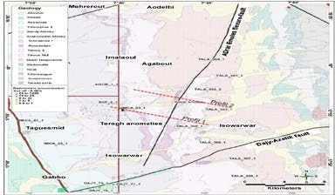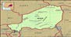  In methodology section 4, how many samples underwent microscopic analysis, cathodoluminescence analysis and SEM analysis?  If a profile could be added to your sample photos indicating exactly where the samples were taken from, it would be an added bonus as an example.  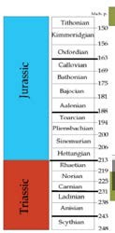  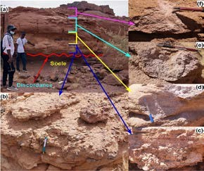  In figure 4 it would increase the quality if you match the size of the pictures shown,  In Figure 5, what type of matrix do you have and if you can observe any type of alteration  What type of microscope was used because if they need to replicate your methodology they will have a reference of the equipment and quality that is generated, example. Nikon Eclipse LV100 POL petrographic microscope (polarized light).  Figure 6 to which unit each core belongs and if you number them it gives more formality in order.  Figure 7 I suggest changing the color of the dotted lines, deformation arrows are lost with the color of the microphotograph of the sample.  The research work is very complete, interesting and important to develop, so only visual details are suggested.

PART 2:

 | Reviewer’s comment | Author’s Feedback (It is mandatory that authors should write his/her feedback here)
Are there ethical issues in this manuscript? | (If yes, Kindly please write down the ethical issues here in details)

Reviewer details:

Loyola Martinez Erika, Ipicyt, Mexico

