Original Research Article

Evaluation of agricultural practices in urban areas: the case of pesticides uses on market garden sites in Sarh (Chad)

.
ABSTRACT

The aim of this study is to assess the phytosanitary practices of urban market gardeners and to provide a better understanding of the risks associated with market gardening practices, particularly the use of pesticides. The study consisted in conducting surveys based on semi-directed interviews using a questionnaire, in order to understand the knowledge, attitudes and practices of growers through the study. A total of 100 market gardeners using pesticides were surveyed. The results showed that the majority (97%) of market gardeners were men aged between 20 and 50, with secondary education. Observations revealed the use of unauthorized pesticides, often intended specifically for other crops. The active ingredients of the most commonly used pesticides are: Acetamiprid, Cypermethrin, Cypermethrin, Cypermethrin and Chlorpyrifos-ethyl. These pesticides are used without any adequate means of protection, and 81% of market gardeners dispose of the packaging in the immediate environment. Concerning the time taken for the last pre-harvest treatment, only 7% of those surveyed observed a normal delay of more than 21 days and 29% applied a delay of less than a week. In the event of product ineffectiveness, 85% of growers adopt the strategy of overdosing, 11% change products and 4% resort to combining with a second product. With regard to the risks to human health associated with handling plant protection products, 92% of those surveyed said they had perceived harmful effects such as headaches and/or fever (58%), nasal congestion, colds and/or coughs (16%), skin burns (10%), dizziness, nausea and/or vomiting (5%) and red eyes (3%). In view of the potential risk of intoxication to growers, it would be urgent to train market gardeners in the use of pesticides. Promoting the use of biopesticides and compliance with standards for pesticide packaging management is an alternative way of reducing the negative impacts of phytosanitary products.

Keywords: urban agriculture, pesticides, market gardening, Sarh, Chad

1. INTRODUCTION

Market gardening is an important component of urban agriculture. It is part of the urban environment in Africa (Massounga et al, 2025, Mougeot and Moustier, 2004). Several studies carried out in Africa show that market gardening is the main agricultural activity (Ouédraogo, 2008). It therefore plays an important role in the diet of urban populations. Market garden crops play a key role in most nutrition and poverty alleviation programs, and contribute significantly to family incomes (James et al., 2010). Market gardener’s supply vegetables to increasingly populated cities, as the world's population is growing, with an estimated 8 billion inhabitants by 2022 (Gross, 2023). Thus, increasing agricultural production and improving plant nutrition is a major challenge for these farming systems (Smith, 2021). On the other hand, in such a constraining environment, it seems important to constantly evaluate the production conditions of vegetable crops in relation to the producers' standard of living (Ballé, 2024). In fact, market garden production in urban areas is limited by multiple abiotic and biotic constraints that affect yields and the ensuing post-harvest operations. The pressure of bio-aggressors has been identified as the major constraint due to the crop losses inflicted on market gardeners (Kanda et al., 2014; Mondédji et al., 2015). The use of synthetic pesticides is increasingly common in developing countries. However, studies have highlighted the existence of poor phytosanitary practices, in particular failure to comply with prescribed doses, protection rules and hygiene instructions recommended during treatments, as well as poor management of phytosanitary product packaging (Soro et al., 2018; Mambe-Ani et al., 2019). In Chad, urban market gardening is an important activity for many city dwellers. Market garden production involves several types of produce that contribute to a balanced diet, either as a supplement or seasoning for sauces, or as a starter (Nazal, 2021). According to Doudoua et al (2020), market gardening offers poor urban populations the opportunity to access products essential to their survival, for both food and financial needs. Although market gardening plays an important role in the diets of urban dwellers and makes a significant contribution to the incomes of vulnerable families, it is faced with pest pressure that limits its productivity. The proliferation of parasites on plants hampers their growth and development. Insects (locusts, caterpillars, aphids, etc.) that feed on plant buds, leaves, flowers, fruit, etc. cause considerable damage (Nazal, 2019). The parasitic pressure exerted on market garden crops in Chad leads to a reduction in production and consequently in market gardeners' incomes. Growers have found solutions to these constraints in the massive application of phytosanitary products, some of which are prohibited, and which ultimately pose environmental and health problems. The aim of the study was to investigate the use of phytosanitary products in the town of Sarh.

2. material and methods

2.1 Geographical scope of the study

The study took place in the town of Sarh, in Chad's Moyen Chari province. The town of Sarh is located in the south of the country, on the banks of the Chari River, close to the border with the Central African Republic. The climate is Sudanian, with a hot dry season from November to April and a hot wet rainy season from May to October. Rainfall averages between 800 and 1,200 mm per year. Average annual temperatures range from 24 to 38°C. The soils are ferruginous, leached and reddish in color, with a uniformly sandy-clay to clay texture and a pH that is slightly acidic at the surface and very acidic at depth. Bordered by the Chari and Barh-Kôh rivers, the town of Sarh is located on a vast, featureless plain. Its topography is marked by a gentle westward slope towards the Bahr Kôh river. The hydrographic layout, soil and climate are ideal for market gardening.

2.2 Methodology

The study is exploratory and descriptive in nature, and took place from March to May 2024, a period conducive to market gardening. It is a descriptive cross-sectional study of market gardeners who use pesticides. The present study covered 9 market garden production sites chosen from the 13 listed in the town of Sarh. These were: Balimba, Banda, Doyaba, Jardin, Kamati, Keguéteré, Malron and Maingara.

The choice of study sites was guided by the exploratory field trip, informal discussions with market gardeners and existing documentation. After first locating the various market garden sites in our study area, we chose the sites on the basis of the organization of the growers and the dynamism of the farms.
Surveys were carried out on the basis of semi-structured interviews using a questionnaire designed for this purpose, in order to understand the knowledge, attitudes, practices and perceptions of the groups targeted by the study. A total of 100 market gardeners using pesticides were surveyed. All market gardeners participating in the study gave their free and informed consent.
The study methodology was based on field surveys of market gardeners in the study area. The main information gathered from market gardeners related to their socio-demographic data (gender, age, level of education), the species produced, the period of market gardening, pesticide use and management, the health of market gardeners following the use of phytosanitary products, and the training of market gardeners in the use of phytosanitary products.

2.3 Statistical Analysis

After checking and coding the forms, the data were statistically processed using Sphinx plus2 software. Statistical parameters (averages and percentages) were calculated and used to construct the graphs, targeting the following variables: socio-demographic profile knowledge of pesticides, characteristics of pesticides used, types of vegetables grown, time of treatment, pre-harvest interval, protective measures during treatment, packaging management, level of risk perception, manifestation of discomfort linked to pesticide applications, attitudes adopted in the event of discomfort and history of training in the application of phytosanitary products.

3. results and discussion

3.1 Socio-demographic profile of market gardeners

Farming in the town of Sarh is widely dominated by men. Women are less interested in production, but are much more involved in marketing market garden produce. This trend corroborates the findings of Cissé et al, (2021) in Dakar, Nazal (2021) in N’Djamena and Agmas & Adugna, (2020) in Ethiopia, where market gardening is predominantly male. The study conducted by Benjamine and Wadou (2023) in the town of Maroua showed that only 14% of women are involved in market garden production. Ganacadja et al, (2022) and Ondo (2011) had reported respectively 1.45% and 5.6% as the proportion of women in three provinces of Gabon and in the Libreville area. The level of women's involvement in market gardening in Haut-Ogooué is 22% (Massounga et al, 2025). For Ondo (2011) and Koffie-Bikpo and Adaye (2014), the low representation of women is linked to the difficulty of accessing land and financing, and to the arduous work involved in making boards and ridges. On the other hand, this study contrasts with the observations of Dasylva et al, (2023) in Ziguinchor and those of Nguegang (2008) in Yaoundé, who reported a proportion of 86% and 65% women market gardeners respectively. In Kampala, men perceive agricultural production as a marginal activity, culturally reserved for women, according to Boland (2005). In terms of marital status, more than half the market gardeners are married (64%), and the majority (87%) have market gardening as their main activity. The majority of market gardeners are aged between 20 and 50, which could be explained by the fact that they are often married and responsible for their households. Young people under 20 and older people over 50 are poorly represented in the town's production activity, with respectively 10% and 7% of market gardeners surveyed. These results are in line with those of Touré (2020) in Banguinéda (Mali), where the dominant age bracket is between 40 and 49. However, they differ from those of Agmas and Adugna, (2020), who observed a higher proportion of young market gardeners (48.7%).

In terms of level of education, more than half the respondents (87%) had attended school, with secondary school dominating (58%). Market gardeners with a primary education accounted for a quarter of respondents (25%). 13% of market gardeners were illiterate. The use of pesticides requires a minimum of theoretical and practical knowledge to rule out any risk to human health and the environment (Cissé et al., 2006; Kanda et al., 2014; Wognin et al., 2013). The study highlighted the low level of education among farmers. This has been observed by other authors (Diao Maty, 2004; Ondo, 2011; Bayendi L. et al., 2017; Massounga et al, 2025). The educational level of market gardeners is predominantly secondary, which could be explained by the difficulties of access to the formal sector for those with little schooling. Overall, the level of education of the growers will enable them to set up a system to reduce the negative impacts of pesticide use. All the market gardeners surveyed have received no training in the application of phytosanitary products. To combat pathogens, they rely on the advice of other growers or suppliers. Those who can read sometimes consult the instructions for use on the packaging. The socio-demographic characteristics taken into account in this survey can greatly influence pesticide use practices.

Table 1. Socio-demographic characteristics of the study population

Characteristics | Frequency (%)
Gender
Men | 97,00
Women | 3,00
Age range (years)
< 20 | 10,0
[20-35] | 45,0
[36-50] | 38,0
˃ 50 | 7,0
Matrimonial status
Single | 23
Married | 64
Divorced | 8
Widow | 5
Education level
No | 13,0
Elementary | 25,0
Secondary | 58,0
University | 4,0
Marketgardening Main activity
Yes | 87,0
No | 13,0
Training in the application of phytosanitary products
Yes | 0
No | 100

3.2 Types of cultivated vegetables

In the town of Sarh, the planting of species depends on the season. In the sites surveyed,
In the town of Sarh, the planting of species depends on the season. In the sites surveyed, during the study period and according to the organs consumed, the distribution of species shows that 50% of species are cultivated for their leaves, 25% for their fruits, 18.75% for their roots or bulbs and 6.25% for their pods (figure 2). Various types of vegetables are produced by market gardeners in Sarh. The results of this study show that, depending on the organs consumed, market garden production is geared towards leafy vegetables. The dominance of leafy vegetables is linked to consumer demand. This diversity of vegetables with a dominance of leafy vegetables has been mentioned by Nazal et al (2017) and Nazal (2021) in N’Djamena, Kanda et al. (2014) in severalTogolesetowns. In the city of Kinshasa, leafy vegetables constitute 87% of the vegetables produced (Muzingu, 2007). The share of leafy vegetables is 80% in Ibadan in Nigeria (Olajide-Taiwo et al., 2011) and Brazzaville in Congo (Moustier and Fall, 2004); 90% in Dar Es Salaam in Tanzania (Jacobi et al., 2000), Bissau and Antananarivo (Moustier and David, 1996). In Bangui, peri-urban areas account for 100% of the city's supply of leafy vegetables (Moustier and David, 1996).
Among leafy vegetables, lettuce predominates with 47.14%, followed by celery (12.52%), sorrel (12.20%), parsley (11.01%) and green onion (8.42%). Fruit vegetables consist mainly of okra; root/bulb vegetables are represented by carrot (63.25%), turnip (35.02%) and beet (1.71%). Green beans are the pod vegetable.

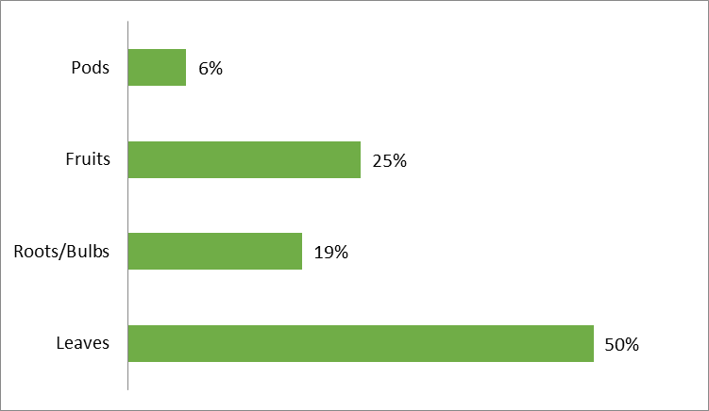

Fig. 1. Distribution of species by organs consumed

3.3 Type of pesticides used and spraying equipment

Market gardeners use pesticides to control pests in their crops. The systematic use of chemical pesticides could be explained by the fact that most market gardeners cannot conceive of producing vegetables and making a profit without chemical pesticides (Ahouangninou, 2013). They generally obtain pesticides on the black market, following the advice of their colleagues or vendors. The choice of pesticides made by market gardeners depends on the availability of pesticides on the market. Various pesticides are used by the market gardeners surveyed, with Optimal 20 SP (65%), Cypercal 50 EC (59%), Vizir 92 EC (56%) and Emir Fort 104 EC (54%) predominating (Table 2). Calthio C 50 WS is an insecticide and fungicide mixture for seed protection. In most cases, some of the chemicals used are not suitable for market gardening. Some pesticides intended for cotton production are used in market gardening (Vizir 92 EC, Emir Fort, …). These results are in line with previous studies. According to Ahouangninou (2019), in the rural Commune of Tori-Bossito the preparation most used by over 84% of market gardeners was COTALMP 218EC, a binary formulation of lambdacyhalothrin and profenophos recommended for cotton production. There is also the problem of a lack of control over the active ingredients used to protect vegetable crops in Chad. For Ouatara (2014), farmers in developing countries, due to lack of training and illiteracy, misuse and abuse chemical inputs. Acetamiprid (Neonicotinoide family) and Cypermethrin (Pyrethrinoide family) are the most widely used active ingredients. Analysis of the phytosanitary practices of market gardeners carried out by Sani Ado et al. (2018) in 9 cuvettes in the Gouré department show that the most widely used pesticides are organophosphates (56%) and pyrethroids (42%).

Table 2. Pesticides used on Sarh market garden sites during the study period

Trade name | Active ingredients | Frequency
Cypercal 50 EC | Cypermethrine 50 g/l | 59 %
Tamega 25% | Deltamethrine25g/l | 36 %
Topiscab 5% | Permethrine | 26 %
Gawa 30% | Imidoclopride 30 g/l | 18 %
Curacron | Profenofos 500 g/l | 10 %
Optimal 20 SP | Acétamipride 200 g/kg) | 65 %
Perfect Killer | Chlorpyriphos-ethyl 480 g/l | 18 %
DD force | Dichlorvos 1000 g/l | 16 %
Thalis 56 EC | Emamectine benzoate 24 g/l  Acétamipride 32g/l | 50 %
Emir Fort 104 EC | Cypermethrine 72 g/l  Acetamipride 32 g/l | 54 %
Vizir 92 EC | Cypermethrine 72 g/l  Albamectine 20 g/l | 56 %
Chemthrin 10 EC | Cypermethrine 10 g/l | 14 %
Calthio C 50 WS | Chlorpyrifos-éthyl 25%  Thiram 25% | 36 %

To spray their crops with phytosanitary products, market gardeners use sprayers, branches with plant leaves or sometimes bottles with twigs.

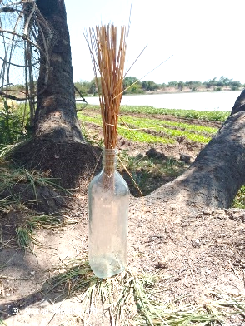
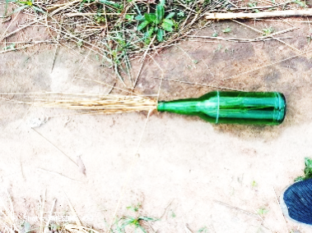

Fig. 2. Bottles used for phytosanitary treatment

3.4 Protective measures during plant protection treatments

The field surveys showed that none of the market gardeners had complete protective equipment, such as overalls, gloves, boots, muffs and goggles. The long-sleeved shirt seems to be the protective equipment most adopted by market gardeners (28%), followed by boots, dust covers and gloves with 7%, 6% and 4% respectively. Goggles are used by only 2% of market gardeners surveyed (Figure 3). On the other hand, the majority of market gardeners surveyed (53%) do not use any means of protection, even though they are aware of the importance of wearing personal protective equipment. Only a third of market gardeners combine two or three items of protective equipment. According to growers, the reasons given for this type of non-recommended use are lack of means, inaccessibility and the high cost of protective equipment. In the Commune of Tori-Bossito, Benin, 4% of growers use personal protective equipment (Fifatin et al., 2020). The study carried out by Jean-Luc (2022) on the analysis of market garden production in the commune of Kenscoff (Haiti) showed that market gardeners do not even protect themselves during applications. This situation is undoubtedly linked to a lack of technical support from the authorities concerned.

Fig. 3. Distribution of respondents by equipment used

3.5 Packaging management

Pesticide packaging management standards are not respected. After using pesticides, the majority of market gardeners dispose of the packaging in the immediate environment (81%). Some growers kept pesticide packaging for reuse (81%). This form of recycling of pesticide packaging is due to the fact that market gardeners are not very well informed about the ecological risks incurred by this poor management of packaging. A small proportion of market gardeners bury their packaging in the ground (5%) or burn it (3%). This situation causes enormous environmental risks, notably contamination of water, soil and the atmosphere.

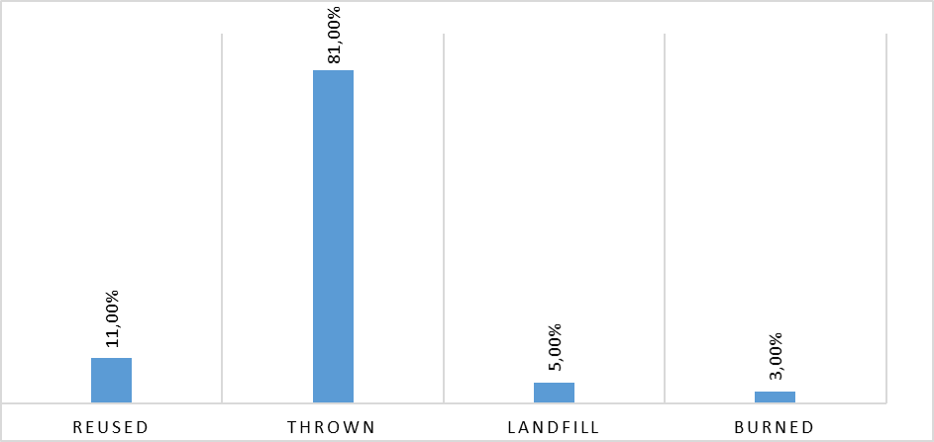

Fig. 4. Packaging management by market gardeners

3.6 Phytosanitary treatment times

The timing of pesticide application by market gardeners varied widely across the sites surveyed. Not all market gardeners have precise times for spraying their crops, although the majority prefer to spray in the morning. Figure 5 shows that 61% of market gardeners prefer to apply pesticides in the morning, while 27% wait until evening to treat their crops. Although 3% of market gardeners prefer to apply pesticides at midday, 9% treat their crops at any time of the day, depending on their availability.

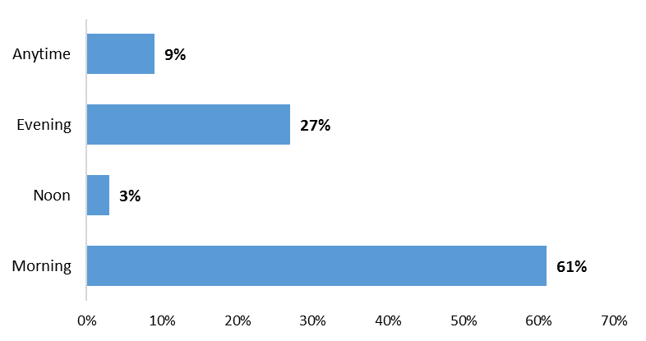

Fig. 5. Distribution of market gardeners according to time of day of treatment

3.7 Delay before harvest

The majority of market gardeners surveyed know that it is essential to respect the time between the last application of pesticides and harvesting. Despite this, the pre-harvest safety period is not respected by these market gardeners, who set the pre-harvest period at their own discretion. Indeed, the majority of market gardeners surveyed observe a pre-harvest interval of less than two weeks. More than a quarter (29%) apply a pre-harvest interval of less than a week. Only 7% of market gardeners observe a normal delay of more than 21 days. Treatment is carried out whenever insects appear on the plant.

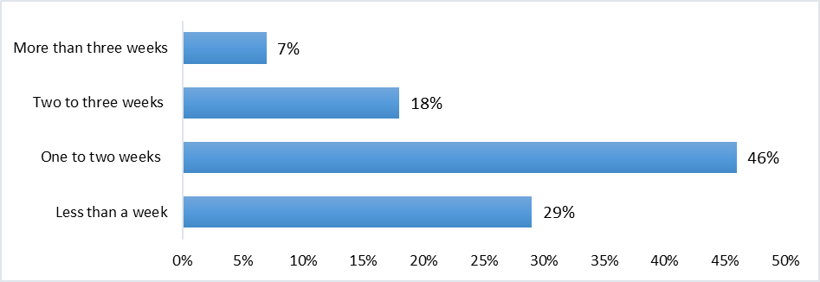

Fig. 6. Delay before harvest

3.8 Strategies in case of inefficiency

The strategy adopted by most market gardeners when pesticides are ineffective is to overdose (85%). This is not without consequences for human and environmental health. If the recommended dose is exceeded, the active ingredients are dispersed into the environment and harm the latter. This strategy was observed among market gardeners in the Commune of Tori-Bossito, Benin, by Fifatin et al (2020). Few market gardeners change products if they are ineffective. Some growers change products (11%), while 4% of market gardeners surveyed indicated that they use a combination with a second product in the event of ineffectiveness of the first product used.

Fig. 7. Strategy in case of treatment failure

3.9 Market gardeners' attitudes to plant protection products

The majority of market gardeners surveyed stated that they had actually perceived the risks to human health from handling plant protection products. Headaches, respiratory problems, coughing, skin burns, dizziness, etc. are all symptoms of intoxication due to the use of these pesticides reported by market garden producers in Sarh and which have been reported by several authors: Kanda et al., 2009; Ahouangninou et al., 2011; Son et al., 2017). Although the majority of market gardeners surveyed are aware of the risks incurred by the inappropriate application of pesticides, few of them wash their hands or take a shower after crop treatments. Medical consultations related to pesticides are almost non-existent. If they feel unwell, market gardeners take medicines without a prescription.

Table 3. Distribution of respondents' complaints about pesticide application

Discomfort | Frequency
Skin burns | 10%
Headache and/or fever | 58%
Nasal congestion, colds and/or coughs | 16%
Dizziness, nausea and/or vomiting | 5%
Eye redness | 3%
Nothing | 8%

The dependence of urban and peri-urban market gardening on chemical pesticides has been reported in N'Djaména by Nazal (2021), in Gabon by Ondo (2011), in Burkina Faso by Son et al. (2017) in Benin by Akogbéto and al. (2005) and by Ahouangninou (2013). This study reveals that in the town of Sarh, a great deal of effort needs to be made in terms of phytosanitary protection of market garden crops. Subsidizing the acquisition of appropriate personal protective equipment by these growers, reinforcing technical supervision, making effective bio-pesticides available on markets and introducing physical methods to combat all market garden pests will reduce the risks associated with the use of chemical pesticides (Ahouangninou, 2013For Schmidt and Courcy (2017), sustainable agriculture practices are an operational response in many developing countries. To achieve this, “Produce more and better” must be the watchword of agricultural policies at local, national and regional levels. The use of organic inputs can help improve yields, reduce environmental and health risks, and ensure food safety. Producers must adopt bio-pesticides and natural pesticides in order to preserve the biological diversity of agricultural soils (Fifatin et al 2020). The FAO and WHO insist that extensive training programs be initiated for pesticide sellers and users to ensure correct selection and appropriate use of products, including the use of protective equipment, to reduce risk.

4. Conclusion

In the town of Sarh, several crops are cultivated in market gardening, thanks in part to the presence of permanent watercourses. The desire to improve yields and protect crops against pathogens has led market gardeners to use pesticides. However, growers do not have a good knowledge of pesticides, nor do they respect the wearing of Personal Protective Equipment and the management of packaging after use. The results obtained reveal the potential risk of intoxication for growers, which urgently requires judicious training in the use of synthetic pesticides. The alternative would be to develop the use of bio-pesticides to reduce the negative impacts of pesticides. To protect consumers, studies need to be carried out to assess the level of contamination and the economic and environmental health risks associated with the consumption of market garden produce from the town of Sarh.

DISCLAIMER (ARTIFICIAL INTELLIGENCE)

Authors hereby declares that NO generative AI technologies such as Large Language Models (ChatGPT, COPILOT, etc) and text-to-image generators have been used during writing or editing of this manuscript.

COMPETING INTERESTS DISCLAIMER:
Authors have declared that they have no known competing financial interests OR non-financial interests OR personal relationships that could have appeared to influence the work reported in this paper.

References

Agmas, B., & Adugna, M. (2020). Attitudes and practices of farmers with regard to pesticide use in NorthWest Ethiopia. Cogent Environmental Science, 6(1), 1791462. https://doi.org/10.1080/23311843.2020.1791462
Ahouangninou C., Boko S.Y.W., Logbo J., Assogba-Komlan F., Martin T. &Fayomi B. (2019). Analysis of the determinants of phytosanitary practices of market gardeners in southern Benin. Afrique SCIENCE 15(5), 252-265
Ahouangninou, C., Fayomi, BE. & Martin, T. (2011). Health and Environmental Risk Assessment of Phytosanitary Practices Used by Market Gardeners in the Rural Commune of Tori-Bossito (Southern Benin). Cahiers Agricultures 20(3): 216–222. DOI: 10.1684/agr.2011.0485.
Ahouangninou, C. (2013). Sustainability of Market Gardening Production in Southern Benin: A Test of the Ecosystem Approach. Single Doctoral Thesis, University of Abomey Calavi, Benin, 333p.
Akogbeto, M.C., Djouaka, R. &Noukpo, H. (2005). Use of Agricultural Insecticides in Benin. Bull Soc PatholExot, 98: 400–405pp.
Ballé, S.G.R. (2024). Urban and peri-urban market gardening in the face of the scarcity of production factors in the city of Korhogo (Côte d'Ivoire). African Journal of Environment and Agriculture; 7(4), 56-66. DOI: https://dx.doi.org/10.4314/rafea.v7i4.7
Bayendi, L., Sandrine, M. Ndoutoume, N. A. & Francis, F. (2017). Peri-urban market gardening in Libreville and Owendo (Gabon): Cultural practices and sustainability. Cahiers Agricultures, 26(4). https://doi.org/10.1051/CAGRI/2017026.
Benjamine, A. & Wadou, B. (2023). Crop diversity and climate change adaptation strategies: The case of market gardening in the Maroua 1st district/Cameroon. https://doi.org/10.19044/esipreprint.7.2023.p116
Boland, J. (2005). Urban agriculture: Growing vegetables in the city. 2nd edition, Agrodok Series No. 24. Agromisa Foundation, Wageningen.
Cissé, A., Gueye, C. M. L. B., Dia, S., Kane, A., & Sembène, M. (2021). Pesticide choice and use in the Niayes area: The case of NottoGouyeDiama. Afrique SCIENCE, 19(2), 55-67.
Cissé G., Matthys B. & Adiko A.F. (2006). The social network of market gardeners in Abidjan acts on the perception of concerns and health risks linked to water, Vertigo - The Electronic Review of Environmental Sciences, Special Edition 3
Dasylva, M., Ndour, N., & Diallo, A. (2023). Diversity and Characteristics of Plant Agricultural Production Systems in the Municipality of Ziguinchor, Senegal. European Scientific Journal, 19(3), 120-147. https://www.academia.edu/download/101708220/16396-Article_Text-47416-3-10-20230131.pdf
DiaoMaty, B. (2004). Situation and Constraints of Urban and Peri-Urban Horticultural and Animal Production Systems in the Dakar Region. Cahiers Agricultures, 13(1), 39-49.
Doudoua, Y., Yengué, J.L., &Djondang, K. (2020). MarketGardening: Production Techniques and DifficultiesEncountered by Producers in Moundou, Chad. Space, Territories, Societies and HealthReview, Vol. 3, No. 5, June 2020, pp. 49-66.
Fifatin, M-A M., Ahouangninou, C., Ayena, A.A., Massede, S. & Tente, B., (2020). Analysis of Chemical Input Management in MarketGardening in the Municipality of Tori-Bossito in Benin. International Journal of Progressive Sciences and Technologies, Vol. 22 No. 2, pp. 60-71
Ganacadja, C., Mavoungou, J. F., Mouketou, A., Biroungou, C. &Nzengue, E. (2022). Analysis of SomeCharacteristics of the MarketGardeningSector in Three Provinces of Gabon. ESI Preprints, August 2022. https://doi.org/10.19044/esipreprint.8.2022.p55
Gross, M. (2023). Human population at the crossroads, 2023. CurrentBiology, Volume 33, Issue 1, 9 January 2023, Pages R1-R3.
Jacobi P., Amend J &Kiango S. (2000). Urban agriculture in Dar es Salaam:providing for an essential part of the diet. In Bakker N et al (Eds) Growing cities, growingfood: Urban agriculture on the policy agenda. German Foundation for International Development:Feldafing, Germany.
James, B., Atcha-Ahowe, C., Godonou, I., Baimey, H., Goergen, G., Sikirou, R., &Toko, M. (2010). Integrated Pest Management in VegetableProduction: A Guide for Extension Agents in West Africa. International Institute of Tropical Agriculture (IITA), Ibadan, Nigeria. 2010, 120p.
Jean Luc ST-P. (2022). Contribution to Peri-UrbanMarketGardeningthrough the Analysis of Vegetable Production in the Commune of Kenscoff (Haiti): The Case of the Grand Fond Communal Section. Master'sThesis in Integrated Production and Preservation of Natural Resources in Urban and Peri-UrbanEnvironments, University of Gembloux Agro-Bio Tech. http://hdl.handle.net/2268.2/16318
Kanda, M., Wala, K., Batawila, K., Djaneye-Boundjou, G., Ahanchede, A. &Akpagana, K. (2009). Peri-urbanmarketgardening in Lomé: cultural practices, healthrisks, and spatial dynamics, Cahiers Agricultures, 18, 4 (2009) 356-363 p.
Kanda M., Akpavi S., Wala K., Boundjou GD., &Akpagana K. (2014). Diversity of cultivatedspecies and constraints to production in marketgardening in Togo. Int. J. Biol. Chem. Sci. 8(1): pp. 115-127.
Koffié-Bikpo, C.Y. &Adaye, A.A. (2014). Commercial agriculture in Abidjan: the case of marketgardening. For, (4), 141-149.
Dasylva, M., Ndour, N., & Diallo, A. (2023). Diversity and Characteristics of Plant Agricultural Production Systems in the Municipality of Ziguinchor, Senegal. European Scientific Journal, 19(3), 120-147. https://www.academia.edu/download/101708220/16396-Article_Text-47416-3-10-20230131.pdf
DiaoMaty, B. (2004). Situation and Constraints of Urban and Peri-Urban Horticultural and Animal Production Systems in the Dakar Region. Cahiers Agricultures, 13(1), 39-49.
Doudoua, Y., Yengué, J.L., &Djondang, K. (2020). MarketGardening: Production Techniques and DifficultiesEncountered by Producers in Moundou, Chad. Space, Territories, Societies and HealthReview, Vol. 3, No. 5, June 2020, pp. 49-66.
Fifatin, M-A M., Ahouangninou, C., Ayena, A.A., Massede, S. & Tente, B., (2020). Analysis of Chemical Input Management in MarketGardening in the Municipality of Tori-Bossito in Benin. International Journal of Progressive Sciences and Technologies, Vol. 22 No. 2, pp. 60-71
Ganacadja, C., Mavoungou, J. F., Mouketou, A., Biroungou, C. &Nzengue, E. (2022). Analysis of SomeCharacteristics of the MarketGardeningSector in Three Provinces of Gabon. ESI Preprints, August 2022. https://doi.org/10.19044/esipreprint.8.2022.p55
Gross, M. (2023). Human population at the crossroads, 2023. CurrentBiology, Volume 33, Issue 1, 9 January 2023, Pages R1-R3.
Jacobi P., Amend J &Kiango S. (2000). Urban agriculture in Dar es Salaam:providing for an essential part of the diet. In Bakker N et al (Eds) Growing cities, growingfood: Urban agriculture on the policy agenda. German Foundation for International Development:Feldafing, Germany.
James, B., Atcha-Ahowe, C., Godonou, I., Baimey, H., Goergen, G., Sikirou, R., &Toko, M. (2010). Integrated Pest Management in VegetableProduction: A Guide for Extension Agents in West Africa. International Institute of Tropical Agriculture (IITA), Ibadan, Nigeria. 2010, 120p.
Jean Luc ST-P. (2022). Contribution to Peri-UrbanMarketGardeningthrough the Analysis of Vegetable Production in the Commune of Kenscoff (Haiti): The Case of the Grand Fond Communal Section. Master'sThesis in Integrated Production and Preservation of Natural Resources in Urban and Peri-UrbanEnvironments, University of Gembloux Agro-Bio Tech. http://hdl.handle.net/2268.2/16318
Kanda, M., Wala, K., Batawila, K., Djaneye-Boundjou, G., Ahanchede, A. &Akpagana, K. (2009). Peri-urbanmarketgardening in Lomé: cultural practices, healthrisks, and spatial dynamics, Cahiers Agricultures, 18, 4 (2009) 356-363 p.
Kanda M., Akpavi S., Wala K., Boundjou GD., &Akpagana K. (2014). Diversity of cultivatedspecies and constraints to production in marketgardening in Togo. Int. J. Biol. Chem. Sci. 8(1): pp. 115-127.
Koffié-Bikpo, C.Y. &Adaye, A.A. (2014). Commercial agriculture in Abidjan: the case of marketgardening. For, (4), 141-149.
Ondo, J.O. (2011). Vulnerability of market garden soils in Gabon (Libreville region): acidification and mobility of metallic elements. Doctoral thesis in Terrestrial Environmental Sciences, University of Provence, France.
Ouattara, S. (2014). Impacts of chemical and organic inputs on soil macrofauna and maize yield. Final thesis in Agricultural Extension, Polytechnic University of Bobo-Dioulasso, Burkina Faso, 59 p.
Ouédraogo, A. (2008). Vulnerability factors and risk adaptation strategies of urban and peri-urban market gardeners in the cities of Ouahigouya and Koudougou. Engineering thesis. Institute of Rural Development, Polytechnic University of Bobo Dioulasso, Burkina Faso, 58 p.
Sani Ado, M.N., Tankari Dan-Badjo, A., Guero, Y., Tidjani, A.D., Dan Lamso, N. &AmboutaK.J.M.. (2018). Diagnosis of pesticide use in the Gouré basins. Geo-Eco-Trop, 42, 2: 343-350
Schmidt, E. & Courcy B. (2017), Sustainable agriculture: Societal issue and political challenge. Institute of Sustainable Agriculture, 12 p. https://agridurable.top/wpcontent/uploads/2017/06/NOTE-STRATEGIQUE.pdf. [Consulted 11/15/2019]
Sinarinzi, F. &Nisabw T. (1999). Study on the problem of land left by the 1972 refugees in the Rumonge and Nyanza-Lac communes, Bujumbura, Burundi, 42 p.
Smith, C. M. (2021). Conventional breeding of insect-resistant crop plants: still the best way to feed the world population. Current Opinion in Insect Science, 45(Figure 1), 7 13. https://doi.org/10.1016/j.cois.2020.11.008.
Son, D., Somda, I., Legreve, A. &Schiffers, B. (2017). Phytosanitary practices of tomato producers in Burkina Faso and risks to health and the environment. Cahiers Agricultures 26:25005. DOI: 10.1051/cagri/2017010.
Soro, G., Koffi, N.M., Kone, B., Kouakou, Y.E., M’Bra, K.R., Soro, P.D., et al. (2018). Use of plant protection products in market gardening around the drinking water supply dam of the city of Korhogo (northern Côte d’Ivoire): risks to public health. Environ. Risk Health, 17(2): 155-163. DOI: 10.1684/ers.2018.1147
Touré, A. A. (2020). Knowledge, Attitude and Practice of Market Gardeners on the Rational Use of Pesticides in Bamako and Baguinéda [Thesis, University of Science, Techniques and Technologies of Bamako].
Wognin, A.S., Ouffoue, S.K., Assemand, E.F., Tano, K. & Koffi-Nevry, R. (2013). Perception of health risks in market gardening in Abidjan, Ivory Coast. International Journal of Biological and Chemical Sciences 7(5): 1829–1827. DOI: 10.4314/ijbcs.v7i5.4.

